Norwegian Ministry of Justice and Public Security

Total preparedness

Prepared for crises and war

Meld. St. 9 (2024–2025) Report to the Storting (white paper)

Recommendation from the Ministry of Justice and Public Security 10 January 2025,   
approved by the Council of State on the same day.   
(Støre Government)

Part I

Introduction

# The Government’s security and preparedness policy

Norway is a long country, but we are bound by strong ties. We live across the length and breadth of the country and we have a fundamental trust in each other and in the authorities. This community of trust and good, safe and vibrant local communities throughout the country are the most important building blocks of Norwegian civil preparedness. Different parts of the country and different groups in society may have different challenges with respect to preparedness. No matter where you live in Norway or who you are, society should be there for you in times of need. With this white paper, the Government is setting out a completely new direction in the development of total preparedness throughout Norway to strengthen the resilience of the entire population.

## The need for a new security and preparedness policy

Norway finds itself in a more dangerous and unpredictable world.

Our situation is defined by the serious security situation in Europe as a result of Russia’s war of aggression against Ukraine, the war in the Middle East, and intensified global competition and rivalry between superpowers such as the US and China for military, political, economic and technological power.

Technological developments are challenging security and preparedness in ways we cannot fully comprehend. The digitalisation of society, use of social media and development of new technology such as artificial intelligence all contribute to this. Climate change increases the risk of natural hazards at home and can intensify migration and conflicts globally.

To address this development, Norway must strengthen its overall defence capability. The Government’s long-term plan for the defence sector heralds a significant boost to our military capability. The Government is now presenting a historic white paper on Norway’s total preparedness. In the white paper, the Government sets the direction for reforming for the civil part of Norway’s total preparedness and for civil resilience. We will ensure that civil society is prepared for crisis and war, and develop a society that supports military efforts and resists hybrid threats. This involves planning our response to acts of war on Norwegian territory as well as on allied territory.

Russia’s willingness to use military force to achieve political goals makes it likely that Norway will have to deal with an unpredictable and risk-taking neighbour for a long time to come. China’s closer strategic partnership with Russia and its support for the war in Ukraine are disquieting, while we depend on cooperation with China in certain areas to solve the greatest challenges of our time.

The use of hybrid activities makes the distinction between peace and crisis less clear, and challenges the conventional distinction between national security and public security. Disinformation, influence operations, covert investments in strategic businesses, supply chain disruptions, insider risk in private or public undertakings, as well as more frequent cyberattacks, have become commonplace in the threat landscape.

Hybrid activities are often employed over a long period of time and include both legal and illegal measures. Such activity is often carried out covertly through the use of intermediaries, and state actors increasingly use profit-motivated criminals to carry out operations. It can be challenging to understand, recognise, handle and counter such activity, and it affects us all. See further discussion in Chapter 7.

The public’s ability to distinguish between the truth and falsehoods is challenged. Hybrid threats may aim to create divisions between groups and destabilise society.

The business sector, which owns much of society’s critical infrastructure and plays a key role in important value chains, is exposed to cyberattacks, insider risk and foreign intelligence. Foreign actors may seek to disrupt basic services to the population and thereby weaken society’s resilience.

Municipalities are responsible for safeguarding the security of their local communities and are an important part of Norway’s basic preparedness. Crisis and war could challenge municipalities’ ability to maintain basic services for their citizens.

These developments and the complexity of the threat landscape require a more vigilant and resilient civil society. The general public, voluntary organisations, the private sector and local, regional and national authorities must increasingly recognise that security and preparedness are a joint responsibility to which we must all contribute.

The Government will ensure that society’s overall resources are better utilised both in the prevention and management of crises, and ensure close involvement of the private and voluntary sectors. During any incident at the high end of the crisis spectrum, society must have a preparedness culture and what it needs to handle various incidents and crises.

Greater demands will be made of citizens’ self-preparedness. The increasingly close link between the economy and security means that businesses must, to a greater extent, integrate national security considerations into their decisions. Municipalities must systematically plan for major incidents where society will depend on resources pulling together. Businesses, municipalities and county authorities must be able to make good evaluations to safeguard national security.

Strengthening society’s resilience to these developments requires a wide range of measures: regulation, financing, guidance, cooperation and self-preparedness. The sum of measures at different levels will contribute to awareness, knowledge and a shared understanding of the situation, and make us better prepared as a society.

At the same time, we cannot fully protect society against all threats. Incidents will happen. The measures we need to implement must be based on an assessment of risk, and the level of risk we have to accept and live with. We need to know which interests and assets we need to protect.

A long-term approach is important to addressing preparedness. The Government therefore appointed a Total Preparedness Commission in January 2022. The Commission has assessed the strengths and weaknesses of Norway’s current preparedness systems and proposed how society’s collective resources can and should be organised to further develop resilience and ensure the best possible overall utilisation of preparedness resources. The recommendations made by the Total Preparedness Commission in Norwegian Official Report (NOU) 2023: 17 Nå er det alvor – rustet for en usikker fremtid (The time is now – prepared for an uncertain future – in Norwegian only) are followed up through, among other things, this white paper on Norway’s total preparedness.

## Basis for a new security and preparedness policy

The preparedness policy must be based on our strategic interests and utilise our advantages. At the same time, the measures must be based on an understanding of the vulnerabilities we face.

Norway is rich in resources, has knowledgeable citizens and a society where people trust each other and the authorities. The business sector, social partners and public authorities are used to working together. We must develop and protect a society where people and resources throughout the country pull together to prevent and handle crises.

Economic resilience is a mainstay of Norwegian society. A well-functioning business sector, trade and financial stability are prerequisites for maintaining the fundamental functionality of society. Norway is an open economy that trades extensively with the rest of the world. This makes cooperation and interaction with other countries important. Norway is a significant export nation, and we also have significant imports. During the pandemic, we learned the importance of international cooperation for gaining access to vaccines. At the same time, the threats we face today mean we must strengthen national control over critical infrastructure, natural resources, property and strategically important undertakings and value chains.

The High North is our most important strategic region and of major significance in the current security situation. Our freedom of action in the area is being challenged by Russia, while China is also showing increasing interest in the region.

Norway is a major energy nation. Following the war in Ukraine, Norwegian energy supplies to Europe have become even more important in the context of security policy. This makes us vulnerable to pressure and sabotage throughout the value chain.

With one of the world’s longest coastlines, we are particularly vulnerable to maritime covert intelligence activity. This challenges, among other things, our maritime industry and critical infrastructure.

Norway is a highly digitalised society. This is important for our competitiveness and innovative strength, but also creates vulnerabilities with great potential for harming society.

Norway is firmly rooted in a Western and European community of values and interests. NATO is the cornerstone of Norwegian security policy and crucial to our defence capability. Finnish and Swedish NATO membership opens up new opportunities for closer Nordic cooperation on security and preparedness. Norway’s most important trading partners are in Europe, and several important partnerships have been established in the field of civil preparedness. This international community is crucial to Norway’s security, but is increasingly being challenged by actors who seek to create division and weaken unity among Western countries.

## The Government’s goals and priorities

The backdrop for this white paper is the most serious security situation in Europe since the Second World War. Through the long-term plan for the defence sector, the Government and the Storting (the Norwegian Parliament) have jointly adopted a historic strengthening of Norway’s defence. The challenges we face as a society also make it necessary to strengthen civil preparedness.

Since the Second World War, Norway’s defence has been based on the concept of total defence. The concept recognises that support and cooperation between civilian and military resources help Norway to counter and handle threats to society and the state. For civil society, this primarily concerns making better use of society’s collective resources. Central government and local authorities, and the business and voluntary sectors must collaborate more closely to ensure that resources pull together more quickly when a crisis strikes. The plans made by civil society must harmonise with military planning, and prioritise resources where they are most needed. Civil authorities, the Norwegian Armed Forces, private organisations and the voluntary sector must have a common understanding of the situation and conduct more training exercises together.

In light of the current security situation, this white paper emphasises work on total defence and the resilience of civil society in situations where the worst-case scenario occurs and Norway again experiences armed conflict or war. At the same time, the Norwegian preparedness model is based on total defence resources also being employed in ordinary preparedness for natural disasters, major accidents and other serious incidents. Strengthening preparedness for incidents at the high end of the crisis spectrum (see Box 2.9) will also help to strengthen society’s capability to prevent and handle other incidents.

A resilient, steadfast civil society is key to Norway withstanding a more acute and complex threat scenario. The Government’s work on strengthening civil society’s resilience is based on three primary objectives:

1. Norwegian civil society is equipped to deal with a crisis or war
2. Norwegian civil society is able to withstand hybrid threats
3. Norwegian civil society is able to support military efforts

In this white paper, the Government presents a number of measures to strengthen the resilience of civil society and help to achieve the Government’s primary objectives. These measures are based on seven strategic directions for the Government’s work, see Box 1.1.

Seven strategic priorities for the Government’s work on security and preparedness

The Government will:

1. ensure settlement, good basic preparedness and vibrant local communities throughout Norway.
2. make better use of society’s collective resources in prevention and crisis management, including involving the business and voluntary sectors in preparedness work at the local, regional and national levels.
3. strengthen cyber resilience and national control over critical infrastructure and strategically important undertakings, natural resources, property and assets.
4. strengthen the population’s resilience and maintain a high level of trust in society.
5. strengthen security of supply, including food security.
6. ensure closer cooperation between the civilian sectors and the defence sector.
7. strengthen civilian capability to support allied military efforts within the framework of NATO and through enhanced Nordic and European preparedness cooperation.

[Boks slutt]

Ensure settlement and activity in local communities throughout Norway

Settlement, activity and vibrant local communities throughout the country are vital for Norway. The Government will therefore pursue a comprehensive policy that ensures settlement throughout the country, enabling us to maintain a vibrant and sustainable society. The Government will ensure strong, local communities and good basic preparedness at the local level.

Ensure good basic preparedness in local communities

Prevention and good basic preparedness enable crises to be handled as quickly as possible at the local level. Municipalities play a crucial role in preventive work and managing incidents. The Government’s proposal that all municipalities should have or be affiliated with a municipal preparedness council will help to strengthen preventive work and ensure that local preparedness resources pull together to a greater extent when needed.

In the event of major incidents, municipalities must quickly be offered support to enable them to handle such incidents in the best possible manner. The Government will establish a reinforcement scheme for municipalities exercising crisis management in the areas of psychosocial support, communication and support for staff functions in crisis coordination. The Government will also consider establishing a cyber security reserve in which the authorities and business sector cooperate in the event of major crises and incidents that require extra capacity and expertise.

The Government has allocated funding for a pilot project to increase resilience and preparedness in Finnmark. The Government will consider measures to further strengthen resilience in Troms and Finnmark counties and in other strategically important geographical areas.

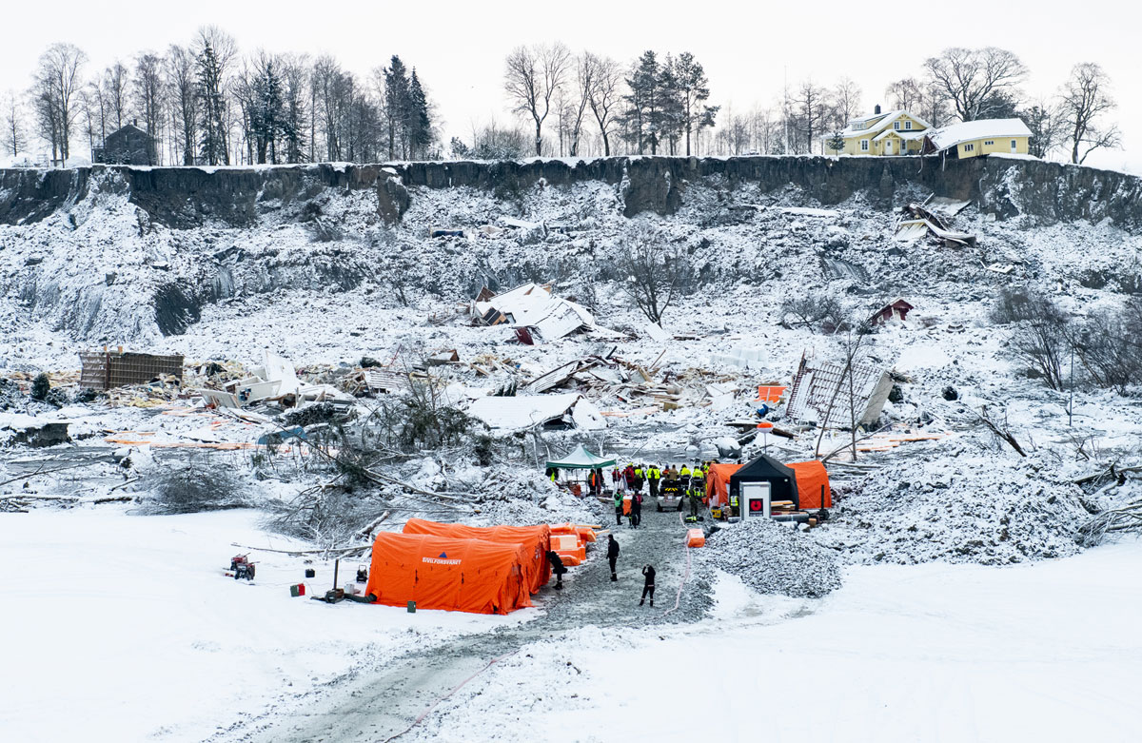

The quick clay landslide at Gjerdrum

Photo: Stian Olberg/DSB.

Strengthen the presence of emergency services throughout Norway

Society’s resilience depends on the emergency services being present where incidents occur. Citizens should have the assurance that they will be taken care of in emergency situations, and should experience that larger society provides resources in critical situations. Given that Norway is a long country with settlements scattered across great distances, this will have an impact on how we organise our services. Local knowledge and rapid response will always be key to handling incidents.

Reintroduce the obligation to build emergency shelters and develop a new protection concept

The war in Ukraine illustrates the need for emergency shelters during war. From 1998, developers were exempted from the obligation to build shelters in new buildings. The government will now revoke the exemption. At the same time, the Government aims to introduce a new protection concept and will soon submit a proposal for public consultation.

Strengthen the business sector throughout Norway

Society’s resilience depends on having a diverse business sector throughout the country. The private sector owns, operates and develops critical infrastructure, and plays a crucial role in both our capability to ensure the continuity of critical societal functions and for civilian support to military operations. The business sector also has a number of tangible resources, such as personnel and mechanical equipment, which can be of great use in handling incidents.

Increase funding for voluntary organisations

The voluntary organisations in the rescue service are a key part of basic preparedness in Norway. The Government will take steps to increase funding, by up to NOK 100 million, for volunteers in the rescue service, scaling the funding up over eight years. In collaboration with the voluntary organisations, an assessment will be made of how the funding can be allocated in the best way possible. The Government has proposed, and the Storting has approved, an increase of NOK 6 million in grants to voluntary organisations in the rescue service in 2025.

Make better use of society’s collective resources in prevention and crisis management, including involving the business and voluntary sectors in preparedness work at the local, regional and national levels

All civilian sectors must be prepared for serious crises and war. Better coordination and prioritisation of resources between the public, business and voluntary sectors is required to ensure good information sharing and to optimise efficient and flexible utilisation of society’s collective resources. The Government will endeavour to ensure that all parts of civil society cooperate more closely, share more information and conduct more training exercises together.

Establish a new council structure that involves the private and voluntary sectors

The Government will establish a uniform council structure at national, regional and local level to improve the coordination of emergency preparedness work.

At the national level, emergency preparedness councils will be established in critical areas of society that do not have such councils at present. The councils will be chaired by the responsible ministry, and other public agencies, businesses and voluntary organisations will participate. Among other things, the councils will contribute to the annual preparation of vulnerability and status assessments within the critical areas of society. This will give the responsible ministries the best possible basis for proposing measures to strengthen preparedness. The Ministry of Justice and Public Security will prepare an overall assessment across all areas of society as a basis for the Government’s priorities.

At the local level, the Government will introduce an obligation for all municipalities to have or be affiliated with a municipal emergency preparedness council. The councils should include local emergency preparedness actors such as voluntary organisations and the private sector.

Establish a long-term plan for civil preparedness

The Government will establish a long-term plan for civil preparedness, and work to this end is scheduled to start in 2025. The purpose of the long-term plan will be to strengthen civil preparedness, ensure continuity, coordination, cross-sectoral work and a long-term approach. The long-term plan will enhance the link between risk assessments and political measures. The new council structure for preparedness planning and status assessments in civilian sectors will give the Government a good basis for preparing the long-term plan, which will be developed over time.

Submit a proposal for a new act on fundamental security for undertakings that are important for society

The Government will submit a proposal for a new act on fundamental security for undertakings that are important for society. The act is linked to the preparation for the national implementation of the directives on the security of networks and information systems (NIS2 Directive) and the critical entities resilience directive (CER Directive). The new act will set common requirements for fundamental security for undertakings that are important to the functioning of society, in peace, crisis and war.

Strengthen our shared situational awareness against hybrid threats

In order to prevent, resist and handle hybrid threats, it is crucial that, as a society, we understand what we are facing and the assets at our disposal. The National Intelligence and Security Centre (NESS) consists of the Norwegian Police Security Service, the Norwegian Intelligence Service, the Norwegian National Security Authority and the police. The centre works to strengthen Norway’s capability to identify hybrid threats and ensure good decision-making support for the authorities. The Ministry of Justice and Public Security and the Ministry of Defence are now further developing NESS to establish a national situational picture of hybrid threats, and to strengthen the cross-sectoral work required to identify, understand, counter and handle hybrid activities.

Conduct more training exercises together with allies, industry and voluntary organisations

If society is to function during crises and war, we must train more. Such training exercises make it easier for society’s collective resources to pull together and increase our capability to deal with serious incidents.

The Government will prepare a strategic framework for national training exercises in civilian sectors and a multi-year plan for national training. The Government will take steps to ensure more training exercises are conducted and that more actors train together. The goal is a more systematic approach and better coordination of training exercises across civilian sectors and together with military exercises.

Develop a national security strategy

The rapidly changing security situation means we need more comprehensive and long-term management of efforts to safeguard national security interests. The Government has therefore initiated work on a national security strategy. The strategy will provide a comprehensive overview of foreign, security, defence and preparedness policy, based on our national security. The strategy will be presented before summer 2025.

Strengthen cyber resilience and national control over critical infrastructure and strategically important undertakings, natural resources, property and assets

Key elements of Norwegian infrastructure are currently owned by private companies. Certain sectors are particularly exposed to changes in the security policy situation. The Government will strengthen cyber resilience and national control over critical infrastructure, natural resources, property and strategically important undertakings. This must be done in a way that ensures the necessary predictability for businesses and maintains Norway’s open economy.

Propose a new act on the control of foreign investments in strategically important sectors

In response to the new security policy reality, several changes have already been made to the Security Act, including tightening the rules for ownership control. National security interests may also impact undertakings that are not covered by the Security Act. In order to further develop the current system for handling foreign investments that potentially threaten security, the Government will present a new act on the control of foreign investments.

The Government has recently established the Directorate for Export Control and Sanctions (DEKSA). Among other things, DEKSA will be responsible for issuing permits, guidance and executive control of exports of defence materiel, dual-use items, technology, services and knowledge.

Improve the overview of the actual owners of properties and establish a system for the approval of buyers of certain properties

The overview of actual owners of real estate is currently inadequate. Nor do we have expedient policy instruments to control the purchase of properties that may have security implications because they are located close to critical infrastructure such as ports, defence facilities or power supplies. The Government will investigate implementing statutory ownership registration to determine who owns real estate, and will propose necessary amendments to ensure prior authorisation to purchase certain properties, for example in the vicinity of military installations or other critical national infrastructure.

Strengthen maritime security and security around port infrastructure

With one of the world’s longest coastlines, we are particularly vulnerable to maritime covert intelligence activity. To strengthen the work on maritime security, the Government has initiated close cooperation between the civil and military authorities, and with the private sector. This work will be further stepped up. The Government has adopted the emergency preparedness regulations for ports (havneberedskapsforskriften), which, among other things, will ensure that military forces have access to relevant ports in a state of war. The Government has also adopted new regulations on entry into territorial waters (anløpsforskrift) to improve control of foreign vessels entering Norwegian territorial waters and, together with our allied neighbours, is helping to ensure that maritime areas are not exploited in connection with sanction evasion, environmentally harmful conduct and other risky activities at sea, such as threats of sabotage, also linked to vessels in what is known as the ‘shadow fleet’, through increased surveillance, cooperation, presence and control in our maritime areas.

Step up work on critical underwater infrastructure

As a result of Russia’s war against Ukraine, the Government has implemented several measures to protect critical underwater infrastructure. In 2024, NATO established a centre for the protection of underwater infrastructure on the initiative of Prime Minister Støre and German Chancellor Scholz. This work will be expanded. The Government seeks close international cooperation to protect critical infrastructure. Close cooperation between private and public actors, across sectors, is also essential to protect critical underwater infrastructure. Protecting critical underwater infrastructure is a priority for the Government.

Establish a personnel clearance system fit for the future

The better cyber security systems become, the more we must expect that malicious actors will attempt to gain access to critical national objects and infrastructure via individuals. As the number of organisations that handle critical national information increases, so does the need for security clearance for personnel. At the same time, organisations need access to critical expertise and personnel. The Government will strive to ensure that we have a personnel clearance system that is fit for the future.

Be clearer about the trade-offs between economy, openness and security

In the current situation, foreign state actors use economic means to gain influence, control and access to sensitive information. National security issues therefore affect not only public authorities, but also businesses, academia and local authorities. As a society, we need to make it clearer that important considerations such as openness and commercial interests must be weighed against national security considerations. The trade-offs can be demanding, and the Government will therefore take steps to establish a clearer dialogue with businesses, academia and local authorities.

Increased expertise in cyber security

Access to cyber security expertise is a prerequisite for developing cyber resilience. The Government will consider measures to increase the number of people with the necessary cyber security expertise and ensure the most effective use of the expertise available.

Investigate establishing a national cyber security reserve with the private sector

The business sector has important capacities, knowledge, expertise and innovative power in the cyber security field. The Government will soon begin work on a national cyber security reserve consisting of relevant authorities and business communities.

Establish closer international cyber cooperation

Cyber incidents often occur across national borders. National capacities for detection and incident management must be supplemented by international cooperation. The Government will strengthen international cooperation by participating in a Nordic-Baltic cyber security partnership.

Strengthen the population’s resilience and maintain a high level of trust in society

A comprehensive strengthening of national preparedness requires the participation of the entire population. Each and every one of us is responsible for following the self-preparedness advice (see Section 6.1.3) and preparing for situations where normal societal functions do not work.

Strengthen the population’s resilience to disinformation

The Government has expanded the self-preparedness advice to the population to include advice on what the individual can do to identify misinformation and disinformation. Our primary defence is counter-information and a free and open debate. In the spring of 2025, the Government will present a strategy to strengthen the population’s resilience to disinformation. The Government will, in consultation with the media industry, assess possible measures to improve people’s ability to scrutinise sources and resist disinformation.

Strengthen the Civil Defence

The Norwegian Civil Defence is Norway’s most important civil reinforcement resource. It can support the emergency services in the event of major accidents and natural disasters and protect civilians in the event of military action. The Government wishes to increase the number of conscripts in the Norwegian Civil Defence from 8,000 to 12,000 over an eight-year period. The need to further develop the Civil Defence’s expertise and capacities will be investigated at the same time.

Criminalise influence operations

When influence operations are of such a serious nature that significant societal interests are at stake, society must be protected by criminal law. Influence operations can undermine trust in society. In 2024, the Government proposed a bill criminalising the most serious influence operations. The act has entered into force.

Safeguard preparedness and security considerations in public procurement to a greater extent

Every year, the public sector procures goods, services and construction work for significant sums. The Government will investigate the possibility of implementing security and preparedness requirements in public procurement in order to safeguard preparedness and national security interests. Good guidance on security and preparedness in public procurement is also important, to enable clients to use the scope provided for in the procurement regulations and ensure that the right requirements are set in the procurements.

Strengthen security of supply, including food security

Stable access to goods and services is crucial for society’s resilience and civil society’s support to military efforts to defend the country. Supply line failures can affect the ability to maintain continuity in critical areas of society, civilian capability to support military efforts, and the individual community’s and individual citizen’s ability to take care of themselves during crises. The COVID-19 pandemic and the war in Ukraine have highlighted vulnerabilities in global supply lines. The Government will also continue its efforts to strengthen Norway’s self-sufficiency, including in relation to food.

Step up work on security of supply

The Government has decided to assign the Ministry of Trade, Industry and Fisheries responsibility for coordinating work on security of supply across sectors, relating to goods and services within the scope of the Act on Business and Industry Preparedness. In connection with the work on strengthening security of supply, the Government will investigate the need for, and design of, an underlying and sector-neutral apparatus in the area of security of supply.

Strengthen national food security

Sufficient and safe food is a prerequisite for any society, and, since taking office, the Government has prioritised stepping up Norwegian food production. Maintaining agriculture throughout the country is crucial to Norway’s preparedness. Increased self-sufficiency, stockpiling grain and strong soil protection increase preparedness and security. The Government will conduct a risk, preparedness and vulnerability analysis of the Norwegian food supply.

Ensure closer cooperation between the civilian sectors and the defence sector

Handling situations at the high end of the crisis spectrum requires that society’s collective resources pull together. Resources and expertise in civilian sectors that are able to support the Norwegian Armed Forces and allied forces strengthen overall defence capability. The Government wishes to strengthen civil protection measures and facilitate civil society’s ability to support military efforts in the event of war or conflict.

New regulation to ensure access to and prioritisation of the civilian workforce in security policy crises and war

In a situation where the realm is at war or war is threatening or the independence or security of the realm is in danger, the civilian workforce will be required to support the country’s defence, including road, rail, sea and air transport. The Government has proposed a new act relating to the preparedness of the civilian workforce. The act will ensure access to and prioritisation of civilian labour in security policy crises and war. The proposal seeks to pre-establish key issues and considerations related to civilian workforce preparedness, and will provide a better basis for planning, carrying out training exercises and making necessary preparations in peacetime.

Develop a common basis for civil preparedness planning

As announced in the long-term plan for the defence sector, the Government will ensure that the need for civilian support for military efforts within the framework of total defence is communicated more systematically by the defence sector to civilian sectors than is currently the case. The Government will coordinate the civilian sectors’ follow-up of the military needs. The Directorate for Civil Protection prepares crisis scenarios, including natural events, supply failures and disease outbreaks. The Government will implement a more binding follow-up of crisis scenarios.

Update the planning framework for wartime relocation of citizens

The Government has initiated work on updating the plan for wartime relocation of citizens. The current planning framework has not been updated for decades.

Strengthen civilian capacity to support allied military efforts within the framework of NATO and through enhanced Nordic and European preparedness cooperation

The capacity to support allied forces is crucial to their ability to assist Norway in crisis and war. The Government will strengthen Norway’s role as a host and transit nation for allied forces.

Follow up NATO’s new host nation support concept

To be able to quickly receive and host allied forces, civil society, as part of our total defence, must be prepared. Civil society must, among other things, have an organised infrastructure and planned deliveries of services and goods to allied forces. NATO is developing a new concept for host nation support. The Government will follow up the new concept at the national level.

Strengthen civil preparedness cooperation in the Nordic countries

To increase our overall capability to provide effective civilian support to military efforts in war, the Government will strengthen civil preparedness cooperation with Finland and Sweden. As a result of Swedish and Finnish membership of NATO, the need to transport materials and personnel across the borders between the three countries has increased. The Government will continue its efforts to increase military mobility, including by developing a strategic corridor for military mobility through northern Norway, northern Sweden and northern Finland.

# A broad approach to preparedness and total defence

This white paper emphasises resilience and total defence in situations at the high end of the crisis spectrum, i.e. our capability to prevent and handle hybrid threats, security policy crises, armed conflict and, in the worst case, war. These situations arise as a result of deliberate actions by one or more malicious actors with the intention of harming us. The perspective in the white paper is motivated by the security policy situation.

However, the work on resilience and preparedness is of a much broader scope. Our broad approach to preparedness is geared to being able to prevent and handle a wide spectrum of different incidents, all of which can have serious consequences.[1] These could be serious natural events such as the extreme weather event ‘Hans’ in 2023 (see Box 2.1) and the quick clay landslide at Gjerdrum in 2020 (see Box 2.2), accidents such as that involving the cruise ship ‘Viking Sky’ off Hustadsvika in 2019 (see Box 2.3), or deliberate actions that have serious consequences, such as a cyberattack. Strengthening the broad approach to preparedness ensures basic preparedness in society. The broad approach to preparedness, including good coordination, is also important for our ability to deal with incidents at the high end of the crisis spectrum, because the same actors and resources are used to handle the most serious incidents.

The extreme weather event ‘Hans’

On 7 August 2023, the extreme weather event Hans hit southern Norway, causing landslides, debris floods and flooding. An unusually severe weather front brought very heavy rainfall on top of an already high groundwater level after heavy rain during late summer and early autumn, causing extensive damage to infrastructure and property. The consequences continued for weeks after the extreme weather had passed.

The evaluation of the incident management1 concluded that the extreme weather event Hans was, on the whole, well managed. The early, clear notification of the various actors involved was vital to expedient and coordinated management of the event. The various central, regional and local services’ resources pulled together, and actors such as the Home Guard, Norwegian Civil Defence, voluntary organisations (such as the Red Cross, Norwegian People’s Aid and Women’s Public Health Association), as well as private actors and businesses, played an important role in handling the incident.

The evaluation made several recommendations to further step up preparedness. These included the need for better guidance to municipalities in their systematic work on flood and landslide protection, for municipalities to carry out more training exercises based on their own needs and analyses, and for the Norwegian Meteorological Institute and the Norwegian Water Resources and Energy Directorate to provide earlier, clearer and more consequence-based extreme weather warnings, so that relevant actors have even more time to prepare.

The evaluation has contributed to a good knowledge base for managing extreme weather events in future. Actors affected by the recommendations are preparing plans for compliance.

1 Evaluering av ekstremværet Hans – forebygging, beredskap og håndtering (Evaluation of the extreme weather event Hans – prevention, preparation and management – in Norwegian only). Norwegian Directorate for Civil Protection, 2024.

[Boks slutt]

The quick clay landslide at Gjerdrum

On 30 December 2020, the village of Ask in Gjerdrum municipality was suddenly and brutally hit by an extensive quick clay landslide. Ten people lost their lives, and many others were rescued from the landslide area during a demanding rescue operation. Many people had to be evacuated. The management of the incident was subsequently evaluated. The evaluation report1 concluded that there was no evidence that more lives could have been saved during the rescue operation, and that the immediate evacuation of residents and the efforts of the organised rescue service saved many lives. A large number of organisations took part in the rescue operation, and voluntary organisations also played a major role in this incident. The evaluation did, however, identify a number of learning and improvement points related to, among other things, the management of the rescue effort in Ask, civil-military cooperation, coordination of actors who participated in the handling of the incident, safeguarding of vulnerable groups and crisis management related to critical societal functions and services. The work on following up the learning points is ongoing.

1 Redningsaksjonen og den akutte krisehåndteringen under kvikkleireskredet på Gjerdrum (Rescue operation and emergency crisis management during the quick clay landslide in Gjerdrum – in Norwegian only) Report to the Ministry of Justice and Public Security. Joint Rescue Coordination Centre, 1 June 2021.

[Boks slutt]

The ‘Viking Sky’ cruise ship incident

On 23 March 2019, the cruise ship Viking Sky suffered engine failure and distress at sea at Hustadvika between Kristiansund and Molde in Norway. The ship was very close to running aground, which could have had disastrous consequences. An extensive rescue operation was launched and almost 500 passengers were evacuated by helicopter and transported to a reception centre on land.

The evaluation of the incident1 concludes that the rescue operation was successful, with excellent efforts and good cooperation between the actors involved. A public committee was subsequently appointed to assess the emergency preparedness challenges associated with increasing cruise traffic in Norwegian waters. A public report was submitted to the Minister of Justice and Public Security in 2022 (Norwegian Official Report (NOU) 2022: 1). The report made a number of recommendations with an emphasis on risk-reduction measures.

Learning points and recommendations in both the evaluation and the report affect several ministries’ sectoral responsibilities and many subordinate agencies. Several of the recommendations have been followed up through ongoing emergency preparedness work in a number of organisations. Among other things, the Joint Rescue Coordination Centre has been awarded more resources to step up its capacity to lead and coordinate complex rescue operations at sea, and planning work has been initiated for mass evacuations. The reviews also show the breadth of actors involved in the management of such incidents. In addition to public agencies at central and regional level and in the affected municipalities, a number of voluntary organisations and many private organisations participated in the rescue operation.

1 Assessment of the Viking Sky incident. Norwegian Directorate for Civil Protection, 31 January 2020.

[Boks slutt]

Good basic preparedness helps ensure that incidents can be handled locally with as little delay as possible. Basic preparedness is also important for credible deterrence and reassurance, by demonstrating that civil society, both nationally and locally, can support military efforts and maintain critical functions as far as possible. For example, fire and rescue services, the emergency services, the police and the health and care services must fulfil their core tasks for the public, while also providing support to military efforts.

The Government shares the Total Preparedness Commission’s view that the population, municipalities, emergency services, the publicly organised rescue service and voluntary rescue and emergency response organisations are the pillars of basic preparedness in Norway. The private sector, broad organisational sector and voluntary sector are also important for our preparedness and the resilience of society.

The broad preparedness approach also includes specific measures in selected areas. One example is the Merkur programme, in which the Government supports local shops in areas with small markets and long distances to the next shop. These shops can be of great importance to local communities in the event of, for example, major natural disasters (see Box 2.4). They could also be of great importance to the local community in the event of security policy crises or war.

The local shop’s important role during the extreme weather event ‘Hans’

The local shop came to the rescue of tourists and locals alike when the extreme weather event Hans ravaged Hallingdal. Snarkjøp Samhald Landhandel in the village of Leveld served as both a supply hub and a base when emergency networks, telephony, internet and other infrastructure failed in other parts of Ål municipality. The contingency solution in the digital shop meant that operations could continue. Customers were also able to use the shop’s network to communicate with the outside world.

[Boks slutt]

The four principles of responsibility, proximity, similarity and collaboration (see Box 2.5) form a common foundation for preparedness work. The Government considers it important that actors who fulfil important roles in preparedness work are mindful of the purpose of the preparedness principles, which entail, among other things, that relevant actors have sufficient knowledge of each other’s tasks and responsibilities. This is paramount for the best possible coordination and utilisation of society’s collective preparedness resources.

Furthermore, efforts to further develop broad preparedness must be systematic and should be seen as a continuous chain, see Figure 2.1. The different parts of the work are interconnected, and they impact each other. Systematic preparedness work requires active efforts in all parts of the figure, and necessary cooperation with relevant actors, including the private and voluntary sectors.

The four basic principles for public security work

* The principle of responsibility means that the organisation responsible for a given area in a normal situation is also responsible for the necessary emergency preparation and for handling extraordinary incidents in the area. The responsible body must define acceptable risk.
* The principle of similarity means that the organisation in operation during a crisis should, in principle, be as similar as possible to the day-to-day organisation.
* The principle of proximity means that crises should be handled at the lowest possible organisational level.
* The principle of collaboration means that authorities, organisations or agencies have an independent responsibility to ensure the best possible collaboration with relevant actors and organisations in the work on prevention, preparedness and crisis management.

[Boks slutt]

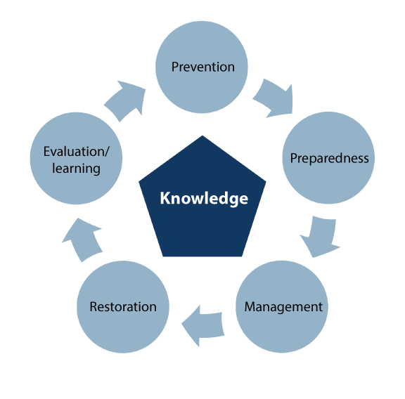

The work on security and preparedness – an ongoing improvement process

Some incidents require regional and national assistance. National reinforcement resources are mobilised when incidents require more resources or different expertise than that available in local communities. Key examples of national reinforcement resources are the Norwegian Civil Defence and the Home Guard, as well as other resources in various sectors, such as the resources of the national police emergency response centre and the national forest fire helicopter service. Good coordination is important for management capability. It is therefore important that preparedness actors regularly practise managing different types of incidents.

Voluntary rescue and emergency response organisations are crucial to preparedness. They play a key role in search operations on land, in forests and in the mountains, and in incidents at sea. They also provide first aid assistance. The organisations have personnel with good fundamental expertise. They also have specialist expertise in communications, rescue in steep, difficult terrain and caves, and searches with dogs, small aircraft and rescue boats. The number of assignments for volunteers is likely to increase in the years to come, and the voluntary sector will continue to play an important role in emergency response work. The presence of voluntary organisations throughout the country is therefore an important element in Norway’s preparedness.

## The Government’s strengthening of the broad approach to preparedness

Regardless of where you live in Norway, it is crucial that emergency response organisations are present in local communities and that they have the capability to provide rapid assistance. After major incidents, good systems are needed to follow up those affected. In recent years, the Government has strengthened its broad approach to preparedness, as a means of helping to safeguard the lives and health of citizens during various types of incidents.

The Joint Rescue Coordination Centre and the rescue services

The rescue services fulfil their social responsibility during peacetime, crises, armed conflict and war. The number of rescue operations has risen steadily in recent years. The pace of rescue operations has also increased, and rescue operations have become more complex. More and more people are being rescued, but this has meant a high workload for the staff at the Joint Rescue Coordination Centre (JRCC) for several years. The Government has increased basic staffing at the JRCC offices at Sola and Bodø by employing more rescue leaders. JRCC rescue leaders manage the use of rescue helicopters in connection with search and rescue missions. Increasing basic staffing at Sola and Bodø has helped to ensure that the Joint Rescue Coordination Centre is well-equipped to manage more rescue operations, address the risks associated with climate change and meet the challenges linked to increased maritime traffic in the High North. Increasing the number of rescue leaders will also strengthen cooperation in the Norwegian rescue service.

The Joint Rescue Coordination Centre can further strengthen and rationalise its efforts to communicate knowledge to emergency response actors by systematising and developing their unique insight in leading rescue operations at sea and on land, in cooperation between public and private, civil and military emergency response actors. The purpose of organising this knowledge more expediently is to ensure that rescue response in Norway is adapted to climate change and changes in demographics. The aim is also for the service to adopt new technology more quickly than it does today to ensure public resources are used correctly in life-saving efforts.

The JRCC plays a key role in the development of procedures, manuals and ICT solutions. Though a development project that has run over several years, it has helped to develop an app that will be used to plan and carry out searches for missing persons on land. The tool will streamline the execution of search and rescue missions by utilising available technologies and exchanging information and data between actors in the rescue service in Norway. Since mid-June 2024, the tool has been tested in a pilot study in the Southwest Police District, and is scheduled to be rolled out nationwide in 2025.

The management of the rescue helicopter service was transferred from the Ministry of Justice and Public Security to the Joint Rescue Coordination Centre on 1 January 2024. The Joint Rescue Coordination Centre is now responsible for ensuring appropriate cooperation and utilisation of the rescue helicopters, and takes a more comprehensive approach to the development of the Norwegian rescue helicopter service.

The rescue helicopter service is a dedicated state resource in the rescue service. It consists of the Air Force’s 330 Squadron, as well as the civil helicopters under the authority of the Governor of Svalbard and the civil rescue helicopter base in Tromsø, which CHC Helikopterservice operates. The Air Force has operated from six permanent bases: Banak, Bodø, Ørland, Rygge, Sola and Florø. SAR Queen was commissioned at its first base at Sola on 1 September 2020. This marked the start of a new era for the rescue service in Norway, with improved range, speed and medical capacity compared with the old Sea King helicopters. On 1 October 2024, SAR Queen was put into operation at the Florø base as the sixth and last base operated by the Norwegian Armed Forces. The new rescue helicopters increase the safety of people at sea, along the coast and in remote areas of Norway. The helicopters are a significant boost to the rescue service and air ambulance capacity, and will help to improve patient transport.

The Government issues grants to voluntary organisations in the rescue service. These organisations are unique resources that work closely with the Joint Rescue Coordination Centre. Grant management for the rescue helicopter service was transferred from the Ministry of Justice and Public Security to the Joint Rescue Coordination Centre on 1 January 2024. See also Section 5.4.1.

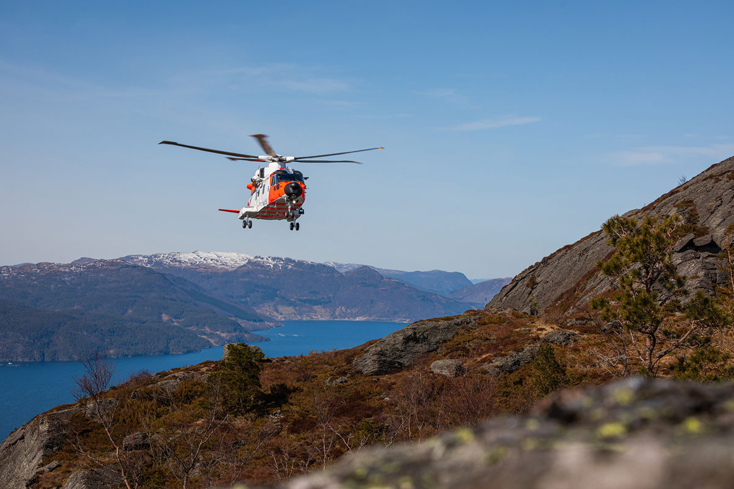

SAR Queen

Photo: Fabian Helmersen/Norwegian Armed Forces.

The police

The Government wants thriving and safe communities throughout Norway. The role of the police in society is to protect, maintain peace, order and security, prevent crime, uncover and stop crime and help citizens in given situations. The police also provide assistance to others when needed.

The police fulfil their social mission in close cooperation with other sections of society, from government agencies and the business sector to individual citizens. The police play a key role in most crises, and it is crucial that they also contribute actively in cases where they assist others. Like the Total Preparedness Commission, the Government believes that the use of police capacity and resources must be seen in the context of other preparedness resources in the civil, private and voluntary sectors, in addition to defence resources. This is particularly true in areas where police expertise or police authority is not essential.

The Government has presented the action plan Trygghet i hverdagen (Safe everyday lives – in Norwegian only), which sets out a clear direction for a police force that is present in the communities across Norway and helps to create a sense of security and prevent crime where people live. Local knowledge and presence are crucial to handling incidents. This also sets an important framework for the organisation of the police force, and is relevant for achieving police presence in both cities and rural areas. For example, one measure in the action plan is to run a pilot decentralised police training programme in Alta from autumn 2025. This will give more police trainees a local affiliation, and contribute to more stability and less turnover in the police force in our northernmost county. Experience shows that local affiliation increases the likelihood of staying in a job and an area for a longer period of time. The programme could also attract applicants from other parts of the country, which would be a positive development.

The national preparedness resources assist the country’s police districts and specialist agencies in connection with incidents of particular complexity and risk. The capabilities and capacities of the national preparedness resources augment the police’s ability to prevent and tackle terrorist incidents and organised and other serious crime. The resources are co-located at the police’s national emergency response centre. The establishment of the police’s national emergency response centre gave some of the response personnel (IP3) in all police districts the opportunity to train with the national resources at the centre. As a result, the local response personnel in each police district will be better equipped to fulfil their duties. See also Section 5.4.7.

Health and care services

Health and care services are part of basic preparedness. The purpose of health preparedness is to protect life and health, and to help ensure that the population can receive the necessary health care and social services in the event of crises and disasters, in times of peace and war. The Government’s Report No 5 to the Storting (2023–2024) A Resilient Health Emergency Preparedness – From Pandemic to War in Europe, and the Storting’s approval, cf. Recommendation No 220 to the Storting (2023–2024), provides political and strategic direction for Norwegian health preparedness. The report presents four main initiatives:

* The Government will step up Norway’s international cooperation on health preparedness. The COVID-19 pandemic showed how vulnerable we are on our own. Most importantly, an agreement must be reached on participation in the strengthened EU health crisis preparedness programme.
* The Government will work to make the health and care services more adaptable and flexible. This requires prioritisation, an overview of personnel resources and the redeployment and mobilisation of resources. In the National Health and Care Coordination Plan 2024–2027, the Government has set out its policy for recruiting, retaining and developing professionals for the health and care services we share. The focus areas to ensure access to personnel are i) working environment and working conditions, ii) task sharing and efficient organisation, iii) recruitment, qualification and skills development. Several specific initiatives have been implemented to address this.
* The Government will establish a new model for work on health preparedness. The model will clarify roles and responsibilities in the health sector and help ensure even greater priority is given to security and preparedness work in the sector.
* The Government is strengthening cross-sectoral collaboration and cooperation with the voluntary and business sectors. We must utilise society’s collective resources better.

The new health preparedness model involves the establishment of structures that will strengthen the ministry, agencies and organisations in their day-to-day follow-up of risk and vulnerability analyses, training exercises, coordination of plans and other public security work and in crisis management in the health sector. The model involves the establishment of a Health Preparedness Council with representation from all sectors, to be chaired by the Ministry of Health and Care Services, and six committees at agency level to work on risk areas and cross-sectoral collaboration. An expert advisory committee for health crises will also be established to ensure a better knowledge base for handling crises that affect society as a whole, which requires comprehensive interdisciplinary assessments. Roles and responsibilities are outlined in the National Health Preparedness Plan, which is currently under revision. This will be the fourth edition of the plan. The structural changes in health preparedness that follow from Report No 5 to the Storting (2023–2024) is an important reason for updating the plan. Roles, responsibilities and structures will be emphasised in the updated version. See also Section 5.4.9.

The fire and rescue service

The fire and rescue service is key to basic preparedness in Norway and an important element in our total defence. Municipalities are responsible for the establishment and operation of a fire and rescue service. The municipalities can choose whether they want to operate the fire and rescue service themselves or cooperate with other municipalities on a joint fire and rescue service or joint management. As of October 2024, there were 194 fire and rescue services in Norway. The fire and rescue service employs a total of approximately 12,000 people, comprising 4,200 full-time employees and 7,800 part-time employees. There are more than 600 fire stations in Norway. Approximately 85% of the population live within a 10-minute drive of a fire station.

On 22 March 2024, the Government presented Report No 16 (2023–2024) Brann- og redningsvesenet – Nærhet, lokalkunnskap og rask respons i hele landet (Fire and Rescue Service – Proximity, local knowledge and rapid response throughout Norway – in Norwegian only) to the Storting, which has approved the report, cf. Recommendation No 413 to the Storting (2023–2024). The report sets out a fire and rescue service that is able to handle current and future challenges, both within its own sectoral responsibility and in collaboration with other emergency services and emergency response organisations. The fire and rescue service will continue to be a municipal responsibility and a nationwide organisation. Their municipal organisation ensures proximity to residents, local knowledge and rapid assistance when people need help, both in cities and in rural areas. The Government intends to build on the strengths of the fire and rescue service and keep up the excellent work performed every day by full-time and part-time personnel.

The fire and rescue services are organised and dimensioned to handle local incidents. Situations may arise that require specialist knowledge and equipment that not all fire and rescue services have access to. Events such as quick clay landslides, extreme weather, major fires in forests or built-up areas are relatively rare, but can occur in areas of the country where there are no resources to effectively deal with such events. Many municipalities have entered into local and regional cooperation agreements to meet these challenges. The Government believes that the municipalities themselves are best placed to assess whether establishing cooperation with others is necessary and appropriate. Regional cooperation should be based on risk and vulnerability analyses and designed to ensure the best possible access to specialist expertise in all parts of the country. See also Section 5.4.8.

Voluntary organisations

Voluntary organisations are an indispensable part of Norway’s preparedness system. In Norway, they enjoy a high level of trust and also contribute to general welfare and confidence in society. Norwegian voluntary organisations have a long tradition of providing assistance in connection with various public tasks, and can mobilise, channel and organise both grassroots involvement and specialist assignments in an effective manner. The organisations are characterised by short response times, good local knowledge and flexibility. In many cases, voluntary organisations can also contribute knowledge about groups that often fall outside crisis and preparedness thinking, or that are difficult to reach through official channels. Further consideration should be given to how voluntary organisations can be well integrated into various coordination bodies at the national, regional and local level to ensure timely and efficient use of resources across the entire crisis spectrum. Closer and more formalised collaboration arenas between voluntary organisations and government agencies are discussed in more detail in Sections 3.1 and 5.1.1.

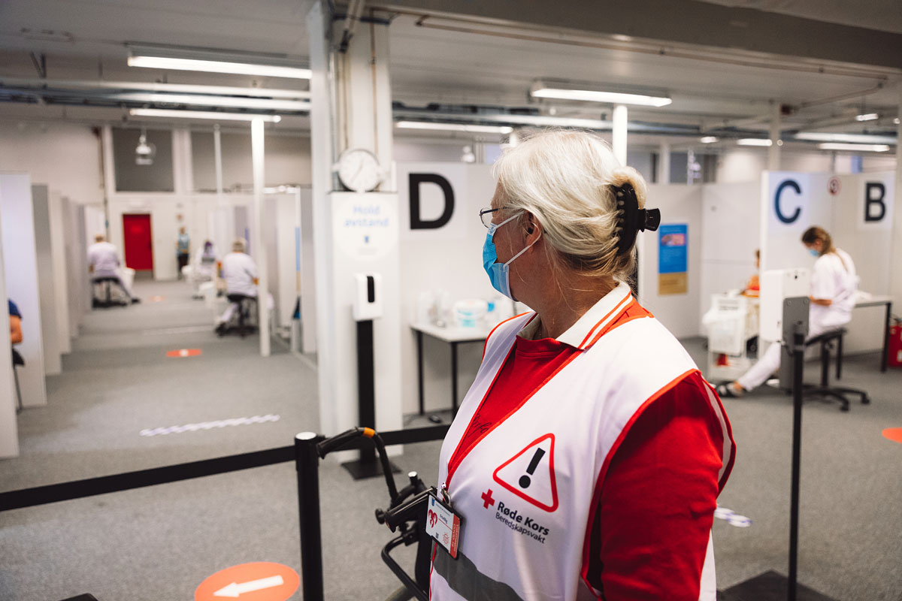

During the pandemic, the Red Cross assisted in connection with vaccinations

Photo: Aleksander Båtnes/Red Cross.

The Government is of the opinion that a state and municipal volunteering policy must be developed in the area of preparedness. This will help to ensure greater involvement of voluntary organisations. The Directorate for Civil Protection’s municipal surveys show that there are still many municipalities that do not cooperate with voluntary organisations in their work on preparedness planning, risk and vulnerability analyses, training exercises and crisis management. Although entering into emergency response agreements with municipalities does not in itself guarantee good collaboration, the Government believes that such agreements can help to clarify roles, needs and expectations between municipalities and voluntary organisations. Establishing meeting places will also be important to further develop collaboration. The Government believes that increased collaboration between municipalities and voluntary organisations will be particularly relevant because both have good knowledge of local emergency preparedness and attach great importance to it.

Voluntary organisations that are involved in the rescue services in Norway have access to the emergency alert system Nødnett. This critical network provides effective radio communication between the police, fire service, health services, Norwegian Civil Defence and voluntary organisations during accidents, crises and other incidents. Voluntary organisations’ expenses for their current Nødnett terminals are covered under the grant scheme for volunteers in the rescue services. In 2022, NOK 10 million was allocated to the voluntary organisations in the rescue services to cover annual operating and subscription expenses for 2,000 new Nødnett terminals. See also Section 5.4.2.

Voluntary organisations with emergency response agreements with public authorities

Voluntary organisations with emergency response agreements with public authorities in Norway. These agreements ensure that volunteers can contribute effectively in crisis situations and strengthen Norway’s preparedness.

For example, many municipalities have agreements with organisations such as the Red Cross, Norwegian People’s Aid, the Norwegian Women’s Health Association and the Norwegian Society for Sea Rescue. Agreements can include financial support, access to equipment and coordination of efforts in emergency situations. The Norwegian Radio Relay League has radio enthusiasts who can be used by the rescue services and in connection with disaster and crisis preparedness, and can organise preparedness for the authorities through contact with central and local police authorities, counties and municipalities. The services are divided into three areas: crisis communication, rescue and other communication assignments. Such agreements are essential to ensure a rapid and coordinated response to crises, and help ensure the effective utilisation of both public and voluntary organisations’ resources. The agreements contribute to continuity and systematisation in preparedness work.

[Boks slutt]

FORF

Frivillige Organisasjoners Redningsfaglige Forum (FORF) is a cooperation body for voluntary rescue organisations in Norway. The main purpose of FORF is to improve the quality of the Norwegian rescue service and serve as a link between the voluntary organisations and public authorities. It is generally the organisations in FORF that are called out on search and rescue assignments. FORF works to

* collect and promote member organisations’ views and needs in relation to the authorities and other stakeholders.
* ensure good cooperation between the member organisations and rescue authorities.
* strengthen total preparedness by coordinating the efforts of the voluntary organisations.

Eight organisations are members of FORF:

* Red Cross Rescue Corps
* Norwegian People’s Aid rescue service and first aid
* Norwegian Society for Sea Rescue
* Norwegian Search and Rescue Dogs
* Norwegian Radio Relay League
* Scout Movement Emergency Response Groups
* Norwegian Speleological Society
* Norwegian Air Sports’ Federation air service

[Boks slutt]

The Norwegian Civil Defence

The Norwegian Civil Defence is a state emergency resource whose primary task is to protect the population during war. In peacetime, it is also the state’s most important civilian reinforcement resource for emergency and preparedness actors and is trained and equipped to support the police, fire service and medical personnel in the event of major accidents and natural disasters. The Civil Defence is therefore an important actor across the entire crisis spectrum (see also Section 5.4.6).

In peacetime, the Civil Defence consists of 8,000 conscripts divided into 20 civil defence districts. It is very important to retain the decentralised structure and organisation of the Civil Defence, to ensure local knowledge, short response times and local affiliation. The Civil Defence may also, by decision of the responsible authority, mobilise a war reserve of additional conscripts.

The Civil Defence, which is subordinate to the Directorate for Civil Protection is responsible for a number of civil protection measures. These are described in more detail in Section 6.1. The Civil Defence is organised with local, regional and national task forces consisting of conscripts and officers. The decentralised structure, with advance storage of equipment and materials throughout the country, facilitates local knowledge and good interaction with key collaborating actors such as the municipalities, county governors, the police and the Home Guard.

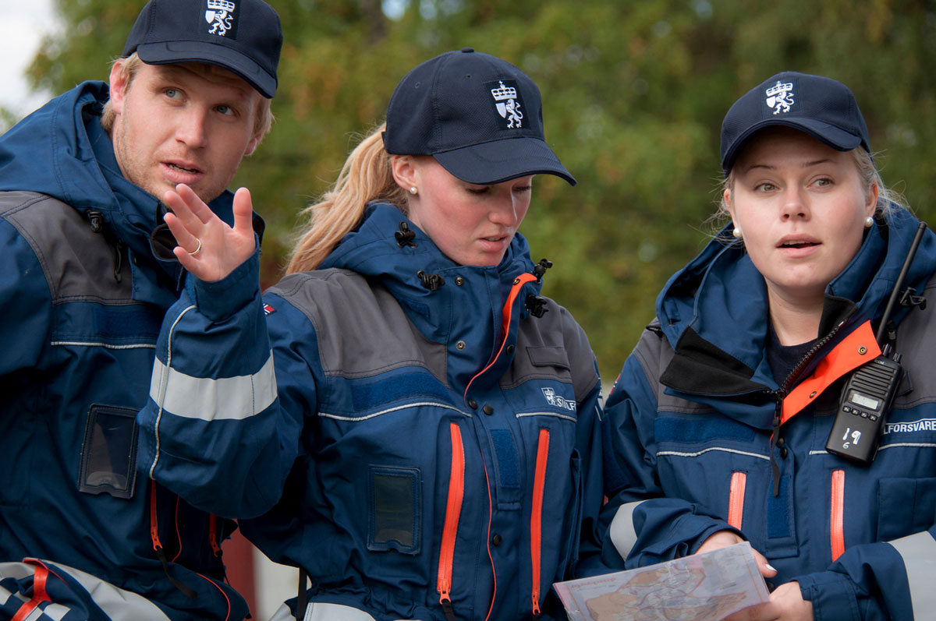

The Norwegian Civil Defence

Photo: Arild Ødegaard/Directorate for Civil Protection.

The municipalities

The municipalities are important for basic preparedness throughout the country, and they have extensive responsibility for ensuring the safety and security of the population. The municipalities must be prepared to handle undesirable incidents, and they must therefore work systematically and comprehensively on public security across sectors in the municipality. It is also the responsibility of the municipalities to, as far as possible, prevent incidents from happening. Climate change demands that we adapt to a climate with a greater frequency of extreme weather events. It is therefore important that our legislation does not act as an obstacle to effective prevention of various incidents.

Norway has a municipal structure that ensures residents have easy access to public services and local elected representatives, and which utilises residents’ local knowledge of site-specific needs and challenges in service development and administration. Settlement throughout the country is crucial to maintaining a resilient, vibrant and sustainable society (see Figure 2.5). A decentralised settlement pattern also helps to ensure that necessary services and resources are available throughout the country. This makes it easier to protect people and communities against various threats and crises. Settlement contributes to local value creation and business development. Cultural life contributes to vibrant communities across the country. When people live and work in rural areas, jobs and economic activity are created that benefit the whole country. At the same time, however, many incidents require extensive collaboration, be it between municipalities, between municipalities and the business sector or between municipalities and others.

The Government is implementing a range of initiatives to increase the breadth of the municipalities’ preparedness work. This applies both to preventive work and to improving their ability to handle major undesirable incidents, crises and, in the worst case, war. These measures are described in more detail in Section 5.1.

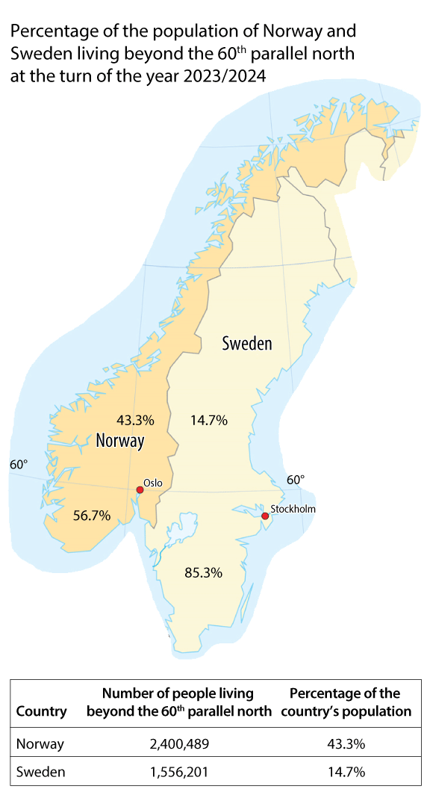

The figure shows the percentage of the population of Norway and Sweden living north of the 60th parallel at the turn of the year 2023/2024

Source: Statistics Norway (for Norway) 1 January 2024 and Statistics Sweden (for Sweden) 31 December 2023. The figures in the table are based on the number of inhabitants in municipalities in Norway and Sweden, respectively, where more than half of the inhabitants live beyond the 60th parallel north.

## Total defence and civil-military cooperation

Total defence encompasses mutual support and cooperation between the defence sector and civil society in relation to incidents in peacetime, crisis and war. It is a framework for use of our collective military and civilian resources to safeguard national security. Total defence will contribute to the utilisation of the country’s collective resources in prevention, preparedness planning, crisis management and impact management. This is important both for broad preparedness and for situations at the high end of the crisis spectrum. See Box 2.8 on the Norwegian total defence concept.

The Norwegian total defence concept

The Norwegian total defence concept was developed in the period after the Second World War. In its report, the Defence Commission of 1946 emphasised the importance of strengthening the Norwegian Armed Forces by means of a total defence concept. The defence of Norway was to be based on both military defence and broad civil preparedness. The objective was, and still is, to protect Norway’s territory, independence and national values, and to protect the civilian population.

The focus of the total defence concept has changed over time however. During the Cold War, the focus of the concept was essentially in line with the 1946 Defence Commission’s recommendation, i.e. how the civil sector should support the Norwegian Armed Forces (war capability) in armed conflict while maintaining a minimum of civil society’s basic functionality and citizens’ fundamental security. After the Cold War, the focus shifted to how the Norwegian Armed Forces, as a significant preparedness resource in peacetime, could support civil society to ensure good preparedness and the best possible utilisation of society’s collective resources to tackle assignments at the lower end of the crisis spectrum. Among other things, this shift meant that several of the measures aimed at situations involving war, the threat of war or similar (known as war planning in civil preparedness) were discontinued during the 1990s and early 2000s. One example of this is the exemption from building emergency shelters in new buildings that has been in force since 1998. The current total defence concept was adopted by the Storting’s consideration of Proposition No 42 to the Storting (2003–2004) Den videre moderniseringen av Forsvaret i perioden 2005–2008 (The further modernisation of the Norwegian Armed Forces in the period 2005–2008 – in Norwegian only) , cf. Recommendation No 234 to the Storting and Report No 39 to the Storting (2003–2004) Samfunnssikkerhet og sivilt-militært samarbeid (Public security and civil-military cooperation – in Norwegian only), cf. Recommendation No 49 to the Storting (2004–2005), and includes mutual support and cooperation between the Norwegian Armed Forces and civil society in connection with prevention, preparedness planning, crisis management and impact management across the entire crisis spectrum from peace through security policy crisis to armed conflict.

Civil support for military efforts at the high end of the crisis spectrum (the original purpose) has gradually been given greater focus in recent years, especially after Russia’s war against Ukraine in 2014 (Donbas in Eastern Ukraine and Crimea).

[Boks slutt]

Proposition No 87 to the Storting (2023–2024) The Norwegian Defence Pledge, underlines that the security policy situation must lead to total defence actors becoming more active in day-to-day life. This is necessary to avert and handle threats in the transitions between peace, crisis and war. One of the most important tasks of those involved in total defence is to function during war. It is therefore necessary to train and practise in peacetime. This also strengthens society’s overall resilience and endurance against hybrid threats, as well as other activities and incidents that present a threat to security in peacetime. Human capabilities are the most important resources in total defence. This is also reflected in the long-term plan for the defence sector, where one of the main priorities is a pledge to greatly increase personnel and expertise. Between now and 2036, the Government plans to recruit around 4,600 more conscripts, 13,700 more reservists and 4,600 more employees, and to boost expertise.

In principle, the term civil-military cooperation encompasses all civil-military cooperation at all levels and spans a very broad field and range of actors. In some cases, the Norwegian Armed Forces support civil activities, while in other situations the Armed Forces are supported by civilian resources.[2] In situations lower down the crisis spectrum, civil-military cooperation, and cooperation with and the involvement of private actors and volunteers, is largely based on partnerships, voluntary schemes or binding agreements.

Today, the Norwegian Armed Forces play a significant and important preparedness role for civil society during peacetime. The Armed Forces assist in dealing with a number of different incidents, such as floods, landslides, various accidents and extraordinary events such as the COVID-19 pandemic. They also play a role in terrorism preparedness, and contribute by attending to regular day-to-day tasks for civil society. Examples include the rescue helicopter service, the border guard and the Norwegian Coast Guard, which carry out fisheries and catch surveillance, emergency towing response, customs inspections, environmental protection assignments etc. The Armed Forces also perform a number of assignments on request, to support the police or other public authorities and preparedness organisations responsible for public security, critical societal functions or critical infrastructure etc.

In situations at the high end of the crisis spectrum, society’s use of resources, prioritisation and the way it goes about its tasks will change significantly. Firstly, the Armed Forces will have to focus on their primary tasks, and the Armed Forces’ assistance to civil society may be downgraded or cease altogether. At the same time, the Armed Forces will be able to seize civil operational resources in such situations, such as rescue helicopters etc. These will, in turn, have less capacity to handle tasks in civil sectors. The Armed Forces will also increase its staffing level by mobilising the Home Guard and reservists in the rest of its structure. This means many people being pulled out of their daily life and civilian jobs.

High on the crisis spectrum – prepared for war

The crisis spectrum is used as an expression of the range of undesirable incidents that could affect us. There is a wide range of potential incidents, and the severity and impact of a given type of incident, such as a cyberattack or a forest fire, can vary considerably. Armed conflict and war, i.e. situations where the nation’s security is under threat, are at the highest level of the crisis spectrum. Hybrid threats are a significant element in the current threat landscape. Hybrid threats may be present across the crisis spectrum (see Chapter 7).

[Boks slutt]

Other resources may also be significantly affected. For example, railway transport capacity may be tied up in the transport of military equipment and personnel, health and care services may have to use significant resources to treat injured military personnel, and the courts may have to use considerable resources to handle cases related to acts of war. This may reduce the capacity to assist civilians and carry out ordinary tasks.

Civil society must therefore, to a much greater extent, be prepared to handle serious incidents itself. Without assistance from the Norwegian Armed Forces, the consequences of undesirable incidents can be more serious than they would be in a normal situation. The use of civilian resources to support military efforts can therefore be a double-edged sword. If civil society is unable to take care of itself, and thus unable to support military efforts, the deterrent effect of a resilient society may also be reduced. On the other hand, without adequate support for the military defence of Norway, there will be nothing left to defend.

In situations higher up the crisis spectrum, it becomes more legitimate and relevant to implement measures that can be very invasive and that are not authorised for use in situations lower down the crisis spectrum. A large part of the preparedness regulations include a situational requirement for Norway to be in a situation at the high end of the crisis spectrum before such regulations can be applied. In addition to mobilising the Armed Forces through conscription, examples include curfews to reduce the burden on emergency services, rationing of goods such as fuel and electricity, and the deployment of the civil workforce. The requisition scheme, expropriation, internment and forced relocation of people are other examples. More invasive measures, and an increased emphasis on the Norwegian Armed Forces’ primary tasks (see Box 2.10), are based on specific assessments of the severity and scope of the situation, and that the decisions taken are necessary and proportionate.

The Armed Forces’ primary tasks

1. Prevent and deter pressure, threats and attacks against Norwegian and allied security based on NATO’s collective defence.
2. Monitor Norwegian areas of interest and notify relevant authorities in a timely manner of matters of importance to national and allied security.
3. Defend Norway and its allies against threats, attacks and assaults.
4. Assert Norway’s sovereignty and sovereign rights.
5. Safeguard the exercise of authority in defined areas.

[Boks slutt]

Incidents at a high level on the crisis spectrum are likely to affect different parts of the country differently. The people in some geographical areas will be able to live almost as normal, with relatively normal access to public services, shops etc. while other areas will be severely impacted by acts of war with a corresponding reduction in private and public services. Nevertheless, less directly affected areas will also be impacted, for example by prioritising personnel and other resources to support the military effort, and by public authorities focusing on the ongoing incident, or by the arrival of internally displaced persons from the affected area. A civil society in a situation at the high end of the crisis spectrum will therefore be very different than in peacetime. It will affect the people, businesses, organisations and public life. The more prepared we are for this, the better we will be able to handle the most demanding situations.

This also underlines the importance of trust. Norway is a country with a high level of trust between the population and the authorities, between public and private organisations, and between different groups in society. Reduced trust between groups in society creates vulnerabilities that malicious actors can exploit to further weaken trust and ultimately undermine democracy. Continuous efforts are therefore necessary to maintain the level of trust, including by ensuring we have a good and informed public debate about the challenges we face and relevant measures.

The broad scope of preparedness work

Total preparedness requires the ability to handle the full range of impacts that undesirable incidents can have for society. The following three public-oriented considerations illustrate the breadth of our work:

* Experience from the COVID-19 pandemic showed that we needed to step up preparedness to protect vulnerable groups. Vulnerable children and young people and their families who were already struggling were hit particularly hard by the infection control measures.
* The escalation plan for violence and abuse against children and domestic violence (2024–2028), adopted by the Storting on 7 May 2024, emphasises that victims of violence and abuse must be identified and supported in times of crisis and receive the assistance and protection they need. It is therefore important that the existing services have the necessary emergency preparedness expertise and resources to adapt their services during a crisis situation.
* In armed conflicts and wars, we must be able to cope with significantly higher death tolls than normal, but still manage to bury our dead with dignity and within almost ordinary deadlines.

Society’s ability to maintain such functions can help to reduce the impact of serious crises, affect people’s ability to get through difficult times and thus contribute to society’s resilience. At the same time, the examples show that a wide range of actors are important for preparedness and crisis management. These include municipalities and county authorities working with children and young people, voluntary children and youth organisations, crisis centres and child welfare services, the funeral service and joint parish councils (which in most cases are the local cemetery authorities).

[Boks slutt]

## The knowledge base

In 2023, the Total Preparedness Commission, the Defence Commission and the Coronavirus Special Committee submitted their reports. These reports provide important input on what works well, what should be further developed and why. The Security Advice (2023) from The Norwegian National Security Authority, the Extremism Commission (Norwegian Official Report (NOU) 2024: 3), threat and risk assessments and evaluation reports after various incidents and training exercises also contribute.

The Total Preparedness Commission’s report is particularly central to this white paper. In the Hurdal Platform, the Government announced that it would ‘appoint a total preparedness commission to assess how society’s total resources should best be organised to ensure satisfactory preparedness’. The Commission was appointed by Royal Decree on 21 January 2022. It was the first comprehensive review of Norwegian preparedness since Norwegian Official Report (NOU) 2000: 24 Et sårbart samfunn – Utfordringer for sikkerhets- og beredskapsarbeidet i samfunnet (A vulnerable society – Challenges for work on security and preparedness in society – in Norwegian only). The Total Preparedness Commission submitted its report on 5 June 2023, where the Commission’s main recommendations are summarised in the following ten points:

* A resilient and steadfast population.
* Strengthen local and regional levels of preparedness.
* Strengthen cross-sectoral collaboration.
* Closer integration of the business sector in the national preparedness structure.
* Develop national situational awareness, leadership and a uniform council structure.
* Expand Nordic preparedness collaboration.
* Further develop basic preparedness.
* Strengthen the role voluntary organisations play in preparedness.
* Step up work on infrastructure and cyber security.
* Strengthen security of supply.

The Government is following up these ten points in this white paper. The Total Preparedness Commission’s recommendations are also followed up under other ministries’ areas of responsibility. This report must therefore be seen in the context of the Government’s other efforts to help prevent, prepare for and handle various undesirable incidents, crises and, in the worst case, war. Including:

* The Ministry of Defence’s Proposition No 87 to the Storting (2023–2024) The Norwegian Defence Pledge Long-term Defence Plan 2025–2036, cf. Recommendation No 426 to the Storting (2023–2024)
* Report No 17 to the Storting (2020–2021) Cooperation for Security – National Defence Industrial Strategy. A Technologically Advanced Defence for the Future, cf. Recommendation No 507 to the Storting (2020–2021)
* Report No 9 to the Storting (2022–2023) National control and cyber resilience to safeguard national security, cf. Recommendation No 247 to the Storting (2022–2023)
* Report No 26 to the Storting (2022–2023) A changing climate – together for a climate-resilient society, cf. Recommendation No 161 to the Storting (2023–2024)
* Report No 14 to the Storting (2023–2024) National Transport Plan 2025–2036, cf. Recommendation No 439 to the Storting (2023–2024)
* Report No 5 to the Storting (2023–2024) A Resilient Health Emergency Preparedness – From Pandemic to War in Europe, cf. Recommendation No 220 to the Storting (2023–2024)
* Report No 27 (2023–2024) Safer future – prevention of floods and landslides
* Report No 26 to the Storting (2023–2024) Svalbard
* Report No 9 to the Storting (2023–2024) Nasjonal helse- og samhandlingsplan (2023–2027) – Vår felles helsetjeneste (National health and care coordination plan (2023–2027) – Our common health service – in Norwegian only), cf. Recommendation No 387 to the Storting (2023–2024)
* Report No 16 to the Storting (2023–2024) Brann- og redningsvesenet – Nærhet, lokalkunnskap og rask respons i hele landet (The fire and rescue service – Presence, local knowledge and rapid response throughout Norway – in Norwegian only), cf. Recommendation No 413 to the Storting (2023–2024)
* Report No 11 to the Storting (2023–2024) Strategi for auka sjølvforsyning av jordbruksvarer og plan for opptrapping av inntektsmoglegheitene i jordbruket (Strategy for increased self-sufficiency in agricultural produce and plan for escalation of income opportunities in agriculture – in Norwegian only), cf. Recommendation No 258 to the Storting (2023–2024)
* Report No 31 to the Storting (2023–2024) Long-Term Perspective on the Norwegian Economy 2024
* Report No 5 to the Storting (2022–2023) Long-term plan for research and higher education 2023–2032, cf. Recommendation No 170 to the Storting (2022–2023)

Part II

Norwegian civil society equipped to deal with crisis and war

# More coordinated prevention and preparedness efforts

All civil sectors must be prepared for serious crises and war. Coordination is necessary to ensure that challenges and considerations in different sectors are seen in context, and for the necessary sharing of information about threats, risks and undesirable incidents. Sectors affected by a threat or incident must have knowledge about how the incident could affect them, what measures could be relevant, and how initiating measures in one sector could have knock-on effects in another. A key objective is to gain a better understanding of interdependencies, such as how the implementation of an initiative in one sector will depend on assistance from actors in another. The breadth of civil preparedness work makes it necessary to employ a comprehensive planning approach. The Government will improve our preparedness by ensuring that planning and strengthening of civil preparedness can take place in a more cross-sectoral and long-term manner.

The Government will:

* establish a common council structure for preparedness planning and status assessments at national level to ensure continuity and systematic preparedness work in civil sectors. The business sector and voluntary organisations will be integrated into the new structure.
* draw up a long-term plan for public security and resilience, which includes the police.
* propose a new act that sets fundamental security requirements for undertakings and review associated regulations such as the Instructions for the Ministries’ work with civil protection and emergency preparedness, sector-specific legislation and the Security Act.
* develop a national security strategy
* set clear requirements for cross-sectoral preparedness cooperation.
* propose that emphasis is placed on providing guidelines for security and preparedness work in agency management.
* regularly appoint a total preparedness commission.
* strengthen the involvement of and cooperation with the private sector on security and preparedness.
* clarify the role of industrial safety systems and major accident enterprises in the total defence.
* contribute to further developing NATO’s work on civil resilience.
* strengthen civil preparedness cooperation between the Nordic countries within the framework of NATO.
* work to prevent regulations from posing an obstacle to joint Nordic cooperation that can increase our resilience.
* follow up NATO’s new host nation support concept at the national level.

## Common council structure at ministry level for preparedness planning and status assessments in civil sectors

To strengthen the total defence capability and resilience of civil society, the Government must be able to make decisions based on cross-sectoral assessments and prioritisation of measures in critical areas of society (such as health, transport and power). These must be based on structured and systematic collection of information from relevant actors (see Box 3.1 for key requirements and expectations for continuity of critical societal functions).

Requirements and expectations for continuity of critical societal functions

* NATO Member States have adopted seven baseline requirements for national resilience in critical societal functions: assured continuity of government and critical government services; resilient energy supplies; ability to deal effectively with the uncontrolled movement of people; resilient food and water resources; ability to deal with mass casualties and disruptive health crises; resilient civil communications systems; and resilient transport systems.
* The framework for critical societal functions (KIKS) is based on the Instructions for the Ministries’ work with civil protection and emergency preparedness and comprises functions that are defined as critical if society cannot do without them for seven days or less without jeopardising life, health or other basic needs. The 14 functions are: management and crisis management; defence; law and order; health and care services; rescue services; cyber security in the civilian sector; nature and the environment; security of supply; water and sewerage; financial services; power supply; electronic communication services; transport; and satellite-based services.
* The Security Act addresses threats to national security interests. It contains, among other things, requirements for preventive security measures to support the functions that are defined as fundamental national functions (FNF). A number of the societal functions identified as critical in accordance with the KIKS framework will also be regarded as FNFs under the Security Act.

[Boks slutt]

The Government is establishing a new council structure for the ministries’ work on preparedness planning and status assessments in civil sectors. The purpose is to ensure the systematic collection and processing of information from all actors, at all administrative levels, which is important for maintaining continuity of functions in critical areas of society. The Government will also ensure that businesses and voluntary organisations are included in the structure, as they possess important information about the state of critical areas of society. The structure is established on the basis of the societal areas identified through the common requirements for fundamental security referred to in Section 3.3. The aim of the structure is to improve our ability to

* maintain continuity of critical functions within important civil societal functions (assessment of status).
* identify cross-sectoral dependencies and vulnerabilities in an ever-changing threat and risk landscape.
* assess relevant measures to ensure necessary preparedness, and prevent and manage incidents. Prevention should be emphasised.
* ensure more systematic and binding involvement of relevant private and voluntary organisations in preparedness planning and status assessments.
* provide a better understanding of the situation and decision-making basis for strategic, cross-sectoral and long-term prioritisation and management of resilience and preparedness efforts in the civil sectors.

A responsible ministry will be appointed for each area of society.[3] Each responsible ministry will ensure

* dialogue with other ministries with co-responsibility for the area of society, including the involvement of relevant public, private and voluntary sector organisations.
* that there is a suitable council in which relevant public agencies, private businesses and voluntary organisations participate (emergency preparedness council). Various councils have already been established in several areas of society, such as the Ministry of Trade, Industry and Fisheries’ business and industry preparedness council, the newly established Health Emergency Preparedness Council, the Power Supply Preparedness Organisation and the Ministry of Transport and Communications’ Civil Transport Readiness Advisory Forum.
* that the situation in the area of society is assessed annually to shed light on assets and vulnerabilities with respect to the threat and challenge landscape. The ability to support military efforts must be included in the assessment.
* that proposals are made for relevant measures as necessary.
* that the assessments are forwarded to the Ministry of Justice and Public Security as the coordinating ministry for civil society.

The Ministry of Justice and Public Security will, by virtue of its coordinating role in public security and emergency preparedness, prepare an overall assessment for the Government across the critical areas of civil society. The assessment will be presented to the Crisis Council. When discussing the overall assessment, the Crisis Council should include appropriate participation from the private and voluntary sectors. The overall assessment will provide the Government with a better decision-making basis for prioritising measures to safeguard assets and reduce vulnerabilities across all areas of society. The work is carried out in collaboration with the Ministry of Trade, Industry and Fisheries, which has the coordinating responsibility for security of supply within the scope of the Act on Business and Industry Preparedness, see Section 11.1. The new council structure does not change the division of responsibilities in the public administration.

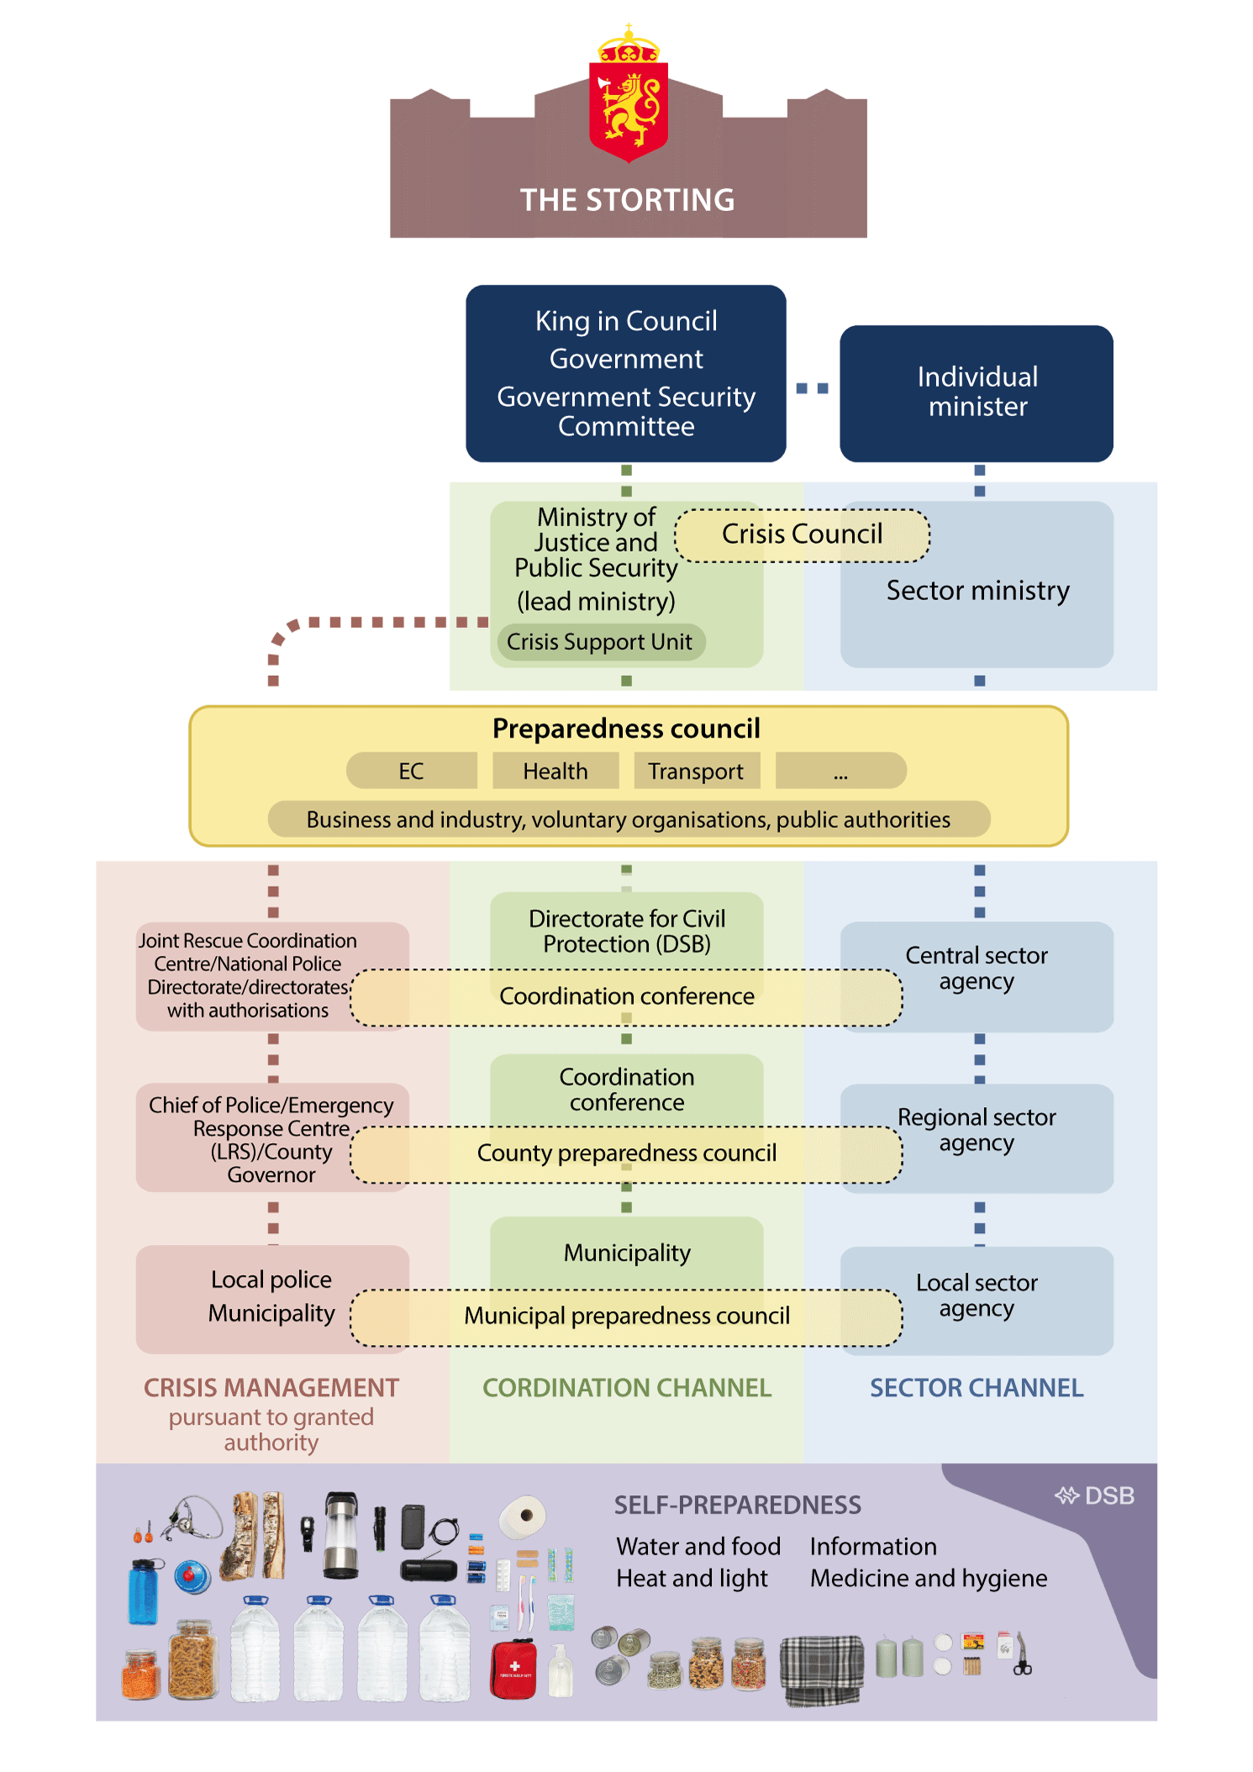

Illustration of the organisation of preparedness work

The circles illustrate arenas for cooperation at different levels.

## Long-term plan for civil preparedness

The Government will establish a long-term plan for civil preparedness, and work on the plan is scheduled to start in 2025.

The Total Preparedness Commission recommends the establishment of a long-term plan for civil preparedness. The Commission stresses that our current challenges imply a greater need to strengthen preparedness across sectors, and the importance of having mechanisms in place that support comprehensive assessments. The Commission also emphasises that the work on a long-term plan for civil preparedness must be seen in the context of preparation of a new long-term plan for the defence sector.

The Government has implemented a number of vigorous measures to strengthen emergency preparedness. With the new long-term plan for the defence sector, the Government has laid the foundation for a substantial and long-term strengthening of Norway’s defence capabilities. In this white paper, the Government lays the foundation for a significant strengthening of civil preparedness in the short and long term. In the spring of 2025, the Government will present a national security strategy to underpin efforts to safeguard national security interests.

The Government nonetheless agrees with the Total Preparedness Commission on the need for more long-term planning in the civil sectors, and will therefore draw up a long-term plan for civil preparedness. The plan will facilitate more long-term and comprehensive management, prioritisation, planning and development of key emergency response resources in civil society. The plan must take the differences between long-term planning in the defence sector and the civilian sector into account. While the long-term plan for the defence sector deals with one sector and one level of administration, civil preparedness is cross-sectoral, encompassing all administrative levels of business and industry and the voluntary sector. The business sector owns and operates critical infrastructure in areas such as electronic communications, energy and financial services. The voluntary sector plays a key role in emergency preparedness across the country.

The sectors involved in civil preparedness differ in terms of their areas of responsibility and organisation, ranging from healthcare and space technology to the grocery trade. Very few organisations have preparedness as their main concern as they are primarily involved in the production of goods and services. This must be taken into account when planning emergency preparedness. In many sectors, efforts to understand threats, assess preventive measures, practise incident management and establish new knowledge are just as important as considering major long-term investments. The long-term plan for civil preparedness must therefore adopt a different approach than the long-term plan for the defence sector.

The Government’s long-term plan

Work on the long-term plan for civil preparedness will begin in 2025 with the establishment of the new council structure for preparedness planning and status assessments in civil sectors, see Section 3.1. The Government aims to have emergency preparedness councils in all critical areas of society by 2026. Among other things, the councils will contribute to the annual preparation of vulnerability and status assessments within critical areas of society.

The knowledge obtained through the status and vulnerability assessments will provide a good basis for the Government to draw up a long-term plan for civil preparedness, which is regularly revised. The plan must address the need for long-term, cross-sectoral planning, while taking into account the special features of the civil preparedness field, and be flexible enough to meet a constantly changing threat and challenge landscape.

The purpose of the long-term plan is to strengthen civil preparedness, ensure continuity, coordination and a long-term approach. The long-term plan will enhance the link between risk assessments and political measures. It will also be a tool for assessing future workforce needs in relation to workforce needs in society in general.

Work on the long-term plan will be based on documents describing challenges, threats and risks, such as the national security strategy (see Section 3.4), worst-case scenarios from the Directorate for Civil Protection, risk assessments from the Norwegian National Security Authority and policing guidance from the National Police Directorate.

To ensure that the plan adapts to changes in the preparedness status and the changing threat and risk situation, the plan must be updated annually with measures. Such measures may be related to structures, expertise, coordination and investments, and could apply to individual sectors or be cross-sectoral. Examples are establishing emergency shelters, see Section 6.1.2, establishing a cyber security reserve, see Section 9.1, build-up of forces in the Norwegian Civil Defence, see Section 5.4.6, and facilitating civil workforce preparedness in crisis and war, see Section 10.5.2. The responsibility for assessing and proposing measures lies with the individual ministry, and will be based in part on the annual status updates and recommendations from the emergency preparedness councils.

The different sectors must be seen in context to ensure that the most important measures are prioritised and that interdependencies are taken into account. By virtue of its coordinating role in the civil sector, the Ministry of Justice and Public Security will annually compile the various status updates from the responsible ministries and, on that basis, recommend prioritised measures. This work is carried out in collaboration with the Ministry of Trade, Industry and Fisheries, which has the coordinating responsibility for security of supply. It is natural that the recommendations are considered as part of the Government’s budget work. The new structure does not change the division of responsibilities in the public administration.

The Ministry of Justice and Public Security is stepping up the long-term and comprehensive development of both the police and the Norwegian Police Security Service. This requires knowledge of future trends, challenges and opportunities, as well as knowledge of how various measures and allocations affect the organisations’ goal attainment. At the same time, the plans must be designed in a way that ensures flexibility to meet the future and a constantly changing threat and challenge landscape. They must, for example, be able to adapt to changes in the crime situation and other trends in society, such as technological developments.

Multi-year plans will address development needs and ambitions related to police capabilities and capacities. Developments in crime must also be taken into account in this respect. The plans must also give the police and the Norwegian Police Security Service room for manoeuvre to develop capabilities and capacities in prioritised areas, and in line with a policy-based level of ambition. This could also apply to the preparedness planning of important collaborating actors, thus facilitating more comprehensive management and development of emergency preparedness in a cross-sectoral perspective. This approach will pave the way for more long-term and comprehensive preparedness planning in the civilian sector.

In its budget proposal for 2026, the Government will provide a status of its work on the long-term plan.

## Common requirements for fundamental security of critical undertakings

The ability to maintain continuity in critical societal functions, such as power, health, electronic communications and digital services, is important for resilience. The Government will propose a cross-sectoral act setting common requirements for fundamental security for undertakings that are important to the functioning of society, in peace, crisis and war. This security is in part intended to help undertakings maintain their activities even if serious undesirable incidents and crises occur.

The Government wishes to set common requirements for fundamental security in undertakings covered by the new act. One of the purposes of the act is to strengthen undertakings’ own preparedness and resilience, and thereby their contribution to society’s overall resilience. In the Government’s view, the act should require undertakings to carry out risk assessments and implement the necessary security measures, as well as requirements for emergency preparedness, incident management and notification of serious incidents and crises.

A cross-sectoral act will be seen in the context of efforts to prepare for the implementation of the NIS2 Directive and the CER Directive. The directives divide society into different areas. These areas largely overlap with similar divisions in the framework for critical societal functions, fundamental national functions under the Security Act and NATO’s baseline requirements (see Box 3.1). The directives have not yet been incorporated into the EEA Agreement.

The Government will use the NIS2 and CER directives as a basis for its further work on national regulation of fundamental security requirements for undertakings. The Government will consider whether the scope of the new act should be expanded compared to the scope of the directives, including whether it should cover the public sector, including municipalities. The scope of a new act and the requirements to be imposed on undertakings must be further assessed.

Areas of society covered by the EU Directives CER and NIS2

Combined, the NIS2 Directive and the CER Directive cover the following areas of society: energy, transport, banking, financial market infrastructure, health, drinking water, wastewater, digital infrastructure, parts of public administration, space activities, food production and food supply, management of ICT services, postal and courier services, waste management, production and distribution of chemicals, production of certain goods, digital service providers and research.

[Boks slutt]

As part of the implementation of the directives, the Government will also review the Instructions for the Ministries’ work with civil protection and emergency preparedness. An assessment will be made of the interface between the new act and the Security Act, as well as the relationship to relevant sector-specific regulations. Such assessment is important to avoid inexpedient double regulation, and any other ambiguities, between the new cross-sectoral act and the applicable security and emergency preparedness legislation in the various sectors. Ambiguities of this kind can make it difficult to ensure good and uniform implementation and follow-up of requirements for undertakings whose functioning is critical to society. They can also challenge effective supervision and accessible guidance. A comprehensive approach to security and emergency preparedness legislation will help to simplify preparedness work in the various sectors. It will also contribute to a more unified approach at a strategic level.

## National security strategy

The Government has initiated work on a national security strategy.

A national security strategy is a cross-sectoral document that provides a comprehensive framework for how a state should promote its own security interests in relation to its surroundings and threats. Key allies such as the US and the UK have had their own variants of such strategies for some time. Germany presented its first national security strategy in 2023, as part of its response to Russia’s war of aggression in Ukraine. Sweden presented the second version of its security strategy in summer 2024.

Norway has not previously had a national security strategy. In 2023, the Government received input from the Norwegian Defence Commission, the Total Preparedness Commission and the Norwegian National Security Authority’s Security Advice, all of which stress the need for such a strategy. Common to all the input is that the gravity of the times we live in, the breadth of security challenges and changes in the framework conditions for Norwegian security reinforce the need for a more coordinated, comprehensive and long-term approach to Norway’s security, defence and emergency preparedness. The input has been assessed in the usual way by relevant ministries and the Office of the Prime Minister. In June 2024, the Storting unanimously decided that the Government should prepare a national security strategy.

The Government takes this mission seriously. There are various documents that present important considerations, goals and priorities of significance to security work, such as white papers on public security, long-term plans for the defence sector, and strategies for cyber security, artificial intelligence and counter-terrorism.

The Government will prepare a national security strategy that provides a comprehensive overview of foreign, security, defence and preparedness policy, based on our national security.

The strategy will be based on fundamental national assets and interests, and how these will be advanced and defended over time. To ensure that the policy areas concerned are seen as a whole, and to emphasise the central position of the strategy, the Office of the Prime Minister will be the issuer. The document will be the Government’s security strategy for Norway. It will be an unclassified product, with an accessible form in clear and understandable language. It will not be presented to the Storting, but will form a natural and authoritative basis for subsequent work in the Government and the ministries.

The Government suggests that a natural frequency for revising a national security strategy is once every parliamentary term.

The Government will present the security strategy by summer 2025.

## Strengthen cross-sectoral collaboration

The Total Preparedness Commission stresses the importance of cross-sectoral cooperation on several points, including crisis management, establishing a picture of the situation, in connection with civil-military cooperation and in the face of hybrid threats. The Government shares the Commission’s assessment of the importance of cross-sectoral collaboration. Such collaboration will also be important in dealing with prioritisation challenges, for example in situations where the ability to maintain continuity in critical societal functions such as power, healthcare, electronic communication or transport comes under pressure.

The Government will therefore consider additional requirements for cross-sectoral cooperation through a revision of the Instructions for the Ministries’ work with civil protection and emergency preparedness. Common requirements for the fundamental security of critical undertakings (see Section 3.3) and the establishment of a common structure at ministry level for preparedness planning and status assessments in civil sectors (see Section 3.1) will also help to strengthen cross-sectoral preparedness efforts.

## Prioritisation of security and emergency preparedness in agency management

The Total Preparedness Commission believes there is a need for increased emphasis on preparedness in the day-to-day work of all sectors. To ensure a common direction for cross-sectoral public security and emergency preparedness efforts, the Commission recommends including preparedness work in common guidelines issued by the Government to all ministries. The Government shares the Commission’s assessment of the importance of prioritising preparedness work in day-to-day activities. The Government wants the ministries to provide guidelines for the work on security and emergency preparedness in their agency management. The nature of such guidelines may vary depending on the challenges.

## Regularly appoint a total preparedness commission

When the Total Preparedness Commission presented its Norwegian Official Report in June 2023, it was the first comprehensive review of emergency preparedness in Norway since the Willoch Committee presented its report NOU 2000: 24 Et sårbart samfunn (A Vulnerable Society – in Norwegian only). The threat and challenge landscape has changed significantly since then, and we must expect it to continue to change going forward. The organisation of society is also changing. Regular cross-sectoral and comprehensive assessments of emergency preparedness, as performed by the Total Preparedness Commission, are therefore necessary. The Government proposes as such that a total preparedness commission be appointed at regular intervals. This will contribute to continuity in emergency preparedness work, ensure an updated picture of the situation and lay the foundation for long-term political prioritisation.

## Coordination arenas at various administrative levels

Society’s resilience depends on coordination at local, regional and central level, and the necessary cooperation and coordination between public, private and voluntary actors. See Figure 3.1 showing coordination arenas.

In the public sector, arenas for coordination have been established at local, regional and central level. At the ministry level, the Crisis Council is the central coordination arena. The Council is chaired by the secretary general of the Ministry of Justice and Public Security, and all ministers attend regularly. Subordinate agencies and expert environments participate as needed. Through a common structure at ministry level for emergency planning and status assessments, separate councils will be established in critical areas of society in which relevant public enterprises, business and industry and voluntary organisations participate (emergency preparedness councils) (see Section 3.1 and Figure 3.1). The Ministry of Justice and Public Security also organises inter-ministerial collaboration meetings when coordination and a common understanding of the situation is needed, such as in the aftermath of the Nord Stream sabotage in 2022 and when the terror threat level was raised in 2024.

The Directorate for Civil Protection’s coordination conferences at agency level are used to share information about the situation with relevant actors and identify issues across public authorities and administrative levels to achieve a common understanding of the situation. At agency level, there are also a number of other arenas where different agencies coordinate their activities within their respective sectors. The National Total Defence Forum is an important arena, where representatives of the Norwegian Armed Forces and the heads of approximately 30 central government agencies and directorates in the total defence field meet. The business and voluntary sectors are not permanently represented, but are invited to attend as needed. In many cases, the participation of business and industry will help to highlight new topics and strengthen the exchange of information.

The county preparedness councils are the established coordination arenas at regional level. The councils are chaired and appointed by the county governor. Participants include representatives of regional organisations responsible for critical infrastructure and critical societal functions, heads of emergency services, the Norwegian Armed Forces, police, the Norwegian Civil Defence, voluntary organisations, county authorities and other government agencies. Other actors can be invited as needed. Such participation should cover particularly important sectors and be tailored to any specific challenges within each region, ensuring the necessary involvement of business and industry.

Many municipalities have established a municipal preparedness council as a local coordination arena. Approximately 75% of all municipalities have established a municipal preparedness council. The councils consist of the mayor (often the chair), the municipal director and the emergency response coordinator, as well as representatives from the municipal and inter-municipal fire and rescue services, police, healthcare, Norwegian Civil Defence, voluntary organisations and owners of local critical infrastructure. Other actors are also invited to participate. There is currently no requirement for municipalities to have an emergency preparedness council. The Government will establish requirements for municipal preparedness councils, see Section 5.1.1.

Through a consistent council structure at central, regional and local level, the Government will ensure the participation of the private sector, voluntary organisations and relevant public actors. Together with the common structure for the ministries’ preparedness planning and status assessments in civil sectors (see Section 3.1), this consistent council structure will contribute to greater exchange of information, better interaction and utilisation of society’s collective resources, and increased common situational awareness.

## Involvement of the private sector

Diverse business and industry throughout the country is important. The private sector owns, operates and develops critical infrastructure, and plays a crucial role in both our capability to ensure the continuity of critical societal functions and for civil support to military operations. Among other things, business and industry possess important knowledge of how technical systems are structured and potential vulnerabilities, and how any damage and loss can be handled. There are also a number of tangible resources in business and industry, including industrial safety systems such as personnel and mechanical equipment, which can be of great use when handling incidents.

Businesses also have a vested interest in being able to prevent and deal with demanding incidents that affect them, since disruptions in the production of goods and services can be costly and ultimately lead to bankruptcy. Many risk-reducing measures are therefore both commercially and socio-economically profitable. The private sector therefore has an important role to play across the crisis spectrum, both in relation to the civilian population and in supporting defence efforts.

Industrial safety systems

Industrial safety systems are industry’s own emergency preparedness systems that can quickly deal with fires, injuries and leaks of gas and hazardous chemicals before the emergency services arrive. Industrial safety is a statutory requirement for self-protection that applies to most large and medium-sized industrial companies.

Companies covered by the Regulations on industrial safety (forskrift om industrivern) are obliged to establish an industrial safety system. When deemed necessary based on a company’s risk or location, the Norwegian Industrial Safety Organisation may order companies other than those initially covered by the regulations to establish an industrial safety system.

Businesses subject to industrial safety regulations must carry out a risk assessment and map the undesirable incidents that may occur in their activities. This determines the organisation, equipment and training involved in their industrial safety system.

[Boks slutt]

Coastal fleet

Coastal shipping companies and their vessels and crews are a major emergency preparedness resource. It is important for Norway that national and coastal transport needs can be met in times of both peace and crisis. A robust and functioning coastal fleet is also particularly important in view of Norway’s role as a receiving and transit country in a NATO context. Based on the changed security policy situation with war in Europe, the Ministry of Trade, Industry and Fisheries has included the coastal shipping companies as a permanent member of the NORTRASHIP management (Norwegian Shipping and Trade Mission).

In 2023, the Norwegian-owned, NOR-registered merchant fleet comprised approximately 850 ships (encompassing ships of 100 gross tonnes and more, and intended for the transport of goods or passengers). NOR-registered ships mainly operate in Norwegian waters, and to some extent in regional traffic between Norway and the Nordic countries/EU. The fleet is distributed along virtually the entire Norwegian coast.

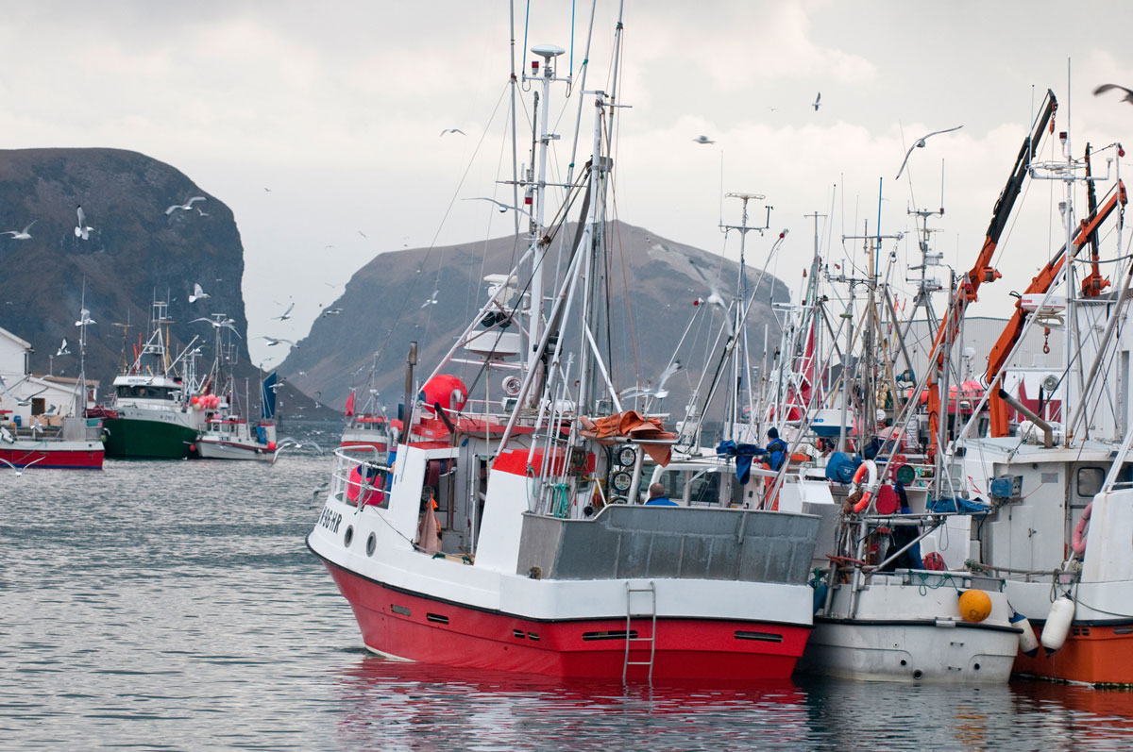

Fishing boats at Røst in Lofoten

Photo: Visit Norway.

[Boks slutt]

Norwegian Centre for Preparedness and Health Industry

Terningen Innovation Park in Elverum has taken the initiative to establish the Norwegian Centre for Preparedness and Health Industry (Norsk senter for beredskap og helseindustri) in Elverum and Sør-Østerdal. The project involves actors at various levels of public administration, private and public organisations, and LO and NHO. The aim is to help strengthen local and regional preparedness through guidance, training, business development and cooperation between the actors involved. The centre signed a collaboration agreement with the University of Inland Norway on 18 December 2024 for a joint initiative on emergency preparedness and public security.

[Boks slutt]

### Increased involvement and collaboration with the private sector

With this white paper, the Government is strengthening and formalising the involvement of and cooperation with the private sector on security and emergency preparedness. This is done through two main tracks. Firstly, by formalising the participation of the private and voluntary sectors in the new structure for status assessments and preparedness planning in civil sectors, see Section 3.1. In the new structure, the private sector and voluntary sectors will be represented in the councils within each of the designated areas of society. This will contribute to more frequent and direct dialogue between public and private actors. Regular contact between actors increases knowledge of each other’s roles, responsibilities, resources and interdependencies. This lays the foundation for better collaboration, both in emergency preparedness and in the handling of crises.

It is also important that business and industry is more closely involved in the work on cyber security. The assessment of a national cyber security reserve (see Section 9.1) will take a closer look at what role the business community could play in such a scheme. The cyber security reserve is intended to consist of relevant authorities and actors in the business sector and will primarily be used in the event of serious incidents that require extra capacity and expertise.

The second main track is setting clearer requirements for security efforts in undertakings, for example through efforts to prepare for the implementation of the CER Directive and the NIS2 Directive, see Section 3.3. The directives cover both broad fundamental security of undertakings that are important for society and requirements for resilience, and encompass more undertakings than those designated under the Security Act. When drafting national legislation, dialogue with the business community is encouraged.

The defence market is a unique market. In order for actors to be available to the defence sector during times of crisis, conflict and war, many of them must also be used in peacetime. The Government will therefore enter into strategic agreements with businesses to ensure the availability of resources both in peacetime and throughout the crisis spectrum leading up to war. Strategic agreements are long-term agreements that entail mutually binding cooperation between the defence sector and businesses. Such agreements contribute to security of supply and strengthened preparedness through long-term access to necessary goods and services. The strategic agreements are intended to supplement the Norwegian Armed Force’s own capacity rather than to replace it.

The civil sector must also enter into strategic agreements and partnerships in peacetime to meet civilian needs in crisis, conflict and war. An example is the Government’s agreement with four businesses in the grain industry, established in summer 2024, which will help to build up a national emergency stockpile of grain.

### A business sector equipped to deal with crisis and war

Private actors may be exposed to undesirable actions in a conflict situation. A malicious actor does not take account of the ownership of designated targets, for example, whether critical infrastructure is owned by the public sector or by private actors. It is therefore important that private undertakings are aware of the threat situation and how it may impact them, and of potential consequences if their assets are affected.

The private sector must be prepared for undesirable incidents. In the same way as public sector organisations and individual households, business and industry should be prepared for the loss of critical inputs such as electricity, electronic communications and water, as well as the failure or reduced capacity of certain supply lines. The Government will also ask the Directorate for Civil Protection to clarify the role of the industrial safety system and major accident enterprises in the total defence work, and in a comprehensive concept for the protection of the civilian population. Reference is also made to Section 6.1.2 where the Government proposes reintroducing a requirement to establish emergency shelters, and to introduce a new requirement to build shelters in certain categories of buildings in specific areas. In the long term, this will mean that more private actors will have to establish such protective measures to safeguard their employees and other personnel using the buildings in question. A description of the Directorate for Civil Protection’s advice on self-preparedness is provided in Section 6.1.3.

In high-level situations on the crisis spectrum, the business community can play an important role in the production of important inputs. This can include weapons and ammunition, but also medical equipment, pharmaceuticals, fuel, food and spare parts.

It will be relevant in such situations to redirect production from what is profitable and appropriate in peacetime towards the goods/products that are deemed necessary to support military efforts and ensure necessary services for the population. The changed security situation in Europe as a result of Russia’s full-scale invasion of Ukraine has put the need for increased production capacity in the defence industry high on the agenda. In response to this challenge, the Government has drawn up a roadmap defining priority products supplied by the Norwegian defence industry and associated measures to increase production capacity for these products (see Box 3.6).

Financial support and fast-track contracts to increase production capacity in the Norwegian defence industry since 2022

Since Russia’s full-scale invasion of Ukraine, the Government has fast-tracked contracts and provided funding to a number of projects aimed at expanding production capacity in the Norwegian and Ukrainian defence industries:

* Contract with Nammo to produce artillery ammunition for NOK 1.95 billion to meet national needs. The total framework for the procurement is around NOK 5.23 billion.
* Joint Scandinavian initiative in which Norway has entered into an agreement with Nammo for the delivery of artillery ammunition to Ukraine. Norway’s share is NOK 200 million out of a total framework of around NOK 600 million.
* Norwegian participation in the EU programme ASAP, which aims to increase the production of ammunition. Norway’s membership fee amounts to around NOK 190 million.
* Establishment of a NOK 180 million project at the Norwegian Defence Research Establishment providing innovation support to Ukraine and supporting the industrialisation of innovative products from small and medium-sized enterprises in the Norwegian defence industry.
* Co-financing of Norwegian companies’ ASAP projects totalling NOK 950 million. Grants from ASAP will trigger billions in investments in production capacity for ammunition, missiles and explosives.
* Approximately NOK 1 billion for the establishment of a new production line for artillery ammunition and rocket engines at Nammo.
* Up to around NOK 940 million for pre-ordering of components with a long lead time to accelerate the upgrade of the NASAMS air defence system and the development of our own air defence system.
* Support to Nammo for the transfer of a licence for producing artillery ammunition to Ukraine.

On 10 October 2024, the Government presented a roadmap for increasing production capacity in the defence industry. The roadmap addresses four main challenges that have been identified in collaboration with the industry. These include access to capital and international cooperation, regulatory conditions, vulnerable value chains and long-term access to skills. In connection with presenting the roadmap, the Government announced four individual measures totalling NOK 967 million:

* NOK 342 million in increased support for industrialisation and deliveries of innovative and cutting-edge products to Ukraine, delivered by small and medium-sized enterprises in the defence industry.
* Support for the establishment of a fourth production line for rocket engines at Nammo.
* Support for the establishment of national production of hexamine, a key input in the production of advanced military explosives.
* A feasibility study for the establishment of a new production facility for producing explosives.

The roadmap also contains a number of other measures that are important for Norwegian preparedness. For example, the Government will prioritise

* work on how defence and security policy considerations, including the defence industry, should be prioritised in connections to the power grid.
* assessing a national level of preparedness for ammunition and weapon systems, as well as the need for and costs of establishing stockpiles of raw materials and components for defence materiel.
* establishing an emergency preparedness council for the production of defence materiel.
* utilising the scope of action in Article 123 of the EEA Agreement for exemptions from the regulations in the agreement where national security interests so dictate.

[Boks slutt]

Robust total defence requires a resilient business sector with a capacity and preparedness level that meets the authorities’ expectations and requirements. The Government will ensure that business and industry is involved at all levels, including at the national level, in efforts to prevent and manage crises.

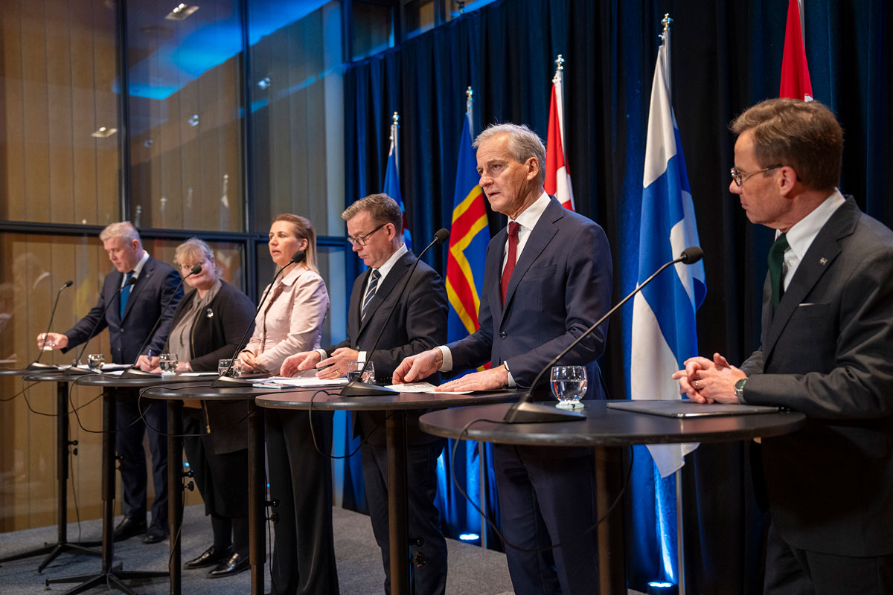

The Nordic prime ministers at the Nordic Council Session in Reykjavik

Photo: Eythor Arnason.

## International cooperation

The international community is crucial to Norway’s security. NATO is the cornerstone of Norwegian security policy. Finnish and Swedish NATO membership provides new opportunities for military mobility and closer Nordic cooperation on civil preparedness. Norway’s most important trading partners are in Europe, and new partnerships are increasingly being established in the field of civil preparedness.

### NATO – the cornerstone of Norwegian security policy

NATO’s security guarantee and collective defence are crucial to our defence capability. Civil resilience and preparedness is important for the alliance’s collective defence and for credible deterrence. The alliance’s work on both civil resilience and military capability at national and allied level is enshrined in Article 3 of the North Atlantic Treaty: ‘In order more effectively to achieve the objectives of this Treaty, the Parties, separately and jointly, by means of continuous and effective self-help and mutual aid, will maintain and develop their individual and collective capacity to resist armed attack.’

NATO has three core functions for civil preparedness: i) continuity of government, (ii) continuity of essential services to the population and (iii) civil support to military operations. Based on these three core functions, NATO’s Member States have adopted seven baseline requirements for the resilience of critical civil society functions and formulated additional criteria for these in the form of resilience objectives, see also Box 3.1.

It is up to each ally to operationalise the common objectives for the civil sectors and prepare national implementation plans. All Member States must report on implementation to NATO. The objectives point to several relevant areas of civil preparedness (public and private) that are important to include in the allied countries’ national efforts. Examples are the importance of bolstering public resilience, and the importance of robust critical infrastructure and supply chains to support national and allied military forces.

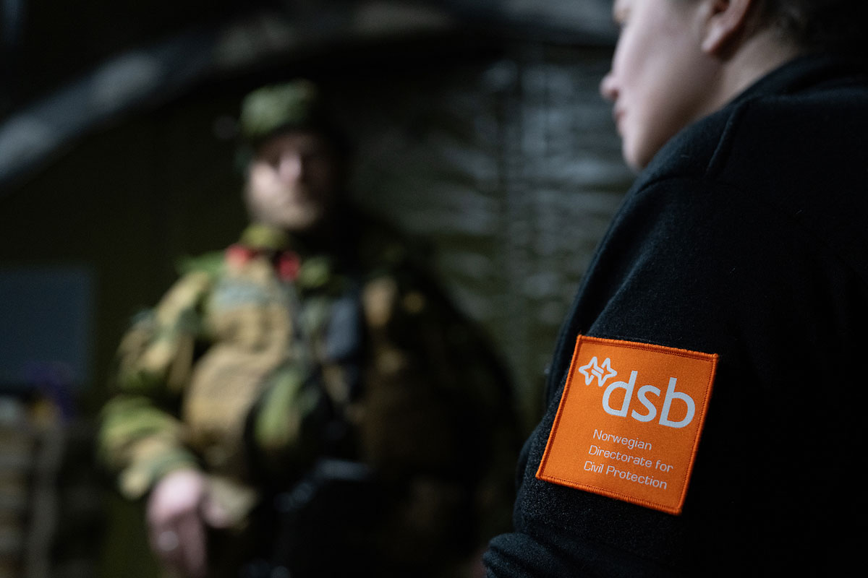

Nordic Response 2024

Photo: Stian Olberg/DSB.

The work on allied resilience objectives provides an integrated and more coordinated approach to reducing vulnerabilities across allied countries, helping military forces to operate effectively in crisis and conflict. An essential element of supporting military efforts is to improve the ability to provide host nation support through allied reception. NATO’s new Host Nation Support concept is wide-ranging and assumes that the countries providing such support have the necessary and well-functioning infrastructure such as roads, railways, airports, seaports, hospitals, power supply, telecommunications networks and services such as board and lodging, laundry, road clearing, construction and transport services. New requirements for Member States are currently under development (MOR: Minimum Operational Requirements) based on the new plan.

The Government will follow up NATO’s new concept for Host Nation Support nationally to improve Norway’s ability to receive and host allied forces. As part of this work, the Government will ensure that the national concept for host country support is updated in light of new NATO requirements and expectations, including Finnish and Swedish NATO membership.

Parts of the existing concept were tested during the Nordic Response 2024 military exercise. It is an objective that the sectors work to rectify any shortcomings in 2025, and for exercises and tests to be carried out in connection with the Total Defence Year 2026, see Section 4.3.2, and planned military exercises in the Cold/Nordic Response series.

The ability to handle incidents at a high level on the crisis spectrum is dependent on efficient deployment of military forces. Military mobility is a core aspect of NATO and involves the reception, transshipment, storage and onward transport of personnel and materiel across borders, as well as the regulations and procedures needed to achieve this. Military mobility capability therefore requires the involvement of and work in a number of civil sectors, including the necessary regulatory clarifications in peacetime, and that the development of countries’ infrastructure is seen in light of NATO’s needs.

Finland’s and Sweden’s membership of NATO entail new requirements for military mobility in the Nordic region, including the reception and onward transport of allied forces. Norwegian ports will serve as a gateway for allied reinforcements and supplies to Finland, Sweden, operations in the Baltic Sea and, ultimately, also for resupplying the Baltics. As a consequence, certain west-east axes, particularly roads and transport infrastructure, will become more important. At the same time, the Finnish and Swedish membership brings with it new requirements for further developing cooperation related to total defence and civil resilience in a Nordic context, within the framework of NATO. This entails increased activity for total defence actors, for example in relation to host nation support. See also Section 10.2 on military mobility.

Immediate Response 2024 exercise

The Immediate Response 2024 exercise was carried out in spring 2024. The exercise included training in Norway’s role as a transit country for allied forces into Sweden and Finland within a defined framework. It involved the arrival of a small American force in Narvik. The American vehicles and soldiers arriving at the Port of Narvik were then transported by rail to Haparanda, before being transported on to Finland. Given the limited size of the American force, there were no further problems with reception, transshipment and onward transport with the current infrastructure. A real situation could pose a greater challenge to transport capacity. The greatest challenges identified were at border crossings. In connection with the exercise, the three transport ministers from Finland, Sweden and Norway issued a joint statement on enhancing cooperation on military mobility, transport plans and training exercises.

[Boks slutt]

### Nordic cooperation

The Government sees a need to further strengthen Norway’s civil preparedness cooperation with Finland and Sweden to support our collective ability to provide effective civilian support to military forces in times of war. Norway cooperates closely with the Nordic countries in the field of public security and civil preparedness, for example through the Haga Process, the Barents Rescue exercises and the Nordic Council of Ministers (see Box 3.8). The Government will strengthen Nordic cooperation on civil-military preparedness, with particular emphasis on NATO’s work on civil resilience and host nation support. The Government will consider how existing structures can be further developed, such as the Barents Euro-Arctic Council, with health preparedness given the highest priority. Furthermore, the Government will assess how cooperation on health emergency preparedness and other preparedness cooperation in the Northern Nordic region can be strengthened.

The Haga Process and the Nordic Council of Ministers

The Nordic cooperation on civil protection and emergency preparedness at ministry level (the Haga Process) was politically enshrined in a declaration by five Nordic ministers in 2009. The objective was a strong and resilient Nordic region, with the capacity to prevent, prepare for, manage, recover and learn from serious accidents and disasters. Since 2013, the Haga Process has been working on specific mutual support capacities between the countries. Closer cooperation with NORDEFCO was agreed during the Norwegian presidency in 2024. There has also been a gradual development in agency-level cooperation.

The Nordic ministers responsible for civil protection and emergency preparedness met in Oslo in November 2024 as part of the Haga Process. A new joint declaration represents stronger Nordic cooperation on civil preparedness and resilience. With all the Nordic countries now members of NATO, the focus is on managing a broader range of crises, from natural disasters to hybrid threats and potential armed conflicts. The declaration seeks to enhance coordination between the countries, promote joint initiatives and strengthen civil-military cooperation through NORDEFCO and the Haga Process. Key areas of cooperation include Nordic scenarios for armed conflicts and crises, including hybrid threats, joint planning of host nation support in the context of NATO, protection of the civilian population and participation in civil-military exercises.

The Nordic Council of Ministers is the official body for inter-governmental cooperation in the Nordic region and works to secure joint Nordic solutions in areas where the Nordic countries can achieve more together than by working on tasks alone.

Based on the lessons learned from the pandemic and the security policy situation, civil preparedness and resilience will be given higher priority in the Nordic Council of Ministers’ cooperation programme for the period 2025–2030.

[Boks slutt]

On 30 April 2024, the Nordic defence ministers signed NORDEFCO’s Vision for Nordic Defence Cooperation 2030. The vision reflects the new strategic reality of war in Europe and the accession of Finland and Sweden to NATO. The vision will contribute to allied security in the Nordic region and the Euro-Atlantic area.

Dismantling Nordic border barriers

Promoting mobility and reducing border barriers between the Nordic countries is a cornerstone of Nordic cooperation. It is a high priority in all the Nordic countries. The purpose is to identify and revise laws and regulations that impede cross-border cooperation, which is necessary to ensure business development, jobs and settlement, especially in border areas. This includes agreements and legislation in areas such as tax, labour, pensions and social benefits. These issues became particularly relevant during the pandemic. A good basis for cross-border activity is also important in a crisis situation. Work on border barriers must therefore be seen in the context of total preparedness efforts.

[Boks slutt]

### European preparedness collaboration

Norway has established good cooperation arenas with allied countries in Europe and with the EU. In addition to Nordic cooperation, Nordic-Baltic cooperation is also important. Close cooperation with the UK on security and emergency preparedness has also been built up over a long period of time. Norway will continue to be an active contributor to closer cooperation with a view to enhancing public security in the Nordic region, NATO and Europe.

Norway is a participant in the EU’s Union Civil Protection Mechanism (UCPM), which is our most important arena for cooperation with the EU when it comes to public security, emergency preparedness and crisis management. Norway participates in the scheme on an equal footing with EU member states. The Directorate for Civil Protection has general management responsibility for the UCPM. The mechanism is also relevant to other civil sectors such as health, transport, the environment and research and education, including through knowledge and capacity building. In a crisis situation, Norway, in the same way as other participating countries, may request joint European, as well as the member states’ own, capacities to support national management (see Box 3.10 on Norwegian civilian support to Ukraine). The UCPM is also important for coordinating pan-European civil assistance to third countries. Through these mechanisms, we ensure that we can request assistance when needed, while also making resources and capacities available to help others. The Government will continue to be a predictable and reliable contributor to emergency preparedness and crisis management through the UCPM.

Norwegian governments recently led society through the COVID-19 pandemic. In Report No 5 to the Storting (2023–2024) A Resilient Health Emergency Preparedness – From Pandemic to War in Europe, the Government clearly states that binding cooperation with the EU is key to national health preparedness. For Norway, the pandemic revealed vulnerabilities in national preparedness that could not be solved by Norway alone, and cooperation with the EU was crucial to ensuring early access to vaccines for the Norwegian population. As presented in the white paper on health preparedness, the Government will work to promote Norway’s association with the EU’s enhanced cooperation on health preparedness on as equal terms as possible with EU member states.

In May this year, the Government signed a strategic partnership agreement on security and defence cooperation with the EU. The agreement provides a framework for stronger cooperation in areas where we can benefit from close collaboration, such as crisis management, defence industry, space cooperation, critical infrastructure and hybrid threats.

The Government will also closely monitor developments in the EU regarding cooperation on cyber, emergency preparedness and crisis management, and assess whether there are initiatives of importance to civil preparedness that Norwegian authorities should be involved in. The CER Directive and the NIS2 Directive are examples of such initiatives. As mentioned in Section 3.3, the Government will draw up a new act on the security of undertakings that are important for society, based on the NIS2 and CER directives.

Norway will be an active contributor to closer cooperation with a view to enhancing public security in the Nordic region, NATO and Europe. In areas where greater international cooperation is being considered, we must also assess what must be built up in terms of our own capacities and what it would be expedient to cooperate on. This assessment must consider Norwegian interests in a broad sense, including the relationship between public security and economic security, and employ a long-term perspective. It is also important to facilitate increased cooperation with the UK, in addition to other EEA countries, in the area of public security and emergency preparedness. Norway will closely monitor developments in the EU regarding emergency preparedness and crisis management, and any new initiatives.

The Government will therefore work closely with allies, Europe and other partner countries in a long-term perspective to identify and reduce undesirable economic vulnerabilities in an increasingly demanding geopolitical landscape.

Norwegian civilian support to Ukraine

Since the outbreak of war, Ukraine has submitted more than 200 formal requests for civilian support through the EU’s UCPM. The Directorate for Civil Protection is the national contact point for receiving and responding to requests for assistance under this mechanism. By virtue of its coordinating role, the Directorate is responsible for liaising with relevant agencies in connection with international incidents, a role that has been an important prerequisite for Norwegian civilian support to Ukraine through the UCPM. Norwegian authorities have chosen the UCPM as a main channel for providing civilian humanitarian assistance to Ukraine, in part because the EEAS Crisis Response Centre established a stable logistics system for delivering aid to Ukraine at an early stage of the conflict.

One clear observation is that the war has a cross-sectoral impact. As of October 2024, 26 different Ukrainian authorities have requested assistance through the UCPM, and Norway has delivered materials to the Ukrainian health sector and to civil protection authorities to safeguard the population. Norway has also supplied materials to aid the protection of Ukrainian cultural heritage sites, as well as materials for the reconstruction of critical infrastructure.

Medical evacuation

When Russia launched a full-scale attack on Ukraine, there was an urgent need for medical evacuation of Ukrainian patients. The EU quickly put a system in place to handle the need, and the first patients were evacuated to Norway in March 2022. So far, Norway has received more than 400 Ukrainian patients through the UCPM. Since August 2022, Norway has collaborated with the EU on regular evacuation flights for Ukrainian patients, transporting more than 2,000 patients for essential medical care in Norway and other European countries. In this way, we help to utilise hospital capacity in several countries to relieve the burden on the Ukrainian health service. Norway is the only country that offers regular flights through the UCPM, and the cooperation agreement on regular flights runs until 30 April 2025.

The Norwegian civil-military cooperation that underpins our contribution to the medical evacuation of Ukrainian patients has accounted for almost half of all flights to European countries. Norwegian expertise is described as a mainstay of the pan-European effort for the medical evacuation of Ukrainian patients.

The medical evacuation of Ukrainian patients to Norway is a collaboration between several ministries, the regional health authorities, the Norwegian Directorate of Health, the Norwegian Armed Forces, SAS and the Directorate for Civil Protection.

[Boks slutt]

# Increased capacity for crisis management

Our ability to manage crises is paramount to the consequences an incident has for life, health and material assets. We must be able to make decisions, build situational awareness, obtain the necessary expertise and share information.

When an incident occurs, it usually affects several sectors. Serious incidents and crises have cross-sectoral consequences. They may call for coordination between the defence sector and civil sectors, between civil sectors, between different levels of the public administration, and between the public sector and private and voluntary actors.

When dealing with incidents high on the crisis spectrum, there will be a particular need for procedures, instructions and legislation that set out clear, binding and broadly known coordination measures. Training exercises must also be carried out regularly. Although the current crisis management system works well, experiences from the ongoing war in Ukraine, the COVID-19 pandemic, the ‘Viking Sky’ cruise ship incident in 2019 and the extreme weather event ‘Hans’ in 2023 have highlighted the need for clear roles, responsibility and authority.

The Government will:

* ensure that the Ministry of Justice and Public Security will be the permanent lead ministry in the event of national civil crises.
* ensure that the Crisis Support Unit has sufficient authority to obtain necessary information and support the lead ministry.
* ensure that the Directorate for Civil Protection has sufficient authority to obtain the information necessary for the agencies in the civil sector to be able to pull together in an incident.
* reinforce training exercises at all levels.
* involve and collaborate more closely with business and industry in exercises.
* conduct a new national cyber security exercise in 2025.
* contribute to improving access to unclassified and classified communication solutions for relevant civil organisations in the total defence.
* ensure the development of a new emergency network (Nødnett) that meets the need for coverage, national control, security and technological development.
* strengthen helicopter preparedness throughout the country. The security policy situation indicates a particular need to enhance helicopter preparedness in the north.
* present a white paper on drones and new air mobility.
* ensure that the state takes over ownership and management of the part of the coastal radio service that is defined as a special public service obligation when the agreement with Telenor expires on 31 December 2025.
* strengthen the requirements for the ministries’ knowledge preparedness in the Instructions for the Ministries’ work with civil protection and emergency preparedness.

## The crisis management system

The system for central crisis management is described in the Instructions for the Ministries’ work with civil protection and emergency preparedness.[4] The instructions state that ‘The ministries shall ensure that operative parties have the necessary authorisation, so that the need for processing at Government level shall not delay management of acute situations where life and health are at risk, or where there may be a major loss of material assets’. The Government, the ministries, the Crisis Council, the lead ministry and the Crisis Support Unit are the core elements of the central crisis management system. Many agencies may also be involved in crisis management, for example by supporting the ministry with specialist advice or through coordination with other actors.

Crises are handled in accordance with provisions granting delegated authority to the executive branch, as well as through the coordination channel and sectoral channels (see Figure 3.1).

Crisis management in accordance with provisions granting delegated authority to the executive branch

Crises require the implementation of measures to safeguard life, health and material assets. Measures can be decided at policy level by the Government and by actors who have been granted authority to implement cross-sectoral measures, including the police, the Joint Rescue Coordination Centre and the Crisis Committee for Nuclear Preparedness. This requires good situational awareness, including good procedures for information sharing and situation reports. This is important both to enable actors to make informed decisions and to ensure coordinated efforts. In war or under threat of war, the Norwegian Armed Forces will also play a key role in crisis management in accordance with their delegated authority.

Crisis Committee for Nuclear Preparedness

The Crisis Committee for Nuclear Preparedness is responsible for and authorised to implement measures to reduce the consequences of a nuclear accident. The Committee is obliged to notify the responsible ministries of decisions and orders concerning measures. The Committee’s remit was provided by the Royal Decree of 23 August 2013.1 The Crisis Committee for Nuclear Preparedness consists of representatives from: The Norwegian Radiation and Nuclear Safety Authority, the Norwegian Armed Forces, the Directorate of Health, the Food Safety Authority, the National Police Directorate, the Ministry of Foreign Affairs, the Coastal Administration and the Directorate for Civil Protection. The Norwegian Radiation and Nuclear Safety Authority chairs and acts as secretariat for the Crisis Committee. It also has one member in the Crisis Committee for Nuclear Preparedness.

1 The remit for and composition of the Crisis Committee for Nuclear Preparedness with advisors, as well as the remit for the County Governor.

[Boks slutt]

The coordination channel

The purpose of coordination is to establish a common understanding of the situation by sharing information and jointly assessing cross-sectoral issues, consequences and measures. The lead ministry is responsible for coordinating the cross-sectoral management at ministry level. The Directorate for Civil Protection supports the Ministry of Justice and Public Security’s coordination role, among other things by facilitating cooperation between directorates and acting as a link between county governors and national authorities. The Directorate for Civil Protection also has an independent coordination role in accordance with separate instructions.[5] The coordination channel is the line of communication between the municipality, the county governor, the Directorate for Civil Protection and the Ministry of Justice and Public Security before, during and after major incidents. It comprises situation reports, coordination conferences and status updates with information from various specialist areas at local, regional and national level. The coordination channel can be used throughout the crisis spectrum, including during security policy crises and war. The Crisis Support Unit at the Ministry of Justice and Public Security, receives and distributes situation reports to the ministries and the Office of the Prime Minister.

Sectoral channels

The ministries are responsible for crisis management within their own sector, in close cooperation with the lead ministry. The Ministry of Health and Care Services, for example, was responsible for handling the medical and healthcare aspects of the COVID-19 pandemic, and similarly, the Ministry of Finance would be responsible for a crisis related to financial stability. Specialist agencies (locally via the regional level and central government agencies) report through sectoral channels to their respective ministries, for example in the areas of health, policing, power and electronic communication. Agencies at different levels coordinate through, among other things, municipal preparedness councils, county preparedness councils and the Directorate for Civil Protection’s coordination conferences (see further description in Section 3.8).

## Clear roles in crisis management

### The Government’s role in crisis and war

The Government has the ultimate responsibility for emergency preparedness in Norway. Section 3 of the Norwegian Constitution assigns executive power to the Government/King in Council. In the military sphere, Articles 25 and 26 of the Norwegian Constitution stipulate that the Government, by decision of the King in Council, exercises the supreme military command authority in Norway.

The Government is therefore the supreme body for managing crises, including in war. The Government not only has the right to manage and handle crises by virtue of being the executive power, but also has a duty to act to safeguard the interests of the realm and the lives, health and material assets of its citizens.

In security policy crises and wars, the Government and the King in Council will have to make strategic and fundamental decisions. This could be a decision to declare war in the realm, to mobilise the armed forces, request a declaration of Article 5 of the NATO Pact, request bilateral military support or decisions on evacuation or wartime relocation of the population. The Government will also have to take steps to maintain fundamental civil functions, such as power and electronic communications.

Several decisions in a crisis and war situation are already delegated, for example through the Instructions for the Chief of Defence and the National Preparedness and Response System. Nevertheless, the Government will have overall responsibility, and many decisions in crisis and war must therefore be considered and established in the Government.

The situation in a security policy crisis or war will affect all areas of society. Examples of tasks that may need to be handled by the Government and ministers are listed below:

* Prime Minister (overall and strategic crisis management and head of the Government/Government Security Council).
* Minister of Defence (management of the Armed Forces, allied reinforcement, bilaterally and within the NATO framework.
* Minister of Foreign Affairs (Norway’s relations with other states. Norway’s relations with international organisations. Diplomatic relations).
* Minister of Justice and Public Security (coordination of civil preparedness, coordination of civilian support for military efforts. Law and order, and protection of the civilian population).
* Minister of Finance (ensure a functioning electronic and cash payment system, stability in the money market, safeguard the Government’s foreign exchange reserves and the Government Pension Fund, financing crisis management).
* Minister of Health and Care Services (health preparedness, treatment of wounded and injured)
* Minister of Energy (secure power supply, oil, gas).
* Minister of Trade and Industry and the Minister of Fisheries and Ocean Policy (ensure that business and industry can support civil society and military efforts, responsibility for the merchant fleet (NORTRASHIP scheme), ports, waters and ensure business and industry preparedness).
* Minister of Transport (ensure functioning modes of transport and logistics in all domains. Ensure civilian transport support to national and allied forces).
* Minister of Digitalisation and Public Governance (ensure functioning electronic communication).
* Minister of Agriculture and Food (ensure the country’s food production and food security).

The Prime Minister leads and coordinates the Government’s work, including in times of crisis and war. The Prime Minister decides how the Government will organise its work and which issues will be politically addressed. Many decisions in a crisis or war will have to be made under great time pressure and on an uncertain basis. The need for a sound decision-making basis, broad participation and good coordination must be weighed against efficiency in decision-making processes and real delegation of authority to ministers and agency directors.

Classified matters of a security policy or emergency preparedness nature are normally dealt with by the Government Security Council. In crisis situations, the Government can also choose to appoint temporary government committees if they appear better suited to the nature of the crisis, as was the case for the Solberg Government’s COVID-19 committee during the handling of the pandemic in 2020-2021.

Efforts to manage major incidents and crises, such as 22 July, the refugee crisis in 2015, the COVID-19 pandemic and the Ukraine war, require an ability to establish a common understanding of the situation across ministries and sectors, handle large numbers of individual cases and assess the overall strategic direction of crisis management. There is a crucial need for coordinated, clear and tailored communication to the public in this type of extensive and cross-sectoral crisis. In security policy crises and war situations, international dialogue and coordination of efforts between allies and other partner countries will also be essential.

The Office of the Prime Minister assists the Prime Minister in leading and coordinating the Government’s work, possibly in other formats such as the Government Security Council. In this role, the Office of the Prime Minister has extensive contact with the ministries to ensure the best possible basis for decision-making. The Office of the Prime Minister also advises the Prime Minister on handling of the matters and assists the ministries in following up the Government’s conclusions. The Office of the Prime Minister also organises the Prime Minister’s international meetings, and in crises of international significance and war situations, this will often take place at head of state level. In a serious crisis and war, the prime minister’s communication with the country’s citizens will be particularly important. The Office of the Prime Minister will as such normally take a coordinating role in communicating with the public in such situations.

Based on lessons learned from handling several major incidents and crises in recent years, the Government will revise the Instructions for the Ministries’ work with civil protection and emergency preparedness. The Government will clarify that the Government is the supreme body for crisis management, and in this connection, also clarify the role of the Prime Minister as Head of Government. Furthermore, the Government will clarify the role of the Office of the Prime Minister in assisting the Prime Minister and the Government, both during crisis management and in ongoing national security efforts. To increase capacity around the Prime Minister in this area, the Office of the Prime Minister has appointed several more full-time equivalents.

### The Ministry of Justice and Public Security as the permanent lead ministry in the event of national civil crises

In accordance with the Instructions for the Ministries’ work with civil protection and emergency preparedness, the Ministry of Justice and Public Security is the permanent lead ministry in national civil crises unless otherwise specified. The lead ministry is tasked with coordinating crisis management at ministry level. The designation of a lead ministry does not entail any changes in constitutional responsibilities, and all ministries retain responsibility and decision-making authority for their respective sectors.

Experience has shown that incidents often require one ministry to coordinate their handling across sectors. This applies regardless of whether the event is defined as a national crisis, as there is no clear-cut distinction between crises and other serious incidents. The Ministry of Justice and Public Security nonetheless has a general coordinating role in civil protection efforts. This role means that the Ministry of Justice and Public Security is responsible for comprehensive, systematic and risk-based civil protection work at the national level across all sectors, including ensuring that issues that cut across sectors and critical societal functions are dealt with and, where necessary, assisting the ministries in clarifying responsibilities.

The coordination role and the role of the lead ministry largely require the same type of expertise, regardless of whether the incident is defined as a crisis. It is therefore natural for both roles to be handled by the same ministry. A ministry that has rarely or never previously had the role of lead ministry will not have the same prerequisites as the Ministry of Justice and Public Security to fulfil this role. The Government will therefore designate the Ministry of Justice and Public Security as the permanent lead ministry in the event of national civil crises. There is no longer an expectation that all ministries should be able to take on the role as lead ministry. The Instructions for the Ministries’ work with civil protection and emergency preparedness will be updated in line with this.

In accordance with Section 1 of the Foreign Service Act, the Ministry of Foreign Affairs has a special responsibility for crisis incidents abroad that affect Norwegian citizens or interests. The Ministry of Justice and Public Security will support the Ministry of Foreign Affairs and address the need for cross-sectoral coordination in Norway. In security policy crises and armed conflicts, the Ministry of Defence and the Ministry of Foreign Affairs will, by virtue of their sectoral responsibilities, address defence, security and foreign policy issues.

Serious incidents may affect many sectors, and all ministries must contribute to cross-sectoral management in close cooperation with the lead ministry. All ministries must also be prepared to lead the part of the crisis management that falls within their areas of responsibility. For example, the Ministry of Finance will fulfil this role in the event of major disruptions or crises in the economy or the financial system as a whole, including by coordinating, proposing and implementing extraordinary measures.

Nord Stream gas pipeline

On 26 September 2022, several explosions were recorded in the Baltic Sea. Shortly afterwards, major leaks were detected from the Nord Stream 1 and 2 gas pipelines, which transported Russian gas to Germany. The evidence quickly pointed in the direction of sabotage, and led to increased attention to security on and around Norwegian oil and gas facilities, partly due to our role as a supplier of energy to Europe. Although the perpetrator behind the sabotage and their motivation has not yet been determined, this incident demonstrates the vulnerability of critical infrastructure.

No direct threats had been made to Norway or Norwegian petroleum facilities, but there was nonetheless a great deal of uncertainty surrounding the situation and how a potential escalation could unfold. This is also the main objective of hybrid activities: to create uncertainty, fear and chaos. Many actors in several sectors were involved in assessing and implementing measures to raise the level of security, as well as organising emergency preparedness resources. This requires coordination, information sharing and a common understanding of what is happening and how the situation might develop.

An established system for security and emergency preparedness cooperation between involved actors at all levels was a good starting point for ensuring security of supply to Europe and for protecting our facilities and everyone working on them.

[Boks slutt]

### New powers for the Crisis Support Unit

In accordance with the Instructions for the Ministries’ work with civil protection and emergency preparedness, the Crisis Support Unit’s mission is twofold. It supports the lead ministry and the Crisis Council, as well as the Ministry of Justice and Public Security in the ministry’s coordination role. In addition, the Crisis Support Unit has a role in the Ministry of Justice and Public Security’s internal incident management. An important part of the Crisis Support Unit is the Civil Situation Centre, which is the Ministry of Justice and Public Security’s permanent point of contact for incidents and crises. The Civil Situation Centre operates 24 hours a day and assists by reinforcing the cross-sectoral flow of information in the event of incidents and crises.

Whereas central crisis management, including the role of the lead ministry and the tasks of the Crisis Support Unit were previously intended for national civil crises, the current situation warrants a permanent need to safeguard several of these tasks both on a day-to-day basis and during incident and crisis management.

One of the Crisis Support Unit’s tasks is to help establish a common understanding of the situation as a basis for strategic decisions. To establish situational awareness during incident and crisis management, the Unit needs information from affected sectors. Experience has shown that the Crisis Support Unit lacks the powers necessary to obtain information from ministries and other actors. Such information provides a better basis for recognising changes in the normal situation and establishing a common understanding of the situation when handling incidents and crises. The Government will ensure that the Crisis Support Unit has sufficient powers to obtain the necessary information and support the lead ministry.

### New powers for the Directorate for Civil Protection

The Directorate for Civil Protection is tasked with contributing to efficient and effective dialogue between the agencies concerned, particularly with respect to cross-sectoral challenges. Coordination conferences are an important tool in crisis management and are used to share information and situational awareness with relevant actors. Current coordination conferences are based on voluntary participation, but it is important that all relevant actors participate, share necessary information and raise issues that cut across sectors. This helps to identify challenges, highlight cross-sectoral dependencies and any ambiguities in roles and responsibilities, and clarify the necessary follow-up of incidents or crises.

The Government will therefore give the Directorate for Civil Protection clearer powers in its coordination role. Such powers are intended to ensure that the Directorate has access to the information necessary for the agencies in the civil sectors to pull together in an incident. The new powers will be established in a way that does not conflict with existing and sectoral emergency preparedness and crisis management arrangements.

The role of the police in emergency rescue efforts

According to Section 27 of the Police Act, the police may ‘(…) initiate and organise rescue operations in cases where people’s lives or health are threatened, unless such authority is assigned to another authority.’ and ‘(…) implement such measures as are necessary to avert danger and limit damage. Until responsibility is assumed by another authority, the police shall organise and coordinate the relief work.’ This is also established in the Organisation Plan for the Rescue Service of 1 February 2020, where the chief of police in each police district is head of the local rescue centres, which are subordinate to the Joint Rescue Coordination Centre. The Joint Rescue Coordination Centre leads and coordinates all types of rescue operations. Pursuant to Section 7 of the Police Act, the police may intervene to protect the safety of individuals or the general public, for example by regulating traffic, prohibiting loitering in certain areas, turning away, removing or apprehending persons, ordering activities to be halted or modified etc. The main instructions for the police are laid down by the Ministry of Justice and Public Security1 and include a description of the police’s responsibilities in crisis management. ‘The police are responsible for establishing the necessary coordination with other relevant agencies in the event of major incidents and crises. The National Police Directorate must be able to quickly establish crisis management leadership when needed and ensure coordination, national situational awareness and national operational crisis management.’

1 Main instructions for the police, issued by the Ministry of Justice and Public Security with effect from 21 July 2022 (in Norwegian only).

[Boks slutt]

Coordination activities and cross-sectoral crisis management

The Directorate for Civil Protection’s coordination activities during incidents and crises must not interfere with the operational management and possible investigation of incidents. Giving the Directorate clearer powers must not affect constitutional responsibilities, or the responsibilities or powers of other agencies and authorities.

The revised remit will also help to clarify the interface between the Directorate for Civil Protection’s coordination role and other actors in crisis management. This is particularly important in relation to actors with delegated authority, such as the police, the Joint Rescue Coordination Centre and the Crisis Committee for Nuclear Preparedness, which, in the acute phase of a crisis, have the authority and power to initiate and organise cross-sectoral efforts in incidents that pose a threat to human life and health. It is also important to clarify the interface with actors that are assigned emergency preparedness and coordination roles on the Norwegian continental shelf.

## Training exercises – ready for crisis, prepared for war

Exercises are a means of training, testing and further developing national preparedness, including the total defence concept. They are also an effective tool for maintaining and improving crisis management expertise, and for further developing plans and procedures.

We have conducted training exercises more frequently over the past few years. This has included different types of exercises, at different levels of the public administration, in different sectors and for different purposes. More emphasis has been placed on training for civilian support to military efforts as part of military exercises. Since Sweden and Finland became members of NATO, joint military exercises have been carried out in which civil sectors have also taken part in exercises across national borders. The business sector has invited public authorities such as ministries and agencies to participate in their training exercises. Efforts to carry out more cross-sectoral exercises, expand military exercises with the participation of civil sectors, as well as close cooperation with the business and voluntary sectors, will continue.

It is essential that exercises are organised at all levels. Exercises for various scenarios must be organised on a regular basis and made part of ongoing preparedness efforts.

### Strategic framework for national exercises in civil sectors

National exercises involve several administrative levels and/or sectors in the same training exercise. The choice of objective, scenario and type of exercise may be based on threat and risk assessments and evaluations from previous exercises and incidents, and is aligned with affected actors. The term ‘national exercises in civil sectors’ does not preclude exercises with participation from the Armed Forces.

The Government will establish a strategic framework for national civil exercises. The purpose is to contribute to a more comprehensive approach to national civil exercises, and ensure consistency between goals and means. The framework is intended to provide a sound decision-making basis when prioritising national exercises in civil sectors. It will also help to ensure that civil participation in military exercises is planned with a more long-term and predictable planning horizon. The framework will help to further develop the use of military exercises for civilian capability to support military efforts in security policy crises and war. See Box 4.4 for information about total defence exercises.

Based on the framework, a multi-year plan is drawn up for national exercises, which is continuously maintained and coordinated with the training exercise plan for the defence sector. The Government will also start work on a strategy for national civil exercise activities.

Total defence exercises

Extensive training exercises are conducted every year, both nationally and within the framework of NATO’s exercise concept, where total defence actors conduct exercises together. Total defence exercises contribute to stronger civil-military cooperation through the sharing of expertise, cooperation on planning and clarification of authority and responsibilities. The exercises are carried out at several levels, both initiated by the defence sector and by civil sectors. Examples of such exercises are the two counter-terrorism exercises Nordlys and Gemini, in which the police, the Armed Forces, the Norwegian Police Security Service and other collaborating actors work together to practise handling terrorist incidents, and the Armed Forces’ annual GRAM exercise, involving training in civil-military liaison functions. Major military exercises such as Trident Juncture, with significant participation from civil actors from several levels of the total defence, have proved to be important in the further development of the total defence. The preparations and development of plans and procedures beforehand have also proved to be as valuable as the exercise itself.

[Boks slutt]

### Total Defence Year 2026

The Directorate for Civil Protection and the Norwegian Armed Forces will collaborate on planning the Total Defence Year 2026 as a new important milestone in total defence efforts. The Total Defence Year will consist of a series of exercises and planning activities in 2025 and 2026. The year will end with a major total defence exercise that will include several levels of authority and appropriate participation from private and voluntary organisations. To prepare for the Total Defence Year 2026, the Directorate for Civil Protection has drawn up a list of measures with proposals for activities that should be prioritised in the development of total defence. The ministries can use this list to prioritise tasks in their respective sectors. The Directorate for Civil Protection will hold a national experience seminar in 2027 to learn from experience of the Total Defence Year.

### Digital 2025 exercise

The Digital 2025 exercise represents the start of the Total Defence Year 2026. To strengthen our national capability to prevent and manage serious cyber incidents, we must raise our competence and awareness. Norway has a long tradition of conducting national cyber exercises, including the IKT 08, IKT 16 and Digital 2020 exercises. The Government has decided to conduct a new national cyber security exercise in 2025. The Directorate for Civil Protection is leading the planning of the exercise in close collaboration with the Norwegian National Security Authority and key players from business and industry and the public administration. A key element of the exercise is the involvement of and cooperation with the business community. The exercise is carried out within the framework of total defence and with a security policy backdrop.

Locked Shields 2024

Commissioned by the Ministry of Justice and Public Security and the Ministry of Defence, the Norwegian National Security Authority and the Norwegian Cyber Defence Force are coordinating Norway’s participation in the international cyber exercise Locked Shields. The purpose of Norway’s participation is to train response environments in the civil and military sectors in incident management. The organisation of and participation in the exercise facilitates close cooperation between expert groups, which the Total Preparedness Commission stressed as important. Around 4,000 experts from more than 40 countries took part in 2024, including Ukraine despite being at war. This illustrates the importance and benefit of the exercise for participating nations. A selection of Norway’s foremost cyber experts, including private actors, worked together to tackle national challenges. For the first time, Norway also participated at ministry level in the strategic part of the exercise.

[Boks slutt]

The Bukkesprang exercise

Since 2017, Telenor Norway has organised Bukkesprang, Norway’s largest cross-sectoral ‘live fire’ exercise in cyber security, focusing on handling attacks and cyber security threats. In collaboration with the Norwegian Cyber Defence Force and the Norwegian National Security Authority, Telenor brings together key actors in the public, civil, military and private sectors at Fornebu. Over the course of a week-long training exercise, attendees gain experience, share knowledge and network across sectors. The exercise is unique in a Norwegian context, and is an important contribution to overall cyber resilience, testing our ability to interact, manage and coordinate. In addition to training in scenarios that reflect the threat situation, the overall aim of the exercise is to strengthen the integration of the business community in Norway’s total defence. Bukkesprang will take place again in spring 2025.

[Boks slutt]

Protect critical underwater infrastructure

Norway is an important energy supplier to Europe. The Nord Stream pipeline incident has raised awareness of our need and responsibility to protect critical underwater infrastructure in Norwegian waters. As a consequence of the incident, Equinor and Gassco initiated a strategic exercise with relevant authorities to share plans for strategic crisis management of a similar scenario. Several areas for improvement were identified. These have since been followed up by the respective organisations.

One of the main conclusions from the exercise was the need for good cross-sectoral understanding and strategic interaction between the private and public sectors in crisis situations. Following this exercise, several similar exercises have been carried out.

[Boks slutt]

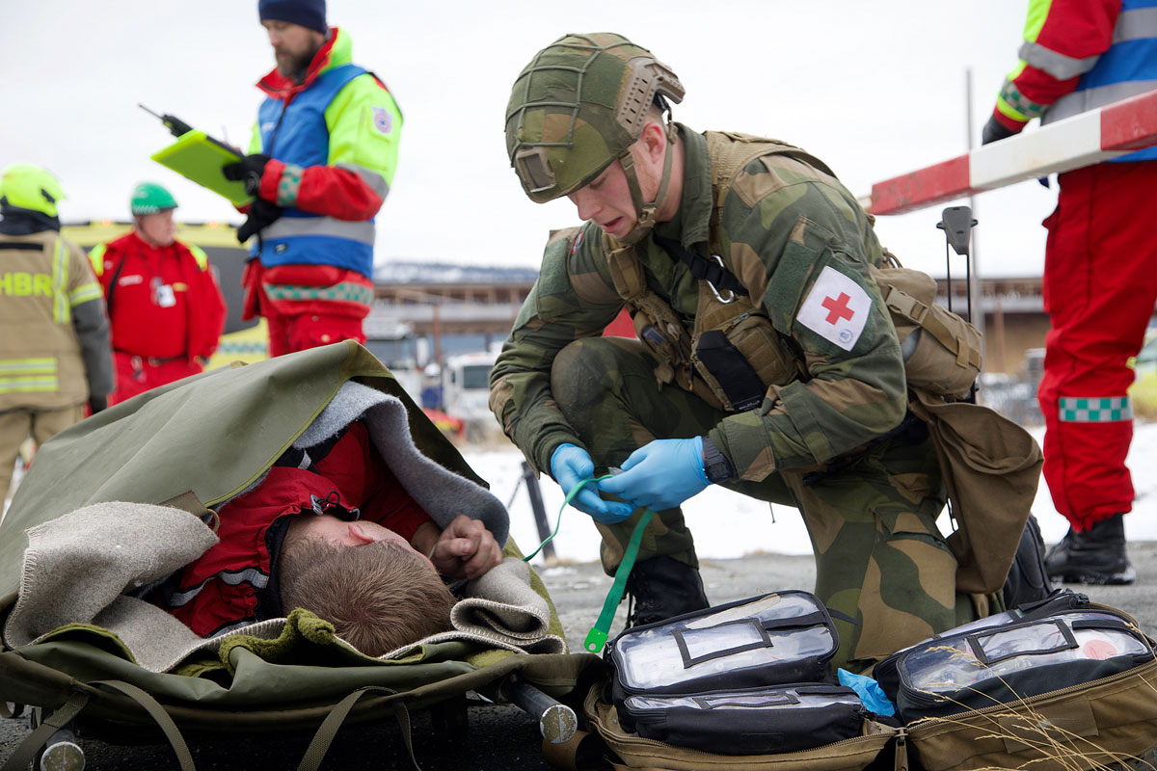

Mass casualty exercise in Tynset

Photo: Tore Ellingsen/Norwegian Armed Forces.

## Secure communication in crisis and war

Efficient and secure communication and information sharing between undertakings involved in total defence, and between the authorities and the general public, is a prerequisite for a well-functioning total defence. Total defence undertakings must have access to unclassified and classified communication systems to have the capability to handle, interact and understand situations. Expertise in how new technologies can and should be used is important to this end. Education, training and exercises are key activities.

Digital communication is essential for incident management. Norway has a good digital infrastructure, with three mobile networks and well-developed broadband networks that must also be further developed. In addition, other digital infrastructure has been developed for certain critical societal functions, including Nødnett and Kystradio. In 2023, the Government launched the emergency alert system Nødvarsel, which allows the authorities to send national public alerts over mobile networks. Work is also underway on a national cloud service (see Box 9.1).

The world’s most extensive jamming test

Actors in different sectors rely on services that can provide accurate position, navigation and time. This includes sectors such as transport, power supply, finance, telecommunications, policing, the Armed Forces and search and rescue services. These services are generally based on global navigation satellite systems (GNSS), the best known of which is GPS. The use of GPS has revolutionised many aspects of modern society, but GPS signals are vulnerable to jamming, which is the interference or blocking of, for example, GPS signals. GNSS signal failure and interference could have major economic impacts for society, and lead to loss of life or health. According to the Norwegian Communications Authority, in 2020 a total of 20 days of GPS signal outages were reported in eastern Finnmark, in 2022 the number increased to 120 days, and in 2023 there were almost daily outages.

An annual jamming test is organised at Andøya, with several hundred participants from all over the world. This makes it the world’s largest open civil sector jamming test, and it has become a unique and important collaborative arena where authorities and industry representatives from Norway and abroad can test their systems together and expose them to actual and realistic interference. Jamming tests help make systems more robust and secure against GNSS interference.

[Boks slutt]

Nødnett emergency network

Nødnett is a national, digital communication network and is an important tool in total defence. It provides secure communication for the police, the Norwegian Police Security Service (PST), fire and rescue service, health and care services, and other organisations with emergency and preparedness responsibilities in their daily work, during exercises and in connection with major incidents. The development of the emergency network is one of the largest public security investments ever made in Norway and has signiﬁcantly raised the country’s emergency preparedness. Widespread utilisation of the network has been a key objective in the development and implementation of the solution and is of significant public benefit. In addition to the core users in the emergency services, the network is also used by volunteer rescue organisations, central government actors, municipalities, industrial safety systems and power companies. The Government has approved and will enter into a contract to extend the operation of the current Nødnett network until 2031.

The Government has initiated a pilot project for the procurement and implementation of the next generation of the network, which combines state ownership and purchases from commercial mobile network operators. The combination capitalises on the strengths of the public and private sectors. The Government will utilise various instruments, such as ownership, the Security Act, regulation, supervision and contracts to achieve a sufficient degree of national control and security in the new emergency network. A new, robust communications solution is crucial to society’s ability to prevent and handle incidents and further strengthen total defence.

Kystradio coastal radio service

Norway is required by international conventions to have a communication system that can receive emergency and assistance messages from seafarers. The telecommunications companies Telegrafverket/Televerket/Telenor have been responsible for coastal radio services on behalf of the state for over 100 years. The coastal radio service Telenor Kystradio receives emergency alerts and communicates with people in distress and rescue resources at sea. They ensure that the Joint Rescue Coordination Centre, which leads and coordinates rescue operations, can communicate with vessels and people in distress. The radio operators at Telenor’s coastal radio service have been co-located with the Joint Rescue Coordination Centre since 2018.

The agreement with Telenor expires on 31 December 2025. Telenor has run the coastal radio service well over the years. Extending the current agreement with Telenor is not possible within the current procurement regulations, and a continued commercial coastal radio service requires that the service is put out to tender.

It has been decided that the state will take over ownership and management of the coastal radio service, which is defined as a special public service obligation, when the agreement expires. This means that the state will take over listening watch and emergency communications duties, and the operation of technical infrastructure from 1 January 2026. The rules for transfer of undertakings will apply when these duties are transferred to the state. The recommendation is that the radio operators are transferred to the Joint Rescue Coordination Centre. The current locations of the coastal radio stations will be continued. This means that the radio operators will continue to work in Bodø and Sola.

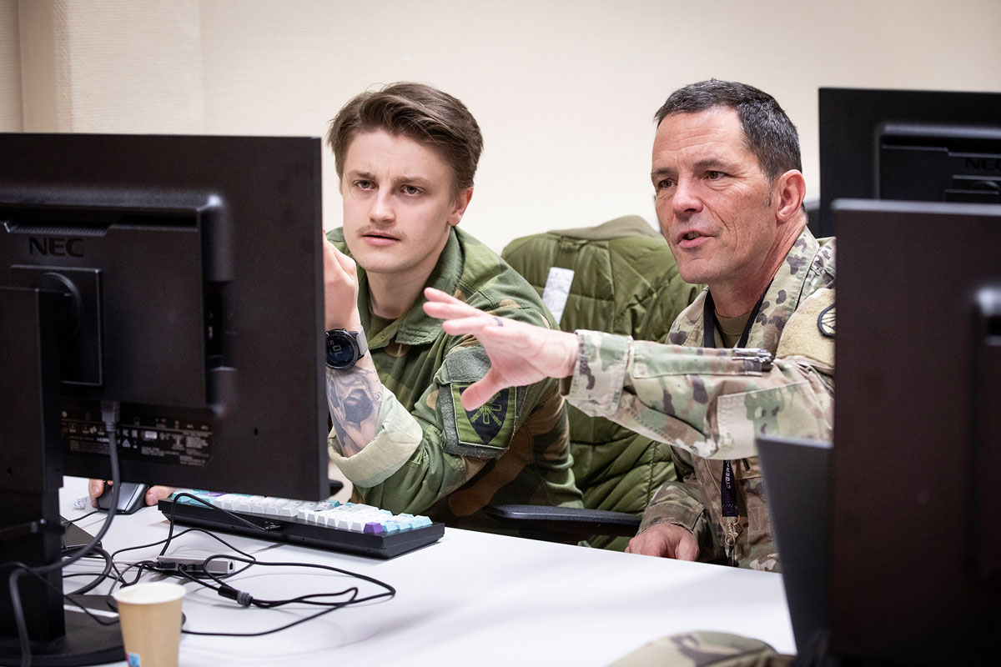

Locked Shield exercise 2024

Photo: Anette Ask/Norwegian Armed Forces.

The decision also means that the state will take over the technical equipment used to exercise the public service obligation. The state has a contractual right to take over ownership of the relevant equipment/infrastructure free of charge. This involves operating technical infrastructure, including the technical centre at Sola. The state will not take over commercial activities that Telenor has built up in connection with the coastal radio service.

Classified communication solutions

The security policy situation, and the complexity and vulnerability of society, entail a greater need for secure and efficient communication at a classified level. Improved interaction, situational awareness and communication between undertakings and authorities increases management capability. On 1 January 2025, a separate agency, The Norwegian Agency for Classified Information Systems, was established under the Ministry of Defence. The agency will be responsible for delivering classified communication solutions to organisations in the civilian and defence sectors. The agency will be a key supplier of national classified platforms to public and private actors in the total defence and other undertakings subject to the Security Act. The restricted communication network Nasjonalt BEGRENSET Nett (NBN) is currently used by around 170 undertakings and more than 10,000 users, and demand is growing. The secret communication network Nasjonalt HEMMELIG nett (NHN) is under development and will soon be available to prioritised users. The Government will prioritise the continued roll-out of classified ICT solutions across sectors with total defence responsibilities.

Secure public network SON

SON (Sikret Offentlig Nett) is a high-speed data network to and between SON participants, where the participants have control over the physical infrastructure. SON is based on internet technology and consists of an encrypted network based on redundant paths. It currently covers several critical functions in society, including secure and redundant transfer of unclassified, low-grade and high-grade classified data, and internal communication between connected participants. Over time, SON has developed into an important solution that has also become more significant in the delivery of other services. A number of private actors wish to connect to SON. In order to further develop the system’s potential and ensure greater geographical coverage, it will be necessary to lease fibre or channels from relevant actors. The Government will transfer the administrative ownership of SON to the newly established Government Classified Platform Services, which will be tasked with managing and further developing the system.

Crisis organisation in the ecom sector

Electronic communications networks and services, including mobile communications, broadband, satellite communications, data centres and internet services, are crucial for managing incidents in society throughout the crisis spectrum. The authorities have established a crisis organisation system so that companies that normally compete on delivering good and secure electronic communication services can work together during a crisis to maintain digital services or restore the delivery of services for as many people as possible. Crisis management in the sector will ensure cooperation at both operational and strategic level. The crisis organisation system also ensures that national and regional levels are involved quickly and at the right level.

[Boks slutt]

## Civil helicopter preparedness throughout the country

Norway has a wide range of helicopter types for various purposes in connection with civil, military, commercial and private use. Helicopter use in Norway is extensive and varied, with applications ranging from military operations, civilian services and leisure activities. On the civilian side, helicopters are essential for air ambulance services, policing, transport to and from oil installations in the North Sea, and for transport missions in various industries. Helicopters are also used for rescue services, fighting forest fires and monitoring natural resources and the environment. Helicopters play a critical role in ensuring both national security and the day-to-day functioning of society in Norway.

Helicopters differ from other response assets in that they can enable a rapid response over longer distances, especially in parts of the country with few road axes or long fjords. In 2024, around 200 helicopters, including both civil and military machines, were registered in Norway. Much of the helicopter capacity is concentrated around southern Norway and offshore operations.

The SAR Queen rescue helicopters are in operation at six bases (see Section 2.1). The SAR Queen can fly further, faster, has better sensor capacity and is better at operating in bad weather conditions than the Sea King helicopters that have now been phased out. This will make it possible to rescue people faster and ensure they receive medical attention more rapidly at a hospital. SAR Queen has already proved to be a significant resource for the Norwegian rescue service and an additional resource in the air ambulance service.

The Government will assess the national helicopter capacity in the short and long term, including how public (civil and military), commercial and private air capacity can be better utilised to strengthen emergency preparedness throughout the country. The Government will strengthen emergency preparedness in helicopter transport throughout the country. The security policy situation indicates a particular need to enhance helicopter preparedness in the north.

Mobilisation of air resources in the handling of extreme weather event Hans

Helicopters were an important resource during the handling of the extreme weather event Hans, particularly because many sections of road were closed and accessibility was extremely limited. At its peak, 28 helicopters were available to assist with the response. In addition to the police’s own helicopters, two Bell helicopters from the Norwegian Armed Forces were requisitioned via the National Police Directorate. The Joint Rescue Coordination Centre used the rescue helicopters at Rygge and Sola airports, as well as the rescue helicopter in Florø at certain points during the event. The Joint Rescue Coordination Centre also mobilised two additional rescue helicopters from the Rygge and Sola bases. A total of five rescue helicopters were involved in handling the extreme weather event.

Source: The Directorate for Civil Protection (2024) Evaluering av ekstremværet Hans – forebygging, beredskap og håndtering.

[Boks slutt]

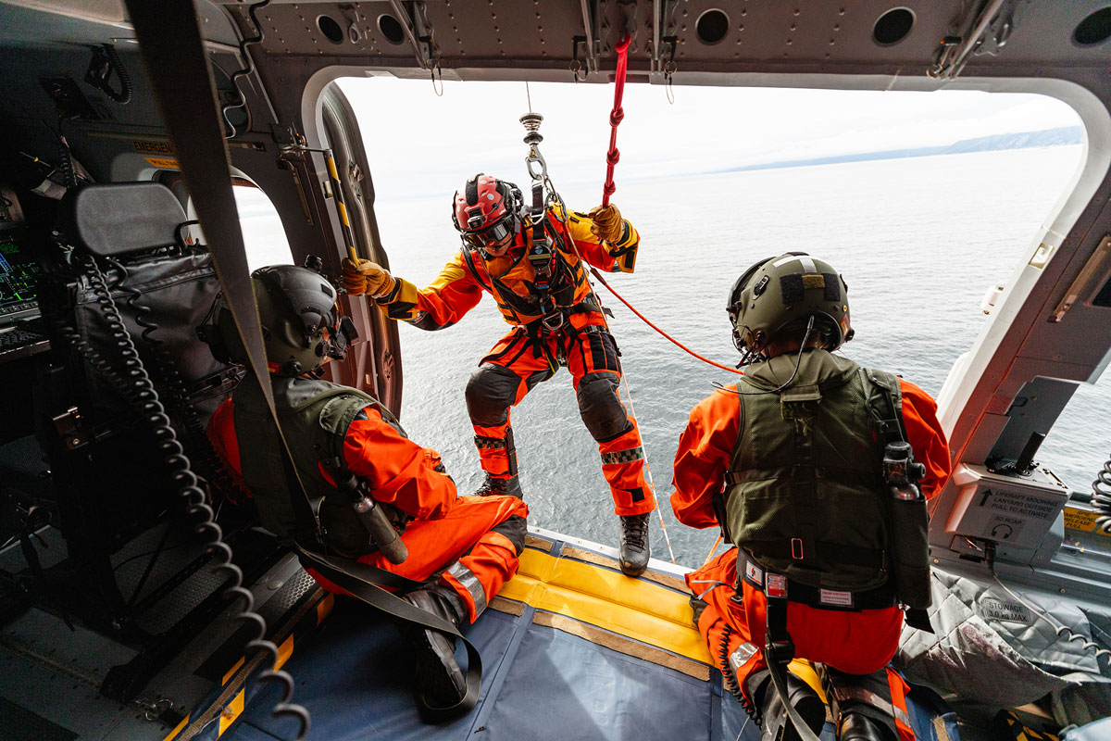

SAR Queen rescue operation

Photo: Fabian Helmersen/Norwegian Armed Forces.

## Drones and new air mobility

Aviation is undergoing considerable changes, with drones and new air mobility[6] now able to carry out increasingly complex operations in a safe, efficient and sustainable way. They can be used in both urban and rural areas, and on the Norwegian continental shelf. Search and rescue, police missions and infrastructure inspections are examples of areas where the use of drones is under rapid development.

However, more extensive use of drones and new air mobility can pose challenges in the form of new types of aviation accidents and incidents, crime and security challenges. The trend may also bring challenges related to the privacy of individuals and noise pollution caused by drones being flown near people and nature. It may also prove problematic to enforce regulations in practice.

The Government wants Norway to remain a pioneer in the responsible and innovative use of drones and new air mobility, and has initiated work on a white paper. This will highlight both societal benefits and challenges associated with the development of drones and new air mobility, and the framework conditions for the industry. The Government aims to present the report to the Storting in 2025.

## Knowledge preparedness and knowledge in crises

The COVID-19 pandemic demonstrated that we need to be better prepared to handle knowledge needs when a crisis occurs, as pointed out by the Coronavirus Commission (cf. Norwegian official report (NOU) 2021: 6). It could, for example, be necessary to know more about the effect of measures, how measures in one sector can have consequences in another sector, or how an incident can be expected to develop. Knowledge that forms the basis for decision-making in crisis situations must be of the necessary quality, relevant and available quickly. Status descriptions, ongoing analysis, real-time research and good impact studies require the production and collection of new data and statistics, rapid access to and use of existing data, the ability to share and link data, collaboration on analyses across units and sectors, sufficient network and computing capacity, and sufficient capacity to summarise and communicate relevant insights.

To improve the knowledge system for managing crises and follow up the Coronavirus Commission, the Government established the core group for a better knowledge system for crisis management (Knowledge in crises) in 2022. The core group works on the premise that the knowledge systems to be used during a crisis should be in place under normal circumstances. Any legal issues related to, for example, the collection, use and sharing of data should have been clarified as far as possible to ensure that they are not a barrier to effective crisis management.

According to the Instructions for the Ministries’ work with civil protection and emergency preparedness, each ministry is responsible for advancing knowledge-based work, research and development within its own sector. The ministries must have a thorough understanding of the knowledge needs that may arise during a serious incident and which knowledge environments could be relevant contributors in order to identify knowledge needs as quickly as possible during a crisis and initiate knowledge production. By revising the Instructions for the Ministries’ work with civil protection and emergency preparedness, the Government will strengthen the requirements for the ministries’ knowledge preparedness.

# Strong local communities and good basic preparedness

The fact that people live in all parts of the country contributes to our preparedness. However, large parts of rural Norway are experiencing population decline in addition to an ageing population.[7] Reversing this trend in the form of increased decentralisation of people, services and capital is a Government goal. The Government will therefore facilitate thriving local communities and jobs throughout the country. Measures are being implemented along several tracks to ensure robust local communities and good basic preparedness. The Government’s policy for building robust and good local communities in the north is described in more detail in Section 10.4. This work will also help to assess whether a similar process can be used to strengthen civil resilience in other geographical areas.

In this chapter, we present the Government’s policy for strengthening key preparedness actors to ensure robust local communities and good basic preparedness. Municipalities, emergency services and other preparedness actors must be prepared to deal with incidents ranging from local incidents with a very limited scope, through major crises of a national scope, and in the worst-case scenario, to war.

The Government will:

* provide a comprehensive policy that ensures settlement throughout the country.
* strengthen local and regional civil total defence work.
* formalise the requirement that all municipalities must have or be affiliated with a municipal preparedness council.
* take steps to ensure that municipal preparedness management has clear lines of responsibility by setting requirements for municipal preparedness councils.
* assess how the role of municipal emergency preparedness coordinator can be further developed and improved.
* facilitate greater support and guidance to municipalities through the development of guidelines and tools aimed at improving emergency preparedness.
* establish a reinforcement scheme for municipalities exercising crisis management in the areas of psychosocial support, communication and support for staff functions in crisis coordination.
* commission the Directorate for Civil Protection to prepare a cross-sectoral guide to the role and responsibilities of municipalities during armed conflict, the threat of war and similar circumstances.
* commission the Civil Security Clearance Authority to prepare a guide for security clearance of personnel at the municipal level to clarify roles, responsibilities and needs.
* strengthen the county governor’s advisory and guidance role and responsibility as a supervisory authority.
* facilitate a better basis from which the county authorities can fulfil their responsibilities in the field of public security and emergency preparedness.
* clarify the county authority’s responsibility for civil transport preparedness.
* assess mandatory response times for all emergency services.
* ensure that the emergency services continue to have a decentralised structure.
* increase the number of conscripts in the Norwegian Civil Defence from 8,000 to 12,000 over an eight-year period.
* assess what can and should be expected of the fire and rescue service, the rescue services, the police and the Norwegian Police Security Service’s capacities and tasks in a crisis or war.
* continue to ensure the presence of the Norwegian Police Security Service throughout the country and particularly in vulnerable areas.
* appoint a police role committee to assess the role and tasks of the police in light of the needs and expected developments in society.
* ensure a regulatory framework that safeguards our national ability to detect and counter activity by foreign states in Norway that threatens security.
* present a white paper in spring 2025 on extremism to follow up on the Extremism Commission’s report.
* conduct a status report on the national counterterrorism strategy, as the basis for a possible revision in 2025.
* prepare a national risk and vulnerability analysis that will form the basis for ensuring tangible national support resources for the fire and rescue services throughout the country.
* establish a financial escalation plan for the voluntary organisations in the rescue service of up to NOK 100 million over 8 years. In collaboration with the voluntary organisations, an assessment will be made of how the funding can be as targeted as possible.

## Strengthen municipalities’ emergency preparedness work

The municipalities are a mainstay of national preparedness and an important interdisciplinary coordination arena. Municipalities play an important role in ensuring public safety, both through the day-to-day services they provide but also through their preparedness to deal with crises.

### Requirement for a municipal preparedness council

Municipalities have a comprehensive responsibility for emergency preparedness across the entire crisis spectrum. Their keys duties include comprehensive risk and vulnerability analyses, an overall emergency preparedness plan, exercises and crisis management. The municipalities’ responsibility for emergency preparedness is regulated by the Act on municipal preparedness duty, civil protection and the Norwegian Civil Defence (Civil Protection Act) and the Health and Social Preparedness Act (Health Preparedness Act) with associated regulations. Municipalities are also subject to the Security Act. In addition, municipalities are planning authorities, which is of great importance in efforts to prevent the consequences of future climate-related events.

Municipal preparedness councils are important for the municipalities’ coordination and leading roles in security and emergency preparedness efforts. Preparedness councils often consist of local stakeholders from both the political and administrative leadership of the municipality, representatives from the voluntary sector, the business community and public bodies such as the police, the Norwegian Civil Defence and the Armed Forces. Municipal preparedness councils are an important arena for the mutual exchange of information, discussion and coordination of emergency preparedness work in the municipality. The councils are also important for sharing situational awareness at local level. This can improve the quality of the municipalities’ reporting to the county governor. However, the preparedness councils do not have decision-making authority. It is up to the individual agency and municipality to exercise the authority assigned to them.

It is not currently a requirement for municipalities to have, or be affiliated with, a municipal preparedness council. County governors are required to have a county preparedness council with more detailed requirements for participation and the council’s role. The municipal survey for 2024 shows that 75% of Norway’s municipalities have established municipal preparedness councils.

DSB’s municipal surveys – municipal preparedness councils

For the past 20 years, the Directorate for Civil Protection has asked all Norwegian municipalities about the status of their work on public security and emergency preparedness. Findings from the 2024 survey show that:

* Nationwide, 75% of municipalities have established municipal preparedness councils, compared to 70% in 2019. The 25% that do not have such a council comprise both large and small municipalities, and they are geographically spread across the country.
* 65% of the municipal preparedness councils are involved in the municipality’s preparation of comprehensive risk and vulnerability analyses, and 47% in the work on the municipality’s overall preparedness plan.
* Municipalities with preparedness councils meet most of the requirements for comprehensive risk and vulnerability analyses and an overall preparedness plan in accordance with the Regulations on municipal preparedness duty.
* Serious incidents have occurred in 71% of municipalities in the past two years, but only 38% of municipal preparedness councils have been involved in crisis management, and only 37% are involved in exercises.

[Boks slutt]

Examples of small and large municipalities with a high level of compliance with municipal preparedness requirements

Many municipalities work systematically on public security and emergency preparedness, but there are still many that do not comply with important requirements. Municipalities with greater financial leeway satisfy the legal requirements to a greater extent than municipalities with less financial leeway. However, there are major variations in compliance with emergency preparedness requirements that cut across indicators such as the municipalities’ financial leeway, degree of geographical centrality and size measured by population. Examples of smaller municipalities that conduct systematic emergency preparedness work are Fyresdal, Tokke and Kåfjord. Examples of larger municipalities that have a high degree of compliance are Stavanger and Oslo.

Source: Directorate for Civil Protection, municipal survey 2024

[Boks slutt]

The Government will strengthen emergency preparedness work in the municipalities by requiring the municipalities to have, or be affiliated with, a municipal preparedness council. This will be ensured by amending the Civil Protection Act. A requirement to ‘be affiliated with’ allows municipalities to collaborate on such a council. Which solution the municipalities choose must be based on local assessments. The solution will provide sufficient flexibility to take account of municipalities’ resource situation, unique characteristics and possibility of autonomy, and ensure closer integration of the voluntary and private sectors in security and preparedness efforts.

By setting requirements for municipal preparedness councils, the Government will ensure that the management of municipal preparedness efforts has clear lines of responsibility, while also facilitating a more unified council structure from the municipality via the county governor to the Directorate for Civil Protection (see Figure 3.1).

Clear and effective management of municipal preparedness work is important for local implementation of preventive and damage control measures. Compliance with the municipal preparedness requirements paves the way for effective management of municipal emergency preparedness and the coordination of prevention, contingency planning and crisis management. Based on comprehensive risk and vulnerability analyses, municipalities must develop preparedness plans that clarify the municipality’s crisis management and its responsibilities, roles and powers.

It is emphasised that the position of municipal preparedness coordinator is not statutory, but the designation comprises people in the municipality who have key roles in efforts to meet statutory requirements in the area of public security and emergency preparedness. The emergency preparedness coordinators help to bring together and coordinate internal preparedness tasks, and contribute to increased awareness of public security and preparedness in the municipalities. The Government will assess how the role of municipal preparedness coordinator can be further developed.

### Better guidance and support from national sector authorities

The development of guidance, a knowledge base and digital solutions and tools are important steps to supporting the municipalities’ preparedness work. There are several examples of measures that help the municipalities to comply with regulatory requirements in a simpler, better and more uniform way. Among the sector authorities that contribute to this are the Norwegian Water Resources and Energy Directorate through the mapping of hazard zones for the municipalities, and the Directorate for Civil Protection through the guide to comprehensive risk and vulnerability analyses, as well as guides addressing more specific areas.

Work is also underway to develop a digital solution that will support the municipalities’ work on risk and vulnerability analyses. In the area of natural hazards, the Norwegian Mapping Authority and the Norwegian Environment Agency also play important roles in making relevant data, tools and guidelines available to support the municipalities’ work. The police, the Norwegian Police Security Service and the Norwegian National Security Authority play important roles with regard to intentional acts, and contribute knowledge through threat and risk assessments.

A number of municipalities have inadequate compliance with several of the requirements in the municipal preparedness duty. Guidance and support from national sector authorities is an important area of action to improve municipalities’ compliance with their preparedness duties. An increasingly demanding challenge landscape makes this need more pressing. The Government will facilitate greater support and guidance to municipalities through the development of guidelines and tools aimed at improving preparedness.

Municipalities play important roles in war, including as owners of municipal infrastructure such as water and electricity supply and in light of their responsibility for critical service areas such as fire and rescue services and healthcare. The municipalities also play an important role in total defence work as local planning authorities. It is important that total defence considerations are taken into account in social planning at national, regional and local levels. The Government will therefore commission the Directorate for Civil Protection to prepare a guide to clarify the roles and responsibilities of the municipalities. The Government will also commission the Civil Security Clearance Authority to prepare a guide for security clearance of personnel at the municipal level to clarify roles, responsibilities and needs.

As a regional coordinating authority for the central government, and a link between the municipalities and the central government, the county governors also play an important guidance role for the municipal sector.

### Establish a reinforcement scheme for municipal crisis management

In the Government’s view, municipalities that are severely affected by major incidents must receive the rapid assistance they need from regional and national levels. In resource-intensive incidents that occur infrequently, there may be a need to support municipalities in terms of expertise and capacity that are not appropriate or possible to establish in each individual municipality.

The Total Preparedness Commission recommended establishing a municipal reinforcement scheme that formalises support from national and regional emergency preparedness actors. These can be utilised at the request of the municipality. The Commission highlighted the need for resources related to psycho-social support, communication and coordination, which are factors in all major crises.

The Government therefore finds it necessary to review and systematise which regional and national resources could assist municipalities affected by extraordinary incidents. The Government will therefore establish a reinforcement scheme for municipal crisis management. The resources in the reinforcement scheme must be readily available at short notice, and there must be a clear overview of who is involved, where the resources are and what expertise they possess. Such a scheme will primarily represent a safety net for municipal emergency preparedness. Ordinary responsibilities and municipal autonomy remain unchanged even if the municipality asks for assistance in addressing specific tasks.

The Government will initiate efforts to detail the organisation of the scheme, both in terms of the resources to be included, the interface with existing preparedness schemes, and the roles and responsibilities of relevant actors. These efforts must be seen in the context of the Government’s strengthening of the role of county governor, see Section 5.3.

## The responsibilities and tasks of the county authority in security and emergency preparedness

The county authority is the elected body at regional level. The ministries and central government agencies have assigned the county authorities key tasks in regional public security and emergency preparedness work. This includes conducting parliamentary elections, county authority elections, transport and civil transport preparedness, business and industry preparedness, public health measures, cultural heritage management, the public dental service and upper secondary education.

River gravel and extraction of material

Flood prevention measures are essential to reducing the extent of damage, safeguarding material assets and saving lives. In 2024, the Government presented Report No 27 to the Storting (2023–2024) Tryggare framtid – førebudd på flaum og skred (A safer future – prepared for floods and landslides – in Norwegian only), which contains a number of measures aimed at strengthening this work. The municipalities have a crucial role to play in flood prevention in cooperation with the central government authorities. Regulations and guidelines that ensure good prevention and damage limitation are therefore vital. In some parts of the country, for example, removing river gravel may be a relevant means of reducing the extent of damage before, during and after a flood, while it will not be appropriate in other places. Cooperation between local, regional and national authorities is therefore pivotal to limiting the damage a flood can cause to society.

[Boks slutt]

County authorities have an important planning and development role at regional level, including the role of regional planning authority. It is important in this role to see different sector goals, policy instruments and measures in context. This applies in particular to cross-cutting societal challenges that require the efforts of several actors and administrative levels, such as public security and emergency preparedness. Regional risk and vulnerability analyses must form the basis for regional planning. Good planning can help prevent undesirable incidents and facilitate more resilient communities.

The county authorities are tasked with mobilising and coordinating regional development. It is important that the instruments associated with regional planning are utilised. This requires good coordination across sectors and administrative levels, and includes the involvement of municipalities in regional planning processes and interaction with central government agencies in regional planning. The Total Preparedness Commission highlighted the need to clarify the county authorities’ responsibility for public security, and that this responsibility must also be clarified for municipalities, other regional actors and ministries. The Government will therefore facilitate a better basis from which the county authorities can fulfil their responsibilities in the field of public security and emergency preparedness.

The county authorities’ responsibility for civil transport preparedness

The county authorities are responsible for planning, building, operating and maintaining the county road network, including county ferry routes, as well as for the development and operation of regional public transport. The framework and schemes for county roads are dealt with in Report No 14 to the Storting (2023–2024) National Transport Plan 2025–2036 – Summary, cf. Recommendation No 439 to the Storting (2023–2024). The county road network is extensive and has crucial functions. Together with the national road network, it ensures a comprehensive road network for passenger and industrial transport. Accessibility and road safety on the county road network are important for settlement and the labour market across the country. County roads also have an important emergency preparedness function as bypasses for the national road network. Some sections of county roads are also important for military mobility and access to critical infrastructure.

The county authorities’ responsibilities related to transport preparedness are described in the Regulations relating to civil transport preparedness. The county authorities are responsible for ensuring and facilitating necessary and regionally adapted civil transport preparedness in the county, and must work alongside the county governor, police, transport industry and other civil and military authorities to optimise the coordination of transport preparedness. Based on risk and vulnerability analyses, the county authority must have an overview of the county’s transport needs in the event of different types of crisis, what types of transport needs may be involved, which actors in the county operate freight and passenger transport and how efforts can be most expediently organised. At the request of a ministry, the county governor, police or other civil or military authority, the county authority must be able to provide transport-related advice and liaise with operators involved in freight and passenger transport in the county.

The Regulations relating to civil transport preparedness do not contain any legal basis for the county authorities to order an actor to carry out transport assignments. The legal basis for this is Section 36 of the Professional Transport Act, with the Ministry of Transport as the decision-making authority.

## Strengthening the county governor’s coordination and guidance role

The county governor is Norway’s foremost representative in the county, and the central link between national authorities and local administration. The county governor has several important duties relating to emergency preparedness, civil resilience and total defence, including:

* Chairing the county preparedness council
* Developing the municipalities’ capability for prevention, preparedness and crisis management
* Ensuring that public security and emergency preparedness efforts at regional level are coordinated and equipped for crisis management
* Coordinating civilian efforts in total defence at the county level, and contributing to mutual support between the civilian sector and the Armed Forces at the regional level
* In the event of war, threat of war and similar circumstances, the county governor must ensure that the county’s resources are distributed and utilised in a way that best meets the needs of the population, coordinate and prioritise between civilian needs and pass on extra resources to the municipalities, and contribute to the procurement, coordination and prioritisation of civilian support to the Armed Forces.
* In the event of war, threat of war or similar circumstances where the county is cut off from communication with the Government, the county must take the necessary steps to safeguard the interests of society, cf. Section 5 of the Emergency Preparedness Act (Beredskapsloven).

There is an expectation among municipalities and regional emergency preparedness actors that the county governor must contribute more to emergency planning, guidance and training exercises, as well as the management of incidents and crises. Like the consequences of climate change, the deteriorating security policy situation will place greater demands on regional and local resilience. The county governor is responsible for advising, guiding and driving the work on public security and emergency preparedness in the county, and acts as a link between municipalities, and between municipalities and central government authorities. The county governor also plays an important role in helping to ensure that renewed attention is given to war planning as part of public security.

The Total Preparedness Commission believes that the county governor’s coordination capacity, including providing guidance and support to municipalities, is under pressure. The Commission also notes that the county governors have had to draw on large parts of the organisation for preparedness work to fulfil their coordination role during both the COVID-19 pandemic and the war in Ukraine, and that this has been demanding to maintain over time while also seeing to their other duties. In the Government’s view, the county governor’s capability for regional coordination and for supporting and guiding the municipalities must therefore be bolstered. The Government has followed this issue up.

The Government has proposed, and the Storting has approved, increasing the funding to county governors by NOK 34 million in the budget for 2025. The purpose is to intensify county governors’ efforts to increase the capability of local and regional levels to provide civil support to military operations, ensure continuity of critical societal functions and protect the civilian population from the consequences of crisis and war. The Government is also strengthening the Home Guard, which plays an important role on the military side of the total defence by coordinating and cooperating with civil authorities at regional and local level (cf. Prop. 87 to the Storting (2023–2024)). The Government has also begun work on upgrading certain secure regional facilities to improve the cooperation capacity of the specific area and regional level in the total defence, thereby contributing to increased resilience. This will also strengthen the classified communication capability in the total defence at local and regional level.

## Key preparedness actors in security policy crises and war

Key emergency preparedness actors have the same roles and responsibilities in security policy crises and war as in normal situations. However, they may be faced with new tasks and prioritisation needs. In addition to those described below, a number of other actors play key roles in emergency preparedness and total defence. This includes sector agencies, local and regional resources and private businesses.

### The Joint Rescue Coordination Centre and the rescue service

The rescue service is a civil function that utilises all of society’s resources to save lives. Air and sea rescue is established in international law in a number of conventions and agreements. The service is organised as a collaboration between public, private and voluntary organisations, and works closely with the Norwegian Armed Forces.

How the rescue service should function in crises and war is inadequately described in current plans, and they must therefore be developed and updated to take into account the challenges associated with the principle of distinction[8] in the international law of war.

The Joint Rescue Coordination Centre and subordinate local rescue centres must also ensure the organisation and coordination of the rescue services in armed conflict and war. This applies in all domains (land, sea and air rescue). Norway must be prepared to fulfil its international search and rescue obligations also during armed conflict and war.

At the high end of the crisis spectrum, given the current conditions, it is possible that the rescue service will face challenges in terms of its organisation and management structure. The Joint Rescue Coordination Centre must be prepared for changed circumstances around the main mission of other organisations contributing to rescue operations, and adapt its organisation and missions accordingly.

High up in the crisis spectrum, there will be uncertainty about the actual availability of public, private and voluntary resources. Greater mobilisation of personnel and requisitioning of equipment for the Armed Forces could lead to fewer available resources and a weakening of the rescue response for emergency handling of land, air and sea incidents. At the same time, the need for rescue services may increase radically. Necessary measures should be prepared to ensure the best possible rescue response in the event of weakening or loss of a critical organisation, management, personnel and equipment.

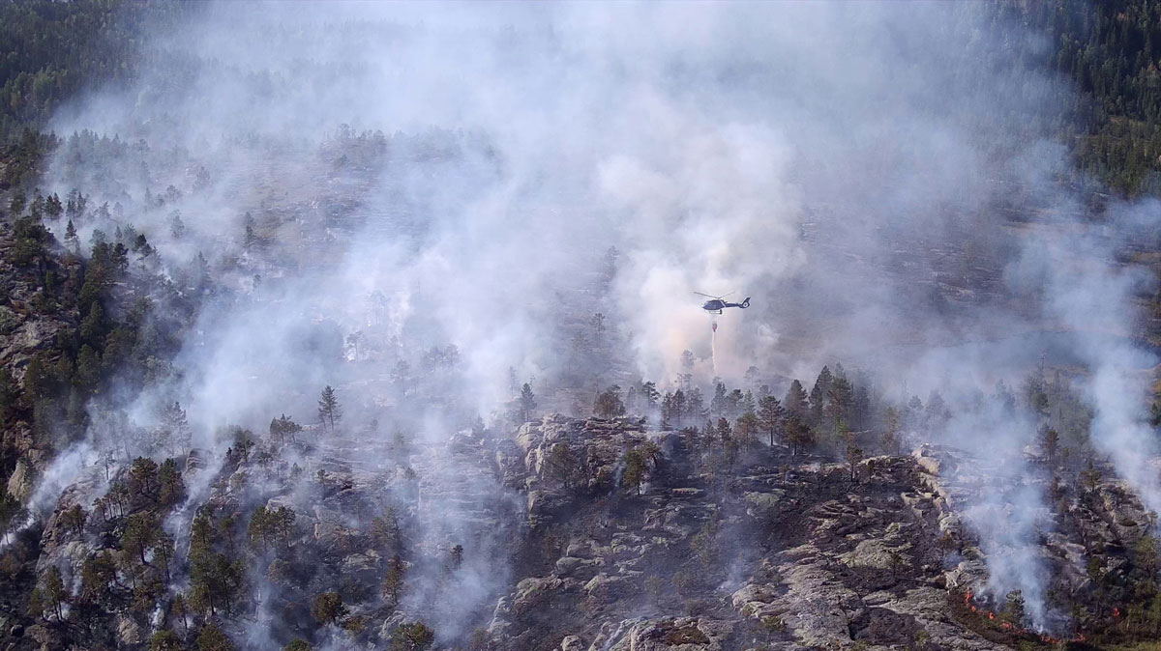

Forest fire

Photo: Helitrans.

### Voluntary organisations

Voluntary organisations play an important role in total defence. The framework conditions for voluntary organisations will change significantly in times of war compared with ordinary emergency preparedness efforts and handling of incidents lower on the crisis spectrum. In situations high on the crisis spectrum, a significant proportion of personnel in voluntary organisations may be mobilised for service in the Armed Forces, or for other service through, for example, civil workforce preparedness (see Section 10.5.2). Furthermore, the need for extra work capacity for ordinary employers may increase, limiting the remaining capacity for voluntary efforts. It is therefore important to ensure that contributions from voluntary organisations can also be maintained in the event of incidents high on the crisis spectrum. This may, for example, mean that key personnel in voluntary organisations must be exempted from other civil service obligations or, in the worst case, that they can serve compulsory service in a voluntary organisation. Voluntary efforts must be planned within the framework of the international law of war and the principle of distinction. Experience from Ukraine shows that voluntary efforts contribute to the country’s defence capability.

The Government wants to ensure that the voluntary organisations in the rescue service remain a key part of Norway’s basic preparedness. The Government will therefore increase funding, by up to NOK 100 million, for volunteers in the rescue service, scaling the funding up over eight years. In collaboration with the voluntary organisations, an assessment will be made of how the funding can be as targeted as possible. The Government has proposed, and the Storting has approved, an increase of NOK 6 million in grants to voluntary organisations in the rescue service in 2025. This increase is in line with the Total Preparedness Commission’s proposal to increase grants to voluntary organisations in the rescue service, and is necessary to maintain voluntary efforts as a mainstay of the rescue service throughout the country. The organisations need funds to be able to maintain a high level of professional expertise, have good operational equipment and materials, and funds to increase their capacity throughout the country.

In recent years, more has been expected of the crews of voluntary rescue and emergency response organisations. They are expected to have greater competence and be able to contribute to more aspects of a mission. This development is expected to continue and will place greater demands on the equipment the volunteers use. Equipment is important for both operational capability and crew safety. The personal equipment of volunteer resources has become more advanced over the years and better suited to the tasks they have to fulfil. This leads to higher equipment costs, however, and costs can be expected to rise further in step with technological developments.

Religious and faith communities are also an important resource in emergency preparedness work. Experiences from the COVID-19 pandemic showed that religious and faith organisations enjoy great trust and are able to establish contact with groups in the population that the public authorities had difficulty reaching. This was of great importance for conveying important health information. Based on the pandemic and the Total Preparedness Commission’s recommendation that consideration should be given to how religious and faith communities should be included in preparedness efforts, the Government is of the view that dialogue with religious and faith communities on preparedness should be further developed.

### Norwegian National Security Authority

The Norwegian National Security Authority (NSM) is Norway’s agency for preventive security. The agency’s mission is to strengthen Norway’s capability to counter espionage, sabotage, terrorism and hybrid threats NSM fulfils Norway’s commitments in the area of preventive security in the NATO Security Committee.

NSM plays a key role in strengthening preventive security work in the defence sector and in the civilian parts of the total defence. It has a national expert and supervisory responsibility across the military and civil sectors. This is a major advantage that enables comprehensive security work. NSM is tasked with overall and cross-sectoral responsibility for preventive security work, and helping to ensure that authorities and organisations have greater capabilities in security management and to meet their responsibilities under the Security Act.

In times of crisis, armed conflict and war, NSM will continue to fulfil its main tasks across the military and civil sectors. In a build-up to a crisis, there will be an increasing need for information about the assets and vulnerabilities that must be protected against activities that pose a threat to security and could affect national security interests. NSM is tasked with contributing to situational awareness and assisting in the management of serious security threats.

NSM has a defined role in the Norwegian Armed Forces’ and NATO’s operational planning, and supports the defence sector within its own field of expertise across the crisis spectrum. Priority will be given to deliveries that are crucial to the Norwegian Armed Forces’ capability to conduct operations in Norway together with allies. The need for the agency’s deliveries will increase at the upper end of the crisis spectrum. NSM is subject to the Norwegian Armed Forces’ directive on build-up of forces and, on the orders of the Chief of Defence, must prepare its organisation in accordance with the Chief of Defence’s approved list of forces and given preparation time.

Through the National Cyber Security Centre, NSM has the national response function for serious cyber attacks. The National Cyber Security Centre is the point of contact for handling cyber security incidents across the entire crisis spectrum, both nationally and in relation to allies, and assists organisations in handling major cyber security incidents. The National Cyber Security Centre is also an arena for national and international collaboration for detection, management, analysis and advisory services related to cyber security. The Centre includes partners from business and industry, academia, the defence sector and the public sector who actively contribute to mutual cooperation for a more resilient digital Norway.

NSM works closely with the Norwegian crypto industry to develop high-grade crypto technologies. According to Norwegian Crypto Policy, national control of high-grade communication is important for Norwegian sovereignty and national security, and forms part of Norwegian defence and security policy. National control means that the development of crypto algorithms and the production and implementation of crypto material are carried out in collaboration between NSM and the Norwegian crypto industry on behalf of the Ministry of Defence.

NSM is the national distribution authority responsible for the control and distribution of crypto material. The agency also fulfils the role of National Distributing Authority Norway for crypto in relation to NATO. NSM is a supplier of crypto-security services to the Norwegian Foreign Service, the Norwegian Police Security Service and the Norwegian Armed Forces, as well as in connection with necessary communication between organisations with total defence tasks and the Norwegian Armed Forces for emergency preparedness purposes. At the high end of the crisis spectrum, there will be an increased need for the NSM’s services both nationally and in the alliance.

### Civil Security Clearance Authority

The Civil Security Clearance Authority’s core task is to grant security clearance to personnel for access to classified information, and critical national objects and infrastructure in the civil sector. This is a fundamental element of the Government’s security work and an important tool for reducing insider risk. It is also a prerequisite for the production, communication and protection of important national security information.

The personnel clearance function is a necessary prerequisite for Norway’s capability to manage crises and war. In a normal situation, the clearance function will lay the foundation for emergency preparedness by enabling crisis management organisations to handle and communicate information securely at the higher levels of the crisis spectrum.

In a crisis or war, the provision of clearances can come under significant pressure. Firstly, the need to exchange classified information will increase in these situations. Secondly, the need to maintain and restore basic national functions will be pivotal to our ability to manage crises and war situations. Thirdly, functions that the Clearance Authority itself is dependent on may be reduced or deprioritised.

In a crisis or war situation, the Civil Security Clearance Authority will in principle have the same role and responsibility as under normal circumstances. It will closely collaborate with organisations on prioritising clearance needs for personnel who have key roles in various crisis scenarios, and also collaborate closely with the Armed Forces. As discussed in Section 7.3, the Government has decided to initiate work to modernise the Civil Security Clearance Authority to make it fit for the future.

### Norwegian Directorate for Civil Protection

The Directorate for Civil Protection’s role in peacetime and times of crisis is also maintained in wartime.

In security policy crises and wars, the Directorate’s cross-sectoral coordination role will be key to achieving an updated picture of the situation, a knowledge base and status assessments related to critical societal functions across sectors of society. The Directorate will also help provide cross-sectoral analyses of future courses of events and consequences. The purpose is to ensure that measures decided at central level are implemented quickly and understood at the local level through the county governor’s coordination function. As described in Section 4.2.4, the Government will therefore give the Directorate for Civil Protection clearer powers in its coordination role.

The Directorate for Civil Protection will maintain a close dialogue with the Norwegian Armed Forces on the implementation of measures in the military preparedness system, and maintain an overview of measures implemented in the Civil Preparedness System. This is important for coordination between the civil and military sectors. The Directorate will also contribute proposals for the implementation of measures in the Civil Preparedness System, and ensure that the county governors and civil defence districts implement these measures.

As a civil preparedness authority, the Directorate for Civil Protection will also be responsible for ensuring that risks, hazards and recommendations are communicated effectively from the authorities to the public, for example through the Civil Defence’s use of the Nødvarsel alert system.

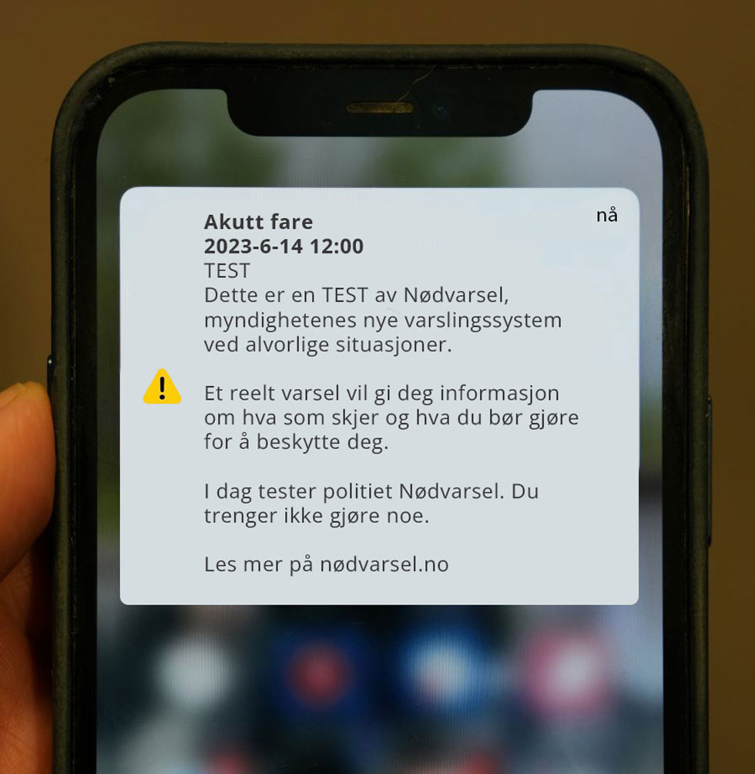

Test of the Nødvarsel mobile phone emergency alert system

Photo: Directorate for Civil Protection.

Wars entail a shortage of resources. The Directorate for Civil Protection has a role in coordinating and quality assuring the Norwegian Armed Force’s support to civilians, and must, if necessary, assist local and regional authorities and other public agencies in requesting assistance from the Armed Forces. In the event of a security policy crisis or war, the Directorate will work closely with the Armed Forces and the police to ensure the best possible utilisation of resources in the total defence. The Directorate has a central coordination responsibility for host nation support, see Section 3.10.1.

The Directorate for Civil Protection is the national contact point for the EU, UN and NATO’s civil preparedness programmes for mutual assistance. It is also the national contact point for the EU’s Emergency Response Coordination Centre (ERCC).

The Directorate will also maintain its function as a professional, administrative and supervisory body in times of security policy crisis and war, but will need to prioritise maintaining the most critical functions. The Directorate is responsible for fire and electrical safety and regulates the municipal fire services, which, being at the high end of the crisis spectrum, means they will need national management and prioritisation of resources.

It is also the responsible authority in areas relating to hazardous substances, explosives, transport of dangerous goods, electrical safety and product safety. Organisations subject to the Directorate’s authority may pose a greater risk to society in a security policy situation, while also possessing significant inputs in emergency preparedness. This also includes organisations subject to industrial safety regulations with capacities and resources of great importance to emergency preparedness and civil protection. The Government will also ask the Directorate for Civil Protection to clarify the role of the industrial safety system and Major Accident Enterprises in the total defence work (see Section 3.9.2).

### The Norwegian Civil Defence

The main task of the Norwegian Civil Defence is to protect the population in times of crisis and war.

Both the Total Preparedness Commission and the Civil Defence itself are of the view that the current number of conscripts is insufficient to fulfil the tasks of the Civil Defence in war. It is also demanding to maintain sufficient preparedness in peacetime as a reinforcement resource. There is a concern that the Civil Defence could be further weakened in the event of a major crisis as a result of personnel being granted exemption from service for the sake of their ordinary work.

With its decentralised organisation, the Norwegian Civil Defence is a very useful resource throughout the country. With its stocks of critical materiel, which are advanced throughout the country, they have a short response time for a wide range of tasks. The Government believes that this decentralised organisation, both the district structure and the advance storage of equipment and materiel, must remain in place. Work on strong, local and decentralised management must be secured and bolstered. In connection with building up the Civil Defence forces, it is natural to look at expertise and capacities as part of a necessary build-up of forces.

The Government wishes to increase the number of conscripts in the Civil Defence from 8,000 to 12,000 over an eight-year period. The need to further develop the Civil Defence’s capabilities and capacities will be investigated at the same time.

### The police and Norwegian Police Security Service

Norwegian society faces challenges from more unpredictable terrorist threats, where security policy developments affect the terrorist threat and entail a more complicated crime situation in the country. The challenges are further characterised by more complex organised crime and an increasing level of cybercrime, increasing youth crime with serious acts of violence in public spaces, the expansion of transnational criminal networks, and state actors who also use non-state actors as means by which to achieve their goals. Organised crime can affect the population’s sense of security and challenge legal social structures. These trends place increased demands on both the police and the Norwegian Police Security Service (PST) in terms of prevention, deterrence and criminal prosecution. It also places increased demands on identifying and handling hybrid activities (see also Chapter 7) and preparing decision-making support for the strategic level. The police’s collection of information for their own intelligence is also important for PST’s assessments of foreign states’ use of hybrid activities in Norway. The police deal with all aspects of an incident until it becomes clear that the responsibility lies with PST and the case is transferred.

The police and PST have different roles as police organisations. While the work of the police is aimed at the safety and security of citizens and society, the work of PST concerns the security of the realm. At the same time as the police and PST fulfil their ordinary duties, they must also be prepared to deal with incidents higher on the crisis spectrum and war.

The police

The police have a wide range of tasks and are a key actor in incident and crisis management, in times of peace, crisis and war, at local, regional and national level, see Box 5.4. The police also have cross-sectoral responsibility for crisis management in situations where people’s lives and health are threatened. Until responsibility is assumed by another authority, the police must organise and coordinate the relief work, cf. the Police Act Section 27.

In principle, the police will have the same roles and responsibilities in wartime as in peacetime. This is established in the Police Act. Only the police and PST (as discussed in more detail below) are able to use civilian force to counter the use of hybrid activities.

A worsening of our current challenges will increase the number of police assignments. At the same time, less assistance from the Norwegian Armed Forces, which will prioritise its military tasks, must be expected high up in the crisis spectrum, during war and the threat of war. Parallel events may also challenge access to resources and expertise. To handle an increasing number of tasks, the police must either be provided with additional resources (personnel, equipment, expertise, technology), reprioritise resources, or both. High on the crisis spectrum, the Norwegian Prosecuting Authority must also prepare for any reprioritisation of criminal cases. A key part of this work is to plan in advance which measures must be implemented to reduce the consequences of cases being downgraded. Investigating violations of human rights and the international law of war are examples of tasks that fall to the police and the Prosecuting Authority. Justice in the aftermath of armed conflict and war helps to restore social order and create a basis for reconciliation. From a total preparedness perspective, it is therefore important that the police fulfil their criminal prosecution function, also at the highest level of the crisis spectrum.

The police’s wide range of duties in crisis and war

The police play an important role in the lives of our citizens, working to ensure their safety and protection, and providing services to and for the public on a daily basis. This will also be important high in the crisis spectrum and in war. The police also have an important role to play in alerting the public in the event of major incidents where an emergency alert is initiated. Other examples of tasks in crisis and war include border control, investigating and securing evidence and preparing threat assessments, evacuating and cordoning off exposed areas, securing objects and crime scenes, and gathering and communicating information about evacuees, injured, dead and missing persons. The police must also provide information to the owners of objects, the general public and the media, and as long as the principle of distinction is respected, they must also be able to implement measures that support military mobility and military forces as part of total defence efforts, including host nation support.

[Boks slutt]

The Norwegian Prosecuting Authority

Society’s civil enforcement system (the police under the leadership of the Norwegian Prosecuting Authority) is responsible for handling and following up crime, and for safeguarding the rule of law and due process. It is led by the Prosecuting Authority, consisting of the Director of Public Prosecutions, the Regional Public Prosecution Offices and the prosecuting authority in the police. It is of great importance to public trust that decisions are made on the right basis and that the authorities follow up their decisions in an appropriate manner.

Threats and incidents high on the crisis spectrum could include very serious offences, and society must also be able to carry out investigations and impose sanctions in such cases as well. Investigations led by the Prosecuting Authority also make an important contribution to situational awareness and management when incidents occur.

The Prosecuting Authority’s social mission stands firm, regardless of whether the country is in peace, crisis or armed conflict. The roles and functions of the Director of Public Prosecutions do not change if a situation escalates from a normal situation, via crisis to armed conflict, or in the event of a de-escalation from an elevated level of preparedness. Maintaining Norway as a state governed by the rule of law also presupposes that the courts function as normally as possible during a crisis or armed conflict.

[Boks slutt]

The Norwegian Police Security Service

The Norwegian Police Security Service (PST) is responsible for preventing, countering and averting threats to national security in accordance with Section 17b of the Police Act. PST is also Norway’s domestic intelligence service and is tasked with preventing and investigating serious crimes against the nation’s security. In that context, it will also identify, assess and handle threats related to foreign states’ use of hybrid activities in Norway, including influence operations. This includes preventing, countering and investigating foreign states’ intelligence operations, sabotage and influence operations in Norway. This responsibility applies in both the physical and digital domains. PST is also responsible for giving notification of threats to national security in accordance with Section 17a of the Police Act. This includes responsibility for providing decision-making support on matters in Norway that may threaten its sovereignty, territorial integrity, democratic form of government and other national security interests.

PST, like the police, will have the same roles and responsibilities in war as they do in peace. This is established in the Police Act and in the Instructions for the Norwegian Police Security Service.

A deterioration in the security situation will increase the volume of assignments under all of PST’s main duties, including an increase in tasks related to state actors’ threat activities in Norway. Increased social unrest will also challenge PST’s counter-terrorism work. Furthermore, we must expect a greater need to protect the country’s government officials. Such an increase in PST’s scope of duties entails a need for additional resources (personnel, equipment, expertise, technology), reprioritisation of resources, or both.

The role of the police and PST high on the crisis spectrum

In addition to the threat situation, stronger ambitions in the defence sector and in NATO are increasing expectations of both the police and PST to support military activity levels. This applies both in connection with exercise activities and in connection with situations high on the crisis spectrum that may arise. The police and PST are not combatants according to the international law of war, nor are they lawful targets, and will thus have civilian status in a war. This means that police employees have the same protection against acts of war as the civilian population. However, according to Section 6 of the Emergency Preparedness Act, the King may decide that ‘… all police, individual police forces or the police in certain districts shall be incorporated into the military forces’.[9] This applies to theatres of war. If the police are incorporated into the military forces, the police personnel become combatants, with the consequences this entails under international law.

Incorporating the police into the military forces will give rise to a number of unresolved elements. Neither the police nor PST are currently equipped or trained to be incorporated into military forces. Nor do they have the resources necessary to be able to fulfil their ordinary social mission in parallel with being incorporated into military forces. It is important that organisations continue to prepare to be able to deal with incidents high on the crisis spectrum to provide a more robust basis for doing so.

A wide range of factors will affect the roles and tasks of the police and PST during armed conflict and war. It is therefore essential to review and assess the legal, resource-related and emergency preparedness issues that may arise during such situations. Legal assessments include international rules such as the international law of war. Reference is made in this respect to the National Police Directorate’s national guidelines on the role of the police in armed conflict and under occupation from 2024.

The Government will swiftly initiate work to look more closely at the portfolio the police and PST should maintain in the upper part of the crisis spectrum, what can or should be assigned to other actors and what must be left out. This will help to clarify what can and should be expected of the police’s and PST’s combined capacities and scope of duties in situations high on the crisis spectrum. It will also help to identify the necessary measures to ensure that society has the necessary police services and domestic intelligence and security services at all times. The Prosecuting Authority’s social mission stands firm, regardless of whether the country is in peace, crisis or armed conflict. However, assessments of which crime should be given the highest priority will change during a crisis.

This work must be seen in the context of ongoing efforts to ensure more long-term and comprehensive management and development of the police and PST, as well as the Government’s efforts to improve cross-sectoral long-term efforts to strengthen civil resilience (see Section 3.2) and work on a common basis for civil preparedness planning (see Section 10.1).

The Government will also set up a public committee to assess the role of the police. The police role committee will provide important input on issues relating to the role of the police and the duties it should fulfil in light of needs and expected developments in society. The police role committee’s assessments will be seen in the context of efforts to facilitate more long-term and comprehensive governance of the police.

It is crucial that we have a regulatory framework that safeguards our national ability to detect and counteract activity by foreign states in Norway that presents a threat to security in peacetime and in heightened security policy situations. The Ministry of Justice and Public Security is collaborating with relevant actors to ensure that we have regulations to this end.

Further develop efforts to combat radicalisation, violent extremism and terrorism

Extremist forces promote polarisation and seek to undermine trust in democracy and democratic institutions. Terrorism, which is the most extreme expression of extremism, can in the worst case destabilise entire societies. State actors can also exploit tendencies towards polarisation to destabilise society.

Relevant measures must be implemented to address challenges related to radicalisation, violent extremism and terrorism. These range from early preventive efforts to managing situations at the high end of the crisis spectrum. Counterterrorism efforts must continue to be prioritised. It has made a substantial impact to reducing the threat of terrorism in Europe. Counter-terrorism work requires comprehensive efforts, close follow-up and an up-to-date knowledge base that is communicated to actors at national, regional and local levels to achieve a shared understanding of the situation and the best possible preparedness.

The first national counter-terrorism strategy was presented in 2021. It describes roles and responsibilities and forms the basis for a joint effort across all relevant sectors with the aim to preventing radicalisation and terrorism. The revised strategy was presented in November 2022 and includes relevant points from the Hurdal Platform, such as the establishment of the Extremism Commission, as well as measures based on lessons learnt from past incidents. Measures targeting cases that may be at the intersection of violent extremism and psychiatry are among the most important priorities in the revised strategy. These include improving the exchange of information between the police, PST and the health and care services, within the framework of confidentiality and privacy rules.

The national Action Plan against Radicalisation and Violent Extremism was launched in 2014 and has been revised several times, most recently in 2020.[10] A report on the status of the measures shows that 29 of 30 measures have been initiated or completed. However, it also identifies challenges in sustaining measures over time, in addition to questions about the division of roles and responsibilities.

These challenges are also highlighted in the Extremism Commission’s Norwegian Official Report (NOU) 2024: 3 Joint efforts against extremism: Better conditions for preventive work. In line with the Hurdal Platform, the Extremism Commission was appointed by the Government on 10 June 2022, and the report was presented on 1 March 2024. The Commission’s task was to generate and analyse knowledge that sheds light on various factors that have given rise to the emergence of radicalisation and extremism in Norway in recent times, and to make recommendations on how this can be more expediently prevented going forward. The Commission makes 41 recommendations in four main areas: (1) Better organisation and more binding cooperation, (2) Knowledge-building and competence enhancement in preventing and countering violent extremism, (3) Better protection and participation opportunities for vulnerable groups and (4) Strengthened support for democracy and human rights. The Government will present a white paper on extremism in the spring of 2025 to follow up on the Extremism Commission’s report.

### The fire and rescue services

The Government will prepare a national risk and vulnerability analysis that will form the basis for ensuring more tangible national support resources for the fire and rescue services throughout the country. This is in line with the recommendations of the Total Preparedness Commission, which highlight challenges relating to major incidents that require special expertise and equipment, such as CBRNE incidents, fire and rescue missions in tunnels and search and rescue missions in collapsed buildings.

The emergency services’ response time

Response time is important to ensure good dimensioning and localisation of important resources.

The Fire and Rescue Service Regulations stipulate requirements for the response time of the emergency call centre (110 centre) and the fire and rescue services. The 110 centre and fire and rescue services work together to minimise the response time for fires and other accidents. The regulations define response time as the time it takes from when the emergency call starts to ring, or the emergency message is received in some other way at the 110 centre, until the response team arrives at the scene of the incident.

The introduction of a national quality indicator entails mandatory response times for the ambulance service. The results are published on the Norwegian Directorate of Health’s website to enable the health trusts to improve their performance. The Government is preparing a white paper on emergency medical services that includes response times and a professional standard for the capacity of the ambulance service.

Since 2015, the police have been subject to binding national requirements for response times set out in the agency’s letters of allocation. Response time requirements currently apply to extraordinary incidents where there is a direct threat to life or health or where there is an immediate need for police intervention. No comprehensive investigation has previously been made of different models for setting response time requirements for the police, with associated socio-economic consequences. In 2022, the Ministry of Justice and Public Security therefore commissioned the National Police Directorate to investigate various models for response time requirements across the country. The National Police Directorate submitted its report to the Ministry in August 2023. The report is being followed up by the Ministry of Justice and Public Security and is an important basis for the Government’s continued work on ensuring rapid response and good preparedness in connection with serious incidents.

[Boks slutt]

According to the Fire and Explosion Protection Act, the fire and rescue services must perform specific preventive and emergency preparedness tasks in times of crisis and war, and these tasks may be regulated in more detail in regulations. Such regulations have not been established. The Government will safeguard the role of the fire and rescue services in Norway’s total defence by clarifying their role in crisis and war, cf. Report No 16 to the Storting (2023–2024) Brann- og redningsvesenet Nærhet, lokalkunnskap og rask respons i hele landet (Fire and rescue services – Proximity, local knowledge and rapid response throughout the country – in Norwegian only), cf. Recommendation No 413 to the Storting (2023–2024). A national risk and vulnerability analysis will contribute to this effort by reviewing the tasks of the fire and rescue service that may be associated with protecting the civilian population in crisis and war.

A national risk and vulnerability analysis will also involve assessing whether the Directorate for Civil Protection should be given a clearer role and responsibility as the national fire authority in the event of major or simultaneous incidents involving a substantial need for coordination.

Local initiatives to strengthen emergency preparedness expertise

As mentioned in the white paper on fire and rescue services (Report No 16 to the Storting (2023–2024) Brann- og redningsvesenet – Nærhet, lokalkunnskap og rask respons i hele landet), cf. Recommendation No 413 to the Storting (2023–2024), competence building is important for developing new knowledge in the fire sector. An example is the initiative to establish a centre of expertise for forest fire preparedness, which is currently under consideration in Åsnes municipality. Forest fires can have a major and lasting impact on nature and the industries that depend on it.

Another local and regional initiative is to develop the former Home Guard school at Torpmoen in the Hallingdal district into a civilian regional emergency preparedness and crisis centre. The organisations behind the initiative, which includes Hallingdal Fire and Rescue Service IKS, envisage establishing Torpmoen as an expertise and training centre that will offer courses in crisis management and emergency preparedness, carry out exercises and support municipalities in the region with planning and risk and vulnerability analyses.

[Boks slutt]

### The health and care service

Norway has one health and care service, and it must be operational across the entire crisis spectrum. In the event of war, it must provide health and care services to the public at the same time as supporting national and allied military forces. Civil-military health preparedness cooperation is discussed in Report No 5 to the Storting (2023–2024) – A Resilient Health Emergency Preparedness, cf. Recommendation No 220 the Storting (2023–2024) and Proposition No 87 to the Storting (2023–2024), The Norwegian Defence Pledge – Long-term Defence Plan 2025–2036, cf. Recommendation No 426 to the Storting (2023–2024). To follow this up, the health sector will work closely with the Armed Forces on preparedness planning for handling mass casualties, including medical evacuation, treatment and follow-up, use of personnel and expertise, medical logistics, blood and blood products, host nation support etc. National preparations must coincide with NATO, Nordic and EU plans for the civil-military evacuation and medical treatment chain.

Norway participates in international cooperation on resilient health systems, monitoring, notification, analysis and measures to prevent, detect and manage incidents. Norway also cooperates closely with the EU on health preparedness and has a Nordic health preparedness agreement.

### Norwegian Customs

Norwegian Customs’ social mission is to ensure compliance with laws and regulations for the cross-border movement of goods, thereby contributing to a safe and sustainable society. As part of this mission, the agency enforces regulations on behalf of 19 other central government authorities.

Norwegian Customs is used to handling changes in import and export restrictions at short notice, and assessing whether it is necessary to implement extraordinary measures to enforce them (e.g. extensive changes to restrictions in the areas of infection control, food safety, product safety, weapons import etc.) Norwegian Customs has formalised border customs cooperation with the EU (through agreements with Sweden and Finland), which gives the agency considerable insight into the various aspects of cross-border traffic and a role in safeguarding Norway’s obligations in border cooperation with our neighbouring countries, also in the event of crises.

Norwegian Customs is defined as an agency with two critical societal functions, see Box 3.1. One function is ‘law and order’, where Norwegian Customs exercises border control, and the second is ‘security of supply’, which encompasses the supply of critical goods to the public and organisations with responsibility for critical societal functions. Norwegian Customs has a role in many different emergency situations, but primarily situations related to two scenarios. These include scenarios requiring more intensive control of goods, such as animal and plant diseases and inputs for terrorist threats, and scenarios where the police intensify border checks of individuals, and Norwegian Customs can assist the police in these checks.

# Civil protection measures and other bases for resilience

Civil protection measures are designed to help protect the population in connection with incidents high on the crisis spectrum. Public procurement that emphasises security and preparedness can also help build resilience in society and contribute to a well-functioning local business sector. Similarly, research and knowledge development will help create a society that has the resources and expertise to prevent and handle undesirable incidents, including those high on the crisis spectrum. Culture and free speech are also of great importance to civil resilience.

The Government will:

* revoke the decision from 1998 to temporarily halt construction of emergency shelters in new buildings.
* establish four categories of shelters; 1) Protection where you are, 2) Locations in safer geographical areas, 3) Improvised emergency shelters (dekningsrom) and 4) Emergency shelters (tilfluktsrom).
* maintain siren warning systems for public alerts high on the crisis spectrum, and consider increasing the coverage of siren systems in relevant areas.
* ensure that public self-preparedness advice is clear and that it reflects the threat situation.
* investigate the possibility of implementing security and preparedness requirements in public procurement in order to safeguard preparedness and national security interests.
* contribute to clear and thorough guidelines on security and emergency preparedness in public procurement, including identifying the categories of procurement in which it is particularly important to set security and preparedness requirements.
* facilitate more research and education in public security and total defence.
* propose a comprehensive research system for open, critical national and classified research.

## Protection of civilians in war

If Norway becomes a party to an armed conflict on Norwegian soil, the authorities have a special responsibility under international law to protect the civilian population. Our current civil protection measures are 1) timely public alerts with a high level of coverage, 2) appropriate evacuation to safe areas and 3) self-preparedness.

A number of actors have roles and responsibilities related to civil protection measures. The Directorate for Civil Protection and the Norwegian Civil Defence have primary responsibility for the development of a comprehensive civil protection concept, but a number of other actors also have roles and responsibilities related to measures involved in such a concept (see Figure 6.1).

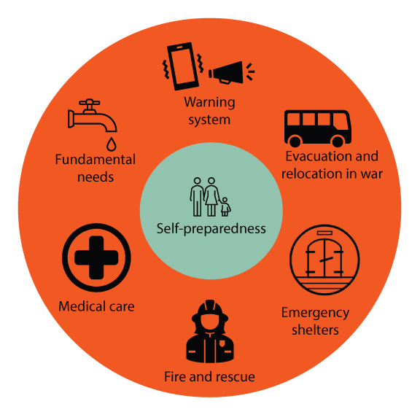

A possible future civil defence concept

In recent years, the Directorate for Civil Protection has further developed the civil protection concept. The Government has tasked the Directorate with adapting the concept to the present threat and risk situation, international experience and the current organisation of civil preparedness. The work is organised in line with the Total Preparedness Commission’s recommendation to develop a comprehensive protection concept. It includes all measures aimed at protecting and safeguarding civilian needs in times of war, and must be incorporated into other total defence efforts, including through plans and exercises.

The general public’s self-preparedness and ability to protect themselves will be at the heart of the civil protection concept (see Figure 6.1). As part of this effort, the Directorate for Civil Protection will also consider changing the three main pillars by adding measures to better protect the population in times of war. Measures set out in the Geneva Conventions are divided into three main pillars that can also form a framework for the Norwegian civil protection concept: a) preventive measures to protect the population against dangers from acts of war, b) measures to help the population overcome the immediate effects of acts of war and c) measures to ensure the survival of the population, including the population’s access to food, water and heat. The organisation of the concept and measures will depend at all times on factors such as the threat situation, weapons technology and demographics.

The international law of war sets the framework for the use of military force in war. The civil protection concept must take into account that different parts of the country may be affected differently by acts of war. It must also take into consideration that parts of the civilian population may be particularly vulnerable to war crimes and have special needs (see Box 6.1).

Action plan for women, peace and security

The Government has prepared the National Action Plan on Women, Peace and Security which is the fifth action plan to follow up on UN Security Council Resolution 1325 and related resolutions, as well as the broader agenda for women, peace and security. The plan runs from 2023 to 2030. This is seen in the context of fulfilling the UN Sustainable Development Goals (SDGs), in particular SDG 5 on gender equality and SDG 16 on peace, justice and strong institutions. It is also important to address gender discrimination in the context of humanitarian efforts and the protection of civilians, both nationally and internationally, in total defence work. In line with the action plan, Norway will take greater account of the gender perspective when drawing up or updating civil protection plans and regulations. Civil authorities with responsibility in the civil protection concept will, together with the Norwegian Armed Forces, have a special responsibility for implementing the action plan. Norway will also work actively to highlight the needs of civilians, particularly in relation to the gender perspective and the needs of vulnerable groups, in international forums to which we contribute.

[Boks slutt]

### Timely public alerts with high coverage

In a crisis situation, the authorities must be able to quickly notify the public of an immediate danger and provide precise information about what is happening and what the population should do to protect themselves and their loved ones. The Government therefore ensured that Nødvarsel, a mobile-based emergency public alert system, was in place from the turn of the year 2022/2023. The emergency alert system is used in connection with local, regional and national incidents, and is an important supplement to existing siren alerts. The police and Norwegian Civil Defence are responsible for deciding which areas should be alerted and for sending out the alert. The system has been tested nationwide four times. The Directorate for Civil Protection estimates that more than 90% of the population can receive the alerts.

The Norwegian Civil Defence’s siren system consists of more than 1,200 operational alert systems. These reach about half the population, mainly those living in cities and densely populated areas where sirens were deployed during the Cold War. Society has seen manifold changes since most of the systems were deployed, both in terms of settlement patterns and which areas will be most vulnerable to armed attack.

Siren systems are still a crucial tool for alerting the public in situations high on the crisis spectrum. As such, the systems will be maintained as a future warning system, the level of coverage will not be reduced and the Civil Defence will assess whether they can increase the coverage over time in relevant areas.

The Norwegian Broadcasting Corporation (NRK) is responsible for broadcasting the authorities’ emergency preparedness messages and important information on the radio. NRK P1 is the emergency radio channel that provides information to the public, even if other news media and public websites are not available.

### Evacuation and shelters

The term ‘safe areas’ can create an unrealistic expectation of absolute safety in these locations. In a war, the state will never be able to guarantee absolute safety and security. The Government therefore wishes to replace ‘safe area’ with the term ‘shelter’. Shelters are categories of areas and spaces designed to help protect civilians in times of war or the threat of war. The Government also wishes to divide shelters into four subcategories, see Box 6.2.

Four categories of shelters

* Protection where you are: When it is deemed sufficiently safe to stay where you are, ‘close and lock doors and windows and stay indoors’.
* Locations in safer geographical areas: When evacuation to pre-designated areas and locations is necessary, and where there are no special requirements for the latter other than that they are outside the unsafe or hazardous area.
* Improvised emergency shelters: Permanent shelter without CBRNE protection for the protection of the population against harm caused by acts of war. Less stringent technical requirements apply for an improvised emergency shelter than for an emergency shelter, but it nonetheless provides protection against conventional weapons, or other relevant threats resulting from the use of such weapons. Improvised emergency shelters could be, for example, underground facilities, tunnels, underground stations, underground car parks etc.
* Emergency shelters: Permanent shelter with CBRNE protection, for protecting the population against harm caused by acts of war, prepared for longer stays including water supply and air purification systems.

[Boks slutt]

Shelters are a necessary protective measure in war. Emergency shelters constitute the civil protection measure that provides the highest level of protection for civilians against harm caused by acts of war (see Box 6.3). In 1998, changes in the security policy situation after the Cold War, among other things, led the Storting to agree to a temporary halt in the construction of new shelters until a new protection concept was in place. As a result of the decision, everyone is exempt from building shelters in new buildings upon application, and no shelters have been built since 1998. This, combined with population growth and the removal of some shelters due to building demolition, means that the level of coverage is gradually decreasing. The Government finds it inappropriate in the current security policy situation to maintain the decision from 1998, which in practice entails a controlled discontinuation over time of the measure that represents the highest wartime protection for civilians. Other nearby countries are also stepping up this type of measure.

Emergency shelters

In legislation, emergency shelters are defined as permanent shelters designed to protect the public from harm caused by acts of war. Municipalities and private individuals may be required to build emergency shelters to the extent deemed appropriate at any given time.

As a rule, private shelters must be built when constructing buildings that exceed 1,000m2 of usable floor space in municipalities subject to shelter requirements, and public emergency shelters for 20% of the inhabitants of such municipalities. There are just under 20,000 emergency shelters in Norway. These are located in densely populated and high-risk areas and can accommodate around 2.5 million people. Of these, 19,000 are private shelters with space for around 2.2 million people and 600 are public shelters with space for 300,000 people. The owner of the emergency shelter is responsible for maintaining it in peacetime and preparing and operating the shelter in the event of an emergency. The shelter must be available for use at 72 hours’ notice. No emergency shelters have been built since 1998. Coverage in Norway is around 45% of the population, while, for the sake of comparison, Finland, Denmark and Sweden have coverage rates of around 90, 80 and 70%, respectively.

[Boks slutt]

The Government will therefore revoke the 1998 interim decision to temporarily halt the construction of emergency shelters. Exemption from the building obligation will not be automatically granted. The Government is of the opinion that emergency shelters will continue to be a crucial protective measure. This is a necessary protective measure during incidents at the high end of the crisis spectrum. Looking at recent history, Report No 5 to the Storting 5 (2020–2021) Samfunnssikkerhet i en usikker verden (Civil protection in an unsafe world – in Norwegian only), cf. Recommendation No 275 to the Storting (2020–2021), states the following about emergency shelters: ‘The emergency shelter scheme in its current form will be discontinued when a new scheme for safe areas for the population across the entire crisis spectrum has been established.’ This was stopped by the Storting and was not based on an adequately long-term approach. The Government therefore proposes that the emergency shelter scheme be continued and reinforced in order to protect the civilian population during crisis and war.



Underground station – an example of a shelter

Photo: Sporveien AS.

The Government will soon submit for consultation a proposal for adjustments to the regulations with new criteria for requirements for the construction of permanent shelters to protect the public from harm in the event of war. The proposal will include shelters with two different levels of protection, the current emergency shelters and a new category of improvised emergency shelters with a lower level of protection. The Government is of the opinion that it would be appropriate to set such requirements for both public and private projects. This must be seen in light of the need for increased preparedness against different types of scenarios. In anticipation of the Storting’s decision, the Directorate for Civil Protection will not discontinue the current practice of granting exemptions from building emergency shelters in new buildings until new regulations and criteria are in place.

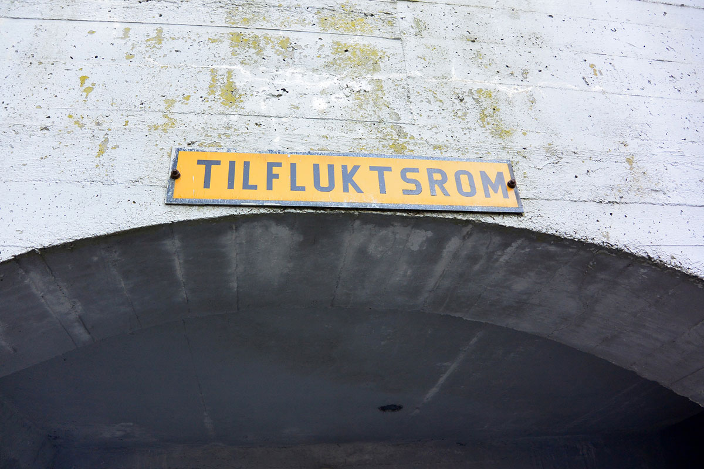

Emergency shelters

Photo: Rogaland civil defence district.

It is important to see shelters in the context of other civil protection measures, particularly evacuation and wartime relocation. Wartime relocation is the evacuation of people from areas that are or may be exposed to acts of war to a safer area. Such relocation can involve moving people over large geographical distances to an area where they may have to stay for an extended period of time. The Government’s plans for evacuation and wartime relocation of the civilian population in armed conflict will be assessed and possibly revised on the basis of the chosen civil defence concept and adapted regulations. The Directorate for Civil Protection has begun work to revise the wartime relocation plan, and is in the process of assessing which areas should have such plans given our current challenges.

Emergency shelters and improvised emergency shelters are mainly built to protect people who have not moved to a safer geographical area during war or where there is a threat of war. Individuals in need of these types of shelter will, for example, be people who are important for maintaining fundamental national functions and critical societal functions, including supporting tasks in a war-prone area.

In Resolution No. 743 of 11 March 2021, the Storting adopted the following: ‘The Storting asks the Government to return to the Storting with an assessment of how existing emergency shelters can be utilised to a greater extent so that they are maintained and form part of national police preparedness in connection with, for example, migration, pandemics or supply crises.’ The request has been assessed, and shows that it is inappropriate to use existing private emergency shelters for other preparedness purposes, in part due to preparation time and the fact that the shelters are the property of the building owner. Furthermore, restricting the areas for preparedness purposes will infringe on the owner’s right of disposal over their own property. Some public emergency shelters have multi-purpose functionality. Such functionality will also be relevant to consider in the event of future establishment of public emergency shelters or improvised emergency shelters.

### New and tailored public self-preparedness advice

The Directorate for Civil Protection has conducted digital self-preparedness campaigns every year since 2018. The main purpose is to remind the public that they must ensure their own basic needs in the event of a serious crisis, either on their own or through cooperation with, for example, family and neighbours. The Directorate recommends having a week’s worth of self-preparedness supplies and suggests a number of things you should have at home, see Box 6.4. Good self-preparedness will reduce the need for help from emergency resources, so that these can be deployed where they are most needed.

Self-preparedness advice

On 29 May 2024, the Directorate for Civil Protection launched updated self-preparedness advice on the website sikkerhverdag.no. The advice has been published in several languages. The updated self-preparedness advice has been distributed in connection with the self-preparedness week in week 44 as printed material to all households in the country as well as remaining available online. This year’s self-preparedness advice provides guidance on the following topics:

* Self-preparedness for one week
* Water
* Heat and light
* Food
* Self-preparedness for payments
* Checklist for your self-preparedness
* Medicines and first aid
* Hygiene
* Information and communication
* Joint self-preparedness
* Mental health in times of crises
* Shelters and places to stay in times of crisis

[Boks slutt]

On behalf of the Government, the Directorate for Civil Protection has adapted the self-preparedness advice to new and more serious times. The advice now also applies to preparedness for crisis and war, and also includes what individuals can do to identify misinformation and disinformation. The Government is also strengthening efforts to prevent influence operations, see Section 7.4.

The Government has concluded that the Directorate for Civil Protection will continue to determine self-preparedness advice. The Government recognises that there are a number of professional considerations that must be taken into account when preparing advice, and the fact that a sector agency issues the advice prevents unnecessary politicisation. In the Government’s view, there is good and increasing public awareness of the advice issued by the Directorate for Civil Protection.

Practical knowledge relating to food

Increasing your knowledge of how to store and prepare food in crisis situations, such as natural disasters or supply shortages, is an important resource for improving self-preparedness. The Government will continue a preparedness initiative that was previously available on the website matportalen.no, which is aimed at crisis situations with food shortages. The initiative is intended to provide information that helps the population to better utilise the food resources that are actually available.

The Norwegian Society of Rural Women has also prepared a guide on food preparedness that addresses, among other things:

* Local food production – food from your doorstep.
* Food when the power goes out. What can we cook without a fridge and electric oven?
* Food from nature – harvesting, gathering and hunting.
* What do we do if the availability of food in the shop changes?
* Cooking food with a long shelf life – what should you stock up on at home?

[Boks slutt]

Resilience throughout society – a shared responsibility

02J1xx2

|  |  |
| --- | --- |
| Resilience throughout society – a shared responsibility | |
| What can the individual do to strengthen civilian resilience?  (individual level) | Keep up to date with the Directorate for Civil Protection’s self-preparedness advice and be prepared to manage on our own for one week, which includes the following:   * Have sufficient water, food and other essentials such as a radio, first aid kit and hygiene products. * Be able to stay warm in the event of a power cut, either by having an alternative heat source or a plan for where you can go. * Learn basic first aid. * Be critical of your sources and how you can access quality-assured information. * Talk to those around you about what might happen and how you can manage together. * Check the latest cyber security advice. |
| What can the local community do to strengthen civilian resilience?  (housing cooperatives, schools, leisure facilities /organisations) | * Spread knowledge and information about the Directorate for Civil Protection’s self-preparedness advice. * Review tips from the Directorate for Civil Protection on how the board can help enhance self-preparedness in your housing cooperative. * Help each other to find an emergency friend. * Conduct or participate in training exercises. * Talk about incidents that could happen and what it may entail for a person in the local community. |
| What can your organisation do to strengthen civilian resilience?  (public, private and voluntary) | * Consider how the organisation can maintain the production of goods and services in the event of serious incidents affecting society or undertakings in accordance with the Directorate for Civil Protection’s guide to business continuity planning. * Comply with the Norwegian National Security Authority’s basic cyber security principles. * Create preparedness plans for different types of incidents that may affect the organisation and its operations. * Create procedures for colleague support and practise this in the event of incidents. * Conduct exercises that may put the organisation under pressure or out of action. * Conduct training in cyber security advice. * Conduct training in source criticism. * Designate an emergency preparedness officer in your organisation. |

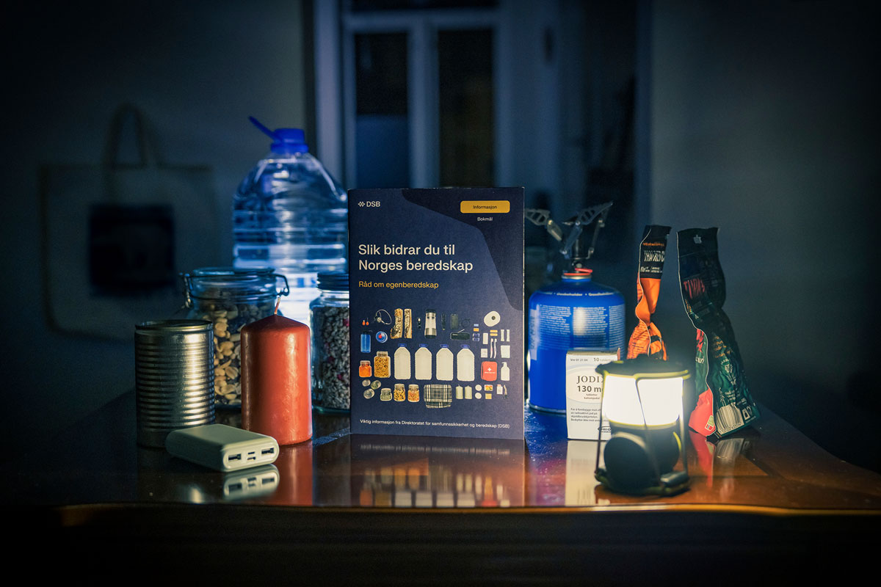

The Norwegian authorities recommend that all households should be prepared to cope on their own in a crisis situation for one week.

Photo: Daniel Fatnes/Directorate for Civil Protection.

## Safeguard preparedness and security considerations in public procurement to a greater extent

Every year, the public sector in Norway procures goods, services and construction work for around NOK 780 billion. What the public sector buys and demands in public procurement is therefore of great importance. The Government appointed the Procurement Committee in 2022 (see Box 6.6).

The Procurement Committee

The Procurement Committee was appointed on 4 November 2022 to review and propose changes to the regulations for public procurement. The Committee has submitted two reports (Norwegian Official Reports (NOU) 2023: 26 and 2024: 9).

The Procurement Committee has emphasised that there is broad scope to set requirements or criteria at the various stages of a procurement process that safeguard security and emergency preparedness considerations. The Committee proposed a legal provision on security and preparedness in the new procurement regulations, stating that the contracting authority may set requirements or criteria to safeguard security or emergency preparedness considerations, and that the contracting authority should do so where relevant.

The Committee also proposed that an updated guide on security and emergency preparedness in public procurement should be prepared, identifying, among other things, special categories of procurements that are particularly vulnerable with respect to security and preparedness.

[Boks slutt]

The Government is of the opinion that the Procurement Committee’s recommendations are based on thorough assessments. The Government will investigate the possibility of implementing security and preparedness requirements in public procurement in order to safeguard preparedness and national security interests. An assessment will be made of whether it is necessary to amend the procurement regulations in order to clarify in legal terms the possibility of setting requirements for security and emergency preparedness in public procurements. The Government will also contribute to clear and thorough guidelines on security and emergency preparedness in public procurement, including identifying the categories of procurement in which it is particularly important to set security and preparedness requirements. Clear guidance will be important to ensure that contracting authorities utilise the full scope of the regulations and that appropriate requirements are set in procurements.

The Procurement Committee has, for instance, emphasised that it is possible to set requirements related to preparedness that require a local presence, and that supply preparedness can justify splitting up procurements. Many local contractors and organisations made active contributions to the handling of the extreme weather ‘Hans’ and in subsequent clean-up efforts. Often, local resources are crucial to managing serious undesirable incidents. It is therefore important that public procurement, within the framework of the regulations, also helps ensure that these resources are available locally and thereby contribute to good basic preparedness throughout the country. Civilian support is crucial for the Norwegian Armed Forces and allies to be able to defend the country in security policy crises and wars. In a war, the Armed Forces will have a significantly greater need for goods and services than in a normal situation, and will be dependent on civilian resources to meet its needs. It is an advantage if these increased needs can be met locally where the Armed Forces are in operation. This capacity must be built in peacetime.

As part of the follow-up of the new long-term plan for the defence sector, the Norwegian Armed Forces will exploit the full scope of laws and regulations in order to make greater use of local and regional suppliers. Local and regional suppliers mainly refer to organisations that contribute to emergency preparedness and security through well-functioning local communities and local and regional business development. One of the measures to strengthen the national defence industry is to require industrial cooperation in connection with major procurements from abroad. The agreements oblige the supplier to carry out projects/activities with Norwegian organisations in areas that are important for national security and preparedness. The Government will continue to use industrial cooperation agreements as a security policy instrument to help maintain a robust national industrial base that can deliver according to the needs of the Norwegian Armed Forces. We do this to ensure a diverse business sector throughout the country.

The Government will also review the procurement regulations for the defence sector. The Ministry of Defence has initiated work on a new Defence and Security Procurement Act. An external working group has been appointed to assess how a new act on defence and security procurement should coincide with the Security Act’s provisions on classified procurements and take account of special circumstances in the defence and security sector. The working group will also assess whether adjustments should be made to the new act to ensure that procurements can be carried out quickly.

The war in Ukraine has shown that Norway needs a robust national industrial sector that is capable of rapidly increasing production and has the capacity to supply the Norwegian and allied defence sector. Russia’s war of aggression against Ukraine has led to a significant and rapid increase in defence sector needs, but the market has not been able to meet demand for several types of deliveries. At times, Government involvement is necessary to ensure that sufficient production capacity is available when needed. Involvement can take the form of ownership in the supply chains, or establishing industry nationally or in collaboration with close allies.

## Research and education in the total defence system

The knowledge sector plays a crucial role in efforts to strengthen civilian resilience and total defence. Research and knowledge development has been a priority area for some time, both nationally and through European cooperation (see Box 6.7). Continued investment is necessary both for broader public security efforts and to meet the need for specialist expertise. There is increasing competition for relevant expertise.

It is important to find a good balance between open research and Norway’s need for classified research and researchers who require security clearance. This must be seen in the context of efforts to ensure good researcher recruitment and Norway’s competitiveness in research on public security and emergency preparedness.

Knowledge development – a long-term endeavour

Since 2007, the Ministry of Justice and Public Security has contributed to the funding of programmes administered by the Research Council of Norway. Norway has also participated actively in security research under the EU’s framework programmes for research and innovation since 2007. Several universities and university colleges have educated many graduates at master’s and doctoral level in public security, risk assessment, crisis management and emergency preparedness. There has been a focus on research and education in the field of cyber security, as well as in subject areas such as building and material security. Norwegian research groups and universities are doing well in European cooperation and attracting significant research funding. They are also gaining experience through collaboration with international researchers.

[Boks slutt]

In the long-term plan for research and higher education 2023–2032 (Report No 5 to the Storting (2022–2023), cf. Recommendation No 170 to the Storting (2022–2023)), the Government states that it will strengthen the work on public security and emergency preparedness through research, innovation and education. Important knowledge needs include global health threats, food safety, drinking water and supply risks, security of power supply, severe natural events, nuclear safety and nuclear preparedness, security and defence policy, responsible international knowledge cooperation, technology and public security and knowledge in crises.

Developing expertise in public security and emergency preparedness requires that various actors find the resources and time to establish and embark on competence-building programmes. At present, the Norwegian Defence University College and the Directorate for Civil Protection are the main organisations offering emergency preparedness courses, as well as cooperation with, among others, the Norwegian Police University College in connection with national preparedness and crisis management. There are similar courses at the Nordic level. An important part of the work on knowledge development is ensuring that the content of such courses is up to date, based on new and systematic knowledge, and that the best possible conditions are created for universities and university colleges to collaborate with user groups. The development of experience-based master’s degrees in recent years is a good example of collaboration between the higher education sector and user environments such as the Armed Forces, the police, the Norwegian Civil Defence and other key actors in the total defence system.

The Norwegian Defence Research Establishment’s project BAS: Total defence towards 2040

The Norwegian Defence Research Establishment’s (FFI) project 1619 – BAS: Totalforsvaret mot 2040 (Total defence towards 2040) is being carried out in the period 2021–2025. It will prepare the necessary knowledge base for long-term development of the total defence capability through R&D and utilisation of technology, with a view to supporting long-term planning and policymaking. The project has generated a number of deliverables in the form of published research products. The goals of the project are to:

* contribute to an increased understanding of how hybrid threats and the development of society in general can affect our total defence capability.
* Contribute to strengthening society’s resilience through a function-based approach to further develop total defence capability across the entire crisis spectrum.
* contribute to strengthening our ability to understand, analyse and manage hybrid threats across sectors to enhance cross-sectoral situational awareness.
* propose alternative approaches to total defence capability in a 2040 perspective, both to strengthen Norway’s security capacity and to help support and enable future operational concepts for the Norwegian Armed Forces.

The project Total defence towards 2040 is a further development of FFI’s research series on public security and preparedness, the Protection of Society (BAS). The Norwegian Defence Research Establishment started the series in the mid-1990s in collaboration with the Directorate for Civil Protection. The first BAS project was a mapping of critical societal functions that should be maintained during both armed conflict and in peacetime. Over the next few years, FFI took a closer look at telecommunications preparedness, power preparedness, transport preparedness and ICT vulnerability. From 2007, BAS came to focus more on civil-military cooperation and crisis management, and how major crises can and should be handled at national level. Based on the BAS research and related research activities, FFI has investigated the strengths and weaknesses of our current total defence for the Total Preparedness Commission. The BAS research series is ongoing and will continue to produce new knowledge that contributes to an active total defence that functions across the entire conflict spectrum and strengthens Norwegian security and defence capabilities.

[Boks slutt]

### Work on research and education in public security, emergency preparedness and total defence

To realise a new direction for total preparedness in society, we must consider more powerful policy instruments targeting competence development. Over time, the Research Council of Norway has focussed on enabling and industrial technologies, including cyber security. Various public security study programmes have been established in the higher education sector in several parts of the country. There are also a number of vocational education programmes. It is important to continue these efforts and to further develop environments and disciplines.

The Government will facilitate research and education in public security and total defence, in accordance with the long-term plan for the defence sector and the long-term plan for research and higher education.[11] Consideration is being given to:

* strengthening research funding for public security and emergency preparedness through the Research Council of Norway, with an emphasis on interdisciplinary issues as well as cyber security and technology.
* providing further incentives to strengthen the participation of private and public sector actors in projects in areas of relevance to security and emergency preparedness work, threat and risk understanding and securing society’s assets, in collaboration with research and education communities.
* establishing continuing education programmes in public security and total defence targeting employees in relevant public and private organisations.

### A comprehensive research system for open, critical national and classified research

The Government will facilitate better coordination of the R&D systems in the civil and military sectors. In the long-term plan for the defence sector, the Government states that Norway’s overall need for open, critical national and classified knowledge will be met through the development of a common national research system. It may become necessary to protect knowledge and technology to a greater extent going forward. It should therefore be possible for more research environments to carry out critical national and classified research. A comprehensive research system will give defence and emergency preparedness actors better access to cutting-edge research. Several research institutes and organisations want to contribute R&D related to defence, security and emergency preparedness, but currently lack access to mechanisms and guidance that make this possible in practice and sufficiently secure. There is a need for better utilisation of resources and greater facilitation to enable needs and solutions to coincide.

To conduct critical national and classified research, the research institutes and organisations must have in place and maintain an acceptable level of security in line with the requirements of the Security Act and pertaining regulations. The Government will continue to develop the research system and provide the necessary mechanisms and guidance resources that are currently lacking, so that more organisations can qualify to conduct critical national and classified research. The Government will return to how this can be operationalised in the forthcoming white paper on the research system.

Openness, academic freedom and research ethics are fundamental principles that the Government seeks to safeguard. All research institutes and organisations that work on sensitive subject areas must be given a secure framework. It must be entirely clear where restrictions are necessary for security reasons. Voluntariness is an essential principle when allowing more people to carry out critical national and classified research. Organisations that conduct research and individual researchers should and must be free to choose whether they wish to take part in this type of research activity.

## The importance of culture, cultural heritage and media for civil resilience

The Government finds it important to maintain strong and independent media and art and cultural institutions that are able to safeguard our cultural heritage and maintain cultural activities during crises and war. According to the Norwegian Constitution, the state has a duty to facilitate ‘… open and enlightened public discourse’. This entails a responsibility to ensure that there are well-functioning channels for the exchange of information and opinions in society. Free media and an active cultural scene form part of this aim.

### Cultural protection and cultural heritage

Culture, cultural heritage and cultural organisations are important, also in times of crisis and war. Cultural heritage is a target and instrument, and fosters resilience. This is emphasised in UN Security Council Resolution 2347 from 2017, which states that cultural heritage, as an expression and representative of a society’s identity, is deliberately used as a target and instrument of terror, war and conflict.

Archaeological heritage sites, historic buildings and memorials are actively used as targets to destabilise society. When cultural heritage is attacked, it weakens a society’s identity and threatens its sense of belonging and security. Norway is a party to and committed to following up the UNESCO Convention for the Protection of Cultural Property in the Event of Armed Conflict (1954) and the Second Protocol (1999), hereafter referred to as the Hague Convention, see Box 6.9. Cultural heritage is often used as a means of financing warfare and terrorism. Cultural artefacts are looted and sold, making them part of global environmental crime.

Cultural heritage is actively used in disinformation, fake news and conspiracy theories, and is also an instrument. Russia’s use of historical revisionism, as part of the annexation of the Crimean Peninsula and full-scale war in Ukraine, is used purposefully and effectively to deliberately promote a narrative intended to undermine the history and identity of Ukrainians.

In recent years, the Government has strengthened cross-sectoral preparedness cooperation to secure and protect cultural heritage. This effort will remain paramount going forward. It is essential that cultural heritage is safeguarded as part of the emergency preparedness system. The Directorate for Cultural Heritage is the national coordinator for the implementation of the Hague Convention.

The Hague Convention for the Protection of Cultural Property

The aim of the Hague Convention is to prevent cultural heritage from being used as a military target and encompasses both cultural heritage and historical buildings and sites, works of art, manuscripts, books and collections of scientific, artistic or historical importance. The Convention requires countries to refrain from using their own cultural heritage, as well as that of their enemies, as a target or shield in a conflict situation. The Hague Convention recognises that deliberate damage to cultural heritage is a violation of international law. State Parties are obliged to have an emergency preparedness system that safeguards cultural heritage.

[Boks slutt]

### Access to culture and activities

Access to independent media, artistic and cultural expression, sports and leisure activities can provide meaning in difficult times and a sense of belonging, identity and hope. The EU report ‘Culture and Democracy – The Evidence’[12] demonstrates a clear and positive correlation between the proportion of citizens participating in cultural activities and civic engagement, democracy and social cohesion. The report shows that participation in cultural activities contributes to, among other things, an increased likelihood of voting in elections, volunteering and developing positive social attitudes related to democratic values and identities.

Voluntary activities, libraries, archives, cultural institutions and the independent arts and cultural scene in all artistic fields are components of the population’s opportunity and ability to be enlightened and apply critically thinking, to find meaning and insight in life, and to be open and search for solutions and opportunities.

Well-informed citizens, with good access to knowledge about and a firm grasp of their own cultural identity, will have greater opportunities to make good choices for themselves and their local community in a time of crisis. This can be decisive for how the nation as a whole withstands a crisis. A cultural sector that functions as normally as possible in times of crisis will be an important aspect of the nation’s overall preparedness and the public’s ability to persevere, and maintain good mental health and morale. This could be decisive for how the nation as a whole weathers a crisis.

The Government expects institutions that receive public funding to prepare plans to safeguard our culture and disseminate culture, art and cultural heritage, even during crises, as far as this is prudent.

The Government facilitates infrastructure for the production and dissemination of art and culture through institutions and public funding schemes. The Government will continue to ensure this as far as possible in crises and war. In such a situation, the Government will seek to maintain arenas and meeting places for culture, sports and voluntary activities to the degree possible.

### The role of the media in crisis and war

Independent, editorial media is fundamental to democracy. Editorial media contributes to informed and engaged citizens who take part in society around them. Through their ‘watchdog function’, the media ensures that the authorities are held accountable for their decisions. This is essential for building trust in institutions and authorities.

Ensuring good framework conditions for editorial media is essential. The public’s ability to distinguish between the truth and falsehoods is challenged at several levels. Artificial intelligence has become both more advanced and more accessible. The global internet platforms amplify the spread of emotional and engaging content, increasing the risk of algorithmic amplification of disinformation. Regulation of these platforms is therefore another important preventive measure, including through the EU Digital Services Act.

It is crucial that the functions of the media are also safeguarded in times of crisis and war. The public has a particularly great need for information in a crisis situation, and information from editorial media is an important addition to information provided by the public authorities. This is both because the media potentially reaches more or different sections of the public than the authorities, but also because the media’s independent assessments and investigations build trust.

Norway has regulations and public grant schemes in place that enable editorial media channels to fulfil their social mission, without censorship and manipulation. The Government will take steps to ensure that the media is able to fulfil this social mission even during crises and war.

Part III

A civil society that is resilient to hybrid threats

# Improve resilience to hybrid threats

Foreign states use hybrid activities that have a broad impact, encompass both legal and illegal activities, take place over a long period of time and below the threshold of armed conflict. Malicious actors may intend to target parts or all of society, create divisions between groups, weaken trust and destabilise society, or weaken emergency preparedness and military capabilities to make society more vulnerable. It can be difficult to understand, recognise, handle and counter this type of activity. The willingness and ability of malicious actors to confront the West and Norway using hybrid threats appears to have increased.[13]

Hybrid activities affect the whole of society. Both the defence and civilian sectors are affected, in physical and digital spheres, and across areas of responsibility. Public bodies, private organisations and individuals can be exposed to the use of such methods. Actors that are affected may, for example, be linked to the supply of critical goods and services such as power, petroleum products, electronic communications and water. In the long term, this activity could threaten our democracy, the rule of law, our social values and Norway’s economic and political scope of action. This does not mean that we are at war, but the activity impacts how Norway – its people, municipalities, business and industry and public administration – addresses the challenges. At the same time, Norway has a toolbox of instruments to tackle such threats. We can strengthen society’s resilience at state, community and individual level. Handling hybrid activities requires information sharing across sectors, the ability to see incidents in context and a shared situational awareness.

Strengthening society’s resilience in peacetime acts as a deterrent and helps to increase preparedness during crisis and armed conflict. A resilient population provides a better foundation for national security and defence capabilities.

Much of the critical infrastructure in Norway is owned by the private sector. These companies have expertise in identifying vulnerabilities and managing incidents effectively within their respective areas of responsibility. They are thus a key part of our resilience and total defence, and must be closely involved in tackling hybrid threats.

The Government will build on and strengthen the measures in Report No 9 to the Storting (2022–2023) National control and cyber resilience to safeguard national security, cf. Recommendation No 247 to the Storting (2022–2023), to strengthen civil society’s resilience to hybrid threats. See Chapter 9 for a more detailed discussion of cyber resilience.

The Government will:

* increase situational awareness of hybrid threats by
* strengthening agencies and intelligence and security services tasked with understanding, detecting, handling and countering hybrid threats.
* further developing the National Intelligence and Security Centre (NESS).
* establishing a new organisational structure at ministry level for preparedness planning and status assessments in civilian sectors.
* intensifying the dialogue with the business community, knowledge sector and other sections of society.
* if necessary, authorising more people to receive and manage classified information.
* stepping up the work to counter disinformation and influence by
* presenting a strategy to strengthen resilience to disinformation in spring 2025.
* in consultation with the media industry, assessing possible measures to improve people’s ability to scrutinise sources and resist disinformation.
* following up the major technology platforms’ influence on public debate in Norway.
* strengthening personnel security through a civil security clearance authority that is fit for the future.
* working towards a close, binding and predictable international cooperation on national security and countering hybrid threats together with allies, partners, NATO, the UN, Nordic countries and Europe.

## Hybrid threats challenge society

The war in Ukraine affects the intelligence, influence and sabotage threat in Norway. In their threat assessments, the Norwegian Intelligence Service and the Norwegian Police Security Service (PST) point out that foreign states will use a wide range of means against and in Norway to achieve their goals. This particularly applies to authoritarian states. One example is the increased risk of sabotage against Norwegian arms deliveries to Ukraine. Fewer bilateral cooperation channels mean that Russia has less access to information about the situation in Norway, which requires more of Russian intelligence and security services than previously. Russia is likely to compensate for this by making greater use of travelling personnel, as well as proxies, to carry out tasks that were previously performed by permanently stationed intelligence personnel. Russian actors are interested in obtaining information about Norwegian politics, energy, the High North, allied activity and defence. Russia is also interested in Norwegian technology in areas they wish to develop themselves. Russia utilises civilian vessels in intelligence operations. They have legitimate access to Norwegian infrastructure and the Norwegian coast. Identifying whether they are carrying out intelligence activities alongside their legitimate activity can be difficult.

China does not pose a direct military threat to Norway, but has an interest in establishing a political and economic foothold in the Arctic and an independent capability to operate militarily in the region. Chinese intelligence services operate throughout Europe. These activities include both intelligence and industrial espionage. The digital sphere is the most relevant point of entry for such activity. Chinese diplomats, visiting delegations, private individuals, businesses and interest organisations regularly perform tasks on behalf of Chinese intelligence services. There are close links between Chinese intelligence services and Chinese commercial companies. Beijing has both institutional resources and a legal framework to utilise Chinese businesses and individuals for state purposes. All Chinese companies and individuals are obliged under Chinese law to assist China’s intelligence and security services. Cooperation with Chinese actors must be considered against this backdrop.

Examples of hybrid activities

Throughout 2024, Russia has used a wide range of activities to undermine NATO countries’ capability and willingness to continue to support Ukrainian defence capabilities. This includes public statements by the Russian authorities, such as threats to use nuclear weapons and accusations against Ukraine and the West, but also the covert use of activities by the Russian intelligence and security services. For example, a number of public and private organisations with a role in the European support for Ukraine have been subject to cyber operations. Russian intelligence has also used proxies to commit several acts of sabotage and other disruptive activities in various European countries. The majority of the latter actions have targeted value chains that support donations to Ukraine or infrastructure used daily by the civilian population in Europe.

[Boks slutt]

## Increase situational awareness of hybrid threats

Hybrid activities impact the whole of society. This makes it necessary to facilitate good information sharing, coordination and situational awareness across sectors, at all administrative levels and with the business sector. Measures are needed to address hybrid threats in a coordinated and targeted manner. The Ministry of Justice and Public Security has a special responsibility to follow up and coordinate the Government’s work to counter hybrid threats, in close cooperation with the Ministry of Foreign Affairs and the Ministry of Defence.

The establishment of the National Intelligence and Security Centre (NESS) in 2022 was key to increasing the authorities’ situational awareness. NESS consists of the Norwegian Police Security Service (PST), the Norwegian Intelligence Service, the Norwegian National Security Authority (NSM) and the rest of the police. These parties work together to strengthen our national capability to identify, build understanding of and provide decision-making support related to central government actors’ use of, or our national security interests’ vulnerabilities to, hybrid threats. The Ministry of Justice and Public Security and the Ministry of Defence are now further developing NESS to establish a national situational picture of hybrid threats, and to strengthen the cross-sectoral work required to identify, understand, counter and handle hybrid activities.

The establishment of a new structure for preparedness planning and status assessments at ministry level, see Section 3.1, is also an important means of countering hybrid threats. Systematic reporting on status and vulnerabilities from different sectors will provide a better and more comprehensive basis for improving the Government’s situational awareness. The new structure will also facilitate more comprehensive input to the Ministry of Justice and Public Security’s leadership and coordinating role in the prevention and handling of hybrid threats.

Another measure to strengthen situational awareness of hybrid threats is to ensure that relevant personnel are authorised to receive classified information if necessary. This will make it easier for personnel with an official need in the ministries and undertakings subject to the Security Act, including subordinate agencies at local and regional level and municipalities, to receive classified information and thus gain a better understanding of the threat and risk situation. Work is underway to strengthen personnel security in the ministries. The Government will also make it easier for municipalities to handle classified information.



Hybrid threats challenge society

Photo: Fabian Helmersen/Norwegian Armed Forces.

## Measures to counter the insider threat

The use of unfaithful servants is part of the intelligence threat. An insider threat can enable malicious actors to gain access to assets that are important for national security. According to NSM, an insider risk is defined as a current or former employee, consultant or hired employee who has or has had legitimate access to the organisation’s systems, procedures, objects and information, and who misuses this knowledge and access to carry out actions that harm or entail a loss for the organisation. An insider risk can carry out or facilitate espionage or sabotage from inside the organisation.

The security policy situation has led to more and more organisations falling under the Security Act, and the need for security clearances is increasing in line with this. This also applies to the Norwegian defence industry, where the need for security-cleared personnel has increased in connection with government-supported capacity expansion, but it is also the case in several civilian sectors.

It is vital and legitimate for the state to have appropriate personnel security measures to protect national security interests. At the same time, different organisations’ need for critical expertise and personnel across the crisis spectrum must be met.

Protection against insider activity can be achieved through various measures related to, among other things, personnel security, and physical and cyber security. The legal rights of the individual to be given clearance must be safeguarded. The Government has decided to initiate work to modernise the Civil Security Clearance Authority to make it fit for the future.

## Resilience to influence operations

Influence operations are part of the hybrid threat picture. By influence operations is meant other states’ use of open and covert campaigns, operations and activities, often without the use of military force, to change attitudes, decisions or outcomes. The aim is often to influence political processes or decisions in a particular direction, but they may also aim to reinforce polarisation, spread distrust or create general unrest in the population. Disinformation is one of several means of achieving this. Traditional media, alternative media and social media can be misused to spread disinformation, initiate smear campaigns, and spread rumours and half-truths. In Norway, some foreign intelligence officers will also target people with political influence in an attempt to influence the outcome of individual cases.

Attempts by foreign states to exert influence are described as a threat by both the Norwegian Intelligence Service and PST in their annual threat assessments. PST believes that we must be prepared for attempts by Russian and Chinese intelligence services in particular to influence decision-makers and the public. Russia has for many years demonstrated the capability and willingness to carry out influence operations in Western countries.

Countering disinformation

As the Total Preparedness Commission points out, several countries have stepped up their efforts to counter hybrid threats in recent years. The Norwegian Defence Research Establishment has carried out a study of other countries’ work to counter hybrid threats. Best practices from other countries have highlighted the importance of increased awareness and knowledge of the threat, asset and vulnerability dimensions. This includes clarifying the roles and responsibilities of key actors and emphasising enhanced collaboration. The Government has implemented several important initiatives in recent years.

Amendments to the Penal Code on the influence of foreign intelligence

PST is tasked with preventing and investigating serious crimes against the nation’s security. In that connection, it identifies, assesses and handles threats related to foreign states’ use of hybrid activities in Norway, including influence operations. To provide PST with an appropriate legal framework for this work, the Storting has adopted amendments to the Penal Code. Two new provisions (Sections 130 and 130a) entered into force in the Penal Code on 1 July 2024. The provisions strengthen legal protection against harmful influence activities by foreign intelligence in Norway. The provisions make it a criminal offence to contribute on behalf of or in agreement with a foreign intelligence actor in activities aimed at influencing decisions or the formation of public opinion, when the activities may harm significant public interests.

The Police Databases Act allows PST to store, systematise and analyse publicly available information for intelligence purposes. Together with the above-mentioned amendments to the Penal Code, this will enable PST to prepare analyses and assessments to provide decision-making support on issues that may threaten Norway’s sovereignty, territorial integrity, democratic form of government and other national security interests.

[Boks slutt]

The Ministry of Culture and Equality has a special responsibility for the public’s resilience to disinformation. The Government has initiated work on a strategy to strengthen resilience to disinformation, which it aims to present in spring 2025. The strategy will address the recommendations of the Norwegian Defence Commission and the Total Preparedness Commission to strengthen the public’s resilience to disinformation. Among other things, the strategy will address:

* The role and framework conditions of editorial media.
* The public’s critical understanding of the media.
* Following up the major technology platforms’ influence on public debate in Norway.
* Knowledge of and research into the spread of disinformation and its impact on Norwegian society.

Actors with a special responsibility to counter influence

The principles of responsibility and cooperation stand firm, and handling disinformation and influence is primarily the responsibility of the individual organisation and the sector concerned. However, certain ministries and agencies have a special responsibility in different areas to counter influence.

Ministries

* The Ministry of Justice and Public Security is responsible for the general coordination of measures to counter influence operations on civil society, as well as technical responsibility for coordination and crisis management in situations where this is required.
* The Ministry of Culture and Equality is responsible for the public’s resilience to disinformation.
* The Ministry of Defence is responsible for influence operations aimed at the defence sector, defence policy and defence capability, or which may otherwise pose a military threat to national security, as well as international defence cooperation in this area.
* The Ministry of Foreign Affairs is responsible for diplomatic, foreign policy and security policy aspects of disinformation and influence operations.
* The Ministry of Local Government and Regional Development is responsible for countering undesirable influence on elections.

Agencies

* The police are responsible for hybrid activities that materialise as crime, and for handling them and restoring normality while they conduct an investigation. The police must deal with all aspects of the incident until it becomes clear that the responsibility lies with PST and the case is transferred.
* PST is Norway’s domestic intelligence service and it is tasked with preventing and investigating serious crimes against the nation’s security. In that context, it identifies, assesses and handles threats related to foreign states’ use of hybrid activities in Norway, including influence operations. PST is tasked with giving notification of threats to national security and providing decision-making support on matters in Norway that may threaten its sovereignty, territorial integrity, democratic form of government and other national security interests.
* The Norwegian Intelligence Service is tasked with giving notification of external threats to Norway and supporting political decision-making processes by providing information of particular interest to Norwegian foreign, security and defence policy.
* NSM is tasked with, within the framework of the Security Act and main instructions, providing information, advice and guidance on preventive security work and the measures required, including influence operations against organisations that fall under the Security Act. NSM is also the national specialist environment for cyber security and is tasked with preventing cyberattacks.
* The Norwegian Media Authority is tasked with increasing the public’s resilience through critical understanding of the media and good framework conditions for an open and informed public debate.
* The Directorate for Civil Protection has a particular responsibility for facilitating good coordination where special cross-sectoral challenges have been identified. It is also responsible for risk and crisis communication to the public, as well as advice on self-preparedness.

[Boks slutt]

In summer 2024, several press organisations, media companies and the fact-checking organisation faktisk.no joined forces in an initiative to establish a national centre for source criticism. The Government is following the initiative with interest and will consider it in connection with the strategy to bolster resilience to disinformation. In the strategy, the Government will also consider strengthening the role and responsibilities of the Norwegian Media Authority in this area. This could be a complementary measure focusing on resilience, on top of the Government’s current efforts to understand and counter foreign state influence operations. The further development of the National Intelligence and Security Centre (NESS), as described in Section 7.2, is a further step towards obtaining a better situational overview and understanding of hybrid threats, which include influence operations.

The legal amendments that give PST greater opportunity to monitor trends and developments on the internet, including influence activities, together with the amendment that makes it a criminal offence to contribute to influence operations on behalf of foreign intelligence, provide a better knowledge base and opportunities to prevent and stop such activities. These were very important legislative amendments. The Total Preparedness Commission’s recommendation to establish closer cooperation between relevant organisations and the EOS services in terms of both surveillance and analysis in order to create a good understanding of the situation will be considered in the Government’s further work on both the strategy for strengthening resilience to disinformation and the further development of NESS. In line with the Total Preparedness Commission’s recommendations, this will strengthen situational awareness across sectors and prevent foreign influence operations.

Major technology platforms such as TikTok and Meta are playing an increasingly important role in public debate. The Government has therefore initiated several dialogue meetings between Norwegian media and major technology platforms, with the aim of establishing a meeting place for these platforms. A number of topics have been discussed. Examples include challenges related to technology platforms’ moderation of Norwegian media content (blocking legal content provided by Norwegian editorial media), the extent to which the platforms’ algorithms prioritise news content, as well as challenges related to social networks spreading fake news stories that are falsely presented as coming from Norwegian media. Crime committed on these platforms has also been discussed at some meetings. The Government will therefore follow up the major technology platforms’ impact on public debate in Norway, including in the upcoming strategy to strengthen resilience to disinformation. For 2025, the Storting has approved the Government’s proposal to increase the allocation to the Norwegian Media Authority by NOK 5 million, among other things to strengthen work on the public’s critical understanding of the media and follow up the technology platforms’ impact on public debate in Norway.

In order for children and young people to learn to resist influence operations and disinformation, it is important to give them suitable, adapted information. The school curriculum provides good opportunities for pupils to learn about democracy and to become active citizens, particularly following the inclusion of the interdisciplinary subject democracy and citizenship in the new curriculum. Critical thinking, democracy and participation are central to the statutory objective of the Education Act, and are important principles in the general part of the curriculum that provides direction for basic education in schools, which includes both primary and secondary education.

Folk high schools and democratic awareness

Democratic awareness is an important part of the curriculum in folk high schools. Norway has around 80 folk high schools that enrol a total of 6,000 students every year. These schools are tasked with promoting general education and public awareness, and help to ensure that knowledge and attitudes are used for the common good. An important aspect of this is creating awareness of what a democracy is nationally and internationally, and helping to build a resilient population with the knowledge, will and courage to stand up for democratic values. This is particularly important at a time when the distinction between truth and falsehood may be becoming less clear, and when attempts at manipulation and influence are part of the challenge. Without democratic awareness, the ability to stand up for democratic values could be weakened, and actors who seek to undermine trust and democracy will have a greater chance of succeeding.

[Boks slutt]

Selected initiatives that contribute to democratic values and attitudes, source criticism and resilience

* The Ministry of Education and Research is responsible for the 22 July Centre, a national memorial and learning centre that disseminates knowledge about the terrorist attack in the government quarter and on Utøya island on 22 July 2011.
* The Ministry of Education and Research provides operational grants to seven peace and human rights centres with different regional affiliations: The Norwegian Center for Holocaust and Minority Studies, the Falstad Centre, Arkivet Peace and Human Rights Center, the Nansen Center for Peace and Dialogue, the Narvik War & Peace Centre, the European Wergeland Centre and the Rafto Foundation. The centres contribute to the work of strengthening democratic citizenship, documenting the past and combating discrimination, racism and hate speech.
* Dembra (Democratic Preparedness against Antisemitism and Racism) offers counselling, courses and online resources for the prevention of various forms of group hostility, such as prejudice, xenophobia, racism, anti-Semitism, Islamophobia and extremism.
* Tenk provides educational programmes, courses and lectures to schools across the country on source criticism and critical thinking. It is part of the fact-checking organisation Faktisk.no, and its teaching programmes are closely linked to topical news that children and young people encounter in everyday life, both in social media and conventional media.
* The Government’s information channel for children and young people, ung.no, run by the Norwegian Directorate for Children, Youth and Family Affairs, is an example of an important source of information.

[Boks slutt]

The Government’s information channel for children and young people, ung.no, run by the Norwegian Directorate for Children, Youth and Family Affairs, is an example of an important source of information. Critical media literacy is also key for children and young people, older people and other vulnerable groups. Ensuring good framework conditions for editorial media is also essential. People’s ability to distinguish between the truth and falsehoods is challenged at several levels. Artificial intelligence has become both more advanced and more accessible. The global internet platforms amplify the spread of emotional and engaging content, increasing the risk of algorithmic amplification of disinformation. Regulation of these platforms is therefore another important preventive measure, including through the EU Digital Services Act.

# National control

The Government aims to strengthen national control and raise the level of public knowledge about risk, malicious actors and preventive security efforts. National control is an important means of safeguarding national security. National control of organisations, infrastructure, natural resources, property and assets of importance to national security can be achieved through, for example, regulations, various forms of ownership, oversight, cooperation and advice and guidance. National control as an instrument must be used in such a way that it contributes to predictability and trust.

The Government will:

* enable undertakings that fall under the Security Act, the business sector, municipalities and county authorities to make good evaluations to safeguard national security.
* ensure adequate national control of property of importance to security, critical infrastructure, natural resources and strategically important companies and value chains.
* increase control over property for reasons of national security by investigating statutory ownership registration to achieve adequate oversight of, and control of, ownership of real property.
* propose necessary amendments to the rules to ensure an approval mechanism for the purchase of certain properties.
* propose a new act for control of foreign investments that will help to safeguard national security interests and ensure that Norway remains an attractive country for foreign investment.
* propose amendments to the Regulations relating to data centres to ensure the authorities are able to prevent, avert, stop and investigate crime and handle the loss of data centre services that are important to society.
* ensure that national security is safeguarded in new regulations and revisions of existing regulations where relevant.
* strengthen security in the maritime sector and ensure that there is close collaboration and coordination between civil and military authorities, as well as between the private and public sectors.
* review responsibility for, and management of, critical infrastructure in Svalbard.

## Trade-offs between openness, business interests and national security

Cross-sectoral security challenges mean national security must be weighed against other important considerations, such as a free and open society and the need to provide the best possible framework conditions and predictability for businesses. The Security Act’s purpose clause emphasises that ‘…security measures are implemented in accordance with the fundamental legal principles and values of a democratic society’.

Safeguarding national security interests in peacetime is a prerequisite for maintaining political and economic freedom of action in times of crisis and war. Weighing up considerations can be demanding at all levels – in government, in business and industry, in the community and in the population. Therefore, it is important to have legislation that contains mechanisms to safeguard national security, both in the Security Act and sector legislation. The Government has also drawn up various guidelines to address the balance between openness, business interests and security. We will reduce risk and our dependency on actors that we do not collaborate with on security policy or that may otherwise present a challenge to our national security interests. Guidelines have been drawn up in the transport sector for how organisations should handle economic activity with foreign actors that may pose a risk to national security interests. The knowledge sector has established guidelines for responsible international knowledge cooperation, which intend to safeguard both academic values and national interests, including national security interests. Guidelines are also available that address the authorities’ cooperation on handling economic activities that present a threat to society.

The Government’s comprehensive approach to China is an example of such a trade-off. We will pursue an interest-based policy on all issues concerning China, and we will cooperate and engage in dialogue with China in several areas. This approach will be based on our interests and our values. At the same time, in the interests of national security, we must exercise greater caution towards China. Cooperation should be avoided in certain sensitive areas. We will reduce risk and our dependence on Chinese actors. This is best done in close collaboration with our Nordic neighbours, closely-related European countries and allies, and by strengthening the dialogue with business and industry and other sections of Norwegian society. The Government is intensifying its dialogue with the business sector, the knowledge sector and other sections of society to ensure they are aware of the risks of cooperating with China.

Control questions relating to national security and risk assessments

In the event of questions arising about whether an activity, investment, acquisition, agreement or similar may affect national security interests, certain control questions should be asked as a basis for risk assessment. For example:

1. Do I manage assets that are important to safeguarding national security interests? Is the organisation I work for subject to the Security Act? For example, all state, county and municipal entities are subject to the Security Act.
2. Can the activity give undesirable actors insight into, influence over or control over important assets, processes, information or infrastructure? Property, big data or infrastructure can be used as leverage in a crisis situation.
3. Can the activity create ties or dependencies with undesirable actors? Formal ties or informal expectations can put you in difficult situations.
4. Does the activity concern sectors, knowledge or areas of technology that are strategically important to Norway? A great deal of civil technology may also have military applications.
5. Is the offer from an undesirable actor too good to be true? An undesirable actor may make an offer that is significantly better than all other offers, and interests other than purely commercial interests may be behind it.

[Boks slutt]

## Economic activity that presents a threat to security and investment control

It is important for the Government to strengthen control of economic activity and investments that present a potential threat to security. The Government’s proposed amendments to the Security Act on ownership control and the scope of the Act were adopted by the Storting on 12 June 2023, and several of the provisions have entered into force. The amendments strengthen the handling of activity that presents a threat to security, including economic activity, by ensuring that more undertakings that are important to national security interests become subject to the Security Act. The amendment also provides for criminal liability for anyone who intentionally or negligently violates a prohibition or order issued pursuant to Section 2-5 or Section 10-3 of the Security Act. The purpose of this is to ensure that the authorities can enforce non-compliance to a greater extent and reduce the risk of harmful impacts occurring before they implement the necessary measures.

The Government’s prioritisation of national security has helped to raise awareness of the various trade-offs between openness, business interests and national security in different sectors and among public and private undertakings. An inter-ministerial network (the ministries’ screening network), led by the Ministry of Justice and Public Security, handles cases that may involve economic activity that presents a threat to security. The agency network, led by the Norwegian National Security Authority (NSM) as the national contact point for reporting such economic activity, uncovers, handles and counters various forms of investments and acquisitions that may present a threat to security. Cooperation with close allies, in NATO and with the EU is also important in this context, and is actively followed up by the Government.

In December 2023, the government-appointed Investment Control Committee submitted Norwegian Official Report (NOU) 2023: 28 Investeringskontroll – En åpen økonomi i en usikker tid (Investment control – An open economy in uncertain times – in Norwegian only). The Committee investigated the need for control of economic activity in relation to undertakings that are not subject to the Security Act and found that the current system for controlling foreign investments in such undertakings is too limited and fragmented. The Government’s finds that the current system for handling foreign investments that may present a threat to security and are not subject to the Security Act should be further developed. Work is therefore underway on a proposal for a new act on the control of foreign investments. The new act will help safeguard national security interests and ensure that Norway remains an attractive country for foreign investment. The work is seen in the context of regulatory developments in the EU in this area and in close dialogue with closely-related countries and the EU.

The Government has also recently established the Directorate for Export Control and Sanctions (DEKSA). Among other things, DEKSA will be responsible for issuing permits and guidance, and for executive control of exports of defence materiel, dual-use items, technology, services and knowledge. DEKSA will also play an important role in improving guidance for businesses.

The Cosl case

Equinor’s 2023 announcement that it was to enter into agreements with the state-owned Chinese company Cosl to lease drilling rigs for use on the Norwegian continental shelf attracted a great deal of attention. Questions were raised about what assessments had been made, both by Equinor, which is subject to the Security Act, but also by the Government. During the process of examining the case, it became clear that Equinor had entered into the contracts following rigorous security assessments, and the company stated that the rigging company, through the contracts entered into, would not have access to Equinor’s process management and security systems, or any other sensitive information or infrastructure considered critical to national security under the Security Act.

[Boks slutt]

## Strengthen national control of critical infrastructure

In recent years, the ministries, NSM and other agencies have carried out considerable work on mapping assets that are important to national security interests, and the dependencies and value chains that form part of this. Knowledge of what assets different sectors and undertakings have at their disposal is vital to ensuring they can protect them and, if relevant, implement risk-reduction measures. However, many assets, including critical infrastructure, have not been adequately mapped. The Government is prioritising this work to strengthen national control of critical infrastructure, companies and value chains that are important for our national security interests. This is a prudent preventive measure for national security in the current security policy situation. A core aspect of this work also includes identifying and addressing different organisations’ needs for critical expertise and personnel across the crisis spectrum.

Mapping the military and civil infrastructure that supports defence capability is particularly important. Sweden and Finland’s membership of NATO means that allied reception and communication and supply lines across Norwegian territory, as well as interdependencies across national borders, are increasingly important. This may entail an increase in the number of critical national objects and infrastructures, also in civil society. NSM is following this up by stepping up its work on asset mapping, in line with the Security Act, and in consultation with the sector ministries and the Ministry of Justice and Public Security.

In their open threat assessments, the Norwegian Intelligence Service and the Norwegian Police Security Service (PST) point out that China and Russia are actively mapping Norway’s critical infrastructure, both through open sources and through intelligence activities. Openness and national security considerations are included in the Government’s assessment of what information about critical infrastructure should be openly available. The purpose is to strengthen national control. Relevant areas include oil and gas, power, electronic communications, ports and water supply.

A description is provided below of key measures initiated by the Government to strengthen national control of critical infrastructure.

Systematic work throughout society

In the current security policy situation, the Government has found it necessary to take a more in-depth look at certain sectors that are particularly affected by the threat and risk situation. These include the oil and gas, power and electronic communications sectors. The purpose has been to assess whether the existing level of security has been sufficient, and whether additional measures should be implemented, for example in personnel security, physical security, cyber security or other measures in line with the Security Act. Worst-case scenarios were also used as a tool. These reviews have contributed to a higher level of awareness across sectors on how to protect important assets. Such reviews will continue to be used as required, based on developments in the threat and risk situation and in connection with the system to be established for obtaining status assessments of areas critical to society, see Section 3.1.

Maritime security

Maritime covert intelligence activity is constantly taking place along the Norwegian coast, including in the form of civilian vessels engaged in gathering information. The activity may be linked to preparation for sabotage, but also to supporting influence attempts, or evading sanction regulations and potential infiltration. According to PST, Russia poses the greatest threat in this area. The intelligence and security services and the police work closely together to prepare open and classified assessments of the threat and risk situation, so that the actors and organisations involved can organise their preventive work in the best possible manner. Maritime security is also about countering sanction evasion, environmentally harmful conduct and other high-risk activities at sea, such as sabotage threats, including those associated with vessels in what is known as the ‘shadow fleet’.

Increased maritime surveillance is a key measure targeting the ‘shadow fleet’, and includes close information sharing and cooperation between relevant authorities in Norway, in addition to close cooperation with allied countries. The Government is therefore strengthening its situational awareness capability through increased surveillance, presence and control in our surrounding areas. As set out in the long-term plan for the defence sector, this will be achieved through new vessels and the development of satellite and drone capabilities. Norway is working together with our allied neighbours to identify and reduce the risk from such third-country vessels carrying Russian oil and oil products.

It is important for the Government to step up security in the maritime sector and ensure that there is close collaboration and coordination between civil and military authorities, as well as between the private and public sectors. Further development of the National Intelligence and Security Centre is one of several tools in this context. Well-functioning maritime transport markets is also important for national security. When assessing measures to prevent activity that presents a threat to security, this will also be weighed against the needs of the industry.

In 2025, the Government will appoint a legislative committee to evaluate and revise the Ship Labour Act and the Ship Safety Act. New technology, fuels and autonomy herald a need for new solutions that require updated maritime regulations. The heightened security situation also makes it more important than ever to have regulations in place that safeguard maritime safety and preparedness. The maritime industry has resources and assets that are of great importance to national security, and which constitute a major emergency resource across the crisis spectrum.

Regulations on entry into territorial waters

The Government has recently adopted new regulations on entry into territorial waters that will strengthen control of foreign vessels sailing to, from and within Norwegian territorial waters. The regulations describe the rules that apply to foreign vessels entering Norway’s territorial and internal waters. This will help to strengthen the Norwegian Armed Forces’ situational awareness and ability to control foreign vessels that may pose a potential threat to Norwegian maritime security. The new regulations reintroduce the possibility of sanctions for breaches of the regulations, which lapsed when the regulations were revised in 2018. The new regulations on entry into territorial waters entered into force on 1 January 2025.

Ports

As a result of the war of aggression against Ukraine, Norway has introduced a number of sanctions against Russia. This includes a comprehensive port ban, which, among other things, means that Russian vessels shall not have access to ports in mainland Norway. Russian fishing vessels have been granted a limited exemption from this ban and can call at the ports of Tromsø, Båtsfjord and Kirkenes to deliver fish, change crew and stock up on provisions. In summer 2024, the Government decided to further tighten the regulations for Russian fishing vessels, including limitations on where and how long these fishing vessels are allowed to spend in port, in addition to strengthening control activities in the three open ports.

The Government has taken several steps to assess the significance of ports for national security. Municipal ports covered by the Security Act have been informed of the relevant requirements set out in the Security Act. Consideration will be given to whether there is a basis for further ports to be subject to the Security Act, and whether there is a need to designate national critical assets. The importance of ports for our own national security, but also for NATO and allied reception across the crisis spectrum, can be significant. Norway’s capability to receive reinforcement forces has become more important since Sweden and Finland joined NATO. Ports and port facilities play an important role in the transport of goods, materials and fuel to the Norwegian Armed Forces. All ports and port facilities, both public and private, have a duty to assist the Norwegian Armed Forces in times of crisis and war. In addition, the Ports and Fairways Act sets further requirements for preparedness plans and training exercises in ports and port facilities that are particularly important for defence. It is therefore important for the Government to step up port security and ensure a close dialogue between central authorities, local authorities and port authorities.

Critical underwater infrastructure

Protecting critical underwater infrastructure is a priority for the Government. There are a number of initiatives, both at the national and international level, to protect this infrastructure, which in many cases crosses national borders. An inter-ministerial working group has been established to coordinate these efforts. A maritime network has also been established comprising the most important public agencies and civil actors that contribute to securing this infrastructure. In 2022, Prime Minister Jonas Gahr Støre and German Chancellor Olaf Scholz took the initiative for NATO to establish a centre to strengthen the protection of underwater infrastructure, which was established in 2024. In October 2024, the defence ministers of Norway and Germany proposed expanding this initiative to regional entities for different marine areas. In addition, in 2024, Norway and several countries bordering the North Sea signed a joint declaration on cooperation to protect underwater infrastructure.

The Norwegian Ocean Industry Authority has the role of central national contact point for exchanging information about incidents related to underwater infrastructure in the North Sea. The role entails following up its own area of responsibility, as well as coordinating and ensuring the necessary contact with and involvement of the Norwegian Communications Authority and the Norwegian Water Resources and Energy Directorate. A notification scheme will be established, which will be adapted to established notification channels and related notification schemes to avoid overlapping functions. Close cooperation between private and public actors, across sectors, is also essential to protect critical underwater infrastructure.

Electronic communications

In January 2024, the Government appointed an expert committee to make specific proposals on how the state can ensure national control of critical digital communications infrastructure (the Lysne III Committee). The Committee will provide the Government with a basis for assessing how we can safeguard and strengthen national control of critical infrastructure, for example through ownership. This also has transfer value to other sectors that manage critical infrastructure, critical value chains and security of supply. It is important for the Government to have a good knowledge base in order to ensure adequate national control of critical infrastructure across different sectors. The Lysne III Committee will submit its report in February 2025.

To ensure the authorities are able to prevent, avert, stop and investigate crime, and handle the loss of data centre services that are important to society, the Ministry of Digitalisation and Public Governance has proposed certain amendments to the data centre regulations to ensure the authorities in the justice sector and the electronic communications sector have access to necessary information and a better opportunity to implement the necessary measures.

The Government has also recently launched a national digitalisation strategy. The Digital Norway of the Future strategy stresses the importance for total defence of an infrastructure that is secure and robust throughout the entire crisis spectrum.[14]

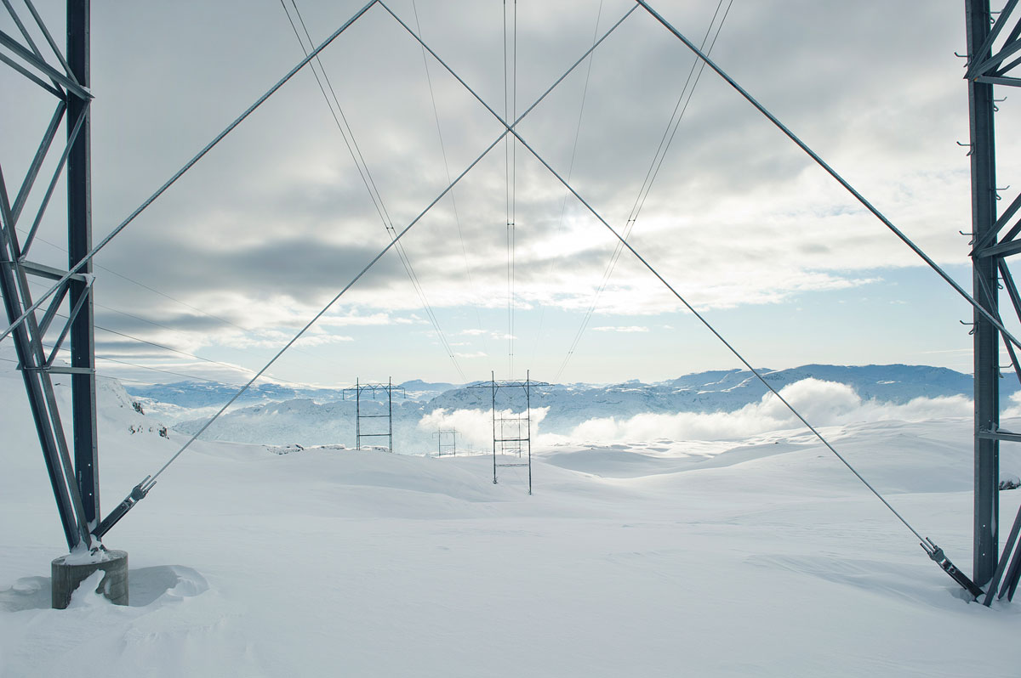

Power lines near the Hylsfjord

Photo: Johan Wildhagen/Statnett.

Power

In June 2024, the Norwegian Water Resources and Energy Directorate submitted a proposal for consultation concerning amendments to the regulations relating to contingency planning in the power supply system (kraftberedskapsforskriften) on the definition of power-sensitive data. The main objective is to clarify what constitutes power-sensitive data. The amendment also aims to adapt the regulations to the technological developments in society, changes in the threat situation and what information is already openly available.

## Strengthen national control over property of strategic significance or importance for security

In recent years, the intelligence and security services’ threat and risk assessments have focused on foreign ownership of properties in certain geographical areas. Ownership can pose a threat to national security interests in that the properties facilitate intelligence activities, sabotage, economic crime or other activities that threaten security. Hidden ownership of real property can facilitate this. The Government takes a broad approach to the ongoing work to address security challenges related to property.

Comprehensive overview of property ownership

Report No 9 to the Storting (2022–2023) National control and cyber resilience to safeguard national security, cf. Recommendation No 247 to the Storting (2022–2023) sets out the need for a comprehensive overview of property ownership. The Norwegian Tax Administration, the Brønnøysund Register Centre and the Norwegian Mapping Authority have mapped the authorities’ possible use of information about direct and indirect ownership and control of shares and real property. The mapping shows that there is no single joint register that serves to provide complete information about ownership of real property. The information available today is also of insufficient quality. The Government intends to increase control over property for reasons of national security by investigating statutory ownership registration to obtain sufficient information about the ownership of real property. The Norwegian Mapping Authority has been commissioned by the Ministry of Local Government and Regional Development to investigate measures to ensure an adequate overview and greater control over real property ownership.

The Bergen Engines case

The Bergen Engines case drew attention to acquisitions as a means of appropriating technology. Royal Decree 21/1898, the decision that halted the sale of the Bergen company, states that: ‘Norwegian industry and Norwegian knowledge and research institutions are targets for Russian intelligence activities. Russia shows particular interest in companies that have unique expertise and technology, including within the defence industry and maritime sector. The Western sanctions regime is causing Russia to seek alternative methods to acquire critical technology and expertise in order to further develop its own military capabilities. The use of private actors is an example of such a method, and is something which makes it more challenging to detect and prevent covert procurement.’

In the Bergen Engines case, the property’s location was emphasised in the grounds for halting the sale: ‘The property is strategically located beside the northern approach to Bergen and defence installations of security importance for Norway and allied nations. Russian intelligence activities against Norwegian targets and interests may make the property an interesting platform for Russian services.’

Pursuant to Section 2-5 of the Security Act, ‘The King in Council (…) may make necessary decisions to prevent activities which present a threat to security or other planned or ongoing activities which may present a not insignificant risk of a threat to national security interests.’ This provision serves as a safety valve and has only been used a few times, including in the Bergen Engines case.

[Boks slutt]

More stringent control over some types of properties

Certain properties may be important to security because they are located close to critical infrastructure such as ports, defence facilities or power supplies, and may thus be subject to activities that present a threat to security. The Government has strengthened control over such properties through amendments to the Security Act. The amendments entered into force on 1 July 2023 and provide an effective preventive tool to safeguard assets of significance to national security interests. If a ‘property of security significance’ poses a risk to an undertaking’s critical national objects and infrastructure, and the undertaking is unable to maintain a satisfactory level of security, the undertaking shall notify the national security authority or supervisory authority. Pursuant to Section 2-5 of the Security Act, The King in Council may make necessary decisions to prevent activities which may present a not insignificant risk of a threat to national security interests. If the state is going to sell a property, it is similarly important that it is aware of the impact this may have on security and preparedness in the future.

The Government will further strengthen control over properties of security significance, and will propose necessary amendments to rules to secure an approval scheme for the procurement of certain properties. The Norwegian National Security Authority (NSM) has made legal and security assessments of whether there is a legal basis for such an authorisation scheme, or whether the legal authority for such a scheme could be achieved by amendments to, for example, the Security Act. NSM has also considered introducing restrictions on foreign nationals buying property near military facilities. In its assessment, NSM has, in line with the assignment, paid particular attention to how the Finnish authorities have established their scheme, but also to other Nordic countries’ regulations as far as relevant.

## Svalbard

In May, the Government presented Report No 26 to the Storting (2023–2024) Svalbard, cf. Recommendation No 36 to the Storting (2024–2025). The report sets out that the Government will continue to actively use policy instruments in its Svalbard policy and strengthen state governance and national control in Svalbard. Svalbard is an important part of Norway, and its administration has always been associated with strong national interests. Report No 26 to the Storting (2023–2024) reflects this, and, in the report, the Government proposes various measures to strengthen national control and support Norwegian communities in the archipelago. This includes a review of responsibility for and management of critical infrastructure. National control contributes to, among other things, achieving the goals set by the Storting in the Svalbard policy. The goals require that regulations and frameworks for Svalbard are assessed and adapted in line with the development of society, as well as according to other relevant developments.

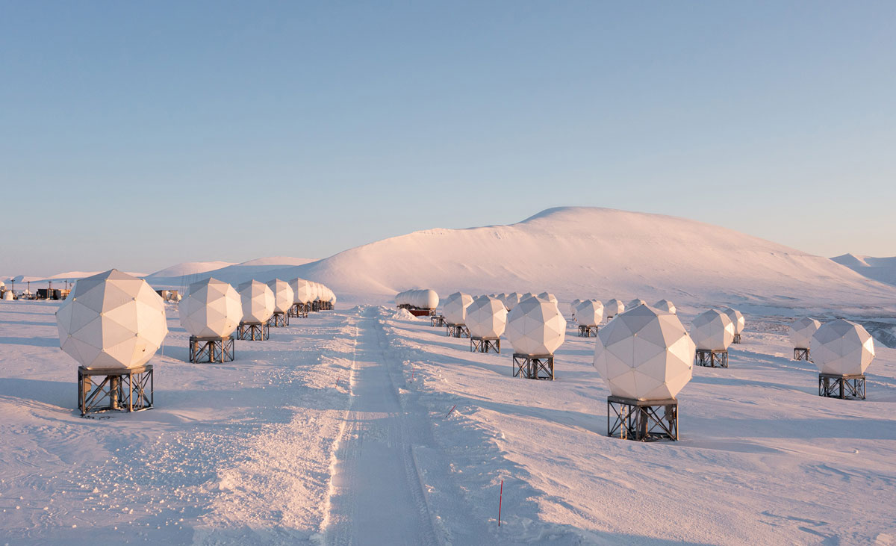

Svalbard ground station

Photo: KSAT – Kongsberg Satellite Services.

## Space activity

The importance of space activity for safeguarding national security is a separate topic in Report No 9 to the Storting (2022–2023) National control and cyber resilience to safeguard national security, cf. Recommendation No 247 to the Storting (2022–2023). The consequences of the loss of satellite-based services are highlighted in the Norwegian National Security Authority’s report Risiko 2024 Nasjonal sikkerhet – et felles ansvar (Risk 2024 National security – a joint responsibility – in Norwegian only). The Government’s digitalisation strategy 2024–2029 Digital Norway of the Future specifies that satellite-based services are part of the digital foundation, and national capability and resilience must be further developed and strengthened in the satellite area.

Society increasingly benefits from and depends on space. Space technology and satellites are of great significance for many important societal functions such as transport, power supply, monitoring of sea and land areas, communication and weather forecasting. Space-based data and services are therefore at the centre of security, preparedness and crisis management, and are already an integral part of safeguarding national security interests, for example for maintaining sovereignty, in the exercise of military force and in intelligence. The importance of space activity and geopolitical developments mean that situational awareness in the North is particularly important to both Norway and our allies.

Norway is a maritime nation with large marine areas in the far north. Satellites play a crucial role in safeguarding Norwegian interests in these areas. In times of emergency, crisis and war, the need for secure communication is significant and growing. We can become more robust by being able to employ different systems. Communication systems should therefore be based on a combination of satellite and ground-based solutions.

Norway is geographically well positioned for space-related activities such as launching and communicating with satellites and space surveillance. This makes it possible to establish national capability within certain satellite capacities. However, Norway is entirely dependent on international cooperation to safeguard total defence needs for secure access to space-based services. Such cooperation will also depend on Norway investing in its own capacities that both meet special national needs and have value for our partners. Norway is developing and deploying capacities to be able to make contributions to NATO cooperation, for example, and to be an attractive partner internationally, such as in the EU’s space programmes and bilateral cooperation.

Greater focus on space security

The Norwegian Armed Forces’ capabilities are largely dependent on civil functions, such as transport services and power supply, functioning in different parts of the crisis spectrum. These functions rely on various satellite-based services. In order to strengthen national security and total defence, we need to increase knowledge and awareness of satellite system dependencies, and of the consequences of the loss of satellite-based services in all sectors of society. The Government is implementing or has implemented a number of measures:

* The Security Act will be implemented in the space sector. Four space-related fundamental national functions have been identified: Satellite-based communication, satellite-based surveillance and earth observation, space surveillance and positioning, navigation and timing.
* The loss of satellite-based services has been included in the planning of the Øvelse Digital 2025 exercise as one of several areas that should be given special attention.
* Investigation of a national ground-based time service that ensures the accuracy of our timekeeping capability.

The Government is drafting a new act on activity in outer space (the Space Act). The new act will safeguard Norway’s obligations as a responsible space nation, commercial development and national security interests. A bill is scheduled to be submitted for consideration by the Storting in the first quarter 2025.

[Boks slutt]

Civil-military cooperation on surveillance and communication

In light of the total defence concept, national coordination through civil-military and public-private cooperation is important for also ensuring effective and secure utilisation of space activities. The following initiatives and capacities, represent some of the key collaborations:

* A civil-military cooperation model has been established, Arctic Surveillance Program (ASP), for the development of new national capacities for maritime surveillance in the High North. This model ensures greater access to better satellite data, multi-use of satellite data, development of a Norwegian industrial value chain and, not least, that civil and military resources pull together in a cost-effective manner. Maritime satellite-based surveillance data is also a useful contribution to allied cooperation. Under the ASP framework, work is now underway on a pilot project for a separate national system for satellite-based surveillance.
* In November 2023, the Norwegian Space Centre was commissioned to temporarily cover the role of national civil entity for space traffic surveillance (SER). Together with the Norwegian Armed Forces, SER will clarify operational national civil-military cooperation and develop Space Surveillance and Tracking (SST) capacity, including assessing an SST sensor under national control.
* Located at high latitudes in Svalbard, Svalsat has a unique capacity for downloading satellite data for both civil and military needs. For example, Svalbard is one of the most important points for downloading weather data that helps ensure accurate weather forecasts the world over. Weather forecasting is critical for civil society, but not least for the Norwegian Armed Forces in a crisis or war situation. A new fibre optic cable to be established from Svalbard and Jan Mayen will ensure the transmission of data to the mainland for both civil and military needs. Space Norway’s geostationary satellites provide similar connectivity as the Troll Station in Antarctica.
* In August 2024, two Space Norway satellites were launched as part of the Arctic Satellite Broadband Mission. The satellites carry payloads from the US military, the Norwegian Armed Forces and the commercial company Viasat, and provide better connectivity and situational awareness in the north.
* We are also making efforts to secure participation in the EU’s new programme for secure global satellite-based connectivity for official purposes, Secure Connectivity/IRIS2. This is a civil system, but may also be used for military purposes.
* Andøya Spaceport has been established on a commercial basis, but will nonetheless be an important strategic resource for Norway in a total preparedness perspective. The development of the spaceport will potentially help to strengthen Norway’s and its allies’ capability to quickly launch new satellites that need to be replaced in peacetime, crisis and war.

[Boks slutt]

# Cyber resilience

The need for cyber resilience is increasing as a result of the security policy situation and the scope of digital vulnerabilities and cyberattacks. Cyber security in a national perspective requires long-term, predictable investment throughout society. The Government is implementing a number of measures to ensure that Norway establishes and maintains adequate national cyber security capacities and expertise. The work includes structural measures for closer involvement of the business sector and material measures to develop increased capacity to prevent, detect and manage cyber incidents.

Report No 9 to the Storting (2022–2023) National control and cyber resilience to safeguard national security – As open as possible, as secure as necessary, cf. Recommendation No 247 to the Storting (2022–2023), lays the political groundwork for the Government’s strategic direction, priorities and measures. A key aspect of the report is the use of regulatory instruments to make organisations accountable. At the same time, the authorities must make efforts to strengthen, coordinate and simplify preventive security work.

In addition to prioritising preventive work, Norway must have sufficient capacity to handle cyberattacks that are constantly increasing in both number and complexity. In recent years, significant resources have been deployed to defend Norway against harmful cyberattacks. Even though many good measures have been implemented, the cyber field is developing rapidly, and the Government will therefore implement further measures to strengthen cyber security on a par with our allies and partners.

The Government will:

* assess, in cooperation with the business sector, a cyber security reserve consisting of relevant authorities and business communities.
* strengthen research, innovation and technology development in cyber security through NCC-NO.
* increase advisory and incident management capacity through the National Cyber Security Centre in the Norwegian National Security Authority.
* participate in a Nordic-Baltic collaboration to increase operational cyber security cooperation.
* develop a national portal for cyber security and a support tool to strengthen advice and guidance, and improve organisations’ digital self-preparedness.
* strengthen the authorities’ cyber security coordination.
* plan a national cloud service to ensure increased national control of critical digital infrastructure, important societal functions and digital assets.
* strengthen quantum technology research through the Research Council of Norway.
* consider measures to increase the number of people with the necessary cyber security expertise and ensure the most effective use of the expertise available.
* continue to earmark funds for the Research Council’s industrial PhD and public sector PhD schemes aimed at cyber security and cryptology, for qualified applicants with security clearance.

## Cyber security reserve in collaboration with the business sector

The lack of adequate cyber security expertise in society makes it all the more important to make the best possible use of the resources we have. Business and industry have important capacities, knowledge, expertise and innovative power. Key business sector representatives should be systematically and formally included in national cyber capacity. A number of leading countries have established or are planning cyber security reserves to strengthen the authorities’ incident management capability. Expert committees and environments have recommended that Norway also establish such a reserve. Efforts to improve preparedness for cyber security incidents are also high on the international agenda, one example being the ongoing work in the EU on the Cyber Solidarity Act. The Government is now following this up.

The Government will assess a cyber security reserve consisting of relevant authorities and business communities. Such a programme will be a predictable and scalable tool for effectively contributing to the management of crises that require efforts beyond ordinary staffing. The programme could also facilitate harmonisation of security work between actors and ensure closer cooperation between the authorities’ expert environments, academia and businesses, as pointed out by the Total Preparedness Commission.

The cyber security reserve will be particularly important in the event of major crises and incidents that require extra capacity and expertise. The structure of the reserve must be assessed in more detail, but it could entail the authorities entering into agreements with pre-designated business and industry actors with special expertise and resources in cyber security. The setup of the reserve will be assessed in collaboration with the business sector. The initial assessment must include existing frameworks and capacities at national and sector level, relevant actors, prioritisation mechanisms for assistance and agreements between authorities and the business sector that can regulate personnel expenses and set predictable thresholds for the use of the reserve. The setup of the reserve must be seen in the context of work on civil workforce preparedness. Consideration will also be given to international schemes and experiences.

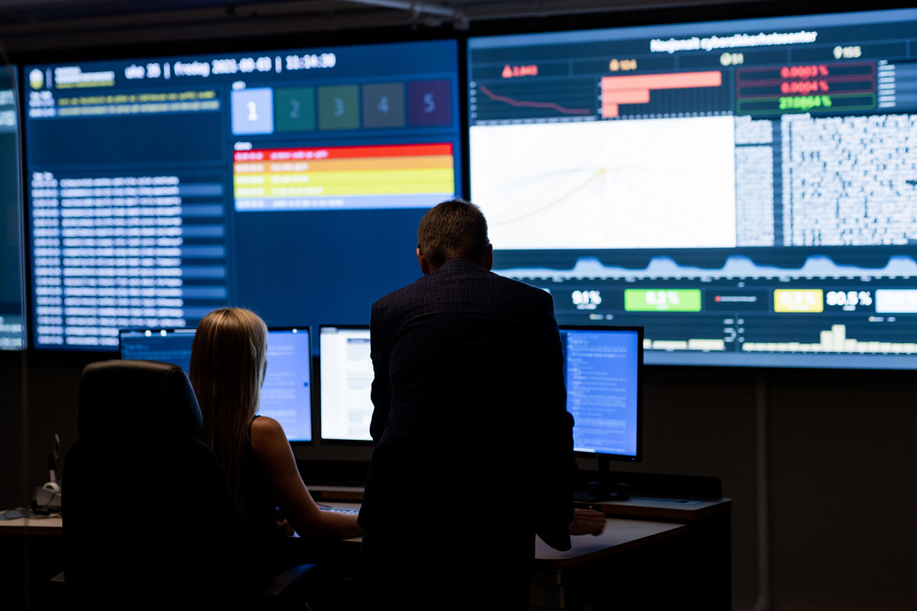

National Cyber Security Centre

Photo: Norwegian National Security Authority.

## Facilitate a stronger cyber security industry

The authorities wish to encourage increased research, innovation and technological development. Among other things, this means contributing to a cyber security industry where security services are requested, developed and offered. One example is NSM’s quality scheme for suppliers’ management of ICT incidents. A stronger cyber security industry will increase the security of society, across public authorities and organisations, by bolstering suppliers who recognise market needs and security requirements.

The EU regulation establishing a network of national cyber security coordination centres is a key measure that Norway is following up. NSM and the Research Council of Norway have joined forces to establish a coordination centre for cyber security research and innovation, referred to as NCC-NO, with EU funding. An important task for NCC-NO will be to promote and guide applicants in the EU’s investment programme DIGITAL and Horizon Europe. Among other things, NCC-NO has established a cyber security grant scheme. The scheme is available to actors that support digital and critical infrastructure, small and medium-sized enterprises, public and private companies, as well as research and educational institutions.

## Increased capacity for advisory services, detection and incident management

Readily available advice and the effective establishment of measures are essential for increasing organisations’ digital self-preparedness. The National Cyber Security Centre under NSM plays a key role in assisting public and private organisations in their preventive security work and ensuring contact between the various environments. The capacity of NSM has been strengthened to meet the ever-increasing need for advice and guidance, in line with the more serious threat and risk picture and in accordance with NSM’s expanded mandate.

The Government will develop a national portal for cyber security and a support tool to strengthen advice and guidance, and improve organisations’ digital self-preparedness. Key actors will participate in the work led by NSM. In the long term, the measure will be a central and effective tool in one-to-many guidance for organisations and possibly private individuals. The portal will be a common gateway for different user groups, but will be designed so that everyone receives uniform advice adapted to their user group. The portal will be launched in 2025.

Cyber incidents often occur across national borders. National capacities for detection and incident management must be supplemented by international capacities. European states and other allies are increasingly influencing Norwegian cyber security policy, and have in recent years taken major steps to secure resilience against cyber threats. The EU’s NIS directives will improve cooperation between member states, both in the event of serious incidents affecting important digital systems and in the event of major crises. Denmark has recently taken the initiative to establish a Nordic-Baltic cyber security collaboration (Cyber Consortium) centred in Copenhagen. Its object is to increase operational cyber security cooperation among the Nordic and Baltic countries. The measure is seen in the context of the EU’s work on cyber security, where the establishment of cyber hubs is a key measure to increase countries’ situational awareness and detection capabilities. The Government has decided that Norway will participate in the cooperation. Participation will increase situational awareness nationally and regionally, and send an important signal that we stand united at a time when multilateral arenas, such as NATO and the EU, are increasing their efforts in the field. The Government is also facilitating stronger incident management by increasing NSM’s capacity for incident management and practical assistance to affected organisations.

National cloud service

The Government has initiated work to establish a national cloud service. The object of a national cloud service is to ensure increased national control of critical digital infrastructure, important societal functions and digital assets. A concept evaluation study is based on the central government’s need for a national cloud service for unclassified critical national information. The study addresses both technological, security-related, organisational, legal and financial issues. A wide range of concepts have been evaluated, with varying degrees of coordination, competitive tendering and own control of cloud services.

The Government’s choice of concept is based on the conclusion of an agreement with one or a few suppliers that will develop, operate and manage a national cloud service. The chosen concept will give the Government access to expertise, resources and innovation. Suppliers will be required to fulfil and provide guarantees for the requirement of national control of the cloud service. The regulations concerning cloud services will also be clarified.

[Boks slutt]

## Consistent advice and guidance from the authorities

It is currently a challenge for organisations that different regulations and guidelines overlap and are poorly harmonised. The lack of good coordination hampers preventive cyber security work, such as knowing which regulations you are covered by, which authorities you need to deal with, and which advice and guides should be used. As a result, the implementation of regulations is often delayed or inadequate, which, in the worst case, can mean that important assets are inadequately secured, in turn entailing significant economic and social consequences.

The Cyber Security Act was adopted on 7 December 2023, but has yet to enter into force. The Act is based on the NIS1 Directive and is an important tool for setting common security requirements for providers of essential and digital services. An advisory service is needed to make advice and guidance more coordinated and accessible, in line with the recommendations from the National Audit Office of Norway, among others.[15]

A key element in Report No 9 to the Storting (2022–2023) on national control and cyber resilience, cf. Recommendation No 247 to the Storting (2022–2023), is to increase coordination. This is to both make it clearer and easier for organisations to maintain an overview of regulations, advice and guidance, but also to ensure a better division of roles and responsibilities for efficient use of public resources.

In order to strengthen resilience, it is also important that organisations adhere to NSM’s basic ICT security principles, which are a set of principles and measures to protect information systems against unauthorised access, harm or misuse.

One key element has been to give NSM an expanded responsibility to provide guidance across the entire spectrum from citizens, small and medium-sized enterprises and municipalities, to large organisations and actors with responsibility for critical infrastructure. NorSIS, the Norwegian Centre for Information Security, has become part of NSM. Employees of the inter-municipal company Kommune-CSIRT have been offered employment with NSM. Moreover, HelseCERT’s mandate has been expanded so that it now also functions as a response and expertise centre for municipalities, including the county authorities. The Government has thus taken steps to strengthen guidance environments in several parts of the country, including rural areas.

The Government will map user needs and experience of the current organisation of cyber security guidance. The aim of this is to assess tasks, responsibilities and organisation.

## Stronger expert environments in quantum technology

Quantum technology is a multi-use technology with civil and military applications. Quantum technology will provide better and more efficient services, products and security measures in most areas of society. At the same time, the technology will provide malicious actors with new tools, capacities and methods whose reach is unknown. The day quantum computers become powerful enough, they will be able to weaken cyber security by breaking many of the most commonly used encryption methods.

Cryptography is currently available that is assumed to be quantum-resistant and that is standardised for public use. IT suppliers such as Microsoft, IBM, Apple and Google use these quantum-proof standards in their products. However, some organisations have specially developed solutions that do not take this into account. It will therefore be important to develop knowledge about how security can be addressed in such solutions. In future systems and services, it will be important to address the need for quantum-resistant algorithms.

For 2025, the Government has proposed, and the Storting has approved, strengthening research into quantum technology through the Research Council of Norway by raising the annual allocation by NOK 70 million in relation to the current rate. This is an investment in knowledge preparedness in Norway, to ensure that Norway has the necessary expertise to handle Norwegian security needs and increase defence capability, and also prepare the business sector for a new technological reality and a new competitive landscape. The Research Council will organise its efforts to develop a robust national expertise environment of high international quality that will be able to compete and succeed in other arenas.

The initiative is part of the R&D pledge in the long-term plan for the defence sector. Quantum technology is of great importance to the defence sector because it can change the future of radars, sensors, navigation and data processing. The technology is both an opportunity and a threat to the technological development of the Norwegian Armed Forces. The initiative must be seen in the context of the Government’s work on a roadmap for tech-based businesses. The roadmap will describe the new terrain that is emerging and how business, research institutions and the public sector can navigate together to find ways to achieve transformation and value creation.

New national digitalisation strategy

In autumn 2024, the Government presented The Digital Norway of the Future – National Digitalisation Strategy 2024–2030. The strategy has specific goals for where Norway should be in terms of digitalisation in 2030. Overall, the strategy will help make Norway the most digitalised country in the world, through, among other things, stronger governance and coordination of digitalisation policy. The strategy refers to a number of prerequisites that must be in place for digitalisation to succeed, including ‘bolstering security, emergency preparedness and crime prevention’. The strategy contains measures for various focus areas, including AI. In connection with the 2024 budget, it was proposed that the allocation for AI research be increased by NOK 1 billion over five years. The funding comes on top of the more than NOK 800 million already allocated to AI research through the Research Council of Norway. During 2025, Norway could see four to six new AI research centres. Together, the research centres will cover the three main tracks of the AI billion-kroner investment: societal impact, technology and innovation.

[Boks slutt]

## Increased expertise in cyber security

Access to cyber security expertise is vital for developing cyber resilience. Cyber security expertise is currently a scarce resource. The lack of such expertise is not only a challenge in Norway, but also an international challenge that has received increased attention from our allies.

A study conducted by the NIFU Nordic Institute for Studies of Innovation, Research and Education in 2023 on the Norwegian labour market’s need for cyber security expertise towards 2030 shows a shortage of 25%, i.e. that one in four positions will be unfilled in 2030.[16] A similar study was also conducted in 2017. Compared with the 2017 study, unmet demand has decreased slightly because educational institutions have increased their capacity. Today, more people are studying cyber security both because more specialised study programmes are available in the field and because more study programmes include cyber security as a subject area.

Over time, there has been increased attention and high expectations in this field, particularly in relation to what the authorities are doing to meet the need for expertise. In 2019, the Ministry of Justice and Public Security and the Ministry of Education and Research drew up a national strategy for cyber security expertise with goals and measures for various focus areas. The 2023 study from the NIFU Nordic Institute for Studies of Innovation, Research and Education confirms the effect of several of the measures, but the challenges have not been solved. It is important to emphasise that Norway already has a high level of expertise in cyber security, but more people are needed with this type of expertise and measures to boost expertise must be sufficiently targeted. In Report No 5 to the Storting (2022–2023) Long-term plan for research and higher education 2023–2032, cf. Recommendation No 170 to the Storting (2022–2023), the Government will, among other things, prioritise facilitating the education of more engineers, graduate engineers and graduates with interdisciplinary expertise on societal security, more PhD candidates who can be granted security clearance and strengthen digital security expertise in key disciplines.

The challenges relating to expertise apply across both the civil and military sectors. The training exercise Locked Shields 2024 (see Box 4.5) showed that the Norwegian participants from NSM, the Norwegian Cyber Defence Force and the business and industry had good, thorough expertise in the topics covered by the exercise. The challenge is that we are not developing and establishing access to enough of this expertise to meet demand. This clearly shows that we must be better at utilising the resources we already have, among other things by considering more efficient work methods, as well as developing and increasing access to expertise.

The Ministry of Education and Research is responsible for education policy and has the most important instruments for assessing measures to ensure that we can meet needs. The Government has decided to consider measures to reduce the skills gap between supply and demand with respect to cyber security. The Ministry of Education and Research will follow this up in consultation with the Ministry of Justice and Public Security, the Ministry of Defence and other key ministries. The Government will continue to earmark funds for the Research Council’s industrial PhD and public sector PhD schemes aimed at cyber security and cryptology. These funds are available to all qualified applicants who have security clearance.

Part IV

Civil society support for military efforts

# Further developing total defence for civil society support for military efforts

As announced in Proposition 87 to the Storting (2023–2024) The Norwegian Defence Pledge – Long-term Defence Plan 2025–2036, the Government will further develop a total defence system that is more active in day-to-day life and prepared for war.

In war, the Norwegian Armed Forces will not be able to provide the same assistance to civil authorities as during peacetime, because the Armed Forces will be tied up with military tasks. In such situations, allied and national military forces will also have a significant need for civil support, including deliveries of critical inputs, support for the reception of allied reinforcements, transport of equipment and personnel and access to personnel with special expertise. The collective defence capability through NATO, including Nordic cooperation, is key to civil society’s support for military efforts (see Section 3.10.1).

The Government will:

* build a common basis for civil preparedness planning to enable civil sectors to support military efforts and handle other undesirable incidents.
* consider common planning assumptions for civil preparedness.
* harmonise national civil plans with military planning.
* assess the need for reinforced cross-sectoral efforts in Troms and Finnmark counties to strengthen civilian resilience in these areas, in dialogue with local and regional actors.
* support a pilot project for bolstering civilian resilience in Finnmark.
* assess the need to strengthen civilian resilience in strategically important geographical areas to be able to maintain fundamental services for the public and to strengthen civilian capability to support military efforts.
* ensure stronger control of the border with Russia.
* consider whether current preparedness legislation contains the necessary authorisations to handle anticipated crisis situations.
* ensure that assessments of legal authority are included as part of contingency plans and training exercises.
* consider the need for separate guidelines for the implementation of legislative and regulatory processes during crises that mean normal procedures cannot be followed due to time constraints.
* ensure that legislation facilitates preparedness of the civil workforce during security policy crises and war.
* further develop military mobility, including by developing a strategic corridor for military mobility through northern Norway, northern Sweden and northern Finland.

Proposition No 87 to the Storting (2023–2024) The Norwegian Defence Pledge – Long-term Defence Plan 2025–2036

* A total defence prepared for war means that the work to support military combat must be prioritised and resourced in peacetime by all sectors with responsibility for total defence. The Government will therefore set annual priorities for this work across the sectors.
* The Government will establish fixed procedures to ensure that estimated military needs for civilian support are communicated in as specific terms as possible to ministries with sectoral responsibility for total defence.
* The Government wishes to ensure that all sectors with responsibility for total defence have plans for supporting military forces in crisis and war, and that the sectors take military needs into account in their emergency preparedness.
* The Government will make it easier for total defence actors to train within the framework of military exercises.

[Boks slutt]

## Develop a common basis for preparedness planning in civil sectors

Prevention, preparedness and crisis management capability require knowledge of the incidents that could affect us. Such knowledge is important for identifying vulnerabilities, assessing and prioritising relevant measures, and training in incident management. Knowledge is also crucial for good coordination and utilising society’s collective resources as effectively as possible. Since all major incidents have cross-sectoral consequences, and therefore require that actors in different sectors contribute and cooperate, the necessary planning must be in place for such incidents A common basis is needed for civil preparedness planning.

In war and under the threat of war, national and allied forces will have a particular need for support from civil sectors. Civil sectors must therefore be familiar with military needs. There is currently close cooperation between the Norwegian Armed Forces and civil sectors at the organisational level on preparedness and crisis management, including the need for civilian support. As pointed out in the new long-term defence plan (Proposition No 87 to the Storting (2023–2024)), the communication of military needs must also be strengthened to ensure it flows to all the necessary levels of civil society. As announced in Proposition No 87 to the Storting (2023–2024), the Government will therefore establish fixed procedures to ensure that the need for civilian support for military efforts in accordance with military planning is communicated more systematically and in as specific terms as possible to ministries with sectoral responsibility for total defence. The need for civil support for military efforts is derived from plans, and they are estimates.

Clearer communication of military needs is important for civil society’s ability to assess, decide and implement measures within their respective areas of responsibility. The capability to support military forces requires all sectors to prepare for this in peacetime. Supporting military efforts for the defence of Norway is a social responsibility that is incumbent on all sectors, agencies and actors, both private and public. At the same time as civil sectors have the capability to support military efforts, civil society must be able to maintain critical societal functions and protect the civilian population.

In addition to their capability to support military efforts in accordance with military plans, civil sectors also need to plan for other serious crises. In its first report, the Coronavirus Commission pointed out that pandemic preparedness was not satisfactory, despite the fact that the Directorate for Civil Protection in its analyses of crisis scenarios had assessed a pandemic as the scenario with the highest overall impact. The Directorate for Civil Protection’s scenarios are not factored into preparedness, but the Government will clarify its expectations of how ministries responsible for civil sectors should assess the impact of new and updated crisis scenarios from the Directorate on their own sector.

Based on the above, the Government is clarifying the common foundation for preparedness planning in civil sectors. The purpose is to facilitate the necessary coordination and cross-sectoral assessments, and to ensure that civil sectors are capable of supporting national and allied military efforts in security policy crises and war. In addition, civil society must be resilient enough to maintain critical functions in important areas of society. The common foundation consists of

* estimated military needs for civilian support in accordance with military plans for defending Norway.
* all civil sector ministries being required to document that they have assessed the impact of new and updated crisis scenarios from the Directorate for Civil Protection on their own sector.

In its work on the planning foundation, the Government will consider common assumptions for civil preparedness. These are conditions that may form the basis for the necessary preparedness, and may include, for example, whether restrictions should be imposed on imports and exports, whether certain geographical areas of the country should be prioritised specifically in preparedness work, the capacity for evacuating people in a given situation, or timeframes for how quickly preparedness measures can be established.

Measures related to a common foundation for preparedness planning in civil sectors could have both financial and administrative consequences. Interdependencies and coordination needs between sectors on the civil side must also be clarified, including prioritisation needs. Follow-up by the civil sectors must therefore be systematic and coordinated. The Ministry of Justice and Public Security will, by virtue of its coordinating role in the civil sectors, provide guidelines for this follow-up work. This work will be seen in the context of the work in the new common structure at ministry level for preparedness planning and status assessments in civil sectors, see Section 3.1. This work is coordinated with the Ministry of Trade, Industry and Fisheries’ follow-up of supply preparedness, see Section 11.1.

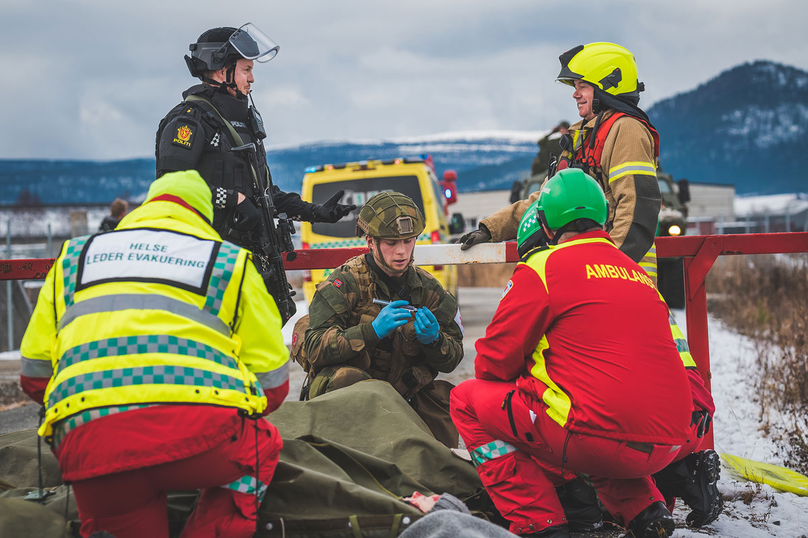

Total preparedness training exercise

Photo: Ole-Sverre Haugli/Norwegian Armed Forces.

## Military mobility

In Report No 14 to the Storting (2023–2024) National Transport Plan 2025-2036, the Government is taking several steps to adapt the transport sector to a new security policy situation. Several projects and measures during the planning period will support both public security and the military defence of Norway. Measures that safeguard effective military mobility must be taken into account in the planning period. See also Section 3.10.1.

The development and improvement of transport infrastructure is usually both time-consuming and costly, and the planning of major infrastructure projects often takes years. A number of goals and considerations must be weighed against each other in relation to the development of the transport system. In order to take military needs into account, it is important that, as far as possible, these needs are included in the ordinary processes for assessing, planning and prioritising measures and resource use in the transport sector. The Government has therefore decided to establish a clearer framework for interaction between the transport sector and the defence sector, which will clarify and communicate military needs. The framework will facilitate timely, coordinated and relevant input from the defence sector to the transport sector, and thus form part of the basis for priorities in the transport sector, including input to budget processes and future national transport plans.

Strengthening military mobility is an important aspect of exercises and training. The main goal of this work is to facilitate rapid and seamless military movement across borders. Cross-border mobility will facilitate cooperation across national borders, including at the high end of the crisis spectrum.

The work to facilitate military mobility must involve all sectors and organisations that have a responsibility for military mobility, such as Norwegian Customs and the police. Civil sectors contribute by coordinating measures related to securing freight, security of supply, evacuation axes, border control, veterinary services, etc., also in connection with major exercises. Norwegian Customs has formalised border customs cooperation with the EU (through agreements with Sweden and Finland), which gives the agency considerable insight into the various aspects of cross-border traffic and a role in safeguarding Norway’s obligations in cooperation on the border with our neighbouring countries, also in the event of crises, see also Section 5.4.10.

The Government will continue its efforts to further develop military mobility in the Nordic region, including by developing a strategic corridor for military mobility through northern Norway, northern Sweden and northern Finland to help move personnel and materiel from Norwegian ports to Sweden and Finland.

## National Preparedness and Response System

The planning basis described in Section 10.1 is important for the further development of the National Preparedness and Response System (NBS) and underlying plans. NBS is a collective term for the Civil Preparedness and Response System (SBS) and the Defence Sector Preparedness and Response System (BFF). NBS is a cross-sectoral procedure and decision-making tool for central political authorities and individual heads of organisations in the event of a security policy crisis, armed conflict and other cross-sectoral crises. Preparedness planning based on NBS, together with relevant underlying plans, facilitates the capability to respond effectively and interact across military and civil sectors. NBS is harmonised with the NATO Response System to ensure rapid and coordinated decisions between Norway and NATO, but is adapted to national conditions and needs.

Clear and thorough underlying plans in the sectors are a prerequisite for the system having effect. The Ministry of Justice and Public Security is responsible for coordinating SBS on the civil side, while the Ministry of Defence is responsible for coordinating BFF in the defence sector. The Ministry of Defence and the Ministry of Justice and Public Security are jointly responsible for ensuring conformity between BFF and SBS. The Directorate for Civil Protection has a special responsibility to help ensure that underlying civil plans are coordinated.

NATO has revised its response system to ensure it supports the Alliance`s Three Core Tasks, and to make it simpler and clearer. The Government will review NBS in 2025, in line with NATO’s revision.

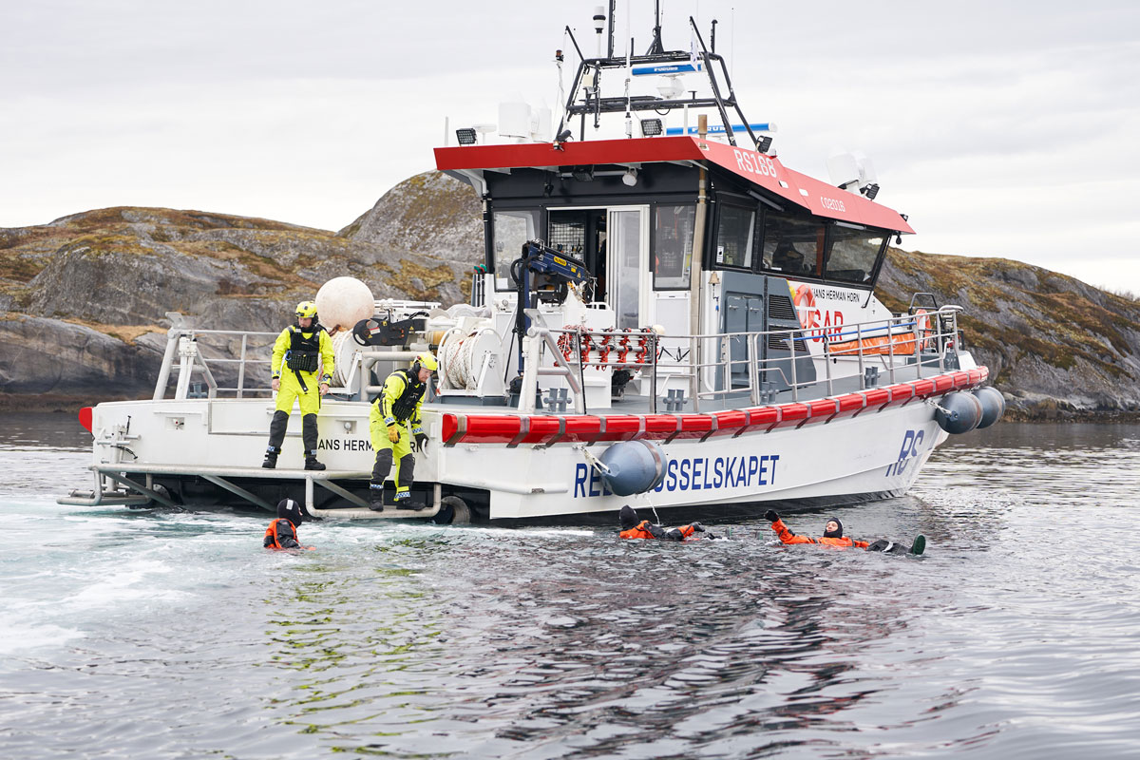

The Norwegian Society for Sea Rescue during the Arctic REIHN exercise in 2023

Photo: Raymond Engmark.

## The High North, the Nordic countries and northern Norway

The High North is Norway’s most important strategic area of interest. The High North comprises the land and maritime areas from southern Helgeland in the south to the Greenland Sea in the west and the Pechora Sea (the south-eastern corner of the Barents Sea) in the east. As pointed out in the new long-term defence plan (Proposition No 87 to the Storting (2023–2024)), the Government aims to contribute to predictability and stability in the High North. In turbulent times in which a growing number of states are showing greater interest in the High North, Norway must be able to understand, influence and shape developments in the region and the Arctic. Safeguarding stability and Norwegian interests will require more of Norway in the years to come, both in civil and military terms. We must expect Russia’s activity in the High North to continue as the area is of strategic military importance to Russia.

Civil resilience must be developed throughout Norway. The security policy situation, seen in the context of NATO’s military planning, national military planning and national conditions, indicates that there are certain geographical areas in Norway that are assumed to be of greater importance for the Norwegian Armed Forces and allied operations in crisis and war, and which therefore require adapted measures. Proposition No 87 to the Storting (2023–2024), cf. Recommendation No 426 to the Storting (2023–2024), stresses that Northern Norway is the Norwegian Armed Forces’ most strategically important operational area and an important hub for allied activity. At the same time, Finland’s and Sweden’s entry into NATO and changes to NATO’s planning framework could mean that other strategic areas of Norway will also play a particularly important role in civilian support for military efforts.

### Bolstered civilian resilience in Troms and Finnmark

The changed security situation in Europe has created a new situation on the Schengen border with Russia. It is of paramount interest to national security to ensure credible and adequate civil surveillance and control along this land and sea border, but also in the land areas and in connection with critical infrastructure in Troms and Finnmark.

Settlement, activity and thriving local communities throughout the country are vital for Norway, particularly in the north. The Total Preparedness Commission (Norwegian Official Report (NOU) 2023: 17) highlights the need for a national action zone for preparedness in Troms and Finnmark counties, based on NATO’s baseline requirements of resilience in critical civil society functions. In addition to the economic measures that are part of the existing action zone to stimulate settlement and business activity, this will involve further measures to strengthen preparedness.

The counties of Troms and Finnmark cover large areas, and critical services such as health and social care, police and fire and rescue services can be apart. Some areas are characterised by population decline, ageing, scattered settlement and the disadvantages of great distances for residents and businesses. There is also poorer access to welfare services due to a lack of sufficient and qualified labour. These are challenges that are part of international trends, and not issues that one actor can solve alone. At the same time, they affect the municipalities’ ability to bolster civilian resilience and fulfil their total defence tasks.

Vulnerable supply lines and limited pre-storage of inputs (food, fuel, medicines etc.) can affect emergency preparedness and resilience in Troms and Finnmark, and necessitate assistance from other parts of the country in the event of major incidents. Demanding climatic conditions can challenge resilience and make it more difficult to handle simultaneous incidents. A decentralised organisation of the emergency services is therefore important to the Government, to ensure, among other things, rapid response and local knowledge.

Eastern Finnmark is in a particularly vulnerable position, given its geographical and strategic location on the border with Russia. In addition to being Norway’s national border, it is also NATO’s northernmost border and the outer border of the EU and Schengen area. Incidents such as GPS interference, photos being taken of installations and border activity are constantly being reported.

The Finnish Border Guard has noted that the Russian authorities at the border between Finland and Russia have changed their practice, and now allow travel from Russia to Finland even without the necessary documents. According to the Finnish authorities, it is evident that the Russian authorities, together with other actors, have helped people to illegally cross the border into Finland. Since the influx of migrants in 2015, Finland has also made changes to its legislation that allow for the closure of border crossing points to safeguard its national security.

In response to Russian instrumentalisation of migration, Finland has closed its border crossing points with Russia indefinitely. Finland, the Baltic states and Poland are all prioritising security measures at their borders. The National Police Directorate and the Norwegian Defence Staff have assessed the security level at the border with Russia. A follow-up report from the National Police Directorate in 2024 outlines a number of possible measures related to the assessment of surveillance, detection and emergency response capacities and the capacity to handle border violations. This report is under consideration. The National Police Directorate applied for EU funding for its work on following up the report. The EU awarded Norway Euro 16.4 million to strengthen surveillance of the border with Russia. The Government will ensure stronger control over the border with Russia.

The border with Russia

The national border between Norway and Russia is 197.7 kilometres long, and two-thirds run through the Pasvikelva river. Since 1959, the Norwegian Armed Forces have been responsible for surveillance on the Norwegian-Russian border. The Garrison in Sør-Varanger (GSV) carries out the task on behalf of and in collaboration with the police. Cooperation with the Norwegian Armed Forces is established in the Border Act. The national border can only be crossed at the Storskog border crossing point, and valid travel documents are required. The Border Guard is actively engaged in preventive information work with its own patrols, and the area is under continuous surveillance. The Border Guard has police authority and works on behalf of the police to provide information and implement preventive measures against offences in border areas and waterways. This also means that the Border Guard’s personnel can issue orders if they identify traffic and behaviour that may lead to a breach of legislation. The police has national responsibility for the Schengen external border and identity checks at the Storskog border crossing point. There is close cooperation between the police in Finnmark, the Border Commissariat and GSV. Among other things, the Border Commissariat is obliged to maintain a dialogue with their Russian counterparty regarding matters described in the Border Agreement in order to assist the work of the Border Guard and the police.

[Boks slutt]

The Government has already initiated work to look at cross-sectoral measures in eastern Finnmark within four main areas: emergency preparedness and security, well-functioning local communities, skills and education, and business development. The work facilitates both professional and political dialogue with local and regional actors, and it will form the basis for measures and priorities in ongoing processes in the sectors. The Government has allocated funding for a pilot project to increase resilience and preparedness in Finnmark (see Box 10.3).

Pilot project – Strengthening resilience in Finnmark

The County Governor of Troms and Finnmark, the police and the Norwegian Armed Forces in Finnmark have joined forces to establish a pilot project to increase resilience and bolster local preparedness in Finnmark. The main aim of the project is to raise awareness of total defence and emergency preparedness, with the goal of increasing young people’s knowledge of preparedness and to strengthen local preparedness councils. The Government believes that this is a good measure and that it is important that the pilot is evaluated with a view to identifying relevant elements that can be implemented in other strategically important areas. The Government has therefore proposed, and the Storting has approved, an allocation of NOK 2 million to the pilot. The Ministry of Justice and Public Security will also ask the Directorate for Civil Protection to contribute to the evaluation and transfer of experience to other county governors.

[Boks slutt]

The Government will also endeavour to increase cooperation with Sweden and Finland in the north to contribute to viable civil communities. The Barents Euro-Arctic Council is already working on health and health preparedness. The Government will facilitate and support regional and local initiatives and focus areas that support national public security and emergency preparedness initiatives.

The Government shares the Total Preparedness Commission’s assessment of the need for stronger measures in the north. The Government will assess the need for stronger cross-sectoral efforts in Troms and Finnmark to strengthen civilian resilience in these areas, taking into account NATO’s seven baseline requirements for resilience in critical civil society functions (see Box 3.1). The Government will enter into dialogue with the affected counties and municipalities to assess possible measures to increase the resilience of civil society.

The Government’s goal of vibrant and thriving communities in the north has a clear regional policy rationale, but strong communities in the north are also important for bolstering Norwegian resilience. The Government’s ongoing work related to eastern Finnmark will help strengthen civilian resilience. This work will also contribute to the assessment of whether a similar process can be used to enhance civil resilience in other geographical areas.

### Follow-up of other strategically important geographical areas

Strategically important geographical areas may be areas for allied reception, host nation support, corridors for the transport of military material or special needs for evacuation both in Norway and between allies, or areas with important inputs and services. There may also be areas that are particularly vulnerable to impacts and incidents that challenge critical societal functions or critical infrastructure, thereby threatening national security.

The Government will consider what measures need to be implemented to strengthen civilian resilience in these areas, including the possibility of increased cross-border cooperation. Relevant measures in the geographical areas may include strengthening critical infrastructure, more targeted work on self-preparedness, skills development, and facilitating the strengthening of municipal preparedness and holding training exercises for specific scenarios. Other examples include measures that increase security of supply through requirements for transport capacity (available transport resources) and stockpiling, as well as measures that ensure the presence of authorities and other measures that enable secure access to preparedness actors. It may also involve facilitating greater coordination and cooperation between different sectors’ approaches to the municipalities, between the municipalities and other public administration levels, cross-sectoral planning, and training and exercises between the defence sector and civilian actors, without weakening local autonomy. These are relevant measures to strengthen public resilience and the total defence capability to handle crises and war. Nordic cooperation, within the framework of NATO and European cooperation, are important elements in this work.

Several of the measures in question require close cooperation between various sectors and administrative levels. The structure for prevention, preparedness planning and status assessments is therefore an important arena for identifying and implementing measures, see Section 3.1. A common foundation for preparedness planning in civil sectors will also be an important starting point for this work, see Section 10.1.

## Stronger legislation for crisis and war

### Preparedness legislation for the entire crisis spectrum

Applicable and forward-looking preparedness legislation is a necessary prerequisite for effective crisis management, and is paramount to both emergency planning and exercises. Current preparedness legislation consists of both cross-sectoral legislation and emergency preparedness provisions in sector-specific legislation. A non-statutory principle of necessity also provides a basis for implementing measures in extraordinary crisis situations. Some of the preparedness powers set out in, for example, Section 3 of the Emergency Preparedness Act, Section 5 of the Public Administration Act and Section 7-12 of the Act relating to control of communicable diseases, may be regarded as a piecemeal codification of the constitutional principle of necessity. Other legal authority for preparedness, such as the legal bases in the Act on Business and Industry Preparedness, the Requisition Act, (rekvisisjonsloven) the Civil Protection Act, the Health Preparedness Act and other authorisation provisions in the Act relating to control of communicable diseases, are important examples of ordinary preparedness powers. The various legal bases for preparedness apply to different parts of the crisis spectrum.

Changes in the security policy and threat situation, the general development of society and experience from the pandemic indicate that the current legal bases should be reviewed to assess whether the legislation provides the necessary legal authority to handle anticipated crisis situations. As pointed out by the Coronavirus Commission, the experiences from the regulatory work during the COVID-19 pandemic provide important learning with transfer value to crises other than pandemics. The need for regulatory changes and new authorisations should, as far as possible, be explored, debated and based on ordinary legislative processes before a crisis occurs. Updated and forward-looking preparedness legislation should provide the necessary legal instruments to handle a crisis, including maintaining fundamental societal functions. It should also, as far as possible, ensure that the measures that can be implemented in the different parts of the crisis spectrum, the procedures for doing so and how citizens’ fundamental rights are to be safeguarded are democratically secured in advance. It is also important to strike the right balance between specific special provisions and more general legal authority, which provides the necessary freedom of action and ability to make rapid changes when needed. The Government is in the process of assessing legislative amendments for important areas and has already proposed legal provisions on civil workforce preparedness, see Section 10.5.2.

The Government will consider whether current preparedness legislation provides the necessary legal authority to handle anticipated crisis situations. Furthermore, the Government will also ensure that assessments of legal authority are included as part of preparedness planning and training exercises. Based on experience from the pandemic, the Government will consider the need for separate guidelines for the implementation of legislative and regulatory processes during crises that mean normal procedures cannot be followed due to time constraints.

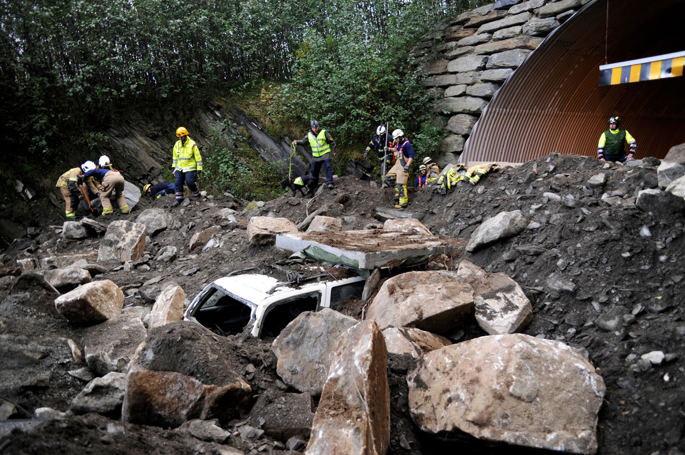

Training exercise, landslide beside a tunnel

Photo: DSB.

### Civil workforce preparedness

In a situation where the realm is at war or war is threatening or the independence or security of the realm is in danger the state may need to draw on society’s collective resources to support the defence of the country, safeguard the fundamental functionality of civil society and protect the civilian population.

The most prominent need for civilian labour will be to support the defence of the country. Furthermore, labour will be needed to maintain key civil functions, and this need may increase as a result of the situation, for example as a result of the destruction of critical infrastructure or due to the reallocation of resources to compulsory military service in the Armed Forces or to support Norway’s defence. There may also be a greater need for labour due to foreign workers returning to their home countries as a result of the situation. The situation may also trigger new tasks that need to be addressed by the supply of labour.

The need to be able to draw on society’s collective resources if the realm is at war or war is threatening or the independence or security of the realm is in danger, including in the form of workforce preparedness, has long been stressed, see for example the Norwegian Defence Commission of 1946, Recommendation Part I page 75 and Norwegian Official Report (NOU) 2023: 14 Norwegian Defence Commission of 2021 Section 13.5.4.

Our citizens are the mainstay of our total defence and enable society as a whole to function in security policy crises and war. Industrial and production workers operate the production machines, IT specialists ensure that mobile networks, broadband, online banking and bankcards work, drivers drive the fuel trucks, mechanics repair military tanks, doctors and nurses save lives in the operating theatre, fire and rescue crews put out fires and pull people out of buildings that have collapsed, and maritime pilots guide supply ships carrying allied reinforcements safely to port. A significant proportion of supplies to Norway are transported by sea, which is also where many of the NATO alliance’s crucial supply lines run.

In a situation where the realm is at war or war is threatening or the independence or security of the realm is in danger, access to food, water, electricity and other primary needs may be difficult, and basic infrastructure such as healthcare and ICT may be jeopardised. This will trigger completely different expectations in society as to what the authorities can and cannot do, and what the civilian population can and should do. The focus will shift to the essentials required for society’s functionality.

Although Section 3 of the Emergency Preparedness Act authorises the Government to regulate the labour market in security policy crises and wars, advance regulation will provide more useful authorisations for regulating civil workforce preparedness and guidelines for the assessments that must be made in the situation. Such advance regulation containing authorisation provisions is also in line with the Total Preparedness Commission’s recommendations in Norwegian Official Report (NOU) 2023: 17 The time is now – prepared for an uncertain future, paragraph 31.8.2. This will make it easier for a number of key issues to be decided in advance. Furthermore, advance regulation will more effectively facilitate preparedness planning and training exercises, providing a basis for better preparation and a clearer framework for the actual use of authorisations when the need arises.

The Government will ensure that legislation facilitates the preparedness of the civil workforce if the realm is at war or war is threatening or the independence or security of the realm is in danger. The Government has submitted a proposal to the Storting for amendments to the Civil Protection Act on civil workforce preparedness in security policy crises and war, cf. Proposition No 11 Bill (2024–2025) Amendments to the Civil Protection Act (civil workforce preparedness).

According to the Government’s bill on civil workforce preparedness, a civilian duty to work may not be imposed that involves performing tasks that are considered direct participation in hostilities under international law.

The international law of war

The international law of war refers to the part of international law that is applied in armed conflict and is not intended to prohibit war, but to regulate warfare. The rules in this part of international law have been developed to address considerations of military necessity on the one hand, and humanitarian considerations on the other. Provisions that aim to protect civilians from the consequences of conflict are therefore key. According to Articles 51(2) and 52(1) of the First Additional Protocol to the Geneva Conventions, civilians and civilian objects shall not be the object of attack. Civilians may nevertheless lose their protected position if they take a direct part in hostilities, see Article 51(3) of the First Additional Protocol.

Persons who are not legitimate targets, such as civilians and civilian objects, must be protected from attack. Even if protected persons are not directly attacked, they will in many cases still fall victim to the effects of attacks on legitimate targets, for example if they are in the vicinity of a legitimate military target. Under the international law of war, civilian casualties from an attack can be accepted if there is proportionality between the expected concrete and direct military advantage on the one hand, and the risk of civilian casualties on the other. The parties to the conflict shall nevertheless take constant care to spare civilians in the conduct of military operations, see Article 57(1) of the First Additional Protocol. This means that the risk of collateral damage must be managed and kept as low as possible.

[Boks slutt]

# Strengthen security of supply

Stable access to goods and services is crucial for society’s resilience and total defence. Supply line failures can affect the ability to maintain continuity in critical societal functions, civilian capability to support military efforts, and the individual community’s and individual citizen’s ability to take care of themselves during crises. Global events will typically be the cause of supply disruption, and international cooperation will therefore often be part of the solution to counter the negative effects of supply disruptions on Norwegian communities.

The COVID-19 pandemic and the war in Ukraine have highlighted vulnerabilities in global supply lines. Good physical security measures are not sufficient if an organisation’s assets can easily be compromised, whether digitally or through the supply chain. The loss of a subcontractor can have serious consequences, not only for interdependent companies, but also for national security. Climate change can also have negative consequences for security of supply. Vulnerabilities may be linked to reduced access to raw materials/active ingredients, higher lead times (for example as a result of longer transport routes or reduced access to personnel) and increased transport costs.

In light of this, security of supply raises special issues related to roles and responsibilities for high-level situations in the crisis spectrum. A widespread supply disruption, for example related to food, fuel, water or pharmaceuticals, could have extensive negative consequences in all sectors. Difficult prioritisation challenges may also arise across sectors. In addition, the main cause of a supply disruption is likely to be beyond the control of the Norwegian authorities and will require cooperation and intensive coordination with allies and close strategic partners such as the EU.

The Government will:

* conduct a risk, vulnerability and preparedness analysis of the Norwegian food supply.
* assign the Ministry of Trade, Industry and Fisheries responsibility for coordinating work on security of supply across sectors, relating to goods and services within the scope of the Act on Business and Industry Preparedness.
* examine the need for, and organisation of, an underlying and sector-neutral system in the area of security of supply.
* take steps to increase cooperation on food security and food preparedness with the Nordic countries.
* stockpile grain for three months’ consumption, increase the degree of agricultural self-sufficiency and ensure strong soil protection.
* reduce our dependence on others for critical goods or functions.
* ensure good cooperation on security of supply with allies and close strategic partners.
* further develop good Nordic cooperation on drinking water preparedness and supply challenges relating to drinking water and wastewater.

## The Ministry of Trade, Industry and Fisheries’ responsibility for coordinating work on security of supply

The Government has decided to assign the Ministry of Trade, Industry and Fisheries responsibility for coordinating work on security of supply across sectors, relating to goods and services within the scope of the Act on Business and Industry Preparedness. This ensures better control of critical and strategic resources, and supply and value chains. Through knowledge production, guidance, preparation of cross-sectoral strategies and planning documents, among other things, the Ministry of Trade, Industry and Fisheries will help ensure that the ministries take a comprehensive, systematic and risk-based approach to security of supply in their sectors, and ensure that cross-sectoral issues are dealt with expediently.

The Ministry of Trade, Industry and Fisheries will help to ensure that ministries responsible for critical goods and services are prepared for supply crises in the event of war in Norway, and that the ministries have plans in place to support military efforts in such a situation. The complexity of global value chains means that each sector should also plan for supply crises resulting from global events such as geopolitical conflicts and natural disasters. Norwegian businesses that are responsible for critical goods and services should be encouraged to plan alternative supply lines before such scenarios potentially become a reality. For Norway, dialogue and cooperation with allies and other international partners will be vital to enabling Norwegian businesses to support military efforts and society in general during crises.

Extensive work is currently underway on security of supply in many sectors. For example, the pharmaceutical industry tackles around 2,000 shortages a year. This means that the healthcare sector must prioritise between patients and patient groups on a daily basis. This work will continue regardless of the new role assigned to the Ministry of Trade, Industry and Fisheries.

The Total Preparedness Commission highlights that supply preparedness in crisis and war should contribute to

* supplying the public with the goods and services required to meet their fundamental needs.
* supplying businesses that secure critical societal functions with the goods and services they depend on to maintain their most important deliveries.
* ensuring that the Norwegian Armed Forces have the materials required to perform their tasks.

The Government believes that these three objectives should form the basis for national work on security of supply. In order to improve supply preparedness, the Commission emphasises the need to improve coordination by, among other things, ensuring oversight, well-structured work across sectors and new common planning assumptions. The extended responsibility of the Ministry of Trade, Industry and Fisheries is an important means of strengthening the work on security of supply. The key tasks assigned to the new coordinating role are to

* assess the need to develop joint strategies across sectors.
* monitor and develop expertise on relevant cross-sectoral issues, including cross-sectoral and simultaneity issues.
* maintain an overview of key vulnerabilities and prioritisation challenges related to cross-sectoral security of supply challenges, and thereby assess their significance for Norwegian security of supply in general.
* facilitate the necessary coordination and exchange of experience with other ministries.
* help ensure that the ministries utilise the potential that lies in collaboration with the business sector.
* maintain a dialogue with the business sector on general issues related to security of supply.
* contribute to raising awareness and providing guidance activities to society at large.
* present cases for the Government when necessary, related to cross-sectoral issues relating to security of supply.

However, the extended responsibility will not change the ministries’ responsibility for security of supply in their own sector. It is still the responsibility of each ministry to contribute to the supply of goods and services to the Norwegian market within its own sector.

The coordination role is limited to industrial preparedness, i.e. goods and services delivered by business and industry. This will include most of the goods and services that society depends on. The role does not currently include the provision of services from the public sector, such as the police, Civil Defence and Food Safety Authority. The role must be based on the Instructions for the Ministries’ work with civil protection and emergency preparedness. Together with the Ministry of Justice and Public Security’s coordinating role for public security, the new role will help make work on security of supply and public security more coherent and comprehensive. This work will be seen in the context of the new council structure for preparedness planning and status assessments in civil sectors, see Section 3.1.

In light of experience from the pandemic and the war in Ukraine, many countries intend to increase their own production to reduce their dependence on other countries. This also applies to Norway. This will change supply lines and may affect the dynamics of international trade. Norway must also emphasise this in its domestic policy. The work on security of supply raises questions about the advantages and disadvantages of stockpiling, and the extent to which functioning international trade systems can still be used as a basis for the work on security of supply. The situation may also differ in different parts of the country. In the north in particular, geographical and climatic conditions mean that the challenges may differ. Norway is a long country with few inhabitants, and this will also have an impact on how we organise measures to strengthen security of supply. Close dialogue and coordination between the defence sector and civil sectors on security of supply is important for resilience and total defence. Awareness of how to handle situations where actors in several sectors are dependent on inputs that are subject to restrictions (simultaneity issues) must also be increased.

Stepping up the work on security of supply follow-up will include assessing various means of safeguarding the Ministry of Trade, Industry and Fisheries’ sectoral responsibility, including the need for, and organisation of, an underlying system in the area of security of supply.

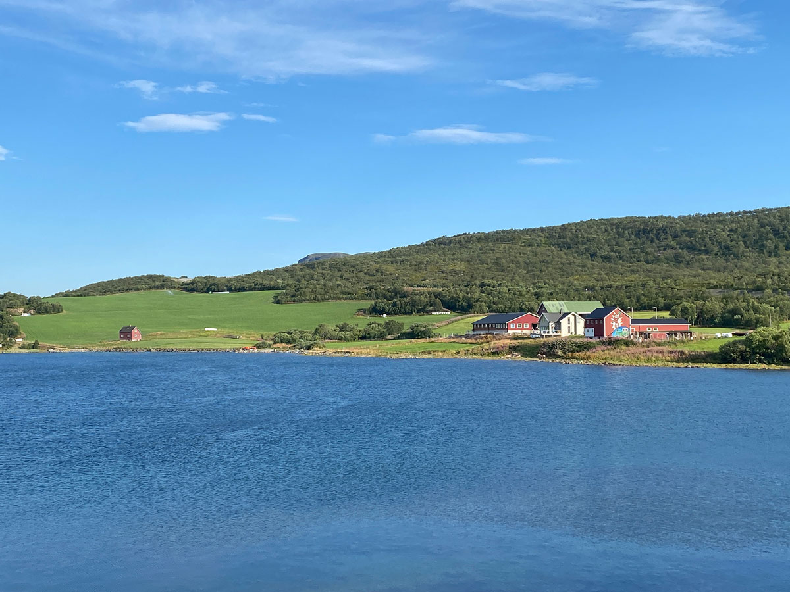

The world’s northernmost dairy farm in Bekkarfjord

Photo: Lise Kaldahl Skreddernes.

## Food supply

Sufficient and safe food is a prerequisite for any society, and, since taking office, the Government has prioritised stepping up Norwegian food production and implementing measures to increase food security. The Norwegian food supply is based on domestic production and distribution of raw materials from agriculture, fisheries and aquaculture, as well as imports of raw materials and finished goods. The Government’s policy of increased self-sufficiency, stockpiling grain and strong soil protection will produce visible results in the form of increased preparedness and security. It is important to continue these initiatives. The channelling policy (geographical distribution of production) is a prerequisite for Norwegian preparedness.

Food preparedness is currently based on domestic production (agriculture and fisheries/seafood), functioning trade systems and safeguarding the production base.

A large proportion of the food items sold in Norway are imported. Today’s food supply is challenged in situations where we cannot supply a sufficient quantity and variety of imported food. The consequences will vary depending on the scope, which inputs, raw materials and products are affected, whether alternative items are available, whether we can and are able to adapt to a new situation, or whether we have measures to deal with this.

Supply preparedness in the food sector is based on both domestic production and imports largely being maintained during crises. The COVID-19 pandemic, Russia’s invasion of Ukraine and recent events in the Taiwan Strait are examples that show that global supply lines are more vulnerable than previously. We have also become more aware of vulnerabilities that were previously not as visible. Current threats, coupled with more extensive climate change and globalisation, mean that we need to assess which common planning assumptions we should use to enable us to safeguard security of supply in different scenarios.

Food security is one of the four main objectives of agricultural policy. Producing enough, safe and varied food of high quality for the population is the primary objective of agriculture. A significant proportion of the food items consumed in Norway is produced by Norwegian agriculture.

In Report No 11 to the Storting (2023–2024) Strategi for auka sjølvforsyning av jordbruksvarer og plan for opptrapping av inntektsmoglegheitene i jordbruket (Strategy for increased self-sufficiency in agricultural produce and plan for escalation of income opportunities in agriculture – in Norwegian only), cf. Recommendation No 258 to the Storting (2023–2024), a self-sufficiency target of 50% has been set, adjusted for imports of feed materials. A majority of the Storting endorsed the target in its consideration of the report and the target is scheduled to be achieved by 2030. The report also addresses the fact that increased income opportunities are a key instrument for achieving the agricultural policy, goals including food security and increased self-sufficiency.

Pilot for a stronger defence through increased food preparedness

Innlandet county authority intends to establish a pilot that facilitates increased use of regional resources to reduce vulnerability and increase food supply preparedness. The pilot will map vulnerabilities based on different scenarios and include food supply in contingency plans at all levels. The project is also seen in the context of the need for nutritious food for Norwegian soldiers, and a dialogue has been established with the Norwegian Armed Forces about this. It will also make expedient plans for resilience in peacetime to provide better security in times of crisis. Through the pilot, Innlandet will work strategically to increase interaction between the food value chains and the preparedness system, as a means of strengthening total defence. Food chains are complex systems with a wide range of essential functions in the form of expertise, technology, organisation, logistics and inputs etc. These functions must work together in peace and crisis.

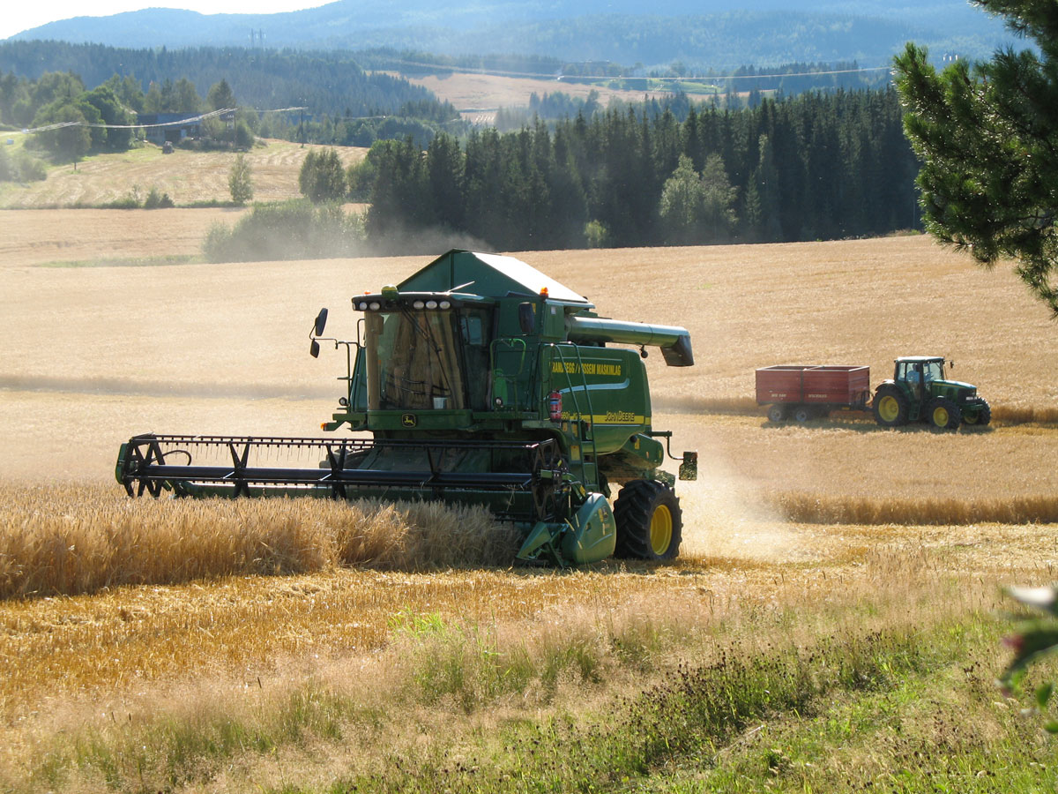

Threshing in Trøndelag

Photo: Anne Berit Lein/FMLA Nord-Trøndelag.

[Boks slutt]

Stockpiling grain is important for food security and reducing vulnerability in the event of an extraordinary supply crisis. As announced in Proposition No 1 to the Storting (2023–2024), the Government decided that stockpiles of grain equivalent to three months’ consumption should be established. The stockpiles will be built up with 15,000 tonnes of grain per year up to 82,500 tonnes. The first contracts were signed at the end of June 2024, with a duration of 25 years.

New grant scheme increases security of food supply in Troms and Finnmark

In the national budget for 2025, the Government has proposed, and the Storting has approved, the establishment of a new grant scheme for food companies in Troms and Finnmark. The grant scheme will be aimed at companies that process raw materials from reindeer husbandry and agriculture, and has a budget of NOK 14 million. Due to long transport distances, the deteriorating security policy situation, and in order to be better prepared for disruptions in value chains, it is important to step up food supply security in the two northernmost counties. The fact that people live in all parts of Norway bolsters our preparedness. It enables food production based on Norwegian resources, which contributes to jobs, value creation and settlement. Strengthening food companies will also provide a stronger basis for agriculture and reindeer husbandry in Troms and Finnmark. The Government’s efforts to strengthen civilian resilience in Troms and Finnmark are discussed in more detail in Section 10.4.

[Boks slutt]

The National Audit Office of Norway and the Total Preparedness Commission both stress that the risk and vulnerability analysis for food security must be updated. They also highlight the potential for reorganising production and consumption in a crisis situation and call for an analysis of Norway’s supply and self-sufficiency capability in different crisis situations. The Ministry of Trade, Industry and Fisheries and the Ministry of Agriculture and Food will ensure such an analysis is carried out. The analysis will be an important management tool in the work to strengthen Norway’s food preparedness.

The Government will appoint a committee to look at the food system of the future. The committee will identify opportunities, dilemmas and challenges in the Norwegian food system. Key national and international objectives and commitments of importance to the food system must be considered in context and form the basis for this work. This can include public health, climate, environment and nature, agriculture, aquaculture, fisheries and food policy, and business and regional policy.

## Drinking water supply

A safe water supply is a fundamental national function. Loss of water and contamination of water can lead to loss of life and health. A prolonged loss of water may trigger the need for evacuation. NATO’s expectations of member states include a resilient water supply. Emergency preparedness in the water and wastewater sector is closely linked to other preparedness in the municipality and the region. Most major waterworks in Norway are owned by municipalities. The Government has adopted national goals for water and health with a cross-sectoral implementation plan. The follow-up of these goals will contribute to a more resilient water supply and better preparedness.

Report No 5 to the Storting (2023–2024) A Resilient Health Emergency Preparedness, cf. Recommendation No 220 to the Storting (2023–2024), describes how the Government is clarifying the Norwegian Food Safety Authority’s coordinating role in security and safe drinking water by establishing a committee to that end. The committee will be chaired by the Norwegian Food Safety Authority and consist of other agencies, one large and one small municipality, county governor and the special interest organisation for the Norwegian water industry, Norsk Vann. The report also discusses how Norway, Sweden and Finland use a lot of surface water for drinking water production and therefore need large quantities of water treatment chemicals for both drinking water and wastewater. The countries also have companies that are important in a Scandinavian and European context to ensure access to and production of water treatment chemicals. Nordic cooperation on emergency preparedness challenges in the field of drinking water has been stepped up in recent years, and is funded by, among others, the Nordic Council of Ministers. The Government will further strengthen this cooperation.

## Security of supply on Svalbard

Svalbard is not connected to a larger, external water or energy system. This underlines the importance of having adequate local emergency preparedness for critical infrastructure. Svalbard relies on the importation of virtually everything that is used on the archipelago, including food and other consumer goods, medicines, fuel and spare parts. This makes Longyearbyen vulnerable to supply line disruptions. The Governor of Svalbard, by virtue of their authority, has coordinating responsibility for public security and emergency preparedness in Svalbard. This includes security of supply. The Governor of Svalbard has established plans regarding security of supply.

Electricity and heating are essential for maintaining the population and businesses in Longyearbyen. Vast distances to the mainland and climatic conditions entail that considerations such as security of supply and a stable energy supply must be given particular emphasis. The Government’s intention is for the state to take greater responsibility for the power supply in Longyearbyen, e.g. through the company Store Norske, and that responsibility for the power supply shall be clarified as soon as possible.

In connection with the revised national budget for 2024, the Government proposed, and the Storting approved, allocations totalling NOK 45 million to help increase security of supply for energy and water in Longyearbyen. The funds have been earmarked for investments in infrastructure to strengthen security of supply and redundancy of energy in Longyearbyen, and government co-financing of a pilot project to establish a reserve drinking water source in Longyearbyen.

Part V

Financial and administrative implications

# Financial and administrative implications

Norway has enjoyed deep peace and financial leeway and prosperity for a long time. Preparedness actors, public agencies, business and industry and the general public have, to a great extent, based their lives on lasting peace. In this white paper, the Government makes it clear that all civil sectors must prepare for situations at the high end of the crisis spectrum, including armed conflict and, in the worst case, war. This ambition requires new assessments of the considerations to be weighed when decisions are made about laws and regulations, the economy, cooperation and about individuals’ own preparedness. The fact that crises and wars must be included in society’s preparedness work also means that security and preparedness must be given higher priority, which may come at the expense of other considerations. The authorities alone cannot prepare civil society for crises and war. Society as a whole must adapt to the risk and vulnerability situation and make choices that strengthen Norway’s resilience. This must be done over time and on a well-considered basis.

The Government believes that security policy developments make it necessary to change how Norway organises its work on security and preparedness. Amendments are proposed to laws, regulations and procedures in addition to specific measures in selected areas. Follow-up of the measures will require inputs from both the public and private sectors in terms of personnel, technology, organisation and budget funding. Some measures will be followed up immediately, while the follow-up of others will take longer because their financial implications must be analysed in more detail.

Some proposals entail relatively large administrative implications compared with the resources currently spent in the respective areas. The measures presented in the report are subject to budgetary coverage. Proposed studies and assessments must, as a rule, be covered within the applicable budget framework. Reference is also made to the intention to compensate the municipal sector for additional expenditure in connection with new tasks and regulatory amendments. Measures that, after prior assessment, cannot be covered under the current framework will be examined further and, if necessary, put forward in the ordinary budget process.

A majority of the measures in the report deal with organisation, collaboration and cooperation across organisations, sectors and countries. As a rule, organisational measures can be implemented within the applicable budget framework. Some selected measures, which are expected to have major financial implications, are discussed at the end of this chapter.

The principle of responsibility stands firm. Whoever is responsible for a given area in a normal situation is also responsible for the necessary emergency preparations and incident management in their area. Based on threat and risk assessments and other relevant knowledge, the responsible body must decide the acceptable level of risk and act accordingly. Risk acceptance assessments fall under exercising the principle of responsibility. It is neither desirable nor possible to create a society that is free of risk. Work on public security and preparedness must be adapted to the challenges we face. This responsibility includes assessing the financial and administrative implications of measures that are necessary to reduce risks that are considered unacceptable. Measures that have financial implications will be presented to the Storting in the annual national budget proposals.

In this white paper, the Government is introducing a number of organisational measures, but also concrete proposals to increase society’s collective defence capability. One of the measures proposed by the Government is a new structure for preparedness planning and status assessments in civil sectors, which will provide a good basis for developing long-term and cross-sectoral planning, including cross-sectoral budget priorities. This work is partly motivated by the Total Preparedness Commission’s proposal for a more comprehensive and coherent council structure and more long-term and consistent management of the central emergency preparedness resources in the civilian sectors.

The Government’s opinion is that the proposed organisational changes will improve utilisation of society’s emergency preparedness resources through systematic information gathering from all levels of the public administration. The Government will formalise the requirement that all municipalities must have or be affiliated with a municipal preparedness council. The central aim of the municipal preparedness councils is to support greater compliance with the municipalities’ existing obligations under the Civil Protection Act, including the municipality’s role as a driving force and partner for other actors of importance to public security at the local level. Reference is also made to the principle that municipalities should be compensated for new statutory tasks and their implications.

Business and industry and the voluntary sector must also be involved in emergency preparedness planning and incident management. The aim is to develop a consistent total defence, where society’s preparedness needs and resources pull in the same direction across all sectors of society. The proposed measures are expected to have several positive effects, such as better coordination across sectors and administrative levels, including increasing expertise and improving networks between preparedness actors, and more efficient resource utilisation through improved work processes.

Strategic corridor for military mobility in Norway, Sweden and Finland

The Government proposes developing a strategic corridor for military mobility through northern Norway, northern Sweden and northern Finland. This measure will have significant financial implications. The three countries must identify bottlenecks and consider updating regulations and plans before reaching any conclusion on specific investment needs. The planning will not in itself have significant financial or administrative implications.

Implementation of the NIS2 Directive and the CER Directive

The Government is preparing to incorporate the NIS2 Directive and the CER Directive in Norwegian law. Among other things, the directives stipulate basic requirements for security, notification and procedures. The incorporation of the directives into Norwegian law, could have financial and administrative implications for the organisations covered. The directives will apply to more sectors, which may mean financial and administrative implications of a given scope for undertakings that are not currently subject to such security requirements. The Ministry of Justice and Public Security will further investigate the financial and administrative implications in connection with the legislative work.

Emergency shelters

The government will revoke the temporary construction moratorium on shelters in new buildings from 1998. The proposal entails significant financial and administrative implications with the potential to affect many administrative entities, including the municipal sector and private sector organisations. The measure will also require the allocation of funds in the national budget. The Directorate for Civil Protection has made some preliminary estimates of the costs associated with establishing emergency shelters in new buildings. The costs will vary between different buildings and the building plans for the buildings themselves, for example whether they have underground areas. The Directorate estimates an additional cost for the developer of NOK 30,000 per shelter space and annual maintenance costs of NOK 85 per space. The Directorate has calculated an additional cost for the developer of NOK 6,000–10,000 per smaller shelter space and virtually no annual maintenance costs. The Ministry will specify the financial and administrative implications in connection with the regulatory work and public consultation on the matter.

The Norwegian Civil Defence

The Government will strengthen the Civil Defence’s ability to meet the new challenges by increasing the target number of conscripts from 8,000 to 12,000. The measure will result in an annual increase in allocations in the national budget of around NOK 87 million, and will trigger a one-off investment of NOK 30 million in the Civil Defence Centre of Excellence. Administrative considerations indicate that the proposal will be implemented over a period of around eight years. The Directorate for Civil Protection will prepare an implementation strategy. The measure also entails an opportunity cost equal to the production and leisure time lost in connection with training exercises and deployment of new conscripts. Strengthening the Civil Defence could also have administrative and financial implications for the municipalities, which under the Civil Protection Act are responsible for storing civil defence material.

Volunteers

A financial escalation plan for increased grants to voluntary organisations of up to NOK 100 million will have financial implications. How great such implications will be depends on the rate of escalation and must be clarified through the ordinary budget processes.

Ministry of Justice and Public Security

recommends:

That the recommendation of the Ministry of Justice and Public Security concerning the white paper on Total Preparedness dated 10 January 2025 be submitted to the Storting.

1. The breadth of potential incidents is illustrated in the Analysis of Crisis Scenarios 2019 by the Directorate for Civil Protection. It describes 25 scenarios that could affect society that we should be prepared for.
2. Ministry of Defence and Ministry of Justice and Public Security (2018). Support and Cooperation – a description of the total defence in Norway.
3. The scheme set out in the Civil Protection Instructions concerning ministries with primary responsibility applies until the new structure is in place.
4. Instructions for the Ministries’ work with civil protection and emergency preparedness, 1 September 2017.
5. Instructions for the Directorate for Civil Protection’s coordination roles of 28 June 2005, and Main instructions to the Directorate for Civil Protection of 19 January 2022.
6. New air mobility encompasses a range of technologies, systems and aircraft.
7. Statistics Norway, Report 2024/20 Befolkningsframskrivinger for kommunene 2024, by Stefan Leknes and Sturla A. Løkken. Løkken.
8. A fundamental principle of the international law of war entails that participants in an armed conflict must at all times distinguish between military targets on the one hand and civilian persons and objects on the other.
9. Act No 7 of 15 December 1950 relating to special measures in time of war, threat of war and similar circumstances.
10. Ministry of Justice and Public Security (2020) Action Plan against Radicalisation and Violent Extremism. Revised in 2020.
11. The Government’s long-term plan for research and higher education (2023–2032) prioritises public security and emergency preparedness in a number of areas, including security of supply and global food security, climate-related issues, geopolitical dynamics and security policy developments, technology utilisation in rescue operations, knowledge of hybrid threats, cybercrime, infection control measures and antibiotic resistance.
12. European Commission: Directorate-General for Education, Youth, Sport and Culture and Hammonds, W., Culture and democracy, the evidence – How citizens’ participation in cultural activities enhances civic engagement, democracy and social cohesion – Lessons from international research, Publications Office of the European Union, 2023.
13. Hybrid threats refer to foreign states’ activities that, based on their purpose, affect Norwegian security directly or indirectly below the threshold of armed conflict. The phenomenon is also referred to internationally as ‘hybrid conflict’ or ‘political warfare’, and can be confused with ‘hybrid warfare’ as a military strategy. In this report, ‘hybrid threats’ is used as defined in Report No 10 to the Storting (2021–2022) Prioriterte endringer, status og tiltak i forsvarssektoren (Prioritised changes, status and measures in the defence sector – in Norwegian only), cf. Recommendation No 392 to the Storting (2021–2022), and Report No 9 to the Storting (2022–2023) National control and cyber resilience to safeguard national security, cf. Recommendation No 247 to the Storting (2022–2023), and hybrid activities is used to describe use of a broad range of methods and tactics.
14. Regjeringen.no (2024) Digital Norway of the future – National digitalisation strategy 2024–2030.
15. National Audit Office of Norway (2023) Myndighetenes samordning av arbeidet med digital sikkerhet i sivil sektor (The authorities’ coordination of work on cyber security in the civil sector – in Norwegian only). Dokument 3:7 (2022–2023).
16. Arbeidslivets behov for digital sikkerhetskompetanse frem mot 2030 (The labour market’s need for cyber security expertise towards 2030 – in Norwegian only). NIFU (Nordic Institute for Studies in Innovation, Research and Education) report 2023:4.