Ministry of Finance

Taxes 2025

Prop. 1 LS (2024–2025)   
Proposition to the Storting (Bill and Draft Resolution)   
For the 2025 Budget Year

Recommendation from the Ministry of Finance of 27 September 2024,   
approved in the Council of State on the same date.   
(Støre Government)

# Main tax policy features

## The tax policy objectives of the Government

Taxes make it possible to finance welfare schemes, thereby enabling Norway to remain a safe and good country in which to live. Tax policy shall contribute to fair distribution and facilitate economic growth, as well as high health and environmental standards, throughout Norway.

Taxes are of importance to how Norway meets the long-term challenges described in the 2024 white paper on Long-term Perspectives on the Norwegian Economy:

* Labour force shortages. The number of caregiving tasks is increasing, but we do not have more individuals of working age to perform them. The tax system needs to support the policy drive to increase labour force participation. Taxes, social security provisions and subsidy schemes need to work well together.
* Continued fair distribution. Small differences and stable access to welfare services need to be preserved in the face of transitions, and as many people are living longer. In order to finance welfare schemes, tax bases need to be robust and broad, and the tax system needs to be adapted to social developments. The tax system is one of the tools the Government can use in its efforts to reduce the disparities between people, both socially and geographically.
* Need for adaptation. Increased global tensions, climate and environmental changes, and declining petroleum activity reinforce the need to use resources wisely and appropriately. The Government is aiming for its tax policy to provide a favourable framework for work, investment and economic growth throughout Norway. Well-designed resource rent taxes give society a share in the extraordinary return that can arise from the use of our natural resources. Environmental taxes at the right level, such as taxes on greenhouse gas emissions, are part of a cost-effective and credible climate and environmental policy and help to ensure that society’s resources are used in the best possible way.

During this parliamentary term, ordinary personal income tax has been reduced significantly, while wealth tax and resource rent taxes have been increased, along with environmental taxes and dividend tax. Such a reorientation of the tax system stimulates increased labour supply and less environmentally harmful emissions, while also making the tax system more redistributive. The corporation tax rate, which affects how profitable it is to invest in Norway, relative to other countries, has been kept unchanged at a moderate level. As announced in the Revised National Budget 2024, it is proposed that the additional employer’s contribution will be abolished from January 1, 2025. The high-price contribution on power production was already abolished on October 1, 2023. With this, both of the temporary tax increases introduced in connection with the 2023 budget have now been abolished. This is in line with the government’s promise that these tax increases were temporary. It is important to emphasize that in the special situation we were in, with increased expenses in many areas and extraordinarily high electricity prices, it was absolutely necessary to take these two temporary measures. The alternative would have been significant welfare cuts or large tax increases for households.

The Government aims to make tax rules easy for taxpayers to understand and comply with and simple for the Norwegian Tax Administration to enforce. Administrative costs for taxpayers and the public sector can be kept down by making the most of the opportunities provided by digitalisation. The Government is considering modifications to the regulations on an ongoing basis, with the aim of further simplifying these for business and industry.

## Main features of the tax programme for 2025

Executive summary

The tax programme for 2025 is adapted to the economic situation described in Report No. 1 (2024–2025) to the Storting, National Budget 2025, and the long-term challenges described in the 2024 white paper on Long-term Perspectives on the Norwegian Economy. This Government is making clear political choices and is pursuing a prudent and responsible economic policy. People should and will be better off.

The Government is not proposing any major tax reform in the 2025 budget, but is continuing its efforts to make the tax system more redistributive. The total net tax and fee reductions in the government’s proposal are NOK 17.5 billion, fully phased in.

As announced in the Revised National Budget for 2024, the Government is proposing a discontinuation of the temporary additional employer’s National Insurance contributions with effect from 1 January 2025. The tax relief is estimated to be about NOK 12 billion accrued in 2025. In addition to the discontinuation of the additional employer’s National Insurance contributions, the Government is proposing net tax reductions of about NOK 5.5 billion, when the changes are fully phased in. The booked tax reductions in 2025 are estimated to be about NOK 9,3 billion; see Table 1.1.

The Government is prioritising targeted tax relief for people on low incomes. The exemption card limit (the threshold for the payment of National Insurance contributions) will be increased from NOK 70,000 to NOK 100,000, and the threshold for paying other taxes on wage income and pension income will be increased from about NOK 163,000 to about NOK 200,000. Lower National Insurance contributions on wages, benefits and self-employment income, combined with a bracket tax increase, will provide tax relief for low and medium incomes and slightly higher taxes on high incomes. The total reductions in income tax for individuals (excluding dividend tax) under this government amount to NOK 10.5 billion with the proposal for the 2025 budget.

The Government is proposing to reduce value added tax on water and sewage services from 25 per cent to 15 per cent from 1 May 2025. This will have an estimated full-year tax relief effect of NOK 4 billion and will help to reduce the cost of living for many households whose purchasing power has been reduced as a result of high inflation and increased interest rates.

The current exit tax rules do not ensure that capital gains on shares, etc., accrued while the owners are resident in Norway are taxed in Norway, and that the tax is actually paid. The Government is therefore proposing to change the exit tax to ensure that the rules work as intended and support a robust, redistributive and fair tax system. The proposed changes are more lenient than the proposal that has circulated for consultation.

The Government has delivered on its plan to increase climate taxes. The tax proposal for 2025 entails additional steps in the same direction, including a further linear increase in climate taxes on non-ETS emissions to NOK 2,000 per tonne of CO2 at 2020 prices in 2030 (equivalent to NOK 2,400 at 2025 prices). The green transition envisaged by the Government needs to also take into account the increased cost of living experienced by large groups over several years. The Government is therefore proposing to return the increased climate tax revenues from road traffic by reducing road usage tax and traffic insurance tax. Climate policy also needs to be considered in the context of other proposals with favourable distributional effects.

Selected tax system thresholds that have been frozen for many years will be increased. In addition, the Government has proposed travel allowance relief, along with relaxation of the two-year rule for commuters. The Government is also proposing more favourable and simpler taxation of the sale of surplus electricity in private homes by introducing a tax-free threshold of NOK 15,000 for such income. The Government proposes to eliminate the remaining overpricing of fee-financed services in 2025. For 2025, this means reductions in the Brønnøysund Register Centre fees, road user and vehicle fees at the Norwegian Public Roads Administration, as well as the lien fee. It will benefit both individuals and businesses that public service fees are thereby aligned with actual costs. With this budget, the overpricing elimination effort has been completed.

Other proposed tax changes

The Government is also proposing other changes to the tax system with effect from 2025:

* The introduction benefit is taxed as wage income.
* The threshold for tax-free employee discounts is increased to NOK 10,000.
* The general threshold for wage income reporting is increased to NOK 2,000.
* The threshold for tax-free sales of berries and garden products, etc., is increased to NOK 10,000.
* The threshold for tax-free letting of own holiday property and short-term letting of own home is increased to NOK 15,000.
* The residence rule for expatriated employees, etc., is amended, with such employees being considered resident in Norway for tax purposes.
* Some income tax and wealth tax thresholds are kept unchanged in nominal terms.
* The Global Minimum Tax Act is amended to introduce the Undertaxed Profits Rule (UTPR) and the associated transitional UTPR Safe Harbour.
* The natural resource tax on hydropower plants is increased to NOK 0.0021 per kWh for counties and NOK 0.0113 per kWh for municipalities.
* The contract exemption for fixed-price agreements under the resource rent taxes on hydropower and wind power is continued without any time limit.
* The emission factor for the waste tax is modified.
* A CO2 tax is introduced on fishing in distant waters at 25 per cent of the full rate.
* A CO2 tax is introduced on international shipping.
* The reduced tax rate on mineral oil is increased to comply with the minimum rate under the Energy Taxation Directive.
* The tax rate on shipping emissions subject to ETS is reduced.
* The air passenger tax is reduced.
* The threshold for what is considered to be de minimis value in the value added tax regulations is circulated for consultation with a view to changing it with effect from 1 January 2025.
* The sectoral taxes under the Norwegian Water Resources and Energy Directorate (NVE) and the Norwegian Communications Authority are increased, while new sectoral taxes are introduced under the Norwegian Ocean Industry Authority and the Norwegian Offshore Directorate.

Several of the proposals serve to simplify the tax system, particularly within personal taxation. These include the proposals to increase the exemption card limit and to simplify the rules on taxation of the sale of surplus electricity in private homes. Simpler rules on the taxation of expatriate foreign service employees are also proposed, along with taxation of the introductory benefit as wage income. In addition, a noticeable increase in various minimum thresholds will mean simplification.

## Revenue effects of the proposed tax changes

Table 1.1 provides an overview of the revenue effects of the Government’s proposal. Accrued effects are changes in payment obligations for the 2025 income year as a result of the Government’s proposal, while booked effects are changes in payments in the same year. Payment routines may lead to discrepancies between accrued and booked effects. For example, companies pay income tax in subsequent years, and not all changes can be fully taken into account in the withholding tax. Proposals may have an accrued effect in years beyond the budget year, for example when the effective date is not 1 January of the budget year.

The revenue effects of the tax programme have been calculated in relation to a benchmark system for 2025. The benchmark system is based on the 2024 rules, adjusted upwards primarily by projected price, wage and wealth growth. Allowances and thresholds, etc., in the standard rate structure of personal taxation have been adjusted to 2025 levels based on projected wage growth of 4.5 per cent in the benchmark system. Special allowances and other thresholds under personal taxation have primarily been adjusted by projected consumer price inflation of 3.0 per cent from 2024 to 2025. A taxpayer who only has ordinary allowances and whose ordinary income and personal income both increase by 4.5 per cent will on average pay approximately the same amount of income tax under the benchmark system for 2025 as in 2024. In the benchmark system, all per unit taxes (for instance taxes per kg or litre) have been adjusted by the projected growth in consumer prices from 2024 to 2025. In real terms, the benchmark system thus results in unchanged tax levels from 2024 to 2025.

Estimated revenue effects of the Government’s proposed tax programme for 2025. Negative numbers signify tax reductions. The estimates have been calculated in relation to the benchmark system for 2025. NOK million

03J2xt2

|  |  |  |
| --- | --- | --- |
|  | 2025 | |
|  | Accrued | Booked |
| Personal income tax | -1,330 | -1,146 |
| Adjust standard allowances (personal allowance and basic allowance) | -130 | -105 |
| Reduce National Insurance contributions on wages/ benefits and self-employment income | -2,245 | -1,795 |
| Adjust the bracket tax | 1,580 | 1,265 |
| Increase the exemption card limit to NOK 100,000 | -515 | -410 |
| Abolish two-year time limit on commuter allowance for employees living in workers’ sheds | -100 | -80 |
| Travel allowance relief in excess of price growth | -35 | -30 |
| Specific nominal thresholds – increase the employee  discount threshold to NOK 10,000 | -75 | -60 |
| Specific nominal thresholds – increase the threshold  for wage income reporting to NOK 2,000 | -50 | -40 |
| Specific nominal thresholds – increase the threshold for  tax-free sales of berries, etc., to NOK 10,000 | -6 | -4 |
| Tax the introduction benefit as wage income | 40 | 32 |
| Increase the threshold for tax-free letting of own holiday property and short-term letting of own home to NOK 15,000 | -50 | -40 |
| Introduce a tax-free threshold of NOK 15,000 for income  from household energy installations | 0 | 0 |
| Abolish the residence rule for expatriated employees, etc. | 1 | 1 |
| Keep allowances and thresholds unchanged in nominal terms, interaction effects, etc. | 180 | 140 |
| Amend the exit tax rules | 100 | 0 |
| Expand the special arrangement for employee options | -25 | -20 |
|  |  |  |
| Wealth tax | 75 | 60 |
| Keep allowances and thresholds unchanged in nominal terms,  rounding | 75 | 60 |
|  |  |  |
| Business taxation | -20 | 0 |
| Increase the natural resource tax on hydropower plants1 | 0 | 0 |
| Continue contract exemption for fixed-price agreements  (north/south exemption) | -20 | 0 |
|  |  |  |
| Climate-, environmental- and car taxes | 1,702 | 1,727 |
| Increase taxes on non-ETS emissions by 16 per cent) | 2,235 | 2,050 |
| Modify the emission factor for the waste tax | 50 | 45 |
| Compensate public transport operators with private  provider contracts for increased CO2 tax | -100 | -100 |
| Introduce a CO2 tax on fishing in distant waters  (25 per cent of the full rate) | 140 | 130 |
| Introduce a CO2 tax on international shipping  (NOK 500 per tonne CO2) | 500 | 450 |
| Increase the reduced tax rate on mineral oil to comply with  the minimum rate under the Energy Taxation Directive | 2 | 2 |
| Reduce the road usage tax on biodiesel by  NOK 0.32 per litre | -80 | -75 |
| Reduce the road usage tax on petrol by NOK 0.50 per litre | -270 | -250 |
| Reduce the road usage tax on fuel by NOK 0.10 per litre | -300 | -275 |
| Reduce the traffic insurance tax on passenger cars and vans with internal combustion engine | -430 | -210 |
| Reduce the tax rate on shipping emissions subject to ETS | -45 | -40 |
|  |  |  |
| Other excise duties | -596 | -547 |
| Adjust the reduced rate of electricity tax due to exchange  rate changes | 4 | 3 |
| Reduce air passenger tax | -600 | -550 |
|  |  |  |
| Value added tax | -2,750 | -2,042 |
| Reduce value added tax on water and sewage fees  to 15 per cent from 1 May 2025 | -2,700 | -2,000 |
| Increase the threshold for what is considered to be  de minimis value in the value added tax regulations | -50 | -42 |
|  |  |  |
| Sectoral taxes and overpriced fees | -507 | -443 |
| Increase the sectoral taxes under the Norwegian Water Resources  and Energy Directorate (NVE) | 17 | 17 |
| Eliminate the overpricing at the Brønnøysund Register  Centre | -128 | -128 |
| Eliminate the overpricing of the lien fee | -466 | -402 |
| Increase the sectoral tax under the Financial Supervisory Authority of Norway | 21 | 21 |
| Increase the sectoral tax under the Norwegian Communications Authority (Nkom) | 6 | 6 |
| Introduce a new sectoral tax under the Norwegian Ocean Industry  Authority | 10 | 10 |
| Introduce a new sectoral tax under the Norwegian Offshore Directorate | 45 | 45 |
| Set fees for road user and vehicle services under the Norwegian Public Roads Administration at cost | -12 | -12 |
| Proposed new tax changes in 20252 | -3,426 | -2,391 |
| Discontinue additional employer’s National Insurance contributions (gross) | -12,030 | -6,860 |
| Total tax changes in the 2025 budget3 | -15,456 | -9,251 |

1 Considered in isolation, the proposal will reduce booked central government corporation tax in 2026 and increase natural resource tax for municipalities and counties by about NOK 50 million. However, the total tax revenues of the central, regional and local government sectors will not be affected. This is implied by the goal that municipal tax revenues should account for 40 per cent of total revenues within the municipal funding programme. Hence, an increase in the natural resource tax will only influence the composition of total tax revenues for the local government sector, and not their level. Overall, there is this no change for either the local government sector or central government. The natural resource tax is directly deductible against the corporation tax paid to central government, and therefore does not normally constitute any burden for companies.

2 The total accrued revenue effect is NOK -5,501 million when the changes are fully phased in. The discrepancy between this figure and the accrued revenue effect in 2025 is primarily due to the proposed reductions in the traffic insurance tax and the value added tax on water and sewage fees also having an accrued effect in subsequent budget years.

3 Fully phased in, the total amount of tax and fee changes in the 2025 budget is NOK ‑17 531 million. This is the sum of new tax and fee changes in the 2025 budget (NOK -5 501 million, see footnote 2) and the accrued effect of abolishing the additional employer’s contribution (NOK -12 030 million).

Source: Ministry of Finance.

Table 1.2 presents estimated booked tax revenues for 2025, as well as estimates for 2024 and accounting figures for 2023, specified by chapter and item.

Booked tax revenues specified by chapter and item. NOK million

07J2xt2

|  |  |  |  |  |  |  |
| --- | --- | --- | --- | --- | --- | --- |
|  | | | | Budget estimate 2024 | |  |
| Chap. | Item | Designation | Accounts 2023 | Balanced  budget | Estimate NB 25 | Proposal for 2025 |
| 5501 |  | Taxes on wealth and income |  |  |  |  |
|  | 70 | Bracket and wealth tax | 103,944 | 118,001 | 124,400 | 136,186 |
|  | 72 | Equalisation tax to central  government, etc., from  personal taxpayers | 144,290 | 155,900 | 156,600 | 151,488 |
|  | 74 | Corporation taxes, etc.,  from non-personal taxpayers  outside the petroleum  sector | 158,468 | 129,200 | 131,100 | 129,100 |
|  | 75 | Wealth tax1 | 9,006 | - | - | - |
|  | 76 | Withholding tax on  dividends | 11,201 | 10,000 | 12,750 | 13,250 |
|  | 77 | Withholding tax on interest  payments | 57 | 100 | 20 | 25 |
|  | 78 | Withholding tax on royalty  payments | 0 | 0 | 0 | 0 |
|  | 79 | Withholding tax on rent  payments for certain  physical assets | 42 | 75 | 10 | 15 |
| 5502 |  | Financial activity tax |  |  |  |  |
|  | 70 | Tax on payrolls | 2,552 | 2,600 | 2,600 | 2,704 |
|  | 71 | Tax on profits | 2,009 | 2,650 | 2,200 | 2,400 |
| 5506 | 70 | Tax on inheritance and gifts | 46 | 0 | 15 | 0 |
| 5507 |  | Tax on petroleum production |  |  |  |  |
|  | 71 | Ordinary tax on wealth  and income | 188,239 | 151,600 | 130,100 | 119,500 |
|  | 72 | Special tax on petroleum income | 426,187 | 330,700 | 277,300 | 259,700 |
|  | 74 | Area tax, etc. | 1,319 | 1,500 | 1,400 | 1,300 |
| 5508 | 70 | Tax on CO2 emissions in  the petroleum sector on  the continental shelf | 7,496 | 7,800 | 7,800 | 8,000 |
| 5509 | 70 | Tax on NOX emissions in  the petroleum sector on  the continental shelf | 4 | 0 | -2 | 1 |
| 5511 |  | Customs revenues |  |  |  |  |
|  | 70 | Customs duties | 3,506 | 3,500 | 3,600 | 3,550 |
|  | 71 | Auction revenues from  customs quotas | 227 | 285 | 285 | 300 |
| 5521 | 70 | Value added tax | 378,585 | 398,897 | 389,500 | 409,258 |
| 5526 | 70 | Tax on alcohol | 16,353 | 17,000 | 16,600 | 16,800 |
| 5531 | 70 | Tax on tobacco  products, etc. | 7,392 | 7,300 | 7,600 | 7,600 |
| 5536 |  | Tax on motor  vehicles, etc. |  |  |  |  |
|  | 71 | Motor vehicle registration  tax | 6,944 | 7,158 | 7,500 | 6,500 |
|  | 72 | Traffic insurance tax | 10,577 | 11,250 | 10,850 | 10,190 |
|  | 73 | Annual weight-based tax | 277 | 300 | 280 | 290 |
|  | 75 | Re-registration tax | 1,747 | 1,900 | 1,700 | 1,850 |
| 5538 |  | Road usage tax on fuel |  |  |  |  |
|  | 70 | Road usage tax on petrol | 3,710 | 3,650 | 3,600 | 3,280 |
|  | 71 | Road usage tax on auto  diesel | 8,099 | 7,470 | 6,700 | 6,520 |
|  | 72 | Road usage tax on natural  gas and LPG | 7 | 5 | 4 | 4 |
| 5540 | 70 | Tax on power production | 7,594 | -500 | -160 | 0 |
| 5541 | 70 | Electricity tax | 8,643 | 8,205 | 10,300 | 10,803 |
| 5542 |  | Tax on mineral oils, etc. |  |  |  |  |
|  | 70 | Base tax on mineral oils, etc. | -18 | 0 | 0 | 0 |
| 5542 | 71 | Tax on lubricating oils, etc. | 113 | 110 | 120 | 120 |
| 5543 |  | Environmental tax on  mineral products, etc. |  |  |  |  |
|  | 70 | CO2 tax | 14,237 | 16,341 | 16,100 | 18,437 |
|  | 71 | Sulphur tax | 8 | 5 | 10 | 10 |
| 5546 | 70 | Waste incineration tax | 222 | 630 | 600 | 695 |
| 5547 |  | Tax on hazardous chemicals |  |  |  |  |
|  | 70 | Trichloroethene (TRI) | 0 | 0 | 0 | 0 |
|  | 71 | Tetrachloroethene (PER) | 0 | 0 | 0 | 0 |
| 5548 |  | Environmental tax on certain greenhouse gases |  |  |  |  |
|  | 70 | Tax on hydrofluorocarbons (HFCs) and perfluorocarbons (PFCs) | 413 | 580 | 330 | 355 |
|  | 71 | Tax on SF6 | 10 | 60 | 50 | 60 |
| 5549 | 70 | Tax on NOX | 48 | 40 | 30 | 30 |
| 5550 | 70 | Environmental tax on  pesticides | 71 | 65 | 65 | 65 |
| 5551 |  | Taxes relating to mineral operations |  |  |  |  |
|  | 70 | Tax on subsea limestone extraction, etc. | 0 | 1 | 3 | 1 |
|  | 71 | Annual tax relating to  minerals | 12 | 14 | 19 | 20 |
| 5552 | 70 | Tax on farmed fish | 869 | 1,300 | 1,310 | 1,350 |
| 5553 | 70 | Tax on wild marine  resources | 124 | 140 | 130 | 130 |
| 5554 | 70 | Tax on wind power | 319 | 387 | 355 | 395 |
| 5557 | 70 | Tax on sugar, etc. | 208 | 200 | 200 | 200 |
| 5559 |  | Tax on beverage packaging |  |  |  |  |
|  | 70 | Base tax on disposable  packaging | 2,699 | 2,700 | 2,850 | 3,000 |
|  | 71 | Environmental tax on  cardboard | 55 | 55 | 60 | 60 |
|  | 72 | Environmental tax on  plastics | 41 | 40 | 55 | 55 |
|  | 73 | Environmental tax on  metals | 9 | 10 | 10 | 10 |
|  | 74 | Environmental tax on glass | 5 | 5 | 5 | 5 |
| 5561 | 70 | Air passenger tax | 2,032 | 2,300 | 2,300 | 1,850 |
| 5565 | 70 | Stamp duty | 11,713 | 11,400 | 11,300 | 12,200 |
|  |  | Sectoral taxes2 | 4,696 | 4,486 | 4,667 | 4,711 |
| 5583 | 70 | Tax on frequencies and  numbers | 393 | 402 | 407 | 675 |
| 5584 | 70 | Abolished taxes, and interest and coercive fines on excise duties | 36 | 0 | 0 | 0 |
| 5700 |  | National Insurance Scheme revenues |  |  |  |  |
|  | 71 | Personal National Insurance  contributions | 180,792 | 190,787 | 191,300 | 197,315 |
|  | 72 | Employer’s National  Insurance contributions | 247,960 | 264,673 | 266,800 | 269,420 |
|  |  | Total | 1,975,587 | 1,873,277 | 1,803,727 | 1,811,782 |

1 Chapter 5501, item 75 was discontinued and incorporated in chapter 5501, item 70 from 2024.

2 Reference is made to Table 1.1 and Chapter 12 for a specification of which sectoral taxes are changed.

Source: Ministry of Finance.

Table 1.3 presents booked effects of proposed new rule changes in 2025, specified by chapter and item.

Estimated booked revenue effects of the tax programme for 2025, specified by chapter and item. Calculated in relation to the benchmark system for 2025. NOK million

04J1xx2

|  |  |  |  |
| --- | --- | --- | --- |
| Chap. | Item | Designation | Change |
| 5501 |  | Taxes on wealth and income1 |  |
|  | 70 | Bracket tax and wealth tax, etc. | 1,327 |
|  | 72 | Equalisation tax to central government, etc., from  personal taxpayers | -207 |
|  | 74 | Corporation taxes, etc., from non-personal taxpayers  outside the petroleum sector | 0 |
|  | 76 | Withholding tax on dividends | 0 |
|  | 77 | Withholding tax on interest payments | 0 |
|  | 78 | Withholding tax on royalty payments | 0 |
|  | 79 | Withholding tax on rent payments for certain  physical assets | 0 |
| 5502 |  | Financial activity tax |  |
|  | 70 | Tax on payrolls | 0 |
|  | 71 | Tax on profits | 0 |
| 5506 | 70 | Tax on inheritance and gifts | 0 |
| 5507 |  | Tax on petroleum production2 |  |
|  | 71 | Ordinary tax on wealth and income | 0 |
|  | 72 | Special tax on petroleum income | 0 |
|  | 74 | Area tax, etc. | 0 |
| 5508 | 70 | Tax on CO2 emissions in the petroleum sector on  the continental shelf | 0 |
| 5509 | 70 | Tax on NOX emissions in the petroleum sector on  the continental shelf | 0 |
| 5511 |  | Customs revenues |  |
|  | 70 | Customs duties | 0 |
|  | 71 | Auction revenues from customs quotas | 0 |
| 5521 | 70 | Value added tax | -2,042 |
| 5526 | 70 | Tax on alcohol | 0 |
| 5531 | 70 | Tax on tobacco products, etc. | 0 |
| 5536 |  | Tax on motor vehicles, etc. |  |
|  | 71 | Motor vehicle registration tax | 0 |
|  | 72 | Traffic insurance tax | -210 |
|  | 73 | Annual weight-based tax | 0 |
|  | 75 | Re-registration tax | 0 |
| 5538 |  | Road usage tax on fuel |  |
|  | 70 | Road usage tax on petrol | -320 |
|  | 71 | Road usage tax on auto diesel | -280 |
|  | 72 | Road usage tax on natural gas and LPG | 0 |
| 5540 | 70 | Tax on power production | 0 |
| 5541 | 70 | Electricity tax | 3 |
| 5542 |  | Tax on mineral oils, etc. |  |
|  | 70 | Base tax on mineral oils and biodiesel, etc. | 0 |
|  | 71 | Tax on lubricating oils, etc. | 0 |
| 5543 |  | Environmental tax on mineral products, etc. |  |
|  | 70 | CO2 tax | 2,537 |
|  | 71 | Sulphur tax | 0 |
| 5546 | 70 | Waste incineration tax | 45 |
| 5547 |  | Tax on hazardous chemicals |  |
|  | 70 | Trichloroethene (TRI) | 0 |
|  | 71 | Tetrachloroethene (PER) | 0 |
| 5548 | 70 | Tax on hydrofluorocarbons (HFCs) and perfluorocarbons (PFCs) | 45 |
|  | 71 | Tax on SF6 | 10 |
| 5549 | 70 | Tax on NOX | 0 |
| 5550 | 70 | Environmental tax on pesticides | 0 |
| 5551 |  | Taxes relating to mineral operations |  |
|  | 70 | Tax on subsea limestone extraction, etc. | 0 |
|  | 71 | Annual tax relating to minerals | 0 |
| 5552 | 70 | Tax on farmed fish | 0 |
| 5553 | 70 | Tax on wild marine resources | 0 |
| 5554 | 70 | Tax on wind power | 0 |
| 5557 | 70 | Tax on sugar, etc. | 0 |
| 5559 |  | Tax on beverage packaging |  |
|  | 70 | Base tax on disposable packaging | 0 |
|  | 71 | Environmental tax on cardboard | 0 |
|  | 72 | Environmental tax on plastics | 0 |
|  | 73 | Environmental tax on metals | 0 |
|  | 74 | Environmental tax on glass | 0 |
| 5561 | 70 | Air passenger tax | -550 |
| 5565 | 70 | Stamp duty | 0 |
|  |  | Sectoral taxes and overpriced fees2 | -443 |
| 5583 | 70 | Tax on frequencies and numbers. | 0 |
| 5700 |  | National Insurance Scheme revenues |  |
|  | 71 | Personal National Insurance contributions | -2,186 |
|  | 72 | Employer’s National Insurance contributions | -6,880 |

1 Effects apply to the central, regional and local government sectors. Reference is made to Section 3.10 in Prop. 1 LS (2023–2024) Skatter og avgifter 2025 for a discussion of regional and local government tax revenues.

2 Reference is made to Table 1.1 and Chapter 12 in Prop. 1 LS (2023–2024) Skatter og avgifter 2025 for a specification of which sectoral taxes and overpriced fees are being changed.

Source: Ministry of Finance.

## Social and geographical profile of the tax programme

### Social distributional effects

The tax policy of the Government is characterised by social and geographical redistribution. This profile is maintained in the 2025 budget, with the Government proposing moderate modifications with redistributional effect. Taxpayers on very low incomes will experience the greatest tax reliefs. Figure 1.1 illustrates how an increased exemption card limit and increased personal allowance, combined with a reduced basic allowance, provide targeted relief at the lower end of the income distribution.

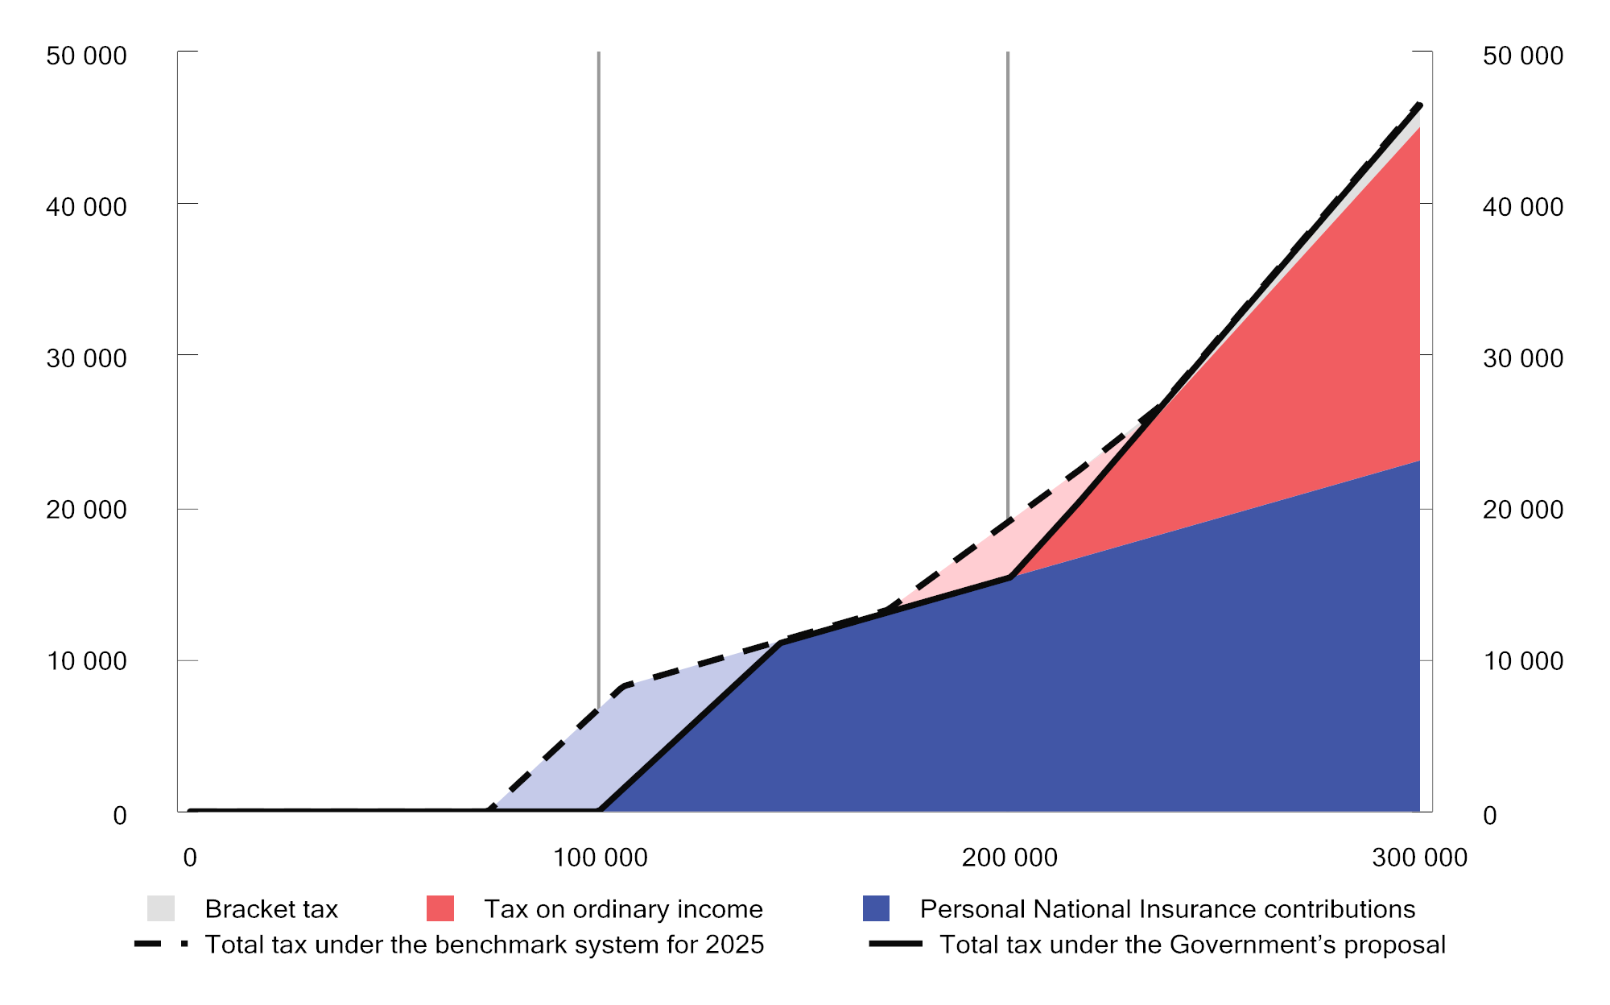

Tax relief on low wage income as a result of increased exemption card limit (light blue field) and increased threshold for paying tax on ordinary income (pink field). Taxpayer with only wage income and standard allowances. The Government’s proposal compared to the benchmark system for 2025

Sources: Ministry of Finance.

To measure the short-term impact of income tax changes on different income groups, the proposals are compared with the 2024 rules applied to 2025 (the benchmark system); see Table 1.4. The estimates include changes in rates, allowances and thresholds under personal income taxation. The isolated, net income tax reduction resulting from the changes included in the calculations is estimated at about NOK 1,235 million accrued.

It is estimated that more than 85 per cent of taxpayers will pay less or the same amount of income tax. The increase in the exemption card limit and the switch from basic allowance to personal allowance mean that the greatest reductions will be experienced by taxpayers on the lowest incomes.

The most important income tax changes for which it is not possible to calculate distributional effects in the Statistics Norway tax model are the proposals to tax the introductory benefit as wage income, to abolish the two-year time limit on commuter allowance for construction workers, and to amend the exit tax rules.

The Hurdal Platform sets out the Government’s intention to keep the overall level of taxes and levies on people’s incomes and consumption unchanged. This is based on the assumptions that dividend tax and wealth tax are excluded and that households’ share of tax changes is included. With the Government's proposal for the 2025-budget, the tax relief for households according to this definition adds up to NOK 10.9 billion under this government; see Table 1.5.

Estimated distributional effects of income tax changes for persons aged 17 and over. Negative numbers are tax reductions. Compared to the benchmark system for 2025

06J1xt2

|  |  |  |  |  |  |
| --- | --- | --- | --- | --- | --- |
| Gross income¹  including tax-free  benefits.  NOK | Number | Average tax under the benchmark alternative. NOK | Average tax under the benchmark alternative. Per cent | Average change  in tax.2  NOK | Change as  a percentage of gross  income.  Per cent |
| 0–100,000 | 308,300 | 1,200 | 3.3 | -200 | -0.6 |
| 100,000–200,000 | 211,900 | 8,200 | 5.4 | -2,200 | -1.4 |
| 200,000–250,000 | 132,200 | 13,000 | 5.7 | -1,200 | -0.5 |
| 250,000–300,000 | 201,300 | 18,600 | 6.7 | -400 | -0.1 |
| 300,000–350,000 | 250,700 | 33,800 | 10.4 | -200 | -0.1 |
| 350,000–400,000 | 288,100 | 52,000 | 13.9 | -200 | -0.1 |
| 400,000–450,000 | 286,200 | 69,400 | 16.3 | -200 | -0.1 |
| 450,000–500,000 | 271,900 | 86,400 | 18.2 | -200 | -0.1 |
| 500,000–550,000 | 283,000 | 103,000 | 19.6 | -400 | -0.1 |
| 550,000–600,000 | 273,300 | 118,800 | 20.7 | -400 | -0.1 |
| 600,000–700,000 | 510,400 | 141,800 | 21.9 | -400 | -0.1 |
| 700,000–800,000 | 424,000 | 174,200 | 23.3 | -400 | 0.0 |
| 800,000–1,000,000 | 508,000 | 229,400 | 25.9 | -200 | 0.0 |
| 1,000,000–2,000,000 | 547,600 | 406,200 | 31.3 | 600 | 0.1 |
| 2,000,000–3,000,000 | 59,700 | 889,000 | 37.5 | 600 | 0.0 |
| 3,000,000 and above | 33,600 | 2,556,200 | 41.6 | 400 | 0.0 |
| Total | 4,590,200 | 165,600 | 25.1 | -200 | 0.0 |

1 Gross income includes wages, National Insurance benefits, pension income, self-employment income and capital income before tax and tax-free benefits.

2 The numbers are rounded to the nearest NOK 200.

Sources: Ministry of Finance and the Statistics Norway tax model; LOTTE-Skatt.

Estimated total revenue effects of changes in personal taxes on income and consumption. Fully phased in. The annual contributions have been calculated in relation to the benchmark system for each year. NOK million accrued

03J1xt2

|  |  |  |
| --- | --- | --- |
|  | 2022–2025  (total) | 2025  (proposal) |
| Tax on personal income (excluding dividend tax) | -10,500 | -1,300 |
| Climate-, environmental- and car taxes | 3,400 | -800 |
| Value added tax | -2,100 | -4,100 |
| Other excise duties | -1,000 | -400 |
| Sectoral taxes | -700 | -500 |
| Total annual contribution to the Government’s tax  intention | -10,900 | -7,100 |

Source: Ministry of Finance.

Over time, the Government has prioritised tax relief for people on low and medium incomes. Table 1.6 presents estimates of distributional effects of adopted income tax changes from previous budgets. People are arranged by gross income and divided into ten equally sized groups for each year (deciles). Each group includes around 450,000 people. Table 1.7 presents corresponding estimates for annual changes in wealth tax specified by estimated net wealth.

It should be noted that the columns cannot be added up directly. Firstly, the same person may be in different deciles in different years. Secondly, the estimates in the table have been calculated on the data basis and with the wage and price growth estimates, etc., that underpinned each budget. Updated estimates will give different results. Furthermore, the estimates only include tax changes that can be calculated in the Statistics Norway tax model; LOTTE-Skatt. Nevertheless, the tables provide a clear illustration of the distributional profile of the income tax programme for individuals for the various years.

During the period, broad income tax relief has been granted, partly financed by tax increases for people on the highest incomes. Over time, the Government has prioritised a sharp increase in the personal allowance, and the threshold for paying tax on ordinary income in the form of wage income and pension income has been more than doubled in nominal terms, from about NOK 97,000 in 2021 to about NOK 200,000 under the proposal for 2025. Personal National Insurance contributions on wage income and pension income have been reduced from 8.2 per cent 2021 to 7.7 per cent in the proposal for 2025. For high incomes, the National Insurance contribution increase is offset by a bracket tax increase. The tax increases for top earners are primarily a result of increased dividend tax in 2022 and 2023. The change in the Revised National Budget for 2023 only applies to pension tax, for which relief was granted in respect of relatively low pensions.

Changes to wealth tax in the 2022 and 2023 budgets made wealth tax more progressive, thus implying that those with the highest wealth pay somewhat more. Valuations have been increased for several assets (shares, primary dwelling value in excess of NOK 10 million and secondary dwellings), and a new tax bracket has been introduced for net wealth over NOK 20 million, for which the rate is 1.1%. At the same time, the standard allowance has been increased. There are no major changes to wealth tax in the 2024 budget and in the proposed 2025 budget.

Historical estimates and estimates for 2025 for distributional effects of income tax changes for persons aged 17 and over. Negative numbers are tax reductions. The annual estimates are calculated in relation to the benchmark system for each year. Divided into deciles by gross income, incl. tax-free benefits

06J2xt2

|  |  |  |  |  |  |
| --- | --- | --- | --- | --- | --- |
|  | Average tax change. NOK | | | | |
|  | NB  2022 | NB  2023 | RNB  2023 | NB  2024 | Proposal 2025 |
| Decile 1 | -200 | 0 | 0 | 0 | -1,000 |
| Decile 2 | -800 | -1,600 | -400 | -400 | -800 |
| Decile 3 | -1,200 | -1,200 | -1,600 | -200 | -200 |
| Decile 4 | -1,400 | -1,400 | -400 | -200 | -200 |
| Decile 5 | -1,600 | -1,600 | -200 | -400 | -400 |
| Decile 6 | -2,000 | -2,000 | 0 | -400 | -400 |
| Decile 7 | -2,200 | -2,200 | 0 | -400 | -400 |
| Decile 8 | -1,400 | -400 | 0 | -200 | -200 |
| Decile 9 | 0 | 400 | -200 | 200 | 200 |
| Decile 10 | 9,200 | 8,000 | -200 | 1,600 | 600 |
| Of which top 1% | 62,600 | 44,800 | -200 | 2,200 | 400 |
| Total | -200 | -200 | -400 | 0 | -200 |

Sources: Ministry of Finance and the Statistics Norway tax model; LOTTE-Skatt.

Historical estimates and estimates for 2025 for distributional effects of wealth tax changes for persons aged 17 and over. Negative numbers are tax reductions. The annual estimates are calculated in relation to the benchmark system for each year. Divided into deciles by estimated net wealth

05J2xt2

|  |  |  |  |  |
| --- | --- | --- | --- | --- |
|  | Average tax change. NOK | | | |
|  | NB 2022 | NB 2023 | NB 2024 | Proposal 2025 |
| Decile 1 | 0 | 0 | 0 | 0 |
| Decile 2 | 0 | 0 | 0 | 0 |
| Decile 3 | 0 | 0 | 0 | 0 |
| Decile 4 | 0 | 0 | 0 | 0 |
| Decile 5 | 0 | 0 | 0 | 0 |
| Decile 6 | 0 | 0 | 0 | 0 |
| Decile 7 | 0 | 0 | 0 | 0 |
| Decile 8 | 0 | 200 | 0 | 0 |
| Decile 9 | 200 | 400 | 0 | 0 |
| Decile 10 | 14,400 | 5,800 | 0 | 200 |
| Of which top 1% | 120,800 | 35,000 | 0 | 400 |
| Total | 1,400 | 600 | 0 | 0 |

Sources: Ministry of Finance and the Statistics Norway tax model; LOTTE-Skatt.

### Geographical distributional effects

The geographical distributional effects of the proposed income tax programme for 2025 are minor. Table 1.8 presents the estimated average tax change from the Government’s proposed income tax changes for people in six centrality zones. Zone 1 is the most central and includes Oslo and some neighbouring municipalities, while zone 6 is the least central. The table shows that the estimated tax changes are evenly distributed across Norway when rounded to the nearest NOK 200.

Estimated geographical distributional effects of income tax changes for persons aged 17 and over. Negative numbers are tax reductions. Compared to the benchmark system for 2025

06J1xt2

|  |  |  |  |  |  |
| --- | --- | --- | --- | --- | --- |
| Centrality  zone | Number of  taxpayers | Average  gross  income.  NOK | Average  calculated  net worth.  NOK | Average  tax under the benchmark system.  NOK | Average  change  in income  tax.1  NOK |
| Z01 | 888,300 | 763,000 | 3,856,600 | 215 200 | -200 |
| Z02 | 1,170,900 | 671,200 | 2,410,200 | 171 000 | -200 |
| Z03 | 1,171,700 | 629,000 | 1,912,400 | 150,800 | -200 |
| Z04 | 737,800 | 614,800 | 1,526,800 | 142,200 | -200 |
| Z05 | 421,200 | 611,600 | 1,551,600 | 141,400 | -200 |
| Z06 | 200,100 | 597,200 | 1,648,800 | 137,600 | -200 |
| Total | 4,590,200 | 660,400 | 2,309,000 | 165,600 | -200 |

1 The numbers are rounded to the nearest NOK 200.

Sources: Ministry of Finance and the Statistics Norway tax model; LOTTE-Skatt.

## Tax rates and thresholds

Table 1.9 presents key tax rates, allowances and thresholds in 2024 and the Government’s proposal for 2025. After adjustment for projected growth in wages, pensions or prices, etc., from 2024 to 2025, the general allowances and thresholds have been rounded off. The upward adjustment may therefore deviate somewhat from the level indicated by the various growth projections. Wage growth is estimated at 4.5 per cent, consumer price inflation at 3.0 per cent and pension growth at 3.65 per cent. Reference is also made to the proposed tax decision in this proposition and to the overview of allowances and thresholds on the Ministry’s website.

Tax rates, allowances and thresholds in 2024 and proposals for 2025

04J1xt2

|  |  |  |  |
| --- | --- | --- | --- |
|  | 2024 rules | Proposal  2025 rules | Change  2024–2025 |
| Tax on ordinary income |  |  |  |
| Individuals1 | 22% | 22% | - |
| Businesses2 | 22% | 22% | - |
|  |  |  |  |
| Tax on resource rent industries |  |  |  |
| Petroleum (special tax)3 | 71.8% | 71.8% | - |
| Hydropower  (resource rent tax)4 | 57.7% | 57.7% | - |
| Aquaculture  (resource rent tax)5 | 32.1% | 32.1% | - |
| Wind power  (resource rent tax)5 | 32.1% | 32.1% | - |
|  |  |  |  |
| Bracket tax |  |  |  |
| Bracket 1 |  |  |  |
| Threshold | NOK 208,050 | NOK 217,400 | 4.5% |
| Rate | 1.7% | 1.7% | - |
| Bracket 2 |  |  |  |
| Threshold | NOK 292,850 | NOK 306,050 | 4.5% |
| Rate | 4.0% | 4.0% | - |
| Bracket 3 |  |  |  |
| Threshold | NOK 670,000 | NOK 697,150 | 4.1% |
| Rate | 13.6% | 13.7% | 0.1 pp |
| Bracket 4 |  |  |  |
| Threshold | NOK 937,900 | NOK 942,400 | 0.5% |
| Rate | 16.6% | 16.7% | 0.1 pp |
| Bracket 5 |  |  |  |
| Threshold | NOK 1,350,000 | NOK 1,410,750 | 4.5% |
| Rate | 17.6% | 17.7% | 0.1 pp |
|  |  |  |  |
| National Insurance contributions |  |  |  |
| Lower thresholds for the payment of personal National Insurance contributions | NOK 69,650 | NOK 99,650 | 43.1% |
| Levelling rate | 25% | 25% | - |
| Rate |  |  |  |
| Wage income | 7.8% | 7.7% | -0.1 pp |
| Fishing and childcare6 | 7.8% | 7.7% | -0.1 pp |
| Other self-employment income | 11.0% | 10.9% | -0.1 pp |
| Pension income, etc. | 5.1% | 5.1% | - |
|  |  |  |  |
| Rate on gross income for  foreign employees  (withholding tax) | 25% | 25% | - |
|  |  |  |  |
| Employer’s National Insurance contributions |  |  |  |
| Zone I | 14.1% | 14.1% | - |
| Zone Ia7 | 14.1/10.6% | 14.1/10.6% | - |
| Zone II | 10.6% | 10.6% | - |
| Zone III | 6.4% | 6.4% | - |
| Zone IV | 5.1% | 5.1% | - |
| Zone IVa | 7.9% | 7.9% | - |
| Zone V | 0% | 0% | - |
| Additional employer’s National Insurance contributions on salaries over NOK 850,000 | 5% | - | To be  discontinued |
|  |  |  |  |
| Maximum effective marginal  tax rates |  |  |  |
| Wage income, excluding employer’s National Insurance contributions | 47.4% | 47.4% | - |
| Wage income, including employer’s National Insurance contributions | 55.8% | 53.9% | -1.9 pp |
| Pension income8 | 44.7% | 44.8% | 0.1 pp |
| Self-employment income | 50.6% | 50.6% | - |
| Dividends, excluding  corporation tax | 37.8% | 37.8% | - |
| Dividends, including  corporation tax9 | 51.5% | 51.5% | - |
|  |  |  |  |
| Personal allowance | NOK 88,250 | NOK 108,550 | 23.0% |
|  |  |  |  |
| Basic allowance against wage income, etc.10 |  |  |  |
| Rate | 46% | 46% | - |
| Upper limit | NOK 104,450 | NOK 92,000 | -11.9% |
|  |  |  |  |
| Basic allowance against pension income10 |  |  |  |
| Rate | 40% | 40% | - |
| Upper limit | NOK 86,250 | NOK 73,150 | -15.2% |
|  |  |  |  |
| Tax credit for pension income |  |  |  |
| Maximum amount | NOK 34,350 | NOK 35,600 | 3.6% |
| Downscaling, bracket 1 |  |  |  |
| Threshold | NOK 258,400 | NOK 267,850 | 3.7% |
| Rate | 16.7% | 16.7% |  |
| Downscaling, bracket 2 |  |  |  |
| Threshold | NOK 391,550 | NOK 405,850 | 3.7% |
| Rate | 6.0% | 6.0% | - |
|  |  |  |  |
| Tax limitation rule |  |  |  |
| Levelling rate | 55% | 55% | - |
| Tax-free net income |  |  |  |
| Single person | NOK 147,450 | NOK 147,450 | - |
| Married person | NOK 135,550 | NOK 135,550 | - |
| Wealth supplement |  |  |  |
| Rate | 1.5% | 1.5% | - |
| Single person | NOK 200,000 | NOK 200,000 | - |
| Married person | NOK 100,000 | NOK 100,000 | - |
|  |  |  |  |
| Special allowance in Finnmark and Northern Troms (action zone) | NOK 30,000 | NOK 30,000 | - |
|  |  |  |  |
| Special allowance for seafarers |  |  |  |
| Rate | 30% | 30% | - |
| Upper limit | NOK 83,000 | NOK 83,000 | - |
|  |  |  |  |
| Special allowance for fishermen |  |  |  |
| Rate | 30% | 30% | - |
| Upper limit | NOK 154,000 | NOK 154,000 | - |
|  |  |  |  |
| Special allowance against  self-employment income from agriculture, etc.11 |  |  |  |
| Income-independent allowance | NOK 93,000 | NOK 95,800 | 3.0% |
| Rate applicable to amounts in excess of the  income-independent allowance | 38% | 38% | - |
| Maximum total allowance | NOK 195,000 | NOK 200,850 | 3.0% |
|  |  |  |  |
| Maximum allowance for payments to individual  pension schemes | NOK 15,000 | NOK 15,000 | - |
|  |  |  |  |
| Allowance for travel between home and work |  |  |  |
| Rate per km | NOK 1.76 | NOK 1.83 | 4.0% |
| Lower allowance threshold | NOK 14,950 | NOK 15,250 | 2.0% |
| Upper limit | NOK 97,000 | NOK 100,880 | 4.0% |
|  |  |  |  |
| Maximum allowance for donations to charities | NOK 25,000 | NOK 25,000 | - |
|  |  |  |  |
| Maximum allowance for paid trade union subscriptions, etc. | NOK 8,000 | NOK 8,250 | 3.1% |
|  |  |  |  |
| Home investment savings scheme for people below the age of 34 years (BSU) |  |  |  |
| Tax deduction rate | 10% | 10% | - |
| Maximum annual savings | NOK 27,500 | NOK 27,500 | - |
| Maximum total savings under  the scheme | NOK 300,000 | NOK 300,000 | - |
|  |  |  |  |
| Parental allowance for documented childcare expenses |  |  |  |
| Upper limit |  |  |  |
| One child | NOK 25,000 | NOK 25,000 | - |
| Supplement per additional child | NOK 15,000 | NOK 15,000 | - |
|  |  |  |  |
| Wealth tax12 |  |  |  |
| Local government |  |  |  |
| Threshold | NOK 1,700,000 | NOK 1,760,000 | 3.5% |
| Rate | 0.7% | 0.525% | -0.175 pp |
| Central government |  |  |  |
| Threshold, bracket 1 | NOK 1,700,000 | NOK 1,760,000 | 3.5% |
| Rate, bracket 1 | 0.30% | 0.475% | 0.175 pp |
| Threshold, bracket 2 | NOK 20 million | NOK 20.7 million | 3.5% |
| Rate, bracket 2 | 0.4% | 0.575% | 0.175 pp |
|  |  |  |  |
| Valuation13 |  |  |  |
| Primary dwelling | 25% | 25% | - |
| High-valuation primary  dwelling14 | 70% | 70% | - |
| Secondary dwelling  (and assigned debt) | 100% | 100% | - |
| Shares (including commercial property) and assigned debt | 80% | 80% | - |
| Operating assets (and assigned debt) | 70% | 70% | - |
|  |  |  |  |
| Financial activity tax |  |  |  |
| Financial activity tax on payrolls | 5% | 5% | - |
| Financial activity tax on profits | 3% | 3% | - |
| Depreciation rates |  |  |  |
| Asset group a  (office machinery, etc.) | 30% | 30% | - |
| Asset group b  (acquired goodwill) | 20% | 20% | - |
| Asset group c  (heavy goods vehicles, lorries, buses, vans, etc.)15 | 24% | 24% | - |
| Asset group d (passenger cars, machinery and equipment, etc.) | 20% | 20% | - |
| Asset group e  (ships, vessels, rigs, etc.) | 14% | 14% | - |
| Asset group f  (aircraft, helicopters) | 12% | 12% | - |
| Asset group g (facilities for the transmission and distribution of electricity and electrotechnical equipment in power companies) | 5% | 5% | - |
| Asset group h (buildings and installations, hotels, etc.)16 | 4 (6/10/20)% | 4 (6/10/20)% | - |
| Asset group i (office buildings) | 2% | 2% | - |
| Asset group j (technical facilities in office buildings and other commercial buildings) | 10% | 10% | - |

1 For taxpayers in the action zone in Finnmark and Northern Troms, the rate is 18.5 per cent in both 2024 and 2025.

2 The tax rate on ordinary income for businesses subject to financial activity tax is 25 per cent in both 2024 and 2025.

3 Since calculated corporation tax is deducted from the special tax base, a formal tax rate of 71.8 per cent will correspond to an effective tax rate of 56 per cent.

4 Since resource rent-related corporation tax is deducted from the resource rent tax base, a formal tax rate of 57.7 per cent will correspond to an effective tax rate of 45 per cent.

5 Since resource rent-related corporation tax is deducted from the resource rent tax base, a formal tax rate of 32.1 per cent will correspond to an effective tax rate of 25 per cent.

6 Self-employed persons engaged in fishing, or in childcare in their own home (children under the age of 12 or with special care needs) pay National Insurance contributions on self-employment income at the rate of 7.8 per cent in 2024 and 7.7 per cent in 2025. The lower National Insurance contribution rate for fishing is related to this industry paying product tax, with such tax being intended to cover, inter alia, the difference between this lower rate and the contribution rate payable on other self-employment income.

7 In zone Ia, employer’s National Insurance contributions shall be paid at a rate of 10.6 per cent until the difference between what the enterprise pays in employer’s National Insurance contributions at this rate and what the enterprise would have paid in employer’s National Insurance contributions at a rate of 14.1 per cent is equal to the tax-free allowance. The rate of 14.1 per cent is applied to the excess contribution base. In 2025, the tax-free allowance is NOK 850,000 per enterprise.

8 For persons encompassed by the tax credit for pension income, the highest effective marginal tax rate may be up to 47.8 per cent in both 2024 and 2025.

9 Includes corporation tax and an upward adjustment factor for dividends, etc. In both 2024 and 2025, the corporation tax rate is 22 per cent and the upward adjustment factor for dividends, etc., is 1.72.

10 Taxpayers with both wage income, etc., and pension income will be granted the sum total of the basic allowance against wage income and pension income. The upper limit on the basic allowance against wage income applies as the upper limit on the sum total of the basic allowances.

11 The income-independent element of the reindeer husbandry allowance will be increased to NOK 95,800, and the maximum allowance will be increased to NOK 200,850 in 2025.

12 The thresholds are for single taxpayers. For married couples, whose taxes are assessed jointly on joint wealth, the thresholds are double those specified in the table.

13 The valuation applies to assets owned directly by the taxpayer liable for wealth tax.

14 High-valuation primary dwelling applies to the part of the property value in excess of NOK 10 million in both 2024 and 2025.

15 The ordinary depreciation rate for asset group c is 24 per cent, with a higher rate of 30 per cent for vans, the abolition of which is proposed for 2024.

16 Livestock buildings in agriculture can be depreciated at a higher rate of 6 per cent. Buildings with such a simple structure that their useful life must be assumed not to exceed 20 years, can be depreciated at a rate of 10 per cent. The rate of 10 per cent also applies to facilities where the useful life must be assumed not to exceed 20 years. Costs for the establishment of fruit and berry fields can be depreciated on a declining-balance basis at a rate of 10 and 20 per cent, respectively.

Source: Ministry of Finance.

Table 1.10 presents the current rates for value added tax and excise duties, as well as the proposed rates for 2025. All excise duties have been generally adjusted upwards by 3.0 per cent to take into account anticipated inflation. Minor deviations may be due to rounding of the rates. Reference is also made to the decision on indirect taxes proposed in this proposition.

Rates of indirect tax in 2024 and proposed rates for 2025

04J1xt2

|  |  |  |  |
| --- | --- | --- | --- |
| Tax category | 2024  rules | Proposal  for 2025 | Change in  per cent |
| Value added tax, per cent of sales value |  |  |  |
| Standard rate | 25 | 25 | - |
| Reduced rate | 15 | 15 | - |
| Low rate | 12 | 12 | - |
|  |  |  |  |
| Tax on alcohol |  |  |  |
| Spirits-based beverages containing over  0.7 per cent alcohol by volume, NOK  per volume per cent per litre | 8.77 | 9.03 | 3.0 |
| Other alcoholic beverages containing from 4.7  to 22 per cent alcohol by volume, NOK per volume per cent per litre | 5.14 | 5.29 | 2.9 |
| Other alcoholic beverages containing up to  and including 4.7 per cent alcohol by volume, NOK per volume per cent per litre |  |  |  |
| 0.0–0.7 volume per cent | - | - | - |
| 0.7–2.7 volume per cent | 3.53 | 3.64 | 3.1 |
| 2.7–3.7 volume per cent | 13.28 | 13.68 | 3.0 |
| 3.7–4.7 volume per cent | 22.99 | 23.68 | 3.0 |
| Fermented alcoholic beverages containing from 3.7 up to and including 4.7 per cent alcohol by volume, produced by small breweries. | variable | variable | - |
|  |  |  |  |
| Tax on tobacco products |  |  |  |
| Cigars, NOK per 100 grams | 315 | 324 | 2.9 |
| Cigarettes, NOK per 100 units | 315 | 324 | 2.9 |
| Smoking tobacco, NOK per 100 grams | 315 | 324 | 2.9 |
| Moist snuff, NOK per 100 grams | 97 | 100 | 3.1 |
| Chewing tobacco, NOK per 100 grams | 128 | 132 | 3.1 |
| Cigarette paper, NOK per 100 units | 4.82 | 4.96 | 2.9 |
| E-liquids containing nicotine, NOK per 100 ml | 511 | 526 | 2.9 |
| Tobacco for heating, NOK per 100 grams | 315 | 324 | 2.9 |
| Other nicotine products, NOK per 100 grams | 48.25 | 49.70 | 3.0 |
|  |  |  |  |
| Motor vehicle registration tax |  |  |  |
| Passenger cars, etc. Tax group a1 |  |  |  |
| All passenger cars |  |  |  |
| Kerb weight, NOK per kg |  |  |  |
| first 500 kg | 0 | 0 | - |
| remainder | 12.08 | 12.44 | 3.0 |
| Passenger cars, etc., with internal combustion engine |  |  |  |
| Kerb weight, NOK per kg |  |  |  |
| first 500 kg | 0 | 0 | - |
| next 700 kg | 28.98 | 29.85 | 3.0 |
| next 200 kg | 72.22 | 74.38 | 3.0 |
| next 100 kg | 225.68 | 232.45 | 3.0 |
| remainder | 262.46 | 270.34 | 3.0 |
| NOX emissions, NOK per mg/km | 83.38 | 85.88 | 3.0 |
| CO2 emissions, NOK per g/km |  |  |  |
| first 70 g/km | 0 | 0 | - |
| next 48 g/km | 1,402.64 | 1,444.72 | 3.0 |
| next 37 g/km | 1,571.81 | 1,618.96 | 3.0 |
| next 70 g/km | 3,050.96 | 3,142.49 | 3.0 |
| remainder | 4,866.87 | 5,012.88 | 3.0 |
| allowance for emissions below 70 g/km, applies down to 50 g/km and only for vehicles with emissions of less than 70 g/km | 887.13 | 913.74 | 3.0 |
| allowance for emissions below 50 g/km,  only applies to vehicles with emissions of  less than 50 g/km | 1,043.72 | 1,075.03 | 3.0 |
| Vans class 2. Tax group b |  |  |  |
| Kerb weight, per cent of passenger car rate | 20 | 20 | - |
| NOX emissions, per cent of passenger car rate | 75 | 75 | - |
| CO2 emissions, NOK per g/km |  |  |  |
| first 84 g/km | 0 | 0 | - |
| next 30 g/km | 432.01 | 444.97 | 3.0 |
| next 36 g/km | 484.12 | 498.65 | 3.0 |
| remainder | 939.70 | 967.89 | 3.0 |
| allowance for emissions below 84 g/km, applies down to 48 g/km and only for vehicles with emissions of less than 84 g/km | 266.14 | 274.13 | 3.0 |
| allowance for emissions below 48 g/km,  only applies to vehicles with emissions of  less than 48 g/km | 313.11 | 322.51 | 3.0 |
| Motorhomes. Tax group c2 |  |  |  |
| Kerb weight, per cent of passenger car rate | 22 | 22 | - |
| Piston displacement | variable | variable | - |
| Motorcycles. Tax group f3 |  |  |  |
| Piston displacement tax, NOK per cm3 |  |  |  |
| first 500 cm3 | 0 | 0 | - |
| next 400 cm3 | 34.51 | 35.55 | 3.0 |
| remainder | 80.65 | 83.07 | 3.0 |
| CO2 emissions, NOK per g/km |  |  |  |
| first 75 g/km | 0 | 0 | - |
| next 60 g/km | 767.91 | 790.95 | 3.0 |
| remainder | 1,038.33 | 1,069.48 | 3.0 |
| Snowmobiles. Tax group g |  |  |  |
| Kerb weight, NOK per kg |  |  |  |
| first 100 kg | 16.21 | 16.70 | 3.0 |
| next 100 kg | 32.42 | 33.39 | 3.0 |
| remainder | 64.82 | 66.77 | 3.0 |
| Engine power, NOK per kW |  |  |  |
| first 20 kW | 26.03 | 26.81 | 3.0 |
| next 20 kW | 52.09 | 53.65 | 3.0 |
| remainder | 104.15 | 107.27 | 3.0 |
| Piston displacement, NOK per cm3 |  |  |  |
| first 500 cm3 | 0 | 0 | - |
| remainder | 11.40 | 11.74 | 3.0 |
| Minibuses. Tax group j4 |  |  |  |
| Kerb weight, per cent of passenger car rate | 40 | 40 | - |
| CO2 emissions, NOK per g/km | variable | variable | - |
|  |  |  |  |
| Traffic insurance tax, NOK per day5 |  |  |  |
| Passenger cars, vans, etc. | 7.60 | 6.38 | -16.1 |
| Diesel cars without factory-fitted particle filter | 9.11 | 7.93 | -13.0 |
| Motorcycles | 5.23 | 5.39 | 3.1 |
| Tractors, mopeds, etc. | 0.37 | 0.38 | 2.7 |
| Electric cars | 8.70 | 8.96 | 3.0 |
|  |  |  |  |
| Annual weight-based tax, NOK per year | variable | variable | - |
|  |  |  |  |
| Re-registration tax | variable | variable | - |
|  |  |  |  |
| Road usage tax on fuel |  |  |  |
| Petrol, NOK per litre | 4.62 | 4.16 | -10.0 |
| Mineral oils, NOK per litre | 2.71 | 2.69 | -0.7 |
| Bioethanol, NOK per litre | 2.16 | 2.12 | -1.9 |
| Biodiesel, NOK per litre | 3.02 | 2.69 | -10.9 |
| Natural gas, NOK per Sm3 | 2.96 | 3.05 | 3.0 |
| LPG, NOK per kg | 3.86 | 3.98 | 3.1 |
|  |  |  |  |
| Electricity tax, NOK 0.01 per kWh |  |  |  |
| Standard rate | 16.44 | 16.93 | 3.0 |
| Lower standard rate in January-March | 9.51 | 9.79 | 3.0 |
| Reduced rate | 0.58 | 0.60 | 3.4 |
|  |  |  |  |
| Tax on lubricating oils, NOK per litre | 2.54 | 2.62 | 3.1 |
|  |  |  |  |
| CO*2* tax on mineral products |  |  |  |
| Petrol, NOK per litre | 2.72 | 3.25 | 19.5 |
| Mineral oils, NOK per litre |  |  |  |
| standard rate | 3.17 | 3.79 | 19.6 |
| subject to ETS | 0.24 | 0.25 | 4.2 |
| domestic aviation | 3.00 | 3.58 | 19.3 |
| domestic aviation subject to ETS | 1.72 | 1.77 | 2.9 |
| domestic shipping subject to ETS6 | 2.07 | 1.96 | -5.3 |
| fishing in distant waters7 | - | 0.93 | New |
| international shipping8 | - | 1.33 | New |
| Natural gas, NOK per Sm3 |  |  |  |
| standard rate | 2.34 | 2.80 | 19.7 |
| subject to ETS | 0.066 | 0.066 | - |
| chemical reduction, etc.9 . | 0 | 0 | - |
| greenhouse industry | 0.35 | 0.42 | 20.0 |
| domestic shipping subject to ETS6 | 1.54 | 1.46 | -5.2 |
| fishing in distant waters7 | - | 0.70 | New |
| international shipping8 | - | 1.00 | New |
| LPG, NOK per kg |  |  |  |
| standard rate | 3.53 | 4.22 | 19.5 |
| subject to ETS | 0 | 0 | - |
| chemical reduction, etc.9 | 0 | 0 | - |
| greenhouse industry | 0.53 | 0.63 | 18.9 |
| domestic shipping subject to ETS6 | 2.33 | 2.21 | -5.2 |
| fishing in distant waters7 | - | 1.05 | New |
| international shipping8 | - | 1.50 | New |
|  |  |  |  |
| Waste incineration tax, NOK per tonne CO2 |  |  |  |
| Non-ETS emissions | 882 | 908 | 2.9 |
| Emissions subject to ETS | 176 | 182 | 3.4 |
|  |  |  |  |
| Tax on HFCs and PFCs, NOK per tonne CO2  equivalents | 1,176 | 1,405 | 19.5 |
|  |  |  |  |
| Tax on SF6, NOK per kg SF6 |  |  |  |
| Undiluted SF6 | 27,636 | 33,018 | 19.5 |
| SF6 included in products | 5,523 | 6,604 | 19.6 |
|  |  |  |  |
| CO*2* tax in the petroleum sector |  |  |  |
| mineral oils, NOK per litre | 2.10 | 2.17 | 3.3 |
| natural gas, NOK per Sm3 | 1.85 | 1.90 | 2.7 |
| natural gas discharged into the atmosphere,  NOK per Sm3 | 16.89 | 20.17 | 19.4 |
|  |  |  |  |
| Sulphur tax, NOK 0.01 per litre | 15.20 | 15.70 | 3.3 |
|  |  |  |  |
| Tax on NOX, NOK per kg | 25.59 | 26.36 | 3.0 |
|  |  |  |  |
| Tax on farmed fish, NOK per kg | 0.935 | 0.965 | 3.2 |
|  |  |  |  |
| Tax on wild marine resources, percentage of gross sales value less fees paid to fishermen’s cooperative sales association | 0.42 | 0.42 | - |
|  |  |  |  |
| Tax on wind power, NOK 0.01 per kWh | 2.30 | 2.37 | 3.0 |
|  |  |  |  |
| Tax on sugar, NOK per kg | 9.18 | 9.46 | 3.1 |
|  |  |  |  |
| Tax on beverage packaging, NOK per unit |  |  |  |
| Base tax, disposable packaging | 1.38 | 1.42 | 2.9 |
| Environmental tax |  |  |  |
| glass and metal | 6.71 | 6.91 | 3.0 |
| plastic | 4.06 | 4.18 | 3.0 |
| cardboard and cartons | 1.65 | 1.70 | 3.0 |
| Air passenger tax, NOK per passenger |  |  |  |
| Low rate | 85 | 60 | -29.4 |
| High rate | 332 | 342 | 3.0 |
|  |  |  |  |
| Stamp duty, per cent of sales value | 2.5 | 2.5 | - |

1 Group a: Passenger cars, vans class 1 and buses less than 6 metres in length with up to 17 seats. Piston displacement is used as the tax component for vehicles whose CO2 emissions are not specified.

2 Group c: Motorhomes. Not subject to NOX component.

3 Group f: Motorcycles. Vehicles for which CO2 emissions are not registered are subject to tax per unit and tax on engine power, in addition to piston displacement tax.

4 Group j: Buses less than 6 metres in length with up to 17 seats, of which at least 10 are forward-facing. The highest bracket of the CO2 component does not apply to group j. Not subject to NOX component.

5 The tax that each insurance policy triggers is determined on the basis of the tax rates that applied as of the start date of the policy. The 2022 rates apply to insurance policies that were established or had their main expiry date before 1 March 2023. The 2023 rates apply to insurance policies that were established or had their main expiry date between 1 March 2023 and 29 February 2024. The 2024 rates apply to insurance policies that are established or have their main expiry date after 1 March 2024.

6 The introduction of a reduced rate for domestic shipping subject to ETS requires the issue of state aid to be clarified with the ESA.

7 The exemption on fishing in distant waters will be discontinued in 2025, and a reduced rate corresponding to 25 per cent of the general level for non-ETS emissions will be introduced; see Section 10.9.4 in Prop. 1 LS (2023–2024) Skatter og avgifter 2025.

8 A separate rate for emissions from international shipping will be introduced in the CO2 tax on mineral products in 2025, provided that this does not contravene the state aid rules; see Section 10.9.4 in Prop. 1 LS (2023–2024) Skatter og avgifter 2025.

9 The tax on natural gas and LPG for chemical reduction, etc., has not entered into effect, pending ESA approval of the exemption for businesses subject to ETS.

Source: Ministry of Finance.

## Distribution of public tax revenues

Table 1.11 provides a general overview of the main groups of taxes and the parts of the public sector that receive revenues from each main group. Total tax revenues are estimated at NOK 2,084 billion in 2024. Of this amount, about 86 per cent will accrue to central government, 12 per cent to local government and 2 per cent to regional government.

Accrued taxes by tax creditor. Estimates for 2024. NOK billion

05J1xt2

|  |  |  |  |  |
| --- | --- | --- | --- | --- |
|  | Total | Central government | Local government | Regional  government |
| Personal taxpayers | 731.0 | 470.6 | 218.2 | 42.2 |
| Tax on ordinary income | 395.1 | 156.4 | 196.5 | 42.2 |
| Tax on personal income | 113.3 | 113.3 |  |  |
| Personal National Insurance contributions | 190.5 | 190.5 |  |  |
| Wealth tax | 32.1 | 10.4 | 21.7 |  |
|  |  |  |  |  |
| Companies (whose taxes are  payable in arrears) | 130.6 | 128.7 | 1.6 | 0.3 |
| Income tax (including power plants) | 129.8 | 127.9 | 1.6 | 0.3 |
| Wealth tax | 0.8 | 0.8 | 0.0 |  |
|  |  |  |  |  |
| Financial activity tax | 5.1 | 5.1 | 0.0 | 0.0 |
| Tax on payrolls | 2.7 | 2.7 |  |  |
| Tax on profits | 2.4 | 2.4 |  |  |
|  |  |  |  |  |
| Property tax | 18.2 |  | 18.2 |  |
|  |  |  |  |  |
| Employer’s National Insurance  contributions | 269.4 | 269.4 |  |  |
|  |  |  |  |  |
| Indirect taxes | 504.7 | 504.7 |  |  |
| Value added tax | 392.1 | 392.1 |  |  |
| Excise duties and customs duties | 112.6 | 112.6 |  |  |
|  |  |  |  |  |
| Petroleum | 357.1 | 357.1 | 0.0 | 0.0 |
| Tax on income | 349.1 | 349.1 |  |  |
| Tax on extraction, etc. | 8.0 | 8.0 |  |  |
|  |  |  |  |  |
| Other taxes | 68.7 | 63.2 | 4.5 | 1.0 |
| National Insurance and pension premiums, other central government accounts | 41.5 | 36.0 | 4.5 | 1.0 |
| Tax on dividends to foreign shareholders | 12.8 | 12.8 |  |  |
| Other taxes | 14.5 | 14.5 |  |  |
| Total taxes | 2,084.8 | 1,798.8 | 242.5 | 43.4 |

1 Excluding certain excise duties and sectoral taxes that are recognised as taxes in the fiscal budget, but are grouped as property income or user payments in the national accounts.

2 Including, inter alia, the Norwegian Public Service Pension Fund.

3 Including some revenue items that are grouped as tax revenues in the national accounts, but are not recognised as tax revenues in the fiscal budget.

Source: Ministry of Finance.

# Overview of the tax system

## Introduction

This chapter provides an overview of the fundamental principles for a good tax system, as well as the general rules for 2024. There are some exceptions to these general rules; so-called tax expenditures. Tax expenditures are discussed in Section 2.8 and described in more detail in Appendix 1.

Direct taxes include, inter alia, ordinary income taxes from individuals and businesses, resource rent taxes, employer’s National Insurance contributions, wealth tax and property tax.

Indirect taxes include value added tax, excise duties, customs duties and sectoral taxes.

Total public sector tax revenues are estimated at NOK 2,084 billion in 2024; see Table 1.11. Figure 2.1 presents estimates for total taxes to central government, regional government and local government for 2024, specified by tax type based on the numbers in Table 1.11. In 2024, personal income tax, i.e. the sum total of personal National Insurance contributions, tax on ordinary income and bracket tax, will constitute the largest component of total tax revenues. Revenues from value added tax constitute the second largest component, but central government revenues from petroleum sector taxes are also a major component. Taxes from the petroleum sector are included in the central government’s net cash flow from petroleum activities, which is transferred to the Government Pension Fund Global.

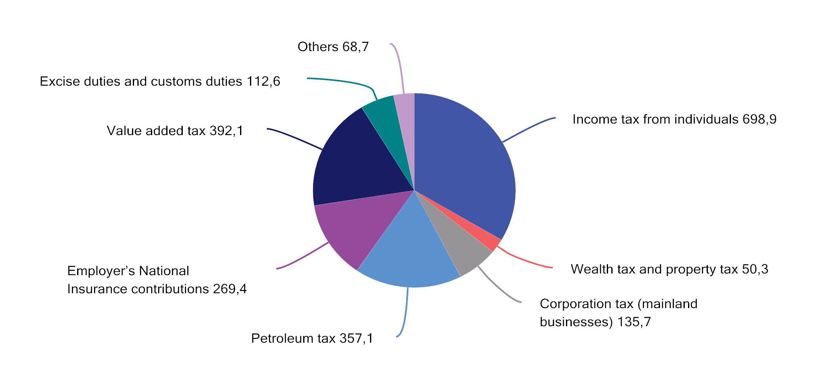

Taxes accrued to central government, regional government and local government. Estimates for 2024. NOK billion

1 Corporation tax includes resource rent taxes on aquaculture and power.

Source: Ministry of Finance.

## Guidelines for an efficient tax system

Taxes are necessary for financing public services and transfers. The tax system also influences labour supply, consumption, savings and investments. To ensure that society’s resources are allocated as efficiently as possible, the tax system design should be based on the fundamental principles of broad tax bases, low rates, the equal treatment of industries, as well as types of enterprises and investments, and the symmetrical treatment of income and expenses. This serves to keep taxation costs down and makes for equal treatment of taxpayers.

Broad tax bases that capture all types of income are also a prerequisite for the progressive tax system to actually contribute to the intended redistribution of income and to stabilising economic development. The principle of broad tax bases and relatively low tax rates guided the 1992 tax reform. This caused taxable income to better reflect actual income and meant that the behaviour of individuals and businesses was less affected by the tax rules.

Exceptions and special arrangements that deviate from the standard rules make the tax system less efficient. In order to maintain tax revenues, other taxes need to be increased, and the economic costs of taxation tend to increase more than proportionally with tax rate increases. If it is desirable to support a specific activity or specific group, measures on the expenditure side of the budget are often less costly and more targeted. As a general rule, revenues from individual taxes should not be earmarked for specific forms of expenditure. Such constraints impede the real prioritisation of funds on the expenditure side of the budget.

The principle of a broad tax base and relatively low tax rates, with few exceptions and special arrangements also makes for a simpler tax system. The tax rules should be as easy as possible for taxpayers to comply with and for the Norwegian Tax Administration to enforce. This will reduce administrative costs and facilitate digitalisation and automation. These are prerequisites for further improvements and simplifications to the tax authority reporting solutions. Overall, simpler regulations will contribute to more effective resource use, while strengthening the rule of law and predictability for taxpayers.

In addition, the tax system needs to be designed in such a way as not to violate Norway’s obligations under the EEA Agreement or other international obligations; see the discussion in Sections 2.5 and 2.6.

Public financing of comprehensive welfare services makes it necessary to maintain considerable tax revenues. The tax system also needs to address other important considerations in addition to generating government revenues; primarily social and geographical redistribution considerations, as well as environmental, climate and health considerations.

In some instances, there may be conflicts between the various objectives for the tax system. Different considerations therefore need to be weighed against each other when designing the tax rules. A single type of tax should generally not be targeted at multiple objectives.

The tax system contributes to redistribution by, inter alia, increasing the average tax rate with income and by taxing net wealth. Taxes on wages will tend to reduce labour supply, and it is therefore important that the tax system inhibits labour force participation, education and career choices as little as possible.

People with the lowest incomes pay little or no tax. Changes to the income tax system are therefore of little significance to this group. Many people with persistently low incomes are not working. The tax rules should, insofar as possible, be structured to make it worthwhile to work. For people receiving social security benefits to compensate for loss of labour income, the interplay between social security rules and tax rules is of importance to the incentives to return to work or to increase working hours. One challenge in the context of tax and welfare policy is to balance the consideration of income security against the consideration of work incentives. This is illustrated in Box 2.1, which demonstrates that there may, in some cases, be little financial gain from working rather than receiving social security benefits.

Incentives to work depend on both the tax system and the National Insurance system

Incentives to work are influenced by both tax rates on wage income and by net transfers to the individual. The income protection system in Norway (primarily the National Insurance Scheme) consists of various transfer schemes to ensure that people who, for various reasons, are not working have an income on which to sustain themselves, such as disability benefit and unemployment benefit. These schemes often lapse entirely or in part when a person starts working, and thus function as an extra “tax” on labour. In other words, the “effective tax” is the tax on wage income plus the net benefit (the benefit after tax) that is forfeited. This is not an actual tax rate, but it influences work incentives.

Figures 2.2 and 2.3 show average effective tax rates on wage income in the transition from unemployment to full employment for the Nordic countries for 2023. The calculations generally only take into account the level of transfers, while time limits on benefit payments and activity requirements for recipients are some of the other factors that will influence incentives to work. The calculations must therefore be interpreted with caution. The examples in the figures are for a sole provider with two children and a couple with two children, one of whom is a homemaker. The figures show that the effective tax rate on labour can be considerable. For example, a sole provider with two children who has an income that is 67 percent of the average will effectively be taxed at 78 per cent of his/her gross wage income in Norway when the loss of unemployment benefit is included.

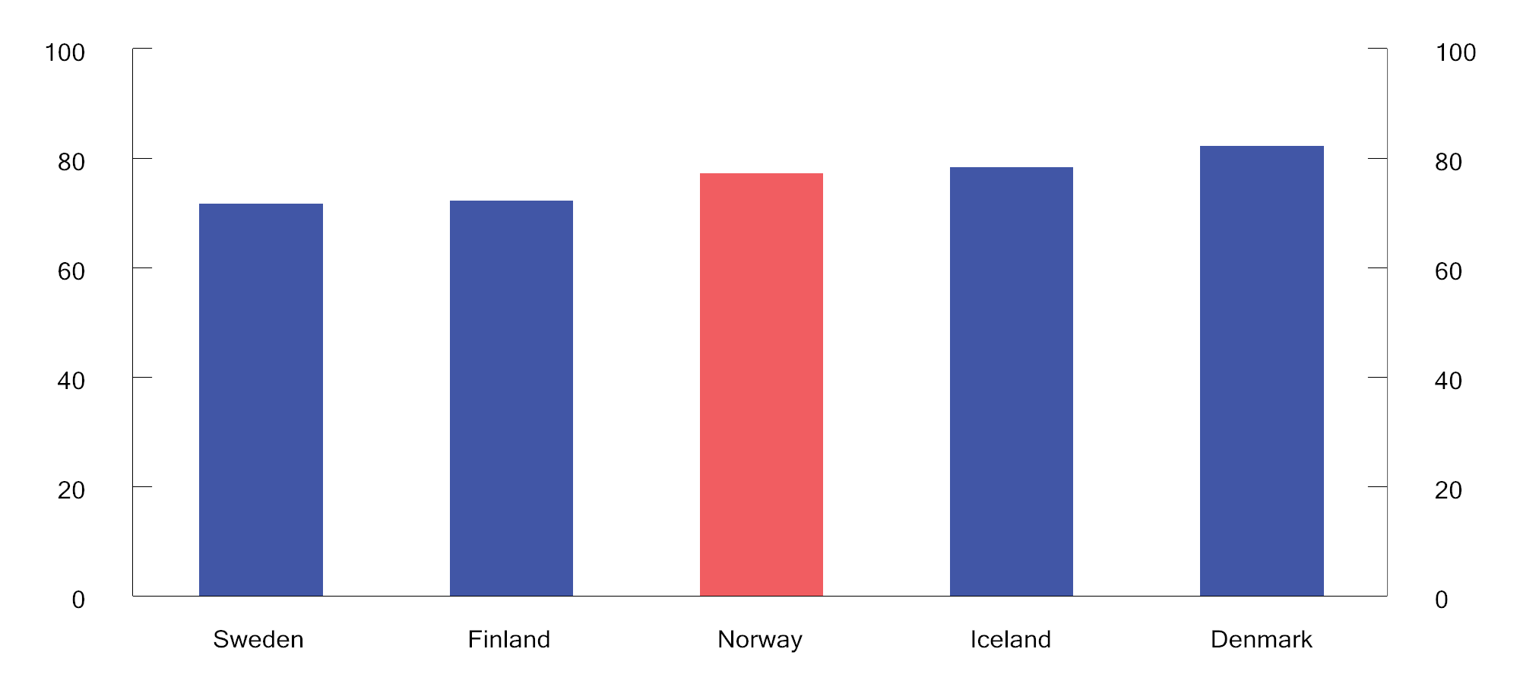

Effective average tax when transitioning from unemployment benefit1 to full-time employment. Sole provider2. 2023. Percentage

1 The calculations are based on unemployment benefits in the various countries as calculated in OECD Benefits and Wages 2023. The benefit level is the level paid for the first year of unemployment.

2 Based on 67 per cent of the average wage in the various countries, both as a basis for calculating benefits and as a level of earned income in full-time employment.

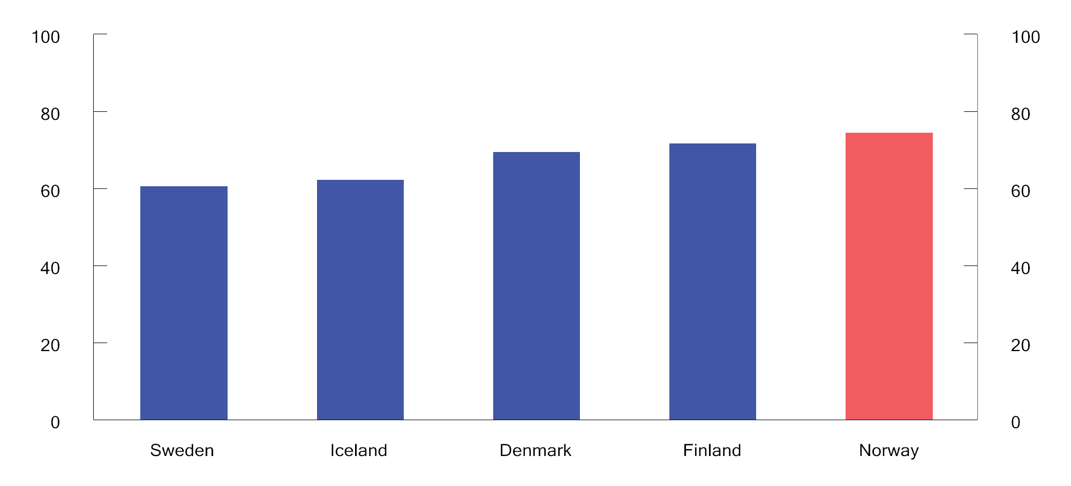

Effective average tax when transitioning from unemployment benefit1 to full-time employment. Couple with one person in the labour force2 and two children. 2023. Percentage

1 The calculations are based on unemployment benefits in the various countries as calculated in OECD Benefits and Wages 2023. The benefit level is the level paid for the first year of unemployment.

2 Based on 100 per cent of the average wage in the various countries, both as a basis for calculating benefits and as a level of earned income when transitioning to full-time employment. The spouse/cohabitant is assumed to be a homemaker.

Sources: OECD and Ministry of Finance.

[Boks slutt]

Environmental taxes and climate taxes contribute to more accurate pricing of environmentally harmful activities and greenhouse gas emissions if they are correctly designed. Such taxes motivate individuals and businesses to engage in more environmentally and climate-friendly behaviour, which is consistent with the “polluter pays” principle. However, environmental taxes and climate taxes may have undesirable distributional effects; socially or geographically. It is therefore important to ensure that the overall tax policy, together with redistributive benefits and transfers, pays heed to the desired distributional considerations.

Taxes on businesses should primarily aim to generate revenues for central government, and such taxes should have the minimum possible impact on commercial decisions. The most consistent and uniform taxation of all real income helps to ensure that resource utilisation is not influenced by, for example, tax-motivated investments. The profits that are taxed should correspond to the actual profits that are made.

Greater mobility of capital, goods and services means that taxation differences between countries may become of increasing significance. Norway needs to have good general tax rules to ensure that it can retain and attract commercial activities and capital. However, localisation decisions depend on more than tax. Political stability, infrastructure, access to qualified labour, functioning financial markets, property rights, as well as stable and predictable regulations, are also important aspects of the overall framework conditions for commercial activities.

In industries that exploit natural resources, an additional return may be generated in the form of resource rent. It is desirable to ensure that society receives a high proportion of this return, without reducing investments in the industries that exploit these natural resources. Resource rent taxes are a good way of attending to these considerations. In Norway, special taxes are levied on the profits generated by petroleum, hydropower, onshore wind power and aquaculture.

Low economic costs of the tax system can be achieved by having a large proportion of taxes that contribute to better resource utilisation, such as taxes on activities that are harmful to health and the environment, along with neutral taxes, such as resource rent taxes. However, in order to raise sufficient tax revenues and meet redistribution objectives, most tax revenues need to come from broad, distortionary taxes. In recent years, there has been a shift from distortionary taxes on labour income to taxes on resource rent, environmentally harmful activities and greenhouse gas emissions.

The scope of public services and transfers varies between countries, and influences the need for tax revenues. In Norway, this is relatively high. Figure 2.4 compares tax revenues as a percentage of gross domestic product (GDP) for Norway, Sweden, Denmark and the OECD average. The figure provides a rough overview of differences in the size of public expenditure and differences in the overall level of taxation. Such a comparison does not take into account sources of revenue other than tax, nor that the tax revenue share will vary depending on, inter alia, whether public pension and social security payments are taxable. In Norway, part of total expenditure via public sector budgets is financed by fund revenues from the Government Pension Fund Global (GPFG). For 2024, fund withdrawals measured by the non-oil budget deficit account for 14 per cent of total public sector expenditure.

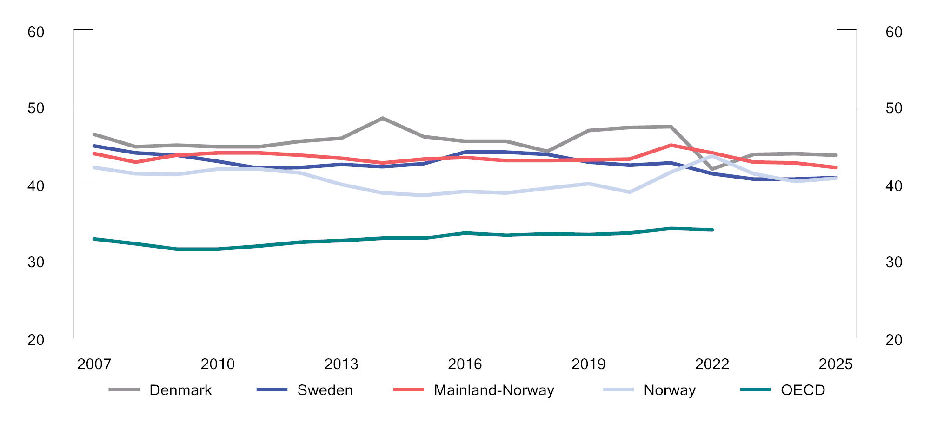

Public tax revenues. Percentage of GDP

1 Mainland Norway includes taxes on petroleum industry employees.

2 Non-weighted average for the OECD.

3 For Sweden and Denmark, figures for 2007–2022 have been obtained from the OECD. Figures and forecasts for 2023-2025 have been obtained from the two finance ministries.

Sources: Ministry of Finance and the OECD.

The tax level, measured by tax revenues as a percentage of GDP, will vary from year to year in different countries. Since 1985, tax revenues in Norway have varied between 38 and 44 per cent of GDP. Some of the variations are due to changes in tax revenues from petroleum activities, which are transferred to the Government Pension Fund Global. This complicates comparisons with other countries in individual years. In recent years, high revenues from the petroleum activities have served to increase the tax to GDP ratio in Norway. In Sweden, the tax to GDP ratio has ranged from 41 to 50 per cent, while it has been between 42 and 51 per cent in Denmark. Over the same period, the average tax level in the OECD has varied between 30 and 35 per cent of GDP.

## Direct taxes

### Income tax for personal taxpayers

Rate structure and tax base

Personal income tax is calculated using two different tax bases. Firstly, a flat tax rate of 22 per cent is paid on ordinary income less the personal allowance and certain special allowances. Ordinary income comprises all taxable income (wages including taxable benefits in kind, social security benefits, pensions, net self-employment income, taxable income from shares and other forms of capital income), less basic allowance, deductible losses and expenses such as debt interest, parental allowance and other allowances.

Secondly, National Insurance contributions and bracket tax are paid on personal income, which comprises gross wage income, social security benefits and pension income, without deductions. Calculated personal income for self-employed persons is also included in personal income.

High-income earners pay a larger proportion of their income in tax than low-income earners. Such progressivity is achieved through the lower threshold for the payment of National Insurance contributions, the standard allowances (basic allowance and personal allowance) and the rate structure of the bracket tax. Box 2.2 shows how income tax is calculated under 2024 rules for a person who only has wage income and standard allowances.

Calculation of tax on wage income under 2024 rules

Figure 2.5 illustrates total tax in NOK at different income levels for a person who only has wage income and standard allowances. Table 2.1 presents examples of how tax is calculated for some selected income levels.

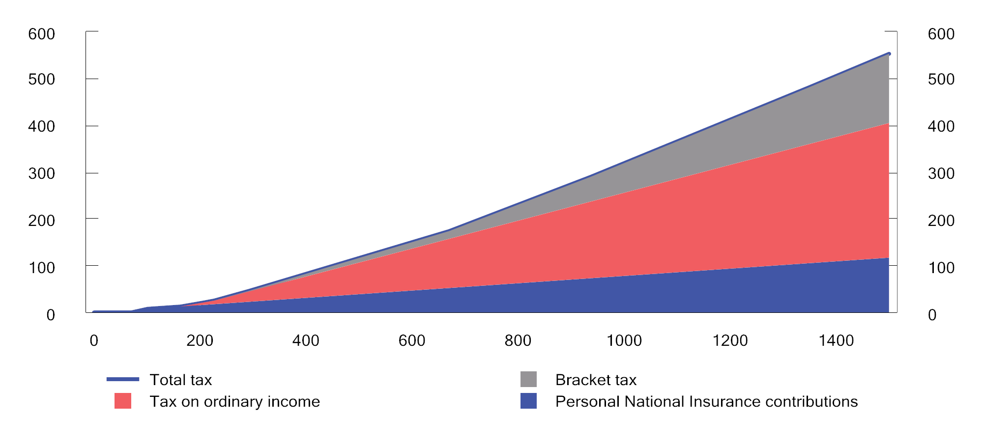

Tax at different levels of wage income for a person who only has wage income and standard allowances. 2024 rules. Wage income and tax measured in NOK 1,000s

Sources: Ministry of Finance.

Calculated tax for selected wage income levels. 2024 rules. NOK

04J0xt2

|  |  |  |  |
| --- | --- | --- | --- |
| Wage income | 200,000 | 650,000 | 1,000,000 |
| - Basic allowance | 92,000 | 104,450 | 104,450 |
| - Personal allowance | 88,250 | 88,250 | 88,250 |
| = Taxable ordinary income | 19,750 | 457,300 | 807,300 |
| Tax on ordinary income  (22 per cent) | 4,345 | 100,606 | 177,606 |
| Personal National Insurance  contributions (7.8%) | 15,600 | 50,700 | 78,000 |
| Bracket 1 (1.7 per cent  above 208,050) | 0 | 1,442 | 1,442 |
| Bracket 2 (4 per cent  above 292,850) | 0 | 14,286 | 15,086 |
| Bracket 3 (13.6 per cent  above 670,000) | 0 | 0 | 36,434 |
| Bracket 4 (16.6 per cent  above 937,900) | 0 | 0 | 10,309 |
| Bracket 5 (17.7 per cent  above 1,350,000) | 0 | 0 | 0 |
| Total bracket tax | 0 | 15,728 | 63,271 |
| Total tax  (per cent of wage income) | 19,945  (10 per cent) | 167,034  (25.7 per cent) | 318,877  (31.9 per cent) |

Source: Ministry of Finance.

Figure 2.6 illustrates the marginal tax rate on wage income, i.e. the tax rate applicable to any incremental increase in income, along with tax as a percentage of wage income. With a progressive rate structure, those with the highest taxable income will pay the largest proportion of their income in tax. The marginal tax rate influences employees’ decisions about how much they choose to work. See Box 2.7 on the labour supply effects of reducing the taxation of labour income.

Figure 2.6 shows that the marginal tax rate predominantly increases with income, and that the average tax rate is lower than the marginal tax rate:

* No tax is paid up to the lower threshold for the payment of personal National Insurance contributions (NOK 69,650). Thereafter, a levelling rate (25 per cent) is paid until it becomes preferable to pay National Insurance contributions at the ordinary rate (7.8 per cent) on the entire income; in 2024 at an income of NOK 101,235.
* When income exceeds the sum total of the personal allowance and the minimum allowance (46 per cent of income), from NOK 163,426, tax is payable on ordinary income (22 per cent). The marginal tax rate increases to 19.7 per cent (7.8 per cent + 22 per cent × (100 per cent – 46 per cent)).
* From NOK 208,050, bracket tax is paid at the rate of 1.7 per cent, and the marginal tax rate is increased to 21.4 per cent.
* When income exceeds NOK 227,065, the taxpayer has reached the maximum basic allowance (NOK 104,450), and the marginal tax rate is increased to 31.5 per cent (7.8 per cent + 22 per cent + 1.7 per cent).
* Thereafter, the bracket tax rate increases from bracket to bracket, until the maximum marginal tax rate of 47.4 per cent is reached at an income of NOK 1,350,000.

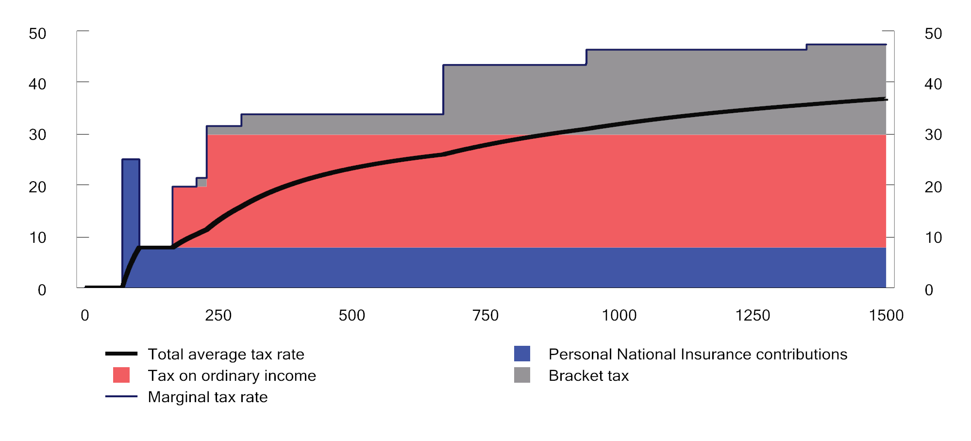

Marginal tax rate and average tax rate (dotted line), excluding employer’s National Insurance contributions, at various wage income levels (NOK thousands) for an employee who only has wage income and standard allowances. 2024 rules. Percentage

Sources: Ministry of Finance.

[Boks slutt]

Figure 2.7 illustrates the highest marginal tax rate on wage income in selected countries in 2023. The figure includes the employee’s contributions to social security schemes (personal National Insurance contributions in Norway), while the employer’s contributions to social security schemes for the employee (employer’s National Insurance contributions in Norway) are excluded. The figure shows that the highest marginal tax rate in Norway is at a level comparable with the highest marginal tax rate in countries such as the UK, Germany and the US, while some of the other Nordic countries have higher marginal tax rates on the highest salaries.

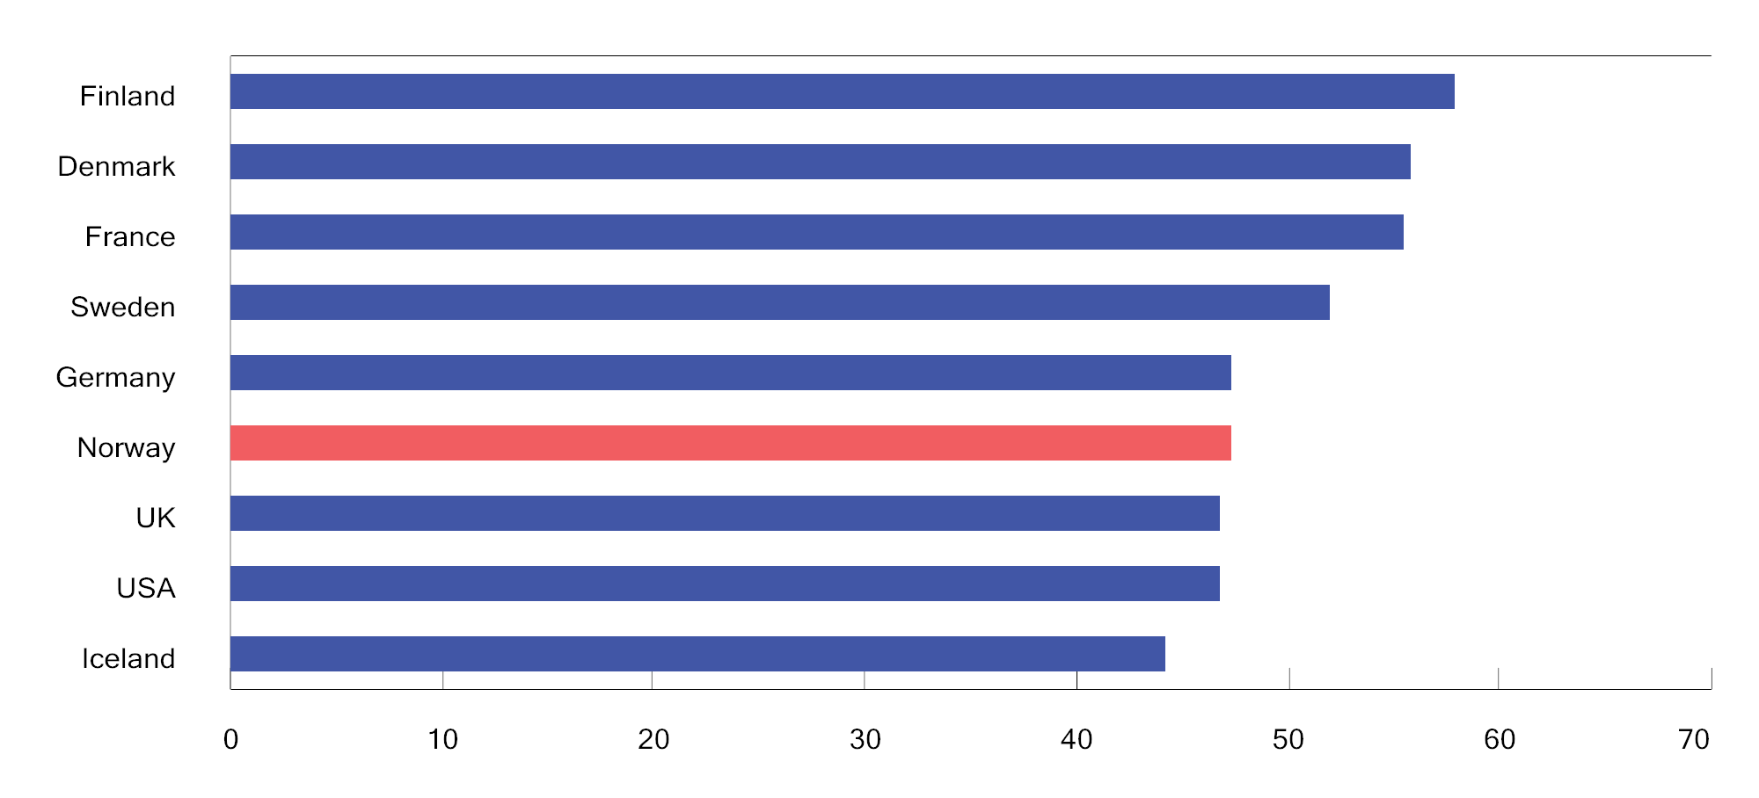

Highest marginal tax rate on wage income, excluding the employer’s contributions to social security schemes for the employee. Some selected countries in 2023. Percentage

Sources: OECD Tax database and Ministry of Finance.

Tax on pension income

Special tax rules mean that pensioners and recipients of certain social security benefits pay less tax than wage earners. National Insurance contributions on pensions are lower than on wages. On the other hand, the basic allowance is somewhat lower for pension income than for wages.

A special tax credit for pension income is granted to those on contractual early retirement pension (AFP) and ordinary retirement pension. The tax credit results in no tax being paid on any pension income up to about NOK 262,480 in 2024, which is slightly above the minimum retirement pension level for singles under the National Insurance Scheme. Above this level, total tax paid is lower on pensions than on wages. The tax credit is reduced with regard to pension income above two thresholds, thus implying that the difference between the tax on pension income and the tax on wage income declines as pension income increases.

Figure 2.8 shows tax under the 2024 rules as a proportion of pension income for recipients of contractual early retirement pension (AFP)/ordinary retirement pension and wage income for wage earners, respectively. It is assumed that taxpayers have no income other than pensions and wages, respectively. It is also assumed that taxpayers can claim no other allowances than the standard allowances. The tax on a NOK 300,000 retirement pension represents 5.7 per cent of the pension income, while tax as a proportion of the same amount of wage income comes to 16.2 per cent.

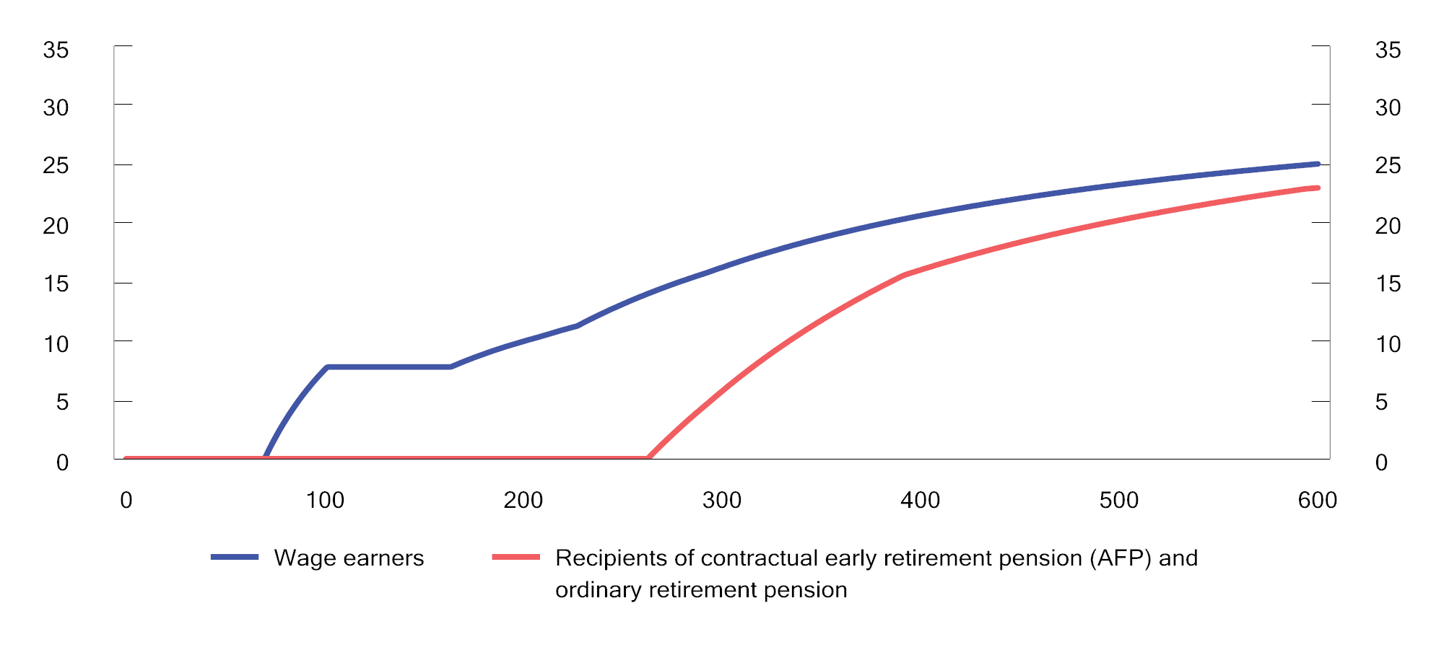

Average tax rate at various gross income levels for wage earners and recipients of contractual early retirement pension (AFP) and ordinary retirement pension under the 2024 rules.1 Percentage

1 It is assumed that the taxpayers only have wage income and pension income, respectively, and can claim no other allowances than the standard allowances.

Source: Ministry of Finance.

Tax on income from shares accruing to individuals

Income from shares (ownership income) consists of realised dividends and capital gains from limited liability companies to owners. The difference between the highest marginal tax rates on wage income and income from shares should not be excessive. When there is a significantly lower marginal tax rate on income from shares than on wage income, there is much to be gained from representing what is actually income from work as income from shares in order to pay less tax (income shifting). In 2024, the difference between the highest effective marginal tax rate on wages and share dividends, respectively, is 4.3 percentage points; see Figure 2.9.

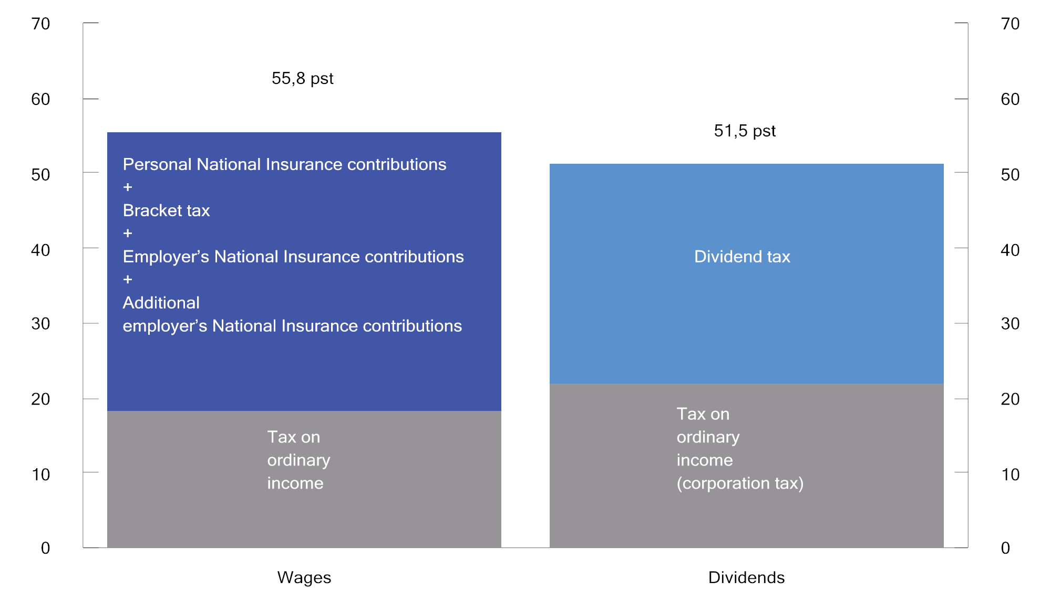

Maximum marginal tax rate on wages and dividends under the 2024 rules1. Percentage

1 The marginal tax rate is calculated as a proportion of total wage costs (including employer’s National Insurance contributions) and thus the tax on ordinary income will be less than 22 per cent in the column for the maximum marginal tax rate on wages.

Source: Ministry of Finance.

The shareholder model implies that income accruing to a personal shareholder from shares, in excess of a risk-free return allowance, is taxed on the part of such shareholder. Taxable income from shares is first multiplied by an upward adjustment factor, and thereafter added to ordinary income. The upward adjustment factor was introduced in 2016 to maintain the desired level of dividend tax when the tax rate on ordinary income was reduced. For 2024, the upward adjustment factor is 1.72 and the total marginal tax rate on dividends is 51.5 per cent.

The purpose of the risk-free return allowance is to counteract distortions in household investments and the financing structure of companies as a result of dividend taxation. The risk-free return allowance is calculated by multiplying the risk-free return base, which is the cost of the share plus any unused risk-free return allowance from previous years, by a risk-free rate of return. The risk-free rate of return is the interest rate on three-month Norwegian treasury bills plus 0.5 percentage points.

If the income from the share is less than the risk-free return allowance, any unused risk-free return allowance is added to the risk-free return base for the next year. In practice, this means that any unused risk-free return allowance is carried forward at an interest rate equivalent to the risk-free rate of return. Unused risk-free return allowance is specific to each share and is deductible against subsequent dividends and realised capital gains on the share.

For practical reasons, it is the holder of a share as of 31 December who is granted the risk-free return allowance for that year. Upon selling the share, the seller may deduct any previously unused risk-free return allowance from any capital gain. In the event of a loss, the entire loss is deductible against ordinary income. Any unused risk-free return allowance will then lapse.

Tax on business income

Owners of sole proprietorships are taxed under the enterprise model, while those holding ownership interests in entities assessed as partnerships (general partnerships, limited partnerships and others) are taxed under the partnership model. The basic principle underpinning both of these models is the same as for the taxation of income from shares, i.e. that income not exceeding the risk-free return allowance shall only be taxed once as ordinary income. This entails a high degree of uniformity in the taxation of different types of business entities.

The profits of companies assessed as partnerships are taxed as ordinary income on the part of the owners, as these accrue. In addition, any distributed partnership profits in excess of the risk-free return allowance are taxed once more as ordinary income on the part of owners who are natural persons, adjusted upwards by 1.72.

Income from sole proprietorships in excess of the risk-free return allowance is taxed as calculated personal income and is subject to bracket tax and National Insurance contributions. The calculated personal income is therefore taxed on an ongoing basis. Income from shares, on the other hand, is not taxed as ordinary income until the time of dividend payment or realisation. This difference needs to be considered in the context that sole proprietorships are not separate legal entities. Consequently, the distribution of funds will only represent a transfer of funds within the owner’s own financial sphere.

The self-employed pay higher National Insurance contributions than wage earners on personal income from self-employment. On the other hand, the self-employed do not pay employer’s National Insurance contributions on their personal income. However, in some cases the self-employed receive lower social security benefits than wage earners. Self-employed fishermen pay National Insurance contributions at a medium rate (like wage earners), but are also subject to a product tax on first-hand sales of fish.

### General business taxation

Employer’s National Insurance contributions

Employers in both the private sector and the public sector are required to pay employer’s National Insurance contributions on wages, etc. The rate of employer’s National Insurance contributions depends on where the enterprise is located. The differentiation of employer’s National Insurance contributions means that enterprises in sparsely populated areas pay lower employer’s National Insurance contributions than enterprises in other municipalities. The rate of employer’s National Insurance contributions varies from zero in the action zone in the counties of Troms and Finnmark to 14.1 per cent in central areas; see Table 1.9 in Chapter 1. The objective of this arrangement is to counteract population decline in sparsely populated areas by stimulating employment and commercial activity.

The regional differentiation of employer’s National Insurance contributions involves state aid. The EFTA Surveillance Authority (ESA) has been notified of the existing arrangement. This arrangement has been approved for the period from 2022 to 2027 on specific conditions stipulated for that period. No changes can be made to the aid without a new authorisation from ESA. Employer’s National Insurance contributions entail an increase in the marginal tax rate on wages; see Figure 2.9.

With effect from 1 January 2023, temporary additional employer’s National Insurance contributions were introduced on salaries, etc., over NOK 750,000 as a situational measure. The additional contributions were intended to cover part of the extraordinarily high expenditure in the fiscal budget for 2023. With effect from 1 January 2024, the threshold was increased to NOK 850,000. The rate is set at 5 per cent and applies to salaries, etc., in all zones, including the action zone. For employers in the most urban parts of the country (zone 1), employer’s National Insurance contributions shall be paid at a rate of 19.1 per cent (14.1 + 5.0) on salaries, etc., over NOK 850,000 in 2024.

Ordinary corporation tax

Company profits are taxed as ordinary income at a flat tax rate of 22 per cent in 2024. Losses can be carried forward and deducted against future profits. The corporation tax system places a particular emphasis on the principles of equal treatment of different investments, funding structures and organisational structures, as well as the symmetrical treatment of income (gains) and costs (losses). This implies, inter alia, that taxable profits should, insofar as possible, be determined in accordance with commercial profits. “Durable and significant” operating assets shall be capitalised under various asset groups and depreciated at rates intended, in principle, to reflect their expected annual decline in value.

The exemption method means that, as a general rule, companies are exempted from the taxation of dividends received and capital gains on shares, etc. At the same time, there is no right to deduct corresponding losses. The purpose of the exemption method is to avoid chain taxation in the corporate sector, i.e. that dividends and capital gains are taxed multiple times for companies owned by other companies.

The corporation tax rate in Norway remained unchanged at 28 per cent from 1992 to 2013. The rate was then gradually reduced to 22 per cent from 2014 to 2019. A corporation tax rate of 22 per cent is slightly below the OECD average, but somewhat higher than the average for Sweden, Denmark and Finland; see Figure 2.10.

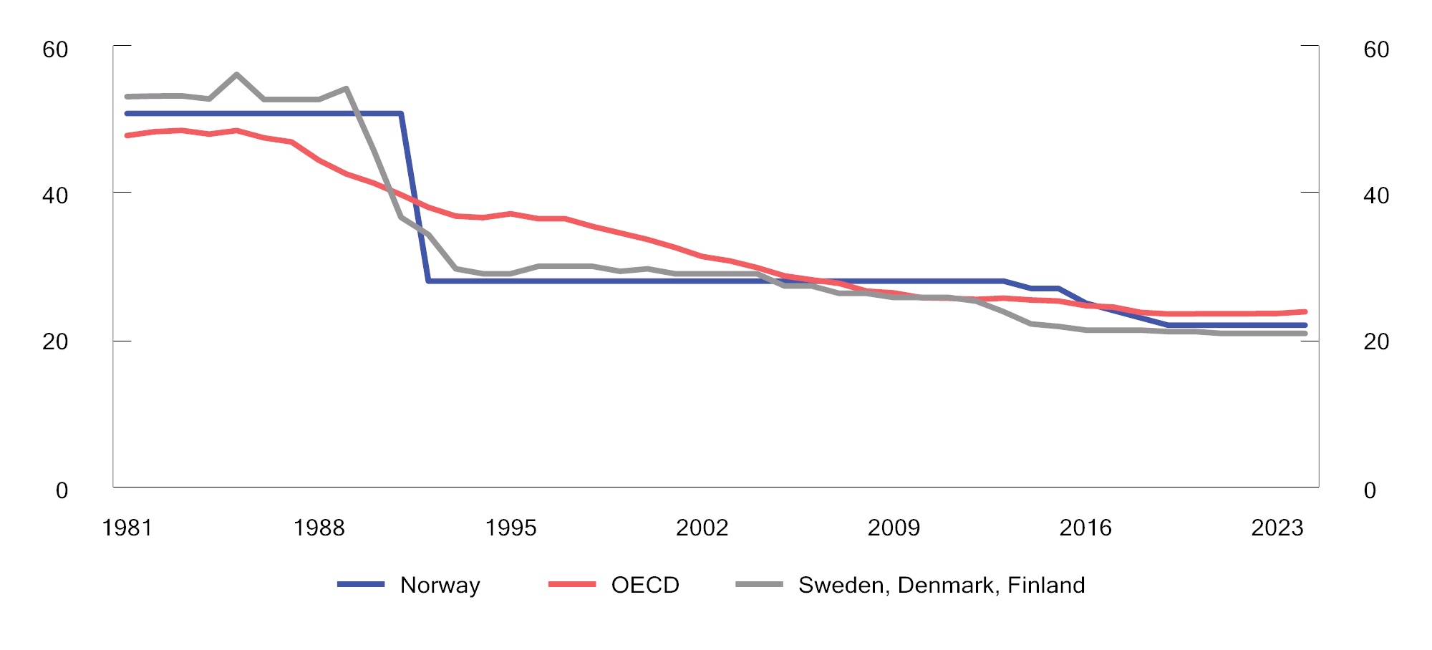

Formal corporation tax rates.1 1981–2024. Percentage

1 Non-weighted average for Sweden, Denmark, Finland and the OECD.

Sources: OECD and Ministry of Finance.

The effective taxation of companies will also depend on the tax base. The effective average tax rate is the tax paid as a proportion of a company’s actual profit. The effective rate may be lower than the formal tax rate due to interest deductions or if investments entail tax credits, for example in the form of excessive depreciation rates. The effective average tax rate is the key variable when a company decides which country to invest in for tax reasons. The effective marginal tax rate is the key variable when a company decides the level of investment.

Table 2.2 presents formal tax rates and calculated effective average and marginal tax rates in selected countries in 2023. Effective tax rates are calculated on the basis of a hypothetical investment that provides a given return, and take into account both formal tax rates and key parts of the tax base (depreciation rates, etc.). The calculations assume a hypothetical investment across selected investment objects, and that the investment is partly funded by equity and partly by debt.

Formal and calculated effective corporation tax rates in 2023. Percentage

04J1xt2

|  |  |  |  |
| --- | --- | --- | --- |
| Country | Formal  tax rate | Effective average  tax rate | Effective  marginal  tax rate |
| Ireland | 12.5 | 12.4 | 13.2 |
| Switzerland | 19.7 | 18.5 | 14.6 |
| Finland | 20.0 | 19.7 | 22.6 |
| Sweden | 20.6 | 19.6 | 17.1 |
| Iceland | 21.0 | 18.8 | 14.9 |
| Denmark | 22.0 | 20.4 | 14.2 |
| Norway | 22.0 | 21.4 | 23.1 |
| Austria | 23.0 | 22.9 | 22.0 |
| Spain | 25.0 | 23.3 | 18.2 |
| United Kingdom | 25.0 | 22.6 | 11.5 |
| United States | 25.6 | 22.7 | 7.0 |
| The Netherlands | 25.8 | 24.5 | 22.8 |
| France | 25.8 | 23.7 | 15.4 |
| Germany | 29.9 | 26.6 | 11.0 |

Source: OECD Corporation tax statistics.

Company profits are also taxed on the part of their owners, by way of dividend and capital gains taxation; see Section 2.3.1. Figure 2.11 illustrates the total formal marginal tax rate on dividends on the part of companies and their owners in selected countries in 2024.

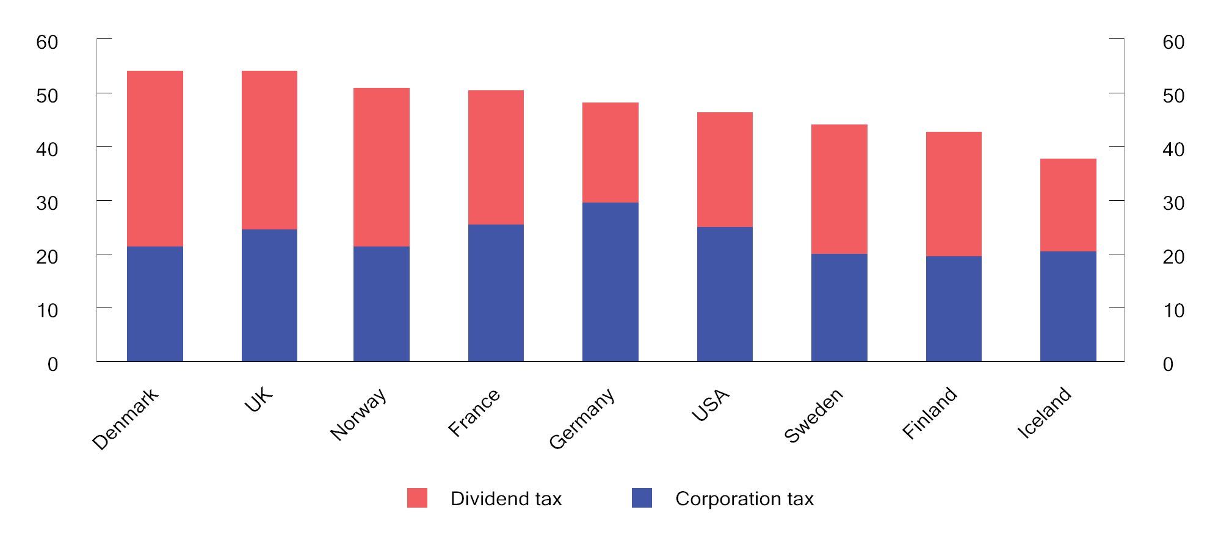

Total marginal tax rate on dividends on the part of companies and their owners in selected countries. 2024. Percentage

Source: OECD.

Taxation of shipping companies

Since the 2007 income year, companies taxed as shipping companies have been exempt from tax on shipping income, and only pay a tonnage tax. The tonnage tax is an annual tax calculated based on the net tonnage of ships, the rate of which varies between different tonnage intervals. The rate may be reduced for ships, etc., that meet environmental requirements stipulated by the Norwegian Maritime Authority. Qualifying for a tax exemption under the shipping tax scheme is subject to a number of requirements, including that the company owns or leases ships that are of a certain size and that travel over a certain distance. For example, the scheme does not include ships that are in scheduled short-distance traffic between Norwegian ports, fishing vessels or pleasure craft, etc.

Financial activity tax

In 2017, a separate tax on payrolls and profits in the financial industry was introduced to compensate for the absence of value added tax on financial services. The sale and distribution of financial services are exempted from value added tax, primarily because it would be difficult to establish a suitable basis for calculating tax on margin-based services, for example, the interest margins of banks. The financial activity tax applies to financial undertakings and comprises a 5 per cent tax on payrolls (the basis for employers’ National Insurance contributions) and a tax on company profits, whereby the tax rate on ordinary income is three percentage points higher than for other undertakings.

### Tax on resource rent industries

In Norway, several industries have exclusive access to valuable natural resources, such as hydropower, wind power, petroleum and aquaculture. Access to valuable natural resources means that such location-specific industries can, over time, achieve higher returns than other industries; so-called resource rent. The principle that a large share of the return on natural resources should be channelled to society has served Norway well.

Of the commercially exploited natural resources, the petroleum industry has generated by far the highest resource rent over time, with the power industry in second place. In recent years, the resource rent in aquaculture has also at times been in the same order of magnitude as the resource rent in the power industry. Figures 2.12 and 2.13 illustrate estimated resource rent in selected industries over the period 1984–2022.

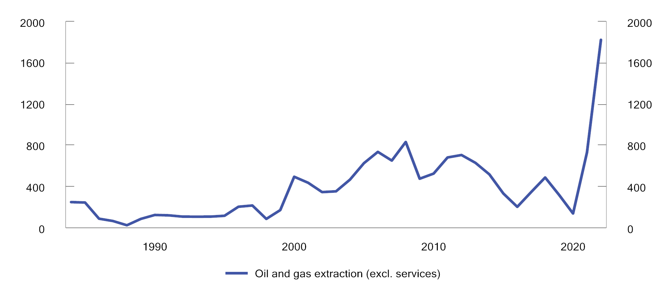

Estimated resource rent on oil and gas extraction. 1984–2022. NOK billion at 2024 prices

Sources: Dalen, Greaker and Hagem (2023) and Ministry of Finance.

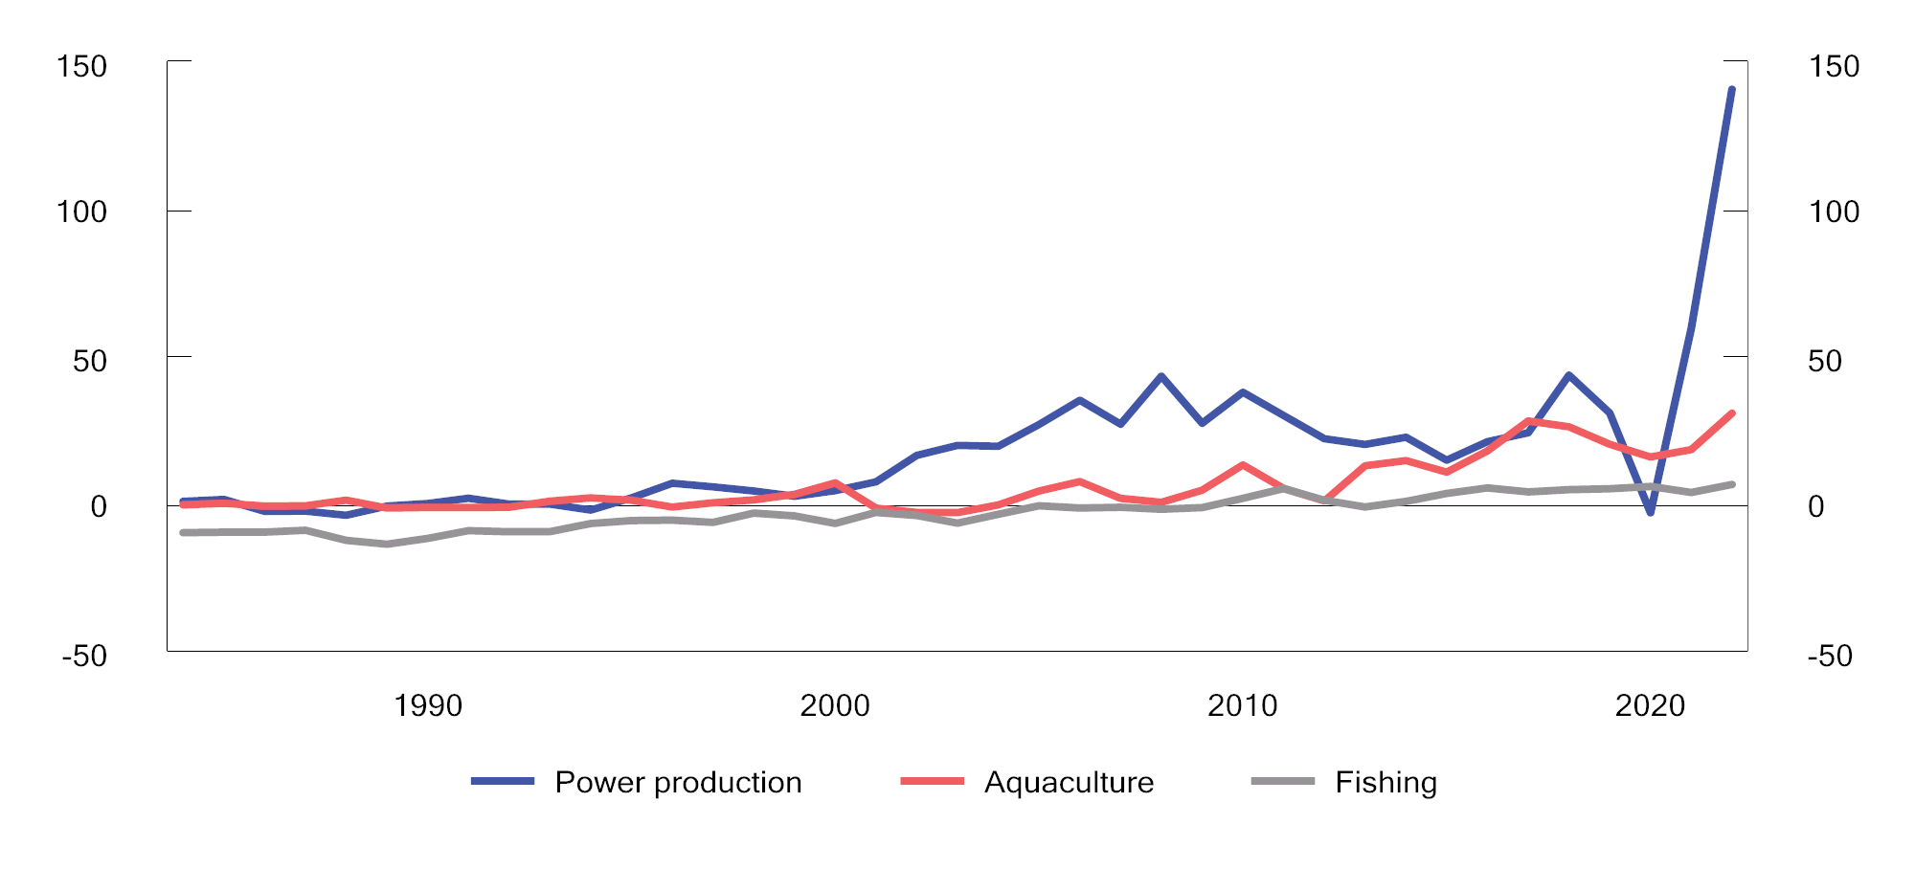

Estimated resource rent on power production1, aquaculture and fishing. 1984–2022. NOK billion at 2024 prices

1 Estimates for the power industry include hydropower, wind power and thermal power.

Sources: Dalen, Greaker and Hagem (2023) and Ministry of Finance.

The tax system plays a decisive role in ensuring that the resource rent from the use of shared natural resources benefits society. For hydropower and petroleum resources, resource rent taxes have been used for a long time. In recent years, resource rent taxes have also been introduced on aquaculture and onshore wind power.

The resource rent taxes on petroleum, hydropower, onshore wind power and aquaculture are based on some common main principles, although with adaptations for each industry. Resource rent tax is paid to central government and is payable in addition to ordinary corporation tax. All resource rent taxes are designed as cash flow taxes, which means that investment costs are expensed immediately rather than deducted over time. With a correctly designed resource rent tax, investments that are profitable before resource rent tax will also be profitable after resource rent tax and vice versa. In other words, the resource rent tax has a neutral effect on companies’ incentive to invest. Moreover, resource rent taxes are well suited for cyclical industries with varying profitability because the tax is automatically adapted to profitability.

In addition to resource rent tax and ordinary corporation tax paid to central government, these industries are subject to several schemes that benefit their host municipalities and counties. This means that many municipalities that are rich in natural resources have high per capita revenues.

The taxation of each of these industries is outlined in more detail below.

Petroleum

Through their production licences, petroleum companies have an exclusive right to explore, drill and extract petroleum on the Norwegian continental shelf. Petroleum is a highly valuable non-renewable natural resource, and the income from the sale of petroleum extracted on the Norwegian continental shelf exceeds the total production costs. Having exclusive access to such a natural resource thus generates a resource rent.

In 1975, a special tax (resource rent tax) payable to central government was introduced on income from petroleum extraction, in addition to ordinary corporation tax. The formal special tax rate is 71.8 per cent in 2024. A calculated corporation tax is deductible against the special tax base, thereby resulting in an effective special tax rate of 56 per cent and a total marginal tax rate of 78 per cent.

Since 2022, the special tax has been structured as a cash flow tax with immediate expensing of investments. For both tax bases, income from the sale of crude oil is valued at administratively determined norm prices. If a company operates with a loss in the special tax base, the taxable value of the loss is paid in connection with the tax assessment.

Temporary petroleum tax rules were introduced in the spring of 2020; see Proposition 113 L (2019–2020); Temporary amendments to the Petroleum Taxation Act, and Recommendation 351 L (2019–2020). The temporary rules mean that, in addition to the investment cost, an uplift amount is immediately expensed in the special tax base. The rules apply to investments covered by a plan for development and operation (PDO) or a plan for installation and operation (PIO) submitted to the Ministry of Petroleum and Energy prior to 1 January 2023 and approved by the Ministry prior to 1 January 2024, but only until the year of the planned start of production or operation of the petroleum deposit/facility. The uplift rate in 2024 is 12.4 per cent of the investment cost. Companies are thus granted an immediate deduction equivalent to 112.4 per cent of the investment cost.

The State’s Direct Financial Interest (SDFI), through which central government takes a direct financial interest in production licences, is also an important source of central government revenues from the Norwegian continental shelf. The SDFI has the same characteristics as a field-specific cash flow tax, whereby the central government covers its share of investments and operating costs on an ongoing basis and receives the same share of the income. The SDFI’s share varies between licences.

Central government revenues from the SDFI, as well as taxes on petroleum activities, form part of the cash flow that is transferred to the Government Pension Fund Global in its entirety.

Figure 2.14 illustrates the composition of central government revenues from petroleum activities. The majority of central government revenues are based on net profits in petroleum activities, and tax revenues will therefore automatically adjust to the industry profitability.

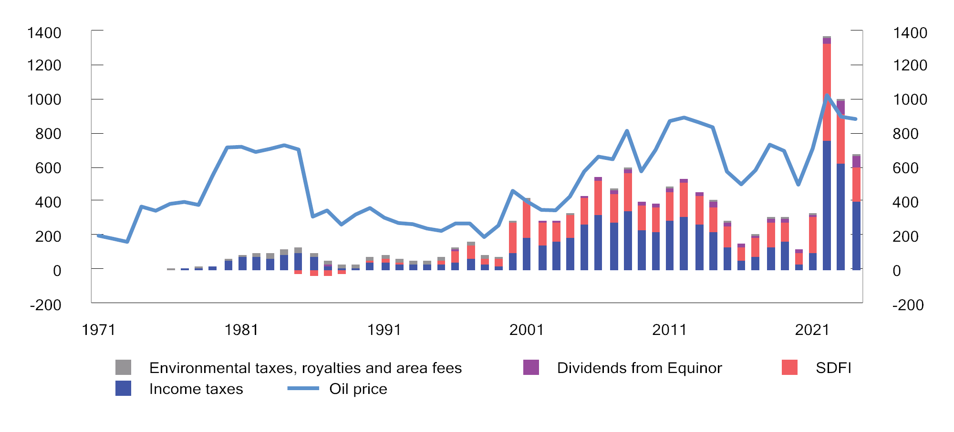

Total net central government revenues from the petroleum sector (NOK billion) and oil price developments (NOK per barrel) from 1971 to 2024. NOK at 2024 prices1

1 Estimates for 2024.

Source: Ministry of Finance.

Hydropower

The climate, topography and precipitation conditions create an excellent basis for hydropower production in Norway. The hydropower industry has exclusive access to a scarce renewable natural resource that generates resource rent.

In 1997, a resource rent tax payable to central government, in addition to ordinary corporation tax, was introduced for hydropower plants. The formal resource rent tax rate is 57.7 per cent in 2024. A calculated corporation tax is deductible against the tax base, thereby resulting in an effective resource rent tax rate of 45 per cent and a total marginal tax rate of 67 per cent.

The resource rent tax has a predominantly neutral structure, thus implying that projects which are profitable before resource rent tax are also profitable after resource rent tax. However, power plants with generators below 10 MVA (lower threshold) are exempted from the resource rent tax, thereby giving companies an incentive to reduce the output of their power plants.

The resource rent tax base (resource rent income) is calculated as a standardised market value of the power generated (as a general rule, actual power generated multiplied by spot market prices), less investment costs, operating costs, licence fees and property tax. For some sales agreements, the contract price is used as the basis for determining income, instead of spot market prices. Since 2021, the resource rent tax has been structured as a cash flow tax, with immediate expensing of new investments. Investments made prior to 2021 will continue to be deducted through depreciation and uplift. Negative resource rent income in one power plant can be coordinated with positive resource rent income in other power plants within the same consolidated tax group. Furthermore, the taxable value of any negative resource rent income following coordination between power plants is paid out.

Hydropower plants are also subject to a natural resource tax at the rate of NOK 0.013 per kWh. The natural resource tax serves as a special mechanism for redistributing part of the resource rent from central government to host municipalities and host counties. The natural resource tax is directly deductible against the assessed corporation tax to central government, and will therefore normally not constitute any extra burden for companies. Hydropower producers also pay licence fees to host municipalities and to central government, while also being required to sell concessionary power to host municipalities and host counties at a cost-based price. In addition, municipalities may impose property tax on hydropower plants in accordance with specific rules.

Aquaculture

Norway has some of the world’s best climatic conditions for salmon farming. Norwegian sea areas are characterised by beneficial currents and oxygen-rich waters with favourable temperatures. Moreover, the fjords provide shelter from the weather. Production in Norwegian fjords can take place at lower costs than in most other places in the world. Licences to engage in aquaculture are issued by central government and provide a protected and indefinite right to conduct business activities. The resource rent in aquaculture arises partly as a result of the favourable production conditions for aquaculture activities, and partly as a result of environmentally based restrictions on the number of licences that can be granted.

In 2023, a resource rent tax was introduced for aquaculture, payable in addition to ordinary corporation tax. The formal resource rent tax rate is 32.1 per cent for 2023. A calculated corporation tax is deductible against the tax base, thereby resulting in an effective resource rent tax rate of 25 per cent and a total marginal tax rate of 47 per cent.

The resource rent tax has a predominantly neutral structure, thus implying that projects which are profitable before resource rent tax are also profitable after resource rent tax. There is a standard allowance of NOK 70 million per company group.

The resource rent tax is limited to the sea phase. Gross income is determined on the basis of the fish’s market value at the edge of the pen, and investments and operating costs in the sea phase are immediately deductible. Any unused deductions are carried forward at a risk-free rate of return and are deductible against positive resource rent income in subsequent years. From the second half of 2024, a pricing council may determine tax assessment prices (norm prices) for use in assessing income for resource rent tax purposes.

In order to redistribute resource rent tax from central government to the local government sector, the production of salmon, trout and rainbow trout is also subject to a production tax. From 1 July 2024, this tax is NOK 0.935 per kg of fish produced. The production tax is directly deductible against the assessed resource rent tax, and will therefore normally not constitute any extra burden for companies that pay resource rent tax. The production tax revenues are channelled to aquaculture municipalities and aquaculture counties via the Aquaculture Fund. In addition, 55 per cent of the proceeds from the sale of new aquaculture licences are allocated to the Aquaculture Fund.

Onshore wind power

The wind power industry has exclusive access to wind resources. By exploiting a location-specific natural resource, the wind power industry can reap a resource rent, partly because wind conditions in Norway are favourable and partly because access to resources is limited by the licensing system. According to the Norwegian Water Resources and Energy Directorate (NVE), wind resources in Norway are among the best in Europe.

In 2024, a resource rent tax payable to central government, in addition to ordinary corporation tax, was introduced for onshore wind power plants. The formal resource rent tax rate is 32.1 per cent. Resource rent-related corporation tax is deductible against the tax base, thereby resulting in an effective resource rent tax rate of 25 per cent and a total marginal tax rate of 47 per cent.

The resource rent tax has a neutral structure for new investments, thus implying that projects which are profitable before resource rent tax are also profitable for companies after resource rent tax. Generous transitional arrangements were adopted, which will reduce the resource rent tax for existing wind power plants.

The resource rent tax base (resource rent income) is calculated as a standardised market value of the power generated (as a general rule, actual power generated multiplied by spot market prices), less investment costs, operating costs and property tax. For some sales agreements, the contract price is used as the basis for determining income, instead of spot market prices. Investments are expensed immediately. Historical investments are deducted by way of input values (which are calculated according to special rules; see Proposition 2 LS (2023–2024) and Recommendation 124 L (2023–2024)) being depreciated on a straight-line basis over 5 years, with the addition of a deferral rate (corresponding to the uplift under the resource rent tax on hydropower). The resource rent tax is calculated per wind farm, and negative resource rent income will for existing wind farms be carried forward at a risk-free rate of return and be deductible against future positive resource rent income. Upon the discontinuation of operations, central government will make payment of the tax value of any outstanding negative resource rent income.

In order to redistribute resource rent tax from central government to host municipalities, wind farms are made subject to a production tax of NOK 0.023 per kWh for 2024. The production tax is directly deductible against the assessed resource rent tax to central government. In addition, municipalities may impose property tax on wind farms in accordance with specific rules.

### Tax on capital assets

Wealth tax

Individual taxpayers pay wealth tax at a rate of 1.0 per cent of their taxable net wealth, i.e. gross wealth less debt, in excess of a standard allowance of NOK 1.7 million in 2024. Married couples are granted a joint standard allowance of NOK 3.4 million. For net wealth in excess of NOK 20 million, wealth tax is paid at a rate of 1.1 per cent. In 2024, total revenues from wealth tax are estimated to be about NOK 32.9 billion. The wealth tax makes the overall tax system for individuals more progressive than does the income tax considered in isolation. This is illustrated by Figures 2.15 and 2.16.

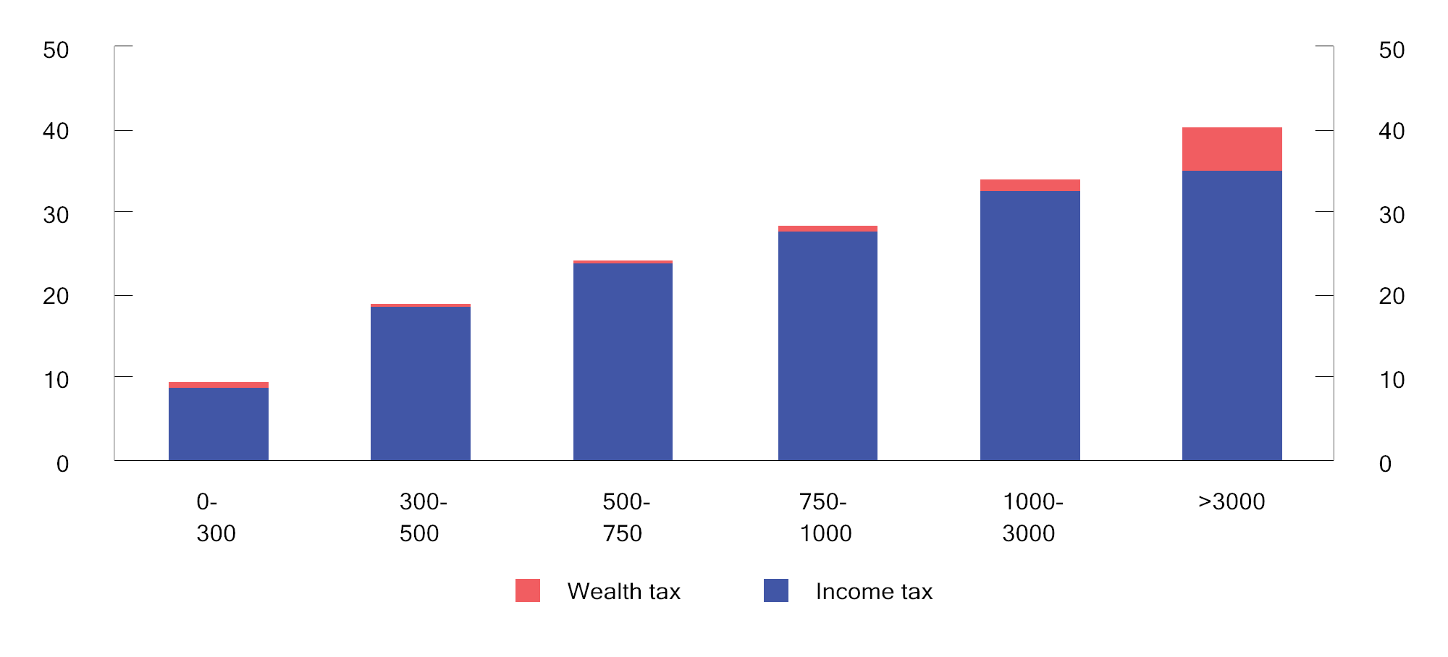

Tax as a proportion of gross income in various gross income intervals (NOK thousands) in 2022. Percentage

Sources: Statistics Norway and Ministry of Finance.

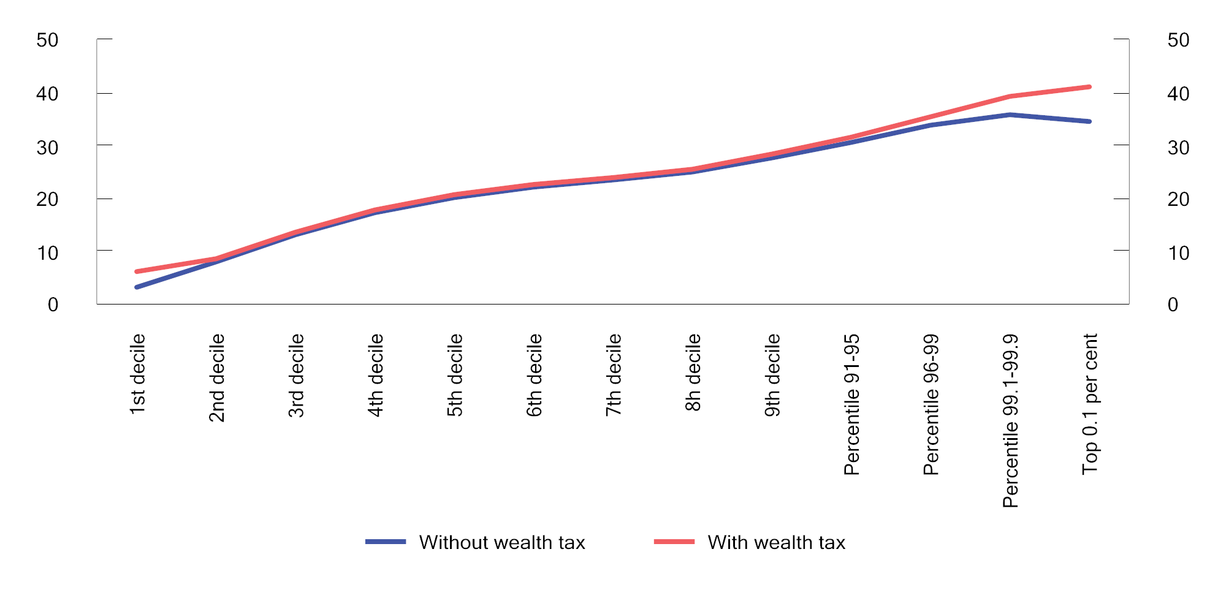

Tax as a proportion of gross income in various income groups1 in 2022. Percentage

1 Persons aged 17 years and over are divided into ten groups of equal size (deciles) by rising gross income. The top decile is then divided into percentiles (hundredths).

Sources: Statistics Norway and Ministry of Finance.

In principle, the taxable value of assets is equal to their market value. However, a number of assets are, in part, valued well below their market value. This is due to both statutory valuation discounts in tax regulations and the difficulty in valuing certain assets.

Primary dwellings (the residential property in which one lives) are valued at 25 per cent up to an estimated market value of NOK 10 million, while the excess value is valued at 70 per cent. Personally owned secondary dwellings (residential properties other than the primary dwelling, which are not commercial properties or holiday properties) are valued at 100 per cent of estimated market value. Owners of primary dwellings, secondary dwellings and commercial properties can have the estimated value reduced to a lower documented value (the safety valve).

The taxable value of holiday properties is based on historical construction costs and, unlike primary dwellings and secondary dwellings, is not determined as a proportion of the estimated market value. However, the taxable value of holiday properties shall not exceed 30 per cent of their market value.

The valuation of shares and commercial properties is at 80 per cent while directly owned operating assets are valued at 70 per cent.

Deductions for debt are granted when assessing wealth tax. Debt attributed to commercial properties, secondary dwellings, bank deposits, shares and operating assets is valued at the same formal percentage rate as the asset. Debt is allocated proportionally based on the proportion of gross wealth accounted for by the various assets. However, debts attributed to primary dwellings and holiday properties are valued in full, despite the low valuation.

The proportion of people paying wealth tax has declined over time as a result of the increased basic allowance. It is estimated that approximately 15.2 per cent of taxpayers will pay wealth tax in 2024; see Figure 2.17. The average tax amount for those who pay wealth tax has generally increased over the past two decades, with the largest increase being registered from 2021 to 2022. The increase over the period is partly due to wealth tax having become more progressive, but is also largely a result of increased wealth and people having become richer.

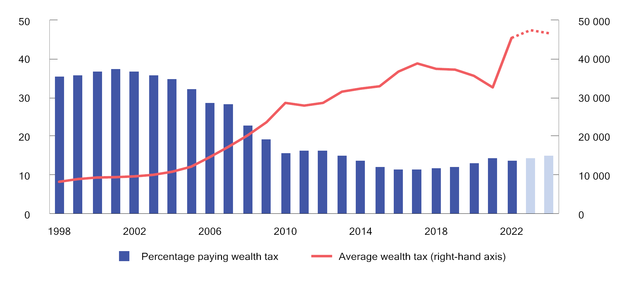

Percentage of people (resident in Norway and aged 17 years and over) paying wealth tax1 and average wealth tax. 1998–2024. Estimates for 2023 and 2024. NOK at 2024 prices

1 Income tax before any reductions as a result of the 80 per cent rule (only relevant for the years 1998–2008).

Sources: Statistics Norway and Ministry of Finance.

Property tax

Each municipality decides whether to levy property tax within the limitations laid down in the Property Tax Act. The revenues will accrue in their entirety to the municipality. In 2023, municipalities’ total revenues from property tax were about NOK 17.6 billion, of which NOK 8.7 billion was property tax on residential properties and holiday properties, see Figure 2.18.

The property tax rate shall be between 0.1 and 0.7 per cent of the valuation basis, with a maximum tax rate of 0.4 per cent for residential properties and holiday properties in 2024. The property tax base shall be determined by ordinary valuation every tenth year. Alternatively, municipalities may choose to use the wealth tax base in their valuation of residential properties. 113 municipalities are exercising this option in 2024, and the property tax base will thus develop in line with market prices. Municipalities shall apply a reduction factor of at least 30 per cent when valuing residential properties and holiday properties. They may also apply a standard allowance to reduce the valuation basis. Since 2017, municipalities have been able to choose to exempt holiday properties from property tax. No municipalities are exercising this option in 2024. Property tax on power plants is governed by special valuation rules, based on production value and subject to minimum and maximum thresholds.

As of 2024, 323 of the 357 municipalities have introduced property tax, of which 250 levy the tax on residential properties in all or parts of the municipality.

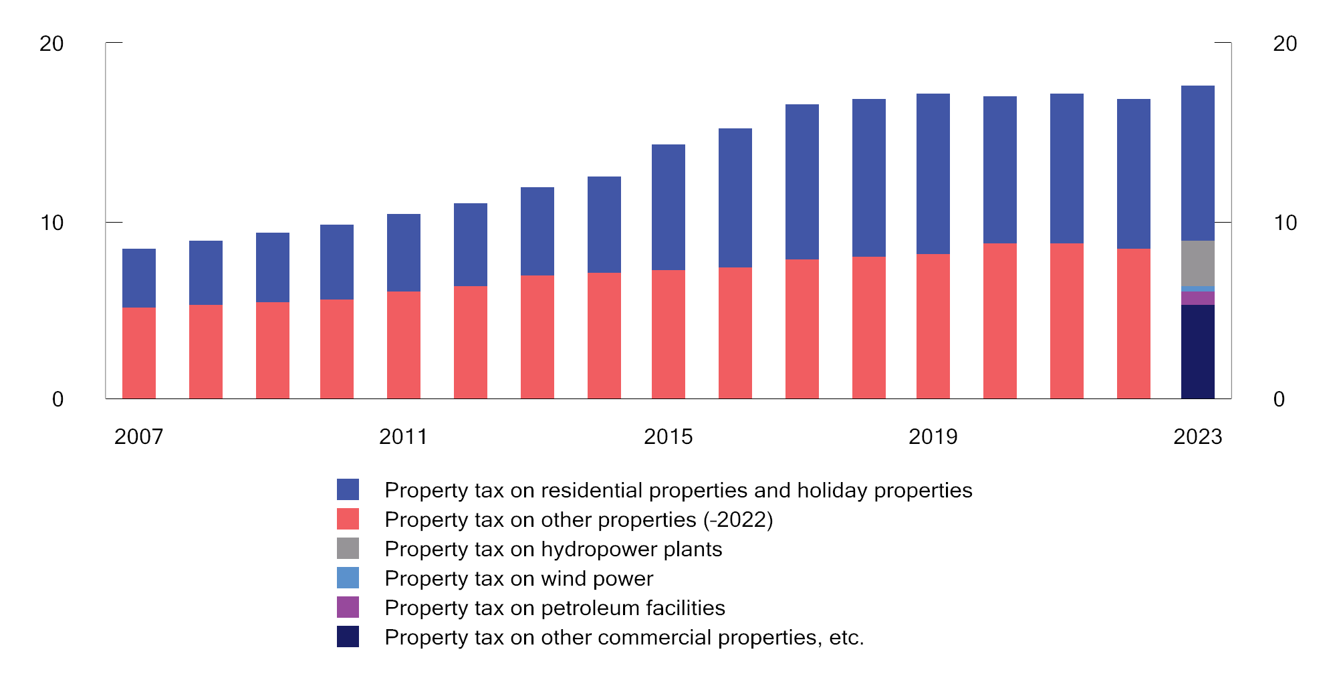

Municipal property tax revenues 2007–2023. NOK billion at 2023 prices

Source: Statistics Norway (KOSTRA).

Tax on capital assets internationally

Box 2.3 provides an overview of tax revenues from capital assets as a share of total tax revenues in selected OECD countries.

Tax revenues from capital assets in the OECD countries

The OECD tax statistics provide an overview of revenues generated by different types of taxes. Taxes on capital assets include taxes on the use, ownership and transfer of capital assets, including real estate. Taxation of returns is not included. In the case of Norway, municipal property tax, wealth tax and stamp duty are all included. Many countries do not have wealth tax, but have inheritance tax and, in some cases, significantly higher property tax than Norway.

For some countries, there may be a difference between the gross and net tax on capital assets. This applies to, for example, the US, where many taxpayers can deduct any local property tax paid when calculating the federal income tax. The OECD figures are based on non-weighted averages of gross taxes.

Figure 2.19 illustrates revenues from taxes on capital assets in selected OECD countries. As with other international comparisons, the numbers should be interpreted with caution. In Norway, the tax on capital assets account for 2.5 per cent of total tax revenues. This is well below the OECD average of 6.1 per cent. The capital asset tax share of total tax revenue is low in Norway compared with several other OECD countries. This is largely due to property tax being lower in Norway than in other countries, as well as to Norway having no inheritance tax. At the same time, it is important to emphasise that the OECD figures include different taxes that have different effects on behaviour. For many of the countries, property taxes on real estate account for the largest share of tax on capital assets. In the estimate for Norway, wealth tax accounts for a larger share. This also includes wealth tax on assets other than real estate, including shares, etc.

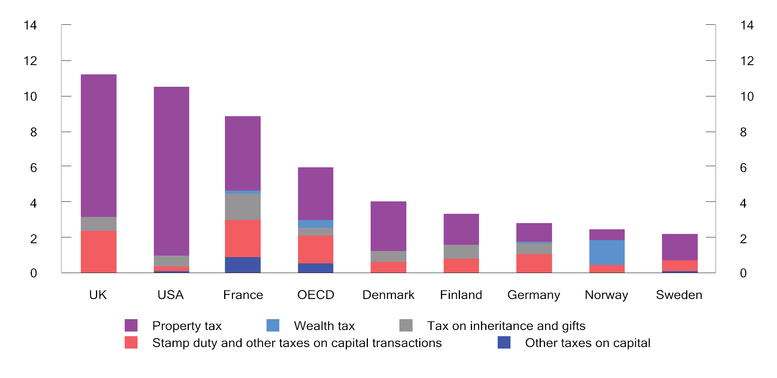

Tax on capital assets. Percentage of total tax revenues. 20221

1 Figures for the OECD are non-weighted averages for the countries that reported for 2021.

Sources: OECD (https://data-explorer.oecd.org) and Ministry of Finance.

[Boks slutt]

## Indirect taxes

### Value added tax

Value added tax is a general tax on the domestic consumption of goods and services, which is intended to raise revenues for central government. In 2024, revenues from value added tax are estimated to be about NOK 390 billion. This represents just under one-quarter of total tax revenues, excluding petroleum revenues.

Value added tax is calculated in all parts of the sales chain. Businesses that are liable for value added tax may deduct input value added tax on their procurement. This serves to ensure that the tax is not charged to the businesses in the sales chain, but on the final consumption of goods and services. Since the tax is charged on final consumption, it does not distort production decisions.

Value added tax should have as little impact as possible on which goods and services are produced and consumed, while at the same time ensuring stable revenues for central government. Besides, the administrative costs of collection and payment should be minimised. This implies that the number of exceptions, exemptions and special arrangements should be curtailed.

The standard rate of value added tax in Norway is 25 per cent. Denmark and Sweden apply the same standard rate. This rate is high by international standards. Revenues from value added tax as a share of GDP are higher in Norway than the OECD average, although it is somewhat lower than in Denmark and Sweden. Box 2.4 compares the value added tax systems in selected OECD countries.

Value added tax in OECD countries

Value added tax has been introduced in more than 170 countries. In OECD countries, value added tax revenues now account for an average of 20 per cent of total tax revenues.

The OECD compares the ability of value added tax to raise revenue in each of the member countries. This is done by comparing the actual value added tax revenues of a country with what such revenues would have been if the entire potential tax base had been subject to a single standard rate. If the entire potential tax base is taxed at the standard rate of value added tax, the value added tax revenues as a proportion of consumption will also be equal to the value added tax rate. A number of factors may cause the revenue proportion to be lower than the standard rate. For example, reduced rates, exemptions and exceptions contribute to reducing the revenue proportion. Tax collection and compliance issues, including the extent of tax planning, evasion and fraud, can also influence the revenue proportion. The revenue proportion needs to be interpreted with caution, but may serve to illustrate how effectively the value added tax system functions.

Figure 2.20 presents the standard value added tax rates for Norway, the OECD average and some other countries. The figure also presents value added tax revenues as a proportion of consumption. Norway has the same standard rate of value added tax as Denmark and Sweden. Denmark does not have reduced rates of value added tax, and value added tax revenues therefore account for a higher proportion of consumption in Denmark than in Norway and Sweden. New Zealand has a value added tax system with one uniform rate and few exemptions and exceptions. Consequently, virtually all consumption is taxed at the standard rate, including public services. Since the taxation of public services is not included in the OECD’s definition of the potential tax base, the actual tax revenues in New Zealand are higher than the estimated revenue potential.

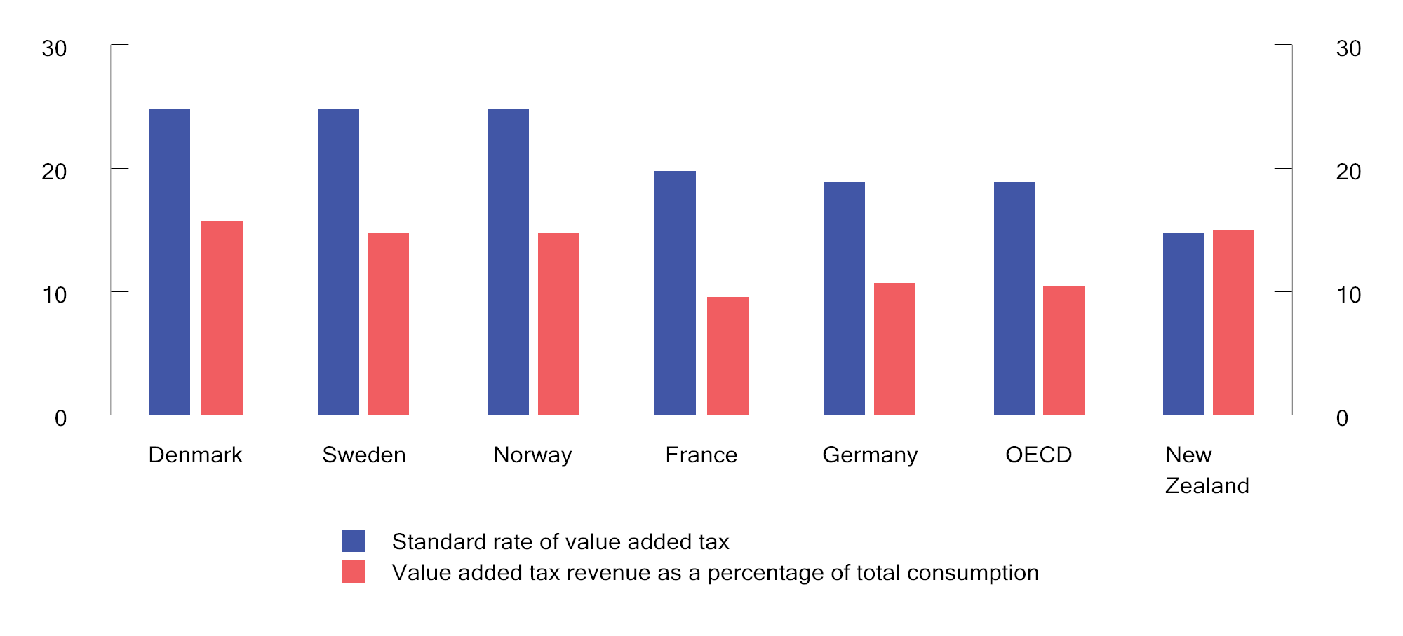

Standard rate of value added tax and value added tax revenue as a percentage of total consumption. 2020

Sources: OECD (2022), Consumption Tax Trends, and Ministry of Finance.

[Boks slutt]

The existing value added tax is, as a main rule, a general tax on consumption, although this is modified by various exceptions, exemptions and reduced rates. In Norway, foodstuffs are taxed at reduced rate of 15 per cent, while a number of services are taxed at a low rate of 12 per cent.

Some goods and services are exempted (so-called zero-rating), which means that the value added tax on goods and services for use in a business is fully deductible on the part of that business, although no value added tax is changed on its sales. Furthermore, several services fall outside the scope of the Value Added Tax Act, including financial services, health services and educational services. The value added tax on goods and services for use in a business that falls outside the scope of the Value Added Tax Act is not deductible on the part of that business.

Value added tax on international trade is based on the destination principle, which means that the country in which the consumption takes place has the right of taxation. This principle also means that value added tax is charged on imports, but not on exports. This means that value added tax is neutral with regard to the country in which goods and services are produced.

A general value added tax charged at a single rate on all goods and services would provide the most neutral system. The use of reduced rates, exemptions and exceptions means that value added tax influences the relative pricing of various goods and services, and thus the composition of consumption and production. Businesses whose sales are outside the scope of value added tax also have an incentive to produce services themselves, without any value added tax, instead of buying services with value added tax. In addition, reduced rates, exemptions and exceptions result in higher administrative costs. In general, the value added tax system is not well suited for addressing distributional considerations, supporting specific objectives or shifting consumption in a desired direction. If, for example, the intention is to reduce the consumption of goods that are considered harmful to individuals and society, it will be more effective to use excise duties or measures on the expenditure side of the budget.

### Excise duties

Excise duties are taxes on specific goods and services, etc., as opposed to value added tax, which is a general tax on the sale of goods and services. Excise duties generate revenues for the treasury, without any form of earmarking, and serve to finance public expenditure.

Most excise duties are taxes on goods. For these, the tax liability arises upon domestic production or importation. This serves to keep the number of entities liable to tax low, thereby reducing the administrative costs of tax collection. Although manufacturers and importers are liable for paying the duties, it is reasonable to assume that a significant proportion of the excise duties are passed on in the pricing of goods, thus implying that buyers of the goods on which excise duties are charged will bear the true cost of such duties. The degree of pass-through depends on market conditions.

Some excise duties are solely intended to raise central government revenues and are often referred to as fiscal taxes. Excise duties increase the price of goods, etc., and contribute to distorting the composition of production and consumption. Excise duties can therefore be used to influence behaviour, for example to reduce production or consumption that is harmful to health and the environment.

The purpose of a tax has a bearing on how it should be designed. In order to limit the economic costs of taxation, fiscal taxes should not be levied on manufactured intermediate goods. On the other hand, environmental taxes that are intended to put a price on an environmental problem should include all sources of that environmental problem, and the tax rate should reflect the environmental damage.

Figure 2.21 shows revenues from excise duties, etc., in selected OECD countries, as a percentage of GDP and total taxes. The figure illustrates that revenues from excise duties account for a lower share of both GDP and total taxes in Norway than in other comparable countries. In the OECD, excise duties averaged 4.1 per cent of GDP in 2005 and 3.6 per cent in 2021. In Norway, by comparison, excise duties represented 4.1 per cent of GDP in 2005 and 2.7 per cent of GDP in 2021. The contribution made by excise duties to total tax revenues has therefore declined more sharply in Norway than in the OECD. This is due, in particular, to the sharp decline in car tax revenues; see Box 10.3 for further details.

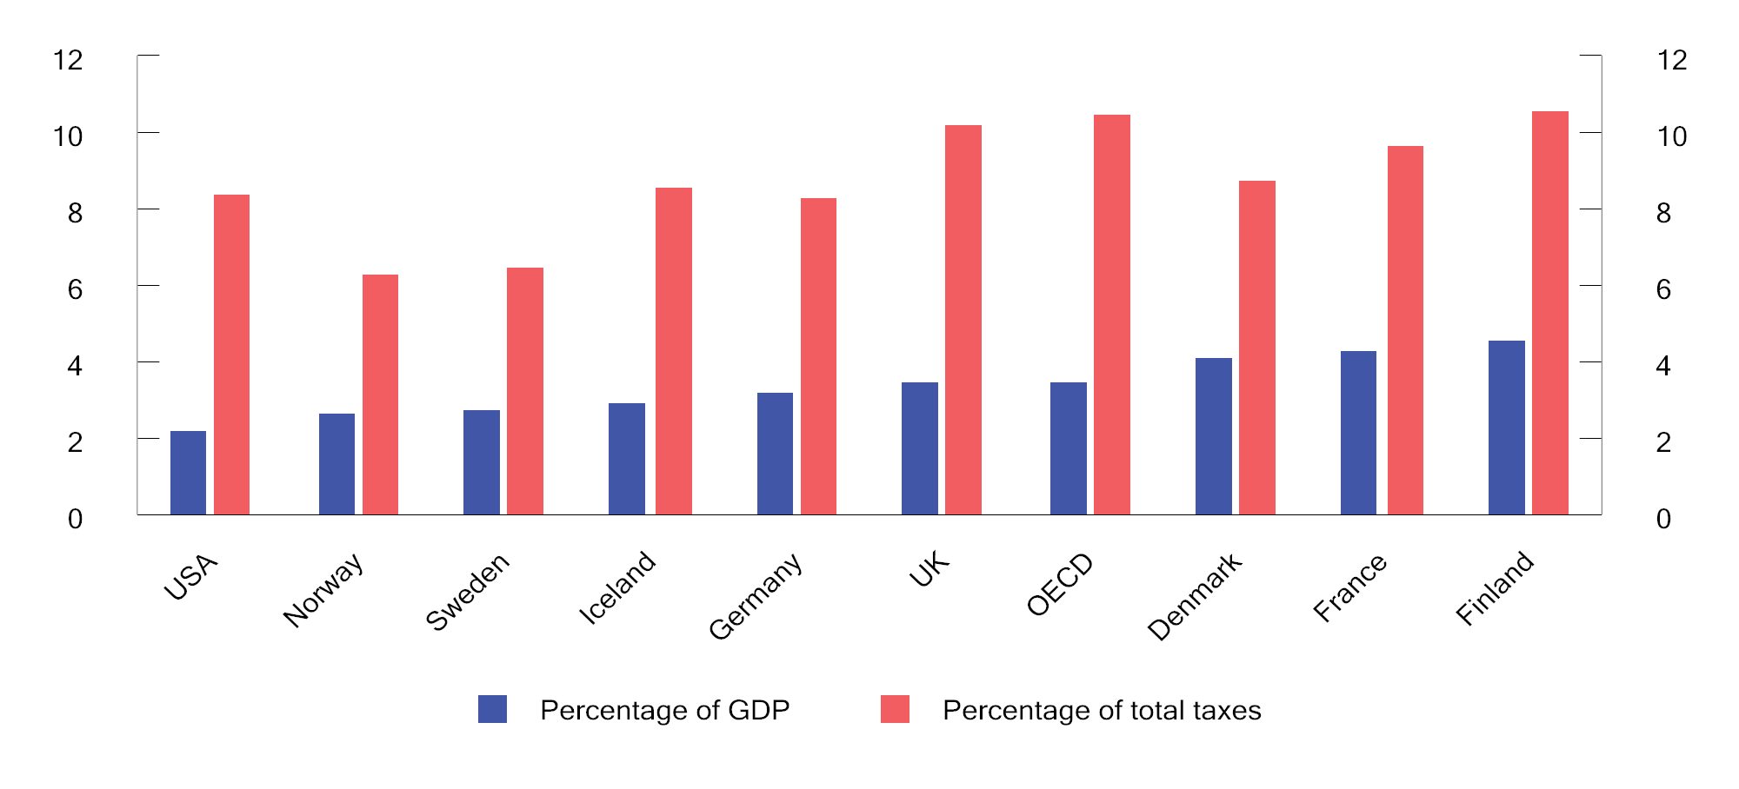

Revenues from excise duties, etc.1, as a percentage of GDP and total taxes. 2021

1 Category 5000 Taxes on Goods and Services less category 5110 General Taxes on Goods and Services.

Sources: OECD (2024) Revenue Statistics and Ministry of Finance.

Taxes in relation to health and social issues

The consumption of certain goods can entail social costs and health costs for society that are not reflected in market prices. The consumption of alcohol and tobacco are examples of this. Such consumption can result in increased health costs for society that have to be covered from the public purse, while also imposing burdens on people other than those who use the goods. Consumers do not necessarily pay sufficient heed to the long-term effects of their consumption, or may be inclined to ignore unfavourable effects. Taxes on alcohol and tobacco products raise revenues for central government, but also serve to ensure that the prices of these products better reflect the costs that their use impose on society.

A high level of tax on consumer goods can lead to increased cross-border shopping, duty-free shopping, smuggling and illicit alcohol distillation. Such unrecorded sales undermine consumption control and entail a tax revenue loss. The health effects of the consumption reduction normally attained by levying excise duties need to be assessed against the social costs of unrecorded sales.

Environmental taxes and environmentally-related taxes

The costs to society of environmentally harmful activities are not normally reflected in market prices. Environmental taxes cause market prices to increase, and thereby serve to curtail such environmentally harmful activities. The revenues from environmental taxes can be used to reduce other distortionary taxes, thus contributing to a more efficient tax system.

The use of environmental taxes is consistent with the “polluter pays” principle. This principle calls for the polluter to pay for the costs that the environmentally harmful activities impose on others in society.

Environmental taxes include climate taxes, but also taxes such as road usage tax, lubricating oil tax, sulphur tax, tax on emissions of NOX, environmental tax on pesticides and environmental tax on beverage packaging.

In addition to environmental and energy taxes, there are other taxes which are fiscally motivated, but which also serve environmental purposes. This applies to, for example, the motor vehicle registration tax, which is differentiated on the basis of, inter alia, CO2 and NOX emissions. Taxes on fuels and motor vehicles account for a large portion of environmentally-related taxes.

Climate taxes

Greenhouse gas emissions and the associated negative consequences of a warmer climate for humans and nature are an example of negative externalities resulting from economic activity. This type of market failure can be corrected by government(s) actively contributing to increasing the price of goods and services in order to make such price reflects the costs to society of the harmful activity. The damage caused by the emission of one tonne of CO2 is global and independent of where the emission occurs. Emissions can be priced either by levying a tax on the activity that creates emissions or by creating a market for tradable emission allowances. Climate taxes are taxes that aim to price greenhouse gas emissions. Pricing emissions through climate taxes and participation in the EU ETS constitutes the most important policy instrument in Norwegian climate policy.

A properly structured climate tax should encompass all sources of emissions, both nationally and globally, at one uniform rate. This would serve to reduce emissions at the lowest possible cost to society (cost-effectiveness). Pricing greenhouse gas emissions provides incentives to develop climate- and environmentally friendly technology by making such technology more profitable. Both taxes and emission allowance systems can be cost-effective measures for achieving specific climate goals. Emission allowances and taxes are discussed in more detail in Box 2.5. Other market failures mean that there is also a need, in addition to the pricing of emissions, for other measures such as support for research and development, investments in infrastructure and information to the population.

The relationship between taxes and tradable emission allowances

When a price tag is put on greenhouse gas emissions, it becomes financially profitable for market participants to implement measures that reduce emissions and that cost less than the tax, either in the form of reduced production, changes in production methods or investments in technological solutions with lower or no emissions. With a tax, the authorities put a price on emissions, but do not control the amount of emissions directly. In a system of tradable emission allowances, on the other hand, the authorities determine the amount of emissions, while the price of emissions is determined through supply and demand in the emission allowance market. An emission allowance entitles the holder to emit a given amount of greenhouse gases. The price of tradable emission allowances will be determined by the cost of the emission-reducing measures that can be implemented, as well as expectations regarding future access to emission allowances.

If the emission allowances in an emissions trading system are auctioned, these can generate government revenues on a par with taxes. If the emission allowances are handed out free of charge, government forfeits such revenues and misses out on the opportunity to achieve additional economic benefits by reducing other taxes. Whether emission allowances are handed out free of charge or auctioned does not affect how large emission reductions will be provided by the emissions trading system as a whole.

[Boks slutt]

When climate taxes work as intended, they serve to reduce emissions and thereby also reduce government revenues from the tax. If climate taxes are replaced by emission allowances that are not sold (free emission allowances), or other types of policy instruments, this serves to further reduce government revenues. Reduced revenues from climate taxes may mean that other taxes need to be increased in order to maintain the level of tax revenues needed to finance public services.

The use of climate taxes in Norway is extensive, also in comparison with other industrialised countries in Europe and beyond. Almost all use of fossil fuels in Norway is priced through taxes and/or the emission allowance system, and the tax rates on the use of fossil fuels are also relatively high. The OECD calculates the net effective carbon price (see Box 2.6) of energy use in the OECD and G20 countries on a regular basis, along with a carbon price score for each country. A carbon price score of 100 per cent means that all energy emissions are priced at more than EUR 60 per tonne of CO2, while a score of 0 per cent means that none are. There is a great deal of variation in the progress made by different countries in the pricing of emissions; see Figure 2.22. The OECD calculations show that Norway had a carbon price in excess of EUR 60 for about 85 per cent of emissions in 2021. The OECD data are several years old and their estimates differ somewhat from those of the Norwegian Ministry of Finance. For 2024, the Ministry of Finance estimates that about 97 per cent of all Norwegian CO2 emissions are priced at more than EUR 60 per tonne.

A uniform and gradually increasing carbon price in all countries would result in a cost-effective reduction of global emissions. This means that we could have achieved greater emission reductions globally for a given level of the total cost of measures for all countries. When the price of emissions is higher in Norway than in other countries, there are incentives to make investments and adopt measures in Norway that entail lower emission reductions than if the same investment had been made in another country. Different pricing also entails a risk of carbon leakage. In other words, that businesses relocate to a country with a lower emissions price. Such relocation can reduce emissions in the country from which the business is moving, but this can be offset by increased emissions in the country to which the business is relocating. Hence, global emissions may be more or less unchanged, or even higher.

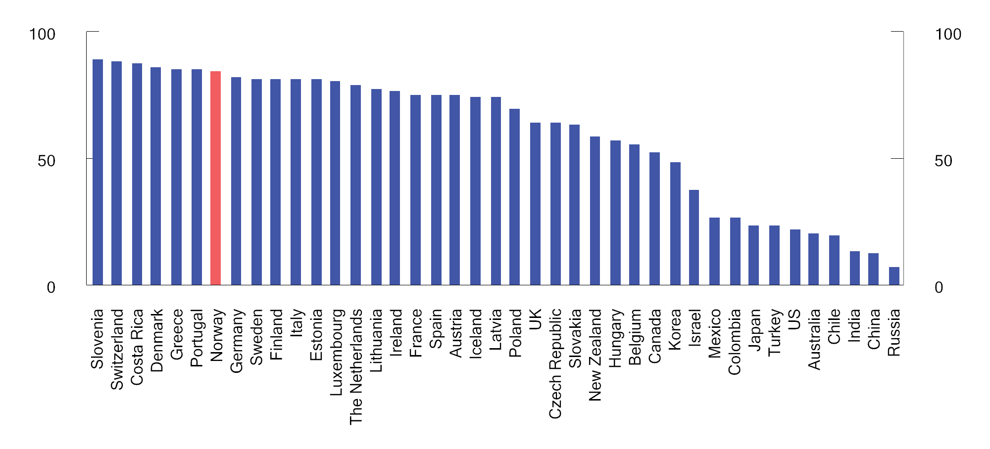

Carbon price score for energy use in selected countries in 2021 at a benchmark price of EUR 60 per tonne of CO2 equivalents. Percentage

Source: OECD.

In 2024, the general tax level on greenhouse gas emissions under the Effort Sharing Regulation is NOK 1,176 per tonne of CO2 equivalents. In comparison, the average emission allowance price is estimated to be about NOK 748 per tonne of CO2 in the period from January to August 2024. The price of emission allowances varies over time. After a marked increase throughout 2021, the price averaged just under EUR 85 in 2022 and 2023. Prices fell in the second half of 2023 and the first quarter of 2024, but have since risen. With the proposed escalation of the tax level, it is expected that the general level for emissions under the effort sharing will be well above the emission allowance price in 2025.

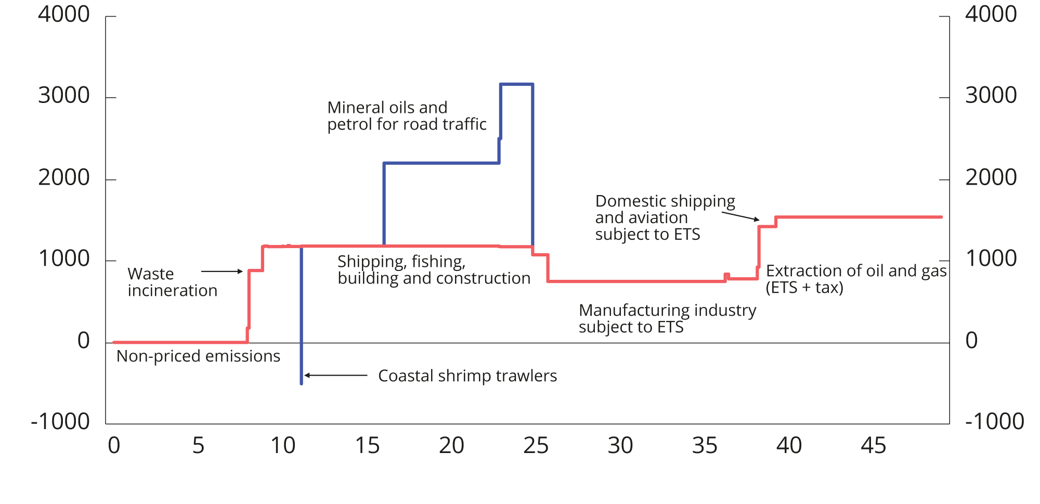

Net effective and explicit prices on greenhouse gas emissions in various sectors. Tax level in NOK per tonne of CO2 equivalents in 2024 and emission allowance price of NOK 748 per tonne of CO2. Emission figures are from 2022.

Sources: Statistics Norway, Norwegian Environment Agency and Ministry of Finance.

Some sectors are subject to both emission allowance requirements and tax. This distorts the pricing situation and may result in the most profitable investments not being prioritised over less profitable investments that are subject to a lower carbon price. The carbon prices faced by the various sectors in Norway are presented in Figure 2.23. The vertical axis of the figure indicates the marginal CO2 price in various sectors, while the horizontal axis indicates the amount of emissions in million tonnes of CO2 equivalents. A distinction is made between effective and explicit carbon prices; see Box 2.6.

Net effective and explicit carbon prices

Explicit carbon prices are all pricing mechanisms that are aimed at pricing greenhouse gas emissions. These may be taxes or emission allowance systems. Effective carbon prices also include other taxes and mechanisms, regardless of purpose. In some sectors, mineral oils and petrol are also subject to road usage taxes which serve purposes other than reducing greenhouse gas emissions, but which nevertheless increase the effective carbon price. Calculations of net effective carbon prices also take into account subsidies or other arrangements that serve to reduce the effective carbon price.

It is the net effective carbon price that determines the price of activities that emit greenhouse gases, for example through the price at the pump. Measures of net effective carbon prices are therefore important for understanding how changes to taxes and subsidies may collectively influence greenhouse gas emissions.

A cost-effective climate policy requires all greenhouse gas emissions to be priced uniformly, as measured by explicit carbon prices. This is evident from the fact that greenhouse gas emissions, measured in CO2 equivalents, are equally harmful to the climate irrespective of where these occur or who emits them. When all emissions are subject to the same explicit carbon price, emissions will be reduced where this costs the least. Emissions targets can thus be attained at the lowest possible cost to society by increasing the explicit carbon price. However, pricing of emissions through taxes may have undesirable distributional effects. The impact of climate taxes on various groups will depend on, inter alia, the ability of stakeholders to adapt to increased climate taxes. Compensation to particularly affected groups should not take the form of a reduced tax, but rather a reduction in other taxes, or the introduction of subsidy schemes that do not weaken the emission reduction incentives.

Comparing explicit carbon prices shows whether the carbon pricing has been designed in a cost-effective manner. However, it is not necessarily appropriate for all market participants to face the same effective carbon price. One of the reasons for this is that externalities other than climate can vary significantly between different sectors. Subsidies or other arrangements that serve to make the net effective carbon price lower than the explicit carbon price, make climate policy less cost-effective.

[Boks slutt]

Oil and gas extraction is, for example, faced with an explicit carbon price of NOK 1,539 and has total emissions of 9.8 million tonnes; see Figure 2.23. Coastal shrimp trawlers pay a CO2 tax on mineral products, but also receive a subsidy from the Guarantee Fund for Fishermen based on how much fuel they consume. This subsidy is considerably more than the tax measured in NOK per litre of fuel, and the total net effective carbon price for the industry is therefore NOK ‑500 per tonne of CO2.

### Customs duties

Customs duties serve to protect domestic producers from foreign competition. Customs duties normally result in more expensive goods for consumers and higher production costs for businesses. In addition, customs duties may limit the range of goods available to consumers. Furthermore, customs duties reduce trade volumes and prevent countries from fully utilising their comparative advantages in the production of goods and services. Trade in goods and services has enabled Norway to utilise its competitive advantages.

Norway is one of the countries in the world with the lowest customs barriers for manufactured goods. Certain types of clothes and textiles are the only manufactured goods subject to customs duties. Customs protection for agricultural products is a key agricultural policy instrument for ensuring emergency preparedness and food supply security in Norway. Import protection can contribute to higher domestic production of agricultural goods. The customs duty rates for agricultural goods are highly variable, depending on the need for protection.

Customs duties have been capped through international agreements. Like other industrialised countries, Norway applies lower customs duties to developing countries under the Generalized System of Preferences (GSP). Under this system, industrialised countries grant developing countries better market access for their goods. The GSP system is unilateral and may be revoked or amended at any time.

### Fees and sectoral taxes

The provision of services and the exercise of authority by central government are normally funded by appropriations via the fiscal budget, although fees and sectoral taxes are used in some areas. The Ministry of Finance has laid down general provisions for central government funding through fees and charges. Fee schemes may be established when the public sector performs a clearly defined service for the payor and payment is not made for anything other or more than the cost of producing and delivering such service. Consequently, cost-reflective funding through fees is not to be considered taxation. In contrast, fees that are higher than the cost of producing and delivering the service will entail an element of hidden taxation. This type of overpricing has been reduced over time.

Sectoral taxes serve a broader purpose as a source of funding and may be used to fund joint measures for an industry or sector if such taxes are paid by stakeholders belonging to, or closely affiliated with, the relevant sector. For example, the operations of a number of supervisory bodies are funded in full or in part by sectoral taxes. Changes to the base or rate of sectoral taxes are therefore classified as part of the tax programme. The provisions laid down by the Ministry of Finance stipulate that considerable restraint should be exercised in introducing sectoral taxes to fund central government expenditure.

## Relationship to the EEA Agreement

There is no obligation under the EEA Agreement to harmonise Norwegian tax rules with EU regulations and directives. Nevertheless, the general provisions in the EEA Agreement on the Four Freedoms and the prohibition on state aid set clear restrictions on the content of the Norwegian tax rules.

The provisions on the Four Freedoms refer to the principles of free movement of goods, services, capital and persons/establishments within the EU/EEA. In the field of tax law, the specific limitations implied by the principle of the Four Freedoms have primarily been developed by the EFTA Court and the European Court of Justice. As a general rule, Norway cannot apply provisions that treat cross-border movements and transactions between Norway and other EEA states more strictly than purely domestic movements and transactions. In certain cases, however, Norway may maintain or introduce provisions that would in principle entail a restriction. This applies where there are so-called justification grounds. In the field of taxation, a restriction may be justified, in particular, by the need for a balanced distribution of taxation powers between states and the need to counteract tax avoidance. Effective tax collection is another relevant consideration. In order to justify a provision that would in principle constitute a restriction, it is an additional requirement that such provision be suitable for attending to the relevant consideration, and that it is not stricter than necessary to attend to the said consideration (proportionality requirement).

The prohibition on state aid means that Norway cannot, as a general rule, apply tax provisions that give individual enterprises or groups of enterprises more favourable tax treatment than these are entitled to under the general provision applicable to such enterprises. The prohibition restricts both advantages for individual enterprises and advantages for certain sectors or geographical areas. However, the EEA Agreement contains various rules that allow for the granting of state aid under certain conditions. The EFTA Surveillance Authority (ESA) adopts guidelines on the interpretation and application of these rules. The said rules, which reflect the relevant EU regulations, stipulate strict conditions for considering the aid to be compatible. Such aid shall be notified to the ESA and cannot be implemented until it has been approved by the ESA. Exemptions from the notification requirement have been laid down in the so-called General Block Exemption Regulation. In certain cases, aid may even be authorised without notification or reporting. This applies to aid that meets the de minimis aid criteria under the Regulation.

Norway is not part of the EU customs union. Nonetheless, the Norwegian customs authorities are increasingly affected by regulations incorporated into the EEA Agreement within areas that fall under the responsibility of other authorities. In recent years, the EU has adopted a number of legal acts that impose requirements on goods imported from third countries for free circulation on the single market. Such requirements pertain to the methods of production, properties, etc., of the products. When goods encompassed by the relevant legal acts are imported into the EU, such goods are checked by the EU customs authorities by way of product passports, certificates, etc. When such rules are incorporated into the EEA Agreement, the Norwegian customs authorities will have a similar task of inspecting goods imported from third countries.

## International tax cooperation

Differences between tax systems and in tax levels between countries may provide opportunities for undesirable international tax planning and harmful tax competition between countries. This can reduce the tax revenues of countries and shift taxation to less mobile tax bases, such as real estate and labour income. In addition, it provides a breeding ground for economically unfavourable forms of taxation, such as gross withholding taxes on services.

These issues have long been high on the political agenda in Norway and internationally. Several international processes are currently underway to develop multinational standards and agreements aimed at counteracting the unfavourable effects of tax planning and harmful tax competition, etc. Norway participates as an active contributor in all of the ongoing processes, including the OECD, the Inclusive Framework on BEPS, the Global Forum on Transparency and Exchange of Information for Tax Purposes, as well as the UN.

The OECD/G20 Inclusive Framework, which comprises 147 jurisdictions, is seeking to negotiate a reform package for the allocation of taxation rights over large multinational enterprises (Pillar 1), as well as the introduction of a global minimum tax (Pillar 2). This package is known as the Two-Pillar Solution. The regulations on a global minimum tax (Pillar 2) were introduced in Norway with effect from 2024.

In July 2024, the G20 finance ministers, with Norway as guest country, agreed a tax declaration that highlighted some areas in which they particularly want to expand international tax cooperation. There is a consensus that additional international coordination is necessary to facilitate more progressivity. This is because high levels of capital income and wealth can be difficult to tax as the result of tax planning. For example, very rich people are often more inclined to move to countries with lower taxes. The declaration therefore expressed a desire to improve the practical scope for each country to increase progressivity in the taxation of individuals. In their declaration, the G20 finance ministers acknowledge that adequate taxation of the very rich is difficult without expanded cooperation between countries.

UN negotiations on a mandate for a Framework Convention on International Tax Cooperation took place in 2024. The UN General Assembly will consider the proposed mandate this autumn. It is expected that this Framework Convention will be negotiated over the period from 2025 to 2027.

## Distributional effects of the tax system

Many complex factors influence the development of economic disparities. Economic cycles and structural factors influence the distribution of market income; see the discussion in Report No. 1 (2024–2025) to the Storting, National Budget 2025 Chapter 6. The tax system is one of the factors that can influence income distribution, both directly and indirectly. The tax system contributes to the redistribution of income because it is, inter alia, progressively designed (the average tax rate increases with the level of income or wealth). Moreover, tax revenues finance transfers to households and public services in areas such as health and education, which also has an equalising effect. Furthermore, taxes can, together with transfers and public services, influence the economic decisions of taxpayers and thereby also the distribution of market income (before tax).

The total equalisation contribution from taxes and transfers has been relatively stable over the past 30 years; see Figure 2.24. The figure shows inequality measured by the Gini coefficient for income before and after taxes and transfers. The figure uses the same income measure as the Statistics Norway income statistics, which includes most cash income received by households. However, a number of contributions to households’ material standard of living are not captured by this definition of income, such as the value of public services, the return on owner-occupied housing, as well as any profits retained in private companies.

Since returns on capital are only captured when realised, the measured income inequality is greatly affected by the extraordinarily high dividend payments made prior to the introduction of the dividend tax in 2006 and the dividend tax increases announced in 2016 and 2022. See Report No. 1 (2024–2025), National Budget 2025 Chapter 6, for an analysis of income inequality under an expanded income definition where retained profits in private companies are included in their owners’ income.

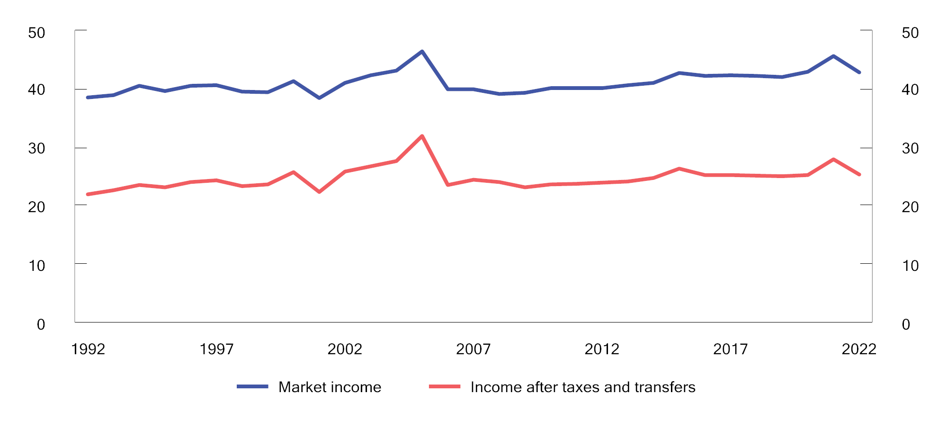

Income inequality before and after taxes and transfers. Gini coefficients for equivalent income per consumption unit (EU scale). 1995–2022

1 Fluctuations around the years 2000, 2005, 2015 and 2021 should be considered in the context of tax rule amendments that have caused short-term spikes in tax-motivated transactions.

2 Market income includes, inter alia, wage income, business income and capital income. Disposable income is market income plus transfers less assessed tax and negative transfers, such as child maintenance payments and pension premiums.

Source: Statistics Norway.

The significance of personal taxes to income distribution

The progressivity of the tax system is clearly illustrated in Figure 2.25, which shows that tax as a percentage of income increases with the level of income. This figure includes both income tax and wealth tax. Figure 2.16 in Section 2.3.4 shows the same without wealth tax, and illustrates that the tax system is regressive, i.e. the tax percentage declines at the very top of the income distribution if wealth tax is not included. The degree of progressivity has been relatively stable in recent decades, except at the very top of the income distribution.

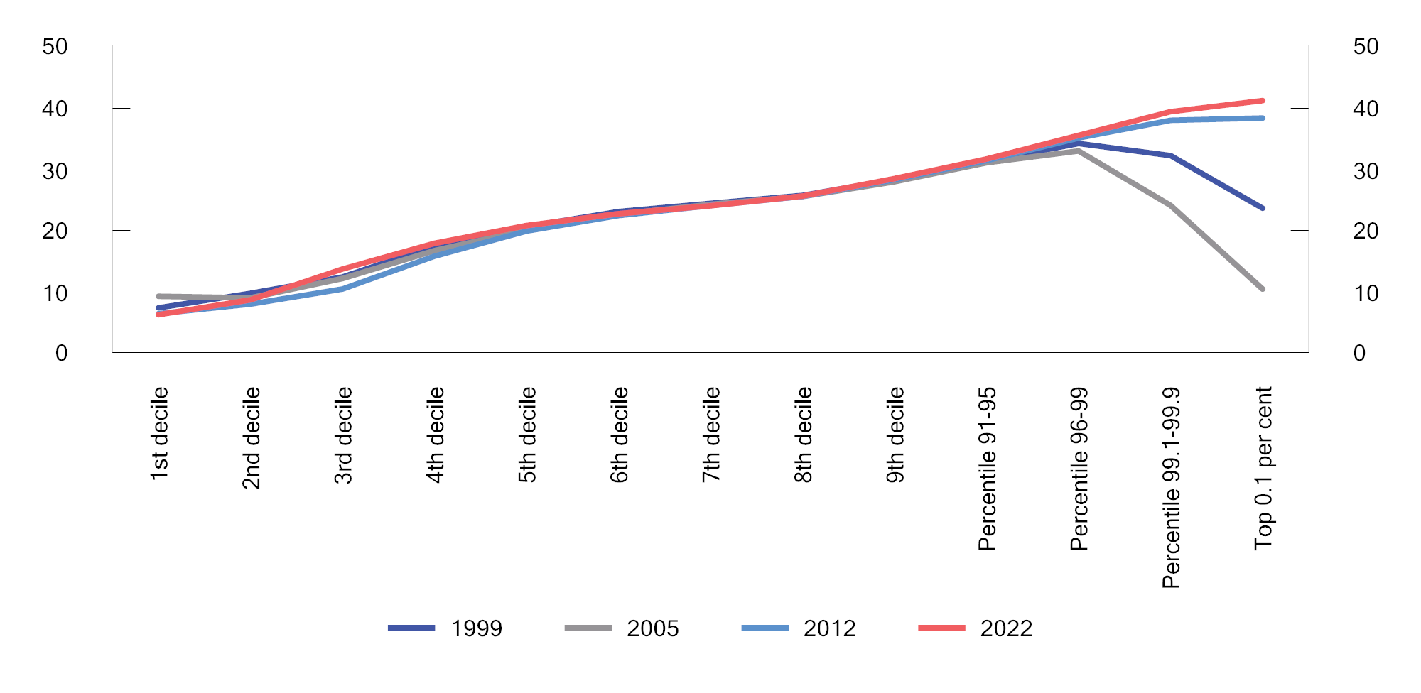

Tax as a percentage of gross income in various income groups. Percentage

Source: Statistics Norway.

For those with the very highest income, the tax rate has varied considerably over time. This is due to both amendments to the dividend tax rules and short-term spikes in dividend distributions motivated by the said amendments; see Figure 2.26. In the late 1990s, the tax rate (including wealth tax) for the richest 0.1 per cent was about 20–25 per cent. The decline in the tax rate from 2001 to 2005 is largely due to large dividends caused by expectations of a dividend tax introduction. A temporary dividend tax was applied in 2001, and a permanent tax on dividends was introduced in 2006. In subsequent years, the tax rate of the richest has also varied somewhat as a result of dividend distribution fluctuations. In years in which extraordinarily high dividends are distributed, such as 2021, the tax measured in NOK will increase, while the tax rate will decline. This is because dividends are taxed at a slightly lower rate than high labour income. The tax rate of the richest is nevertheless at a higher level now (35–40 per cent) than before the introduction of the dividend tax (20–25 per cent) when the tax is measured as a percentage of gross income as defined in the official statistics (excluding ownership income retained in companies).

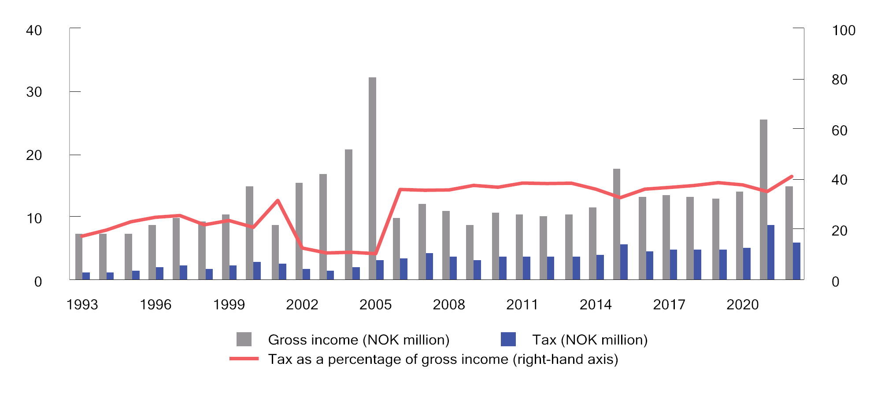

Average gross income, tax and tax as a percentage of gross income for the top 0.1 per cent. NOK at 2022 prices. 1993–2022

Source: Statistics Norway and Ministry of Finance.

The significance of indirect taxes to income distribution

When examining how the tax system influences households’ consumption opportunities and welfare, one should ideally take into account that indirect taxes also influence consumption opportunities. Indirect taxes do not depend on an individual’s income or wealth. Unlike direct taxes, indirect taxes are not normally levied directly on consumers, but indirectly via producers and importers of the goods and services subject to such taxes. The extent to which the tax burden is passed on in the prices charged to consumers depends, inter alia, on supply and demand for the goods and services subject to the relevant indirect tax. However, no information is available that would show whether the tax burden is carried by individuals or businesses, respectively, or how this tax burden is divided across various income intervals for any given indirect tax. In Figure 2.27, the Ministry has estimated aggregated revenues from indirect taxes by income decile based on the Lotte-Konsum model.

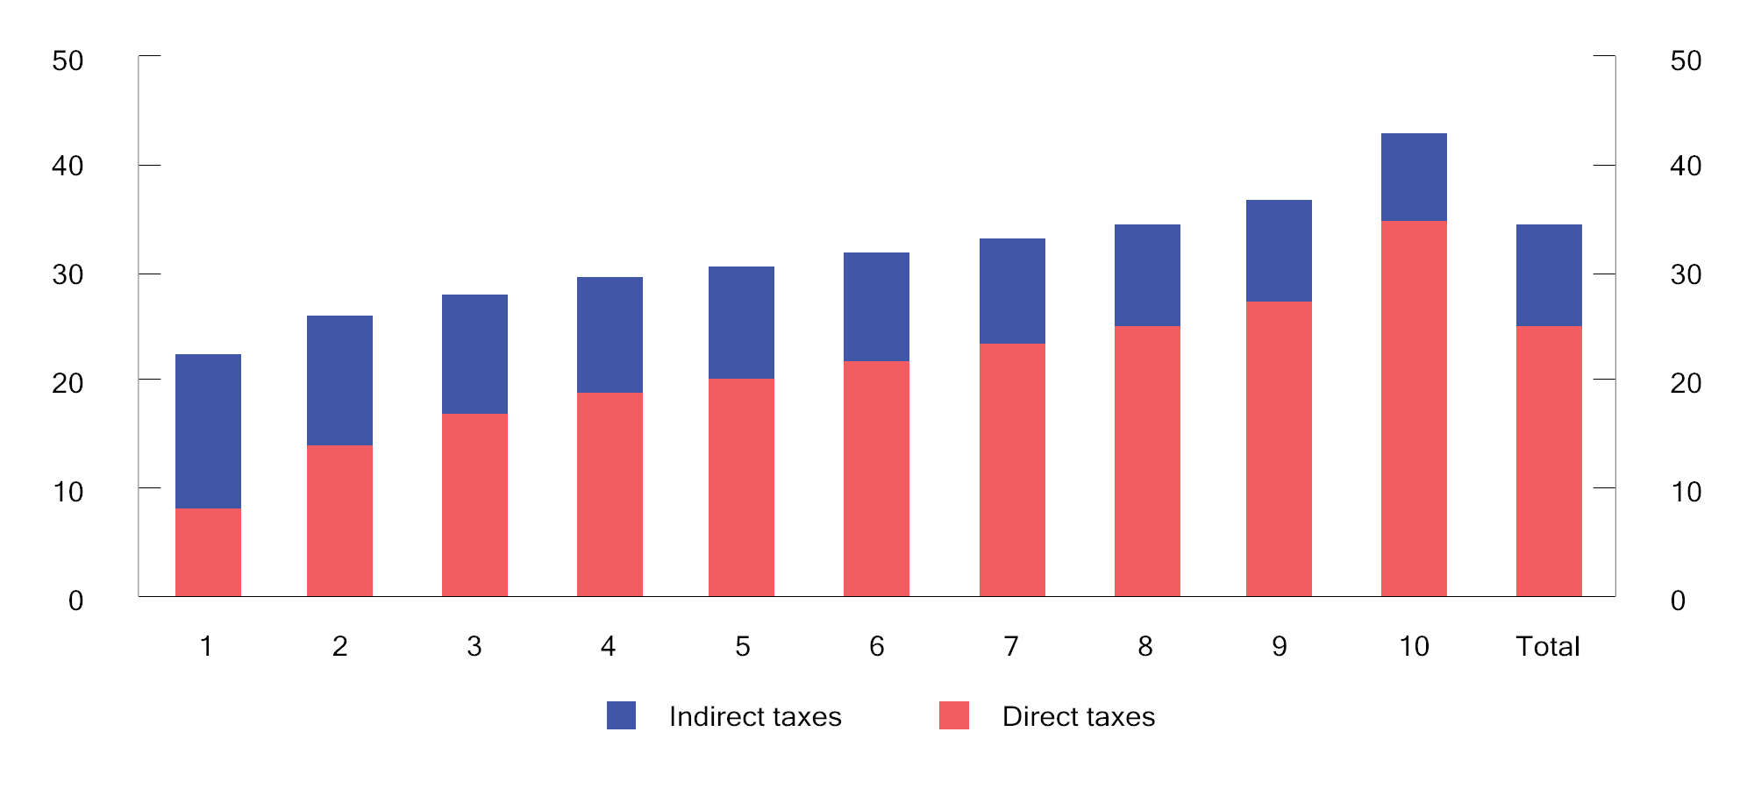

Direct and indirect taxes per person as a percentage of household-adjusted income by income deciles. 2024 rules. Percentage

Sources: Statistics Norway and Ministry of Finance.

In the figure, individuals have been assigned a share of household income and tax, adjusted for economies of scale (household-adjusted income), and ranked by rising income in ten equally sized groups (income deciles). Correspondingly, individuals have been assigned a share of the estimated indirect taxes paid by their household.

The figure illustrates that people on low incomes have a lower overall tax burden than people on high incomes. However, indirect taxes weaken the progressivity of the tax system. This is partly because the calculations are based on gross household income. People with a high gross income pay a larger proportion of their gross income in tax than people with a low gross income and thus have a smaller proportion of their income available for consumption. It is the income after direct tax that can be consumed, and thus be subject to indirect taxes. Therefore, indirect taxes will constitute a smaller proportion of the gross income of a person with a high gross income than that of a person with a low gross income. If the calculations were based on income after tax (disposable income), the burden of indirect tax would have been more equal as a proportion of income across the various income groups.

## Estimated tax expenditures and tax sanctions

The tax system includes a number of exemptions, exceptions and special arrangements that serve to reduce government revenues. When compared with taxation under the ordinary rules, these exemptions, exceptions and special arrangements represent an advantage to those who fall within their scope.

The Norwegian tax system is based on the principle that all income and assets should be taxed, and that the tax base should correspond to actual, financial values. However, to the extent that this is not the case in practice, the explanation may, for example, be a desire to attend to other considerations or to serve specific purposes.

Correspondingly, the tax system may feature tax sanctions, i.e. that a tax is sometimes levied that is higher than what is stipulated in a general and uniform set of rules or key principles. One example is fiscal taxes on input factors in business activities.

Unlike measures funded via the expenditure side of the budget, the Storting does not decide the level of tax expenditures and tax sanctions in the annual budgets. This implies that tax expenditures are not subject to annual budgetary prioritisation in the same way as schemes on the expenditure side. This section is therefore intended to provide supplementary information and to highlight the budgetary effects of deviations from the tax rules. The overview of such exemptions is not complete, as it has not been possible to, inter alia, quantify all tax expenditures. Appendix 1 provides a detailed overview of the Ministry’s calculations of tax expenditures and tax sanctions, as well as further analysis of tax expenditures.

The extent of tax expenditures and tax sanctions depends on how the benchmark system is defined. For the main part, the standard tax rules are applied. In some areas, the main principles underpinning the structure of the tax system are applied, as established in, inter alia, the 1992, 2006 and 2016 tax reforms. Examples include depreciation rates, the taxation of residential properties and certain indirect taxes. As in most other countries, the Ministry uses the so-called revenue-foregone method, i.e. the tax expenditures are estimated as the tax revenues foregone by the government as the result of more lenient rules than would be indicated by the benchmark system. It is important to note that a weakness of this model is that the calculations disregard behavioural changes. In many cases, the calculations will therefore not provide a realistic estimate of the revenues that would be generated by removing or reducing tax expenditures. The figures therefore need to be used with considerable caution. The tax expenditures are discussed in more detail in Appendix 1.

Figure 2.28 illustrates how net tax expenditures in 2024 are distributed across different areas. The largest tax expenditures are the result of value added tax exemptions/special arrangements, the absence of income taxation of owner-occupied housing, as well as wealth tax valuation discounts.

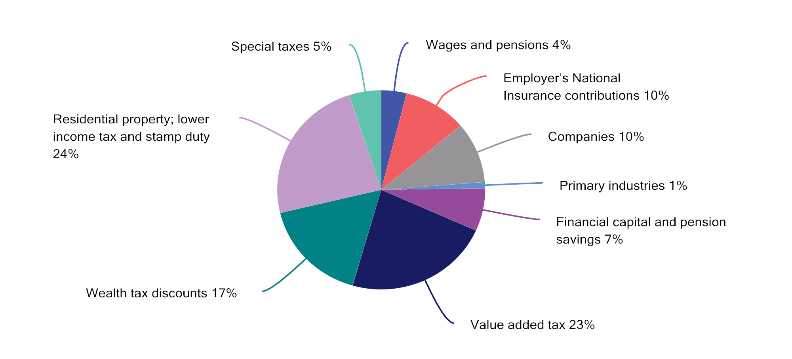

Net tax expenditures in 2024 specified by different areas. Percentage

Source: Ministry of Finance.

## Revenue calculation methods

The effects of changes in the tax rules on central government revenues are often referred to as revenue effects, and differ from changes in tax revenues caused by other developments, including economic cycles. The Ministry of Finance uses a number of different methods for estimating the revenue effects of tax changes. These methods vary from sophisticated models to simple estimates based exclusively on statistics. The method used will depend on which models have been developed, the data that are available and the deadline by which the calculation has to be made. The calculation methods are summarised below.

### Benchmark system and benchmark alternative

Benchmark system for the tax rules

The revenue effects of changes in the tax rules in the budget year are calculated in relation to a benchmark system for the tax rules. In the benchmark system, taxes are kept unchanged in real terms from the year prior to the budget year. This means that the limits and rates[1] in the tax rules are adjusted by an estimate of the relevant growth factor, such as the growth in consumer prices, wages, pensions or asset values. If a rate or limit that is adjusted in the benchmark system is kept unchanged in nominal terms, a revenue effect will therefore be calculated.

The benchmark system for direct taxes is based on the tax rules applicable in the current year, with allowances and income thresholds under the standard rate structure for individual taxation being, as a main rule, adjusted in line with projected wage growth. A taxpayer who only has standard allowances (personal allowance and basic allowance) and whose ordinary income and personal income both increase by the projected wage growth rate, will pay approximately the same average income tax in the benchmark system as in the current year. Pension tax rules are adjusted on the basis of the growth in the minimum level of the retirement pension and the growth in the ordinary retirement pension. Correspondingly, the standard allowance against wealth tax in the benchmark system is adjusted such that a person with a wealth composition equal to the average is subject to the same wealth tax in the benchmark system as in the current year, measured as a proportion of the wealth. Special allowances and certain other personal taxation thresholds are adjusted by the estimated inflation rate.

Under the benchmark system for excise duties, all per unit rates are adjusted by projected inflation (changes in the consumer price index). The tax burden under the benchmark system thus remains unchanged in real terms. The benchmark system for value added tax is based on the current value added tax regulations.

Benchmark alternative for tax revenues

Under the benchmark alternative for tax revenues in the relevant budget year, all taxes are kept unchanged in real terms from the previous year. The benchmark alternative is determined by the benchmark system for the tax rules and by estimated developments in the tax base. Tax base projections are based on factors such as estimated macroeconomic developments. The total revenue estimate for a budget item will therefore be comprised of the estimate under the benchmark alternative plus the estimated effect of any regulatory changes. It is the booked effects that form the basis for appropriation decisions.

### Revenue calculations that do not incorporate behavioural effects

The most basic form of revenue calculation assumes that the tax change has no influence on the behaviour of households and businesses. The revenue effect will therefore only reflect the direct effect on tax revenues. For example, the revenue effect of a change in the tax rate is calculated as the tax base multiplied by the change in the tax rate.

For the budget year in which a tax rule is changed, revenue calculations that only include direct effects will, in many cases, provide a good approximation of the revenue effects. This applies, in particular, to instances in which there is little reason to assume that the change will occasion significant short-term behavioural changes or appreciably affect other tax bases.

### Revenue calculations that incorporate behavioural effects

Changes to taxes and certain government expenditure items may influence government finances beyond the immediate, direct budgetry effect. This is because such changes may influence the behaviour of businesses and households. For example, an increase in an excise duty will normally result in an increase in the price of the relevant goods, and thus in a reduction in demand for such goods.

The revenue estimates for changes in taxes are intended to contribute to making government revenue budgeting as realistic as possible. Although behavioural effects can be an important aspect of the justification for a change, these are only included in the revenue estimate if they are expected to affect revenues in the relevant budget year. It is reasonable to assume that it will take time before, for example, changes to the taxation of wage income and pension income induce behavioural changes with a permanent impact on labour supply. Many people have fixed working hours and are therefore unable to change these without finding a new job or renegotiating their existing employment contracts. For these reasons, it will, as a general rule, be most relevant to incorporate the revenue effects in the budget without behavioural changes.

However, in some cases it may be relevant to include behavioural effects already in the first year. The revenue calculation will in those cases take into account both the rule change and how the resulting behavioural changes on the part of households and businesses will influence the tax base. Financial adjustments generally occur relatively swiftly, while changes in the real economy take more time. For example, dividends more than halved from 2000 to 2001 as a result of the temporary dividend tax in 2001. Changes to indirect taxes may also have a fairly rapid impact on consumption. As a general rule, the Ministry therefore incorporates behavioural effects in the budget estimates for indirect taxes. In some cases, it may also be appropriate to assume that there will be relatively rapid adaptations to certain changes in the income tax for individuals. One example is the restructuring of taxation of pensioners in 2011, which the Ministry assumed would have some impact on the labour supply in the first year.

Adjustments may also occur before the tax change has entered into effect. One example is adjustments to the dividend tax that was introduced as part of the 2006 tax reform; see Section 2.7. Another example is the reorganisation of the motor vehicle registration tax. When the budget proposal was presented in October 2006, it became evident that cars with low CO2 emissions would be subject to a lower motor vehicle registration tax after 1 January 2007, while cars with high CO2 emissions would have a higher motor vehicle registration tax. This resulted in purchases of car models that would be subject to a lower tax being postponed, while purchases of car models that would be subject to a higher tax were accelerated.

In some instances, it should be taken into consideration that changes to one tax base may have behavioural effects that also influence other tax bases. The rule change will in such case have an indirect effect on tax revenues via a tax base that is not directly affected by the rule change. For example, an increase in the tax on spirits may shift alcohol consumption away from spirits and towards wine or beer. An increase in the tax on spirits may therefore increase the revenues from the taxes on wine and beer.

Self-financing of reduced tax on labour

When tax rates are reduced, some of the immediate revenue loss may over time be offset by tax base growth. For taxes on labour, this is because lower taxes lead to more people working more. Tax cuts can therefore entail an element of self-financing. The degree of self-financing expresses how much of the tax cut central government gets back due to an increased tax base. There is considerable uncertainty regarding the degree of self-financing, and this will vary between different taxes. The table below presents estimates of the self-financing ratios from Statistics Norway’s simulation model LOTTE-Arbeid.

For example, a self-financing ratio of 6 per cent (as estimated for a reduced tax rate on ordinary income) means that about NOK 6 million of an immediate revenue loss of NOK 100 million will be recouped after a certain period of time as a result of increased labour supply and thereby a larger tax base. There is considerable uncertainty associated with these estimates.

The immediate loss of revenue in these calculations includes all taxpayers (i.e. wage earners, self-employed persons, social security recipients and pensioners, etc.), while the counteracting effect via increased labour supply for the main part only includes wage earners in the 26–62 age group. Increased labour supply will also affect other parts of the fiscal budget, including expenditure on National Insurance benefits and revenues from corporation tax and value added tax. Such effects have also not been taken into account in these calculations.

Estimates of the self-financing ratios for tax cuts through various changes in tax rates, thresholds and allowance amounts. The benchmark for 2024

02J1xt2

|  |  |
| --- | --- |
| Change in tax rate, threshold or allowance amount | Self-financing ratio |
| Reduced tax rate for bracket tax, bracket 3 | 10% |
| Increased threshold for bracket tax, bracket 3 | 9% |
| Reduced tax rate for ordinary income for individuals | 6% |
| Reduced National Insurance contributions on wages/ benefits and self-employment income | 5% |
| Reduced tax rate for bracket tax, bracket 2 | 4% |
| Increased threshold for bracket tax, bracket 2 | 1% |
| Increased cap for the basic allowance against wages/ benefits | 0% |
| Reduced tax rate for bracket tax, bracket 1 | 0% |
| Increased threshold for bracket tax, bracket 1 | 0% |
| Increased personal allowance | 0% |
| Increased rate for the basic allowance against wages/ benefits | -12% |

Sources: Statistics Norway (LOTTE-Arbeid) and Ministry of Finance.

[Boks slutt]

1. Tax rates specified as a percentage, such as the rates for value added tax and National Insurance contributions, are kept unchanged from the previous year in the benchmark system.