The Ministry of Climate and Environment
Norway’s integrated ocean management plans
Barents Sea–Lofoten area; the Norwegian Sea;
and the North Sea and Skagerrak
Meld. St. 21 (2023–2024) Report to the Storting (white paper)
The Ministry of Climate and Environment
Norway’s integrated ocean management plans
Barents Sea–Lofoten area; the Norwegian Sea;
and the North Sea and Skagerrak
Meld. St. 21 (2023–2024) Report to the Storting (white paper)
Recommendation from the Ministry of Climate and Environment of 5 April 2024,
approved by the Council of State on the same day.
(Støre Government)

Summary
Norway has a long tradition of managing the ocean environment and its resources sustainably, using a long-term approach for the benefit of society as a whole. Over the past 20 years, the management plan system has been developed into the most important political tool for an integrated Norwegian ocean policy. In this white paper, the Government is continuing and consolidating the system, which includes preparing an integrated, ecosystem-based ocean management plan for all of Norway’s ocean areas every four years.
Purpose of the management plans
The purpose of the management plans is to provide a framework for value creation through the sustainable use of marine natural resources and ecosystem services and at the same time maintain ecosystem structure, functioning, productivity and diversity. The management plans are thus a tool both for facilitating value creation and food security, and for maintaining the high environmental value of Norway’s seas and oceans.
The management plan system
Norway laid the foundation for integrated, ecosystem-based ocean management in the white paper Protecting the Riches of the Sea (Report No. 12 (2001–2002) to the Storting). The white paper described the vision of maintaining clean, rich seas so that future generations can continue to harvest the wealth of resources that the sea has to offer. Including this document, nine white papers have since 2002 been presented to the Storting on integrated management of Norway\s ocean areas. The present white paper is the second in a four-year cycle of management plans for all Norway’s ocean areas.
The management plans clarify an overall framework and encourage closer coordination and clear priorities for management of Norway’s marine areas. They increase predictability and facilitate coexistence between industries that are based on the use of these areas and exploitation of their natural resources. Activities in each management plan area are regulated on the basis of existing legislation governing different sectors. The various sectoral authorities are responsible for implementing the measures set out in the management plans, under relevant legislation that they administer.
This white paper deals with the management plans for all three of Norway’s sea areas: the Barents Sea–Lofoten area, the Norwegian Sea, and the North Sea and Skagerrak. The Forum for Integrated Ocean Management and the Advisory Group on Monitoring are responsible for providing the scientific basis for the management plans, and completed their work for this white paper in spring 2023.
International developments
Since the previous white paper on the management plans was published, important progress has been made in international ocean cooperation, particularly as regards the marine and coastal environment. The new UN Agreement on the Conservation and Sustainable Use of Marine Biological Diversity of Areas Beyond National Jurisdiction (the BBNJ Agreement) was adopted in June 2023. The Kunming-Montreal Global Biodiversity Framework was adopted in December 2022. In summer 2023, the International Maritime Organization (IMO) adopted the common ambition of reaching net-zero greenhouse gas emissions from international shipping by 2050. Norway is actively involved in the negotiations on a binding, effective global instrument with the aim of ending plastic pollution by 2040. The goal is to conclude an agreement by the end of 2024.
Through its participation in the High-level Panel for a Sustainable Ocean Economy (Ocean Panel), Norway has undertaken a political commitment to sustainably manage 100 % of the ocean area under its jurisdiction by 2025, on the basis of sustainable ocean plans.
Ecosystem condition, drivers and impacts in Norway’s ocean areas
Since the previous white paper on the ocean management plans was published, a scientific panel has been established for each of the management plan areas. The panels have used a classification system to assess ecosystem condition in the three areas. This provides an overall assessment of the extent to which the ecosystems in an area are affected by human activity. The system has been incorporated into the work of the Advisory Group on Monitoring and supplements the information provided by the set of indicators used in the monitoring system.
The Barents Sea–Lofoten area
Climate change is an important driver in the Barents Sea–Lofoten area, and has probably already altered both ecosystem structure and functioning, particularly in the Arctic part of the management plan area. The fisheries are another important driver in this area, in addition to anthropogenic climate change, although some of the impacts of the fisheries appear to have diminished in recent years. Over the past 50 years, there has been a severe decline in seabird populations in all three management plan areas. In the Barents Sea–Lofoten area, certain populations are still declining, while others are stable or increasing.
The Norwegian Sea
The impacts of climate change are also becoming apparent in the Norwegian Sea management plan area, in the form of rising temperatures, shrinking sea ice cover and signs of ocean acidification. The fisheries are an important driver in the Norwegian Sea as well. The Norwegian Sea has become generally warmer in the last 40 years, and this can be clearly linked to anthropogenic climate change. There are signs of increasing ocean acidification in this area. The severe decline in seabird populations has been linked to factors including rising sea temperatures in the Norwegian Sea. The increasing occurrence of southerly species may be linked to higher sea temperatures. These are partly explained by an increase in water transport from the North Atlantic, which is one factor behind the northward shift in the distribution of more southerly species
The North Sea and Skagerrak
In the North Sea and Skagerrak, climate change is resulting in higher temperatures and ocean acidification, and also coastal water darkening, probably because of increasing runoff of organic material from land. The assessment of ecosystem condition concludes that climate change and other anthropogenic pressures, particularly the fisheries, are having substantial impacts on the ecosystem. New data show a dramatic decline in a number of seabird populations that breed along the coast of the Skagerrak and North Sea. This management plan area is generally more polluted than the other two.
Particularly valuable and vulnerable areas
Particularly valuable and vulnerable areas are identified on the basis of scientific assessments as being of great importance for biodiversity and biological production in an entire management plan area. The previous white paper on the ocean management plans stated that a review of valuable species and habitats and their vulnerability in all the particularly valuable and vulnerable areas identified in the management plan areas was to be completed. This has now been organised by the Forum for Integrated Ocean Management. A new set of particularly valuable and vulnerable areas has been identified on the basis of updated scientific evidence. As previously, the geographical distribution of valuable ecological features has been used as a starting point for identifying relevant areas. Areas have been identified as particularly valuable and vulnerable using criteria defined under the Convention on Biological Diversity (CBD) for evaluating ecologically or biologically significant marine areas (EBSAs). A group of scientists under the leadership of the Institute of Marine Research has, using these criteria, identified 19 particularly valuable and vulnerable areas in Norway’s management plan areas. This is a smaller number of areas than previously, but the total area included is larger. Some of the areas are new, while in other cases the boundaries have been adjusted on the basis of stronger scientific evidence. Another group of more than 40 experts has subsequently assessed the intrinsic vulnerability of various ecosystem components.
The designation of areas as particularly valuable and vulnerable does not have any direct effect in the form of restrictions on commercial activities, but indicates that these are areas where it is important to show special caution, and where activities must be conducted in such a way that the ecological functioning and biodiversity of an area is not threatened. The scientifically-based identification of particularly valuable and vulnerable areas is not an administrative measure, and does not provide any special legal status or have other direct effects.
Ocean industries and value creation
Ocean industries play a vital part in value creation in Norway, and the oceans provide livelihoods for many coastal communities. For the foreseeable future, the oceans will continue to be a vital basis for jobs, value creation and welfare throughout Norway. At the same time, the oceans and ocean industries can play a part in reducing greenhouse gas emissions.
Fisheries and aquaculture. Norway has a large and profitable fisheries and aquaculture sector, which harvests and produces a total of more than 3 million tonnes of seafood a year, mainly for export. Aquaculture is one of Norway’s largest export industries. In 2022, sales of farmed fish totalled about 1.65 million tonnes, with an overall first-hand value of about NOK 106 billion.
Climate change and other drivers are expected to result in major changes in the size and distribution of fish stocks in the years ahead, creating challenges for fisheries and fisheries management.
Greenhouse gas emissions associated with ocean-based food production vary between species, production methods, types of fishing gear and geographical areas, but are generally lower than for land-based production of animal protein.
Shipping. Fleet composition and activity levels vary between the management plan areas. In 2021, about 44 % of total distance sailed in Norwegian waters was in the North Sea, almost 32 % in the Norwegian Sea and 24 % in the Barents Sea. A similar split between the management plan areas has been observed for several decades.
In a normal year, about 7 000 unique vessels are registered in Norwegian waters. This includes transit, international and domestic traffic.
Norway’s ambition is to reduce emissions from domestic shipping and fishing vessels by half by 2030.
Petroleum activities. The activity level on the Norwegian shelf has been high in recent years. Licensees have taken decisions to develop many new discoveries, and many field development projects are now nearing completion or have reached the production phase. To improve recovery, major investments have also been made in fields that are already in production. In the period 2020–2022, the authorities received plans for development and operation for 18 new projects and 13 plans for further development of fields that were already in production. On 1 January 2024, 92 fields on the Norwegian continental shelf were producing oil and gas, and 27 projects were in the development stage.
In 2023, daily production from the Norwegian continental shelf was about 233 million standard cubic metres of oil equivalents (Sm3 o.e.), corresponding to roughly 4 million barrels o.e. In recent years, the North Sea fields have accounted for about 70 % of production on the Norwegian shelf. The North Sea is the most thoroughly explored part of the Norwegian shelf, and the area that has produced most oil and gas. The fields in the Norwegian Sea have accounted for about 25 % and those in the Barents Sea for about 5 % of production from the Norwegian shelf.
The largest reductions in greenhouse gas emissions from petroleum activities can be achieved by supplying fields with power from shore.
Offshore wind is expanding both globally and in Norway. The Government’s ambition is for licences for 30 GW of wind power production capacity to be allocated by 2040. In 2020, the first areas of the Norwegian continental shelf were opened for offshore renewable energy production, and the authorities have since then been developing the necessary legislation in close cooperation with the industry and other users of the oceans. In 2023, the first tenders were announced for acreage in the areas Utsira Nord and Sørlige Nordsjø II. In the same year, the Hywind Tampen wind farm was opened. This is currently the world’s largest floating wind farm.
Carbon capture and storage (CCS) under the seabed. Norway is well placed to implement CO2 capture, transport and storage, and storage under the seabed on the Norwegian continental shelf can become an important industry. By March 2024, seven licences had been granted under Norway’s CCS regulations, six of which were exploration licences. Stakeholders in the industry are focusing particularly on developing profitable business models so that large enough volumes are stored to ensure further operations and encourage the development of new industries. The presence of geological formations that are suitable for CO2 storage means that Norway can play a key role in the further development of CCS as an important mitigation measure in climate policy.
Extraction of seabed minerals. In June 2023, the Government presented a white paper on mineral extraction on the Norwegian continental shelf, opening of acreage and a strategy for managing these resources (Meld. St. 25 (2022–2023)), which was debated by the Storting in January 2024. Seabed mineral activities have the potential to become a new ocean industry in Norway, contributing to value creation and employment and also ensuring supplies of vital metals in the future. Seabed mineral extraction is an emerging and immature industry. The technology is being developed, and more information is needed about conditions in deep-sea areas and the environmental impacts of mineral activities before extraction can be started.
Increasing human activity in the oceans
Norway has long experience of enabling the fisheries industry, maritime transport and the petroleum industry to share marine space. The management plans increase predictability and facilitate coexistence between industries that are based on using the ocean and its natural resources. As emerging industries seek to find their place, it will become even more important to provide a framework for satisfactory coexistence between different activities.
Overall framework and measures for conservation and sustainable use of ecosystems in the management plan areas
The ocean management plans set goals for ecosystem condition, value creation, coexistence between ocean industries, and conservation and sustainable use in the management plan areas. The present white paper reviews and assesses the degree to which these goals have been achieved, based on assessments by the Forum for Integrated Ocean Management. The general conclusion is that the goals for value creation, commercial activities and society have been achieved, whereas many of the goals for biodiversity, ecosystems and pollution have not been achieved or progress is difficult to assess.
The white paper Norway’s integrated plan for the conservation of areas of special importance for marine biodiversity, Meld. St. 29 (2020–2021) is the basis for the Government’s work on the conservation of these areas. The Government will draw up a draft of a new act on the conservation of marine biodiversity outside territorial waters.
The Government will draw up a national action plan to improve the situation for seabird populations.
The Government has made adjustments to the framework for petroleum activities around Bjørnøya and determined a framework for petroleum activities in the central Barents Sea. Otherwise, the existing frameworks will continue to apply.
Norway is one of the world’s leading coastal states in sustainable harvesting and use of the oceans, and intends to maintain this position.
The Government will continue to promote integrated, ecosystem-based management in international ocean cooperation, and will advocate the use of knowledge about climate change and other factors with an impact on the oceans as a basis for work in relevant international forums and agreements.
The Government will present the next white paper on Norway’s integrated ocean management plans in 2028.

Introduction – integrated, ecosystem-based management
Over the past 20 years, the management plan system has been developed into the most important political tool for an integrated Norwegian ocean policy. Norway has a long tradition of sustainable management of the ocean environment and its resources, using a long-term approach for the benefit of society as a whole. Value creation from Norway’s ocean-based activities now and in the future depends on maintaining good ecosystem condition and high biodiversity in the marine and coastal environment. Future growth of the ocean economy requires sustainable harvesting of resources and integrated ocean management.
Many problems in the marine environment are transboundary in nature, and the distribution of many living marine resources extends across national borders. Moreover, the ocean is under growing pressure from human drivers of change. Changes in the ocean environment resulting from climate change, ocean acidification, the loss of biodiversity and inputs of pollutants not only have environmental impacts, but also have consequences for food security and nutrition. There is also growing international recognition that the ocean offers part of the solution to major global problems such as hunger, malnutrition and climate change.

Norway’s system of integrated, ecosystem-based ocean management plans
The purpose of the management plans is to provide a framework for value creation through the sustainable use of marine natural resources and ecosystem services and at the same time maintain ecosystem structure, functioning, productivity and diversity. The management plans are thus a tool both for facilitating value creation and food security, and for maintaining the high environmental value of Norway’s seas and oceans. They clarify an overall framework and encourage closer coordination and clear priorities for the management plan areas. They increase predictability and facilitate coexistence between industries that are based on sustainable use of these areas and exploitation of their resources. Activities in each management plan area are regulated on the basis of existing legislation governing different sectors. The various sectoral authorities have the main responsibility for implementing the measures set out in the management plans, under relevant legislation that they administer.
Integrated, ecosystem-based ocean management is an approach to managing ecosystems and resources that involves finding a balance between use and protection of rich, productive ecosystems and the ecosystem services they provide, and thus promoting an equitable system of conservation and sustainable use. Ecosystem-based management uses available knowledge as a basis, and considers ecosystems as a whole, including people, when decisions are needed on ocean management and marine ecosystem management. The management plans implement an integrated, ecosystem-based management regime by evaluating the cumulative impacts of all human activities on the marine environment and by managing the use of the oceans in a way that maintains the natural functions of ecosystems and ecosystem services. Ecosystem services are a vital basis for long-term value creation.
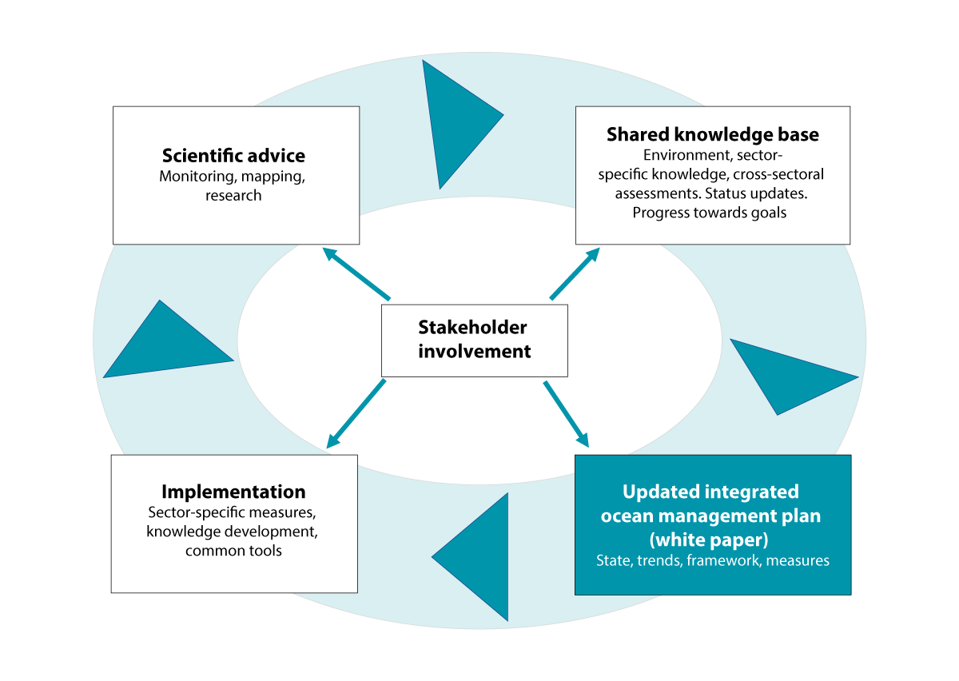
          - Integrated, ecosystem-based ocean management: the four-year cycle for Norway's ocean management plans.
Source: Norwegian Environment Agency/Ministry of Climate and Environment
The basis for Norway’s system of integrated, ecosystem-based ocean management plans was laid in the white paper Protecting the Riches of the Sea (Report No. 12 (2001–2002) to the Storting). The white paper described how an integrated, ecosystem-based ocean management regime could be developed based partly on the Malawi Principles under the Convention on Biological Diversity and on experience gained from the environmental and fisheries cooperation between the North Sea countries. The first of Norway’s ocean management plans was published as the white paper Integrated Management of the Marine Environment of the Barents Sea and the Sea Areas off the Lofoten Islands (Report No. 8 (2005–2006) to the Storting). It has served as a model for subsequent management plans. The national target that integrated, ecosystem-based management plans were to be presented for all of Norway’s sea areas by 2015 was adopted in connection with the Storting debate on another white paper, The Government’s Environmental Policy and the State of the Environment in Norway (Report No. 26 (2006–2007) to the Storting). This target was achieved with the publication of the first management plans for the Norwegian Sea in 2009 and the North Sea and Skagerrak in 2013. In 2016, in connection with its debate on the white paper Nature for life (Meld. St. 14 (2015–2016)), the Storting decided that the ocean management plans were to be updated ever four years. Ocean management plans for all three areas were published together for the first time in the white paper Norway’s integrated ocean management plans (Meld. St. 20 (2019–2020)). Including this document, nine white papers have since 2002 been presented to the Storting on integrated management of Norway’s ocean areas. The system has been under continual development, and has been developed, improved and modernised with each white paper on the ocean management plans. In this white paper, the Government is continuing and consolidating the system, which includes publishing an integrated, ecosystem-based ocean management plan for all of Norway’s ocean areas every four years.

Key trends and developments
Key trends and developments both in Norway and internationally form an important backdrop to this update of the Norwegian ocean management plans.

Progress in international ocean cooperation
Recognition of the crucial importance of ensuring integrated, sustainable ocean management is a key element of Norway’s foreign and development policy. At the same time, developments and progress in international ocean cooperation are important for the further development of Norway’s ocean management regime.
Since the previous white paper on the management plans was published, important progress has been made in international ocean cooperation, particularly as regards the marine and coastal environment. The new UN Agreement on the Conservation and Sustainable Use of Marine Biological Diversity of Areas Beyond National Jurisdiction (the BBNJ Agreement) was formally adopted by consensus in June 2023. The Kunming-Montreal Global Biodiversity Framework was adopted in Montreal in December 2022. One of its global targets is as follows: ‘Ensure and enable that by 2030 at least 30 per cent of terrestrial and inland water areas, and of marine and coastal areas, especially areas of particular importance for biodiversity and ecosystem functions and services, are effectively conserved and managed through ecologically representative, well-connected and equitably governed systems of protected areas and other effective area-based conservation measures, …’
Norway has for some years been working to enhance international cooperation to address the problem of marine litter and plastic waste. A negotiation process for a legally binding global instrument to end plastic pollution is now in progress, and the aim is to conclude the negotiations in the course of 2024. Norway is playing an active role and seeking to achieve a binding, effective global instrument with the aim of ending plastic pollution by 2040. As regards climate action, in summer 2023 the International Maritime Organization (IMO) adopted the common ambition of reaching net-zero greenhouse gas emissions from international shipping by 2050. Norway played a key role in the development of IMO’s strategy on greenhouse gas emission reductions, which includes checkpoints for reductions in greenhouse gas emissions from international shipping in 2030 and 2040, to reach net-zero in 2050.
International cooperation to strengthen integrated, ecosystem-based ocean management is an essential basis for achieving several of the UN Sustainable Development Goals, particularly SDG 14, which is ‘to conserve and sustainably use the oceans, seas and marine resources’.
There is emerging international consensus on a description of the state of the ocean, and what needs to be done to protect it better and ensure that we can continue to use ocean resources sustainably in the future. The UN Ocean Conferences are an important meeting place, and Norway is spearheading efforts to ensure that knowledge-based, sustainable ocean management stays high on the agenda of the next conference in 2025. Norway’s participation in the UN Decade of Ocean Science for Sustainable Development and its work within the Intergovernmental Oceanographic Commission (UNESCO-IOC) play a key role in this context.
As co-chair of the High-level Panel for a Sustainable Ocean Economy (Ocean Panel), Norway has played a part in raising awareness internationally about the key links between the state of the ocean and economic development, and the need to ensure that the ocean as a whole is managed sustainably.

The ocean as part of the solution to climate change, and green ocean-based industrial development
While climate change is a threat to life in the ocean, many of the solutions we need to limit anthropogenic climate change are linked to ocean management and the ocean economy. In managing Norway’s ocean areas, it is therefore vital both to tackle the challenges arising from the environmental impacts of climate change, and to make use of all ocean-based options for reducing greenhouse gas emissions and increasing CO2 uptake. This approach is crucial to success in the green transition, for achieving climate targets, and for improving the competitive position of the Norwegian ocean industries in a global market.
The previous white paper on Norway’s ocean management plans, Meld. St. 20 (2019–2020), identified climate change as the driver of change that is accelerating most rapidly, both globally and in Norwegian seas. It described how ocean management can play a significant part in the global transition to a low-emission future, by strengthening the ocean’s capacity for carbon uptake and facilitating a green transformation in the ocean industries. The white paper also pointed out that offshore wind, carbon capture and storage under the seabed and green shipping are three areas where Norway has much to offer and where a green transition can be promoted through the ocean management system. Marine ecosystems such as kelp forests, seaweed communities and eelgrass meadows absorb and store CO2, and the conservation of such ecosystems is therefore important.
Climate change and ocean acidification are altering the ocean environment and the ecological basis for exploiting ocean resources; at the same time, action to achieve the necessary emission reductions will increase the need to make use of the oceans, for example to expand production of food with a low carbon footprint and renewable energy. This can further increase pressure on the environment in the areas that are used. It is therefore essential to ensure that activities linked to the green transition are also managed within a framework designed to maintain the productivity and biodiversity of ecosystems.
Natural uptake and storage of greenhouse gases in the ocean is discussed in Chapter 4. Chapter 5 includes an account of the role the ocean industries can play in reducing greenhouse gas emissions.

Growing pressure on marine and coastal waters
The oceans contribute to human well-being by providing resources such as food, minerals and energy, transport routes and a basis for recreation and tourism. The oceans are affected by global warming, but also moderate it by absorbing heat and CO2, and act as a sink for various types of pollutants and waste. Population growth and the expansion of the economy globally are creating a constantly growing need for ocean transport and for food, energy and other resources from the oceans. The goal of rapid reductions in greenhouse gas emissions is intensifying this need, for example by increasing demand for offshore renewable energy production, seafood production with low greenhouse gas emissions, and CO2 storage under the seabed. This also means that the global ocean system, from the coastline to the deep sea, is under growing pressure from human activity – through the fisheries, pollution, developments in the coastal zone, the spread of alien species, and large-scale physical, chemical and ecological changes as a result of greenhouse gas emissions and global warming. Further development of Norway’s ocean management system must be based on an understanding of the environmental impacts of large-scale processes of change in Norway’s ocean areas, the types of change to be expected, and the long-term implications for management and use of the management plan areas. These large-scale processes will result in constantly changing environmental conditions and patterns of species distribution in different parts of Norwegian waters. In some cases, shifts in species distribution will result in new species replacing others that are currently present in an area, while many species and ecosystems will become more vulnerable, for example to human activity in the management plan areas. In these circumstances, there is much more uncertainty about environmental conditions in the future, which will alter the relationship between harvesting and other uses of Norway’s ocean areas.
Coastal and open ocean ecosystems are closely linked, and ecological processes in coastal waters have a strong influence on the marine environment in large parts of the management plan areas. There are many examples of species that move between coastal waters and the open ocean. Various fish species spawn in the fjords and coastal waters, while their nursery areas and feeding grounds are further out to sea. Similarly, many seabirds and marine mammals move between the open ocean and coastal waters to find food or as part of an annual cycle in which they use different areas at different seasons. The close links between coastal and open waters are also apparent when we consider environmental pressures from human activity. Continual movement in the water masses results in water exchange between fjords, coastal waters and the open ocean. Pollution from land-based sources can thus reach the open ocean and cause environmental impacts there as well. Conversely, pollution and waste carried by ocean currents can reach coastal waters and fjords. More knowledge is needed about interactions between coastal waters and the open ocean to improve understanding of the expected impacts of human activity combined with climate change both on various species and on ecosystem condition.
Chapter 3 gives an account of ecosystem condition in Norwegian marine and coastal areas, and Chapter 4 describes the management regime for these areas.

Growing awareness of the importance of ocean spatial planning
The 2019 Global Assessment Report of the Intergovernmental Science-Policy Platform on Biodiversity and Ecosystem Services (IPBES) states that globally, land and sea-use change is the direct driver that is causing the greatest losses of biodiversity in terrestrial and freshwater ecosystems, and that this is also an important factor in the oceans. Under the global Kunming-Montreal Global Biodiversity Framework, countries have committed themselves to a set of targets, including one to ‘ensure that all areas are under participatory, integrated and biodiversity inclusive spatial planning and/or effective management processes addressing land- and sea-use change, to bring the loss of areas of high biodiversity importance, including ecosystems of high ecological integrity, close to zero by 2030, while respecting the rights of indigenous peoples and local communities.’
According to the Intergovernmental Oceanographic Commission (UNESCO-IOC), more than 100 countries now have or are in the process of establishing national systems for marine spatial planning. Norway’s ocean management plans are considered to constitute an established marine spatial planning system.
The ocean management plans are intended to provide an overall balance between use and conservation, based on knowledge about ecological functions and the value and vulnerability of different areas together with information about economic activity now and forecasts for the future. Chapter 7 discusses how Norway is facilitating the conservation and sustainable use of ocean areas as part of an integrated ocean management regime.

Growing strategic importance of Norway’s ocean areas
The major security policy changes we are witnessing at present are influencing Norwegian and Allied needs for a military presence and surveillance in Norwegian waters. Norway’s geographical situation and the growing strategic importance of the Arctic are making the country more vulnerable. There is growing activity in waters under Norwegian jurisdiction and adjacent areas, and this trend is expected to continue. To ensure that it has the capacity to maintain both its influence in neighbouring areas and its own security, Norway must have a naval presence, a sound situational awareness, response capabilities and an emergency preparedness system. Norway must have the maritime capabilities to act in Norwegian territorial waters, in other marine areas where Norway has jurisdiction and in the Arctic, both alone and together with allies. The deteriorating security policy situation is creating a greater need for a maritime presence, both Norwegian and Allied, and for both surface and subsea activity. Moreover, the Armed Forces need access to areas where they can train and exercise. In addition, it is important to maintain a civilian presence in Norway’s waters, for example through environmental and resource mapping activities.

The Ocean Panel and sustainable ocean plans
The High-level Panel for a Sustainable Ocean Economy (Ocean Panel) is co-chaired by Norway’s prime minister and Palau’s president. It consists of leaders from 18 coastal states: Australia, Canada, Chile, Fiji, France, Ghana, Indonesia, Jamaica, Japan, Kenya, Mexico, Namibia, Norway, Palau, Portugal, the Seychelles, the UK and the US. The Norwegian Government wishes to make use of the Ocean Panel to create greater international understanding of the links between the economic importance of the ocean and of the state of the ocean. Norway endorsed the recommendations published by the Panel in 2020, and has undertaken a political commitment to sustainably manage 100 % of the ocean area under its jurisdiction by 2025, on the basis of sustainable ocean plans, or SOPs. The Ocean Panel has urged all coastal states to do this by 2030.
The Norwegian ocean management plans have received a great deal of international recognition and have served as a model for the sustainable ocean plans recommended by the Ocean Panel. At the UN Ocean Conference in Lisbon in 2022, the Norwegian Government stated that the planned 2024 white paper on the ocean management plans would be the key element of Norway’s plans for a sustainable ocean, and that it would use the white paper together with industrial development plans and other regulatory measures to achieve sustainable ocean management.
              - The Norwegian Government’s ocean conference 2023
The Government’s ocean conference (‘Norge og havet’) was held in Bergen on 17 April 2023. One of its main themes was integrated, sustainable ocean management. The Prime Minister took part together with five ministers from other ministries with ocean-related responsibilities (Ministry of Climate and Environment, Ministry of Energy, Ministry of Trade, Industry and Fisheries, Ministry of Labour and Social Inclusion and Ministry of Foreign Affairs). This highlights the cross-sectoral responsibility for ocean affairs in the Norwegian Government. In addition, a wide range of experts from the voluntary sector, the business sector and research institutes participated. The purpose of the conference was to put the Ocean Panel’s international work into a Norwegian context and highlight overall Government policy for a green ocean transition.
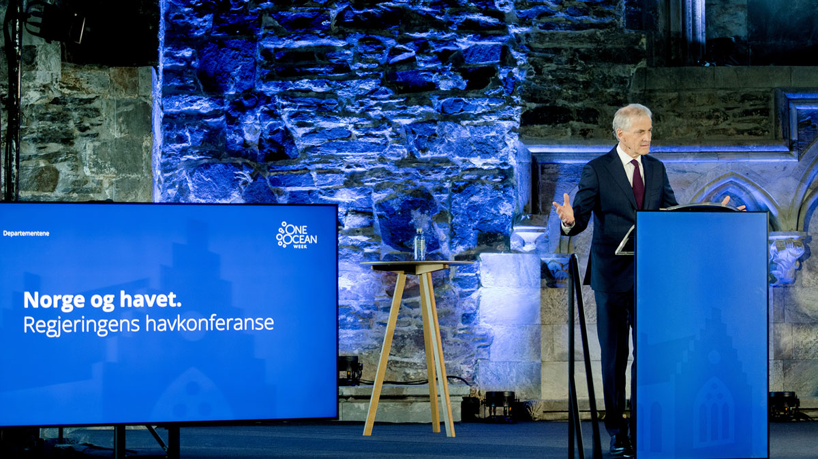
          - Prime Minister Jonas Gahr Støre at the Government's ocean conference in Bergen on 17 April 2023. The conference was intended to put the Ocean Panel's international work into a Norwegian context and highlight overall Government policy for a green ocean transition.
Photo: Paul S. Amundsen
[Boks slutt]
According to the Ocean Panel, a sustainable ocean plan ‘… describes policies and mechanisms to facilitate sustainable use of the ocean and maximise benefits and value creation for current and future generations'. The Panel emphasises the importance of conservation as an instrument of a sustainable ocean economy. Sustainable ocean plans ‘provide a framework for reconciling conflicts related to different uses of the ocean and its resources’, and ‘enable long-term sustainable growth in the ocean economy’. The Ocean Panel also emphasises how important it is to develop and implement sustainable ocean plans through ‘an inclusive, participatory, transparent and accountable process’.
The Ocean Panel has also commissioned a guide to the development of sustainable ocean plans. Several countries that are members of the Panel, including Chile and Mexico, have already presented their plans, and these demonstrate that the process may involve considerable variation and a wide range of solutions, depending on national circumstances. Chapter 8 discusses the work of the Ocean Panel further.

Preparation of the white paper
In line with the routines established as an important element of the management plan system, work on this white paper has brought together all relevant parts of the public administration. Work on the management plans is coordinated by the interministerial Steering Committee for integrated ocean management, which is headed by the Ministry of Climate and Environment. Other ministries represented in the committee are the Ministry of Energy, the Ministry of Finance, the Ministry of Defence, the Ministry of Justice and Public Security, the Ministry of Local Government and Regional Development, the Ministry of Education and Research, the Ministry of Trade, Industry and Fisheries and the Ministry of Foreign Affairs.
The management plans are knowledge-based. The scientific basis for the plans has been drawn up by two advisory groups: the Forum for Integrated Ocean Management and the Advisory Group on Monitoring. The Forum for Integrated Ocean Management (headed by the Norwegian Environment Agency) is responsible for drawing up an overall scientific basis for updating and revising the management plans in cooperation with the Advisory Group on Monitoring. The Advisory Group on Monitoring (headed by the Institute of Marine Research) coordinates monitoring programmes for marine ecosystems and reports on ecosystem condition in the management plan areas, see Figure 2.3.
The Forum for Integrated Ocean Management and the Advisory Group on Monitoring presented the main report on the updated scientific basis for this white paper in spring 2023. This was based on a report from the Advisory Group on Monitoring on ecosystem condition in the management plan areas and a number of other reports on various topics. Some of the reports are available in English or have an English summary and are available here: https://havforum.miljodirektoratet.no/en/knowledge-base/reports/.
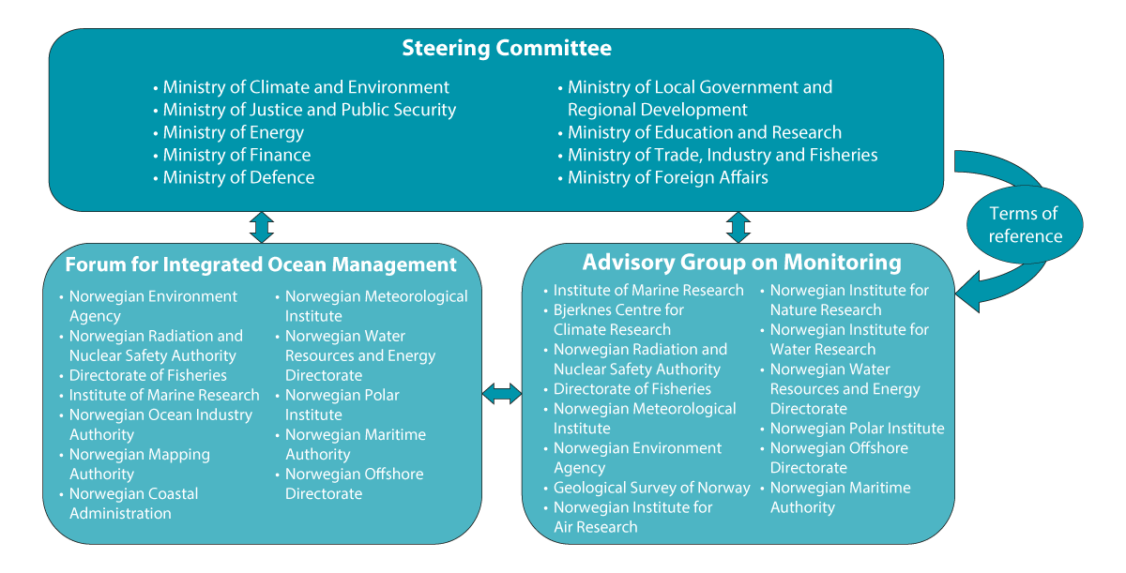
          - Organisation of the management plan work
Source: Ministry of Climate and Environment
The particularly valuable and vulnerable areas have been one of the main elements of the management plan system since it was initiated with the preparation of a scientific basis and then, in 2006, the first management plan for the Barents Sea–Lofoten area. Knowledge built up about these areas, which have been identified as containing the most important and vulnerable ecological features in Norwegian waters, provides a sound basis for political assessments and decisions on the management plans, for example in determining the framework for petroleum activities in specific geographical areas.
The previous white paper on the ocean management plans (Meld. St. 20 (2019–2020)) stated that the ongoing review of valuable species and habitats and their vulnerability in all the particularly valuable and vulnerable areas identified in the management plan areas was to be completed. This has now been organised by the Forum for Integrated Ocean Management.
Regional dialogue meetings were held in Bergen, Trondheim and Tromsø in August–September 2023, and a conference was held at the Ministry of Climate and Environment on 27 September 2023 to give all interested parties an opportunity to discuss the reports. In all, 24 parties provided written responses during the preparation of the white paper, and these are available on the Government website regjeringen.no. A central theme in the responses was a call for more clarity and detail on what is involved when an area is designated as particularly valuable and vulnerable. In addition to clarification of what the designation means, this white paper gives a thorough account of the new scientific method of identifying particularly valuable and vulnerable areas, see Chapter 4.

Geographical and thematic scope
Geographically, Norway’s ocean management plans cover all marine areas off the Norwegian mainland and around Jan Mayen and Svalbard that are under Norwegian jurisdiction, delimited to coincide with three large marine ecosystems: the Barents Sea–Lofoten area, the Norwegian Sea and the North Sea and Skagerrak. Along the mainland coastline, the management plan areas extend to the baseline. The area considered in the scientific basis extends beyond the actual management plan areas to allow a satisfactory description of status and trends, such as pressures and impacts associated with land-based activities, ecosystem components in the coastal zone, and links with ecosystems, activities and ecosystem condition in adjacent marine areas.
Norway, Denmark/the Faroe Islands and Iceland have concluded three bilateral agreements on the delimitation of the continental shelf in the area known as the ‘Banana Hole’ in the Norwegian Sea. These entered into force in 2022, thus clarifying the maritime delimitation between the three countries’ continental shelves in the southern part of the Banana Hole. The boundary of the Norwegian Sea management plan area has been altered to reflect this. The extent of the Norwegian continental shelf as recommended by the Commission on the Limits of the Continental Shelf has been used as a basis for determining the new boundaries of the management plan areas in the northern part of the Banana Hole (Norwegian Sea) and north of Svalbard (Barents Sea–Lofoten area), with the exception of areas where there may be some overlap between Norway’s and Denmark’s continental shelf.
The measures proposed in this white paper focus mainly on the management plan areas from the baseline outwards towards the open sea, but also take into account factors such as how external drivers may have impacts inside the management plan areas or vice versa. This is for example relevant when considering the interplay between coastal waters and the open sea.
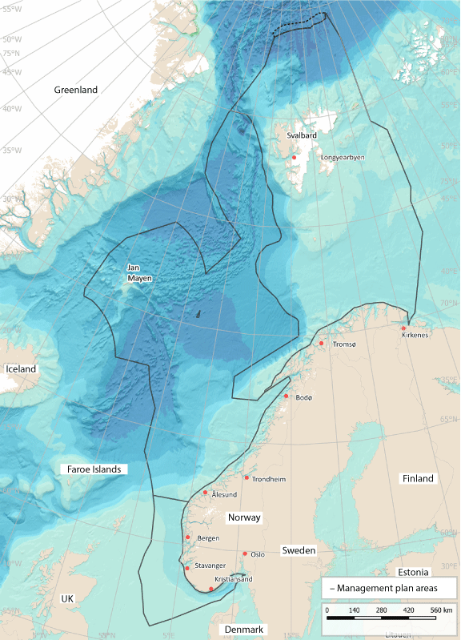
          - Map of the three management plan areas: the Barents Sea–Lofoten area, the Norwegian Sea and the North Sea and Skagerrak
Source: Norwegian Environment Agency
Norwegian ocean areas in the Antarctic are managed through the Antarctic Treaty system, including the Commission for the Conservation of Antarctic Marine Living Resources (CCAMLR). The Norwegian Polar Institute monitors the fur seal and penguin colonies on Bouvet Island as part of the CCAMLR ecosystem monitoring programme (CEMP). These areas are completely separate from Norway’s northern ocean areas, and no scientific basis has been prepared to include the waters around Bouvet Island and the Norwegian dependencies in Antarctica (Dronning Maud Land and Peter I’s Island) in the current white paper.
New white paper on biodiversity
Norway will implement the Kunming-Montreal Global Biodiversity Framework, which was adopted in Montreal in December 2022, through a new biodiversity action plan. The action plan will be presented to the Storting in the form of a white paper, according to plan in autumn 2024. Norway’s plans for following up the global targets set out in the Biodiversity Framework, including those relating to the ocean, will be described in the action plan.
New white paper on climate policy
In view of Norway’s statutory target of being a low-emission society by 2050, meaning that emissions will have been reduced by 90–95 %, the Government also intends to present a white paper on climate policy for the period up to 2025. The white paper will set out a long-term, integrated framework for Norway’s climate policy in the years ahead.

Ecosystem condition, drivers of change and impacts in Norway’s ocean areas – status and trends
Climate change and rising ocean temperatures are having increasingly marked impacts on ecosystem condition in Norwegian waters. Anthropogenic climate change has already resulted in changes in the ocean climate in all three management plan areas. These are reflected for example in higher water temperatures, shrinking sea ice cover in the Barents Sea and coastal water darkening (increased light attenuation) in the North Sea and Skagerrak. Rising CO2 emissions are also making the oceans more acidic. These changes have in turn led to changes in ecosystem condition (see Box 3.1).
The impacts of climate change are becoming apparent in the Barents Sea–Lofoten area in the form of higher sea temperatures and a decline in sea ice. Climate change has had negative impacts on various populations of Arctic seabirds, marine mammals and fish. These impacts have to some extent been reversed in recent years as a result of a certain decline in sea temperature. The evidence does not indicate that there are impacts on the ecosystem as a whole, but this conclusion is very uncertain because only short time series are available for many ecological groups. There appears to have been some reduction in the impacts of fisheries in the Barents Sea in recent years. The large fish stocks play a key role in ecosystem dynamics and are also commercially important. The major Barents Sea stocks are generally in good condition, but poor recruitment is resulting in a decline in condition.
Temperatures are also rising in the Norwegian Sea as a result of climate change. Ecological condition has only been assessed for the pelagic ecosystem in this management plan area. Changes observed here include a decline in the stocks of mackerel and Norwegian spring-spawning herring. Catches have been far higher than the recommended TACs (total allowable catches) after the international system for sharing the TACs collapsed in 2013. There has also been a considerable decline in seabird populations.
Climate change has had a substantial impact on ecological condition in the North Sea and Skagerrak, particularly in the form of higher sea temperatures. The changing abiotic conditions together with other drivers of change, including the fisheries, are having major impacts on the rest of the ecosystem. In the North Sea and Skagerrak, changes have been observed in key groups of zooplankton, fish stocks, seabirds and benthic communities.
The situation for Norwegian seabirds is critical. It is estimated that the number of Norwegian seabirds has declined by more than 80 % in the period 1970–2020. Red-listed species make up 63 % of the species typically categorised as seabirds. More and more populations are showing a dramatic fall in numbers. Populations of species that breed along the coast of the North Sea and Skagerrak are in particularly poor condition. For most seabird species, the decline is a result of food shortages combined with climate change.
The status of a number of threatened species and habitat types has been deteriorating in recent years. Some improvements have also been observed, but for a considerably smaller number of species and habitats. Alien species can have major impacts on marine ecosystems, and in Norwegian waters are largely found along the coast. The number of alien species registered is highest in the south of Norway, and has risen in the past ten years.
Long-range transport of hazardous substances with air and ocean currents is the main source of pollution in the management plan areas. These inputs have been decreasing since measurement series started from the 1990s onwards, but this trend has levelled off to some extent in recent years. Hazardous substances are found in all Norwegian waters, and their bioaccumulation poses a health risk for seabirds and marine mammals at the highest trophic levels of food chains. However, seafood from Norwegian waters is safe to eat, since concentrations of contaminants are generally below the maximum permitted levels for food safety in edible parts of most species. Measures such as prohibiting catches or advising against consumption are introduced if levels of contaminants are found to be above the maximum permitted concentrations.
Coastal waters inside the baseline are included in the area considered in the scientific basis for the management plans (see Chapter 2). Ecosystems in coastal waters are under considerable pressure from a range of activities, including construction and other permanent occupation of areas, fisheries, dredging, aquaculture, land reclamation, shipping, recreation, fishing tourism and petroleum-related activities, and processes including discharges and runoff. Activities in coastal waters may have impacts on the marine environment further out to sea, for example through harvesting of species that move between coastal waters and the open sea (e.g. from spawning areas in fjords), or through degradation of spawning and nursery areas for such species in coastal waters.
Inputs of nutrients (phosphorus and nitrogen) and copper to coastal waters have risen considerably, mainly as a result of increasing discharges from coastal aquaculture facilities. Continual movement in the water masses results in water exchange between fjords, coastal waters and the open ocean. However, it is unclear what proportion of these pollutants is transported from coastal waters into the open sea. Eutrophication is a problem in coastal waters in some areas, including the Oslofjord, but not in the open ocean.
Large quantities of plastic pollution and marine litter are still being registered along the coast, on beaches, during seabed mapping, in trawls and in the stomachs of seabirds and other animals.
Up to 2100, it is expected that warming will intensify in Norwegian waters and that marine heatwaves will become more frequent, resulting in growing pressure on marine ecosystems. The seawater will become more acidic. There will also be a decline in oxygen levels, but this is not expected to be a limiting factor for marine organisms. Many species and habitats will suffer negative impacts and will either shift their distribution or be lost.
              - Assessing ecosystem condition
A scientific panel for each of the management plan areas has assessed ecosystem condition in the three areas as part of the scientific basis for this white paper. This provides an overall assessment of the extent to which the ecosystems in an area are affected by human activity. The system has been incorporated into the work of the Advisory Group on Monitoring and supplements the information provided by the set of indicators used in the monitoring system for the marine environment.
In the assessments of ecosystem condition, a deviation from good condition is defined as meaning that the ecosystem has changed from the reference condition, which is called ‘intact nature’. ‘Intact nature’ refers to ecosystems that show little impact of modern industrial activities, including anthropogenic climate change. This means that in practice, what has been assessed is the extent to which an ecosystem is influenced by anthropogenic drivers. Ecosystem condition has been assessed for each of the three management plan areas using seven ecosystem characteristics that together cover the main features of structures and processes in the ecosystems. The seven characteristics are primary productivity; biomass distribution among trophic levels; functional groups within trophic levels; functionally important species and biophysical structures; landscape-ecological patterns: biological diversity; and abiotic factors. After an overall assessment of condition for each ecosystem characteristic, the condition of the ecosystem as a whole is assessed. An ecosystem that is in good condition does not show any substantial deviation from the reference condition.
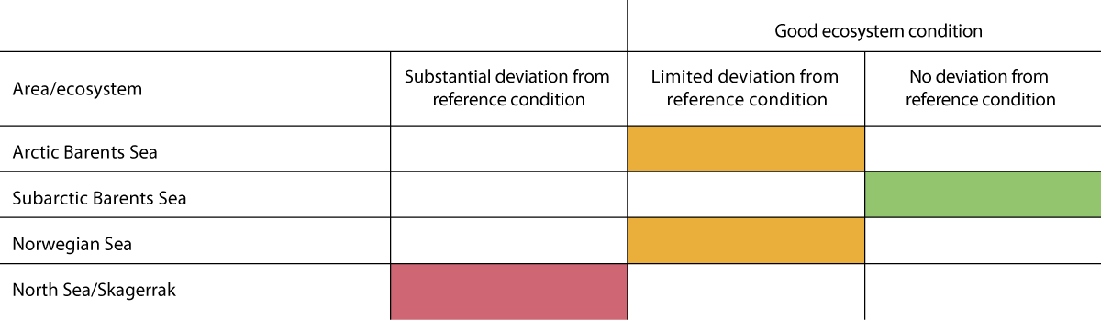
          - Overall assessment of ecosystem condition in the three management plan areas.
Source: Norwegian Environment Agency/miljøstatus.no
[Boks slutt]
Assessment of cumulative impacts
As part of the scientific basis for this white paper, a report has been published describing risk assessments of the cumulative impacts of pressures in each of the particularly valuable and vulnerable areas in the three management plan areas (North Sea–Skagerrak, Norwegian Sea and Barents Sea–Lofoten), based on information on activity in various sectors from a representative period (2017–2019). This is a first trial of risk-based assessment of cumulative impacts, using a preliminary version of the methodology. So far, the risk-based assessments indicate wide variation in the risks associated with cumulative impacts in the various particularly valuable and vulnerable areas identified in Norwegian waters. The highest risk of adverse impacts is in the areas closest to the coast, where there is activity in the largest number of sectors and the degree of exposure to various pressures is high.

Ecosystem condition, drivers of change and impacts in the Barents Sea–Lofoten management plan area
Climate change is an important driver in the Barents Sea–Lofoten area, and has probably already altered both ecosystem structure and functioning, particularly in the Arctic part of the management plan area. The fisheries are another important driver in this area, in addition to anthropogenic climate change, although some of the impacts of the fisheries appear to have diminished in recent years. Over the past 50 years, there has been a severe decline in seabird populations in all three management plan areas. In the Barents Sea–Lofoten area, certain populations are still declining, while others are stable or increasing.
For the Barents Sea–Lofoten area as a whole, the sectors that are most important in driving environmental change have been identified as the fisheries, transport, and oil and gas, but aquaculture, coastal infrastructure, wastewater treatment and agriculture also play a role. They are responsible for a range of pressures, some of the most important being selective species extraction, abrasion, pollution, underwater noise and smothering.

Ecosystem condition in the Barents Sea–Lofoten management plan area
Ecosystem condition has been assessed separately for the Arctic (northerly) and subarctic (southerly) parts of the Barents Sea, limited to Norwegian waters. Based on long time series starting around 1970, the scientific panel for the Barents Sea has concluded that anthropogenic drivers have had substantial impacts on the climate and the physical environment in these ecosystems, particularly through rising temperatures and declining sea ice cover. In contrast, the biological components of the ecosystem have largely been assessed on the basis of data for the period 2004–2020. As a result, the impacts of warming up to 2004 are uncertain. Nevertheless, there is evidence of limited human impact on the Arctic ecosystem as a whole. For the Arctic part of the Barents Sea, the observed changes include a weak tendency for primary production to increase and algal blooms to take place earlier in spring, and a tendency for the food web to change, with a decline for both top predators and seabirds. Nevertheless, important ecosystem functions appear to have been maintained. A decline in Arctic fish species was observed up to about 2015 but has been reversed to some extent in recent years, when temperatures have been lower.
For the subarctic part of the Barents Sea, changes in the physical environment have been observed as a result of climate change and fisheries pressure. Apart from this, there is not currently any evidence of impacts on the ecosystem as a whole, but climate change is expected to have impacts on the biological ecosystem components as well in the years ahead. However, there is considerable uncertainty associated with these conclusions because the time series for the biological components are so short. It is therefore also very uncertain whether the impacts really are limited or whether more extensive impacts have not been demonstrated because there are important indicators that were not included in the assessment and many of the time series are too short.
Fisheries pressure appears to have diminished in recent years. The assessment of ecosystem condition includes three indicators for benthic fauna that may be affected by bottom trawling. For the period 2004–2020, there is no sign of major changes in these indicators that can be linked to bottom trawling, but there is uncertainty associated with the assessment.
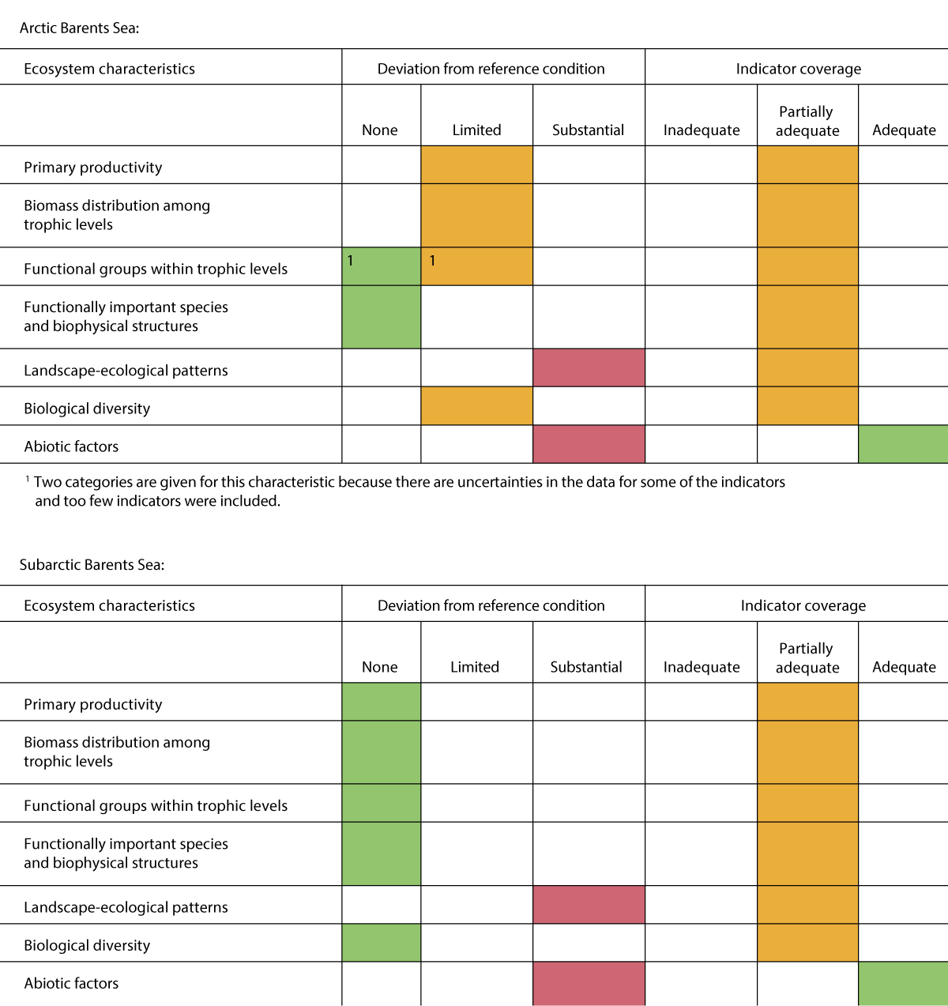
          - Summary of the assessment of ecosystem condition for each of the ecosystem characteristics. Upper panel: Arctic part of the Barents Sea. Lower panel: subarctic part of the Barents Sea.
Source: Panel-based Assessment of Ecosystem Condition of Norwegian Barents Sea Shelf Ecosystems. Rapport fra havforskningen 2023-14.
The ecological status of most of the coastal water bodies in the Barents Sea is classified as good according to the system used in the Water Management Regulations. There are only a few areas of fjords that are classed as of moderate status, and one is classed as poor. The biological quality elements used to classify the ecological status of coastal water bodies are soft-bottom benthic invertebrates, eelgrass, macroalgae, and phytoplankton, and in addition there are hydromorphological and physico-chemical quality elements.

Oceanic climate change: Barents Sea–Lofoten management plan area
The ocean climate in the Barents Sea–Lofoten area is to a large extent determined by the temperature and volume of Atlantic water that flows into the area from the Norwegian Sea. Ocean climate variables are water temperature, salinity, ocean currents, ocean acidification and sea level.
In the Barents Sea, there has been an average rise in sea temperature of about 1.5 °C over the past 50 years. Recently, a certain decline in sea temperature has been observed, coinciding with a reduction in the inflow of Atlantic water from the Norwegian Sea (Figure 3.3), but the temperature now appears to be rising again.
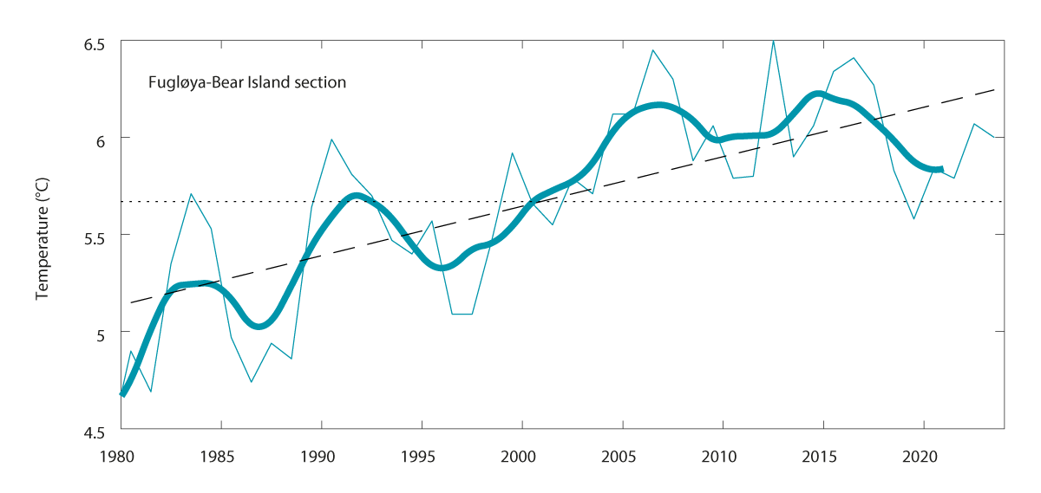
          - Temperature averaged within the depth interval 50-200 m, in the core of Atlantic water for the Fugløya-Bear Island section. The narrow line shows annual means, the bold line shows a smoothed curve using five-year means, and the dashed line shows the linear trend.
Source: Institute of Marine Research
In addition, the climate in the northern Barents Sea is strongly influenced by the extent of the sea ice. Climate change has resulted in a decline in sea ice in the Barents Sea over the past 40 years (Figure 3.4). Snow-covered sea ice can reflect up to 80 % of incoming solar energy, whereas open sea absorbs 90 % of the energy. Warming in the Arctic that causes sea ice to melt is amplified because this results in the absorption of more energy and further Arctic warming.
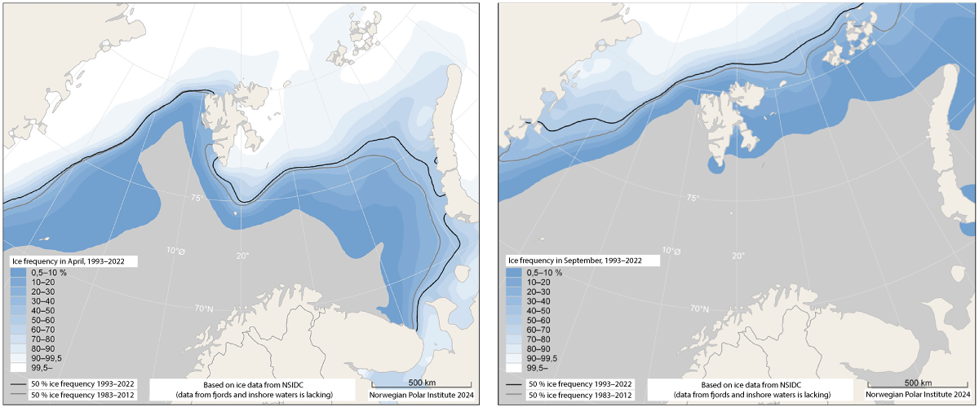
          - Sea ice extent in the Barents Sea and Fram Strait. The maps show the situation in April, when sea ice extent normally reaches its annual maximum, and September, when it is at a minimum. Sea ice extent is shown as ice persistence, based on a time series of satellite observations for the 30-year period 1992-2022. Ice persistence is a measure of how often at least 15 % of the water surface is covered by ice in a specific period within a specific area. The grey and black lines show the change in sea ice extent in April and September from the period 1983-2012 (grey line) to the period 1993-2022 (black line). The lines show where there was ice for half of each of the two months in the relevant 30-year period.
Source: Norwegian Polar Institute
The degree of ocean acidification (Box 3.2) varies widely across the Barents Sea, largely as a result of variations in water masses, biological production and ice formation. In the past 20 years, CO2 levels have risen rapidly, particularly in parts of the Barents Sea where there is seasonal ice cover, where the rise is twice as large as the global trend. This has been linked to shrinking ice cover. In the southern Barents Sea, which is most strongly influenced by southerly water masses (Atlantic water), the rate of ocean acidification appears to be following the global trend.
              - Ocean acidification
The oceans absorb about 30 % of anthropogenic CO2 emissions to the atmosphere. As a result, the CO2 concentration in the oceans is rising. When CO2 reacts with water, it forms carbonic acid, which releases hydrogen ions. This results in lower pH and ocean acidification. Some of the hydrogen ions react with carbonate ions in the seawater to form bicarbonate, which makes carbonate less accessible to living marine organisms. Carbonate is essential for organisms that build calcareous shells and skeletons consisting of calcium carbonate. These include the sea snail Limacina helicina, bivalves and cold-water corals. Such calcifying organisms may meet serious problems as carbonate levels drop. Their shells or skeletons may begin to dissolve, or they may need more energy to build the shell or skeleton. Ocean acidification has been monitored in Norwegian waters since 2010. Arctic seas are particularly vulnerable to ocean acidification, because cold water can absorb more CO2 than warmer water. The impacts of ocean acidification on ecosystems are very uncertain, but are potentially serious.
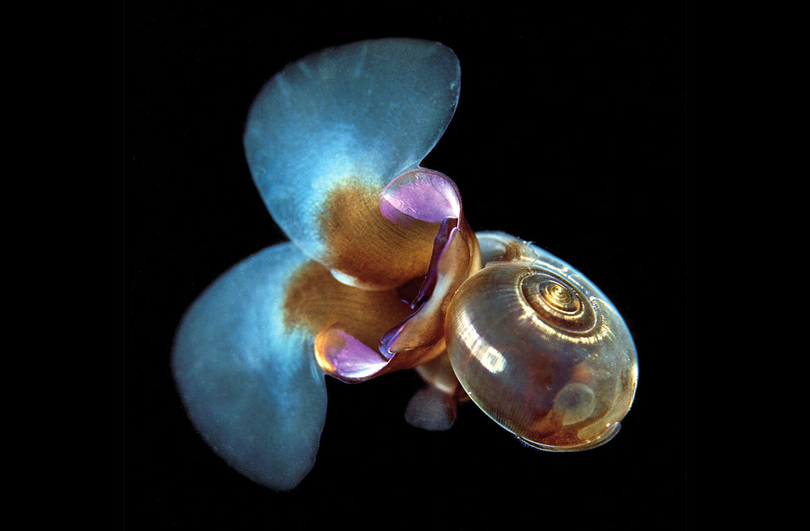
          - Sea snail (or 'sea butterfly') Limacina helicina
Photo: Erling Svensen
[Boks slutt]
Climate change has resulted in rising temperatures, ocean acidification and melting of the sea ice in the Barents Sea–Lofoten area. Because the time series are relatively short, the impacts on the ecosystems are uncertain. However, further warming of the climate is expected in the future, and is likely to result in large-scale changes to the ecosystems in the area.
Observed effects of changes in ocean climate
Seawater temperatures influence primary production in the oceans and the distribution of many species, and thus species composition in particular areas. In the Barents Sea, there is a weak tendency both for primary production to increase and for algal blooms to occur earlier in spring. A considerable increase in quantities of krill (which belong to the zooplankton) has been observed in parallel with the warming of the Barents Sea. The previous white paper on the management plans described how Atlantic and more southerly fish species are shifting their distribution northwards and eastwards from the southwestern part of the Barents Sea, and displacing Arctic species such as polar cod (Boreogadus saida). This trend has been reversed as a result of the recent decline in sea temperature.
Most seabird species are showing a negative population trend, which in many cases can be explained by food shortages combined with the impacts of climate change. Changes in food supplies may be the result of a combination of lower production of prey species, natural competition for food, fisheries, and secondary effects of climate change. Warming seas influence zooplankton species composition, for example different Calanus species in the North Sea (see Chapter 3.3.2). In recent years, mackerel have been observed much further north in the Barents Sea. Their diet includes large quantities of zooplankton and small fish, and mackerel may therefore be important as competitors for food with seabirds. Climate change may also have direct impacts on seabird populations, since more frequent extreme weather events can affect both survival and breeding success. Changes in climatic conditions in turn influence oceanographic conditions, which determine the availability of food such as fish larvae for breeding seabirds. As a result, the timing of maximum food availability may shift, leading to a mismatch between the peak prey availability and the seabird breeding season, which often does not shift correspondingly.
Climate change is now generally the most important driver of change for Arctic marine mammals. Blue whales and fin whales, which are subarctic species, are shifting their distribution northwards as the sea ice retreats.

Condition and trends for various ecosystem components in the Barents Sea–Lofoten area
The condition and main trends for various ecosystem components in the Barents Sea–Lofoten area are described below using the results of the assessment of ecosystem condition for the management plan area.
Plankton
In the Arctic part of the Barents Sea, there is some evidence that annual primary production is rising and that the spring algal bloom is starting earlier in the year.
The benthic fauna and benthic communities
New benthic species (crustaceans, sponges, seapens, corals, etc) are constantly being identified during the annual Norwegian-Russian ecosystem surveys in the Barents Sea. Over time, the largest biomass quantities have been observed in the northeastern part of the Barents Sea, followed by the southwestern, northwestern and southeastern parts. Results for the period 2006–2021 show a moderate positive trend in the biomass of megabenthic species. Several types of benthic communities (for example soft-bottom sponge aggregations, coral gardens and sublittoral seapen communities) are vulnerable to human pressures such as bottom trawling and other activities that involve contact with the seabed.
The snow crab (Chionoecetes opilio) is widely distributed in open sea areas of the Barents Sea. The distribution of the stock on the Norwegian continental shelf has not changed significantly in recent years. New genetic analyses indicate that snow crabs spread naturally to the Barents Sea, and it has therefore been removed from the list of alien species maintained by the Norwegian Biodiversity Information Centre. At present, the snow crab does not appear to have the same negative impacts on benthic communities in the Barents Sea as the red king crab (Paralithodes camtschaticus). The westward spread of snow crabs in the Barents Sea is expected to continue. Bottom trawling has major impacts on the seabed, especially on habitats for organisms such as corals, sponges and seapens. The extent to which bottom trawling has resulted in changes to the ecosystem is uncertain. The most intensive bottom trawl fisheries in the Barents Sea are along the coast of Finnmark, in the southeastern part of the Norwegian sector, around Bjørnøya (especially south of the island), and south of Spitsbergen. There may be interest in bottom trawling in areas that become accessible as the ice retreats, but strict management rules have been established to limit the expansion of the fisheries to previously ice-covered areas.
Fish stocks
The major fish stocks play a key role in ecosystem dynamics and are important in economic terms. Following the introduction of more sustainable fishing practices, there was a period when the major commercial fish stocks (cod, haddock, capelin, beaked redfish and saithe) showed a positive development trend. More recently, the cod and haddock stocks have declined, but their spawning stocks are still above the precautionary level. The Greenland halibut stock is just below the precautionary level, while the golden redfish is endangered, and the stock is declining and is at a critically low level. Fishing mortality (the harvest) is too high for cod, Greenland halibut and golden redfish. The shrimp stock is healthy.
Capelin and polar cod are key species in the Barents Sea ecosystem throughout the year. The capelin stock is showing a positive trend. The polar cod stock is endangered, and has been declining since 2000, but showed an upturn in 2020 and 2021. The quantity of young herring in the Barents Sea is currently at a low level.
Apart from climate change, the fisheries are the most important driver in the Barents Sea–Lofoten area. Pressure from the fisheries has generally been reduced since 2000 through the introduction of management measures and developments in fishing gear.
Seabirds
Populations of most seabird species in the Barents Sea are still declining, but there are positive indications for some populations and breeding colonies. Certain gannet, fulmar, great skua and common guillemot colonies are growing. The outbreak of avian flu early in the 2022 breeding season appears to have hit the gannet and great skua populations hardest, and this is expected to slow or reverse the positive trend for these two populations. The kittiwake population suffered badly from the avian flu outbreak in 2023. The populations of Brünnich’s guillemot, kittiwake, razorbill and shag are still declining (Figure 3.6). Many of the seabird species in the Barents Sea–Lofoten area are on Norway’s red list. Regional estimates of seabird populations will be updated in 2025.
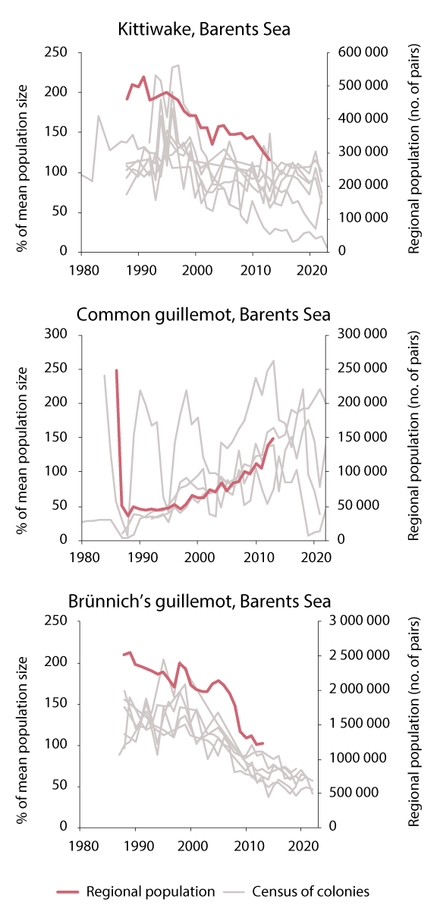
          - Seabird populations in the Barents Sea. Population trajectories for kittiwake, common guillemot and Brünnich's guillemot. Bold red lines show the estimated population size, thin grey lines show figures from monitoring at specific colonies.
Sources: Regional population figures from NINA Report 1151 (2015), monitoring data from seapop.no
In addition to climate change and food shortages, drivers for seabird populations may include hazardous pollutants and plastic pollution. High levels of persistent, bioaccumulative and toxic substances have been measured in seabird eggs, including two Arctic species, glaucous gull and ivory gull. Such pollutants may have various impacts on seabirds, for example impaired reproduction, skewed sex distribution in offspring and higher mortality. The growing white-tailed eagle population is having a negative impact on cliff-nesting birds such as common guillemot and kittiwake.
Marine mammals
Populations of some marine mammals in the Barents Sea are at low levels as a result of historical whaling operations, but are now growing after being protected (for example walrus, hooded seal, polar bear and blue whale). Numbers of several whale species have increased along the coast of Svalbard. Harp seals and minke whales are currently harvested in the Barents Sea, and their populations are in good condition. Sealing operations are also carried out in Svalbard. Marine mammals are top predators, and accumulate hazardous substances in their tissues. There is concern, for example, about high levels of persistent, bioaccumulative and toxic substances in polar bears and orcas. A number of whale species communicate over long distances by means of sound, and noise from shipping, seismic activities and sonar may have negative impacts on these species.
The Arctic marine mammals in the Barents Sea are expected to be adversely affected by climate change. The impacts may be direct, through the loss of sea ice for species that are dependent on the ice as a habitat (ringed seal, bearded seal, harp seal, hooded seal, bowhead whale, narwhal, beluga, polar bear), or indirect, as a result of changes in food supplies. Climate change is expected to have a positive impact on the subarctic species blue whale and fin whale through higher pelagic biological production, which is predicted to be a result of shrinking sea ice cover. The increase in krill biomass that has been observed in parallel with the warming of the Barents Sea may be particularly important. Humpback and minke whales are expected to be able to adapt to changes in the food web. Rising temperatures and the loss of sea ice are expected to result in a northward shift in the distribution of various prey species, and both humpback and minke whales are therefore expected to expand their distribution northwards. Continued warming is expected to result in an increase in orca numbers, and if important prey species such as mackerel and herring spread northwards, orcas are expected to follow suit.
Alien species
Species that are introduced outside their natural range through human agency are considered to be alien species. Alien species can alter the natural species composition in an area and thus the local ecosystem. With only a few exceptions, alien species in Norwegian coastal and marine waters are not systematically monitored.
There are few alien species in the Barents Sea. The most important are the red king crab and pink salmon (Oncorhynchus gorbuscha), and the distribution of both species is being monitored. The king crab is found mainly in the large fjords in eastern Finnmark, and is not as numerous in open waters along the coast. There has been little change in the population size and distribution of red king crab in recent years. Studies show that in areas where king crabs have been present in large numbers for a long time, the species has substantial effects on benthic ecosystems. At the same time, the species is a valuable resource for the fisheries industry. In coastal waters and fjords east of North Cape, harvesting of king crabs is regulated by quotas. In coastal waters west of North Cape, harvesting is unrestricted to attempt to limit the westward spread of the species. Individual crabs are regularly observed in several areas in western Finnmark and in Troms, and especially around Tromsø, where they are frequently observed and caught (Figure 3.7).
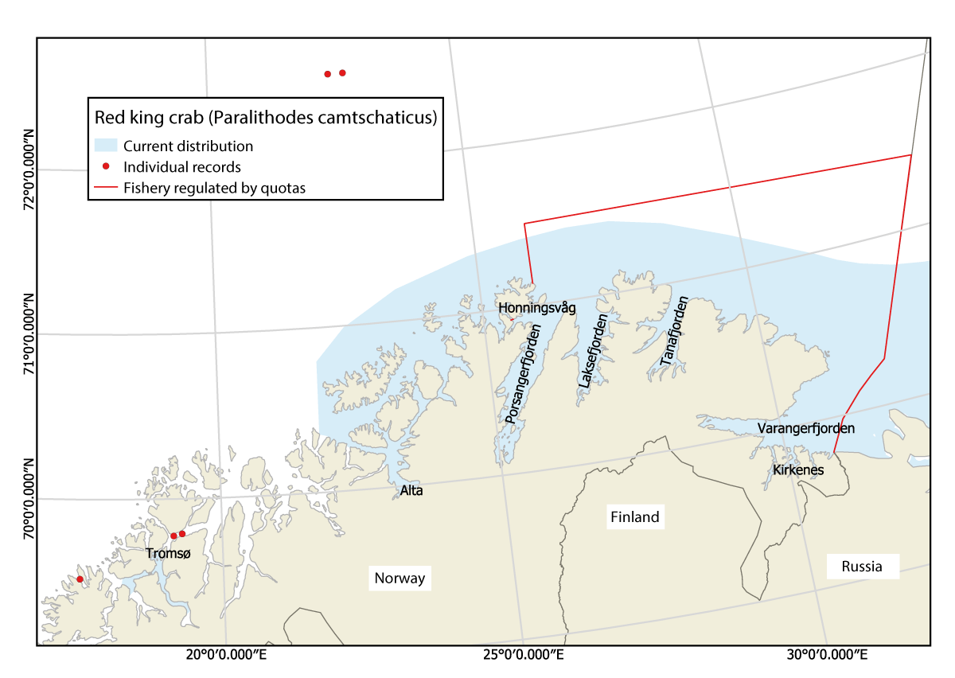
          - Current distribution of red king crab in the Barents Sea (both the Norwegian and the Russian sectors of the continental shelf), and individual records.
Source: Institute of Marine Research
Pink salmon first appeared in rivers along the Norwegian coast in 1960. The species is originally from the Pacific Ocean, but was introduced in rivers on the Atlantic side of Russia, and has since spread to Norwegian rivers. Pink salmon numbers in the North Atlantic remained very low for many years. The species has a two-year life cycle, and the population that spawns in odd-numbered years has exploded from 2017 onwards. In these years, pink salmon is now the most numerous salmonid species in rivers in Troms and Finnmark. The rise in sea temperatures in northern waters has probably played an important role in the increase in pink salmon numbers. Pink salmon poses a serious risk for wild Atlantic salmon and biodiversity in general. Since all pink salmon die in the rivers after spawning, there is also a risk to water quality. In both 2021 and 2023, considerable efforts were made to remove pink salmon from rivers in Troms and Finnmark. In 2023, action was taken in more than 90 rivers, and more than 99 000 pink salmon were caught in the sea and 243 000 in the rivers.
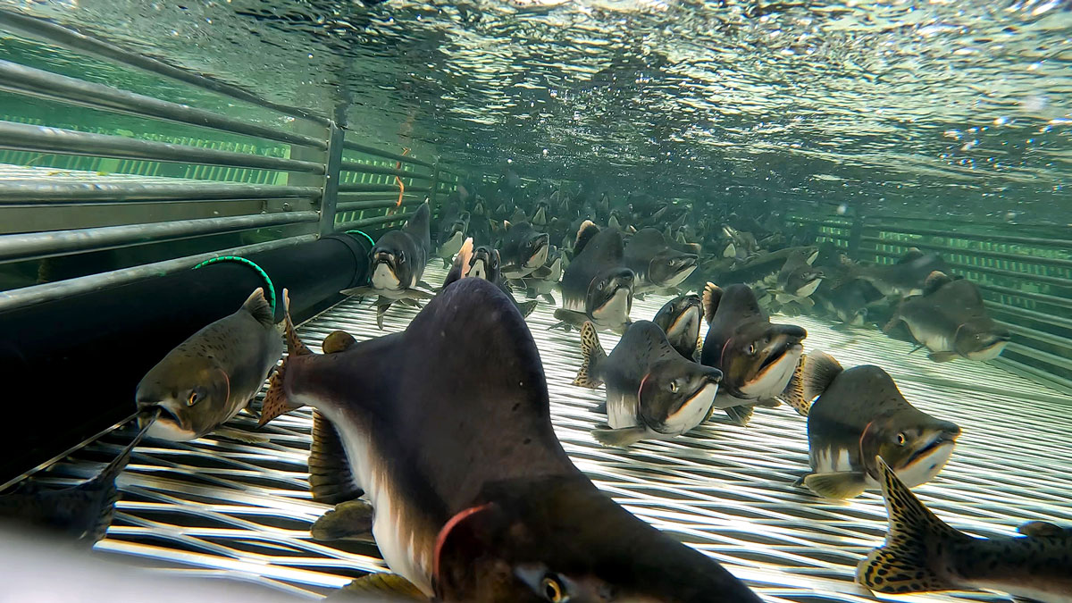
          - Pink salmon (Oncorhynchus gorbuscha) caught in a trap.
Photo: Malin Solheim Høstmark, Office of the County Governor of Troms og Finnmark
Threatened species and habitat types
The Norwegian red lists of habitat types and species were updated in 2018 and 2021 respectively. There has been a clear deterioration in the situation for threatened species and habitat types in Norway’s marine and coastal waters. In all, 45 species in the Barents Sea–Lofoten area, including Svalbard, are on the 2021 Norwegian red list, and 39 of these are listed as threatened (in one of the categories critically endangered, endangered or vulnerable). Conservation status is poorer for 18 species and better for six species than in the 2015 red list. Species that are now considered to be critically endangered or endangered include mammals (bowhead whale, beluga and hooded seal), nine bird species (including black-headed gull, puffin, Brünnich’s guillemot and common guillemot) and seven fish species (including basking shark, the skate Dipturus intermedius, golden redfish and polar cod). Overall, changes in conservation status are assessed as most negative for seabirds.
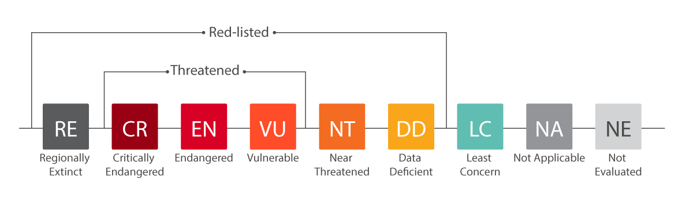
          - Red list categories for species.
Source: Norwegian Biodiversity Information Centre
Only two habitat types in the Barents Sea were assessed as threatened in the 2011 red list, but eight more were added in the 2018 red list. The conservation status of Radicipes coral gardens deteriorated from vulnerable to endangered, while coral reefs showed an improvement, from vulnerable to near-threatened. Arctic sea ice is classified as critically endangered, and northerly sugar kelp forests as endangered.

Pollution
Pollution levels are generally lower in the Barents Sea–Lofoten area than in the other two management plan areas. Long-range transport of hazardous substances with ocean currents and in the atmosphere is the main source of pollution in the Barents Sea, while inputs from rivers are also an important source of mercury. Otherwise, there are few local sources of pollution in the management plan area. Discharges of produced water (oily water from the oil reservoirs) and of chemicals from oil and gas activities in the area are small. Aquaculture facilities along the coast are another source of pollution.
For many years, the quantities of various persistent, bioaccumulative and toxic substances that are transported to the Barents Sea–Lofoten area with ocean currents and in the atmosphere have been declining, but this reduction has stagnated in recent years. Levels of certain substances, including chlorinated pesticides such as hexachlorobenzene (HCB), increase from south to north in biological samples, and the highest levels are therefore found in the Barents Sea.
Persistent, bioaccumulative and toxic substances, particularly those that are fat-soluble, accumulate along food chains and have particularly serious impacts on top predators. Research indicates that these chemicals are having impacts on seabirds and marine mammals in the Barents Sea–Lofoten area. Starving polar bears may be particularly vulnerable to the effects of these pollutants. However, seafood from Norwegian waters is safe to eat, since concentrations of contaminants are generally below the maximum permitted levels for food safety in edible parts of most species.
Levels of man-made radioactive substances in the Barents Sea are low. Levels of caesium-137 (originating from the Chernobyl accident), which are measured in sea water, seaweed and several fish species, are low and sinking. Concentrations of man-made radioactive substances are low, and below the maximum levels for human consumption.
There has been a steep rise in inputs of phosphorus, nitrogen and copper to the coastline bordering the Barents Sea–Lofoten area since 1990 (Figure 3.10). There are inputs from various sources, but fish farming is responsible for most of the large increase in inputs. The use of copper for impregnation in the aquaculture industry has been reduced in recent years. Little is known about how nutrients are transported from coastal waters to the open sea. It is therefore unclear what proportion of nutrient inputs is transported from coastal waters into the management plan area.
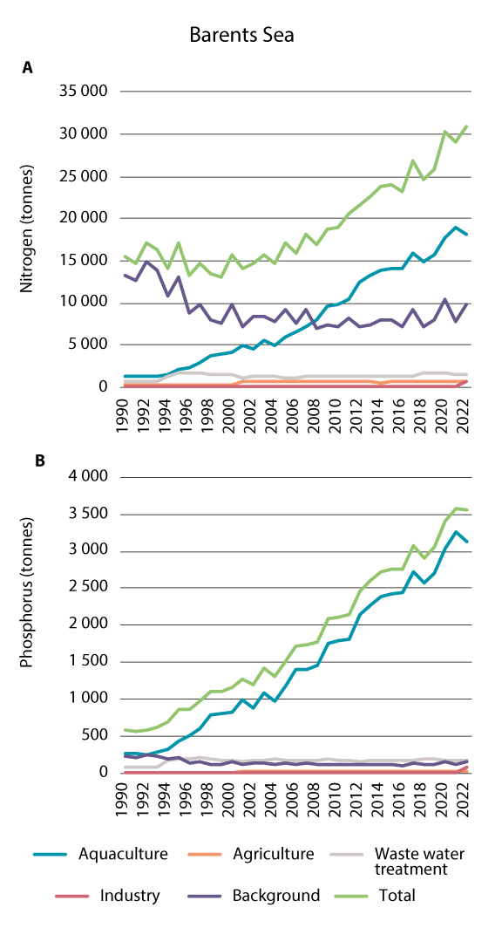
          - Inputs of nitrogen (a) and phosphorus (b) to the coastline bordering the Barents Sea–Lofoten area in the period 1990-2022.
Source: NIVA report 7963-2024
Fisheries-related waste, including lost fishing gear, is a major source of marine litter and plastic pollution in the Barents Sea–Lofoten area. Most floating waste is of relatively local origin, but waste can also be transported from distant waters. Little is known about trends for marine litter and plastic pollution in this management plan area. Marine litter has been monitored on four beaches along the border of the management plan area, two in Svalbard, one in Tromsø and one in Finnmark. Monitoring shows continued inputs of marine litter, but the data are not sufficient to draw conclusions about trends over time. Knowledge will be built up through national monitoring programmes for microplastics and macroplastics and more intensive monitoring of beach litter under OSPAR.

Ecosystem condition, drivers of change and impacts in the Norwegian Sea management plan area
As in the Barents Sea–Lofoten area, the impacts of climate change are becoming apparent in the Norwegian Sea management plan area, in the form of rising temperatures, shrinking sea ice cover and signs of ocean acidification. The fisheries are an important driver in the Norwegian Sea as well. The stocks of mackerel and Norwegian spring-spawning herring are declining, while the stocks of Northeast Arctic saithe and beaked redfish are at high levels. The golden redfish stock is declining and has fallen below the critical level. Seabird populations in the Norwegian Sea are still declining steeply, but improvements have been observed at certain colonies.
There are signs that southerly zooplankton species that prefer higher water temperatures are shifting their distribution northwards into the Norwegian Sea.
Inputs of hazardous substances with air and ocean currents are generally declining. Levels of contaminants in seafood are generally low and below the maximum permitted levels for food safety. However, there are some exceptions, and the authorities have either taken steps to prevent the relevant species from reaching the market or issued advisories against consumption. Inputs of phosphorus, nitrogen and copper to coastal waters have risen a great deal in recent years. It is unclear what proportion of discharges to coastal waters is transported into the management plan area.

Ecosystem condition in the Norwegian Sea management plan area
In the Norwegian Sea, ecosystem condition has only been assessed for one of the eleven ecosystems identified in the area: the pelagic ecosystem south of the Arctic front. This includes the upper 800 m of the water column in the deeper parts of the Norwegian Sea. For most of the other ecosystem types in the Norwegian Sea, little or no monitoring data is available.
There is evidence that human activities are having limited impacts on the pelagic ecosystem in the Norwegian Sea (see Figures 3.1 and 3.11). The clearest climate-related change is the temperature rise that has been observed over the past 70 years. There are also signs of increasing ocean acidification, but the biological consequences of this are very uncertain. In addition, stocks of mackerel and Norwegian spring-spawning herring are declining. This is because catches have been far higher than the recommended TACs (total allowable catches) after the international system for sharing the TACs collapsed in 2013. The herring stock has declined so much that advice has been issued for 2024 that fishing pressure must be reduced to avoid a decline to below the critical level in the long term.
The substantial decline that has been observed in seabird populations has been linked to rising sea temperatures in the Norwegian Sea and to changes in food supplies. For other ecosystem components than seabirds, no observed changes in the indicators used for this assessment can reasonably certainly be attributed to climate change. It is very uncertain whether the impacts really are limited or whether there are more serious impacts that have not been demonstrated because important indicators were not included in the assessment and many of the time series are too short.
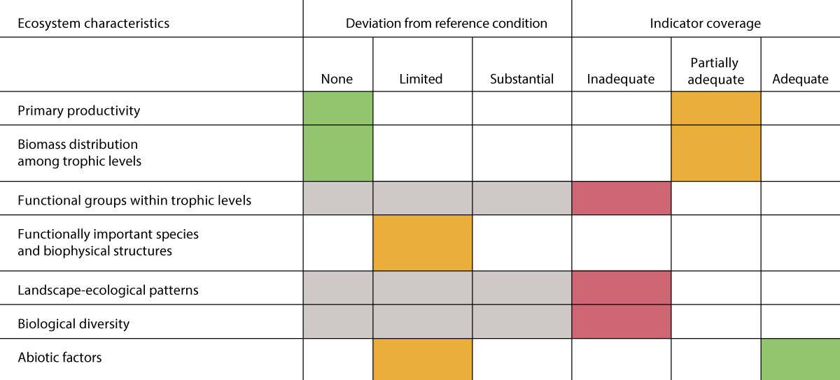
          - Summary of the assessment of ecosystem condition for each of the ecosystem characteristics for the Norwegian Sea pelagic ecosystem. Grey cells indicate that no information is available.
Source: Panel-based Assessment of Ecosystem Condition of the Norwegian Sea Pelagic Ecosystem. Rapport fra havforskningen 2023-16.
The ecological status of about 80 % of the coastal water bodies in the Norwegian Sea is classified as good, and in some cases high, according to the system used in the Water Management Regulations. About 17 % are classed as of moderate status, and only a few water bodies are classified as bad. The biological quality elements used to classify the ecological status of coastal water bodies are soft-bottom benthic invertebrates, eelgrass, macroalgae, and phytoplankton, and in addition there are hydromorphological and physico-chemical quality elements.

Oceanic climate change: Norwegian Sea management plan area
The ocean climate in the Norwegian Sea is closely linked to the characteristics of the Atlantic water that flows into the area from the south with the Norwegian Atlantic current. Long-term variations in the Norwegian Sea will therefore follow general climate trends in the North Atlantic, but with a few years’ delay. In addition, interannual variations in the Norwegian Sea are strongly influenced by variability in heat loss from the sea to the atmosphere and fluctuations in the inflow of relatively cold, fresh Arctic water from the Iceland and Greenland Seas. Because the time series are relatively short, the impacts of climate change on the ecosystem are uncertain.
The Norwegian Sea has become generally warmer in the last 40 years (Figure 3.12), and this can be clearly linked to anthropogenic climate change. The temperature rose by 1 °C from 1980 to about 2005. Since then, the Norwegian Sea has been relatively warm despite an increase in the inflow of relatively cold Arctic water from the west.
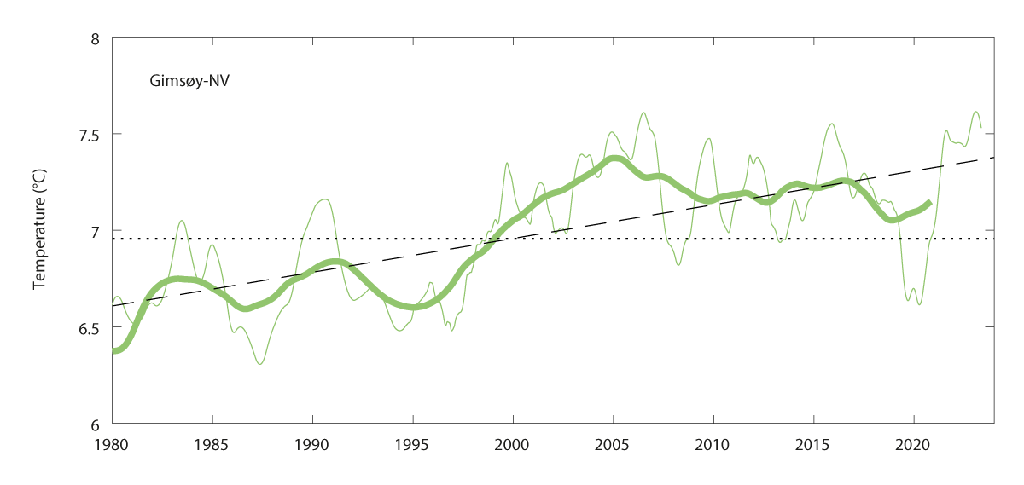
          - Temperature for the period 1980-2020 averaged within the depth interval 50-200 m, in the core of Atlantic water for the Gimsøy section (northern part of the Norwegian Sea, west of the Lofoten Islands). The narrow line shows annual means, the bold line shows a smoothed curve using five-year means, and the dashed line shows the linear trend.
Source: Institute of Marine Research
There is sea ice in the Fram Strait in the northern part of the Norwegian Sea. Higher sea and air temperatures are reducing sea ice extent. There are large interannual variations, but also a clear negative trend for sea ice extent in the Fram Strait.
There are signs of increasing ocean acidification in the Norwegian Sea. In the Norwegian Basin, pH in the surface waters has fallen by 0.12 units over the past 40 years. It appears that pH is decreasing more rapidly in parts of the Norwegian Sea than at global level. Changes in aragonite saturation are also significant because this carbonate mineral is very important for species with calcium-based shells or skeletons (see Box 3.2). The observed changes in pH and aragonite saturation level in the Norwegian Sea are largely explained by the higher CO2 content of the water as a result of CO2 emissions to air from human activity. Changes in the water masses or inputs of freshwater also add to ocean acidification.
Observed effects of changes in ocean climate
Several copepod species and Cymbulia peronii, a pelagic sea snail, are examples of southerly warm-water zooplankton species that have been observed in the Norwegian Sea. A sharp increase in southerly species was observed in the area from 2006 onwards. Since 2011, there has been a general decline, but with wide interannual variations. Changes in the occurrence of southerly species may be linked to higher sea temperatures. These are partly explained by an increase in water transport from the North Atlantic, which is one factor behind the northward shift in the distribution of more southerly species.
The severe decline in seabird populations has been linked to factors including rising water temperatures in the Norwegian Sea. Climate change also influences where and when fish spawn and the survival of young fish. This can cause a mismatch between the availability of fish larvae and the breeding cycle of seabirds, disrupting seabird reproduction. Thus, rapid climate change is having negative impacts on the productivity of pelagic seabirds that breed in colonies around the Norwegian Sea management plan area, and this mechanism is partly responsible for the current decline in seabird populations.

Condition and trends for various ecosystem components in the Norwegian Sea
The condition and main trends for various ecosystem components in the Norwegian Sea pelagic ecosystem are described below using the results of the assessment of ecosystem condition.
Plankton
No changes have been observed in primary production (phytoplankton) in the Norwegian Sea in the past 20 years. The time series for zooplankton are too short to assess whether warming has resulted in important changes for this group, as has been observed in other areas where longer time series are available.
Benthic communities
The MAREANO programme for mapping of the seabed has been collecting data on the benthic fauna in the Norwegian Sea since 2011 (Figure 3.13). Benthic animals may have a scattered distribution or be found in dense stands. A number of benthic communities, such as hard- and soft-bottom coral gardens, coral reefs, hard-bottom sponge aggregations and seapen communities, are vulnerable for example to abrasion. Biodiversity is highest in areas of the continental shelf with a sloping seabed and in the upper parts of the continental slope, for example in coral reef complexes such as Røstbanken, the Storegga area and the Møre banks.
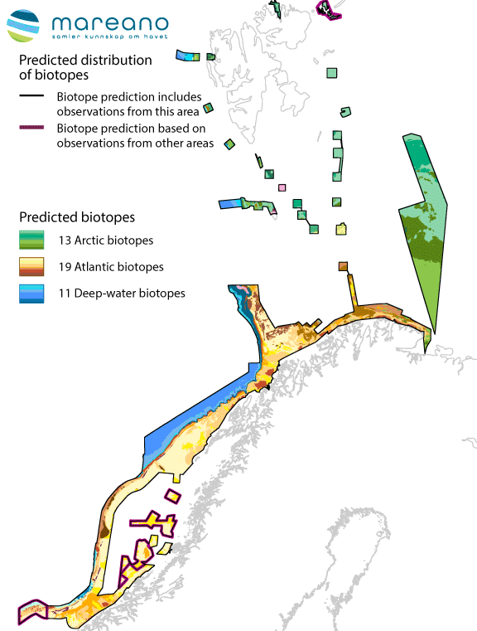
          - General biotope map showing the predicted distribution of benthic biotopes in the Norwegian Sea and Barents Sea.
Source: MAREANO programme
Kelp forests are considered to be particularly productive ecosystems with a high level of species diversity. They function as important nursery areas and shelter for fish larvae, and also play a role in carbon storage. Northerly sugar kelp forests along the coast of the Norwegian Sea are endangered by intense grazing pressure from sea urchins, probably because species that are sea urchin predators (wolf-fish, haddock and cod) were overfished up to the 1970s. However, crabs are expanding northwards with rising temperatures, and this appears to be having a positive impact on kelp forests, since crabs feed on sea urchins and reduce their numbers.
The largest kelp forests are formed by Laminaria hyperborea, and there are particularly extensive stands along the coast of Møre og Romsdal and Trøndelag counties. Given its temperature preference, the distribution of L. hyperborea is expected to remain stable in southerly coastal waters and expand somewhat further north in the coming decades. Kelp forests are a renewable resource that can be harvested sustainably along the coast. Kelp trawling can have major impacts on the flora and fauna in and around kelp forests. After harvesting, the physical structure and age distribution of kelp forests change and become more uniform. Harvesting is permitted every five years, by which time the biomass of kelp has recovered. However, it may take longer than this before a re-established kelp forest is ‘ecologically mature’ and all ecosystem functions have recovered.
Fish stocks
Fishing pressure on mackerel, herring and blue whiting has been higher than recommended in recent years. This is largely because no binding international agreement has been reached on sharing these fisheries in the Norwegian Sea since 2013. The mackerel stock is nevertheless in relatively good condition, and recruitment is strong. Since 2008, the spring-spawning herring stock has been declining, largely because of weak recruitment. The most recent strong year class was observed in 2016. Harvesting above recommended TACs weakens the stock, which in 2024 is expected to fall below the level at which further management measures are needed to prevent it from reaching a critically low level. Over the long term, the blue whiting stock is becoming stronger. Even though catches are higher than the recommended TAC, strong recruitment has ensured that the stock is resilient in recent years. The stock of Northeast Arctic saithe was close to a historically high level in 2022.
The other commercial fish stocks are healthy – these are beaked redfish, Greenland halibut, tusk, ling, spiny dogfish and greater argentine. Stocks of golden redfish and blue ling are low, and both species are endangered. Catches of these species and of three elasmobranches, the skate Dipturus intermedius, basking shark and porbeagle, are prohibited. The stocks of coastal cod are in poor condition.
It is possible that there will be interest in expanding Norwegian Sea fisheries for species at lower trophic levels, such as the copepod Calanus finmarchicus. This would be one way of providing feed for the growing aquaculture industry. Potential problems such as overharvesting, bycatches of other species and impacts on the structure of ecosystems will be investigated if this is the case.
Seabirds
Populations of most seabird species in the Norwegian Sea are still declining, but there are indications of a positive trend for some populations and individual breeding colonies (Figure 3.10). Both kittiwake and fulmar, which are pelagic surface-feeding species, are still declining steeply, but numbers of gannets are rising. Of the pelagic diving species, Brünnich’s guillemot and puffin are declining, as is the common guillemot colony on Jan Mayen. There are signs of improvement at certain colonies of common guillemot and razorbill. As regards coastal species, great skua numbers are rising or stable, while populations of gulls and terns, shag and cormorant are stable or declining populations.
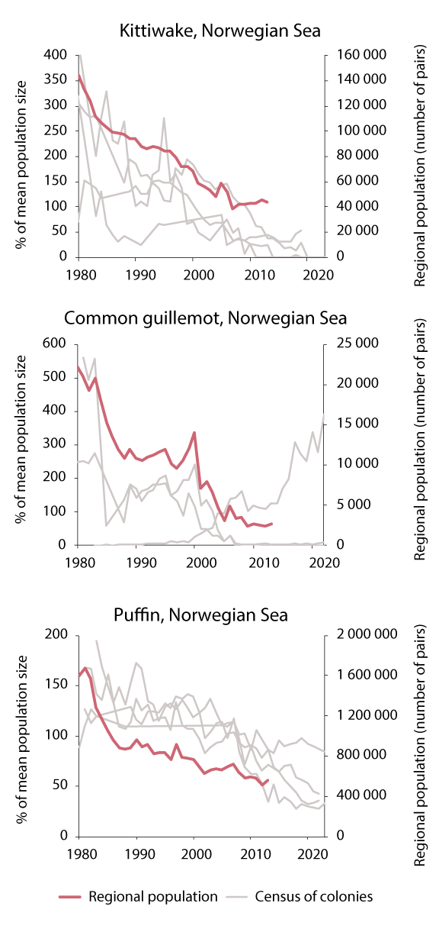
          - Seabird populations in the Norwegian Sea. Population trajectories for kittiwake, common guillemot and puffin. Bold red lines show the estimated population size, thin grey lines show figures from monitoring at specific colonies.
Sources: Regional population figures from NINA Report 1151 (2015), monitoring data from seapop.no
The breeding populations of common eider in the Norwegian Sea have declined greatly all along the coast from Møre og Romsdal county to Røst at the southern tip of the Lofoten Islands (Figure 3.15). Causes of the decline in seabird populations are discussed in Chapter 3.1.2.
              - Common eider
Predation by mink, ravens, gulls and white-tailed eagles, which take eggs, chicks and adult birds, affects the common eider population. Historically, there was a tradition of eiderdown ‘farming’ in coastal areas from Central Norway and northwards. People provided sheltered nesting sites for eider ducks and harvested the eiderdown. This system has been abandoned, leaving the common eider with less protection. Predation by mammals and raptors probably puts considerable pressure on the common eider, but this has not been quantified. Disturbance by people often causes incubating eider ducks to leave the nest, leaving eggs and chicks exposed to predators.
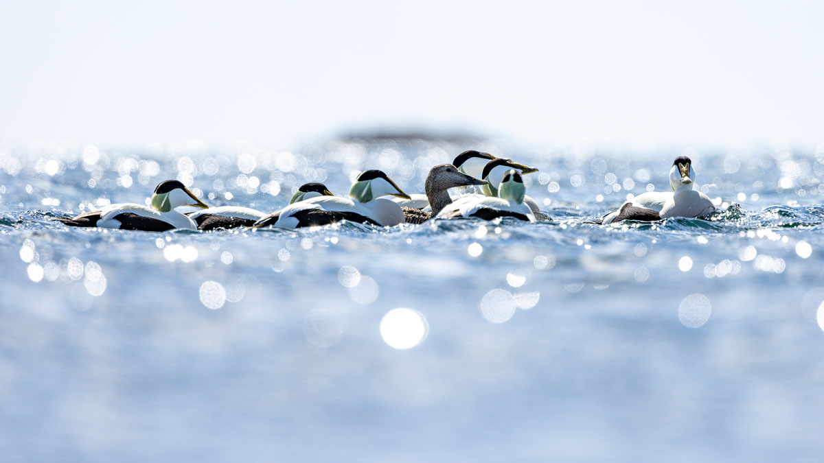
          - Common eider
Photo: Kim Abel/Naturarkivet
The population along the coast of Møre og Romsdal is now only 15 % of what it was in 1986. In the Trondheimsfjorden, the breeding population has dropped by 90 % since 1982, and in Leka municipality on the coast of Trøndelag, the population has declined by 80 % since 2001. In the southern half of Nordland county, the populations in the inner part of Ranfjorden and along the open coast have declined by 90 % and 75 % respectively since 2000. The breeding population on Røst has been reduced by about 75 % since 1988.
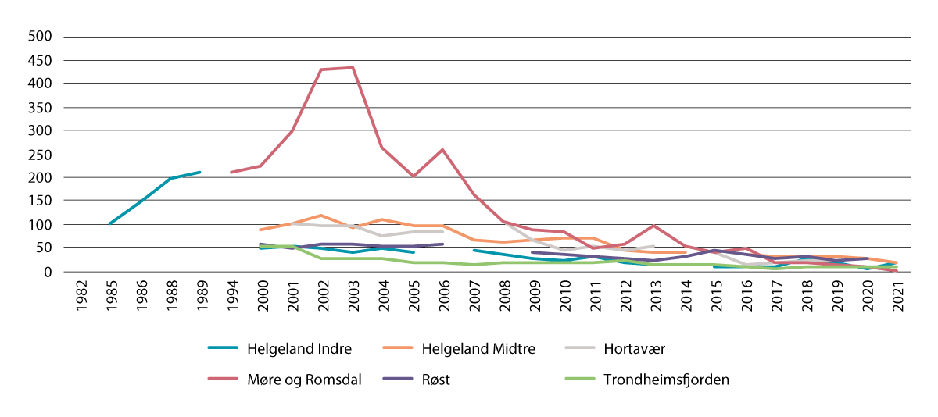
          - Population trajectories for common eider in Nordland county between the 1980s and 2021.
Source: Norwegian Institute for Nature Research/Miljøstatus
[Boks slutt]
Marine mammals
The marine mammal fauna in the Atlantic part of the Norwegian Sea is dominated by whales. Some species, such as harbour porpoises and orcas, spend the whole year in the Norwegian Sea. Others, such as minke whales and other baleen whales, are present mainly in summer. The total minke whale population in the Northeast Atlantic has been stable, but in the past 10 –15 years there has been a certain decline in numbers in the Norwegian Sea and a corresponding increase in the Barents Sea. The minke whale is the only species that is harvested.
Population estimates for orca have varied considerably over time, but without any clear trend. This species feeds primarily on herring and mackerel in the Norwegian Sea, but a few groups also catch seals. Orcas that feed on seals contain very high levels of persistent, bioaccumulative and toxic substances, which may affect their health and reproductive capacity.
The harbour porpoise is relatively abundant, and is most widely distributed in coastal waters bordering on the Norwegian Sea management plan area. This species is particularly vulnerable to bycatches in gill nets, and rules have therefore been introduced requiring the use of pingers (acoustic deterrent devices) on gill nets in the Vestfjorden from 1 January to 30 April.
The hooded seal is one of the largest seal species in the North Atlantic, and also the one that dives deepest, to more than 1000 metres. The West Ice between Jan Mayen and Greenland is the only known whelping area for hooded seals in the Northeast Atlantic. This species is endangered. Until the 1980s, sealing was probably the most important driver for the hooded seal population, but the decline since then can probably be attributed to changes in reproduction rate and natural mortality. Both of these variables can be influenced by changes in food supplies. The hooded seal population has been protected since 2007, with the exception of a limited harvest for research purposes.
Coastal waters bordering the Norwegian Sea management plan area are important habitats for the relatively small Norwegian populations of grey and common seal. Regular monitoring since the late 1990s shows a general decline in pup production for grey seals and in the total population of common seals. Bycatches during gill netting for angler are believed to be one explanation for these trends.
Alien species
The alien species that have been registered in the Norwegian Sea are largely associated with coastal waters. The number of observations has risen in recent years, partly because of the continued spread of Pacific oysters (Crassostrea gigas) and pink salmon. By 2022, between 15 and 20 alien species had been registered. The comb jelly Mnemiopsis leidyi has spread rapidly from the Oslofjorden to the Trondheimsfjorden, and can dominate plankton communities locally in late summer and autumn. There are individual records of Pacific oyster from the southern part of the Møre og Romsdal coast, which indicates that the species may be spreading further northwards. The carpet sea squirt (Didemnum vexillum) has not yet been found in the Norwegian Sea, but it is probably only a matter of time before it spreads northwards.
Threatened species and habitat types
In all, 36 species in the Norwegian Sea, including algae, are listed as threatened (in one of the categories critically endangered, endangered or vulnerable). Conservation status is poorer for 13 species and better for 10 species than in the 2015 red list. Several species of annelid worms have been added to the list. Critically endangered species now include the black-headed gull, common guillemot, the skate Dipturus intermedius and shagreen ray (Leucoraja fullonica). Species listed as endangered include fish (golden redfish, blue ling, basking shark and European eel), marine mammals (hooded seal and bowhead whale), seabirds (puffin, fulmar and common tern), and the Baltic stonewort Chara baltica.
Four habitat types in the Norwegian Sea have been red-listed. Northerly sugar kelp forests are now classed as endangered because of intense grazing by sea urchins. The conservation status for coral reefs has improved from vulnerable to near-threatened. The other two habitat types are oarweed forests and mussel beds that are exposed to wave action, both of which are listed as vulnerable.

Pollution
Transport in the atmosphere and with ocean currents is the main source of inputs of hazardous substances and other pollutants to the Norwegian Sea. There are also inputs of pollutants via rivers, with runoff from land, and from activities in coastal waters and at sea. Oil and other naturally occurring substances are released with produced water and chemicals from petroleum activities in the Norwegian Sea, and there are also releases of oil and chemicals from shipping. There is a great deal of oil and gas activity in the Norwegian Sea, and releases of pollutants are relatively high, but because there are fewer fields in production, considerably lower than in the North Sea–Skagerrak management plan area. The industry is responsible for environmental monitoring programmes, which these generally show that releases of pollutants have only limited local impacts.
The volume of shipping in the Norwegian Sea is lower than in the North Sea and Skagerrak, but higher than in the Barents Sea–Lofoten area. Shipping in the Norwegian Sea is dominated by passenger transport. Given the expected increase in activity, operational releases of oil and chemicals will rise, as will the level of underwater noise, and the risk of the spread of alien species will increase.
Inputs of heavy metals from the atmosphere are low and declining. This is a result of reductions in emissions in Central and Eastern Europe. Atmospheric inputs of persistent organic pollutants (HCB and perfluoroalkyl substances (PFAS)) are stable or decreasing.
Estimates of annual inputs of nitrogen and phosphorus, and the heavy metals copper and lead to the coastline bordering the Norwegian Sea are based on data from monitoring of river systems, modelling results and data reported by industry, waste water treatment plants and fish farms. Inputs of lead have been declining since the late 1990s, and have levelled off at a low level after 2015. However, inputs of copper have risen in the past 10 years. Both direct releases of phosphorus and nitrogen and inputs via rivers have increased a great deal, and have almost doubled in the past 20 years (Figure 3.17). Rising inputs of phosphorus, nitrogen and copper are largely explained by an increase in discharges from the aquaculture industry. The use of copper for impregnation in the aquaculture industry has been somewhat reduced in recent years. Little is known about how nutrients are transported from coastal waters to the open sea. It is therefore unclear what proportion of nutrient inputs is transported from coastal waters into the management plan area.
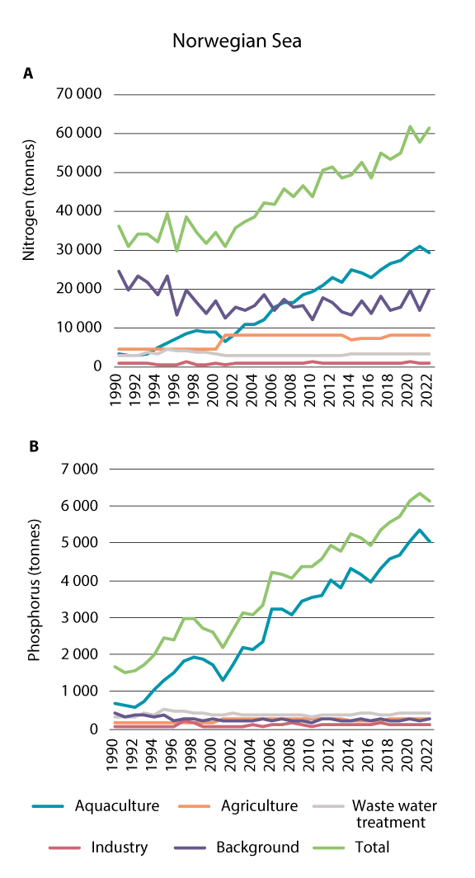
          - Inputs of nitrogen (a) and phosphorus (b) to the coastline bordering the Norwegian Sea management plan area in the period 1990-2022.
Source: NIVA report 7963-2024
In the Norwegian Sea management plan area, levels of persistent, bioaccumulative and toxic substances are monitored in selected species including mussels, shrimps, shag (eggs) and some commercial fish species. Seafood from the Norwegian Sea is generally safe to eat, since concentrations of contaminants are below the maximum permitted levels for food safety in edible parts of most species. There are a few exceptions. In an area around the outer Sklinnadjupet trench, fishing for halibut has been banned because high levels of mercury, dioxins and PCBs have been found in halibut caught in the area. Another exception is coastal cod. Levels of persistent, bioaccumulative and toxic substances in cod fillets are well below the maximum permitted levels for food safety. However, concentrations of such substances in the liver of coastal cod are often above the maximum permitted levels, and the Norwegian Food Safety Authority has issued a general warning to the population to avoid eating the liver of fish caught inside the baseline. High levels of cadmium have been measured in edible crabs caught along the coast from Saltfjorden (Nordland county) and northwards, and the Food Safety Authority has warned against catching crabs from this area. It is not known why unusually high levels of persistent, bioaccumulative and toxic substances, exceeding the maximum permitted levels, are found in a few cases and in specific areas in some seafood species caught in the Norwegian Sea.
Levels of persistent, bioaccumulative and toxic substances in sediments in the Norwegian Sea are generally very low.
Levels of radioactive substances from human activity are low in seawater along the coast and in the Norwegian Sea itself. As a result of stable or declining inputs and radioactive decay, these levels are stable or declining. Bladder wrack (Fucus vesiculosus) is a good indicator of trends in the level of technetium-99 (from the Sellafield plant) in marine organisms, since this seaweed accumulates technetium. Levels of technetium-99 in seawater are currently so low that they are generally below the detection limit, whereas levels in bladder wrack are low but quantifiable. The levels of caesium-137 (from the Chernobyl accident) measured in bladder wrack are also low. The dose from natural radioactive nuclides in seafood is greater than the dose from man-made substances, but the risk associated with natural radioactive substances in seafood is nevertheless low.
Fisheries-related waste, including lost fishing gear, is an important source of marine litter and plastic pollution in the Norwegian Sea. Other important sources are aquaculture and shipping. Most floating waste is of relatively local origin, but waste can also be transported from distant waters. Too little is known about marine litter and plastic pollution in this management plan area. Knowledge will be built up through national monitoring programmes for microplastics and macroplastics and more intensive monitoring of beach litter under OSPAR.
Underwater noise, for example from shipping, seismic surveys and sonar, is another form of pollution in the Norwegian Sea, but little is known about levels and effects.

Ecosystem condition, drivers of change and impacts in the North Sea–Skagerrak management plan area
In the North Sea and Skagerrak, anthropogenic climate change is resulting in higher temperatures and ocean acidification, and also coastal water darkening (increased light attenuation), probably because of increasing runoff of organic material from land. The assessment of ecosystem condition concludes that climate change and other anthropogenic pressures, particularly the fisheries, are having substantial impacts on the ecosystem. Ecosystem changes that have been observed involve key groups of zooplankton, fish stocks, shrimps and benthic communities. New data show a dramatic decline in a number of seabird populations that breed along the coast of the Skagerrak and North Sea. This management plan area is generally more polluted than the other two.
For the North Sea–Skagerrak, it was concluded that the sectors that make the greatest contribution to cumulative impacts on ecosystems are the fisheries, transport, sewage and wastewater treatment, agriculture, oil and gas and land-based industry. Selective species extraction, litter and pollution, and abrasion and smothering are particularly important pressures.

Ecosystem condition in the North Sea–Skagerrak management plan area
The assessment of ecosystem condition (see Box 3.1) for the North Sea and Skagerrak includes the entire management plan area except for the seabed and water column at depths below 200 m in the Norwegian Trench, which are considered to make up a different ecosystem from shelf ecosystem in the shallower parts of this area.
The impacts of human activity on the ecosystem in the Norwegian sector of the North Sea–Skagerrak are substantial. There is little uncertainty about this conclusion, which is based on an overall assessment using results for all seven of the ecosystem characteristics that were considered (Figure 3.18). Climate change is having considerable impacts on abiotic parts of the ecosystem, particularly through rising temperatures. Together with other drivers, such as the fisheries, this has substantial effects on the rest of the ecosystem. There are major impacts on key fish stocks and other functionally important species, and on benthic habitats. There are also signs that human activity has caused changes in species diversity and ecological functions and in biomass distribution among trophic levels.
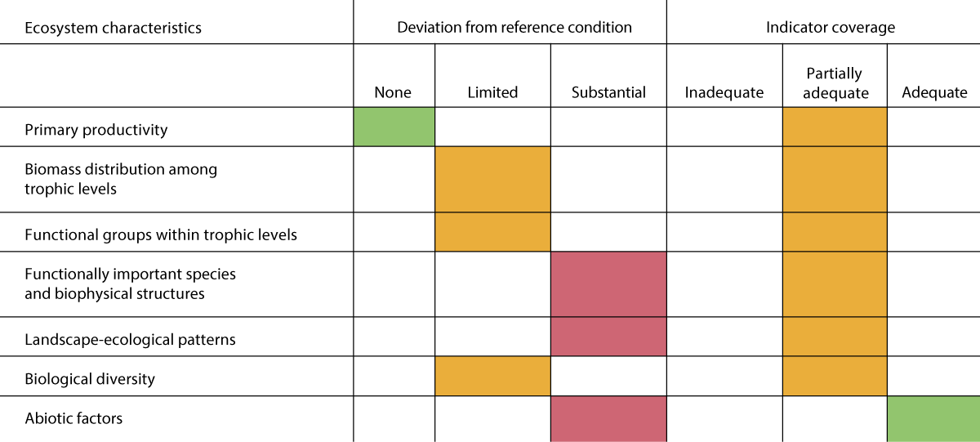
          - Summary of the assessment of ecosystem condition for each of the ecosystem characteristics for the North Sea-Skagerrak.
Source: Panel-based Assessment of Ecosystem Condition of the North Sea Shelf Ecosystem. Rapport fra havforskningen 2023-17.
The indicators for zooplankton account for a large proportion of the substantial deviation from the reference condition that was observed. Earlier overfishing is another important factor. Efforts to rebuild fish stocks after overfishing was stopped have been hampered by poor recruitment in the 2000s and 2010s. Zooplankton groups are important sources of food for fish larvae. For cod and herring, which have been thoroughly studied, poor recruitment has been clearly linked to the climate-driven changes in the zooplankton community. Another important aspect of human pressure on the ecosystem is the large proportion of the seabed and benthic communities that are affected by bottom trawling.
The ecological status of about half of the coastal water bodies in the North Sea–Skagerrak area is classified as good, and in some cases as high, according to the system used in the Water Management Regulations. The status of about 42 % of the water bodies is classed as poor and of 8 % as bad. The biological quality elements used to classify the ecological status of coastal water bodies are soft-bottom benthic invertebrates, eelgrass, macroalgae, and phytoplankton, and in addition there are physico-chemical quality elements.

Oceanic climate change: North Sea–Skagerrak management plan area
The ocean climate in the North Sea–Skagerrak area can be split into two main types, corresponding to the Atlantic deep water in the northern North Sea and the Norwegian Trench, and the North Sea water in continental shelf areas. The North Sea water is strongly influenced by local weather conditions, and there is considerable variability between seasons and years. The deep water, on the other hand, is strongly influenced by the Norwegian Atlantic current that flows in from the Norwegian Sea and southwards along the Norwegian Trench.
Towards the end of the 1980s, the temperature of both the surface water and the deep water in the North Sea rose by about 1 °C, and has remained at about this level since (Figure 3.19).
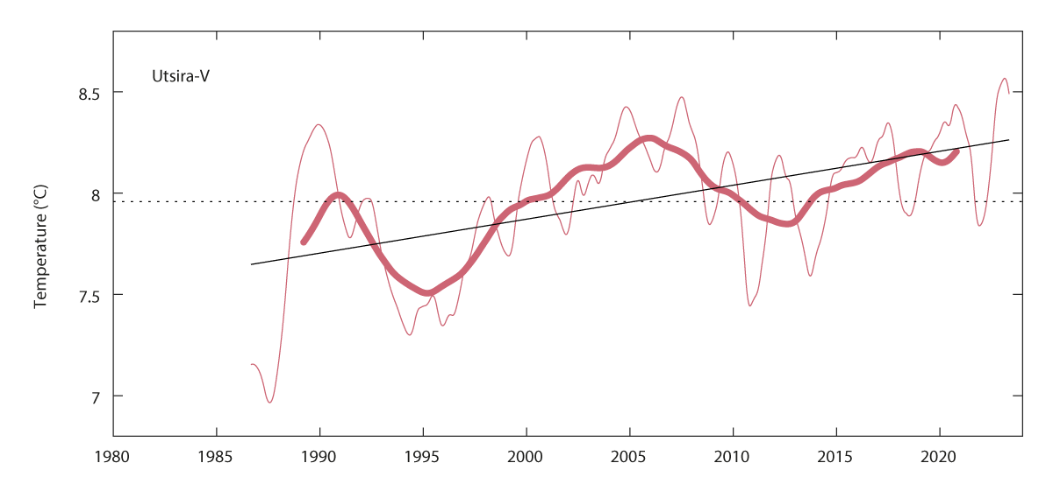
          - Temperature for the period 1980-2020 averaged within the depth interval 50-200 m, in the core of Atlantic water in the North Sea (Utsira-V section). The narrow red line shows annual means, the bold red line shows a smoothed curve using five-year means, and the black line shows the linear trend.
Source: Institute of Marine Research
Although only short time series are available and there is wide geographical and temporal variability in CO2 content and pH values in the North Sea and Skagerrak, signs of increasing ocean acidification can be seen (lower pH and lower aragonite saturation levels). Acidification is largely explained by increasing CO2 levels in seawater as a result of higher atmospheric emissions. Changes in the water masses or inputs of freshwater also add to ocean acidification.
The accumulation of particulate organic matter, particularly in deep-water basins where bacteria consume oxygen during degradation processes, can result in low oxygen levels at certain times of year. However, regular turnover and renewal of the bottom water improves the conditions. Since 1980, there has been a weak decline in oxygen levels in the Skagerrak bottom water (Norwegian Trench). Nevertheless, oxygen levels in the bottom water are considered to be satisfactory.
Observed effects of changes in ocean climate
The rising sea temperature is one factor behind the northward shift in the distribution of various zooplankton species, and the enhanced survival of more southerly zooplankton species. In the North Sea, there has been a shift in the copepod fauna from dominance of Calanus finmarchicus to dominance of C. helgolandicus. There has also been a decline in the total biomass of the copepod genera Pseudocalanus and Paracalanus. This has been related to a reduction in primary production, which in turn is linked to climate change. These changes have had impacts on many links in food chains.
Climate change may have an indirect effect on recruitment to fish stocks through changes in zooplankton communities. There is strong evidence that recruitment to both cod and herring stocks has declined substantially as a result of changes in zooplankton communities that result in poorer food supplies for the youngest life stages of fish. This also affects food supplies for seabirds, and is one of the causes of the decline in seabird populations in the North Sea and Skagerrak.
The coastal water has become markedly darker, probably because of increasing runoff of organic matter from land. This is linked to higher precipitation levels on land as a result of climate change. A reduction in the lower growth limit has been observed for several species of macroalgae in the Skagerrak, and this is partly attributed to light attenuation. In the North Sea, increased light attenuation has resulted in a delay in the spring algal bloom.
              - Coastal water darkening
There has been an increase in runoff and inputs of dissolved organic matter from land to coastal waters in Norway in the past 30 years. This is a result of climate change and other anthropogenic drivers, and the trend is expected to continue in the future. Areas that are particularly vulnerable to changes in light penetration in water are fjords, the Skagerrak, the North Sea and the waters around Svalbard.
Marked darkening of the water has been observed in the North Sea and Skagerrak, probably because of increasing runoff of organic matter from land. Dissolved organic matter makes the water darker and less transparent. Changes in light penetration influence the depth of the euphotic zone (where sufficient light is available), and have impacts on all organisms that need light for photosynthesis and growth, such as phytoplankton, seaweed, kelp and eelgrass. Predators that hunt by sight are also affected by reduced light penetration. A reduction in the lower growth limit has been observed for several species of macroalgae (seaweed and kelp) in the Skagerrak, and this is partly attributed to light attenuation.
Water darkening has been found to delay the spring algal bloom in the North Sea, which has an important ecological function. A later spring bloom may reduce the food supplies available to the zooplankton, and in turn reduce the availability of food (quantities and/or timing) for juvenile fish, seabirds, etc. Thus, the effects of water darkening can spread throughout the food web.
[Boks slutt]

Condition and trends for various ecosystem components in the North Sea and Skagerrak
Kelp forests
Sugar kelp forests are an important habitat type in Norway’s coastal waters, and are nursery areas and habitats for many marine species. In the Skagerrak and southwestern Norway, a number of factors have had substantial impacts on sugar kelp forests and eelgrass meadows. Since 2000, there has been a weak improvement in the condition of sugar kelp forests, but over the past 50 years there has been a decline in the distribution of this species in the southern half of Norway, particularly in the Skagerrak. This is probably a result of rising temperatures and nutrient levels, together with an increase in levels of particulate matter and humus, all of which have negative impacts on the sugar kelp growth and recruitment. Where sugar kelp has declined, areas have become dominated by filamentous algae. The greatest losses took place in the Skagerrak around 2000, but there has also been a considerable loss of sugar kelp in the North Sea. Southern sugar kelp forests are categorised as endangered on Norway’s red list. In the long term, there is a risk that the situation will deteriorate because a continued rise in temperature and in runoff from land will increase levels of nutrients and particulate matter in the sea.
The benthic fauna
There are no indicators for the benthic fauna in the North Sea and Skagerrak, and no regular monitoring except of shrimps (Pandalus borealis). The shrimp stock reached a historical low in 2012, then increased up to 2016, but was very low again in 2022. Its distribution has declined, and the density of shrimps in the Norwegian Trench off Rogaland and northwards is now very low. Recent surveys have shown that shrimps have also disappeared from fjords in Vestland county.
There is a high level of bottom trawling activity in the North Sea and Skagerrak, and the impacts can be seen across a large proportion of the seabed and benthic communities. These impacts may have consequences for ecological functions and the productivity of benthic communities.
Fish stocks
The important commercial stocks of mackerel, North Sea herring, Norway pout and sandeel are in good condition, but the coastal cod stocks are in poor condition. The stocks of North Sea saithe and North Sea cod are at low levels. Mackerel numbers in the North Sea have risen considerably in recent years. The mackerel stock is nevertheless still at a relatively low level, but is stable. Harvesting from the component of the mackerel stock that spawns in the North Sea is strictly limited, and it thought that this component of the stock is still in poor condition.
After 10 years of weak recruitment between 2000 and 2010, the sandeel stock in the central North Sea has now been strengthened. The stock on the Viking Bank is still very low. Sandeels are an important prey species. Low sandeel numbers have a strong influence on food availability for seabirds and minke whales.
After a period of gradual increase in the North Sea cod stock, the spawning stock has declined steeply in the past three years (Figure 3.20). Three substocks of North Sea cod have recently been identified (northwestern, Viking, and southern cod substocks). The northwestern substock is largest and in good condition. The Viking substock is smaller, but may increase as a result of strong recruitment. The southern substock is in poor condition and recruitment is very low.
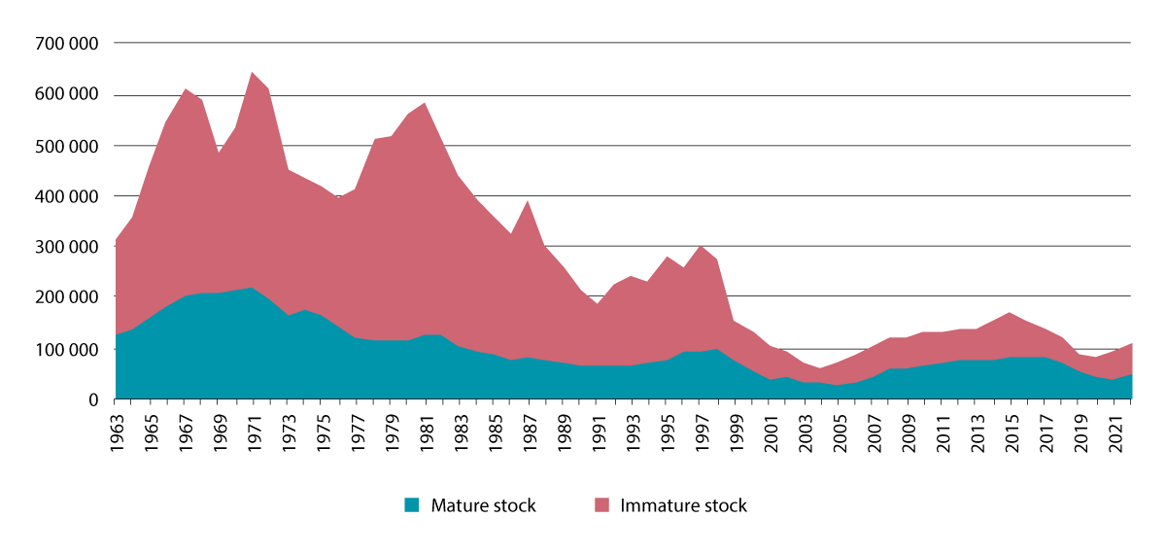
          - Stock trajectories for cod in the North Sea
Source: Institute of Marine Research
The haddock stock is now high as a result of limited harvesting and several strong year classes in recent years. However, the rise in water temperature is putting pressure on the stock. The North Sea saithe stock is declining and recruitment is weak, but the reasons for this are uncertain. There are signs that the stock may be stabilising at a low level.
The stock of North Sea herring is in good condition. The new year classes after 2001 have been weak, with the exception of the 2013 year class, but management of the herring stock is designed to take this into account.
The stocks of golden redfish and blue ling are at low levels (golden redfish is classed as endangered) and coastal cod stocks are in poor condition.
Seabirds
Populations of most seabird species in the North Sea–Skagerrak area are still declining steeply (Figure 3.21), but there are signs of a positive trend for certain populations and individual colonies. Populations of pelagic surface-feeding species are showing the steepest decline. The fulmar is disappearing as a breeding species in the management plan area. Colonies of the coastal species great black-backed, herring and lesser black-backed gull and common tern are still declining. The colonies of cormorant and shag are growing, but common eider populations are declining. Many of the negative changes in in seabird populations are linked to food shortages combined with climate change (see Chapter 3.1.2).
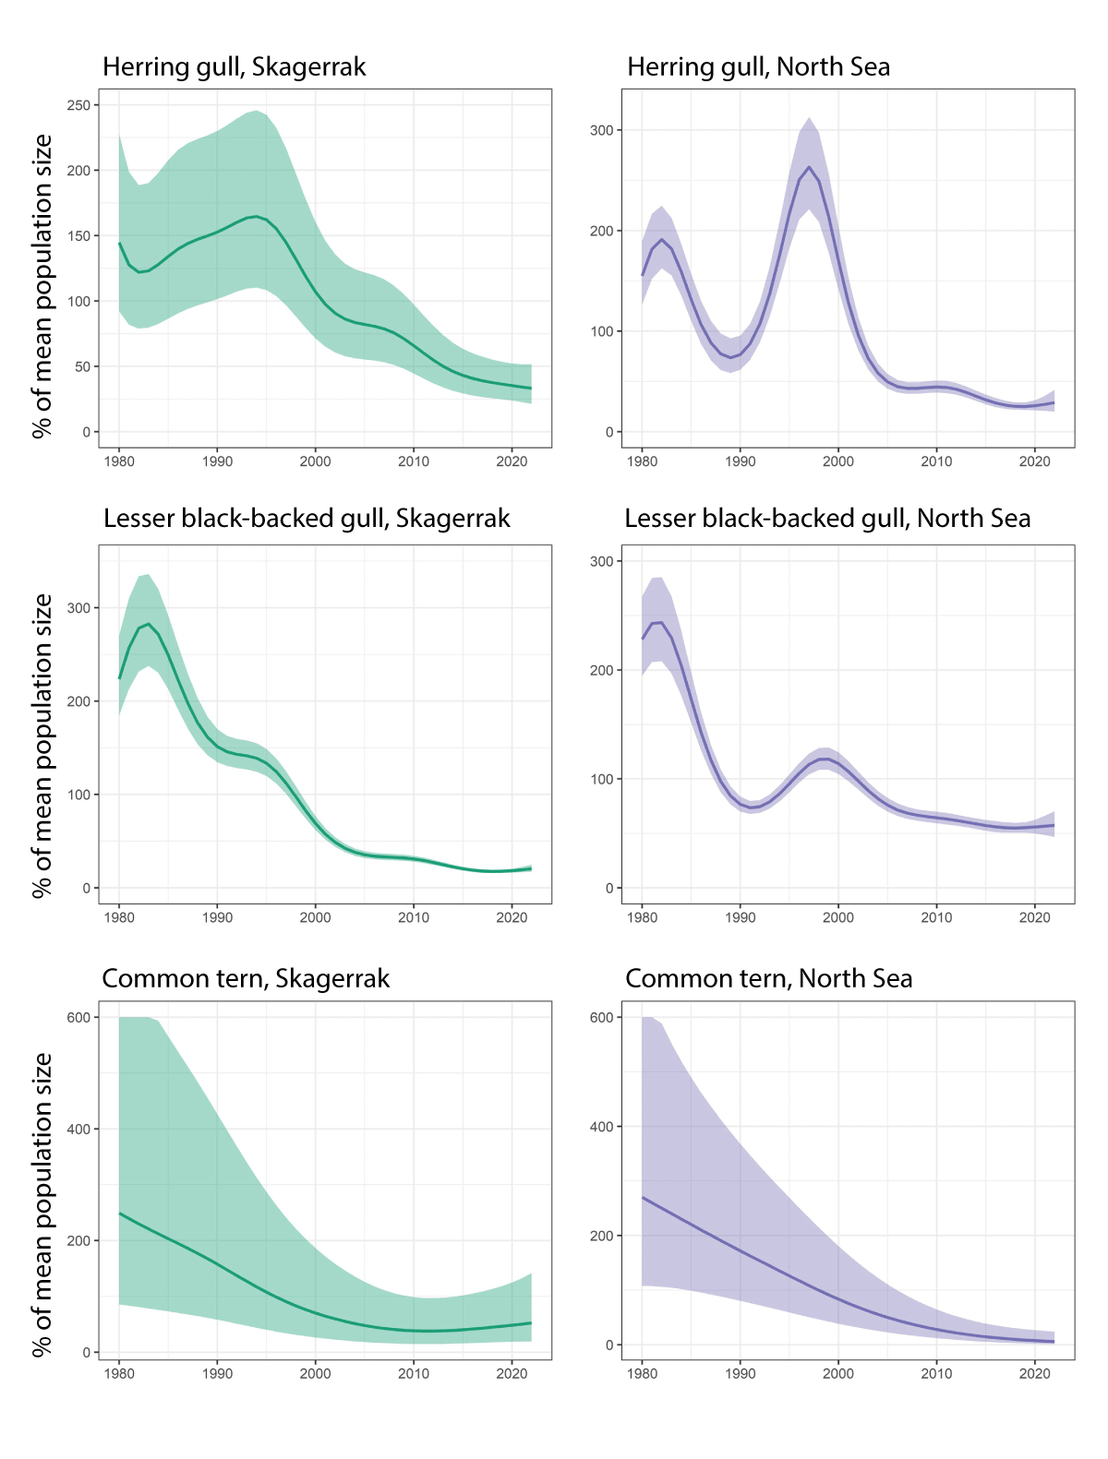
          - Population trajectories for herring gull, lesser black-backed gull and common tern in bird reserves in the North Sea-Skagerrak area. The figures show average trends with 95 % confidence intervals.
Source: Norwegian Institute of Nature Research
Marine mammals
The dominant marine mammal in the North Sea is the harbour porpoise, a small toothed whale with an estimated population of about 91 000 based on recent surveys. Porpoises are vulnerable to bycatches in the fisheries, but this does not appear to have resulted in population decline in the North Sea–Skagerrak area. Other toothed whales such as orcas and white-beaked dolphins are also observed regularly in the management plan area, but in small numbers. There are considerable numbers of minke whales in the North Sea in summer, but their abundance has varied widely according to surveys in the past 30 years.
There are two coastal seal species in the management plan area. The grey seal occurs from Rogaland and northwards. The estimated total population in the management plan area is around 200 animals. In 2022, the total population of common seal in the area was estimated at a minimum of 1689 animals, which is more than twice the estimate from the period 2016–2021. Seals are harvested as a renewable resource.
Alien species
There are more alien species in the North Sea–Skagerrak area than anywhere else in Norway’s marine and coastal waters. This is probably because of the greater volume of shipping and higher level of activity in this area, and also because the ocean currents in Norway’s southerly waters are more liable to spread alien species that have already become established elsewhere in Europe. Most alien species in the North Sea–Skagerrak area are associated with coastal waters. Examples include Pacific oysters, japweed (Sargassum muticum), the comb jelly Mnemiopsis leidyi and carpet sea squirt.
Pacific oysters can form very dense oyster reefs and alter coastal habitats. In some areas, the species can compete strongly with mussels and to some extent with European flat oysters. Pacific oysters have become established along the Skagerrak and North Sea coast of Norway as far north as Bergen. The species may still be in an early phase of establishment along the coast of Western Norway. It is dependent on fairly high summer temperatures for successful spawning, and is also sensitive to low winter temperatures.
The carpet sea squirt was found in the port of Stavanger in 2020. This species is spread by shipping through hull fouling and on other objects floating in the sea. It tolerates temperatures between -2 and 24°C and can therefore thrive along most of the Norwegian coast. It appears to be spreading rapidly along the coast of Western Norway. It can overgrow and displace most other naturally occurring filter feeders (for example mussels and oysters). It can also have an impact on other habitat types in shallow waters such as Laminaria hyperborea kelp forests, eelgrass meadows and maerl beds.
Threatened species and habitat types
The number of threatened species in the North Sea–Skagerrak management plan area has continued to increase. In all, 33 species in the area are listed as threatened (in one of the categories critically endangered, endangered or vulnerable) in Norway’s 2021 red list. Conservation status is poorer for 16 species and better for four species than in the 2015 red list. Several species of annelid worms have been added to the list. The common guillemot and the skate Dipturus intermedius are still listed as critically endangered, and the shagreen ray and black-headed gull are now also classed as critically endangered. Species listed as endangered include fish (blue ling, golden redfish, basking shark, European eel) seabirds (kittiwake, common tern, puffin and fulmar) and two species of annelid worms. The common eider population has continued to decline, and the species has now been classed as endangered.
Three deep- and shallow-water marine habitat types are classed as threatened. Bamboo coral gardens are now considered to be endangered both in the North Sea and in the Skagerrak. Bottom trawling (for shrimps) is widespread within the distribution area of bamboo coral in the North Sea, and is liable to damage this habitat type. Sugar kelp forests are also endangered as a result of pollution and climate change. The situation for mussel beds that are exposed to wave action has improved. The conservation status of coral reefs has improved from vulnerable to near-threatened.

Pollution
The North Sea-Skagerrak area is generally more polluted than the other two management plan areas. Inputs of persistent, bioaccumulative and toxic substances and other pollutants to this area take place with ocean currents and in the atmosphere, with rivers, in runoff from land, in discharges from land-based industry, and may also originate from petroleum activities, the fisheries, aquaculture and shipping.
There is a higher level of activity in the petroleum industry and maritime transport in the North Sea and Skagerrak than in the other management plan areas. The largest source of oil discharges to the North Sea is the continual release of produced water from offshore oil and gas extraction. There has been a weak reduction in releases of oil with produced water in the North Sea since 2015. Monitoring has identified impacts of oil pollution on haddock caught near petroleum installations in the North Sea, in the form of DNA damage as a result of exposure to PAHs (polycyclic aromatic hydrocarbons). It is uncertain how much of this can be attributed to earlier discharges of drill cuttings contaminated with oil-based drilling fluids, and how much to operational discharges in connection with current activities. Samples of other fish species have not shown similar effects. We lack recent modelling results for operational discharges of oil from shipping.
Across most of the North Sea, inputs via the atmosphere appear to be most important source for most of the persistent, bioaccumulative and toxic substances that have been investigated: mercury, most other heavy metals, PAHs and PCBs. In the Skagerrak, inputs from rivers and areas near the coast are most important for most heavy metals and PCBs. Atmospheric inputs of most heavy metals and other persistent, bioaccumulative and toxic substances that are monitored have declined considerably since measurements started during the 1990s. Inputs have levelled off at low levels in recent years. The reduction in inputs can be explained by large emission reductions in other European countries.
Levels of most contaminants in seafood species from the management plan area are below the maximum permitted levels for food safety. In certain cases, for example shrimps, the levels of contaminants are higher than the Environmental Quality Standards (EQS), and could potentially have an impact on animals at the top trophic levels, such as seabirds and marine mammals. We lack indicators for the levels and effects of hazardous substances in vulnerable top predators such as seabirds and marine mammals in the North Sea.
Levels of man-made radioactive substances in the North Sea and Skagerrak are low, but somewhat higher than in the Norwegian Sea and Barents Sea–Lofoten area. This is explained by the outflow of water from the Baltic Sea, which contains higher concentrations of caesium-137 from the 1986 Chernobyl accident. The oil and gas industry releases naturally occurring radioactive substances in produced water, but on most fields the levels of radioactivity involved are low. The largest releases are in the North Sea. No negative environmental impacts have been identified at the levels of radioactive pollution found in Norway’s marine and coastal waters.
Patterns of inputs of nutrients differ between the North Sea and the Skagerrak. Inputs of phosphorus and nitrogen and of organic matter to the Skagerrak coast vary from year to year but with no clear trend over time. Inputs of copper have declined. In contrast, inputs of phosphorus to the North Sea coast show a large increase throughout the whole measurement period.
Inputs of nitrogen show a marked rise from 2000 to 2015, but have since declined somewhat. The rise in inputs of nutrients (Figure 3.22) and copper to the North Sea is to a large extent linked to releases from fish farming. The use of copper for impregnation in the aquaculture industry has been somewhat reduced in recent years. Little is known about how nutrients are transported from coastal waters to the open sea.
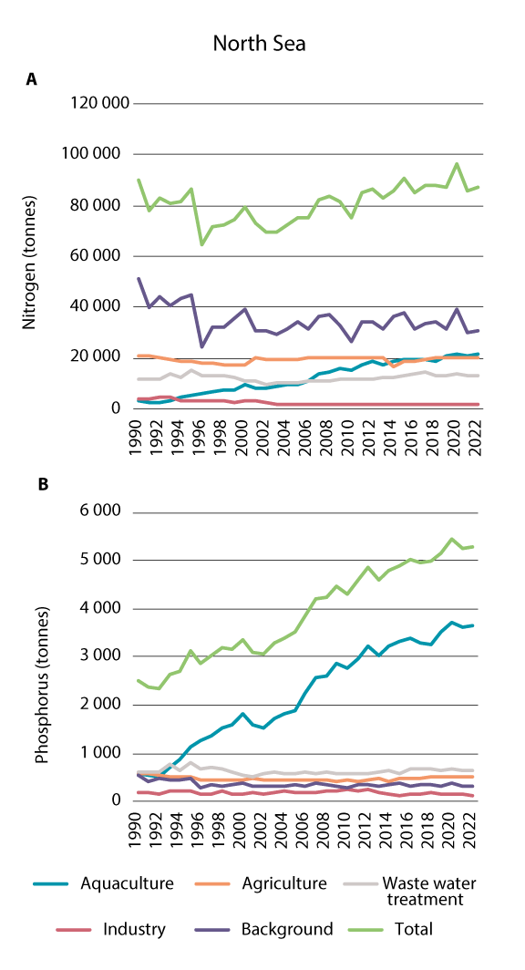
          - Inputs of nitrogen (a) and phosphorus (b) to the coastline bordering the North Sea-Skagerrak management plan area in the period 1990-2022.
Source: NIVA report 7963-2024
Runoff of nutrients from land and transport with ocean currents can carry nutrients from coastal waters to the open sea. The concentration of nutrients is measured in the water column in the Skagerrak. Over the past 20 years, the concentration of nitrogen in open waters in the Skagerrak has declined.
There have been improvements in nutrient levels over the years. There is no eutrophication in open waters in the Skagerrak, but certain areas close to the coast do show signs of eutrophication, for example the Oslofjord.
There are many sources of underwater noise in the North Sea and Skagerrak. Underwater noise from shipping appears to be particularly intense in the Norwegian sector of the North Sea. The level of seismic activity is also high here. Underwater noise can alter the behaviour of a variety of marine organisms including marine mammals, seabirds and fish, but currently little is known about possible effects at population and ecosystem level.
The largest source of marine litter and plastic pollution in the North Sea and Skagerrak is consumer waste. Sea-based sources are also important, especially the fisheries. In the North Sea, fulmars are used as an indicator species for plastic pollution. The target is for the percentage of fulmars from the North Sea with more than 0.1 g plastic in the stomach to be below 10 %, but this has not been achieved. The percentage of fulmars with more plastic in their stomachs is considerably higher, and has been fairly constant at around 50 %. Monitoring of beach litter at Lista and Ytre Hvaler has shown no reduction in quantities. Too little is known about trends for marine litter and plastic pollution in this management plan area. Knowledge will be built up through national monitoring programmes for microplastics and macroplastics and more intensive monitoring of beach litter under OSPAR.
Ammunition dumped at sea
Several hundred thousand tonnes of ammunition and chemical weapons have been dumped in Norway, most of it at sea. However, much of this was never registered, and the real quantities are therefore unknown. Most of the dumped ammunition is from the Second World War. In the post-war years, entire ships carrying German chemical weapons were sunk in the Skagerrak, with the permission of the Norwegian authorities. At the time, this was regarded as a simple and low-cost way of dealing with the problem.
Ammunition contains explosives, heavy metals, and a variety of hazardous substances. The Norwegian Defence Research Establishment is mapping and carrying out environmental monitoring of dumping sites. Pollutants have started to leak from dumped ammunition, but little is known about the environmental impacts. The Defence Research Establishment has found that heavy metals, explosives and other substances are leaking from several dumping sites in Norwegian waters (in the Skagerrak, near Bergen and in Nordland and Troms counties). Investigations in the other four areas in the list have revealed residues of explosives in fish and shellfish near all the sites investigated, while residues of chemical warfare agents were found in fish and shellfish near the site investigated in the Skagerrak. Dumped ammunition poses a risk to the fishing industry and others using areas near the dumping sites. Explosives in ammunition that was dumped at sea or buried on land are often functional for long periods after they were produced, and may in some cases become more sensitive to disturbance over time. In the worst case, ammunition may self-detonate where it was dumped or if it is moved.

Analyses of future climate change in Norwegian waters
In its Sixth Assessment Report (2021–2023), the IPCC concludes that climate change is expected to intensify in all regions of the world, and that the global temperature rise will exceed 1.5°C in the next 20 years at current emission levels. The IPCC’s findings show that it is very likely that ocean acidification will continue to increase for several decades if global CO2 emissions go on rising. This will have major negative impacts on marine ecosystems. Knowledge about how climate change is likely to affect Norway’s coastal and marine waters has been considerably improved. In the previous white paper on the management plan areas, it was decided to conduct a risk analysis of direct and indirect effects of climate change on marine ecosystems under different emission scenarios, and this work has now been done. The Institute of Marine Research modelled changes in Norway’s ocean areas for three global emission scenarios, SSP1-2.6 (low), SSP2-4.5 (intermediate) and SSP5-8.5 (very high). Using the same emission scenarios, the Norwegian Institute of Water Research assessed how climate change will affect the physical and biological environment in Norwegian coastal waters. This section presents the main points from these two reports, supplemented with findings from the assessments of ecosystem condition.

Norway’s ocean areas – future climate change and impacts
Seawater temperatures will rise, both at the surface and in deeper water layers. Projections for surface water temperatures from 2015 to 2100 show only small expected changes under the low emission scenario, whereas very large changes are expected under the very high emission scenario towards the end of this century (Figure 3.23). Under this scenario, it is also expected that the sea ice will almost completely disappear by 2100. With rising temperatures, the oxygen content of the seawater will also decline, particularly under the very high emission scenario, and the greatest reduction will be in the northernmost parts of the Barents Sea. A reduction in pH is expected under both the intermediate and the very high emission scenario. The decline in pH is expected to be largest in the Arctic water in the easternmost parts of the Barents Sea.
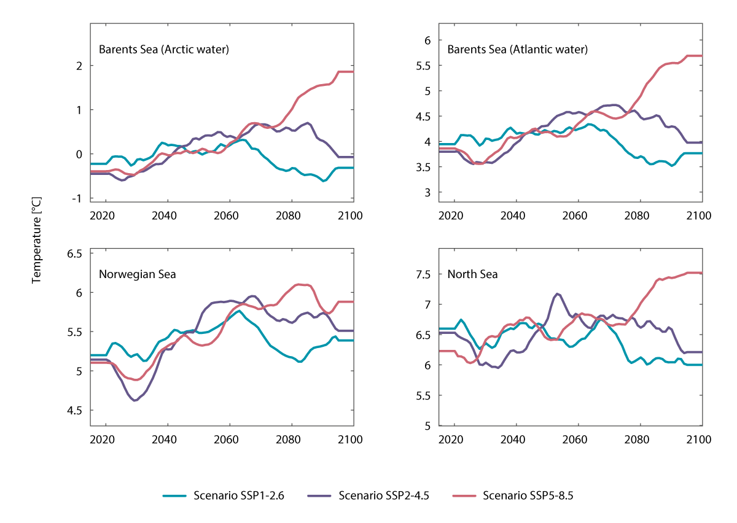
          - Projected surface water temperatures (°C) in March for the period 2015-2100 in ocean basins and neighbouring coastal waters. The colours of the time series indicate the emission scenarios used: SSP1-2.6 (blue), SSP2-4.5 (purple) and SSP5-8.5 (red). The low (SSP1) scenario represents a green pathway and sustainable growth. The intermediate scenario (SSP-2) represents a pathway following historical trends. The very high scenario (SSP5) represents a world of rapid and unlimited growth in production and energy use.
Source: Sandø A. B. et al (2022) Risikoanalyse for de norske havområdene om direkte og indirekte virkninger av klimaendringer på marine økosystemer under ulike utslippsscenarier [Risk analysis for Norway's ocean areas of direct and indirect effects of climate change on marine ecosystems and other relevant factors under different emission scenarios] Rapport fra havforskningen 2022-4
Primary production is expected to increase in northern parts of the Barents Sea with the retreat of the sea ice. This effect is particularly marked under the very high emission scenario. In the North Sea, primary production is expected to decrease, especially under the very high emission scenario. This is reflected in projected changes in secondary production, which is expected to increase in the Barents Sea and the Norwegian Sea, but decrease in the North Sea.
Changes in temperature, ice extent, oxygen content, pH, primary and secondary production, and knowledge about how sensitive different populations are to changes in these variables, were used as a basis for assessing the overall effects on 13 populations of selected key species of plankton, fish and shellfish.
It seems likely that the North Sea population of European hake, a temperate species, will benefit from a warmer ocean climate in the North Sea, while there will probably be negative impacts on other populations in the North Sea, for example North Sea herring, North Sea cod and the copepod Calanus finmarchicus. This applies especially to the North Sea cod population, since both direct effects of temperature on cod and indirect effects through changes in zooplankton production and species composition are important factors. C. finmarchicus provides an important link between primary production and fish and other organisms at higher trophic levels. It therefore plays a key role in Norwegian marine ecosystems. The projected decrease in secondary production is due to the expected drop in primary production.
Of the populations in the Norwegian Sea, European hake, Northeast Atlantic mackerel, Norwegian spring-spawning herring and C. finmarchicus will all benefit from higher temperatures. This conclusion is based on expansion of their distribution as a result of rising sea temperatures, and higher secondary production (food availability).
In the Barents Sea, a large increase in the population of Northeast Arctic cod is expected. This is explained by the loss of sea ice as temperatures rise, which will result in higher primary and secondary production in areas where the ice melts. Thus, rising temperatures will result in more abundant food supplies for Northeast Arctic cod and other species such as C. finmarchicus. However, the cod stock is currently declining despite warming sea temperatures. This is linked to weak recruitment, the cause of which is unknown. Under the very high emission scenario, the disappearance of the sea ice is very likely to have negative impacts on populations of species that are more closely associated with the marginal ice zone, such as capelin and Arctic cod. This effect may to some extent be counteracted by higher primary and secondary production. Because of this, the overall impact of climate change on capelin is expected to be positive. In contrast, climate change may have serious negative impacts on polar cod, since this species spawns under the sea ice and is closely associated with the marginal ice zone.

Norway’s coastal waters – future climate change and impacts
For Norwegian coastal waters, projected climate change during the 21st century will result in considerable warming and acidification of the seawater. The higher the level of greenhouse gas emissions are, the greater the changes are projected to be. Depending on latitude, the average surface water temperature will rise from the current level of 6.5–9 °C to 9–11°C under the intermediate emission scenario. As the water warms, it can hold less dissolved oxygen. Dissolved oxygen in the water column shows a declining trend up to 2100, but oxygen availability is not expected to become a limiting factor in Norwegian waters. The largest changes in temperature and oxygen content are expected to occur along the coast of North Norway. Acidification is expected to increase along the entire coastline, particularly under the very high emission scenario, with the largest reduction in pH in the southern half of the country. Salinity is expected to decline along the coast as a result of higher precipitation on land and an increase in runoff from rivers. The lowest salinity values for the whole Norwegian coast are measured in the surface waters of the Skagerrak, and this is also where the largest reductions in salinity are expected, especially under the very high emission scenario. An increase in runoff will also cause darkening of the water, particularly in the Norwegian coastal current, and this may have an impact on productivity in the areas affected.
Projected impacts on coastal species
An assessment was made of the impacts of projected climate change in Norway’s coastal waters on the quality and extent of the habitat used by five species – Atlantic salmon, coastal cod, the kelp Laminaria hyperborea, green sea urchin (Strongylocentrotus droebachiensis) and red king crab. These species play an important role in the coastal ecosystem and also for the regional and national economy, historical and cultural traditions and food security.
Changes in physical conditions along the Norwegian coast will result in changes in the distribution of many marine species, including the five selected for this analysis. The estimates for red king crab habitat indicate that the species will be mainly confined to North Norway, but even there, habitat quality will decline up to 2100 under all three scenarios. The estimates for coastal cod suggest that it will be able to find suitable habitat all along the Norwegian coast and through the entire period up to 2100. The best conditions will be in North Norway, where physical conditions will continue to be within the species’ tolerance limits in future, while temperatures in other parts of the country will gradually become too high. For Atlantic salmon, rising seawater temperatures will result in declining habitat quality in coastal areas, but coastal waters will continue to provide suitable habitat for the species under all three emission scenarios. Given its temperature preference, the distribution of L. hyperborea is expected to remain stable in southerly coastal waters and expand somewhat further north in the coming decades. However, the temperature will rise more steeply towards the end of the century under the intermediate and very high emission scenarios. The result is expected to be a decline in distribution or local extinction in the southern half of the country, respectively. The green sea urchin is generally resilient to climate change, and the estimates indicate that its distribution will be stable under the low and intermediate emission scenarios. Under the very high emission scenario, a steep decline ending in local extinction is expected along the whole of the Norwegian coast, mainly as a result of higher temperatures and a sharp drop in pH.
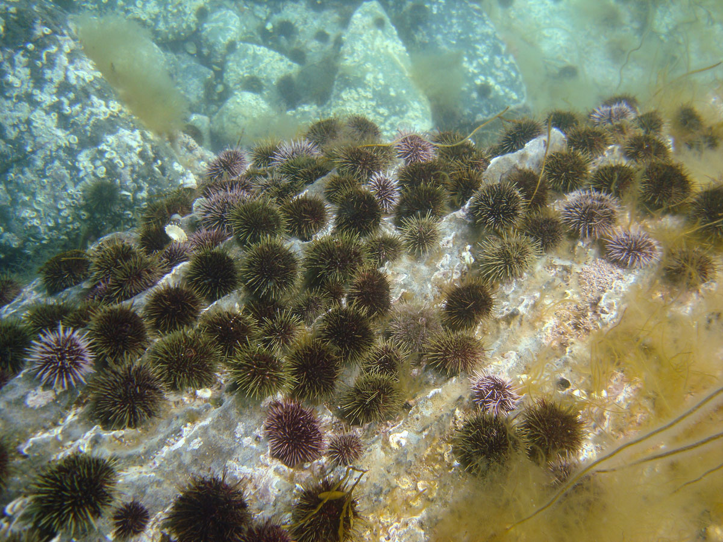
          - Green sea urchins in the Vega archipelago. Large areas of kelp forest along the coast of the Norwegian Sea have been overgrazed by sea urchins
Photo: Eli Rinde/ Norwegian Institute for Water Research

Marine heatwaves
As a consequence of global warming, both the frequency and the duration of marine heatwaves have increased over time in the world’s oceans, most rapidly in recent decades. They are expected to become even more frequent and more intense in the future. A marine heatwave can be defined as a discrete, prolonged (more than five days) anomalously warm water event. Marine heatwaves are described in terms of their duration, intensity, frequency and spatial extent. Heatwaves may be triggered by both large-scale and regional atmospheric and oceanic processes.
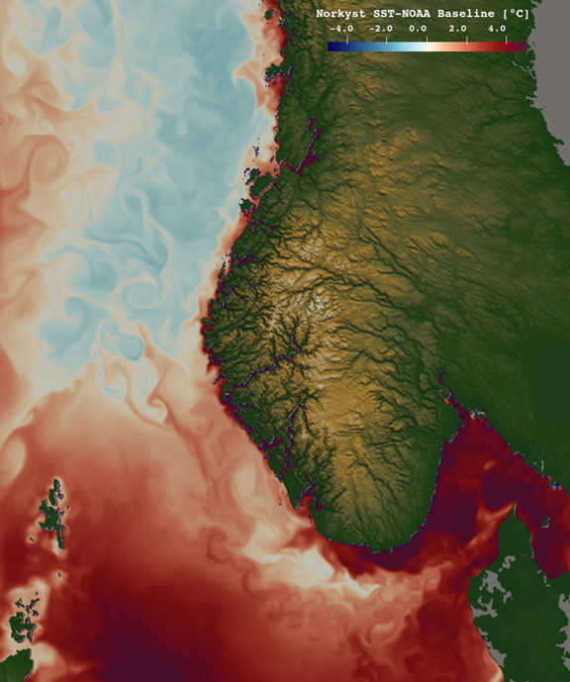
          - Marine heatwave in the North Sea, showing the sea surface temperature anomaly on 18 June 2023. This was during an intense marine heatwave in the North Atlantic and North Sea, with temperatures up to 4-5 °C higher than expected on the basis of the long-term mean for the period 1991-2020.
Data source: Norwegian Meteorological Institute, Norkyst_v3 model for coastal forecasting and NOAA Optimum Interpolation SST V2. Figure: Marta Trodahl, Norwegian Meteorological Institute
Knowledge about the scale and impacts of marine heatwaves is limited, but there is growing evidence of major biological impacts in many parts of the world’s oceans. The effects of marine heatwaves are linked to the heat tolerance of marine species and how mobile they are. Observed impacts of marine heatwaves in the Pacific, Atlantic and Indian Oceans include coral bleaching, toxic algal blooms, loss of kelp forests and seagrass meadows, and declining fish stocks or shifts in their distribution. Marine heatwaves are probably a greater threat to marine ecosystems than the gradual temperature rise associated with global warming. There are few studies of the possible effects of marine heatwaves on marine ecosystems in northern waters. Knowledge of possible impacts is based on studies from other regions with comparable ecosystems.
A literature review commissioned by the Norwegian Environment Agency contains a description of what is known about marine heatwaves in Nordic waters in the period 1982–2020. In waters north of 60 oN, which on both the Barents Sea and the Norwegian Sea, the intensity, duration, frequency and spatial extent of marine heatwaves have all increased during this period. In this region, the increases are correlated with rising air temperatures at the sea surface and a decline in sea ice extent. Marine heatwaves in Arctic waters are just as intense as or even more intense than those in other waters. There is a stronger increase in their frequency than in other waters.
The spatial extent of marine heatwaves in the Barents Sea varies widely. In the waters around Svalbard, there have been 2–3 marine heatwaves per year since 1982, while in the rest of the Barents Sea they occur 1–2 times a year. For the Barents Sea as a whole, the frequency of marine heatwaves has risen by 62 % over this period, and particularly strongly in the last decade. Since 1982, there have been 1–2 marine heatwaves per year in the Norwegian Sea. This is believed to be 2–4 times the frequency in the pre-industrial period.
The frequency of marine heatwaves is rising in the North Sea and Skagerrak as well. Sugar kelp is the dominant kelp species along the North Sea and Skagerrak coast of Norway. The decline of sugar kelp forests has been explained by a combination of eutrophication, a rise in the content of particulate matter in seawater, sediment deposition and higher water temperatures. New studies have shown that marine heatwaves may also be a cause of sugar kelp decline. Sea temperatures during marine heatwaves have regularly exceeded the lethal limit for sugar kelp.
An indirect positive effect of higher sea temperatures combined with marine heatwaves is that recruitment of sea urchins, which overgraze kelp forests, is declining in Norway’s southerly waters. The sea urchins do not tolerate such high water temperatures, and the main distribution area is shifting northwards. This has resulted in less overgrazing along the North Sea and Norwegian Sea coasts.
Using analyses of historical data for seawater temperatures combined with more intensive monitoring, particularly of species that are sensitive to temperature, it will be possible to build up more knowledge about marine heatwaves in Norwegian waters.

Knowledge building and knowledge needs
Knowledge-based management of Norwegian waters must be based on adequate knowledge about ecosystem condition, drivers of change and impacts. This is built up through mapping, monitoring and research. A considerable amount of knowledge has been built up since the previous white paper on Norway’s ocean management plans was published, especially about the particularly valuable and vulnerable areas. We have also learned more about the effects of climate change, the spread of microplastics and cumulative impacts. However, further work needs to be done to continue knowledge development, in particular about ecosystem condition, changes, the impacts of drivers, causal relationships and cumulative impacts. Important knowledge needs relating to integrated ocean management are also discussed in the white paper on a long-term plan for research and higher education 2023–2032 (Meld. St. 5 (2022–2023)) under the thematic priority oceans and coastal waters.
Biodiversity and ecosystems
Mapping and monitoring are needed in areas where knowledge is currently limited, for example open waters in the Barents Sea and the Norwegian Sea. In areas that are already better known, there should be long-term monitoring of species and habitats and the physical environment. Monitoring programmes need to include organisms at all trophic levels and in all functional groups in representative marine ecosystems.
More knowledge is needed about how climate change, pollution and environmental conditions influence population, species and ecosystem trends, and what can be done to repair damage that has been done to species and habitat types.
In addition, the distribution of endangered marine habitat types needs to be mapped. We also need to learn more about ecological processes such as interactions between species and trophic levels. Moreover, we need to build up knowledge about factors that affect the vulnerability vulnerable of species to habitat change. More knowledge is needed about the causes of changes in seabird populations.
There is a need for more systematic monitoring of the spread of alien species and their impacts on native species and habitat types, particularly near the coast. In addition, we need to learn more about pathways of introduction, how to avoid the spread of alien species, and how to contain and control alien species that have already become established.
Climate change and ocean acidification
Since the previous white paper on the management plans was published, a great deal of new knowledge has been obtained about climate change and its effects in Norway’s ocean areas. Nevertheless, there are still knowledge gaps as regards current and future effects of climate change on natural carbon stores, levels of hazardous substances in ecosystems and their effects, and the spread of alien species. Marine habitat types and species that are vulnerable to and/or are being adversely affected by climate change and ocean acidification should be mapped and monitored.
Pollution and litter
Much more information is still needed to give a complete picture of the levels of hazardous substances in the management plan areas. The monitoring programmes only include a limited selection of substances, and new chemicals are constantly being registered in these areas. More knowledge is needed both about the levels of ‘new’ substances, including micro- and nanoplastics, and about their implications for seafood safety and human health. Our knowledge about concentrations of persistent, bioaccumulative and toxic substances in organisms at the lowest trophic levels is also limited and should be further developed. The same applies to knowledge about the effects on fish, seabirds and marine mammals.
Marine organisms are exposed to many different substances simultaneously, and more knowledge is needed about critical levels of exposure to persistent, bioaccumulative and toxic substances and about the cocktail effects of releases of multiple pollutants. In the North Sea and Skagerrak, regular monitoring of levels of metals in sediments is needed. The Environmental Specimen Bank Norway is one important tool in national and international efforts to deal with hazardous substances. Environmental samples stored here provide an archive of the past for future use. More knowledge is also needed about levels of plastic pollution and about its spread and impacts, particularly as regards micro- and nanoplastics. It is important to use suitable indicators for monitoring based on countries’ national monitoring programmes, and to implement and harmonise programmes with regional and international initiatives. More knowledge is needed about levels of micro- and nanoplastics, and chemicals associated with them, in the environment and in seafood. We also need a better understanding of the implications for seafood safety and human health. Our understanding of the impacts of underwater noise on ecosystems is also inadequate. In addition, we need to build up knowledge of indicators for underwater noise (pressure and ecosystem effects), vulnerability to noise at population level and threshold levels for behavioural change, for example in fish.
Radioactivity in seawater is already being monitored, but more knowledge is needed on uptake, accumulation and possible impacts of radioactive pollution of the marine environment. We also know too little about various aspects of operational releases from the offshore oil and gas industry. For example, little is known about the effects of complex mixtures of chemicals, or about the long-term effects of exposure to releases of naturally occurring substances and chemical additives. With the methodology and information currently available, it is also difficult to identify links between operational discharges and elevated levels of hazardous substances in organisms such as fish. Sandeels are a key species in the North Sea and are under growing pressure from existing and emerging ocean industries. Too little is known about the vulnerability of sandeels to various types of human-induced drivers, including pollution, and the possible impacts of these factors. Studies of the vulnerability of sandeels to crude oil are now being carried out by the Institute of Marine Research, financed by the petroleum industry.

Management of marine biodiversity
Safeguarding marine biodiversity must be an integral part of ocean management. In addition to being crucial for the marine environment itself, an ocean management regime that can maintain and enhance biodiversity and biological production is important for maintaining and strengthening ecosystem services that are vital to people, and for improving the resilience of the oceans to the impacts of climate change. The extent of intact ecosystems can be boosted through integrated ocean management, including coordination and sound spatial management of marine areas. Natural ecosystem functions and services have a decisive role to play in addressing the problems associated with biodiversity loss and climate change. This is something the Norwegian Government recognises as an important consideration in developing an integrated ocean management system. With this white paper, the Government is continuing to develop its efforts to ensure the conservation of areas of special importance for marine biodiversity as part of an integrated, sustainable and ecosystem-based ocean management regime. The sustainable use of ocean areas for commercial activities is discussed in Chapters 5 and 7.
Norway considers it important to ensure knowledge-based, integrated and responsible management of marine and coastal waters. Mapping, research and environmental monitoring provide a sound knowledge base for the management system. By building up knowledge, we gain a better understanding of marine ecosystems and their functions, including the provision of ecosystem services that benefit people. The knowledge base will also provide a better basis for developing a system of ocean accounts, which is discussed later in this chapter. This system will include the development of ecosystem accounting for the oceans, which includes the valuation of marine ecosystems and ecosystem services. An overall scientific review of the particularly valuable and vulnerable areas has been completed since the previous white paper on the management plans was published, thus improving the basis for one important element of the integrated ocean management system.

Particularly valuable and vulnerable areas
Particularly valuable and vulnerable areas are identified on the basis of scientific assessments as being of great importance for biodiversity and biological production in an entire management plan area. This system is both a scientific way of identifying areas of particular value and an important basis for knowledge-based management of marine areas. The designation of areas as particularly valuable and vulnerable does not have any direct effect in the form of restrictions on commercial activities, but indicates that these are areas where it is important to show special caution, and where activities must be conducted in such a way that the ecological functioning and biodiversity of an area is not threatened.
The occurrence and geographical distribution of valuable ecological features is used as a starting point for delimiting particularly valuable and vulnerable areas. After this, the vulnerability of each area is assessed separately. The areas are selected using predefined criteria, the main ones being their importance for biodiversity or for biological production. To describe the overall environmental value of each area, it needs to be assessed against the criteria for EBSAs (ecologically or biologically significant marine areas), which is an internationally recognised scientific method for identifying valuable marine areas, developed under the UN Convention on Biological Diversity. Such areas are often to be found where there are distinctive topographic or oceanographic features. Areas may for example be identified as particularly valuable and vulnerable because they are important habitats or spawning grounds for fish, important habitats for seabirds and marine mammals, or contain coral reefs.

Particularly valuable and vulnerable areas and implications for economic activity
The identification of particularly valuable and vulnerable areas is not in itself an administrative measure. These areas do not have any special legal status and their designation does not have other direct effects in the form of conservation measures or restrictions on or a framework for economic activity. However, the designation of areas does indicate a need for special caution, for example to safeguard biodiversity and biological production. The authorities can evaluate whether there is a need to introduce a framework for activities in specific areas.
The identification of an area as particularly valuable and vulnerable does not automatically determine which management measures are relevant or whether a framework for economic activity should be introduced, and if so for which types of activities. Any political decision on a framework for activities in a specific area will be based on an assessment of the level of environmental pressure and risk that is considered to be acceptable, weighed against the benefits to society of permitting economic activity. The area or areas to which a framework for a particular activity applies will not necessarily coincide with the boundaries of particularly valuable and vulnerable areas. This will be further assessed based on the best available scientific information about the spatial and temporal distribution of valuable ecological features and when and where they are vulnerable to different types of activity. We need to find the most appropriate ways of incorporating concerns about the ecological value of individual areas, but without making the framework for economic activity in fields such as petroleum, CCS, offshore wind, seabed minerals, fisheries, aquaculture and shipping more restrictive than needed to safeguard the valuable ecological features of each area.
The pressures that human activities may put on the valuable ecological features of an area, and their possible impacts, must be assessed to identify relevant management measures. It is important to recognise that ecological features may exhibit varying degrees of vulnerability to different pressures, and that the distribution of many ecological features varies over space and time.
A cautious approach can be built into integrated ocean management by setting an overall framework that protects valuable ecological features against pressures to which they are vulnerable. Different sectors can exercise due care through spatial planning for commercial activities. The authorities can make it clear that businesses are expected or required to exercise due care when planning and carrying out their activities. The competent authorities must evaluate whether businesses are in fact exercising due care, or whether it is necessary to establish separate requirements for specific activities. To ensure proper assessments relating to due care, it is also essential to ensure the involvement of the authorities for relevant sectors and dialogue between them and the environmental authorities.
There is already extensive commercial activity in Norwegian ocean areas, including the particularly valuable and vulnerable areas that have been identified. For example, several oil and gas fields and many of the most important and intensively used fishing grounds are within particularly valuable and vulnerable areas. A number of management measures have already been implemented, some of which apply to specific geographical areas while others are more general. These measures influence the extent to which particular activities have pressures and impacts on important ecological features. Both the pressures and impacts associated with existing activities and the effects of already existing management measures are included when assessing the need for new measures in a particularly valuable and vulnerable area.
Particularly valuable and vulnerable areas were initially identified in the white paper on the first management plan for the Barents Sea–Lofoten area (Report No. 8 (2005–2006) to the Storting). The white paper described seven areas that had been scientifically identified as particularly valuable and vulnerable. In subsequent white papers, eleven areas were identified as particularly valuable and vulnerable in the Norwegian Sea (Report No. 37 (2008–2009) to the Storting), and twelve areas in the North Sea and Skagerrak (Meld. St. 37 (2012–2013)).
An important topic in the previous white paper on the ocean management plans (Meld. St. 20 (2019–2020)) was the delimitation of the marginal ice zone as a particularly valuable and vulnerable area and the framework for petroleum activities in this area. The white paper also stated that a review of valuable species and habitats and their vulnerability in all the particularly valuable and vulnerable areas identified in the management plan areas was to be completed. Candidate areas that had been identified and if relevant, new areas, were also to be evaluated. This process was also to include an assessment of whether areas containing underwater mountains meet the criteria for designation as particularly valuable and vulnerable areas. The review was subsequently commissioned by the Forum for Integrated Ocean Management. On the basis of updated scientific evidence, interdisciplinary expert groups have presented an extensive synthesis of knowledge about valuable ecological features, intrinsic vulnerability and cumulative environmental effects in the particularly valuable and vulnerable areas.
The review of the particularly valuable and vulnerable areas is discussed below, followed by a presentation of the new set of areas and their boundaries. The approach used by the Forum for Integrated Ocean Management was to start by delimiting areas on the basis of their environmental value, and subsequently to assess vulnerability for each of the areas identified.

The review of particularly valuable and vulnerable areas
An interdisciplinary expert group was commissioned by the Forum for Integrated Ocean Management to propose a set of particularly valuable and vulnerable areas, based on a scientific assessment of their ecological and biological value. The expert group based its work on the existing particularly valuable and vulnerable areas, earlier valuations and new knowledge, and assessed value on the basis of the seven EBSA criteria (see Table 4.1) for identifying ecologically or biologically significant marine areas.
Seven ecosystem components were assessed using this set of criteria: sea ice biota (organisms that live in, on or associated with sea ice), plankton (phyto- and zooplankton), fish, mesopelagic fauna (animals living in the mesopelagic zone, 200–1000 m below the surface), benthic communities, marine mammals and seabirds.
            - The EBSA criteria and their definitions
02J1xx2
Criterion | Definition
Uniqueness or rarity | Area contains either (i) unique (“the only one of  its kind”), rare (occurs only in few locations) or  endemic species, populations or communities, and/or (ii) unique, rare or distinct, habitats or  ecosystems; and/or (iii) unique or unusual  geomorphological or oceanographic features.
Special importance for life-history stages  of species | Areas that are required for a population to survive and thrive.
Importance for threatened, endangered or  declining species and/or habitats | Area containing habitat for the survival and  recovery of endangered, threatened, declining  species or area with significant assemblages of such species.
Vulnerability, fragility, sensitivity, or  slow recovery | Areas that contain a relatively high proportion  of sensitive habitats, biotopes or species that  are functionally fragile (highly susceptible to degradation or depletion by human activity or  by natural events) or with slow recovery.
Biological productivity | Area containing species, populations or communities with comparatively higher natural biological productivity.
Biological diversity | Area contains comparatively higher diversity of ecosystems, habitats, communities, or species,  or has higher genetic diversity.
Naturalness | Area with a comparatively higher degree of  naturalness as a result of the lack of or low level  of human-induced disturbance or degradation.
Source: Convention on Biological Diversity/https://www.cbd.int/decision/cop/default.shtml?id=11663
After reviewing the existing list of particularly valuable and vulnerable areas, the expert group identified a total of 19 particularly valuable and vulnerable areas in Norwegian waters. Seven of these are in the Barents Sea–Lofoten management plan area, eight in the Norwegian Sea and four in the North Sea–Skagerrak area. The geographical delimitation of all of these areas is based on the distribution of important ecological features.
Another expert group subsequently assessed the intrinsic vulnerability of a range of ecosystem components to various environmental pressures in all the particularly valuable and vulnerable areas that were identified. A thorough account of the assessment is provided in the scientific basis for this white paper. The vulnerability assessments are more systematic and science-based than previously, and in all 17 different pressures were assessed for 21 ecosystem components and sub-components. In line with the practice established by the Forum for Integrated Ocean Management, the term vulnerability was in this context understood to mean an intrinsic property of ecosystem components, and not dependent on whether or not specific environmental pressures are actually acting on them. The assessment took account of when and where different ecosystem components are present and of any particularly vulnerable life-history stages, including spawn and fry. It did not include an evaluation of whether the ecosystem components assessed are exposed to environmental pressures in the particularly valuable and vulnerable areas, or whether specific activities in these areas pose a risk to them. In some geographical areas, vulnerability varies through the year with seasonal variations in the distribution and occurrence of ecosystem components. Seabirds are for example most vulnerable at times of year when they aggregate in large numbers, for example along the coast in the breeding season (April–August) and during their swimming migration to nursery areas in the open sea (early autumn).
The ecosystem components included in the researchers’ analyses were restricted to those about which enough is known to determine whether the EBSA criteria are met. The knowledge base has been assessed as sufficient to identify the particularly valuable and vulnerable areas identified as ecologically or biologically significant. The particularly valuable and vulnerable areas are described in more detail below, in line with the scientific basis for this white paper.

Particularly valuable and vulnerable areas in the Barents Sea–Lofoten management plan area
On the basis of the scientific review of the particularly valuable and vulnerable areas, changes have been made to the list for the Barents Sea–Lofoten management plan area. BH1, Waters around Svalbard has been expanded to include the polar tidal front, which is no longer treated as a separate area. Four other particularly valuable and vulnerable areas have also been expanded (and three of them renamed): the Marginal Ice Zone (BH2), the Coastal Zone Finnmark (BH4), the Senja-Tromsøflaket Bank Area (BH5) and the Coastal Zone Lofoten (BH6). The Central Barents Sea (BH7) has been identified as a new particularly valuable and vulnerable area. Finally, the delimitation of Eggakanten North (BH3) is unchanged.
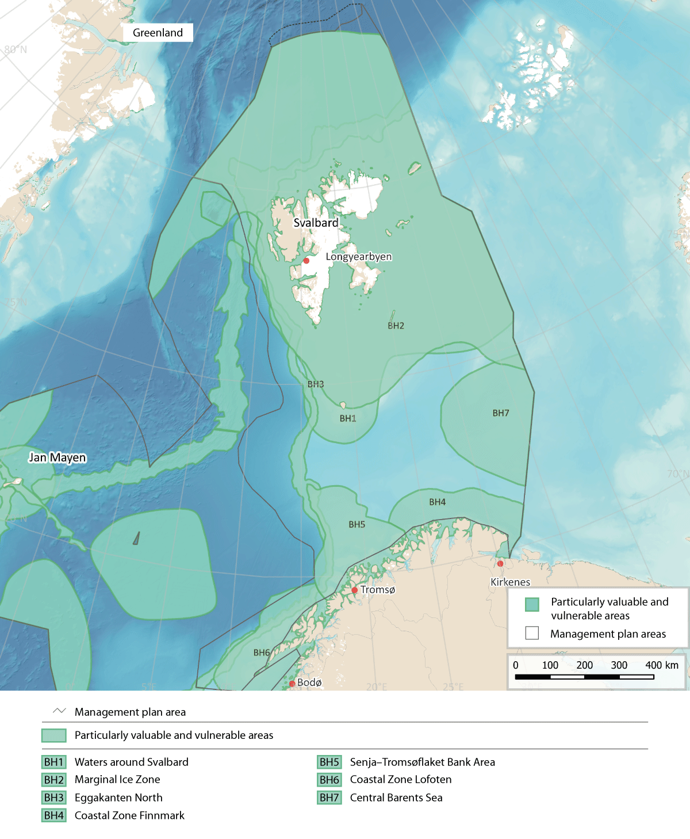
          - Particularly valuable and vulnerable areas in the Barents Sea-Lofoten management plan area. Note that some of the areas overlap
Source: Forum for Integrated Ocean Management/Institute of Marine Research/Norwegian Mapping Authority/ GEBCO Compilation Group (2023)
Waters around Svalbard (BH1)
This area surrounds many islands of all sizes and includes areas of open sea and also coastal waters and fjords. The topography of the seabed, current conditions and hydrography are all complex and variable. Parts of the area, including some of the fjords, may be covered by sea ice for parts of the year. Ice conditions vary from year to year.
Various species and other ecological features found in this area have a local or seasonal distribution, and some are unique to the area. Most animal life and a good proportion of the plant life of Svalbard is directly or indirectly dependent on nutrients from the sea.
Both sea ice and fjord ice in this area support ice biota. The ice biota is very distinctive, including a variety of community types and species belonging to a wide range of different groups, and therefore intrinsically valuable. It also plays a vital role in biological production, which is subsequently channelled through the food web.
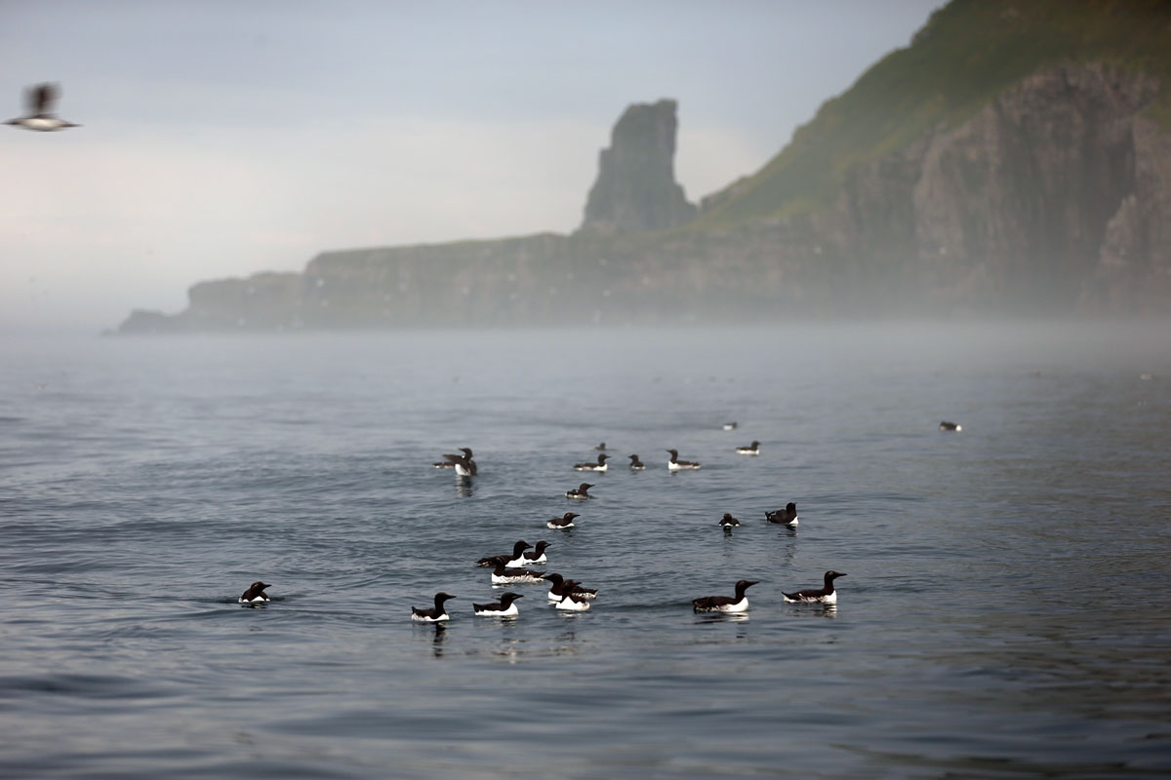
          - Common and Brunnich's guillemots on the sea near Bjørnøya.
Photo: Hallvard Strøm, Norwegian Polar Institute
There are important areas for phyto- and zooplankton production in the Waters around Svalbard. The Spitsbergen Bank, the Hinlopen Strait, and the underside of the fjord ice near certain glacier terminuses are examples of areas that sustain an elevated level of primary production in the water column. Glacier terminuses in the sea around the whole of the Svalbard archipelago are also important feeding areas because they support high primary production.
The Waters around Svalbard include important spawning grounds for polar cod (Boreogadus saida), nursery areas for polar cod, redfish and cod, and feeding grounds for capelin (a key species in the ecosystem), and for polar cod, cod and haddock.
In addition, this area is important for marine mammals, and is one of the parts of the Arctic where the species richness of marine mammals is highest. All the Arctic marine mammals found in the North-East Atlantic occur here, and in addition several species migrate to the area to feed in summer.
Several million seabirds breed in Svalbard, particularly in the southern and western parts of the archipelago. It is estimated that about 45 % of the Svalbard population of Brünnich’s guillemot, a threatened species, breeds around the Storfjorden (between Spitsbergen and Edgeøya).
On the Yermak Plateau northwest of Spitsbergen, there are unique, undisturbed benthic communities that are vulnerable to physical damage. There are also rich, diverse benthic communities in areas north and northeast of Svalbard. Unattached calcareous algae on the seabed (rhodoliths) have an important ecological function on the continental shelf around Svalbard.
There are substantial shrimp populations near the coast and in fjords and inlets.
The area is important for a number of threatened species, including golden redfish (endangered), various species of auks, ivory gull (vulnerable), bowhead whale (endangered), walrus (endangered), sponge aggregations (on the OSPAR List of Threatened and/or Declining Species and Habitats since 2010) and seapens. There are also several habitat types in the area that are on Norway’s red list.
The Spitsbergen Bank is a very distinctive part of the Waters around Svalbard. The level of annual primary production here may be higher than almost anywhere else in the Barents Sea. This is of crucial importance for other parts of the ecosystem as well.
There are large protected areas in and around Svalbard, and this together with other features such as ice cover and the remoteness of the area from the mainland results in limited pressure from human activities in relatively large parts of the Waters around Svalbard.
In this area, the vulnerability of zooplankton, benthic fauna, ice biota, early life stages of fish, seabirds, and Arctic ice-associated marine mammals to various pressures is assessed as high.
The benthic fauna shows high vulnerability to bycatches, abrasion and habitat loss through sealing of the substrate. Early life stages of fish show high vulnerability to pollution and the extraction of non-living resources. Seabirds and marine mammals show high vulnerability to bycatches, disturbance due to human presence, litter and pollution, including oil pollution.
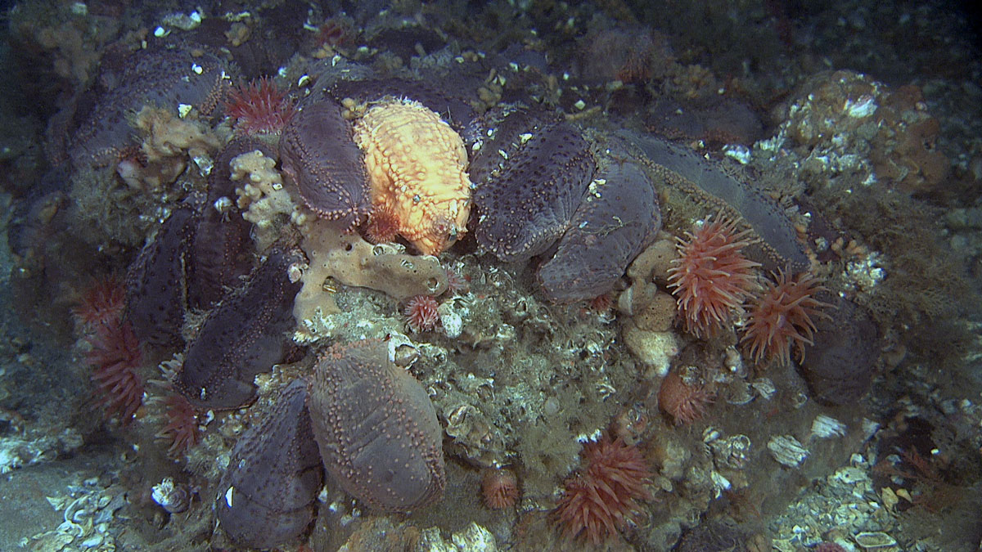
          - Benthic fauna on the Spitsbergen Bank
Photo: Mareano/Institute of Marine Research
In addition, the zooplankton, benthic fauna, ice biota, seabirds, Arctic ice-associated marine mammals and polar bears show high vulnerability to climate change. Climate change is expected to have both positive and negative impacts on different species or life stages in most species groups, with the exception that the impacts on polar bears will be exclusively negative.
The Marginal Ice Zone (BH2)
This is a relatively large area, defined in terms of winter and summer sea ice extent in the Barents Sea. In scientific terms, the marginal ice zone is the transitional zone between open sea and ice-covered sea, where the ice concentration (the proportion of the sea surface that is ice-covered) is between 15 and 80 %. The marginal ice zone is extremely dynamic, moving annually between Bjørnøya in the south and somewhere north of Spitsbergen depending on the time of year, and with most ice to the east of Svalbard. The area delimited as the Marginal Ice Zone (BH6) is intended to cover the variable extent of the marginal ice zone, i.e. the area across which it moves during an annual cycle between maximum ice cover in April and a minimum in September. The maximum southerly extent of the marginal ice zone is largely determined by the location of the polar front, while ice melt in the summer depends on factors including air temperature, the temperature of the underlying seawater, the amount of snow on the sea ice and wind conditions. The southern boundary of the Marginal Ice Zone is delimited using the line where ice is present for 15 % of the days in April, when the sea ice reaches its maximum extent. The boundary is calculated statistically, based on satellite observations of sea ice extent for the 30-year period 1993–2022.
The presence of sea ice makes this a very distinctive habitat. The physical and chemical environment in the marginal ice zone promotes phytoplankton production, since ice-melt results in vertical stability and better light conditions. Ice algae are adapted to low light levels, and primary production in the ice therefore starts earlier in spring in the ice than in open water, which prolongs the productive season in areas where there is sea ice. The phytoplankton bloom starts where the marginal ice zone is located in March-April, when the sea ice extent reaches its maximum, and follows the ice as it retreats northwards during the spring and summer. Grazing and feeding plankton, fish, seabirds and marine mammals follow primary production as it moves northwards. In addition, a substantial proportion of biological production in the marginal ice zone sinks through the water column to the seabed, where it provides food for benthic organisms. Species diversity is high in the area, and includes benthic communities with a highly diverse megafauna.
Seabirds, particularly Brünnich’s guillemots and little auks, can congregate in large numbers in the marginal ice zone and in leads in the ice in spring. Black guillemots and ivory gulls are also common. In addition, fulmars, glaucous gulls and kittiwakes are observed in the area all year round.
The marginal ice zone in the Barents Sea is also one of the areas of the circumpolar Arctic where the species richness of marine mammals is highest. Several seal species use the ice for whelping, moulting and hauling out, but the importance of the marginal ice zone varies both between species and between seasons. There are separate, genetically unique populations of several whale species, polar bear and walrus in the area, and their conservation is important with a view to maintaining global biodiversity. The bowhead whale, beluga and narwhal are the only whale species that are adapted to living in areas with ice all year round. The Spitsbergen population of bowhead whale is genetically distinct from other populations. In addition, other whale species (blue, fin, humpback and minke whales and orcas) feed in the marginal ice zone in the summer months.
There are different benthic communities on the west, north and east sides of the Svalbard archipelago. These are adapted to different environmental conditions and therefore contribute to the high biodiversity in areas where sea ice may be present. These areas support the highest megafauna diversity in the Barents Sea.
For the commercially important fish species in the Barents Sea, the marginal ice zone is primarily a feeding area, and to some extent a nursery area. Most fish species found in the marginal ice zone in the Barents Sea are strongly associated with the seabed, except for two pelagic species, polar cod and Arctic cod (Arctogadus glacialis).
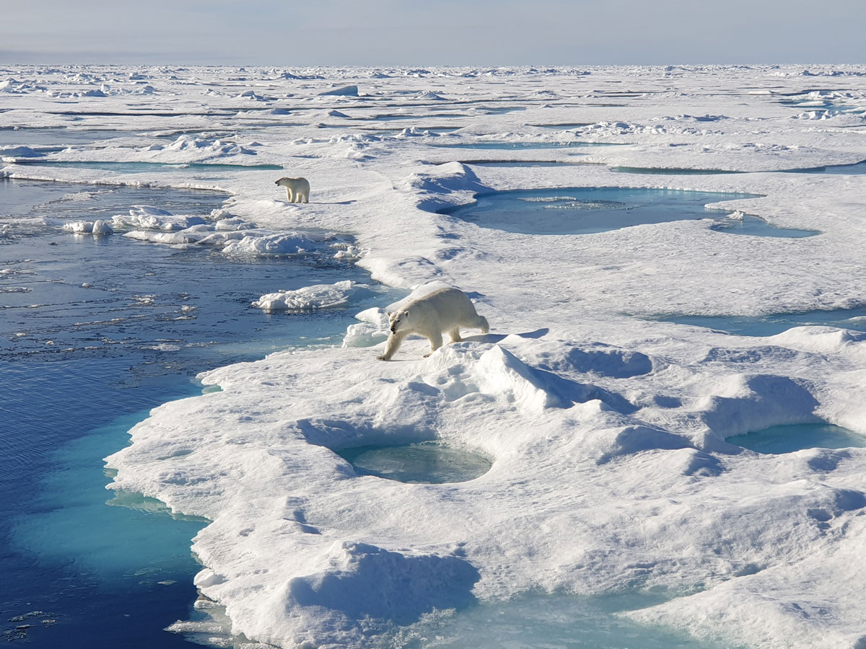
          - Polar bears in the marginal ice zone north of Svalbard in August 2023.
Photo: Cecilie von Quillfeldt, Norwegian Polar Institute
Many of the fish, seabird and marine mammal species found in this area are vulnerable, fragile, slow to recover and/or red-listed. One of the most obvious impacts of climate change in the Arctic is the temporal and spatial reduction in sea ice extent. The long-term trend that is being observed is a gradual withdrawal northwards of the limit of the sea ice in both summer and winter, but there are large interannual variations. The ice cover is also becoming thinner. Climate change is a growing threat to a range of species and habitat types found in the designated Marginal Ice Zone that are dependent on the sea ice.
Multi-year Arctic sea ice is a habitat type that is found in the northernmost parts of the Marginal Ice Zone, north of Svalbard. It comprises the multi-year ice cap that covers the central Arctic Ocean, and the marine organisms (ice flora and ice fauna) directly associated with it. Multi-year Arctic sea ice is considered to be a critically endangered habitat because of the substantial decline in its extent. The area of multi-year ice around Svalbard has been greatly reduced because the ice is melting more quickly around the edges of the Arctic Ocean than in central parts. The marginal ice zone is also considered to show a high degree of naturalness as defined by the EBSA criteria, with the exception of impacts associated with climate change. This is because there is little or no human disturbance or human-induced degradation as a result of activity within the area.
Within the Marginal Ice Zone, the vulnerability of Arctic zooplankton species, benthic communities, ice biota, early life stages of fish, seabirds and Arctic ice-associated marine mammals is assessed as high.
The benthic fauna shows high vulnerability to bycatches, alien species and habitat loss through sealing of the substrate. Early life stages of fish show high vulnerability to pollution, particularly oil spills. Seabirds show high vulnerability to bycatches, disturbance due to human presence, litter and all forms of pollution. Marine mammals show high vulnerability to selective species extraction and pollution.
All species groups except fish show high vulnerability to climate change. For some species groups, positive impacts are expected on certain species and negative impacts on others, but the impacts on seabirds will be exclusively negative.
The distribution of vulnerable species within the Marginal Ice Zone varies through the year and between years, as a result of variations in ice extent and other physical conditions, biological production and the occurrence and distribution of migratory species. However, regardless of the time of year, the entire zone is important for various species and biological processes.
Ice extent in the Barents Sea is showing a negative long-term trend, and this is expected to continue in response to anthropogenic climate change. As a result, the ecosystem components that are used as a basis for delimiting the Marginal Ice Zone are likely to disappear gradually from the southernmost parts of the area, and in a few years’ time it will probably be necessary to update the delimitation of the Marginal Ice Zone using newer ice data.
Eggakanten North (BH3)
Eggakanten North stretches from the boundary of the Norwegian Sea management plan area northwards to the ice-covered sea north and west of Svalbard, including the Yermak Plateau. It is contiguous with Eggakanten South in the Norwegian Sea management plan area. Oceanographic processes are comparable along the whole length of the Eggakanten area, where there is a sudden drop from the continental shelf to deeper waters. However, environmental conditions change rapidly where the slope is steep. There is a strong northerly Atlantic current along the Eggakanten area.
Heat transport in the Atlantic current off the Norwegian coast and the meeting with cold, fresher Arctic water flowing from the north strongly influence fluctuations in sea temperatures in this area. The west Spitsbergen current carries warm Atlantic water along the continental slope west and north of Spitsbergen and keeps this area ice-free for much of the year, while sea ice normally covers parts of the area north of Spitsbergen (southeastern part of the Yermak Plateau) and further northeast.
There is a generally elevated level of biological production and high biodiversity in the Eggakanten area. Eggakanten North supports a number of vulnerable habitat types including bathyal seapen communities, Radicipes coral gardens, Lophelia coral reefs, hard-bottom coral gardens and deep Arctic sponge aggregations. The only site where Radicipes is known to occur in Norwegian waters is a small area north of the Tromsøflaket bank area. There are several Lophelia coral reefs in the southern part of Eggakanten North. The Røstrevet reef complex, the world’s largest known reef of the stony coral Lophelia pertusa (now called Desmophyllum pertusum), lies in the Eggakanten area, in the upper part of a major underwater landslide. Particularly in steep parts of the continental slope, where environmental conditions change rapidly over short distances, there may be small areas of high biodiversity.
Vertical mixing processes that enhance primary production locally, and northwards transport of nutrient- and biomass-rich Atlantic water are two reasons why productivity is high in Eggakanten North and why the area is also very important for productivity in other parts of the Barents Sea, the waters around Svalbard and the Arctic Ocean.
Eggakanten North includes the most important spawning and breeding grounds for many commercially and ecologically important fish species. These include cod, haddock, herring, beaked redfish and golden redfish (endangered), and also Greenland halibut, which in Norway only spawns along the northern section of the Eggakanten area. This is also the only area in Norwegian waters where several Arctic species of eelpouts can be found.
For seabirds, Eggakanten North is an important summer feeding area. This is particularly true of pelagic feeders, including several threatened species, during the breeding season. It is also an important feeding area for whales such as fin and blue whales for which zooplankton is an important part of the diet.
In this area, the vulnerability of the benthic fauna, early life stages of fish, Arctic and ice-associated seabirds, and some species of toothed whales to various pressures is assessed as high.
The benthic fauna shows high vulnerability to bycatches, abrasion and habitat loss through sealing of the substrate. Early life stages of fish show high vulnerability to pollution and the extraction of non-living resources. Seabirds show high vulnerability to bycatches, disturbance due to human presence, litter and pollution, including oil spills. Marine mammals show high vulnerability to pollution.
In addition, the benthic fauna and seabirds are the species groups that are most vulnerable to climate change. Climate change may have either positive or negative impacts depending on species’ individual temperature preferences.
Coastal Zone Finnmark (BH4)
This area is situated north of the coast of Finnmark county, on the edge of the continental shelf, and stretches from the Tromsøflaket bank area to the Russian border and 100 km out to sea. The coastal current, which follows the continental slope off the coast, transports plankton and fish eggs and larvae eastwards through the area. The Coastal Zone Finnmark includes a number of fjords opening towards the Barents Sea where environmental conditions are very distinctive.
This is one of the most important breeding areas for seabirds on the Norwegian mainland, and a large proportion of a number of Norwegian seabird populations feed on the fish larvae and fry that are transported through the area. Depending on the availability of food, seabirds may feed close to the breeding colonies or further out to sea, up to at least 100 km from the breeding colonies. This is also an important wintering area for sea diving ducks, divers and gulls from other parts of the Arctic. The Steller’s eider is the rarest diving duck in the world, and 5–10 % of the world population winters in the Varangerfjorden. Norwegian and Russian populations of common eider, king eider and other sea ducks also use the coastal zone Finnmark during the moult.
The area includes Gjesværstappan, a group of islands that is home to what is now Norway’s largest puffin colony, numbering more than 300 000 breeding pairs. It is also important for other threatened or declining seabird species, such as the common guillemot (critically endangered), razorbill (vulnerable) and kittiwake (endangered), and for the large gull species, which are now declining.
The Coastal Zone Finnmark is one of the main spawning areas for capelin, a key species in the ecosystem. Capelin spawn on the seabed from early March. The larvae drift in the upper 50 m of the coastal current, moving eastwards and then northwards out into the Barents Sea together with large quantities of plankton, eggs and larvae of other fish species.
There are several important breeding sites for grey seals and areas of important habitat for common seals in the Coastal Zone Finnmark. Cold-water corals are to be found in shallow water, including some near the coast.
Inner parts of the Porsangerfjorden are very cold, providing Arctic conditions and supporting ecosystems including species that otherwise are only found further north in the Barents Sea, such as polar cod.
In the Coastal Zone Finnmark, the vulnerability of eelgrass, benthic communities, early life stages of fish, seabirds and some marine mammals to various pressures is assessed as high.
Seaweed, kelp and eelgrass show high vulnerability to the extraction of non-living resources. Benthic communities are considered to be vulnerable to bycatches, abrasion, alien species and habitat loss through sealing of the substrate. Early life stages of fish are vulnerable to pollution, including oil spills, and the extraction of non-living resources. Seabirds show high vulnerability to bycatches, disturbance due to human presence, litter and pollution, including oil spills. Marine mammals show high vulnerability to bycatches, selective species extraction, litter, pollution and oil spills.
The vulnerability of benthic communities and seabirds to climate change is high. For seabirds, the impacts of climate change will be negative only, whereas the changes may have either positive or negative impacts on benthic communities, depending on the species involved.
Senja–Tromsøflaket Bank Area (BH5)
This bank area lies near the edge of the continental shelf in the southwestern part of the Barents Sea, stretching roughly from north of the island of Senja to Hammerfest. The Senja–Tromsøflaket Bank Area also includes Lopphavet, where the coastal current flowing from further south splits into two branches, one of which continues close to land while the other follows the topography around the Tromsøflaket bank area. This lengthens the water residence time around the Tromsøflaket, making it a retention area.
This area (previously called the Tromsøflaket bank area) has been extended northwards to include rich benthic communities, and further towards the coast to provide better coverage of seabird feeding areas and important fish spawning grounds. It has also been extended southwards to include an area that was included in the Coastal Zone Lofoten in the expert group’s proposal.
The variability of the coastal current is closely linked to variations in wind, and the current is stronger in winter than in summer. In spring and summer, when the water in the area is stratified, winds strongly influence the surface circulation. This influences water exchange between the continental shelf and the open ocean, and the wind direction is crucial for drift trajectories and the residence time of the water. Tidal currents also contribute to water exchange between the continental shelf and the deep sea in this area.
The Senja–Tromsøflaket Bank Area plays a particularly important role in the transport of plankton and fish eggs and larvae that are carried eastwards and northwards into the Barents Sea. The current system in this area creates an eddy, which means that the water masses have a long retention time.
There are rich benthic communities in the Tromsøflaket bank area. These include the world’s northernmost cold-water coral reef complex, Korallen, off Sørøya island, and extensive soft-bottom sponge aggregations. In the Lopphavet area, there are deep trenches and large coral communities that provide nursery areas for several fish species.
Capelin spawn along the coast in March-April, and the eggs adhere to the bottom substrate for 3–4 weeks. Once the larvae are hatched, they float up to the surface and are transported by the current. In the spring and early summer months, large quantities of fish larvae (herring, cod, haddock, saithe, redfish and capelin) are transported through the Senja–Tromsøflaket Bank Area in the upper 50 metres of the water column, and find rich feeding in the shallow bank areas. Each summer, a large proportion of the year class of cod and haddock passes through the area. The spawning area for golden redfish stretches along the edge of the continental shelf and northwards and eastwards into the Barents Sea, along the entire length of the designated Senja–Tromsøflaket Bank Area. The northern part of the Tromsøflaket bank area is an important spawning ground for several species. Coastal cod spawn in more sheltered areas in the fjords. Some spawning grounds for coastal cod are within the designated area. However, the landward boundaries of particularly valuable and vulnerable areas near the coast are largely determined by the occurrence of ecosystem components associated with the management plan area further out to sea, so that coastal cod spawning areas are not fully included in the near-coastal areas that have been designated.
The concentration of planktonic organisms results in very rich food supplies for a number of breeding and wintering seabirds, including several red-listed species. There are nationally important breeding colonies of puffin and common guillemot, and historically also of kittiwake. One of Norway’s largest puffin colonies is on Sørøya island, and accounts for about a quarter of the Norwegian population. Some of Norway’s largest breeding colonies of shag are also in this area, and it is an important wintering area for sea diving ducks, divers and gulls from other parts of the Arctic. In winter, whales, particularly orcas and humpback whales, follow the herring as they move into the fjords for spawning. Coastal seals feed in the area all year round.
In the Senja–Tromsøflaket Bank area, the vulnerability of eelgrass, benthic communities, early life stages of fish, seabirds and some marine mammals to various pressures is assessed as high.
Benthic communities show high vulnerability to bycatches, abrasion and habitat loss through sealing of the substrate. Early life stages of fish are vulnerable to pollution, including oil spills, and the extraction of non-living resources. Seabirds show high vulnerability to bycatches, disturbance due to human presence, litter, pollution, including oil spills, and alien species. Marine mammals show high vulnerability to bycatches, selective species extraction, and pollution, including oil pollution.
In addition, the vulnerability of benthic communities and seabirds to climate change is high. However, the changes may have either positive or negative impacts, depending on the species involved.
Coastal Zone Lofoten (BH6)
The area designated as the Coastal Zone Lofoten stretches from the waters around the Lofoten Islands (including the Vestfjorden) and northwards to Troms county. The continental shelf is narrow in this area, and the continental slope is very steep. There are several markedly shallower bank areas on the shelf, including Røstbanken, Sveinsgrunnen and Malangsgrunnen, and deeper trenches such as Bleiksdjupet and Andfjorden.
The main elements of the current system are the coastal current along the continental shelf and the strong, one-way, narrow Norwegian Atlantic current along the continental slope. The coastal current influences and is influenced by the water masses around skerries and in fjords, as determined by the topography, including sills and deep basins.
The narrow continental shelf and strong, narrow coastal current result in the concentration of zooplankton, fish eggs and larvae and other organisms that are transported with the current.
The Coastal Zone Lofoten is a very important spawning area for both cod and haddock in late winter and spring. It is also extremely important as a transit zone for eggs, larvae and fry of these species, and also for herring. The area includes the Vesterålen banks, which provide some of the most important breeding areas for golden redfish (endangered), and are also important to a number of other fish species. The coastal zone is also an important wintering area for Norwegian spring-spawning herring, although in some periods they concentrate in other fjord systems further north. Spring-spawning herring are an important part of the diet of orcas. The waters around the Lofoten Islands are an important feeding area for basking sharks, an endangered species.
The Coastal Zone Lofoten includes a wide variety of marine habitat types and marine landscapes. One of the world’s largest cold-water coral reef complexes, Røstrevet and Hola, is within the designated area. In Andfjorden there are bamboo coral (Isidella lofotensis) gardens and sublittoral seapen communities. The Steinaværrevet reef in Andfjorden and Bleiksdjupet, one of Europe’s largest underwater canyons, support distinctive coral habitats and sponge aggregations.
Most seabird species present in Norway breed in this area, and it is also one of the most important feeding areas for seabirds in the country, both in winter and in the breeding season, making it nationally important. The Coastal Zone Lofoten is an important wintering area for coastal species such as eider, cormorant and shag. The common guillemot, puffin and kittiwake, which breed in the large seabird colonies in the area, are all threatened species.
Around Øksnes and Andøya, there is important habitat for common seals.
The importance of the area varies through the year for many species, but because it is so species-rich, it is important for one or more groups of fish, seabirds, benthic animals and marine mammals throughout the year.
In this area, the vulnerability of the benthic fauna, early life stages of fish, seabirds, and some marine mammals to various pressures is assessed as high.
The benthic fauna is particularly vulnerable to bycatches, abrasion and habitat loss through sealing of the substrate. Early life stages of fish are vulnerable to pollution and the extraction of non-living resources. Seabirds show high vulnerability to bycatches, disturbance due to human presence, litter, all types of pollution, and alien species, including mink (during the breeding season). Marine mammals show high vulnerability to bycatches, selective species extraction and pollution, including oil spills.
In addition, the vulnerability of the benthic fauna and seabirds to climate change is high. However, the changes may have either positive or negative impacts, depending on the species involved.
The Central Barents Sea (BH7)
The area designated as the Central Barents Sea includes the southern part of the Central Bank and the Thor Iversen Bank, and the deeper basin southeast of them in the direction of Novaya Zemlya.
The Norwegian Atlantic current enters from the southwest and splits in the southwestern part of the area, so that two branches flow eastwards south of the Central Bank. In addition, colder Arctic water, and in winter ice, flow into the northern part of the area.
The Central Barents Sea is used by seabirds from the breeding colonies all around the Barents Sea, both on the Arctic islands and on the mainland. The area is particularly important after the breeding season for seabirds such as common and Brünnich’s guillemots, which migrate by swimming into the area to feed while they are moulting and cannot fly. It is also an important wintering area for these species. In addition, the designated area covers part of the autumn and winter distribution of puffins and glaucous gulls, and waters used by the kittiwake populations in spring. These species use larger parts of the Barents Sea, but congregate in the designated Central Barents Sea for large parts of the year. A number of seabirds, including common and Brünnich’s guillemot, puffin and fulmar, are red-listed.
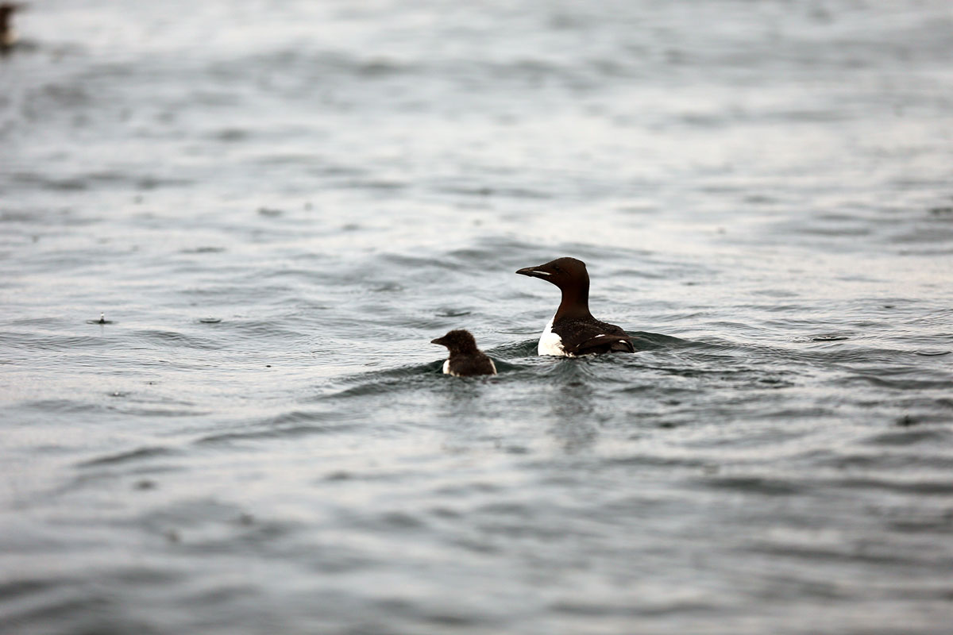
          - Brünnich's guillemot with a chick on swimming migration.
Photo: Hallvard Strøm, Norwegian Polar Institute
In spring and summer, the ocean currents carry zooplankton and fish eggs, larvae and fry into the area. It is therefore a feeding area for adult fish, seabirds and to some extent marine mammals. Cod and haddock larvae settle on the bottom in winter, while larvae of other species remain in the surface water layers. The species richness of fish is higher in the central part of the Barents Sea than in the surrounding areas.
There are large Haploops communities on the Thor Iversen Bank. These are rare and unusual amphipods that live in small, self-built tubes.
Overall, the area is considered to score high on the uniqueness criterion, and is important because it is a particularly attractive feeding area for threatened seabird species during the moulting period in the Atlantic part of the Barents Sea, and is also of great significance for biological productivity and diversity.
In this area, the benthic fauna, early life stages of fish, seabirds and toothed whales are considered to be particularly vulnerable to various pressures.
Benthic communities show high vulnerability to bycatches, abrasion, alien species and habitat loss through sealing of the substrate. Early life stages of fish show high vulnerability to pollution, including oil pollution. Seabirds show high vulnerability to bycatches, disturbance due to human presence, litter and pollution, including oil pollution. Marine mammals show high vulnerability to pollution.
The benthic fauna and seabirds in particular show high vulnerability to climate change. However, the changes may have either positive or negative impacts, depending on the species involved.

Particularly valuable and vulnerable areas in the Norwegian Sea
On the basis of the scientific review of the particularly valuable and vulnerable areas, changes have been made to the list for the Norwegian Sea management plan area. Three of the areas – Sea Ice, Fram Strait (NH1), the West Ice (NH2), and Eggakanten South (NH5), are unchanged. The Mid-Atlantic Ridge (NH4) has been identified as a new particularly valuable and vulnerable area. It partly overlaps the Arctic front, which is no longer included in the list. The Coastal Zone Norwegian Sea North (NH6) corresponds to the northern part of the area called Coastal waters Norwegian Sea in 2020, somewhat expanded, and also includes the Iverryggen reef, Sklinna bank, Frøan archipelago and Sula reef, and the Remman archipelago, which were designated as separate areas in 2020. The Coastal Zone Norwegian Sea South (NH7) corresponds to the southern part of the Coastal waters Norwegian Sea, again somewhat expanded, and also includes the Møre banks. Finally, Norwegian Sea Deep Waters (NH8) has been designated as a particularly valuable and vulnerable area for the first time.
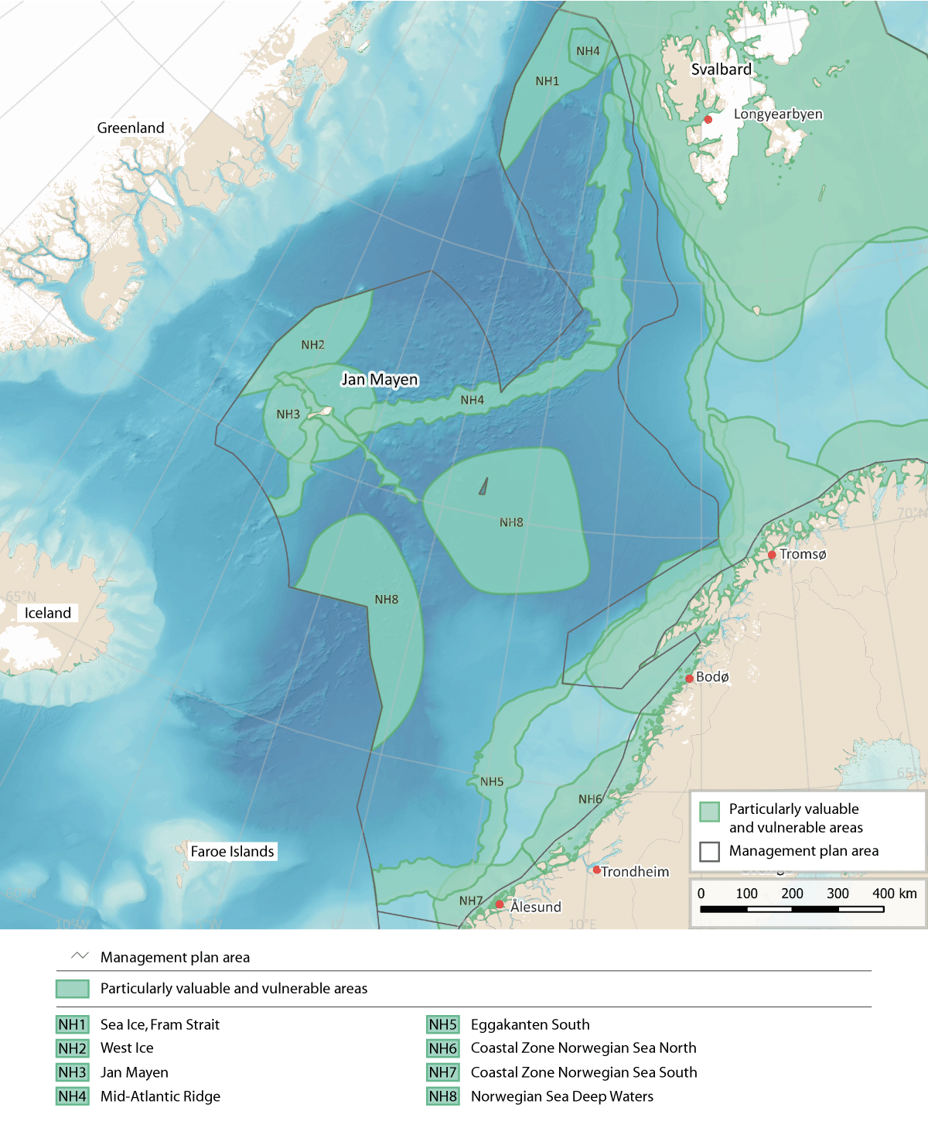
          - Particularly valuable and vulnerable areas in the Norwegian Sea management plan area.
Source: Forum for Integrated Ocean Management/Institute of Marine Research/Norwegian Mapping Authority/ GEBCO Compilation Group (2023)
Sea ice, Fram Strait (NH1)
This area in the eastern part of the Fram Strait is dominated by sea ice transported southwards from the Arctic Ocean by ocean currents. The ice in this area is a mixture of ice of different origins, and includes a wide variety of ice types. In the eastern part of the area, the ice is similar to that in the Barents Sea, while there is older, thicker ice further north and west. Sea Ice, Fram Strait is a westerly continuation of the Marginal Ice Zone (BH2), and updating the time series for sea ice extent has only resulted in small adjustments of the delimitation of the area.
Primary production in spring starts earlier in the ice than in open water, which prolongs the productive season in this area. In some periods, phytoplankton production and the quantity of biomass will therefore be higher where ice is present than in nearby areas of open water.
The sea ice is important as the habitat of the ice biota, which includes a range of community types including a large number of species and many different species groups. Species that live in multi-year ice are particularly vulnerable to climate change. The spatial reduction in sea ice extent, delayed ice formation and early ice-melt result in a shorter productive season for the ice biota. However, thinner ice can improve light conditions, which may increase production. The proportion of multi-year ice in the Fram Strait is higher than in the Barents Sea, making this area particularly important for species that spend their entire life cycle within or attached to the underside of the ice (for example rotifers and small crustaceans such as amphipods and copepods).
Atlantic zooplankton that is transported with Atlantic water from the Norwegian Sea to the Arctic via the Fram Strait may be an important food source for mesopelagic plankton predators in the Arctic Basin.
The marginal ice zone in the Fram Strait is important for ivory gulls (vulnerable) both before the start of the breeding season and in autumn. Both Greenland whales (critically endangered) and narwhals (vulnerable) use the drift ice areas in the Fram Strait all year round. The Spitsbergen population of bowhead whale breeds in the northwesterly part of the Fram Strait. Regional extinction of these species would mean the loss of important biodiversity.
There is very little direct pressure from human activity in areas of sea ice and the marginal ice zone.
The vulnerability of the benthic fauna, ice biota, seabirds, and marine mammals (toothed whales and polar bears) to various pressures is assessed as high in this area. Seabirds show high vulnerability to bycatches, litter, and pollution, including oil pollution. Marine mammals (toothed whales and polar bears) show high vulnerability to pollution. Ice biota, seabirds, marine mammals and polar bears show high vulnerability to climate change, which will generally have negative impacts on these species groups.
The West Ice (NH2)
The area designated as the West Ice covers the sea ice north and west of Jan Mayen. Updating the time series for sea ice extent has only resulted in small adjustments of the delimitation of the area. This area of drift ice is influenced by the cold south-flowing East Greenland current, which carries ice and cold water from the Arctic Ocean. The West Ice varies considerably in area from year to year, and may be situated much further to the east in spring. There has been a downward trend in sea ice extent in recent decades.
The West Ice is a core breeding area for hooded seals (endangered), and also an important breeding and feeding area for harp seal. Both these species are endemic to the North Atlantic. Pup production in both species is dependent on the sea ice, since they whelp on the ice that forms in the area in March-April. The decline in the hooded seal population may be related to the reduction in drift ice and the fact that there are fewer, thinner drift ice floes.
There is little pressure from human activities in the West Ice, although a small harvest of seals is taken in the area. Marine mammals (seals) show high vulnerability to various pressures, particularly to pollution in the form of oil spills. Seals also show high vulnerability to climate change.
Jan Mayen (NH3)
Topographical conditions in the area designated as Jan Mayen are very distinctive because these waters are above the Mid-Atlantic Ridge. Cold water from the East Greenland current and warmer water from the North Atlantic Current meet in this area.
The area is particularly valuable for seabirds. Jan Mayen itself is of outstanding importance in Norway as a seabird breeding area. There are 18 breeding species and 22 different seabird colonies, holding more than 300 000 pairs of seabirds in total. The most numerous species are fulmar, little auk and Brünnich’s guillemot. Razorbills, black guillemots, common guillemots and kittiwakes also breed, and in addition more southerly species such as lesser black-backed and herring gulls. Both Arctic and great skuas are also fairly numerous. The pelagic species that dominate on the island generally feed in areas up to 100 km out to sea from the colonies. Several of the seabird species that breed on Jan Mayen are showing an overall decline or are red-listed, but the Jan Mayen colonies appear to be relatively resilient. The island may thus serve as a refugium for species that are declining elsewhere.
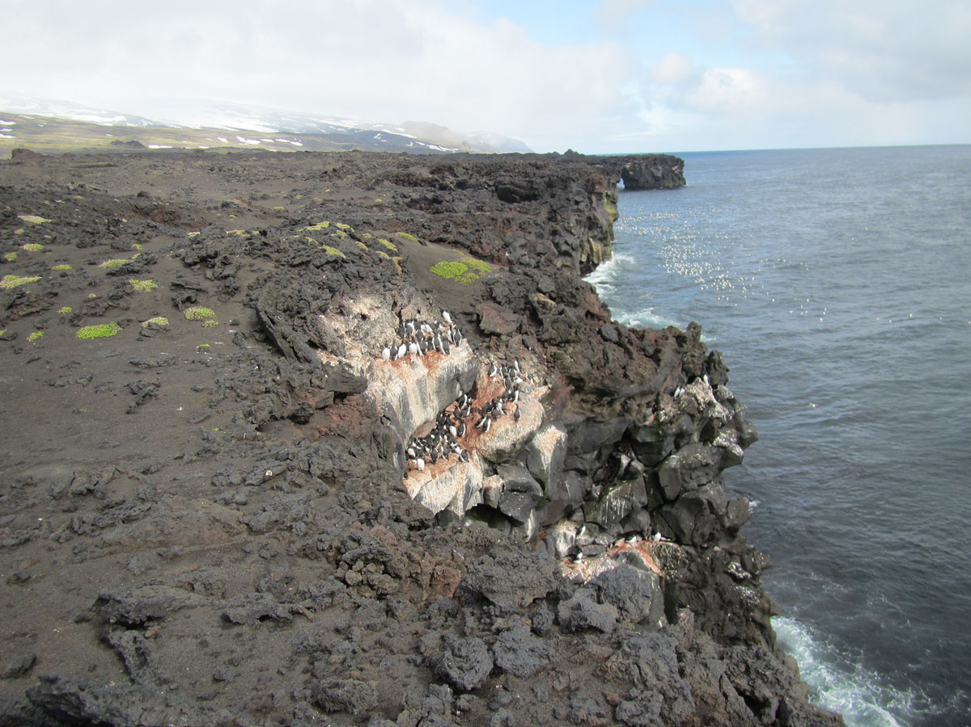
          - Skrinnodden/Splittodden, geologically one of the youngest areas of Jan Mayen. Five of the six species of auks found on the island breed here.
Photo: Erlend Lorentzen, Norwegian Polar Institute
Nutrient-rich waters support high, stable biological production in the Jan Mayen area. Zooplankton associated with a variety of habitats is found here, and species diversity may therefore be high. High levels of zooplankton biomass have been recorded in the area.
The convergence of different ocean currents on the Mid-Atlantic Ridge provides suitable conditions for many different fish species. The eelpout Lycenchelys platyrhina, for example, has not been registered anywhere else in Norwegian waters.
Benthic communities in a 4-km wide belt near the island of Jan Mayen are still showing the effects of the volcanic eruption in 1970, which covered subsea areas down to a depth of 30 m with lava. This is the only area in Norwegian waters where it is possible to follow the reestablishment of shallow-water coastal benthic communities after a volcanic eruption.
Because of its remote position, there is very little pressure from human activity in the Jan Mayen area.
The vulnerability of the benthic fauna and seabirds to various pressures is assessed as high in this area. Benthic communities show high vulnerability to bycatches, selective species extraction, abrasion and habitat loss through sealing of the substrate. Seabirds show high vulnerability to bycatches, disturbance due to human presence, litter, pollution, and oil pollution. Climate change may have either negative or positive impacts on the benthic fauna depending on the species that are affected, but the impacts on seabirds will be exclusively negative.
The Mid-Atlantic Ridge (NH4)
The area designated as the Mid-Atlantic Ridge consists of a number of ridges and fracture zones in the northern Norwegian Sea, stretching over a considerable distance from west of Svalbard to the waters around Jan Mayen. At the northern end, near Svalbard, the ridge meets Molloydypet, the deepest basin in Norwegian waters. The complex topography generates enhanced vertical mixing along the ridge. There are also scattered active and inactive hydrothermal vent fields in the area.
There are a number of active hydrothermal vent fields, for example Loki’s Castle, and also inactive vent fields both along the rift valley of the Mid-Atlantic Ridge and in the Jan Mayen fracture zone. Both active and inactive vent fields support a varied fauna and microorganisms that are specialised to withstand high temperatures and that are only found in association with hydrothermal vent fields. Many species are chemosynthetic or have a symbiotic relationship with chemosynthetic microorganisms. Chemosynthetic species use chemical reactions to convert inorganic substances discharged from the hydrothermal vents into nutrients. This means that they are not dependent on a food chain starting with sunlight and primary production, neither of which exists in deep water. The species found here and the species composition of these hydrothermal vent communities are both quite distinct from those found around hydrothermal vents elsewhere in the world.
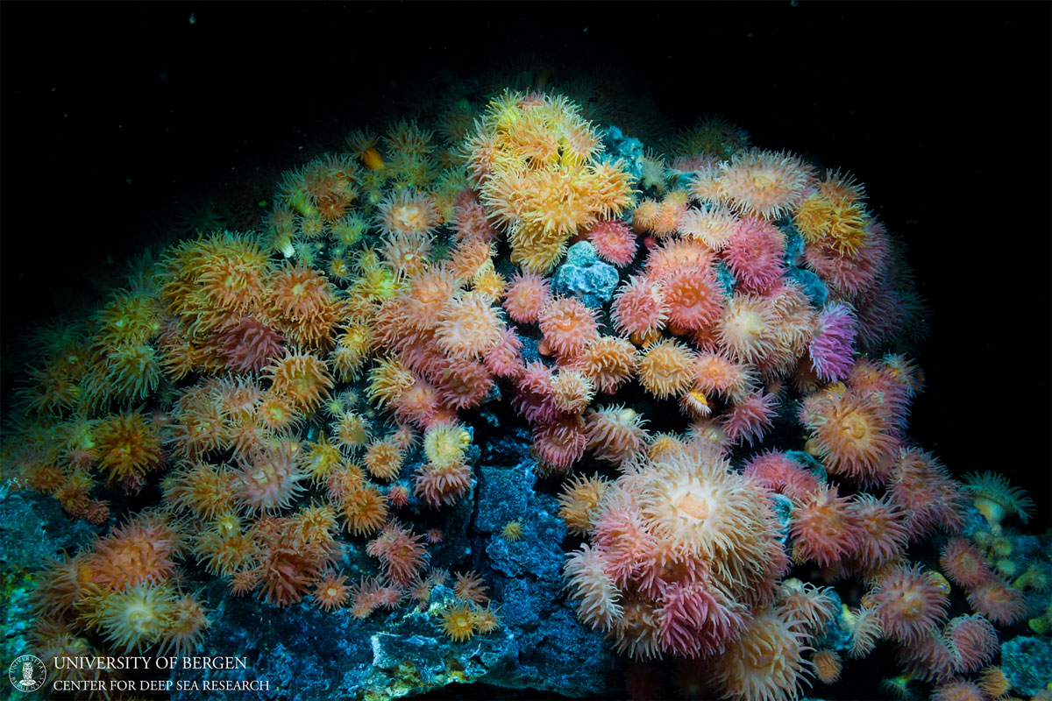
          - Sea anemones growing at a depth of about 500 m near the Jan Mayen hydrothermal vent fields on the Mid-Atlantic Ridge.
Photo: Centre for Deep Sea Research, University of Bergen
This is an area of particularly high productivity, with benthic communities dominated by sponges and corals and with seamounts that function as spawning and nursery areas for populations of slow-growing fish. These habitats are all included in the OSPAR List of Threatened and/or Declining Species and Habitats. In addition, the area supports hard-bottom coral gardens that are classified as near-threatened in Norway’s Red List of ecosystems and habitat types. These are typically living habitats that are slow-growing, fragile, and slow to recover, and that support distinctive species assemblages. A number of species are dependent on a specific bottom substrate. Several other vulnerable habitat types are also to be found in the new Jan Mayen designated area.
The Mid-Atlantic Ridge overlaps to a large extent with the Arctic front. High concentrations of phyto- and zooplankton have been observed near the Arctic front, and this has been explained by physical processes in the area. The Arctic front is important as a habitat boundary for various species, and is an area where large numbers of species at different levels in the food chain are concentrated by the ocean currents.
There are indications that the Mid-Atlantic Ridge maybe an important summer feeding area for bottlenose whales.
The seabed is relatively undisturbed in the deeper parts of this area. The benthic fauna shows high vulnerability to physical disturbance and habitat loss through sealing of the substrate. Vulnerability to climate change is also high. However, the impacts of climate change may be either negative or positive for different species of the benthic fauna.
Eggakanten South (NH5)
The area designated as Eggakanten South includes the entire continental slope and extends about 10 km on to the continental shelf. Its width varies depending on the steepness of the continental slope. The continental slope results in a strong, one-way, narrow Norwegian Atlantic current along the continental slope. The water temperature declines northwards as a result of heat loss to the atmosphere and mixing with adjacent water masses. The ocean floor rises towards the continental shelf as a steep wall interrupted by ravines and fissures.
Like Eggakanten North, this area supports a number of vulnerable habitats: bathyal seapen communities, Lophelia coral reefs, hard-bottom coral gardens and deep Arctic sponge aggregations. There are more known coral reefs in Eggakanten South than in Eggakanten North. The only reliable observation of Madrepora oculata reefs in Norwegian waters is from Storneset, towards the southern end of Eggakanten South.
Large quantities of the mesopelagic fish species glacier lantern fish (Benthosema glaciale), silvery lightfish (Maurolicus muelleri) and spotted barracudina (Arctozenus risso) are found in the Eggakanten area and adjacent waters. This is probably a more important spawning area for these species than more westerly parts of the Norwegian Sea.
Eggakanten South is also an important spawning area for haddock and several deep-water species, including golden redfish (endangered) and greater argentine. Redfish also show a preference for the distinctive coral reefs, which are slow-growing and slow to recover.
The availability of various life stages and sizes of plankton and fish makes this an important feeding area. The abundance of zooplankton provides favourable conditions for the survival of early life stages of many fish species that drift northwards along the edge of the continental shelf, including Norwegian spring-spawning herring, cod, and golden and beaked redfish. This is also important as a feeding area for pelagic seabirds, particularly during the breeding season. These include several red-listed species, for example common guillemot and puffin, which feed on fish larvae drifting in the current.
The edge of the continental shelf and the upper part of the continental slope also form an important feeding area for sperm whales and hooded seals. The seabed in the deeper parts of Eggakanten south appears to be completely undisturbed.
In this area, the vulnerability of the benthic fauna, early life stages of fish and marine mammals (seals and toothed whales) to various pressures is assessed as high. The benthic fauna shows high vulnerability to bycatches, abrasion and habitat loss through sealing of the substrate. Early life stages of fish show high vulnerability to pollution, including oil spills. Toothed whales show high vulnerability to pollution. Both the benthic fauna and seals show high vulnerability to climate change. However, the impacts of climate change on the benthic fauna may be either negative or positive, while the impacts on seals will be negative.
Coastal Zone Norwegian Sea North (NH6)
This area includes a large number of inlets and sounds lying between islands and skerries. Parts of the area extend far from land towards the Eggakanten area, and feature eddy fields that lengthen the residence time of the water and create retention areas. The area covered by the Coastal Zone Norwegian Sea North includes the Halten bank, Sklinna bank, Frøan archipelago and Sula reef, Coastal waters Norwegian Sea (northern part) and Remman archipelago, all of which were designated as particularly valuable and vulnerable areas in the previous white paper.
Overall, the area supports a high diversity of habitats and species, especially where there are kelp forests. It includes very important spawning grounds for a number of fish species, particularly commercially important species such as Northeast Arctic cod and Norwegian spring-spawning herring, but also Norway pout and golden redfish (endangered). Spawning takes place in late winter and spring, and the larvae drift northwards in late spring and early summer. Plankton become concentrated in retention areas, resulting in higher levels of biomass on which fish larvae and fry can feed. This is also an important feeding area for basking shark (endangered) and porbeagle (vulnerable).
The Coastal Zone Norwegian Sea North is an important breeding and feeding area for seabirds, particularly for coastal species such as common eider, shag, cormorant, black guillemot, and great and lesser black-backed gull, but also for some pelagic species such as kittiwake and Arctic skua. Several of these are red-listed. The shallow-water parts of the area are also important moulting areas for common eider and important wintering areas for species including common eider, black guillemot, shag, cormorant, large gulls, divers and grebes. One of the world’s largest shag colonies is on the Sklinna archipelago. Most of the Norwegian population of lesser black-backed gull (subspecies Larus fuscus fuscus) is to be found in this area. This subspecies has been suffering a prolonged period of decline.
There are several important breeding sites for common seals in the area. Although the total population of common seals in Norway has been increasing in recent years, there has been a certain decline in Trøndelag county, including the Froan archipelago.
The area includes a large number of coral reefs and other vulnerable habitat types, most of which are intact and shown no signs of being damaged by bottom fishing. There are coral reefs both close to the coast and further out on the continental shelf, with concentrations in the Sula reef and Iverryggen reef area.
In this area, the vulnerability of seaweed, kelp and eelgrass, the benthic fauna, early life stages of fish, and seabirds and marine mammals (seals and toothed whales) to various pressures is assessed as high.
Seaweed, kelp and eelgrass show high vulnerability to the extraction of non-living resources (shell sand). The benthic fauna shows high vulnerability to bycatches, abrasion and habitat loss through sealing of the substrate. Early life stages of fish show high vulnerability to pollution, including oil pollution, and the extraction of non-living resources. Seabirds show high vulnerability to bycatches, disturbance due to human presence, litter, pollution, including oil pollution, and alien species. Marine mammals show high vulnerability to bycatches, selective species extraction, and pollution, including oil pollution.
Climate change will have both positive and negative impacts. The impacts will be largely positive for seaweed, kelp and eelgrass and for fish. The benthic fauna and seabirds show high vulnerability to climate change, and the impacts on seabirds will be exclusively negative. The changes may have either positive or negative impacts on the benthic fauna, depending on the species involved.
Coastal Zone Norwegian Sea South (NH7)
Atlantic water and the Norwegian coastal current meet in the Coastal Zone Norwegian Sea South, and as a result the waters are particularly nutrient-rich. The topography is very distinctive, with only a short distance from the edge of the continental shelf to the mainland in the southernmost part of the area, and shallow underwater plains, islands and skerries in the northern part. This creates retention areas where the water has a relatively long residence time. The luxuriant kelp forests in the area also influence current patterns. The Coastal zone Norwegian Sea south includes the Møre banks, Coastal waters Norwegian Sea (southern part), and Bremanger–Ytre Sula, all of which were designated as separate areas in the previous white paper.
The Møre banks are a core area for spawning and early life stages of Norwegian spring-spawning herring and saithe, and are also important for cod (coastal cod and historically for Northeast Arctic cod), haddock, Norway pout and golden redfish (endangered). They are also used by the first-feeding stage of herring, cod, saithe and other fish larvae. Coastal cod spawn both in more exposed coastal waters and in sheltered fjord arms, relatively close to the nursery areas used by the larvae. The Møre banks are also important, especially in summer, for the basking shark, a particularly vulnerable species that exhibits late sexual maturity, low fecundity and slow growth. Records do not show generally enhanced levels of zooplankton production in the area as a whole. However, there may be large local variations, since plankton is concentrated in retention areas, where biomass is higher. The zooplankton in the area is important for fish larvae and fry.
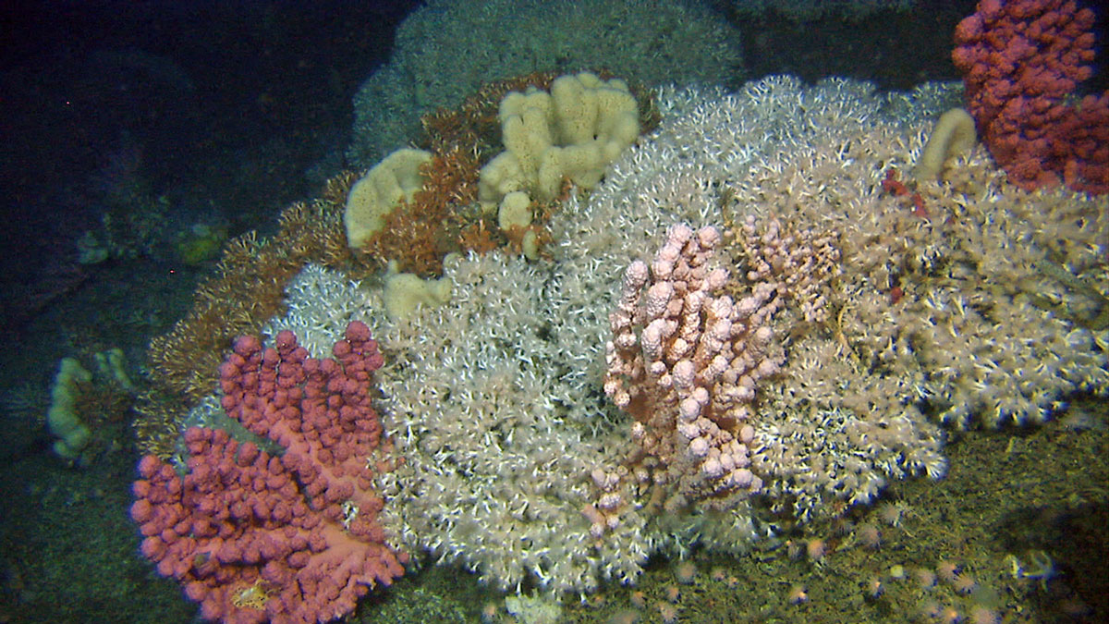
          - Coral reef in Stjernsund at a depth of about 250 m.
Photo: Institute of Marine Research
The Coastal Zone Norwegian Sea South is an important breeding, moulting, passage and wintering area for seabirds. A number of localities within the area are of national importance as breeding sites and/or moulting areas. This is an important feeding area for species including gannet, common guillemot, puffin and razorbill. A number of coastal species also feed in the shallower parts of the area, and there are considerable numbers of common eider, black guillemot, shag, herring gull and lesser black-backed gull both in the breeding season and in winter. In the breeding season, species diversity in the seabird colonies on Runde island is higher than anywhere else in Norway, and various threatened species breed here. The largest puffin colony south of Røst is also on Runde, and the gannet colony on the island accounts for more than 50 % of the total Norwegian population. The Coastal Zone Norwegian Sea South is also an important wintering area for little auk and yellow-billed diver.
There are colonies of common seals throughout the area, the largest being at Sandøy and Haram in Møre og Romsdal county.
A number of vulnerable habitat types are also to be found in the area, including coral reefs, hard-bottom coral gardens, seapen communities and hard-bottom sponge aggregations. The combination of the current system, the availability of zooplankton, and the presence of sponge aggregations and coral reefs, which are species-rich in themselves and provide a habitat for many pelagic animals, results in high species diversity. Laminaria hyperborea kelp forests are very valuable; they provide shelter and feeding areas for early life stages of benthic animals, and moderate wave action and ocean currents, thus resulting in the retention of water, plankton and fish larvae. Kelp forests are important for many declining species of coastal seabirds, for example for auks that lay only one or a few eggs a year.
In this area, the vulnerability of seaweed, kelp and eelgrass, the benthic fauna, early life stages of fish, seabirds and marine mammals (seals and toothed whales) to various pressures is assessed as high.
Seaweed, kelp and eelgrass show high vulnerability to the extraction of non-living resources (shell sand). The benthic fauna shows high vulnerability to bycatches, abrasion and habitat loss through sealing of the substrate. Early life stages of fish show high vulnerability to pollution, including oil pollution, and the extraction of non-living resources. Seabirds show high vulnerability to bycatches, disturbance due to human presence, litter, pollution, including oil pollution, and alien species. Marine mammals show high vulnerability to bycatches, selective species extraction, and pollution, including oil pollution.
Climate change will have both positive and negative impacts. The impacts will be largely positive for seaweed, kelp and eelgrass and for fish. The benthic fauna and seabirds show high vulnerability to climate change, and the impacts on seabirds will be exclusively negative. The changes may have either positive or negative impacts on the benthic fauna, depending on the species involved.
Norwegian Sea Deep Waters (NH8)
This area consists of two separate deep-water basins, one on each side of the Jan Mayen fracture zone. They are the Norwegian Basin in the south (3600 m deep) and the Lofoten Basin in the north (3600 m deep), which are the two deepest basins in the central part of the Norwegian Sea.
There is a clearly cyclonic (anti-clockwise) circulation system in the deep water. The currents are weaker in the flat central parts of the two basins than in the outer parts. This means that the central parts of the basins are retention areas, where the water has a long residence time.
The topography of the deep-water basins in the Norwegian Sea is complex, with many seamounts rising high above the abyssal plains and precipitous mountainsides surrounding the deep-water basins. The Ægir Ridge stretches across the Norwegian Basin.
The Norwegian Sea Deep Waters meet the EBSA ‘uniqueness’ criterion. They are particularly important as wintering areas and reservoirs for Calanus species (copepods), and are of vital importance in sustaining the large populations of these species. Movement of various Calanus species from the deep-water basins of the Norwegian Sea replenishes numbers in surrounding areas of ocean and continental shelf and is thus important for secondary production, for example in the Barents Sea, the North Sea and Norwegian coastal waters. These plankton reservoirs are also important for fish and seabird productivity and reproduction along the edge of the continental shelf and in the particularly valuable and vulnerable areas in the coastal zone.
Waters down to a depth of 1500 m are the year-round habitat for mesopelagic species such as glacier lantern fish, silvery lightfish and spotted barracudina, and for krill, amphipods, copepods and cephalopods, which in turn are important food for deep-diving whales such as sperm, fin and bottlenose whales. In the upper mesopelagic zone, zooplankton, especially Calanus species, are a key part of the diet of pelagic fish such as herring, blue whiting and mackerel, which in turn are part of the diet of minke whales.
The Norwegian Sea Deep Waters also support benthic communities that are fragile and slow to recover, such as coral gardens and hard-bottom sponge aggregations. Sponge aggregations on the deep muddy plains appear to be particularly important as nursery areas for many other species. There is a mosaic of soft-bottom areas and hard-bottom ridges along the Ægir Ridge, and as a result species-richness is exceptionally high. Hard-bottom sponge aggregations and coral reefs have been assessed by the OSPAR Commission as threatened, and are on Norway’s Red List of ecosystems and habitat types.
At such great depths, human activity has very little impact. The zooplankton in the area is not considered to be particularly vulnerable. However, the benthic fauna and marine mammals (seals and toothed whales) show high vulnerability to various pressures. The benthic fauna shows high vulnerability to abrasion and habitat loss through sealing of the substrate. Toothed whales show high vulnerability to pollution. Both the benthic fauna and seals show high vulnerability to climate change. The impacts on seals will be negative, while the changes may have either positive or negative impacts on the benthic fauna, depending on the species involved.

Particularly valuable and vulnerable areas in the North Sea and Skagerrak
On the basis of the scientific review of the particularly valuable and vulnerable areas, changes have been made to the list for the North Sea and Skagerrak. The southern end of the Coastal Zone Norwegian Sea South extends into the North Sea–Skagerrak management plan area, and includes the Bremanger–Ytre Sula area. The area Outer Boknafjorden/Jærstrendene Protected Landscape (NS) includes the Karmøyfeltet bank area (previously a separate area). Sandeel habitat (NS2) includes the previously designated areas sandeel habitat south and the Viking Bank (or sandeel habitat south). The Norwegian Trench (NS3) includes three previously designated areas: the Skagerrak transect, the Siragrunnen bank area and the Skagerrak. The area designated as the Outer Oslofjord (NS4) has been extended. Two areas designated in the previous white paper, Korsfjorden and mackerel spawning grounds, have been removed from the list.
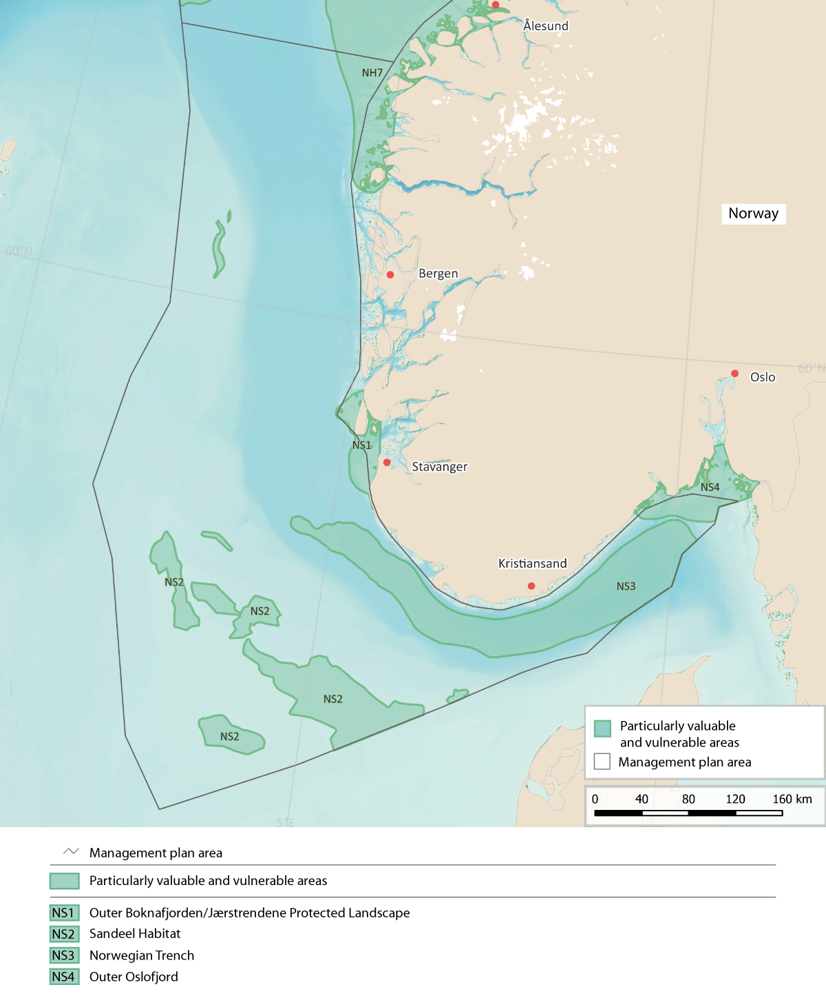
          - Particularly valuable and vulnerable areas in the North Sea and Skagerrak.
Source: Forum for Integrated Ocean Management/Norwegian Environment Agency/Norwegian Mapping Authority/ GEBCO Compilation Group (2023)
Outer Boknafjorden/Jærstrendene Protected Landscape (NS1)
The geological and ecological diversity of this area is high, ranging from open sea out towards the North Sea and the deep Norwegian Trench in the west to shallow kelp forests near the coast. The area is strongly influenced by the Norwegian coastal current flowing out of the Skagerrak, and also largely in contact with the northern part of the North Sea. Water exchange between the Norwegian coastal current and Atlantic water from the deeper layers of the Norwegian Trench results in high zooplankton species diversity and biomass.
The area is important for seabirds and scores high on the EBSA uniqueness criterion. It is an important breeding area for many red-listed species, especially the common tern, and includes the southernmost breeding sites in Norway for kittiwake, common guillemot and puffin. both northerly and southerly species occur here, and it is also an important wintering area, with high species diversity throughout the year. There are relatively large breeding populations of seabirds including common eider, cormorant (subspecies Phalacrocorax carbo sinensis) and shag, and large populations of lesser black-backed gull and herring gull. The Jærkysten MPA, which is part of the area, is in addition an important wintering area for divers, grebes and sea diving ducks from large parts of the Arctic and Fennoscandia.
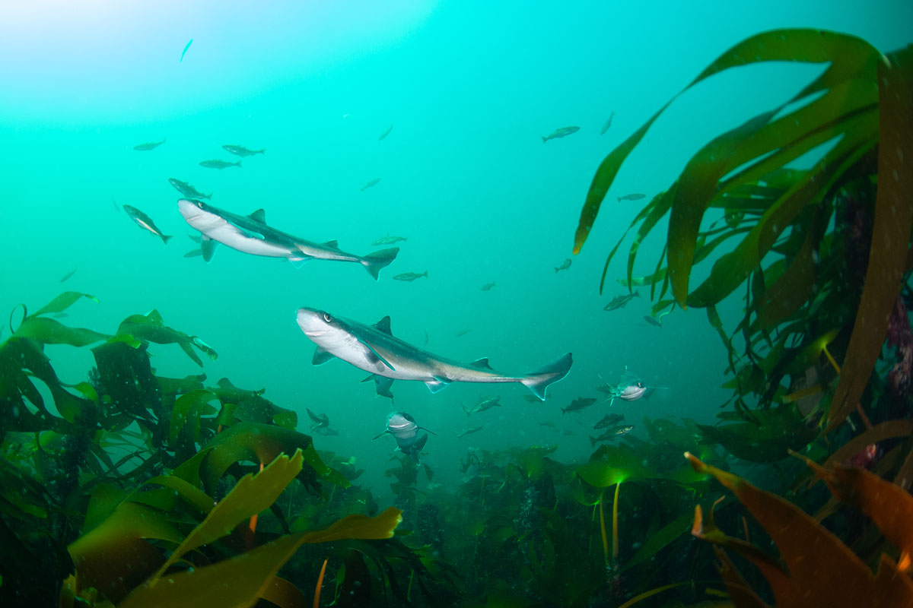
          - Spiny dogfish in the Jærkysten marine protected area.
Photo: Fredrik Myhre, World Wildlife Fund (WWF)
This is also the only area in Norway south of 62 oN where grey seals are known to breed regularly, and is a breeding and moulting area for common seals.
Coastal cod and Norwegian spring-spawning herring are the only fish species for which there is spatial data on spawning areas in the Outer Boknafjorden/Jærstrendene Protected Landscape, but eggs of North Sea cod, haddock, saithe, whiting and flatfish have also been recorded in the area. The sandy seabed in the Jærstrendene area provides particularly good spawning areas for flatfish. Historically, there were also important spawning sites for herring in the area, and these could become important again in the future.
The Karmøyfeltet bank area is important at ecosystem level because of the large concentrations of shrimps, a key species in the ecosystem here. In addition, large aggregations of sponges have been found, and other vulnerable species occur here, such as the bamboo coral Isidella lofotensis, which is considered to be endemic to Norway.
In this area, the vulnerability of eelgrass, the benthic fauna, fish (early life stages of demersal species), seabirds and marine mammals (seals) to various pressures is assessed as high.
Seaweed, kelp and eelgrass show high vulnerability to the extraction of non-living resources (shell sand). The benthic fauna shows high vulnerability to bycatches, selective species extraction, abrasion and habitat loss through sealing of the substrate. Early life stages of fish show high vulnerability to pollution, including oil pollution, and the extraction of non-living resources. Seabirds show high vulnerability to bycatches, disturbance due to human presence, litter, pollution, including oil spills, and alien species (mink). Seals show high vulnerability to bycatches, selective species extraction, and oil pollution.
Seaweed, kelp and eelgrass, benthic fish and most seabirds show high vulnerability to climate change, and negative impacts are expected. The changes may have either positive or negative impacts on the benthic fauna and diving seabirds, depending on the species involved.
Sandeel Habitat (NS2)
Sandeel habitat includes the most important areas of habitat and spawning grounds for sandeels in the Norwegian part of the North Sea.
The seabed in these areas is distinctive, with a substrate of coarse sand and fine gravel at moderate depths, and with good oxygenation conditions. Sandeels have specific habitat requirements, and need specific sediment types that they can burrow into.
Sandeel is the name used for any of several species of the family Ammodytidae, but the lesser sandeel (Ammodytes marinus) is the dominant species in Norwegian waters. In addition to being an important commercial species, the lesser sandeel is a key species in the North Sea ecosystem. Because it has such specific benthic habitat requirements, the species is highly stationary. Sandeels older than about six months spend much of the time buried in the sediment, and when they spawn, the eggs become attached to the sand and gravel. The only period when lesser sandeels are not entirely dependent on suitable bottom conditions is between hatching in February/March and when the larvae settle on the bottom in May/June.
Sandeel Habitat is very important for seabirds, since the lesser sandeel is one of the most important prey species for auks and gulls. The central parts of the North Sea are important for wintering fulmars and to some extent also for kittiwakes. Common guillemots and razorbills also use the area. In addition, Sandeel Habitat is important for feeding grey seals and minke whales.
A decline in the lesser sandeel stock would result in a lack of food for seabirds, fish and marine mammals in the North Sea and along the coastline of Norway and the UK.
Some of the areas designated as Sandeel Habitat are within larger areas where enhanced levels of phytoplankton biomass have been registered. These areas also have higher concentrations of zooplankton than surrounding areas, particularly in spring and summer.
The vulnerability of fish (early life stages and benthic species), seabirds and marine mammals (seals and toothed whales) to various pressures is assessed as high in Sandeel Habitat.
Fish (early life stages and demersal species) show high vulnerability to pollution, including oil pollution, abrasion, and the extraction of non-living resources. Seabirds show high vulnerability to bycatches, litter and pollution, including oil pollution. Seals show high vulnerability to bycatches and selective species extraction, while toothed whales show high vulnerability to pollution.
Seabirds, with the exception of coastal diving species, and benthic fish show high vulnerability to climate change, and the changes are expected to have exclusively negative impacts. The benthic fauna and coastal diving seabird species also show high vulnerability to climate change. However, the changes may have either positive or negative impacts depending on the species.
The Norwegian Trench (NS3)
The area designated as the Norwegian Trench is the section of this deep trench that runs through the Skagerrak parallel to the coast. Because this is a deep-water trench in otherwise shallow waters above the continental shelf, light and temperature conditions, current patterns and other physical conditions are very different from those in surrounding areas. The water is darker, colder and more saline than the shallower waters elsewhere in the North Sea. The Norwegian Trench includes three previously designated areas: Skagerrak, Skagerrak transect (parts) and Listastrendene protected landscape and Siragrunnen.
The species composition of the zooplankton in the Norwegian Trench is quite distinct from that in the rest of the North Sea–Skagerrak, with a large share of mesopelagic species. These include pelagic shrimp species, gelatinous plankton, krill and large copepods, and are not common in the shallow parts of the North Sea. Plankton species from other areas are transported with the inflow of Atlantic water to the deeper water layers. The Norwegian Trench is the only area of the North Sea–Skagerrak that has wintering populations of the copepod Calanus finmarchicus, which is a key species in the pelagic ecosystem. This may be crucial for the distribution of the species along the North Sea–Skagerrak coast, particularly in the spring months when these copepods migrate vertically to surface waters to spawn.
The Norwegian Trench is the only area of the North Sea that offers a natural habitat for deep-water fish. Silvery lightfish is the dominant species. The Skagerrak is an important nursery area for the shrimp Pandalus borealis in the southern part of its range, and may provide a climate refugium for the species in this area as seawater temperatures rise further. Zooplankton, shrimps and various fish species are important in the diet of species that live in the Norwegian Trench, but fish, seabirds and marine mammals living in shallower waters also feed on species that originate from the Trench. The fauna of the Norwegian Trench is part of a separate ecosystem with a unique species composition, and is to a large extent protected from human activity.
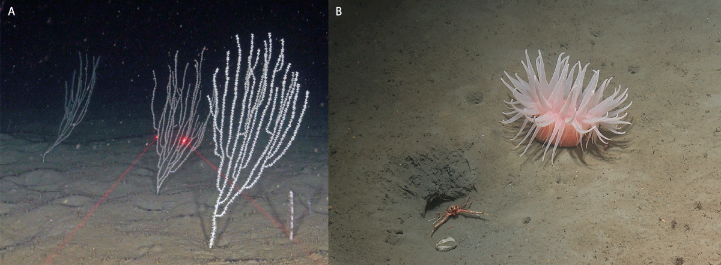
          - Deep-water fauna in the Norwegian Trench. Left: bamboo coral (the red laser dots are 10 cm apart). Right: deeplet sea anemone (Bolocera tuediae).
Photo: From Buhl-Mortensen L, Thangstad TH, Søvik G, Wehde H. 2023. Sea pens and bamboo corals in Skagerrak and the Norwegian trench, Marine Biology Research, Vol 19. https://doi.org/10.1080/17451000.2023.2224967 (left). Mareano/Institute of Marine Research (right).
In this area, the vulnerability of the zooplankton, benthic fauna and seabirds to various pressures is assessed as high. The benthic fauna shows high vulnerability to bycatches, selective species extraction, abrasion and habitat loss through sealing of the substrate. Seabirds show high vulnerability to bycatches, litter, and pollution, including oil pollution. The zooplankton shows high vulnerability to climate change. The benthic fauna also shows generally high vulnerability to climate change, but the impacts may be positive or negative depending on the species involved.
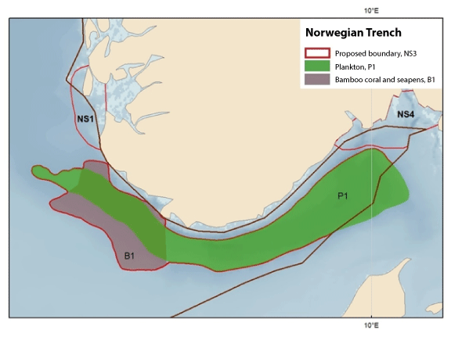
          - Map showing important ecosystem components in the Norwegian Trench. Winter distribution of copepods in the Norwegian Trench (P1) and core areas for bamboo coral (Isidella lofotensis) and several seapen species (B1). The map is based on relative quantities in trawl bycatches from shrimp surveys in the period 2017-2020, and video recordings showing corals and seapens on the seabed. The core areas for seapens coincide with areas where large catches of the shrimp Pandalus borealis were taken.
Source: Institute of Marine Research
There are high densities of vulnerable bamboo coral and seapens in the western section of the deep water in the Skagerrak/Norwegian Trench. Higher densities of bamboo coral stands have been recorded in this area than anywhere else except in fjords. Bamboo coral gardens are listed as an endangered habitat type on Norway’s Red List of ecosystems and habitat types. The seabed in western parts of the Norwegian Trench is being mapped in more detail as part of the MAREANO programme. This includes area B1 (see Figure 4.13), which overlaps with the Norwegian Trench. The results of further surveys and mapping of bamboo coral gardens and seapen communities will provide a basis for evaluating the delimitation of the western part of the Norwegian Trench in the next update of the management plan.
Outer Oslofjord (NS4)
This area is strongly influenced by the Norwegian coastal current, resulting in very distinctive physico-chemical and climatic conditions.
The Outer Oslofjord is an important breeding, passage and wintering area for seabirds, including several threatened species, and meets the EBSA uniqueness criterion. One of the most important breeding areas for the common term (endangered) in Norway is within the designated area. Coastal species such as common eider and red-breasted merganser feed here throughout the year, and the eider populations are of national importance. Herring, great black-backed and common gulls are important species outside the breeding season. The area is also important for little auks in the autumn. The designated area covers part of the wintering distribution of common guillemots from British colonies, and probably also of those from the more southerly colonies in Norway. Considerable numbers of common gulls spend the winter here. Parts of the area are important for common seals all year round, both for breeding and for feeding. The Outer Oslofjord has one of the largest coastal cold-water coral reef complexes in the world. Corals and kelp are habitat-building organisms that are associated with high levels of biodiversity. Kelp detritus that sinks to the bottom is used by shrimps and other crustaceans that live in deep water. Phytoplankton biomass and primary production are higher in the Outer Oslofjord than in the inner Skagerrak and other fjord systems.
In this area, the vulnerability of seaweed, kelp and eelgrass, the benthic fauna, fish, seabirds and marine mammals (seals) to various pressures is assessed as high.
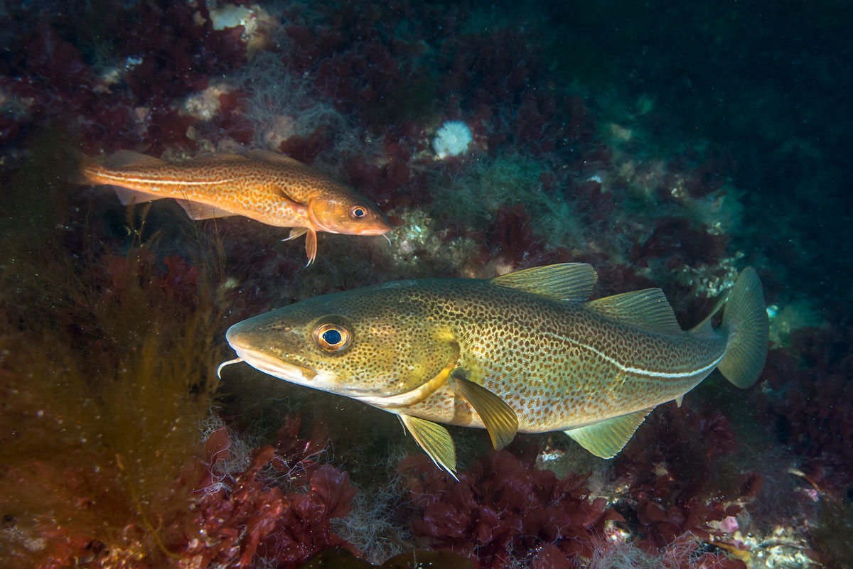
          - Cod in the Skagerrak.
Photo: Erling Svensen
Seaweed, kelp and eelgrass show high vulnerability to pollution and the extraction of non-living resources (shell sand). The benthic fauna shows high vulnerability to bycatches, selective species extraction, abrasion and habitat loss through sealing of the substrate. Fish and shellfish show high vulnerability to species extraction and pollution. Seabirds show high vulnerability to bycatches, selective species extraction, disturbance due to human presence, litter, pollution, oil pollution and alien species (mink). Seals show high vulnerability to selective species extraction and oil pollution.
Seaweed, kelp and eelgrass and seabirds show high vulnerability to climate change. The benthic fauna includes species that show high vulnerability to climate change, but the impacts may be either positive or negative depending on the species involved.

The conservation of marine biodiversity
Conservation measures, sustainable use and knowledge development are key components of integrated ocean management. Marine ecosystems and their functions relating to biodiversity, production and harvesting from the oceans must be managed in a way that strengthens ecosystem resilience and safeguards biological production in the future.
Efforts to protect valuable biodiversity and marine ecosystem services are based on the new knowledge acquired through mapping, monitoring and research. Knowledge about the marine environment has been developing rapidly in recent years in various areas, including the seabed, seabird populations and oceans and climate change.
The term conservation measures is used to mean both marine protection and other effective area-based conservation measures. Measures and policy instruments are referred to as ‘area-based’ if they apply to geographically delimited areas. Marine protection in Norway refers to the establishment of protected areas under the Nature Diversity Act. These may be either marine protected areas (MPAs), which are a separate category, or for example national parks or nature reserves that include marine areas. Establishing such areas provides long-term protection against environmental pressures and impacts across sectors. The term ‘other effective area-based conservation measures’ (OECMs) was defined by the Conference of the Parties to the Convention on Biological Diversity in a decision in 2018 (CBD/COP/DEC/14/8 Protected areas and other effective area-based conservation measures). Such areas must be geographically defined, their governance and management must achieve positive and sustained outcomes for biodiversity conservation, and management must have the ability to adapt to new threats. Positive and sustained outcomes must be achieved by preventing or significantly reducing threats and by restoring degraded ecosystems. It is also necessary to identify the biodiversity attributes for which an area is important, and as far as possible, such attributes should be documented and monitored.
Marine protected areas and other effective area-based conservation measures are intended to safeguard valuable underwater nature and ecological functions. Rich biodiversity and high biological production, ecosystem services that offer a potential for harvesting, and the value creation that can be achieved by harvesting renewable resources, are all closely interlinked.
Conservation as part of integrated, ecosystem-based ocean management
Conservation measures are used to safeguard areas of importance for biological productivity and diversity, and to maintain ecological functions in areas of special importance for marine biodiversity. Conservation measures also help to enhance ecosystem resilience and improve ecological connectivity where area-based conservation networks are established.
Norway is playing a leading role in developing an integrated, ecosystem-based ocean management regime in order to safeguard biodiversity and ensure sustainable use of ocean resources. Initiatives to promote green solutions and ocean industries will require the availability of large ocean areas for both existing and emerging industries. The High-level Panel for a Sustainable Ocean Economy (Ocean Panel) has published a set of recommendations in which they highlight that achieving a sustainable ocean economy requires effective protection, sustainable production and equitable prosperity to go hand-in-hand. The member countries of the Ocean Panel have undertaken a political commitment to sustainably manage 100 % of the ocean areas under their jurisdiction by 2025. Norway’s system of ocean management, including its ocean management plans and sectoral legislation, has served as a model for these developments. It is in Norway’s interests to maintain and further develop its role as a responsible steward of the oceans.
Climate change and the green transformation are an important part of the backdrop to this update of the ocean management plans. Norway has always had to take large-scale natural fluctuations into account in its ocean management. However, the ocean environment is now undergoing a continuous process of change towards a new and to some degree unknown state, and this is a different and more demanding task than dealing with natural fluctuations.
Conservation of a selection of Norway’s marine areas, habitats and ecosystems is intended both to safeguard valuable biodiversity and ecological functions and to reduce pressures on and the vulnerability of marine ecosystems that are exposed to climate change and ocean acidification.
Conservation measures and climate change
Conservation measures can moderate cumulative impacts on areas of special importance for marine biodiversity, and improve the resilience of the oceans to the impacts of climate change. Thus, conservation measures are a tool for safeguarding marine biodiversity and ecological functions even when conditions in the marine environment are changing.
The nature crisis is affecting life everywhere, including in the oceans. Both the Intergovernmental Panel on Climate Change (IPCC) and the Intergovernmental Science-Policy Platform on Biodiversity and Ecosystem Services (IPBES) have concluded that ocean governance must be adapted to the accelerating pace of climate and environmental change. Ocean governance must take into account the possible impacts of climate change in combination with other drivers of change, and it must be possible to adapt quickly as the situation changes. The IPCC and IPBES have highlighted the importance of developing well designed networks of protected areas to safeguard key marine biodiversity areas. This can help to reduce cumulative impacts on areas and ecosystems that are given special protection, and to protect areas that will become important as the distribution of species and ecosystems changes in response to climate change.
International framework
The Kunming-Montreal Global Biodiversity Framework was adopted at the Conference of the Parties to the Convention on Biological Diversity (CBD COP15) in Montreal in 2022. It applies to all ecosystems, including marine ecosystems. It sets global targets for 2030, including sound planning and management for all areas, restoration of at least 30 % of degraded ecosystems and effective conservation of at least 30 % of terrestrial and marine areas.
In addition to the Global Diversity Framework itself, the conference adopted a separate decision on the conservation and sustainable use of marine and coastal biodiversity. This recognises the importance of marine and coastal biodiversity as one of the key cross-cutting elements of the Global Biodiversity Framework and as critical to achieving the 2050 Vision for biodiversity, in addition, Norway, together with Australia, took the initiative for a statement on the importance of protecting and conserving marine and coastal biodiversity, which was supported by 37 countries. The statement highlights that ‘Recognising the importance of marine and coastal biodiversity, and the connections between coastal and open ocean ecosystems, is one of the key cross-cutting elements of the Post-2020 Global Biodiversity Framework. It is critical we have strong goals and targets on marine and coastal biodiversity, including to protect and conserve at least 30% of the global ocean.’
The conservation of areas of special importance for marine biodiversity
The targets of the Global Biodiversity Framework deal among other things with integrated management, restoration and conservation of ecosystems, including marine ecosystems. The Norwegian Government will present a white paper on a new national biodiversity action plan and describing how the Government will implement the Global Biodiversity Framework.
In 2021, the Storting (Norwegian parliament) formally requested the Government to take action to achieve the target of protecting 10 % of marine and coastal areas by 2030, and to propose a national marine protection plan. The work that is already under way on marine protection will be relevant to this goal. The Government will report back on practical steps to follow up the Storting’s request concerning protection of marine and coastal areas at a later stage.
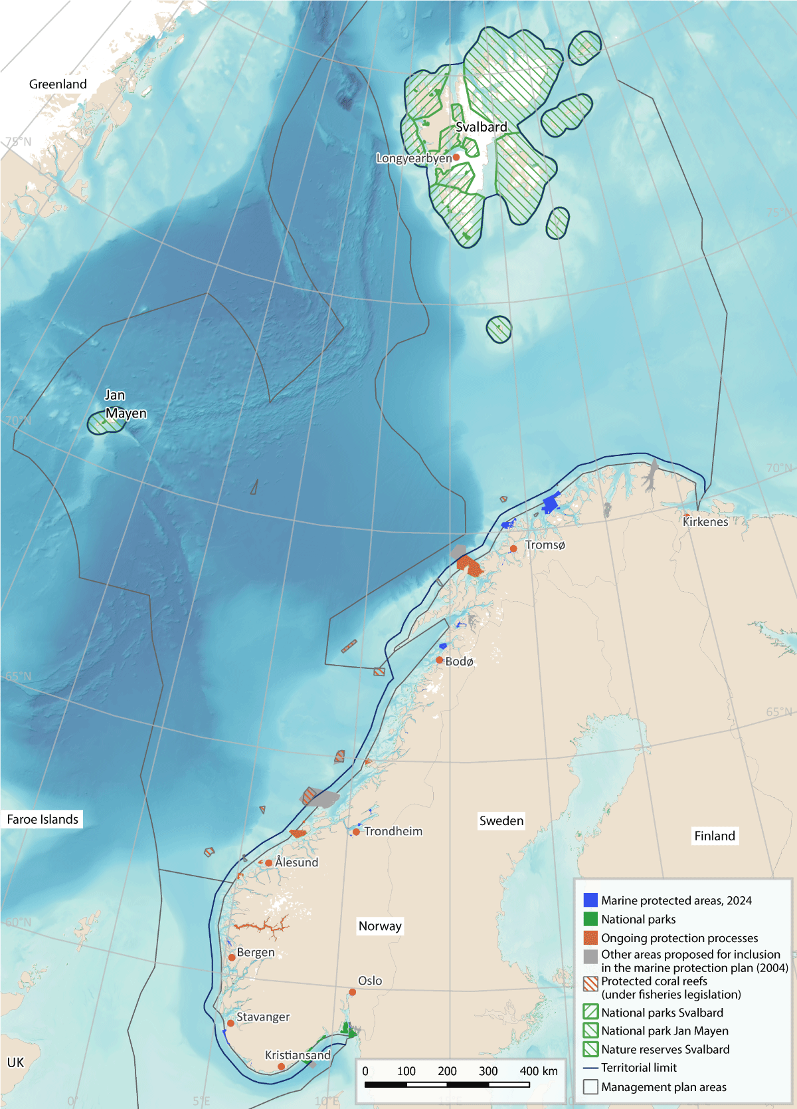
          - Map showing area-based conservation measures (both established and candidate areas) in Norwegian waters.
Source: Norwegian Environment Agency/Marine spatial management tool
Follow-up of the measures set out in the white paper Norway’s integrated plan for the conservation of areas of special importance for marine biodiversity, Meld. St. 29 (2020–2021), will be a key element of further work on the conservation of such areas in Norwegian waters. This work includes the establishment of marine protected areas (MPAs) and identification of other effective area-based conservation measures (OECMs). The Government is continuing work on a draft new act on the conservation of marine biodiversity outside territorial waters and other measures to strengthen conservation efforts, see Chapter 10. The status of work on marine protected areas in territorial waters is further discussed in Chapter 7.2. Areas that need to be shielded from additional pressure caused by human activity – either because they are already under pressure as a result of climate change or ocean acidification, or because they are major carbon sinks – are being identified. This work will continue. The changing ocean climate makes it important to identify areas that are particularly resilient to climate change, known as climate refugia, and to give such areas sufficient priority when establishing MPAs and OECMs.
A proposal has been made to add coral reefs to the list of selected habitat types under the Nature Diversity Act has been made, and a public consultation has been held. The Government’s plan for measures to safeguard threatened species and habitats also includes coral reefs. The other marine habitat types on the list are Radicipes coral gardens, southern sugar kelp forests, eelgrass meadows and mud volcanos. An assessment of the need to protect distinctive and rare species and habitats in deep-sea areas is continuing.
Ecosystem restoration
Restoration of ‘blue forests’ and other valuable habitat types widens the scope of ocean governance to include safeguarding valuable ecological features and enhancing biological production and natural carbon storage. Restoration involves measures to assist the recovery of ecosystems that have been degraded, damaged or destroyed. Conservation measures can contribute to restoration processes. The Global Biodiversity Framework, the UN Decade of Ocean Science for Sustainable Development (2021–2030) and the UN Decade on Ecosystem Restoration (2021–2030) all highlight the importance of both providing access to and disseminating knowledge about the ocean environment, and taking concrete action to improve environmental status and restore ecosystems in marine and coastal areas. Restoration to rebuild ecosystems that have been degraded or destroyed may involve active measures to re-establish habitats, remove sources of pollution, clean up waste, etc. In other cases, passive restoration may be used, which involves limiting use and moderating pressures on the environment, so that ecosystems can recover naturally.
Restoration is an essential tool for halting the loss of biodiversity, limiting greenhouse gas emissions from degraded habitats and dealing with the impacts of climate change. The nature crisis and the climate crisis need to be addressed together, and this is precisely what nature-based solutions such as ecosystem restoration achieve. For example, restoration of ‘blue forests’ – kelp forests, eelgrass meadows, salt marshes and the like – can both maintain major carbon sinks and safeguard biodiversity. Restoration of eelgrass meadows and kelp forests will enhance carbon storage, boost the potential for harvesting and safeguard biodiversity in coastal waters. Marine ecosystems play a key role in efforts to enhance natural carbon capture and storage capacity.
The aim of restoration is to improve the condition of damaged ecosystems, ensure the provision of ecosystem services and make it possible to continue sustainable uses of nature in the future. Reviving ‘blue forests’ can boost carbon storage and also provide a basis for new commercial activities. Action to improve ecosystem condition can both enhance natural biological production and have a positive effect on biodiversity and the potential for harvesting resources.
In the Skagerrak–Oslofjord area, ecosystem condition is being affected by inputs of nutrients and particulate matter from land, and by warmer seawater. The kelp forests have suffered serious decline, much of the natural nursery habitat for gadids and other fish is being lost, and the ecosystem is becoming poorer. Numbers of fish larvae are dropping, and fish stocks are declining. Work on the restoration of marine ecosystems has been started, with a special focus on the Skagerrak–Oslofjord area. The aim is to enhance the productivity and biodiversity of the ecosystems and their capacity for natural carbon capture and storage. A Government initiative is under way to restore good ecosystem condition in the fjord.
‘Blue forests’ – marine and coastal ecosystems such as kelp forests, eelgrass meadows, salt marshes, marine wetlands and in other parts of the world also mangrove forests – have a vital role to play in avoiding and resolving challenges related to the climate and nature crises. Blue forests are nature’s own way of moderating climate change and supporting high levels of biodiversity. Intact blue forests provide ecosystem services such as carbon sequestration and healthy fish stocks. They support rich biodiversity and are important habitats and nursery areas for a wide range of species. In addition, carbon uptake and storage in these ecosystems means that they play a part in mitigating climate change. The Ocean Panel highlights the importance of blue carbon ecosystems in providing solutions to challenges related to carbon storage, acidification, warming and the loss of biodiversity in the oceans. The restoration of degraded ocean ecosystems can prevent the loss of habitats of special importance for marine biodiversity and carbon storage, such as blue forests.

Management of coastal water bodies
Various authorities at national, regional and municipal level are involved in the management of Norway’s coastal waters. They are responsible for different activities and interests, for example the fisheries, aquaculture, shipping, spatial planning, pollution and the environment. These authorities operate at different but overlapping geographical scales.
The EU Water Framework Directive has been implemented in Norwegian law through the Water Management Regulations. This is a permanent ecosystem-based management regime. The purpose of the regulations is to provide a framework for establishing environmental objectives to ensure an integrated approach to the protection and sustainable use of water bodies. For coastal waters, the geographical scope of the regulations is from land or the outer limit of transitional (brackish) waters to one nautical mile outside the baseline, and out to the outer limit of territorial waters in respect of chemical status. The general objectives of the Water Management Regulations are to achieve good ecological status and good chemical status. Coastal waters are divided into water bodies, and the management plans drawn up under the regulations specify the environmental objectives for each water body. Norway’s coastal waters are divided into 2284 water bodies. In 2023, almost 75 % of these were classified as having good or high ecological status according to the system used in the Water Management Regulations.
The status of water bodies is assessed according to the classification system set out in the Water Management Regulations. The overall status of each water body is determined using chemical, physical and biological parameters. The regulations specify biological quality elements for each category of water body (rivers, lakes, coastal water and groundwater).
The ecological status of coastal water bodies is defined on the basis of assessments of four selected biological quality elements as set out in the regulations: phytoplankton, macroalgae, eelgrass and soft-bottom benthic invertebrates. These quality elements were primarily developed to give an indication of pressure from eutrophication and to some extent from organic matter, sedimentation, chemical pollution and physical disturbance that changes tidal and hydromorphological conditions. However, these four biological quality elements are not particularly suitable for providing information on the ecological status of coastal waters with respect to biodiversity. For example, fish are not currently included as a biological quality element for coastal waters either in the Water Framework Directive or in the Water Management Regulations. In many other European countries, large areas along the coastline are defined as transitional waters, and the fish fauna is included as a biological quality element for these water bodies in the directive. However, there are few areas of this kind in Norway. This means that the criteria currently used in the Water Management Regulations do not give a complete picture of the status of coastal waters. For example, under the Water Framework Directive, ecological status is found to be good in some parts of the Oslofjord and moderate in other parts. This is despite the fact that we know, to give one example, that stocks of cod and other gadids have collapsed and are at historically low levels.
It is possible for Norway to include extra quality elements in the Water Management Regulations, in addition to those specified in the Water Framework Directive. Quality elements in the regulations should be designed to provide a satisfactory assessment of pressures that are of significance for ecosystems in coastal waters. These ecosystems also have ecological links with adjoining marine areas. To provide a better knowledge base and a more complete picture of the ecological status of coastal waters under the Water Management Regulations, the Government will consider whether more ecosystem components should be included in the assessments.

Nature-based solutions
Nature-based solutions are solutions inspired or supported by nature to address major environmental, social and economic challenges in sustainable ways. Examples include action to maintain or restore nature or the climate benefits of nature, and action that uses nature to enhance the uptake of greenhouse gases. In the past ten years, there has been growing awareness across sectors of the role nature-based solutions can play in addressing climate change.
In 2022, the UN Environment Assembly agreed on a definition of the term ‘nature-based solutions’, which has been adopted by both the Climate Change Convention and the Convention on Biological Diversity. This makes it clear that nature-based solutions must provide biodiversity benefits, and reads as follows: ‘… nature-based solutions are actions to protect, conserve, restore, sustainably use and manage natural or modified terrestrial, freshwater, coastal and marine ecosystems which address social, economic and environmental challenges effectively and adaptively, while simultaneously providing human well-being, ecosystem services, resilience and biodiversity benefits.’

Blue forests and carbon sequestration in sediments
‘Blue forests’ is a generic term for marine and coastal ecosystems that capture and store carbon, support rich biodiversity and form habitats for many different organisms, and so can be likened to terrestrial forests. Kelp forests make up the largest ecosystem by area in both Norway and the world as a whole. Kelp forests, together with seaweed communities, eelgrass meadows and salt marshes, are Norway’s blue forests. They form vital habitats for biodiversity in both coastal and marine waters. In addition, blue forests can play an important role in the green transition.
Interest in and understanding of the oceanic carbon cycle has been growing in recent years, and there has been a particular focus on the importance of organic carbon stored in marine vegetation or sequestered in the seabed. The marine ecosystems that are most important for carbon storage in Norwegian waters are macroalgae (kelp and seaweed), eelgrass meadows, salt marshes, and sediments and the soft-bottom fauna.
A large proportion of European kelp forests are in Norwegian waters. Healthy kelp forests sequester large quantities of carbon dioxide (CO2), while at the same time producing oxygen (O2), which is vital for life in the sea. Kelp can also remove inorganic nitrogen (N) and phosphorus (P) from coastal waters. These nutrients are currently a growing problem for water quality in many densely populated coastal areas. Macroalgae (kelp and seaweeds) make the largest contribution to carbon uptake and storage in Norway’s coastal waters.
Macroalgae grow in all coastal counties from Agder in the south to Troms and Finnmark in the north, and also around Svalbard, and cover around 10 000 km2 of the seabed along the coast of mainland Norway. Two kelp species, Laminaria hyperborea and Saccharina latissima (sugar kelp), and seaweeds make up about one third of this area each. Eelgrass meadows cover an area of only about 90 km2. Salt marshes have not been mapped sufficiently to estimate the total area in Norway. Soft-bottom habitats on the seabed are the most widespread of the marine habitats that are important for carbon storage in Norway, covering a total of more than 77 000 km2 in coastal waters (less than 12 nautical miles from the baseline).
It is estimated that in the territorial waters around mainland Norway, these ecosystem types account for annual uptake and storage of about 5 million tonnes CO2eq. This is equivalent to about 10 % of Norway’s emissions and 1/3 of annual uptake and storage on land. We lack updated figures for the remaining ocean areas under Norwegian jurisdiction.
Blue carbon, i.e. carbon captured by living organisms in coastal ecosystems (macroalgae, eelgrass meadows, salt marshes, and sediments and the benthic fauna) and stored in biomass and sediments, has become a focus of international policy in recent years. The growing interest in blue carbon is linked to recognition of the important opportunities that restoration and conservation of these ecosystems may provide for achieving several of the sustainable development goals – this may be through adaptation to climate change, greater protection against storms and coastal erosion, food supplies from the oceans, improvements in living conditions, employment opportunities, protection of biodiversity or better water quality.
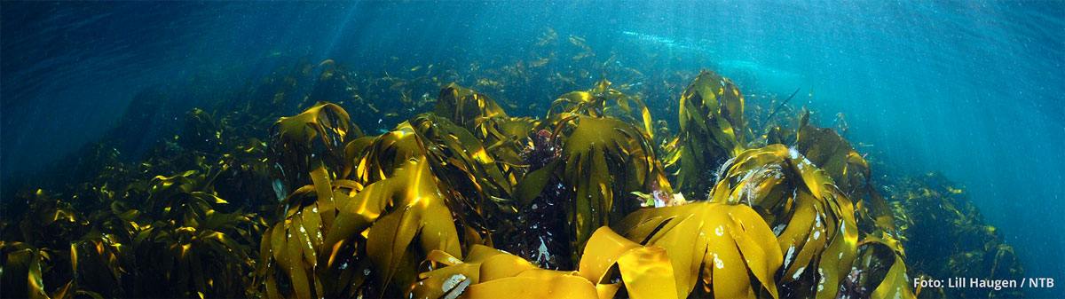
          - Blue forest. A kelp forest off the island of Runde.
Photo: © Lill Haugen, NTB
At global level, kelp and seaweed cultivation is the most rapidly growing aquaculture industry, with an annual growth rate of 6.2 % over the past 20 years. Seaweed output is highest in Asia, but commercial cultivation has now started in Norway as well. Industrial extraction of alginate has also started, based on kelp harvesting along the coast. Efforts are under way to develop new industrial opportunities based on kelp, such as renewable feed supplies for fish farming, replacements for plastics, and biofuel.
Healthy kelp forests are also important for sustainable fisheries, aquaculture and tourism because they support healthy, productive ecosystems and provide ecosystem services. In Norway, coastal communities have a long history of using kelp forests as an importance resource, both as a nutritious supplement to other livestock feed and for soil improvement. The conservation of kelp forests can also reduce carbon loss and emissions and safeguard a variety of other ecosystem services. Similarly, the restoration of kelp forests will boost carbon fixation, re-establish habitats and improve resilience to extreme weather events. Thus, healthy blue forests improve the health and resilience of a range of ecosystems.
Short-term carbon storage
Marine vegetation functions as a short-term carbon store through carbon uptake from the seawater and storage in biomass. The short-term carbon pool in kelp forests along the coast of mainland Norway is estimated at almost 5 million tonnes carbon, or 18 million tonnes CO2eq. This corresponds to about 1 % of the standing stock of carbon in trees in Norwegian forests. The carbon pool in seaweed communities is estimated at 0.9 million tonnes carbon (about 3.2 million tonnes CO2eq), while eelgrass meadows store 252 000 tonnes carbon (about 0.9 million tonnes CO2eq). In eelgrass meadows, most of the short-term carbon pool is in the form of dead organic material in the sediments below the vegetation.
In total, it is estimated that the carbon pool in seaweed, kelp and eelgrass ecosystems is about 22.1 million tonnes CO2eq in the vegetation itself and in the sediments directly below the vegetation.
Long-term carbon storage (sequestration)
The seabed is the final destination for carbon that is captured by marine habitats, and makes up the largest marine carbon store. Long-term storage of carbon takes place in the sediments. Carbon sequestered in the seabed may also originate from land. It is estimated that there is a carbon pool of about 137 million tonnes in the upper 25 cm of the seabed sediments in soft-bottom areas in Norway’s coastal waters (less than 12 nautical miles from the baseline), an area of about 77 000 km2. If the upper metre or several metres of the sediments is included, the estimated figure for the carbon pool increases more or less proportionally.
Soft-bottom areas of seabed and kelp forests cover large areas and are carbon stores of national importance. Eelgrass meadows and salt marshes cover considerably smaller areas, but store more carbon per unit area than for example kelp forests.
Estimates of annual sequestration rates for the different ecosystem types in coastal waters show that kelp forests store the largest quantity of carbon per year, about 0.5 million tonnes (1.8 million tonnes CO2eq), followed by seaweed communities (0.43 million tonnes CO2eq per year) and eelgrass meadows (0.017 million tonnes CO2eq per year). In total, these ecosystems sequester roughly 2.2 million tonnes CO2eq per year, corresponding to 4.5 % of Norway’s total CO2 emissions. These figures provide an estimate of how much CO2 is removed from the atmosphere each year by the blue forests in Norway’s coastal waters.

Ocean accounting
The Ocean Panel brings together 18 countries that have undertaken a political commitment to sustainably manage 100 % of the ocean area under their jurisdiction by 2025 on the basis of sustainable ocean plans. The Ocean Panel has adopted a framework with various outcomes to be achieved by 2030. One of these is that ‘decision-making affecting the ocean reflects the value of and impacts on the ocean’s natural capital.’ The Panel identifies the development of national ocean accounts as one way of achieving this outcome. The Forum for Integrated Ocean Management has considered how the development of ocean accounting can be followed up in Norway, and in particular how ocean accounting can be used in further work on the elements of the ocean management plans relating to value creation and ecosystem services.
A pilot version of an ocean satellite account for Norway has already been published (consistent with the System of National Accounts, SNA), while the development of a system of ecosystem accounting (based on the SEEA EA) and complete thematic ocean accounts will take longer.
              - Main components of an ocean accounting system
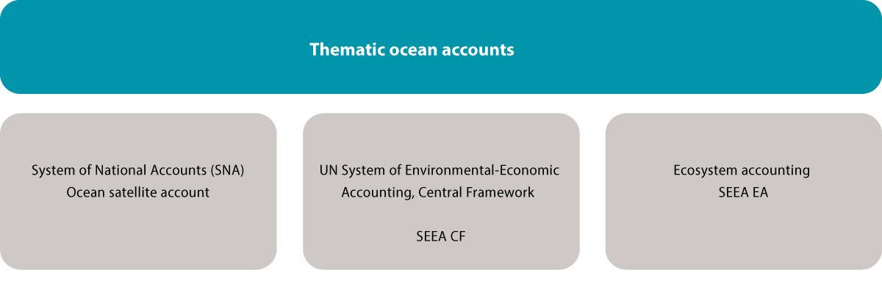
          - Main components of an ocean accounting system
Source: Norwegian Environment Agency
Thematic ocean accounts combine information on economic, environmental and social topics relating to marine and coastal waters using a country’s national accounts and the UN System of Environmental-Economic Accounting (SEEA). Three internationally agreed accounting frameworks are used: the System of National Accounts (SNA), the SEEA Central Framework and SEEA Ecosystem Accounting. The SEEA Central Framework is based on the same principles as the SNA, so that accounts based on them are complementary and compatible with each other.
Ocean-related economic activity is extracted from the national accounts in an ocean satellite account. This provides an overview of economic activity at national level in a particular year in industries and sectors that are directly or indirectly ocean-related. For example, it could provide information on the proportion of value creation from the fisheries industry in the course of a year. The satellite account will not provide any information on whether or not this value creation is sustainable.
The SEEA Central Framework (SEEA CF) provides information on links between the economy and the environment. Information on direct anthropogenic drivers and the use of natural resources is recorded here, for example emission and energy accounts. The SSEA CF provides information on how human/economic activity affects the natural environment.
The SEEA Ecosystem Account (SEEA EA) system is based on spatially explicit (map-based) information and consists of five core accounts: ecosystem extent, ecosystem condition, two ecosystem services accounts (biophysical and monetary) and a monetary ecosystem asset account. The system is designed to be developed from the bottom upwards, using spatial data on ecosystem extent as a basis. The ecosystem extent account provides systematic information on the area of different ecosystem types. The ecosystem condition account records the condition of the same ecosystems relative to a reference state. The biophysical ecosystem services account provides information on the flows of ecosystem service provided by ecosystems and who uses them. The monetary ecosystem services account is based on the previous account and uses monetary values for transactions in order to estimate the monetary value of some ecosystem services. Provided that the other four accounts exist, it is possible to estimate the monetary value of ecosystem assets (also known as natural capital) for each year.
[Boks slutt]
Most work on establishing environmental economic accounting has focused on terrestrial ecosystems and freshwater resources. Further development of the accounting framework is therefore needed to take into account issues of particular relevance to marine ecosystems, such as their three-dimensional nature (water column and volume), migratory species and determining the reference condition of ecosystems. In addition, the concept of incorporating information from the three different accounting frameworks into a thematic ocean account is relatively new. The UN has therefore initiated work on the development of SEEA Ocean, which will consider how to develop the three accounting frameworks and use them together to develop a thematic ocean account.
The results from Norway’s ocean satellite account have been used to describe value creation in the ocean industries. A project to develop a pilot marine ecosystem account for the area Coastal Zone Lofoten has also been started, focusing mainly on the three physical accounts – ecosystem extent, ecosystem condition and a biophysical ecosystem services account. The purpose of this project is to build up expertise on ocean accounting in the public administration, test the use of the accounting frameworks in practice and provide input to international development work.

Ecosystem services
Norwegian society derives major benefits from the ecosystems in Norwegian waters, which for example contribute to food supplies, regulating services and opportunities for recreation. Well-functioning ecosystems that provide ecosystem services are essential to ensure that Norway’s ocean areas continue to contribute to Norway’s welfare in the future.
In contrast to economic value creation, which is reported in the national accounts, no system has been established for collecting data on ecosystem services in Norway. The Norwegian Environment Agency and Statistics Norway, in cooperation with the Forum for Integrated Ocean Management, are now working on the development of ecosystem accounting for Norwegian ocean areas. The particularly valuable and vulnerable area Coastal Zone Lofoten has been chosen as a pilot, since a great deal of data and knowledge is available about the ecosystems and ecosystem components in this area. This makes it possible to test the extent to which ecosystem services can be described using the current knowledge base. The work will also provide a basis for evaluating whether the results can be used to describe changes and trends, and whether the methodology is transferable to other ocean areas.
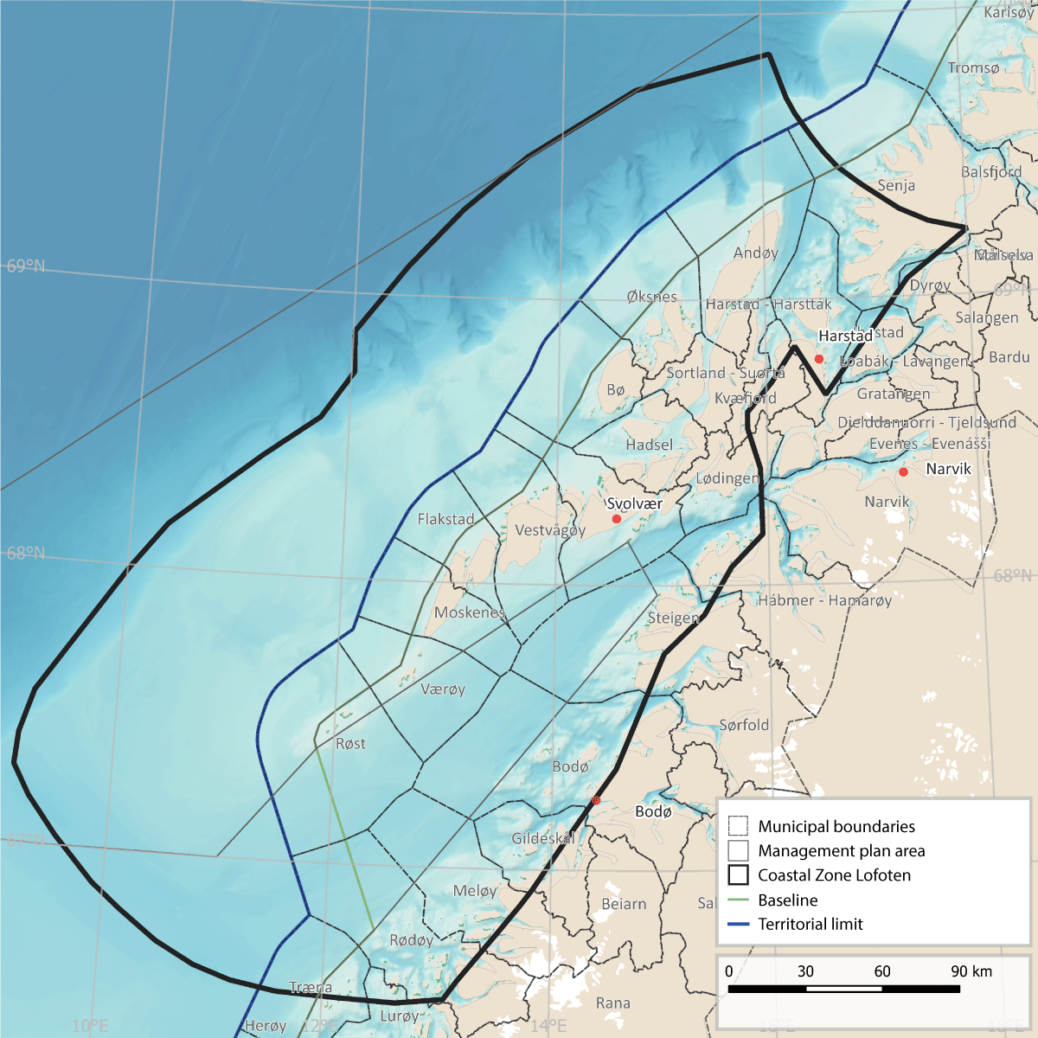
          - Map of the pilot area for ecosystem services, Coastal Zone Lofoten, showing municipalities within and adjacent to the area.
Source: Norwegian Environment Agency
Biological resources can move or be transported for considerable distances, and within the Coastal Zone Lofoten many ecosystem services are dependent on processes that take place outside the area. Moreover, processes in the marine environment can have implications for recreation and tourism on land or closer to the coast, and processes on land can influence marine ecosystems. Many of the ecosystem components that are typical of the area are only found there for parts of the year. A report has been published describing marine ecosystem components and ecosystem services within the boundary of the Coastal Zone Lofoten.
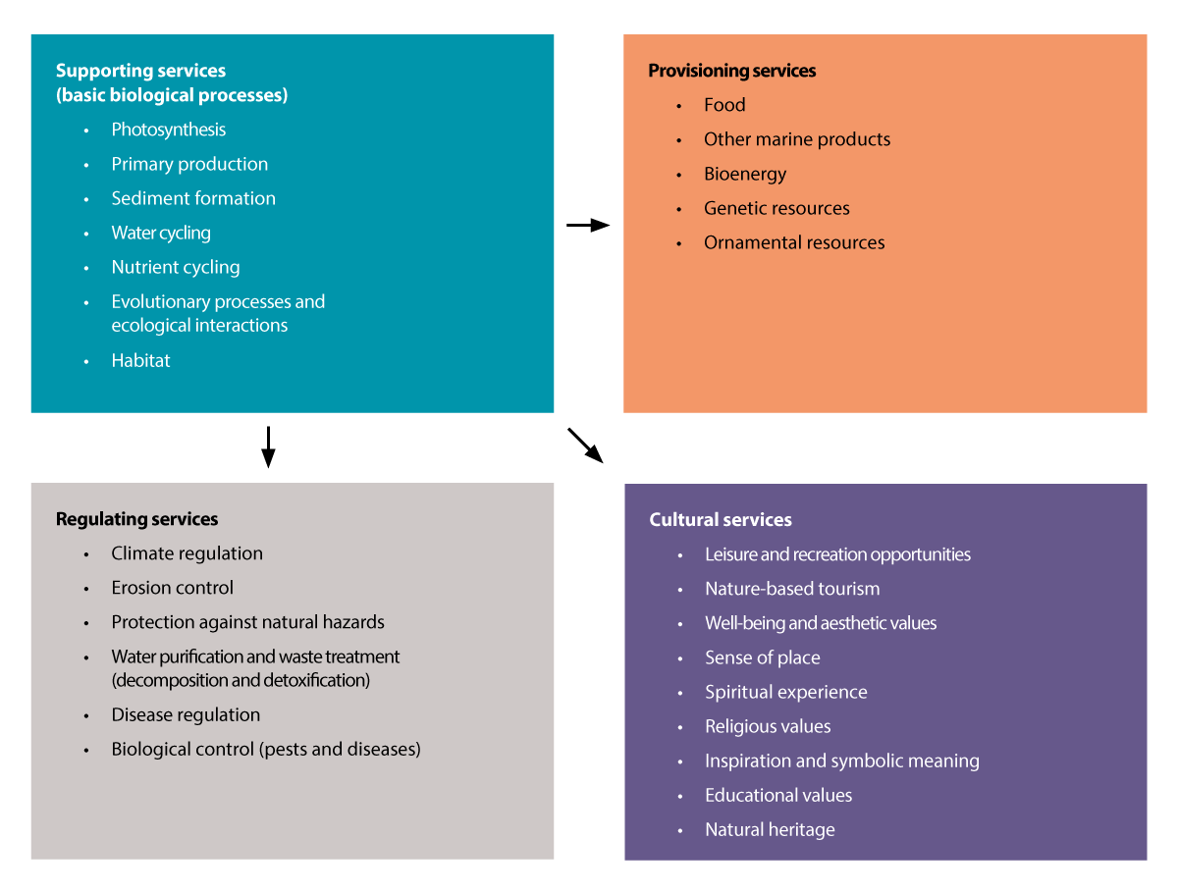
          - The four categories of ecosystem services, with examples that are relevant to marine and coastal waters.
Sources: Adapted from NOU 2013: 10.
More knowledge is needed both about the ecological structures and functions that underpin ecosystem services and about flows of ecosystem services to make it possible to describe changes and trends. Knowledge about changes in ecosystems and the structures and functions underlying ecosystem services is needed to identify whether current patterns of use are sustainable and reveal what future changes are to be expected in flows of ecosystem services. Similarly, information about changes in flows of ecosystem services is important for an understanding of how society is using ecosystems and ecosystem components. In the pilot project, the ecosystem components present in the area have been used as a basis for describing the ecosystems, and thus the structures and functions underlying ecosystem services. The descriptions of these components are largely based on earlier work on the scientific basis for the management plans, using the following ecosystem components: benthic communities, phytoplankton, zooplankton, fish, seabirds and marine mammals.
The ocean currents and topography in the Coastal Zone Lofoten result in upwelling of nutrient-rich deep water to the upper water layers, creating highly favourable conditions for biological production. As a result, primary production by phytoplankton, seaweed and kelp is continuously high. Because the continental shelf is narrow in this area, there are strong currents, concentrating passively transported organisms (zooplankton and fish eggs and larvae). The high level of production and large concentrations of organisms that are important as food for other animals in the food web mean that this is a very important area for seabirds, whales, various benthic species, and commercially important fish species such as cod, saithe, haddock and herring.

Knowledge building and knowledge needs
A sound knowledge of ecosystems, ecosystem condition and ocean-related activities is the foundation for integrated ocean management. Information on areas of importance for ecosystem functioning and nature-based solutions is crucial for sustainable ocean management. Norway is therefore focusing closely on the management of the designated particularly valuable and vulnerable areas.
Growing problems related to the oceans and climate change, including biodiversity loss, ocean acidification, pollution, plastic waste and other drivers, are affecting the dynamics and functioning of ecosystems, and action must be taken to ensure that marine ecosystems are resilient and productive. We need more knowledge and a better understanding of ecosystem functioning and ecological relationships, and about the cumulative impacts of climate change and other drivers. Work is being done to improve our knowledge of species, habitats and marine ecosystems and their vulnerability, for example for seamounts and active vent fields in deep-sea areas.
Research cooperation and the establishment of pilot projects on the restoration of marine ecosystems is an important element of Nordic cooperation. Experience gained from work in the Baltic Sea can be used in strengthening cooperation on environment and sustainability in the Skagerrak region. Norway is also working on a national pilot project to improve ecosystem condition in the Skagerrak, focusing on the national parks in the Skagerrak-Oslofjord area. One aim is to build up knowledge of the effects of restoration measures.
Seabed ecosystems and habitat types
Seabed mapping provides important information on areas of crucial importance for marine ecosystem functioning. The MAREANO programme is mapping the seabed in Norwegian waters and thus strengthening the knowledge base. Seabed mapping is also an important basis for integrated, ecosystem-based management. It is important to continue this work to build up knowledge about seabed habitat types and biotopes with important functions, and about the resilience and vulnerability of marine benthic ecosystems to different pressures and to cumulative impacts, based partly on data from the MAREANO programme.
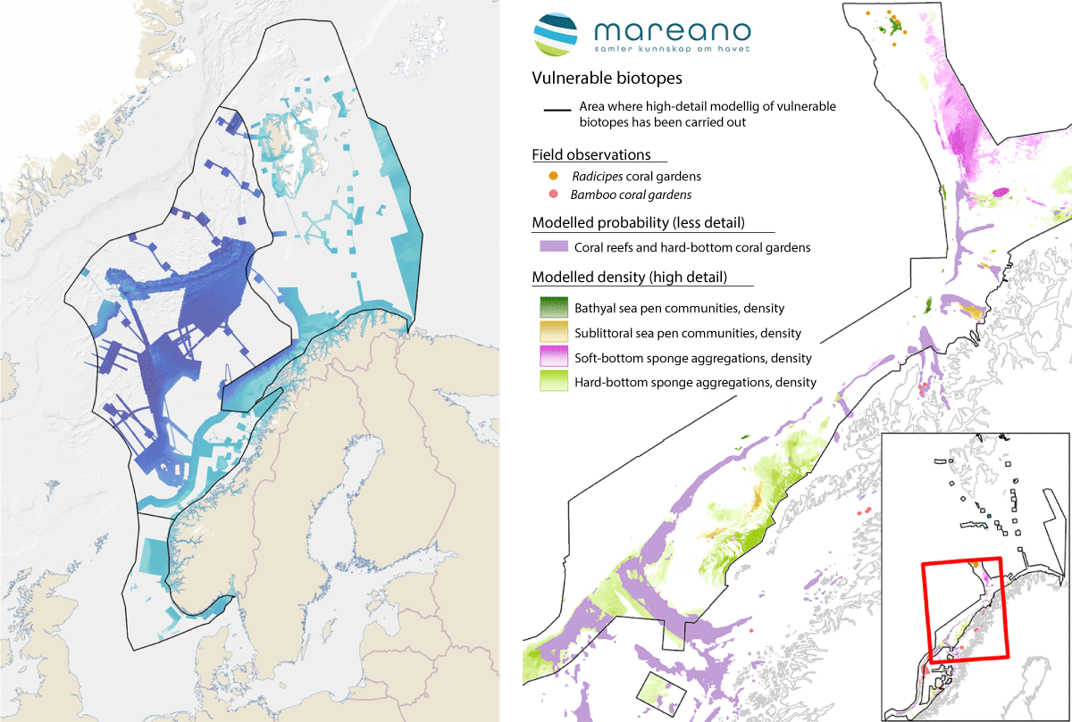
          - Mapping the seabed. Areas where the MAREANO programme has mapped depth and topography or obtained data from other sources (left). Vulnerable habitats modelled on the basis of data collected by the MAREANO programme (right).
Source: Mareano
Seabird populations, distribution and migration
Systematic mapping and monitoring is generating a considerable amount of new information about seabird population trends, and more understanding of changes in ecosystems, and information about migratory patterns and seabird habitat use throughout the year. Knowledge about seabird populations is being built up through the SEAPOP programme and the SEATRACK tracking module. Since 2014, the winter distribution of Norwegian seabirds has been mapped using light loggers, or GLS loggers. This has given a completely new understanding of seabird migration patterns and wintering areas. The results so far show that the ice-free parts of the Barents Sea and waters north of Iceland are very important wintering areas (November–January) for adult birds of the six most abundant Norwegian pelagic seabirds (fulmar, kittiwake, common guillemot, Brünnich’s guillemot, puffin and little auk). The entire Norwegian population of common guillemot winters in the Barents Sea. Brünnich’s guillemots follow a mixed strategy. Birds from mainland Norway and the eastern parts of Svalbard winter in the Barents Sea, while those that breed on Bjørnøya and along the west coast of Spitsbergen winter around Iceland and south of Greenland. For kittiwakes, puffins and little auks, other important wintering areas are north of Iceland and south and west of the southern tip of Greenland (the Labrador Sea). Fulmars from Norwegian colonies spread across large areas of the Northeast Atlantic during the winter. Tracking data and knowledge generated through SEAPOP and SEATRACK is providing a very important scientific basis for ocean management both in Norway and internationally at a time when ecosystems are changing rapidly and an integrated approach is crucial.
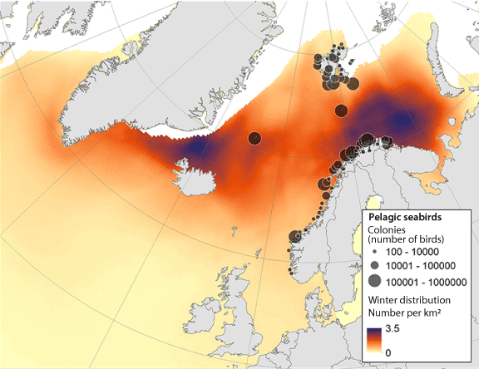
          - Colonies and winter distribution (November-January) of the six most abundant pelagic seabirds that breed in Norway (fulmar, kittiwake, common guillemot, Brünnich's guillemot, puffin and little auk).
Source: SEATRACK and SEAPOP.

Norway’s ocean industries: status, trends and developments for value creation and environmental pressures and impacts
Norway’s seas and oceans are rich in natural resources, and the country has always taken a long-term approach to resource management for the benefit of society as a whole. This chapter describes status, trends and expected developments for Norway’s ocean industries, value creation by these industries, and the associated environmental pressures and impacts. This includes an account of their potential role in climate change mitigation.
Ocean industries account for a large proportion of value added in Norway, totalling NOK 2306 billion in 2022. The ocean industries provided employment for 233 600 people in 2022, and provide a significant share of employment all along the Norwegian coast. The largest ocean industries in Norway are the fisheries, the petroleum industry and shipping. In addition, new industries such as offshore wind, offshore aquaculture, CO2 storage on the continental shelf and seabed mineral activities will result in value creation and employment opportunities in the years ahead.
Clean and productive oceans are an essential basis for a wide range of industrial activities at sea. However, ocean industries also affect ecosystems through harvesting, physical disturbance of the seabed, pollution, litter, noise and the spread of alien species. They also represent a risk of environmental damage as a result of acute pollution.
Climate change mitigation measures related to the oceans and ocean industries have the potential to contribute substantially both to reducing emissions and to enhancing carbon uptake. This contribution is an important element of the long-term social benefits and value creation these industries can provide. According to a report commissioned by the Ocean Panel, The Ocean as a Solution to Climate Change. Updated Opportunities for Action, ocean-based mitigation options could up to 2030 close as much as 18 % of the gap between current policy and the mitigation needed to limit global warming to 1.5 oC. Over a longer time frame, up to 2050, the estimated proportion is 35 %. These figures are based on a range of assumptions and the level of uncertainty is high. Overall estimates of this kind have not been made for Norwegian waters.

Fisheries and other harvesting of living marine resources
Fishing has historically been an essential basis for settlement all along Norway’s long coastline. Harvesting of living marine resources accounts for substantial value creation. There is also considerable activity by foreign fishing vessels in Norwegian waters. Seafood is Norway’s most important export, and of great significance for world food security.

Description of the industry
Catches by Norwegian vessels for the country as a whole totalled 2.2 million tonnes in 2016 and 2.6 million tonnes in 2021 (figure 5.1). This rise is mainly explained by higher catches of Norwegian spring-spawning herring and mackerel. Catches of cod and haddock declined somewhat in the same period, and totalled 376 000 tonnes and 101 000 tonnes respectively in 2021, while catches of saithe have risen from 155 000 tonnes in 2016 to 189 000 tonnes in 2021.
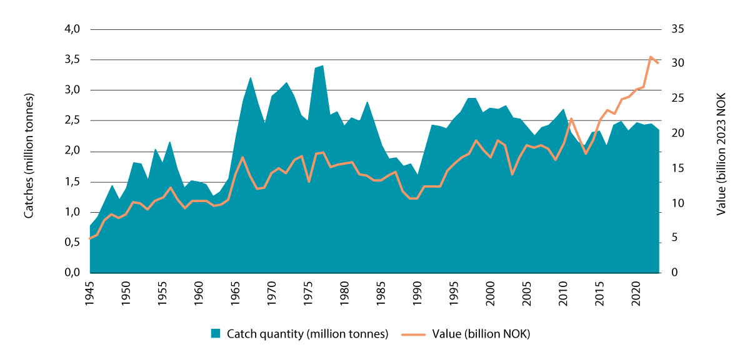
          - Norwegian marine capture fisheries in all three management plan areas, 1945–2023. The figure shows catch quantities (blue shading) and total first-hand value (orange line).
Source: Directorate of Fisheries
Major structural changes have been made in the Norwegian fishing industry over a number of decades. In 1960, the peak year, there were 41 000 registered fishing vessels in Norway. By 1990, the number of vessels had been reduced to about 17 000, and in 2021 there were only 5 633 registered vessels. Catches per person are about 30 times larger today than they were in 1945, and as a result the fishing industry is profitable and subsidies have been virtually eliminated.
Status and trends for fish stocks
The most important commercial stocks in the Barents Sea–Lofoten area are Northeast Arctic cod, haddock, saithe, shrimps, Norwegian spring-spawning herring and capelin. The stocks of Northeast Arctic cod, haddock and saithe are in good or very good biological condition. The recruitment cycle of Norwegian spring-spawning herring is variable, and stock growth is therefore dependent on a few particularly strong year classes. The shrimp stock in the Barents Sea is in good condition, while there are fluctuations in the capelin stock. These are explained by considerable predation pressure from the large Northeast Arctic cod stock, and at times poor recruitment to the capelin spawning stock.
Changes have been observed in the distribution of the Northeast Arctic cod stock in the last few years. Spawning is now also taking place in areas further north and northeast than the traditional spawning grounds around the Lofoten and Vesterålen Islands, and the range of the mature stock has shifted further north and northeast. This is illustrated by that fact that cod have been caught as far north as Franz Josef Land and as far east as the northern Kara Sea. In recent years, spring-spawning herring have been overwintering on bank areas and in waters west of the Lofoten and Vesterålen Islands and Troms, and numbers of herring in the Vestfjorden east of the Lofoten Islands have been low. Herring spawn mainly off the coast of Møre og Romsdal in February–March, but there is also some spawning off the coast of Nordland and around the Lofoten and Vesterålen Islands.
The snow crab has become a valuable commercial species on the Norwegian continental shelf in the Barents Sea. The first Norwegian catches were registered in 2012, and in 2022, the harvest reached a total of 7 960 tonnes. For 2024, a total allowable catch (TAC) of 10 300 tonnes was set for the Norwegian shelf, and knowledge about the stock has been improved through the monitoring programme run by the Institute of Marine Research.
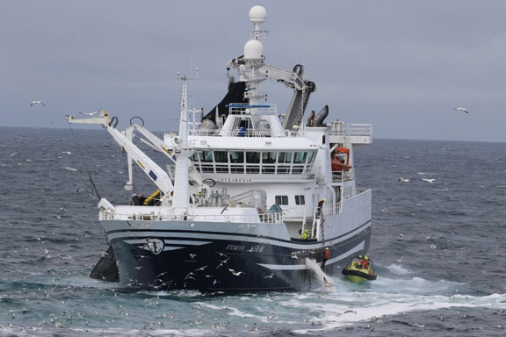
          - Fishing vessel during fishing operations, showing Coast Guard personnel boarding for inspection.
Photo: Norwegian Coast Guard
The most important commercial stocks in the Norwegian Sea (Norwegian spring-spawning herring, blue whiting, mackerel and Northeast Arctic saithe) are in good condition, meaning that the harvest is well within biological limits. Coastal cod stocks are in poor condition. Golden redfish is classed as endangered in the Norwegian Red List in Norwegian waters, including both the Norwegian Sea and the Barents Sea. The recruitment cycle of Norwegian spring-spawning herring is variable, and stock growth is therefore dependent on a few particularly strong year classes. Management of the mackerel stock is based on multilateral agreements between the coastal states, but despite many rounds of negotiations, they have failed to reach agreement on mackerel quotas for a number of years.
In the North Sea–Skagerrak area, the most important commercial stocks (mackerel, North Sea herring, shrimps, Norway pout and sandeel) are in good condition, meaning that the harvest is well within biological limits. Coastal cod stocks are in poor condition. The cod stock in the North Sea and Skagerrak is in poor condition, even though fish mortality has been reduced and the spawning biomass has risen after a historical low in 2006. Sandeels are highly stationary, and Norway follows an area-based management model in the North Sea. Only selected areas of sandeel habitat are opened for fishing each year. The sandeel stock varies greatly as a result of wide variation in recruitment and because sandeels are very short-lived.
Catch quantities
In the period 2016–2021, catches by Norwegian vessels in the Barents Sea–Lofoten area varied between 746 000 tonnes in 2016 and 1 102 000 tonnes in 2021. The overall increase from 2016 to 2021 is mainly explained by a rise in herring catches.
In the same period, catches by Norwegian vessels in the Norwegian Sea varied between 481 000 tonnes in 2016 and 581 000 tonnes in 2021. The largest change in this period was in mackerel catches, which rose from 151 000 tonnes to 248 000 tonnes.
Herring and sandeels make up a very large proportion of catch quantities in the North Sea fisheries. North Sea herring is managed on the basis of a bilateral agreement between Norway and the UK, and the recommended TAC for 2021 was 359 367 tonnes. This is lower than in previous years. In the North Sea–Skagerrak area, the catch of North Sea herring by Norwegian vessels varied between 150 000 tonnes in 2016 and 95 000 tonnes in 2021. In the same period, there was a large rise in sandeel catches, from 41 000 tonnes in 2016 to 146 000 tonnes in 2021.
Expected developments in future
There are strong expectations that exploitation of marine resources in general, and of living marine resources in particular, will become even more important in future. To ensure continued sustainable fisheries management, it will be vital to maintain and further develop the management strategies for the major commercial stocks. It will also be important to continue the development of management strategies for all wild marine fish stocks and wild living marine resources generally.
Climate change is part of the backdrop for the future, and the Intergovernmental Panel on Climate Change (IPCC) has pointed out how important it is to manage fish stocks in a way that builds up their resilience. Important fish stocks are already shifting their distribution further north and northeast both in the North Sea and in more northerly waters. Northeast Arctic cod is currently distributed across much of the area north of 62 oN, and is fished in large parts of the Barents Sea and Norwegian Sea. If, as expected, its distribution continues to shift further northwards and eastwards, the Barents Sea is likely to become even more important for the cod fishery in future, while the Norwegian Sea becomes correspondingly less important. The northerly shift in the distribution of Northeast Atlantic mackerel in recent years, on the other hand, may also be linked to large natural cyclic fluctuations. Mackerel were for example also observed in far northern waters 90–100 years ago.
Marine bioprospecting
Marine bioprospecting is a subspeciality of marine biotechnology involving a systematic search for organisms, genes and molecules that could have a potential for commercial exploitation.
Marine bioprospecting activities, for example at UiT the Arctic University of Norway, have resulted in the discovery of a range of products that may be of commercial interest. Of particular interest are a number of cold-adapted enzymes, which among other things are being used in pharmaceutical applications. Such enzymes are already being produced and sold commercially, licensed by UiT. This has created a good many jobs and is generating sales income. Another innovation is the world’s first natural product that can reduce blood pressure, based on peptides in shrimp shells. Other products are also being developed using findings from marine organisms living in cold Norwegian waters, and may provide a basis for establishing new businesses or diversifying existing companies.
Technological advances combined with developments in gene technology are considered to offer a potential for expanding value creation based on biological resources. Research institutes and other expertise in marine bioprospecting and the utilisation of marine resources have in the past provided a basis for the establishment of many industrial ventures using new species or residual raw materials from species that are already in commercial use.
Harvesting of the copepod Calanus finmarchicus and mesopelagic species
There is a huge biomass of resources at lower trophic levels, so that there is theoretically a large potential for value creation. This will primarily be of interest in the Norwegian Sea, but less relevant in the North Sea. There are many areas of use for these resources, and feed for a growing aquaculture sector is particularly important. Knowledge development in a number of areas will be required to realise the potential for harvesting both C. finmarchicus and mesopelagic species, including learning more about their biology and developing catch technology and processing techniques. However, the scale of bycatches of fish eggs and larvae makes harvesting in coastal waters problematic, while further out to sea it is a considerable challenge to find areas where resources are reasonably accessible. Profitability has also proved to be variable, even though there has been a long period of experimental harvesting.
C. finmarchicus belongs to the zooplankton and is a key species in the ecosystem. Experimental harvesting started in 2003. From 2019, ordinary commercial harvesting has also been permitted, based on a management plan specifically for this species, which includes a system of quotas and permits. The aim is to phase out the experimental fishery gradually now that a commercial harvesting regime is in place.
Mesopelagic is a generic term used to describe species that live at depths of 200 to 1 000 metres in the water column. There is a very large biomass of mesopelagic species, but only a limited experimental fishery targeting these species, mainly various species of lantern fish (Myctophidae). Finding accessible resources has proved to be a considerable challenge, and accidental bycatches can be a problem, particularly when harvesting near the coast. The development of harvesting technology and products is at an early stage. The Directorate of Fisheries has issued a number of licences for mesopelagic fisheries as a way of promoting development, but many of them are not in use.

Management, value added and employment
Fisheries management
The aim of fisheries management is to ensure ecologically sustainable and economically viable management of wild living marine resources and the genetic material derived from them. In other words, wild living marine resources must be used in a way that maintains biodiversity and ecosystem productivity and functioning. The fisheries management regime is also intended to promote employment and settlement in coastal communities.
The knowledge base for and approach to Norwegian fisheries management are continually updated, and the management regime has evolved from single-species management to a more ecosystem-based system that includes elements such as precautionary spawning stock reference points and fishing patterns.
Important areas of work within fisheries management include taking part in international negotiations on TACs and quotas, setting national quotas, regulating the right to take part in fisheries, and inspection and control of catches to ensure compliance with the legislation.
The environment and natural resources in the seas and oceans are the basis for all marine value creation. To ensure a high long-term yield from commercial stocks, they must be managed on the basis of scientific advice, sound management principles and good control of harvesting. Quotas and TACs fluctuate with the size of the stocks. Within biological limits, Norway seeks to maintain stability in the way TACs are shared, so that the situation for fishing vessels and companies is as predictable as possible.
Climate change and ocean acidification are expected to result in considerable changes in marine ecosystems. This is likely to affect the distribution, stock size and catch potential of many fish stocks, but the extent of the changes will vary between fish stocks and between different parts of Norway’s marine and coastal waters. The resulting changes in ecosystem dynamics and the greater uncertainty regarding the future resource base are factors that are taken into account in fisheries management, and the management regime is adapted as necessary. Norway’s fisheries management regime is already being continually adapted to the latest available knowledge about stocks and ecosystems, which is obtained from marine research groups and institutions and the International Council for the Exploration of the Sea (ICES). This makes it relatively straightforward to incorporate climate change adaptation into the system. From 2024 onwards, all proposals for new regulatory measures for the fisheries will include an assessment of how climate change will affect stocks and ecosystems.
Over many years, the fisheries administration has developed various types of area-based regulatory measures that have differing primary aims. There is considerable interest in area-based fisheries management measures, both in Norway and internationally. The Food and Agriculture Organization of the UN (FAO), ICES and the North East Atlantic Fisheries Commission (NEAFC) are all drawing up guidance and reviewing existing regulatory measures to assess which of them can be classified as ‘other effective area-based conservation measures’ (OECMs) in line with the criteria adopted under the Convention on Biological Diversity. Norway is carrying out a similar review of national measures. Area-based measures that include restrictions on bottom trawling or that prohibit fishing, for example around coral reefs, will also provide protection for benthic ecosystems. The Institute of Marine Research published reports in 2021 and 2023 on fisheries management measures that also contribute to the conservation of marine biodiversity.
Value added and employment
In 2021, total value added from the Norwegian fishing industry was NOK 16.2 billion.
            - Value added in the seafood sector, shown in NOK billion (in constant 2021 prices).
05J2xt2
Industry | Value added
 | 2018 | 2019 | 2020 | 2021
Fishing | 15.9 | 13.7 | 14.7 | 16.2
Aquaculture | 22.9 | 22.8 | 26.5 | 29.3
Processing and preserving of fish, crustaceans and molluscs; feed, fish farming | 16.0 | 16.6 | 14.1 | 12.8
Total1 | 54.5 | 53.0 | 55.5 | 58.3
1 The individual figures in constant prices do not add up to the totals because of chaining and rounding errors.
Source: Statistics Norway
Quota sizes and market prices are the main factors that determine the value of the resources harvested from the ocean by the fishing industry. In addition, the value in NOK varies with fluctuations in the currency market. The TAC for cod, which is one of the important fish stocks, will be lower in 2024 than in the preceding years. This is expected to result in somewhat higher market prices, but the effect on the overall value of the cod harvest is uncertain. There is generally some uncertainty concerning the estimates for future market prices. In recent years, there has been growing interest in harvesting new species such as snow crab. At the moment, costs are high in this fishery, but economic losses have been reduced in recent years. It is expected that harvesting will become more efficient, and that prices will rise with a greater willingness to pay in the market. The impacts of higher fuel prices vary between different fishing vessel groups, and are greatest for trawlers. It is uncertain how much impact this will have on value added. In the short term, no major changes in value added in the fishing industry are expected.
In 2021, the fishing industry provided employment for 9 100 people.
            - Employment in the seafood sector. Employment figures in 1 000s.
05J2xt2
Industry | Employees
 | 2018 | 2019 | 2020 | 2021
Fishing | 9.4 | 9.3 | 9.4 | 9.1
Aquaculture | 8.3 | 9.0 | 9.8 | 10.5
Processing and preserving of fish, crustaceans and molluscs; feed, fish farming | 12.8 | 13.0 | 14.1 | 14.4
Total | 30.5 | 31.3 | 33.3 | 34.0
Source: Statistics Norway

Contribution to greenhouse gas emission reductions
Global food systems account for up to one third of anthropogenic greenhouse gas emissions, driven particularly by land-based production of animal protein, especially red meat.
Estimates of global food-related greenhouse gas emissions early in the present century range between 4.6 and 13.7 billion tonnes CO2e. Modelling indicates that changes in the composition of people’s diets and a shift away from the most GHG-intensive types of food production are the most effective ways of cutting greenhouse gas emissions from the food system.
Emissions associated with ocean-based food production vary between species, production methods, types of fishing gear and geographical areas, but are generally lower than for land-based production of animal protein, particularly red meat.
Greenhouse gas emissions can be reduced through direct cuts in emissions from seafood production. For the fisheries, possible approaches include switching to fishing methods, gear and vessels that use less fuel, and decarbonising the fuel used by fishing fleets. Aquaculture establishments can for example use more renewable electricity, locally produced feed, or feed ingredients from fisheries, crops and other upstream systems that generate lower emissions. Emissions can also be reduced by increasing production and consumption of low-emission seafood products, and at the same time promoting a dietary shift to a larger share of plant-based food and seafood and a smaller share of GHG-intensive foods such as red meat. Reducing food waste throughout the value chain will increase the amount of food available for consumption.

Environmental pressures and impacts
Fishing activities put substantial pressure on ocean ecosystems through harvesting of target species, disturbance of the seabed, and intentional and unintentional bycatches. Additional pressure is caused by accidental losses of fishing gear leading to plastic pollution and ghost fishing, and by noise, physical disturbance, sediment deposition and the spread of alien species.
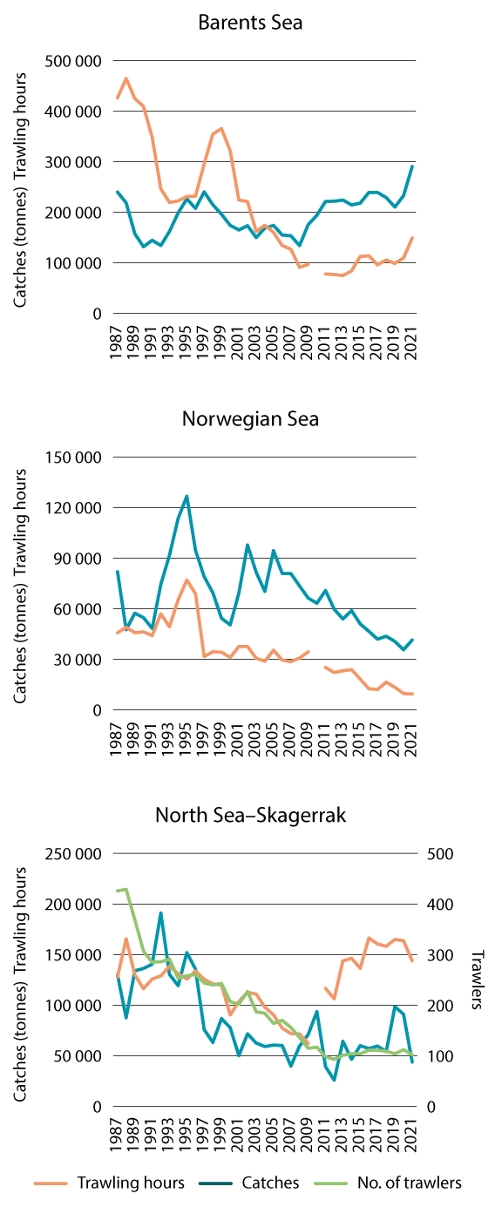
          - Trawling hours, catches (tonnes) and number of trawlers in bottom trawl fisheries in the management plan areas.
Source: Directorate of Fisheries
Physical disturbance of habitats
The fisheries put direct physical pressure on a larger area than any other commercial activity in Norwegian waters. This is because of the geographical extent of benthic fisheries, including trawling. The impacts of these activities are accepted as an inevitable consequence of effective food production from the oceans. However, in certain areas active management of fishing activities is used limit the impacts and safeguard vulnerable species and marine ecosystems, for example by prohibiting towed gear that may touch the seabed. Coral reefs, sponge aggregations and seapen communities are good examples of vulnerable ecosystems.
Benthic communities such as corals, sponge aggregations and species that live partly or entirely buried in sediments can be damaged by benthic trawls and other fishing gear that comes into contact with the seabed.
Measured by the number of trawling hours, trawling activity has increased in the North Sea–Skagerrak area and the Barents Sea–Lofoten area in the period 2011–2021, but has declined somewhat in the Norwegian Sea in the same period.
Catches and harvesting of biomass
The fisheries put pressure on ecosystems primarily through annual harvesting of a proportion of the commercial fish stocks.
The potential catch volume in the fisheries is limited by the productivity of the relevant fish stocks. When setting TACs for fish stocks, it is therefore important to ensure that the overall harvest does not exceed a level that will maintain a stable, high level of productivity. Since the carrying capacity of the marine environment is not constant, fish stocks must be monitored closely and at frequent intervals to obtain data on the wide variations in recruitment that are characteristic of most of Norway’s fish stocks.
Over time, the management regime has evolved from single-species management to a more ecosystem-based system that includes elements such as precautionary spawning stock reference points and fishing patterns. The system is being developed continually. The Directorate of Fisheries and the Institute of Marine Research have developed an approach to ecosystem-based fisheries management that also includes environmental pressures and impacts on the ecosystem, and where challenges are identified and assigned priorities for follow-up.
The most important commercial stocks in Norwegian waters are generally in good condition. However, stock sizes fluctuate. For example, the spawning stock of Norwegian spring-spawning herring is expected to fall below the precautionary level in 2024 as a result of high overall fishing pressure and poor recruitment.
Of the smaller stocks, Norwegian coastal cod, European eel and golden redfish are still in poor condition, while stocks of species such as beaked redfish, sandeels and spiny dogfish have grown in recent years. The harvesting of target species also has wider impacts on the ecosystem through effects on the food chain. This may influence predation pressure on some species, food availability for other species, or competitive relationships between species. Norway has therefore undertaken to pursue an ecosystem-based approach to fisheries management.
Bycatches
Both fishing gear and regulatory measures are designed to minimise bycatches.
However, some catches of species other than the target species are unavoidable during ordinary fishing activities. To avoid excessive harvesting of other species, bycatch quotas and other targeted regulatory measures have been introduced. The aim is to ensure that harvesting of bycatch species is also sustainable.
Unintentional bycatches of fish below minimum sizes and larvae of commercial species are effectively regulated through rules on mesh sizes, the use of sorting grids and the closure of areas where there is a high proportion of fish under the minimum size.
Bycatches may also include seabirds, marine mammals and benthic animals such as corals and sponges. The scale of the bycatch depends on factors including the type of fishing gear, the geographical area and the time of year. Regulatory measures have been developed on the basis of knowledge about bycatch quantities and options for further reducing unintentional bycatches. One example of an effective targeted measure is the rule that the use of pingers is mandatory in the Vestfjorden in winter in order to scare porpoises away from gill nets. Another is the closure of areas where there are coral reefs and the requirement for fishing vessels to move to another area if sponge bycatches are too large.
Ghost fishing
Lost or abandoned fishing gear can continue to catch fish and other animals, a phenomenon known as ghost fishing. Anyone fishing commercially in Norway is required to search for lost gear and report losses to the Norwegian Coast Guard if the gear is not retrieved. The Directorate of Fisheries organises an annual retrieval programme in selected parts of fishing grounds along the coast and offshore to find and return gear that has been reported as lost. A smaller-scale programme targets more limited areas close to the coast and in fjords. Despite this, the quantity of fishing gear lost, abandoned, or in some cases apparently dumped, is larger than the quantity retrieved. Some types of pots and traps are now required to have an escape hatch closed with cotton thread that degrades over time, reducing ghost fishing. The Directorate of Fisheries supports and contributes to research on and the development of new materials, gear types and technology to reduce both ghost fishing and pollution.
Pollution and waste
Lost, abandoned and dumped fishing gear is a source of litter and plastic pollution. Ropes and rope ends are also a major source. Other items found in marine litter include fish boxes, packaging foil, packing tape, floats and consumer products. Fishing vessels can also spread pollutants and microplastics through wear and tear of paint and antifouling systems.
Fishing vessels are permitted to dump trimmings from their catches to the sea. In 2021, a total of 144 000 tonnes of residual raw materials in the whitefish sector was not utilised. Trimmings are dumped over a large geographical area. However, there is no indication that this has negative impacts on marine ecosystems. Trimmings that are dumped are also a source of food for various species, including seabirds.

Aquaculture

Description of the industry
The Norwegian aquaculture industry is currently dominated by production of salmon and rainbow trout. Norway accounts for a relatively small proportion of total global aquaculture production, but is the world’s largest producer of Atlantic salmon. Other segments of the Norwegian aquaculture industry are farmed production of other fish and crustaceans, cultivation of seaweed and kelp, and sea ranching.
Aquaculture is one of Norway’s largest export industries. In 2022, sales of farmed fish totalled about 1.65 million tonnes, with an overall first-hand value of about NOK 106 billion. Production of salmon and rainbow trout has for the last few years been highly profitable.
At present, there is no aquaculture production in the management plan areas, only closer to shore. Aquaculture is a coastal and regional industry, and production takes place both in the sea and on land. One of the current trends in the industry is that Norwegian companies are gradually expanding to use areas of sea, still within the baseline, that are further from land and more exposed to wind, waves and currents.
Plans are also being developed for offshore aquaculture, in other words outside the areas that are currently used, in Norway’s territorial sea and exclusive economic zone. The Ministry of Trade, Industry and Fisheries is following up the recommendations of a report on offshore aquaculture published in 2018, and is working with other ministries and directorates to develop appropriate legislation.
The potential for reducing greenhouse gas emission reductions is discussed in Chapter 5.1.3 for the seafood production sector (fisheries and aquaculture) as a whole.

Management, value added and employment
An overriding objective in the management of the aquaculture industry is to increase value creation on the basis of predictable growth within sustainable limits. Important elements of aquaculture management include biosecurity, environmental pressures and impacts, fish health and welfare, and spatial management. Aquaculture licences are a key tool for managing the aquaculture industry. One condition for issuing licences under the Aquaculture Act is that all necessary permits and licences under the Pollution Control Act, the Food Act and other legislation have already been obtained.
A spatial management and licensing system for offshore aquaculture has been established in chapter 4 of the regulations on licensing of commercial production of salmon, trout and rainbow trout. The Government has commissioned an overall impact assessment for offshore aquaculture for three areas: the southern Norwegian Trench, the northern part of the Frøyabanken bank area and the Trænabanken bank area. These areas lie between 12 and 40 nautical miles outside the baseline. The regulations require an overall impact assessment to be carried out before an area can be opened for licensing applications for offshore aquaculture. An overall impact assessment is intended to provide the authorities with a basis for deciding how suitable different areas are for aquaculture, and whether offshore aquaculture in an area is compatible with existing uses and with environmental interests. Before the three areas were selected for the overall impact assessment, several other areas were considered, and more areas may be included in later impact assessments. A decision on whether to open an area for offshore aquaculture is to be taken by the Government (formally the King in Council). After this, the Ministry of Trade, Industry and Fisheries will decide when licences for offshore aquaculture establishments are to be issued, and where they are to be sited in areas that have been opened. More detailed rules on the allocation of offshore aquaculture licences will be set out in regulations. Establishing aquaculture establishments at offshore sites will require licences under legislation for various sectors, in the same way as aquaculture in coastal waters.
The aquaculture industry has expanded considerably, measured both in terms of overall value added and as a share of mainland Norway’s GDP. In 2019, the industry provided about NOK 28 billion in total value added, corresponding to about 1 % of GDP for mainland Norway. The aquaculture industry also supports activity in related sectors, and is important for employment along the Norwegian coast. Further development of the industry is expected to result in larger contributions to value added and employment.
Environmental change may alter the geographical distribution of areas that are suitable for different types of aquaculture. As the sea temperature rises, there may be a northward shift in the areas that are most suitable for salmon farming. According to the IPCC, climate change, particularly in combination with inputs of nutrients, may be the reason for the observed increase in the frequency of toxic algal blooms in many areas, including the North Atlantic. The aquaculture industry and the management regime may need to be adapted to climate and environmental change.

Environmental pressures and impacts
So far, no offshore aquaculture production has been established in Norway. Offshore aquaculture will generally result in environmental pressures and impacts that are similar to those associated with coastal aquaculture, but there will probably be some additional challenges at offshore sites. Because the level of production at each establishment will typically be higher, offshore aquaculture may have greater impacts. The weather conditions will be harsher, affecting both facilities and fish.
Environmental impacts of aquaculture are regulated through general requirements on establishment, operation and closure set out in the aquaculture legislation and under the Pollution Control Act.
Fish farming in open net pens results in discharges of dissolved and particulate organic matter such as feed residues and faeces, dissolved inorganic nutrients (nitrogen and phosphorus), pollutants from fish feed, impregnating agents for nets, and pharmaceuticals. In addition, fish farms are responsible for noise and light pollution in connection with production and transport, and for waste, microplastics from wear and tear on facilities, and emissions to air from energy sources. The industry also contributes to pollution when Marine litter consisting of equipment and fragments of equipment such as plastic rings, rope, nets, floats and fish boxes that end up in the environment is another source of pollution from the industry.
The most serious adverse impacts of aquaculture on wild anadromous salmonid stocks are associated with the spread of sea lice and infectious pathogens and the genetic impact of escaped farmed fish. The largest greenhouse gas emissions from fish farming originate from raw materials used in fish feed and from transport and production.
The development of offshore aquaculture production will involve longer distances between establishments and from other infrastructure and land. This may result in greater logistical challenges than those facing coastal aquaculture production. Supplies must be maintained, both for fish production and for personnel at the fish farms, and weather conditions must be taken into account. The distance to land will also require changes to the rules for emergency equipment and training and various back-up solutions that apply to inshore aquaculture establishments and sites. The changes could include systems for responding to acute pollution or large-scale fish escapes.
Offshore aquaculture establishments will be located in more exposed areas with stronger currents than the localities currently in use, so that pollution will spread more widely and have impacts at a greater distance than is the case for coastal aquaculture. For organic matter, the wider spread and dilution of effluent may mean that offshore sites have a greater assimilative capacity than semi-enclosed sites in fjords. However, in the case of hazardous substances, wider spread of pollutants is not desirable, even though greater dilution may keep pollution levels below the assimilative capacity close to a particular locality. Another potential problem is that the establishment of offshore aquaculture production may force salmon smolt to swim longer distances in areas where they risk infection with sea lice and other pathogens on their way out to sea. In addition, this may pose a risk to other countries’ fish stocks, since salmon from stocks in other European countries probably also migrate through and feed in certain areas that are being considered for offshore aquaculture.
Although we have built up a great deal of knowledge about the environmental impacts of coastal fish farming, it is important to be aware that there are some major gaps in our knowledge about such activities in offshore waters. For example, we need to know more about biodiversity in the areas under consideration, about processes for selecting suitable areas for offshore aquaculture and about the operation of fish farms once they are established. The impact of offshore aquaculture will in practice also depend on the scale of production, the technology chosen, the precise locations used and how close fish farms are to vulnerable biodiversity. Offshore aquaculture will probably be developed in addition to rather than instead of coastal aquaculture. Its environmental impacts must therefore be assessed in a similar way. It will be important to ensure that establishment of the first offshore fish farms is followed up with documentation and research that can help to fill knowledge gaps relating to the environment, fish welfare and coexistence with other ocean industries.

The petroleum industry

Description of the industry
The petroleum sector is highly productive, and the industry provides Norway with large revenues and a great deal of value creation and employment. Petroleum activities can be divided into three main parts: the discovery of oil and gas resources; the development of fields where there are commercially viable finds; and the production and sale of oil and gas.
The activity level on the Norwegian shelf has been high in recent years. Licensees have taken decisions to develop many new discoveries, and many field development projects are now nearing completion or have reached the production phase. To improve recovery, major investments have also been made in fields that are already in production. In the period 2020–2022, the authorities received plans for development and operation for 18 new projects and 13 plans for further development of fields that were already on stream. On 1 January 2024, 92 fields on the Norwegian continental shelf were producing oil and gas, and 27 projects were in the development stage.
In 2023, daily production from the Norwegian continental shelf was about 233 million standard cubic metres of oil equivalents (Sm3 o.e.), corresponding to roughly 4 million barrels o.e. In recent years, the North Sea fields have accounted for about 70 % of production on the Norwegian shelf. The North Sea is the most thoroughly explored part of the Norwegian shelf, and the area that has produced most oil and gas. The fields in the Norwegian Sea have accounted for about 25 % and those in the Barents Sea for about 5 % of production from the Norwegian shelf.
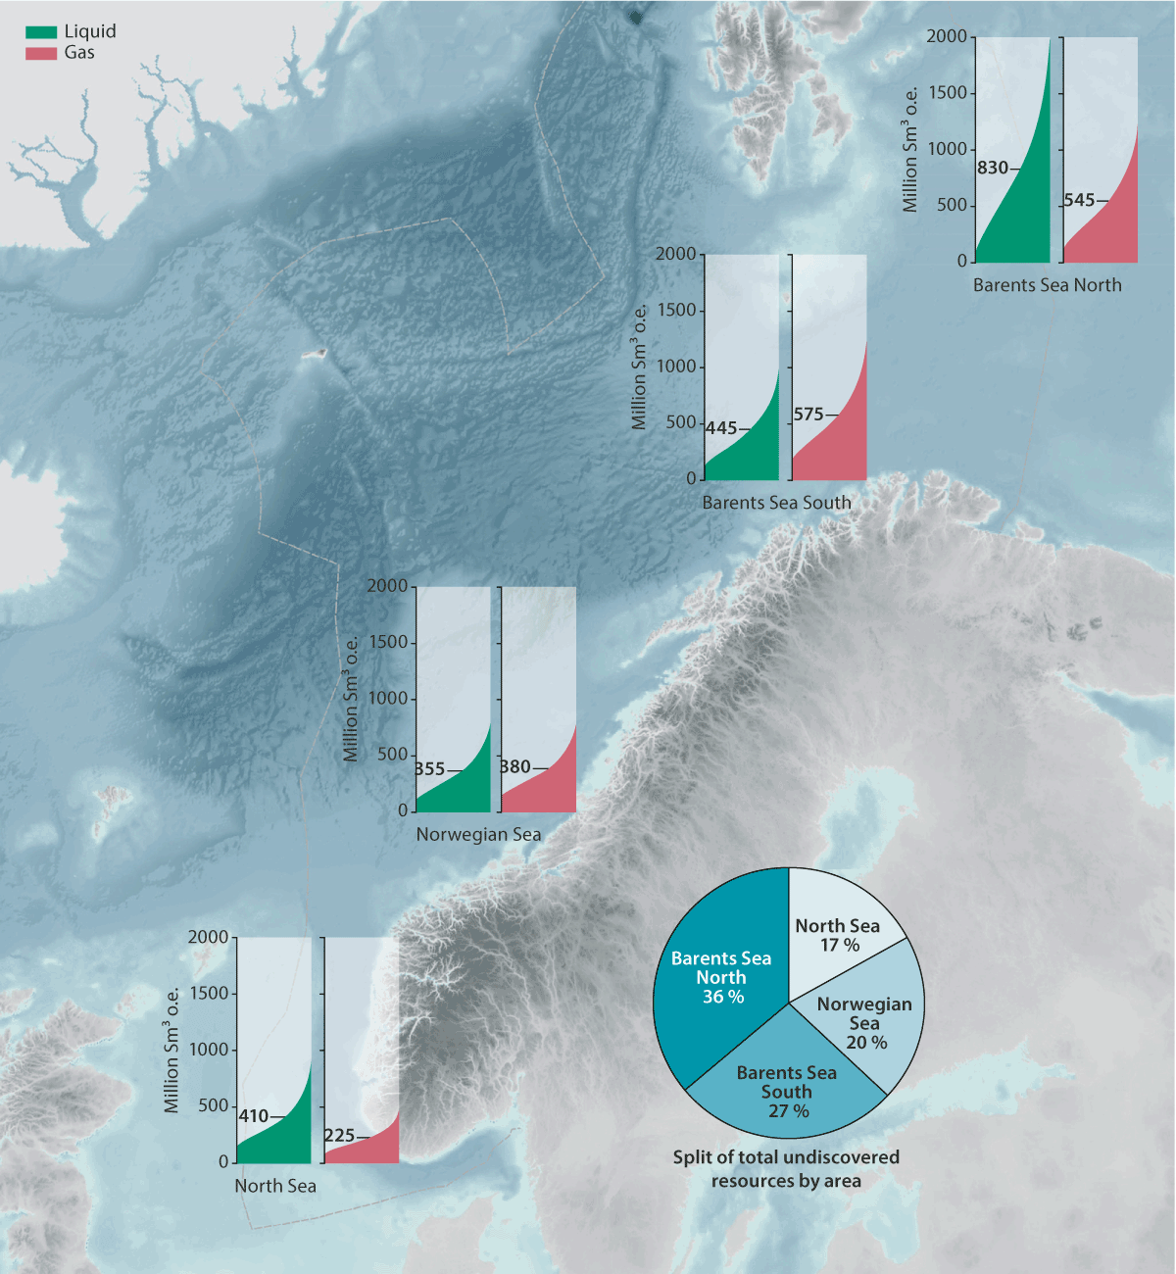
          - Expected remaining recoverable oil and gas resources in the main areas of the Norwegian continental shelf.
Source: Norwegian Offshore Directorate

Management, value added and employment
Petroleum activities may take place in areas opened by the Storting (Norwegian parliament) and in accordance with other regulatory measures, including the framework for specific geographical areas set out in the ocean management plans. Sectoral legislation is used to ensure compliance with the framework.
New production licences are as a general rule awarded through the system of awards in predefined areas (APA system), which provides predictable access to exploration areas.
Value added and employment
The petroleum industry is currently Norway’s largest, measured in terms of value added, state revenues, investment and export value. One of the overall principles of Norway’s management of its petroleum resources is that petroleum activities must result in maximum value creation for society, and that revenues must accrue to the Norwegian state and thus benefit society as a whole, including future generations.
Value added in the petroleum sector has been stable and high in the period since the previous update of the management plans. Value added in this sector depends mainly on total oil and gas production, which has also been relatively stable during this period. There are larger fluctuations in value added in the sector measured in current prices, because of the variability of oil and gas prices.
The number of people employed in the petroleum sector varies with the level of activity, and has been just under 100 000 during this reporting period. This figure excludes a large proportion of employment in onshore supply industries serving the petroleum industry. If indirect employment is included, Statistics Norway estimates that the petroleum sector employs about 156 000 people. In addition, petroleum activities have substantial spin-off effects throughout the country in the form of both value added and employment.
            - Value added in the petroleum sector, shown in NOK billion (in constant 2021 prices).
05J2xt2
Industry | Value added
 | 2018 | 2019 | 2020 | 2021
Extraction of crude petroleum and natural gas | 936.9 | 901.0 | 993.7 | 988.0
Support activities for petroleum and natural gas extraction, geological surveys etc. | 52.5 | 74.0 | 69.7 | 73.1
Oil platforms and modules | 8.6 | 9.3 | 9.5 | 9.2
Supply activities | 25.3 | 23.8 | 1.7 | 2.9
Total1 | 1001.5 | 998.7 | 1067.9 | 1073.1
1 The individual figures in constant prices do not add up to the totals because of chaining and rounding errors.
Source: Statistics Norway

            - Employment figures for the petroleum sector, shown in 1 000s.
05J2xt2
Industry | Employees
 | 2018 | 2019 | 2020 | 2021
Extraction of crude petroleum and natural gas | 24.9 | 24.4 | 24.7 | 24.6
Support activities for petroleum and natural gas extraction, geological surveys etc. | 50.7 | 55.5 | 57.9 | 57.7
Oil platforms and modules | 9.6 | 9.6 | 9.5 | 8.9
Supply activities | 5.7 | 5.8 | 5.5 | 5.2
Total | 90.9 | 95.3 | 97.6 | 96.4
Source: Statistics Norway

Contribution to greenhouse gas emission reductions
The largest reductions in greenhouse gas emissions from petroleum activities can be achieved by supplying fields with power from shore. Since the previous management plan period, the joint solution for supplying power from shore to the Utsira High region has been put into operation. This includes the fields Johan Sverdrup, Edvard Grieg, Ivar Aasen, Gina Krog and Sleipner Øst. The Martin Linge field is also on stream and is operated using power from shore. In addition, several projects that include power from shore have been approved by the authorities and are under development. Infrastructure for power from shore is under construction for the Oseberg Field Centre and Oseberg Sør, Troll B and C, Draugen, Njord and for the onshore liquefied natural gas plant Hammerfest LNG. Development of the Yggdrasil field has been approved with power supplied from shore. Other action companies are taking includes improvements in energy efficiency, a reduction in flaring, and connecting facilities directly to offshore wind turbines. In February 2020, the Norwegian oil and gas industry presented its climate roadmap, which includes an ambition to reduce greenhouse gas emissions from the sector by 40 % by 2030 and to close to zero by 2050. Using power from shore will be an important way of achieving these targets.
The technology and expertise built up by the petroleum sector will be important for the development of other technologies and industries that can play a part in reducing greenhouse gas emissions, for example floating offshore wind (Chapter 5.4) and carbon capture and storage (Chapter 5.5).

Environmental pressures and impacts
Petroleum activities result in operational discharges to the sea and air, underwater noise from seismic surveys and physical disturbance of the seabed. Operational discharges during petroleum activities are regulated by permits under the Pollution Control Act, issued by the Norwegian Environment Agency. In addition to operational discharges, petroleum activities involve a risk of acute pollution. This is discussed in Chapter 6.
Operational discharges to the sea
The largest discharges of oil during normal operations are with produced water. The quantities of produced water and oil discharged vary widely between geographical areas as a result of differences in activity level.
Total discharges of produced water to the Barents Sea are much lower than in other sea areas. This is because only two fields (Goliat and Snøhvit) were on stream during the reporting period.
Discharges of produced water to the North Sea have remained fairly stable since 2016, and account for 12 % of total discharges on the Norwegian continental shelf. Discharges are higher in the Norwegian Sea than in the Barents Sea because the activity level is higher. There were discharges of produced water from seven fields in the Norwegian Sea in the period 2017–2021. The remaining fields in the Norwegian Sea are subsea templates and produce via production facilities on other fields. The largest sources of discharges in the period 2017–2021 were the fields Norne, Draugen and Kristin.
In the North Sea, discharges of produced water declined in the period 2017–2021, and there has also been some reduction in discharges of oil (Figure 5.5). The North Sea fields account for about 88 % of total discharges of produced water and oil on the Norwegian continental shelf. There are discharges of produced water from 29 fields, while the remaining fields are subsea templates and produce via production facilities on other fields. The largest sources of discharges in the period 2017–2021 were the fields Statfjord, Gullfaks and Troll.
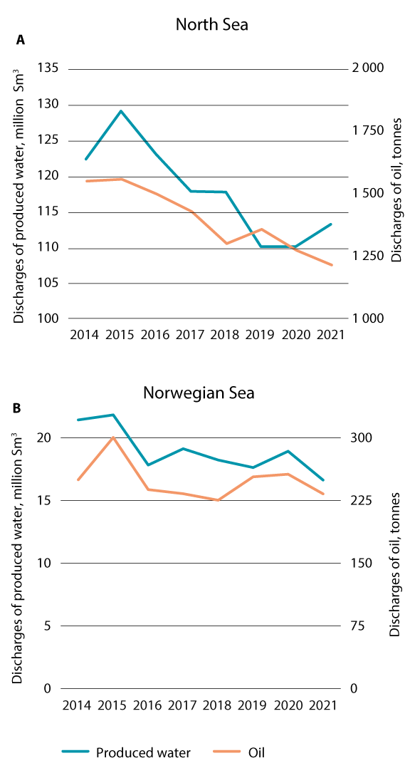
          - Discharges to the sea of produced water (blue line, left-hand axis) and oil (orange line, right-hand axis) for the Norwegian Sea (top) and the North Sea (bottom. Note the different scales of the y axes in the upper and lower panels.
Source: Collabor8 Footprint
Exploration drilling does not result in discharges of produced water, but there may be discharges of drainage water and oily water. These are generally small and vary from one exploration well to another.
Discharges of chemicals to the sea tend to vary with drilling activity and the quantity of produced water, and are highest during drilling.
Overall releases of chemicals to the sea are highest in the North Sea, because this is the area where the number of producing wells is highest. Reported figures for discharges of red-category substances (see Box 5.1) have risen because a new requirement to include discharges of hypochlorite produced on the facilities in this category was introduced in 2021. Hypochlorite is a biocide that is used to clean pipeline systems carrying seawater. There has also been an increase in reported discharges of black-category substances, which is explained by leakages during the operation of submersible seawater pumps. A product that can replace the lubricating oils currently in use (which contain black-category substances) in some of the seawater pumps has been identified, and discharges of black-category substances from this source are therefore likely to decline in the years ahead. In the North Sea, discharges of green-category substances were somewhat lower in the period 2017–2020 than in the preceding years, while there appears to have been some increase in discharges of yellow-category substances.
In the Barents Sea, total discharges from fields on stream are small. This is because polluting activities only take place on the Snøhvit and Goliat fields, at the onshore plant Hammerfest LNG and in connection with the development of the Johan Castberg field. Discharges of yellow- and green-category substances have been relatively stable during the reporting period. Discharges of hypochlorite produced on the facilities account for 99.8 % of red-category discharges. These releases are expected to increase as the number of field developments in the area increases. The only discharges of black-category substances reported in the area in 2020 were from submersible seawater pumps.
In the Norwegian Sea, releases of green- and yellow-category substances have been fairly stable throughout the period. Discharges of red-category substances rose in 2020, largely because of reporting of hypochlorite produced on the facilities. Discharges of lubricating oils from submersible seawater pumps accounted for about 82 % of total discharges of black-category substances in the North Sea in 2020.
The operators are largely expected to replace the current lubricating oils with less environmentally hazardous alternatives in the years ahead.
Discharges of chemicals to the sea from exploration activities vary with the level of activity, and are higher in years when more exploration wells are drilled. Exploration drilling results in relatively high discharges of green- and yellow-category substances, and in several years, overall discharges from exploration drilling have been similar to discharges from all producing fields in the Norwegian Sea. Exploration drilling makes little contribution to discharges of red- and black-category substances.
              - Zero-discharge targets for the petroleum industry
The zero-discharge targets were adopted in a white paper on an environmental policy for sustainable development (Report No. 58 (1996–1997) to the Storting). They apply to operational discharges of oil, added chemicals and naturally occurring substances discharged with produced water, including radioactive substances. Norway’s goal is to eliminated discharges of the most hazardous added chemicals (black and red categories) and to eliminate or minimise discharges of naturally occurring environmentally hazardous substances. For oil and other substances, the target is zero or minimal discharges of substances that may cause environmental damage. The targets were reproduced in full in the 2017 update of the Norwegian Sea management plan (Meld. St. 35 (2016–2017)).
For pollutants in operational discharges from offshore petroleum activities, progress towards the goal varies between sea areas. Operational discharges from petroleum activities in the Barents Sea are limited and not on a scale that is expected to result in rising background levels of oil or other environmentally hazardous substances over time. Levels of pollution are lower in the Norwegian Sea than in the North Sea, and there have been no appreciable changes in inputs of oil or other environmentally hazardous substances from petroleum activities. Operational discharges from petroleum activities in the North Sea are substantial, and are resulting in rising background levels of oil and other environmentally hazardous substances and naturally occurring substances over time.
[Boks slutt]
Discharges of drilling fluids and drill cuttings to the sea
Total discharges of water-based drilling fluids and drill cuttings depend on the number of wells drilled each year and the length of the wellbores. Figure 5.6 shows discharges of water-based drilling fluids and drill cuttings to the sea from petroleum activities on the Norwegian shelf in the period 2014–2021.
For wells drilled in this period, consumption of water-based drilling fluids has been about twice consumption of oil-based drilling fluids. Oil-based fluids are generally left in the wells or transported to land for further processing. The only exception is the Johan Sverdrup field in the North Sea, where the operator has held a permit to discharge drill cuttings contaminated with oil-based drilling fluids after the cuttings have been treated with a thermomechanical cuttings cleaner (TCC).
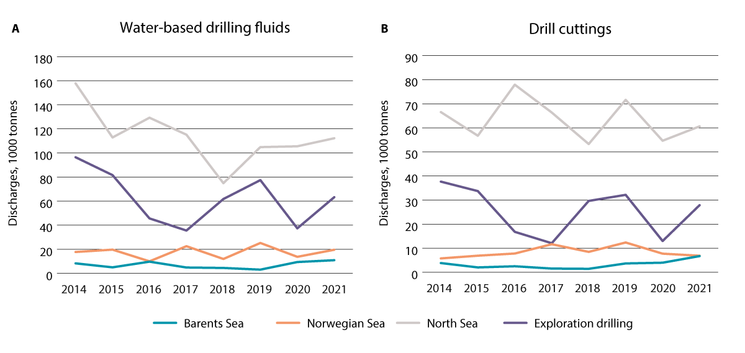
          - Discharges of water-based drilling fluids and drill cuttings to the sea.
Source: Norwegian Environment Agency
Discharges of water-based drilling fluids and drill cuttings from fields in production in the Barents Sea were low in the period 2017–2019. There was a slight rise in 2020, as a result of production drilling on the Johan Castberg field. In the Norwegian Sea, discharges of water-based drilling fluids and drill cuttings from fields in production were fairly stable in the period 2017–2021. Discharges of produced water in the North Sea decreased from 2017 to 2018, but rose again in 2018 and remained stable after this. Discharges of drill cuttings in the North Sea followed the same pattern as drilling fluids from 2017 to 2019, but decreased again in 2020. Overall discharges of water-based drilling fluids and drill cuttings from exploration activity in all three areas rose from 2017 to 2019 and then decreased in 2020.
Inputs of radionuclides
Some radionuclides occur naturally in the environment, and can become concentrated and be released during the extraction of petroleum resources. Naturally occurring radioactive material (NORM) is released with discharges of produced water by the petroleum industry.
Discharges of NORM to the North Sea and Norwegian Sea were fairly stable in the period 2017–2021. Most of the material is discharged into the North Sea, where there was a slight rise in the quantity, while there was a slight decrease in the Norwegian Sea. If radionuclides are dissolved in the seawater, they may be transported long distances from the discharge point. If they are bound to larger particles, they will be deposited closer to the discharge point, but may be resuspended from the sediments and transported further afield. The additional concentrations of NORM that can be attributed to produced water are small compared with the background levels. Operational discharges of produced water, and therefore of NORM, from the petroleum industry in the Barents Sea are very low.
There is thought to be some spread of NORM from petroleum operations in the North Sea and Norwegian Sea with ocean currents to the Barents Sea. However, the additional concentrations are so small relative to the background levels of naturally occurring radionuclides that they are not detectable. Based on the most recent figures for the Barents Sea, there appears to be a slight decrease in discharges of radium-226 and radium-228.
Emissions to air
Both exploration drilling and field operation result in emissions to air. Emissions to air from exploration activities are largely from energy production and flaring of hydrocarbons during well testing. Total emissions to air from exploration activity depend on the level of activity, and are therefore higher in years when a large number of exploration wells are drilled or the rig count is high.
Reporting of emissions to air includes emissions from energy production, flaring, well cleanup, storage and loading of crude oil, cold venting and fugitive emissions. Historically, emissions to air have shown a tendency to follow the same pattern as production levels. However, there was some change in the picture from 2019 to 2020, when production on the Norwegian shelf rose but CO2 emissions were reduced. In the period 2015–2022, CO2 emissions to air from the Norwegian petroleum industry were reduced by 20 %. The most important steps that have been taken to reduce emissions are supplying fields with power from shore, improving energy efficiency and reducing flaring. In addition, the floating wind power farm Hywind Tampen is now in operation and is supplying a share of the electricity needed by the existing platforms on Snorre and Gullfaks. There are few sources of emissions in the Barents Sea at present, and the onshore plant Hammerfest LNG accounts for the largest proportion of emissions of both CO2 and nitrogen oxides (NOx) to air. The licensees of the Snøhvit field and Hammerfest LNG have decided on full electrification of the LNG plant using power from the onshore grid. This will reduce CO2 emissions by 90 % and eliminate NOx emissions from the plant. Other emission sources in the Barents Sea include drilling and construction activities on Johan Castberg and Snøhvit, and exploration activities. Emissions to air are expected to increase in the years ahead when Johan Castberg comes on stream.
Emissions of CO2 and NOx to air from fields in the Norwegian Sea have been fairly stable over time. There has been a decline in emissions of non-methane volatile organic compounds (NMVOCs), which is largely explained by reduced production and thus lower losses through evaporation during loading of crude oil on to tankers.
CO2 emissions from fields in the North Sea followed a weakly rising trend from 2014 to 2017, before showing some reduction again in the following years. NOx emissions to air from fields in the North Sea have been declining since 2014. A switch to alternative forms of power supply has reduced emissions of both CO2 and NOx. Emissions of both methane and NMVOCs have followed the same pattern as in the Norwegian Sea – emissions were high in 2014 and have declined since. The changes can to a large extent be explained by lower production and a reduction in loading of crude oil on to tankers.
Other environmental impacts of petroleum activities
Seismic data are acquired by transmitting sound waves from a source located above or in the substratum. The sound waves travel through the rock layers, which reflect them up to sensors on the seabed, at the water surface or down a borehole. This makes it possible to build up an image of the geological structures in the substratum.
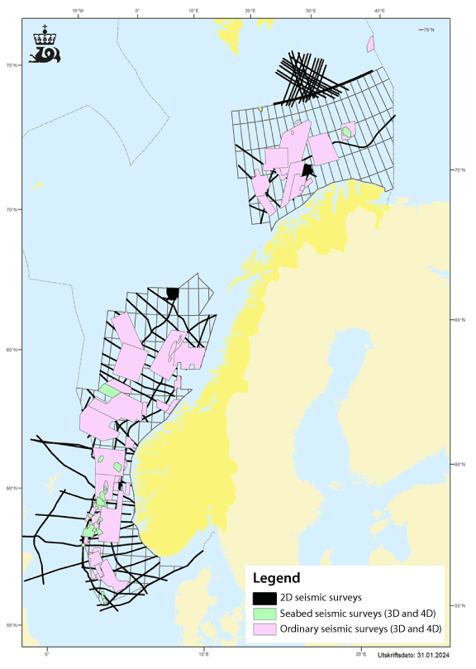
          - Areas of the Norwegian continental shelf where seismic surveys were carried out in the period 2017–2021.
Source: Norwegian Offshore Directorate/Diskos National Data Repository
Information is available on all seismic surveys in Norwegian waters, but there are no good compilations showing seismic data acquisition over time and changes in the noise impacts of the surveys. Measures have been introduced to reduce the impacts of seismic activities on fish eggs and larvae. Requirements to use soft-start procedures (which ramp up the sound intensity gradually) for seismic surveys have also been introduced to reduce the likelihood that marine mammals will suffer hearing damage. The Institute of Marine Research produces maps of areas where it advises against seismic activities, and updates them annually. These maps show spawning grounds for fish and feeding areas for baleen whales where seismic surveying should be limited or avoided at specific times of year. For further information on seismic surveys, see Box 7.1.
Petroleum activity can put pressure on vulnerable benthic fauna such as corals and sponges, for example through deposition of drill cuttings. Corals and other benthic fauna can also be damaged when pipes and cables are laid and anchor chains and other installations are placed on the seabed. Operators are therefore required to survey any coral reefs and other valuable benthic communities that may be affected by petroleum activities and ensure that they are not damaged.

Offshore wind power
Offshore wind power is a growing industry both globally and in Norway. There are large-scale plans for wind power development. The EU has set a target of an installed capacity of at least 300 GW of offshore wind by 2050, much of which is expected to be developed in the North Sea. Norwegian industry clusters and energy companies are playing an active role in this process. The Norwegian Government’s ambition is for licences for 30 GW of wind power production capacity to be allocated by 2040. In 2020, the first areas of the Norwegian continental shelf were opened for offshore renewable energy production, and the authorities have since then been developing the necessary legislation in close cooperation with the industry and other users of the oceans. In 2023, the first tenders were announced for acreage in the areas Utsira Nord and Sørlige Nordsjø II.

Description of the industry
The areas Utsira Nord and Sørlige Nordsjø II are both in the North Sea–Skagerrak management plan area. Sørlige Nordsjø II may be suitable for fixed wind power, while Utsira Nord has such deep water that it is only suitable for floating wind power. Fixed wind turbines use established technology and are widespread in Europe, while floating turbines are still an immature technology, and the costs are considerably higher.
Norway has been involved in floating wind power from an early stage of its development. Hywind Demo, the world’s first floating wind turbine, was installed by Equinor in 2009 at the Marine Energy Test Centre (METCentre) off Karmøy in Rogaland county. In 2023, the geographical scope of METCentre’s licence was expanded to allow an installed capacity of up to 85 MW split between seven turbines. The Norwegian Water Resources and Energy Directorate has also issued a licence to METCentre for a single wind turbine with an installed capacity of 1 MW, to be installed off Bokn in Rogaland for a period of 5 years. The Hywind Tampen wind farm, which is currently the world’s largest floating wind farm, was also opened in 2023. Hywind Tampen is supplying a share of the electricity needs of the Snorre and Gullfaks fields in the northern part of the North Sea.
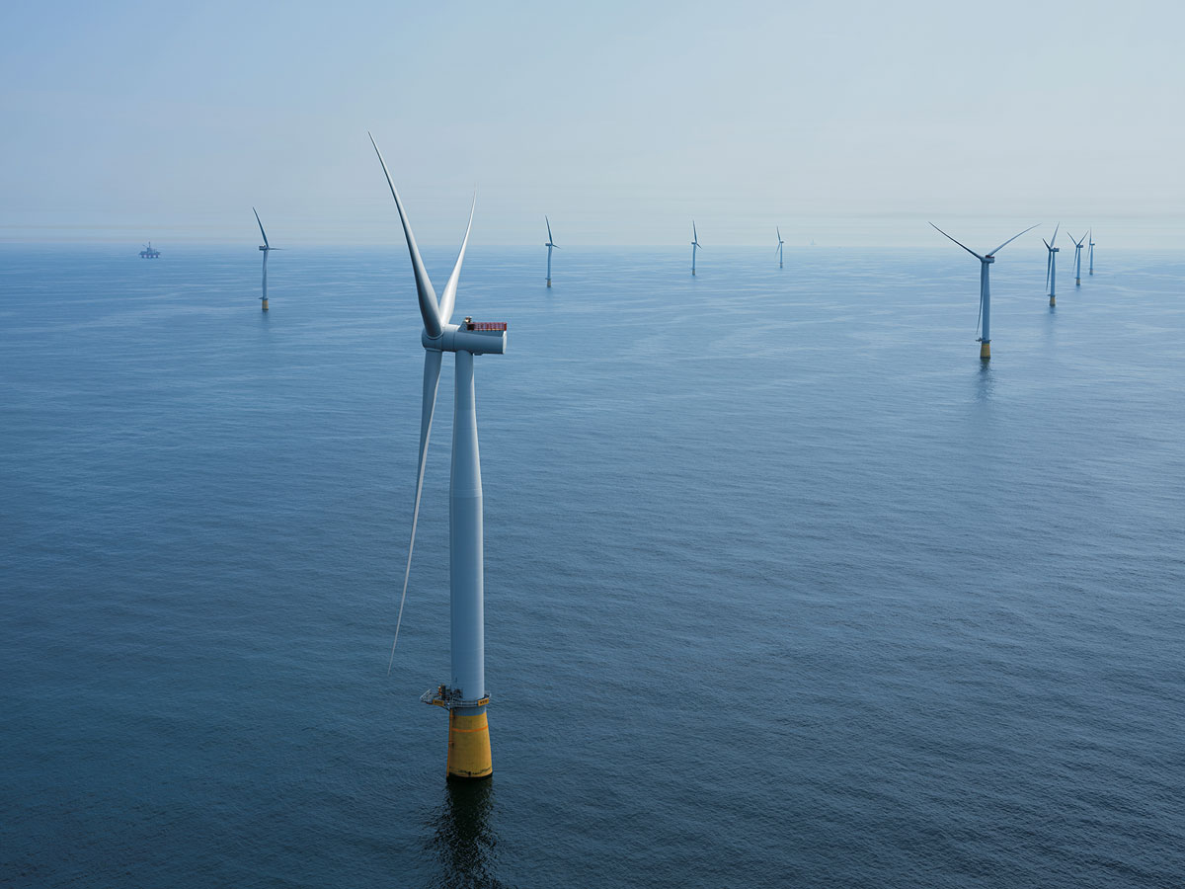
          - Floating wind turbines in the Hywind Tampen wind farm.
Photo: Ole Jørgen Bratland/©Equinor
Further technology development and reductions in costs are nevertheless essential to ensure that offshore floating wind power is competitive in the long term.
The development of offshore wind power may offer opportunities for Norway and Norwegian industry and result in technological progress and industrial development. However, it is vital that the impacts of any proposed developments on the power supply system on land are assessed and that cost-benefit analyses are carried out, including possible environmental impacts. Analyses of potential wind power developments in Norwegian waters should also include access to marine space and possible spatial conflicts with other sectors such as the fisheries, shipping and petroleum. Norway has large marine areas with good wind resources, but a considerable proportion is only suitable for floating wind power.

Management, value added and employment
The opening of areas for offshore renewable energy production is governed by the Offshore Energy Act, which entered into force on 1 July 2010. Under the Act, offshore renewable energy production outside the baseline may as a general rule only be established after the public authorities have opened specific geographical areas for licence applications. The Act also allows for licences to be awarded for smaller demonstration projects for offshore wind power or wind power integrated with offshore petroleum installations in area that have not been opened beforehand.
The offshore wind industry is growing. In 2022, total turnover in the industry was NOK 34.5 billion, and it provided employment for about 4 800 people. The opening of the Sørlige Nordsjø II and Utsira Nord areas, combined with construction of the Hywind Tampen wind farm, marked a change of pace in the development of the offshore wind industry in Norway. However, most of the turnover in the industry is still turnover in Norwegian companies’ operations abroad or in the form of exports.
Floating offshore wind may be an important segment of the industry in future, and offers opportunities for Norwegian value creation. Norway’s ocean areas are suitable for floating offshore wind, but technological developments and further reductions in costs will be needed before it can become cost-competitive. Norwegian industry is in a strong position to play a part in achieving this, with the involvement of both the offshore service fleet and the shipbuilding industry.
The offshore wind industry may create new opportunities for employment, and at the same time make it possible for companies that provide services for the oil and gas industry to expand their clientele and thus secure existing employment. However, the number of jobs involved is uncertain.

Contribution to greenhouse gas emission reductions
The North Sea countries have ambitious plans for developing offshore renewable energy production, and offshore wind is an important element of the European Commission’s efforts under the European Green Deal. The EU’s current target is to reach 300 GW of offshore wind capacity by 2050.
The Norwegian Government’s ambition is to allocate licences for 30 GW of production capacity on the Norwegian continental shelf by 2040, which corresponds to about 75 % of current installed capacity in the Norwegian power system. This will offer a considerable potential for replacing fossil energy use with electricity, both in Norway and in other European countries if some of the power is exported.
Offshore wind in Norway may also provide new market opportunities for the country’s supply industry. When offshore wind areas in Norway are opened for licensing, Norwegian supply companies will be in a good position to compete because of their proximity to the market and their earlier experience on the Norwegian continental shelf. As the technology is further developed and deployed, the costs of floating wind power are expected to decrease.
              - Other offshore renewable energy production
In addition to offshore wind power, both tidal power plants and wave power have been tested in Norway, and a licence for a pilot floating solar photovoltaic (PV) plant was issued in 2021. However, these are less mature technologies and require considerable development before they can become profitable.
Wave power makes use of the energy in waves to generate electricity. In Norway, a 100 kW prototype wave energy system was tested off the island of Runde in Møre og Romsdal in 2017. The theoretical potential of global wave power is estimated at 29 500 TWh. Most of this potential is available between latitude 30 and 60 degrees, both south and north of the equator, in water depths of more than 40 m. So far, it has proved challenging to find effective solutions for generating electricity from wave energy. In addition, the structures used have to withstand the power of the waves in exposed areas.
Tidal power makes use of the energy in tidal currents. The theoretical electricity production potential from tidal energy is estimated at 1 200 TWh globally, and is concentrated in fewer locations than is the case for the other technologies discussed here. There are two main approaches to electricity generation from tidal energy. The first uses structures resembling wind turbines that are placed under water where tidal currents are strong. A number of variants have been proposed. The second is a tidal barrage, which uses a combination of sluice gates and water turbines. Water fills the tidal basin at high tide, and is released through the turbines as the tide falls. In Norway, a tidal power plant using a device similar to a wind turbine, with an installed capacity of 300 kW, was tested in Kvalsundet near Hammerfest. The turbine technology from this project has since been used in a larger-scale tidal power plant in Scotland.
Floating solar technology uses solar panels mounted on floating structures. This technology offers a large production potential, and the market is growing strongly. By the end of 2019, the installed capacity was about 1.9 GW globally. This includes systems both on lakes and at sea. It is expected that offshore floating solar will largely be located in areas near large population centres, where space on land limited and there is plenty of sunshine. In 2021, the Norwegian Water Resources and Energy Directorate issued a licence to Equinor for a floating solar power plant (capacity 1 MW) off Frøya in Trøndelag country. This was intended as a pilot plant to test the technology in relatively rough conditions, but the project was shelved before the plant was constructed.
Alternative offshore wind technologies use other solutions than traditional wind turbines. For example, vertical-axis wind turbines have reached the demonstration stage. For example, there are plans to test a concept called SeaTwirl at the METCentre test site off Bokn. Another type of technology is known as airborne wind energy systems (AWES), and has been tested in Norway off Karmøy. A report published by the European Commission in 2018 concluded that the technology is still immature and that it remains unclear whether it can reach cost-competitiveness.
[Boks slutt]

Environmental pressures and impacts
Pollution
Wind turbines do not themselves produce emissions of any significance to air, and it is considered unlikely that there will be any operational discharges to the sea. Any releases of pollutants to air or the sea will occur during construction work and operation and maintenance. There is also a certain environmental risk associated with the possibility of vessels colliding with wind turbines and subsequent releases of pollutants. Wind turbines also generate noise, both during construction and when operating.
Problems associated with noise may arise during three phases: establishment, operation and maintenance, and decommissioning.
At present, there is little experience of noise impacts during decommissioning of wind turbines. During construction, drilling and pile-driving for fixed foundations may generate high noise levels, but for relatively short periods of time. Noise from the installation of fixed foundations can be reduced by using bubble curtains. Noise from pile-driving is avoided if floating wind turbines with suction anchors are used. During the operation and maintenance phase, there is continuous noise, but at a lower level. Floating turbines may also generate noise from movement of the mooring lines, in the form of loud ‘snaps’ or ‘bangs.’
There is still little knowledge of how noise during the operational phase affects fish and marine mammals. With the currently available knowledge base, it is not possible to predict whether the overall effects of offshore wind farms on the marine environment will be positive or negative. Much less is known about pressures and impacts associated with floating offshore wind than is the case for fixed offshore wind, since experience of floating installations is so limited.
Physical disturbance of habitats
Offshore wind farms can affect the marine environment in two main ways, through purely physical changes and by altering marine ecosystems. Physical changes may for example be changes in water movements. Alterations of the marine ecosystem are often divided into the three types: the introduction of new structures, electromagnetism from cables, and noise from wind turbines.
There are clear indications that fixed offshore wind farms attract various marine species, and that many species feed and reproduce within the installations. They can function as artificial reefs, providing more food and shelter for fish. The development of offshore wind power may affect birds that use the same areas. For seabirds, migratory birds and bats, there is a risk of collisions with wind turbines on offshore wind farms, or birds may avoid areas where there are wind farms. Offshore wind farms may become barriers to movement, reducing available areas of habitat. Migratory birds may need to fly past a whole series of wind farms. If there is widespread development of offshore wind power in European waters, the overall impacts on seabirds and migratory birds may be serious. However, this will depend on various factors, including the distribution of birds in relevant areas, the distribution of prey species, how birds behave while feeding and their response to wind farms.
In addition, conflicts may arise between the use of an area for offshore wind production and cultural heritage interests, for example in areas where there are shipwrecks or other historical objects on the seabed. Since wrecks are static objects, conflict can where necessary be avoided through careful planning of exactly where wind farms are to be sited.
The Government has initiated comprehensive mapping of biodiversity in offshore wind areas that may be opened for licensing in 2025. This includes mapping of the seabed through the MAREANO programme, investigations of seabirds through the SEAPOP programme and the SEATRACK module, and investigations of fish and marine mammals through the Institute of Marine Research. These studies will build up more knowledge of areas that are of interest for offshore wind developments.

CO2 storage under the seabed

Description of the activity
Carbon capture and storage (CCS) involves capturing CO2 from power production and industry and transporting it for safe storage in deep geological formations. Norway is well placed to implement CO2 capture, transport and storage, and storage under the seabed on the Norwegian continental shelf can become an important industry. In Norway, only options for CO2 storage in subsea reservoirs on the continental shelf are being considered.
Norway already has many years’ experience of CO2 storage on the continental shelf, in connection with petroleum production; storage began in 1996 on the Sleipner field, followed by the Snøhvit field from 2007. These are the only operational CCS projects in Europe, and are unique in an offshore context.
By March 2024, seven licences had been issued under Norway’s CCS regulations, six of which were exploration licences.
Longship is one of the world’s first CCS projects that is developing a complete value chain for CO2 capture, transport and storage. The Longship infrastructure is under construction, and should be in operation from 2025. The first phase of Northern Lights, the transport and storage component of the project, has a planned annual storage capacity of 1.5 million tonnes CO2. The company is considering whether to expand this to about 5 million tonnes CO2 a year.

Management, value added and employment
Norway has for many years had a strong focus on the entire CCS chain. Current initiatives draw on 27 years of experience of CO2 storage at the Sleipner and Snøhvit fields and on research and development, funded for example through the CLIMIT programme and the Technology Centre Mongstad, where CO2 capture technologies are tested. The demonstration of a full-scale CCS value chain in the Longship project is providing additional experience. The project is also intended to facilitate learning about the regulation and promotion of CCS activities that can be used in subsequent projects in Europe and elsewhere in the world. A number of Norwegian manufacturing companies have also been involved in long-term CCS projects for their facilities.
The Government will facilitate commercial CO2 storage on the Norwegian continental shelf by allocating storage space to companies that have specific industrial plans involving a need to store CO2.

Contribution to greenhouse gas emission reductions
According to the IPCC, CCS is a key tool for reducing global greenhouse gas emissions from fossil-fuel combustion and industrial production. Norway also views CCS as an important tool for achieving the long-term temperature target of the Paris Agreement.
For some industries, particularly cement production and waste incineration, CCS is at present the only known technology that can give substantial reductions in greenhouse gas emissions.
New commercial CO2 storage projects for the Norwegian continental shelf are currently being developed. The presence of geological formations that are suitable for CO2 storage means that Norway can play a key role in the further development of CCS as an important mitigation measure in climate policy. CO2 storage also makes it possible to produce hydrogen and ammonia from natural gas with very low overall emissions. This may open the way for value chains for hydrogen production in Norway and for hydrogen produced at receiving terminals for natural gas elsewhere in Europe, combined with CO2 storage on the Norwegian continental shelf.

Environmental pressures and impacts
CO2 storage on the Norwegian continental shelf is only being considered as an option in areas that have been opened for petroleum activities. Since most activity related to CO2 storage on the shelf at present is exploratory, there is little information on the environmental impacts. Seismic data will be collected in connection with exploration for suitable reservoirs and monitoring of storage facilities.

Extraction of seabed minerals

Description of the industry
Demand for minerals and metals is expected to increase considerably as a result of the global transition to a low-emission future. According to a report from the International Energy Agency (IEA), The Role of Critical Minerals in Clean Energy Transitions, clean energy technologies are becoming the fastest-growing segment of demand for critical minerals. The IEA estimates that achieving the goals of the Paris Agreement would mean a quadrupling of mineral demand by 2040. In the longer term, extraction of seabed minerals could play a part in diversifying supplies of critical minerals, provided that it can be done sustainably and responsibly.
The Norwegian Offshore Directorate has prepared a resource assessment of seabed minerals on the Norwegian continental shelf, which shows that there are deposits of polymetallic manganese crusts and sulphides on the Norwegian shelf, and that the expected resources in place are significant relative to current global annual extraction rates. Analyses show that metals in the minerals include copper, zinc and cobalt, all of which are important for the low-emission transition.

Management, value added and employment
The Act of 22 March 2019 No. 7 relating to mineral activities on the continental shelf (Seabed Minerals Act) provides the legal basis for management of the mineral resources on the Norwegian continental shelf.
In June 2023, the Government presented a white paper on mineral extraction on the Norwegian continental shelf, opening of acreage and a strategy for managing these resources (Meld. St. 25 (2022–2023)), which was debated by the Storting in January 2024. The area that has been opened for seabed mineral activities covers 281 000 km2 and lies in the Norwegian Sea and Greenland Sea, in an area where there is currently little other activity.
Seabed mineral activities have the potential to become a new ocean industry in Norway, contributing to value creation and employment and also ensuring supplies of vital metals in the future. So far, no seabed mineral extraction in deep-sea areas has been started anywhere in the world. The potential for future activities, their timing and the scale of any activities in future are therefore very uncertain.
Seabed mineral activities on the Norwegian continental shelf must take place within a framework and in accordance with requirements that safeguard the external environment and take account of other users of the ocean. Areas that are opened will be managed on the basis of a step-by-step approach, and there will be requirements to collect data on both resources and the environment before any minerals can be extracted. Thus, a cautious approach will be taken, and environmental concerns will be given considerable weight.
To protect biodiversity in the vicinity of active hydrothermal structures, the white paper on seabed mineral extraction included the condition that extraction from active hydrothermal structures will not be permitted, and that such structures are to be protected so that they are not damaged by activities in nearby areas. Plans for the extraction of mineral deposits will only be approved if it can be substantiated that extraction can be carried out in a way that does not entail substantial negative impacts on biodiversity associated with the active hydrothermal structures.
Norway’s legislation on seabed mineral extraction and its strategy for managing these resources are discussed in greater depth in 2023 white paper and the subsequent recommendations from the Storting.

Environmental pressures and impacts
Seabed mineral extraction is an emerging and immature industry. The necessary technology is being developed, and more information is needed about conditions in deep-sea areas and the environmental impacts of mineral activities before extraction can be started.
The area that has been opened for seabed mineral activities contains both sulphides and manganese crusts. Sulphides are formed at active hydrothermal vent sites, where precipitation produces ores containing various metals before the vents eventually become inactive and leave behind mounds of sulphide ores. Inactive hydrothermal vent sites are of most interest for mineral extraction, since this is where the bulk of the resources is to be found. Manganese crusts are formed on hard-bottom areas of seamounts rising up from the seabed. Both active hydrothermal vents and seamounts are considered to be particularly important for benthic biodiversity in deep-water areas, but knowledge about the occurrence and distribution of species and habitats is limited. Mapping of species and habitats is therefore necessary to provide a sound knowledge base for any areas where there are plans to start up mineral activities.
According to the impact assessment that was carried out as part of the opening process, exploration activities for seabed minerals are only expected to result in minor environmental impacts, since there will only be small-scale and short-term physical disturbance.
The impacts of mineral extraction will vary from one activity to another, and will depend on the technology used, any mitigating measures implemented and which habitat type is affected. More knowledge is needed both about the seabed environment and about the technologies that will be used, which means that there is considerable uncertainty about the possible environmental impacts of seabed mineral extraction. The most serious impacts would be expected to be associated with local physical disturbance of benthic habitats or substrates and associated ecosystems during mineral extraction from active hydrothermal vent systems and manganese crusts. The direct physical impacts will be local, limited to the area where minerals are being extracted.
Seabed mineral extraction may also result in the spread of particulate matter from extraction sites on the seabed, and from any discharges of water used to lift the mineral resources up to a support vessel or installation at the surface. In both cases, this can lead to sediment deposition on the seabed and smothering of benthic species. The size of the areas that are likely to be affected is uncertain, and will depend on the extraction technology used, current patterns in the relevant areas, and what mitigation measures are introduced.
Seabed mineral activities may also have put pressure on the environment in other ways, for example through emissions to air, releases of chemicals, noise and vibrations, light pollution, the risk of introducing alien organisms, and the removal of organisms where there are water intake systems near the seabed. It should be possible to mitigate these pressures through conditions included in operators’ licences.
The impact assessment that has been carried out concludes that the impacts of individual projects will be local, limited to the extraction site itself and the surrounding area. The cumulative impacts over time will depend on the number of extraction projects, the scale of each project and where they are sited in relation to the distribution of important species and habitats in the whole area that has been opened. Information on the habitats and species found in areas of interest for seabed mineral extraction will be included in assessments of where extraction is to be permitted. Once efforts by the public and private sector to obtain more information have progressed further and experienced has been gained in regulating this new industry, the Government will re-evaluate whether it is appropriate or necessary to introduce a framework for seabed mineral activities in specific areas as a way of protecting biodiversity at the regional scale in the area that has been opened. The aim is to carry out this evaluation before the first plan for the extraction of mineral deposits is approved.
The findings of the impact assessment and other information on ways of safeguarding the environment in connection with future seabed mineral activities are discussed in greater depth in 2023 white paper and the subsequent recommendations from the Storting.

Maritime transport

Description of the industry
Fleet composition and activity levels vary between the management plan areas. In 2021, about 44 % of total distance sailed in Norwegian waters was in the North Sea–Skagerrak area, almost 32 % in the Norwegian Sea and 24 % in the Barents Sea–Lofoten area. In other words, traffic is heaviest, measured in distance sailed, in the North Sea–Skagerrak, which is the smallest management plan area, and lightest in the Barents Sea–Lofoten area, the largest of the three. A similar split between the management plan areas has been observed for several decades.
In a normal year, about 7 000 unique vessels are registered in Norwegian waters. This includes transit, international and domestic traffic.
In 2021, shipping in Norwegian waters was dominated by vessels with a gross tonnage of between 1 000 and 5 0000. Vessels in this size category account for almost half of the total distance sailed in Norwegian waters (48 %). The second largest size category is vessels under 1 000 gross tonnage, which in 2021 accounted for 27 % of the total distance sailed in Norwegian waters. Vessels in Norwegian waters are smaller than in many other ocean areas. This is explained by the dominant vessel types (for example fisheries vessels) and by Norway’s decentralised port structure. In addition, transit traffic accounts for a large proportion of traffic involving vessels larger than 10 0000 gross tonnage.
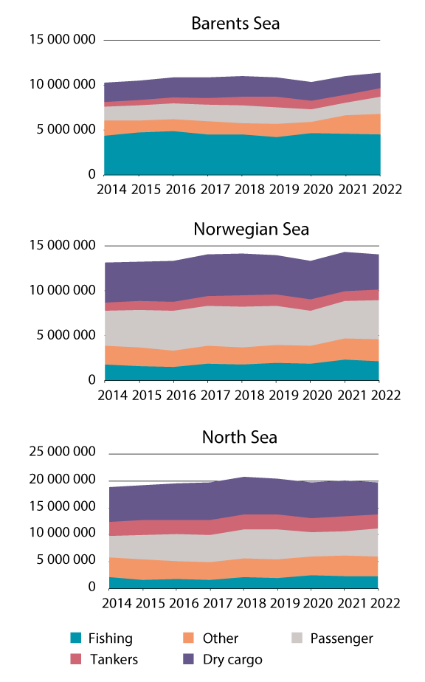
          - Annual distance sailed (nautical miles) by different vessel categories in the management plan areas.
Source: Norwegian Coastal Administration/Ministry of Climate and Environment
Growing volume of shipping in the Arctic
Changing ice conditions in the Arctic as a result of climate change have triggered growing interest in opportunities for shipping through both the Northeast and the Northwest Passage. Sailing across the Arctic Ocean, for example between ports in Europe and Asia, will result in shorter transport times and lower fuel costs, but will also involve a higher level of risk. In 2020, ice conditions were particularly favourable north of Russia, and even low ice-class vessels were able to sail through the Northeast Passage in greater numbers than previously, see Figure 5.10.
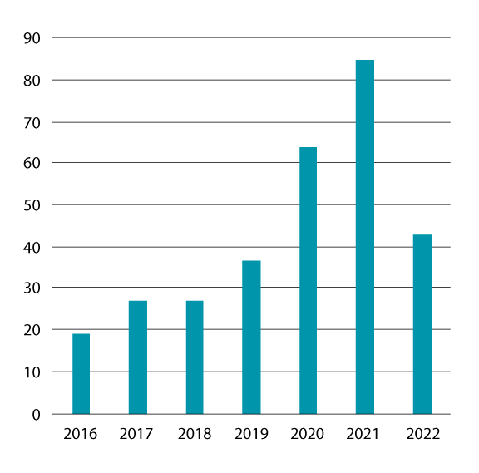
          - Numbers of vessels transiting the Northeast Passage in the period 2016–2022.
Source: Norwegian Coastal Administration.
The volume of shipping in far northern waters has been growing rapidly in recent years. There has been increasing activity, including production from the Goliat field and the start of LNG production at Sabetta in Russia, and consequently higher volumes of traffic. This includes high-risk vessels, which are ships that carry dangerous and/or polluting cargo or that have sufficient bunker capacity to be included in the high-risk category. The Vardø Vessel Traffic Service Centre registered a record volume for transport of petroleum products and record numbers of high-risk vessels in 2019. However, in 2020 and 2021 there was a reduction in the volume of petroleum products transported and in the number of high-risk vessels and vessels carrying dangerous cargo. The following year, 2022, was marked by unrest around the world and the introduction of sanctions against Russia. The effects of the current security policy situation and further sanctions remain to be seen.
Maritime transport projections up to 2050
During the preparation of the National Transport Plan 2025–2036, projections for freight transport up to 2050 were made with the assistance of the Institute of Transport Economics. It is estimated that maritime freight transport excluding crude oil and natural gas will rise by 28 % in the period up to 2050. If oil and gas are included, the overall rise is only 12 %. This is in line with the expected developments in the petroleum sector as presented in the most recent white paper from the Ministry of Finance on long-term perspectives on the Norwegian economy. The volume of traffic to and from offshore installations is expected to decline in line with a decrease in petroleum activity. For fishing vessels, climate change is expected to result in a northward shift in fishing activities, and a trend towards larger vessels is also expected. With the exception of passenger transport during the pandemic, maritime transport has been relatively stable despite the effects of COVID-19 and geopolitical upheaval in the past couple of years. Nevertheless, there is a high degree of uncertainty in the projections.

Management, value added and employment
Management of the shipping industry
Several authorities have tasks related to management of the shipping industry at national level, and two key agencies are the Norwegian Maritime Authority and the Norwegian Coastal Administration. The Norwegian Maritime Authority is the administrative and supervisory authority for vessels flying the Norwegian flag and foreign ships that call at Norwegian ports. The Authority is also responsible for registering vessels flying the Norwegian flag. The Norwegian Coastal Administration is responsible for ensuring safe, environmentally sound and efficient traffic in fairways and Norwegian waters generally. It is also responsible for preventing and limiting environmental damage in the event of acute pollution or the risk of acute pollution.
Developing a framework for green shipping
Maritime transport is a safe and effective form of transport, and average greenhouse gas emissions per tonne transported are low. Efforts are ongoing to ensure competitive conditions for a safe, secure, effective and environmentally friendly maritime transport sector.
The MARPOL Convention is the main instrument for pollution prevention under the International Maritime Organization (IMO). It regulates releases of oil, chemicals, sewage, waste and various types of air pollutants from ships. The Convention is still being developed to prevent pollution of the sea and air, and other forms of pollution such as plastic waste.
At regional level, the EU plays a leading role in the development of legislation to reduce emissions. This also applies to Norwegian shipping through inclusion of shipping in the EU Emissions Trading System (EU ETS) and the introduction of requirements to reduce the greenhouse gas intensity of fuels used on board ships (the FuelEU Maritime Regulation (EU) 2023/1805).
At national level, the Government is working on various measures to reduce emissions from shipping, for example by setting requirements for low- and zero-emission solutions. These are detailed in the Government’s climate status report and action plan, published in connection with the budget proposal from the Ministry of Climate and Environment (Prop. 1 S (2023–2024)).
Value added and employment
Shipping has a long history in Norway, and the Norwegian maritime industry has over time developed into a complete maritime value chain including shipowners, shipyards, equipment suppliers and service providers. The maritime industry plays a key role in Norwegian ocean industries and the Norwegian business sector, and makes a contribution to value creation and employment throughout Norway. Businesses operate along the entire Norwegian coast, and therefore depend on maritime transport to meet their needs for freight transport both nationally and internationally.
            - Value added in the maritime transport sector, shown in NOK billion (in constant 2021 prices).
05J2xt2
Industry | Value added
 | 2018 | 2019 | 2020 | 2021
Foreign shipping | 39.2 | 40.5 | 19.7 | 20.6
Domestic shipping | 2.2 | 1.9 | -0.1 | -0.1
Services related to maritime transport | 6.7 | 6.9 | 7.0 | 7.6
Shipyards | 2.1 | 4.6 | 4.0 | 4.9
Total1 | 51.4 | 55.1 | 30.6 | 32.9
1 The individual figures in constant prices do not add up to the totals because of chaining and rounding errors.
Source: Statistics Norway
            - Employment in the maritime transport sector, shown in 1 000s.
05J2xt2
Industry | Value added
 | 2018 | 2019 | 2020 | 2021
Foreign shipping | 20.9 | 21.1 | 19.3 | 18.8
Domestic shipping | 9.3 | 9.4 | 9.1 | 8.8
Services related to maritime transport | 5.5 | 5.5 | 5.0 | 4.8
Shipyards | 7.3 | 8.0 | 7.2 | 6.4
Total | 43.0 | 44.0 | 40.6 | 38.8
Source: Statistics Norway

Contribution to greenhouse gas emission reductions
In 2021, overall CO2 emissions from all shipping in Norwegian waters totalled 9 156 513 tonnes. This was a small rise (2.3 %) from 2020, when emissions from shipping totalled 8 950 591 tonnes CO2. Almost 53 % of the total in 2021 was released in the North Sea–Skagerrak area, the smallest but most heavily trafficked of the management plan areas, while the corresponding figures for the Norwegian Sea and the Barents Sea–Lofoten area were 26 % and 21 % respectively.
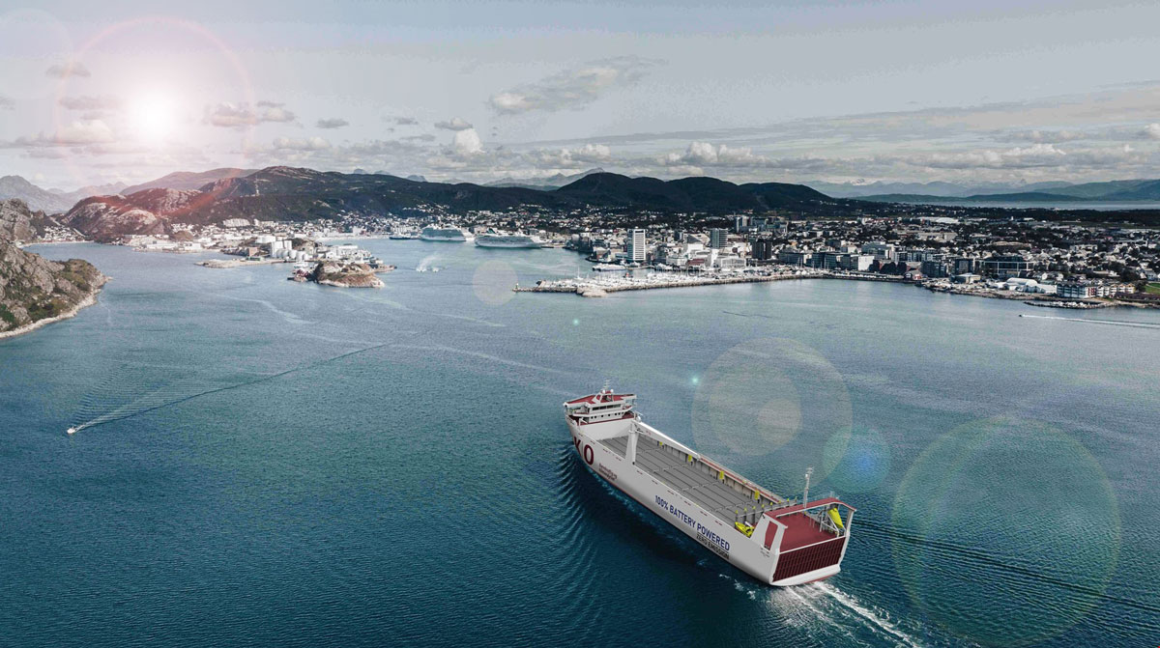
          - Green shipping. Illustration of a zero-emission sea route between Bodø and Troms that is being planned by the grocery wholesaler ASKO.
Source: ASKO/Green Shipping Programme
The Government’s ambition of halving emissions from domestic shipping and fisheries by 2030 compared with the 2005 level was included in a white paper on the maritime industry (Meld. St. 10 (2020–2021)). DNV GL publishes an annual barometer for the green transition in the shipping sector, which shows that the pace of change must be increased substantially to achieve this ambition. For the transition to succeed, ships must be built using zero-emission solutions and climate-friendly fuels must be made available. Many ports have already developed shore power systems and taken new technology into use to cut emissions. Various types of support are being used to facilitate the transition, including grant schemes through Enova and high-risk loans administered by Innovation Norway. The loan scheme applies to purchases of zero- and low-emission vessels and investments in existing vessels that are refitted to lower their emissions.
The global transition in the maritime industry has only just begun. A report from Menon Economics shows that only 5 % of the world fleet consists of zero- and low-emission vessels. In July 2023, IMO made a historic decision to adopt the common ambition of reaching net-zero greenhouse gas emissions from international shipping by 2050. In addition, targets for large emission reductions by 2030 and 2040 were adopted. IMO’s revised climate strategy includes checkpoints for emission reductions to reach net-zero in 2050. In the seven years up to 2030, total emissions from international shipping are to be reduced by 20–30 % compared to 2008. By 2040, international shipping is to reduce emissions by 70–80 % compared to 2008. Norway has taken on a leading role in efforts to establish ambitious climate and environmental standards for international shipping, including the pricing of greenhouse gas emissions.
Negotiations within the EU on the ‘Fit for 55’ climate legislation package have largely been completed. The package includes several legislative measures that will have consequences for shipping in and between EU and EEA countries, and to and from third countries. The directive on the EU ETS has been amended and its scope extended to include maritime transport. These amendments have now been incorporated into the EEA Agreement. One consequence of this is that shipping became part of the EU ETS from the beginning of 2024. The FuelEU Maritime Regulation will bring about reductions in greenhouse gas emissions through requirements for progressively reducing the greenhouse gas intensity of fuels used on board ships and the use of shore power or zero-emission technology. The EU has also agreed on the Alternative Fuels Infrastructure Regulation (AFIR). This will promote the development of publicly accessible and well functioning infrastructure for climate-friendly fuels throughout the EU. Both regulations (FuelEU and AFIR) were formally adopted by the EU in 2023 and the EEA EFTA countries have started processes for their for incorporation into the EEA Agreement.
A stricter international regime and more ambitious climate targets for shipping can help to build a market for low- and zero-emission solutions in the maritime sector. The Norwegian maritime industry is at the forefront of progress internationally, and includes world-leading companies in fields including ship design and shipbuilding, propulsion systems, and equipment and services.

Environmental pressures and impacts
Releases of pollutants to air and water
Shipping is responsible for releases of pollutants to both air and water. Emissions to air include greenhouse gases and other pollutants such as sulphur, nitrogen oxides and particulate matter. Emissions of greenhouse gases, including CO2, contribute to global warming and must be reduced as part of global efforts to limit global warming. Efforts to reduce greenhouse gas emissions from shipping are discussed in the previous section (Chapter 5.7.3). Emissions of sulphur and particulate matter are particularly problematic in built-up areas and where traffic is heavy, as local air pollution of this kind can result in environmental and health problems.
Emission volumes rise with the increase in distances sailed, though not to the same extent. NOx and CO2 are clearly the dominant components of emissions to air. Operating discharges to water (oil in bilge water, waste from oil and chemical cargoes, sewage, and waste and cargo residues) are strictly regulated and the requirements are being gradually tightened. Shipping also causes plastic pollution through marine litter, and spreads pollutants including hazardous substances and microplastics through wear and tear on paint and antifouling systems.
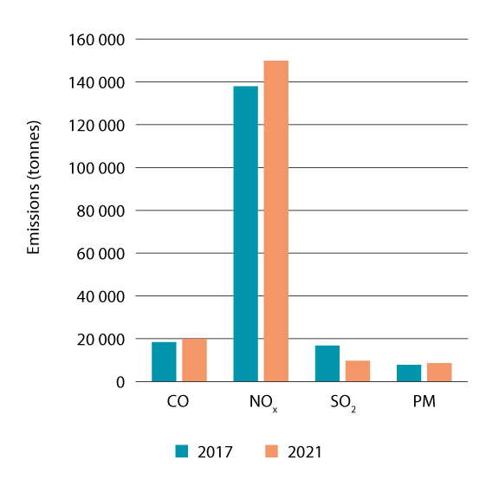
          - Emissions of CO2, NOx, SO2 and particulate matter (in tonnes) from shipping in Norwegian waters, including waters inside the baseline, in 2017 and 2021.
Source: Norwegian Coastal Administration
Emission figures for other pollutants show that there was almost no change in emissions in the period 2017–2021. The only exception is SO2 emissions, which were almost halved during this period. The main explanation for this change is the introduction of new rules on the sulphur content of fuels in the North Sea area.
The North Sea has been designated as an emission control area (ECA), as defined by IMO, for emissions of sulphur oxides (SOx) emissions for many years, and from 1 January 2015 the maximum sulphur content of fuel used in this area was reduced to no more than 0.10 %. From 1 January 2021, NOx emissions have also been regulated in the North Sea ECA. This means that any ships whose construction began on or after that date and that operate in the area will have to comply with stricter NOx emission limits. Norway is preparing a possible application to establish an ECA north of 62 oN, since the area designated as the North Sea ECA only extends to 62 oN.
Ships’ biofouling and the spread of alien species
Another major environmental problem associated with shipping is biofouling of ships’ hulls resulting in the spread of alien marine species. The introduction of alien marine species can have serious negative impacts on marine ecosystems. One recent example is the carpet sea squirt (Didemnum vexillum), which has been introduced to and become established along the Norwegian coast. In 2023, IMO adopted revised guidelines for the control and management of ships’ biofouling. These are intended to prevent biofouling and the further spread of alien species through inspection routines and cleaning procedures to be followed if biofouling is observed. Norway played a leading role in the revision of the guidelines, and is now seeking the establishment of binding international legislation to prevent biofouling and the further spread of alien species.
Underwater noise
Shipping has been identified as the most important source of continuous anthropogenic noise in the oceans. Marine organisms have been shown to respond to sounds, and in some cases, noise of anthropogenic origin may have severe negative effects, including disturbance and in the most serious cases, physical injury. Underwater noise and its effects on marine life and ecosystems are not currently subject to IMO regulatory measures, but guidelines for the reduction of underwater noise from commercial shipping (MEPC.1/Circ.833) have been prepared and are now being revised. At present, noise reduction technologies are only used on naval and research vessels and some fishing vessels.
Several studies of anthropogenic noise have been carried out in the North Sea and Baltic Sea, and tools have been developed for modelling noise from specific sources such as shipping, based on noise signatures linked to AIS data. No corresponding tools are available for waters further north (the Norwegian Sea and Barents Sea).

Tourism and leisure activities
A number of travel destinations in Norway are globally unique, and tourism activities related to such sites has positive effects on the Norwegian economy and Norwegian communities. The Norwegian travel and tourism sector has been developing rapidly in the past 10 years, and numbers of visitors to many destinations in Norway have been growing. Few countries have as long and varied a coastline as Norway, and the coastal environment, fjords and marine areas offer great potential for the development of attractive tourism products. However, growing numbers of tourists are putting greater pressure on the environment, resources and coastal communities.
The islands, skerries and fjords along the coast offer a wide variety of opportunities for outdoor recreation, including bathing, recreational fishing and boating. Foreign tourists are still drawn to Norway primarily by the scenery and natural surroundings, and these are also important for Norwegian tourists. Tourism and leisure activities in Norway’s marine and coastal areas depend on well-functioning ecosystems and opportunities to experience a clean natural environment.
            - Value creation in ocean-related tourism, shown in NOK billion (in constant 2021 prices).
05J2xt2
Industry | Value creation
 | 2018 | 2019 | 2020 | 2021
Ocean-related tourism | 7.2 | 7.7 | 4.8 | 5.8
Source: Statistics Norway
The Government’s tourism policy is intended to promote a competitive tourism sector that is both more sustainable and more profitable than was previously the case. The Government will give high priority to tackling challenges related to social and environmental sustainability to avoid excessive pressure on natural resources, the cultural heritage and local communities.
            - Employment in ocean-related tourism, shown in 1 000s.
05J2xt2
Industry | Employees
 | 2018 | 2019 | 2020 | 2021
Ocean-related tourism | 14.9 | 15.3 | 13.7 | 12.9
Source: Statistics Norway
Cruise traffic
The volume of cruise traffic is highest in summer, but has increased considerably in the spring, autumn and winter seasons. Most cruises in Norwegian waters visit Western Norway and North Norway.
Figures from the Norwegian Coastal Administration show that in 2019, before the COVID-19 pandemic, about 4.1 million cruise passengers visited the Norwegian coast. Corresponding post-pandemic figures show that about 4.3 million cruise passengers (3469 port calls) visited Norway in 2023, rising to about 6.1 million passengers (3943 port calls) in 2023. Passenger numbers show how many passengers are on board when ships call at port, and are registered for each port call.
Cruise ships in international traffic release various pollutants including NOx emissions, which have negative impacts on local air quality and damaging effects on marine ecosystems, particularly near major ports. Cruise traffic is also an energy-intensive form of tourism, and greenhouse gas emissions per passenger-kilometre are very high.
In 2005, the West Norwegian Fjord Landscape was inscribed on the UNESCO World Heritage List. From 1 March 2019, strict restrictions were introduced on releases of local pollution from cruise ships and ferries in the world heritage site. These include a ban on sewage discharges and SOx emissions. The purpose is to improve local air quality and avoid pressure on marine ecosystems. For larger cruise ships, restrictions on NOx emissions are being gradually tightened. The Government commissioned the Norwegian Maritime Authority to draw up a proposal for zero-emission requirements for cruise ships and ferries in the West Norwegian Fjord Landscape from 2026. Consultations have now been held on the proposal, and the Government is continuing to follow this up.
The Government has also asked the Norwegian Maritime Authority to assess whether the scope of these environmental requirements should be extended to other Norwegian fjords.
In 2020, the Government appointed a committee to assess challenges in the fields of maritime safety and emergency preparedness associated with cruise traffic in Norwegian waters and adjacent areas. The committee presented its report in February 2022. The Government is now following up the committee’s proposals.
Fishing tourism and outdoor recreation
In recent decades, a large number of tourist companies have grown up along the coast that cater for fishing tourism. This has provided a boost in activity and jobs in many coastal communities, but also puts greater pressure on fish resources. More knowledge is needed about the resources harvested by the fishing tourism industry. Rules have been adopted to obtain a better overview of the resources harvested by the fishing tourism industry, and also to make the industry more professional and give it greater legitimacy.
Recreational activities in coastal waters are extensive and increasing. Summertime is particularly busy. According to a 2018 survey, there are 900 000 leisure craft in Norway. Most recreational activity takes place in the waters closest to the coast, so that there has only been limited spatial conflict with commercial shipping. Increased activity and boat traffic may nonetheless disturb vulnerable species and habitats in the coastal zone, for example breeding and moulting seabirds, fish and marine mammals. More marine litter is also registered in areas where the activity level is high. Prohibitions on boat traffic and access are introduced as needed to reduce pressure on the most vulnerable areas, particularly to protect seabirds.
Traditionally, recreational fishing and trapping activities have not been subject to regulation to the same extent as commercial fisheries and, more recently, fishing tourism. Recreational fishing and trapping is a form of outdoor recreation as well as providing food, and forms an important part of Norway’s coastal culture.

Risk of acute pollution and the preparedness and response system – status and trends
Acute pollution is defined as significant pollution that occurs suddenly and that is not permitted under the Pollution Control Act. Any activity that may result in acute pollution entails an inherent risk of damage to the environment and living marine resources. This chapter deals with the risk of acute pollution associated with the shipping industry, petroleum activities, and civilian and military activities that pose a risk of acute radioactive pollution, and Norway’s emergency preparedness and response system for acute pollution.

Environmental risk and accident risk
The term ‘accident risk’ refers to the risk that an accident resulting in acute pollution will occur, while ‘environmental risk’ describes the risk of environmental damage as a result of acute pollution.
The way accident risk and environmental risk are described differs from one sector to another. The shipping sector, petroleum industry and activities that may result in radioactive pollution take somewhat different approaches, related to factors including the different authorities involved, the legislation that applies to each sector, and the varying functions that risk descriptions play in risk management. The differences in approach also reflect developments in risk management and methodology based on experience gained from inspection and control activities and cooperation between authorities, and from accidents in the different sectors. For all sectors, it is important that accident risk and environmental risk are assessed together. Status and trends for accident risk and environmental risk for the three sectors are further described in Chapter 5.3–6.5.
Environmental risk can be reduced by taking steps to reduce the likelihood of acute pollution or to reduce the environmental consequences in the event of acute pollution. In general, preventing accidents involving acute pollution is essential to maintain a low level of environmental risk. Measures to prevent accidents are particularly important as a means of reducing environmental risk in and close to environmentally vulnerable areas. The risk of damage to vulnerable areas and populations of vulnerable species can also be reduced by avoiding high-risk activities away in such areas or at times of year when vulnerability is high.
If an accident involving acute pollution does occur, it may cause damage to organisms in the water column, on the seabed, at the sea surface (seabirds and marine mammals), or to organisms that live in coastal waters and the shore zone or marginal ice zone. An accident may also reduce the amenity value of an area and have negative impacts on recreational and commercial activities. Every spill is different, and the environmental consequences will depend on a range of factors, including the type of spill, when and where it happens, how the pollution spreads, which species and habitat types are to be found in the area affected by pollution and their vulnerability to the relevant type of pollution.
In the event of an accident, rapid and effective detection of acute pollution is of crucial importance for an early response that can stop the pollution at source. This is vital in limiting the quantities of pollutants released and the damage to the environment and marine resources. The level of environmental risk determines preparedness and response needs in different areas of Norway’s waters.
The assessment of environmental risk in this chapter focuses mainly on oil spills, since these involve the greatest potential for environmental consequences from acute pollution. Releases of natural gas would not have major impacts on the marine environment and are therefore not discussed further here.
The potential consequences of chemical spills vary, but these are often smaller spills from petroleum activities, and have only local effects. Chemicals carried as cargo on ships also pose an accident risk, particularly in the approaches to industrial areas where there are chemical plants. However, at present we have insufficient knowledge to assess environmental risk or vulnerability to chemical spills.
Sudden releases of significant quantities of solid waste such as plastics are also defined as acute pollution. Plastic pellets, or nurdles, are persistent microplastics that often contain hazardous substances. In February 2020, there was a major spill of plastic pellets in the North Sea during a storm. Damage to a container on a cargo vessel resulted in the loss of 13 tonnes of plastic pellets, which washed up on beaches in Scandinavia, including the shoreline of the Oslofjord in Norway.
An incident involving radioactive pollution is unlikely to have significant consequences for the marine environment. There could be some local pollution, but dilution in the water column would reduce levels of radioactivity considerably.
The development of new industries in Norway’s ocean areas, such as offshore aquaculture, offshore wind and seabed mineral extraction, may result in different types of acute pollution incidents in areas where there is currently little or no activity. As yet, we have no experience of such incidents and types of pollution, but they are generally likely to be linked to shipping serving the new industries. It will be important to build up knowledge on environmental vulnerability to the types of acute pollution that may occur.

Vulnerability to acute pollution
There are many areas in Norway’s waters where vulnerability to acute pollution is high, and particularly to oil spills. These are generally:
- areas that are important for seabirds (areas used for breeding and feeding, for swimming migration, or where there are large aggregations, especially of pelagic and coastal diving species);
- areas that are important for early life stages of fish (spawning products, eggs and larvae);
- areas where there are large aggregations of certain marine mammal species, particularly in the whelping and moulting seasons;
- coastal areas, particularly less exposed areas where oil that reaches the shore or sea ice may persist for a long time.
Since the occurrence and distribution of vulnerable species such as seabirds and marine mammals varies from one area to another and through the year, there will also be spatial and temporal variations in the vulnerability of different areas to acute pollution. Knowledge about important species and habitats and their vulnerability to acute pollution is essential for an understanding of potential environmental risk related to acute pollution incidents. Such knowledge is also important for evaluating how environmental risk varies from one area to another and through the year, so that measures can be targeted as needed. We therefore need adequate information about the distribution of vulnerable habitat types and species in Norway’s ocean areas, and about which life stages are particularly vulnerable to exposure to oil.
In connection with the review of the particularly valuable and vulnerable areas in Norwegian waters and identification of a new set of areas, updated assessments have been made of the vulnerability of a range of ecosystem components to various environmental pressures, including oil pollution. Vulnerability can be defined as a measure of how prone an area is to be negatively affected by human activity or changes in environmental conditions; conversely, its resilience is a measure of how well it can resist or recover from damage. Thus the vulnerability of an area is considered to be an intrinsic property of the species and habitats to be found there, regardless of whether or not specific environmental pressures are actually acting on them. Assessments of intrinsic vulnerability therefore do not take into account whether or not a specific activity is being carried out in an area. Since the previous scientific basis was published, knowledge about the vulnerability of various fish species to oil has been improved. The results have been used in simulations of oil spills and their effects on fish stocks. Work is also in progress to learn more about the vulnerability of seabird colonies to acute pollution.

Shipping
The environmental risk associated with acute pollution from shipping is calculated on the basis of the likelihood of accidents involving different spill volumes and the environmental consequences of a spill. The maritime safety level in Norwegian waters is high, and in recent years, maritime safety has been further improved through a number of preventive measures. Despite this, there is always a possibility of an accident involving acute pollution.

Relevant developments
There has been a slight overall increase in ship traffic, expressed as the distance sailed, in the period 2015–2021. However, this has had little effect on overall levels of spill risk and environmental risk. From 2015, the number of incidents where vessel casualties result in acute pollution has been fairly stable for the three management plan areas considered together. There has been some variation in total annual discharge volumes from vessel casualties resulting in acute pollution during the same period, but no clear trend.
Recently, international requirements to use fuels with a lower sulphur content have been introduced in order to reduce sulphur emissions. As a result, additives such as waxes must be used to lubricate ships’ engines. This means that low-sulphur fuels have a higher pour point (the temperature at which the oil solidifies as it cools), and therefore congeal more readily than traditional fuel types. This also makes it more difficult to recover oil from the sea using the current types of skimmers, and lumps of solidified fuel may be transported over long distances and break up in the shore zone when temperatures rise. Too little is known about the overall effects the new low-sulphur fuel types may have on environmental risk. In addition, little experience has been gained of acute pollution response operations involving a wide range of low-sulphur fuels on a cold sea surface. Norway is the lead country in an Arctic Council project on the fate and behaviour of new low-sulphur fuels in cold-water conditions, which is intended to fill gaps in our knowledge.
Other changes in the shipping sector that are affecting the level of environmental risk include a longer cruise traffic season. Moreover, climate change is resulting in greater environmental vulnerability and an increase in the number of red-listed species, thus altering the level of environmental risk. Any risk of acute pollution from offshore wind production and other new offshore industries is expected to be linked mainly to shipping to and from their facilities.
The volume of shipping in far northern waters has risen in recent years. According to figures registered by the Vardø Vessel Traffic Service Centre, ship traffic almost doubled from 2017 to 2019, but after this there was a small decrease in 2020 and 2021. The number of high-risk vessels and vessels carrying dangerous cargo registered in this period was also higher than previously. However, figures for this category show the same tendency as the overall figures, with a decrease in 2020 and 2021.
Norway maintains a good overview of all tankers sailing through its waters, and monitors all tankers and other high-risk traffic along the Norwegian coast and in the waters around Svalbard. No increase has been registered in tanker traffic sailing north-south and south-north along the Norwegian coast, but there has been a rise in the number of crude oil tankers sailing from Russia and out through the Baltic Sea, linked to the war in Ukraine and the sanctions imposed on Russia. Most of their route takes them through Danish and Swedish water, but any incidents involving these ships could also affect Norwegian waters and coastal areas in the Skagerrak and outer Oslofjord.
The Norwegian Coastal Administration is responsible for coordinating the preparedness and response system for acute pollution along the coast. International agreements ensure that the Coastal Administration will receive early warnings of any incidents in neighbouring countries that may affect Norway. In the event of acute pollution from such incidents, the response will be handled through the established governmental system, if necessary with international assistance.
Stricter rules for the types of fuel that are permitted in the waters around Svalbard are reducing risk levels and the potential for damage in areas where vulnerability to oil spills is high.

Maritime safety – measures to reduce the likelihood of vessel casualties
The purpose of maritime safety measures is to prevent injuries and the loss of life, environmental damage and material damage. Over the years, a range of measures has been implemented to reduce the likelihood of vessel casualties. Important examples include traffic separation schemes, including routeing systems approved by the International Maritime Organization (IMO), the government emergency tugboat capability, navigation technology (the AIS system and satellite navigation), the quality-assured digital route service, vessel traffic services to monitor and regulate maritime traffic, regulatory measures for national and international shipping, port state control measures, improvements to fairways and pilot services.
Norway has established traffic separation schemes and recommended routes all along the mainland in its exclusive economic zone in order to divert high-risk traffic, including international transit traffic, further away from the coast. This gives the authorities more time to respond to incidents and emergencies. Keeping vessels further out from the coast will also help to reduce the consequences of any accidents involving oil spills. The routeing systems are mainly used by vessels of 5000 gross tonnage and above, nuclear-powered ships and ships carrying dangerous or polluting cargo. Routeing systems outside territorial waters must be approved by IMO, and Norway is obliged to ensure that fixed installations are not sited in conflict with IMO-approved routes.
The main purpose of the government emergency tugboat capability is to ensure safety and prevent or limit acute pollution at sea. The Coast Guard has the operational responsibility for this service, as agreed with the Norwegian Coastal Administration.
Vessel monitoring systems in Norwegian waters make it possible to provide assistance or take steps to limit damage at the right time. These systems also make it easier for the authorities to deal with accidents and run search and rescue operations. Further development of the infrastructure for receiving Automatic Identification System (AIS) signals from vessels has significantly enhanced vessel monitoring in recent years. A network of AIS base stations has been established along the entire mainland coast and for the most heavily trafficked waters off Svalbard. Satellites equipped with AIS receivers have also greatly enhanced monitoring in the open sea. The Vardø Vessel Traffic Service Centre monitors shipping in Norway’s exclusive economic zone along the mainland coast and in the waters around Svalbard, focusing particularly on tankers and other large vessels. The Vardø VTS Centre also monitors compliance with the rules for the traffic separation schemes, and issues navigational warnings.
Both the system of vessel inspections for Norwegian ships and the port state control (PSC) system for foreign vessels play a part in maintaining a high level of maritime safety in Norwegian waters. Risk-based inspections ensure that the main focus is on areas that give the greatest benefits for health, safety and the environment.
Measures to improve fairways reduce the likelihood of accidents, facilitate passage for shipping in narrow channels and reduce distances sailed. Aids to navigation improve maritime safety in coastal waters.
The main new development since 2019 is the introduction and publication of the quality-assured digital route service. The routes are quality assured for vessels up to 150 m in length and a maximum draught of 9 m, and can be downloaded directly to navigation systems on board from routeinfo.no. Digital routes are available for most ports from Halden to Kirkenes. The establishment of vessel traffic services for the waters between Florø and Måløy in 2021 is another important maritime safety measure introduced since the previous white paper on the ocean management plans.
Together, the measures that have been implemented provide a high level of maritime safety in Norway’s marine and coastal waters. Given measures that have been adopted internationally and further measures that are already being implemented at national level, a further decline in the risk of accidents is expected up to 2040.
Climate change is affecting weather conditions at sea and along the coast, and may in turn influence maritime safety and accident risk. This must be taken into account in continued efforts to maintain a high level of maritime safety and limit the risk of vessel casualties.

Acute pollution from shipping
The frequency of accidents is influenced by a number of factors, including the volume of traffic, the traffic situation, the technical standard and equipment of vessels, crew qualifications and preventive measures such as steps to secure cargo. Navigation is more challenging in Norwegian coastal waters than along the coast of most other countries. Grounding while under way is the dominant accident type along the Norwegian coast. In some cases, vessel casualties result in acute pollution, for examples oil spills (cargo or fuel), chemical spills, spills of products or plastic pellets, or releases of radioactive substances. Incidents where cargo is lost or damaged occur frequently, and in some cases they can result in acute pollution, such as releases of plastic pellets.
From 2015 to 2021, the number of incidents involving acute pollution as a result of vessel casualties was relatively stable for the three management plan areas considered together. There have been about 100 incidents a year, generally involving only small quantities of pollutants. The largest spill during this period resulted from the collision between the frigate NHoMS Helge Ingstad and the tanker SOLA TS in 2018. Substantial quantities of marine diesel and helicopter fuel leaked to the sea. However, environmental investigations carried out in May 2019 showed no major environmental consequences in the area around the wreck of the Helge Ingstad. To make it easier to describe developments in this field, linear trends over several years are used. For the period as a whole, there was a weakly rising trend in vessel casualties involving acute pollution, but the rise for each of the management plan areas was small, and the situation can be described as relatively stable. Thus, there has been little change in the number of incidents and the level of accident risk during the reporting period, and the accident risk is considered to be low.
Fuel spills
The likelihood of fuel spills varies through the year and between different areas of Norway’s marine and coastal waters, mainly linked to variations in traffic density. The likelihood of fuel spills is higher in the North Sea-Skagerrak area than in the other two management plan areas, and is highest in the Oslofjord and inner Skagerrak and off the coast of Telemark, and in Agder and Rogaland counties. The likelihood of spills from vessels of 5000 gross tonnage and above is also highest in the same areas. In the Norwegian Sea (off the coast of Møre og Romsdal, Trøndelag and Nordland), the likelihood of spills declines gradually from south to north, and this trend is also found for vessels of 5000 gross tonnage and above. In the Barents Sea–Lofoten area, the likelihood of spills is somewhat higher from the Lofoten Islands to northern Troms than for Nordland, but lower than for Nordland off the coast of Finnmark. The likelihood of spills is even lower in the water around Svalbard than off Finnmark.
Cargo spills
The likelihood of spills of oil carried as cargo is considerably lower than for fuel oil, and is highest in the North Sea–Skagerrak management plan area, particularly in the Oslofjord and inner Skagerrak and off the coast of Telemark, Agder and Rogaland counties. Oil is normally carried as cargo by three different vessel types: chemical, product and crude oil tankers. In the period 2015–2021, the likelihood of spill from crude oil and product tankers has been fairly stable for the area analysed as a whole.
Within the framework of IMO, Norway has proposed the introduction of stricter binding rules on the transport of plastic pellets by classifying them as a ‘harmful substance’ under Annex III of the MARPOL Convention. This and other possible solutions are now being considered by member states, and they are also working on recommendations on the carriage of plastic pellets that can be used as a temporary measure and can be quickly adopted by the IMO Marine Environment Protection Committee (MEPC) once agreement is reached.
The use of chemicals is becoming more and more widespread in manufacturing and in other areas of society. Chemicals transported by sea may include biofuels to be mixed with other fuels and chemicals used in the petroleum sector or the aquaculture industry. Chemical tankers are being used to deliver cargo to a growing number of onshore facilities and terminals, which increases the risk of acute pollution.

The environmental risk associated with shipping in different areas
The maritime safety level in Norwegian waters is generally high, and there are relatively few spills with environmental consequences. However, the consequences of a major spill could be very serious for vulnerable species and habitats, and as a result the level of environmental risk is considered to be high in many areas.
The North Sea–Skagerrak area
The Oslofjord and inner Skagerrak: this area is heavily trafficked and the calculated frequency of exposure to oil is high. Combined with very high environmental vulnerability at certain times of year, this results in a high level of environmental risk in the area.
Agder and waters off the coast: the level of environmental risk varies between moderate and high. Both the calculated frequency of exposure to oil and vulnerability are high during parts of the year. Taking account of oil from vessel casualties in Swedish and Danish waters in the Kattegat and Skagerrak results in a slightly higher figure for the frequency of exposure to oil.
Rogaland: the level of environmental risk in much of this area is high or very high during parts of the year. Special care is therefore needed when deciding on the design and capabilities of the preparedness and response system for the area. However, preparedness and response resources are readily available along this part of the coast.
Vestland county (southern part): the risk level is very high in several parts of this area. There is high-risk traffic in the area, and evaluations of the preparedness and response system must take into account both accident risk and environmental risk.
Vestland county (northern part): there is high-risk vessel traffic in the southern part of this area, and environmental vulnerability is very high further north. Any oil drift from south to north would influence the level of environmental risk. As for the southern part of Vestland, the combination of accident and environmental risk is of crucial importance for decisions on the capabilities and siting of preparedness and response resources. Areas of special concern are around the Sula reef, coastal waters and the Møre banks.
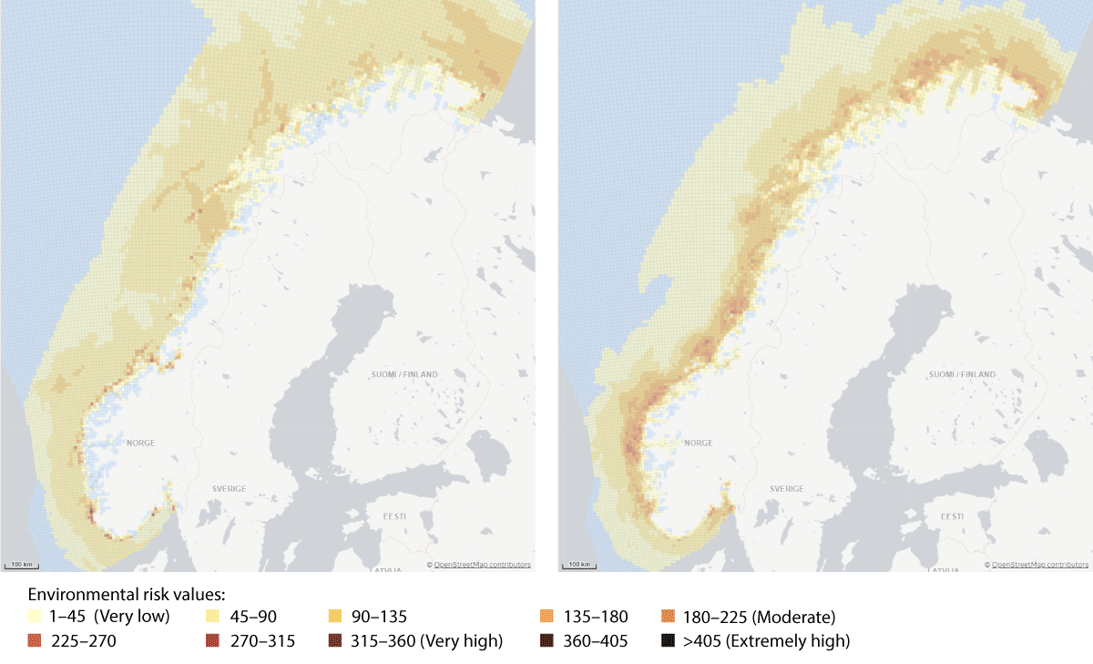
          - Examples of how the Norwegian Coastal Administration's analysis of the environmental risk associated with shipping can be presented in map form. The two maps show environmental risk values for surface water in January (left) and July (right) 2019. They show that environmental risk values are high or very high in many areas, and that there are wide variations between months.
Source: Norwegian Coastal Administration
The Norwegian Sea
Møre og Romsdal: the Møre banks and the coastal zone of the Norwegian Sea from 62 oN northwards to Runde island are the areas in Møre og Romsdal where environmental risk is highest. These waters include a number of protected areas that are important for seabirds. Marine mammals such as the grey seal, harbour porpoise, common seal and orca are also found in the area.
Trøndelag: the Froan archipelago, the Sula reef and the coastal zone of the Norwegian Sea are important for various species of corals, fish, seabirds and marine mammals, particularly in spring and summer.
Helgeland: this is the southern part of Nordland county, and a number of areas are particularly vulnerable to exposure to oil. The Vega Archipelago is a UNESCO World Heritage Site, and its conservation value is particularly high. In the event of an oil spill in the area, there would be a very high likelihood of oil reaching the shore, and the logistics of an oil spill operation would be very complicated. These factors must be taken into account in analyses of the preparedness and response resources that are needed.
The Barents Sea–Lofoten area
Northern Nordland and southern Troms: a long stretch including a number of areas that are vulnerable at some times of year because of the rich bird life and spawning areas for fish.
Northern Troms and Finnmark is another large area including important spawning, nursery and wintering areas for many different fish species. This supports a rich bird life and many seabird colonies, and in some periods also many marine mammals. Ocean currents that carry drifting fish larvae northwards towards the Barents Sea explain why 90 % of Norway’s seabird colonies are located in the Lofoten Islands and further north.
Waters around Svalbard (including Bjørnøya), Jan Mayen: levels of environmental risk are estimated to be quite low because there is relatively little shipping and calculated accident frequency is low for much of the year. However, the environmental consequences of a spill would be very high at some times of year because of large concentrations of seabirds and marine mammals and high vulnerability to oil pollution. This area also includes a large proportion of the protected areas in Norway’s territorial waters.
Although levels of environmental risk for waters around Svalbard (Figure 6.2) are low on average, high values have been found for specific areas in certain months of the year, and the months when the risk level is highest vary from one part of the area to another.
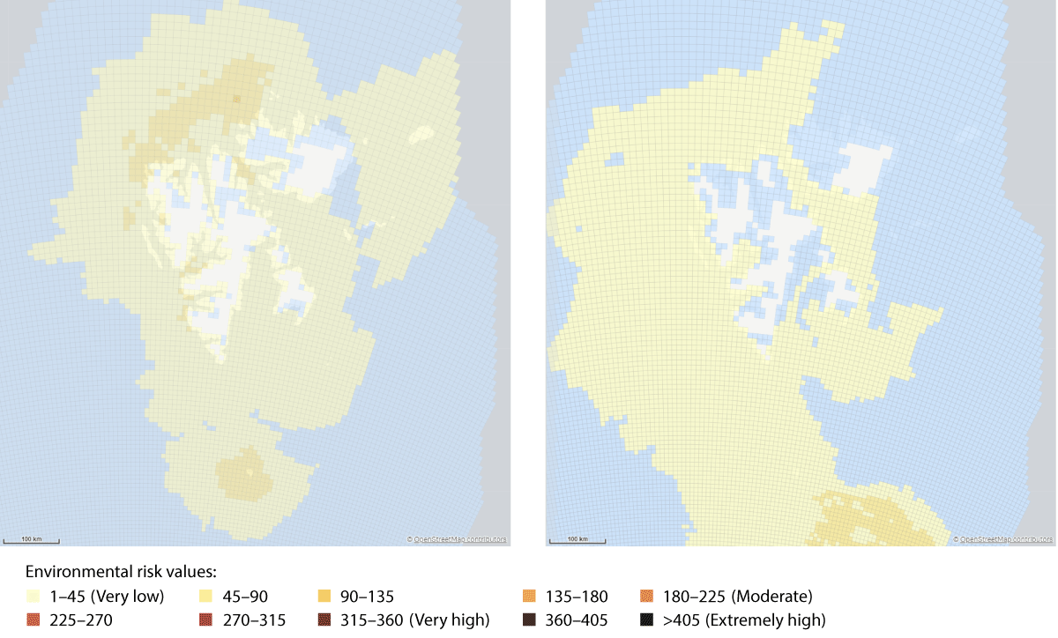
          - Maps showing environmental risk values for the waters around Svalbard, including Bjørnøya, for July (left) and January (right) 2019.
Source: Norwegian Coastal Administration
In the waters around Svalbard, Bjørnøya and Jan Mayen, the potential environmental consequences are more important than risk values in the context of preparedness and response for acute pollution. This is also in line with political guidelines for the management of these areas.
A general prohibition on the use of heavy fuel oil in the territorial waters around Svalbard was introduced from 1 January 2024. This means that permitted fuels are specific light marine gas oils and new, greener fuels such as liquefied natural gas (LNG) and hydrogen. This will reduce the level of environmental risk in the territorial waters around Svalbard, which consist largely of protected areas where many species and habitats are vulnerable to oil pollution.

Petroleum activities
Acute pollution in connection with petroleum activities may be caused by events ranging from uncontrolled blowouts that can potentially release large volumes of oil to the sea, to minor spills of oil or chemicals. The likelihood of an accident that results in a major spill is low, but the environmental consequences could be very serious.
The risk of spills during petroleum activities is referred to as accident risk in this white paper. The risk of spills causing environmental damage is referred to as environmental risk. However, in contrast to the more traditional understanding of risk, the concept of risk used in the petroleum industry puts less emphasis on the likelihood of accidents, see Box 6.1. Health and safety and protection of the external environment are closely linked, and the Norwegian authorities cooperate to ensure an integrated approach. Accidents may have environmental consequences if they result in oil or chemical spills or emissions to air. In connection with integrated ocean management, the authorities consider it particularly important to ensure that stakeholders do not assess and manage accident risk and environmental risk separately. The current health, safety and working environment legislation also requires an integrated approach to assessments, and provides a framework for cooperation between the safety and environmental authorities so that they can meet their obligations together rather than separately.
The level of activity in the North Sea and the Norwegian Sea has been consistently high since the previous white paper on the management plans was prepared. In the period 2017–2021, 52 exploration wells and 100 production wells were drilled in the Norwegian Sea, while the figures for the North Sea were 127 exploration wells and 777 production wells. In the same period, 23 new discoveries were made in the Norwegian Sea and 40 in the North Sea. Goliat and Snøhvit are still the only fields that are in production in the Barents Sea. The Johan Castberg field is under development, and drilling of production wells has started. The Wisting field is in the clarification phase. In the period 2017–2021, 31exploration wells and seven appraisal wells were drilled, and 13 discoveries were made. The level of risk and uncertainty is considerably higher for drilling of exploration wells than for production wells, among other things because conditions in the reservoir are known in advance when production wells are drilled.

Incidents and near misses
There have been both large and small spills on the Norwegian continental shelf since the first petroleum activities were initiated, but they have all occurred relatively far from land and under favourable weather conditions, and as a result of the response measures that were implemented, the pollution has not reached land or caused any known environmental damage. Stakeholders are obliged to take steps to prevent all types of incidents and near misses. The same barriers are used to prevent both minor and major spills. Learning from experience of minor spills is therefore important as a basis for improving barriers that are also intended to prevent major accidents.
Most incidents involving acute pollution on the Norwegian continental shelf are chemical spills. Chemicals are used because they have important functions and improve operational safety. Chemical spills accounted for about 80 % of the total number of incidents in the period 2005–2022. Spill quantities vary from year to year, and higher volumes are generally explained by individual more serious accidents. In recent years, high spill volumes have been registered in certain years both in the Norwegian Sea and in the North Sea. The highest figures for the Norwegian Sea were the result of chemical spills with volumes of 599 m3 (2015), 500 m3 (2018) and 202 m3 (2020).
The number of incidents involving crude oil spills on the Norwegian continental shelf shows a long-term declining trend for the whole period 2005–2022. However, the last part of the period, 2016–2022, does not show the same positive trend as the years 2002–2016 (Figure 6.3).
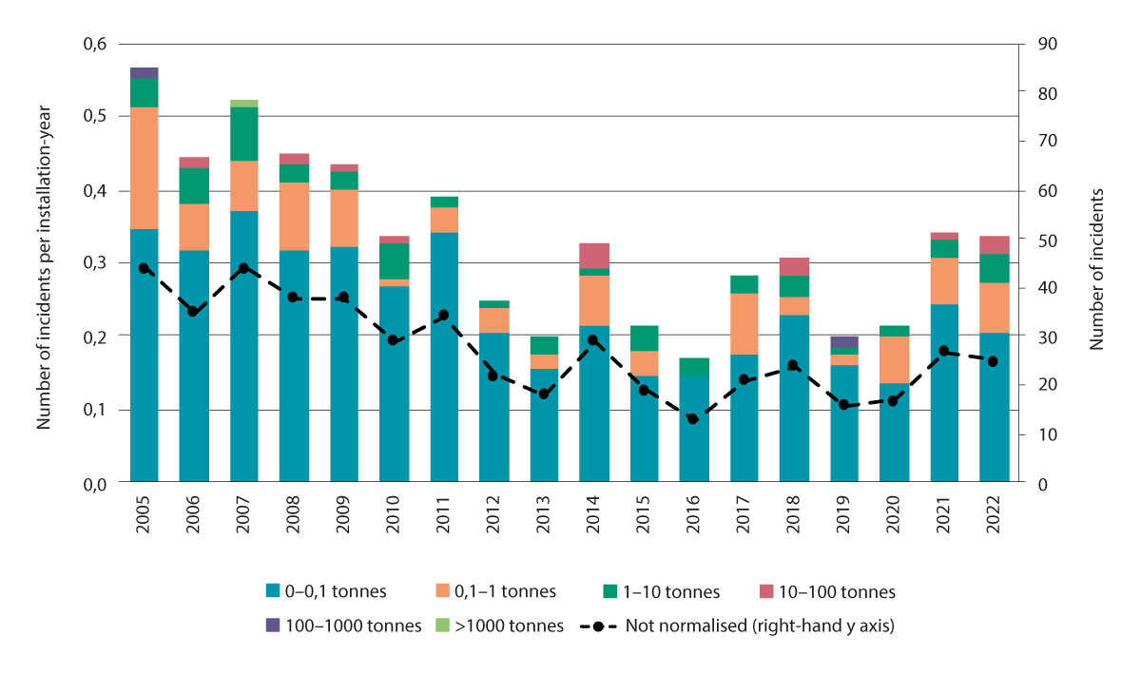
          - Number of incidents involving crude oil spills on the Norwegian continental shelf, 2005–2022.
Source: Norwegian Ocean Industry Authority
There have been large variations in the annual discharge volumes of crude oil in the period 2002–2022. Most spills are in the size category 0–0.1 tonnes. However, the largest annual discharge volumes are the result of individual more serious incidents. The only incident involving a spill of more than 1000 tonnes (3596 tonnes) occurred in 2007, when a hose was severed during the transfer of oil to a tanker. In 2019, overpressurisation of a sludge cell on a fixed facility in the North Sea resulted in cracking of the cell dome, and 126 tonnes of oil leaked into the sea.
A near miss is an event that could have led to a spill under different circumstances, if several of the barriers designed to prevent spills had failed. Such events are analysed and followed up by the operators and the authorities to monitor trends in accident risk and to make improvements in preventive efforts and risk treatment. There was a downward trend in the number of near misses in the period 2005–2013, followed by a weak rise from 2013 to 2015. After 2015, the number of near misses has been relatively stable, but there has not been a downward trend either in the number of near misses or in the size of the potential spills from these events (Figure 6.4).
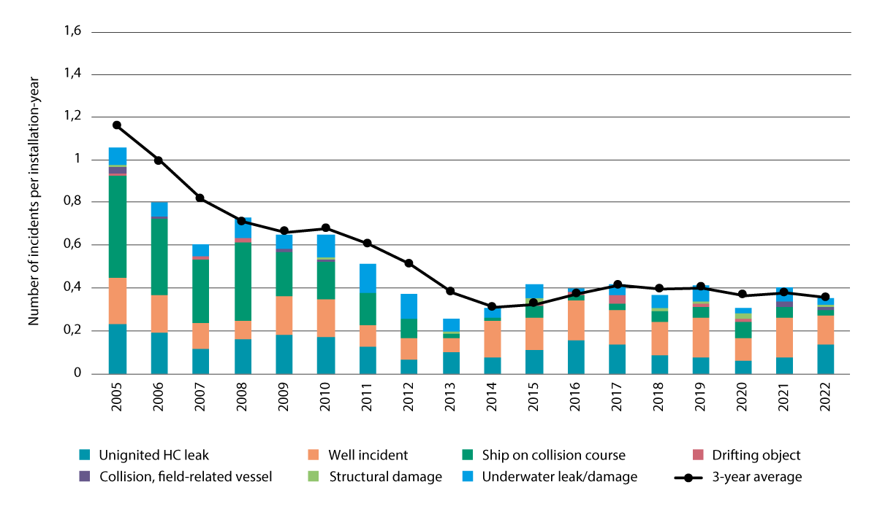
          - Number of near misses that could have led to oil spills on the Norwegian continental shelf in the period 2005-2022.
Source: Norwegian Ocean Industry Authority

Accident risk
There is some risk of spills of crude oil or chemicals during any oil production or drilling in oil-bearing formations. It is therefore vital that the industry maintains high safety standards and continues its efforts to reduce the risk of such events. The most important measures for reducing environmental risk are the same as those for preventing accidents.
Accident risk is dynamic, and continuous action by both the companies and the authorities is necessary to maintain a consistently low level of risk. All companies must therefore to seek to reduce accident risk when planning, carrying out, monitoring, adjusting and further developing their own petroleum activities. They must also follow this up and learn from incidents and accidents and their causes, and if necessary adjust their routines.
The authorities play a part in risk reduction through the single regulatory framework that has been established for health, safety and the environment, and which makes the petroleum companies responsible for reducing accident risk. This regulatory framework sets ambitious requirements for risk reduction regardless of geographical area, location and type of field development. The authorities also play a part through inspection and enforcement activities to ensure that companies are complying with the rules, by investigating serious accidents and monitoring accident and incident trends, through their influence on research and development, and through cooperation between the social partners and public authorities. Regulatory and supervisory activities by the authorities are intended to be a supplement to and not a replacement for accident prevention by the companies.
One important focus area that has been identified since the Forum for Integrated Ocean Management published its 2019 risk report is learning and improvement processes in response to incidents and accidents. It is also important to learn from major accidents in other parts of the world in order to avoid making the same mistakes in the Norwegian petroleum industry. The aim is to encourage the companies to improve the way they evaluate environmental risk in conjunction with accident risk and to give higher priority to accident prevention. Since 2019, cooperation between the Norwegian Ocean Industry Authority and the Norwegian Environment Agency has been further developed to improve compliance with requirements in the current legislation.

Environmental risk
There is some environmental risk associated with all petroleum activities on the Norwegian continental shelf. Under the health, safety and working environment legislation, environmental damage must be limited or prevented as far as possible and the risk level minimised. It is also considered very important to identify the ecosystem components that are most vulnerable to serious damage in the event of an oil spill, so that risk reduction measures can be targeted as necessary, and risk can be limited for example through a framework for petroleum activities in specific geographical areas.
According to the historical data, the likelihood of major spills is low. However, the authorities take into account the potential for large-scale events to have serious environmental consequences, particularly if they affect the most valuable areas that are also highly vulnerable to oil. Activities generally have a potential for more serious consequences if they may affect areas where there is a high concentration of vulnerable species. Knowledge about the distribution of habitats and species in Norwegian waters, and about the habitats, species and life stages that are most vulnerable to exposure to oil is therefore of crucial importance.
              - The concept of risk in the petroleum sector
The petroleum sector in Norway expresses risk in terms of the potential consequences of petroleum activities and the uncertainty associated with them.
‘Consequences’ include all possible outcomes of incidents that could potentially arise during petroleum activities. Environmental consequences include damage or nuisance to the environment, whether from operational discharges or acute pollution in the form of solid matter, liquids or gases released to the air, water or ground, and effects on temperature.
‘Associated uncertainty’ is uncertainty relating to the potential consequences of petroleum activities. Given the way consequences are defined above, uncertainty may be related to the possible types of incidents, how often they are likely to occur, and the damage or loss that different incidents may entail for human life, health and material assets. In addition, there is uncertainty relating to the types of environmental damage that may be caused by operational discharges.
In contrast to a more traditional understanding of risk, the concept of risk in the petroleum industry puts less emphasis on the likelihood of accidents. This is because it has been found that focusing on likelihood and using expected values and historical data can in practice result in oversimplification. A stronger focus on uncertainty results in a better basis for decision making. This approach can improve processes that take place before decisions are made, ensure that more useful information is available and result in more effective use of the available knowledge and experience.
[Boks slutt]
Restrictions on when drilling is permitted and where petroleum activities may be carried out can substantially reduce the environmental risk associated with exploration and other drilling. By the time production drilling starts, there is much more information about reservoir conditions and types of oil, and the likelihood of a blowout is considerably lower than during exploration drilling. However, the level of risk will depend on the discharge potential and the distance to vulnerable species and areas during production and production drilling as well, and therefore on where companies are allowed to start up petroleum activities.
Norway has developed comprehensive legislation on health, safety and the environment, which requires companies to meet strict safety and governance standards. The legislation is designed in such a way that the requirements become stricter in areas where conditions make this necessary. All petroleum-related activities, including exploration, field development, operation and field closure, require consent or permits from the authorities.
There are many important and valuable species and habitats in Norway’s ocean areas that show high intrinsic vulnerability to oil pollution. Carrying out petroleum activities in such areas requires both industry stakeholders and authorities to maintain a high level of awareness and show special care, so that the goal of maintaining a low level of environmental risk can be achieved. The ocean management plans include a framework for petroleum activities in different geographical areas, which helps to protect selected species, habitats and areas. For example, there are areas where no petroleum activities may be initiated, and others where there are restrictions on when drilling is permitted. Since the framework was last updated in the previous ocean management plans, new and improved knowledge about various species and habitats and their vulnerability to oil has been obtained, which can be used as a basis for assessing whether the framework for petroleum activities needs to be adjusted.
Both drilling and other petroleum activities take place in areas where an incident could have serious consequences. Although the likelihood of a serious incident is very low, it is therefore important to maintain the focus on risk reduction and continued work on preventive measures to reduce the environmental risk to the most valuable species and habitats in Norway’s waters.
              - Scenario for a major accident during drilling on the Norwegian continental shelf
The Directorate for Civil Protection and Emergency Planning is responsible for maintaining an overview of risk and vulnerability in Norway. The Directorate has published risk analyses for a range of crisis scenarios since 2011. These analyses deal with the risk associated with various disasters that could affect Norwegian society, and that the country needs to be prepared to deal with.
The report Analysis of Crisis Scenarios 2019 includes a risk analysis of an oil and gas blowout during drilling of a well in the North Sea.
The scenario is based on the following course of events: a critical mistake is made during drilling operations on a normal-sized installation in the Oseberg/Troll area off Western Norway (Hordaland). A number of safety barriers fail, including the blowout valve, and gas streams out through the borehole and up on to the deck. The gas covers large parts of the installation and ignites after a few minutes. A violent explosion occurs with subsequent fire on board the rig. Large volumes of oil start to flow out into the sea. The blowout lasts for 43 days and the discharge rate is 7 000 tonnes/day, giving a total discharge volume of about 300 000 tonnes of oil.
This scenario combines three relatively rare events: a blowout, emissions of a large volume of gas, which ignites, and a very prolonged discharge. The likelihood of the scenario is the product of the likelihood of each of its three elements, and is therefore very low. The annual likelihood of this scenario occurring on the specific drilling installation is estimated at 1:500 000 or 0.0002 %. The likelihood of the scenario occurring on this installation during a 100-year period is therefore 0.02 %. In all, around 200 wells are drilled on the Norwegian continental shelf every year. If we assume that an average safety level is maintained during activity on the installation in the scenario, the likelihood of such an incident occurring somewhere on the Norwegian continental shelf during a 100-year period is 4 %. This puts the scenario in the ‘very low’ likelihood category as defined in the methodology used in the analyses of crisis scenarios. The overall consequences of this scenario have been assessed as very large, with oil slicks affecting up to 3 000 km of the Norwegian coastline, particularly in Western Norway. A very large number of seabirds would be affected. The direct and indirect losses of this incident are estimated at NOK 12–15 billion.
This specific scenario combines a blowout, ignition of the gas released, and a large oil spill. The likelihood of a blowout without ignition of the gas is ten times higher than for the combination of a blowout and ignition. An incident of this type without gas ignition could also result in very large consequences.
Although an attempt was made to generalise from a potential incident on a specific installation to the Norwegian continental shelf as a whole, it is important to note that the Directorate’s calculations were for the likelihood of a specific course of events on a specific installation. There are many different installations on the Norwegian shelf, and many possible courses of events that could lead to a major accident. It is therefore not possible to extrapolate from the estimated likelihood of this specific incident to the overall likelihood of a major accident on the Norwegian shelf or the overall environmental risk level.
[Boks slutt]
In general, seabirds are considered to be the ecosystem component for which environmental risk is highest in the event of acute oil pollution from petroleum activities. This applies both to the breeding colonies along the coast and to birds on the open sea. Many seabird populations are suffering a prolonged decline, probably mainly as a result of climate change and food shortages. This situation makes populations more vulnerable to acute oil pollution. Other ecosystem components that are exposed to environmental risk are species in the water column, marine mammals, habitat types that are vulnerable to oil, the marginal ice zone, and coastal and littoral areas. The text below gives an overview of important factors relating to environmental risk in different geographical areas.
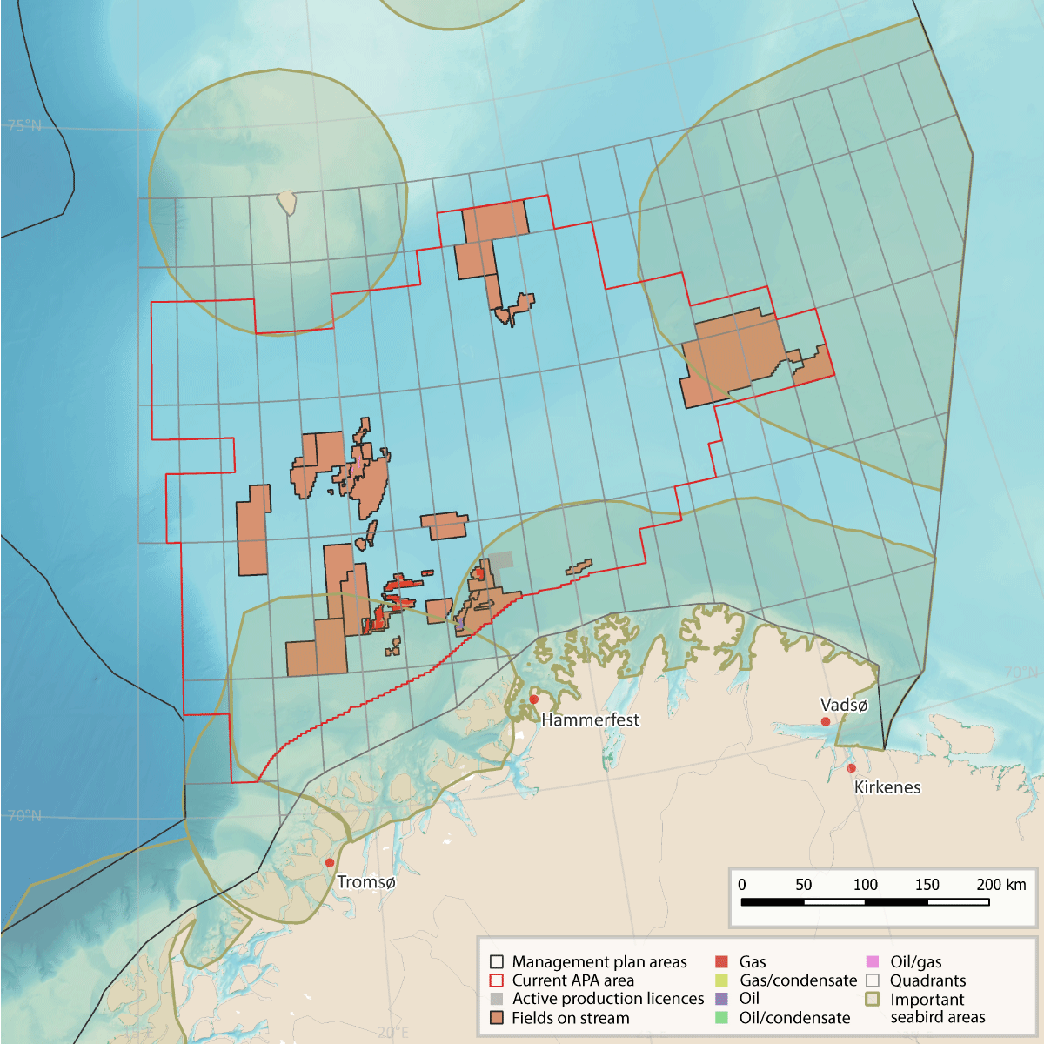
          - Map showing petroleum activities and areas that are important for seabirds in the Barents Sea.
Source: Norwegian Environment Agency/Norwegian Offshore Directorate/Marine spatial management tool
The Barents Sea
The likelihood of serious accidents is considered to be low, but the potential consequences for vulnerable areas are large, because of the presence of important species and habitats in large areas in the Barents Sea, resulting in high vulnerability to oil pollution throughout the year (see Chapter 4.1.2). Since the previous white paper on the marine management plans was published, the environmental authorities have focused particularly on the following areas, species and habitats and times of year when regulating petroleum activities with a view to reducing the level of environmental risk:
- the large seabird breeding colonies along the coast and on Bjørnøya in spring and summer, and nearby feeding areas, up to 100 km out to sea from the breeding colonies;
- the areas used by common guillemots during swimming migration, and other coastal waters after the breeding season, and the wintering areas they use in the eastern part of the Barents Sea;
- the marginal ice zone;
- coastal and littoral areas (all year round);
- the Tromsøflaket bank area, where there are spawning products in the water column in spring and summer, sponge aggregations on the seabed, and large numbers of seabirds at certain times of year.
Seabirds are still the ecosystem component for which environmental risk related to oil spills from petroleum activities in the Barents Sea is highest, and also the ecosystem component that has been most intensively studied since the previous white paper on the ocean management plans was published. Results from SEATRACK have shown that both coastal waters and large areas of the open sea are important for seabirds at various times of year.
The North Sea, Norwegian Sea and Skagerrak
There is petroleum activity both near the coast and further out to sea. As was the case when the previous white paper on the management plans was published, the level of environmental risk associated with most drilling and other field activity in the North Sea, Norwegian Sea and Skagerrak is within the range expected for such activities in these areas. The likelihood of serious accidents is considered to be low, and the potential for environmental consequences in the most vulnerable areas is limited for many petroleum operations. In the Norwegian Sea, activities in certain areas could have serious consequences. For example, some wells are near the coast, where there is a risk that a large oil slick could make landfall after an accident and the level of environmental risk to seabirds is high.
During this planning period, the environmental authorities have been focusing particularly on certain areas, species and habitats that are particularly important and very vulnerable to oil pollution in connection with regulation of activities in the Norwegian Sea (see Chapter 4.1.3) and the North Sea–Skagerrak area (see Chapter 4.1.4). These are as follows:
- the seabird colonies along the coast and nearby feeding areas;
- the complex and valuable coastal waters from Smøla to Hitra, Frøya, Froan and off the Helgeland coast (southern part of Nordland county);
- the valuable areas around Røst and the Lofoten and Vesterålen islands;
- spawning areas for the major fish stocks on the Møre banks, Sklinna bank and Halten bank;
- the Sula reef area;
- the Træna reef area;
- sandeel habitat in the North Sea.
in the North Sea, important sandeel populations have been the focus of a great deal of attention. It is difficult to assess the level of environmental risk to sandeels because too little is known about their vulnerability to crude oil. Research on this topic has therefore been initiated with funding from the petroleum industry.

Activities involving nuclear and radioactive material

Accident risk
The volume of nuclear-powered shipping along the Norwegian coast is rising, and an accident involving a vessel of this type could result in releases of radioactivity that affect Norway. There are two ports in Norway that have regular calls by nuclear-powered submarines, one near Bergen and one near Tromsø.
Norwegian waters could also be affected by releases as a result of accidents at nuclear facilities on land. European nuclear power plants are ageing, and there is a growing risk of serious accidents. The likelihood of terrorist attacks on such facilities has also increased.
In the event of either a vessel casualty or an accident at an onshore facility, the consequences for marine and coastal waters would depend on various factors, including the location of the accident, the composition and size of any radioactive releases, and weather conditions.

Environmental risk
Many of the factors that affect the vulnerability of the environment to radioactive pollution are the same as for other types of pollution. Where, when and how radioactive pollution spreads will influence which species are affected.
In the event of an incident involving radioactive pollution, the likelihood of significant consequences for the marine environment would be low. Dilution in the water column would reduce levels of radioactivity considerably, and it is unlikely that there would be major changes in levels of radioactivity in the sea. There could be some local pollution, depending on the nature of the accident. In the past, accidents have led to questions about levels of radioactive pollution in fish for export. It is therefore important to maintain monitoring programmes for radioactive substances in the marine environment and in seafood, so that there is good documentation of background levels before an accident.

The preparedness and response system for acute pollution

Organisation and responsibilities
The Pollution Control Act distinguishes between private, municipal and governmental levels of the preparedness and response system for acute pollution. A basic principle of the Act is the polluter pays principle. In this context, it means that anyone who is engaged in any activity that may result in acute pollution must ensure that the necessary preparedness and response system is in place to prevent, detect, stop, remove and limit the impacts of pollution. Shipping is excepted from the duty to maintain its own preparedness and response system for acute pollution. At governmental level, the Norwegian Coastal Administration has therefore established a risk-based preparedness and response system for dealing with acute pollution.
The Norwegian Coastal Administration, under the Ministry of Trade, Industry and Fisheries, is responsible for government-level preparedness and response for acute pollution. To ensure closer coordination of municipal and governmental levels of the system, supervisory responsibility for municipal-level preparedness and response was transferred from the Norwegian Environment Agency to the Coastal Administration from 1 January 2022. The Coastal Administration is also responsible for coordinating all three levels of preparedness and response for acute pollution – private, municipal and governmental – in one national system. In addition, the Coastal Administration is the supervisory agency for all acute pollution incidents. A municipality where there is a pollution incident has an obligation to take action if those responsible for the pollution are unable to deal with it. Each municipality belongs to one of the intermunicipal acute pollution control committees, which organise cooperation on resources and share information on the response to acute pollution. The Norwegian Ocean Industry Authority, under the Ministry of Energy, has the supervisory responsibility for safety, the working environment, emergency preparedness and security in the petroleum industry and other ocean industries. Its responsibilities include the operators’ efforts to deal with any releases of pollution at source.
The petroleum sector organises its own private-sector preparedness and response system for acute oil pollution through the operators and the Norwegian Clean Seas Association for Operating Companies (NOFO). The Norwegian Environment Agency, under the Ministry of Climate and Environment, is responsible for setting requirements for this system and supervising compliance with them. In the event of a major incident, additional assistance may be brought in through the voluntary sector, the Norwegian Civil Defence and international agreements on mutual assistance.

Governmental preparedness and response system for acute pollution
Governmental preparedness and response capabilities are dimensioned on the basis of knowledge about the environmental risk associated with oil spills from shipping in Norwegian waters.
The Norwegian Coastal Administration’s environmental risk and preparedness and response analyses from 2022 are used to optimise the design of the governmental preparedness and response system. The reports show that the ocean-going resources available for dealing with incidents within the recommended response time are inadequate in a number of areas where the level of environmental risk is high. The Coastal Administration has recommended action that should be taken on the basis of its reports. The Government will give priority to the measures discussed in the 2022 analyses, so that the governmental preparedness and response system for acute pollution is developed in line with changes in environmental risk.
              - The preparedness and response system for acute pollution
The governmental preparedness and response system for acute pollution consists of the following elements:
- Round-the-clock response system under the Norwegian Coastal Administration
- 15 oil spill response depots and response teams (total personnel 170)
- 39 vessels available for coastal response operations, attached to the depots
- 29 intermunicipal acute pollution control committees that have governmental oil response equipment
- 14 Coast Guard vessels, including six that provide the government emergency tugboat capability
- 1 surveillance aircraft
- 5 drones (deployed to and operated by the Coast Guard)
- 5 multi-purpose vessels owned by the Coastal Administration, with inspection teams
- Agreements with two fire services for dealing with chemical spills at sea (RITS Kjem)
- Rapid-response resources at 17 locations (provided by the company Buksèr og berging and the Norwegian Sea Rescue Society)
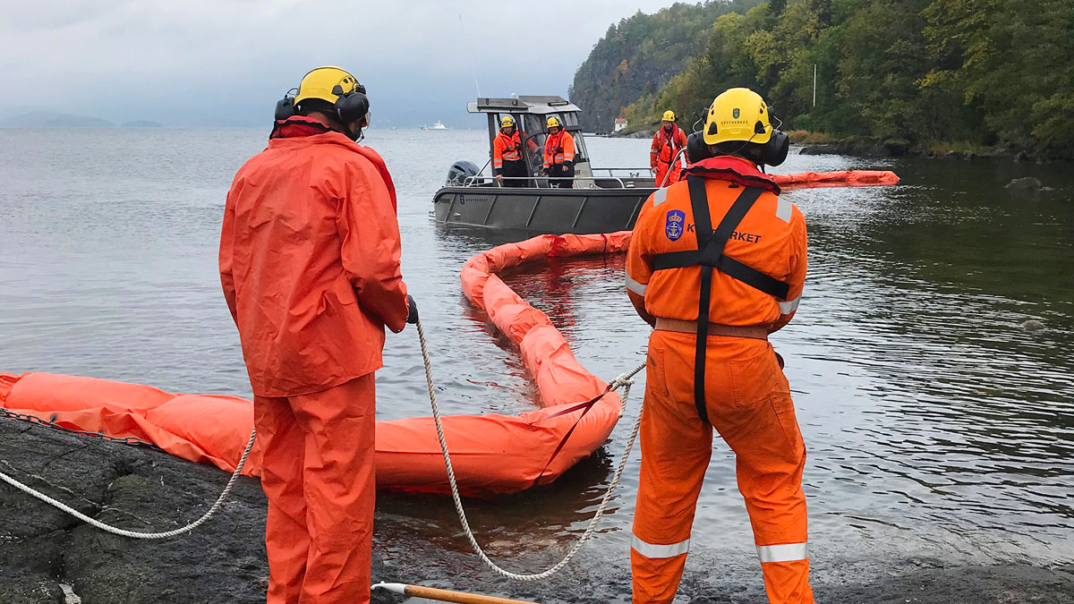
          - From the oil spill response exercise Nordisk 2020.
Photo: Lill Haugen, Norwegian Coastal Administration
[Boks slutt]

The petroleum industry’s preparedness and response system
Dimensioning preparedness and response capabilities
Every operator in the petroleum sector on the Norwegian continental shelf is responsible for establishing a preparedness and response system to prevent, detect, stop, remove and limit the impacts of acute oil pollution from its own activities. The capabilities of the system must be based on the activities the operator plans to carry out on each oil or gas field, and must be sufficient to deal with the whole range of possible incidents. The resources needed to deal with minor spills are very different from those needed in the event of a major accident such as a blowout. If no drilling is being carried out, there is less need for resources than in periods when well drilling or other high-risk operations are in progress. The level of activity and the distance to emergency response resources vary from one area to another. In areas where the activity level is high, the operators and NOFO have built up the emergency preparedness and response system to provide more shared resources, for example through agreements for specific areas.
Rapid deployment and arrival at a spill site is one of the most important damage limitation factors. In the Barents Sea, response teams may need to travel long distances, and the availability of resources and personnel is more limited than in the North Sea and the Norwegian Sea. These factors are taken into account in designing the preparedness and response system, which is adjusted to the activities in progress at any time and the potential hazards and accident types that have been identified. The bulk of preparedness and response resources are in the North Sea and Norwegian Sea, which is only natural since this is where there is most petroleum activity.
Methods and equipment for dealing with oil in icy waters are unchanged since the previous update of the ocean management plans.
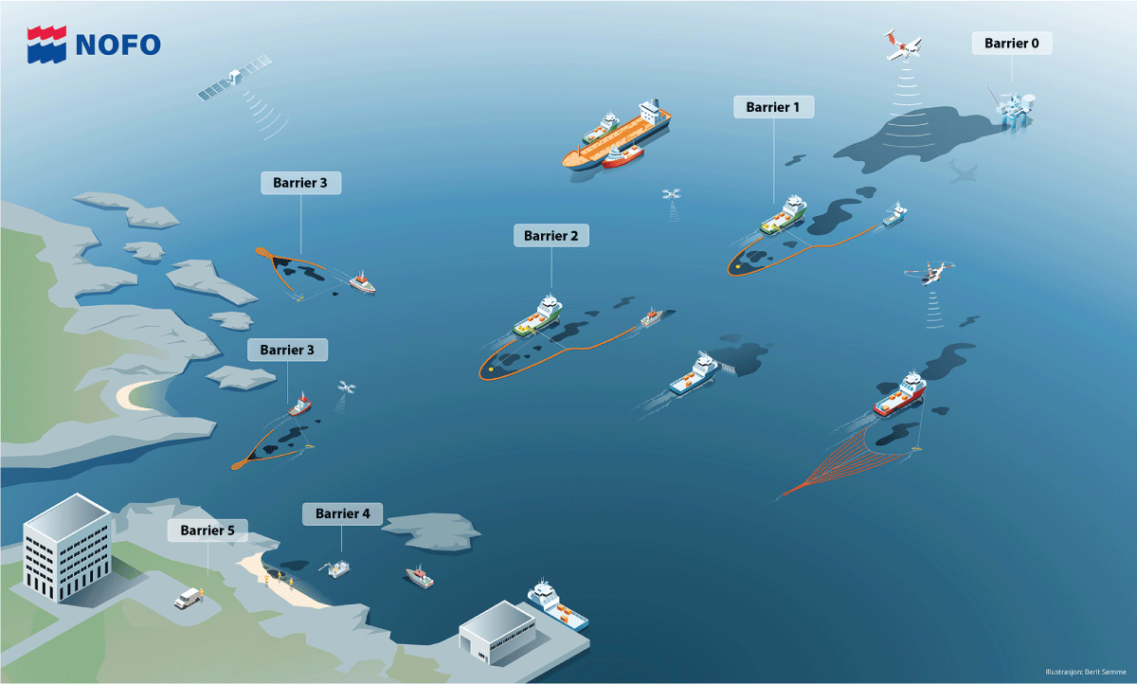
          - Barriers against spills: well barriers to reduce the risk of spills (drilling mud, blowout preventer (BOP), redundant valves, open drainage system to collect any oil spilt on the platform), and barriers to limit oil volumes in the event of a spill (emergency preparedness and response system).
Source: NOFO
Current status
Preparedness and response capabilities in the petroleum industry’s system are dimensioned in relation to activity levels and the hazards and accident types that have been identified. Resources are deployed where there is most activity. It is natural that a larger proportion of emergency response resources is located in Norway’s more southerly waters, since there is substantially more petroleum activity in the North Sea and Norwegian Sea.
The resources available are much the same as they were when the previous white paper on the ocean management plans was published. In 2022, NOFO had 30 offshore oil recovery systems, 26 of which were conventional systems operated by two vessels, with 400 m of boom systems and skimmers. The remaining four are high-speed systems including booms and skimmers that only require one vessel for their operation.
To provide preparedness and response capability for oil in coastal waters, NOFO has agreements on the use of about 65 vessels, about half of which are attached to the Goliat field in the Barents Sea. These are mainly fishing vessels, workboats for the aquaculture industry and vessels from the oil and gas terminals. NOFO has 29 high-speed oil recovery systems for coastal waters, consisting of booms and various types of skimmers and requiring only vessel for their operation.
NOFO also has access to drones that can be used to detect and map oil spills on the open sea and in coastal waters. Other activities include funding the establishment of HF radar chains off Western Norway and Finnmark to measure surface water currents, and further developing the use of satellite data to provide more reliable detection of oil on the sea and measurements of its thickness. Together with oil drift modelling, all these activities improve the efficiency of oil spill operations when accidents happen.
In recent years, NOFO has ensured that more people are available to command and carry out operations to clean up beached oil. NOFO runs well over 250 drills every year involving oil spill response vessels, tugboats and equipment, with subsequent verification of vessels and equipment. Exercises are also carried out involving oil companies and partners from the governmental, municipal and private sectors.
Further development
The petroleum industry is running several projects with the aim of improving oil spill preparedness and response. Both chemical and mechanical subsea oil dispersal are being further developed. Work is also in progress on new methods such as burning off oil on water, and trials have been run with different types of booms that are designed to withstand this. However, burning is not an acceptable solution if it is possible to collect the oil using booms and remove it from the sea surface. Technology is developed by the petroleum industry as it is needed. This means that preparedness and response for icy waters is not a priority unless it is needed. There is most sea ice in the northern Barents Sea, which is not open for the petroleum industry.
The Barents Sea Operation Cooperation (BaSOP) is a cooperation forum for operators in the region. BaSOP considers it appropriate to build up preparedness and response capacity, coordinate plans and consider preparedness and solutions for the southwestern part of the Barents Sea as an integrated whole. BaSOP has recommended working towards the formal establishment of an area-wide emergency preparedness system for the southwest Barents Sea. This will improve coordination and make it easier to share resources.

The overall national preparedness and response system for acute oil pollution
The overall national preparedness and response system consists of three parts: governmental, municipal, and the petroleum industry’s own preparedness and response system. There is close operational cooperation between the different parties involved.
The Norwegian Coastal Administration’s environmental risk and preparedness and response analyses are used as a basis for dimensioning the capabilities of the governmental preparedness and response system for acute pollution. The analyses point out that the ocean-going resources available for dealing with incidents are below the recommended levels in a number of areas where the level of environmental risk is high. The Government will give priority to the measures discussed in the 2022 analyses, so that the governmental preparedness and response system for acute pollution is developed in line with changes in environmental risk.
The petroleum industry has concluded that further development of oil and gas fields in the Barents Sea would require an increase in the resources available for oil spill preparedness and response. The industry’s own analyses show that the distances involved and weather conditions in Barents Sea would make year-round operations and emergency preparedness a challenging prospect, and that oil spill preparedness and response in the winter months would be particularly difficult. The petroleum industry’s ocean-going preparedness capacity in the North Sea and the Norwegian Sea has generally been considered to be better than in the Barents Sea. This is because the largest share of resources is attached to fields and bases further south. The petroleum industry is required to maintain preparedness and response capabilities that are adequate for the level of activity at any given time, so that it is possible to deal with any incidents at all producing fields and planned field developments.
It is uncertain whether the preparedness and response system has the capability to deal adequately with oil in icy water. The Norwegian Coastal Administration has boosted the capacity of the system with robust oil booms for use in icy water and skimmers that function better in icy water, but their effectiveness is uncertain. The operators have equipment that has been tested and can be used in areas with a certain amount of ice, but in this case too, the effectiveness of the equipment is uncertain. Two points from the framework for petroleum activities must be taken into account when assessing whether there are adequate preparedness and response capabilities for icy water. These are the clear specification of where new petroleum activities can be initiated in relation to the marginal ice zone, and the condition that exploration drilling in oil-bearing formations is not to be permitted in areas less than 50 km from observed sea ice.
According to updated information, emergency preparedness and response capabilities for oil pollution in coastal waters and the shoreline are not adequate. In the event of a shipping casualty near the coast, a blowout near the coast or a major blowout, it would be almost impossible to prevent oil from making landfall. Once oil has reached land, factors such as sparsely populated areas, limited infrastructure, low temperatures, darkness and ice could make oil recovery operations extremely challenging.
The overall nationwide national preparedness and response system puts Norway in a good position to deal with the acute phase of most expected types of incidents involving oil spills. However, in the event of a major accident or a protracted incident, maintaining the response would become challenging, whether on the open sea, in coastal waters or along the shoreline. This applies particularly to major blowouts related to petroleum activities. In the case of shipping casualties, the ability to maintain a lengthy response is likely to be most problematic during the beach clean-up phase of an operation. However, there is considerable uncertainty regarding this assessment. Existing agreements with private, voluntary and international organisations would make more resources available, but the extent of the extra resources available for a lengthy response is uncertain.
Since the previous white paper on the marine management plans was published, there has been more focus on problems relating to the recovery of waxy oils, both because the shipping industry is using greater volumes of waxy fuel oils and because several oil fields contain waxy oils that have a long lifetime on the sea surface.
Preparedness and response capabilities for oil pollution are dimensioned on the basis of analyses of needs and the technology available. Nevertheless, weather conditions during a spill may reduce the effectiveness of the emergency response or even make an effective response impossible, or a spill may affect areas that are difficult to reach with effective response measures. In such cases, the preparedness and response system will have little effect on the consequences of acute pollution.

The preparedness and response system for nuclear accidents and acute radioactive pollution
Norway’s nuclear emergency preparedness system is designed to be able to deal with any incident involving acute radioactive pollution. This includes releases both in connection with shipping casualties and from incidents at nuclear facilities on land.
The Crisis Committee for Nuclear Preparedness is responsible for and has the authority to implement measures to reduce the consequences of a nuclear accident. The Government has used six scenarios for different types of incidents as a basis for setting priorities and planning the best possible nuclear preparedness scenario for Norway. A seventh scenario describing the consequences of the use of nuclear weapons is being prepared.
In spring 2023, an exercise called Arctic REIHN (Arctic Radiation Exercise in High North) was carried out. Its purpose was to test preparedness and the international response in the event of a nuclear or radiological accident on a nuclear-powered vessel in Arctic waters.

Area-based conservation and sustainable use as part of integrated ocean management
Chapter 5 of this white paper gives an account of value creation in Norway’s ocean industries, and describes a continuous increase in activity levels in Norwegian waters. The growth in activity requires access to new areas of ocean space. The most intensively used part of Norwegian waters is the North Sea–Skagerrak management plan area. This is one of the most heavily trafficked areas in the world, with a large volume of shipping and considerable fisheries activity. The North Sea is Norway’s most important petroleum province, and is also becoming an important area for the development of offshore wind power and CO2 storage. The Norwegian Sea is important for the fisheries and petroleum activities, and may also become important for seabed mineral extraction in the long term. In the Barents Sea–Lofoten area, the fisheries are the dominant industry, while the petroleum industry is growing.
In all three management plan areas, ecosystem condition and the distribution of habitat types, species and populations is being affected by climate change. Climate and environmental change combined with rising activity levels is reinforcing the need for sound management of Norway’s ocean areas to ensure sustainable use, conservation, predictability and a long-term perspective, and to avoid conflict between sectors in the future.
Marine spatial management tool
The spatial management tool for the ocean management plans is a map portal that provides information on industrial activities, species and habitats and regulatory measures in these areas. It was developed to support sound spatial management in the management plan areas, and is designed to be useful for the authorities, the business sector, interest organisations, other users of Norway’s waters and the general public.
The spatial management tool contains geospatial data sets for natural resources, commercial activities, species and habitats, plans and regulatory measures, relevant reference data and basic marine data.
The Nordic Council of Ministers has allocated funding for the development of a similar tool for the Baltic Sea, a project involving several countries. The project manager is the Norwegian Mapping Authority, while BarentsWatch is the technical supplier and user contact. The main focus of the project is valuable and vulnerable areas and offshore wind.
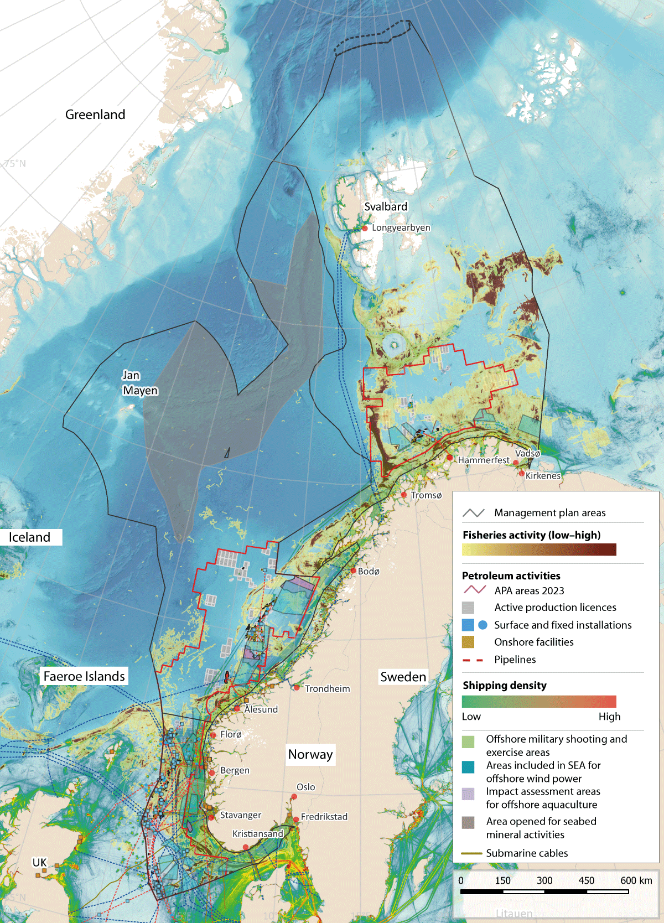
          - Overview of activity in the management plan areas.
Source: Directorate of Fisheries, Norwegian Coastal Administration, Norwegian Environment Agency, Norwegian Water Resources and Energy Directorate, Norwegian Offshore Directorate/Marine spatial management tool. Base map for the marine spatial management tool: GEBCO Compilation Group and Norwegian Mapping Authority
Particularly valuable and vulnerable areas
The particularly valuable and vulnerable areas have been one of the main elements of the management plan system since it was initiated with the preparation of a scientific basis and then, in 2006, the first management plan for the Barents Sea–Lofoten area. These areas have been identified as containing the most important ecological features in Norwegian waters, and knowledge that has been built up about them provides a sound basis for political assessments and decisions on the management plans. The new set of particularly valuable and vulnerable areas identified in Norwegian waters is further discussed in Chapter 4.
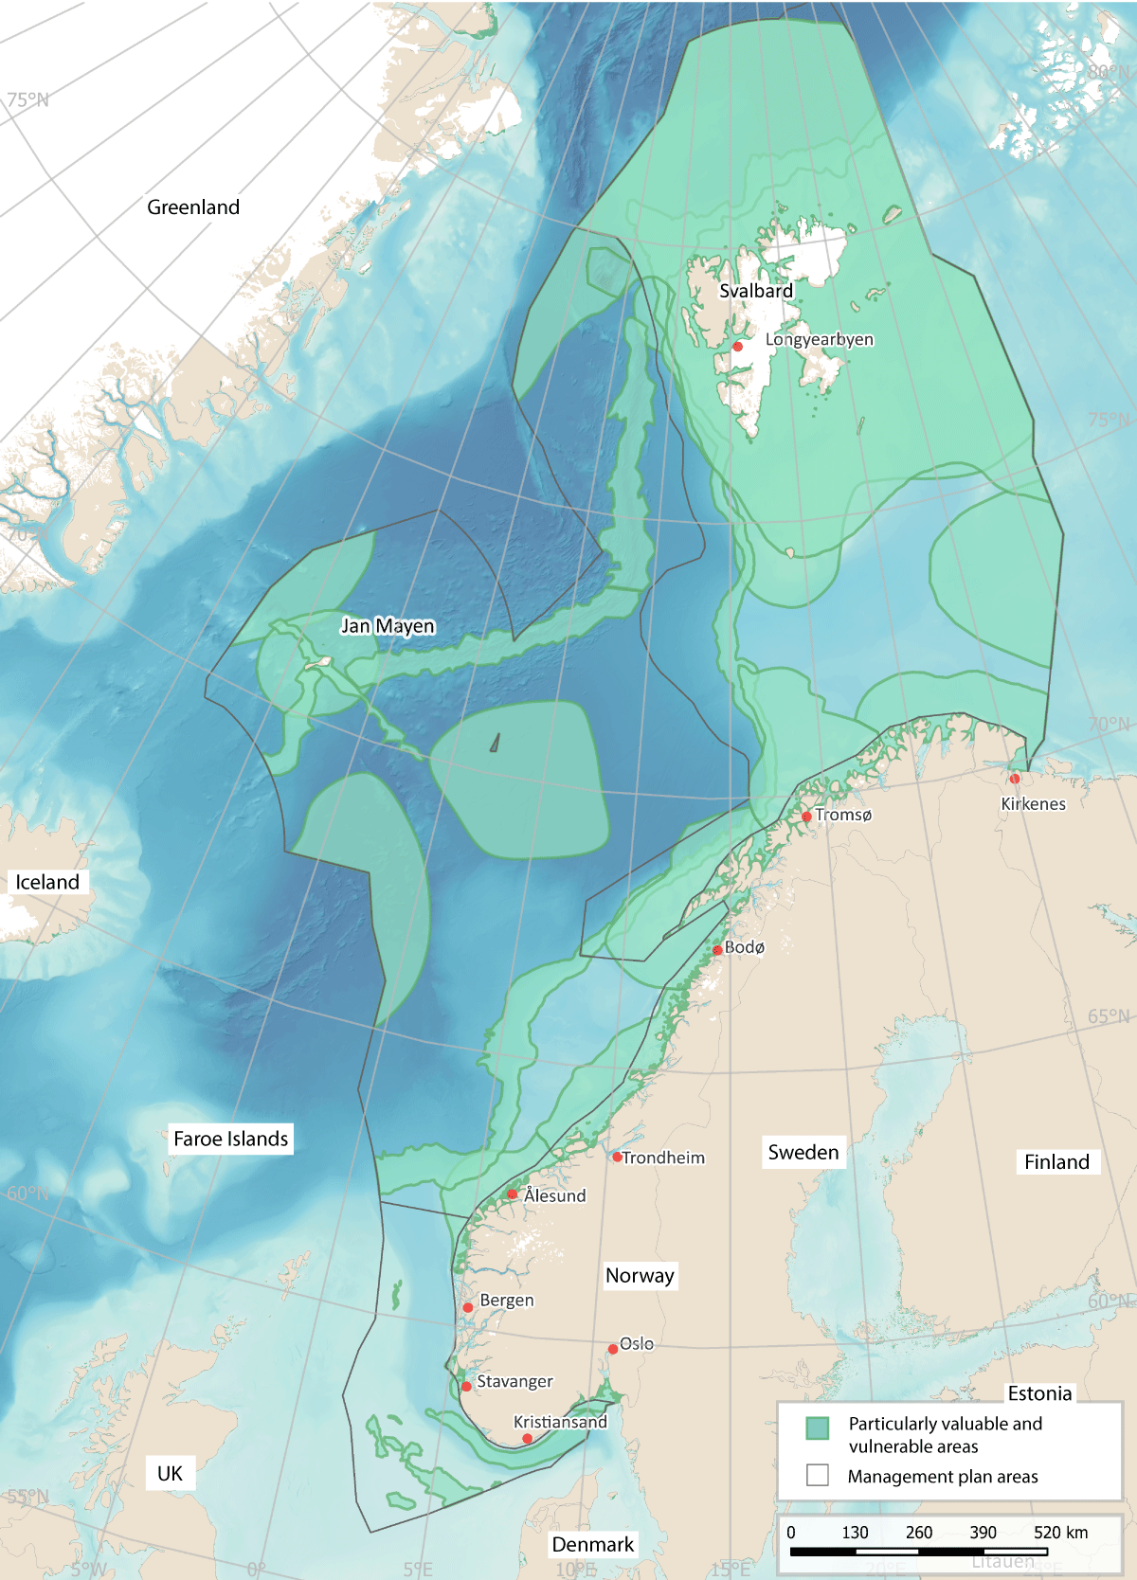
          - The particularly valuable and vulnerable areas identified in the three ocean management plans.
Source: Forum for Integrated Ocean Management/Institute of Marine Research/Norwegian Environment Agency/Marine spatial management tool

Ocean management in Norway and its implications for regional growth and development
Norway’s national ocean policy is developed through cooperation between central government, county and municipal authorities. Marine spatial planning and developments on land are closely linked. Decisions on where to site activities at sea may have major implications for developments at municipal and county level on land. At the same time, ocean-based commercial activities are dependent on infrastructure on land, including ports, transport networks and emergency preparedness and response resources.
Central government authorities are responsible for spatial management in waters beyond the geographical scope of the Planning and Building Act, which extends to one nautical mile beyond the baseline. Insides this limit, municipal authorities are responsible for spatial management under the Planning and Building Act. Other legislation also contains provisions that have implications for spatial management along the coast, including the Act relating to ports and navigable waters, the Security Act, the Marine Resources Act and the Aquaculture Act.
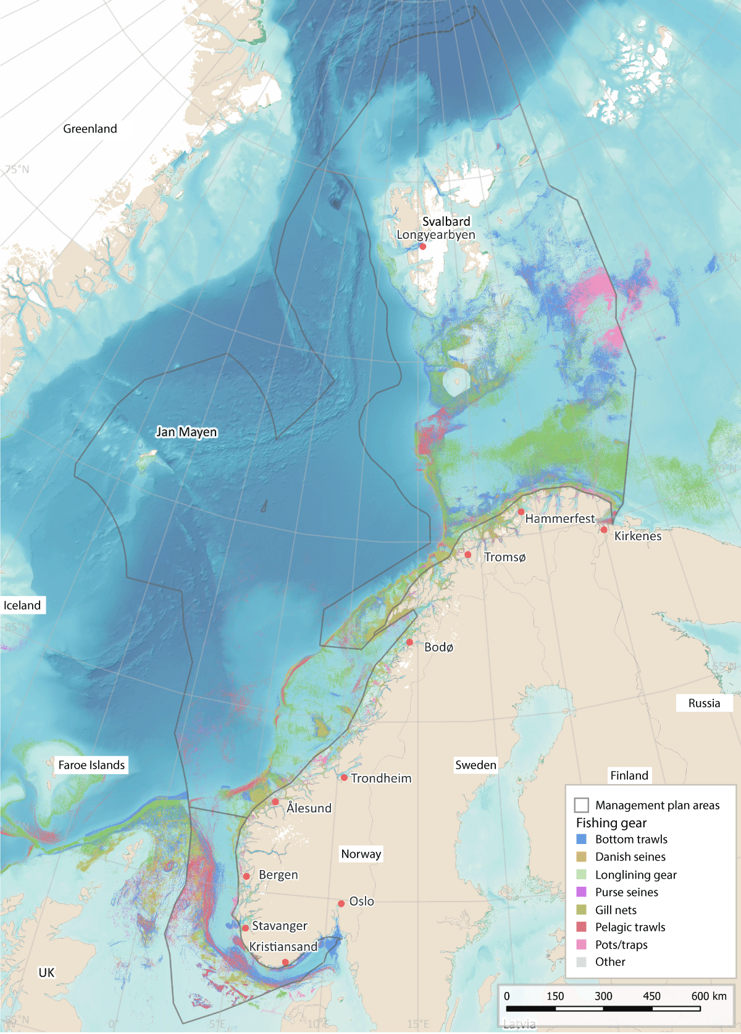
          - Map of fisheries activity in Norwegian waters
Source: Directorate of Fisheries/Norwegian Environment Agency/Marine spatial management tool

Designating marine space for different uses
Authorities in different sectors are responsible for decisions on which parts of marine space are to be allocated to different types of activities under the legislation they administer.

Fisheries
The level of fisheries activity varies over the year, from year to year, and with stock development and changes in distribution and migration patterns. Fishing grounds are not clearly delimited areas. Regulatory measures and spatial needs vary from one type of fishing gear to another. The distribution of some species, for example herring, is highly dynamic. In addition, changes are being observed in the distribution and migration patterns of many fish species as a result of climate change.
Currents along the Norwegian coast often form eddies rich in plankton and nutrients in the shallow bank areas. The availability of food and good light conditions result in high densities of fish locally in these waters. In addition, bottom conditions are favourable for the use of fishing gear, and the bank areas are therefore important fishing grounds.
The use of marine space by the fisheries is regulated under the Marine Resources Act.

Offshore aquaculture
There has been growing interest in offshore aquaculture in recent years. This is explained by a need for more marine space and by environmental and disease problems in a number of the areas currently used for aquaculture. The Government’s policy is to develop a separate licensing system for offshore aquaculture, including strict requirements relating to biodiversity and the coexistence of different ocean industries. The Ministry of Trade, Industry and Fisheries is coordinating the development of a licensing system for offshore production of salmon, trout and rainbow trout.
At present, there are no aquaculture establishments outside the baseline. On 1 November 2022, the King in Council decided that an impact assessment for offshore aquaculture should be carried out for three areas, in the southern Norwegian Trench, the northern part of the Frøyabanken bank area and the Trænabanken bank area. The sizes of these areas are as follows:
- Norwegian Trench south: 485 km2
- Frøyabanken north: 2327 km2
- Trænabanken 4698 km2.
Once the impact assessment has been completed, decisions on whether to open these areas or parts of them for offshore aquaculture will be taken by the King in Council.
In autumn 2023, the Directorate of Fisheries authorised the use of an offshore area in Norwegian waters for aquaculture establishments for the first time. This process makes it possible to use development licences that were provisionally issued in 2019 for the development of technology for offshore aquaculture establishments.
Environmental conditions at offshore aquaculture establishments will be more difficult than at the conventional coastal locations currently in use. The design and operation of offshore aquaculture establishments must be adapted to conditions in the open sea. Wave action, current conditions and temperatures affect fish welfare and growth. This has implications for which areas are suitable for offshore aquaculture.
If aquaculture establishments are sited further out from the coast, new conflicts of interest are likely to arise with the traditional fisheries, shipping and offshore wind farms.
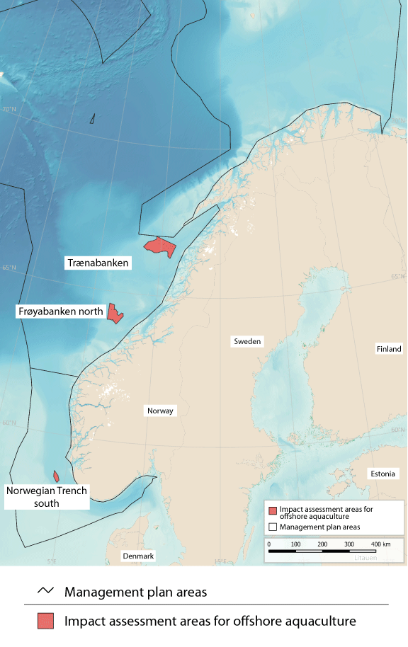
          - Areas where impact assessments for offshore aquaculture are being carried out in Norwegian waters.
Source: Directorate of Fisheries/Norwegian Environment Agency/Marine spatial management tool

Petroleum activities
Petroleum infrastructure, including surface and subsea installations, pipelines and safety zones around installations, occupies large areas. Areas affected by operational discharges from petroleum activities are generally restricted to the seabed in the immediate vicinity of installations and the water column within a few kilometres of them. Any major oil spills from the petroleum industry could potentially affect wider areas. In addition to the permanent installations, seismic surveys occupy considerable areas while they are in progress. Seismic surveys are carried out at all stages from exploration to final production. Even though they only last for a relatively short time in each phase, seismic surveys are the activity type that leads to most conflict with the fisheries. Delaying seismic surveys can be extremely costly for the petroleum industry. Processes have been established to reduce conflict between the fisheries and the petroleum industry (see Box 7.1).
At the beginning of 2024, 92 oil and gas fields on the Norwegian continental shelf were in production: 69 in the North Sea, 21 in the Norwegian Sea and two in the Barents Sea.
Most of the areas that have been opened for petroleum activities are now included in the system of awards for predefined areas (APA system), which is used for licensing in mature areas of the continental shelf. The petroleum industry is described further in Chapter 5.
              - Seismic surveys and fisheries interests
Over time, the authorities have introduced a number of amendments to the petroleum legislation to take fisheries interests into account. There are now requirements for seismic vessels to be tracked and to carry fisheries experts on board, and temporal and spatial restrictions on seismic data acquisition. One important step is the introduction of requirements to use soft-start procedures (which ramp up the sound intensity gradually). The authorities and the employer and industry organisation Offshore Norge have each published guidelines on coexistence between the fisheries and petroleum industries in connection with seismic surveys. The Petroleum Act also includes provisions on compensation to Norwegian fishermen in the event of financial losses incurred as a result of activities including seismic surveys.
Routines have also been established for resolving disagreements between the Norwegian Offshore Directorate and the Directorate of Fisheries. If the Directorate of Fisheries has objections to a planned seismic survey, these are forwarded to the company that sent notification of the plans, so that they can be adjusted. If the Offshore Directorate and the Fisheries Directorate disagree on whether a survey should be carried out as planned, the case is referred upwards to the offices of the directors general in the two directorates. If they are unable to reach agreement, the Offshore Directorate refers the case to the Ministry of Energy, which makes a decision in consultation with the Ministry of Trade, Industry and Fisheries.
To improve communication, the Norwegian Offshore Directorate, the Fisheries Directorate and the Institute of Marine Research hold joint meetings with the petroleum industry before the start of the seismic survey season. This improves understanding and cooperation between the authorities and licensees. Offshore Norge also holds an annual conference on fish and seismic activities, which serves as an arena for the exchange of experience and communication between the two industries and the authorities.
[Boks slutt]
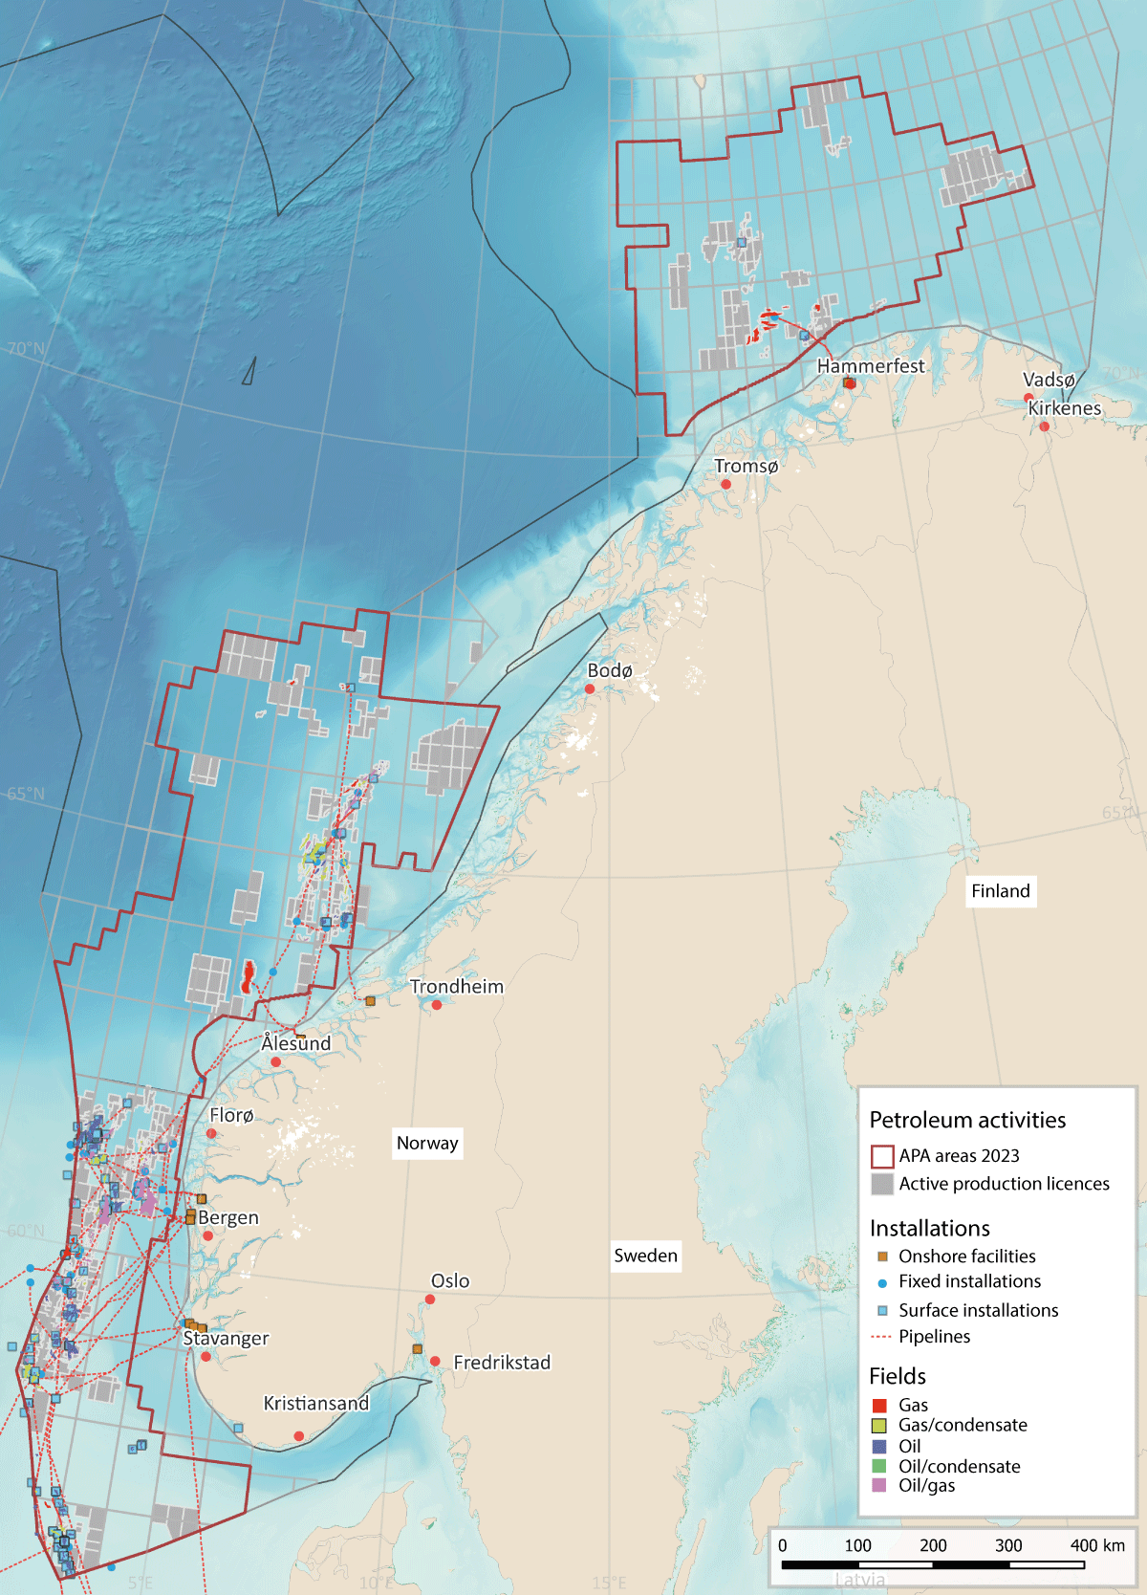
          - Petroleum activity on the Norwegian continental shelf.
Source: Norwegian Offshore Directorate/Norwegian Environment Agency/Marine spatial management tool

Offshore wind power
Norway has large marine areas with good wind resources, but a considerable proportion is only suitable for floating wind power. Two areas, Sørlige Nordsjø II and Utsira Nord, were opened for offshore wind power in 2020. These areas cover 2691 km2 and 1010 km2 respectively. In addition, 11 wind turbines are in operation at the Hywind Tampen wind farm, which supplies electricity to two oil fields in the North Sea.
The area needed to develop 30 GW of production capacity for offshore wind by 2040 depends on several factors, including capacity density and the proportion of an area developed for offshore wind production. For the first two areas, Sørlige Nordsjø II and Utsira Nord, the Ministry of Energy is requiring installed capacity density to be at least 3.5 MW/km2. The first phase of the Sørlige Nordsjø II project covers an area of 520 km2, and the installed capacity is to be 1400–1500 MW. This means that around 82 % of the area will be used for the offshore wind project.
The Norwegian Water Resources and Energy Directorate has headed a working group appointed to identify further suitable areas for offshore wind power. The working group was asked to propose areas where it will be possible to ensure satisfactory coexistence with other industries and safeguard important ecosystem components, while also taking into account forecasts for electricity demand and grid capacity and any need to upgrade the electricity grid on land.
In spring 2023, the working group put forward proposals for 20 potential new areas for wind power (see Figure 7.6) and for a programme for strategic impact assessment. The areas identified cover a total of 54 000 km2, which according to the Norwegian Water Resources and Energy Directorate is several times more than the area needed to achieve the Government’s ambition of allocating licences for 30 GW of production capacity by 2040. The working group has used the process to identify areas that are technically suitable for wind power production and where current knowledge indicates that there will be relatively few conflicts of interest with other sectors. However, this does not mean that no conflicts of interest will arise. The next important stage is to carry out thorough strategic impact assessments, one of the aims being to reduce the area of marine space to be occupied. The assessments will also provide further information and a basis for finding a balance between relevant interests in each area and identifying measures that can and need to be introduced to mitigate the impacts of developments.
In autumn 2023, the Norwegian Water Resources and Energy Directorate was given the task of carrying out strategic impact assessments for all 20 areas. Three of the areas – Sørvest F, Vestavind B and Vestavind F – may be opened for licensing in 2025, while opening and licensing rounds for the other 17 areas will take place later on. The programmes for the strategic impact assessments include a requirement to assess the impacts on particularly valuable and vulnerable areas in the vicinity of the offshore wind areas or that overlap with them, taking into account valuable ecosystem components that are present and the purpose of the ocean management plans.
Offshore wind production requires large areas of marine space, and the location of wind turbines depends on a number of factors. Wind turbines can obstruct other marine industries. For example, fishing vessels and other shipping have to stay out of a safety zone around wind turbines.
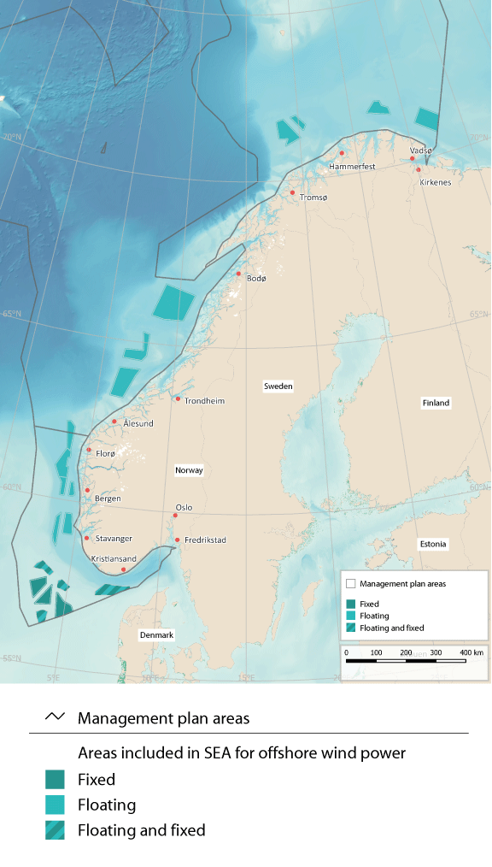
          - The twenty areas included in the strategic environmental assessments for offshore wind power.
Source: Norwegian Water Resources and Energy Directorate/Norwegian Environment Agency/Marine spatial management tool

CO2 storage under the seabed
CO2 capture, transport and storage technology (often referred to as CCS) is still in an early phase of development. Its success will be dependent on the development and establishment of complex value chains and extensive infrastructure requiring substantial investments.
Norway has adopted CCS regulations for the continental shelf, which apply to surveying and exploration of potential reservoirs under the seabed, to the exploitation of such reservoirs for CO2 storage, and to CO2 transport. Like the EU’s CCS Directive, the Norwegian regulations establish a system based on licences and permits. The Norwegian Offshore Directorate has mapped areas that are theoretically suitable for CO2 storage and has prepared a CO2 storage atlas for the Norwegian continental shelf.
As of March 2024, seven licences had been granted under Norway’s CCS regulations, including six exploration licences. One storage facility is currently being developed.
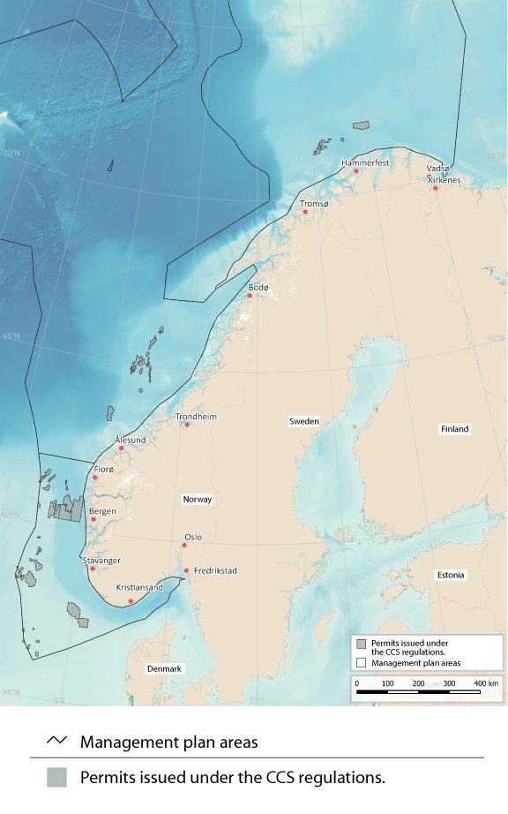
          - Areas allocated for CO2 storage under the seabed.
Source: Norwegian Offshore Directorate/Norwegian Environment Agency/Marine spatial management tool

Maritime transport
Maritime transport accounts for about 40 % of domestic transport work and more than 80 % of the volume of international transport. Maritime transport is thus very important both for the Norwegian business sector and for foreign trade. The volume of shipping (expressed as distance sailed) is expected to rise by about 40 % by 2040.
Areas are designated for traffic separation schemes, recommended routes and other regulatory measures for fairways under the Act relating to ports and navigable waters. Traffic separation schemes and recommended routes in Norway’s exclusive economic zone must also be approved by the International Maritime Organization (IMO). The introduction of traffic separation schemes and recommended routes along the coast has helped to move shipping further out from the coast, separate traffic streams in opposite directions and establish a fixed sailing pattern. This reduces the likelihood of collisions and groundings and makes it easier to intervene in the event of an accident.
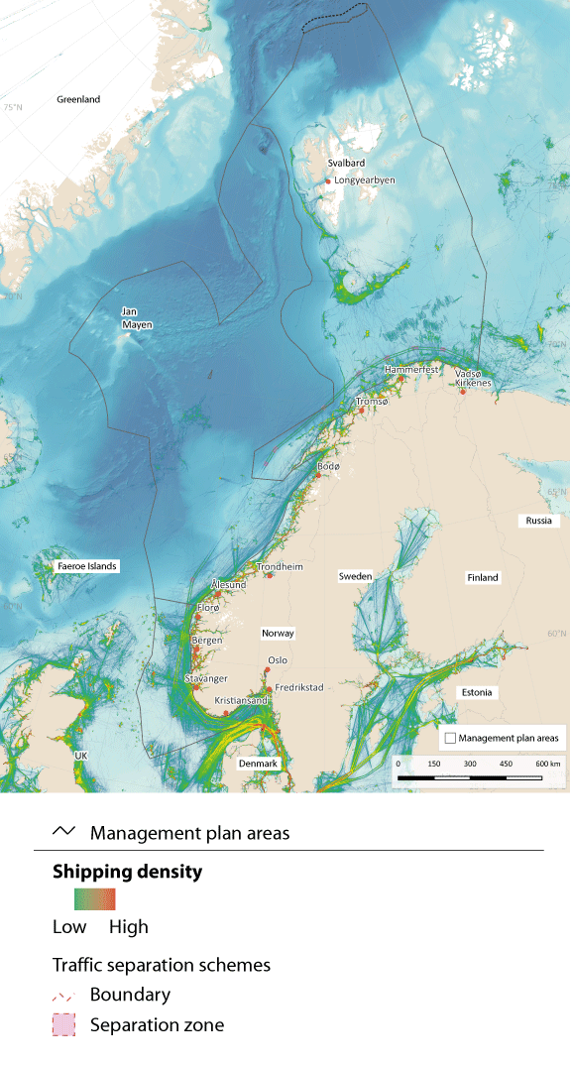
          - Map of shipping density in waters under Norwegian jurisdiction.
Source: Norwegian Coastal Administration/Norwegian Environment Agency/Marine spatial management tool

Seabed mineral activities
In accordance with the Seabed Minerals Act, an area must as a general rule have been officially opened for seabed mineral activities before licences can be issued to private companies.
The area of the Norwegian continental shelf that has been opened for seabed mineral activities lies in the Norwegian Sea and Greenland Sea and covers an area of 281 000 km2, as set out in a white paper published in 2023 (Meld. St. 25 (2022–2023)). This area is a long way from the mainland Norwegian coast, and other commercial ocean-based activity in the area is limited, consisting mainly of some fisheries and ships sailing through the area. The Government has decided that extraction from active hydrothermal structures will not be permitted, and this will help to limit any conflict with bioprospecting activities.
The processes that form minerals are also very important for biodiversity on the seabed in deep-water areas. The decision not to permit extraction from active hydrothermal structures and to protect such structures so that they are not damaged by activities in nearby areas will help to reduce the potential for conflict. During its consideration of the previous white paper on the ocean management plans, the Storting agreed that the need to protect distinctive and rare species and habitats in deep-sea areas should be assessed. Further investigations of species and habitats will be needed in any areas where there are plans to start up mineral activities.
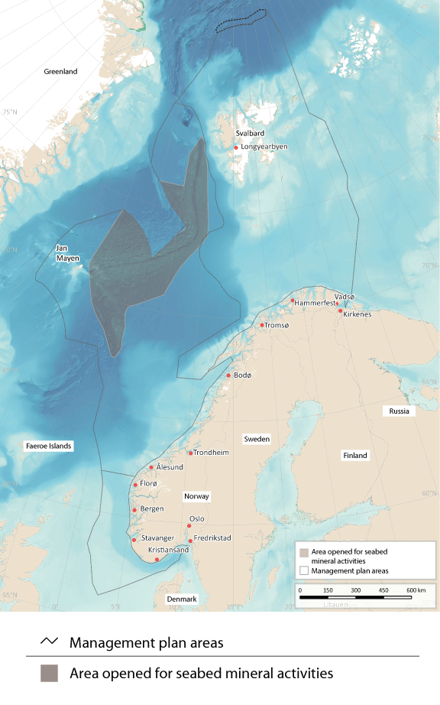
          - Map of the area of the Norwegian continental shelf that has been opened for seabed mineral activities.
Source: Norwegian Offshore Directorate/Norwegian Environment Agency/Marine spatial management tool

Bioprospecting
Bioprospecting is the systematic search for organisms, genes and molecules that could provide key components for various products and processes in medicine, the process industries, food production and other sectors. Such activities are already taking place, and as new sampling technology is developed, larger parts of the oceans will be of interest for bioprospecting.
Marine bioprospecting is of particular interest in northern seas because they are home to many species that are specialised to survive extreme and often changeable conditions. Along the Mid-Atlantic Ridge, there are hydrothermal vent fields that emit plumes of hot fluids. The living organisms found in such an extreme deep-water environment also have extreme properties. Microorganisms and biomolecules can be harvested for industrial and medical uses from hydrothermal vent fields.
Both the Marine Resources Act and the Nature Diversity Act could be used to regulate bioprospecting, and any regulation of the use of specific areas for bioprospecting would be introduced using one or both pieces of legislation. Norway has no current plans to designate specific areas for bioprospecting, and areas where there are organisms that might be possible to exploit through bioprospecting in the future have not yet been identified.

Routes for submarine cables
Submarine communications cables carry large volumes of data traffic. For example, almost all internet data traffic between islands and continents is transferred by cable. In Norwegian waters, the network of communications cables will be expanded and they will occupy larger areas of the seabed as the volume of data traffic rises.
When new subsea cables are being planned on the Norwegian continental shelf, the Ministry of Digitalisation and Public Governance is responsible for coordinating input from the authorities. Article 79 of the Convention on the Law of the Sea is applicable when new submarine cables and pipelines are laid on the Norwegian continental shelf.
The Norwegian National Coastal Administration is responsible for coordinating applications for new submarine communications cables in Norway’s territorial waters. Anyone planning to lay submarine cables in territorial waters is required to apply for a permit under the Act relating to ports and navigable waters. Information on new communications cables must be forwarded to the Norwegian Mapping Authority for inclusion on charts.
Norway has submarine power cables from the mainland to island communities, from the mainland to other countries (interconnectors), and from the mainland to certain petroleum installations. There are four subsea interconnectors between Kristiansand and Denmark, one between Feda and the Netherlands, one between Feda and Germany and one between Kvilldal and the UK.
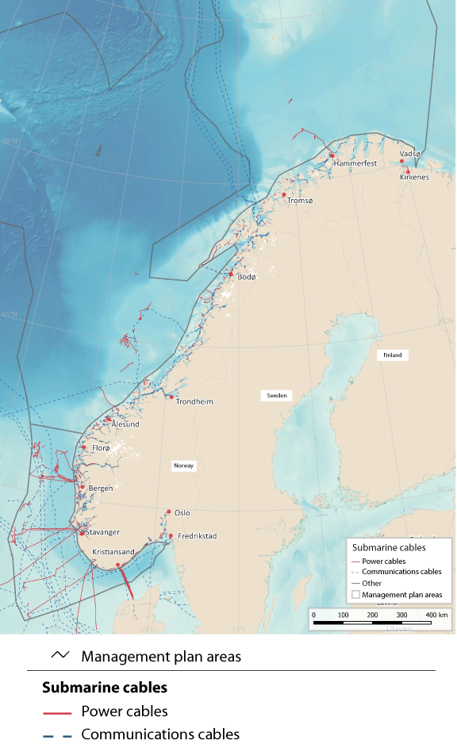
          - Map of submarine communications and power cables.
Source: Norwegian Water Resources and Energy Directorate/Norwegian Environment Agency/Marine spatial management tool
The installations on the oil and gas fields Valhall, Gjøa, Troll A, Ormen lange, Snøhvit, Goliat, Martin Linge, Johan Sverdrup, Edvard Grieg, Ivar Aasen, Gina Krog and Sleipner Øst are all now supplied with power from shore. Infrastructure for power from shore for the platforms on Oseberg, Troll B and C, Yggdrasil, Draugen og Njord and to the onshore facility Hammerfest LNG is under construction. Routes for power cables for use by the petroleum industry are designed to minimise inconvenience for other users of the relevant areas.
The development of offshore wind power also requires the construction of associated infrastructure. It will be possible to connect offshore wind power to the mainland, other countries and other offshore industrial installations, in the same way as for petroleum installations. The development of grid facilities offshore requires a licence under section 3-2 of the Offshore Energy Act.

Offshore military shooting and exercise areas
Offshore military shooting and exercise areas are essential to the Norwegian Armed Forces’ operational activities and for national emergency preparedness and crisis management capabilities.
New weapons systems and exercise concepts have resulted in a need to revise the system of offshore shooting and exercise areas. The deteriorating security policy situation has also made it even more important to ensure that the Armed Forces maintain access to exercise areas along the whole Norwegian coast. This includes Finnmark, the northernmost county, where there are currently no offshore military shooting and exercise areas. In addition, expanding the size of shooting areas will facilitate coexistence with other interests and industries by making it easier for the Armed Forces to adjust their activities to those of other sectors.
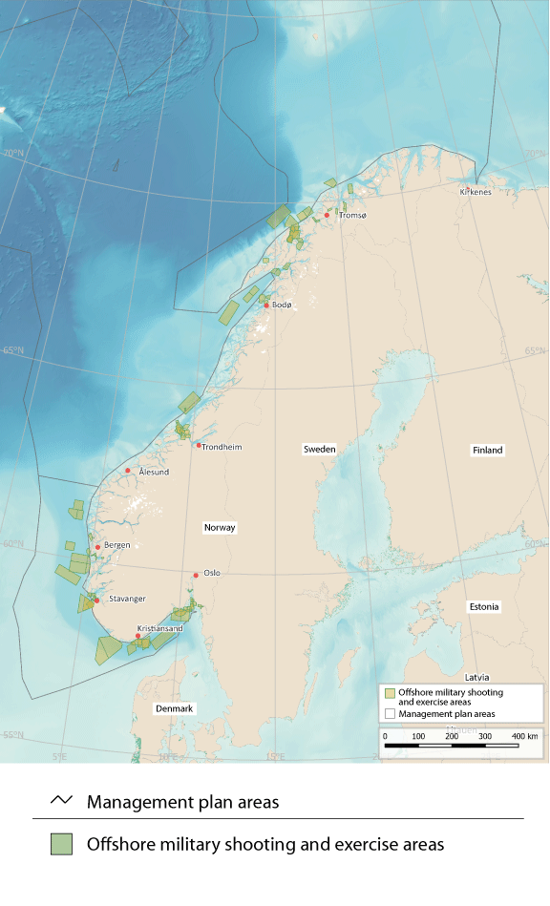
          - Offshore military shooting and exercise areas for the Norwegian Armed Forces
Source: Norwegian Armed Forces/Norwegian Environment Agency/Marine spatial management tool

The conservation of areas of special importance for marine biodiversity
Marine protection under the Nature Diversity Act and area-based conservation under the Marine Resources Act are tools for safeguarding areas where there are important ecosystems, habitats and species. The purpose of these tools is to ensure that areas are managed in a way that maintains their conservation value for the future. To achieve this, it must be possible to regulate pressures on conservation areas, and to implement active conservation measures where necessary. Any restrictions imposed on activity in such areas must be proportional to the purpose of protection.
Marine protected areas established under the Nature Diversity Act may extend up to 12 nautical miles beyond the baseline (up to the territorial limit). Around Svalbard, important marine species and habitats are protected where they are included in the marine parts of the national parks and nature reserves established under the Svalbard Environmental Protection Act.
In addition to the areas that are protected under these two Acts, the Marine Resources Act can be used to introduce area-based conservation measures in all Norwegian waters and on the Norwegian continental shelf. The Government is now drafting a new act that will provide the legal authority to establish marine protected areas in all Norwegian waters beyond the 12-nautical-mile limit.
Norway has been working for many years to safeguard marine areas and their species and habitat diversity for the future. In 2004, a broad-based advisory committee identified 36 marine areas along the coast for further evaluation, and current efforts are based partly on the committee’s recommendations. By the end of 2023, 17 marine protected areas and four national parks including substantial marine areas had been established under the environmental legislation, and in addition area-based conservation measures had been introduced for 18 coral reef areas under the Marine Resources Act. Marine conservation measures were further discussed in the white paper Norway’s integrated plan for the conservation of areas of special importance for marine biodiversity (Meld. St. 29 (2020–2021). A review of relevant area-based conservation measures has also been started based on the criteria for other effective area-based conservation measures (OECMs) adopted by the Convention on Biological Diversity. The aim is to identify which conservation measures, particularly relevant fisheries management measures, can be included when Norway reports to the Convention and other international forums on progress towards the conservation target set out in the Global Biodiversity Framework.
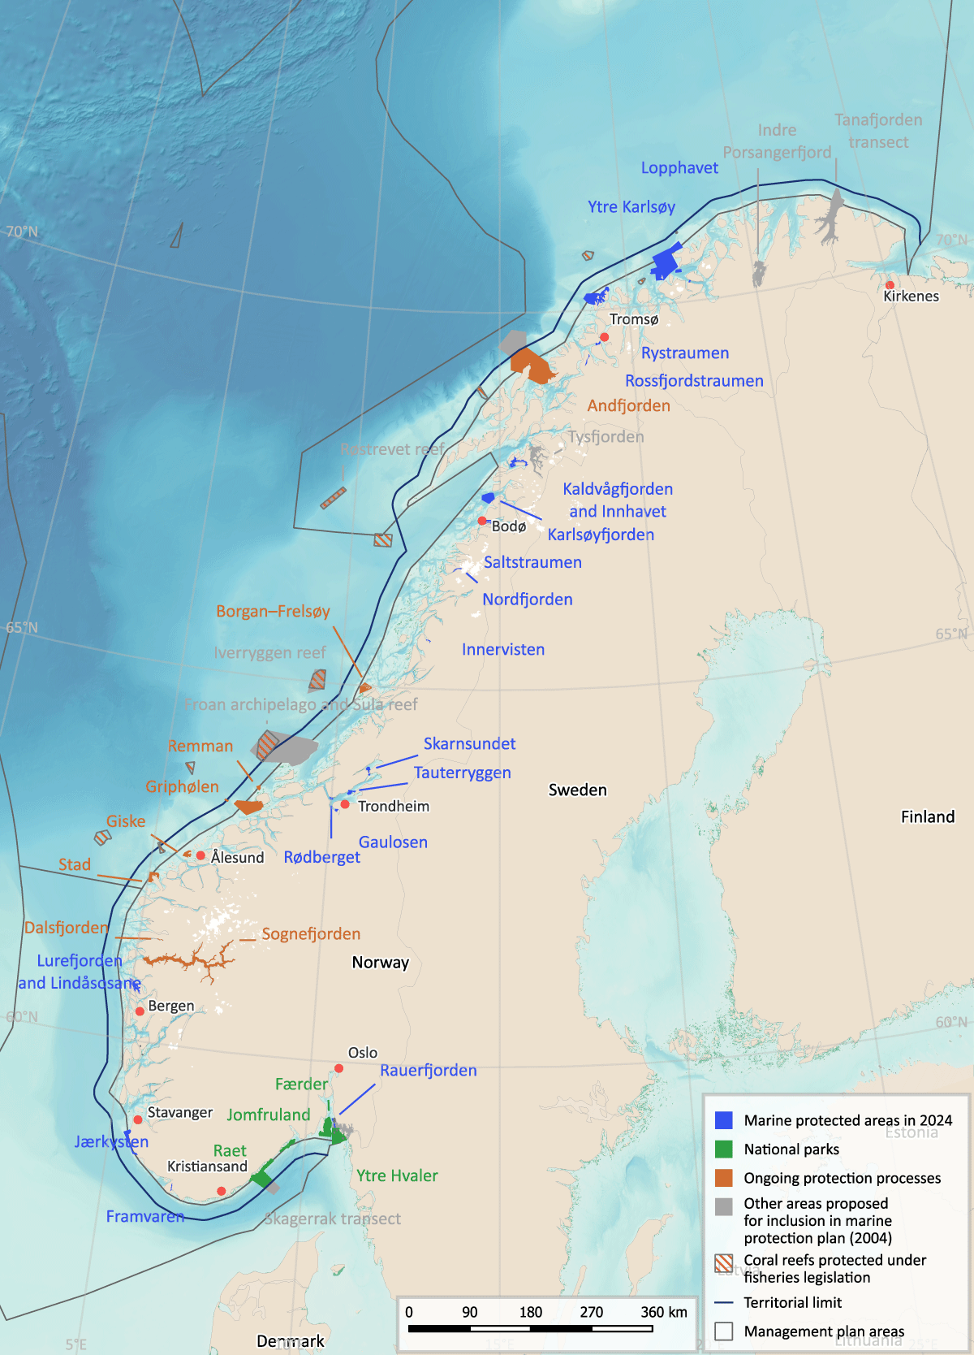
          - Existing and planned marine protected areas and other area-based conservation measures around mainland Norway.
Source: Norwegian Environment Agency, Norwegian Mapping Authority and Directorate of Fisheries/Marine spatial management tool

Rising activity levels and coexistence between ocean sectors
Norway has long experience of enabling the fisheries industry, maritime transport and the petroleum industry to share marine space. The management plans increase predictability and facilitate coexistence between industries that are based on using the ocean and its natural resources. As emerging industries seek to find their place, it will become even more important to provide a framework for satisfactory coexistence between different activities.
The Government will present an industrial plan for Norway’s ocean areas.

Climate and environmental considerations as a basis for marine spatial management
The 2019 Global Assessment Report of the Intergovernmental Science-Policy Platform on Biodiversity and Ecosystem Services (IPBES) states that globally, land- and sea-use change is the direct driver that is causing the greatest losses of biodiversity. The Intergovernmental Panel on Climate Change (IPCC) highlights the importance of ecosystem conservation through area-based measures, including developing networks of protected areas on land and at sea, in the context of climate change adaptation.
Under the global Kunming-Montreal Global Biodiversity Framework, countries have committed themselves to a set of targets, including one to ‘ensure that all areas are under participatory, integrated and biodiversity inclusive spatial planning and/or effective management processes addressing land- and sea-use change, to bring the loss of areas of high biodiversity importance, including ecosystems of high ecological integrity, close to zero by 2030, while respecting the rights of indigenous peoples and local communities.’
The ocean management plans are intended to provide an overall balance between use and conservation, based on knowledge about the natural environment, ecological functions and the value and vulnerability of different areas together with information about economic activity now and forecasts for the future. The framework for petroleum activities determines which activities take place in specific geographical areas, and is a form of spatial planning that takes special account of environmental value and fisheries interests. The framework for petroleum activities is implemented under existing petroleum-sector legislation, and more generally, activities in each management plan area are regulated on the basis of existing legislation governing different sectors.
When planning and implementing ocean-based solutions to the problem of climate change, it will be important to assess how the potential for reducing emissions and enhancing carbon uptake can be realised in ways that safeguard marine ecosystems, limit conflict between different user groups and prevent piecemeal development of ocean areas.

International cooperation on sustainable ocean management
Sustainable use of the ocean and sustainable management of ocean resources form a key element of Norway’s foreign and development policy. Norway’s ocean management plans have provided inspiration for many of our partner countries and for the work of the High-level Panel for a Sustainable Ocean Economy (Ocean Panel). Sustainable use of ocean space is crucial for achieving a number of the Sustainable Development Goals (SDGs), specifically numbers 2, 4, 14 and 17. In the case of SDG 14, which is ‘to conserve and sustainably use the oceans, seas and marine resources for sustainable development’, it is vital to continue efforts in international forums to promote the importance of integrated, sustainable ocean management.
The UN Convention on the Law of the Sea is the international legal framework for all ocean-related activities. As a responsible steward of the ocean and marine resources, Norway supports and acts in accordance with the Convention. Pressures on marine ecosystems are often transboundary in nature. This means that problems must be resolved through international efforts, such as those designed to combat plastic pollution. In addition, Norwegian activities that support capacity-building in developing countries make an important contribution to ensuring a clean and productive ocean.
In addition to taking part in formal international ocean-related processes, Norway has assumed a leading role in other forums for the ocean and sustainable ocean management, particularly as co-chair of the Ocean Panel, in developing a global agreement on plastic pollution and in the implementation of the UN Decade of Ocean Science for Sustainable Development (2021–2030).

Status and developments in international ocean governance
The UN Convention on the Law of the Sea, or UNCLOS, provides the international legal framework for all ocean-related activities, and is sometimes known as the ‘constitution of the ocean’. It sets out a general duty for states to cooperate at global and regional level on the protection and preservation of the marine environment. Norway shares ecosystems and important marine resources with other countries, and bilateral and regional cooperation is therefore an essential basis for sound ocean management. Norway has played a key role in the development of regional fisheries and ocean management organisations, which are important channels for promoting Norwegian policies and ocean interests. We have also played a part in the development of similar organisations in other parts of the world.
Norway’s main priorities for global developments in the Law of the Sea are the implementation of the new UN Agreement on the Conservation and Sustainable Use of Marine Biological Diversity of Areas Beyond National Jurisdiction (the BBNJ Agreement) once it has entered into force, ensuring the legitimacy and effectiveness of the work of the Commission on the Limits of the Continental Shelf, the ongoing negotiations on the development of a regulatory regime for seabed mineral activities under the International Seabed Authority, capacity building measures for developing countries, safeguarding the marine environment more widely, scientifically based sustainable use of ocean resources, the negotiations on a new global instrument on plastic pollution, and action to combat plastic pollution.
The new BBNJ Agreement
The new BBNJ Agreement was formally adopted by consensus in June 2023. Norway signed the agreement when it was opened for signature on 20 September 2023. As of 1 February 2024, 87 states had signed the agreement, and two (Chile and Palau) had ratified it. The agreement will enter into force once 60 states have ratified it. The Government plans to submit the agreement to the Storting (Norwegian parliament) as soon as possible to obtain its consent to ratification, with a view to ensuring Norwegian ratification at the latest by the 2025 UN Ocean Conference. The BBNJ Agreement puts in place effective measures to implement the rules of UNCLOS on conservation and sustainable use of marine biodiversity in areas beyond national jurisdiction, in other words areas outside states’ 200 nautical-mile zones and their continental shelves. The BBNJ Agreement will be an important tool for establishing marine protected areas (MPAs) and other effective area-based conservation measures (OECMs) in areas outside national jurisdiction. This will be valuable in achieving the global target of protection of at least 30 % of the global ocean, which is a political target that Norway has also adopted. The negotiations on the BBNJ Agreement produced a satisfactory result in Norway’s view, and it will uphold Norway’s main interests. The fact that the agreement was adopted by consensus reinforces its legitimacy.
Negotiations on a regulatory regime for seabed mineral activities
The International Seabed Authority (ISA) is responsible for negotiations on a regulatory regime for seabed mineral activities in the ‘Area’, i.e. the seabed beyond the limits of national jurisdiction. At its meeting in July 2023, the Council of the ISA agreed on a timeline for continuing its work. The aim is to finalise the regulations in the course of 2024 and adopt them during the 30th session of the Council in 2025. Norway will work in good faith in line with this. Norway’s general position in the negotiations is that a regulatory regime must be based on robust environmental standards, including the precautionary principle, and must include effective mechanisms for inspection, compliance and enforcement, and an equitable financial mechanism which safeguards developing countries’ interests, as required by UNCLOS.
UN General Assembly resolutions on oceans and the law of the sea and on sustainable fisheries
Norway takes part in the annual negotiations on the UN General Assembly resolution on oceans and the law of the sea. This is an important arena where Norway can demonstrate its position as a responsible coastal state that can be relied on to support and implement UNCLOS, and as a responsible steward of the oceans and marine resources. The negotiations are also an opportunity for Norway to highlight the priority it gives to the work of safeguarding the marine environment, for example efforts to combat plastic pollution and Norway’s contributions to capacity building in developing countries. It is important to ensure that practice within traditional areas of the Law of the Sea (for example in UN specialised agencies and regional fisheries management organisations) develops in accordance with the provisions of UNCLOS. One of Norway’s main aims in all work on issues relating to the Law of the Sea is to ensure that the UNCLOS system is strengthened and developed as the main legal framework for all activity in the marine sector. The resolution on sustainable fisheries further develops requirements for responsible fisheries management by states and regional fisheries management organisations. The current geopolitical situation is affecting international fisheries management, making it more difficult to incorporate general environmental principles and decisions into the fisheries management system.
The ocean and global climate negotiations
Since 2020, an annual ocean and climate change dialogue has been held each year under the UN Framework Convention on Climate Change (UNFCCC), as mandated by COP25 in Madrid. At COP26 in Glasgow, during the annual Earth Information Day, researchers highlighted the need to expand knowledge about the links between climate change and the oceans. The importance of marine ecosystems as sinks and reservoirs of greenhouse gases was emphasised in the Glasgow Climate Pact. A decision by COP27 in Sharm el-Sheikh formalised the ocean and climate change dialogue and decided that future dialogues would have two co-facilitators to decide on topics and report from the dialogue. In addition, parties were encouraged to consider ocean-based action in their national climate goals and long-term climate strategies. At COP28, the key outcome was the conclusion of the first global stocktake under the Paris Agreement. The decision on the global stocktake calls on parties to preserve and restore the ocean and coastal ecosystems and to scale up ocean-based mitigation action. It also highlights the fact that ocean-based adaptation can reduce a range of climate change risks.
Climate-related decisions by the International Maritime Organization (IMO)
Norway chaired the negotiations that resulted in a historic decision by IMO on 7 July 2023, when it adopted the common ambition of reaching net-zero greenhouse gas emissions from international shipping by 2050. IMO’s revised climate strategy includes checkpoints for reductions in greenhouse gas emissions from international shipping in 2030 and 2040, to reach net-zero in 2050. In the seven years up to 2030, total emissions from international shipping are to be reduced by 20–30 % compared to 2008. In addition, between 5–10 % of the energy used by shipping is to be from zero-emission sources by 2030. By 2040, international shipping is to reduce emissions by 70–80 % compared to 2008. To support efforts to achieve these goals, Norway will support the GreenVoyage2050 project, providing a total of NOK 210 million in the period 2024–2030. The project is intended to help developing countries to make the transition to low- and zero-emission shipping, both as part of their development generally and to ensure progress towards IMO’s ambition of achieving net-zero emissions from shipping in 2050.
Global cooperation on biodiversity
The Kunming-Montreal Global Biodiversity Framework was adopted in December 2022 at the 15th meeting of the Conference of the Parties (COP 15) to the Convention on Biological Diversity (CBD). The purpose of the Global Diversity Framework is to halt and reverse biodiversity loss. It includes a global target for 2030 of ensuring that ‘… at least 30 per cent of terrestrial and inland water areas, and of marine and coastal areas, especially areas of particular importance for biodiversity and ecosystem functions and services, are effectively conserved and managed through ecologically representative, well-connected and equitably governed systems of protected areas and other effective area-based conservation measures, …’. Norway is a member of the High Ambition Coalition for Nature and People, which is working towards this target. Another target of the Global Diversity Framework is to ‘ensure that by 2030 at least 30 per cent of areas of degraded terrestrial, inland water, and marine and coastal ecosystems are under effective restoration, …’. Ocean ecosystems are included in the Framework in the same way as other ecosystems. The Government will follow up the Biodiversity Framework by preparing a new biodiversity action plan and presenting it to the Storting in the form of a white paper. The white paper will describe the contributions Norway intends to make to achieving the global targets.
Global cooperation on pollution and marine litter
In 2022, the UN Environment Assembly decided to start negotiations with a view to establishing a new independent intergovernmental body in 2024, to provide information on chemicals and waste management and pollution prevention. This is to be a science-policy panel, modelled on the Intergovernmental Panel on Climate Change (IPCC) and the Intergovernmental Science-Policy Platform on Biodiversity and Ecosystem Services (IPBES). The new science-policy panel will play a crucial role in developing recommendations for new policy and legislation for preventing pollution from chemicals and waste globally. It is a general problem that research results are not adequately communicated to decision makers, who in turn do not communicate clearly enough to scientists the kinds of information they need. The panel will provide robust, independent information and submit scientific recommendations in all relevant areas, to support the work of UN bodies, global conventions and other multilateral agreements, national authorities and the private sector.
The 2001 Stockholm Convention on Persistent Organic Pollutants (POPs) is a key instrument that regulates or prohibits the use of the most dangerous substances, thus preventing the spread of substances that resist degradation, bioaccumulate along food chains and are transported across long distances through air and ocean currents. Norway played a key role in the adoption of the convention, and has proposed a number of additional POPs for listing under the convention, so that their use can be prohibited.
The 2013 Minamata Convention is a global agreement with aim of reducing and ultimately eliminating releases of mercury.
In 2023, agreement was reached on the Global Framework on Chemicals (GFC). It was adopted as a new voluntary framework to encourage cooperation on global action in the field of chemicals and waste management, including the many substances that are not covered by globally binding instruments. The GFC includes a number of targets that supplement the SDGs and are to be achieved by 2030 or 2035.
Norway has been working for some years to strengthen the international framework to reduce and eliminate marine litter and plastic waste. In 2022, the UN Environment Assembly agreed to convene a negotiating committee to develop a legally binding global instrument to end plastic pollution, with the aim of completing the process by the end of 2024. Norway is playing a leading role in efforts to achieve a binding, effective global instrument, and together with Rwanda is co-chairing the High Ambition Coalition to end Plastic Pollution. The coalition is seeking to develop an effective global instrument with the aim of ending plastic pollution by 2040, and including commitments that will reduce the production and consumption of primary plastics to sustainable levels. The agreement must include releases from all ocean- and land-based sources; measures to phase out certain plastic materials, chemical additives and plastic products; and measures to increase recycling of plastics and minimise quantities of plastic waste. It is also intended to encourage sustainable waste management and prevent releases of microplastics. Norway is also chairing work relating to a global plastics agreement under the Nordic Council of Ministers.
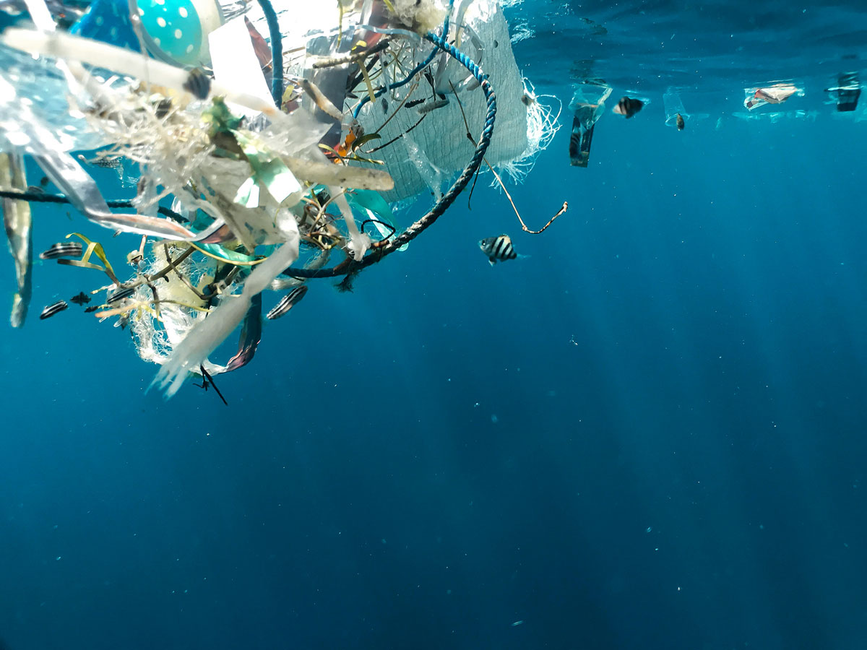
          - Plastic pollution in the ocean. Norway has been working for some years to strengthen the international framework for preventing and reducing marine litter and plastic pollution.
Photo: Naja Bertolt Jensen/Ocean Image Bank
Norwegian support for global cooperation on the marine environment
Norway played an active role in the establishment of the PROBLUE multi-donor trust fund in the World Bank system in 2019, and co-chaired the fund’s Partnership Council until summer 2022. PROBLUE’s overall goal is to achieve integrated, sustainable economic development and a clean and healthy ocean. Its main focus areas are sustainable fisheries and aquaculture; marine litter and pollution management; sustainable development of key oceanic sectors; and building government capacity for integrated management of marine and coastal resources. PROBLUE plays a key role in Norwegian funding of measures to combat marine litter and follow-up of the Ocean Panel’s call for sustainable ocean management. Other donors to the fund are Australia, Canada, Denmark, the EU, Iceland, France, Germany, Ireland, the UK, the US and Sweden. PROBLUE is now in a transitional phase from largely performing analytical work to engaging in large-scale technical activities in cooperation with other parts of the World Bank system.
Since 2019, Norway has been cooperating with IMO and the Food and Agriculture Organization of the United Nations (FAO) on the GloLitter Partnerships project. The purpose of the project is to assist developing countries in ratifying and implementing the IMO MARPOL Convention, in exchanging experience with other countries in their region, and in developing national action plans to deal with ocean-based sources of marine litter. Norway is also following up the IMO action plan on marine plastic litter as part of its regional cooperation on the marine environment under OSPAR, and is involved in the development of a regional action plan on marine litter under the Arctic Council.
Norway also works within the framework of the UN Environment Programme (UNEP), which has a wide-ranging mandate covering the triple planetary crisis of climate change, nature and biodiversity loss, and pollution and waste. UNEP’s work on the marine environment, including the Regional Seas Programme, aims to reinforce environmental efforts through a regional approach. UNEP runs several global initiatives for the conservation, protection and sustainable management of blue ecosystems. Norway considers it important for UNEP to take an integrated, knowledge-based approach to work on the marine environment, which should also be in line with UNCLOS, the Convention on Biological Diversity, the BBNJ Agreement, the recommendations of the Ocean Panel, and the principles underlying the Norwegian ocean management plans. UNEP plays an important role as the secretariat for the negotiations on a new global instrument to combat plastic pollution.

The Ocean Panel and the goal of 100 % sustainable ocean management
Norway has played a part in raising awareness internationally about the key links between the state of the ocean and economic development, both as co-chair of the Ocean Panel and through other work within the Panel. Norway was one of the countries that took the initiative for the Panel’s work on sustainable ocean plans, for which Norway’s ocean management plans have served as a model.
The work of the Ocean Panel has raised international awareness of how the oceans can provide many of the solutions to global issues – for example access to renewable energy, nature-based solutions to climate change, food security and value creation. Marine ecosystems and resources are public goods that must be managed responsibly. The members of the Ocean Panel, including Norway, have made a political commitment to achieve sustainable management of 100 % of the ocean area under national jurisdiction by 2025, guided by sustainable ocean plans. The goal is for all countries that are members of the Ocean Panel to have such plans in place by 2025, and for all coastal and ocean states to do so by 2030. Over the past three years, France, the Seychelles, the UK and the US have joined the Ocean Panel, and have adopted the same political commitment to develop sustainable ocean plans within five years of joining. Once the 18 members of the Ocean Panel have finalised and implemented their plans, there will be an integrated, sustainable management regime for about 50 % of the total area of exclusive economic zones in the ocean.
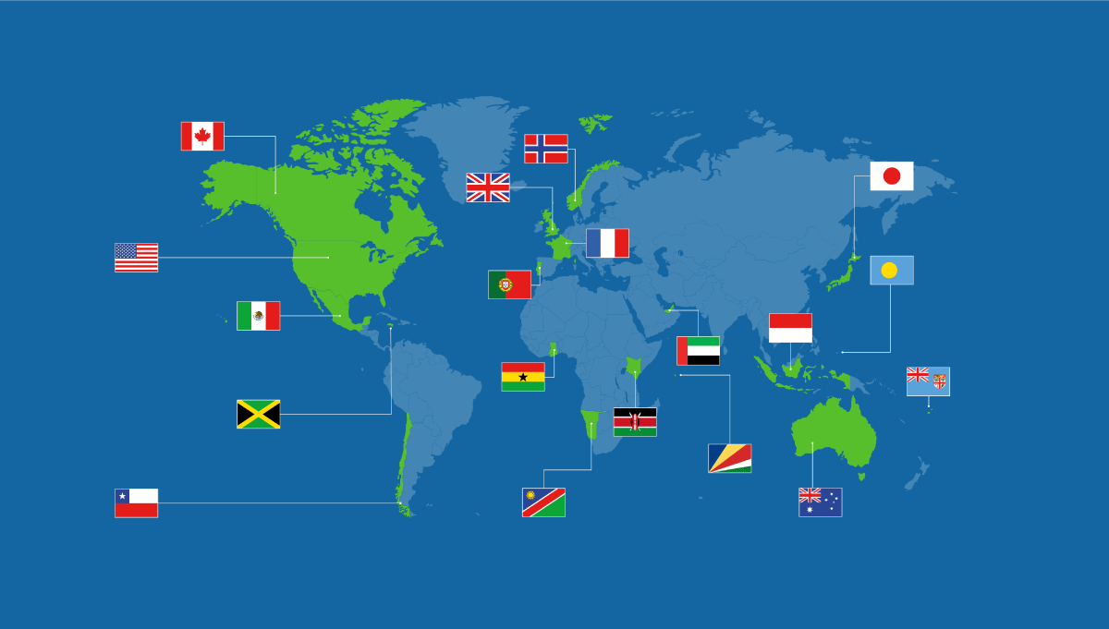
          - Membership of the Ocean Panel in January 2025.
Source: Ocean Panel
Since 2020, the Ocean Panel has been focusing on the action needed to ensure sustainable ocean management and national follow-up. The member states of the Ocean Panel are developing sustainable ocean plans for waters under their national jurisdiction. In support of this, the Ocean Panel has published a guide and introduction to sustainable ocean plans, and has held several events where countries and key scientific and technical bodies can exchange experience. There is widespread interest in the Norwegian model and the experience Norway has gained.

International initiatives to promote integrated ocean management
UN Decade of Ocean Science for Sustainable Development – knowledge-based ocean management
The Intergovernmental Oceanographic Commission (UNESCO-IOC) was tasked by the UN General Assembly with coordinating the UN Decade of Ocean Science for Sustainable Development (2021–2030). Its purpose is to promote and coordinate ocean research activities at national and global level. The recently appointed Executive Secretary of UNESCO-IOC, Vidar Helgesen, is Norwegian. The IOC is an important channel for the world’s ocean and coastal states as they follow up the Ocean Panel’s recommendations and implement sustainable ocean plans.
The Ocean Secretariat in the Research Council of Norway is responsible for coordinating Norwegian efforts relating to the UN Decade of Ocean Science. A National Ocean Decade Committee has been established including representatives of research institutes, the business sector and voluntary organisations. Norway is also a member of the Ocean Decade Alliance, and Prime Minister Jonas Gahr Støre is one of its patrons.
The purpose of the Ocean Decade Alliance is to raise awareness of the UN Decade, and to catalyse support so that the Ocean Decade can achieve its vision of ‘the science we need for the ocean we want'. A wide range of Norwegian research groups and other stakeholders are actively involved in UNESCO-IOC’s work in connection with the Ocean Decade and other ocean-related activities.
Since 2020, Norway has allocated about NOK 10 million a year from the aid budget to the UNESCO-IOC Secretariat. Half of this has been earmarked for capacity building in developing countries, and the rest for the Ocean Decade. Norway has for example supported coordination of Ocean Decade activities in Pacific small island developing states (SIDS).
The 2024 Ocean Decade Conference is being held in April 2024 in Barcelona in Spain. This is an opportunity both to present results from the first few years of the decade and to look ahead to the rest of the period up to 2030. One aim is to formulate agreed measures of success for each of the challenges identified for the Ocean Decade. This is part of the Vision 2030 process, in which Norway is playing a key role. This conference and the major UN Ocean Conference to be held in Nice in France in 2025 are being closely coordinated.
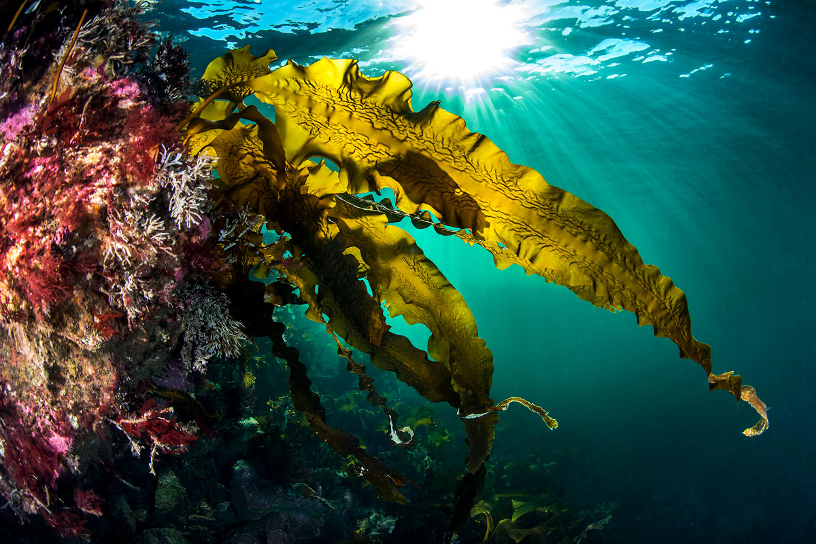
          - Sugar kelp. The UN Ocean Decade is promoting knowledge-based ocean management, and its vision is 'the science we need for the ocean we want'.
Photo: Erling Svensen
UN Decade of Action on Nutrition – a healthy ocean means a healthy population
Under SDG 2, the world has adopted the goal of ending hunger and malnutrition and ensuring sustainable food production. To ensure progress towards this goal, the period 2016–2025 was announced as the UN Decade of Action on Nutrition. Boosting the sustainable production, harvesting and consumption of aquatic food can make it easier to achieve the aims of SDG 2. Aquatic food provides essential nutrients for a growing population. Norway’s seas and oceans play an important role for national food security. In addition, Norwegian expertise and experience can play a part in stimulating production, harvesting and consumption of aquatic food internationally. As part of the Nutrition Decade, Norway has established the Action Network for Sustainable Food from the Oceans and Inland Waters for Food Security and Nutrition, and has sought to coordinate work on the two UN decades. Although the Nutrition Decade comes to an end in 2025, Norway has decided that the Global Action Network will continue until 2030.
Norway is supporting the proposal for a new independent expert report to be produced on sustainable fisheries and aquaculture in connection with the 2024 plenary session of the Committee on World Food Security. It is ten years since the previous report on aquatic food was published. Norway’s strategy for promoting food security in development policy, Combining forces against hunger – a policy to improve food self-sufficiency, also recognises that aquatic food is an important factor for improving food security in developing countries.
The UN Ocean Conferences and progress towards SDG 14: life below water
There is emerging international consensus on a description of the state of the ocean, what we must do to protect the ocean better, and how to ensure that we can continue to use ocean resources sustainably in the future. Norway has maintained a clear, strong profile on sustainable ocean management at the UN Ocean Conferences, most recently in Lisbon in 2022. The next conference is at the planning stage, and it will be held in Nice in June 2025, co-hosted by France and Costa Rica. The main themes of the conference will be financing of the blue economy and knowledge-based ocean management. Costa Rica is responsible for organising a high-level event on ocean action in the run-up to the conference, in June 2024.
The Ocean Conference in Nice will represent an important milestone for the work of the Ocean Panel. In 2025, its members are to report on progress towards their political commitment to ensure sustainable management of 100 % of ocean areas under national jurisdiction, guided by sustainable ocean plans. It is hoped that the conference will inspire all ocean and coastal nations to do the same by 2030.

Regional cooperation on shared ocean areas
International interest in the Arctic has been growing. Norway is chair of the Arctic Council for the period 2023–2025, and is seeking to maintain the council’s position as the chief platform for international cooperation in the Arctic. The oceans are one of the priority topics for Norway’s chairship. The combination of increasing activity, rapid climate change and loss of sea ice is putting growing pressure on the marine environment in the Arctic. To ensure ocean health and productivity and strengthen the sustainability of Arctic ocean industries, Norway will maintain the focus on integrated ocean management in the work of the Arctic Council. During its chairship, Norway will continue the development of tools for ocean management, cooperate on the protection of ice-dependent species and ecosystems, develop Arctic observation systems, take action to combat marine litter, and strengthen cooperation on emergency preparedness and safe shipping in the Arctic, and green shipping initiatives.
Ecosystem-based ocean management is encouraged in Arctic Council’s 2021 strategic plan, and is one of the approaches underpinning the Arctic Marine Strategic Plan for 2015–2025, which sets out goals and principles for the Council’s work on the marine environment. As Chair of the Arctic Council, it is important for Norway to support and play a part in the continued development of ecosystem-based ocean management.
The EPPR working group of the Arctic Council is responsible for emergency prevention, preparedness and response for environmental disasters and other emergencies. The eight Arctic states have also concluded agreements on search and rescue and on oil spill preparedness and response. During Norway’s chairship of the Arctic Council, Arctic cooperation on sustainable shipping and risk reduction measures related to the growing volume of shipping in the Arctic is being strengthened. The Arctic Council will seek closer cooperation with the Arctic Coast Guard Forum and further develop cooperation on maritime and aeronautical search and rescue, oil spill preparedness and response and the response to nuclear/radiological accidents at sea through initiatives and exercises.
Norway is the host country for the North Atlantic Marine Mammal Commission (NAMMCO), and the secretariat is located in Tromsø. The members of NAMMCO are Norway, Iceland, Greenland and the Faroe Islands, while Russia and Canada are observer countries. In 2023, Japan and NAMMCO signed a letter of intent on cooperation. Norway has leading expertise in international scientific research on the whale populations in the North Atlantic. NAMMCO is committed to sustainable and responsible use of all living marine resources by developing effective conservation and management measures for marine mammals, while also acknowledging the rights and needs of coastal communities. Sustainable use of marine mammals by coastal communities helps to lower their environmental footprint, improve people’s livelihoods and reinforces efforts to achieve the SDGs.
The Greater North Sea Basin Initiative (GNSBI) was established in November 2023 to expand cooperation across sectors and countries to ensure sustainable use of the North Sea basin (for energy, food and transport) and at the same time meet goals for the conservation and restoration of ecosystems. Cooperation under the initiative is not legally binding. Cooperation will include knowledge sharing on relevant topics and other ocean-related cooperation as agreed by the parties.
Norway is also a member of the North Seas Energy Cooperation (NSEC), which is a voluntary forum for cooperation on offshore wind power and infrastructure. Belgium, Denmark, France, Germany, Ireland, Luxembourg, the Netherlands, Norway, Sweden and the European Commission are currently members of the NSEC. Norway has been a member of this cooperation forum since 2016.
Norway is engaged in fisheries cooperation with a number of countries. Norwegian-Russian cooperation on the fisheries in the Barents Sea goes back to 1974 and 1975, when the first agreements were negotiated. The Joint Norwegian-Russian Fisheries Commission was established under these agreements. Every year, recommendations on total allowable catches (TACs) for the relevant stocks are made on the basis of advice from Norwegian and Russian scientists. In October 2023, Norway and Russia concluded a fisheries agreement for 2024, from which quotas to third countries are set. Even given the current geopolitical situation, it is crucially important to continue this fisheries cooperation.
Research cooperation with Russian scientists is also important. Russia’s membership of the International Council for the Exploration of the Sea (ICES) has been suspended, but there is considerable marine and fisheries research activity in the Russian zone, and Russian scientists share their raw data with Norwegian researchers.
Through the North East Atlantic Fisheries Commission (NEAFC), Norway and the other North Sea and Norwegian Sea coastal states agree on annual TACs for the pelagic species blue whiting, Norwegian spring-spawning herring and mackerel. Although agreement has been reached on the TACs, it has not been possible to agree on quotas for each of the NEAFC member countries. As a result, Norway and other coastal states have set quotas unilaterally, and several of the pelagic stocks have been overfished. The members of NEAFC are Norway, the UK, the EU, Denmark (in respect of the Faroe Islands and Greenland), Iceland and Russia.
Norway is an active participant under the Convention for the Protection of the Marine Environment in the North-East Atlantic (the OSPAR Convention). Fourteen other states and the EU are also parties to the Convention, and a number of organisations are observers. In 2021, the OSPAR Commission adopted the North-East Atlantic Environment Strategy 2030, which describes joint action to tackle the triple threat facing the marine environment: biodiversity loss, pollution and climate change. The strategy also highlights the importance of regional cooperation in ensuring the effective protection and sustainable use of our shared seas. In 2023, OSPAR published its flagship report Quality Status Report 2023, which gives a thorough, detailed overview of the environmental status of the North-East Atlantic and developments since the previous report was published in 2010. The report concludes that a great deal remains to be done to avoid further biodiversity loss and tackle the causes of environmental degradation.
International interest in Arctic research has been growing. To maintain Norway’s leading position in research in the region, we need detailed, updated knowledge about the Arctic Ocean. Norwegian interests are upheld through research and by maintaining activity and a presence in the Arctic Ocean. The Government supports Norwegian research activity and initiatives in the Arctic Ocean.
GoNorth is one such initiative. Its purpose is to organise a series of scientific expeditions to investigate the seabed and subsea geology, the water column and the sea ice. GoNorth partners include a number of universities and research institutes: the universities of Bergen, Oslo and Tromsø, the Norwegian University of Science and Technology, the University Centre in Svalbard, Akvaplan-niva, the Geological Survey of Norway, NORCE, NORSAR, the Norwegian Polar Institute, the Norwegian Institute of International Affairs, the Nansen Center and SINTEF. GoNorth has been allocated NOK 30 million from the national budget to organise expeditions in the period 2022–2024. It has also received a total of NOK 12 million for operating and development costs for the project, provided by the Ministry of Foreign Affairs, the Ministry of Trade, Industry and Fisheries and the Ministry of Education and Research and channelled through the Research Council of Norway.
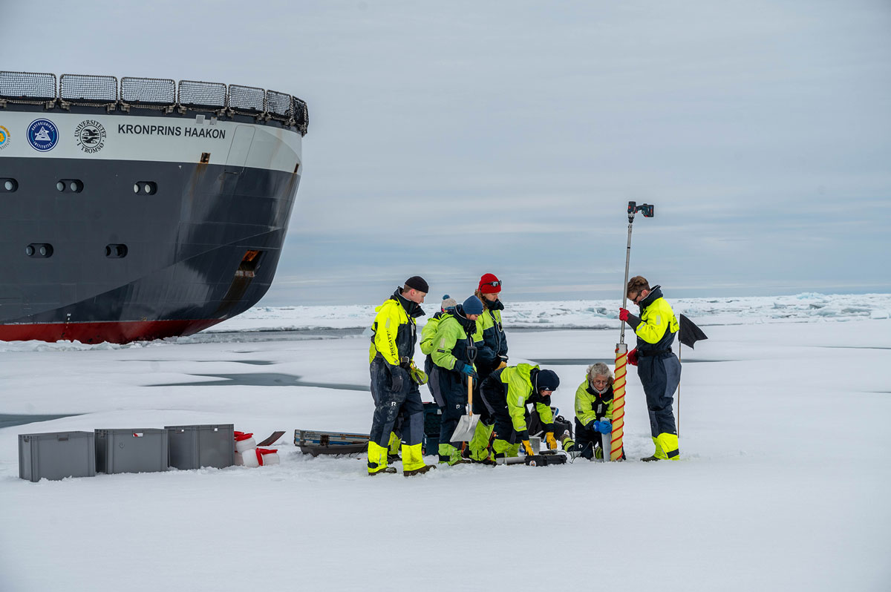
          - The research vessel Kronprins Haakon during an expedition to the Arctic Ocean. Scientists drilling ice cores to study organisms that live within the ice.
Photo: Arctic Council Secretariat/Jessica Cook
A new Norwegian initiative on the Arctic Ocean of the future is being developed to build up more knowledge about climate change, the environment, political and industrial developments and resources in the Arctic Ocean in the years ahead. The consortium behind the initiative includes Norwegian universities, research institutes and administrative bodies that have scientific expertise and interest in developments in the Arctic Ocean. The Research Council of Norway has allocated funding for a pre-project, to be completed by the end of 2024.
The European Green Deal is the EU’s comprehensive plan for a green transition, involving a commitment to reduce net greenhouse gas emissions by at least 55 % by 2030 and achieve climate neutrality by 2050. Priorities in the European Green Deal include many ocean-related actions and cover a range of different areas, from protecting biodiversity and ecosystems and reducing pollution of air, water and soil to making the transition to a circular economy, improving waste management and ensuring the sustainability of fisheries and the blue economy.
Ocean management in the Antarctic
Norway is one of the countries that maintains a territorial claim in Antarctica, and its interests are best safeguarded through smoothly functioning, robust international cooperation under the Antarctic Treaty. Norway maintains a presence in the Antarctic as a research nation, an environmental and maritime nation, and a leading industrial stakeholder.
Norway has played a key part in developing the Antarctic Treaty system, and has also had an important role in developing regional management mechanisms and organisations, including the Commission for the Conservation of Antarctic Marine Living Resources (CCAMLR).
For more than 40 years, Norway has been actively involved in CCAMLR’s efforts to manage the ecosystems and fisheries in the vulnerable Antarctic waters both effectively and sustainably. The Government considers it important for Norway to maintain its efforts so that CCAMLR continues to lead the way in the development of credible, effective management regimes. Norway is therefore giving high priority to CCAMLR’s work on the development of a dynamic approach to managing the krill fisheries, which can also respond to new challenges arising as a result of climate change. Norway has also been playing a central role in efforts to establish a network of marine protected areas around Antarctica, and has submitted a proposal to establish a marine protected area (Weddell Sea MPA Phase 2) in Haakon VII Sea (off Dronning Maud Land). The proposal was submitted for consideration during CCAMLR’s annual meeting in Hobart, Tasmania in October 2023. CCAMLR is a consensus-based organisation, and it takes time to reach agreement on the protection of large ocean areas. During 2024, Norway will further develop its proposal, and will invite the active involvement of other CCAMLR members.
Norway is the largest fisheries nation in the Southern Ocean measured by catch volume. Two large krill fishing companies, Aker Biomarine and Rimfrost AS, are active in the area. Norway sets the same requirements for sound resource management in Antarctic waters as in other areas where vessels from the Norwegian fishing fleet operate. Bouvet Island, a Norwegian dependency, is situated north of the Antarctic Treaty area. However, the waters around Bouvet Island, outside the territorial waters, are part of the CAMLR Convention area.
Fisheries crime and illegal, unreported and unregulated fishing (IUU fishing)
IUU fishing is a serious threat to marine resources and creates challenges for communities and countries around the world.
              - Combating overfishing in the Barents Sea
In the early 2000s, there was massive overfishing in the Barents Sea. There was considerable fishing activity by vessels from flag states that were neither willing nor able to contribute to a sound management regime for fish resources in Norway’s neighbouring areas. Widespread transhipment of catches in the Barents Sea was one factor behind the extent of overfishing in the area. Concerted efforts to deal with this were initiated, partly through NEAFC, and intensified by means of targeted inspections and vessel monitoring in the Barents Sea. Norway’s efforts have resulted in the implementation of a number of management instruments by the regional fisheries management organisations and FAO. These are now helping to enhance international acceptance of and compliance with international obligations.
[Boks slutt]
Norway has considerably intensified its efforts to combat IUU fishing in recent years, for example by increasing support to the UN and civil society organisations in order to strengthen expertise and capacity in developing countries. It is particularly challenging to tackle IUU fishing in areas where there is little monitoring and inspection by national authorities. IUU fishing is therefore often a problem in remote parts of the high seas, in areas where organising cooperation between fisheries nations proves to be difficult, and where the coastal state has insufficient economic resources and capacity to ensure effective monitoring and inspection systems in its economic zone.
After IUU fishing in the Barents Sea was brought under control during the 2000s, it was recognised that a focus on transnational organised crime in the global fishing industry was also needed. Norway considered this to be an important approach because the Norwegian fishing industry is very globalised and needs to be able to operate in a market that is as equitable as possible. To support these efforts, Norway, together with eight other coastal states, adopted the International Declaration on Transnational Organized Crime in the Global Fishing Industry at a conference in Copenhagen in 2018. The declaration has now been endorsed by 61 states, accounting for almost 37 % of the total area of exclusive economic zones in the world. The declaration has become an important political framework, providing guidance on what fisheries crime is and how we should address it.
Norway followed up the declaration by launching the Blue Justice initiative in 2019, at the Our Ocean conference in Oslo. Through the initiative, Norway funds capacity building for efforts to combat fisheries crime in developing countries. The initiative is being followed up by the Ministry of Trade, Industry and Fisheries in cooperation with the Ministry of Foreign Affairs. The initiative works with international partners including the UN Development Fund (UNDP), the UN Office on Drugs and Crime (UNODC), the International Organization for Migration (IOM) and the International Labour Organization (ILO). The initiative provides some shared tools that all partner countries can access. In 2023, Norway launched the Blue Justice Ocean Surveillance Programme, which provides AIS tracking data gathered from Norwegian microsatellites. Countries will also have access to expertise in vessel monitoring at the Blue Justice initiative’s international vessel tracking centre, which is the analysis unit at the Vardø Vessel Traffic Service, run jointly by the Directorate of Fisheries and the Norwegian Coastal Administration. Countries will be able to use the Ocean Surveillance Programme to monitor activities in their own waters. They will also be able to track their own vessels globally, which will strengthen flag states’ efforts to combat IUU fishing and to comply with their international obligations.
Norway has provided substantial support to UNODC and the FishNET project, which has both enhanced awareness and built up capacity for combating various forms of crime linked to the fishing industry internationally. Action ranges from strengthening the legal and policy framework to criminal prosecution and law enforcement, increasing the capacity of customs authorities, providing assistance to identify areas where there is a risk of corruption and taking action to reduce undue influence and risk.
Fish for Development, which is one of the aid programmes included in Norad’s Knowledge Bank, has provided support for a regional fisheries management organisation called the Fisheries Committee for The West Central Gulf of Guinea (FCWC) through TMT, a Norwegian non-profit organisation. The funding goes to a project involving national authorities in the region, and has strengthened capacity, resulting in closer cooperation between countries, including vessel tracking and analyses of illegal fishing.
Norway also provides substantial funding for FAO to assist developing countries in implementing the Port State Measures Agreement (PSMA), an international agreement to combat IUU fishing. Seventy-six countries are now parties to the agreement.

Intensifying efforts to promote sustainable ocean management in partner countries
Norway’s model for ocean management plans has provided inspiration for a number of countries we cooperate with, and is often highlighted internationally as an example for others to follow. Sharing Norwegian experience and expertise has for many years been particularly important in the field of development cooperation. Sound ocean management and good governance generally are closely related, and development assistance in this area therefore requires a long-term approach.
Through two programmes in the Norad Knowledge Bank, Fish for Development and Oceans for Development, Norway is assisting a number of developing countries to put in place sustainable ocean and fisheries management regimes. Both programmes make use of Norwegian experience and public-sector expertise, and are based on scientific cooperation and sharing of knowledge and experience. Norway’s aid is helping to boost expertise and capacity in the public administration in partner countries to ensure sustainable fisheries, healthy ecosystems and a sustainable ocean economy. In addition, Norway supports multilateral partners such as FAO, the International Fund for Agricultural Development (IFAD) and the World Bank system, and also civil society organisations.
Fish for Development was established in 2016 with the objective of increasing the ability of fisheries and aquaculture to contribute to socio-economic development in partner countries, for example through higher employment and better food and nutrition security. Programme activities are intended to help public authorities to build up their capacity for sustainable management; encourage research and educational institutions to assist the authorities and businesses with knowledge, data and advice about sustainable fisheries and aquaculture; and ensure that businesses exploit fisheries resources and engage in aquaculture production in a sustainable manner. The largest area of investment under Fish for Development is the EAF-Nansen programme, which uses the research vessel Dr. Fridtjof Nansen and involves cooperation between Norad, FAO and the Institute of Marine Research.
The primary goal of Oceans for Development is to contribute to more sustainable and inclusive ocean economies in partner countries. The programme forms part of Norway’s international work on ocean-related issues, and is an important tool for implementing the Ocean Panel’s recommendations. It is closely integrated with the Fish for Development programme. Indonesia and Mozambique are pilot countries for this initiative, and Kenya and Ghana are potential partners.
The development programme to combat marine litter and microplastics was established in 2018 and lasts until 2024. Its objective is to prevent and greatly reduce the scale of marine litter originating from major sources in developing countries. A mid-term review concluded that the programme has largely met its targets and has provided a moderate to large contribution to preventing and reducing marine litter. The programme also played a crucial role in the establishment of the GloLitter Partnerships project, which involves cooperation between IMO and FAO and is largely funded by Norway.
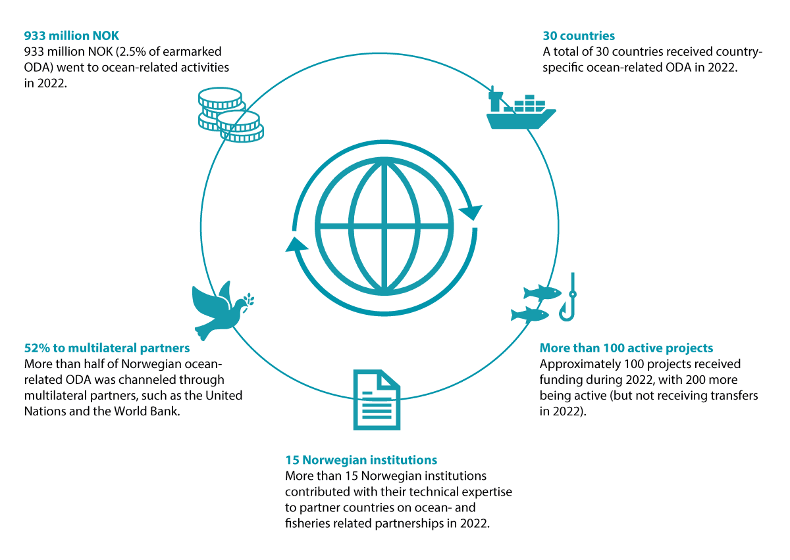
          - Norwegian ocean-related development aid. From the report Making Waves - Norway's support for a sustainable ocean.
Source: Norad
Norway also supports the Blue Action Fund, a non-profit foundation that channels investment for new marine protected areas, improved management of existing MPAs and sustainable livelihoods in communities in and around MPAs. So far, the fund has supported the establishment of new MPAs covering a total area of 147 944 km2, and more effective management of existing MPAs covering 231 387 km2.
Norway has strengthened bilateral ocean-related cooperation with several partner countries. In 2018, a process to formalise an ocean dialogue with China was started. China has a large maritime sector and a fishing fleet with a global reach. It is a major producer of food from the ocean, but also responsible for substantial marine pollution. Indonesia is a member of the Ocean Panel and has one of the world’s longest coastlines. It is the largest recipient of funding from the development programme to combat marine litter and microplastics, and a pilot country for the Oceans for Development programme. We are working to establish a formal ocean dialogue with Indonesia as a framework for our extensive ocean-related cooperation. As a member of the Ocean Panel, Indonesia has a responsibility to promote the Panel’s work at regional level, and Norway is supporting Indonesia’s work on this in the ASEAN region.
Norway and India are engaged in a bilateral cooperation project on sustainable ocean plans. The blue economy is one of the priorities of the current Indian government. A formal ocean dialogue and an India-Norway task force on the blue economy were established in 2019. The main elements of this cooperation are marine litter and sustainable ocean management, and it also includes green shipping, marine research, fisheries and aquaculture.
Chile is a member of the Ocean Panel, and has recently completed its sustainable ocean plan. The ocean dialogue between Norway and Chile includes the exchange of experience from work on ocean management plans in both countries.

Goals of Norway’s ocean management regime and progress towards them
A key part of Norway’s system of ocean management plans is devising a set of goals for the Government’s ocean policy and for ocean management. The ocean management plans include goals for ecosystem condition, value creation, coexistence between ocean industries, and conservation and sustainable use in the management plan areas. An important element of the process of updating the plans is to review the goals and report on the progress that has been made towards them.
In the previous white paper on the ocean management plans, the goals were harmonised so that they all apply to all three management plan areas. In some cases, they were clarified and simplified to facilitate reporting on progress towards the goals.
The text below reviews and assesses the degree to which these goals have been achieved, based on assessments by the Forum for Integrated Ocean Management.

Review of progress towards the goals
The goals for value creation, commercial activities and society are considered to have been achieved, whereas many of the other goals – for biodiversity, ecosystems and pollution – have not been achieved or progress is difficult to assess. Nevertheless, pollution levels are generally declining, and stocks of commercial species are generally being maintained at healthy levels.

Goals for value creation, commercial activities and society
General goals
- Norway’s ocean management will promote sustainable use of ecosystems, areas and resources that ensures long-term value creation, employment and people’s welfare, to the benefit of Norway’s regions and the country as a whole.
- The ocean industries will continue to promote value creation and secure welfare and business development to the benefit of the country as a whole.
- Management of commercial activities in the management plan areas will be coordinated to ensure that the various industries are able to coexist and that the overall level of activity is adjusted to take account of environmental considerations.
The Norwegian ocean industries make a significant contribution to employment and value creation in the Norwegian economy. In the period 2016–2020, they accounted for 16–22 % of Norway’s gross national product (GDP) measured in current prices. Rising prices, particularly for natural gas, meant that this share rose to 31 % in 2021 and 57 % in 2022. This corresponded to a monetary value of about NOK 2306 billion in 2022, and the industries provided employment for a total of 233 600 people. The petroleum industry accounts for the largest proportion of value creation, followed by the seafood industry, shipping, and ocean-related value creation in tourism and other land-based industries. Norway’s ocean areas also provide a range of ecosystem services that individuals and society value and depend on, but that are not reflected in the national accounts. Ecosystem services range from use of the sea for recreational fishing and other leisure activities to water purification, climate regulation, sediment formation and primary production. However, there are still major gaps in our knowledge about the scale and significance of ecosystem services in Norway’s marine and coastal waters. A system of national ocean accounts is being developed, and may provide an important tool for building up an overview of value creation in these areas.
The coexistence of different ocean industries is ensured through knowledge-based, open processes involving all relevant parties before decisions are taken on the establishment of new activities. As new ocean industries are established, ocean areas are used more intensively and in new ways.
Fisheries and seafood
- Living marine resources will be managed sustainably through an ecosystem approach based on the best available knowledge.
The Marine Resources Act requires fisheries management to be ecosystem-based, and sets out principles on which the management system must be based. Annual processes organised by the Directorate of Fisheries ensure implementation of the Marine Resources Act. During these processes, the different fisheries are reviewed, their impacts are identified, and priority is given to finding ways of reducing these impacts. The goal of managing living marine resources sustainably is considered to have been achieved.

- Norway’s seas and oceans will be a source of safe seafood.
Levels of hazardous substances in seafood from the Barents Sea–Lofoten area are still generally low and well below the maximum permitted levels for food safety. In the Norwegian Sea and the North Sea–Skagerrak, levels of hazardous substances in seafood are generally below the maximum permitted levels for food safety. However, concentrations above the maximum permitted levels have been found in certain species in specific areas. The available information indicates that the safe seafood goal has been achieved for the Barents Sea–Lofoten area, and partially achieved for the Norwegian Sea and the North Sea–Skagerrak.

- Harvesting activities and natural resource use that provide a high long-term yield within sustainable limits will be facilitated.
Norway splits fish stocks into three categories, depending on how good the knowledge base is for each stock. Goals have been set for each of the three categories, for example on value creation (depending on the knowledge available), stock status, harvesting goals and so on. The underlying principle is that the more information we have about a stock, the more precisely it can be managed with the aim of ensuring a high long-term yield within sustainable limits. Thus, the goal of facilitating high long-term yields is considered to have been achieved.
Petroleum activities
- Steps will be taken to facilitate the long-term profitable production of oil and gas. Petroleum activities will be carried out within a predictable framework and on the basis of health, environment and safety requirements and standards that are adapted to environmental considerations and the needs of other industries.
The oil and gas industry is Norway’s largest measured in terms of value added. For many years, there has been substantial a cash flow from oil and gas production, 80 % of which accrues to the Norwegian state as net tax revenues. The goal for value creation from the industry is thus considered to have been achieved.
Offshore renewable energy
- The development of offshore renewable energy production will be facilitated, taking into account environmental considerations and other activities.
Since the previous white paper on the management plans was published, more progress has been made on facilitating the development of offshore wind production. The Government’s ambition is to allocate licences for 30 GW of offshore wind production capacity by 2040. The areas Utsira Nord and Sørlige Nordsjø II were opened for licence applications in 2020 (4.5 GW). A strategic environmental assessment for new offshore wind areas has been initiated to provide the information needed for decisions on whether to open further areas. It is difficult to determine whether the goal relating to environmental considerations has been achieved before environmental impact assessments have been completed for relevant areas and experience has been gained from the first commercial developments. The goal for offshore renewable energy production is considered to have been partially achieved.
Maritime transport
- Favourable conditions will be provided for safe, secure, effective and environmentally friendly maritime transport.
The number of low- and zero-emission vessels is showing a positive trend. A number of maritime safety measures have also been adopted and/or implemented, and their overall effect will be to improve maritime safety and reduce the forecast likelihood of accidents. However, this is a complex goal involving a number of elements that do not necessarily all follow the same trend, and it is therefore not possible to draw a clear conclusion on progress towards achieving the goal.

Goals for biodiversity and ecosystems
A number of management measures have been or are being implemented to achieve the goals of the ocean management plans. However, a number of the goals are yet to be achieved, and in some cases is difficult to assess. Information from monitoring and mapping is used as part of the basis for assessing progress towards the goals. Where the necessary data is not available, the conclusion is that it is uncertain whether the relevant goal has been achieved.
General goals
- Norway’s seas and oceans will be managed in a way that maintains diversity at ecosystem, habitat, species and genetic levels, and the productivity of ecosystems. Human activity in the management plan areas will not damage the structure, functioning or productivity of ecosystems.
Continuous efforts are being made to achieve this general goal through work on the ocean management plans and measures introduced under sectoral legislation. Progress has not been assessed specifically for this general goal, but is discussed for the more specific goals in the text below.
Management of particularly valuable and vulnerable areas
- In particularly valuable and vulnerable areas, activities will be conducted with special care and in such a way that the ecological functioning and biodiversity of these areas are not threatened.
- The management regime will take special account of the need to protect vulnerable habitat types and species in particularly valuable and vulnerable areas.
Regulatory measures and guidelines apply to a number of these areas to ensure that special caution is exercised to protect valuable habitats and species. It is difficult to evaluate whether this goal has been achieved because too little information is available on how the ‘special care’ requirement is being met in practice.
Species and habitat management
- Naturally occurring species will exist in viable populations that provide for sufficient reproductive capacity and long-term survival.
This goal has been achieved for zooplankton, the major commercial fish stocks and most marine mammals. It is uncertain whether it has been achieved for the benthic fauna and non-commercial fish stocks. The goal has not been achieved for seabirds.

- Species that are essential to the structure, functioning, productivity and dynamics of ecosystems will be managed in such a way that they are able to maintain their role as key species in these ecosystems.
This goal is considered to have been achieved for the Norwegian Sea and the North Sea and Skagerrak. It has only been partially achieved for the Barents Sea–Lofoten area, where stocks of key species such as polar cod (Boreogadus saida) and redfish are very weak and are showing a negative trend. Only the capelin stock is showing a clearly positive trend.

- Harvested species will be managed within safe biological limits so that their spawning stocks have good reproductive capacity.
The goal is considered to have been achieved for commercially harvestable stocks in the North Sea–Skagerrak and the Norwegian Sea. The situation for the smaller commercial stocks in the North Sea–Skagerrak is uncertain. The goal is considered to have been only partially achieved for small stocks in the Norwegian Sea, because the stocks of golden redfish and blue ling are very weak.
In the Barents Sea, the goal has been partially achieved for harvestable stocks. It has been achieved for red king crab and most commercially harvestable fish stocks, but not for redfish and coastal cod.

- Populations of endangered and vulnerable species and species for which Norway has a special responsibility will be maintained or restored to viable levels.
The conservation status of a number of species is assessed as poorer in 2021 than in 2015. In addition, new marine species have been added to the Red List. The negative trend for seabirds has not been reversed since the previous white paper on the ocean management plans was published. This goal is not considered to have been achieved.

- The introduction and spread of alien organisms through human activity will be avoided.
The westward spread of red king crab has been contained, stabilising the western limit of its distribution. This is an improvement from 2010, and the goal is considered to have been achieved for this species. There is inadequate monitoring of alien organisms that are spread with ballast water or on ships’ hulls, so that it is not possible to assess progress towards the goal for such species. Overall, it is uncertain whether this goal has been achieved.

- In marine habitats that are particularly important for the structure, functioning, productivity and dynamics of ecosystems, activities will be conducted in such a way that all ecological functions are maintained.
Progress towards this goal has not been specifically assessed. However, there is further discussion of ecosystem condition and impacts in the three management plan areas in Chapter 3, and of the environmental impacts of the ocean industries in Chapter 5.

- Damage to marine habitats that are considered to be endangered or vulnerable will be avoided.
This goal has been achieved or partially achieved for coral reefs as a result of the prohibition on bottom trawling in their vicinity. We do not have sufficient information to assess whether the goal has been achieved for other vulnerable marine habitats.
Sustainable harvesting
- Management of living marine resources will be based on the principles of sustainable harvesting.
The management of all stocks that are harvested is based on the principles of sustainable harvesting. The goal is considered to have been achieved for commercial stocks.

- Harvesting will not have significant adverse effects on other parts of the marine ecosystem or its structure.
The goal for sustainable harvesting is considered to have been partially achieved. Current harvesting patterns have not been shown to have significant adverse effects on other parts of the marine ecosystem or its structure.

- Bycatches of marine mammals and seabirds will be minimised.
It is uncertain whether bycatches of marine mammals and seabirds have been reduced as far as possible. It is therefore difficult to assess whether this goal has been achieved.

- Living marine resources will be harvested making use of the best available techniques for different types of gear to minimise negative impacts on other ecosystem components such as marine mammals, seabirds and benthic communities.
Continual efforts are being made to improve fishing gear and minimise its impacts on the ecosystem. The goal of making use of the best available techniques is therefore considered to have been achieved.

- Management of fish stocks and other biological resources will be adapted to a changing climate so that stocks are maintained at sustainable levels.
Progress towards this goal has not been specifically assessed. However, there is further discussion, among other things of fisheries management, in Chapter 5.
Marine protected areas
- A representative network of well-managed marine protected areas that will improve ecological connectivity will be established in Norwegian waters.
The goal of establishing representative and well-managed marine protected areas that will improve ecological connectivity has been only partially achieved, mainly because the areas involved are small (for example limited to a coral reef complex) and are scattered across large marine areas along the coast. The goal of protecting areas that form ecologically effective networks has not been achieved, partly because it has proved to be challenging to implement the 2004 national marine protection plan. This means that conservation areas, except to some extent coral reefs, do not form a representative network that ensures conservation of the full range of habitat types in an area, and will not ensure adequate ecological connectivity. Efforts to achieve this goal include implementing measures set out in the white paper Norway’s integrated plan for the conservation of areas of special importance for marine biodiversity, Meld. St. 29 (2020–2021).
Climate change and ocean acidification
- When marine ecosystems are used as carbon sinks, the need to maintain biodiversity and natural ecosystem functions will be taken into account.
This goal sets out a precautionary approach to future activities – no such activities have as yet been initiated in Norwegian waters.
No decisions have so far been made to start activities such as kelp cultivation in Norwegian waters with the aim of enhancing biological carbon storage. In addition, there is a general lack of data on the potential for biological carbon storage. Thus, there is no adequate basis for assessing the extent to which this goal has been achieved.

- The cumulative impacts of human activities on habitats and species that are adversely affected by climate change or ocean acidification (e.g. coral reefs) will be minimised, in order to maintain ecosystem functioning as fully as possible.
We lack sufficient information to assess whether this goal has been achieved.

Goals for pollution, marine litter and the risk of acute pollution
General goals
- Releases and inputs of pollutants to the management plan areas will not result in injury to health or damage the productivity of the natural environment and its capacity for self-renewal. Activities in these areas will not result in higher levels of pollutants in seafood.
Progress has not been assessed for this general goal, but is discussed for the more specific goals in the text below.
Hazardous and radioactive substances
- Environmental concentrations of hazardous and radioactive substances will be reduced to background levels for naturally occurring substances and will be close to zero for synthetic substances. Releases and inputs of hazardous or radioactive substances will not cause these levels to be exceeded.
Hazardous substances in Norwegian waters originate mainly from long-range pollution carried with ocean currents and in the atmosphere.
For pollutants in operational discharges from offshore petroleum activities, progress towards the goal varies between sea areas. Operational discharges from petroleum activities in the Barents Sea are limited and not on a scale that is expected to result in rising background levels of oil or other environmentally hazardous substances over time.
Levels of pollution in the Norwegian Sea are considered to be low, and there have been no appreciable changes in inputs of oil or other environmentally hazardous substances from petroleum activities. However, there is still uncertainty about the potential adverse impacts of these discharges.
Operational discharges from petroleum activities in the North Sea are substantial, and are resulting in rising background levels of oil and other environmentally hazardous substances and naturally occurring substances over time. However, little is known about any adverse impacts of these discharges.
Under normal circumstances, operational discharges from shipping consist mainly of oil in bilge water. Almost 90 % of oil separation systems on ships meet the requirement that the oil content of discharged water must not exceed 15 ppm. In addition, there is some unregulated discharge of stern tube lubricants from all ships, but less is known about these releases, and estimates of quantities are uncertain.
An overall evaluation of inputs and levels of hazardous and radioactive substances in Norwegian waters shows that this goal has not been achieved, and inputs of priority hazardous and radioactive substances are still occurring.

- Releases and use of substances that pose a serious threat to health or the environment in Norwegian waters will be continuously reduced with a view to eliminating them.
Reductions have been made in the use and releases of many of the persistent, bioaccumulative and toxic substances on the priority list since the previous white paper on the ocean management plans was published. For many of the priority substances, the main source of releases is now believed to be imported products. This goal is not considered to have been achieved.

- Operational discharges from activities in the management plan areas will not result in damage to the environment, higher levels of pollutants in seafood, or elevated background levels of oil, naturally occurring radioactive substances or other environmentally hazardous substances over time.
See the section above on the goal relating to environmental concentrations of hazardous and radioactive substances. There is considerable uncertainty relating to the effects of operational discharges from activities in the management plan areas.
Inputs of nutrients, sediment deposition and organic matter
- Anthropogenic inputs of nutrients, sediment deposition and inputs of organic matter will be limited in order to avoid significant adverse impacts on biodiversity and ecosystems in the management plan areas.
Anthropogenic inputs of nutrients to all Norwegian marine and coastal waters are rising. At the same time, the climate is changing, with higher temperatures and more intense precipitation, resulting in higher inputs from land as well. Inputs of nutrients have had negative environmental impacts (eutrophication, sediment deposition, water darkening) in certain areas along the coast. The goal is therefore only considered to have been partially achieved.
Marine litter
- Inputs of waste and microplastics to the management plan areas will be avoided.
Large quantities of litter and microplastics are being registered at many localities along the coast, in trawls, during mapping of the seabed and in the stomachs of seabirds and other animals. This goal is not considered to have been achieved.

- Waste quantities in marine and coastal areas will be reduced by means of clean-up operations where appropriate.
Public and private grant schemes and national projects promote action to reduce marine litter through the removal of litter and preventive measures. The Directorate of Fisheries organises an annual retrieval programme for lost fishing gear. However, an overall assessment of current knowledge indicates that the goal has not been achieved. Information from the clean-up measures that have been introduced shows no reduction in the quantities of beach litter.
Underwater noise
- Activities entailing a noise level that may affect species’ behaviour will be limited to avoid the displacement of populations or other effects that may have negative impacts on the marine ecosystem.
Measures have been implemented to limit the negative impacts of seismic activities, shipping and military sonar. However, too little is known about the scale of underwater noise and its impacts. It is uncertain whether the goal has been achieved.
Risk of environmental damage as a result of acute pollution
- The risk of damage to the environment and living marine resources from acute pollution will be kept at a low level and continuous efforts will be made to reduce it further.
It is difficult to assess whether the goal of reducing the risk of damage from acute pollution has been achieved. The likelihood of accidents that result in significant environmental damage is generally low, but the consequences of a major spill could be very serious. The level of risk is always uncertain, since potential future events are being considered. There is also uncertainty as regards the extent to which preparedness and response systems will reduce the consequences of accidents in practice. In the paragraphs below, progress towards the goal of reducing the risk of environmental damage as a result of acute pollution is assessed for different sectors.
Shipping: The Norwegian Coastal Administration’s analysis of the environmental risk associated with shipping in Norwegian waters (2022) shows that the level of risk is high or very high in many areas near the coast and on the continental shelf. The risk of accidents occurring is low, but the consequences of a major spill could be very serious for a number of species at certain times of year, and many species are therefore considered to face a high level of environmental risk.
The goal of ensuring a low level of risk of damage to the environment and living marine resources is considered to have been partially achieved for the shipping sector. According to the analysis of environmental risk, the level of environmental risk has shown a weak downward trend from 2017 to 2019. However, if 2020 is included, there appears to have been a weakly rising trend in risk from 2017 to 2020. This is a result of adverse effects caused by several physical properties of the new low-sulphur fuels.
Petroleum activities: The probability of a large spill is low, and the current legislation for petroleum activities is designed to deal with safety issues. The risk of accidents is therefore considered to be low in all three management plan areas. However, an accident could have major consequences. The risk of serious consequences is highest in the Barents Sea, where seabirds in particular occur in large numbers and are vulnerable to any oil spills. A steep decline has been observed for various species and colonies, and they are therefore especially vulnerable to further pressure. In the Norwegian Sea and North Sea, the potential for environmental consequences in the most vulnerable areas is limited for many petroleum operations. Using the information available, we cannot conclude that the goal of ensuring a low level of risk of damage to the environment and living marine resources has been achieved for the Barents Sea, but it is considered to have been partially achieved for the Norwegian Sea and the North Sea. However, given the very low likelihood of a serious incident, achievement of the goal in itself does not give a full picture of whether operations are responsible in environmental terms.
Radioactivity: The volume of nuclear-powered shipping in all three geographical areas is rising, as is the volume of radioactive cargo in the Russian part of the Barents Sea. The goal of reducing the risk of environmental damage from these activities is therefore not considered to have been achieved.

- The high safety level in maritime transport will be maintained and strengthened
Shipping is generally a safe form of transport, but any maritime traffic involves a certain level of risk. In recent years, the number of incidents involving small discharges to the sea registered in the Norwegian Maritime Authority’s accident database has increased, but much of the increase is probably explained by greater willingness to report such releases. A number of maritime safety measures have also been adopted and implemented, and their overall effect will be to reduce the expected likelihood of accidents in the years ahead.
This goal is considered to have been achieved as regards measures to maintain and strengthen the high level of maritime safety, and partially achieved as regards the trend in the number of accidents (both involving and not involving releases of pollutants), and as regards port state control.

- The governmental preparedness and response system for acute pollution will be adapted to and dimensioned on the basis of the level of environmental risk at any given time.
The governmental preparedness and response system for oil spills from shipping is dimensioned on the basis of the results of several environmental risk and preparedness and response analyses published in 2009–2014. Measures in an action plan based on the preparedness and response analysis for the mainland Norwegian coast have been implemented, while many of those in an action plan for the waters around Svalbard and Jan Mayen still remain to be implemented.
New analyses of the likelihood of accidents, environmental risk and preparedness and response were carried out in 2021–2022, and identified gaps between appropriate and actual preparedness levels in Norwegian waters. The analyses showed that it is not realistic to close all the gaps by altering or adapting the existing preparedness and response system. This has been followed up by developing an action plan containing measures to reduce and eliminate the gaps, which will be implemented in the coming years. The goal is therefore only considered to have been partially achieved.
The national nuclear emergency preparedness and response system for Norwegian waters has been strengthened to some extent, but is still inadequate as regards the resources available for monitoring and measuring radioactivity and the action that can be taken to prevent releases of radioactivity from disabled ships. The goal that the system will be adapted to and dimensioned on the basis of the level of environmental risk at any given time is therefore only considered to have been partially achieved.

Updating the structure and organisation of the goals
The goals for the ocean management plans have gone through several stages of development since 2002. The Forum for Integrated Ocean Management, partly in connection with reporting on progress towards the goals, has found ambiguities, wording that needs interpretation and adjustment, and a need to supplement the existing goals. It will therefore be appropriate to carry out an overall review to ensure that the goals are updated and adapted to developments in Norway’s ocean management regime.
The aim of this process, involving tightening up and adjusting the goals and updating their structure and organisation, will be to reduce the need for interpretation, reduce overlap between goals and make it easier to assess progress towards the goals. Restructuring the goals will also make assessments of progress towards the goals more systematic and verifiable over time. The process may also reveal thematic areas where there is a lack of operational goals, making it possible to include new goals where such gaps are identified.
A clearer thematic and hierarchical structure for the goals will create an overall framework that clarifies the links between the ocean management goals and the knowledge base.
The thematic areas of the goals should as far as possible reflect the areas dealt with in the scientific basis for the management plans. The inclusion of new thematic areas such as physical disturbance, cumulative impacts, the coexistence of different industries and climate change should therefore be considered during the restructuring process.

Overall framework and measures for conservation and sustainable use of ecosystems in the management plan areas
Norway has a long tradition of taking a long-term approach to ocean resource management for the benefit of society as a whole. The basis for value creation from Norwegian ocean-based activities now and in the future depends on maintaining the value of Norway’s marine and coastal environment, safeguarding the oceans as a source of food and using ocean resources sustainably. In this white paper, the Government describes how it intends to continue and consolidate Norway’s integrated, ecosystem-based ocean management plan system.

Measures to ensure good ecosystem condition and conservation of marine ecosystems
The ocean areas under Norway’s jurisdiction support important species and habitat types. Ocean-based activity in these areas is increasing, and new ocean industries are emerging. Clean and healthy oceans are an essential basis for a sustainable ocean economy. However, ecosystem condition in Norwegian waters is under growing pressure from climate change and expanding industrial activities. New and more effective measures are still needed to ensure good ecosystem condition and the conservation of marine ecosystems in Norway’s ocean areas.

Marine protected areas and species and habitat conservation
Conservation measures are needed for a selection of Norway’s marine areas, habitats and ecosystems, both to safeguard valuable biodiversity and ecological functions, and to reduce pressures on and the vulnerability of marine ecosystems that are exposed to climate change and ocean acidification. Protected areas are established on the basis of their conservation value and to maintain their value in the long term. Establishing a protected area is a stand-alone management measure rather than a response to or part of preparations for industrial or other activities in an area. To maintain well-functioning ecosystems and ecological resilience to climate change, it is important to establish representative and well-managed marine protected areas that will improve ecological connectivity, and also ecologically effective networks to ensure conservation of the full range of habitat types in an area. In addition to their role in conservation, marine protected areas and other effective area-based conservation measures can play a part in maintaining natural carbon sinks (‘blue forests’). The white paper Norway’s integrated plan for the conservation of areas of special importance for marine biodiversity, Meld. St. 29 (2020–2021), is the basis for the Government’s work on the conservation of these areas. A more systematic approach to the conservation of areas of importance for marine biodiversity is being established using the areas identified as particularly valuable and vulnerable as a starting point and giving these areas priority.
We have a generally sound knowledge base for the large commercial fish stocks, seabird populations and some marine mammal species. The knowledge base is poorer for non-commercial fish stocks. Information on the occurrence and status of threatened and vulnerable species and habitats is also limited.
The Government will:
- continue the establishment of a network of marine protected areas and other effective area-based conservation measures (OECMs) that will improve ecological connectivity and is representative of the full range of variation in marine biodiversity and well managed, as described in the Global Biodiversity Framework;
- draw up a draft of a new act on the conservation of marine biodiversity outside territorial waters;
- implement an active management regime for coastal cod and other depleted fish stocks, and take steps to rebuild these stocks;
- build up knowledge about the effects of the use of bottom fishing gear in Norwegian waters on coral reefs and other benthic ecosystems, including assessing the use of marine and coastal waters that have previously been trawled as reference areas;
- consider whether to prohibit catches and bycatches of all red-listed fish species, including the option of regional restrictions;
- to ensure that the criteria used under the Water Management Regulations, which implement the EU Water Framework Directive in Norwegian law, give a more complete picture of ecological status in coastal waters, and to facilitate conservation of biodiversity in these waters, consider whether more ecosystem components should be included as biological quality elements for coastal waters under the regulations.

Adapting to climate change and a warmer ocean
According to the Intergovernmental Panel on Climate Change (IPCC), the oceans are as a result of rising CO2 levels and global warming entering a state of which we have no experience. This involves higher temperatures, more frequent marine heat waves, acidification, oxygen depletion, a loss of sea ice, and changes in current patterns, productivity and species distribution. These changes may lead to far-reaching impacts on marine ecosystems and living resources, including those in Norwegian waters, which in turn will affect ocean industries and coastal communities. The impacts on ecosystems may be further intensified by human activity. Achieving sustainable management of Norway’s sea areas will require knowledge about how these factors interact and how the impacts can be limited through ocean management.
The Government will:
- enhance knowledge of how climate change and ocean acidification affect marine ecosystems and how they interact with other drivers;
- enhance knowledge of vulnerability to different drivers and the cumulative impacts on sandeel habitats;
- adapt the management of marine ecosystems and the harvesting of living marine resources to climate-related environmental change and the uncertainty climate change entails as regards future environmental conditions;
- develop methodology for monitoring the biological impacts of ocean acidification;
- start up a permanent system for monitoring ocean acidification in the North Sea.

Nature-based solutions
Marine ecosystems such as kelp forests, seaweed communities and eelgrass meadows absorb CO2 through photosynthesis, thus helping the oceans to absorb a substantial proportion of CO2 emissions. These ecosystems comprise natural carbon sinks in the ocean and are sometimes called ‘blue forests’. They are also important for marine biodiversity and can protect the coastline against extreme weather events by moderating wave action.
The Government will:
- conserve, manage and restore areas of marine vegetation and carbon-rich sediments in order to ensure good ecosystem condition, remove CO2 from the atmosphere and protect biodiversity;
- identify areas/habitats that are candidates for restoration and encourage the development of suitable, effective methods for their restoration;
- evaluate measures that can effectively reduce adverse pressures and impacts on marine vegetation and areas of carbon-rich sediment;
- enhance knowledge of which drivers directly or indirectly result in the loss of kelp forests and other types of marine vegetation;
- enhance knowledge about carbon fixation by marine vegetation types such as kelp forests, seaweed communities and eelgrass meadows;
- focus on the conservation and restoration of marine vegetation and areas of carbon-rich sediment in further work on marine protection and other effective area-based conservation measures (OECMs);
- facilitate the development of new ocean industries such as environmentally friendly cultivation of seaweed and kelp as a measure for boosting carbon uptake.

Improving the situation for seabird populations
Populations of a number of seabirds have shown a considerable decline over time. In summer 2023, seabirds were also hit by an outbreak of avian flu, which entailed particularly high mortality in kittiwakes in certain areas of North Norway. We know a certain amount about the reasons behind the major changes in seabird populations, but more knowledge is needed about causal relationships and about ecological interactions in ecosystems that are important for seabird populations. It is also important to compile an overview of pressures on seabirds and measures that can be introduced to avoid seabird mortality. Earlier work involving cooperation between seabird experts and marine scientists should be further developed.
A national action plan for seabirds is being finalised, in which various policy instruments and measures are being considered, including whether certain seabirds should be designated as priority species. Knowledge about seabirds is being built up through the SEAPOP mapping and monitoring programme, including the SEATRACK module, which is mapping the non-breeding distribution of seabirds. A considerable amount of new information on seabird populations in Norwegian waters has been acquired through the programme. It is important to update and further develop this information, since it forms part of the knowledge base on seabirds and on the major marine ecosystems.
The Government will:
- draw up a national action plan to improve the situation for seabird populations;
- further develop the systematic efforts to build up knowledge about seabirds through the mapping and monitoring programme for seabirds, SEAPOP, including the SEATRACK module for their non-breeding distribution;
- carry out a new total census of breeding, staging and wintering seabirds along the Norwegian mainland coast in 2027 and around Svalbard in 2030;
- make map services on seabird habitat use and vulnerability available by publishing data through the marine spatial management tool for the ocean management plans;
- consider the establishment of a permanent monitoring system for seabird bycatches in fisheries;
- develop targeted measures for reducing the scale of unintentional bycatches of seabirds;
- strengthen cooperation between seabird experts, marine scientists and climate researchers in order to promote further progress in research on seabirds and marine ecosystems and on how climate change will affect food supplies and the viability of Norwegian seabird populations.

Preventing the spread of alien species
The spread of invasive alien species is regarded as one of the most serious threats to biodiversity. Shipping, aquaculture activities and the unintended release of alien species are responsible for large-scale transfers of marine organisms between the world’s oceans. A number of alien species have become established in Norwegian waters. Most of them are benthic plant and animal species found near the coast, such as Pacific oysters (Crassostrea gigas), japweed (Sargassum muticum) and carpet sea squirt (Didemnum vexillum). Introduced microalgae in ballast water have caused several algal blooms in Norway, resulting in commercial losses, for example in the fish farming industry. Alien species can cause severe damage to Norwegian nature by displacing naturally occurring species. Rising sea temperatures as a result of climate change make it easier for alien species from further south to spread in Norwegian waters.
The Government will:
- improve knowledge about and monitor the occurrence, spread and impacts of alien species in Norwegian waters;
- enhance knowledge about how climate change and warmer seas, combined with changing shipping patterns, will alter the risk of alien species spreading in Norwegian waters, and assess whether additional measures are needed;
- continue to give priority to efforts to prevent the spread of carpet sea squirt in Norwegian waters and to reduce numbers of Pacific oysters along the shoreline and around coastal islands and skerries;
- implement new measures to prevent the spread of alien organisms through biofouling, including requirements based on IMO’s regulatory framework;
- take the initiative for IMO to establish legally binding requirements to prevent the introduction and spread of alien organisms through biofouling.

Combating plastic pollution
Action at both national and international level is needed to reduce plastic pollution. Measures must target all phases in the life cycle of plastics to ensure that resources are used more effectively and prevent plastics from ending up in the environment. Norway has played an active part in initiating a negotiation process for a legally binding global instrument on marine plastic pollution, which according to plan is to be completed in 2024. At national level, Norway has for many years had sound, comprehensive legislation on pollution and litter, including plastics. Various preventive measures have been put in place, and more are being developed. Extensive joint EU/EEA legislation is an important part of this framework, which involves the use of substantial resources but is expected to have an impact in both international and Norwegian waters. Priority will be given to implementing and enforcing EEA legislation, including the Single-Use Plastics Directive, as required by the EEA Agreement to prevent plastic pollution.
The authorities also play a part in beach clean-up efforts through support for building up information about the need for beach clean-up, collecting data on litter cleared, and in coordinating the work through digital tools and a national coordination council.
Further work will continue to be needed on the sources of different types of plastic pollution, their effects, and effective measures to deal with them. This also includes the chemicals found in plastics.
The Norwegian Plastics Strategy, which was published in 2021, provides a general basis for this Government’s priorities too. The need for further measures and instruments will be assessed in the light of the new knowledge being generated in this area.
The Government will:
- intensify monitoring of macro- and microplastics in Norwegian marine and coastal waters, among other things to enable Norway to meet reporting commitments under OSPAR’s coordinated environmental monitoring programme and globally under SDG 14 (life under water), indicator 14.1.1 on plastic debris intensity;
- continue the retrieval programme for lost fishing gear to reduce ghost fishing and the amount of marine litter;
- follow up the 2021 Norwegian Plastics Strategy;
- play an active part in international efforts to reduce amounts of marine litter and microplastics, including the development and implementation of joint measures to combat marine litter and plastic pollution within the framework of OSPAR, IMO, the Nordic Council of Ministers and the Arctic Council;
- strengthen research on the sources of plastic pollution and its effects on marine ecosystems and food security, and promote international cooperation in this field.

Reducing pollution by hazardous substances
Many persistent, bioaccumulative and toxic substances and other hazardous substances are regulated through legislation and international agreements. The pressures and impacts associated with such substances in Norwegian waters need to be further reduced. For many years, Norway has been taking the lead both in Europe and globally in efforts to prohibit the use and releases of substances on the Norwegian priority list of persistent, bioaccumulative and toxic substances. This work is continuing.
Transport from other countries with ocean currents and in the atmosphere accounts for a large proportion of inputs of hazardous substances to the management plan areas. This highlights the need for extensive international cooperation in order to achieve our goals. There are known to be considerable inputs with ocean currents, but only very rough estimates are available for individual substances, so that there is little information on changes in inputs. Certain hazardous substances originate from microplastics containing them that are spread with ocean currents.
More knowledge is needed about persistent, bioaccumulative and toxic substances in Norwegian waters.
The Government will:
- continue screening studies to detect new persistent, bioaccumulative and toxic substances in the management plan areas and develop new methods to make it easier to detect the potentially most dangerous pollutants;
- survey and monitor both new and old persistent, bioaccumulative and toxic substances in the Arctic, including substances from local sources;
- enhance knowledge about the impacts on marine ecosystems of long-range transport of hazardous substances and the cumulative impacts of activities in various sectors on different ecosystem components;
- work actively towards a stricter international regime governing persistent, bioaccumulative and toxic substances, for example by proposing prohibitions and other regulatory measures for new substances in EU/EEA law, by nominating new substances for global prohibition under the Stockholm Convention or for inclusion in the regional Convention on Long-Range Transboundary Air Pollution, and by seeking to phase out substances under the Global Framework on Chemicals;
- give priority to prohibition and other types of restrictions on hazardous substances in plastics in the negotiations on a global instrument on plastic pollution.

Reducing underwater noise
Human activity has resulted in a considerable rise in noise levels in the oceans. Noise can disturb acoustic communication between marine animals and make it more difficult for them to find and catch food and to navigate. The rise in ambient noise levels is primarily a result of the growing volume of shipping. In addition, intense sound pulses produced by seismic activity, military sonar, detonations and pile-driving may cause direct injury and result in behavioural changes. Although much more information has been gained over the past 10–15 years, and there is a better understanding of the importance of underwater noise, little specific information is available about how noise pollution over time, often combined with other pressures, may affect populations of vulnerable species.
The Government will:
- consider the introduction of measures to limit underwater noise from shipping, based on IMO’s guidelines;
- build up knowledge about the pressures and impacts of underwater noise on fish and marine mammals;
- further develop the monitoring system based on national pressure indicators for underwater noise and harmonise monitoring with the regional system under OSPAR.

The preparedness and response system for acute pollution
The design and capabilities of the preparedness and response system must be adapted to the prevailing likelihood of major spills, both from shipping and from petroleum activities, and to the environmental risk such releases would entail. The risk of accidents in Norwegian waters is low, but the consequences of an accident involving large releases of pollutants could be very severe.
Although the maritime safety level in Norwegian waters is generally high and there are relatively few spills with environmental consequences, the Norwegian Coastal Administration’s analysis of the environmental risk associated with shipping in Norwegian waters (2022) shows that the level of risk is high or very high in many areas. The likelihood of vessel casualties is low, but the consequences of a major spill could be very serious for a number of species, and many species are therefore considered to face a high level of environmental risk. It is also important to take into account changing levels of environmental risk as a result of climate change, the rising vulnerability of many species, and the introduction of new fuel types such as low-sulphur fuel. According to the Coastal Administration’s emergency preparedness analysis, there are several regions of Norway where the ocean-going resources available for dealing with shipping accidents within the recommended response time are inadequate.
The Government will:
- give priority to the measures discussed in the Norwegian Coastal Administration’s environmental risk and preparedness and response analyses from 2022, so that the governmental preparedness and response system for acute pollution is developed in line with changes in environmental risk;
- continue to build up knowledge about the basic properties of low-sulphur fuels in the event of spills, and their effects on the environment.

Value creation and the green transition in the ocean industries, and an overall framework and measures for sustainable use
The ocean industries are vital to employment and value creation in Norway, and the oceans provide livelihoods for many coastal communities. Norwegian waters contain rich oil and gas resources, which have played a key role in the country’s development. The oceans are also the basis for Norway’s large, sustainable seafood industry and its large maritime industry. Some of the country’s most innovative businesses, jobs and knowledge institutions have their origins in human settlement along the coast and use of the oceans. For the foreseeable future, the oceans will continue to be a vital basis for jobs, value creation and welfare throughout Norway. The Government will present an industrial plan for Norway’s ocean areas.
Clean and productive oceans are an essential basis for a range of industrial activities at sea. However, ocean industries also affect ecosystems through harvesting, physical disturbance of the seabed, pollution, litter, noise and the spread of alien species.
Norway’s ocean areas and ocean economy have the potential to contribute substantially to the green transition and emission reductions.

Green transition in the ocean industries
Climate change mitigation measures related to the oceans and ocean industries have the potential to contribute substantially to the green transition and emission reductions. This contribution is an important element of the long-term social benefits and value creation these industries can provide.
The Government will:
- facilitate large-scale development of offshore wind on the Norwegian continental shelf, with the ambition of allocating licences for 30 GW of production capacity by 2040;
- facilitate long-term development of offshore wind in Norway by regularly opening up areas of the shelf for wind power; the next licensing round is planned to take place in 2025;
- further develop international and Nordic cooperation to facilitate the demonstration and testing of green solutions through the establishment of green corridors/zero-emission maritime transport corridors in areas including Norwegian waters;
- build up knowledge about what impacts new, green ocean industries will have on the marine environment, and how adverse environmental impacts can most effectively be limited.

Framework and measures for petroleum activities
Each of the ocean management plans sets out a framework for petroleum activities in specific geographical areas. On 1 December 2022, the Storting (Norwegian parliament) made a formal request to the Government in connection with the revision of the ocean management plans. The Government was asked to consider whether parts of the areas where the current management plans specify that no new production licences are to be issued, or certain areas that have not been opened, should be designated permanently as areas where no petroleum activities are to be initiated.
The established system of specifying a framework for petroleum activities in different geographical areas as part of the marine management plans provides a good basis for sound resource management and a predictable regulatory framework for the oil and gas industry. The framework can be adjusted on the basis of new and updated information. The framework set out in the management plans applies until any changes are made in connection with updates to the management plans.
The Trænarevet coral reef area will not be opened for petroleum activities in the current parliamentary period, in line with the wording of the present Government’s political platform.
The Government has made adjustments to the framework for petroleum activities around Bjørnøya. Otherwise, the existing frameworks will continue to apply. Figures 10.1, 10.2 and 10.3 show the framework for each of the three management plan areas, and information is also available through the marine spatial management tool on the BarentsWatch portal, https://kart.barentswatch.no/arealverktoy.
Framework for petroleum activities that applies to all the management plan areas
The Government will use the following framework as a basis for petroleum activities in all the management plan areas.
- In connection with numbered licensing rounds, and when licences are issued through the system of awards in predefined areas (APA), the authorities will continue to hold public consultations and take into account all available new knowledge about the effects of produced water and drill cuttings and other impacts on the environment and living marine resources.
- New production licences must include requirements for any necessary measures to ensure that coral reefs and other vulnerable benthic fauna are not damaged by petroleum activities. Operators must be prepared to meet special requirements in order to avoid direct physical damage to the reefs from bottom gear and anchor chains, sediment deposition from drill cuttings and pollution from produced water.
- Continue efforts and follow-up to achieve the zero-discharge target for releases of hazardous substances to the sea from petroleum activities.
- Seek to reduce uncertainty as regards acoustic disturbance and other possible negative impacts of seismic surveys on marine life.
- Establish strict requirements for activities in vulnerable areas to avoid damage, in line with current practice (consistent with the risk-based approach of the health, safety and working environment legislation).
Framework for petroleum activities in the Barents Sea–Lofoten area
The Government will use the following framework as a basis for petroleum activities in the Barents Sea–Lofoten area.
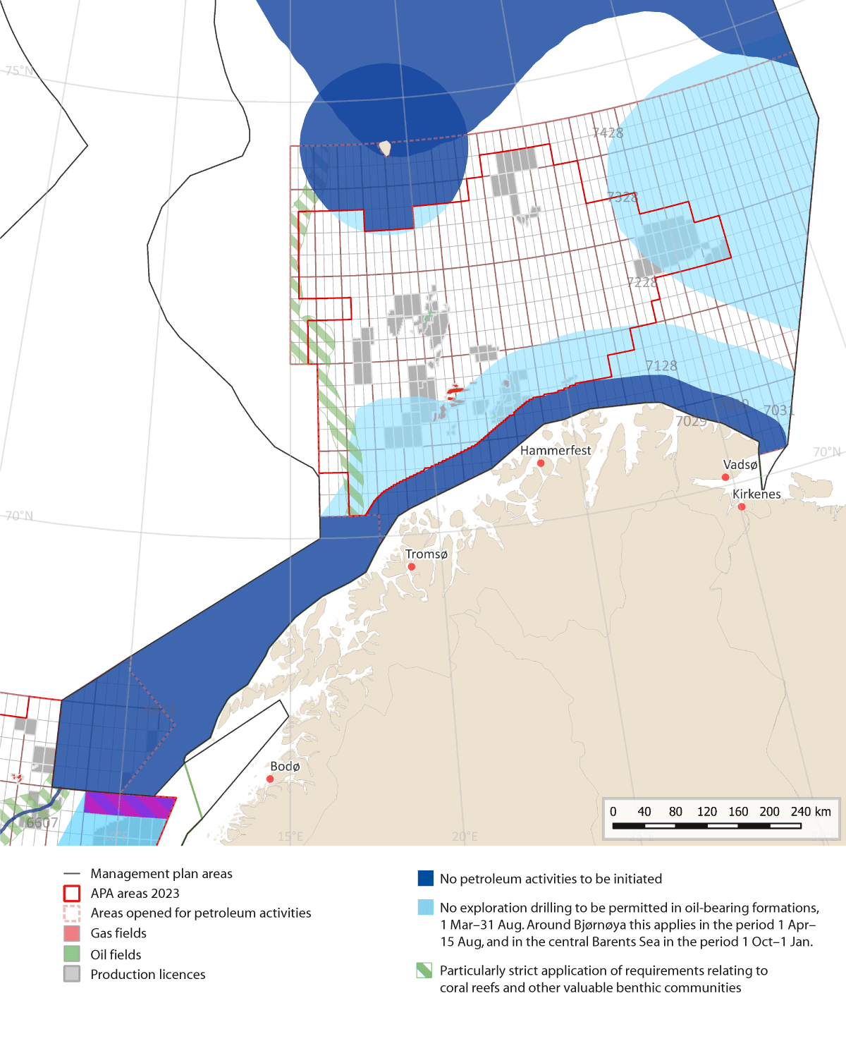
          - Framework for petroleum activities in the Barents Sea–Lofoten area.
Source: Norwegian Environment Agency/Norwegian Offshore Directorate/Marine spatial management tool
- Coastal waters off Troms and Finnmark county to the Russian border
  - No petroleum activities will be initiated within a zone stretching 35 km outwards from the baseline from the Troms II petroleum province along the coast to the Russian border.
  - In a zone stretching between 35 km and 100 km outwards from the baseline, no exploration drilling in oil-bearing formations will be permitted in the period 1 March–31 August.
- Tromsøflaket bank area (as shown in Figure 10.1)
  - In coastal waters of the Tromsøflaket, restrictions apply corresponding to those set out in the framework for the area ‘coastal waters, Troms and Finnmark county to the Russian border’.
  - No exploration drilling will be permitted in oil-bearing formations on the Tromsøflaket outside 65 km from the baseline in the period 1 March–31 August.
- Eggakanten North
  - There is a general principle that new production licences must include requirements for surveys to identify any coral reefs or other valuable benthic communities that may be affected by petroleum activities and ensure that they are not damaged. This will be particularly strictly applied in the Eggakanten North area. Special conditions may be included in licences in vulnerable areas to avoid damage.
- The marginal ice zone
  - No new petroleum activities will be initiated in areas where sea ice is found on more than 15 % of the days in April, based on sea ice extent data for the 30-year period 1993–2022.
- Bjørnøya
  - No new petroleum activities will be initiated within a 100-km zone around Bjørnøya. This does not apply to the parts of the zone that are included in the system of awards in predefined areas (APA).
  - In the parts of the 100-km zone around Bjørnøya that are included in the APA system, no exploration drilling will be permitted in oil-bearing formations in the period 1 April–15 August.
- Central Barents Sea
  - No exploration drilling will be permitted in oil-bearing formations in the period 1 October–1 January.
- Nordland IV (unopened part), Nordland V (unopened part), Nordland VI (open part), Nordland VI (unopened part), Nordland VII and Troms II
  - The waters off the Lofoten and Vesterålen Islands and Senja will not be opened for petroleum activities and no impact assessments under the Petroleum Act will be carried out in these areas.
- Other conditions
  - In areas less than 50 km from observed sea ice, exploration drilling in oil-bearing formations will not be permitted in the period 15 December–15 June.
Framework for petroleum activities in the Norwegian Sea
The Government will use the following framework as a basis for petroleum activities in the Norwegian Sea.
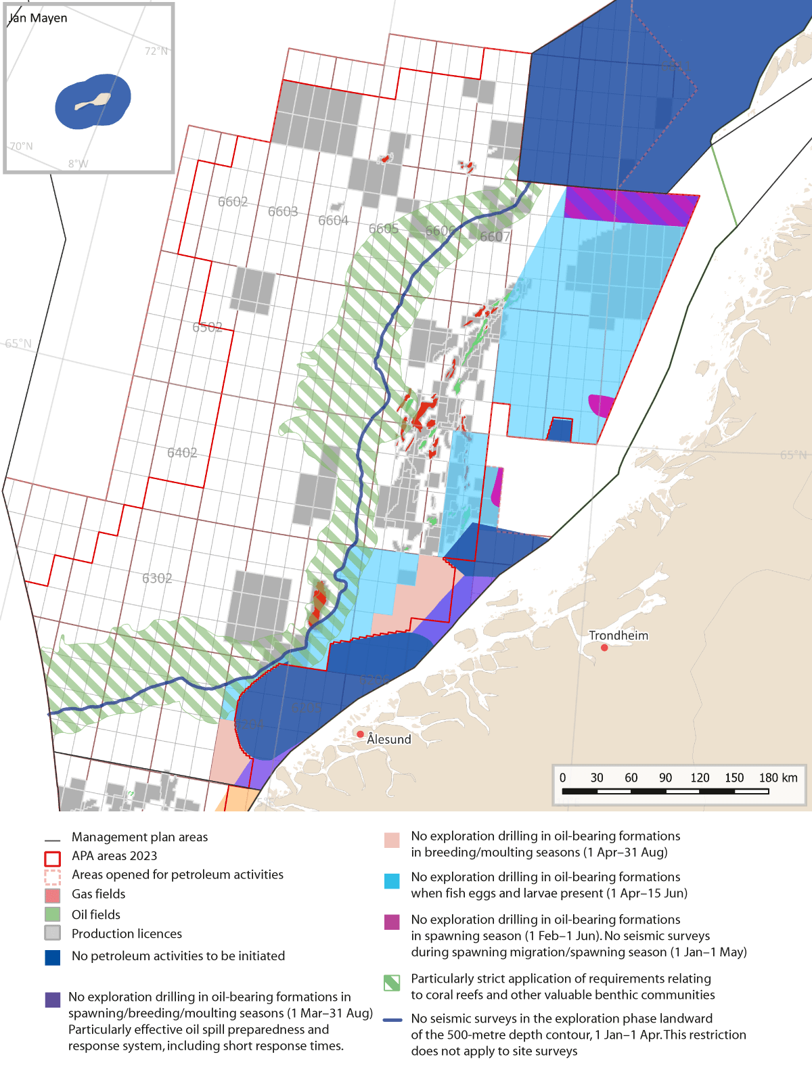
          - Framework for petroleum activities in the Norwegian Sea
Source: Norwegian Environment Agency/Norwegian Offshore Directorate/Marine spatial management tool
a) The Møre banks (as shown in Figure 10.2)
  - No production licences will be awarded for the Møre banks. This does not apply to the parts of the Møre banks that are included in the system of awards in predefined areas (APA).
b) Halten bank, open part
  - No exploration drilling in oil-bearing formations in the spawning season (1 February–1 June).
  - No seismic surveys during spawning migration/in the spawning season (1 January–1 May).
  - Use of technology to deal with drill cuttings and drilling mud on herring spawning grounds.
c) Sklinna bank, open part
  - No exploration drilling in oil-bearing formations in the spawning season (1 February–1 June).
  - No seismic surveys during spawning migration/in the spawning season (1 January–1 May).
  - Use of technology to deal with drill cuttings and drilling mud on herring spawning grounds.
  - Particularly effective oil spill preparedness and response system, including short response times.
d) Coastal waters, northern part
  - No further opening of areas of coastal waters that are not currently open for petroleum activities.
e) Coastal waters, southern part
  - No exploration drilling in oil-bearing formations in spawning/breeding/moulting seasons (1 March–31 August).
  - Particularly effective oil spill preparedness and response system, including short response times.
f) Entrance to the Vestfjorden, open part
  - No exploration drilling in oil-bearing formations in the spawning season (1 February–1 June).
  - No exploration drilling in oil-bearing formations in the breeding and moulting seasons (1 March–31 August).
  - No seismic surveys during spawning migration/in the spawning season (1 January–1 May).
  - Particularly effective oil spill preparedness and response system, including short response times.
Delimitation of the area – blocks: 6609/1, 2, 3 and 6610/1, 2, 3, 6611/1, 2.
g) Iverryggen reef
  - No new petroleum activities will be initiated in the Iverryggen reef area.
h) Froan archipelago/Sula reef
  - No new petroleum activities will be initiated in the Froan archipelago/Sula reef area.
i) Eggakanten South
  - There is a general principle that new production licences must include requirements for surveys to identify any coral reefs or other valuable benthic communities that may be affected by petroleum activities and ensure that they are not damaged. This will be particularly strictly applied in the Eggakanten South area. Special conditions may be included in licences to avoid damage.
j) Jan Mayen/West Ice
  - No petroleum activities will be initiated around Jan Mayen.
k) Other areas that have been opened for petroleum activities in the Norwegian Sea
  - No seismic surveys in the exploration phase are to be carried out landward of the 500-metre depth contour in the period 1 January–1 April. This restriction does not apply to site surveys.
  - No exploration drilling in oil-bearing formations in the period 1 April–15 June in the blocks 6204/1,2,3,4,5,7,8 and 6304/12 within the 500-metre depth contour; quadrant 6305 within the 500-metre depth contour, quadrants 6306, 6307, 6407/2,3,5,6,8,9,11,12; 6408/4,7; 6508, 6509, 6510, 6608/3,5,6,7,8,9,10,11,12; 6609, 6610 and 6611.
  - No exploration drilling in oil-bearing formations in the breeding and moulting seasons (1 April–31 August) in the blocks 6204/7,8,10,11; 6306/6,8,9; 6307/1,2,3,4,5,7.
Framework for petroleum activities in the North Sea and Skagerrak
The Government will use the following framework as a basis for petroleum activities in the North Sea and Skagerrak.
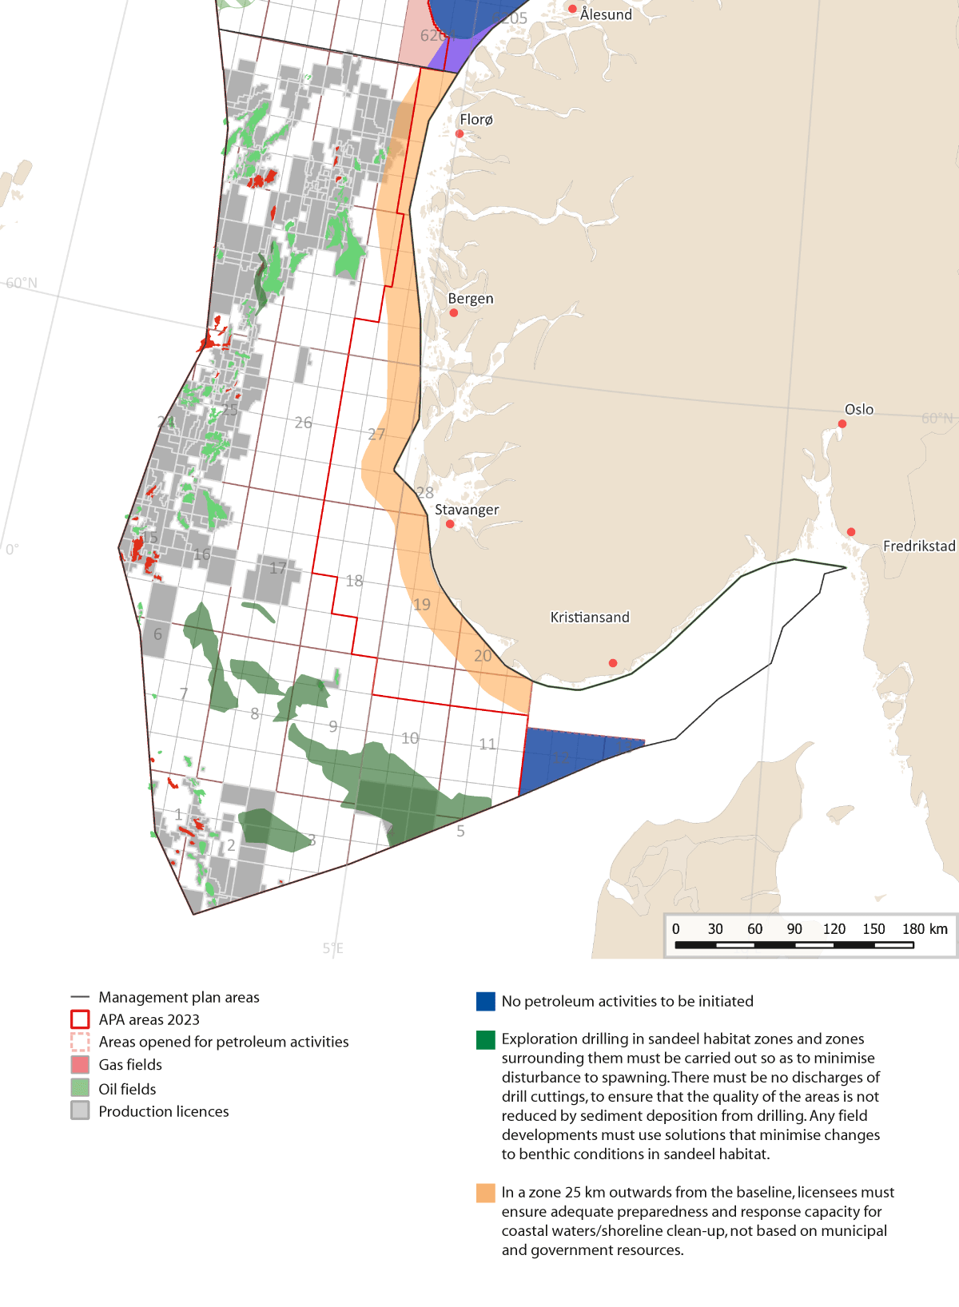
          - Framework for petroleum activities in the North Sea and Skagerrak
Source: Norwegian Environment Agency/Norwegian Offshore Directorate/Marine spatial management tool
a) Skagerrak
  - No petroleum activities will be initiated in the Skagerrak.
b) North Sea coastal waters
  - In a zone stretching 25 km outwards from the baseline, licensees must ensure adequate preparedness and response capacity for coastal waters and shoreline clean-up that is not based on municipal and government resources.
c) Sandeel habitat south and sandeel habitat north (Viking Bank)
  - Exploration drilling in the areas of sandeel habitat and in a zone surrounding them must be carried out in a way that minimises disturbance to spawning, and there must be no discharges of drill cuttings, to ensure that the quality of these areas is not reduced by sediment deposition from drilling activities.
  - Any field developments in these areas must use solutions that keep changes to benthic conditions in the areas of sandeel habitat to a minimum.

Extraction of seabed minerals
Norway’s strategy for management of the mineral resources on its continental shelf was described in a white paper published in 2023 (Meld. St. 25 (2022–2023)), and has since been debated by the Storting. The Government described a step-by-step approach to the development of seabed mineral activities. Developments are to be based on the precautionary approach and the best available scientific information at all stages of the process. According to the white paper, the Government will incorporate any relevant framework determined for seabed mineral activities into the integrated ocean management plans. Each time the Ministry of Energy announces that new areas are to be opened for licensing, it will use new and updated information obtained from both governmental and commercial actors as a basis for the procedure. The Ministry will assess whether opening of specific areas for mineral extraction should be avoided in the interests of the natural environment.
Some particularly relevant points from the framework and measures set out in the white paper on mineral activities on the continental shelf and the debate in the Storting are listed below.
The Government will:
- not permit extraction from active hydrothermal structures, and protect such structures so that they are not damaged by activities in nearby areas;
- only approve plans for the extraction of mineral deposits if it can be substantiated that extraction can be carried out in a way that does not entail substantial negative impacts on biodiversity associated with the active hydrothermal structures;
- submit the first plans for exploitation of mineral deposits on the seabed to the Storting for approval;
- build up knowledge about how seabed mineral activities may affect biodiversity in deep-water areas.

Offshore wind power
The Government will promote large-scale developments in offshore wind power as part of the effort to achieve Norway’s climate targets. To ensure that the offshore wind industry is sustainable, it is important to find solutions that take into account climate and environmental considerations and the need for coordination and coexistence with other industries. Suitable areas for offshore wind power were identified by a working group led by the Norwegian Water Resources and Energy Directorate, which highlighted the interests of other industries and environmental considerations in its recommendations. The selected areas will be considered more closely as developments continue.
The Government will:
- Carry out field studies to improve knowledge of biodiversity and the environment in areas that are being considered for wind power developments in 2025, in line with the Government’s overall plan for mapping biodiversity in areas identified as suitable for wind power.

Sustainable, safe food production from the oceans
Norwegian fisheries and aquaculture management has evolved over many decades as new knowledge has developed. Norway is one of the world’s leading coastal states in sustainable harvesting and use of the oceans, and intends to maintain this position. This development will continue. Monitoring results indicate that concentrations of contaminants are generally below the maximum permitted levels for food safety, but frequent monitoring is needed so that action can be taken if these levels are exceeded.
The objective of Norwegian fisheries management is to ensure that the fisheries are sustainable, including the extent of their impacts on the seabed. The introduction of measures to protect seabed/habitat types that may be of great importance for ecosystems needs to be assessed on an ongoing basis. It is also necessary to improve knowledge of the impacts of the fisheries so that ecosystem status can be assessed.
The Government will:
- enhance knowledge about the impacts on ecosystems of harvesting new species and harvesting at lower trophic levels for all Norwegian sea areas;
- continue to build up the knowledge base for the management and sustainable harvesting of snow crab in the Barents Sea;
- continue to collect data on bycatches and assess whether further measures are needed to reduce bycatches of marine mammals in fisheries;
- continue efforts to prevent and expose fisheries crime;
- support measures and initiatives to improve resource utilisation in the seafood value chain;
- maintain good monitoring systems for documenting healthy and safe seafood;
- build up knowledge about the impacts of Danish seining and bottom trawling on the ecological functioning and biodiversity of marine ecosystems;
- compile spatial data on the management plan areas and make such data available through public map services such as the BarentsWatch marine spatial management tool; this will among other things facilitate effective evaluation of the environmental pressures and impacts associated with offshore aquaculture;
- compile an overview of information on the migration routes of wild salmon, and use this to model the migration routes of salmon smolt in and around areas for which impact assessments of offshore aquaculture are to be carried out; in addition, more data will be collected to improve and validate the models;
- build up knowledge about the impacts of aquaculture on carbon sinks and ecosystems, for example through environmental surveys of areas where there are aquaculture operations;
- build up knowledge about the impacts of offshore aquaculture (including goods and services for the industry) on biodiversity, for example through environmental surveys of areas where there are aquaculture operations;
- develop a licensing system for offshore aquaculture, including strict requirements relating to biodiversity and the coexistence of different ocean industries;
- ensure that the relevant authorities are involved in the design of future programmes for overall impact assessments for offshore aquaculture activities, and of guidelines for impact assessments and applications for specific offshore aquaculture projects;
- generate knowledge about pressures and impacts on local seabird populations associated with offshore aquaculture, including compiling data on seabird habitat use, for example through environmental surveys of areas where there are aquaculture operations;
- in cooperation with the Institute of Marine Research, establish a working group involving relevant directorates to strengthen the knowledge base on the environmental impacts of offshore aquaculture.

Safe, environmentally friendly maritime transport
The maritime safety level in Norwegian waters is generally high. In recent years, there has been a certain increase in the number of accidents, but the number of serious accidents involving large-scale spills has been reduced. A continued decline in the risk of accidents is expected up to 2040. Measures to prevent the spread of alien organisms are described in Chapter 10.1.5, and measures to limit underwater noise from shipping in Chapter 10.1.8. Acute pollution from shipping can result in serious environmental damage. The Norwegian Maritime Authority and the Norwegian Coastal Administration tailor the action they take to trends in maritime transport and the risk of accidents in Norwegian waters. The importance of sewage discharges and inputs of nutrients varies from one part of the Norwegian coastline to another. For example, the pressures and impacts associated with sewage discharges are generally higher in the coastal waters of the Skagerrak than in marine and coastal waters in the north. The rules on sewage discharges from shipping that have been introduced in neighbouring areas such as the Baltic Sea are stricter than those for the Skagerrak.
The Government will:
- further develop and tailor maritime safety measures to developments in maritime transport and the risk of accidents in Norwegian waters: this work will be organised to give priority to measures that give the greatest possible risk reduction at the lowest possible cost;
- implement international rules on sewage discharges from shipping in the Skagerrak.

Military shooting and exercise areas
Offshore military shooting and exercise areas are essential to the Norwegian Armed Forces’ operational activities and for national emergency preparedness and crisis management capabilities. The designated areas meet the Armed Forces’ needs for training and exercise of personnel, and make it possible to test equipment without the need for long-distance movements in advance. These areas are particularly important in security policy terms since a Norwegian maritime presence strengthens the exercise of sovereignty, supports operational needs, and facilitates exercises and training with allies, particularly in northern waters.
The Government will:
- continue the established practice of regulating military shooting and exercise areas in waters out to one nautical mile outside the baseline under the Planning and Building Act;
- adopt regulations designating military shooting and exercise areas outside one nautical mile beyond the baseline as areas of importance to the Norwegian Armed Forces where access can be prohibited under the Security Act;
- introduce a duty for the Norwegian Armed Forces to draw up instructions for shooting areas that provide guidelines for defence activities and specify how environmental concerns are to be taken into account.

Spatial data as a basis for area-based conservation and sustainable use
The management plans are a tool for spatial management of Norway’s ocean areas. Sound knowledge of these areas and marine ecosystems is an essential basis for finding a balance between conservation and sustainable use across sectors. Activities in each management plan area are regulated on the basis of existing legislation governing different sectors.
The Government will:
- provide for access to spatial data from research, the public administration and commercial actors and make the information available through public map services such as the marine spatial management tool on the BarentsWatch portal.

Strengthening the knowledge base on the oceans and climate change – mapping, monitoring and marine research
There is a sound scientific basis for Norway’s ocean management regime. However, there are still many gaps in our understanding of the marine and coastal environment, and further development of knowledge and expertise is needed. Further developing our understanding of the oceans and coastal waters is a vital basis for sustainable management of marine ecosystems.
The oceans play a vital role in climate regulation and in moderating global warming by absorbing excess heat and CO2. In an ecosystem-based management regime for marine and coastal waters, the impacts of climate change must be considered together with those of other drivers of change. In addition, the management regime must be tailored to changes in climatic and environmental conditions. Climate change adds to the challenges of ensuring the sustainability of the overall management regime and patterns of resource exploitation. At the same time, the knowledge base underpinning the ocean management regime must be further developed.
We need more knowledge and a better understanding of ecosystem functioning and the impacts on ecosystems of factors such as human activity, climate change, ocean acidification, pollution, and plastic and microplastics. This understanding is a vital basis for sustainable ocean management, use of natural resources, innovation and economic development. The UN Decade of Ocean Science for Sustainable Development (2021–2030) is highlighting the need to further develop knowledge and put it to use in seeking to improve ocean management. Continued efforts to build fundamental knowledge are still needed, for example by mapping the seabed.
The Government will:
- facilitate the generation of knowledge about the oceans and climate change through mapping, monitoring and research, and by strengthening expertise and intensifying cross-sectoral cooperation between key agencies and research institutes;
- build up knowledge and a better understanding of ecosystem functioning and ecological relationships, and about the cumulative impacts of different drivers;
- learn more about the impacts climate change will have on marine ecosystems and species, what interactions there will be with other local and large-scale drivers, and the implications for ocean management;
- map habitats that are important in connection with CO2 uptake and adaptation to climate change;
- map the carbon content of sediments in Norwegian waters and analyse the sources of the carbon;
- consider whether monitoring and if possible forecasting of marine heatwaves can be introduced;
- enhance knowledge about the ecological relationships between marine and coastal waters;
- continue the MAREANO programme for mapping the seabed in Norway’s marine and coastal waters.

International ocean cooperation
Ocean management, sustainable use of ocean resources and conservation of the marine environment are key elements of Norway’s foreign and development policy. Norway’s ocean management plans have provided inspiration for a number of countries we cooperate with and for the work of the High-level Panel for a Sustainable Ocean Economy (Ocean Panel).
Norway will continue to play a leading role internationally in work on the ocean and sustainable ocean management, both through active participation in global and regional ocean cooperation and by continuing to seek the expansion of research and knowledge generation relating to the ocean, the ocean environment, and the management and sustainable use of ocean resources.
The Government will:
- promote integrated, ecosystem-based management in international ocean cooperation;
- seek to ensure the inclusion of sustainable ocean plans, a tool recommended by the Ocean Panel, as a key element of work under the 2025 UN Ocean Conference in Nice, and use the conference to secure broad support for the Ocean Panel’s agenda up to 2030;
- through the Ocean Panel, provide support for developing countries in developing sustainable ocean plans;
- work towards the conclusion in 2024 of an ambitious global instrument with the aim of ending plastic pollution by 2040;
- work towards Norwegian ratification of the new Agreement on the Conservation and Sustainable Use of Marine Biological Diversity of Areas Beyond National Jurisdiction (the BBNJ Agreement) before the 2025 UN Ocean Conference;
- continue to support the efforts of developing countries to combat marine litter and plastic waste;
- continue to work within the International Seabed Authority (ISA) towards the adoption of regulations governing the exploitation of seabed minerals in the international seabed Area in line with Norwegian positions;
- continue Norway’s active role in the development of new climate- and environment-related requirements for shipping under IMO;
- work towards the establishment of a new global science-policy panel on chemicals, waste and pollution prevention, on the lines of the IPCC and IPBES;
- continue support for combating illegal, unreported and unregulated fishing (IUU fishing) in developing countries; an important element of this will be continued financial support for capacity building and implementation of the Port State Measures Agreement (PSMA);
- continue the efforts of the Blue Justice initiative to combat fisheries crime;
- work internationally towards sustainable management and restoration of existing carbon sinks in marine ecosystems, such as mangrove forests, eelgrass meadows and kelp forests;
- continue to share relevant and valuable expertise and experience in the field of sustainable fisheries and ocean management to assist developing countries in establishing sustainable ocean management regimes;
- expand the Oceans for Development programme in the next few years to include at least two more cooperating countries;
- continue to support the efforts of developing countries to reduce greenhouse gas emissions from shipping in the period up to 2030 through support to the GreenVoyage2050 project;
- strengthen the links between sustainable ocean management and promoting the role of aquatic food in sustainable food systems in forums including the Global Action Network Sustainable Food from the Oceans and Inland Waters for Food Security and Nutrition, the EAF-Nansen programme and other relevant forums and UN processes;
- continue to support the work of the Intergovernmental Oceanographic Commission (UNESCO-IOC) on the UN Decade of Ocean Science for Sustainable Development, and advocate the implementation of knowledge-based ocean management globally;
- ensure that Norwegian research institutes and groups are actively involved in implementation of the UN Decade of Ocean Science for Sustainable Development;
- continue cooperation on the marine environment within OSPAR to ensure good ecological status in the North East Atlantic, including Norwegian waters;
- focus on the oceans during Norway’s chairship of the Arctic Council; important topics include marine biodiversity, ecosystem-based ocean management, marine litter, strengthening cooperation on emergency preparedness and safe shipping in the Arctic, and green shipping initiatives;
- continue cooperation on the oceans and climate change through the Nordic Council of Ministers, using the joint statement on a sustainable ocean economy and the green transition made by the Nordic prime ministers in Oslo in 2022 as a starting point;
- play a part in ensuring that the Commission for the Conservation of Antarctic Marine Living Resources (CCAMLR) continues to be a pioneering organisation in the development of ecosystem-based regional resource management regimes.

Further development of the management plan system
As part of the integrated ocean management plans, goals have been set for the Government’s ocean policy and for management of the three management plan areas. These goals concern ecosystem condition, value creation, coexistence between ocean industries, conservation and sustainable use. The goals have gone through various stages of development from 2002 onwards, but in the previous white paper on Norway’s integrated ocean management plans, in 2020, they were harmonised so that each goal now applies to all three management plan areas. Some of them were also clarified and simplified to facilitate reporting on progress towards the goals.
However, the wording of the goals needs to be further tightened up and adjusted and their structure and organisation by thematic areas needs to be updated. This will reduce the need to interpret their scope and meaning, and will simplify reporting on progress towards the goals. Over time, assessments of progress towards the goals will also become more systematic and verifiable. A review of the goals may also reveal thematic areas where there is a lack of operational goals and make it possible to include new goals where gaps are identified.
An important element of the management plan system is the consistent involvement of relevant stakeholders in the process of updating the management plans every four years.
The Government will:
- ask the Forum for Integrated Ocean Management to draw up a plan for ensuring the participation of relevant stakeholders in the preparation of the scientific basis for the next white paper on the ocean management plans;
- review and update the structure and organisation of the goals for the ocean management plans;
- use the updated goals to report on progress towards the goals in the next white paper on the ocean management plans;
- present the next white paper on Norway’s integrated ocean management plans in 2028.

Economic and administrative consequences
This white paper focuses mainly on the further development of existing policy instruments and measures. Management of Norway’s seas and oceans is to be based on the best possible knowledge, and the intention is to enhance knowledge about ecosystem-based management of Norwegian waters through mapping, monitoring and research.
Measures announced in this white paper will be funded within the existing budgetary framework.
The economic and administrative consequences of the measures proposed in the white paper can be predicted with varying degrees of accuracy, but as the proposals are implemented, the consequences for public and private actors will be assessed in the usual way as set out in Norway’s official instructions for planning and management of central government programmes and projects.
The Ministry of Climate and Environment
recommends:
that the Recommendation by the Ministry of Climate and Environment concerning Norway’s integrated ocean management plans – Barents Sea–Lofoten area; the Norwegian Sea; and the North Sea and Skagerrak dated 5 April 2024 should be sent to the Storting.

