The Norwegian industry – competitiveness for a new time

Meld. St. 16 (2024–2025) Report to the Storting (white paper)

Presented by the Minister of Trade and Industry Cecilie T. Myrseth

Summary

|  |
| --- |
| Did you know that Norwegian industry…  … is a stable supplier of 1/3 of Europe’s natural gas, important for energy and industry, reducing CO2 emissions by 50% when replacing coal?  … has been based on ~100% renewable power for more than 100 years?  … is a leading supplier to Europe and the United States of several critical raw materials for the green and digital transitions, incl. aluminum and silicon?  … includes leading suppliers of technology and services to new green technologies like offshore wind and carbon capture and storage?  … hosts some of the key suppliers to the defense industry in Europe and the US, including advanced weapons systems and ammunition?  … is the world’s second largest exporter of seafood?  … is highly integrated in international value chains and is an important producer of nickel, cobalt, graphite and ferrosilicon for the global market?  … is an integral part of the internal market as a member of the European Economic Area (EEA)? |

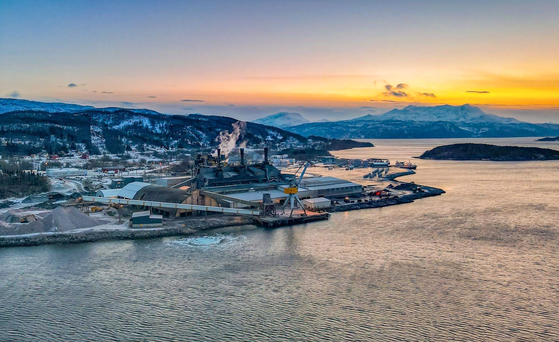

Photo: Finnfjord. Production of ferrosilicon, a high-quality product that is an important raw material in the steel industry.

In Spring 2025 the Norwegian Government presented a new white paper on industrial policy. The white paper describes the state of play for Norwegian industry and sets out political priorities for the future.

Norwegian industry is doing well. The industrial sector currently represents around 11 percent of all Norwegian business revenue, and production remains at a high level. The sector’s revenue reached a new record high in 2024, and more growth, increased exports and job growth is expected.

However, the backdrop of this white paper is a complex one. The uncertain geopolitical situation, climate and environmental challenges, and the rapid technological development proposes both opportunities and challenges for the Norwegian industry.

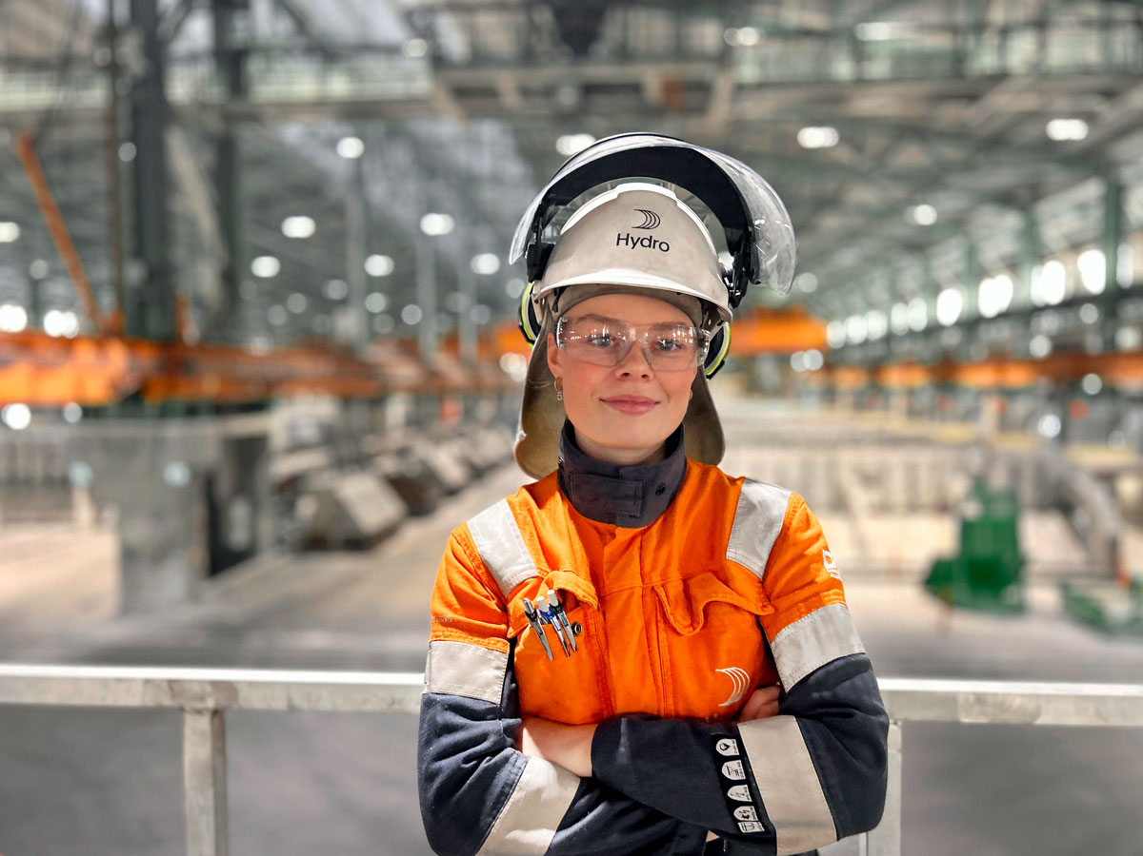

Photo: Hydro. Production of primary aluminum at Europe’s biggest aluminum works.

The object of Norway’s industrial policy is to contribute to incresed value creation, facilitate profitable private investments and making our business more adaptable for the green transition.

To support this objective, the white paper on industry focuses on horizontal policies which apply across the industrial sector. These policies include but are not limited to taxation, competitiveness policy, efficiency in the public administration, access to energy, access to labor and competence, access to markets, access to capital, research and innovation, digitalization, climate and the environment, management of natural areas, transport infrastructure, as well as security and preparedness.

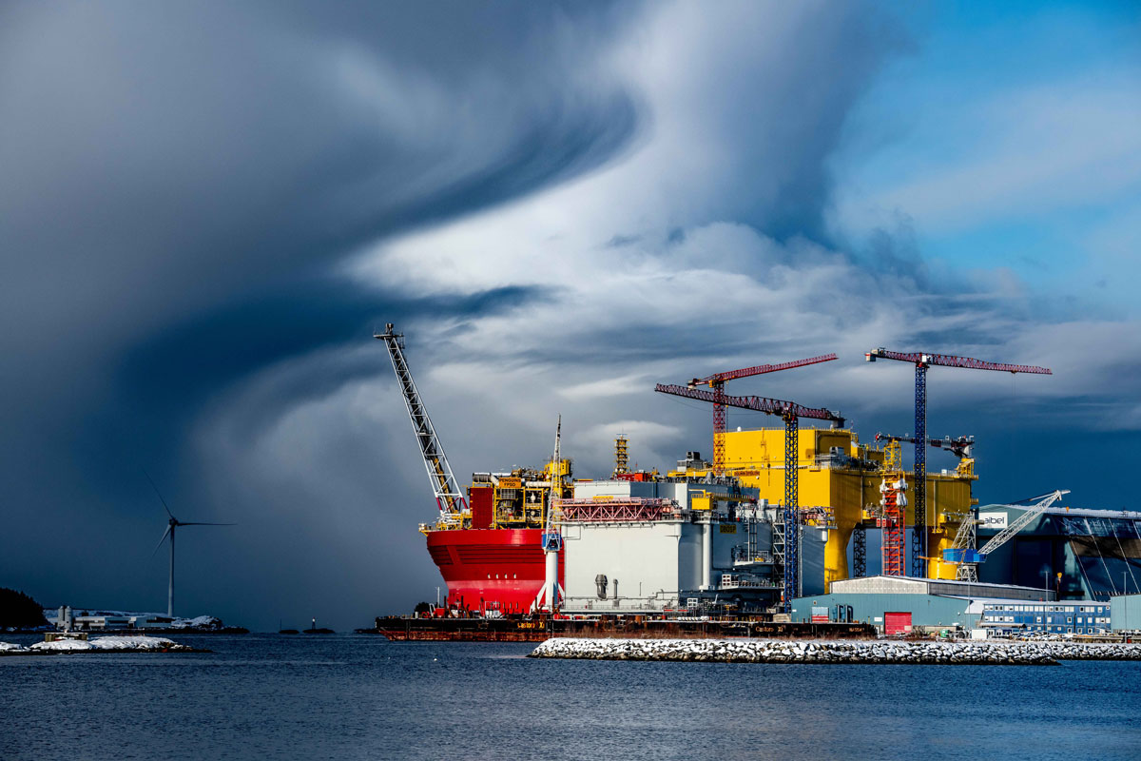

Photo: Aibel. Production of platforms for offshore wind farms (Dogger Bank C and DolWin epsilon).

The white paper outlines six industrial policy priorities to promote value creation, profitable investments and jobs.

|  |
| --- |
| The Norwegian Government’s main priorities for the industrial policy is that Norwegian industry shall   1. have access to clean and affordable power. 2. have access to competent workforce and a well-organized work life. 3. be innovative and develop and utilize new technology. 4. contribute to the low emission society. 5. have good market access. 6. support the Government’s security and emergency preparedness policy. |

Norwegian industry is spread across the entire country and is important for many local communities. The geographical spread of the industry reflects the country’s many natural advantages, like access to renewable hydroelectric power, occurrence of raw materials and proximity to the coast.

This white paper echoes many of the same priorities of Norway’s trading partners and allies, even though it is mainly based on the particularities of Norway’s situation, with our unique challenges and opportunities. As an example, the Norwegian priorities for industrial policy in many areas echo the EU Commission’s proposal for the Clean Industrial Deal.

In times of uncertainty, the Government will contribute with good, predictable and stable framework conditions. This white paper on industry will facilitate private investments and further growth, in line with the tripartite cooperation and the Norwegian model. This is about ensuring our competitiveness for a new era.

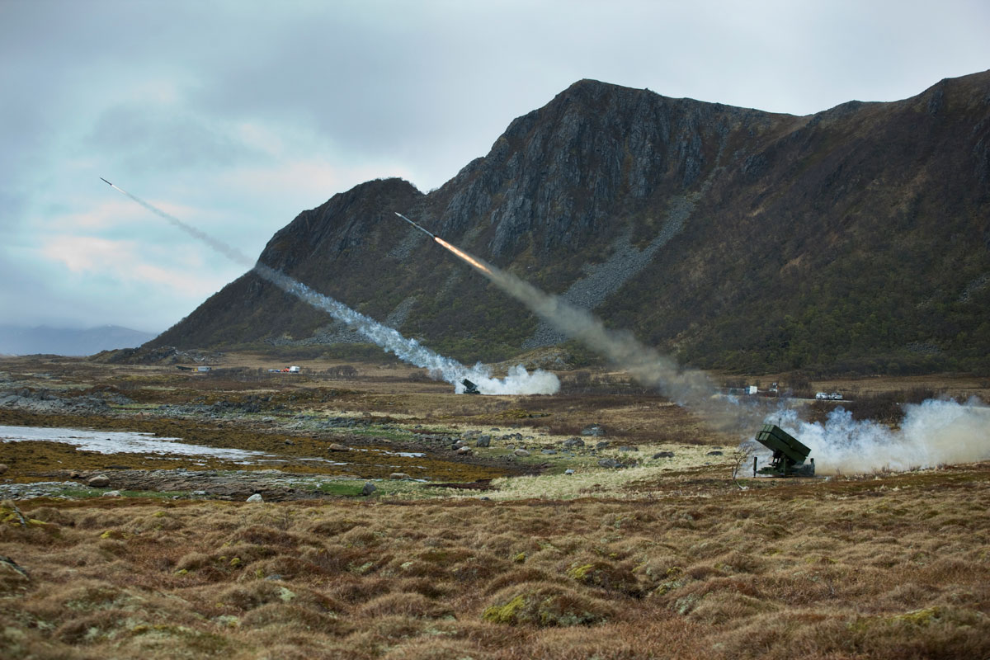

Photo: Kongsberg Defence & Aerospace. NASAMS (Norwegian Advanced Surface-to-Air Missile System).