Strategy for Gender Equality 2025–2030

Preface
The Norwegian government has set ambitious goals for equality. An equal society forms the foundation for everyone to live a fulfilling life and for building a better society. We now present the first-ever gender equality strategy from a Norwegian government. We want everyone, regardless of their gender, to have more freedom and the opportunity to live the life they want. The Strategy for Gender Equality is an important step towards realising this vision.
Equality concerns all of us and impacts every area of society. A key element of equality policy is therefore incorporating the equality perspective into all levels of policymaking – national, regional and local. This means that every ministry is responsible for equality within its respective field, while the Ministry of Culture and Equality is responsible for coordination.
We are launching this strategy to ensure coherence and consistency in all gender equality policies. The strategy serves as a framework to coordinate national efforts to address key challenges within equality. We will continue to work actively, purposefully and systematically to promote equality and prevent discrimination.
The government’s objectives are: (1) Financial independence and equality in the labour market, (2) Fewer gendered educational choices, (3) A society without violence, rape, sexual and online harassment, (4) Freedom from negative social control and honour-based violence, (5) Better health for women and men, and (6) Effective national mechanisms for promoting gender equality.
To achieve these objectives, we need to understand the current situation and how it is changing. We have therefore devised a set of indicators to track the annual progress in each of the six objectives. We will closely monitor developments and implement measures as necessary. This framework is groundbreaking and allows us to adjust our direction if necessary. We will be measured based on whether we are heading in the right direction and will adapt our efforts and introduce new measures if necessary.
A closer focus on the specific equality challenges faced by men is also long overdue. We will elevate the discourse on equality for boys and men. The government has therefore decided to present a White Paper on this topic, in addition to this strategy. The proposals from the Men’s Equality Commission’s report will be evaluated and followed up in this White Paper.
On behalf of the Norwegian government,
Lubna Jaffery – Minister of Culture and Equality
Tonje Brenna – Minister of Labour vand Social Inclusion
Jan Christian Vestre – Minister of Health and Care Services
Kjersti Toppe – Minister of Children and Families
Bjørn Arild Gram – Minister of Defence
Emilie Enger Mehl – Minister of Justice and Public Security
Karianne Oldernes Tung – Minister of Digitalisation and Public Governance
Cecilie Myrseth – Minister of Trade and Industry
Kari Nessa Nordtun – Minister of Education
Oddmund Løkensgard Hoel – Minister of Research and Higher Education
Marianne Sivertsen Næss – Minister of Fisheries and Ocean Policy

Introduction
Norway is a global leader in gender equality and its numerous legislative changes and initiatives in this area have paved the way for other countries. Through the Strategy for Gender Equality, Norway will continue to set the standard as a leading role model.
Nevertheless, we still face challenges, which is why the government has outlined six objectives for gender equality policy going forward. For example, women still earn less than men, and more women than men work part time. Women are also overrepresented among those subjected to sexual harassment, domestic violence and intimate partner killings. Meanwhile, men are overrepresented in suicide statistics. Gender disparities in education continue to grow as the proportion of women with a higher education is increasing at a faster rate than that of men. Consequently, the education gap is also widening.
There is generally strong support for equality within the population. The majority of men and women believe that advancements in equality should continue. Meanwhile, we are also seeing a tendency for greater polarisation between young women and young men in Norway. More young men than older men are also opposed to the further advancement of equality. This serves as a reminder that even in Norway we should not take gender equality for granted. As the Men’s Equality Commission points out, there is still more work to be done. We must elevate policies aimed at boys and men. Boys and men, girls and women must be involved in building an equal society with universal equal opportunities.
Gender equality in Norway cannot be viewed in isolation from gender equality worldwide. In many parts of the world, the rights of women, girls and LGBT+ persons are being curtailed and opposed by well-organised and influential actors, including radical right-wing forces and religiously motivated organisations and alliances who view gender equality as a threat to family values, culture and traditions. In addition to being well-organised, these groups operate internationally and are well-funded.
Opposition is particularly focussed on sexual and reproductive health and rights, including abortion rights, the teaching of sexuality in schools and the freedom to promote gender and sexual diversity, as well as basic rights for LGBT+ people. Norway should serve as a counterforce to conservative and regressive forces that seek to strip women and girls of their hard-earned rights. The Norwegian government places a high priority on gender equality in national policy and international efforts.
In A just world is an equal world. Action Plan for Women’s Rights and Gender Equality in Norway’s Foreign and Development Policy (2023–2030), the government has set the framework for Norway’s international efforts within women’s rights and gender equality.
Norway is committed to playing a role in ensuring that the Sustainable Development Goals (SDGs) are achieved by 2030. This strategy will form a core part of Norway’s work on SDG 5: Gender equality. Gender equality is also a prerequisite for achieving most of the other SDGs. This strategy will contribute to the achievement of several other SDGs, including 1, 3, 4, 8, 10 and 16.
This is a strategy for gender equality, but the government recognises that gender is not the only factor in determining our ability to live the lives we want. The interplay between gender and other factors that can lead to discrimination, for example, ethnicity, religion, disability, sexual orientation, gender identity, gender expression and age, also plays a role. The government therefore places a major emphasis on the following efforts:
- A Society For All. The government’s strategy for the equality of persons with disabilities 2020–2030.
- A Society for All – Equality, Democracy and Human Rights. The government’s action plan for the equality of persons with disabilities 2020–2025
- The government’s Action Plan on Gender and Sexual Diversity (2023–2026)
- Action Plan on Racism and Discrimination – New Initiatives 2024–2027
- Action Plan against Anti-Semitism 2025–2030
- Forthcoming action plan to combat harassment and discrimination of the Sámi
- Forthcoming action plan to combat racism and discrimination against Muslims
The Norwegian government has set six objectives within gender equality for the period 2025–2030.

Objective 1: Financial independence and equality in the labour market
Financial independence is about being able to live a free life. Without it, we are not free to make independent choices, and many are unable to escape harmful and violent relationships. Financial independence for women and men is essential for creating a more equal society.
Norway has been a leader in promoting equal participation of women and men in the workforce. The pursuit of gender equality in this area has been a key political initiative. Parental leave, statutory paternity leave, good kindergarten coverage, access to out-of-hours school care, the right to leave for employees with sick children, nursing breaks for mothers and flexible working hours have been crucial in ensuring that both women and men can prioritise paid work.
The main rule in the Norwegian labour force is permanent, full-time positions. Part-time work can be a useful way of including individuals currently outside the labour force, but it can also reinforce traditional gender roles and the gender pay gap.
Achieving equal representation of men and women in positions of power is a political goal. In 2024, Norway was the first country in the world to require at least 40% of each sex on the boards of medium-sized and large companies.
The tripartite cooperation between trade unions, employers and the government is crucial for addressing the major challenges Norway will face in the years ahead. The cooperation must be both binding and strategic, with key objectives, including promoting gender equality efforts in the public and private sector and improving the knowledge base for policy development.

Goals
The government has outlined the following goals, measures and indicators:

Goal 1.1 Higher percentage of full-time and permanent positions in the public and private sector
Status
Norway generally has a well-functioning labour market, characterised by high employment and low unemployment. Employment rates among women, older adults and young people are also high compared to many other European countries. However, fewer women than men are in employment, and more women than men work part time. In 2023, just under 78% of women aged 20–64 years were in employment, compared to slightly more than 83% for men in the same age group. The proportion of women in part-time work is significantly higher than for men. Part-time working varies considerably across industries and sectors. For example, the percentage of women in the state sector who work part time is low (10.5% in 2022). A considerable share of employees in health and care services work part time.
All public-sector employers and large companies in the private sector are required to map involuntary part-time working broken down by sex every two years.
Measures
- Investigate employers’ compliance with the obligation to map involuntary part-time working broken down by sex (Ministry of Culture and Equality).
- Continue pilot projects aimed at reducing part-time working and increasing the proportion of full-time positions. In 2023, NOK 15 million was allocated for implementing these projects and for trailing research on the pilots. The same amount was allocated for 2024, with plans to maintain this level in 2025 (Ministry of Labour and Social Inclusion).
- Help to increase the proportion of full-time positions in the health and care service through the ‘Tørn Project’, which tests new work and organisational structures in primary health and care services. The aim is to promote proper organisation and task distribution in health and care services throughout Norway, while ensuring better use of personnel resources (Ministry of Health and Care Services).
Indicators
- Percentage of employed and unemployed women and men, broken down by region
- Working hours for women and men in employment, broken down by age, industry and county of workplace
- Percentage of men and women in part-time employment who are working part time involuntarily
- Recipients of disability benefit in the population, broken down by sex and age
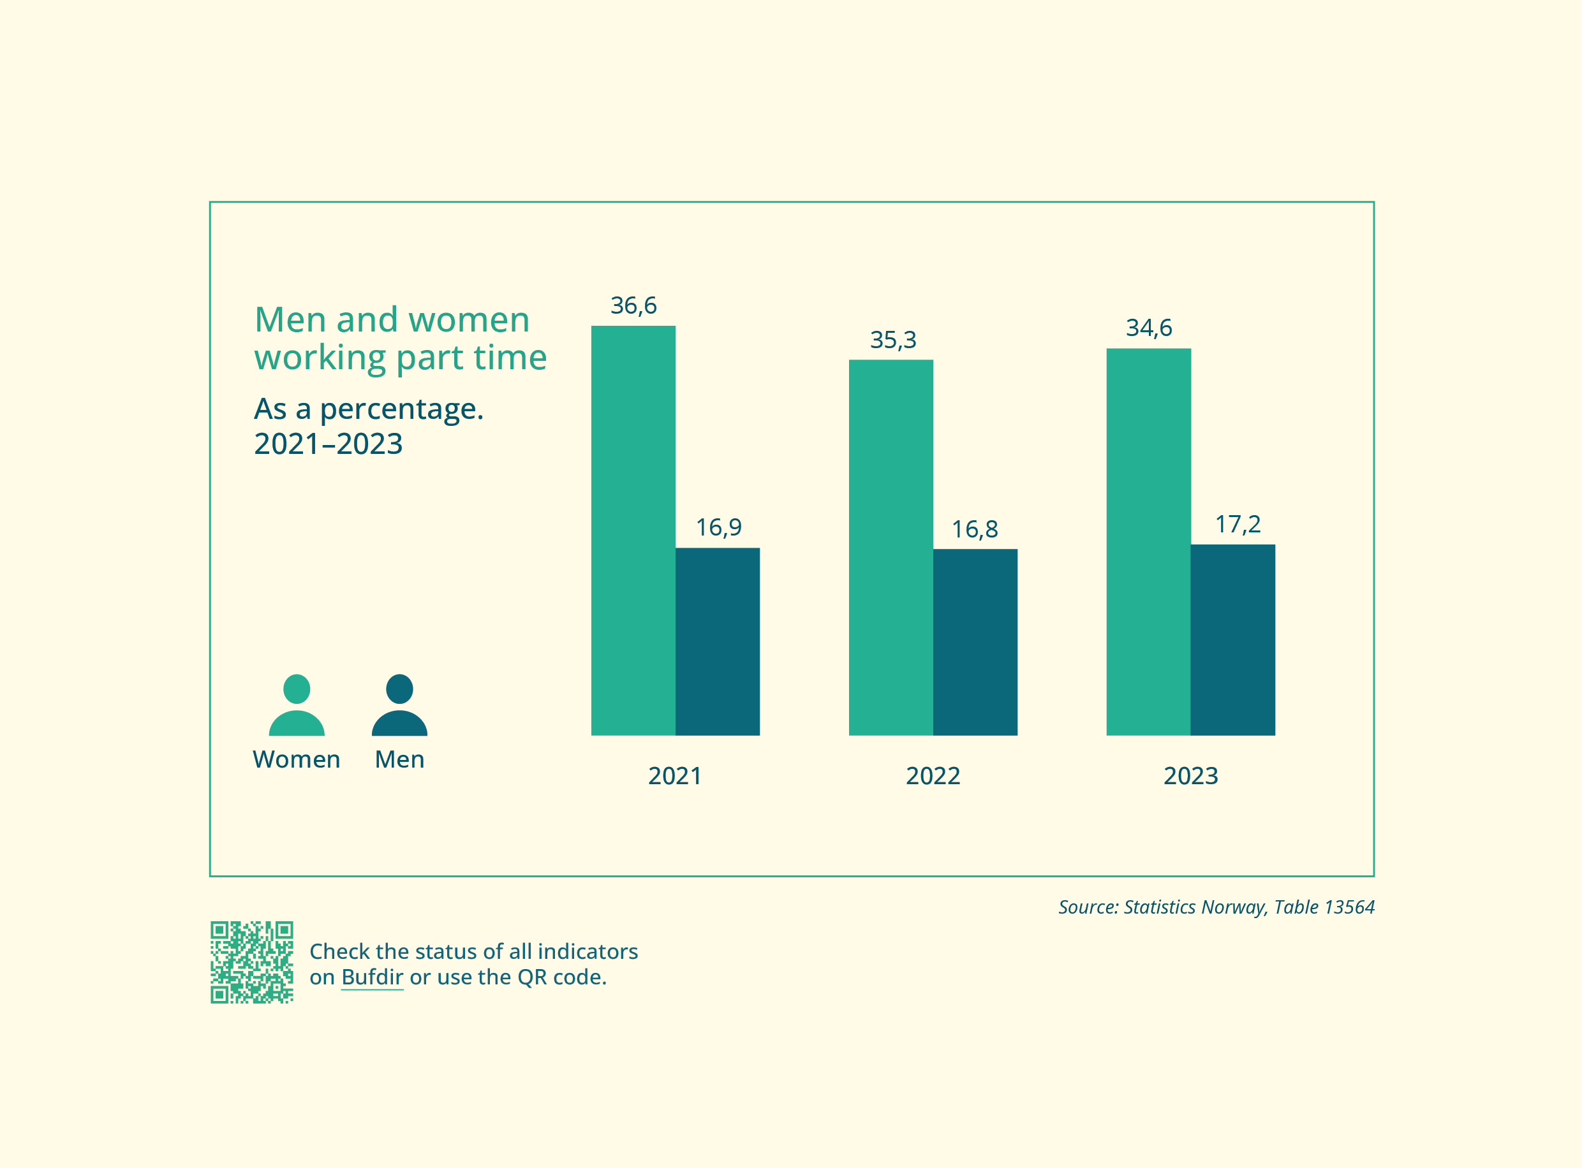

Goal 1.2 Good work-life balance
Status
Gender disparities in the home can have an impact on gender gaps in the labour market and in career trajectories. A clear disparity remains in the amount of time women and men spend on household chores. On average, women spend 1 hour and 23 minutes on housework per day – almost three hours less than in the 1970s. According to Statistics Norway, this is one of the most significant changes in women’s time use over the past 50 years. In contrast, the time that men spent on housework only increased by 14 minutes over the same period, from 38 minutes in 1970 to 52 minutes in 2022. Among couples with children under the age of seven, women typically spend nearly an hour more every day on caregiving tasks than men. This gender gap almost disappears when the couple’s youngest child is seven years old or older.
Despite women – and particularly mothers – spending significantly more time on housework and caregiving, most women and men believe that this work should be shared equally.
In Norway, mothers typically take most of the shared parental leave quota as well as their statutory maternity leave, while fathers tend to only take the statutory paternity leave. Fathers and mothers broadly support reserving parts of the parental leave for fathers, but fathers are more in favour of an arrangement with only two separate leave quotas as opposed to the current three.
Men and women face different challenges in balancing work and family life. According to the Men’s Equality Commission’s report, this is linked to the division of labour within families as well as the gendered labour market. Men lose out because it is difficult to reconcile family life with work norms that are not family-friendly, such as a culture of full-time working and overtime. Meanwhile, women often end up working part time to accommodate family needs. The Men’s Equality Commission has highlighted the need to examine how male-dominated industries can better facilitate men’s participation in caregiving in the home.
The labour market must be based on the principle of gender equality in work and family life. This means that both male-dominated and female-dominated industries must have systems in place to accommodate caregiving responsibilities.
Measures
- Establish a tripartite cooperation for a better work-life balance in male-dominated and female-dominated industries. The work should begin with gathering knowledge. The approach is to be discussed by the Working Group for Gender Equality in the Labour Market under the Council on Labour and Pension Policy (Ministry of Culture and Equality, Ministry of Labour and Social Inclusion).
- Fund surveys on public attitudes to gender equality and analyses of these. Such analyses could, for example, cover attitudes to an equal distribution of family responsibilities and of parental leave between mothers and fathers (Ministry of Culture and Equality).
- Analysis of data from Statistics Norway’s Time Use Survey 2022–2023 (Ministry of Culture and Equality).
- Assess analyses of data from the Generations and Gender Survey 2024 (Ministry of Culture and Equality, Ministry of Children and Families, Ministry of Labour and Social Inclusion).
- The Norwegian Directorate of Health has been tasked with initiating a cooperation with relevant organisations and groups to raise awareness of and improve the implementation of regulations on nursing leave for mothers, as well as to draw up proposals for assessing mothers’ possibilities to combine nursing and work (Ministry of Health and Care Services).
Indicators
- Average number of days with parental benefit for men compared to women
- Unpaid leave after the parental benefit period, broken down by sex
- Average time spent on various forms of housework per day, broken down by sex and age
- Attitudes to home and family responsibilities, broken down by sex
- Perception of gender equality in caregiving and housework, broken down by sex
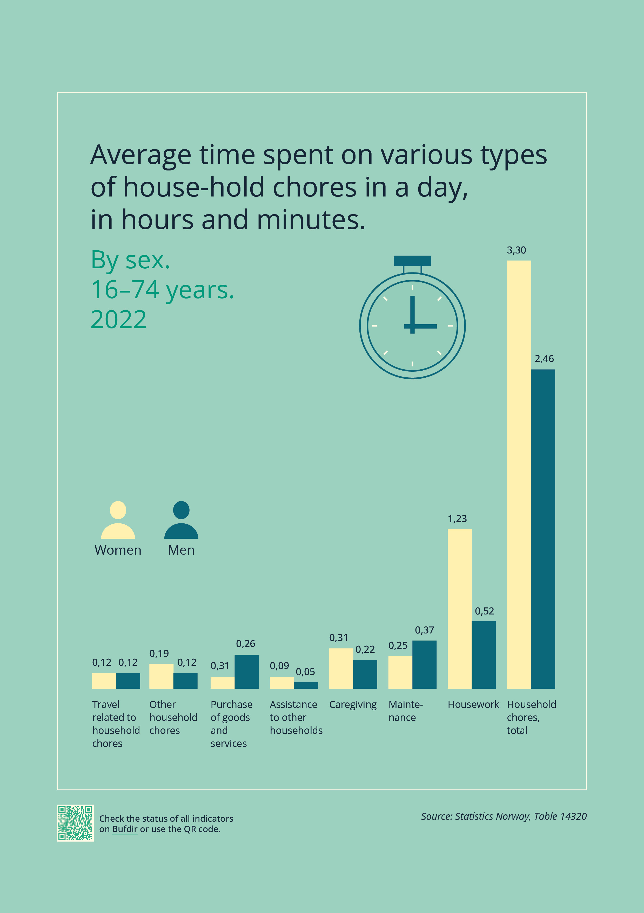

Goal 1.3 Continue the good coverage of high-quality, affordable out-of-hours school care and kindergartens
Status
Access to kindergartens is a key component of equality in the labour market, and almost all pre-school children in Norway attend a kindergarten. Kindergartens are beneficial for children’s development and help facilitate parents’ participation in the labour force. All local authorities shall provide before- and after-school care for children in Years 1–4 and those with special needs in Years 1–7. This is necessary for managing working life and family life, and is also valuable in terms of integration.
Measures
- Reduction in the maximum charge for a kindergarten place from NOK 3000 to NOK 2000, and to NOK 1500 in the least central municipalities, starting 1 August 2024 (Ministry of Education and Research).
- Free kindergarten place for the third child and any subsequent children attending kindergarten simultaneously, starting 1 August 2023 (Ministry of Education and Research).
- Free kindergarten places for all children in the designated Action Zone in Nord-Troms and Finnmark (Ministry of Education and Research).
- Earmarked funding for information and recruitment efforts in municipalities facing particular challenges in enrolling children from minority language backgrounds in kindergarten (Ministry of Education and Research).
- Twelve hours of out-of-hours school care per week for Year 1 from autumn 2022, for Year 2 from autumn 2023 and for Year 3 from autumn 2024 (Ministry of Education and Research).
Indicators
- Percentage of children in kindergarten, broken down by age and county
- Percentage of residents aged 6–9 years in municipal and private out-of-hours school care, broken down by county
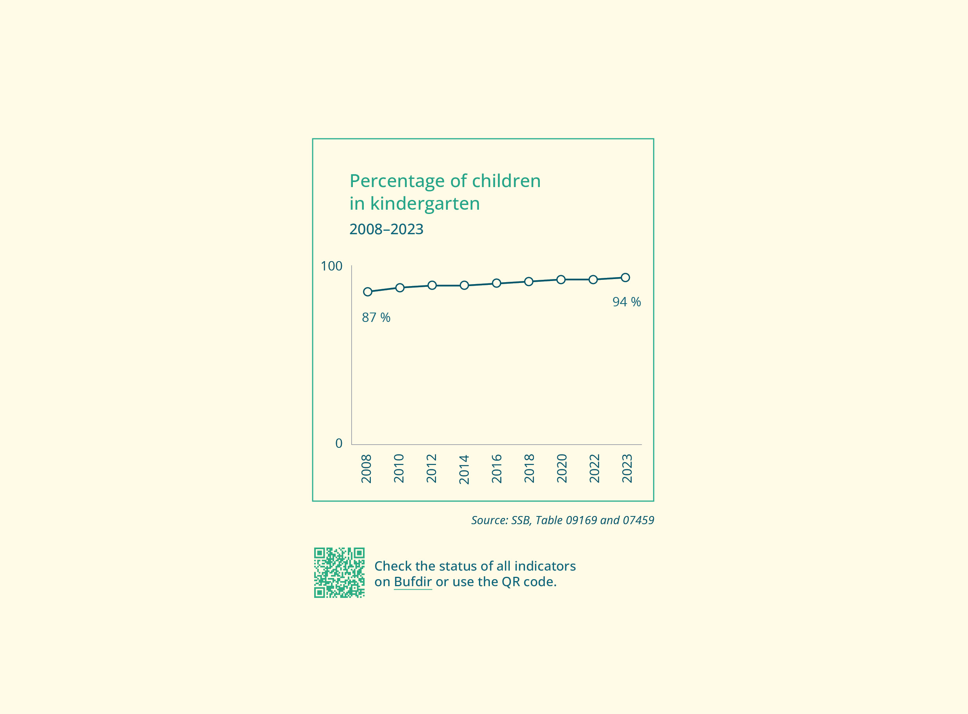

Goal 1.4 Higher employment rate for women and men with an immigrant background
Status
In Norway, a lower proportion of immigrants are employed compared to the rest of the population. Of those employed, fewer work full time. Both the employment rate and the proportion working full time are generally lower among female immigrants than male immigrants. Just over 64% of female immigrants were in employment in 2023, and about 64% of these worked full time. The corresponding figures for male immigrants are 72% and 83%.
Measures
- Continue the qualification programme for recently arrived migrants and refugees (the introduction programme and Norwegian language training and social studies) and the Job Opportunity initiative (Jobbsjansen) (for women only) (Ministry of Labour and Social Inclusion).
- Continue labour market initiatives through the Norwegian Labour and Welfare Administration (NAV) to increase the employment rate (ongoing). Immigrants from non-EEA countries are one of the groups prioritised in labour market initiatives (Ministry of Labour and Social Inclusion).
Indicators
- Male and female immigrants in employment
- Unemployment rate among immigrants and the rest of the population, broken down by sex
- Goal achievement in the Job Opportunity qualification programme.
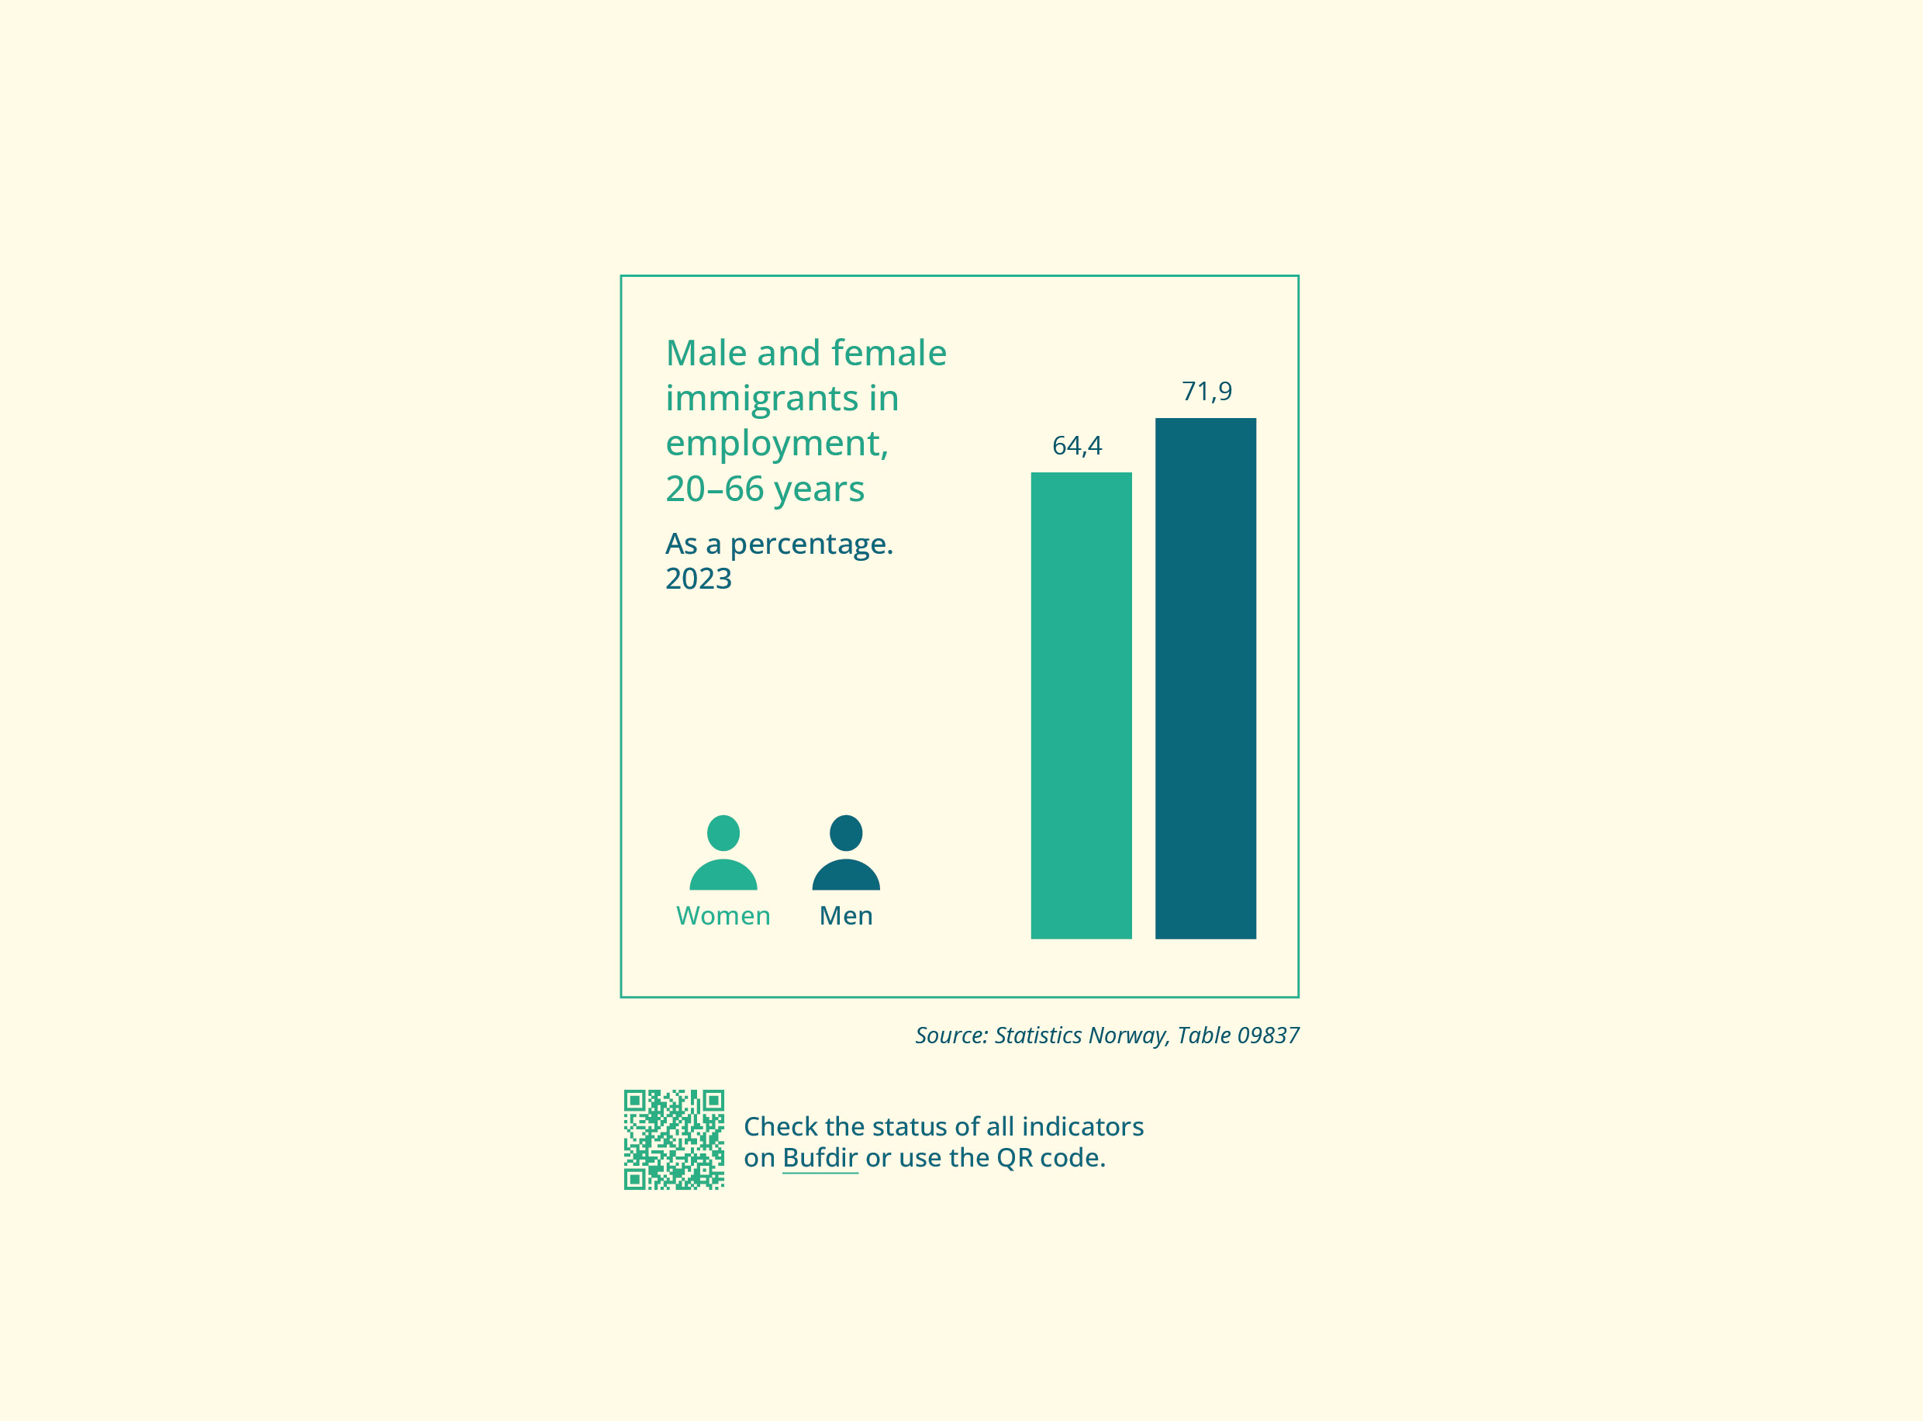

Goal 1.5 More women in male-dominated occupations and more men in female-dominated occupations
Status
Women and men work in different parts of the labour market, occupations, industries and sectors. Only 15% of the working population in Norway work in a gender-balanced occupation, i.e. one with more than 40% of both sexes. This means that some parts of the labour force are female-dominated and some are male-dominated. There are also geographical differences in employment.
Research from CORE – The Centre for Research on Gender Equality shows that the gendered dimension of the labour market is decreasing, as women are increasingly choosing occupations that were previously dominated by men. In contrast, men are less likely to choose occupations that have traditionally been female dominated. CORE points out that many of today’s gender inequalities are still linked to the gendered labour market, such as the gender pay gap, extensive part-time working among women, and the need to address men’s educational and career choices.
The Norwegian government presented the Gender Equality Strategy for the Maritime Sector in June 2023. The strategy has four focus areas: Recruitment and role models, A working environment that benefits everyone, A working life free from harassment, and An adapted workplace.
The Ministry of Trade, Industry and Fisheries is actively working on the follow-up of the strategy and its four focus areas. As part of this work, the ministry has commissioned the Norwegian Maritime Authority to assess the need for changes in the Norwegian maritime regulations with a view to promoting gender equality and highlighting and strengthening efforts to combat harassment.
The Ministry of Trade, Industry and Fisheries is in the final stages of preparing a Declaration of Cooperation to improve equality in the maritime industry with relevant organisations in the sector (including trade unions and employer organisations). As part of this work, a set of indicators will be developed to help measure progress over time in relation to goal achievement. The indicators for gender equality in the maritime sector will be linked to the four focus areas.
The Norwegian Armed Forces’ Action Plan for Gender Equality and Diversity emphasises that equality and equal opportunity are fundamental principles of Norwegian democracy, and that diversity is crucial for the Armed Forces’ development and for fulfilling its role in times of peace, crisis and war.
The Armed Forces’ action plan aims to systematise efforts in three areas: Societal mission and strategic goals, Leadership and culture-building, and Recruitment, selection and retention. The action plan sets out measures that address topics such as mental health, work-life balance, leadership and recruitment, as well as external communication, operational issues and public reputation.
A gendered labour market is often linked to gendered educational choices. Goal 1.5 must therefore be viewed in conjunction with Objective 2.
Measures
- Follow up on the Gender Equality Strategy for the Maritime Sector (Ministry of Trade, Industry and Fisheries).
- Follow up on the Action Plan for Gender Equality and Diversity in the Norwegian Armed Forces (Ministry of Defence).
- Monitor the development of the gender balance in the arts and cultural sector through reports from institutions, agencies and enterprises (Ministry of Culture and Equality).
Indicators
- Percentage of women and men employed in the public sector (government administration, municipal administration, county administration and publicly owned companies) and private sector, broken down by county
- Percentage of men in female-dominated occupations (nursing associate, intellectual disability nurse, psychologist, nurse, kindergarten teacher and primary/lower secondary school teacher)
- Percentage of women in male-dominated occupations (carpenter/joiner, electrician/electronics technician, engineer/technician, software developer/programmer)
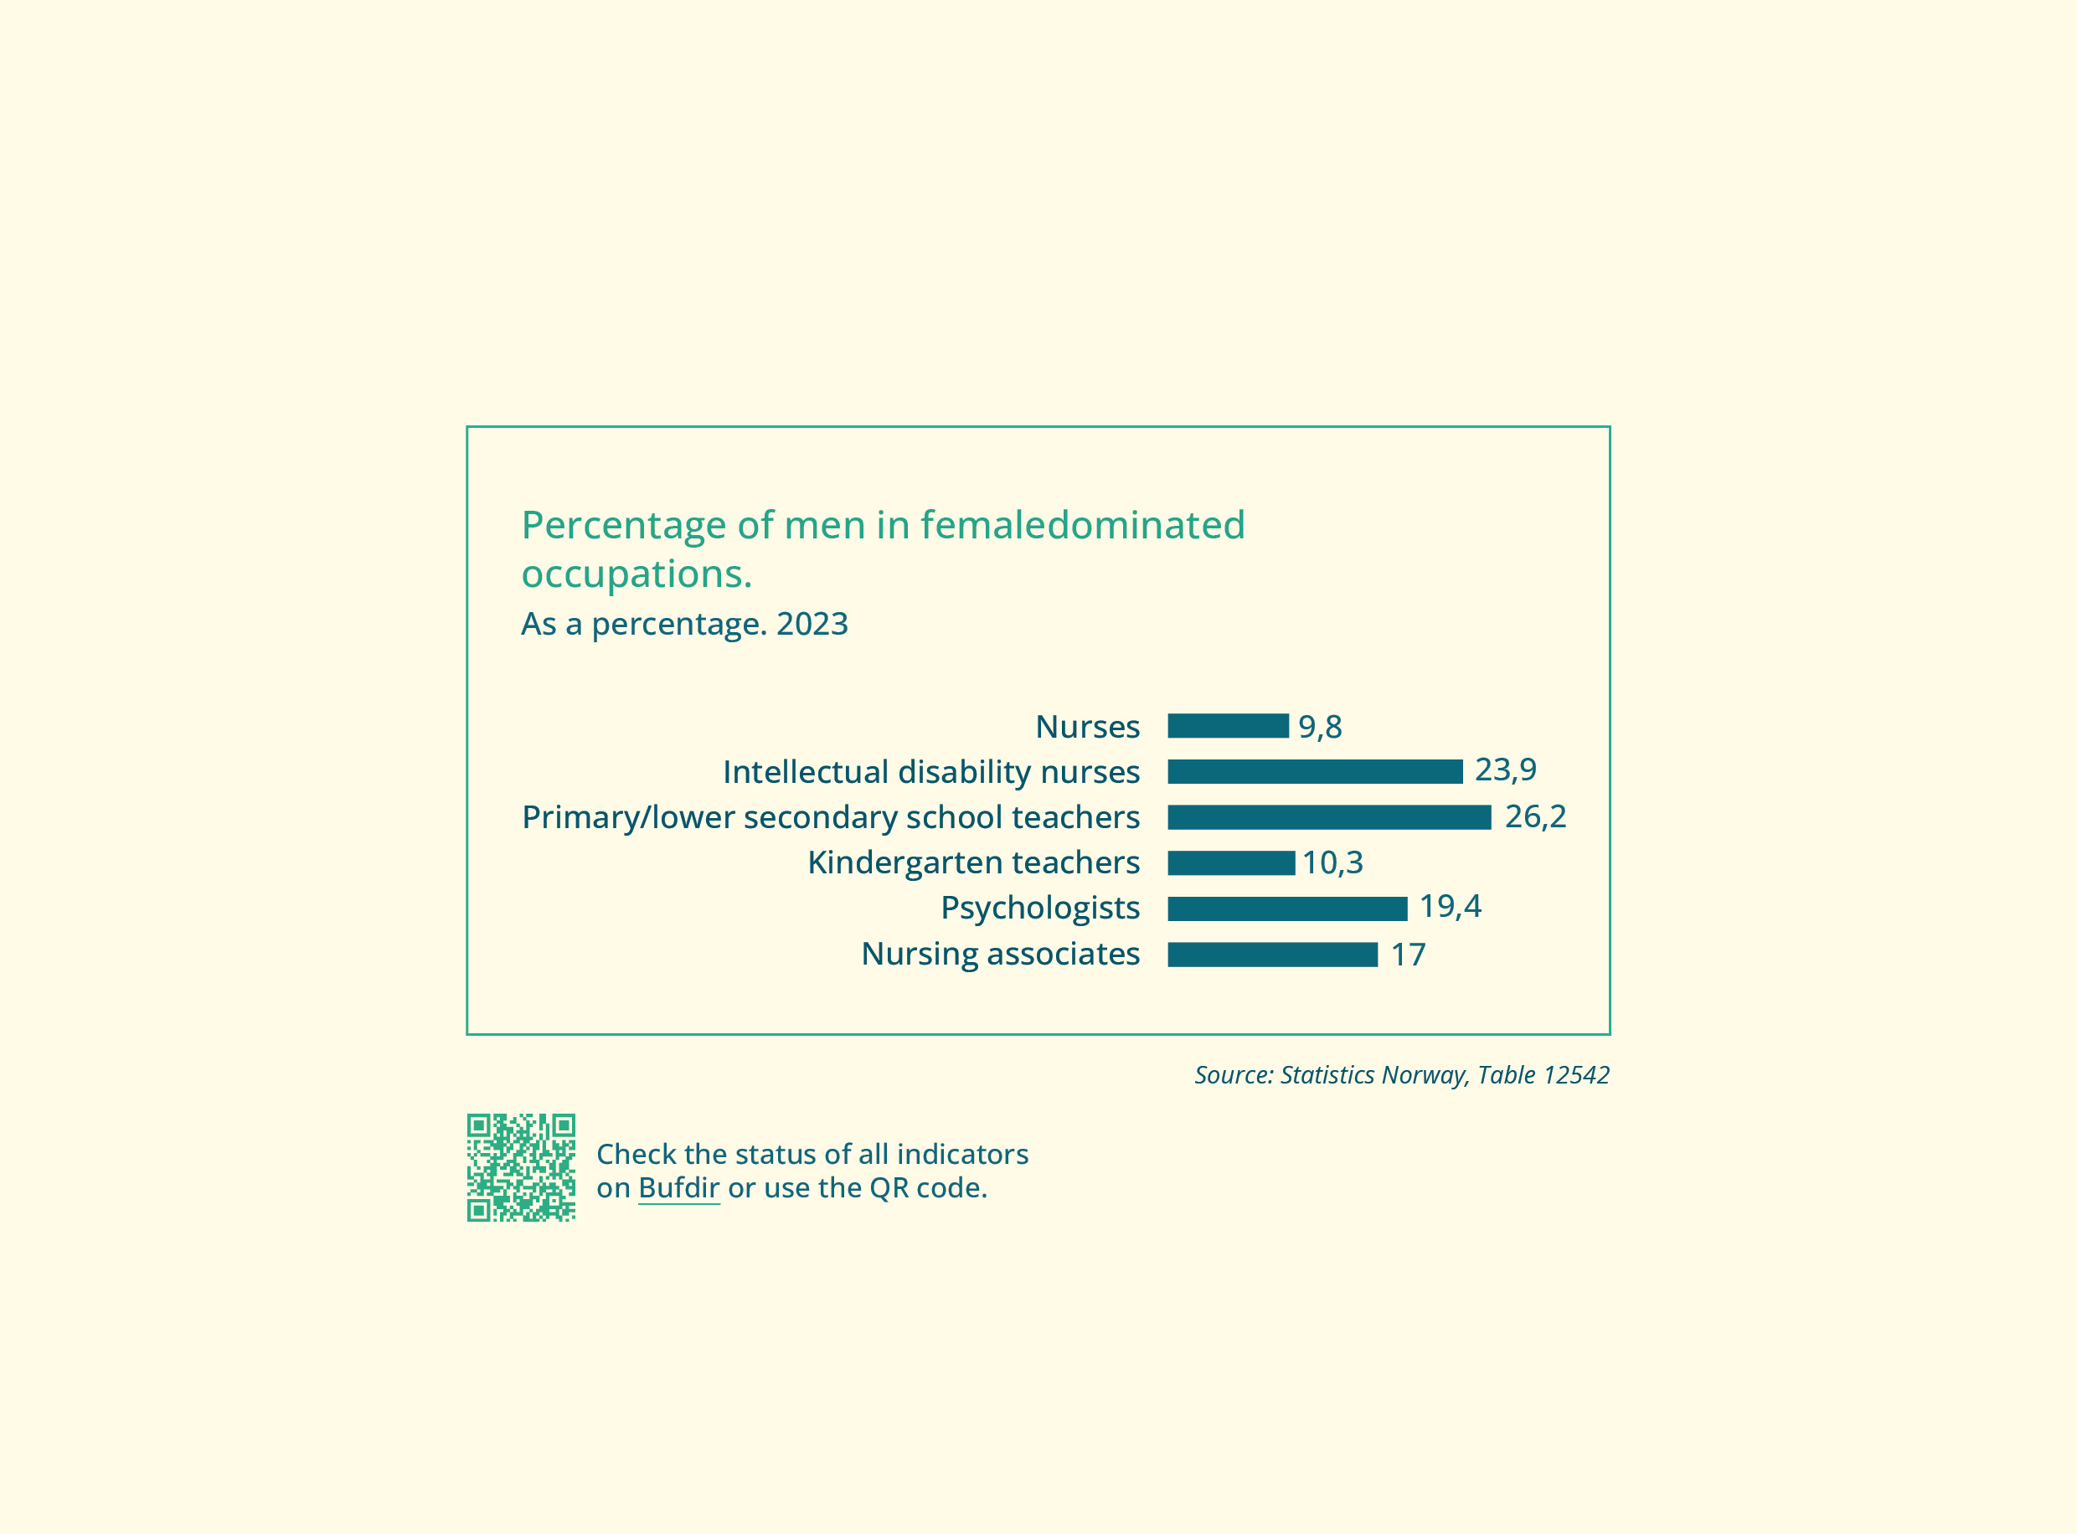

Goal 1.6 Reduce the gender pay gap and ensure more even distribution of income and wealth between women and men
Status
Women still earn less than men on average. In 2023, women’s monthly wages were 88.3% of men’s monthly wages. In terms of full-time employees and median wages, women’s monthly wages were 95.5% of men’s. The gender pay gap is three times greater among parents than those without children.
A new report from the Institute for Social Research shows that well over half of the pay gap is due to women and men working in different sectors of the labour market, more women working part time, and gender disparities in levels of education and experience.
Researchers found that a significant part of the pay gap can be attributed to the fact that male-dominated sectors of the labour market offer higher hourly wages on average than those in female-dominated sectors. Attempts were also made to measure the pay gap between female-dominated and male-dominated occupations that could be considered work of equal value. These analyses suggest that typical male work is paid higher than typical female work, even when the working conditions and the demands of the job in terms of responsibility, competence and effort can be considered comparable.
Major disparities can be seen in average gross salaries broken down by sex. Women earn an aver-age of 70.5% of men’s income. Wages are the largest source of income. Men also have higher capital income and share dividend income than women. Furthermore, men own more property and financial capital than women. However, net wealth is much more evenly distributed between men and women when accounting for men’s significantly higher debt.
All public-sector employers and large companies in the private sector are required to map wage differences by gender every two years.
An analysis of gender equality reports from 75 major employers in Norway, conducted by CORE – The Centre for Research on Gender Equality, showed that all of them mapped and reported pay disparities.
Employers viewed wage mapping as a useful tool for uncovering disparities that they had not been aware of, enabling them to implement specific measures to address the situation. However, the analysis also shows that employers found the extensive wage mapping to be resource-intensive. Assessing work of equal value was particularly labour-intensive, but several employers also gained new insight from these assessments. The researchers explored the possibility of creating a national overview of companies’ wage mapping. One of the options they suggested involves establishing a national portal for uploading reports and gender equality assessments.
The EU Pay Transparency Directive 2023/970 seeks to reinforce the principle of equal pay for equal work, or work of equal value, between men and women through pay transparency and enforcement mechanisms. The Directive is considered relevant to the EEA, but has not yet been incorporated into the EEA Agreement.
There is no simple solution for eliminating the gender pay gap. In addition to gathering more knowledge, it is important to facilitate equality in both work and family life. Employers’ fulfilment of their activity and reporting obligation is central to achieving this. Efforts to reduce the gender pay gap must therefore be viewed in conjunction with the goal of achieving a good work-life balance and the goal of improving employers’ fulfilment of their activity and reporting obligation.
Measures
- Evaluate measures to reduce the gender pay gap, based on, inter alia, the findings in two reports: Lønnskartlegging: Et verktøy for et mer likestilt arbeidsliv? (Gender pay reporting: a tool for a more equal working life?) and Ulik lønn for likt arbeid? Lønnsforskjeller mellom kvinner og menn, 2015–2022 (Equal pay for equal work? Gender differences in wages, 2015–2022) (Ministry of Culture and Equality).
- Incorporate the EU Pay Transparency Directive 2023/970 into Norwegian law. This work will be viewed in the context of the findings in the aforementioned research reports (Ministry of Culture and Equality, Ministry of Labour and Social Inclusion).
- Follow up on the research project on the gender pay gap and equal pay for equal work or work of equal value, including assessing the possibility of developing national indicators for work of equal value. Follow-up will be carried out together with the social partners in the tripartite cooperation (Ministry of Culture and Equality, Ministry of Labour and Social Inclusion).
- Obtain information on gender disparities in income and other economic resources, such as wealth, ownership and shares (Ministry of Culture and Equality).
- Participate in a Nordic cooperation on equal pay for work of equal value (Ministry of Culture and Equality).
Indicators
- Women’s average wage as a percentage of men’s wages
- Women’s average wage as a percentage of men’s wages in selected gender-skewed occupational groups
- Percentage of pensioners receiving the minimum pension, broken down by sex and county
- Women’s and men’s average gross income, personal income, share dividends, pensions and capital income
- Women and men (excluding students) with long-term low incomes
- Single mothers/fathers with children aged 0–17 years, with long-term low incomes, broken down by sex
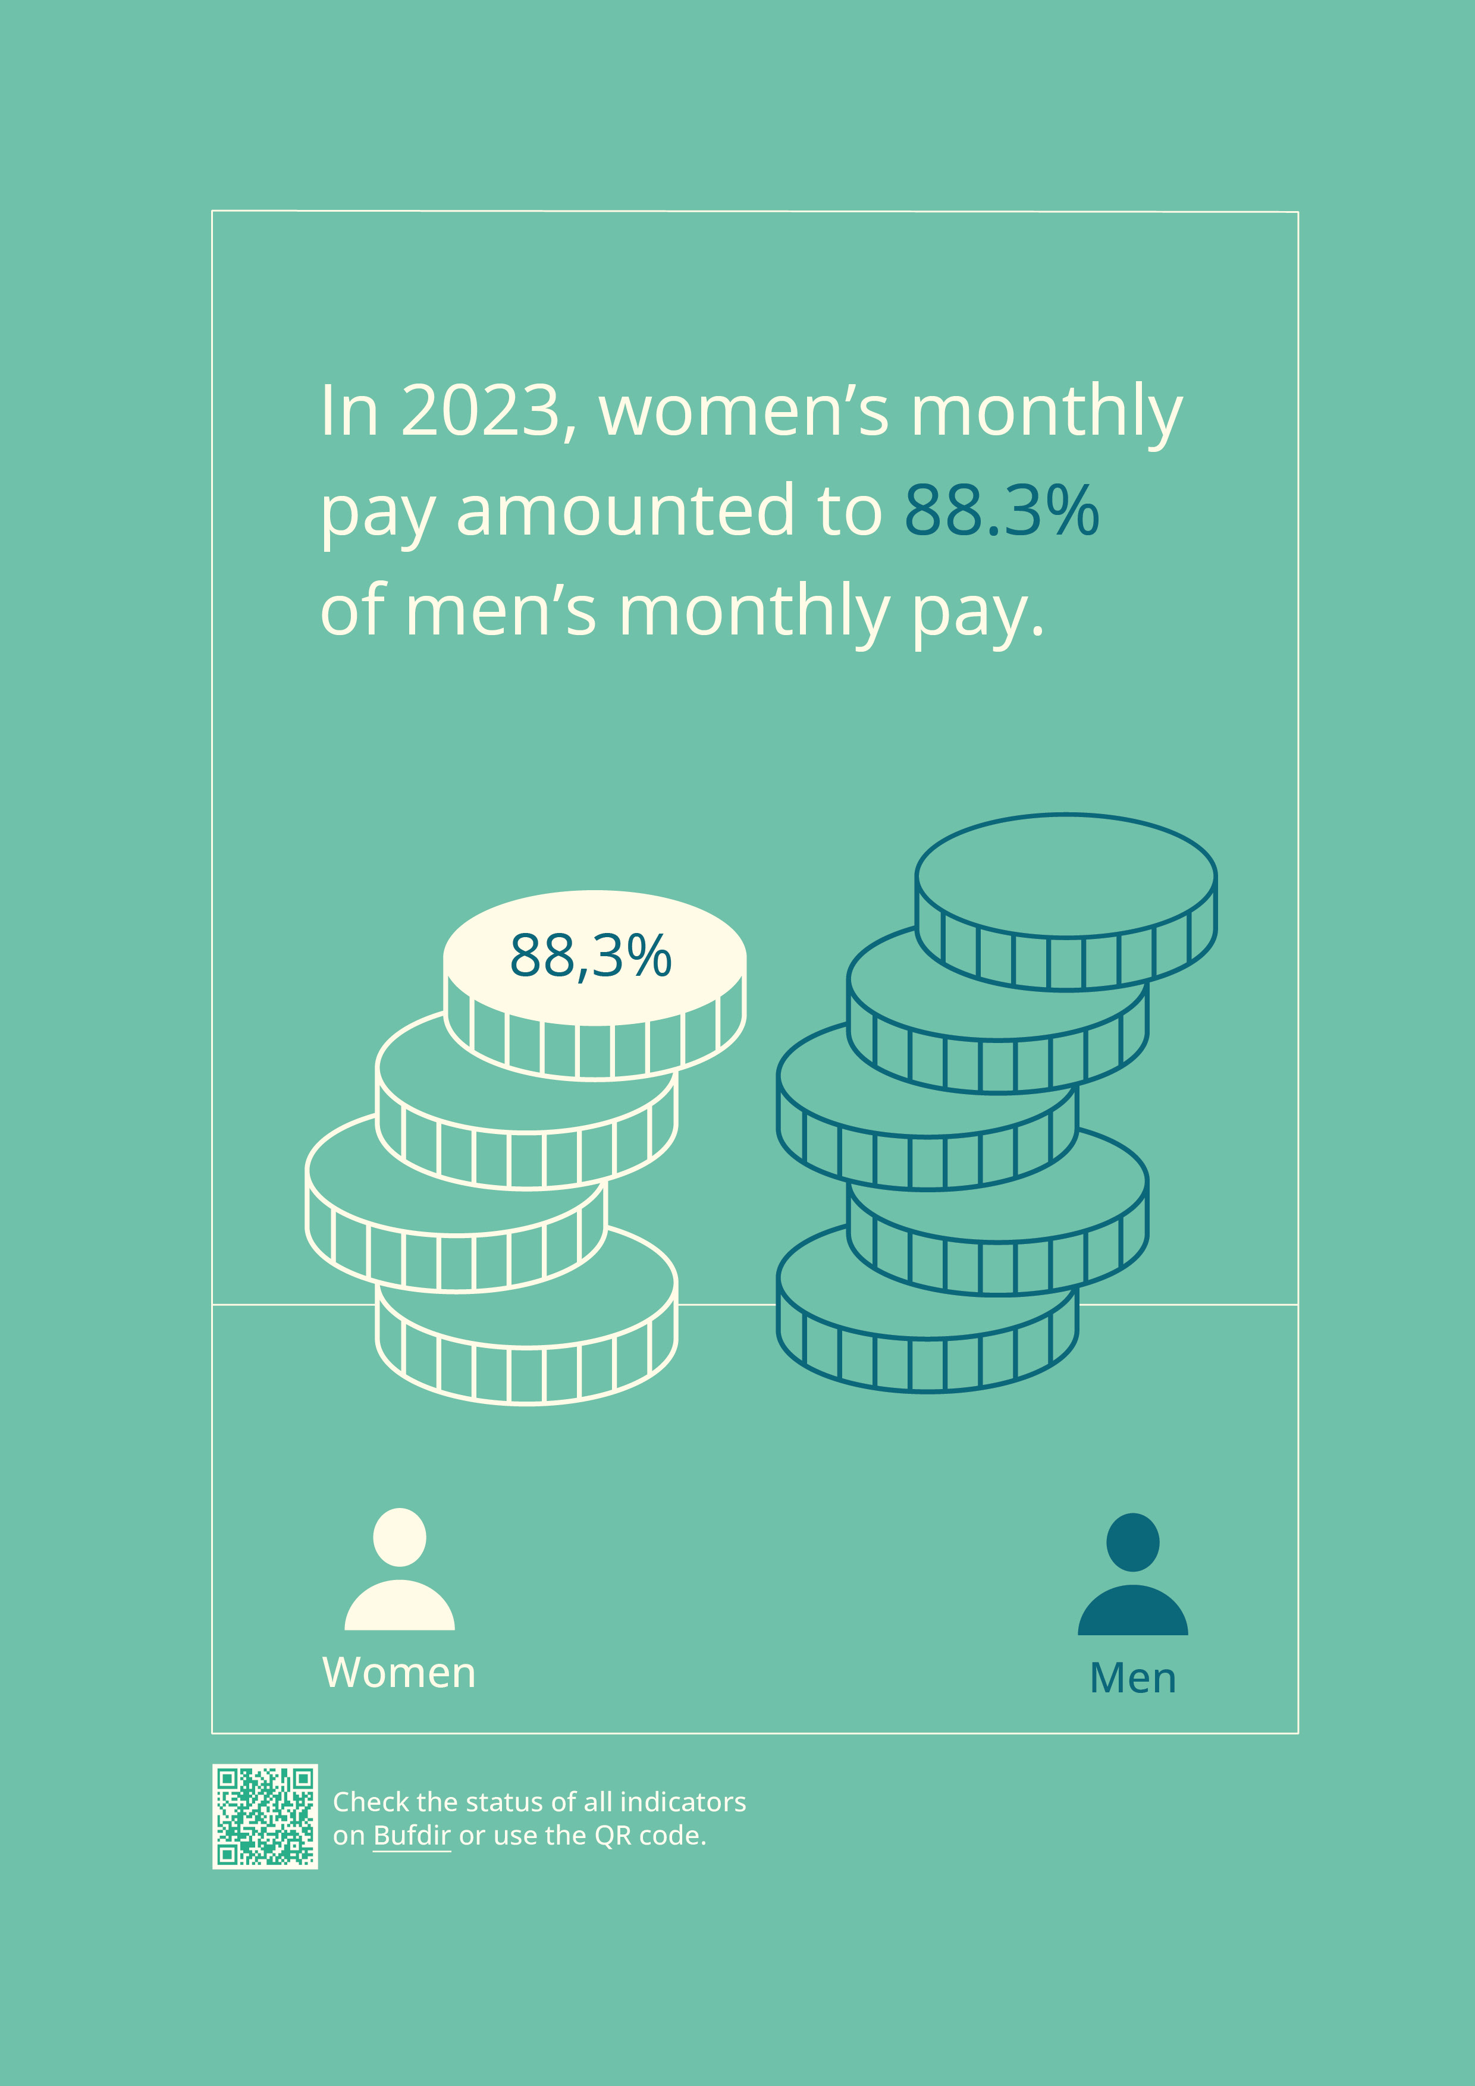

Goal 1.7 Increase the percentage of women starting businesses, on company boards, in executive positions and management positions with financial responsibility in publicly and privately owned companies and in the voluntary sector
Status
The gender imbalance in management positions is a challenge for equality, and it is particularly pronounced in the private sector. Women make up 20% of board members and 17% of managing directors in limited companies. In 2024, 17.5% of CEOs in Norway’s 200 largest companies were women. Working conditions are one of the contributing factors to this imbalance. If companies want to achieve a gender balance in management, they need to rethink career paths and employee availability outside of working hours. In the government sector, there is a gender balance among senior executives. However, far fewer women than men start their own business; only 1 in 4 business founders are women.
In the voluntary sector, there is an imbalance in the representation of female board chairpersons. According to the Register of Non-Profit Organisations, only 37% of board chairpersons in Norwegian associations and organisations are women. The Norwegian Olympic and Paralympic Committee and Confederation of Sports (NIF) has set a target of 40% women in elected board positions. Figures from 2023 show that women account for 26.5% of administrative managers and 28% of board chairs in Norwegian sport.
Measures
- Monitor the effects of new legislation limiting the proportion of board members of the same gender to a maximum of 60% in medium-sized and large companies (Ministry of Trade, Industry and Fisheries).
- Follow gender balance developments in management positions by continuing to fund the CORE Norwegian Gender Balance Scorecard (Ministry of Culture and Equality).
- Follow up on central government’s expectations for companies that are wholly owned by the Norwegian state (Ministry of Trade, Industry and Fisheries).
- Follow up on adherence to legal requirements for gender balance on the boards of companies wholly owned by the Norwegian state (Ministry of Trade, Industry and Fisheries).
- Follow up on the White Paper on business founders and start-ups. The White Paper includes a chapter on female entrepreneurship, with initiatives for improving the proportion of women in new growth companies in Norway (Ministry of Trade, Industry and Fisheries).
- Monitor gender balance developments on boards and among senior executives in the voluntary sector (Ministry of Culture and Equality).
Indicators
- Gender distribution on boards of private companies with at least three board members
- Gender distribution among executive management groups, boards, board chairs and CEOs in the 200 largest companies in Norwegian business, with and without legislation on gender balance
- Attitudes to the higher number of male senior executives, broken down by sex
- Gender distribution in management positions and boards of companies where the Norwegian state has direct ownership (CEOs, the management group overall, board chairs and boards overall)
- Gender distribution among founders of newly established sole proprietorships, private limited companies (AS) and public limited companies (ASA)
- Gender distribution among senior executives in public administration, advocacy groups and CEOs
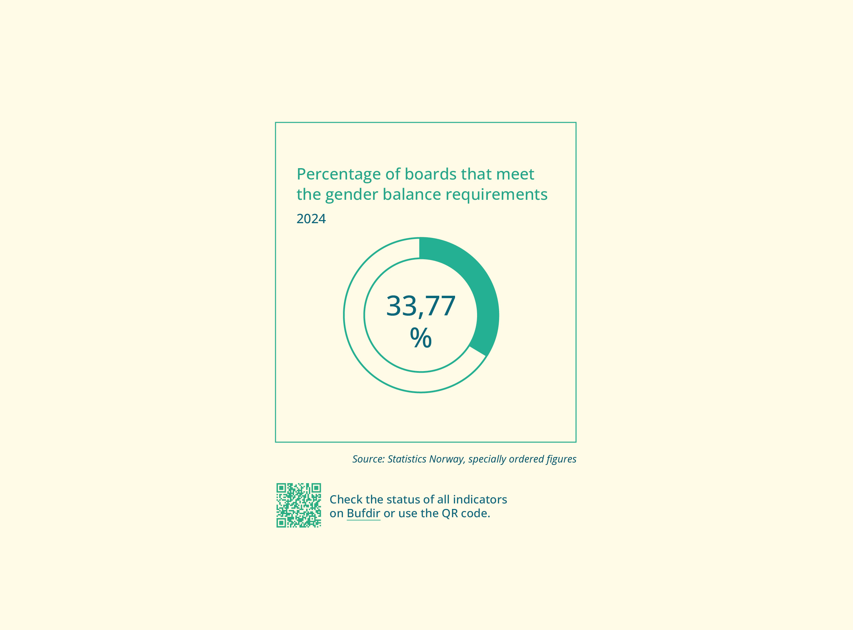

Goal 1.8 Gender equality and diversity in higher education and research
Status
Research and education play an important role in policy development and public administration, fostering a more critical, diverse and open societal debate. Ensuring that the gender balance among students and academic staff reflects the diversity of the population will help create a more diverse and balanced recruitment pool for the labour force, enhance the credibility and relevance of research, improve the quality of research and provide a competitive advantage.
Women make up the majority of doctoral research fellows and half of the academic staff in the higher education sector. In the research institute sector and the business sector, the proportion of women is lower, and in 2021, it was 46 and 22% respectively. The higher up the academic career ladder, the lower the percentage of women.
In the period 2013–2022, the proportion of female professors and docents increased from 25% to 36%. In 2023, women made up over 50% of associate professors. Academic disciplines continue to have a gendered dimension, and some ethnic minorities remain underrepresented. The proportion of women is generally highest in medicine and health sciences, accounting for 62% in 2021, and lowest in technology, at 28% in 2021. A gender balance exists among researchers in the humanities, arts and social sciences, while mathematics and natural sciences were made up of 38% women in 2021.
The Committee for Gender Balance and Diversity in Research (KIF) plays a key role in strengthening gender balance and diversity in the research sector, and seeks to raise awareness of and advocate for inclusive measures. KIF’s efforts have included identifying critical career transitions and obstacles faced by underrepresented groups in the academic workforce. (See also KIF under Goal 2.3.)
Measures to improve gender balance should be based on the best available knowledge. The Research Council of Norway’s strategic initiative, BALANSE+ (2023–2028), seeks to drive structural and cultural change within the research system, with a view to promoting gender balance and diversity. BALANSE+ administers NOK 15.6 million annually throughout the period of the initiative.
Measures
- Follow up the government’s ambitions for greater equality, less discrimination and increased diversity in the Long-Term Plan for Research and Higher Education 2023–2032.
Indicators
- Gender distribution among researchers/academic staff, broken down by position
- Gender distribution among R&D personnel in the higher education sector and in the research institute sector, broken down by field of study
- Completed doctoral degrees, broken down by sex
- Number of years between doctoral admission and defence of thesis, broken down by sex
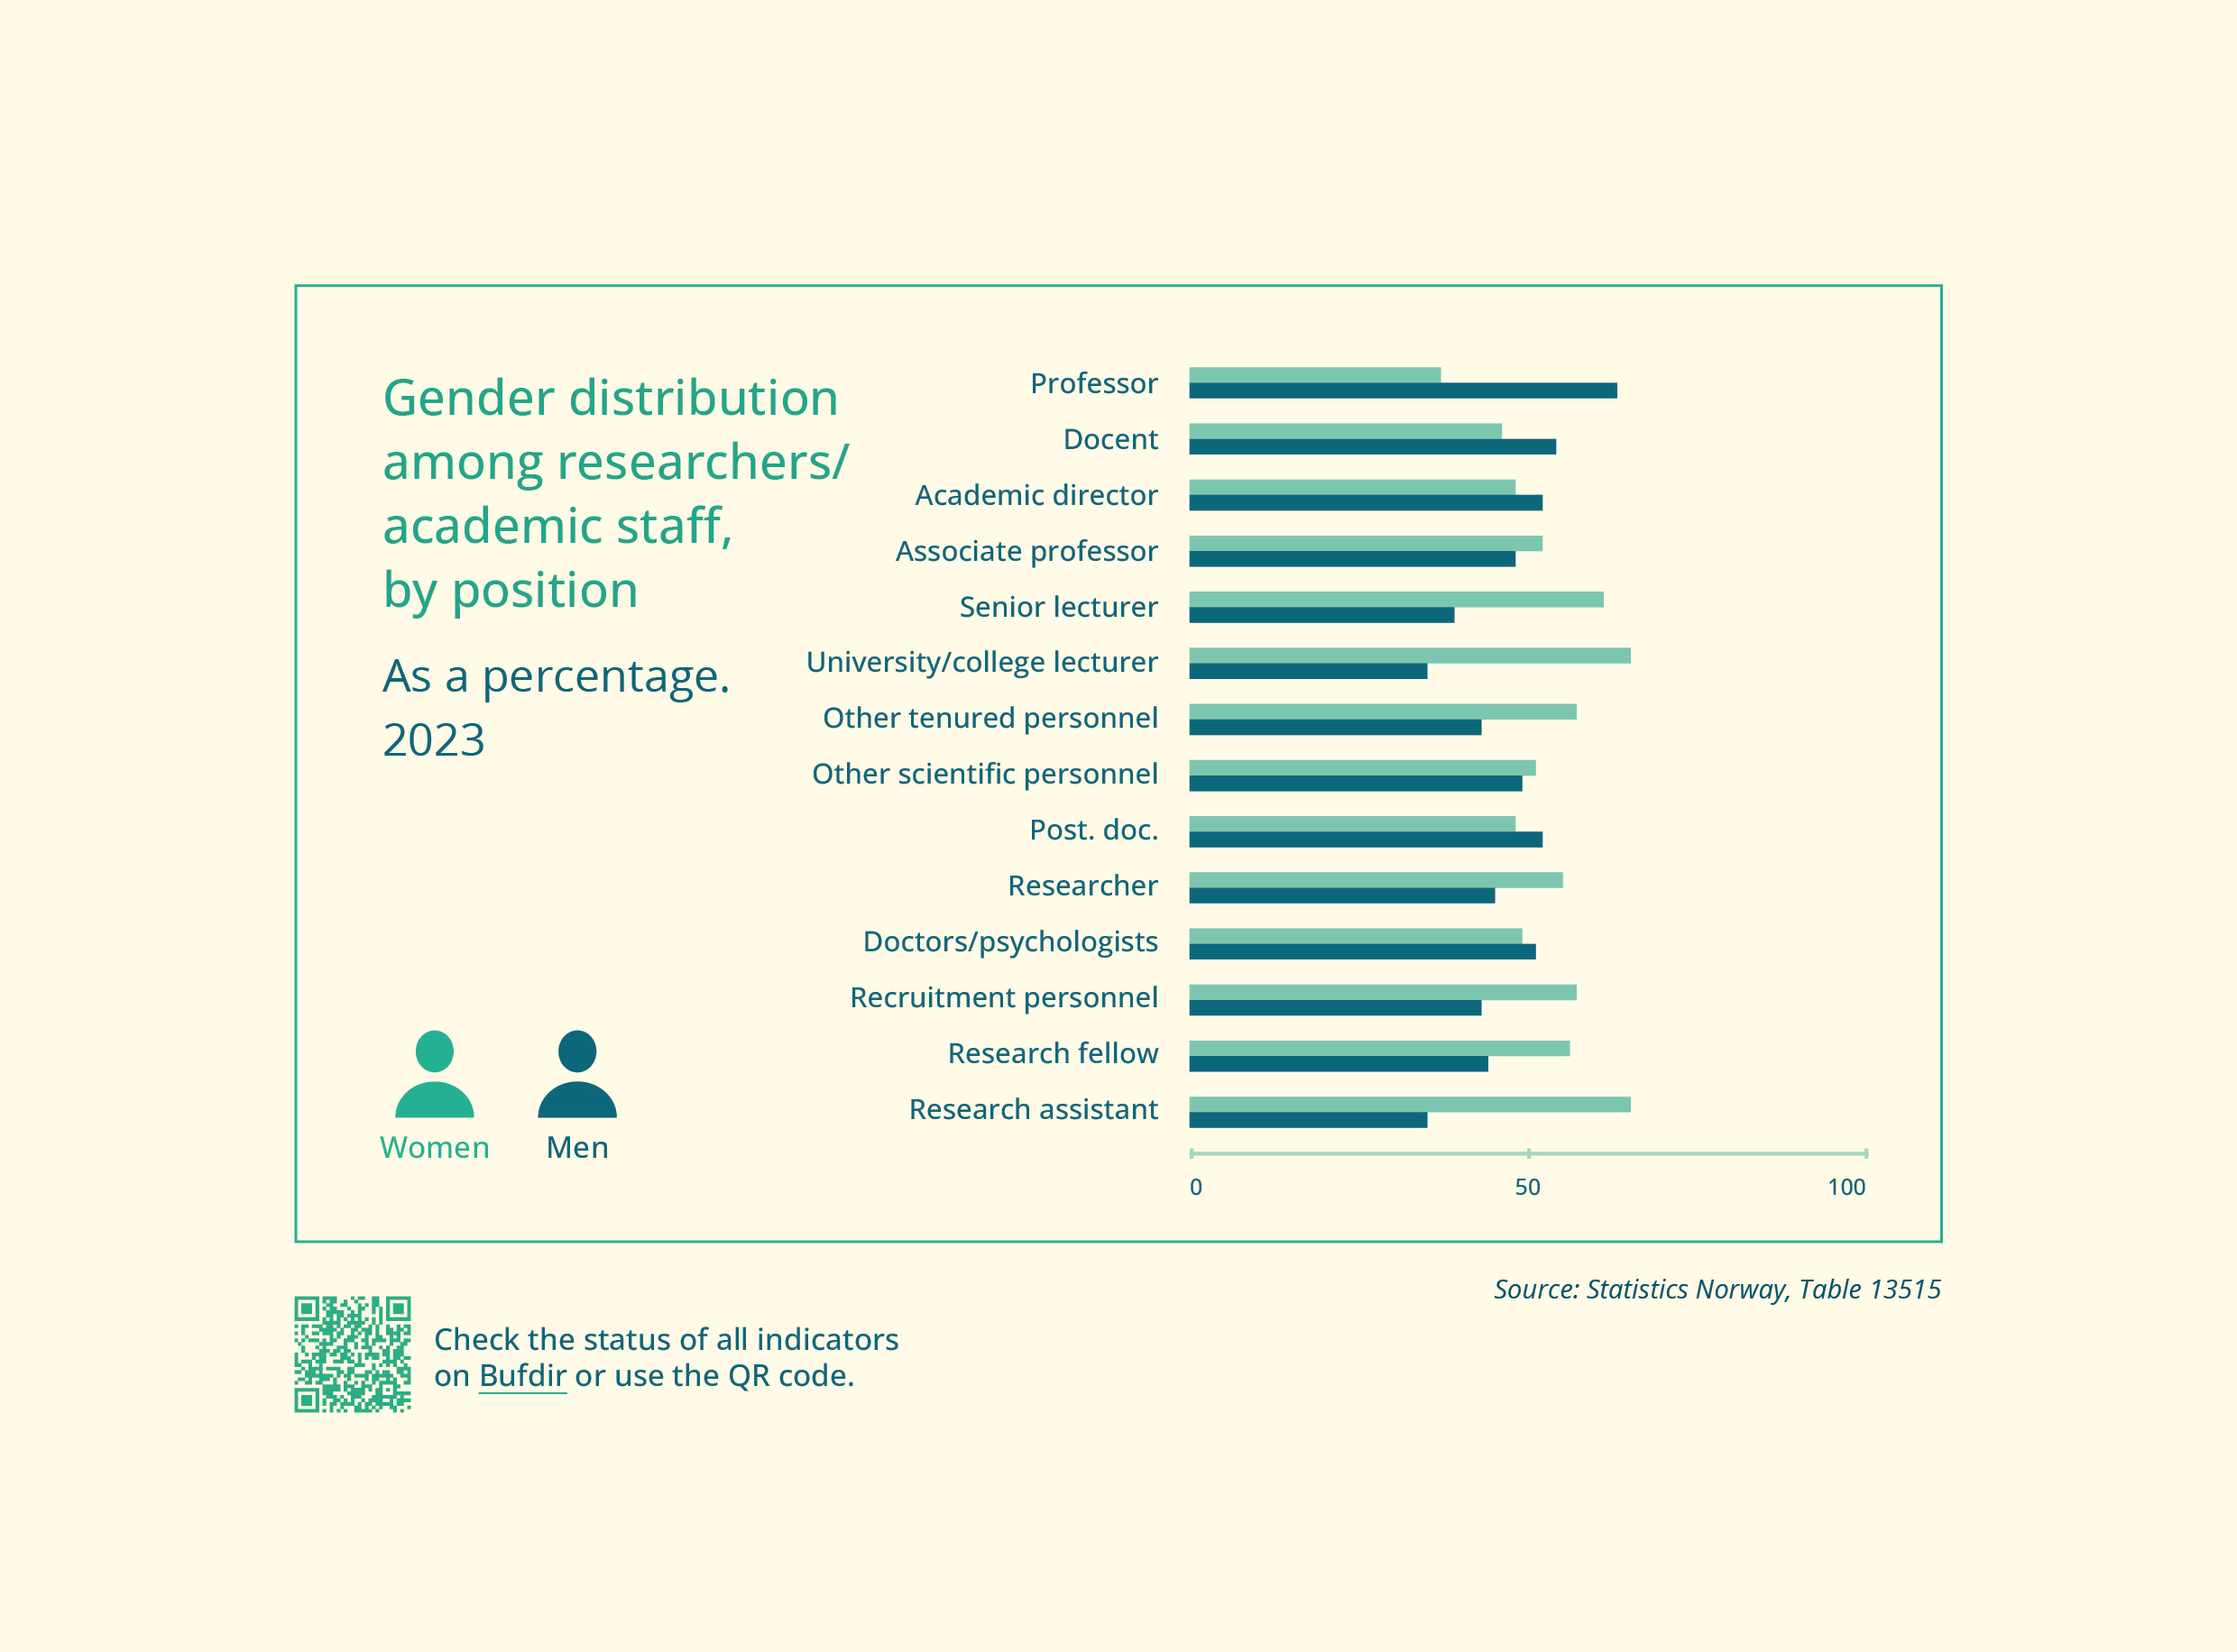

Goal 1.9 Improved knowledge on women’s occupational health
Status
It is well documented that various factors in the working environment can impact on employees’ occupational health, absenteeism and labour market participation. Sick leave rates are consistently higher for women compared to men. Over the past 20 years, the sick leave rate for women has generally been 2–3 percentage points higher than for men. Musculoskeletal disorders and mental health issues are particularly common reasons for sick leave.
One in three sick leave cases are reported as work-related, meaning that the absence is either fully or partially due to work-related factors. This indicates considerable potential for prevention and development in relation to the working environment and its impact on health, as well as withdrawal from and participation in the labour market.
A number of individual factors, such as health challenges related to genetic factors, life phase/life situation (e.g. caregiving responsibilities, violence, overall burden), lifestyle, and/or non-work-related illness also impact on women’s sick leave rate and labour market participation.
On 8 March 2024, the Norwegian government established a public committee to assess how employment impacts on women’s health and labour market attachment. This includes working conditions and the working environment. The committee will evaluate potential and relevant measures to prevent work-related health issues and illnesses. In addition to generating a comprehensive knowledge base and proposing measures, the committee will examine the framework conditions and follow-up employment measures for those with non-work-related health challenges. This may include individuals facing a large overall burden from multiple caregiving responsibilities, as well as those who have been subjected to sexual harassment or violence.
Measures
- Follow up the recommendations of the committee on women’s occupational health. The committee’s report should be completed by 1 April 2025 (Ministry of Labour and Social Inclusion).

Goal 1.10 Close cooperation with the social partners on gender equality in the labour market
Status
Effective arenas for cooperation between the authorities and social partners are built on a strong tradition in Norwegian labour relations and politics. Since 2013, there has been a formal tripartite cooperation to promote gender equality in the labour market. This cooperation is anchored in the Council on Labour and Pension Policy, which regularly discusses gender equality. A special working group under the Council also discusses matters related to gender equality.
The main confederations in the government sector (LO State (LO Stat), YS State (YS Stat), the Confederation of Unions for Professionals (Unio) and the Federation of Norwegian Professional Associations (Akademikerne)) and the Ministry of Digitalisation and Public Governance (representing employers) have reached agreement on the following provision in the Basic Collective Agreement for 2022–2024 and the Main Agreement in the government sector: ‘the parties at a local level shall work actively, purposefully and systematically to promote gender equality and diversity and prevent discrimination, in accordance with the Equality and Anti-Discrimination Act. Union representatives shall be involved in the employers’ efforts relating to the activity and reporting obligation, including planning and following up equal pay mapping’.
Measures
- Further develop the tripartite cooperation on gender equality in the labour market through annual projects and initiatives to strengthen gender equality in the workplace (Ministry of Culture and Equality, Ministry of Labour and Social Inclusion, Ministry of Digitalisation and Public Governance).
- Continue to support employers in the public sector covered by the collective agreement in meeting their activity and reporting obligation (Ministry of Digitalisation and Public Governance).

Goal 1.11 Improved follow-up of employers’ activity and reporting obligation
Status
All employers are required to promote gender equality. The activity and reporting obligation, as outlined in the Equality and Anti-Discrimination Act, requires all employers in the public and private sector to work actively, purposefully and systematically to promote gender equality and prevent discrimination within their organisation. Employers must also document and report on their work in this area. The obligation entails ensuring that wage and personnel policies actively contribute to equal opportunities and that they are adapted to employees and jobseekers in different life situations.
Public and large private employers are required to follow a legally mandated method in this work and to work together with employee representatives. They must also document their efforts in their annual report or other publicly accessible document.
CORE – The Centre for Research on Gender Equality has analysed the gender equality reports from the 50 largest employers in Norway (in terms of turnover). The study shows a marked increase in the use of terms describing diversity and equality efforts in annual reports following the introduction of new gender equality requirements in 2020.
EY’s evaluation of local authorities’ follow-up of employers’ activity and reporting obligation shows that the rules are not well-known, are perceived as complex and that local authorities generally do not adhere to the legal requirements for activity and reporting.
New rules on sustainability reporting under the Accounting Act and the Securities Trading Act are being introduced gradually starting from the financial year 2024. The aim of the new rules is to ensure there is comparable, reliable and easily accessible information about the various types of sustainability risks companies face and how they impact on the population and the environment. The gender equality and equal pay initiatives are integral to the sustainability efforts and form part of the reporting requirements. It is therefore appropriate to view these requirements and the activity and reporting obligation in conjunction with each other.
Measures
- Draw up a regulation on the content and execution of wage mapping. This should be viewed in conjunction with the EU directives on sustainability and equal pay transparency (Ministry of Culture and Equality).
- Explore potential measures for better follow-up of employers’ activity and reporting obligation, including the possibility of introducing more effective sanctions (Ministry of Culture and Equality).
- Follow up on government agencies’ efforts and reporting in relation to their activity and reporting obligation, including a review of their work on wage reporting and involuntary part-time working (Ministry of Digitalisation and Public Governance).
- Support the certification scheme for employers in the county of Agder in relation to equality, inclusion and diversity (Likestilt arbeidsliv Agder). The scheme is partly based on employers’ activity and reporting obligation (Ministry of Culture and Equality).

Goal 1.12 The future of work – AI and the green transition
Status
The use of artificial intelligence (AI) is becoming increasingly common in both the public and private sector, offering significant opportunities to streamline work processes and generate new insights and knowledge.
Digitalisation and the transition to a greener, more climate-friendly society are creating new challenges in relation to gender equality. We must remain vigilant and proactively work to ensure that societal changes do not reinforce or exacerbate gender disparities. These societal changes also, however, present new opportunities to build a country in which both women and men can fully exercise their rights and have equal opportunities to participate in work and public life. We must seize this opportunity.
The Norwegian government has presented a national digitalisation strategy, The Digital Norway of the Future. National Digitalisation Strategy 2024–2030.
Measures
- Further develop and implement guidelines for responsible use and development of AI in line with existing and forthcoming regulations on equality and discrimination (Ministry of Digitalisation and Public Governance, Ministry of Culture and Equality).
- Follow up on ongoing work related to the implementation of the EU AI Act (Ministry of Digitalisation and Public Governance).
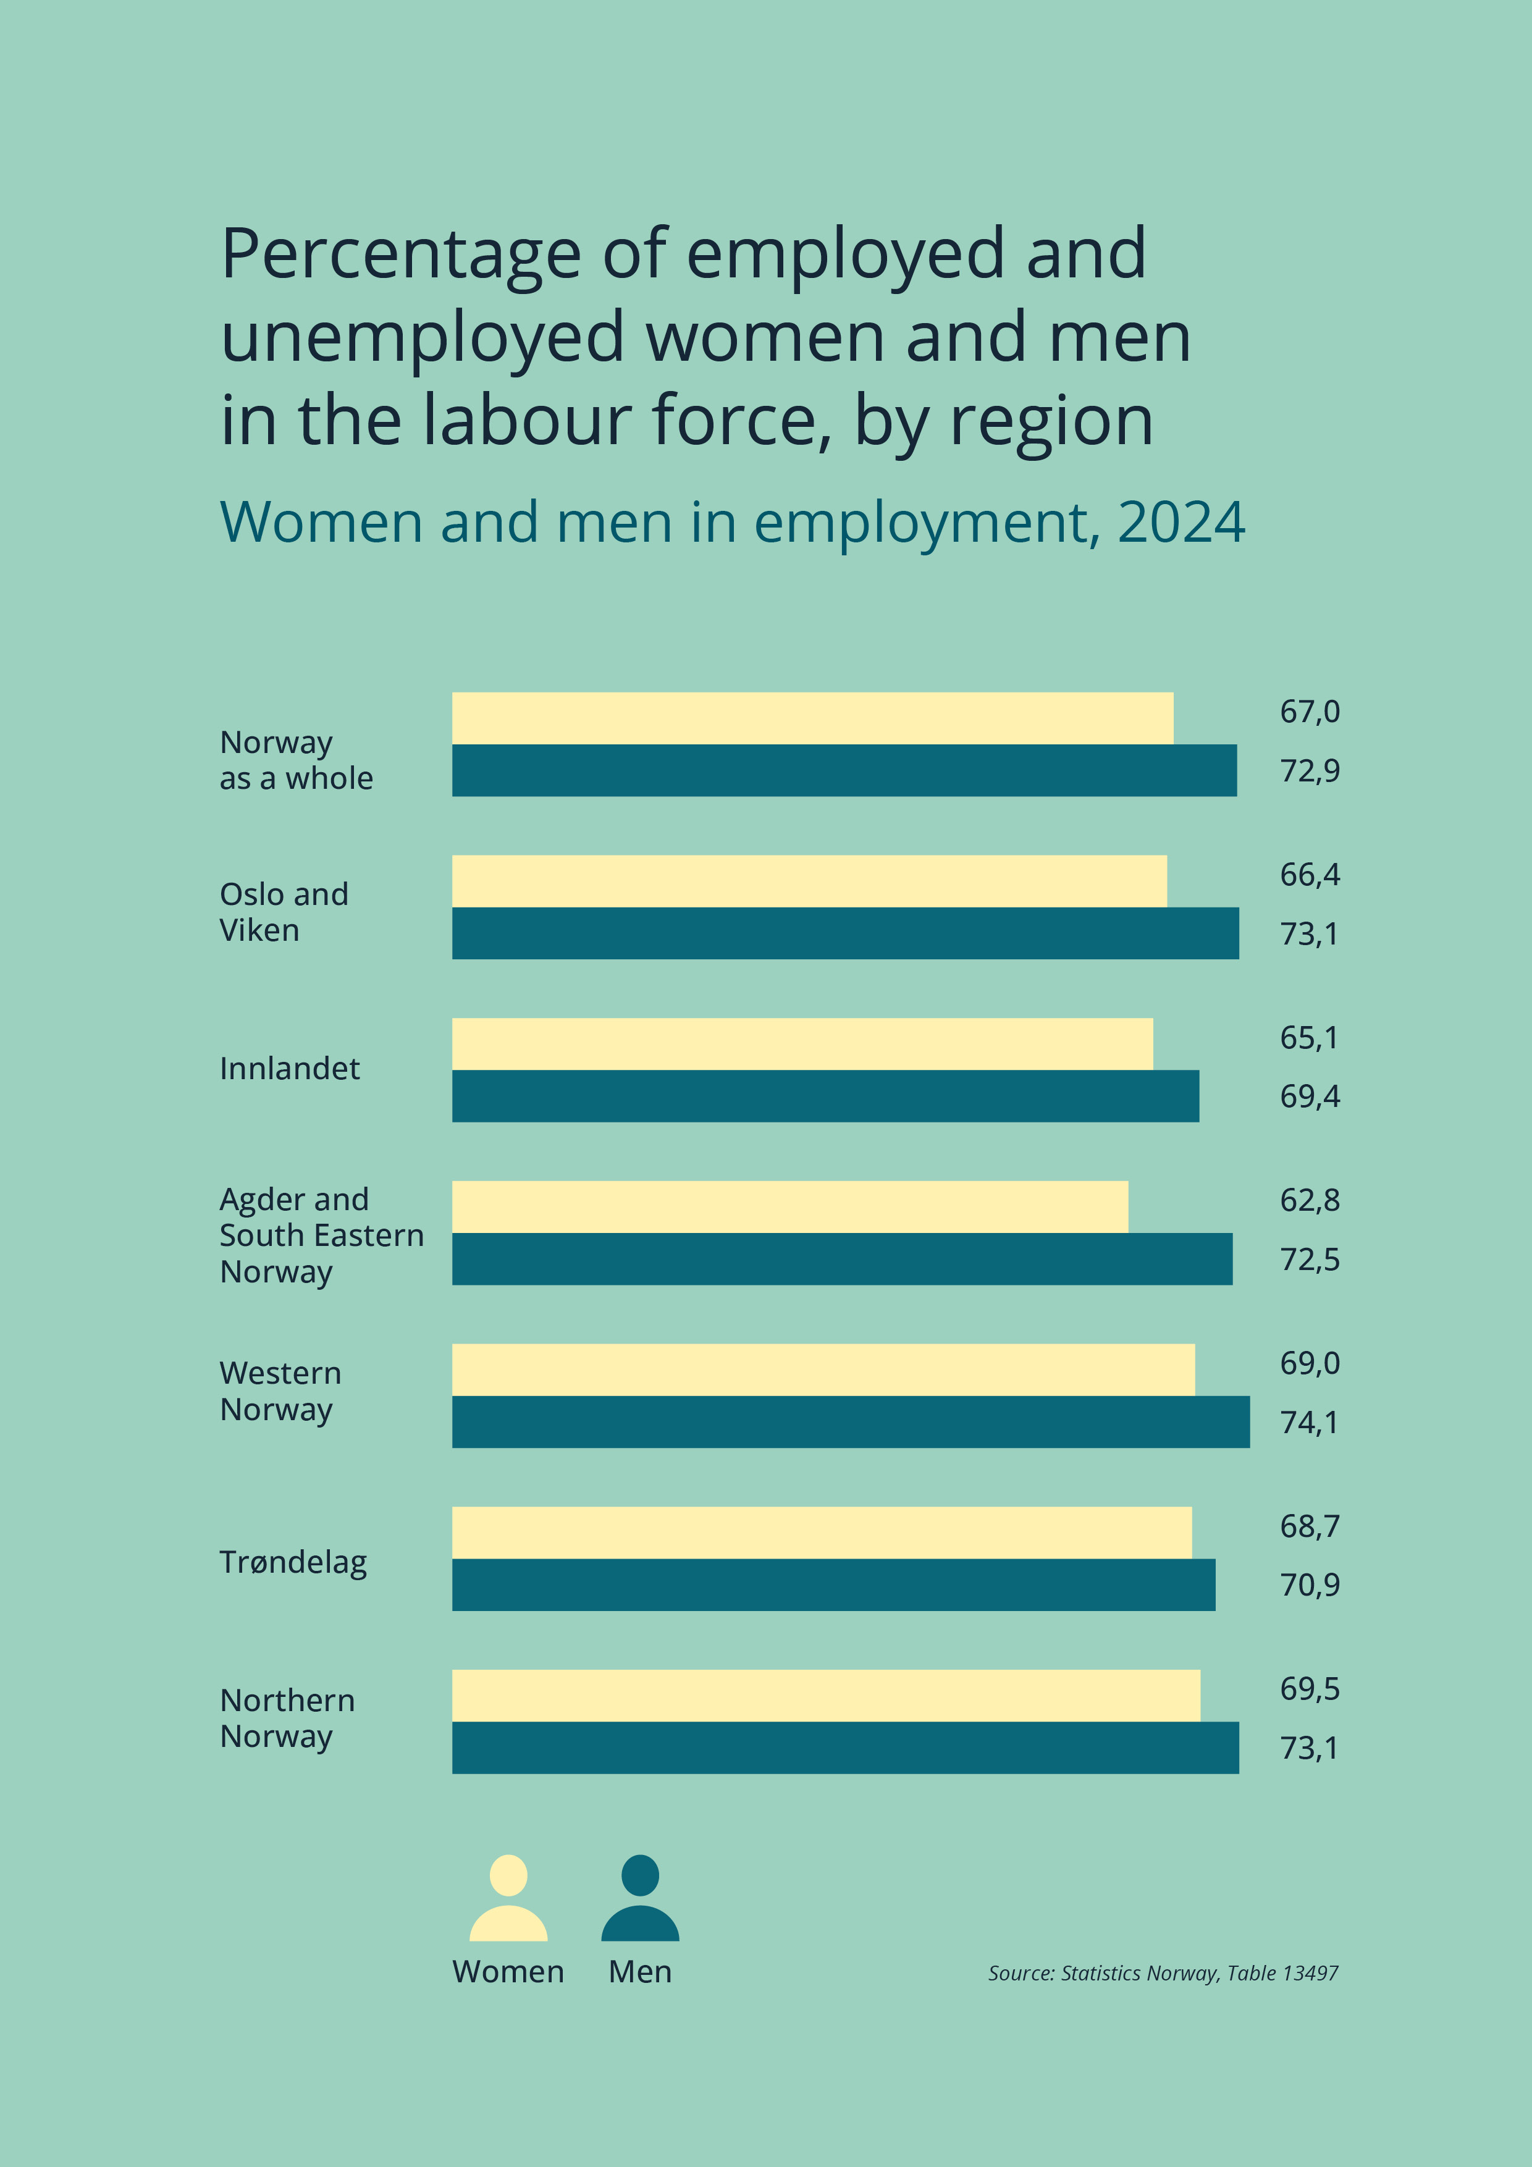

Objective 2: Fewer gendered educational choices
The Norwegian government aims to reduce the gendered dimension of the labour market by improving the gender balance in education. Equality in the labour market makes for a more productive labour force and creates a better foundation for providing quality services in the public sector.
Men and women tend to follow different educational paths and end up in different parts of the labour market; in different occupations, industries and sectors. According to estimates, two-thirds of the gender distribution in the labour market is directly attributable to gendered educational choices.
Gendered educational choices play a role in shaping how services are developed and delivered, who we encounter in the workforce and who we, as a society, interact with in situations involving, for example, welfare services. It also has implications for the gender pay gap, disparities in working hours and the financial return on education for women and men.
The government believes that workforces in important societal institutions, such as the health service, schools and kindergartens, should reflect the population as a whole. The goal is therefore for professional education programmes in engineering, teaching and health and social services to recruit more widely from the population, regardless of gender, disability or social and cultural background.
In the Long-term Perspectives on the Norwegian Economy White Paper, the government estimates that 180,000 additional employees will be needed in the health and care sector by 2060. To achieve this, more men will need to be recruited in these roles in the years ahead.
Women and men should have the opportunity to shape the development of a changing labour market. Between 2015 and 2020, there was significant growth in IT jobs, but the proportion of women remains consistently low. The transition to a greener economy will lead to a substantial demand for expertise in the STEM fields (science, technology, engineering and mathematics). However, only one in four STEM workers are women.
The government seeks a systematic and coordinated effort from various sectors and stakeholders to reduce the extent of gendered educational choices.

Goals
The government has outlined the following goals, measures and indicators:

Goal 2.1 Fewer gendered choices in upper secondary education
Status
Application figures for upper secondary education in the 2024–2025 school year show that more girls than boys are choosing general studies programmes, while more boys than girls are opting for vocational programmes. In the vocational programmes, the gender distribution tends to be highly skewed, whereas general studies show a better gender balance.
The overall picture is that applications to the various education programmes largely follow traditional gender patterns, such as a significant overrepresentation of girls in healthcare, childhood and youth development, and a substantial overrepresentation of boys in IT and media production. Recent figures show an increase in applications from girls for electrical engineering and computer technology, as well as technological and industrial production, though these fields remain largely male dominated.
The Ministry of Education and Research presented a White Paper aimed at pupils in Years 5 to 10 (Meld. St. 34 (2023–2024) En mer praktisk skole – Bedre læring, motivasjon og trivsel på 5.–10. trinn), outlining plans to make the school system more practical and varied, with a view to boosting pupils’ motivation and improving their learning outcomes.
In order for young people to be able to make educational and career choices regardless of gender, it is crucial that they develop basic skills that offer genuine opportunities. Today, too many pupils, particularly boys, have such poor skills in areas like reading and mathematics that they will struggle to advance in education and the workforce. The decline in educational attainment and the rising number of pupils at the lowest proficiency levels in reading and mathematics must be reversed. This will also lay a stronger foundation for pupils to pursue the education they genuinely desire.
The government wants to enhance career education by making it mandatory for lower secondary schools to offer career guidance and by better integrating career education, education choices and elective subjects.
Good career guidance can prevent young people from dropping out of education with no qualifications or ending up outside the labour force, or from having to start a new educational pathway and ‘going back to square one’. This guidance strengthens pupils’ agency to make informed choices in relation to their education, occupation and career. It is also important for addressing societal challenges. The population’s skills are currently underutilised, and the available skill sets do not adequately align with the needs of the labour market.
Measures
- A national centre for vocational education will be established in 2025. The centre’s goal will be to improve quality and development in vocational education and training throughout the vocational pathway, while also increasing the number of people completing a vocational education. The centre will focus on key areas, including promoting a more balanced gender distribution in vocational subjects (Ministry of Education and Research).
- Collaborate on and further develop the online resource aimed at overcoming gendered educational choices. The resource was devised by Bufdir and is aimed at local authorities, school administrators, teachers and advisors (Ministry of Culture and Equality, Ministry of Education and Research).
- Follow up on the report Knowledge about tools and measures for reducing gender- divided educational choices. This project examined how lower and upper secondary schools, as well as school authorities, work to encourage more pupils to make educational choices that are not based on traditional gender patterns, how they understand their role, which tools they use and their needs (Ministry of Culture and Equality, Ministry of Education and Research).
- Monitor the impact of the national competence standards for career guidance in schools on those working in career guidance and on teachers of the subject ‘Education Choices’ (Ministry of Education and Research).
- Follow up on and continue ongoing projects in the field of education, including:
- Men in Health (Menn i helse). This is a national project aimed at recruiting unemployed men aged 25–55 into a dedicated education pathway to become nursing associates. A proposal has been made to strengthen the project in 2025 (Ministry of Health and Care Services).
Indicators
- Number of applicants and pupils in healthcare, childhood and youth development, technological and industrial production, and building and construction, broken down by sex
- Number of applicants and pupils in general studies programmes (specialisation in general studies; sports and physical education; music, dance and drama; art, design and architecture; and media and communication), broken down by sex
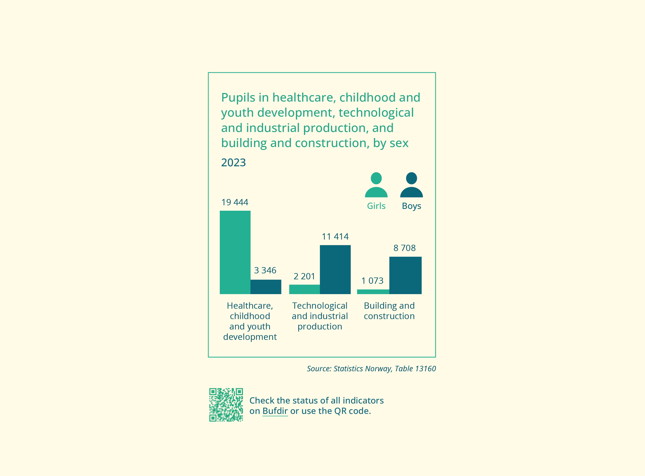

Goal 2.2 Lower drop-out rate among boys in upper secondary school
Status
The drop-out rate in upper secondary school is far higher for boys than girls. This could be viewed as a form of marginalisation and have implications for their future finances and life opportunities, see NOU 2024: 8. Girls are more likely than boys to complete upper secondary school, and are more likely to do so within the standard time frame. Drop-out rates are higher among boys and girls in vocational studies than in general studies programmes. It is important that upper secondary school pupils have the opportunity to complete their studies and qualify for apprenticeships, employment, further education and lifelong learning. This is how the government intends to build a sustainable welfare society for all and improve lives. The government anticipates that expanding rights in upper secondary education will result in higher completion rates, including among boys.
The new Education Act in Norway grants the right to upper secondary education until a pupil attains the higher education entrance qualification or a vocational qualification, as well as the right to vocational retraining. This includes access to skills and vocational training for individuals who have already attained the higher education entrance qualification or a vocational qualification.
Measures
- Continue the pilot project for a buddy scheme in upper secondary school. A pilot buddy scheme was implemented in the spring of 2023, and was re-introduced on 1 January 2024. In this scheme, an apprentice/trainee serves as a mentor (‘buddy’) for an upper secondary school pupil. The aim is to help the pupil in the process of securing an apprenticeship/trainee placement (Ministry of Digitalisation and Public Governance).
Indicators
- Percentage of girls and boys who complete upper secondary school, broken down by vocational or general studies programmes
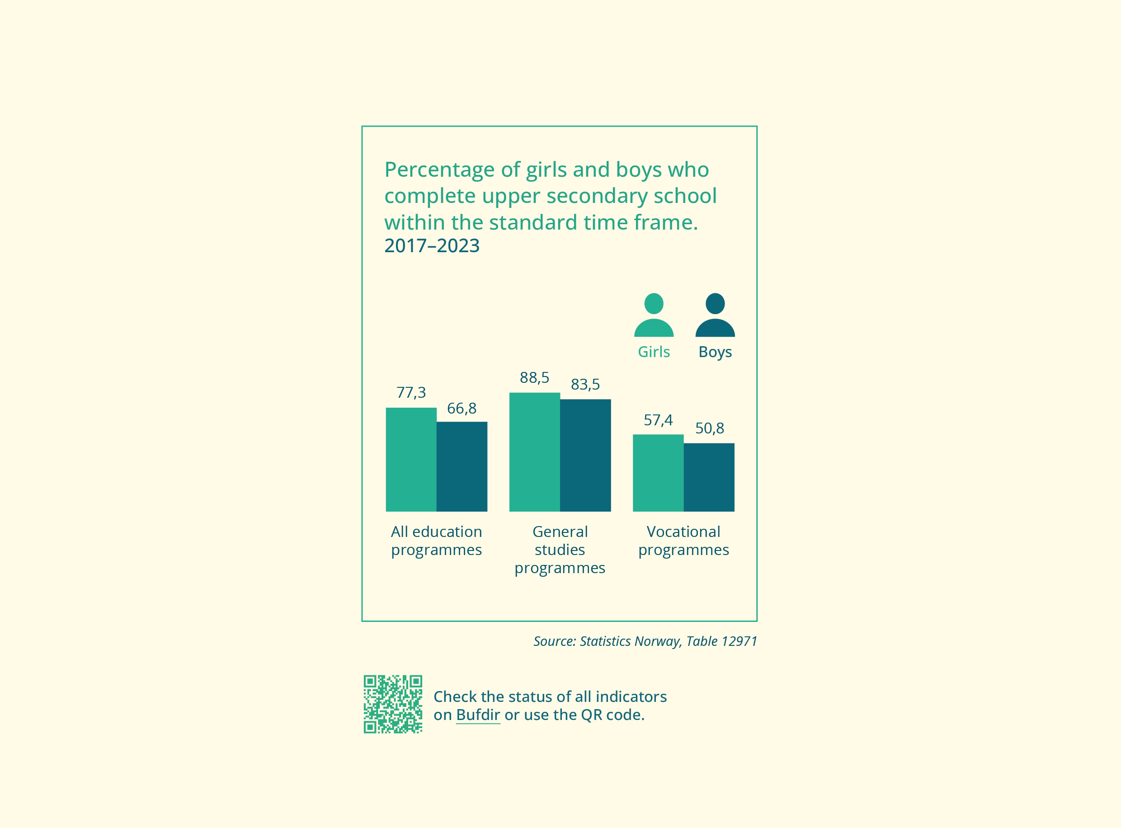

Goal 2.3 Better gender balance in higher education
Status
For the past few decades, the gender distribution among applicants to undergraduate programmes in higher education has remained stable at around 60% women and 40% men, despite the fluctuating application figures. The higher proportion of women in higher education mirrors the trend in all Western countries. Gender imbalance in higher education is a constant challenge that has proven difficult to address. The gender distribution among successful applicants roughly mirrors the overall applicant distribution. The gender gap is small in higher education of more than four years.
The major challenge in higher education is that women and men tend to apply for different fields of study, resulting in a highly skewed gender balance in various study programmes. Research suggests that the use of role models can positively influence diversity in higher education recruitment. Men dominate in sports, IT and technological studies, while women outnumber men in health and social sciences, teacher education, law and language studies. A more even gender balance is found among students in natural sciences, history and business administration.
The large female-dominated study programmes play a major role in the gender imbalance in higher education. In 2020, one-third of all female students were enrolled in study programmes within nursing and care, teacher education (general teaching, pedagogy and advanced teacher training), psychology and social work. There were 63,919 more women than men in higher education in 2020 (315,581 students in total). Almost three-quarters of this gender gap is attributable to the overrepresentation of women in the largest female-dominated fields of study. Simulations indicate that a gender balance in the largest female-dominated fields would lead to almost full gender parity in higher education as a whole.
In NOU 2024: 8, the Men’s Equality Commission proposes a national initiative to encourage more young people to choose and complete vocational training that is not based on traditional gender patterns, and for more men to choose and complete a higher education in health, care, social work and teaching. The Commission notes that this is important in order for individuals to have the opportunity to choose careers based on their abilities and interests, rather than their gender. It is also crucial for optimising the population’s resources, achieving more diverse workforces across various sectors, and ensuring an equitable service provision and access to professionals of both sexes. The Commission also highlights the significant and growing demand for personnel in health and care services, and stresses the need to recruit more men into these roles in the years ahead.
The Boys into Health Studies (Gutter til helsefag) project was expanded in 2024 into a regional initiative in the three northernmost counties in Norway, with a view to recruiting more boys into the health and care sector. The goal is to be achieved by highlighting role models for boys. This includes ensuring that boys in lower and upper secondary school receive comprehensive and nuanced information about opportunities in the sector. It also entails helping school staff to gain a deeper understanding of how educational choices are influenced by gender and to recognise that the initiative is a valuable tool.
For many years, applicants of the underrepresented gender have been awarded up to two additional points for certain study programmes in higher education. In 2022, the Admissions Committee proposed replacing gender-based points with gender quotas for study programmes. In the White Paper on higher education admissions (Opptak til høgare utdanning), the government proposed changes to the rules for higher education admissions. This included introducing gender-neutral quotas for study programmes with a major gender imbalance instead of the gender-based points system. In practice, this means that for study programmes with a major gender imbalance, where gender-neutral quotas would be desirable, quota places would be filled first to ensure a minimum representation of both sexes. The remaining places would then be filled according to the standard ranking. The Storting supported this measure in its review of the White Paper.
In the White Paper on professional education programmes (Meld. St. 19 (2023–2024) Profesjonsnære utdanningar over heile landet), the government announced that the mandate of the Committee for Gender Balance and Diversity in Research (KIF) for the next committee period (2026–2029) will be expanded to also include gender balance in higher education. Expanding the committee’s mandate will allow it to have a long-term focus and assess key transitions and barriers throughout the entire higher education and research trajectory.
Measures
- Develop the Boys into Health Studies (Gutter til helsefag) project into a national, multi-year initiative (Ministry of Culture and Equality, Ministry of Education and Research).
- Follow up and continue ongoing projects in the education sector, including:
- Continue the support for Girls and Technology (Jenter og teknologi). This is a national project aimed at encouraging more girls to apply for technology education. The Confederation of Norwegian Enterprise (NHO), the Norwegian Society of Engineers and Technologists (NITO) and the National Centre for STEM Recruitment are behind the project (Ministry of Culture and Equality).
- Continue the national teacher recruitment project. The goal of this project is to increase the number of applicants to teacher education and teachers, while promoting greater diversity among teachers in kindergartens and schools (Ministry of Education and Research).
Indicators
- Women’s and men’s education levels, broken down by county
- Percentage of female and male students in higher education
- Gender distribution in selected gender- skewed education programmes
- Highest degree attained in higher education within eight years, broken down by sex
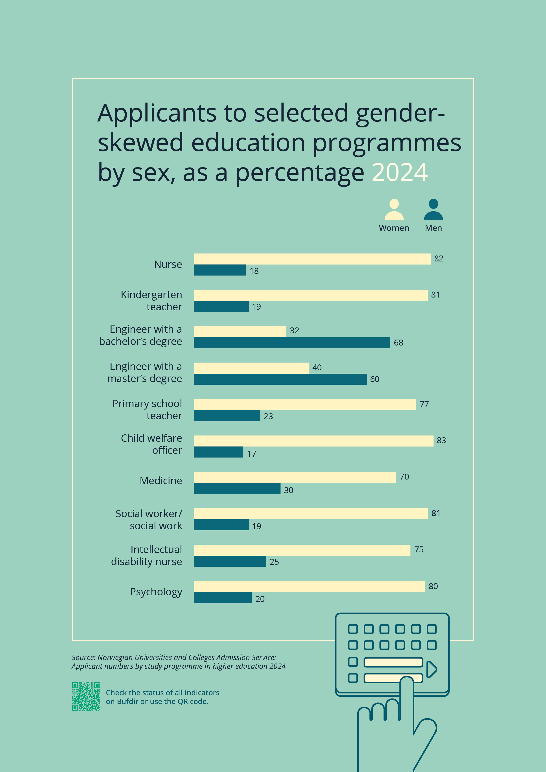

Objective 3: A society without violence, rape, sexual and online harassment
Domestic violence, rape, sexual and online harassment are barriers to a safe and equal society.
The Norwegian government’s goal is to prevent violence and abuse. Effective prevention will enable more people to live safe lives and reduce the need for more drastic measures at a later stage. Measures targeting those who are violent and abusive, or who are at risk of becoming so, are a crucial component of preventive efforts. A wide range of services is available to support those subjected to violence and abuse, and the goal is to ensure effective follow-up. Timely, well-coordinated support can help prevent the negative aftereffects of violence and abuse.
The government believes that sexual harassment is a societal problem and wants to tackle it head on. Sexual harassment is a major burden for the individual concerned and for society as a whole.

Goals
The government has outlined the following goals, measures and indicators:

Goal 3.1 Better prevention and combatting of domestic violence
Status
Domestic violence is one of the biggest obstacles to achieving gender equality. Both women and men experience domestic violence, but research shows that women are more likely than men to be subjected to severe and repeated violence, including sexual violence. In 2023, the Norwegian Centre for Violence and Traumatic Stress Studies (NKVTS) conducted a national survey on violence and abuse among the Norwegian population, which revealed that one in ten women have experienced severe violence at the hands of a partner.
Violence and sexual abuse are not only challenges to gender equality, they are also serious crimes, significant societal issues and a public health problem. In the most extreme cases, violence leads to loss of life. In 2023, 13 women and 4 men were killed by a current or former partner, and this constituted 45% of all murders in Norway that year. The person subjected to the violence bears the brunt of the consequences. A socioeconomic analysis from 2023 estimated that domestic violence cost Norwegian society NOK 92.7 billion in 2021.
In December 2023, the government presented an escalation plan to combat violence and abuse towards children and domestic violence (Opptrappingsplan mot vold og overgrep mot barn og vold i nære relasjoner (2024–2028) Trygghet for alle). The plan provides for more targeted prevention, better support and protection for victims, and more effective criminal prosecution and follow-up of perpetrators. This will be achieved through a more comprehensive and coordinated policy in this area.
The government is also working to establish a permanent commission to review all intimate partner killings. The purpose of the commission is to uncover systemic failures, learn from mistakes and further develop the efforts to prevent serious partner violence and intimate partner killings. The commission chair and members were appointed in September 2024, and its secretariat is located within the Norwegian Civil Affairs Authority.
Measures
- Prevent and combat domestic violence through the escalation plan to combat violence and abuse towards children and domestic violence (2024–2028) (Ministry of Justice and Public Security).
- Prepare draft legislation that grants the permanent commission for intimate partner killings access to the necessary information. The commission will start its review of intimate partner killings as soon as the law is passed by the Storting (Ministry of Justice and Public Security).
Indicators
- Number of victims of domestic abuse reported to the police, broken down by sex.
- Number of victims of intimate partner killings, broken down by sex.
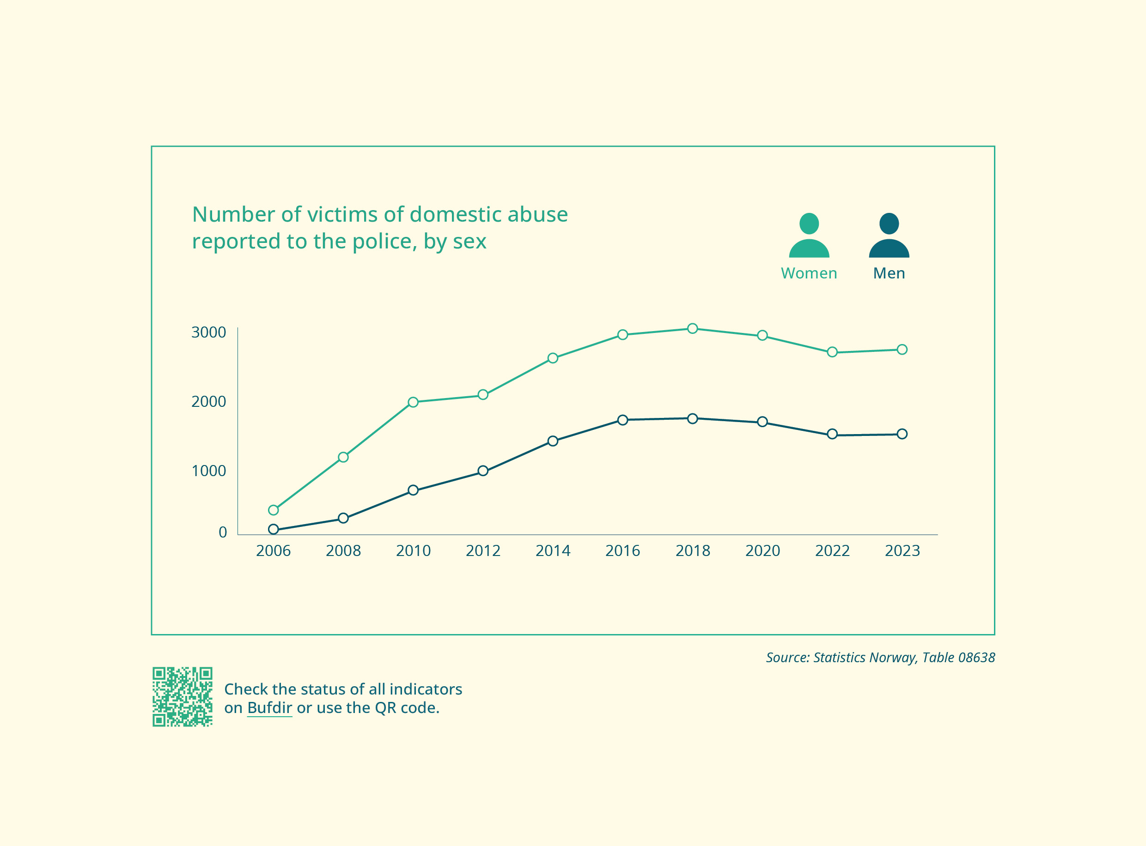

Goal 3.2 Better follow-up of persons subjected to violence
Status
Violence and abuse can affect many areas of victims’ lives. There are a wide range of services that could play a role in the follow-up, treatment and protection of persons subjected to violence and abuse, including crisis centres, the family counselling service, primary health and care services, and the specialist health service. The police have a specific responsibility to protect victims from violence and abuse.
Measures
- Follow up on the public consultation regarding proposed changes to the Crisis Centre Act (Ministry of Children and Families).
- Map the medical and psychosocial emergency service provision for those subjected to domestic violence and assess follow-up measures (Ministry of Health and Care Services).
- Facilitate increased use of restraining order with electronic control (known colloquially in Norway as ‘reverse violence alarms’) to enhance the safety and security of victims and shift the burden of violence and threats from the victim to the perpetrator (Ministry of Justice and Public Security).
- Establish a Risk Analysis and Criminal Prevention (RISK) division in all police districts. RISK in Oslo is involved in preventing domestic violence and protecting victims. Funding has been allocated to open a RISK division in the Nordland, South-West and South-East police districts in 2024. The work will continue in 2025 (Ministry of Justice and Public Security).
Indicators
Services
- Number of repeat residents at crisis centres, broken down by sex
- Number of crisis centre stays that resulted in a return to the perpetrator, broken down by sex
- Number of family counselling cases where partner violence or violence in parent-child relationships was reported as an issue
- Number of mediation cases in family counselling where violence was reported
- Number of individuals with electronic monitors in cases of domestic violence
Violence and abuse
- Victims of severe physical violence, broken down by sex and perpetrator

Goal 3.3 Prevent and combat rape
Status
Rape is a severe violation of the physical integrity of a person that can cause them extensive harm. It is a serious gender equality issue, with women being the most affected. The NKVTS study on violence and abuse in the Norwegian population from 2023 shows that 20% of women have been subjected to rape by force/coercion, incapacitated rape (known colloquially in Norway as ‘sleep-rape’), or both. The corresponding figure for men was 3%. Rape is almost exclusively committed by men. The NOVA UngVold study from 2023 revealed that one in four respondents had experienced at least one instance of sexual violence during their lifetime. The prevalence of sexual violence was nearly four times higher for girls than for boys, and the rate had doubled since a similar survey in 2015. Overall, one in ten had experienced sexual violence that could legally be defined as rape.
Measures
- Follow up on the Rape Committee’s report NOU 2024: 4 on rape as an unresolved societal problem (Voldtekt et uløst samfunnsproblem) (Ministry of Justice and Public Security).
- Propose changes to the Penal Code’s chapter on sexual offences. This will help to strengthen the right to sexual autonomy (Ministry of Justice and Public Security).
Indicators
- Victims of rape, broken down by sex
- Number of rape victims who reported it to the police, broken down by sex
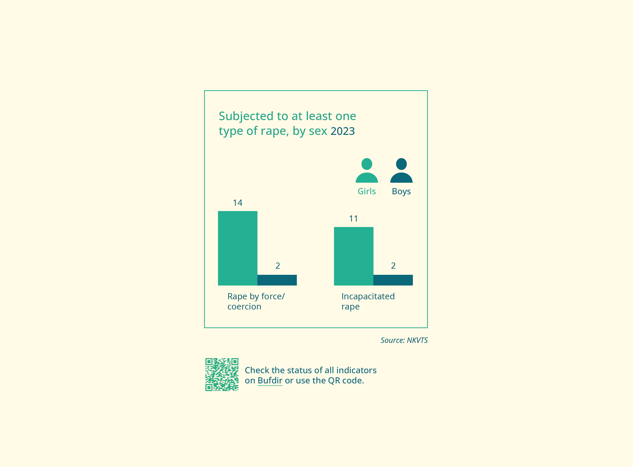

Goal 3.4 Improve support services for perpetrators of violence
Status
Men are overrepresented among perpetrators of violence, including domestic violence, severe physical violence in public spaces and sexual violence against women and children. Boys are strongly overrepresented among those exhibiting problematic or harmful sexual behaviour. In NOU 2024: 8, the Men’s Equality Commission writes that providing better support for perpetrators of violence will help reduce violence. The Commission also highlights significant geographical disparities in the access to support services for perpetrators in Norway.
Enhancing support for perpetrators of violence or those who are at risk of perpetrating violence or engaging in harmful sexual behaviour is a key aspect of current violence prevention efforts.
Various treatment and follow-up options are available for adults and children who perpetrate violence or abuse, or are at risk of doing so. These services are offered through the health service, the family counselling service, the child welfare service and organisations like Alternative to Violence.
The Norwegian Directorate of Health has devised a national strategy for the health sector’s work with perpetrators of violence or abuse. Since 2023, the Directorate’s sole focus has been on children and adolescents. Efforts include establishing treatment programmes for children and adolescents at high risk of harming others and creating a common framework to guide various services’ work with individuals at risk of perpetrating, or who have already perpetrated, violence and/or sexual abuse.
Measures
- Strive to ensure an equitable and accessible service provision within the health and care sector for individuals who have perpetrated or are at risk of perpetrating violence and sexual abuse (Ministry of Health and Care Services).
- Ensure cross-sector access to information, methods and tools for identifying and working with children and adolescents at risk of harming others (Ministry of Health and Care Services).
- Continue efforts to prevent problematic and harmful sexual behaviour among children and adolescents (Ministry of Health and Care Services).

Goal 3.5 Increased efforts to combat sexual harassment in the workplace, schools and other educational settings, cultural and sports arenas, and online
Status
Sexual harassment is an obstacle to gender equality and can limit people’s freedom and ability to live the life they want. Despite the #MeToo movement raising awareness about sexual harassment, it remains an ongoing problem. Anyone can be subjected to sexual harassment, but it is particularly women who are targeted, and especially young women. Sexual harassment can have serious consequences for individuals, workplaces and organisations, as well as for society as a whole.
Measures
- Present a White Paper on sexual harassment (Ministry of Culture and Equality).
Indicators
- Percentage of women and men who report being subjected to unwanted sexual attention at work, broken down by occupation
- Percentage of girls and boys who have been subjected to various forms of sexual harassment, broken down by sex and school level
- Percentage of men and women who have been subjected to digital sexual violence, broken down by sex and age
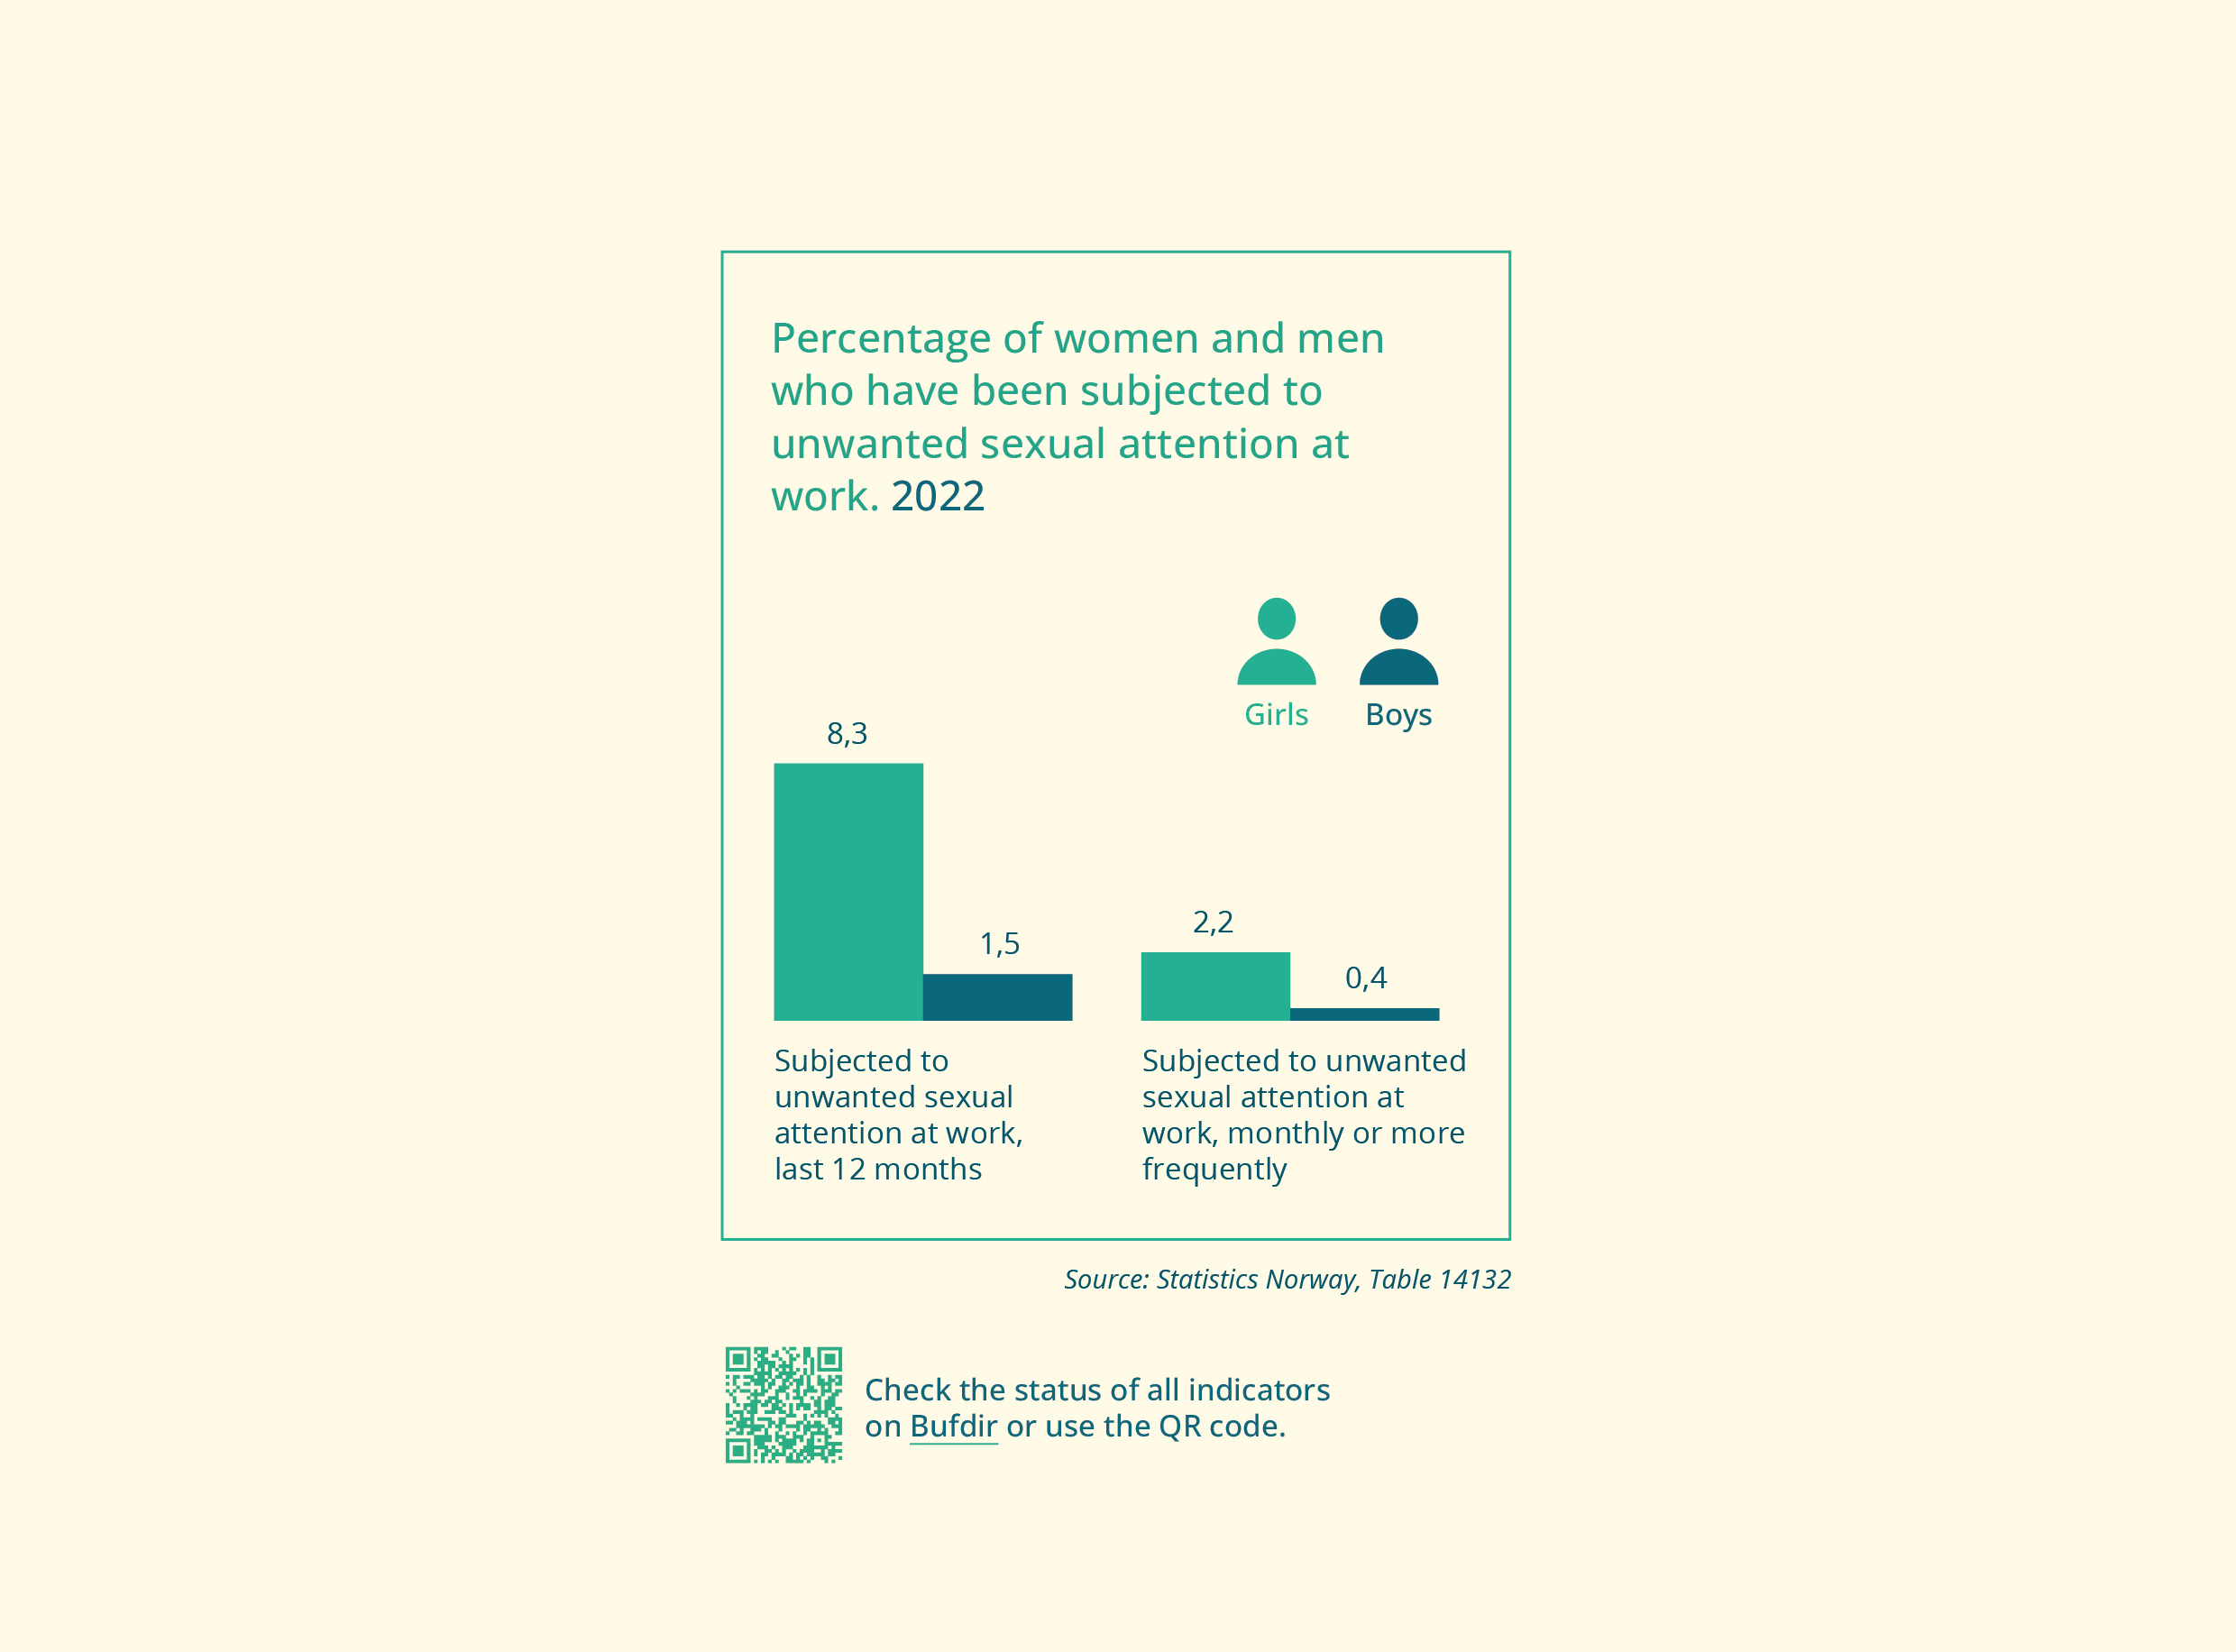

Goal 3.6 Less online harassment
Status
More men than women experience online harassment, but women are more likely to face it due to their gender. Twice as many young women as young men report being negatively affected by hateful comments online. Significantly more young men than young women feel capable of handling hateful abuse.
Measures
- Follow up on the research project on racism and ethnic discrimination. The project has three parts, one of which focuses on the use of AI to identify and prevent hate speech on social media. The project is due for completion by the end of 2026 (Ministry of Culture and Equality).
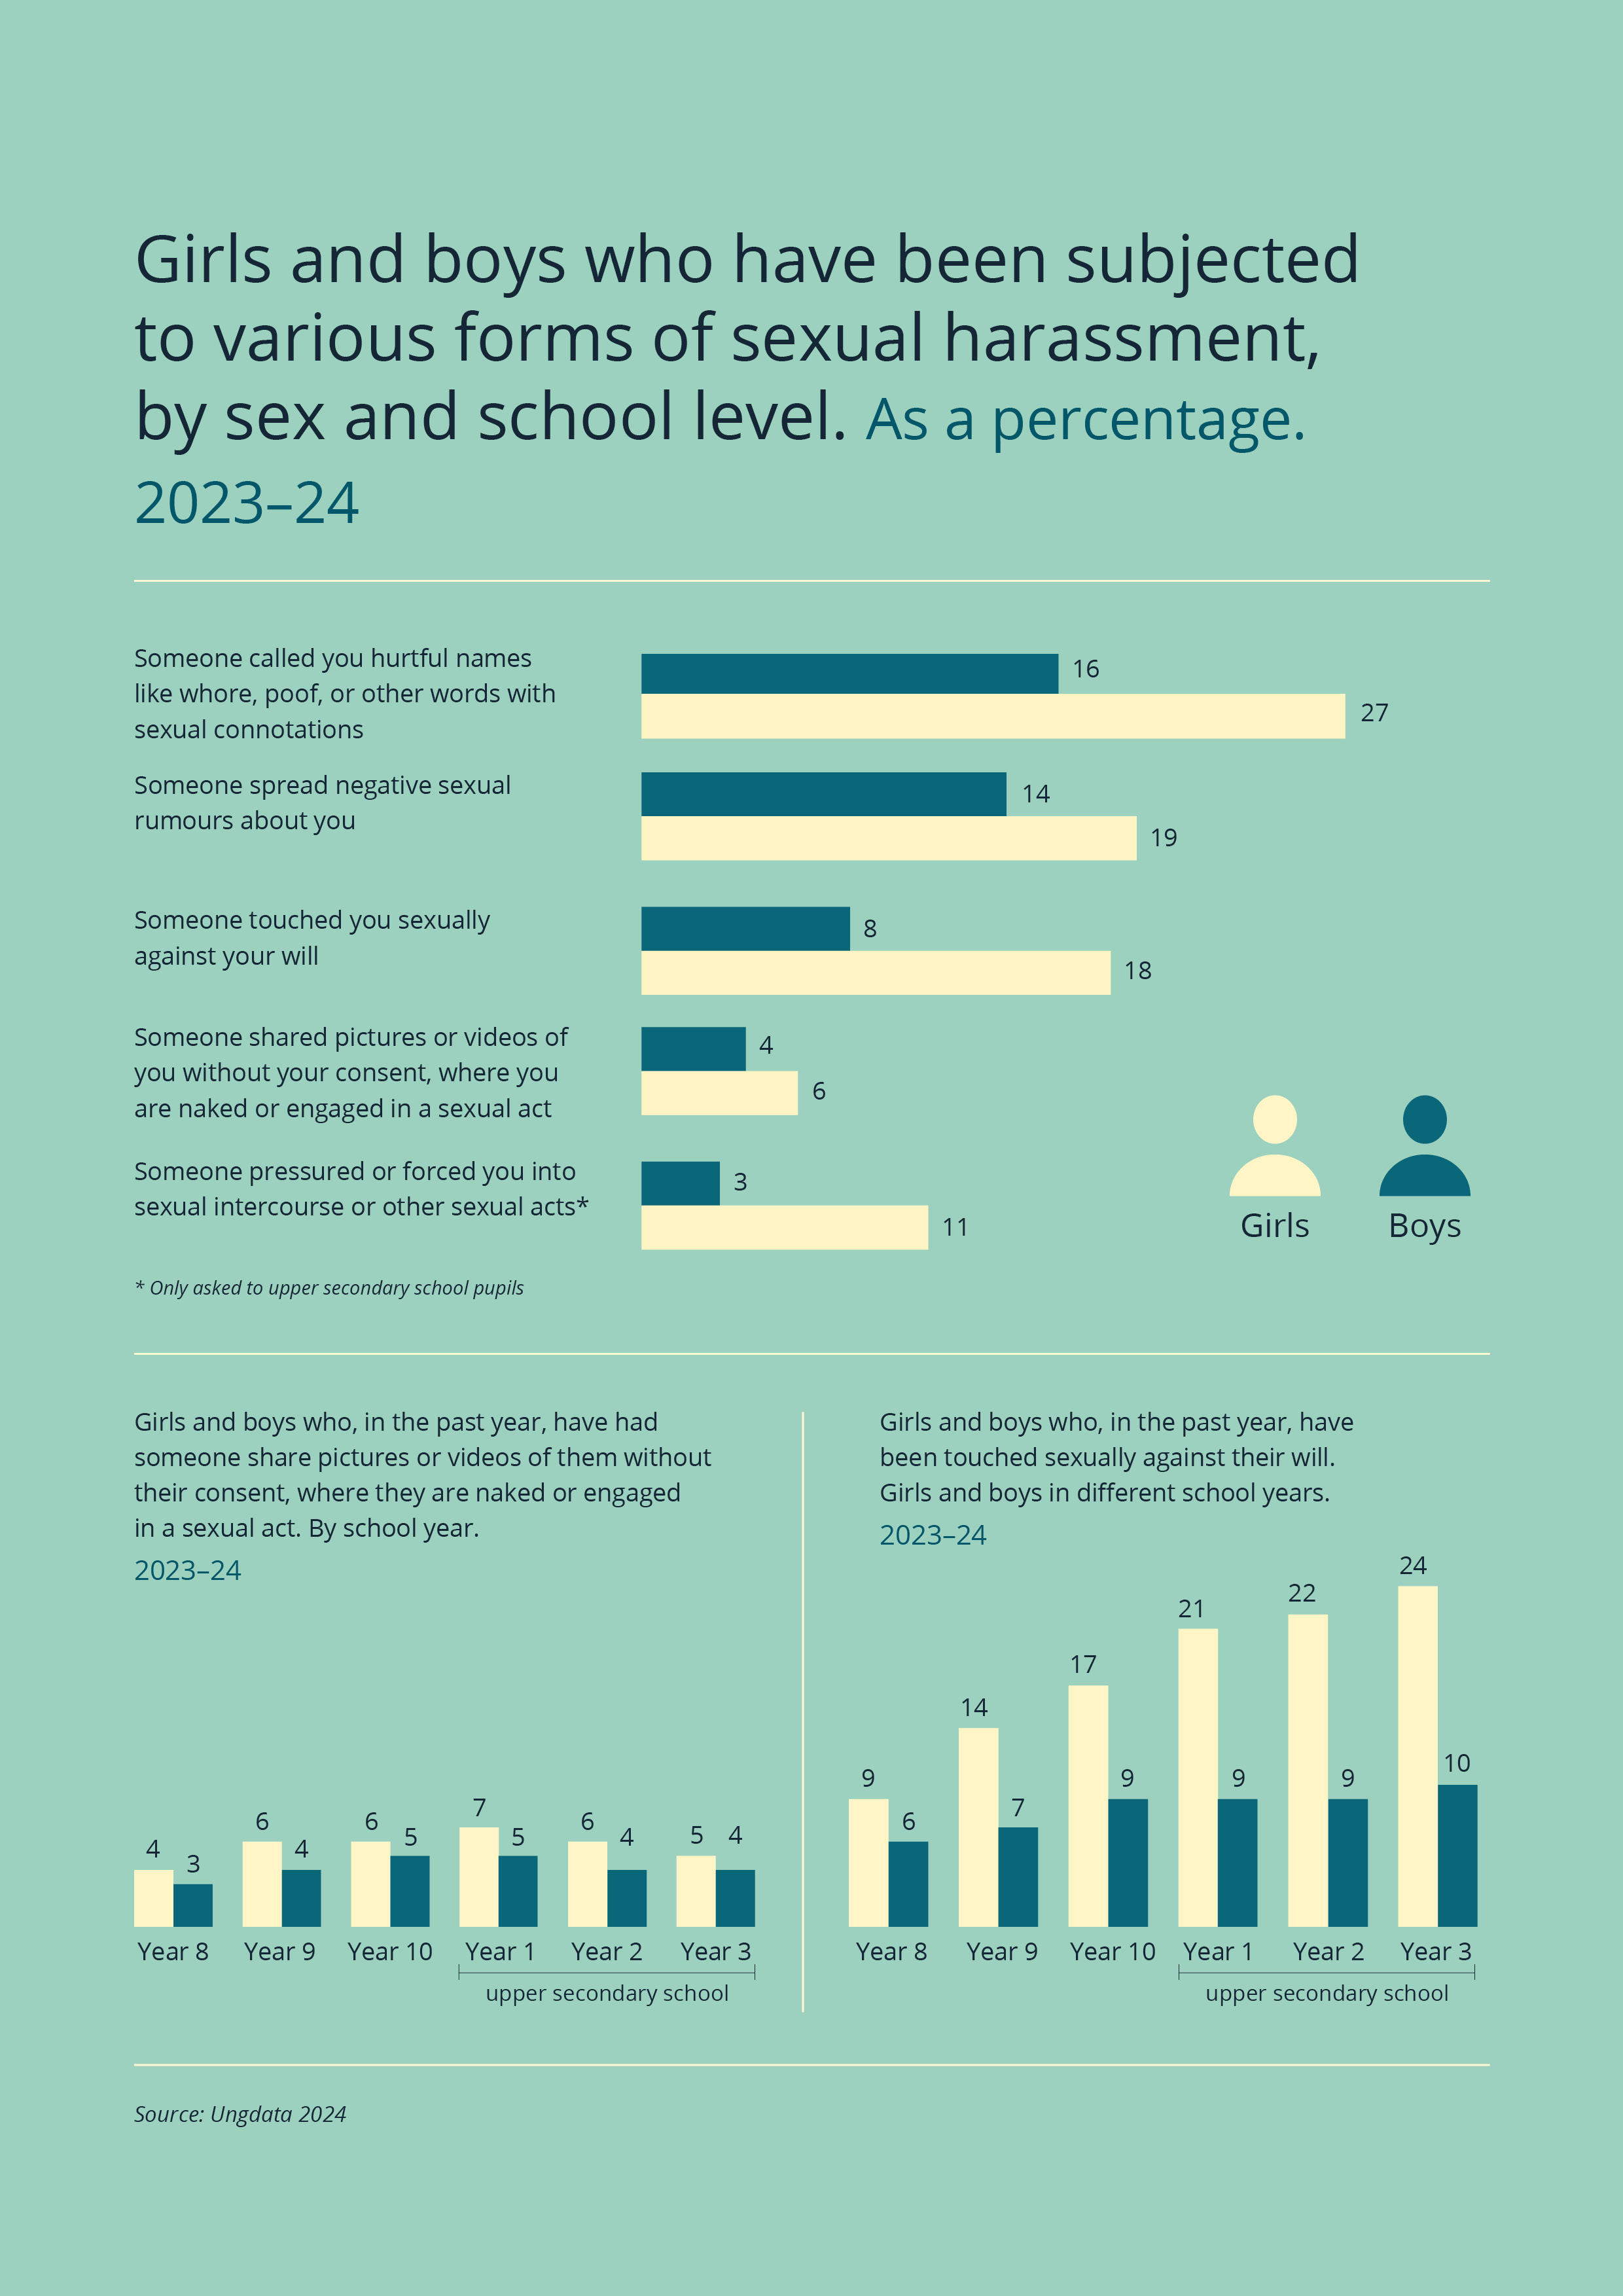

Objective 4: Freedom from negative social control and honour- based violence
The freedom to make decisions about our own life is fundamental in our society. Combating attitudes and actions that lead to negative social control and honour-based violence, including forced marriages and female genital mutilation, is a key part of the government’s efforts to promote gender equality. This work entails protecting basic rights, combating violence and abuse, and ensuring the freedom of individuals to make their own life choices.
The government is working on multiple fronts to safeguard these basic rights. Efforts are underway to combat negative social control and honour-based violence through the action plan Freedom from Negative Social Control and Honour Based Violence (2021–2024) and the escalation plan to combat violence and abuse towards children and domestic violence (Opptrappingsplan mot vold og overgrep mot barn og vold i nære relasjoner (2024–2028) Trygghet for alle). Of the 33 measures in Freedom from Negative Social Control and Honour Based Violence, 26 are ongoing and 7 have been completed as of 31 December 2023. The government is further strengthening efforts and will present a new action plan to combat negative social control and honour-based violence in spring 2025. Legislation is an important part of the wide-ranging measures, and the government has now received the Official Norwegian Report NOU 2024: 13 Law and Freedom. The report will form part of the knowledge base for the new action plan.

Goals
The government has outlined the following goals, measures and indicators:

Goal 4.1 Better prevention and combating of negative social control and honour-based violence
Status
Women and men can both be subjected to negative social control and honour-based violence, but approximately three out of four cases reported to the national interagency Expert Team for the prevention of forced marriage, female genital mutilation and negative social control (the Expert Team) involve girls and women. Control over women’s and girl’s sexuality is a key factor in such cases. In recent years, there has been an increased focus on male victims, and the number of cases involving boys and men reported to the Expert Team is rising. Boys and men can also experience a cross-pressure to exert control over or be violent towards a family member, while simultaneously being subjected to such behaviour themselves.
Measures
- Follow up on the measures in the escalation plan to combat violence and abuse towards children and domestic violence, which includes efforts aimed at negative social control and honour-based violence (Ministry of Labour and Social Inclusion).
- Develop a new action plan against negative social control and honour-based violence for the period 2025–2028, and follow up on the measures therein (Ministry of Labour and Social Inclusion).

Goal 4.2 More staff in standard support services trained in dealing with negative social control and honour-based violence
Status
Several specialised services with expertise in negative social control and honour-based violence are available to support those directly affected, advise staff in standard support services on individual cases, and offer skills enhancement through training courses and presentations. The Expert Team has seen a significant rise in the number of cases over time, likely due to increased awareness about the team and more cases being identified by staff in the support services.
Diversity advisors at selected lower and upper secondary schools and adult education centres across all counties in Norway provide a low-threshold service that offers early-stage counselling and preventive measures for individual cases. In 2024, both the Expert Team and diversity advisor service at selected schools and adult education centres were expanded with additional positions. Additionally, there are four special representatives for integration (Integration Advisor) at the diplomatic missions in Ankara, Amman, Nairobi, and Islamabad, who provide consular assistance to vulnerable individuals in their respective regions.
A national housing and support service is also in place for adults subjected to negative social control and honour-based violence. The purpose is to provide those in need of protection with a safe place to live and subsequently help them reintegrate into society. The service was expanded in 2024 with a three-year pilot programme, providing places for adults who have returned from involuntary stays abroad and are not covered by the current service because they are not at risk or have additional issues, such as substance use and mental health challenges.
Measures
- Improve the information about the specialised support services (Ministry of Labour and Social Inclusion).
- Improve expertise in negative social control and honour-based violence in standard support services (Ministry of Labour and Social Inclusion).
- Implement additional skills enhancement measures for staff in standard support services, organised by the specialised support services (Ministry of Labour and Social Inclusion).
Indicators
- Number of cases in which the Expert Team has provided guidance or otherwise assisted individuals, service providers or voluntary organisations, broken down by the gender of the person concerned
- Number of cases handled by diversity advisors at lower and upper secondary schools, and adult education centres, broken down by the gender of the person concerned
- Number of cases handled by the special representative for integration (Integration Advisor) at diplomatic missions, broken down by the gender of the person concerned
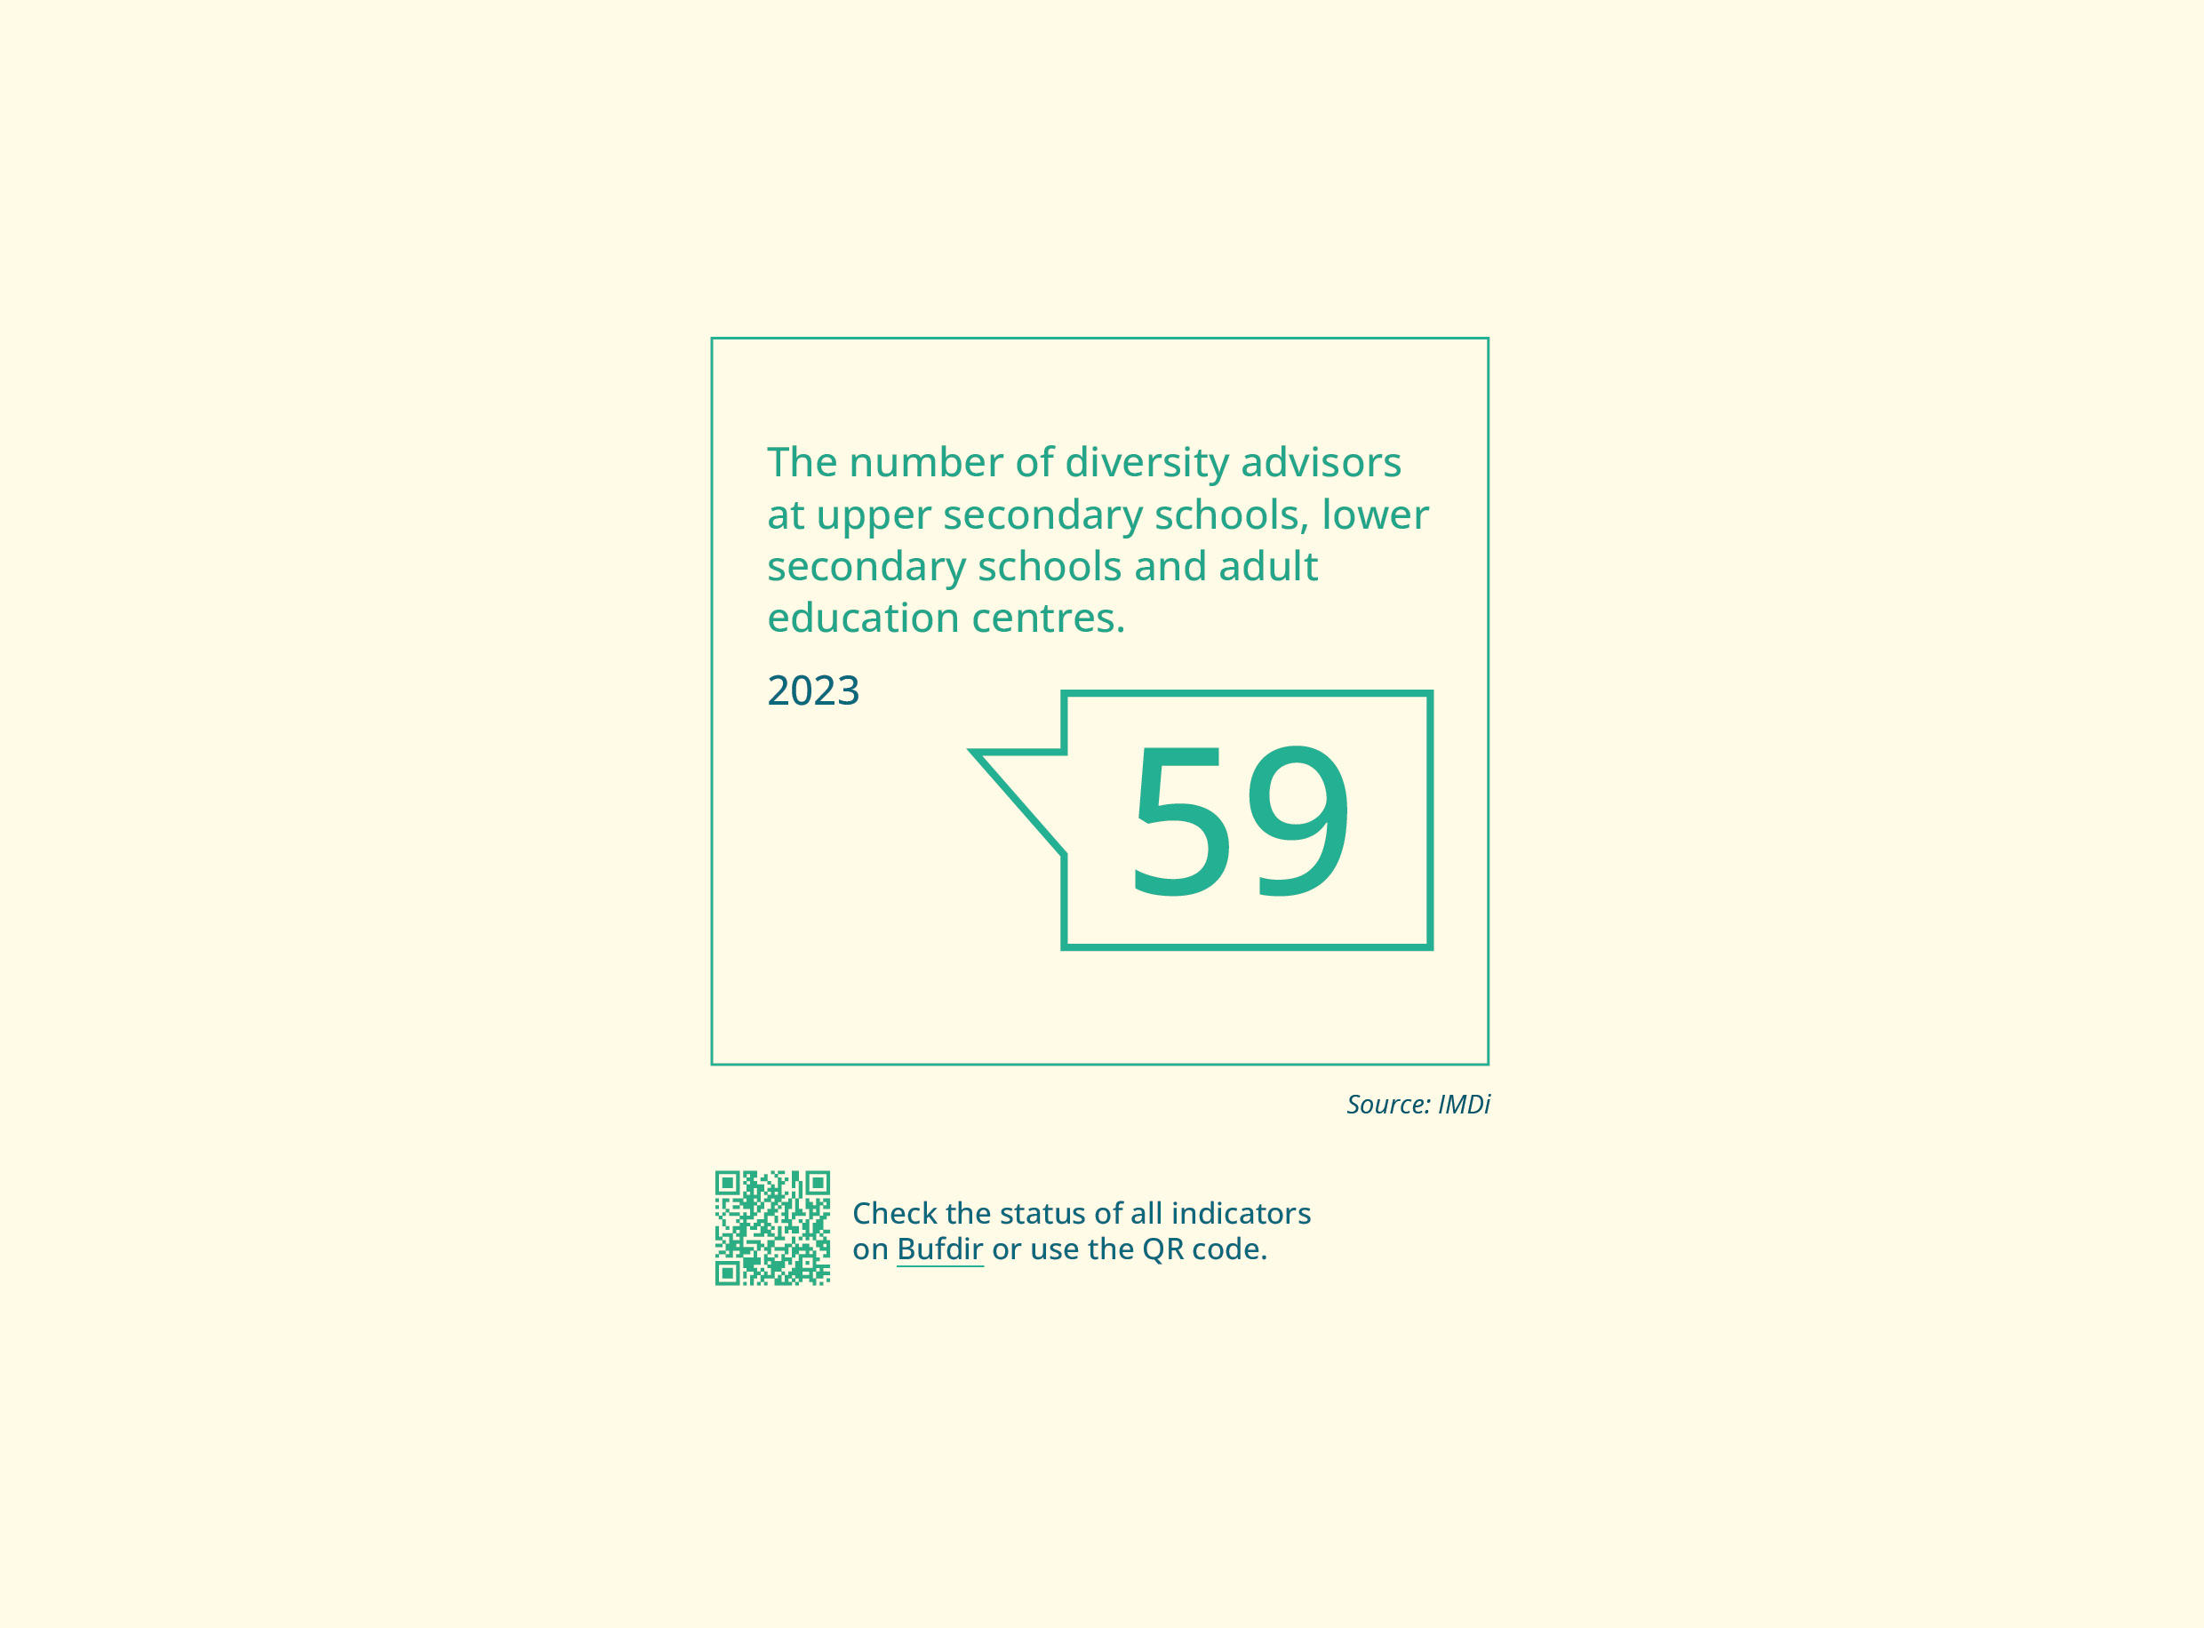

Goal 4.3 Better legal protection
Status
A legal committee has examined the overarching legal issues in cases related to negative social control, honour-based violence, forced marriage, female genital mutilation and psychological violence.
The committee assessed whether children and young people who are subjected to such behaviour have adequate legal protection or if legislative changes are needed. It also evaluated whether these phenomena are sufficiently regulated in Norwegian law and whether Norway fulfils its human rights obligations in this area. On 24 June 2024, the committee submitted its report, NOU 2024: 13 Law and Freedom. The report proposed numerous amendments to the legislation, including the Penal Code, the Child Welfare Act and the Immigration Act. Other laws affected include the Children Act, the Passport Act, the Criminal Procedure Act and the Integration Act. These proposals collectively aim to improve the protection against serious violations of an individual’s physical and psychological integrity and to clarify the legal framework for the support services.
Measures
- The report was sent out for public consultation on 28 June 2024 with a four-month deadline for feedback. The report will also form part of the knowledge base for a new action plan to combat negative social control and honour-based violence (Ministry of Labour and Social Inclusion).

Goal 4.4 Improved support for individuals subjected to involuntary stays abroad
Status
Involuntary stays abroad remain an ongoing challenge, and the specialised services have reported an increase in the number of enquiries on this topic.
Measures
- Follow up on research and development (R&D) regarding children and young adults held abroad against their will (Ministry of Labour and Social Inclusion).
- Follow up on R&D regarding women and their children who are held abroad against their will (Ministry of Labour and Social Inclusion).
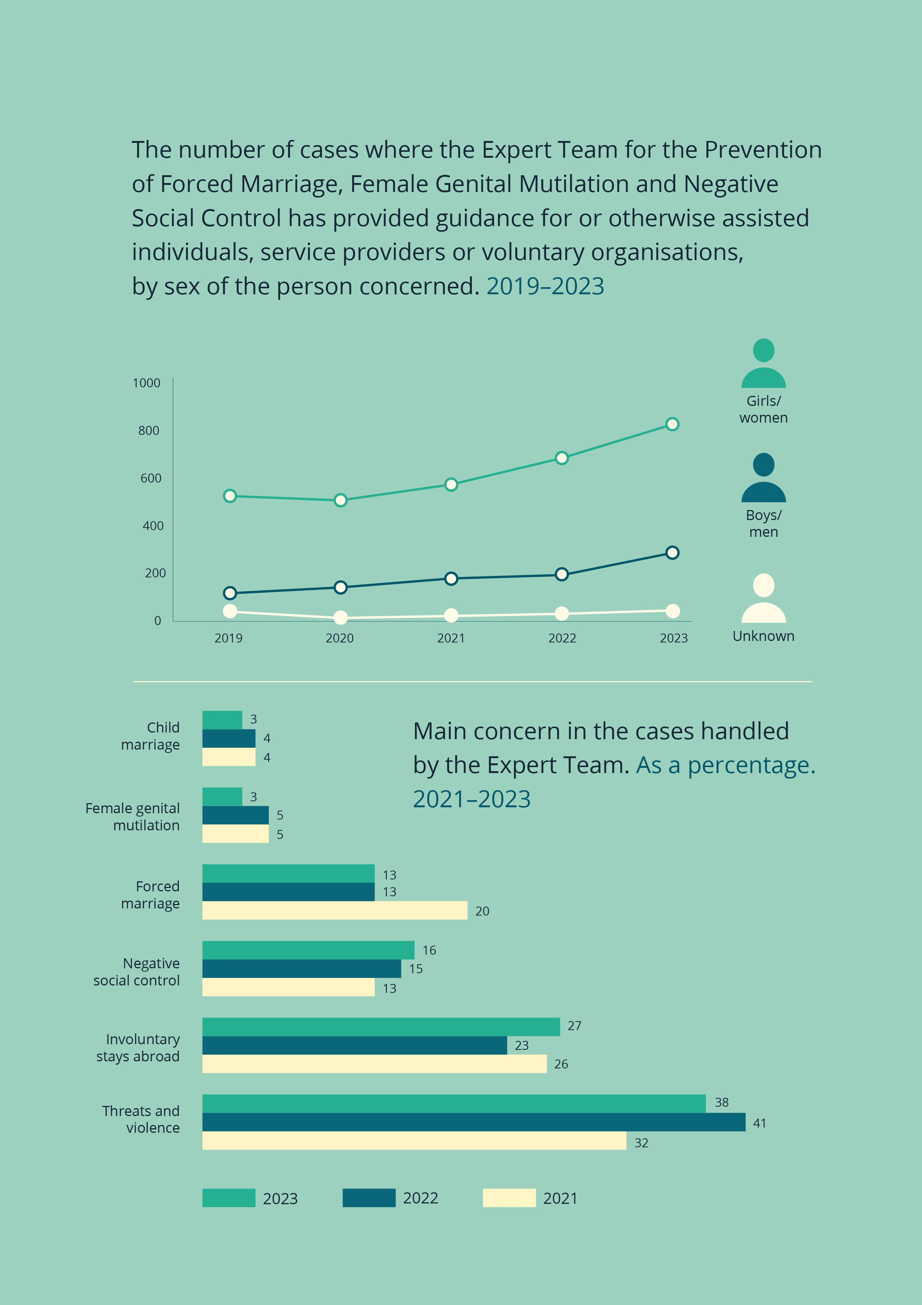

Objective 5: Better health for women and men
Everyone in Norway, regardless of gender or other factors that could lead to discrimination, should have equal opportunities for optimum health. The White Paper on public health emphasises that lifestyle habits are not just individual choices but are largely influenced by social conditions and background.
Opportunities for men and women to maintain a healthy lifestyle and enjoy a good quality of life are often shaped by policies outside the health sector. Efforts to improve health in a lifelong perspective are crucial for healthier aging. Knowledge and understanding of gender should form the basis for the design of public campaigns, recommendations and guidelines in the field of public health. The aim of this is to improve goal attainment in public health efforts. The government seeks to reduce social inequalities on the basis that universal measures will apply to everyone but will be most effective for those with the greatest need.
Norway has a zero-vision objective for suicide (see the Action Plan for Suicide Prevention 2020–2025). The vision is to be achieved through a range of measures aimed at improving prevention, implementing more systematic suicide prevention efforts, and providing effective support and treatment pathways for individuals at risk. The plan emphasises that many people face significant barriers to seeking help, particularly men.
Mental health is one of the government’s key focus areas. The primary goal of the government’s mental health escalation plan is to improve more people’s mental health and quality of life, while ensuring accessible and effective support for those in need. A greater effort is needed to prevent mental health issues and disorders, and the threshold for receiving help must be lowered. Meanwhile, those with severe mental health disorders should receive more comprehensive treatment and follow-up.

Goals
The government has outlined the following goals, measures and indicators:

Goal 5.1 Clearer gender equality perspective in health
Status
Women still have a longer life expectancy than men. Statistics show that although women live longer than men, they have fewer healthy years of life. Morbidity and uptake of health services are higher for women than men, and more women than men report having mental health issues and musculoskeletal diseases. Dissatisfaction with own physical and mental health is also more common in women. Fifteen-year-old girls are less physically active than their male peers, and women are also generally less physically active than men. Physical activity is generally too low for men and women compared to the recommended levels. There is also a social disparity. Furthermore, women are more susceptible to osteoporosis than men, and are at almost twice the risk of hip fractures.
Men face significant health challenges, as highlighted in the report by the Men’s Equality Commission: NOU 2024: 8 The Next Step in Gender Equality. Men experience poorer health due to the early onset of serious diseases and premature death, resulting in a shorter average lifespan than women. In 2022, the gender gap in life expectancy was three and a half years. The Men’s Equality Commission points to various factors, such as the considerably higher mortality rate in men as a result of substance use, accidents and suicide. Men are also at a higher risk of developing and dying from cancer, and more men than women die from non-communicable diseases before the age of 75. Life expectancy is linked to income and education for both men and women, but the correlation is stronger for men. The life expectancy gap between those with the highest and lowest income is 13.8 years for men and 8.4 years for women. The Men’s Equality Commission also notes that men use the health service less frequently than women, even when excluding consultations related to pregnancy.
Loneliness and social isolation have a negative impact on health and quality of life. The Men’s Equality Commission highlights the need to establish more support forums specifically aimed at men. The government has proposed allocating NOK 10 million in funding for support forums for boys and young men, with the goal of preventing crime and recruitment to criminal environments in vulnerable areas.
A better understanding is needed of how diseases affect women and men differently. The government believes it is crucial to better incorporate the biological and sociocultural gender perspective into all aspects of health and care services. An ongoing goal is to establish systems that incorporate up-to-date knowledge about men’s and women’s specific needs. This requires awareness and support from the authorities and managers at all service levels, as well as the development of a culture that can adapt practices in line with current knowledge.
When designing health and care services and public health efforts, it is important to incorporate the gender perspective, as emphasised by both the Men’s Equality Commission and the Women’s Health Commission. The government believes that a targeted approach to gender in health could high-light disparities in women’s and men’s access to tailored services. Raising awareness of the different needs of women and men, and developing more gender-specific treatment options can improve the quality of health and care services. This approach will help achieve the broader goal of reducing the gender gap and ensuring a more equitable service provision. It will also provide a more robust basis for identifying and addressing geographical differences in the nationwide service provision.
Health research is a key tool in health and care policy. Evidence-based knowledge forms part of the basis for policy-making and healthcare decisions, as well as for evaluating measures implemented at the local and national levels. In the government’s long-term plan for research and higher education for the period 2023–2032, health is a specific priority. The government aims to facilitate better utilisation of health data in addressing women’s health and gender perspectives in health, with the goal of ensuring equal access to services and public health initiatives.
Measures
- Implement the government’s health strategy for women (Ministry of Health and Care Services).
- Follow up on NOU 2024: 8 The Next Step in Gender Equality, specifically the health- related proposals, via a White Paper (Ministry of Culture and Equality, Ministry of Health and Care Services).
- Follow up on the Action Plan for Suicide Prevention (Ministry of Health and Care Services).
- Follow up on the Action Plan for Physical Activity (Ministry of Health and Care Services).
- Follow up on the National Alcohol Strategy (2021–2030) and the National Tobacco Strategy, as outlined in the White Paper on public health (Meld. St. 15 (2022–2023) Folkehelsemelding) (Ministry of Health and Care Services)
- Use data on men’s and women’s health and quality of life to inform public campaigns (Ministry of Health and Care Services).
- Highlight gender disparities in information about morbidity, disability, risk factors and mortality (disease burden) in the population (Ministry of Health and Care Services).
Indicators
Health situation
- Expected number of healthy life years among women and men
- Percentage of the population with musculoskeletal injuries, broken down by sex and type of illness/injury
- Percentage of young people who have experienced multiple mental health issues in the past seven days, broken down by sex and school level
- Average score for women’s and men’s sense of mastery, meaning, engagement and optimism for the future
- Number of deaths by suicide per 100,000, broken down by sex
- Total number of deaths from non- communicable diseases (cardiovascular diseases, cancer, diabetes, chronic respiratory diseases) in the 30–69 age group, broken down by sex
- Overweight and obesity among children and adults, broken down by sex
- Location and mechanism of injuries, broken down by sex and age
Lifestyle habits
- Percentage of men and women who report smoking and using snus daily
- Use of alcohol, cannabis and addictive medications among men and women
Sick leave and uptake of health services
- Certified sick leave among women and men, broken down by age and industry
- Use of general practitioners, broken down by sex, age and immigrant background
- Percentage of girls and boys who have visited a school nurse or health centre for adolescents in the past year, broken down by school level
- Satisfaction with public health services, broken down by sex
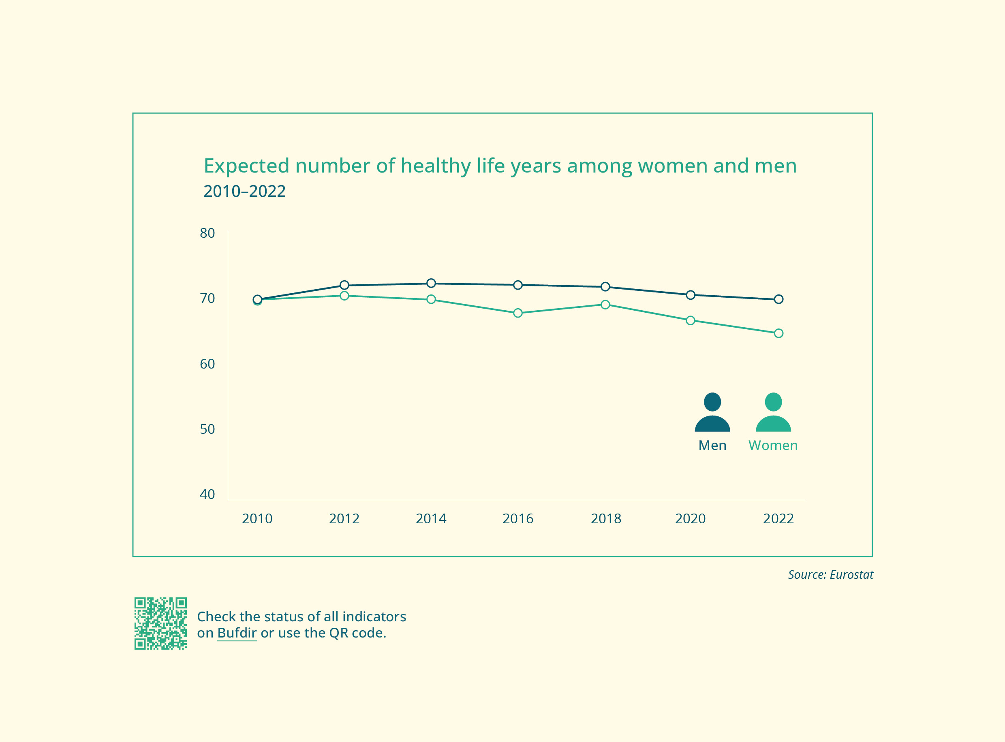

Objective 6: Effective national mechanisms for promoting gender equality
A well-structured framework for gender equality efforts is essential to achieving the political ambitions in this field.
The Ministry of Culture and Equality is responsible for coordinating government policies on gender equality and discrimination. It is also responsible for the administration of the Equality and Anti-Discrimination Act, the Equality and Anti-Discrimination Ombud and the Equality and Anti-Discrimination Tribunal. All ministries are responsible for gender equality within their respective areas, and the Ministry of Culture and Equality supports this important work.
The Norwegian Directorate for Children, Youth and Family Affairs (Bufdir) is the government agency responsible for promoting gender equality and combatting discrimination and sexual harassment both nationally and internationally.
The role of the Centres for Equality and Reform - Resource centre for men is to engage in long-term advocacy and development efforts aimed at promoting equality. With the establishment of a fifth Centre for Equality in Western Norway, all regions now have their own centre. The grant scheme for family and gender equality work aims to sustain operations, foster diversity and boost activity among voluntary organisations in Norway.
Effective national mechanisms for promoting gender equality are founded on a robust knowledge base and are crucial for developing equality policies. The Ministry of Culture and Equality is working on a cross-sectoral R&D initiative within equality and discrimination. The ministry funds research on gender equality, with a particular focus on challenges in the labour market and the work-life balance. CORE – The Centre for Research on Gender Equality is a key contributor to this research. The Ministry of Culture and Equality also funds a framework agreement with Statistics Norway, along with various other initiatives.

Goals
The government has outlined the following goals, measures and indicators:

Goal 6.1 Improve the follow-up of public authorities’ activity and reporting obligation
Status
Public authorities’ activity and reporting obligation enshrines in law what is commonly referred to as the sectoral responsibility for equality – the duty to ensure that each sector is responsible for ensuring active equality efforts, and that these permeate all public activities.
Section 24 of the Equality and Anti-Discrimination Act stipulates that all public authorities, both locally and nationally, must work actively, purposefully and systematically to promote equality and prevent discrimination in all their activities. This means that public authorities must ensure that their services, administration and exercising of authority promote equality, are tailored to a diverse population and do not result in unequal outcomes for different parts of the population.
The work must be preventive and involves authorities mapping the status and challenges related to equality in their operations, setting goals, evaluating measures and reviewing overall progress. Authorities should also devise principles, procedures and standards for their equality work, such as a equality policy.
Authorities must also report on their equality work in their annual report or other publicly accessible document. This should include an explanation of how they are putting their principles, procedures and standards for equality and non-discrimination into practice. Finally, they must assess the results they have achieved and outline their expectations for future efforts.
Through their main directive and allocation letter, Norway’s county governors are tasked with encouraging local authorities to actively promote equality. The county governors must help raise awareness of the activity and reporting obligation, as well as the working method required under sections 24 and 26 of the Equality and Anti-Discrimination Act.
Bufdir has developed guidance materials and training resources relating to public authorities’ duty to promote equality. In collaboration with the Norwegian Association of Local and Regional Authorities, the Equality and Anti-Discrimination Ombud, and the Centres for Equality, Bufdir has launched an e-learning course on equality, inclusion and diversity for local authorities and other public entities. The courses are designed to equip public sector employees with the skills and practical tools needed for gender equality, inclusion and diversity in their daily work and in the service provision.
Measures
- Enhance tools and methods for equality work in the public sector, based on, inter alia, findings in the research project on the activity and reporting obligation of public authorities and employers, conducted by CORE on behalf of Bufdir. The project aims to provide insight into the significance of this obligation and the factors that hinder or promote active, targeted and systematic work to promote equality. The project covers the period 2021–2026 (Ministry of Culture and Equality).
- Ensure more systematic follow-up of the ministries’ work on equality and their reporting on this (Ministry of Culture and Equality).
- Perform a country scan of Norway to map public authorities’ compliance with the activity and reporting obligation across the different sectors (Ministry of Culture and Equality).

Goal 6.2 Closer collaboration on gender equality between public authorities
Status
The Strategy for Gender Equality is a cross-sectoral plan aimed at strengthening the mainstreaming of equality. It serves as a guide for the gender equality efforts and provides an overview of the government’s prioritised gender equality issues. The strategy will promote collaboration and ensure that equality is an important part of the government’s work, resulting in more comprehensive and coordinated measures. The indicators measure progress and enable ongoing adjustments and improvements based on experiences and results.
Every year, the Minister of Culture and Equality presents a report on equality policies to the Storting. The report is prepared in collaboration with several ministries and outlines the status of equality efforts in various sectors.
The Instructions for Official Studies and Reports are intended to provide a solid foundation for decisions on government measures, ensuring that they are well-founded and carefully considered. The instructions require an assessment of whether the measures under consideration raise fundamental questions. In the guide to the Instructions for Official Studies and Reports, equality and discrimination issues are cited as examples of fundamental questions.
Measures
- Establish structures for collaboration across ministries in the follow-up of the Strategy for Gender Equality (Ministry of Culture and Equality).
- Annual update of equality indicators and reporting to the Storting (Ministry of Culture and Equality).
- Devise e-learning courses for local authorities and other public entities on the follow-up and coordination of equality and diversity efforts (Ministry of Culture and Equality).
- Further develop guidance materials and support resources for assessing equality implications in reports (Ministry of Culture and Equality, Ministry of Digitalisation and Public Governance).

Goal 6.3 An effective low-threshold service for guidance on discrimination issues under the Equality and Anti-Discrimination Act
Status
The enforcement mechanism for equality and discrimination cases consists of the Equality and Anti-Discrimination Ombud, which serves as an advisory and advocacy body, and the Equality and Anti-Discrimination Tribunal, which provides a low-threshold service for complaints regarding discrimination.
The Ombud’s work includes promoting equal opportunity and preventing discrimination across all areas of society. It provides guidance to individuals, employers and others on anti-discrimination regulations and is responsible for monitoring compliance with the activity and reporting obligation.
The Equality and Anti-Discrimination Tribunal is a free, low-threshold service for assessing complaints pursuant to anti-discrimination legislation and serves as an alternative to ordinary court proceedings. It enforces employers’ compliance with the reporting obligation under the Equality and Anti-Discrimination Act and is authorised to impose coercive fines to ensure fulfilment of non-compliance notices.
The allocation to the secretariat of the Equality and Anti-Discrimination Tribunal was increased by NOK 3.5 million in 2024, which will help to ensure effective anti-discrimination protection and reduce the tribunal’s case processing times.
The Ministry of Culture and Equality commissioned a legal review of the enforcement mechanism in relation to anti-discrimination legislation. The review indicates that the enforcement mechanism largely functions as intended, but the government is considering following up on several of the recommendations.
Measure
- Follow up the review of the enforcement mechanism (Ministry of Culture and Equality).
Indicators
- Number of enquiries to the Equality and Anti-Discrimination Ombud, broken down by area of society
- Number of cases received by the Equality and Anti-Discrimination Tribunal, broken down by sex and area of society
- Number of cases concluded by the Equality and Anti-Discrimination Tribunal

Goal 6.4 Strengthen equality organisations
Status
The objective of the grant scheme for family and gender equality policy initiatives is to sustain operations, foster diversity and boost activity among voluntary organisations working with such policies in Norway. These organisations’ work helps advance gender equality.
In 2024, the grant was increased by NOK 4 million, bringing the total for the year to NOK 16.5 million. Prioritised initiatives include those that promote gender equality, engage boys and men in gender equality efforts and address gender equality challenges faced by children and young people in various settings, such as kindergartens, schools, out-of-hours school care and leisure spaces.
The Norwegian Women’s Lobby received a grant of NOK 1 million in 2023, part of which was to establish an office and secretariat. As of 2024, the Norwegian Women’s Lobby is a direct recipient under the national budget, and its funding was increased by NOK 1 million, bringing the total to NOK 2 million for 2024.
Measures
- Review the grant schemes in the equality field with the aim of making them more targeted (Ministry of Culture and Equality).
- The government proposes allocating NOK 17 million to the grant scheme for family and gender equality policy organisations (Ministry of Culture and Equality).
- The government proposes continuing the support for the Norwegian Women’s Lobby (Ministry of Culture and Equality).

Goal 6.5 Strengthen the Centre for Equality network
Status
The government opened a new Centre for Equality in Western Norway, which will enhance the nationwide structure for equality efforts. This fifth centre means that all regions in Norway are now covered. The Ministry of Culture and Equality already partly funds the KUN Centre for Equality and Diversity, the Centre for Gender and Equality at the University of Agder, the Centre for Gender Equality and Reform - Resource centre for men. Four of the five Centres for Equality are foundations, and the fifth is affiliated with a university.
All five centres share a common social mission, which in broad terms outlines the government’s expectations for how the centres should utilise the operational support from the Ministry of Culture and Equality to address challenges related to equality and discrimination. The centres are valuable partners for the authorities in several prioritised areas. Reform has a special focus on the male perspective.
As per their social mission, all centres shall engage in long-term advocacy and development efforts aimed at promoting equality. The public, private and voluntary sectors, as well as the general population, are target groups for this work. The centres must base their activities on the best available knowledge and work to ensure that national guidelines are followed. The centres also have a responsibility to generate evidence-based knowledge and to maintain and utilise practical expertise in equality. They are also required to stay up to date on, generate and share knowledge on all types of discrimination.
In the 2022 national budget, the rise in the centres’ operating funds, which was equivalent to 1–2 full-time positions, enabled them to increase activity levels. The funding was continued in 2023, and an extra NOK 4 million was allocated in 2024 to establish the new centre in Western Norway. In total, the centres received NOK 27.5 million in 2024, reflecting the government’s ongoing support for their work.
Measures
- Establishment of the fifth Centre for Equality in Bergen, Western Norway (Ministry of Culture and Equality).
- The government proposes funding of NOK 28.5 million for the Centres for Equality in 2025 (Ministry of Culture and Equality).

Conclusion
Equality across all areas of society requires a targeted effort. The equality efforts have been crucial to the development of the welfare state and have had major socioeconomic benefits.
Development of this policy area requires a structured and methodical approach to gathering information and producing statistics. The indicators developed to measure annual progress on the six key objectives outlined in the strategy are groundbreaking and commit the government to act.

References
Ministry of Labour and Social Inclusion. (2024). Prop. 1 S (2024–2025). https://www.regjeringen.no/contentassets/f9e26b0c8eff4c61b96302d122d1ae1a/nn-no/pdfs/prp202420250001aiddddpdfs.pdf
Ministry of Children and Equality. (2019). Prop. 63 L (2018–2019) Endringer i diskrimineringsombudsloven og likestillings- og diskrimineringsloven (etablering av et lavterskeltilbud for behandling av saker om seksuell trakassering og en styrking av aktivitets- og redegjørelsesplikten). Downloaded from https://www.regjeringen.no/contentassets/9212083910af493cbf1cd42d2db2e718/no/pdfs/prp201820190063000dddpdfs.pdf
Bufdir. (2021). Aktivitets- og redegjørelsesplikt (ARP) for offentlige myndigheter. Downloaded from https://www.bufdir.no/fagstotte/produkter/aktivitets__og_redegjorelsesplikt_for_offentlige_myndigheter
Bufdir. (2024). Nytt e-læringskurs om likestilling, inkludering og mangfold. Downloaded from https://www.bufdir.no/aktuelt/nytt-e-laringskurs-om-likestilling-inkludering-og-mangfold
Bufdir. (a). Aktivitets- og redegjørelsesplikt (ARP) for arbeidsgivere. Downloaded from https://www.bufdir.no/fagstotte/produkter/aktivitets__og_redegjorelsesplikt_for_arbeidsgivere
Bufdir. (b). Korleis jobbe med kjønnsdelte utdanningsval? Downloaded from https://www.bufdir.no/likestilling/kjonnsdelte-utdanningsvalg
Bufdir. (c). Samlet bruttoinntekt. Downloaded from bufdir.no: https://www.bufdir.no/statistikk-og-analyse/kjonnslikestilling/okonomi-kjonn#section-444
CORE – The Centre for Research on Gender Equality, ISF. (2023). Faktaflak: Aktivt likestillingsarbeid – En analyse av rapportering i de 50 største norske virksomhetene. Downloaded from https://www.samfunnsforskning.no/core/publikasjoner/grafiske/a4_core_faktaflak_arp_digital_v2.pdf
CORE – The Centre for Research on Gender Equality, Institute for Social Research. (2023). Årsrapport CORE Senter for likestillingsforskning. Downloaded from https://www.samfunnsforskning.no/core/om/aarsrapporter/core-arsrapport-for-2023.pdf
Dale, M. G., Aakvaag, H. F., Strøm, I. F., Augusti, E.-M., & Skauge, A. D. (2023). Rapport nr. 1 2023 Omfang av vold og overgrep i den norske befolkningen. Norwegian Centre for Violence and Traumatic Stress Studies.
Norwegian Agency for Public and Financial Management. (2023). Veileder til utredningsinstruksen. Downloaded from https://dfo.no/fagomrader/utredning-og-analyse-av-statlige-tiltak/veileder-til-utredningsinstruksen
Ministry of Digitalisation and Public Governance. (2024). Fremtidens digitale Norge. Nasjonal digitaliseringsstrategi 2024–2030. Downloaded from https://www.regjeringen.no/contentassets/c499c3b6c93740bd989c43d886f65924/no/pdfs/nasjonal-digitaliseringsstrategi_ny.pdf
Ministry of Digitalisation and Public Governance. (2024). Hovedinstruks for statsforvalteren. Down-loaded from https://www.regjeringen.no/contentassets/d67450e0530a42bca857db10314d7e47/2024_hovedinstruks-for-statsforvalteren.pdf
Norwegian Directorate for Higher Education and Skills (HK-dir). (n.d.). Andel søkere (apriltall) og søkere med tilbud (hovedopptakstall) totalt for alle studier. Tall fra Samordna opptak. Downloaded from https://rapport-dv.uhad.no/t/SO-datavarehus/views/KjnnsfordelinghistoriskskereogskeremedtilbudtilKD/Sker-ogtilbudstallkjnnsfordeling?%3Aembed=y&%3AisGuestRedirectFromVizportal=y
Norwegian Directorate for Higher Education and Skills. (2023). Tilstandsrapport for høyere utdanning 2023. Downloaded from https://hkdir.no/rapporter-undersokelser-og-statistikk/tilstandsrapport-for-hoeyere-utdanning-2023
Evensen, M., Kitterød, R. H., & Teigen, M. (2023). Mild tvang, bred oppslutning: En analyse av holdning til deling av foreldrepermisjonen blant fedre og mødre. Søkelys på arbeidslivet, pp. 1–18.
EY. (2024). Kommunenes arbeid med aktivitets- og redegjørelsesplikten inkludert liklønnskartlegging.
Ministry of Finance. (2024). Meld. St. 31 (2023–2024) Perspektivmeldingen 2024. Downloaded from https://www.regjeringen.no/contentassets/7400c9d08a5543b8912fbf700f3344fd/no/pdfs/stm202320240031000dddpdfs.pdf
Research Council of Norway. (2023). Mangfold blant forskere. Research Council of Norway.
Norwegian Armed Forces. (2023) Handlingsplan for økt likestilling og mangfold i Forsvaret 2023–2026. (n.d.). Downloaded from https://www.forsvaret.no/om-forsvaret/likestilling-og-mangfold/Handlingsplan-likestilling-mangfold.pdf/_/attachment/inline/302ac524-e8f3-46e0-bca5-4a3fb68ec5f6:2d61e37fd1f5138585e8d02117ac08da28133512/Handlingsplan%20likestilling%20og%20mangfold.pdf
Frøyland, L., Lid, S., Schwencke, E. O., & Stefansen, K. (2023). Vold og overgrep mot barn og unge. Omfang og utviklingstrekk 2007–2023. NOVA/OsloMet.
Halrynjo, S. (2024). CORE Topplederbarometer 200 : 2024. Institute for Social Research.
Halrynjo, S., Kitterød, R. H., Mangset, M., & Skorge, Ø. S. (2022). CORE næringslivsstudie – kjønnsbalanse på toppen i næringslivet: Hindringer og muligheter. Institute for Social Research.
Ministry of Health and Care Services. (2023). Meld. St. 23 (2022–2023) Opptrappingsplan for psykisk helse (2023–2033). Downloaded from https://www.regjeringen.no/contentassets/0fb8e2f8f1ff4d40a522e3775a8b22bc/no/pdfs/stm202220230023000dddpdfs.pdf
Ministry of Health and Care Services. (2024). Regjeringens kvinnehelsestrategi – betydningen av kjønn for helse. Downloaded from https://www.regjeringen.no/contentassets/6d6a3d6fecc04fce8d149febd406f971/no/pdfs/kvinnehelsestrategi.pdf
Hoen, M. F., Reisel, L., Rogne, A. F., & Salvanes, K. V. (2024). Ulik lønn for likt arbeid? Lønnsforskjeller mellom kvinner og menn, 2015–2022. Institute for Social Research.
Institute for Social Research. (n.d.). Stabilitet og endring i det kjønnsdelte arbeidsmarkedet. Downloaded from https://www.samfunnsforskning.no/core/publikasjoner/grafiske/stabilitet-og-endring-i-det-kjonnsdelte-arbeidsmar/stabilitet-og-endring-i-det-kjonnsdelte-arbeidsmarkedet-enkeltsider.pdf
Ministry of Justice and Public Security. (2024). Prop. 36 S (2023–2024) Opptrappingsplan mot vold og overgrep mot barn og vold i nære relasjoner (2024–2028) Trygghet for alle. Downloaded from https://www.regjeringen.no/contentassets/9f13c290967946d9b9ccf721bcfa58b8/no/pdfs/prp202320240036000dddpdfs.pdf
Kitterød, R. H., & Teigen, M. (2024). Stor oppslutning om likedelt ansvar for familie og forsørgelse. (Notat 2024:3). Institute for Social Research.
Ministry of Local Government and Regional Development. (2023). Prop. 1 S (2023–2024). Downloaded from https://www.regjeringen.no/contentassets/35c6fd0bde24448e96d6f191789e6c36/nn-no/pdfs/prp202320240001kdddddpdfs.pdf
Ministry of Local Government and Regional Development. (2024). Prop. 1 S (2024–2025). Downloaded from https://www.regjeringen.no/contentassets/63673689274d45de9283e7420d574a1c/nn-no/pdfs/prp202420250001kdddddpdfs.pdf
Norwegian Association of Local and Regional Authorities (KS). (2023). Flere på heltid i 2023. Downloaded from https://www.ks.no/fagomrader/statistikk-og-analyse/statistikk-om-heltid--deltid/andelen-heltidsansatte-oker/
Ministry of Education and Research. (2024). Meld. St. 19 (2023–2024) Melding til Stortinget. Profesjonsnære utdanningar over heile landet. Downloaded from https://www.regjeringen.no/contentassets/4ab6bbb12ed54f9f959364aec06ba3f6/nn-no/pdfs/stm202320240019000dddpdfs.pdf
Lovdata. (2017). Forskrift om opptak til høgare utdanning § 7-9. Tilleggspoeng for det underrepresenterte kjønnet. Downloaded from https://lovdata.no/dokument/SF/forskrift/2017-01-06-13/KAPITTEL_7#%C2%A77-9
Lovdata. (2022). Forskrift om tilskudd til frivillige organisasjoner på familie- og likestillingsområdet. Downloaded from https://lovdata.no/dokument/SF/forskrift/2022-01-14-70
Pedersen, S., Johnsen, P.F.F., von Hanno, I., L., Myrvold, T., Stokke, O., M. (2023) Samfunnskostnader av vold i nære relasjoner. Menon Economics.
Myklebust, R. B., Teigen, M., & Tica, N. (2024). Lønnskartlegging: et verktøy for et mer likestilt arbeidsliv? Institute for Social Research.
Official Norwegian Report 2022: 17 Veier inn – ny modell for opptak til universiteter og høyskoler.
Official Norwegian Report 2023: 5 Den store forskjellen. Om kvinners helse og betydningen av kjønn for helse.
Official Norwegian Report 2024: 6 Grunnlaget for inntektsoppgjørene 2024. Downloaded from regjeringen.no
Official Norwegian Report 2024: 8 Likestillingens neste steg.
Ministry of Trade, Industry and Fisheries. (2023). Likestillingsstrategi for maritim næring. Ministry of Trade, Industry and Fisheries.
Ministry of Trade, Industry and Fisheries. (2024). Meld. St. 6 (2024-2025) Gründere og oppstartsbedrifter. https://www.regjeringen.no/no/dokumenter/meld.-st.-6-20242025/id3068703/
National Criminal Investigation Service. (2024). Drap i Norge 2013–2023. Nasjonal drapsoversikt. Downloaded from https://www.politiet.no/globalassets/tall-og-fakta/drap/nasjonal-drapsoversikt-2023.pdf
Reisel , L., & Seehus, S. (2022). Flere kvinner enn menn i høyere utdanning. Institute for Social Research.
Seddighi, G., Jentoft, N., Losnedal, F., Arnesen, S.M.K., Corneliussen, H.G. (2024). Kunnskap om verktøy og tiltak for å motivere til kjønnsutradisjonelle utdanningsvalg. NORCE.
Statistics Norway. (2020). Gode skoleresultater – liten endring i yrkesvalg. Downloaded from https://www.ssb.no/utdanning/artikler-og-publikasjoner/gode-skoleresultater-liten-endring-i-yrkesvalg
Statistics Norway. (2021a). Gjeld utjevner formuesforskjeller mellom menn og kvinner. Downloaded from ssb.no: https://www.ssb.no/inntekt-og-forbruk/artikler-og-publikasjoner/gjeld-utjevner-formuesforskjeller-mellom-menn-og-kvinner
Statistics Norway. (2021b). Kraftig vekst i antallet med IT-yrker. Downloaded from https://www.ssb.no/arbeid-og-lonn/sysselsetting/artikler/kraftig-vekst-i-antallet-med-it-yrker#:~:text=%C3%85tte%20av%20ti%20er%20menn&text=kvartal%202020%20har%20kvinneandelen%20ligget,yrkene%20var%20det%20for%204.
Statistics Norway. (2023 a). Forskning og utvikling i universitets- og høgskolesektoren. Tabell 13515: FoU-personale (forskere/faglig personale), etter lærested, stilling og kjønn 2007–2023. Statistics Norway.
Statistics Norway. (2023b). Norge blant landene med flest i jobb. Downloaded from https://www.ssb.no/arbeid-og-lonn/sysselsetting/statistikk/arbeidskraftundersokelsen/artikler/norge-blant-landene-med-flest-i-jobb
Statistics Norway. (2024 a). Barnehager. Downloaded from https://www.ssb.no/utdanning/barnehager/statistikk/barnehager
Statistics Norway. (2024 b). Flere kvinner i styrer og ledelse. Downloaded from ssb.no: https://www.ssb.no/virksomheter-foretak-og-regnskap/eierskap-og-roller/statistikk/styre-og-leiing-i-aksjeselskap/artikler/flere-kvinner-i-styrer-og-ledelse#:~:text=%C3%98kende%20antall%20kvinnelige%20daglige%20ledere,tilsvarende%20til%2017%2C5%20prosent.
Statistics Norway. (2024 c). Hvor mye jobber innvandrere i Norge. Downloaded from https://www.ssb.no/arbeid-og-lonn/sysselsetting/artikler/hvor-mye-jobber-innvandrere-i-norge#:~:text=Innvandrere%20var%20mest%20utsatt%20p%C3%A5,lag%2068%20prosent%20i%202023.
Statistics Norway. (2024 d). Slik kan lønnsforskjellen mellom kvinner og menn forklares. Downloaded from https://www.ssb.no/arbeid-og-lonn/lonn-og-arbeidskraftkostnader/statistikk/lonn/artikler/slik-kan-lonnsforskjellen-mellom-kvinner-og-menn-forklares
Statistics Norway. (2024 e). Vi bruker stadig mindre tid på husarbeid. Downloaded from https://www.ssb.no/kultur-og-fritid/tids-og-mediebruk/statistikk/tidsbruksundersokelsen/artikler/vi-bruker-stadig-mindre-tid-pa-husarbeid
Statistics Norway. (2024 f). Økende kjønnsforskjeller i høyere utdanning. Downloaded from https://www.ssb.no/befolkning/likestilling/statistikk/indikatorer-for-kjonnslikestilling-i-kommunene/artikler/okende-kjonnsforskjeller-i-hoyere-utdanning
Teigen, M., & Myklebust, R. B. (2023). Aktivt likestillingsarbeid. En analyse av rapportering i de 50 største norske virksomhetene. Institute for Social Research.
Teigen, M., Nygård, S. T., & Kitterød, R. H. (2024). Stor oppslutning om at likestillingen bør føres videre, men unge menn er mer skeptiske enn andre (Notat 2024:6). Institute for Social Research.
Norwegian Directorate for Education and Training. (2023). Flere jenter søker guttedominerte utdanningsprogram. Downloaded from https://kommunikasjon.ntb.no/pressemelding/17959855/flere-jenter-soker-guttedominerte-utdanningsprogram?publisherId=17847813
Norwegian Directorate for Education and Training. (2024). Søkere til videregående opplæring – utdanningsprogram. Downloaded from https://www.udir.no/tall-og-forskning/statistikk/statistikk-videregaende-skole/sokere-vgs/sokere-utdanningsprogram/
Ministry of Foreign Affairs. (2023). En rettferdig verden er en likestilt verden. Handlingsplan for kvinners rettigheter og kjønnslikestilling i Norges utenriks- og utviklingspolitikk (2023–2030).
World Economic Forum. (2024). Global Gender Gap Report 2024. Downloaded from https://www.weforum.org/publications/global-gender-gap-report-2024/
Østbakken, K. M., Reisel, L., Schøne, P., Barth, E., & Hardoy, I. (2017). Kjønnssegregering og mobilitet i det norske arbeidsmarkedet. Institute for Social Research.

World Economic Forum, 2024
Statistics Norway, 2024f
Teigen et. al., 2024
Ministry of Foreign Affairs, 2023
Statistics Norway, 2023b
Ministry of Local Government and Regional Development, 2024
Statistics Norway, 2024e
Kitterød & Teigen, 2024
Evensen et al., 2023
Official Norwegian Report 2024: 8
Statistics Norway, 2024a
Statistics Norway, 2024c
Misje Østbakken et. al, 2017
CORE, 2023
Ministry of Trade, Industry and Fisheries, 2024
Norwegian Armed Forces, 2023
Statistics Norway, 2024d
Official Norwegian Report 2024: 6
Hoen et al, 2024
Hoen et.al, 2024
Bufdir, n.d. c
Statistics Norway, 2021a
Myklebust et.al, 2024
Statistics Norway, 2024b
Halrynjo, 2024
Halrynjo et. al, 2022
Ministry of Local Government and Regional Development, 2023
Ministry of Trade, Industry and Fisheries, 2024
Research Council of Norway, 2023
Statistics Norway, 2023a
Bufdir, n.d. a
Teigen & Myklebust, 2023
EY, 2024
Institute for Social Research, n.d.
Report no. 19 to the Storting (2023–2024)
Report no. 31 to the Storting (2023–2024)
Official Norwegian Report 2024
Statistics Norway, 2021b
Statistics Norway, 2020
Norwegian Directorate for Education and Training, 2024
Norwegian Directorate for Education and Training, 2023
Bufdir, n.d. b
Seddighi et. al, 2024
Norwegian Directorate for Higher Education and Skills, n.d.
Norwegian Directorate for Higher Education and Skills, 2023
Statistics Norway, 2024f
Reizel & Seehus, 2022
Official Norwegian Report 2024: 8
The project is primarily aimed at lower secondary school pupils, with a specific focus on recruitment to higher education
Cf. Regulation concerning admission to higher education, section 7-9 https://lovdata.no/forskrift/2017-01-06-13/§7-9
Official Norwegian Report 2022: 17
Dale et. al, 2023
National Criminal Investigation Service (2024)
Pedersen et. al, 2023
Proposition no. 36 to the Storting (2023–2024)
Dale et. al, 2023
Frøyland et. al, 2023
Official Norwegian Report 2024: 8
Report no. 23 to the Storting (2022–2023) (regjeringen.no)
Official Norwegian Report 2024: 8
Ministry of Labour and Social Inclusion, 2024
Ministry of Health and Care Services, 2024
Official Norwegian Report 2023: 5
Ministry of Health and Care Services, 2024
Bufdir 2021
Covering the various forms of discrimination
Proposition no. 63 to the Storting (2018–2019) (section 5.2 of the amendments in the Equality and Anti-Discrimination Act)
Ministry of Digitalisation and Public Governance, 2024
Bufdir, 2024
Norwegian Agency for Public and Financial Management, 2023
Lovdata, 2022

