Annual Report 2024

Council on Ethics for the Norwegian Government Pension Fund Global

# Introduction

## Foreword by the Chair

The task of the Council on Ethics is to provide advice concerning the observation or exlusion of companies in which the Norwegian Government Pension Fund Global (GPFG) is invested. However, the Council is not free to do as it pleases. It is bound to work within the framework of the GPFG’s ethical guidelines, which are determined at the political level. Based on these guidelines, the Council has worked with over 250 companies in 2024. Of these, the Council recommended that 15 be excluded from investment by the GPFG.

Given that the GPFG is invested in almost 9,000 companies, identifying those whose products or conduct fall within the scope of the ethical guidelines is a mammoth undertaking. We have established multiple systems tasked with picking up on such cases. Yet this is just the starting point for the Council’s endeavours. In the subsequent investigation phase, we sometimes engage consultants to obtain information. In other cases, we base our assessments on publicly available information collected by the Council’s secretariat. Companies under review are also given the opportunity to provide information and share their views when we contact them. Occasionally, we also hold meetings with senior company executives. In general, more than one go around in the Council is needed before it reaches a decision. Ultimately, our recommendations are published for all to see. We endeavour to base them on solid facts and they are intended to stand the test of time. Although the multiple steps involved in the assessment process entail that each individual case takes time, we are confident that this is the best way for us to fulfil the mandate we have been given.

Loss of biodiversity has long been an important issue for the Council. The Kunming-Montreal Global Biodiversity Framework (GBF), which was signed in 2022 and aims to halt and reverse the loss of nature and ecosystems by 2030, has increased its significance for the Council. We increasingly identify and investigate companies engaged in activities that pose a threat to endangered species, ecosystems, biodiversity hotspots and large, contiguous areas of natural wilderness. Our starting point is that the GPFG’s investments should not contribute to the destruction of globally important biodiversity. In 2024, the Council recommended that three companies be excluded on the grounds of their impact on biodiversity.

In the past year, the Council also devoted a considerable portion of its resources to the review of companies that may have links to the Israeli occupation of the West Bank and the war in Gaza. The majority of these cases have now been concluded, although some remain under investigation. We explain the Council’s work in relation to such cases in more detail in a separate article in this annual report. The Council’s assessments have so far resulted in recommendations to exclude two companies.

The Council’s work has a long-term perspective and embraces a wide range of issues on every continent. Over the 20 years that the Council has existed, it has recommended that almost 200 GPFG-invested companies be placed under observation or be excluded from investment. However, it has been in contact with many more. Some of these have implemented measures to avoid exclusion. The Council’s objective is not to exclude as many companies as possible, but to help ensure the GPFG is not invested in companies that are responsible for or contribute to the serious violation of fundamental ethical norms covered by its ethical guidelines. If this can be achieved through improvements in companies’ practices, it is beneficial for those impacted by the companies, for the companies themselves and for the GPFG.

Svein Richard Brandtzæg – Chair of the Council on Ethics

## Members of the Council on Ethics

The Council on Ethics

Svein Richard Brandtzæg (Chair)

Brandtzæg has a doctorate in engineering from the Norwegian University of Science and Technology (NTNU) and a diploma in business administration from BI Norwegian Business School. Over the course of 34 years, he occupied a variety of positions at Norsk Hydro ASA, both in Norway and abroad. For 10 years up until 2019, he was the company’s CEO. Brandtzæg has served on the boards of directors of numerous enterprises and industry associations. He is currently chair of Dormakaba AG (Switzerland) and a director of Mondi PLC (UK) and Rotork PLC (UK).

Siv Helen Rygh Torstensen (Vice Chair)

Rygh Torstensen is a lawyer, who is currently EVP Legal & Compliance at Equinor ASA. She has worked for Equinor in a variety of roles since 1998, mostly in the Legal & Compliance Department. She has previously served as the company’s Chief Compliance Officer. Torstensen also headed the CEO’s Office for three years until August 2019. Before joining Equinor, she worked as a lawyer with the law firm Cappelen & Krefting DA and in Stavanger City Council’s Legal Services Department.

Cecilie Hellestveit

Hellestveit is a lawyer, with a doctorate in humanitarian law. She also holds an MPhil in Middle Eastern Studies. Hellestveit works within academia on issues relating to international law and armed conflict. She has worked at various research institutions, including PRIO, SMR, NUPI, IKOS and ILPI. She has also been affiliated with the Atlantic Council in Washington DC and the Max Planck Institute in Germany. She is currently a researcher at the Norwegian Academy of International Law and is a special advisor at the Norwegian National Human Rights Institution. She is also affiliated with the Norwegian University of Science and Technology (NTNU). Hellestveit has authored a textbook on the international law of war as well as several books on contemporary armed conflicts.

Vigdis Vandvik

Vandvik has a PhD in plant ecology and is a professor at the Department of Biological Sciences at the University of Bergen, where she also heads the CeSAM Centre for Sustainable Area Management. Since 2017, she has been affiliated with the Bjerknes Centre for Climate Research. Vandvik has extensive experience at the intersection between research, public administration and environmental policy, and has participated in a number of national and international research projects, knowledge processes and committees. She has also participated in various advisory councils and commissions. Vandvik was previously a member of the Norwegian government’s Nature Risk Committee. She is the lead author of several reports published by the Intergovernmental Science-Policy Platform on Biodiversity and Ecosystem Services (IPBES).

Egil Matsen

Matsen holds a PhD in Economics from the Norwegian School of Economics and Business Administration (NHH) and is CEO of Sparebankstiftelsen DNB. He has previously served as Deputy Governor of Norges Bank, with particular responsibility for the Norwegian Government Pension Fund Global (GPFG) and was a member of the Bank’s Executive Board. He has also been employed as CEO of Forte Fondsforvaltning, professor and head of the Department of Economics at the NTNU, and a member of KLP’s board of directors.

Secretariat

The Council on Ethics has a multi-disciplinary secretariat, whose members carry out assessments and prepare matters for the Council’s consideration. At the start of 2024, the secretariat had nine employees and is led by Eli Lund.

## The work of the Council on Ethics

The Council on Ethics for the Norwegian Government Pension Fund Global (GPFG) is an independent body which makes recommendations to Norges Bank to either exclude companies from the GPFG or place them under observation. The Council’s assessments are based on ethical guidelines determined by the Norwegian Ministry of Finance. The guidelines contain both product-based exclusion criteria, targeting the production of tobacco, cannabis, coal and certain types of weapons, and conduct-based exclusion criteria, such as financial crime, the sale of weapons to certain states, human rights abuses, environmental damage and greenhouse gas emissions. The threshold for exclusion is intentionally high. The guidelines are forward-looking and apply to unacceptable conditions that are ongoing or may occur in the future. They are not meant to be a mechanism through which to punish companies for past actions. All the Council’s recommendations are published on its website as soon as Norges Bank has announced its decision.

The Council on Ethics’ activities in the period 2022–2024

|  |  |  |  |
| --- | --- | --- | --- |
| Year | 2022 | 2023 | 2024 |
| No. of limited companies in the GPFG at year-end | 9228 | 8859 | 8659 |
| No. of companies excluded at the recommendation of the Council on Ethics at year-end | 91 | 92 | 105 |
| No. of companies placed under observation at the recommendation of the Council on Ethics at year-end | 9 | 12 | 8 |
| No. of companies on which the Council on Ethics issued a recommendation during the year | 21 | 15 | 21 |
| No. of companies excluded during the year at the recommendation of the Council on Ethics | 13 | 6 | 14 |
| No. of companies placed under observation during the year | 4 | 5 | 0 |
| No. of observations terminated during the year | 4 | 2 | 4 |
| No. of exclusions revoked during the year | 2 | 2 | 1 |
| No. of new cases accepted for assessment during the year | 81 | 102 | 163 |
| No. of cases concluded during the year | 79 | 100 | 143 |
| Total no. of companies under assessment during the year | 193 | 209 | 268 |
| No. of companies the Council has been in contact with | 71 | 69 | 76 |
| No. of companies the Council has met with | 14 | 11 | 22 |
| No. of Council meetings | 10 | 10 | 10 |
| No. of Council meetings | 9 | 9 | 9 |
| Budget (NOK million) | 20,2 | 18,1 | 20,3 |

The table above summarises the extent of the Council’s endeavours with respect to companies in 2024, compared with in 2023 and 2022. Companies excluded by Norges Bank under the coal criterion, without the Council’s recommendation, are not included in the table.

Summary of the Council’s activities in 2024

Table 1.1 provides an overview of the Council’s activities in the past three years. The starting point for the Council’s endeavours is the companies in which the GPFG is invested. At the close of 2024, the GPFG was invested in just under 9,000 companies, the headquarters of which were located in more than 60 countries. Half of the companies in the GPFG are domiciled in Asia, although they account for only 18 per cent of the shareholdings’ value. By comparison, 21 per cent of the companies are domiciled in the USA, but account for 54 per cent of the share portfolio’s value.

Regional distribution of the GPFG’s 8,659 shareholdings at the close of December 2024

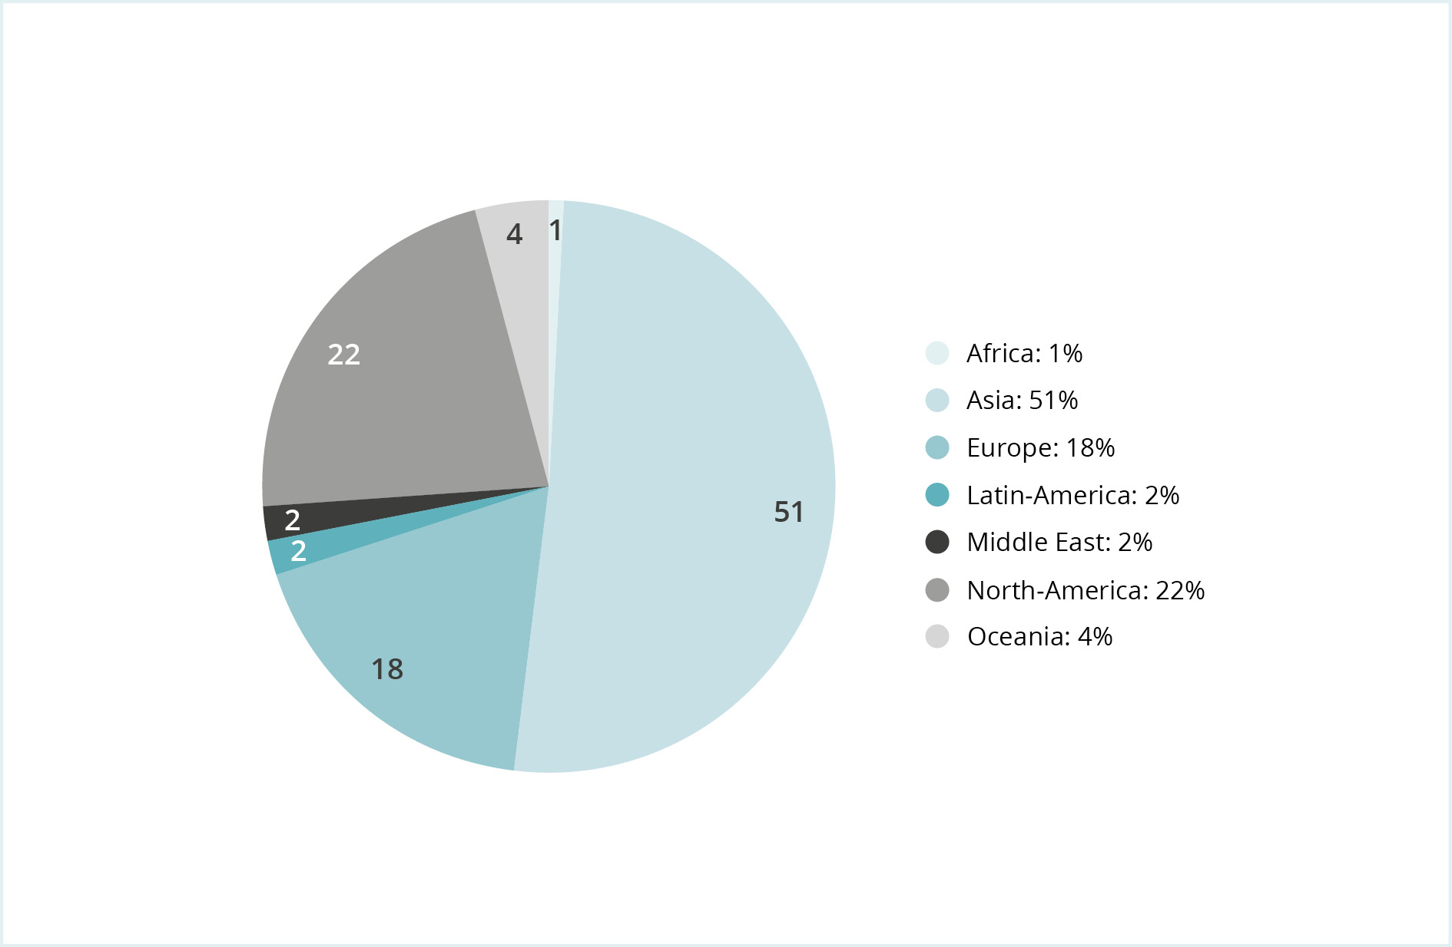

The Council on Ethics issues recommendations concerning the observation or exclusion of companies from the GPFG to Norges Bank, which makes a decision in each case. At the close of 2024, 105 companies were excluded from investment by the GPFG at the recommendation of the Council, while eight had been placed under observation. In addition, Norges Bank has, at its own initiative, excluded 66 companies pursuant to the coal criterion and placed 10 under observation. Since 2022, Norges Bank has also been able to assess companies under the climate criterion without a recommendation from the Council.

In 2024, the Council recommended that 15 companies be excluded and two be placed under observation. The Council also recommended that the exclusion of one company be revoked and the observation of three companies be terminated.

Since Norges Bank performs a thorough assessment of all the Council’s recommendations and also needs time to divest the GPFG’s shareholdings in the companies concerned, some of the decisions published in 2024 were based on recommendations issued by the Council in 2023. For the same reasons, not all the Council’s recommendations from 2024 have yet been published.

The Council always has many cases in progress. These normally include matters relating to the majority of exclusion criteria. It is not unusual for a company to be linked to several different cases. Some cases also involve more than one company. In 2024, the Council worked on a total of 284 active cases, relating to 268 different companies. Of these, 165 cases were opened during the year, while 53 were opened in 2023. The assessment of 146 cases was concluded. This includes companies for which a recommendation was issued to Norges Bank, companies where no grounds to exclude or place under observation were found, and companies in which the GPFG was no longer invested. Nine companies investigated by the Council exited the GPFG’s portfolio before the Council had concluded its assessment.

Status of the year’s 163 new cases

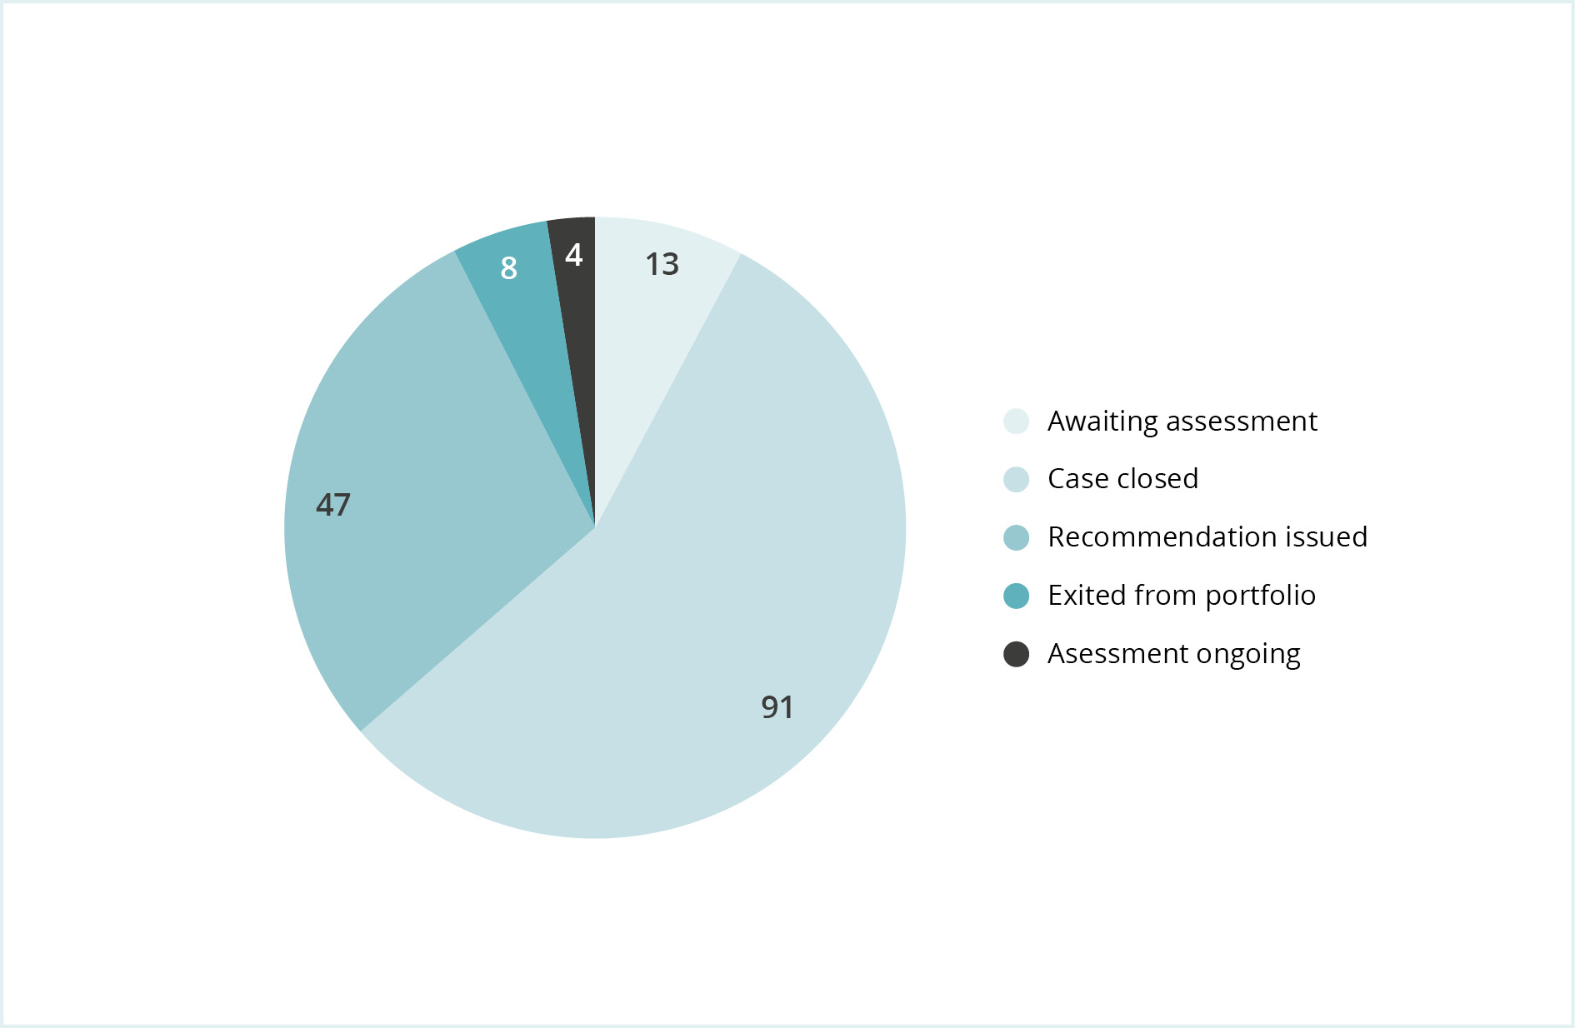

Figure 1.2 shows a breakdown of how the 163 cases that were opened in 2024 were dealt with. The majority of cases did not end in a recommendation for exclusion or observation but were closed at an earlier stage in the assessment process. A recommendation to exclude, observe or revoke a previous decision was issued in eight of the 163 new cases in 2024, while 91 were closed. The assessment of four new cases was terminated because the companies were no longer in the portfolio, 47 cases remain under investigation, while 13 cases are awaiting assessment to begin.

The risk of contributing to serious violations of the rights of individuals in situations of war or conflict was the subject of assessment in over 60 of the cases opened in 2024. These cases related primarily to companies operating in the West Bank. Several sector-wide reviews linked to financial crime account for almost 40 cases that were assessed and closed at an early stage in 2024. Moreover, some of the new cases related to industrial pollution and workers’ rights.

Regional breakdown of the companies assessed by the Council in 2024

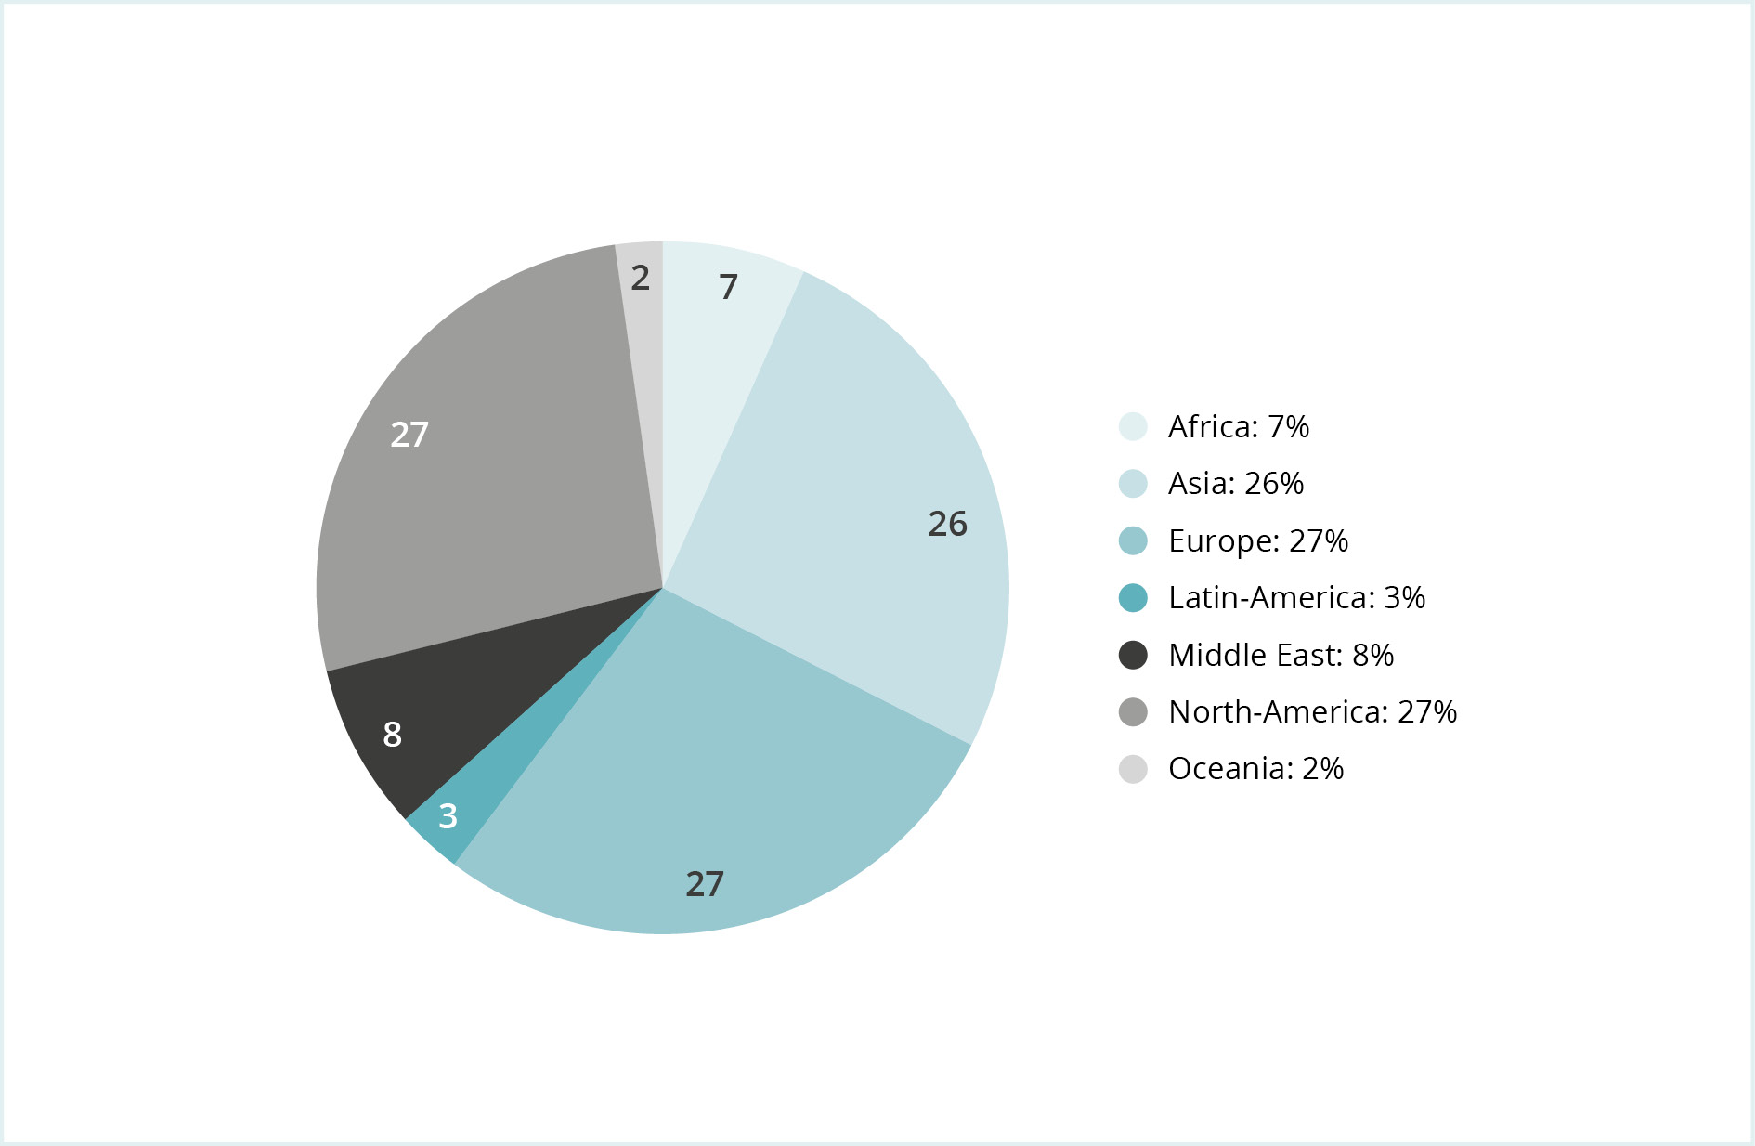

Countries with the most companies under investigation

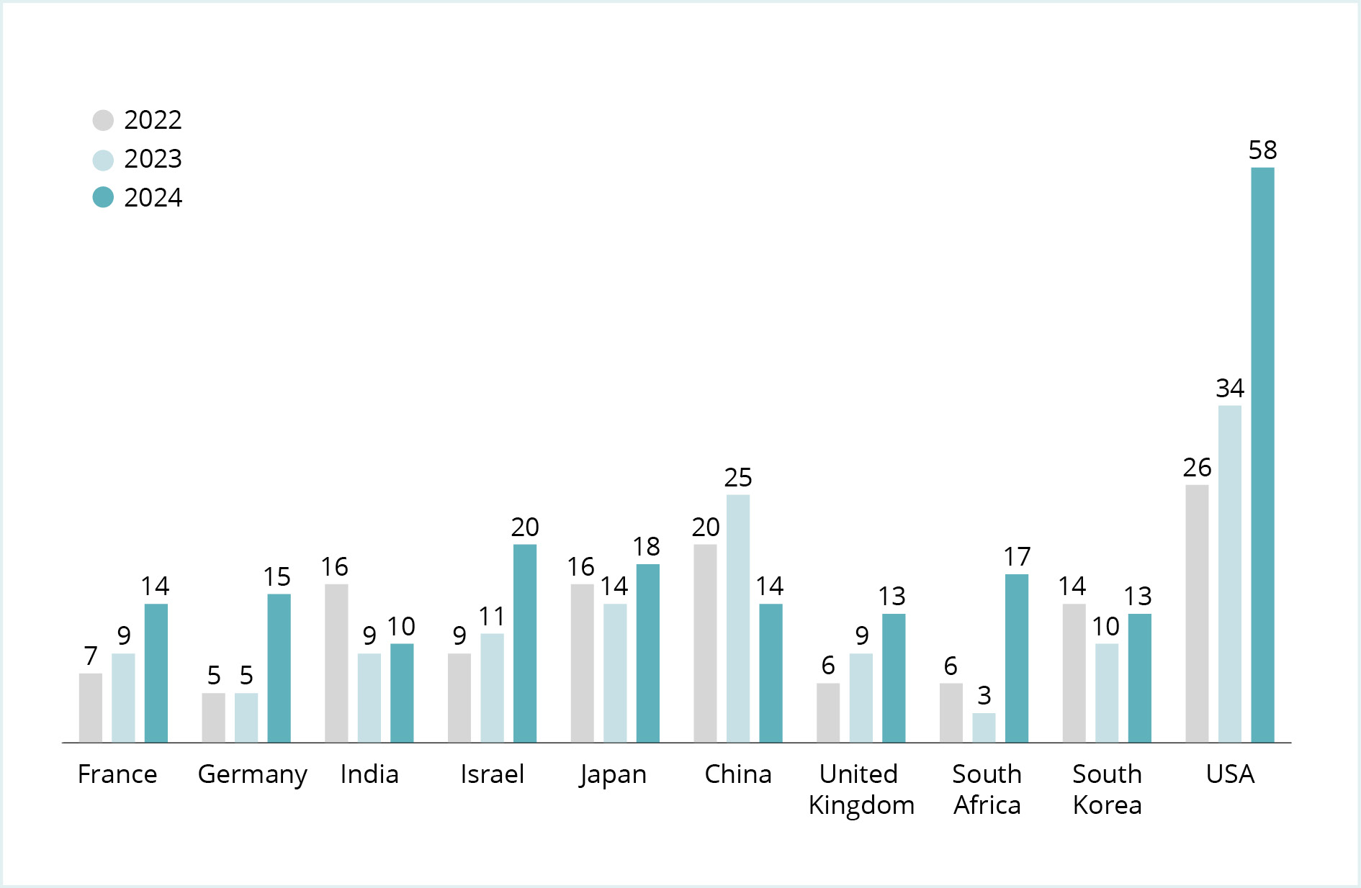

Figure 1.3 shows a regional breakdown of the companies the Council has assessed during the year. The percentage of companies from the different regions varies from year to year and reflects contemporary concerns and the general issues that the Council is focusing on at the time. Figure 1.4 shows the ten countries which had the most companies under assessment in 2024, with the actual number of companies concerned in 2022, 2023 and 2024. The review of companies linked to the West Bank and the war in Gaza is the main reason for the increase in the number of companies from France, Germany, Israel and the USA.

Of the 20 African companies which the Council assessed in 2024, 18 were selected due to the risk of money laundering. South Africa is a newcomer to the list of countries with the most companies under assessment. This is due to a sector-wide review of the banking sector and the risk associated with money laundering. In 2023, South Africa was placed on the Financial Action Task Force (FATF) and the EU’s list of countries with an elevated money laundering risk.

Over half of the cases relating to the approximately 70 Asian companies under assessment relate to human rights abuses. Some of these cases also have an environmental aspect. This applies to companies which dispose of ships for breakup in certain Asian countries. There are also purely environment-related cases, while other cases encompass several different criteria. In the last couple of years, the Council has investigated a smaller proportion of Asian companies than previously. For 2024, this is due in part to Asian companies not doing as much business in the West Bank as companies from other regions. In 2024, there was a decrease in the number of Chinese companies under assessment. Nevertheless, three of the recommendations issued in 2024 related to Chinese companies. Six of the companies about which the Council issued recommendations during the year were from Asia.

In 2024, the Council worked with almost 80 companies from 14 countries in Europe. Almost half of these cases related to the risk of financial crime and contribution to the violation of the rights of individuals in situations or war or conflict through their business activities in the West Bank. There were also a number of cases that related to various human rights abuses and serious environmental damage. The human rights cases concern labour rights violations, violations of the rights of indigenous peoples and forced labour. Seven of the companies about which the Council issued a recommendation in 2024 were European.

The dominant issue for the approximately 80 companies domiciled in the American continent was their contribution to the violation of the rights of individuals in situations of war or conflict through their business activities in the West Bank. The Council has also assessed several US companies under the criteria relating to the production and sale of weapons. Moreover, a significant number of cases related to corruption. Four of the companies about which the Council issued a recommendation in 2024 were from North America.

The Council assessed 23 companies from the Middle East in 2024, 19 of which were Israeli. The basis for assessing these companies was the risk that they were violating the rights of individuals in situations of war or conflict due to their business activities in the West Bank. Two of the companies about which the Council issued a recommendation in 2024 were from the Middle East.

Breakdown of the Council’s work by criterion

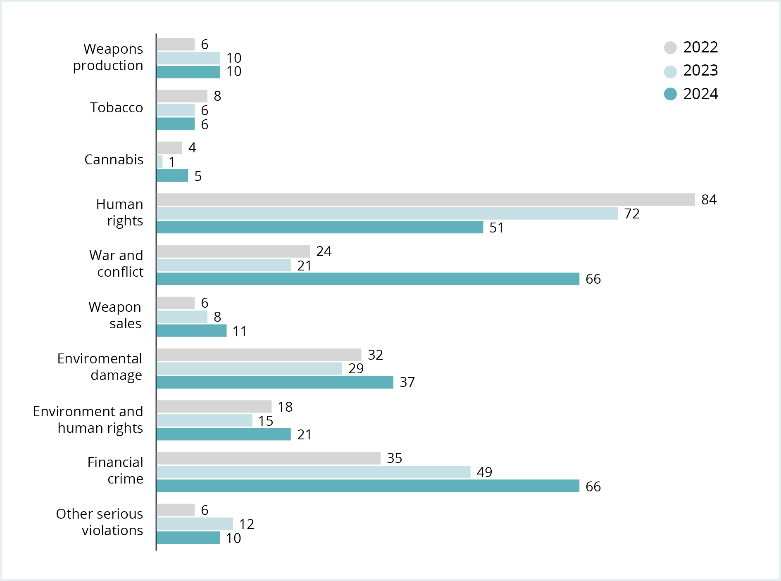

Work under the various criteria

Figure 1.5 shows a breakdown of cases by criterion in 2022, 2023 and 2024. The number of cases assessed in connection with financial crime continued to rise. This is partly due to the broadening of the guidelines’ corruption criterion to include all forms of financial crime in the wake of the Ethics Commission’s report. In addition to corruption in multiple business sectors, the Council’s main focus in 2024 has been banks that are accused of compliance failures with respect to legislation intended to prevent and deal with suspicions of money laundering. Initially, the Council assesses all the companies involved in such cases. It then selects those companies which have been involved in the most serious cases, where there have been repeated norm violations and where the risk of new norm violations seems to be highest. In connection with such investigations, an initial assessment is often made of a large number of companies, which are then relatively quickly whittled down to just a few. The three recommendations issued in 2024 pursuant to this criterion all relate to corruption.

The number of cases assessed under the war and conflict criterion is three times higher than in 2023. This is due to the review of companies with operations linked to the West Bank, which has resulted in recommendations to exclude two companies.

Despite a decrease in recent years, human rights cases remain an extremely large part of the Council’s work. Labour rights, including forced labour, is the dominant issue. Of the six recommendations issued under the human rights criterion in 2024, four relate to working conditions. Forced relocation and violation of the rights of indigenous peoples are also topics to which the Council pays considerable attention. Indigenous people are often extremely vulnerable in connection with the extraction of natural resources and the construction of infrastructure projects. Other cases relate to companies that have established plantations on land claimed by indigenous peoples.

Under the environmental criterion, loss of biodiversity and industrial pollution are the dominant issues. The three companies whose exclusion the Council recommended under the environmental criterion in 2024 all relate to loss of biodiversity.

Under the criterion concerning other serious violations of fundamental ethical norms, the Council has examined several cases relating to the risk of serious animal welfare violations. The Council has further assessed companies in connection with resource extraction in contested areas and contribution to an unlawful war of aggression. The recommendation issued in 2024 related to Russia’s war of aggression in Ukraine.

Under the product-related criteria, the Council has assessed several companies that produce launch platforms for nuclear weapons. Two of the recommendations issued in 2024 concerned such products. The Council has also assessed several companies which produce cannabis and tobacco, and has recommended that Norges Bank exclude two companies under the tobacco criterion and revoke the exclusion of another.

Contact with companies

Figures 1.6 and 1.7 show a breakdown of the companies with which the Council has been in contact in 2024, broken down by exclusion criterion and region. The Council has been in contact with 76 companies and met with 22 of them. The Council contacts companies at an early stage in its investigations. The companies therefore have the opportunity to provide information and state their views early in the process. At the same time, the Council makes clear to the company concerned which matters may form grounds for observation or exclusion. Whenever the Council recommends observation or exclusion under the conduct-related criteria, the company is given the opportunity to comment on a draft recommendation to exclude it or place it under observation.

Breakdown of contact with companies by criterion

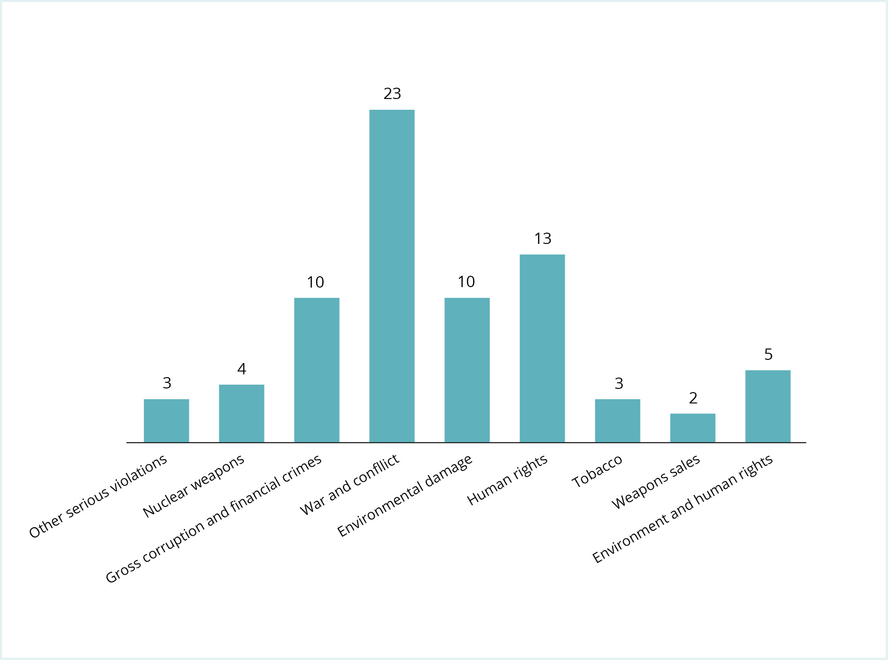

Breakdown of contacts with companies by region of domicile

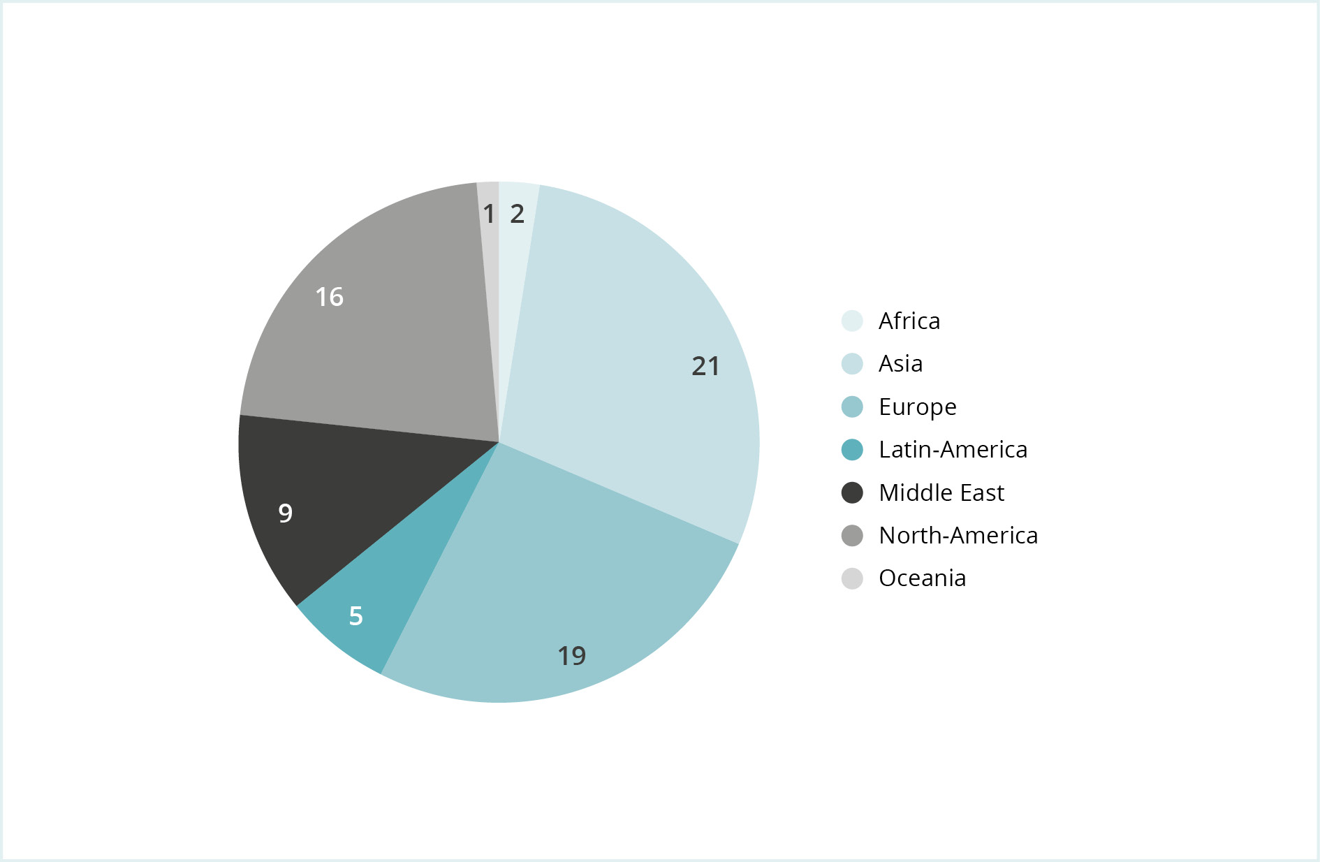

The Council places great emphasis on information provided by the companies themselves and takes the view that any failure to respond on the part of companies may help to heighten the ethical risk. Despite a few exceptions, most companies respond. Of the 60 or so companies that the Council reached out to in 2024, 23 did not reply. Some of these were contacted late in the year, so their response may yet be forthcoming. In 2024, the Council recommended the exclusion of six companies which failed to reply to its requests for information. One company had its exclusion revoked without it having replied to the Council’s communications.

In 2024, the Council contacted more companies domiciled in the Middle East and North America than the year before. This is largely attributable to the assessment of companies with business activities linked to the West Bank. The number of Asian companies with which the Council has been in contact continued to fall. This reflects the regional distribution of companies under assessment.

When the Council meets with companies, it is often late in the assessment process. Such meetings are frequently prompted by their receipt of a draft recommendation to exclude them or place them under observation. Figure 1.8 shows a breakdown of the 22 companies which the Council met with in 2024, by criterion. At six meetings, companies provided information that contributed to the Council not recommending their exclusion. Two of the companies which the Council met with in 2024 are under observation. The Council also met with four excluded companies which wanted to explain changes they had made after the Council’s previous assessment, with a view to their reinstatement in the list of potential GPGF investees.

Breakdown of companies that the Council met with in 2024, by criterion

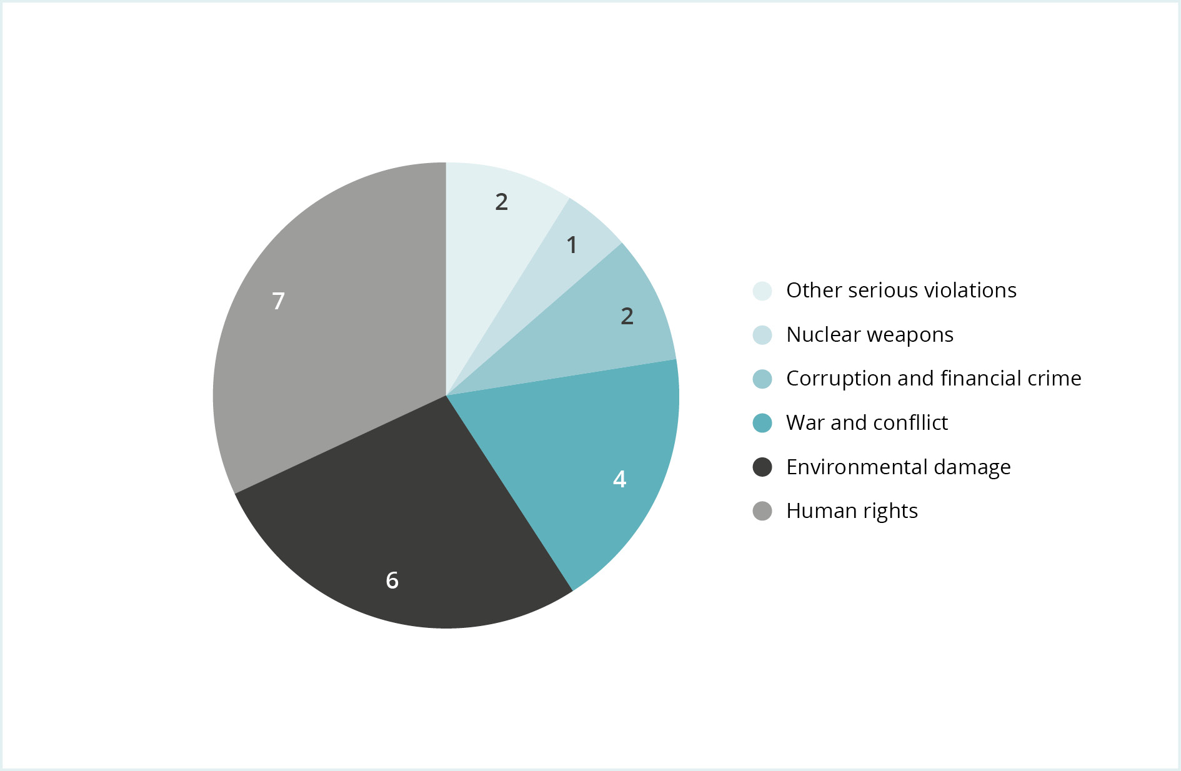

Assessment of companies that have been excluded or placed under observation

Companies are not excluded for a specific period of time and their exclusion may be revoked if the grounds therefor no longer exist. Norges Bank decides whether to revoke a company’s exclusion on the basis of a recommendation from the Council on Ethics. The exclusion of one company was revoked in 2024.

During the observation period, the Council normally submits one or more observation reports to Norges Bank on each company placed under observation. Two such reports were issued in 2024.

Ultimately, the Council either issues a recommendation to terminate observation of a company or exclude it from investment. In 2024, the observation of four companies was terminated. Two of these are now excluded. One company had its two-year observation period extended at the Council’s recommendation.

# The work under the various criteria

## Product-based criteria



Section 3 of the guidelines sets out the criteria for the product-based observation and exclusion of companies as follows:

(1) The GPFG shall not be invested in companies which themselves or through entities they control:

1. develop or produce weapons or key components of weapons that violate fundamental humanitarian principles through their normal use. Such weapons include biological weapons, chemical weapons, nuclear weapons, non-detectable fragments, incendiary weapons, blinding laser weapons, antipersonnel mines and cluster munitions
2. produce tobacco or tobacco-products
3. produce cannabis for recreational use

(2) Observation or exclusion may be decided for mining companies and power producers which themselves, or consolidated through entities they control, either:

1. derive 30 per cent or more of their income from thermal coal,
2. base 30 per cent or more of their operations on thermal coal,
3. extract more than 20 million tonnes of thermal coal per year, or
4. have the capacity to generate more than 10,000 MW of electricity from thermal coal.

In 2024, the Council issued recommendations to exclude two companies which serve as the lead contractors for the construction of strategic submarines, i.e. submarines built primarily as launch platforms for nuclear missiles. In connection with the changes in the ethical guidelines adopted in 2021, it was determined that launch platforms for nuclear weapons are deemed to constitute key components of such weapons and therefore fall within the weapons criterion.

The day-to-day work on the product-based criteria involves making decisions with respect to cases that emerge via the portfolio monitoring process. In 2024, the Council issued recommendations to exclude two companies due to their production of tobacco-products. A recommendation was also issued to revoke the exclusion of a company which is no longer involved in the production of tobacco-products.

With regard to the coal criterion, Norges Bank is authorised to make decisions concerning the observation or exclusion of companies without a recommendation from the Council on Ethics. A division of labour has been agreed between Norges Bank and the Council, under which the Bank identifies and assesses companies which fall within the scope of the coal criterion. The consultant charged with monitoring the portfolio with respect to the product-based criteria nevertheless reports to the Council on companies which may fall within the scope of this criterion. The Council shares all relevant information with the Bank.

## Human rights, rights of individuals in situations of war and conflict



Section 4 of the guidelines states that «Companies may be excluded or placed under observation if there is an unacceptable risk that the company contributes to or is responsible for:

a. serious or systematic human rights violations

b. serious violations of the rights of individuals in situations of war or conflict […]».

Serious or systematic human rights violations

In 2024, the work under this criterion has largely focused on labour rights in addition to violence perpetrated by security guards, the rights of indigenous peoples, forced relocation and human rights abuses to which technology companies may contribute. In 2024, the Council recommended that three companies be excluded, and one placed under observation in relation to this criterion. The Council also recommended that observation of two companies be terminated.

On the basis of cases identified via the portfolio monitoring process, previous sectoral studies and input from civil society organisations, we have investigated working conditions at companies in 11 countries located in Africa, the Middle East, Asia and Europe. The norm violations have ranged from the gross sexual harassment of women, excessive and unpaid overtime, poor staff accommodation, a lack of employment contracts and employment conditions that exploit people in vulnerable situations. Experience shows that such labour rights violations are not necessarily related to geographical location, although the risk is probably higher in some regions than others.

The Council will continue to emphasise labour rights in 2025. For example, a framework agreement has been entered into with a consultant who will investigate working conditions at shoe manufacturers in which the GPFG is invested. These investigations will include factory inspections, if the companies cooperate, and interviews with employees. The shoe manufacturers’ factories are located primarily in Asia.

Migrant workers are especially vulnerable to exploitation in the labour market because their work and residence permits are often tied to a particular employer. Since little information on the situation for migrant workers is publicly available, the Council performs its own investigations where possible. In 2024, the Council commissioned consultants to survey business sectors and companies with many migrant workers in Taiwan. In 2025, we will examine some of these companies in greater depth. In addition to working conditions, recruitment fees will be an important topic in the further investigation of these companies.

In some countries, investigations into working conditions pose a considerable risk for consultants and those who provide them with information. In such cases, the Council must rely on publicly available information and base its decisions on risk assessments of countries and business sectors, as described in the Report to the Storting (White Paper) on the Government Pension Fund 2021 (Meld. St. 24 (20–21)). In 2024, the Council followed up reports of forced labour at companies with operations in the Gulf States and China. For security reasons, the Council does not perform physical investigations in these countries.

The Council receives many reports of the rights of indigenous peoples being infringed. Several of these cases also have an environmental aspect. Indigenous people traditionally live close to nature and major changes in the natural environment in areas in which they live impinge on their land rights and livelihoods. A combination of inadequate consultation, ignorance and poor management of these processes on the part of the companies involved often contribute to serious norm violations. Many of these cases are linked to the transition to renewable energy sources and the extraction of critically important minerals. The Council prioritises cases that affect particularly vulnerable indigenous groups and those where indigenous people’s lives and livelihoods are threatened.

The GPFG invests in a number of different technology companies, including those which supply social media platforms and online retail outlets, as well as companies which have platforms offering various delivery services. The portfolio monitoring process regularly identifies reports of human rights violations at such companies. In 2024, the Council had several technology companies under assessment.

Serious violation of the rights of individuals in situations of war or conflict

Full-scale wars and armed conflicts are ongoing in many parts of the world. Some of these conflicts stand out because a significant number of companies are associated with them in various ways. This is particularly true of the areas that Israel occupies in the West Bank, which are fully integrated in the Israeli economy. The Council assessed some 65 companies under this criterion in 2024. Almost all of these companies were assessed on the basis of their links to the West Bank and Gaza. This work is described in greater detail in a separate article. In 2024, the Council recommended the exclusion of two companies on the basis of their business activities in the West Bank.

The Council is also still closely monitoring GPFG-invested companies with operations in Myanmar. Reports published by the UN High Commissioner for Human Rights continued to document abuses perpetrated by the armed forces on the country’s civilian population. The High Commissioner has repeatedly urged businesses with operations in Myanmar not to cooperate with companies controlled by the armed forces and to avoid business activities that help to strengthen the armed forces’ financial position.

Two companies were placed under observation in 2023 on the basis of their partnership with a state-owned telecoms company in Myanmar. The Council will assess the risk that these companies are contributing to serious human rights violations enabled by surveillance of the telecoms network. The Council communicated with the companies concerned in 2024 and will continue to engage them in dialogue in 2025. In November 2023, the Council recommended the exclusion of one company that had been under observation since 2022 due to its operations in Myanmar. That recommendation was published in 2024.

The Council is also continuing to monitor GPFG-invested companies which contribute to Russia’s war of aggression against Ukraine. These cases are assessed under the criteria relating to weapons sales and other serious violations of fundamental ethical norms. Since it has been decided that all Russian companies shall be divested from the GPFG’s portfolio whenever practically possible, the Council does not follow up on Russian companies. The companies which the Council has assessed in 2024 are therefore domiciled in other countries.

## Companies’ sales of weapons to certain states



Section 4 of the guidelines states that «Companies may be excluded or placed under observation if there is an unacceptable risk that the company contributes to or is responsible for: […]

c. the sale of weapons to states engaged in armed conflict that use the weapons in ways that constitute serious and systematic violations of the international rules on the conduct of hostilities

d. the sale of weapons or military materiel to states that are subject to investment restrictions on government bonds as described in section 2-1(2)(c) of the Management mandate for the Government Pension Fund Global […]»

Sections 4(c) and 4(d) both apply to companies’ sales of weapons to certain states. A total of nine companies were under assessment in relation to these criteria in 2024.

Pursuant to section 4(c), companies may be excluded if there is an unacceptable risk that they are selling weapons to states that use them in violation of humanitarian law. This criterion was introduced in 2021. The provision’s wording makes it clear that it applies to violations of humanitarian law that are both serious and systematic. The preparatory work states that the criterion shall apply to weapons that may impact civilians in particular. In other words, the criterion does not open the way for a general exclusion of companies that sell weapons to states that violate humanitarian law in an armed conflict. The Council is also required to base its assessment on a broad pool of information and reports from authoritative institutions, which show that the weapons are consistently being used in ways that contravene international rules on the conduct of hostilities. The criterion has been applied to companies that sell weapons to the Myanmar authorities. In 2024, the Council further assessed whether companies’ sales of weapons to Israel may constitute grounds for exclusion. This is explained in greater detail in a separate article.

The so-called government bond exception is included in the GPFG’s mandate. The objective is to preclude the GPFG from investing in government bonds issued by states that are subject to extensive international sanctions that are also endorsed by Norway. The Ministry of Finance decides which countries the provision should be applied to – currently North Korea, Syria, Russia and Belarus. Section 4(d) of the guidelines warrants the exclusion of companies which sell weapons to states encompassed by the government-bond exception. It applies to the sale of all weapons and all military materiel and therefore has a far wider scope than section 4(c). Pursuant to section 4(d), moreover, it is not required than any assessment be made of how the weapons are used; it is not even presumed that the weapons will be used at all, since the purchasing states are not necessarily belligerent. At the Council’s recommendation, one company was excluded from investment by the GPFG in 2024, pursuant to section 4(d) of the ethical guidelines. This was a Chinese company which supplies engines to Russian and Belorussian military vehicles.

## Environment and climate



Section 4 of the guidelines states that «Companies may be excluded or placed under observation if there is an unacceptable risk that the company contributes to or is responsible for: […]

e. severe environmental damage

f. acts or omissions that on an aggregate company level lead to unacceptable greenhouse gas emissions […]»

Severe environmental damage

In 2024, the Council examined around 60 cases under the environment criterion. Around a quarter of these cases related to the loss of biodiversity. Various types of industrial pollution have also been an important topic, as has beaching, a process whereby ships are run up onto beaches in Bangladesh and India, and broken up for scrap. These are issues that the Council has worked on previously.

In recent years, companies with business operations that impact nature have seen a development in the norms governing acceptable practices. As a result of this development, the Council has raised its expectations with respect to the due diligence exercised by companies operating in areas designated as important for biodiversity. The Council’s work on cases relating to biodiversity is described in a separate article in this annual report.

The Council has also reinforced its endeavours with respect to companies which risk of harming vulnerable ecosystems and causing biodiversity loss, through deforestation or resource extraction, for example. In 2024, the Council recommended the exclusion of three companies under the environment criterion, in connection with two separate cases. In both cases, the basis for exclusion was the risk that areas of high natural value will be lost. The Council has also submitted a report to Norges Bank on a company that is under observation due to the risk of deforestation resulting from the company’s operations.

In several of the cases assessed under the environment criterion in 2024, empirical knowledge about the area’s biodiversity – what species there are, population sizes and ecosystems – is incomplete. Although companies often possess such information, they do not always wish to share it with the Council. This can make it difficult to assess the impact of the companies’ activities. In cases assessed by the Council in 2024, it has been presumed that deforestation of large swathes of intact tropical forest and activities which help to impoverish and diminish the size of habitats for critically endangered species constitute a significant risk that important biodiversity will be lost.

In 2024, the Council commissioned a report by a third-party consultant to obtain a better overview of GPFG-invested companies which operate in environments designated as being of high conservation value. The objective was to identify companies in the GPFG’s portfolio that operate in biodiversity hotspots. These are biogeographical regions characterised by an exceptionally rich biodiversity, where less than 30 per cent of the original area retains intact areas of nature and habitats. The consultant’s study identified seven GPFG-invested companies as relevant for further investigation.

Cases relating to serious pollution are constantly being identified by the portfolio monitoring process. The Council regularly commissions consultants to help it gain an overview of serious pollution linked to companies in the GPFG’s portfolio. In 2021, a third-party survey of companies operating particularly polluting gold mines was commissioned. In 2024, the Council assessed the final two of the 11 companies which the study found to cause high levels of pollution and pose a risk of serious environmental damage. In both cases, the Council terminated its assessments because there was insufficient documentation to substantiate the allegations of serious pollution.

In 2024, the Council investigated several other cases relating to pollution caused by industrial activity, mining, oil extraction and refining. It can be difficult to distinguish between companies, particularly when they are located in industrial clusters where many contribute to the elevated pollution levels. In such cases, impacts on the local population’s health are often better documented or more widely reported than the damage to the environment. The Council will continue to investigate companies with emissions which may constitute a high risk to people and the environment, but a lack of data is often a challenge in such cases.

Perfluoroalkyl and polyfluoroalkyl substances (PFAS), also known as forever chemicals, are a large group of synthetic chemical compounds. They are water, stain and grease-resistant, and have countless applications in everyday life. However, they also have major environmental and health impacts, not least because they are extremely slow to degrade in nature and in the human body. Knowledge about their adverse environmental and health impacts has prompted stricter regulation of these substances. Some companies are therefore phasing out the use of PFAS in their production processes. In 2024, the Council commissioned a consultant to discover whether any GPFG-invested companies produce the types of PFAS that are subject to regulation. So far, the survey has identified 15 companies.

Unacceptable greenhouse gas emissions

The Council on Ethics’ guidelines have contained a criterion concerning unacceptable greenhouse gas emissions since 2016. The Council has issued five recommendations to exclude, and a total of four companies have been excluded under this criterion. A change in the guidelines in 2022 permitted Norges Bank to exclude companies under this criterion at its own initiative, without a recommendation having previously been issued by the Council on Ethics. In practice, therefore, Norges Bank has assumed primary responsibility for the climate criterion. For a period going forward, the Council will follow up the companies that have already been excluded but will not normally assess new companies under the climate criterion.

## Gross corruption and other serious financial crime



Section 4 of the guidelines states that «Companies may be excluded or placed under observation if there is an unacceptable risk that the company contributes to or is responsible for: […]

g. gross corruption or other serious financial crime […]»

Gross corruption

In 2024, the Council issued recommendations to exclude two companies, terminate the observation of one company and extend the observation of another. In addition, the observation of one company was paused until further notice, since the GPFG currently has no investments in it.

The Council monitors allegations of corruption linked to GPFG-invested companies on an ongoing basis. Companies linked to multiple serious allegations of corruption are systematically logged, sorted by business sector and ranked with respect to level of risk. This overview is constantly updated and expanded. Within certain sectors, allegations concerning such a large number of companies have been identified that it is also possible to perform a more holistic review of them.

In the same way as the Council has previously assessed companies in the oil and gas extraction and construction industries, it launched a review of companies in the water/power/gas supply sector in 2024. (Utilities in the FTSE). The review encompasses 19 companies that have all been involved in corruption cases. The construction of hydroelectric or gas-fired power plants, or the laying of power lines and gas or water pipes, often involves large contracts, with public authorities heavily involved as client, regulator and licence/permit issuer. The risk of corruption is high when so much is at stake for the individual companies, while decision-making authority is restricted to just a few people. Obtaining access to the water/power/gas supply network, metering consumption etc., may also create a downstream corruption risk, although this is generally on a smaller scale (petty corruption).

Within the utilities sector, wind and solar power has become increasingly important in recent years. In addition to major capital investments, the amount of money to be gained from these types of energy production in the form of public subsidies and the issue of renewable certificates also opens the way for potential rent-seeking behaviour. The industry is, moreover, in a relatively early development phase compared with traditional forms of energy production. As a result, the renewable energy sector is not yet as fully regulated as, for example, the production of oil and gas.

The Council’s review of utilities companies had not been completed by the close of the year. So far, one company in this sector has been selected for more detailed assessment.

In connection with corruption cases, the Council recommends observation more often than in other cases. This is because the norm violations have generally occurred at some distance in the past when they become publicly known, while the companies involved in corruption will often implement changes that sow doubt about developments forward in time.

The Council evaluates how those companies that have been placed under observation are applying and developing their anti-corruption systems. The Council also monitors for the emergence of new allegations of corruption. If no new corruption cases are reported and the company seems to have established an anti-corruption system that aligns with internationally recognised recommendations, the Council normally recommends that observation be terminated. Nevertheless, this does not guarantee that the company will not engage in corruption at some future date. Should it do so, the company’s continued inclusion in the GPFG’s portfolio will be subject to reassessment.

Other serious financial crime

In 2024, the Council has worked primarily with respect to companies operating in the financial sector as well as companies in the property sector. The focus of these assessments has been the companies’ compliance with regulatory requirements relating to money laundering and whether they have had adequate systems and routines to fulfil their obligation to prevent and uncover money laundering. For financial institutions, inadequate systems may be a punishable offence, since they have a statutory duty to take steps to know their customers, monitor customer activity on an ongoing basis, investigate suspicious circumstances and report suspicious transactions. Failures in this area could mean that banks are, under the terms of the ethical guidelines, contributing to the underlying norm violations committed by their customers or employees. The Council has also investigated companies that are accused of actively having facilitated money laundering by accepting or forwarding funds that are the proceeds of crime.

The Council’s starting point is generally a police investigation, criminal conviction or out-of-court settlement that the company has entered into. In such situations, the companies concerned will, as a rule, implement wide-ranging measures to avoid becoming involved in new cases. This is because financial institutions need a licence to operate and may also be ordered to curtail their business activities by relevant financial supervisory authorities.

The Council has therefore focused on companies domiciled or with significant business activity in countries or sectors where there is a heightened risk of money laundering. In this context, South Africa and Nigeria were examined in 2023 and 2024. The Council has also assessed individual companies domiciled in well-regulated markets that have been subject to wide-ranging and repeated legal penalties.

The Council instigates a dialogue with the companies under assessment at an early stage. In this connection, the Council was in contact with five companies in 2024. Dialogue with some companies has been fairly extensive, involving several meetings and the review of a large number of documents. At the close of the year, the assessment of three companies had been completed, while seven remained ongoing at the start of 2025.

So far, the Council has issued no recommendations to exclude companies or place them under observation pursuant to the criterion’s expansion to cover «other serious financial crime» as well. Due to the public authorities’ comprehensive control of the financial sector, it is expected that only a few cases will lead to exclusion or observation. The Council is keeping abreast of specific allegations concerning matters that naturally fall within the scope of this criterion. In line with the guidance provided by the Ethics Commission in its report NOU 2020: 7, the Council is particularly interested in companies that are repeatedly involved in malfeasance. Such incidents are logged on an ongoing basis and are used as the basis for assessing whether the company should be contacted and assessed in greater depth.

## Other particularly serious violations of fundamental ethical norms



Section 4 of the guidelines states that «Companies may be excluded or placed under observation if there is an unacceptable risk that the company contributes to or is responsible for: […]

h. other particularly serious violations of fundamental ethical norms»

In recent years, there has been an increase in the number of companies assessed under this criterion, which may be applied to cases that do not fit into any of the others. In 2024, the Council worked particularly with cases relating to gross animal welfare violations and companies’ possible contribution to Russia’s war in Ukraine. The Council also followed up one company that is under observation due to the risk that its activities may damage prehistoric and irreplaceable cultural heritage sites. In February 2024, the Council submitted an observation report on this case to Norges Bank.

In 2024, the Council recommended the exclusion of one company which has had long-term links to the Russian defence industry, in part as a supplier of steel. The disclosure that these links continued to exist was sufficient for the Council to consider there to be an unacceptable risk that the company was contributing significantly to Russia’s capacity to wage war in violation of international law. The company is listed on the London Stock Exchange but has the bulk of its business activity in Russia. Since it has been decided at the political level that the GPFG shall divest its shareholdings in Russian companies, there are few such companies for the Council to assess.

In connection with animal welfare cases, the Council assesses companies on the basis of the seriousness of the alleged norm violations, the proximity of the company to them and the likelihood of the company’s practices continuing going forward. Under normal circumstances, therefore, a significant number of individual animals must be subject to cruel and inhumane treatment before the Council will open an assessment. Primarily, the Council examines cases where GPFG-invested companies subject a large number of individual animals to gross welfare violations within their own operations and do not seem to have tangible or credible plans to improve those conditions.

# Selected issues

## The Council’s working methods

The selection of companies for assessment

The Council constantly monitors whether GPFG-invested companies engage in business practices which may lead to their exclusion pursuant to the ethical guidelines. Two portfolio monitoring services sift out relevant information about product-related, weapons sales and conduct-related cases from media sources, publicly available databases etc. The Council assesses every company identified in relation to the product-related criteria. With respect to the conduct-related criteria, which covers many cases of a highly divergent nature, the Council assesses those where the risk of the company causing or contributing to serious norm violations seems to be greatest.

The Council also monitors a number of databases and websites containing information on, for example, corruption, weapons sales or activity in areas of war or conflict. This ensures that we identify the most serious cases where public information is readily available. The Council also receives requests to consider specific cases from organisations and individuals. These requests may be made directly or be passed on by Norges Bank.

To pick up on cases that are not necessarily covered by the news monitoring process, the Council also examines specific areas where there is a high risk of serious norm violations that are encompassed by the ethical guidelines. In 2024, the Council commissioned the production of two reports about companies in individual countries with a high risk of migrant workers’ rights being violated. The Council also surveyed companies whose operations impact intact areas of nature in biodiversity hotspots.

Furthermore, the Council monitors issues that have previously led to the exclusion of companies and where new, similar cases may arise. Examples include beaching (the process of running ships aground on beaches so they can be broken up for scrap) and the extraction of natural resources in Western Sahara.

Members of the Council’s secretariat perform an initial assessment of each case. In this assessment, emphasis is placed on the seriousness and scope of the norm violations in question, the closeness of the company’s links to the norm violation and the likelihood of the norm violation continuing in the future. The secretariat then presents the cases to the Council, which decides whether further investigation is warranted. During the course of a year, the Council normally has a couple of hundred cases under assessment.

Particularly serious new cases are given priority. These may be cases linked to escalating conflicts or serious individual incidents in which GPFG-invested companies are involved.

A typical evaluation process for conduct-related cases

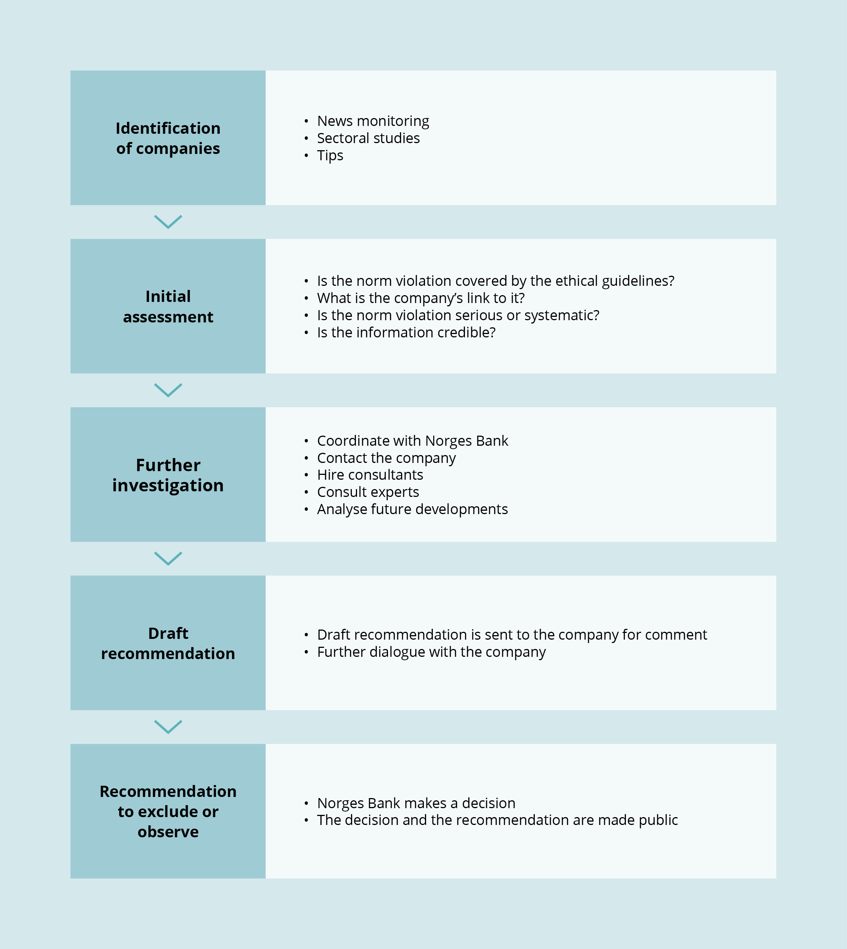

Assessment and dialogue with companies

The Council’s decision to proceed with a case triggers a thorough investigation into the allegations levelled at the company. The secretariat obtains further information through conversations with experts and from open sources. In some cases, we also use consultants in order, for example, to investigate working conditions or the environmental impact of companies’ activities.

Early in the investigative process, we send a letter to the company concerned containing questions about the matter at hand. To optimise communications with these companies, we coordinate with Norges Bank, which notifies those with which it already has well-established relations. Some companies provide a lot of information, although responses vary considerably. Some companies do not respond at all.

After our initial contact with the company, the secretariat presents all relevant information to the Council, which decides which cases should be investigated further and which should be closed. Cases may be closed at any stage in the assessment. This may take place if a company has discontinued the activities which could constitute grounds for exclusion, or if the activity proves to be of a different nature than initially presumed. Some cases are closed because the companies exit the GPFG’s investment portfolio independently of the Council.

According to the ethical guidelines, companies assessed under the conduct-related criteria must be given the opportunity to comment on a draft recommendation to exclude them or place them under observation. Many companies provide additional information, while some also ask for a meeting with the Council.

Although the majority of such meetings are carried out as videoconferences, some company representatives come to Oslo, or we visit the company’s offices. Videoconferences save on resources, while face-to-face physical meetings often provide deeper insight and greater opportunities for the Council to present its points of view. The secretariat arranges the meetings, which are generally also attended by several Council members. Dialogue with the companies is an important part of the assessment process but can also prolong it.

Some companies notify us of measures they have taken to change their operations, often after receiving a draft recommendation for their exclusion. In such cases, the Council may choose to quietly monitor developments in the company or recommend that it be placed under formal observation. The Council assesses each case with an open mind and does not embark on an assessment with the objective of excluding the company concerned. The outcome is not given at the outset.

A recommendation is issued to Norges Bank

Finally, the Council issues Norges Bank with a recommendation to exclude the company concerned or place it under observation. Norges Bank then makes a final decision on the matter. If the decision involves exclusion, all shares and securities relating to the company are divested. Divestment may take several months, and the Bank publishes its decision only when this process has been completed. Simultaneously, the Council makes its recommendation public. Both decisions and recommendations are published irrespective of whether or not Norges Bank abides by the Council’s recommendation.

## Conflict in the West Bank and Gaza

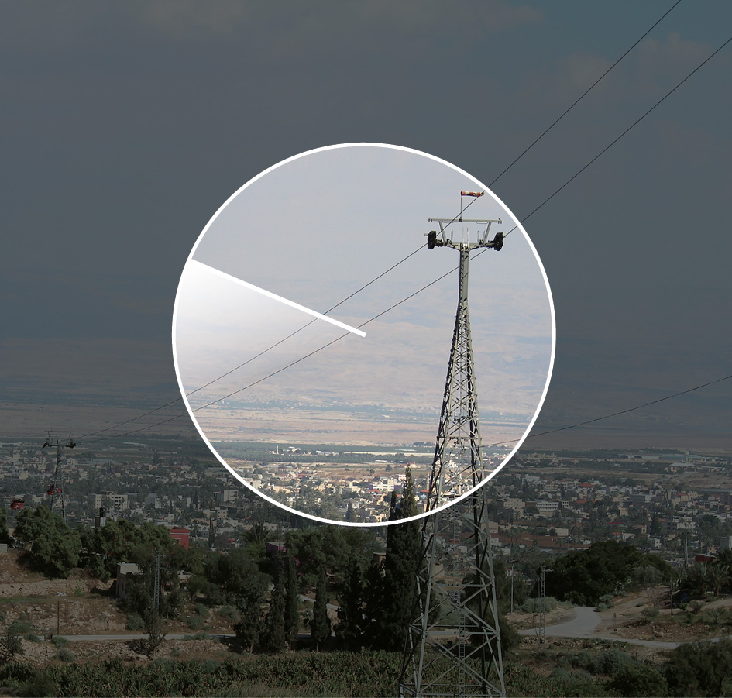

In June 2024, the Ministry of Finance asked the Council to provide an account of its work with respect to companies with business activities linked to the Occupied Palestinian Territories (OPT). The Council submitted its account in a letter to the Ministry dated 30 August. The letter is available on the Council’s website (etikkradet.no).

An important part of the Council’s work in 2024 has consisted of examining companies’ business activities in the West Bank and Gaza. In relation to Gaza, the Council has assessed companies’ sales to Israel of weapons used in the war in Gaza. With respect to the West Bank, attention has been directed at the role of companies in contributing to the establishment or maintenance of Israeli settlements and occupation of the West Bank in violation of international law. Questions arising in relation to Gaza and the West Bank are in general covered by different sections of the GPFG’s ethical guidelines.

Companies’ sales of weapons used in Gaza

Section 4(c) of the ethical guidelines encompasses the «sale of weapons to states engaged in armed conflict that use the weapons in ways that constitute serious and systematic violations of the international rules on the conduct of hostilities.»

When the guideline was introduced, the following conditions for its scope were set out:

The sale must be ongoing or at least recent. The criterion is not meant to impact the GPFG’s investments in companies on the basis of sales that were finalized years back.

The criterion applies to the sale of weapons from a company to a belligerent state and will not, in principle, apply to weapons transferred between states.

The criterion is intended for types of weapons that may expose civilians to harm. This entails that companies in the business of e.g. air defence systems or weapons primarily intended for use against naval targets will not be a primordial focus, nor the sale of transport aircraft or various types of military vehicles.

In other words, the guidelines do not imply that the GPFG must exclude companies due to the sale of any type of weapon or military materiel to a state, even if that state uses weapons in violation of the international rules on the conduct of hostilities. Each weapon sale must be assessed individually in light of the ethical guidelines wording and its preparatory work.

Based on data from the Swedish International Peace Research Institute (SIPRI) among others, the Council has assessed 14 recent weapons deliveries to Israel. The review showed that the companies involved in the sale of weapons that may notably impact civilians have already been excluded from investment by the GPFG for other reasons.

The Council has been in contact with two weapons manufacturers, one German and one from the US. Neither company had any ongoing deliveries of relevant weapon types to Israel. If new contracts regarding weapons deliveries are published, the Council will investigate whether this may fall within the scope of the criterion.

Companies with business activities linked to the West Bank

The Council’s point of departure is that the Israeli settlements in the West Bank are unlawful under international law. A total of ten companies have so far been excluded from investment by the GPFG at the Council’s recommendation on the basis of their activities in such settlements. The first companies were excluded in 2009, when a construction company involved in the building of Israeli settlements and a company supplying surveillance equipment for the separation barrier were excluded. At the time, the Council considered that these types of business operations to the largest extent contributed to the illegal transfer of Israeli citizens to the OPT, and therefore qualified for exclusion from the GPFG. Following the recommendation of the Council, further companies were excluded from investment by the GPFG on the grounds of similar activities in the West Bank in 2011, 2013, 2021 and 2024.

A number of companies in the GPFG’s portfolio may, in various ways and to various degrees, be linked to Israel’s occupation of the West Bank. Examples include services supplied to the Israeli settlements, or products that are used for purposes that violate international law. Over half a million Israelis currently live in settlements in the West Bank and East Jerusalem. All goods and services offered in Israel are, in principle, also available to the inhabitants of the settlements. A large number of companies may therefore be said to have links to the occupation of the West Bank in one way or another. It is difficult to provide any estimate of how many companies this concerns, as the number will vary greatly with the type of linkage envisaged.

The threshold for excluding companies from the Fund based on the ethical guidelines is high by intention. This point was elaborated in detail when the guidelines were first adopted and has been repeated in several subsequent white papers on the management of the GPFG. The Council therefore presumes that the guidelines are not intended to result in the exclusion from the GPFG of companies with any or all forms of association with violations of international law, either in the West Bank or in other conflict areas. An important factor in the Council’s assessment is whether the activities of a given company are a prerequisite for the international law violation to occur. Furthermore, it must be likely that the companies’ activities or links to activities which may constitute grounds for exclusion will continue into the future. The Council also attributes weight to the nature of a company’s contribution, e.g. whether it is sporadic or resulting from a permanent presence in the occupied territory. Moreover, the Council will assess whether a company manufactures and sells purely generic products or products and services especially adapted for use in the area. It has also been important for the Council to establish a practice that is consistent with the assessment of companies’ contributions to similar norm violations in other areas of occupation or armed conflict.

There are various lists and overviews linking companies to the occupation of the West Bank and Israeli settlements in the OPT. From 2019, the UN’s Office of the High Commissioner for Human Rights (OHCHR) entertains a list of companies linked to the Israeli settlements. The Initiative Don’t Buy Into Occupation has published annual reports on financial institutions’ investments in companies linked to the occupation since 2021, and the Israeli organisation WhoProfits publishes a database listing several hundred companies which, in various ways, may be linked to the occupation. Such overviews are a useful starting point for the Council’s assessments.

The Council’s efforts primarily involve clarifying the companies’ link to ongoing norm violations and assessing whether their role qualifies for exclusion. In 2024, the Council assessed around 65 companies in the GPFG’s portfolio. We contacted 16 of these companies and met with four. The companies engage in the following business areas:

* Energy supply
* Infrastructure construction (roads, railways, telecommunications)
* Manufacture of construction equipment and vehicles
* Banking and finance
* Travel and tourism
* Surveillance and control systems
* Extraction of natural resources
* Various forms of commercial activity in Israeli settlements

Two companies have so far been recommended for exclusion as a result of this review. They are companies involved with business operations within critical infrastructure. These companies are present in the settlements with their own business operations and supply products and services that are necessary for the continued existence of the settlements.

The Council has concluded that the majority of companies reviewed do not meet the threshold for exclusion in the ethical guidelines of the GPFG for two main reasons:

In some cases, the Council’s investigations and dialogue with the companies have shown that their operations in the West Bank have ceased, even though they are listed by some entities as doing business there. In a couple of cases, companies have conveyed that they will discontinue their operations in the occupied territory. In such cases, the Council has decided to monitor the developments going forward.

However, in most cases where the Council has not recommended exclusion, it is because the companies’ activities are not considered to fall within the scope of the GPFG’s ethical guidelines.

The Council assesses the companies’ contribution to serious violations of international law in the West Bank. In the Council’s view, some of the companies’ operations have little significance for the violations taking place. Other companies produce generic, mass-produced items that are sold in Israel and used for a variety of purposes also in the West Bank. In such cases, several factors have influenced the Council’s assessment. On the one hand, norms have evolved such that there is a greater expectation that companies take responsibility for their entire supply chains. On the other hand, how products are used may be outside the manufacturer’s control, and the link between product and company may diminish over time. This may occur if, for example, there are multiple sales and distribution levels from producer to end-user, or if products are used for many years after they were produced, or if they are sold in the second-hand market. The Council’s assessment to date has been that the threshold for excluding a manufacturer of generic products, such as construction machinery or IT equipment, on the grounds that the company’s products are used in the West Bank must be quite high. If products are closely associated with norm violations or are specifically designed to support norm violations in the West Bank, the Council will assess the matter on a case-by-case basis.

Examples of the Council’s assessments

The Council has previously recommended the exclusion of construction companies building roads and settlements in the West Bank. However, it considers that the producers of generic materials used in such construction projects should not be excluded. The distinction resides, in part, in the fact that construction companies provide a customised service and are themselves present in the occupied territory. A producer of building materials to the contrary participates in the construction to a lesser extent and has less control over how its products are used. The same applies to manufacturers of agricultural machinery, fertiliser and irrigation equipment used in some settlements.

Similar assessments apply to a number of companies which may be linked to the occupation of the West Bank only through the sale of generic products. Although, for example, the Israeli police force and other Israeli authorities in the West Bank use vehicles of a certain make, the Council does not consider that this is sufficient grounds to exclude the carmaker from investment by the GPFG. In this context, vehicles must be considered generic products that are sold worldwide. The same assessment applies, for example, to producers of generic electronics and IT equipment. However, the Council will assess companies supplying specially adapted products and services in a different manner. Thus, in 2009, the Council recommended the exclusion of a company which supplied specially developed surveillance equipment to Israel’s separation barrier.

The Council has also assessed companies selling construction machinery that contractors may use for the construction of settlements in the West Bank or the demolition of Palestinian homes. In principle, construction machinery are generic products that can be used for a wide range of purposes and for many years after they were made, and there is a large second-hand market for such equipment. The Council has discussed this issue with several manufacturers of construction machinery. They have all communicated that they do not wish to contribute to illegal actions but that they have limited influence over their products’ future day-to-day use. Nevertheless, companies approach this issue in slightly different ways. The extent of their policies and efforts in this area also vary. So far, the Council has chosen not to recommend the exclusion of such companies primarily because it is difficult to establish a clear line of responsibility between a construction machinery’s manufacturer and its end user. The Council is also consciously refraining from applying a different and more stringent standard to companies operating in Israel compared to those operating in other countries where violations of international law of a similar gravity are taking place.

Furthermore, the Council has assessed companies supplying food products to the settlements. International law requires that the fundamental needs of all civilians in an occupied territory be met, irrespective of the occupation’s legality. This includes food and medicines, and also applies to the occupying power’s own civilian population. The Council therefore considers that supplying Israeli settlements with food products does not constitute grounds for exclusion from investment by the GPFG.

The Council has also assessed GPFG-invested companies engaging in tourism in the West Bank, both companies organising package tours to the occupied territory and to those facilitating overnight accommodation in Israeli settlements. The Council considers that the companies acting as tour operators have a limited presence in the territories and that their activities do not materially contribute to the continued existence of the settlements or the overall occupation. Similarly, the Council finds that online services which facilitate overnight accommodation in the settlements do not make such a material contribution to the occupation that they fall within the scope of the ethical guidelines.

Continuation of the work in 2025

An important part of the Council’s work is to assess companies operating in areas of conflict. The Council will therefore continue its efforts to investigate companies’ links to norm violations in the West Bank. In line with established practice, the Council takes the position that companies operating in areas of conflict must exercise a higher level of due diligence. The due diligence requirement is heightened when the norm violations are more serious. The situation is dynamic, in that the GPFG’s portfolio of companies, these companies’ operations and the situation in the area are constantly changing. Over time, the fundamental norms that the Council abides by have also evolved. Here, as elsewhere, the Council will make an individual assessment of each company’s links with the ongoing norm violations and the risk of it contributing to future norm violations and will evaluate its findings in light of the GPFG’s ethical guidelines.

## Biodiversity

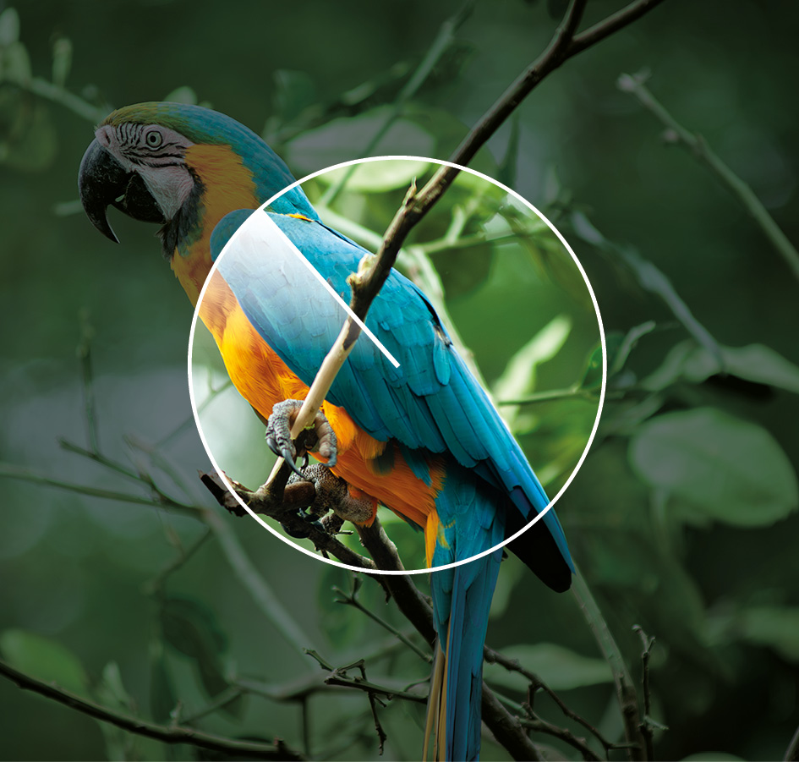

Biodiversity is the variety of all living things and their interactions; in other words, the variety of ecosystems, species and genetic variations with species, as well as the ecological links between these components.[1]

In 2019, the Intergovernmental Science-Policy Platform on Biodiversity and Ecosystem Services (IPBES) concluded that biodiversity on Earth is being lost at a faster rate than ever before in human history, and that this loss of nature is due to human activity.[2] The main threats to biodiversity are the loss or degradation of habitats, overexploitation of natural resources (overfishing, overhunting and overharvesting), climate change and invasive, non-native species. Over the past 50 years, the pressure on nature from these factors has intensified. While climate change is itself a growing threat, due to rising temperatures, extreme weather events and ocean acidification, for example, it can also accelerate other threats.[3]

Loss of biodiversity has major adverse impacts on ecosystems and the essential services and benefits that these systems provide to us humans. The 2022 Kunming-Montreal Global Biodiversity Framework (GBF) states that «Biodiversity is fundamental to human well-being, a healthy planet, and economic prosperity for all people.»[4]

For many years, the Council has worked on cases where loss of biodiversity has constituted grounds for exclusion from investment by the GPFG. Forestry companies and plantation operators have been excluded when large areas of tropical forest that were in good condition have been destroyed. This is because deforestation is one of the greatest threats to ecosystems and biodiversity, and because tropical forests are particularly valuable. Companies engaged in operations which may harm World Heritage Sites have also been excluded from investment by the GPFG. UNESCO World Heritage Sites are designated as such pursuant to the World Heritage Convention due to their outstanding universal value to natural heritage, which may relate to landscapes, geology, ecosystems and/or biodiversity. Universal value implies importance in a global perspective, not merely regional or national importance.

In recent years, the sum of knowledge about biodiversity has increased, and international agreements in the field have been signed. This is changing what is considered acceptable practice for companies that impact biodiversity. Both the status summaries published by IPBES and the GBF from 2022 conclude that loss of biodiversity must be stopped and reversed. Although the GBF primarily addresses nation states, the Council considers that companies must also strive towards the framework’s goals. This implies that the loss of both areas of great significance for biodiversity and ecosystems of high integrity must be reduced to practically zero by 2030. Examples of areas that are important for biodiversity include areas with high species diversity, endangered species, unique (endemic) species or threatened ecoregions. The Council expects that companies exercise a high level of due diligence when they plan activities in areas deemed to be important for biodiversity.

The Council also attaches importance to the GBF’s expectations that businesses and financial institutions will contribute to the reduction of nature loss. Major international companies and financial institutions are therefore expected to monitor and assess their risks, as well as their biodiversity-related dependencies and impacts, and make this information publicly available.

Neither biodiversity nor human impact is equally distributed across the globe. Some areas are therefore more important than others for the conservation of biodiversity. When assessing companies’ activities, the Council will, for example, attach importance to whether they take place in wilderness areas. Wilderness areas are vast areas of contiguous, intact forest with little human activity. Some of these areas, such as the rainforests of the Amazon and New Guinea, are defined as high biodiversity wilderness areas.[5] Such areas act as a safety net for biodiversity because of their size and because they host many endemic species (i.e. species that are found only in that location). The Council considers that companies should, in some cases and in some areas, refrain from intervening in the natural landscape, since this could seriously harm global biodiversity.

To prioritise areas where conservation measures would have the greatest impact, the British biologist Norman Myers introduced the concept of biodiversity hotspots in 1988.[6] Biodiversity hotspots are geographic regions with an exceptionally high number of endemic species and where less than 30 per cent of the original habitat remains intact. There are 36 such regions globally. Together, they cover around 2.5 per cent of the Earth’s landmass. These biodiversity hotspots contain more than half of the total number of the world’s species. Conservation of the remaining intact areas in these regions will therefore play a vital role in reducing the risk of losing globally important biodiversity.

In 2024, the Council surveyed the GPFG-invested companies that have or are planning business activities in intact areas of nature in biodiversity hotspots. The survey was limited to sectors with a high risk of causing the loss of species, habitats or ecosystems. Examples include resource extraction and the operation of plantations. This survey will be an important basis for the Council’s further work with companies which have a high risk of adversely affecting biodiversity.

The threshold for exclusion is set intentionally high and any assessment of what constitutes serious environmental damage pursuant to the ethical guidelines must be made individually. At the same time, expectations regarding the way companies handle the risk of biodiversity loss have risen. The Council will continue to attach importance to the risk that important natural components may be lost. This includes both species and ecosystems. The Council will also attach importance to whether companies damage designated Natural Heritage Sites or other conservation areas, avoid harming biodiversity in other important, intact areas of nature, and focus on preventing biodiversity loss rather than merely mitigating the damage once it has been done.

# Observation and exclusion of companies

## List of excluded companies as at 31 December 2024

Serious environmental damage

* Astra International Tbk
* Barrick Gold Corp
* Beijing Tong Ren Tang Chinese Medicine Co Ltd
* Bharat Heavy Electricals Ltd
* China Traditional Chinese Medicine Holdings Co Ltd
* Duke Energy Corp (including the wholly owned subsidiaries listed below)
* Duke Energy Carolinas LLC
* Duke Energy Progress LLC
* Progress Energy Inc
* ElSewedy Electric Co
* Freeport-McMoRan Inc
* Genting Bhd
* GMK Norilskiy Nickel PAO
* Grand Pharmaceutical Group Ltd
* Halcyon Agri Corp Ltd
* Jardine Cycle & Carriage Ltd
* Jardine Matheson Holdings Ltd
* NHPC Ltd
* POSCO Holdings Inc
* Posco International Corp
* Power Construction Group of China Ltd
* Ta Ann Holdings Bhd
* Tianjin Pharmaceutical Da Re Tang Group Corp Ltd
* Tong Ren Tang Technologies Co Ltd
* Vale SA
* Volcan Cia Minera SAA
* WTK Holdings Bhd
* Young Poong Corp
* Yunnan Baiyao Group Co Ltd
* Zijin Mining Group Co Ltd

Serious environmental damage | Serious human rights abuses

* Evergreen Marine Corp Taiwan Ltd
* Korea Line Corp
* Vedanta Ltd

Serious violations of the rights of individuals in situations of war or conflict

* Adani Ports and Special Economic Zone Ltd
* Ashtrom Group Ltd
* Bezeq The Israeli Telecommunication Corp Ltd
* Danya Cebus Ltd
* Elco Ltd
* Electra Ltd/Israel
* GAIL India Ltd
* Korea Gas Corp
* Mivne Real Estate KD Ltd
* Oil & Natural Gas Corp Ltd
* PTT Oil and Retail Business PCL
* PTT PCL
* Shapir Engineering and Industry Ltd
* Shikun & Binui Ltd

Other serious violations of fundamental ethical norms

* Delek Group Ltd
* Elbit Systems Ltd
* Evraz PLC

Gross corruption or other serious financial crimes

* China State Construction Engineering Corp Ltd
* JBS SA
* ZTE Corp

Serious or systematic human rights abuses

* Centrais Eletricas Brasileiras SA (Eletrobras)
* Cognyte Software Ltd
* Formosa Chemicals & Fibre Corp
* Formosa Taffeta Co Ltd
* Honeys Holdings Co Ltd
* Li Ning Co Ltd
* Lu Thai Textile Co Ltd
* Page Industries Ltd
* Prosegur Cia de Seguridad SA
* Zuari Agro Chemicals Ltd

Sale of weapons to states engaged in armed conflict that use the weapons in ways that constitute violations of the international rules on the conduct of hostilities

* AviChina Industry & Technology Co Ltd
* Bharat Electronics Ltd

Sale of weapons or military materiel to states that are subject to investment restrictions on government bonds as described in section 2-1(2)(c) of the Management Mandate for the Government Pension Fund Global

* Weichai Power Co Ltd

Unacceptable greenhouse gas emissions

* Canadian Natural Resources Ltd
* Cenovus Energy Inc
* Imperial Oil Ltd
* Suncor Energy Inc

Production of nuclear weapons

* Airbus SE
* BAE Systems Plc
* Boeing Co
* BWX Technologies Inc
* Fluor Corp
* General Dynamics Corp
* Honeywell International Inc
* Huntington Ingalls Industries Inc
* Jacobs Solutions Inc
* L3Harris Technologies Inc
* Larsen & Toubro Ltd
* Lockheed Martin Corp
* Northrop Grumman Corp
* Safran SA

Production of cluster munitions

* Poongsan Corp
* Textron Inc

Production of tobacco

* Altria Group Inc
* British American Tobacco Malaysia Bhd
* British American Tobacco Plc
* Eastern Co SAE
* Gudang Garam tbk pt
* Hanjaya Mandala Sampoerna Tbk PT
* Huabao International Holdings Ltd
* Imperial Brands Plc
* ITC Ltd
* Japan Tobacco Inc
* KT&G Corp
* Philip Morris Cr AS
* Philip Morris International Inc
* Scandinavian Tobacco Group A/S
* Shanghai Industrial Holdings Ltd
* Turning Point Brands Inc
* Universal Corp/VA
* Vector Group Ltd

Production of cannabis

* Aurora Cannabis Inc
* Canopy Growth Corp
* Cronos Group Inc
* Tilray Brands Inc

Production of coal or coal-fired energy

* Aboitiz Power Corp
* AES Andes SA
* AES Corp
* AGL Energy Ltd
* ALLETE Inc
* Alliant Energy Corp
* Ameren Corp
* American Electric Power Co Inc
* CESC Ltd
* CEZ AS
* China Coal Energy Co Ltd
* China Power International Development Ltd
* China Resources Power Holdings Co Ltd
* China Shenhua Energy Co Ltd
* Chugoku Electric Power Co Inc/The
* CLP Holdings Ltd
* Coal India Ltd
* CONSOL Energy Inc
* Datang International Power Generation Co Ltd
* DMCI Holdings Inc
* DTE Energy Co
* Electric Power Development Co Ltd
* Electricity Generating PCL
* Emera Inc
* Engie Energia Chile SA
* Evergy Inc
* Exxaro Resources Ltd
* FirstEnergy Corp
* Glencore PLC
* Great River Energy
* Guangdong Electric Power Development Co Ltd
* Gujarat Mineral Development Corp Ltd
* HK Electric Investments & HK Electric Investments Ltd
* Hokkaido Electric Power Co Inc
* Hokuriku Electric Power Co
* Huadian Energy Co Ltd
* Huadian Power International Corp Ltd
* Huaneng Power International Inc
* IDACORP Inc
* Inner Mongolia Yitai Coal Co Ltd
* Korea Electric Power Corp
* Lubelski Wegiel Bogdanka SA
* Malakoff Corp Bhd
* MGE Energy Inc
* New Hope Corp Ltd
* NRG Energy Inc
* NTPC Ltd
* Okinawa Electric Power Co Inc/The
* Otter Tail Corp
* PacifiCorp
* Peabody Energy Corp
* PGE Polska Grupa Energetyczna SA
* Reliance Infrastructure Ltd
* Reliance Power Ltd
* RWE AG
* Sasol Ltd
* SDIC Power Holdings Co Ltd
* Shikoku Electric Power Co Inc
* Tata Power Co Ltd/The
* Tenaga Nasional Bhd
* Tri-State Generation and Transmission Association Inc
* Washington H Soul Pattinson & Co Ltd
* WEC Energy Group Inc
* Whitehaven Coal Ltd
* Xcel Energy Inc
* Yankuang Energy Group Co Ltd

## List of companies under observation

Serious violations of the rights of individuals in situations of war or conflict

* KDDI Corp
* Sumitomo Corp

Serious environmental damage

* Marfrig Global Foods SA

Serious environmental damage | Serious or systematic human rights abuses

* Pan Ocean Co Ltd

Other serious violations of fundamental ethical norms

* Semen Indonesia Persero Tbk PT

Gross corruption or other serious financial crimes

* Bombardier Inc
* Petrofac Ltd

Serious or systematic human rights abuses

* ORLEN SA

Production of coal or coal-fired energy

* Berkshire Hathaway Energy Co
* CMS Energy Corp
* Kyushu Electric Power Co Inc
* MidAmerican Energy Co
* NorthWestern Corp
* OGE Energy Corp
* Pinnacle West Capital Corp
* Tohoku Electric Power Co Inc
* Uniper SE
* Vistra Corp

The list is updated on an ongoing basis and may be found at <https://www.nbim.no/no/ansvarlig-forvaltning/etiske-utelukkelser/utelukkelse-av-selskaper/>

Published recommendations regarding companies

List of companies about which recommendations were published in 2024

|  |  |  |  |  |  |
| --- | --- | --- | --- | --- | --- |
| Company | Criterion | Recommendation | Decision | Issued | Published |
| Adani Ports & Special Economic Zone Ltd | War & conflict | Exclusion | Exclusion | 21.11.2023 | 15.05.2024 |
| Astra International Tbk PT | Serious environmental damage | Exclusion | Exclusion | 12.05.2023 | 29.02.2024 |
| Bezeq The Israeli Telecommunication Corp Ltd | War & conflict | Exclusion | Exclusion | 30.08.2024 | 03.12.2024 |
| Bollore SE | Human rights | Exclusion | Exercise of ownership rights | 19.03.2024 | 26.06.2024 |
| Bombardier Inc | Corruption & financial crime | Continue observation | Observation continued | 13.03.2024 | 26.06.2024 |
| China State Construction Engineering Corp Ltd | Corruption & financial crime | Exclusion | Exclusion | 25.04.2024 | 05.09.2024 |
| Cie de L’Odet SE | Human rights | Exclusion | Exercise of ownership rights | 19.03.2024 | 26.06.2024 |
| Evraz PLC | Other serious violations | Exclusion | Exclusion | 26.06.2024 | 03.12.2024 |
| General Dynamics Corp | Nuclear weapons | Exclusion | Exclusion | 25.04.2024 | 05.09.2024 |
| Hyundai Engineering & Construction Co Ltd | Corruption | Terminate observation | Observation terminated | 08.10.2024 | 03.12.2024 |
| Jardine Cycle & Carriage Ltd | Serious environmental damage | Exclusion | Exclusion | 12.05.2023 | 29.02.2024 |
| Jardine Matheson Holdings Ltd | Serious environmental damage | Exclusion | Exclusion | 12.05.2023 | 29.02.2024 |
| L3Harris Technologies Inc | Nuclear weapons | Exclusion | Exclusion | 19.12.2023 | 15.05.2024 |
| Larsen & Toubro Ltd | Nuclear weapons | Exclusion | Exclusion | 25.04.2024 | 05.09.2024 |
| Mativ Inc | Tobacco | Revoke exclusion | Exclusion revoked | 24.04.2024 | 26.06.2024 |
| Prosegur Cia de Seguridad SA | Human rights | Exclusion | Exclusion | 25.04.2024 | 05.09.2024 |
| Supermax Corp Bhd | Human rights | Terminate observation | Observation terminated | 26.06.2024 | 09.10.2024 |
| Tianjin Pharmaceutical Da Re Tang Group Corp Ltd | Serious environmental damage | Exclusion | Exclusion | 25.04.2024 | 05.09.2024 |
| Turning Point Brands Inc | Tobacco | Exclusion | Exclusion | 12.03.2024 | 05.09.2024 |
| Weichai Power Co Ltd | Military materiel | Exclusion | Exclusion | 19.12.2023 | 15.05.2024 |

The Council on Ethics publishes its recommendations on its website at the same time as Norges Bank publishes its decision on the case concerned. Below there follows a brief summary of the recommendations published in 2024. The summaries have been drawn from the full recommendations, which may be found at www.etikkradet.no.

Before making a decision to exclude a company or place it under observation, the ethical guidelines require Norges Bank to consider whether the exercise of ownership rights may be a suitable method for reducing the risk of continued norm violations. In one case in 2024, the Bank elected to exercise its ownership rights instead of accepting the Council’s recommendation to exclude the company concerned. The recommendation related to the French company Bolloré SE and its parent company Cie de l’Odét SE. In consequence, Norges Bank will itself follow up these companies and may also decide to exclude them at a later date if the exercise of ownership rights does not give the desired results.

Brief summary of the year’s recommendations

Adani Ports & Special Economic Zone Ltd

Issued 21 November 2023

The Council on Ethics recommends that Adani Ports & Special Economic Zone Ltd (APSEZ) be excluded from investment by the Norwegian Government Pension Fund Global (GPFG) due to an unacceptable risk that the company is contributing to serious violations of the rights of individuals in situations of war or conflict.

APSEZ is an Indian logistics company that engages, among other things, in vessel management, the operation of ports and port services. APSEZ is part of the Adani group of companies. At the close of 2022, the Government Pension Fund Global (GPFG) owned 0.3 per cent of APSEZ’s shares, worth approx. USD 63.4 million.

APSEZ has been under observation since March 2022 due to its business association with the armed forces in Myanmar in the development of Ahlon International Port Terminal in Yangon. APSEZ had announced that it would pull out of the business in Myanmar. Due to the uncertainty surrounding whether and when it would be possible to accomplish this, the Council recommended that the company be placed under observation.

The Council has reassessed the company following the disclosure that APSEZ had sold its port-related operations in Myanmar to Solar Energy Ltd in May 2023. No information on the buyer is available, and APSEZ has stated that it cannot share any such information on the grounds of confidentiality.

The Council attaches importance to the fact that the company has failed to help shed light on the matter, that no other information is to be found about the company that is said to have acquired APSEZ’s operations in Myanmar, and that APSEZ’s auditor did not have sufficient information to assess whether the sale to Solar Energy was a transaction between related parties. This lack of information means that the Council cannot establish whether APSEZ has links to the enterprise concerned. In a situation in which extremely serious norm violations are taking place, this constitutes an unacceptable risk that the GPFG’s investments in APSEZ may breach its ethical guidelines.

Astra International Tbk PT, Jardine Matheson Holdings Ltd and Jardine Cycle&Carriage Ltd

Issued 12 May 2023

The Council on Ethics recommends that PT Astra International Tbk (Astra) and the parent companies Jardine Cycle & Carriage Ltd (JC&C) and Jardine Matheson Holdings Ltd (Jardines) be excluded from investment by the Norwegian Government Pension Fund Global (GPFG) due to an unacceptable risk that they are contributing to or are themselves responsible for serious environmental damage. The Council’s recommendation rests on an assessment of the Martabe Gold Mine in Sumatra, which is located within the habitat of the critically endangered Tapanuli orangutan and other endangered species.

Astra has been under observation since October 2015 due to the development of oil palm plantations in Indonesia by one of its subsidiaries, PT Astra Agro Lestari Tbk, and consequent risk of deforestation and loss of biodiversity. The Council recommends that observation pursuant to this issue be discontinued, irrespective of the decision to exclude Astra on the grounds of its involvement in the Martabe Gold Mine.

The recommendation is divided into two parts. The first explains the reasoning for the Council’s recommendation to exclude the above-mentioned companies. The second relates to the Council’s recommendation to discontinue observation of Astra.

Recommendation to exclude

The Council takes the view that parent companies which have a controlling influence over their subsidiaries’ business operations are accountable for the actions of those subsidiaries. Jardines is the parent company of JC&C, which is Astra’s controlling shareholder. Astra is the majority shareholder of PT United Tractors (United Tractors), which, via wholly owned subsidiaries, owns 95 per cent of the mining company PT Agincourt Resources (PTAR) that operates the Martabe Gold Mine.

Astra is listed on the Indonesia Stock Exchange (IDX), Jardines is listed on the London Stock Exchange (LSE), while JC&C is listed on the Singapore Exchange (SGX). At the close of 2022, the GPFG owned 0.19 per cent of the shares in Astra, worth USD 28.4 million. At the same time, the GPFG owned 1.14 per cent of the shares in Jardines, worth USD 168.5 million, and 0.47 per cent of the shares in JC&C, worth USD 39.2 386 million.

The Martabe Gold Mine lies within the confines of the Tapanuli orangutan’s habitat in the Batang Toru Forest in North Sumatra. The Tapanuli orangutan is the most critically endangered of all the great apes. There are fewer than 800 individuals left in this forest, which constitutes the species sole remaining habitat. As such, the survival of the species depends on the preservation of this habitat. The area has been designated a Key Biodiversity Area due to its exceptionally rich biodiversity, including many endemic and endangered species.

PTAR has operated the Martabe Gold Mine since 2012. It plans to expand the mining area, and the search for new gold deposits further inside the orangutan’s habitat is currently underway. PTAR has told the Council about a number of studies, initiatives and measures to protect biodiversity, including the establishment of a panel of experts to advise on future conservation work and biodiversity offsets. The Council has been unable to assess these measures, due to government restrictions on access to the studies.

For the Council, the decisive factor is that the Tapanuli orangutan is a critically endangered species and that any further reduction in the size of its habitat would, according to many experts, worsen its situation and increase the risk of it becoming extinct. The company’s efforts to preserve these orangutans does not to any great degree seem to be limiting the mine’s expansion or prospecting deeper into the orangutans’ habitat. The Council attaches importance to the fact that the company is planning to significantly increase the mining area during the mine’s lifetime, that new deposits will be exploited if commercially viable, and that the Indonesian authorities have granted permission for mining operations in an area that is as yet undeveloped. The Council considers that, as long as PTAR’s activities result in a reduction in the size of the orangutan’s habitat, the risk of the companies contributing to serious environmental damage will remain unacceptable.

Recommendation to discontinue observation

The Council considers that there is no longer an unacceptable risk of serious environmental damage relating to the development and operation of oil palm plantations by Astra’s subsidiary PT Astra Agro Lestari Tbk (AAL). The Council therefore recommends that observation of Astra be discontinued. AAL operates oil palm plantations in Sumatra, Kalimantan and Sulawesi through 43 subsidiaries.

The Council has submitted observation reports to Norges Bank in 2018, 2019 and 2020.

The Council’s observation of Astra and AAL has focused particularly on how AAL conserves and manages biodiversity and areas of high conservation value (HCV) in its concessions. During the observation period, AAL has not opened up any new areas of peat or forest, and has undertaken to preserve High Carbon Stock (HCS) forests, peat and HCVs. The company’s sustainability strategy, which rests on a policy of zero deforestation, no conversion of peatlands and respect for human rights, has been operationalised through three-year action plans. AAL has introduced systems to prevent forest fires, preserve peatland and avoid deforestation in its supply chain.

During the observation period, the Council has also raised the impact of the company’s operations on the Orang-Rimba people – a semi-nomadic Indigenous people who live in extreme poverty at the margins of the plantation concession operated by one of AAL’s subsidiaries. For several years, AAL has assisted with food aid, health services and the provision of schooling and educational services to improve the families’ living standards. In the last few years, AAL has also initiated processes to improve the more long-term outlook for the Indigenous groups. Although the Council understands that the public authorities and other actors are responsible for finding solutions, it considers that AAL still has an important role to play in these endeavours to safeguard the Orang-Rimba’s living areas and livelihoods.

The Council is aware of reports of conflict between local communities and three of AAL’s subsidiaries, but has not investigated these in further detail. However, the Council presumes that AAL-s new sustainability action plan will underpin intensified efforts to protect biodiversity and strengthen AAL’s endeavours in the area of human rights and conflict resolution.

Bezeq The Israeli Telecommunication Corp Ltd

Issued 30 august 2024

The Council on Ethics recommends that Bezeq The Israeli Telecommunications Corp (Bezeq) be excluded from investment by the Norwegian Government Pension Fund Global (GPFG) due to an unacceptable risk that the company is contributing to serious violation of the rights of individuals in situations of war or conflict.

Bezeq is an Israeli company that supplies telecommunications services to businesses and private individuals in Israel and the Israeli settlements in the West Bank.

At the close of June 2024, the GPFG owned 0.76 per cent of the company’s shares, worth NOK 252 million. The company is listed on the Tel Aviv Stock Exchange.

The Council notes the company’s assertion that it also provides telecom services to Palestinian areas in the West Bank. However, the Council does not consider this to outweigh the fact that the company, through its physical presence and provision of telecom services to Israeli settlements in the West Bank, is helping to facilitate the maintenance and expansion of these settlements, which are illegal under international law. By doing so, the company is itself contributing to the violation of international law.

With respect to future risk, Bezeq has confirmed to the Council that it has no possibility of terminating its provision of telecom services to the Israeli settlements in the West Bank. It must therefore be considered certain that this part of Bezeq’s operations will continue for the foreseeable future. The company will thereby continue to help support the violation of international law that these settlements constitute.

Bollore SE og Cie de L’Odet SE

Issued 19 March 2024

The Council on Ethics recommends that the companies Compagnie de l’Odet SE (Cie de l’Odet) and Bolloré SE be excluded from investment by the Norwegian Government Pension Fund Global (GPFG) due to the risk that the companies are contributing to serious and systematic human rights abuses. This recommendation relates primarily to working conditions at oil palm plantations in Cameroon and their consequences for local communities.

Cie de l’Odet and Bolloré are holding companies listed on the Euronext stock exchange in Paris. At the close of 2023, the GPFG owned 1.15 per cent of the Bolloré’s shares, worth USD 84.5 million. The GPFG owned 0.13 per cent of the shares in Cie de l’Odet, worth USD 14.1 million.

Cie de l’Odet owns 62,19 per cent of the shares in Bolloré. Bolloré has considerable ownership interests in rubber and oil palm plantations in several countries in Africa and Asia, including Société Financière des Caoutchoucs (Socfin), in which Bolloré has a 39.75 per cent shareholding. Socfin controls Socfinaf, which is, in turn, the controlling shareholder of Socapalm. Bolloré has direct and indirect shareholdings in Socfinaf totalling 34.4 per cent.

The Council’s own inquiries into Socapalm’s plantation operations in Cameroon have revealed serious norm violations, including extensive sexual harassment of women by supervisors and security guards at the plantation. The abuses concern both women who work at Socapalm plantations and those who are passing through the plantation or the surrounding areas. More than half of Socapalm’s workforce are contract workers or day labourers. The inquiries showed that almost none of them have an employment contract, they earn less than the legal minimum wage, have their pay docked for social benefits they do not receive, and can be hired and fired at will. For the women, the provision of sexual services has become a way to secure a job or avoid being fired. In addition, Socapalm has extended the plantation to areas belonging to local communities and made it difficult for them to access their properties, which weakens the population’s ability to make a living.

Similar human rights abuses have for many years been reported at several of Socfin’s plantations in Liberia and Sierra Leone. The Council on Ethics considers that Cie de l’Odet and Bolloré are contributing to these norm violations, which are both serious and systematic.

Neither Cie de l’Odet nor Bolloré have provided information in connection with this matter. The companies maintain that they hold minority stakes in Socfin and therefore have no influence over how the plantations are operated. Lack of formal control over the plantations is not decisive for the Council’s assessment. Cie de l’Odet has controlling interest in Bolloré. Bolloré has, and has always had, a material ownership interest in Socfin and Socfinaf. Bolloré’s senior executives have served on Socfin’s board of directors since 1990 and on Socfinaf’s board of directors since 1993. In the Council’s opinion, this indicates that Bolloré should have sufficient influence to improve the situation at the plantations if the company so wished. It seems to the Council as though neither Cie de l’Odet nor Bolloré acknowledge the risk of contributing to serious norm violations relating to the plantation business and therefore does nothing to put an end to them. The Council concludes that this raises the risk that the companies, also in future, will contribute to serious and systematic human rights abuses to an unacceptable level.

Bombardier Inc

Issued 13 March 2024

In March 2022, Norges Bank decided to place Bombardier Inc (Bombardier) under observation for a period of two years due to an unacceptable risk that the company is contributing to or is itself responsible for gross corruption. The Council’s recommendation from October 2021 was based on the fact that Bombardier or its subsidiaries could be linked to allegations or suspicions of corruption in six countries over a period of more than ten years. In its assessment of future risk, the Council attached importance to multiple deficiencies in the company’s follow-up of corruption risk. This included top management’s lack of communication of zero tolerance for corruption, as well as inadequate third-party assessments and follow-up of when corruption was reported.

Bombardier has provided the Council with limited documentation during the observation period to show how the company’s anti-corruption and anti-money laundering systems work in practice. This applies, for example, to due diligence assessments and the follow up of whistleblower reports, which were highlighted in the Council’s original recommendation as major failings. All in all, therefore, the Council considers that the risk attaching to Bombardier’s efforts to prevent, detect and deal with corruption still is not acceptable.

The Council therefore recommends that observation of the company be extended.

China State Construction Engineering Corp Ltd

Issued 25 April 2024

The Council on Ethics recommends that China State Construction Engineering Corp Ltd (CSCEC) be excluded pursuant to the criterion relating to gross corruption or other serious financial crime in the Guidelines for Observation and Exclusion of Companies from the Government Pension Fund Global (GPFG).

CSCEC is a Chinese construction company with a total workforce of approx. 380,000 people, including subsidiaries, and operations in more than 70 countries worldwide. It is listed on the Shanghai Stock Exchange. The company’s primary business activities include the construction of all types of public buildings, as well as infrastructure, property investment and development, and various forms of engineering activities. At the close of 2023, the GPFG owned 0.03 per cent of the company’s shares, worth NOK 90 million.

CSCEC may be linked to allegations or suspicions of corruption in a number of countries in the period 2004–2021. As far as the Council is aware, neither the company nor any of the company’s employees have so far been convicted in relation to any of the allegations, but the company has on several occasions been banned from tenders or had contracts canceled due to suspicions of financial fraud.

The Guidelines for Observation and Exclusion of Companies from the GPFG are forward-looking, and the issue to be assessed is whether there is an unacceptable risk that the company is contributing to or is itself responsible for gross corruption. In its assessment of future risk, the Council attaches importance to the assessments of authoritative sources with respect to the risk of corruption in the countries and business sector in which CSCEC operates. The Council points out that CSCEC operates in many countries that are ranked very low on international corruption indexes, that the construction industry has long been identified as one of the sectors with the highest corruption risk in the world, and that this risk is also deemed to be high in the BRI where CSCEC is engaged in many projects. The Council also attaches importance to the fact that China was ranked in the lowest category when Transparency International in 2022 assessed the country’s performance in enforcing corruption committed by its own citizens or companies abroad.

Still, most important for the Council’s assessment of future risk is whether the company is implementing measures capable of preventing, detecting and reacting to corruption, and which could indicate that the risk is nevertheless acceptable. The Council has contacted CSCEC and asked it a number of questions, but the company has failed to reply to the Council’s queries. Nor does the company provide any information on such measures on its website or in published reports. The Council refers to the Report to the Storting on the Government Pension Fund in 2008, which states that «a lack of information concerning a company’s behaviour and, not least, a lack of willingness on the part of the company to provide information, may in itself contribute to the risk of it contributing to unethical behaviour being deemed unacceptably high.»

On this basis, and in light of the cases described, the Council considers that the risk of gross corruption linked to CSCEC’s operations is unacceptable and recommends that the company be excluded from investment by the GPFG.

Evraz PLC

Issued 30 August 2024

The Council on Ethics recommends that Evraz PLC (Evraz) be excluded from investment by the Norwegian Government Pension Fund Global (GPFG) due to an unacceptable risk that the company is contributing to serious violations of fundamental ethical norms. The Council’s recommendation rests on the company’s contribution to maintaining Russia’s unlawful war of aggression against Ukraine.

Evraz is a steel producer, among other things, and engages in mining operations, principally in Russia. Evraz is listed on the London Stock Exchange. At the close of 2023, the GPFG owned 0.96 per cent of the company’s shares, worth NOK 43,766,783.

The Council considers that there is an unacceptable risk that Evraz is contributing to particularly serious violations of fundamental ethical norms by supplying steel to the company UralVagonZavod, which produces combat vehicles for use in the war Russia is waging against Ukraine in violation of international law.

The Council’s recommendation rests on information from a variety of media, official information from British authorities, a court ruling from the UK, as well as information from the company’s website and financial reports. The Council has contacted Evraz to request further information, but the company has failed to respond.

General Dynamics Corp

Issued 25 April 2024

The Council on Ethics recommends that General Dynamics Corp be excluded from investment by the Norwegian Government Pension Fund Global (GPFG) due to its production of key components of nuclear weapons.

At the close of 2023, the GPFG owned 1.01 per cent of the company’s shares, worth NOK 7.2 billion.

General Dynamics is a US company that operates primarily in the defence sector. The company is listed on the New York Stock Exchange.

The Council’s recommendation relates to the company’s role in the construction of the USA’s strategic submarines.

Hyundai Engineering & Construction Co Ltd

Issued 8 October 2024

In July 2021, Hyundai Engineering & Construction Co Ltd (HDEC) was placed under observation due to the risk that the company was contributing to or was itself responsible for gross corruption. Norges Bank made this decision on the basis of a recommendation issued by the Council on Ethics in April of that year. The original recommendation to place HDEC under observation was prompted by allegations or suspicions of corruption in Algeria, South Korea and Indonesia in the period 2008–2018, as well as the company’s involvement in widespread bid rigging and illegal price

collusion in South Korea between 2005 and 2013. The Council considered that HDEC had not taken the various allegations seriously enough and that much remained to be developed and implemented with respect to the company’s systems and procedures for the prevention and detection of corruption.

Throughout the observation period, the Council has had the impression that HDEC’s efforts to prevent, detect and deal with corruption have steadily improved, and the Council’s assessment now is that the company seems to have put in place an anti-corruption system that, in most areas, aligns with internationally recognised recommendations. Also, during the observation period, the Council has not uncovered any new allegations of corruption relating to the company’s business.

Hence, the Council no longer considers the risk of gross corruption in the company’s business operations to be unacceptable and recommends that observation of HDEC be discontinued.

L3Harris Technologies Inc

Issued 19 December 2023

The Council on Ethics for the Norwegian Government Pension Fund Global (GPFG) recommends that L3Harris Technologies Inc (L3Harris) be excluded from investment by the GPFG due to the company’s production of key components for nuclear weapons. At the close of 2022, the GPFG owned 0.84 per cent of the company’s shares, worth NOK 3.2 billion. In addition, the GPFG owned NOK 94 million in bonds issued by the company.

Larsen & Toubro Ltd

Issued 25 April 2024

The Council on Ethics recommends that Larsen & Toubro Ltd (L&T) be excluded from investment by the Norwegian Government Pension Fund Global (GPFG) due to the company’s production of key components of nuclear weapons.

At the close of 2023, the GPFG owned 0.81 per cent of the company’s shares, worth NOK 4.92 billion. L&T is an Indian company, listed on the Delhi Stock Exchange (DSE).

The company has operations in multiple business sectors, including building & construction, oil & gas, electricity generation, minerals & metals, precision engineering, naval shipbuilding and the production of heavy machinery.

The Council’s recommendation relates to the company’s role in the construction of India’s strategic submarines.

Mativ Inc

Issued 24 April 2024

Mativ Inc (formerly Schweitzer-Mauduit International Inc) was excluded from investment by the Norwegian Government Pension Fund Global (GPFG) in 2013 due to its production of tobacco. Since the company is no longer involved in such production, the Council on Ethics recommends that the company’s exclusion be revoked.

Prosegur Cia de Seguridad SA

Issued 25 April 2024

The Council on Ethics recommends that Prosegur Cia de Seguridad SA (Prosegur) be excluded from investment by the Norwegian Government Pension Fund Global (GPFG) due to an unacceptable risk that the company is contributing to serious human rights abuses. Prosegur is a Spanish company which, among other things, provides security services in several Latin American countries. The recommendation is based on accusations of violence that can endanger life and health, and abuse of tribal people’s rights in Brazil.

At the close of 2023, the GPFG owned 0.67 per cent of Prosegur’s shares, worth NOK 72 million. Prosegur is listed on stock exchanges in Madrid and Barcelona.

Prosegur operates in 31 countries and employs around 150,000 people. Security services in Brazil are provided by the wholly owned subsidiary Segurpro, which employs 35,000 people. Among Segurpro’s customers are the mining company Vale and the palm oil producer Agropalma.

In 2022, a security guard employed by Segurpro shot and killed a man suspected of stealing from Vale’s railway. In 2020, masked security guards equipped with rubber bullets, tear gas and batons attacked around 150 people belonging to families who were residing illegally on Vale’s property. 20 people were injured. Brazil’s prosecuting authorities have stated that this action violated the right to personal integrity. In 2020, they recommended that Vale replace Segurpro as its security company.

In the period 2021–2023, during guard duty for Agropalma, Segurpro’s security guards prevented tribal people from visiting their ancient grave sites, fishing in the Acará river and travelling into the town they depend on for purchasing supplies and seeking medical attention. Brazilian prosecuting authorities have stated that this violates the rights of these tribal peoples. In 2022, they recommended that Agropalma rein in Segurpro’s activities.

The Council notes that Prosegur has established governing instruments and reporting systems that are intended to ensure respect for human rights. Since the company does not perceive recommendations from the prosecuting authorities as alerts of human rights abuses, the Council considers that these systems are of limited significance. When the company sets such a high threshold for addressing the risk of human rights abuses, it is difficult to both identify risks and establish adequate initiatives to mitigate them.

Since the company continues to perform the assignments mentioned above, and also operates in numerous countries in which there are land disputes and serious antagonism between commercial companies and local populations, the Council presumes that new situations may arise involving a considerable risk of human rights abuses. Given that the company has not substantiated that its systems for identifying and managing such risks are adequate, the Council deems the risk that Prosegur will contribute to serious human rights abuses in future to be unacceptable.

Supermax Corp Bhd

Issued 26 June 2024

In February 2022, the Council on Ethics recommended that Malaysian company Supermax Corp Bhd be excluded from the Norwegian Government Pension Fund Global (GPFG) due to an unacceptable risk that the company was contributing to human rights abuses. In June the same year, Norges Bank decided to place Supermax under observation.

At the close of 2023, the Fund’s shareholding in the company was worth USD 2,480.

Supermax is a Malaysian company that produces rubber and latex gloves. The Council’s recommendation was based on reports of extremely poor living and working conditions for migrant workers at the company’s production facilities in Malaysia.

During the observation period, Supermax reported that it has implemented numerous measures to improve conditions for migrant workers. In September 2023, furthermore, the US authorities lifted import restrictions on Supermax’s products because the conditions that had led to the company being blacklisted due to the risk of forced labour had been rectified.

The US authorities’ rescinding of import restrictions on the company’s products combined with the company’s disclosures about the measures it had implemented, could indicate that conditions for workers at Supermax’s production facilities have improved.

The Council recommends that its observation of Supermax be discontinued.

Tianjin Pharmaceutical Da Re Tang Group Corp Ltd

Issued 25 April 2024

The Council on Ethics recommends to exclude Tianjin Pharmaceutical Da Re Tang Group Corp Ltd (Da Ren Tang) from the Government Pension Fund Global (GPFG) due to an unacceptable risk that the company contributes to serious environmental damage. The Council on Ethics’ assessment focuses on the companies’ use of ingredients based on body parts of threatened animal species in the production of Traditional Chinese Medicine (TCM).

At the close of 2023, the GPFG owned shares in Da Ren Tang valued at approximately 2.2 mill USD corresponding to an ownership interest of 0.14 per cent.

Da Ren Tang develops, manufactures and markets TCM products. The Council’s investigation shows that the company manufactures a number of products which include animal parts from threatened species. This pertains to leopard bones, pangolin scales and musk from musk deer. The products are advertised on the company and its subsidiaries’ websites.

The Council has focused on species listed on the IUCN Red List of Threatened Species, i.e., critically endangered, threatened or vulnerable species, as well as species listed in Annex 1 of the Convention on International Trade in Endangered and Vulnerable Species (CITES). The Council is of the view that companies, whose activities contribute to species becoming extinct, are depleting biodiversity. By producing medicines with ingredients that include the body parts of threatened species, there is a risk of the company contributing to irreversible and severe environmental damage.

In light of the extensive illegal trade in threatened species, the Council places emphasis on the fact that the company does not disclose information regarding traceability of purchases or where the animals originate from. The Council finds that the lack of such information and lack of transparency in the company’s practices constitute an unacceptable risk that the threatened species the company uses in its products may originate from illegal sources.

Due to lack of information, the Council is unable to quantify the company’s contribution to environmental damage. Since the quantity of body parts of threatened wildlife used, the provenance and stockpiles of these and how these are replenished are not known, the Council finds that the question of the company’s contribution is a matter of whether the company uses endangered species in its production or not. When the activities themselves constitute a risk of species becoming extinct, there is also a risk that the company contributes to the depletion of biodiversity and serious environmental damage.

Da Ren Tang has not publicly announced a specific goal to stop using threatened species in its production of TCM. The Council therefore considers the risk that the company will continue to contribute to severe environmental damage to be unacceptable.

Turning Point Brands Inc

Issued 13 March 2024

The Council on Ethics recommends that Turning Point Brands Inc be excluded from the investment universe of the Government Pension Fund Global (GPFG) due to this company’s production of tobacco products.

Weichai Power Co Ltd

Issued 19 December 2023

The Council on Ethics recommends that Weichai Power Co Ltd (WP) be excluded from investment by the Norwegian Government Pension Fund Global (GPFG) due to an unacceptable risk that the company is contributing to the sale of weapons or military materiel to states that are subject to investment restrictions on government bonds as described in section 2-1(2)(c) of the Management Mandate for the Government Pension Fund Global.

WP is a Chinese company producing, among other things, engines for use in heavy vehicles.

WP is listed in Beijing. At the close of 2022, the GPFG owned 0.46 per cent of the company’s shares, worth NOK 553 million.

This recommendation is inter alia based on information from Chinese and Belarusian authorities, as well as from companies with which WP has formed joint ventures. Although the Council has contacted WP to obtain additional information, the company has not replied to the Council’s queries.

The Council considers that there is an unacceptable risk that WP is contributing to the sale of military materiel to the authorities in Russia and Belarus. This constitutes grounds for recommending that WP be excluded from investment by the GPFG.

# Guidelines for Observation and Exclusion of companies from the Government Pension Fund Global (GPFG)

As of 5 September 2022

This translation is for informational purposes only. Legal authenticity remains with the original Norwegian version, Retningslinjer for observasjon og utelukkelse av selskaper fra Statens pensjonsfond utland, as published in Norsk Lovtidend (lovdata.no).

I. Purpose and scope

§ 1 Purpose

The purpose of the Guidelines for Observation and Exclusion of companies from the Government Pension Fund Global (the ethical guidelines) is to avoid that the Government Pension Fund Global (GPFG) is invested in companies that cause or contribute to serious violations of fundamental ethical norms, as set out in these guidelines’ sections 3 and 4.

§ 2 Scope

These guidelines apply to the work of the Council on Ethics for the Government Pension Fund Global (the Council on Ethics) and Norges Bank (the Bank) on the observation and exclusion of companies from the GPFG’s equity and fixed-income portfolios. Advice and decisions pursuant to the criteria set out in section 3 may also apply to companies only included in the reference index or to be included in the reference index.

II. Criteria for observation and exclusion of companies

§ 3 Criteria for product-based observation and exclusion of companies

(1) The GPFG shall not be invested in companies which themselves or through entities they control:

1. develop or produce weapons or key components of weapons that violate fundamental humanitarian principles through their normal use. Such weapons include biological weapons, chemical weapons, nuclear weapons, non-detectable fragments, incendiary weapons, blinding laser weapons, antipersonnel mines and cluster munitions
2. produce tobacco or tobacco-products
3. produce cannabis for recreational use

(2) Observation or exclusion may be decided for mining companies and power producers which themselves, or consolidated through entities they control, either:

1. derive 30 per cent or more of their income from thermal coal,
2. base 30 per cent or more of their operations on thermal coal,
3. extract more than 20 million tonnes of thermal coal per year, or
4. have the capacity to generate more than 10,000 MW of electricity from thermal coal.

§ 4 Criteria for conduct-based observation and exclusion of companies

Companies may be excluded or placed under observation if there is an unacceptable risk that the company contributes to or is responsible for:

1. serious or systematic human rights violations
2. serious violations of the rights of individuals in situations of war or conflict
3. the sale of weapons to states engaged in armed conflict that use the weapons in ways that constitute serious and systematic violations of the international rules on the conduct of hostilities
4. the sale of weapons or military materiel to states that are subject to investment restrictions on government bonds as described in section 2-1(2)(c) of the Management mandate for the Government Pension Fund Global
5. severe environmental damage
6. acts or omissions that on an aggregate company level lead to unacceptable greenhouse gas emissions
7. gross corruption or other serious financial crime
8. other particularly serious violations of fundamental ethical norms.

III. Organisation of the work

§ 5 The Council on Ethics’ work

(1) The Council on Ethics makes recommendations to the Bank on the observation and exclusion of companies in the GPFG’s portfolio, in accordance with the criteria set out in sections 3 and 4, and on the revocation of observation and exclusion decisions; see subsection 7 and section 6(7).

(2) The Council on Ethics monitors the GPFG’s investments, see section 2, for the purpose of identifying companies that contribute to or are themselves responsible for the products or conducts set out in sections 3 and 4.

(3) The Council on Ethics takes up cases at its own initiative or at the request of the Bank. The Council on Ethics shall develop and publish principles for the selection of companies for closer investigation.

(4) The Council on Ethics shall be free to gather the information it deems necessary and shall ensure that each matter is thoroughly investigated before making a recommendation regarding observation, exclusion or revocation of such decisions.

(5) A company that is being considered for observation or exclusion shall be given an opportunity to present information and opinions to the Council on Ethics at an early stage of the process. In this context, the Council on Ethics shall clarify to the company what circumstances may form the basis for observation or exclusion. If the Council on Ethics decides to recommend observation or exclusion under section 4, its draft recommendation shall be presented to the company for comments.

(6) The Council on Ethics shall describe the grounds for its recommendations to the Bank. The Bank may adopt more detailed requirements relating to the form of such recommendations.

(7) The Council on Ethics shall have routines for assessing whether basis for observation or exclusion still exists. In light of new information, the Council on Ethics may recommend that the Bank revoke an observation or exclusion decision. These routines must be made public. Companies that have been excluded must be informed of these routines separately.

§ 6 Norges Bank’s work

(1) Based on the advice submitted by the Council on Ethics, the Bank makes decisions on observation and exclusion in accordance with the criteria set out in sections 3 and 4, and on the revocation of observation and exclusion decisions; see section 5(7) and section 6(7). The Bank may, at its own discretion, make decisions on observation and exclusion, and on the revocation of such decisions under section 3(2) and section 4(f).

(2) In assessments pursuant to section 3(2), importance shall also be attached to forward looking assessments, including any plans the company may have that will change the level of extraction of coal or coal power capacity relating to thermal coal, reduce the income ratio or business share based on thermal coal and/or increase the income ratio or business share relating to renewable energy sources.

(3) Advice and decisions on the exclusion of companies pursuant to section 3(2) shall not encompass a company’s green bonds, where these are recognised through inclusion in indexes for such bonds or verified by a recognised third party.

(4) In assessing whether a company is to be excluded under section 4, the Bank may, inter alia, consider factors such as the probability of future violations of norms, the severity and extent of the violations and the connection between the norm violation and the company in which the Fund is invested. The Bank may also consider the breadth of the company’s operations, including whether the company is doing what can be expected to reduce the risk of violations of norms within a reasonable time frame. Relevant factors in these assessments include the company’s corporate governance, guidelines and efforts on environmental and social conditions, and whether the company is contributing to remedying measures with respect to those who are or have previously been affected by the company’s conduct.

(5) Companies may be placed under observation if it is uncertain whether grounds for exclusion exist or what developments may occur forward in time, or when expedient for other reasons. Before any decision to exclude a company or place it under observation is made pursuant to section 6(1), the Bank must consider whether the exercise of ownership rights could be an appropriate way to reduce the risk of continued norm violations or could be more appropriate for other reasons. The Bank shall consider the full range of measures at its disposal and apply the measures in a coherent manner.

(6) The Bank shall ensure that sufficient information is available before it makes a decision regarding the exercise of ownership rights, observation or exclusion, or revokes any such decision.

(7) On the basis of new information, the Bank may ask the Council on Ethics to assess whether the grounds for observation or exclusion continue to exist.

§ 7 Exchange of information and coordination between the Bank and the Council on Ethics

(1) To facilitate good coordination between the Bank and the Council on Ethics, and the effective interaction of different measures, the Bank and the Council shall hold regular meetings.

(2) The Council on Ethics provides the Bank with information about companies it has selected for an initial assessment under these guidelines. The Bank provides the Council on Ethics with a list of the companies it is working on and company information that could be relevant for the Council’s assessments.

(3) The Council on Ethics may ask the Bank for information on matters concerning individual companies, including how specific companies are dealt with in the context of the exercise of ownership rights. The Council on Ethics may ask the Bank to contact companies with which the Council is unable to establish contact for the purpose of soliciting information. The Bank may ask the Council on Ethics to make its assessments of individual companies available to it and be given access to the Council’s communications with the companies concerned.

(4) The Bank and the Council on Ethics shall establish detailed procedures for the exchange of information and coordination to clarify responsibilities and promote productive communication and integration of the work of the Bank and the Council on Ethics.

(5) Communication with the companies shall be coordinated. The Bank may attend meetings that the Council on Ethics has with companies. The Bank exercises the GPFG’s shareholder rights; see Management mandate for the Government Pension Fund Global.

§ 8 The Council on Ethics’ composition and organisation

(1) The Council on Ethics consists of five members based on nomination by the Bank and appointed by the Ministry of Finance. The Ministry also appoints a chair and deputy chair based on nomination by the Bank. The Bank’s nominations shall be submitted to the Ministry no later than three months prior to the expiry of the appointment period.

(2) The Council on Ethics performs its work independently and autonomously. The Council on Ethics’ composition must ensure that it possesses the required expertise to perform its functions as defined in these guidelines.

(3) Members of the Council on Ethics shall be appointed for a period of four years. If a Council member steps down during their period of appointment, a new member may be appointed before the remaining portion of the period has expired.

(4) The Ministry sets the remuneration payable to the members of the Council on Ethics and the Council on Ethics’ budget.

(5) The Council on Ethics has its own secretariat, which falls administratively under the Ministry’s purview. The Council on Ethics shall ensure that the secretariat has appropriate procedures and routines in place.

(6) The Council on Ethics shall prepare an annual operating plan, which shall be submitted to the Ministry. The operating plan shall describe the priorities set by the Council on Ethics for its work; see section 5.

(7) The Council on Ethics shall provide the Ministry with an annual report on its activities. This report shall be submitted no later than three months after the end of each calendar year.

(8) The Council on Ethics shall evaluate its work regularly.

§ 9 Meetings with the Ministry of Finance

(1) The Ministry, the Bank and the Council on Ethics shall meet at least once a year. The report on responsible investment management included in the annual report to the Norwegian parliament (Stortinget) on the management of the GPFG shall be based in part on the information exchanged at such meetings.

(2) The Ministry and the Council on Ethics shall meet at least once a year. The following matters shall be discussed at these meetings:

1. activities in the preceding year
2. other matters reported by the Ministry and the Council on Ethics for further consideration.

IV. Public disclosure

§ 10 Publication

(1) The Bank shall publish its decisions pursuant to these guidelines. Such public disclosure shall be in accordance with section 6-1(5) of the Management mandate for the Government Pension Fund Global. When the Bank publishes its decisions, the Council on Ethics shall publish its recommendations. When the Bank makes decisions in accordance with section 6(1)(2) at its own discretion or decides to implement a measure other than that recommended by the Council on Ethics, the Bank shall explain its decision.

(2) The Bank shall keep a publicly available list of companies that have been excluded from the GPFG or have been placed under observation pursuant to these guidelines. Each year, the Bank shall publish details of the progress made in cases involving the exercise of ownership rights under these guidelines.

V. Other provisions

§ 11 Power of amendment

The Ministry may issue additions or make amendments to these guidelines.

§ 12 Entry into force

§ 4(1)-(3) enter into force immediately. Other sections enter into force 1 January 2015. From that same date, the Guidelines for Observation and Exclusion from the Government Pension Fund Global (GPFG) adopted on 1 January 2010 are rescinded.

1. Norway’s Nature Diversity Act (Naturmangfoldloven) and the UN Convention on Biological Diversity (CBD). Note that the Nature Diversity Act encompasses the management of biological, geological and landscape diversity. In the Norwegian translation of the GBF, however, the term naturmangfold (nature diversity) is used as a synonym for biodiversity and does not encompass the non-organic components of the natural world.
2. IPBES (2019): Global assessment report on biodiversity and ecosystem services of the Intergovernmental Science-Policy Platform on Biodiversity and Ecosystem Services. E. S. Brondizio, J. Settele, S. Díaz, and H. T. Ngo (editors). IPBES secretariat, Bonn, Germany. 1,148 pages. <https://doi.org/10.5281/zenodo.3831673>
3. Pörtner, H.O. et al., 2021. IPBES-IPCC co-sponsored workshop report on biodiversity and climate change; IPBES and IPCC. <https://doi.org/10.5281/zenodo.4782538>
4. Kunming-Montreal Global Biodiversity Framework, adopted at COP 15 in December 2022: <https://www.cbd.int/article/cop15-final-text-kunming-montreal-gbf-221222>
5. Mittermeier, Russell A., et al. «Wilderness and biodiversity conservation». Proceedings of the National Academy of Sciences 100.18 (2003): 10309–10313.
6. Myers, N. (1988). Threatened biotas: «Hot spots» in tropical forests. The Environmentalist, 8(3), 187–208, and Mittermeier, R. A., Myers, N., Mittermeier, C. G., da Fonseca, G. A. B., & Kent, J. (2000). Biodiversity hotspots for conservation priorities. Nature, 403(6772), 853–858.