Meld. St. 20 (2024–2025) Report to the Storting (white paper)

Promoting democracy, rule of law and human rights in Europe – Norway’s work in the Council of Europe

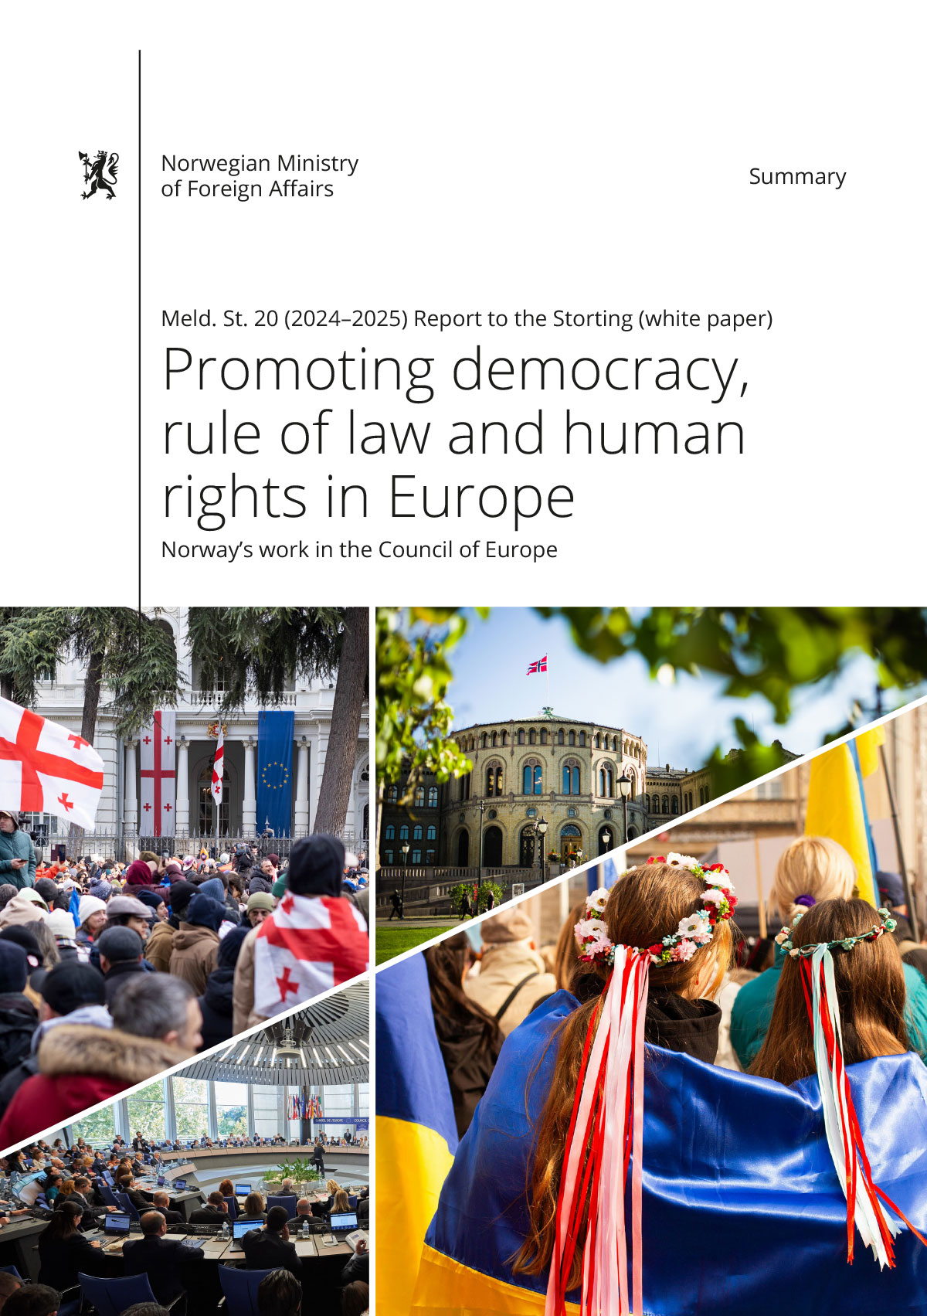

Summary

Background

We are living in a period of geopolitical upheaval and rapid changes, where much seems uncertain. Three decades ago, we experienced a strengthening of democratic values and multilateral co-operation. Today, the situation is starkly different. Globalisation has stalled amidst rising great power rivalry and deepening polarisation. We are witnessing authoritarian political forces gaining ground – even in allied and closely aligned countries. The rules-based world order, which has served Norway well, is now being challenged.

The Government is deeply concerned about how human rights, democracy and the rule of law are being undermined in Europe. Freedoms are weakened and democratic institutions are being eroded and pressurised from both internal and external forces. This situation is compounded by the three major global environmental crises – climate change, biodiversity loss and pollution – which we also require both global and regional co-operation to solve.

The Council of Europe was established to ensure peace in Europe, with standards for democracy, human rights and the rule of law, centred around the European Court of Human Rights (ECtHR). Being surrounded by well-functioning democracies is key to our security. European history post-World War II has demonstrated that democracies do not go to war against each other. The Council of Europe was born out of this conviction in 1949.

While NATO and military co-operation constitutes the hard power of our security policy, part of our soft security is derived from stable democratic neighbouring states.

Russia’s invasion of the Crimean Peninsula in 2014 and its full-scale invasion of Ukraine on 24 February 2022 pose a threat to international peace and security and marked a watershed moment both globally and for Europe. We also see that Russia is using a wide range of destructive means – major intelligence activities, influence campaigns, cyberattacks, infiltration and sabotage against targets in Europe. Thus, the timing of this report is particularly apt.

With this report, the Government is seeking to ensure a strategic and targeted engagement that strengthens both Norway’s position and the European response to some of the present challenges.

Chapter 2 of the report describes our current threat landscape, while Chapter 3 outlines the most important European institutions. Chapters 4 and 5 present the Government’s priorities and how Norway is working to address the threats.

The threats

While political propaganda, fake news, and disinformation are by no means modern phenomena, new technology has provided even greater opportunities to influence entire societies. Such operations threaten national security and civil protection. Openness in society and individual freedom are fundamental values, constituting a source of strength – but also a vulnerability that can be exploited. Public administration, critical infrastructure, military targets, the business sector and other societal functions are all potential targets for such threats. Illegitimate influence operations often unfold covertly and at a low intensity over time, making them difficult to detect and defend against. It is likely that states or non-state actors will increasingly seek to influence other states or decision-makers by unlawful means. Disinformation and influence campaigns undermine the public’s trust in democratic processes and institutions, have a polarising effect, and fuel intolerance and hatred.

In recent years, several European countries have experienced a gradual erosion of democratic norms and institutions. This is reflected in the weakened distribution of power, reduced judicial independence and shrinking civic space. In many cases, these processes are initiated by democratically elected leaders.

In many countries, judicial independence is weak. Rule of law challenges are characterised by inadequate legislation, ineffective administration, a lack of reform, and political or economic pressure. In some cases, the political or economic pressure is so intense that the judiciary is perceived as being controlled by political or economic elites.

In several European states, the room for manoeuvre of civil society and democratic opposition is being restricted. Restrictive legislation is used to hinder the registration of non-governmental organisations. Freedom of expression is being curtailed, political bias in the media is on the rise, and journalists are subjected to threats, harassment and surveillance. Women journalists are particularly vulnerable to gender discrimination, sexual harassment and other abuses. Vulnerable minorities and other groups in society are subjected to discrimination. Women and girls often have poorer legal protection and physical safety, health and education than men. When democracies are under pressure, workers’ right to freedom of association and the right to form trade unions may also be at risk. The climate, nature and pollution crises are creating challenges for democracy, human rights, security and the rule of law.

The institutions

The Council of Europe is an intergovernmental organisation mandated to promote human rights, democracy, and the rule of law in its 46 member states. Norway was among the 10 states that signed the Treaty establishing the Council of Europe in London in May 1949. NATO was established in the same year. The OSCE, as we know it today, came into being later as a continuation of the Conference on Security and Co-operation in Europe (CSCE), which was established in 1975 during the Cold War when Europe was divided between East and West. During the same period, the EU emerged as the dominant political actor on the continent.

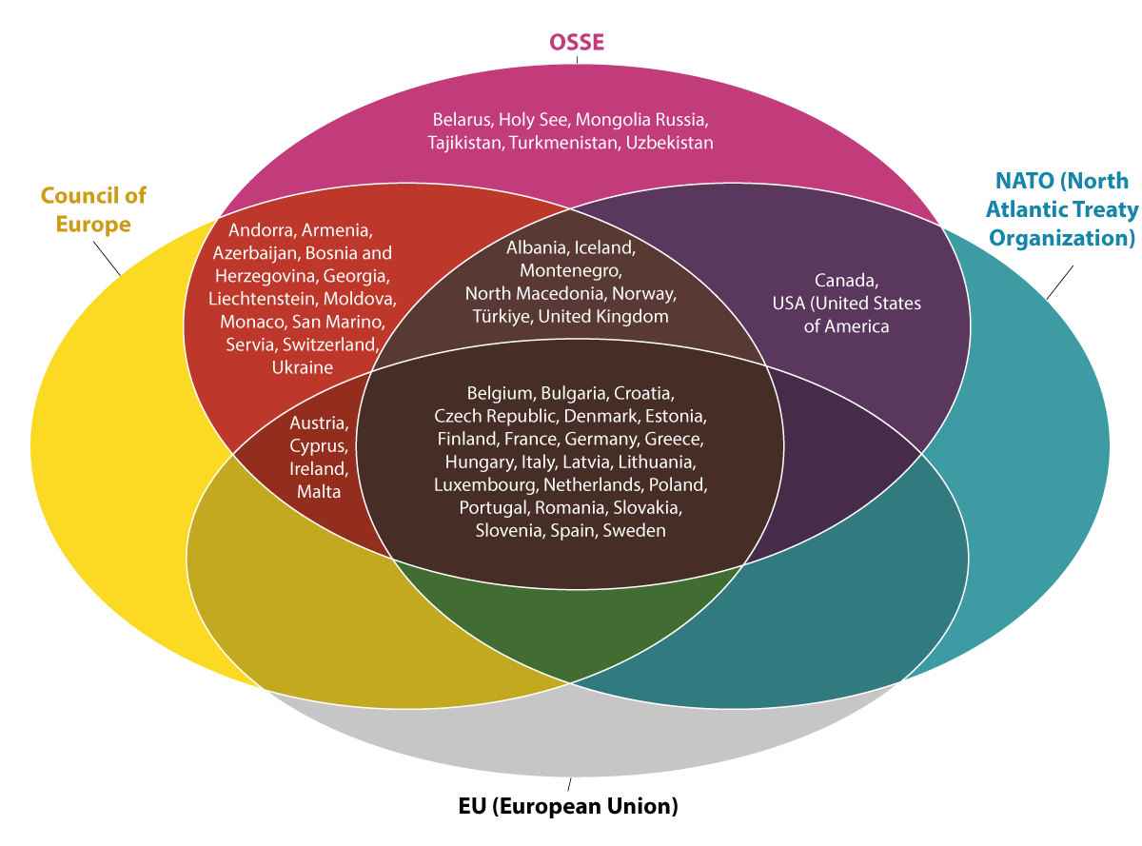

The Council of Europe as a shared community of values

The Council of Europe is a shared community of values – an organisation of like-minded states. The Council of Europe’s statutes stipulate that a state that seriously violates its values may be suspended from the organisation and, in extreme cases, expelled. This was the sanction imposed on Russia following the attack on Ukraine in 2022.

Authoritarian elected officials, as well as the threat of Russian hybrid warfare, now threaten the European project. In the areas of democracy, rule of law, and human rights, we are witnessing member states of the Council of Europe failing to comply with the rules, and the backlog in the implementation of judgments of systemic significance from the ECtHR is growing. In some countries, the authorities are more openly opposed to legislative compliance than before.

The Government adopts a principled stance on the need to uphold the shared community of values and the legitimacy of the Council of Europe. States that lack the political will to fulfil the obligations of Council of Europe membership should not be members of the organisation.

Summary: “The Government will”

Strengthening democracy and democratic institutions

* Strengthen the position of democracy in Europe by bolstering independent courts, free media, trade unions and other civil society organisations.
* Stand up for democratic values, the rule of law and human rights when they are challenged.
* Strengthen and coordinate Norwegian efforts to promote democracy in the Council of Europe.
* Strengthen the Office for Democratic Institutions and Human Rights’ (ODIHR) election observation efforts, including in co-operation with other Nordic countries.
* Advocate for the implementation of the Reykjavík Principles for Democracy in a manner that promotes the exchange of good practices and provides support and guidance to member states in preventing and resisting democratic decline. Furthermore, be a driving force in ensuring that member states are effectively held accountable for democratic backsliding.
* Strengthen the dialogue with the European Commission and the presidency of the Council of the EU on initiatives to reinforce democracy and the rule of law in Europe.
* Use Nordic and Nordic-Baltic co-operation as forums to discuss the rule of law and democracy in Europe and communicate shared messages.
* Strengthen co-operation between the Council of Europe and the OSCE, particularly in conflict areas where the OSCE has an operational presence.
* Support the development of national legislation and institutions that safeguard media pluralism and diversity and editorial freedom, protect sources and prevent censorship and surveillance of the media.
* Be a driver of international co-operation to combat the spread of disinformation, enhance critical media literacy, and ensure greater transparency and better control of content moderation on the major social media platforms.
* Strengthening democratic resilience in Europe through education.
* Contribute to promoting culture and cultural heritage as a prerequisite for democratic societies based on mutual understanding and with favourable conditions for a free cultural life, artistic freedom and cultural diversity.
* Effectively deploy EEA funds to support common binding standards and norms.

Strengthening the rule of law

* Continue efforts to strengthen and improve the efficiency of criminal justice co-operation in Europe, including through participation in relevant expert groups in the Council of Europe.
* Continue the Norwegian Courts Administration’s work on collecting and contributing to good practices for independent courts through participation in European judicial co-operation.
* Promote the principles of the rule of law in all European co-operation, including by considering third-party interventions before the European Court of Justice in cases of fundamental importance to the rule of law.
* Be a driving force behind efforts to prosecute crimes against humanity.

Human rights

* Continue to support the legitimacy of the ECtHR, including by faithfully complying with its judgements in relation to Norway and ensuring that our reports to the Committee of Ministers of the Council of Europe on the follow-up of judgments are submitted on time and of high quality.
* Use findings and recommendations from the Council of Europe’s monitoring mechanisms and the ECtHR’s rulings more systematically as a knowledge base in bilateral dialogue with member states.
* Be a vocal defender of freedom of expression and freedom of the media, including through strengthened support for the OSCE Representative on Freedom of the Media.
* Support international efforts to protect journalists and media workers and combat impunity for abuses.
* Advocate for international regulation that ensures effective reporting and removal of illegal hate speech on social media.
* Support initiatives to map and combat digital violence against girls and women, as well as other vulnerable groups.
* Be a driving force for strengthening civil society participation in the work of the Council of Europe.
* Counteract the curtailment of democracy and human rights and oppose violations of international law, including international human rights law, wherever they may take place, with particular emphasis on freedom of expression, religion or belief and assembly.
* Make active use of the tripartite co-operation between the government, trade unions and employers and emphasise labour rights in efforts to promote human rights.
* Contribute to co-operation between Norwegian artists and artists in countries where human rights and freedom of expression are under pressure.
* Be a driving force for gender equality efforts in the Council of Europe, including the implementation of the Council of Europe’s Gender Equality Strategy for 2024-2029.
* Work to strengthen the Council of Europe as a forum for constructive knowledge-based dialogue for equality and non-discrimination.
* Support international efforts to combat gender-based violence, including by promoting adherence to and implementation of the Istanbul Convention on preventing and combating violence against women and domestic violence.
* Support measures that promote the inclusion and equal treatment of minorities, including through conflict-mitigating and dialogue-promoting measures between groups in society.
* Combat persecution and discrimination of people on the basis of sexual orientation.
* Support regional initiatives for the protection of human rights defenders.

Interaction between Norway, the Council of Europe and the EU

* Pursue an active and comprehensive European policy to safeguard Norwegian interests.
* Promote the Council of Europe as a platform for co-operation and accountability and as an instrument for upholding human rights, democracy and the rule of law throughout Europe.
* Continue efforts to recruit more Norwegians to the Council of Europe.
* Use the work of the Council of Europe to strengthen regional and bilateral co-operation with prioritised European countries.
* Through the Council of Europe, assist countries and regions that are particularly vulnerable to disinformation, attacks on democracy and the undermining of human rights and the rule of law.
* Contribute to promoting a mutually reinforcing interaction between climate and environment and security, democracy, rule of law and human rights, in co-operation with the EU and like-minded countries.
* Strengthen contributions to the Council of Europe’s action plans, with a particular focus on Ukraine, Moldova, and Armenia. Contribute to improving the efficiency and impact of the Council of Europe’s work at the country level to develop the rule of law and democracy.
* Actively deploy EEA funds as a unique foreign policy instrument with a clear profile that promotes civil society, democracy, the rule of law and human rights, including increased resilience against foreign malign influence.
* Continue to set requirements for the use of EEA funds.
* Strengthen strategic co-operation with the Council of Europe, the OECD and the EU’s Agency for Fundamental Rights (FRA) through EEA funds.

Accountability of Russia

* Use the Council of Europe to build resilience against Russian subversion of fragile states.
* Use the Council of Europe to hold Russia accountable.
* Coordinate with like-minded countries and build alliances with more distant countries on weakening Russian narratives and attempts at subversion.