National Security Strategy

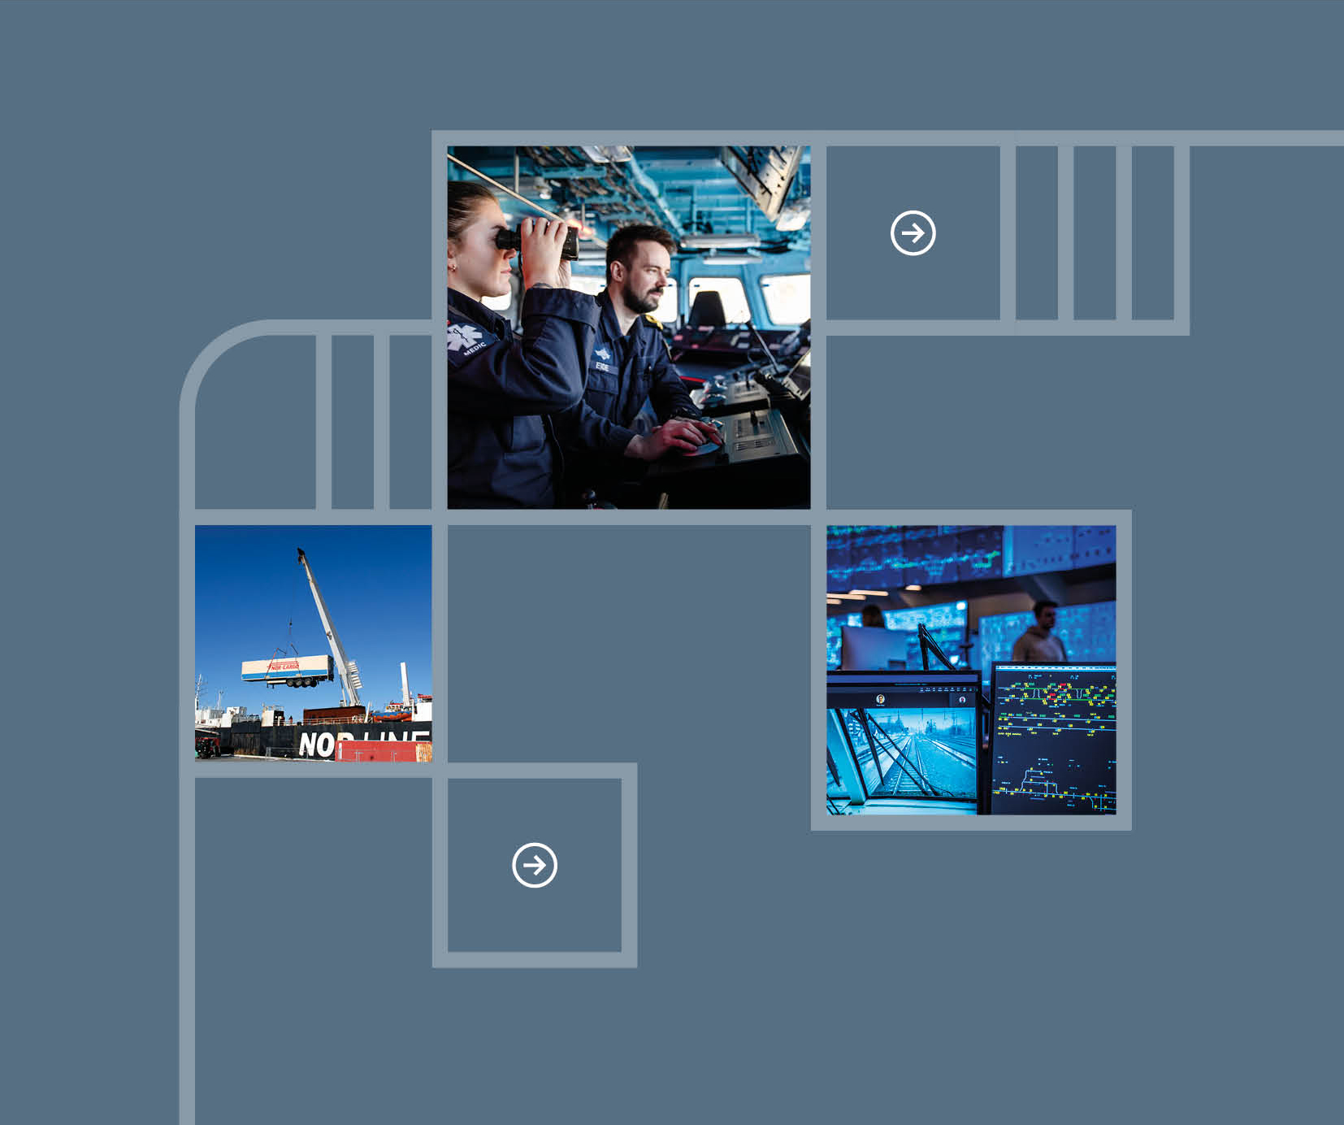

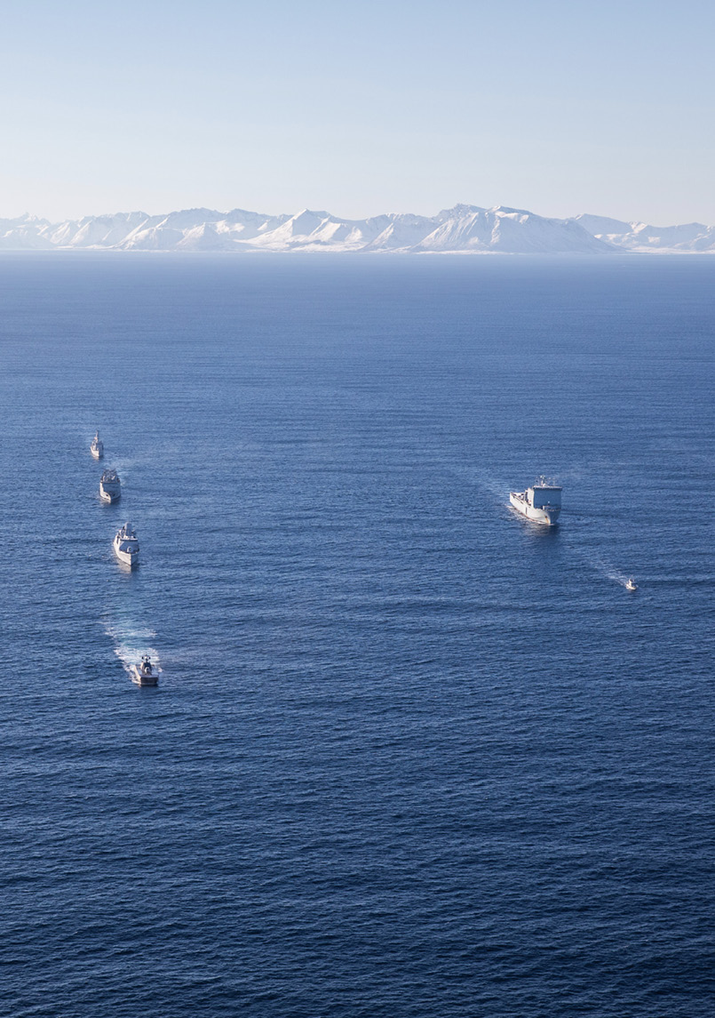

Introduction

This is Norway’s first national security strategy.

It has been drawn up against the backdrop of the most serious security situation our country has faced since the Second World War.

After decades of peace, a new era has begun for Norway and for Europe as a whole.

Norway and NATO pose no threat to anyone.

Nevertheless, we are facing serious threats from Russia. A stronger, more assertive China is creating long-term challenges. Binding international cooperation has been weakened. Relations between the US and Europe are strained.

A broad, overarching national security strategy is needed to respond to the gravity of the current situation. We must pull together to do what it takes to keep Norway secure and safe.

Norway’s fundamental security interests form the basis for this strategy. At a time of great global upheaval, these interests must be our fixed points of reference:

* A free and independent Norway.
* A robust democracy.
* A safe society with a high level of trust.
* An open and adaptable economy.
* Allied solidarity and unity in Europe.
* A world that seeks solutions based on international law.

These points represent our fundamental security interests. We must set clear priorities in order to safeguard, defend and promote them.

Norway has a strong foundation to build on.

The principles of our security policy are well established.

Our country has robust institutions, a high level of trust, a long tradition of cooperation, substantial economic resources and close allies, in NATO and Europe.

Over the past few years, we have made significant investments in strengthening the Norwegian Armed Forces and in enhancing the resilience of our society.

The main message of this strategy is nevertheless that we still need to do more.

Norwegian society as a whole must acknowledge and face up to the severity of the current security situation.

There is considerable uncertainty surrounding a number of key factors, not least Russia’s war against Ukraine and its long-term ramifications for global and European security.

At the same time, it is clear that fundamental shifts have taken place that have major implications for Norwegian security and our national priorities:

We must accept that our neighbour Russia has become more dangerous.

We must ensure our security at a time of growing rivalry between the major powers.

We must respond to a situation where the distinction between war and peace is becoming increasingly blurred.

We must deal with complex issues at the intersection between security, economic affairs and technology.

This strategy identifies three main strategic priorities in response to these challenges.

First, we must *rapidly strengthen our defence capability*. We must be prepared for the fact that war could once again come to Norway. Within the framework of NATO, we will work to ensure that Europe assumes far greater responsibility for its own security.

Second, we must *increase the resilience of Norwegian society*. We all need to understand the threats we are facing. We must work together to reduce our vulnerabilities and strengthen our ability to deal with serious incidents.

Third, we must *strengthen our economic security*. To do so, we must increase the competitiveness of the Norwegian economy, reduce vulnerabilities vis-à-vis countries with which Norway has no security cooperation, and strengthen our economic cooperation with allies and partners.

Delivering on these priorities will require commitment from all of us. It will require a whole-of-society approach – from the central government to private companies, trade unions, the voluntary sector, municipalities and everyone who lives in Norway.

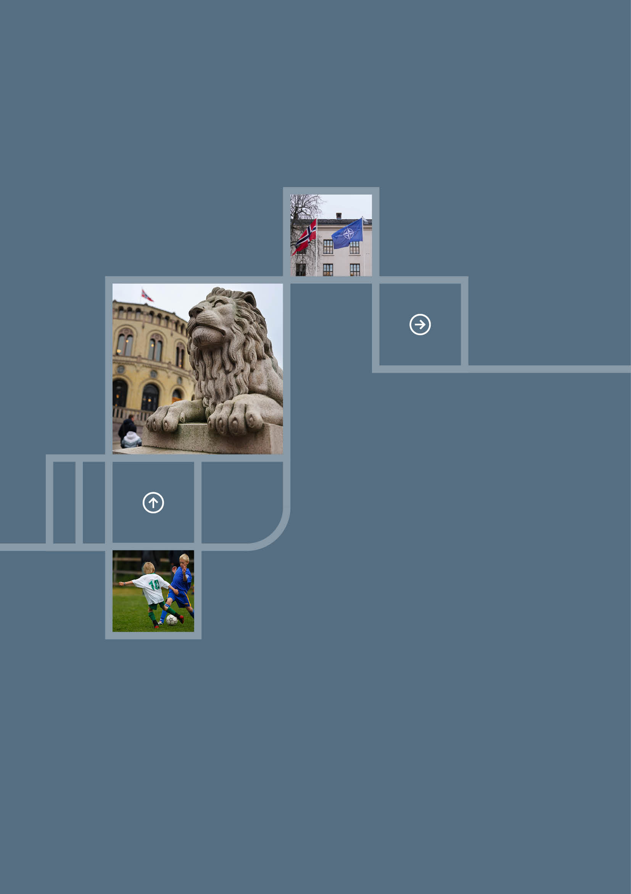

Our fundamental security interests

Our fundamental security interests must be safeguarded in order to ensure Norway’s continued existence and to preserve Norway’s freedom of action and core values. These interests reflect the underlying values and key features of our society and provide the basis for defining national priorities.

A free and independent Norway

As set out in the Norwegian Constitution, Norway is a free, independent, indivisible and inalienable realm. Maintaining our formal and actual freedom to decide over our own country, including in times of crisis and war, is our most vital security interest.

We must have the freedom to determine our own policies, choose our ties to other countries and alliances, and decide the framework for foreign activity in Norway.

Our population and our natural resources must be protected. We must be able to assert our sovereign rights – on land, at sea and in our airspace, and we must be able to defend the whole of Norway.

A robust democracy

A commitment to democracy, the rule of law and human rights underpins who we are and what we stand for in Norway.

Our society is based on free and fair elections, legal safeguards, independent courts, respect for human rights, and an open and enlightened public discourse supported by a free and independent press and academic freedom. These are the core features of our society. They make our society strong and must be protected.

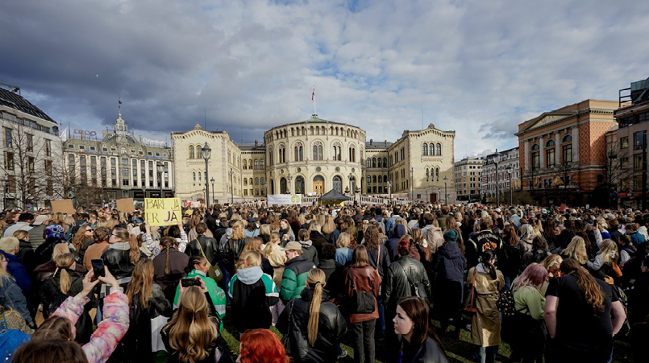

A safe society with a high level of trust

A high level of trust is essential to our social model. Trust fosters a sense of fellowship and solidarity.

Our trust in each other and in our country’s core institutions enhances our ability to withstand threats and hostile influence activities. A high level of trust is a key prerequisite for enabling the country to mobilise effectively and come together in times of crisis or war.

A sense of security among the population is essential to building this trust. People in Norway must feel confident that society will support them in the event of a serious crisis or war, and they must feel a shared responsibility to do their part for the country.

An open and adaptable economy

Norway has a robust economy, a high level of welfare and significant financial resources. Our economic stability and freedom of action mean that we can mobilise resources to achieve our security policy objectives.

To safeguard our security, we must maintain our competitiveness and adaptability.

The Norwegian economy is based on international trade, and we benefit greatly from participation in the EU’s internal market. The Government Pension Fund Global is a significant investor. We need well-functioning financial markets and security for the fund’s assets. Trade and investment activities are also a crucial means of forging ties with allies and partners.

Norway considers it vital to promote a common European approach to enhancing economic security and stability. The EEA Agreement is Norway’s most important trade agreement, but it is also essential in terms of Norwegian security and preparedness.

Allied solidarity and unity in Europe

The most effective way to ensure our security is through cooperation with others. Mutual commitments within the framework of a strong Alliance are critical to preserving our security, prosperity and freedom of action. Our alliances make Norway less susceptible to external pressure and aggression and promote security in our region.

The credible and collective security guarantee provided by NATO is crucial for Norway. Close ties to Allies in the Nordic region and Northern Europe and broad integration into binding European collaboration provide protection for Norway. The US is our most important Ally. Our cooperation is based on shared security needs.

A world that seeks solutions based on international law

International law and binding international cooperation form the foundation for peace and international security, and remain our first line of defence.

International law provides the basis for resolving conflicts and safeguarding humanity’s common interests. For a small country like Norway, this is particularly important. International law provides protection against the unregulated use of force. Our open economy is best served by a rules-based system for international trade.

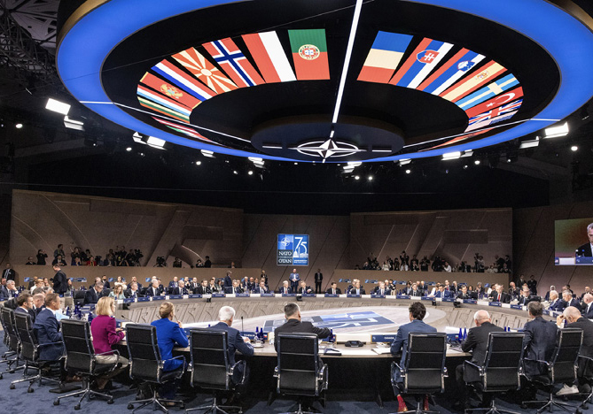

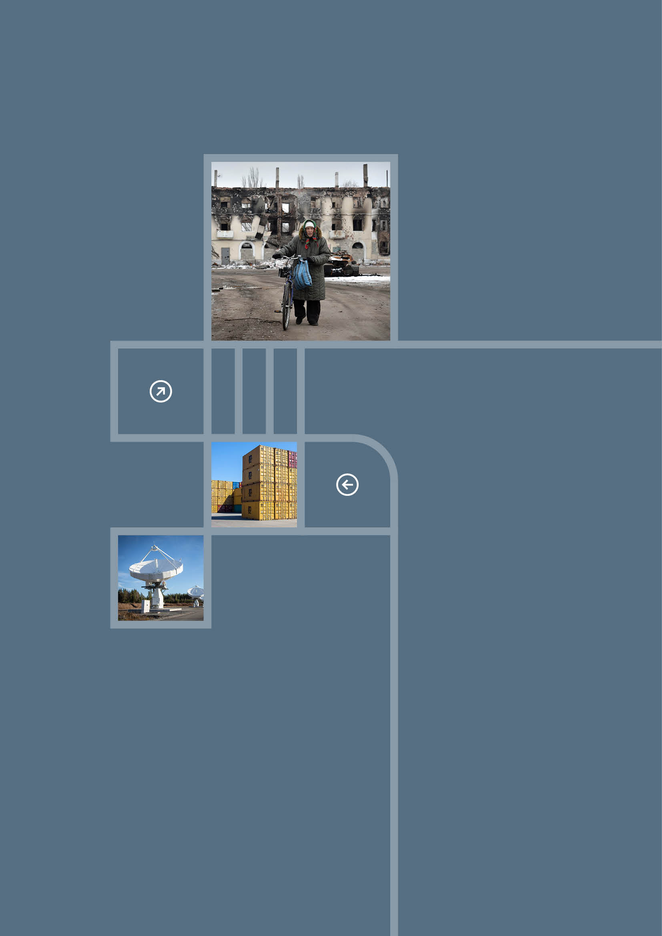

Our current security situation

Within a short span of time, the world has become more dangerous and unpredictable. There is war in Europe, increasing rivalry between the major powers and significant tensions in transatlantic relations. Norway is contending with the most serious security situation it has faced since the Second World War.

War in Europe

Russia’s war against Ukraine poses a direct threat to peace and security across the European continent. As Russia’s neighbour, Norway has to deal with an aggressive, unpredictable Russia that is challenging Norwegian interests.

Ukraine’s fight to defend itself is a fight for the future of Europe. Russia is seeking to establish an alternative security architecture in Europe that will leave it free to dominate neighbouring countries at will. This is a long-term, strategic objective that Russia is pursuing, vis-à-vis Ukraine and other countries as well. Russia is employing a range of methods including cyberattacks and threats to use nuclear weapons, as well as sabotage, disinformation and other covert activities. This affects Norway too.

Russia is receiving military support from the Democratic People’s Republic of Korea (DPRK) and Iran. DPRK troops have been deployed to fight in Ukraine. China has provided political support to Russia, as well as an extensive supply of materiel and technology. This has strengthened Russia’s military capability and helped to keep the war going.

Ukraine is the second largest country in Europe and has a large population, abundant natural resources and substantial industrial capacity. A Ukraine that is under Russian control would undermine stability throughout Europe. Ukraine will be dependent on foreign assistance for many years to come to support the reconstruction efforts and ensure adequate military deterrence in the future.

Increasingly blurred distinction between war and peace

Russia uses a wide range of tools in its attempts to exploit vulnerabilities in Europe and to achieve its strategic objectives. The distinction between war and peace is becoming increasingly blurred.

Norway is not shielded from these developments. We and other countries are subject to activities that pose a threat to our security, primarily from Russia, but also from China. There is considerable intelligence activity. We are a target for hostile influence operations. The threat of sabotage is a serious concern. There has been a marked increase in economic activities that pose a threat to national security. Migration is being deliberately used by state actors as a means of exerting pressure on many European countries. We must be prepared for a situation where hostile activities could increase in scale and become more aggressive. This is a development that affects every part of society.

Another worrying development is that state actors are financing radicalised groups and criminal networks and using them to carry out acts on their behalf. They commit serious acts of violence and spread disinformation to sow division and fear.

A major shift in transatlantic relations

Relations between the US and Europe have changed. New US priorities have far-reaching implications for international relations and our societies. Unconventional and confrontational policies, including major changes in trade policy, have generated considerable uncertainty in transatlantic relations.

For nearly eight decades, the US has been the main contributor to NATO. US political and military strength is vital to Allied deterrence and the defence of Norway and the rest of Europe. US engagement and direct investment in European security and stability are now changing. The US has for some time made it clear that its resources are stretched and that it expects more from its European allies. Europe must shoulder a greater share of the cost of ensuring security and stability on its own continent. A continued extensive US military presence in Europe is not a given.

Increasing rivalry between major powers

The global balance of power is changing. Competition between the major powers is growing.

China is challenging international rules and values that are essential to maintaining Norwegian security, economic growth and prosperity. China’s significant military build-up and use of coercive measures are creating uncertainty and changing the military balance of power, at both the regional and the global level. At the same time, because of its size, power, and economic weight, it will not be possible to solve many of the key challenges of our time without cooperating with China.

The US is turning its attention towards the Pacific region. This reinforces the need for European Allies to shoulder greater responsibility for security on their own continent. It also means that Norwegian security will to a greater extent be affected by developments in Asia, and that NATO’s partners in the region will become more important for Norway.

After three decades of globalisation, multilateral cooperation is under pressure. Power politics is on the rise. As a result, greater weight is being placed on security considerations in the areas of trade, investment and technological cooperation. Control of value chains and critical input factors has become more important – both for states and for commercial enterprises.

Tougher technological competition

The growing rivalry between the major powers is reflected in an intensifying race to develop technology, with far-reaching implications for Norwegian security. New and disruptive technologies expand the potential for the use of force, intelligence, disinformation and cyberattacks, by both state and non-state actors.

This development creates new vulnerabilities and increases the importance of understanding and applying new technology effectively, not least artificial intelligence, which is revolutionising how information is compiled, how decisions are taken and how tasks are carried out. Technological advances are opening up a wide range of opportunities, but are also creating challenges, for example relating to responsibility and control in autonomous systems.

The US and China are leading the technological race. Both countries are seeking to maximise and protect their comparative advantages. The contours of two technological ecosystems are emerging, separate from and competing with one another. The EU is trying to strengthen its position by pursuing a more ambitious economic policy. For Norway, these developments mean that there will be difficult decisions to make about which technologies to prioritise and which to restrict, particularly technologies coming from countries with which Norway has no established security cooperation.

The expansion of algorithm-driven media platforms has led to increased polarisation, more frequent hostile influence activities and the spread of disinformation. This has given rise to echo chambers and parallel versions of reality in many countries. This development threatens to undermine public debate and trust in society.

Major security challenges in Europe

The war in Ukraine and the rise in geopolitical tensions are a serious wake-up call for Europe. The war has revealed significant vulnerabilities and deficiencies in European defence capabilities and production capacity. Europe’s dependence on Russian gas was a serious vulnerability. The decrease in European imports of Russian gas has had a significant impact on European economy and industry. Many European countries are experiencing weak economic growth and high debt levels. A global trade war will have major ramifications for Europe.

The EU has strengthened its role in international security in recent years. The EU has imposed wide-ranging sanctions on Russia and provided substantial military and civilian assistance to Ukraine. This has helped to isolate Russia and support Ukraine in its fight to defend itself. At the same time, European cooperation has continued to develop, with new forms of collaboration and broader integration in several areas. The EU has introduced a number of important initiatives to strengthen its overall defence capability, resilience and competitiveness.

The EU is pursuing a more active industrial and business policy that will have an impact on Norway. Policy development is increasingly cross-sectoral, with initiatives that fall wholly or partially outside the scope of the EEA Agreement. Norway’s close ties to the EU through the EEA Agreement place us in a good position to participate in important cooperation initiatives, but there are no guarantees. To promote Norwegian participation in European initiatives, we will need to set clear priorities, intensify our political efforts and take a proactive approach to cooperation with the EU.

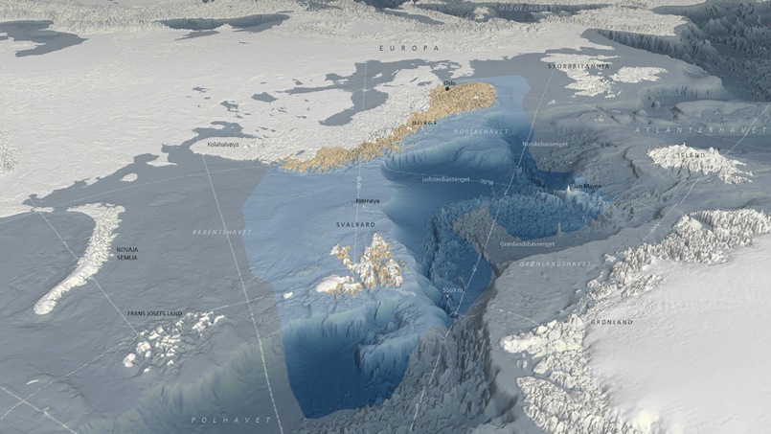

A new situation in the High North

Norway’s relations with Russia in the High North have traditionally been stable. Now, however, our neighbour to the east has become more dangerous. The more antagonistic relations between NATO and Russia heighten the risk of undesirable incidents and confrontation. Allied interest in the region is increasing.

At the global level, the trend is towards rearmament, weaker arms control and a lower threshold for threatening to use nuclear force. Nuclear weapons are once again gaining a more prominent role in security policy. The world’s largest concentration of nuclear weapons, extensive weapons testing facilities and other Russian military capabilities are situated near our border.

Growing geopolitical competition is amplifying the strategic importance of the Arctic. The impacts of climate change also affect national security and preparedness efforts in the Arctic, and are opening up new opportunities for activity and use of resources.

Northern European defence and security cooperation is becoming increasingly defined, operational and binding. Closer cooperation enhances the region’s political influence and room for manoeuvre.

The accession of Sweden and Finland to NATO is a fundamental change that benefits Norway. The Nordic Allies can now work more closely together on plans, solutions and operations, and NATO can present a united front vis-à-vis Russia in the High North. Norway will have a more important role to play in terms of facilitating transit of Allied forces in the Nordic and Baltic Sea regions. This places new demands on us while offering new opportunities relating to mobility, joint infrastructure and logistics.

The partnership between Russia and China could lead to increased competition and rivalry in the High North. In today’s uncertain security landscape, where interest in the Arctic is growing, it will be even more crucial for Norway to be able to understand, influence and shape developments in the north. Demographic changes and economic challenges in eastern Finnmark are a particular cause for concern.

Binding international cooperation is being undermined

The growing tendency towards national assertiveness and power politics is undermining the UN’s standing and making it more difficult to find political solutions to global challenges. The UN’s ability to prevent and resolve conflicts has been diminished. Progress in international arms control has suffered significant setbacks. International law and established norms are being challenged, with serious violations in Ukraine, Gaza, Sudan and elsewhere.

These negative developments are making the world a more dangerous place. We are seeing an increase in the use of force, diminished respect for human rights and fewer constraints on the arms race and the proliferation of weapons of mass destruction.

Democracy is backsliding across the world. More and more people live in countries with authoritarian forms of government. Even in many democratic countries, free elections, freedom of expression and the independence of the judiciary are under threat.

At the same time, the world is facing global challenges that can only be addressed through broad-based international cooperation, not least those relating to climate change and the environment, health, and regulation of artificial intelligence and advanced biotechnology. The world is a long way from achieving the climate goals set out in the Paris Agreement. The risk of new deadly pandemics remains high, and international cooperation on health and pandemic preparedness is inadequate. Unresolved global challenges such as these pose a direct threat to the health and safety of people in Norway, and also have a direct impact on other Norwegian interests.

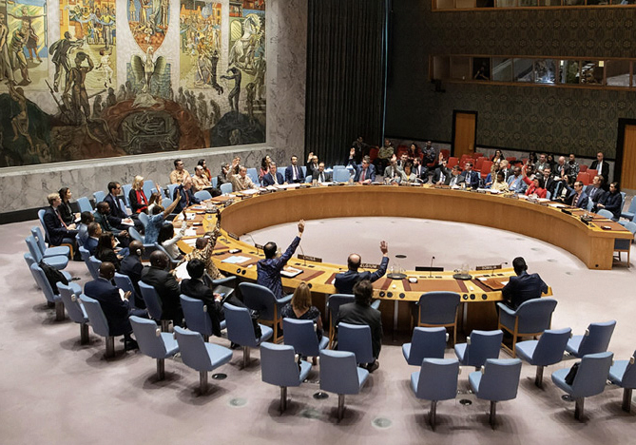

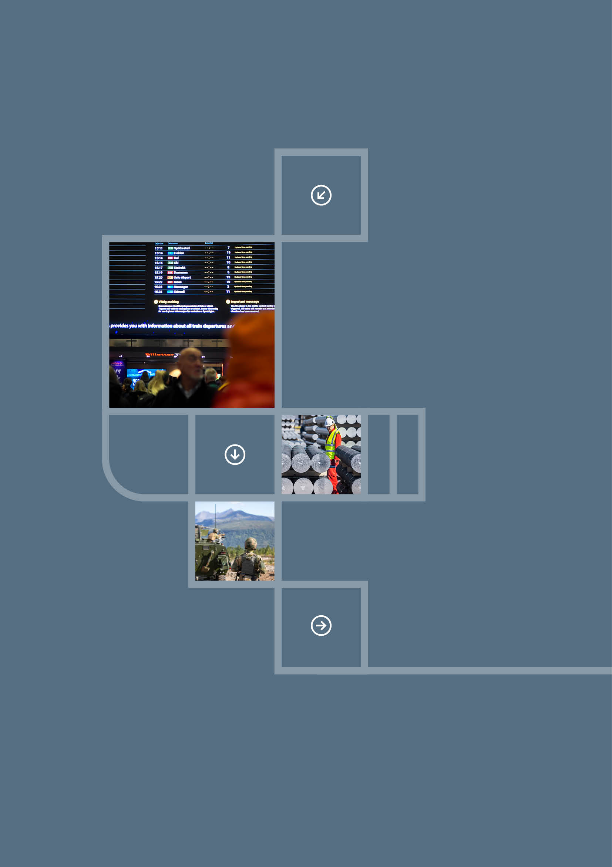

Our main strategic priorities

In today’s more perilous and unpredictable situation, it is essential that we rapidly strengthen both national and Allied *defence capabilities*. We must devote a greater share of public resources to security, defence and emergency preparedness than previously, and work to ensure that Europe assumes more responsibility for its own security.

We must enhance the *resilience* of Norwegian society. We must prevent, detect and respond to threats and take steps to ensure that we are better equipped to deal with serious incidents. This will help to keep us safe in the face of hostile activity below the threshold of armed attack.

In a world where security, economic affairs and technology are becoming more and more closely intertwined, higher priority must be given to strengthening our *economic security*. We must improve the competitiveness of the Norwegian economy, reduce vulnerabilities vis-à-vis countries with which Norway has no established security cooperation, and strengthen our economic cooperation with allies and partners.

We will rapidly strengthen our defence capability

Strengthening the Norwegian Armed Forces

Norway must take steps to rapidly enhance the operational capability of the Norwegian Armed Forces to maintain national and Allied freedom of action. We must strengthen our military capabilities on land, at sea, in the air, in cyberspace and in space.

The Long-term Defence Plan has broad-based political support and is to be implemented as rapidly and effectively as possible. The plan is flexible and will be adjusted as needed. We must learn from the rapid technological and industrial developments we are seeing in Ukraine. Experience gained from the war will be incorporated into the operational development of the Norwegian Armed Forces. The overall initiative to enhance civil security and preparedness must be aligned as closely as possible with the needs of the defence sector.

Our efforts must reflect that the risk of war or crisis has increased. We must revise our military plans, improve our ability to lead and conduct complex operations and increase defence industrial production.

Expanding and strengthening our national defence capability will require investments in personnel, and greater recognition must be given to those serving in the Armed Forces. If we are to succeed in achieving the aims of the Long-term Defence Plan, it is crucial that the defence sector improves its ability to attract and retain personnel with the necessary skills and expertise. Our success will depend on dedication, professionalism and effective leadership at all levels.

Strengthening Norway’s total defence and preparing for crisis or war

In the event of a crisis or war, it is essential that the Norwegian Armed Forces and civil society work closely together. In all crisis situations, critical public functions must be maintained for as long as possible.

Strengthening our total defence and preparedness will entail ensuring that the need for other sectors to support military efforts is communicated clearly and that the necessary resources can be rapidly made available when a crisis occurs. This means that the ability of civilian sectors to back up military efforts must be strengthened based on clear, long-term priorities.

The business and voluntary sectors have much-needed capacity, infrastructure and expertise of relevance to national defence. Steps will be taken to involve such actors as well as the trade unions and municipalities more closely in preparedness efforts and emergency planning. We will work together to ensure that we can make optimal use of our society’s resources in the event of a serious crisis or war.

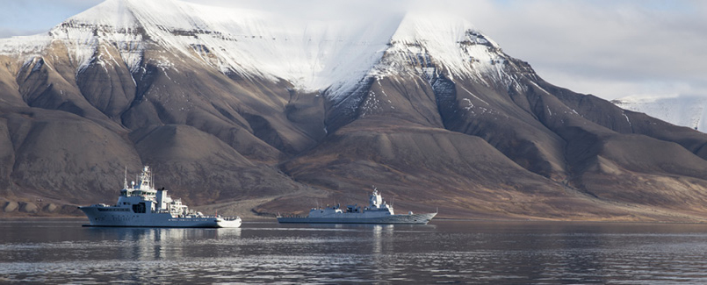

Maintaining NATO’s credibility

Norway depends on NATO and its close Allies for its security. As an Ally, we must shoulder greater responsibility for national and regional security, and promote more equitable burden-sharing. In doing so, we help to ensure that the Alliance remains relevant and credible. We must meet agreed planning targets for weapons and troops, contribute to operations and joint funding arrangements, and further develop the Norwegian defence industry so that it can continue to supply critical defence materiel to our Allies.

It is in our clear interest that NATO continues to serve as the main framework for collective defence and for enhancing European defence capabilities. Norway will contribute to efforts to promote a good division of responsibilities between NATO and the EU. Both organisations have their own strengths that must be capitalised on. It is not in Norway’s interests for the EU to develop competing structures, objectives or capabilities.

Norway supports NATO’s nuclear deterrence policy. As long as nuclear weapons exist, an appropriate mix of nuclear and conventional forces will be essential for maintaining credible deterrence. Norway will continue to work to promote nuclear arms control, non-proliferation and disarmament, and will continue to support the long-term objective of a world without nuclear weapons.

Consistency and predictability in dealing with Russia

Norway will pursue a coherent, consistent and predictable Russia policy. We will do so in close dialogue with our Allies.

Norway will employ a combination of deterrence and reassurance vis-à-vis Russia. An aggressive Russia that is willing to take risks must be deterred from threatening Norwegian or Allied security. Within the framework of NATO, we will work to reduce the risk of conflict and misunderstandings that can lead to escalation and heightened tensions, and enhance understanding among our Allies of our national positions.

Norway will maintain diplomatic representation in Russia, and keep channels of communication with Russia open. We will ensure that we continue to have in-depth expertise on Russia and Russian affairs.

Shaping developments in our own neighbourhood

Norway will play an active role in promoting stability in the Arctic and respect for the Law of the Sea. We will maintain a military and civilian presence in the region. Vibrant local communities in the north, including in Svalbard and eastern Finnmark, are vital to our national security. We must ensure that we are at the cutting edge when it comes to knowledge and policy development in the Arctic region.

The exercise of national control in Svalbard is to be strengthened. The archipelago is Norwegian territory and an integral part of Norway. Norway will exercise its sovereignty over Svalbard in a predictable and consistent manner. Norway will adhere to and work to ensure full compliance with the Svalbard Treaty. Norwegian settlements in Svalbard are to be maintained.

We are investing in maritime security and situational awareness in our region. Our presence is being strengthened through investments in new military vessels, undersea capabilities, intelligence, surveillance and closer civilian-military and public-private cooperation.

We will continue to adapt Allied presence in the Arctic as necessary, in part based on our own national guidelines for foreign military activity in Norway. We must also help to draw up plans for receiving and facilitating the transit of Allied forces in the Nordic and Baltic Sea regions.

Norway will follow a restrictive policy with regard to Chinese activity in the High North.

Maintaining US engagement in our security

In order to maintain a credible defence, Norway is dependent on support and reinforcements from the US. Security cooperation between our countries is to be developed on the basis of lasting US and Norwegian interests.

There are strategic nuclear forces and nuclear submarines based close to our border in neighbouring Russia, and the US needs to be able to monitor these capabilities in order to safeguard its own security. We will facilitate US presence and seek to enhance US understanding of developments in our region.

We will continue to make use of our geographical location and expertise, and invest in capabilities that make us a relevant partner for the US. We will strengthen our ability to implement complex military operations in cooperation with the US and the UK.

Our strategic cooperation relating to intelligence, special forces and space activities is to be further developed. Under the long-term Supplementary Defense Cooperation Agreement between Norway and the US, we will continue to facilitate joint investments in infrastructure for use in operations, training and exercises.

Our defence industrial cooperation is to provide us with world-leading, technologically advanced products that will strengthen national and Allied defence capabilities.

Closer regional cooperation in northern Europe

We will work to strengthen regional security and defence cooperation in northern Europe. This is where we find our closest Allies. We will work together to strengthen implementation of NATO’s regional plans and enhance the capacity of our region to deal with serious crises.

Close defence cooperation is already well established in the Nordic region, and this will be strengthened further. We are also taking steps to expand Nordic-Baltic cooperation.

We will bolster our bilateral, strategic cooperation with close Allies, in particular the UK, Germany, France and Poland.

The various regional cooperation arenas have gained increasing importance in recent years and play a vital part in enhancing Norwegian security. The most significant of these is the Joint Expeditionary Force (JEF), which comprises the Baltic and Nordic countries, as well as the UK and the Netherlands. Norway will promote the role of JEF as a key framework for cooperation.

Closer cooperation with the EU

A greater focus on defence in the EU will benefit Norway. Norway will work to further strengthen its security and defence cooperation with the EU, based on the EEA Agreement and the EU-Norway Security and Defence Partnership signed in 2024. Through our cooperation, we will seek to ensure that the EU complements NATO. We will work to put in place arrangements that enable Norway to participate in important initiatives relating to emergency preparedness, civilian crisis management, the defence industry, space activities and the efforts to combat transnational threats such as crime.

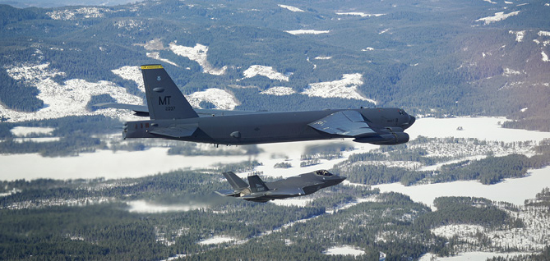

Effective support for Ukraine

Norway will continue to be a significant long-term partner to Ukraine. Our support is an expression of our solidarity with Ukraine and the Ukrainian people. It reflects our respect for international law, and is also a critical investment in Norwegian and European security.

Under the Nansen Support Programme for Ukraine, Norway will continue to provide military, economic, humanitarian and political support to Ukraine, with the aim of enabling Ukraine to remain a free, independent and viable country.

We will enhance the resilience of Norwegian society

Communicating and understanding the gravity of the situation

Each and every one of us needs to understand the gravity of the situation at hand. It is essential that the Norwegian authorities provide clear information about the threats we are facing, and raise awareness of the need to increase security and preparedness in all sectors of society.

All individuals in Norway have a responsibility to keep themselves informed of developments and take the necessary precautions in light of the more serious security situation.

The Norwegian authorities need to gain a better overview of activities that pose a threat to our society. A more comprehensive overview of the situation will make it easier to identify anomalies and take swift action in response.

Increasing resilience to serious incidents

We must be better prepared for the possibility that Norway may experience incidents that are more serious than those we have seen to date.

Public authorities, the voluntary sector, businesses and other organisations must map their assets, identify their own vulnerabilities and develop plans to improve their ability to withstand serious incidents. It is particularly important to be able to resume operations rapidly.

In order to facilitate the best possible coordination in the event of a crisis, it is essential that civilian and military actors involved in emergency preparedness carry out joint exercises to train for all kinds of crisis scenarios, in order to gain an understanding of each other’s roles and capabilities.

In order to build resilience, we must increase self-preparedness among the population. Increasing people’s own self-preparedness will not only enhance our security and safety but will allow the authorities to prioritise those most in need of help.

We must limit the ability of malicious state and non-state actors to operate in Norway, through deterrence, countermeasures and prevention. The Norwegian police and the Norwegian Police Security Service (PST) have a special responsibility in this regard.

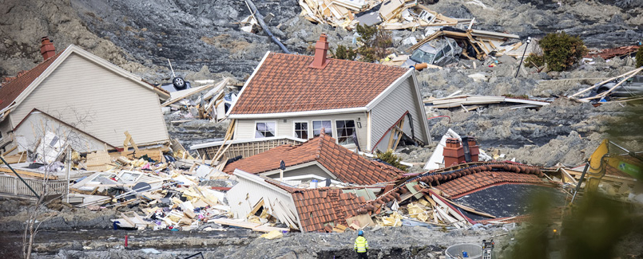

Systematising security efforts

The municipal, voluntary and private sectors have an important role to play in efforts relating to Norwegian security. They must ensure that national security considerations are systematically incorporated into key decision-making processes.

Control questions relating to national security and risk reduction should be employed in both the public and the private sectors. While security considerations may not always be decisive, they must be taken into account when there is a possibility that activities, investments, acquisitions or agreements with other states will affect national security interests.

Cooperation and information-sharing across sectors and areas of responsibility, and between the various public and private actors involved in emergency preparedness, must be improved.

Protecting critical infrastructure and critical services

Norway’s national critical infrastructure must be secure and robust. Services that are essential to the functioning of our society must have reserve capacity. It is vital to be able to restore these services following a disruption and they must be kept under adequate national control.

We are dependent on well-functioning infrastructure particularly in areas such as electricity and telecommunications, but also to maintain financial systems, space activities, transport and health systems. Priority is to be given to mapping assets and protecting fundamental national functions.

We will also strengthen our capacity to protect and repair critical infrastructure on the Norwegian continental shelf, in close cooperation with Allies.

We must have an independent capacity to apply and control technology and services in particularly sensitive areas, such as classified communication, data storage and decision support systems.

We must ensure that we have good food security and safe food and water supplies in Norway.

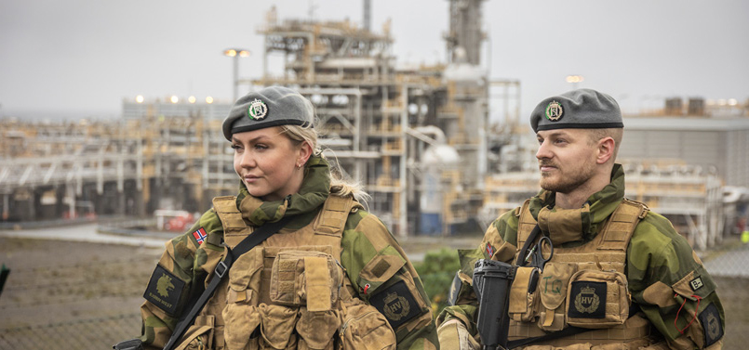

Combating terrorism and criminal networks

Terrorism and organised crime undermine people’s safety, and can pose a serious threat to national security. Norway will step up its efforts to combat organised crime and terrorism by means of intelligence activities, prevention, information exchange and effective response.

Islamist extremists and right-wing extremists pose the greatest terrorist threat to Norway. We are seeing a particularly worrying trend whereby minors are being used to carry out acts of terrorism. Efforts to prevent violent extremism in children and young people will be intensified.

Organised crime is a serious social problem in itself. At the same time, criminal networks can also be used as tools by foreign states to carry out illegal activities. We will prevent criminal networks from gaining a stronger foothold in Norway.

Protecting democracy, the rule of law and the public debate

We will protect our well-functioning democracy and defend human rights. We will uphold the rule of law and preserve our rules-based society, with independent courts as a guarantor of equal treatment and predictability.

Disinformation and covert influence activities pose a threat to the values on which our society is based. Maintaining a constructive public debate is increasingly difficult as algorithm-driven media platforms become more prevalent.

We will support editor-controlled media and seek to enhance the ability of people, especially children and young people, to evaluate the credibility of sources. Norway will work, in close cooperation with the EU, to ensure appropriate regulation of technology companies. Legislation must be updated in line with new technological advances.

Efforts to counter disinformation and hostile influence activities are also important in terms of ensuring high voter turnout and safe political elections. The relevant authorities must be prepared to deal with such threats and must ensure that there is effective coordination and adequate capacity to do so.

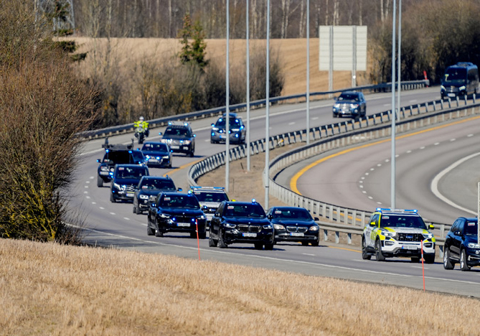

Promoting solutions to global challenges

Unresolved global challenges pose a direct threat to Norwegian interests, and could exacerbate the impacts of other threats. We will maintain our active engagement at the global level in areas of greatest significance to our interests.

Norway will continue to be a principled defender of democracy, the rule of law, human rights and international law. These values are fundamental to building well-functioning societies and reducing the risk of war and conflict.

Climate change is affecting all countries and communities and is a threat multiplier. This has implications for national security; it could for example lead to the emergence of new conflicts and increased migration. Norway will promote climate change mitigation and adaptation, biodiversity conservation, food security and the green transition at both the national and the international level.

The COVID-19 pandemic uncovered a number of fundamental weaknesses in Norway’s health preparedness. Norway is not equipped to deal with these challenges alone. We are therefore seeking to cooperate more closely with the EU in this area.

Norway will continue to invest in global health cooperation. The World Health Organization (WHO) will remain the most important platform for dealing with new and existing health threats, including antimicrobial resistance, pandemics and the impacts of climate change on human health.

We will strengthen our economic security

Ensuring that the Norwegian economy remains strong

A strong economy and an adaptable business sector are crucial to Norwegian security. Ensuring continued growth and prosperity is essential in order to be able to finance initiatives relating to security, defence and emergency preparedness. In order to navigate the new situation in the global economy successfully and increase our competitiveness, we will, among other things, further develop our ability to adapt, based on research and innovation.

Preserving an open and rules-based system for trade and the free movement of capital

Norway is dependent on international trade to gain access to the goods and services that we need, and to maintain an innovative and competitive business sector. Rivalry between the major powers and trade wars are encouraging the formation of blocs and creating new trade barriers that affect Norway.

We will seek to preserve and promote the conditions that have served the Norwegian economy so well, including an open, predictable and rules-based system for international trade and the free movement of capital.

Safeguarding the EEA Agreement

The EEA Agreement is of crucial importance to the Norwegian economy. We will contribute to a well-functioning internal market by implementing the EEA Agreement. We will further develop our cooperation with the EU and align our efforts closely with the EU’s economic security agenda.

Securing Norwegian energy supplies to Europe

Secure and reliable gas deliveries are our most important contribution to economic security in Europe. The wide-ranging energy cooperation between Norway and Europe serves to strengthen our competitiveness and facilitate the climate and energy transition. We will maintain our position as a stable, long-term supplier of energy to Europe by taking steps to facilitate new profitable discoveries. The critical infrastructure needed to maintain stable energy supplies must be secure and must be able to be rapidly restored if necessary.

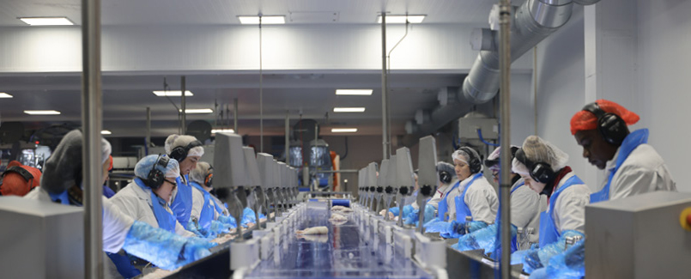

Reducing vulnerabilities in our economic cooperation with other countries

Our economy must remain open, but we must make it more resilient to external pressures and disruptions. We will identify and map dependencies and safeguard value chains of vital significance to our national security and preparedness.

We will carry out broader, more predictable controls of foreign investments. Actors involved in the delivery of critical services or in vulnerable value chains must exercise due diligence with regard to investments from countries with which Norway has no established security cooperation. This also applies to actors in the supply chain. Public and private actors in the maritime, energy, telecommunications, defence, health and finance sectors and companies that supply products and services of vital importance to Norway’s total defence capability have a special responsibility in this context.

Steps are being taken to improve the effectiveness of the export control system in order to prevent sensitive security technology and information from being shared through trade relations with actors that do not share our security interests.

There is a need for a better overview of import dependencies in industries that are particularly critical for Norwegian security and value creation. This overview is to be drawn up in cooperation with the business sector.

Norway is working with the EU and its Allies to improve security of supply. We will facilitate Norwegian manufacturing of products that are part of key strategic value chains, both for us and our Allies. Norway will work to further develop this cooperation, with a focus on strengthening industrial and business policy ties with the other Nordic countries, the EU, the UK and the US.

Identifying and mitigating risks in our relations with China

China has a key position in the global economy and is Norway’s most important trading partner in Asia. The country accounts for an increasing proportion of global knowledge production. It is in Norway’s interest to seek China’s engagement in trade and efforts to find solutions to global issues, and we will work to avoid an unintentional decoupling in relations with China. At the same time, China poses an increasing security threat to Norway and our Allies. For reasons of national security, we will increase our vigilance in our dealings with China and Chinese actors.

Efforts to identify and reduce risks in our economic cooperation must be strengthened and carried out more systematically. This can best be achieved through close cooperation with our Nordic neighbours, like-minded European countries and Allies. The Norwegian authorities will seek to raise awareness of risks, working in close dialogue with the business sector, the municipalities and the knowledge sector.

In certain sensitive areas, cooperation is to be avoided. This applies in particular to Chinese involvement in areas designated as fundamental national functions and critical assets, where this could create significant ties.

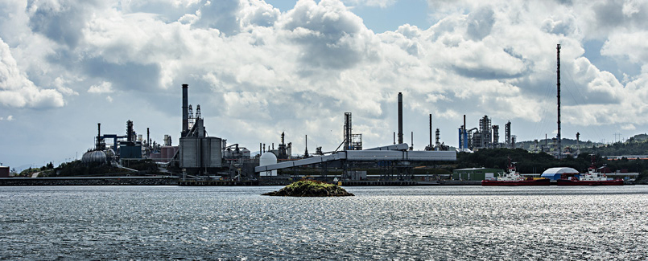

Ensuring access to strategically important knowledge and expertise

International cooperation in the area of research and higher education is essential to maintaining Norway’s competitiveness and our ability to find solutions to new challenges.

Responsible international knowledge cooperation entails weighing the benefits of open research against security considerations at all levels of the knowledge sector.

We will improve our ability to prevent unwanted knowledge transfer and hostile influence activities, as well as the misuse of knowledge and technology that can undermine core social values.

Investing in the application and development of new technology

Norway will be at the forefront when it comes to understanding and applying new technology. This is vital for the Norwegian economy and for Norwegian security.

We will educate our population and provide people with the skills they need to become technologically proficient. We will increase investment in the development and application of new technologies, such as artificial intelligence and quantum technology. Participation in international research and technology cooperation will be crucial in this context.

We must improve our ability to make use of new technology for defence purposes, particularly in areas where we have comparative advantages. Norway will seek to be at the technological forefront in areas such as ground-based air defence, missile, space and sensor technology, as well as ammunition and military explosives. We will continue to develop underwater technology that strengthens our security and enables us to maintain our leading position in the maritime sector.

Maintaining strategically important industries and a strong industrial base

The business sector plays a key role in delivering critical functions that are vital to Norwegian and Allied security.

In today’s more serious security situation, it is crucial to maintain these functions, and ensure adequate national capacity, controls and expertise in strategically important areas. We will take steps to ensure that there are Norwegian-owned companies in strategically important sectors such as telecommunications, banking and finance, and space technology.

Securing access to industrial production capacity and critical raw materials is vital for Norway and Europe as a whole. Norwegian industrial clusters and expert communities have a crucial role in ensuring Norwegian and Allied security. Norway will focus on areas where it has comparative advantages. We will maintain a strong industrial base so that we can help to meet national and Allied needs, in areas such as oil and gas, the processing industry, the maritime sector and the defence industry.

Norway will never be fully self-sufficient. We must therefore work to enter into binding partnerships that provide us with what we need. This applies to areas such as vaccines and pharmaceuticals, semiconductors and electronic components and production inputs and imports of goods that help to meet the population’s basic needs.

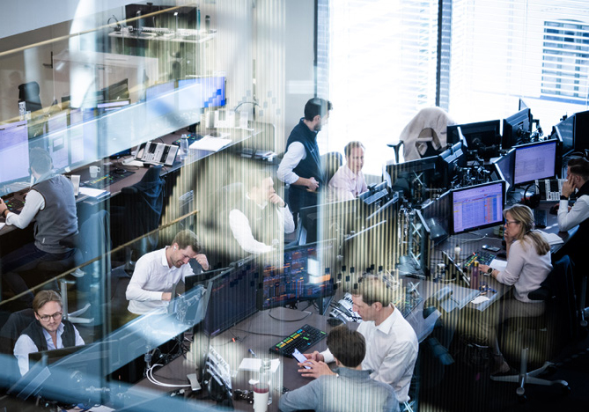

Ensuring sound management of our investments in a more uncertain world

The Government Pension Fund Global plays a vital role in preserving Norway’s economic stability and room for manoeuvre. The new security situation has made management of the fund more challenging, and effective risk management has become all the more important. Norway will work to maintain good, stable framework conditions for international investment activities. Norway will provide clear information about the role of the Government Pension Fund Global in order to reinforce its financial purpose and legitimacy. The fund is not an instrument of foreign and security policy.

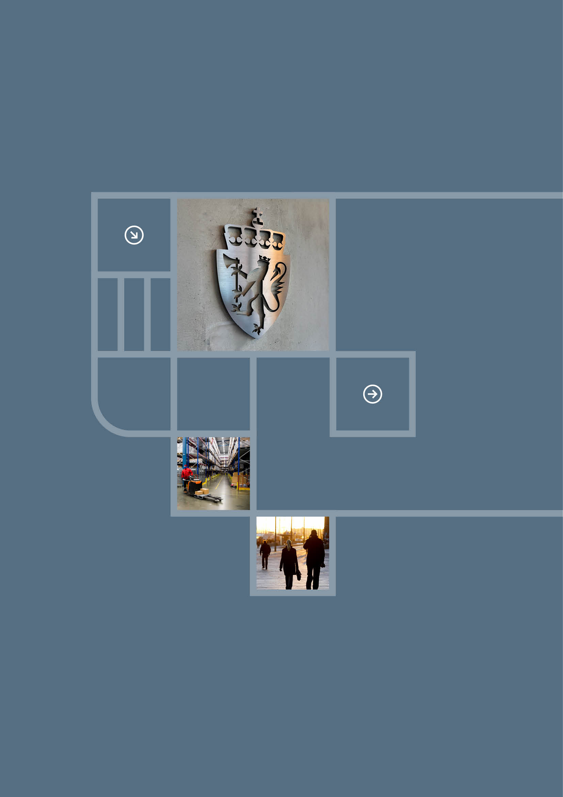

Responsibilities and revision

This strategy provides a comprehensive, authoritative framework to guide efforts to ensure Norway’s security.

The Government has overall responsibility for ensuring that the strategy is followed up, across the central government administration, vis-à-vis other relevant stakeholders in Norwegian society and at the international level.

This strategy is to underpin efforts relating to national security in the various government ministries, and is to be used as a basis for establishing overall priorities, identifying concrete measures and developing policy.

Implementation of the strategy will require a whole-of-society approach. More time and resources need to be devoted to security across all sectors and at all levels of society.

For this reason, the strategy places higher expectations on a range of actors in our society, in particular the business sector and the public authorities.

Everyone living in Norway also has a clear responsibility to contribute to this national effort. We must all do more to keep ourselves, and Norway, safe.

This strategy is planned to be revised in two years’ time.

Images

**Page 1**

Navigation officers on the bridge of KNM Otto Sverdrup. Photo: Torgeir Haugaard / Norwegian Armed Forces

Semi-trailer being loaded onto a cargo ship in Ålesund. Photo: Sigmund Krøvel-Velle / Samfoto

Control room at the Bane NOR Train Management Centre. Photo: Ole Berg-Rusten / NTB

**Page 2**

Norwegian and allied vessels during the Joint Viking exercise in the Andfjord east of Andøya. Photo: Thomas Haraldsen / The Norwegian Armed Forces

**Page 5**

The NATO flag and the Norwegian flag outside the Prime Minister’s Office. Photo: Heiko Junge / NTB

The Norwegian Parliament (Stortinget). Photo: Ørn E. Borgen / NTB

Nine-year-old boys playing football in Nedre Eiker. Photo: Tom Schandy / NN / Samfoto

**Page 7**

Demonstration in front of the Norwegian Parliament. Photo: Lise Åserud / NTB

**Page 9**

NATO summit in Washington D.C., July 2024. Photo: NATO

**Page 10**

From the village of Vuhleirsk in Ukraine. Photo: Harald Henden / VG

Container port at Sørenga in Oslo. Photo: Svein Nordrum / NTB

Arctic Satellite Broadband Mission. Photo: Anette Ask / Norwegian Armed Forces

**Page 14**

Norwegian coast and maritime areas, including the seabed. Map: Developed for the Defence Commission of 2021 with support from the Norwegian Polar Institute

**Page 16**

The United Nations Security Council. Photo: UN Photo

**Page 17**

Departure hall at Oslo Central Station. Photo: Annika Byrde / NTB

Aluminium production at Hydro Aluminium Karmøy. Photo: Ole Berg-Rusten / NTB

The Army conducting live fire training at Setermoen training ground. Photo: Johanne Søstuen / Norwegian Armed Forces

**Page 19**

Vessels from the Coast Guard and Navy outside Svalbard. Photo: Jakob Østheim / Norwegian Armed Forces

**Page 22**

An American B-52H Stratofortress flying alongside a Norwegian F-35 over Norway. Photo: Norwegian Armed Forces

**Page 24**

Quick clay landslide in Gjerdrum municipality. Photo: Tore Kristiansen / VG

**Page 25**

The Home Guard providing enhanced security at the Kårstø petroleum facility. Photo: Kristian Kapelrud / Norwegian Armed Forces

**Page 26**

Motorcade with Ukraine’s President Volodymyr Zelenskyy on the E6 from Gardermoen Airport to Oslo in 2025. Photo: Lise Åserud / NTB

**Page 28**

Lerøy Norway Seafoods’ facility in Båtsfjord. Photo: Prime Minister’s Office

**Page 30**

The oil refinery at Mongstad in Nordhordland. Photo: Marit Hommedal / NTB

**Page 31**

Employees in the trading room of Nordea Markets. Photo: Ole Berg-Rusten / NTB

**Page 33**

The Coat of Arms (Riksløve) on a sign at the Prime Minister’s Office. Photo: Prime Minister’s Office

ASKO’s cold storage facility at Kalbakken. Photo: Berit Roald / NTB

People at Aker Brygge in Oslo. Photo: Berit Roald / NTB