Norway’s Brazil strategy: Partnership for a common future

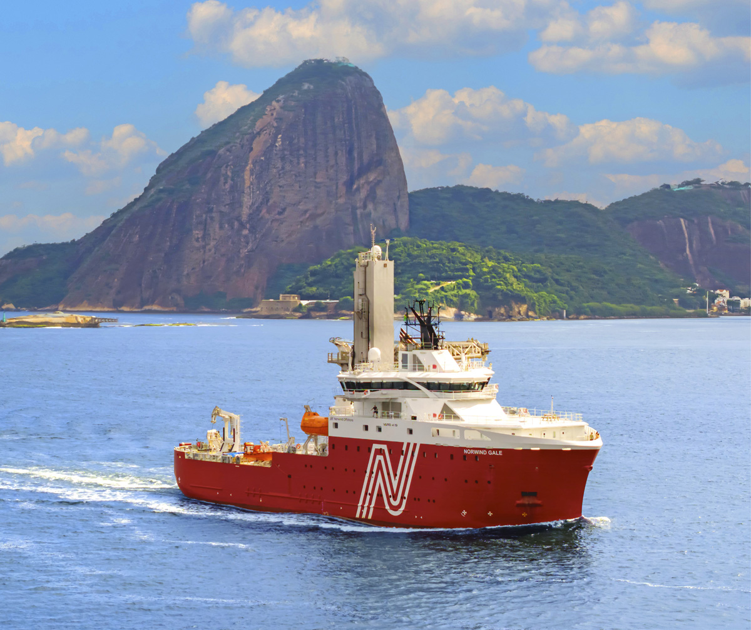

Foreword

Brazil is Norway’s most important partner in Latin America. In 1842, the first Norwegian-registered ship, Nordstjernen (‘the Northern Star’), sailed into the port of Rio de Janeiro. The ship was loaded with split, salted and dried cod (‘clipfish’), and returned with coffee beans. This was the start of extensive relations between our two countries. It began with trade, which still constitutes the most important relation with Brazil. In recent decades, climate and the environment, foreign policy cooperation and research have also become keystones of our collaboration. Despite our different geographies, cultures and histories, we share a number of commonalities as oil- and gas-producing coastal nations with ambitions to contribute to the green transition, and a genuine belief in democracy and a rules-based order.

More than 230 Norwegian companies are present in Brazil. The country is the most important investment market for Norwegian businesses outside of Europe and the USA. Brazil will play a key role in the global energy market and in the global energy transition in the years to come, and looks to Norway for partnership, technology and investments.

Brazil’s commitments under the Paris Agreement are extensive and affect all sectors. Deforestation is one of the largest sources of greenhouse gas emissions in Brazil. One third of the world’s remaining tropical rainforests are in Brazil, corresponding to an area larger than the whole of India. Norway has been cooperating with Brazilian authorities in this field since 2008, and with environmental and indigenous organisations for more than 40 years. Brazil’s emissions reduction from reduced deforestation is one of the world’s most important climate measures, and Norway has been a key partner in this work.

Over the years, Norway and Brazil have also developed an important and solid partnership within higher education, research and innovation. Brazil has outstanding research environments, and the cooperation, which is anchored in the Panorama strategy and linked to the business and the climate and environment sector, covers a wide range of topics. High-quality international research networks are necessary to solve global challenges, and academic partnerships between Brazil and Norway benefit business, society and academia.

The world is changing. Polarisation, increasing great power rivalry and pressure on the multilateral system create challenges for our own economy and security. It is in Norway’s interest to further develop strong relations with countries that share our values and views on how the world can and should be steered safely into port. Brazil is one such country. A broad collaboration to solve the challenges of our time is beneficial for both of us.

# Democracy and a rules-based world order

Mural entitled «Peace» presented to the United Nations in 1957 by Brazil 
(artist: Candido Portinari)

Cooperation with Brazil as a global player.

Brazil is a key global and regional player, including in forums such as the UN, G20 and the intergovernmental organisation BRICS. It is therefore important for Norway to strengthen our good relationship with the country, regardless of political changes. This provides an opportunity to both gain insight into important perspectives and create an understanding of Norwegian positions outside of our immediate neighbourhood. Brazil is one of the world’s largest democracies and contributes to a well-functioning international order based on the UN Charter and international law. It is in Norway’s interest that international cooperation, conflict resolution and the management of new challenges are based on such an order. This provides greater predictability and security, which in turn benefits both Norway and the rest of the global community. To succeed in this, countries need to feel that international law and the multilateral system are representative and fair, and deliver results on common global challenges.

|  |
| --- |
| Cooperation between Norway and Brazil in the Security Council  In 2022, when Norway and Brazil were both elected members of the UN Security Council, we worked closely together, for instance by leading the work on resolutions that ensured cross-border humanitarian aid to vulnerable groups in Syria.  Furthermore, Brazil and Norway supported the UN Secretary-General’s conflict prevention work in general, in particular the efforts for an agreement that ensured the safe transport of grain and food from Ukrainian ports in the wake of the war there. The agreement has been important for both global food security and economic stability in Ukraine. Norway and Brazil also worked closely together to strengthen coordination between the elected members of the Security Council and to find common solutions. |

Brazil and Norway already have a close dialogue on global issues and challenges, and work well together in several contexts. Foreign policy cooperation was strengthened when both countries sat on the UN Security Council, and when Norway was a guest country during Brazil’s presidency of the G20 in 2024. Norway also cooperates with other Nordic countries in a number of areas to promote common values and positions in Brazil.

Given our different geographical positions and histories, it is natural that we have different views on certain issues. Brazilian foreign policy naturally varies between different governments, but tends to be pragmatic and independent. It is in the interest of both countries to cooperate closely on fundamental principles of international law and reform of the UN system, as well as on peace and conflict resolution, climate and the environment, human rights and gender equality, and sexual and reproductive health and rights. The same applies to cooperation with Brazil in the World Trade Organisation (WTO) and support for reform of the organisation in order to safeguard a well-functioning and rules-based multilateral trading system.

Peace and conflict issues.

Norway and Brazil are engaged in dialogue on peace and conflict issues both globally and in a regional context. Through political dialogue, concrete cooperation and exchange of experience, both countries have gained greater insight into various conflicts and a broader understanding in this field. One example of operational cooperation is the peace process in Colombia, in which both Norway and Brazil have roles as guarantor countries.

Global health.

Norway and Brazil are engaged in productive dialogue in multilateral forums on global health. Pandemic prevention and response is becoming increasingly important, and cooperation in this area will continue. The Inter-American Development Bank (IDB) is the most important regional development bank in Latin America and the Caribbean, and Brazil is one of its largest owners. Norway and Brazil cooperate well in the IDB, for instance on the financing of reduced deforestation.

Anti-corruption.

Corruption is a global challenge that needs to be addressed both nationally and through cross-border cooperation. Norway and Brazil collaborate well in the anti-corruption field, e.g. in the UN, in the Organisation for Economic Co-operation and Development (OECD) Working Group on Bribery (WGB) and in the G20 context. Norway aims to be a driving force in the fight against corruption, and will work closely with Brazil to promote international norms, standards and operational measures in this and in related fields. This includes in particular the continuation of work to prevent cross-border money laundering, for instance in the UN and the Financial Action Task Force (FATF).

Cultural promotion.

Promoting Norwegian culture internationally is an integral part of Norwegian foreign policy. Culture as an independent expression has an important role in building reputation. Efforts in the cultural field in Brazil are part of the promotion of fundamental cultural rights, and must be seen in the context of Norway’s efforts to create favourable framework conditions for artistic freedom. It is desirable to see efforts in the cultural field in Brazil in the context of other policy areas, such as climate and the environment, and the promotion of key human rights and Norwegian values.

Bridge builders.

Norway and Brazil can both contribute to developing more robust partnerships between countries across different regions. A well-established partnership between Brazil and Norway will help enable us to find common solutions to global challenges.

Goal 1: Strengthened multilateral and bilateral cooperation to safeguard the international legal order and ensure Norwegian security and welfare.

Political dialogue and cooperation.

Norway will continue to develop effective multilateral cooperation with Brazil on global challenges to preserve a rules-based world order based on the UN Charter. Norway will have regular foreign policy consultations with Brazil, as well as regular consultations on multilateral issues and on the UN cooperation.

Peace and conflict resolution.

Norway will strengthen the contact and cooperation with the Brazilian authorities on peace and conflict resolution. Through more regular and structured political dialogue on conflicts in the region, we will explore concrete opportunities to establish new collaborative initiatives, both regionally and globally. We will share experiences and strengthen relevant knowledge development on approaches to peace and conflict resolution.

Human rights.

Norway will strengthen the dialogue with the Brazilian authorities on human rights and gender equality, both bilaterally and multilaterally. In particular, we will emphasise cooperation on civil society participation, indigenous peoples’ rights, protection of human rights defenders and environmental activists, gender equality, sexual and reproductive health and rights and the human rights of LGBT+ people, as well as prevention and combating of racism. The UN Human Rights Council, the UN Commission on the Status of Women and the Third Committee of the UN General Assembly are relevant forums for multilateral human rights cooperation.

Multilateral trade cooperation.

Norway will strengthen the bilateral dialogue on trade issues and the reform work in the WTO, including regarding the needs of developing countries. In particular, we will work towards the WTO finding balanced solutions that help to strengthen the multilateral trading system.

Culture.

Norway will utilise the potential of promoting Norwegian culture as a diplomatic and foreign policy tool to strengthen the bilateral relationship between Norway and Brazil and further develop strong networks and cooperation.

# Industry and trade cooperation



Brazil is the largest economy in Latin America and an important trade and investment partner for Norway. The market is particularly important for Norwegian companies operating in the petroleum, energy, maritime, process and seafood sectors. Many large Norwegian companies have investments in the country, and Norwegian expertise, experience and solutions are in demand.

Many of Norway’s export-oriented policy instruments are set up in Brazil. Innovation Norway, the Norwegian Seafood Council and Norwegian Energy Partners are all represented in the country. Together with the foreign service missions, they collaborate through Team Norway to offer a wide and coordinated range of services to Norwegian businesses with interests in Brazil.

The petroleum and energy sector.

Norway’s and Brazil’s petroleum and energy sectors share several similarities. In both countries, a significant share of the energy production comes from renewable sources, especially hydropower. In addition, both Norway and Brazil have extensive oil and gas operations, and Brazil’s oil and gas sector is among the largest in the world. Brazil sees itself as a leading country in the global energy transition while at the same time seeking a balanced further exploration and utilisation of its significant oil and gas resources. Production is expected to increase, driven by major investments and new technology. This will create new opportunities in a market that is already one of the most important for suppliers to the offshore industry. Brazil has a large share of biomass energy and increasing use of wind and solar energy. The country is well positioned for further growth in renewable energy and low-carbon solutions. New regulatory frameworks for the storage of CO2 in geological formations and offshore energy production are paving the way for the development of a market for carbon capture and storage and for offshore wind power.

Brazil will continue to be an important partner for Norway and Norwegian industry in light of the development of the petroleum sector and renewable energy. The substantial revenues from these industries are important for the development of the Brazilian society.

Maritime sector.

As one of Norwegian shipping’s most important markets, Brazil is vital to the maritime sector. Several Norwegian shipping companies are established in the country, mainly linked to the oil and gas sector, where around one in four vessels on the Brazilian continental shelf is Norwegian-controlled. The average age of the Brazilian offshore fleet is high, and significant investments are expected in the coming years. Brazil also has great ambitions in offshore wind, and the construction and maintenance of offshore wind farms is another area where Norwegian shipping companies have a leading position. Combined, this can offer opportunities for Norwegian companies and for bilateral cooperation on issues such as knowledge, digitalisation and green transition.

The process industry.

Brazil produces minerals that are used in the Norwegian process industry. Such minerals include alumina, which Norwegian companies use as input factor in aluminium production in Norway, and ammonia, which is used to make products such as fertilisers.

The seafood sector.

As the second most important market for Norwegian clipfish after Portugal, Brazil is also an important market for Norwegian seafood. In 2024, exports of clipfish accounted for around 98 % of total Norwegian seafood exports to the country. The same year, Norway and Brazil reached an agreement on a new health certificate for the export of aquaculture products to Brazil, which is an important step towards ensuring that Brazil can also import Norwegian salmon. Agreement was also reached on terms for the export of herring to Brazil. The Brazilian seafood market is regulated and bureaucratic. Ensuring access to the market requires continuous follow-up from the Norwegian authorities in the form of responding to notifications, listing businesses and interpreting regulations. Norway has a constructive bilateral dialogue with the Brazilian authorities and considers dialogue with the authorities to be essential for safeguarding market access for Norwegian seafood to Brazil.

Strengthening bilateral dialogue and framework conditions for businesses.

It is important for Norway to have a close bilateral dialogue with Brazil and good framework conditions for Norwegian businesses that want to operate in the country. The trade policy framework for the relationship between Norway and Brazil is the WTO regulations. In addition, negotiations are currently underway on a trade agreement between the EFTA states and the Mercosur countries, which when finalised will cover trade in goods and services, as well as topics such as investment, intellectual property, public procurement and trade and sustainable development. Brazil applies relatively high tariffs on imported goods, and the potential for increased Norwegian goods exports by entering into a trade agreement is therefore great. An agreement will provide more predictability for Norwegian service providers and investments, and will ensure that Norwegian service providers have access to provide services in a number of sectors on an equal footing with Brazilian service providers.

To give Norwegian companies greater predictability in relation to Brazilian tax authorities and better facilitate the avoidance of double taxation, Norway and Brazil entered into a new agreement in 2022 that revises the old agreement in this field from 1980. The new agreement entered into force on 1 January 2025.

Within maritime issues, Norway and Brazil cooperate well bilaterally and internationally in the International Maritime Organisation (IMO). To structure the bilateral dialogue, a Memorandum of Understanding (MoU) on shipping cooperation was signed in 2015. The agreement highlights topics of common interest, such as international shipping, port cooperation, maritime regulations, education and competency, digitalisation and the green transition. The Norwegian authorities want a close dialogue with Brazil under the agreement, as well as under the bilateral cooperation agreement for climate-friendly shipping from 2025, which aims to establish a decarbonised route between Brazil and Europe (see also Chapter 3).

For decades, Brazil and Norway have had a mutually beneficial dialogue on petroleum management at government level. The management of petroleum resources and revenues will continue to be key topics for further cooperation.

The framework for market access for Norwegian seafood exports to Brazil is a priority in the dialogue with the Brazilian authorities. This applies in particular to sanitary, technical and other trade barriers related to Norway’s existing market access for clipfish, which is our main seafood product to Brazil. Salmon and efforts to establish exports of herring to Brazil are also key.

In order to strengthen the overall bilateral dialogue with Brazil on business and trade policy issues, the Government will initiate regular meetings being held in the established bilateral Economic Commission between Norway and Brazil.

Cooperation on green transition, climate-friendly solutions, technology and research.

Brazil and Norway share challenges related to environmental and climate issues, which are high on the political agenda in both countries. Brazil is increasingly focussing on the green transition and cooperation on climate-friendly solutions, and is looking to Norway and Norwegian companies for solutions and technology in this field. Like Norway, Brazil is well placed to produce renewable energy.

Norwegian companies have expertise and experience that are in demand in Brazil. They have particularly relevant expertise in low-emission technology for oil and gas production, industrial decarbonisation through e.g. increased use of biomethane and natural gas, and in energy efficiency.

The Norwegian Sovereign Guarantee Scheme for Renewable Energy is administered by Norad, while Norfund contributes with risk assessment. The scheme is open to Norwegian companies and aims to mobilise both public and private capital. The purpose is to contribute to development and combat poverty, through access to renewable energy and reduced greenhouse gas emissions and by supporting national agendas for the transition of energy systems to green and renewable energy.

Technology and research cooperation, particularly in the fields of petroleum and energy research, is also very important in the relationship between Brazil and Norway and for Norwegian business and industry, and is discussed in more detail in Chapter 4.

|  |
| --- |
| The energy industries  Brazil is one of the most important markets for Norwegian suppliers in the energy sector. The country has significant potential for increased production of petroleum and renewable energy, and Norwegian companies can contribute sought-after expertise and technology. At the same time, certain energy projects can pose social and environmental challenges that need to be addressed. The Norwegian authorities expect Norwegian companies operating in Brazil to comply with international standards for responsible business conduct.  The Raia project in the Campos Basin in south-east Brazil contains large reserves of natural gas and oil. Production is scheduled to start in 2028 and will then be able to meet up to 15 % of Brazil’s overall gas demand. The project is located in deep waters that require advanced technology for drilling and production. It also includes an innovative offshore gas treatment solution, which will enable the supply of gas directly to the national grid without the need for further onshore processing. The project is expected to help promote technological innovation and emission-reducing solutions.  The Ventos de Santa Eugênia wind power complex in the state of Bahia consists of 14 wind farms and is expected to produce around 2.3 TWh annually – enough to supply 1.17 million Brazilian households. The integration of a solar park is planned for 2025, making this Brazil’s first hybrid energy project.  The Mendubim solar plant in the state of Rio Grande do Norte started commercial operation in 2024. The plant is expected to produce 1.2 TWh of electricity annually, equivalent to the consumption of approximately 600,000 Brazilian households. |

Responsible business conduct.

It is important that Norwegian-Brazilian business cooperation and trade contribute to sustainable development in a local, national and global perspective. Norwegian companies operating in Brazil are also expected to comply with internationally recognised standards for responsible business conduct, including the UN Guiding Principles on Business and Human Rights (UNGP) and the OECD Guidelines for Multinational Enterprises on Responsible Business Conduct. Among other things, this means that companies must carry out due diligence, map their impact and work with stakeholders to address social and environmental issues. Companies covered by the Norwegian Transparency Act must also fulfil the requirements for due diligence, reporting and information sharing.

|  |
| --- |
| The Norwegian policy instrument system  Through the Norwegian policy instrument system, the Norwegian authorities offer loan and guarantee schemes, as well as various support programmes for businesses wishing to establish themselves or invest abroad. The most important players are Innovation Norway, Export Finance Norway (Eksfin), the Norwegian Seafood Council (NSC) and Norwegian Energy Partners (NORWEP), all working to promote Norwegian business in prioritised markets. This is done through services such as expertise, advice, financing, marketing and access to networks. The services are provided both by advisors in Norway and locally in prioritised markets abroad.  Innovation Norway is Norway’s official organisation for promoting exports and investments internationally, and by virtue of these roles it aims to contribute to sustainable growth in international markets for Norwegian businesses and attract international investments to Norway.  Eksfin offers loans and guarantees in line with international regulations for export financing. This is primarily done in two ways: either by financing foreign companies’ purchases of Norwegian goods and services, or by financing Norwegian export-oriented investments in Norway or abroad.  The purpose of the NSC is to maximise the export value of Norwegian seafood by increasing demand and knowledge of Norwegian seafood abroad, as well as to contribute to increased demand and knowledge of seafood in Norway. The NSC will also seek to develop new and established markets, as well as promote and safeguard the reputation of Norwegian seafood.  NORWEP is a foundation established by the Norwegian Ministry of Trade, Industry and Fisheries, the Ministry of Energy and the Ministry of Foreign Affairs, together with several energy companies and industry organisations, and it has around 340 corporate partners in all segments of the energy industry. The foundation’s mission is to support the internationalisation of Norwegian technology and solutions for the industry. |

Goal 2: The greatest possible total value creation in the Norwegian economy, within a sustainable framework, through increased market access and cooperation with Brazil.

Facilitating increased trade and investment.

Norway will work to finalise a trade agreement between Mercosur and EFTA in line with Norwegian interests. Once it has been signed, the Norwegian authorities will help to ensure that the Norwegian business community is familiar with and utilises the opportunities offered through the agreement. In response to demand from the Norwegian business community, Norway will also strengthen business cooperation in sectors of mutual benefit.

Effective and holistic efforts in the policy instrument system that assists Norwegian businesses in Brazil through Team Norway will continue to be important.

Strengthened government dialogue on business and trade cooperation.

Norway will strengthen the business dialogue with the Brazilian authorities through regular meetings of the Economic Commission between Norway and Brazil; through close dialogue on market access for Norwegian seafood exports; through increased dialogue on petroleum management and common opportunities and challenges within emission reductions, energy transition and climate-friendly solutions; and through regular meetings under the cooperation agreements for shipping.

Green transition and collaboration on climate-friendly solutions.

Norway will promote the green transition and cooperation on climate-friendly solutions by actively assisting Norwegian companies with relevant expertise and technology that is in demand in Brazil.

Responsible business conduct.

The Norwegian government encourages Norwegian-Brazilian business cooperation to follow internationally recognised guidelines such as the OECD Guidelines for Multinational Enterprises on Responsible Business Conduct, the UN Guiding Principles on Business and Human Rights (UNGP) and the principles in the ILO’s core conventions.



# Climate, environment and food security



Brazil has set ambitious targets to reduce greenhouse gas emissions, combat deforestation and ensure the conservation and sustainable use of natural resources. The Intergovernmental Panel on Climate Change (IPCC) emphasises that a rapid and significant reduction in deforestation is crucial to achieving the global climate and nature targets. The current Brazilian government’s overall objective is to end deforestation in the Amazon by 2030. In addition, Brazil has committed to ambitious national targets in line with the Kunming-Montreal Global Biodiversity Framework. It is important that Norway and Brazil cooperate well on issues related to the implementation of the agreement.

Brazil, like Norway and several other countries, has challenges related to environmental and climate issues. Both countries face complex trade-offs in their efforts to reach ambitious climate and nature targets.

The Climate and Forest Initiative.

Norway’s International Climate and Forest Initiative (NICFI) was established in 2008, and has been our most important international climate and nature initiative ever since. In the same year, Brazil launched the Amazon Fund, which has been central to Brazil’s ambitious strategy to reduce deforestation, preserve important ecosystems and promote sustainable development. Brazil’s emissions reduction from reduced deforestation is one of the world’s most important climate mitigation measures. Norway has been and remains a key partner for Brazil in this endeavour.

Political shifts have in the past, and will in the future, affect our climate and forest cooperation with Brazil. In an earlier period, parts of the Norwegian funding were frozen. At the same time, the collaboration under NICFI has shown that it is possible to customise support and ensure impact through flexible solutions.

Pressure on Brazil’s forests remains high, particularly in the Amazon, Cerrado and Atlantic Forest regions. Widespread environmental crime is increasingly threatening both nature and the lives and health of indigenous peoples, quilombolas (descendants of African slaves), and other communities with a way of life linked to the forest. The fight against illegal deforestation is highly prioritised by Brazil. The same applies to sustainable development in the region in order to counteract illegal economic activities, as well as the protection of indigenous territories and other protected areas.

Brazil has great potential for increased agricultural production without deforestation, through increased productivity and the restoration of deforested areas to agriculture or forests. A change in agricultural practices is needed to reduce legal deforestation. Norway seeks to strengthen cooperation with Brazil in the following areas: implementation of Brazil’s national strategies to reduce deforestation and promote sustainable development, conversion to more sustainable agriculture without deforestation, strategic support to indigenous peoples, quilombolas and other forest-based communities, nature monitoring through high-resolution satellite images and other tools that provide better transparency in relation to value chains, efforts against nature crime and facilitation of voluntary carbon markets and other innovative financing mechanisms that can make standing forests more valuable also in an economic sense.

Brazil has an important voice internationally and has emphasised regional and global cooperation for forest conservation. Norway is well positioned to be a good dialogue partner and supporter of increased regional efforts in the Amazon region and of global cooperation on rainforest conservation.

|  |
| --- |
| The Amazon Fund  Brazil’s reduction in deforestation has led to reduced emissions of more than 4.3 billion tonnes of CO2. This is equivalent to 80 times Norway’s annual emissions. Norway has financed around 12 % of Brazil’s achieved results.  Since the start of the partnership, Norway has contributed NOK 8.8 billion to the Amazon Fund. The fund is internationally recognised as a well-functioning mechanism for climate and environmental financing. The Amazon Fund is a performance-based mechanism with a dual effect: payments are made only after a documented reduction in deforestation, and the funds are then spent on measures to further reduce deforestation. The fund’s resources are in addition to Brazil’s own financing of forest protection.  Through project support to both national and state authorities, as well as civil society, the fund has contributed to e.g. field operations against illegal deforestation, fire prevention, increased protection of protected areas and indigenous territories, and the development of sustainable local businesses. |

Indigenous rights and environmentalists.

Environmental activists in Brazil face a number of challenges. Many are threatened or killed because of their work to protect the rainforest and the rights of indigenous peoples. Article 6 of ILO Convention No. 169, to which Brazil is a signatory, recognises the right of indigenous peoples to be consulted on matters that may directly affect them. The UN Declaration on the Rights of Indigenous Peoples also includes indigenous peoples’ participation and involvement in decisions that affect them. Brazil implements a number of measures to support environmentalists and indigenous peoples, and this work will continue to be a priority in the bilateral cooperation between Norway and Brazil.

Multilateral efforts for climate, nature and the environment.

Brazil is a key player in international negotiations and an important strategic partner for Norway in global climate and environmental work. The UN Climate Change Conference (COP30) will be held in Brazil in 2025. Norway will strengthen its cooperation with Brazil on global climate, nature and environmental issues, with the aim of reducing greenhouse gas emissions and halting and reversing the loss of biodiversity. This applies not only where Brazil and Norway have coinciding interests, but also where there are divergent views.

Constructive dialogue and well-functioning cooperation with leading countries such as Brazil is important in order to secure support for Norwegian priorities and find joint solutions to common challenges.

Norway will seek opportunities for strategic cooperation through international and bilateral processes and negotiations.

Sustainable ocean economy.

Clean and productive oceans are more important than ever, and a sustainable ocean economy will create more prosperity for all. Dialogue with Brazil on the link between the state of the marine environment and economic development will therefore be key. Knowledge-based management to ensure effective and comprehensive plans for the conservation and sustainable use of marine areas and resources is a high priority for Norway. The negative impacts on marine ecosystems are largely transboundary. They must be addressed through international efforts, for example by ensuring broad support for “the High Seas Treaty” (BBNJ Agreement) and efforts to combat fisheries crime, environmental crime and plastic pollution. The ocean also plays a key role in achieving climate targets. Thus, there is a great need to promote the importance of integrated and sustainable ocean management internationally, and Norway wants to join forces with Brazil to promote this agenda in international forums.

Food security.

Both Norway and Brazil are committed to food security and the fight against hunger. Norway has developed close cooperation with Brazil in this area, particularly in 2024 when Norway was a G20 guest country during Brazil’s presidency. Norwegian authorities will build on this, for instance by promoting the importance of fisheries and aquaculture for food security and nutrition. Through NICFI, Norway supports Brazil’s transition to sustainable agriculture. Norway will keep food and climate high on the agenda in relevant forums, and will continue its cooperation with Brazil in this area.

Research and innovation.

Cooperation within research and innovation on climate, the environment and food security is important in the bilateral cooperation between Brazil and Norway. This is discussed further in chapter 4.

|  |
| --- |
| Climate-friendly shipping corridor  At the beginning of 2025, Norway and Brazil entered into a partnership for climate-friendly shipping. The aim is to establish a route between Brazil and Europe where ships can use technology and fuels that produce less greenhouse gas emissions. Together, Norway and Brazil have the expertise and technology to lead the way with a project that can demonstrate the potential of green (decarbonised) shipping to the whole world. A pilot project will initially identify suitable routes, ports and fuels with key partners in the shipping industry on both sides of the Atlantic. |

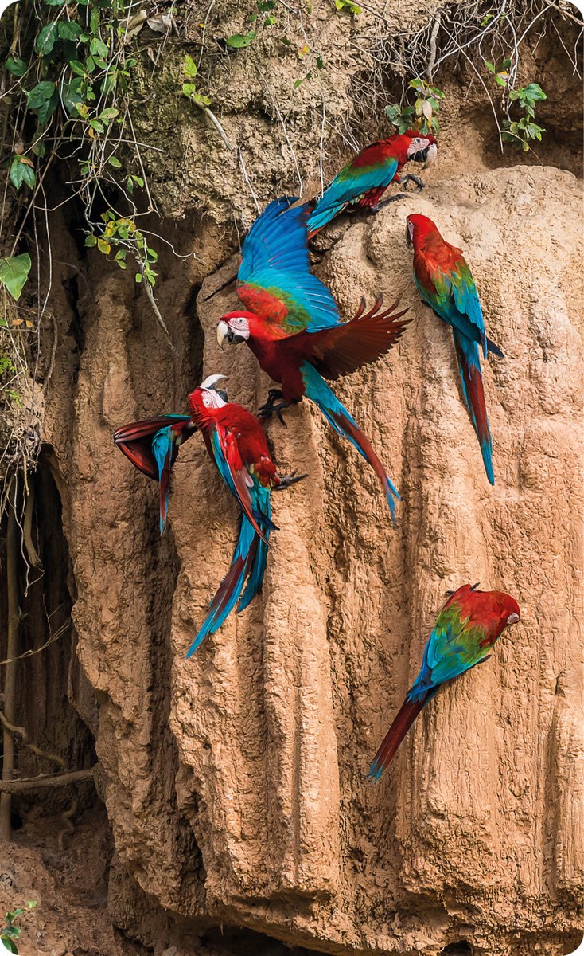

Goal 3: Strengthened cooperation on climate, environment and food security to help combat climate change, preserve biodiversity and promote sustainable development.

Climate and forest cooperation.

Norway will continue the close and strong collaboration with Brazil to reduce and reverse the loss of tropical forests.

Multilateral efforts for climate, nature and the environment.

Norway will strengthen cooperation on global climate, nature and environmental issues and seek opportunities for a strategic partnership with Brazil with a focus on reducing greenhouse gas emissions and halting and reversing the loss of biodiversity.

Sustainable ocean management.

Norway will further develop the bilateral dialogue on sustainable ocean management and strengthen the multilateral cooperation with Brazil on the protection and sustainable use of the world’s oceans.

Food security.

Norway will continue its cooperation with Brazil to fight hunger and poverty, and increase climate- and nature-friendly food production globally.

# Knowledge cooperation, innovation and digitalisation



Brazil has a high-quality research, innovation and education sector and unique research infrastructure in several areas. Most Norwegian universities and technological research institutes already have agreements in the country, and Norway is an attractive partner. The Norwegian authorities want to strengthen the knowledge triangle, i.e. the link between research, education and innovation, in their cooperation with Brazil.

Knowledge cooperation with Brazil in a number of fields.

Knowledge cooperation between Norway and Brazil ranges from energy, ocean space, health, biology, engineering and digitalisation to nature management and diversity, land registration, social sciences, economics and art. Joint research production in the form of co-publications increased almost fivefold from 2010 to 2025. Knowledge cooperation has the potential to create sustainable solutions, increase expertise, improve welfare and strengthen competitiveness.

Through the Government’s Panorama strategy, Brazil is one of Norway’s prioritised countries for knowledge cooperation outside the EU. According to this strategy, knowledge cooperation with Brazil is based on principles linked to quality, relevance, reciprocity, long-term perspectives and accountability. International cooperation is also anchored in the Norwegian white papers “Long-term plan for research and higher education 2023–2032” and “A world of opportunities”, as well as in several bilateral agreements at government and institutional level.

Multilateral knowledge cooperation.

Multilateral arenas where both countries participate are valuable for strengthening the bilateral relationship and working together towards common goals. Examples of such arenas are the Belmont Forum, Mission Innovation, Erasmus+, the UN Global Digital Compact and the Digital Public Goods Alliance. There is great potential for collaboration between Norwegian knowledge environments and Brazilian partners through the EU Framework Programme for Research and Innovation, which is the world’s largest programme of its kind, and thus an important arena.

Close links between academia and business are very important because the knowledge produced must be utilised in society. The Research Council of Norway, the Norwegian Directorate for Higher Education and Skills, and Innovation Norway all contribute to a good interplay between education, research and business. Together with the Ministry of Education and Research, these institutions have a knowledge and technology envoy in Brazil.

Instruments for higher education and research cooperation.

There are currently good instruments for cooperation between Norwegian and Brazilian students, researchers, institutions, businesses and authorities, but these instruments can be further developed and strengthened. Norwegian students receive extra travel support for exchange programmes in Brazil from the Norwegian State Educational Loan Fund. Brazilians on exchange programmes in Norway can also receive grants and travel support through specific projects. Most of the Research Council of Norway’s calls for proposals are open to international collaboration, and Brazilian partners can receive funding in projects unless the call excludes it. Targeted instruments such as INTPART (International Partnerships for Excellent Education, Research and Innovation) and UTFORSK (a programme for educational collaboration for enhanced quality and relevance of higher education) strengthen research and education cooperation between Norway and Brazil.

|  |
| --- |
| Academic collaboration on aquaculture  The Ålesund branch of the Norwegian University of Science and Technology (NTNU) leads an active network that includes seven educational institutions primarily in Norway and Brazil, as well as business partners in both countries. This project contributes to high quality education and research, as well as international cooperation in aquaculture. The collaboration has led to new research relationships, improved exchange possibilities, an increased number of joint applications to calls for proposals and cooperation in research education.  The industry partners strengthen the relevance of the educational programme and provide students and staff with valuable insight into complex issues in marine environments and aquaculture. Through interaction with the industry and other local stakeholders, the students also gain an understanding of social and economic aspects, which are crucial for the sustainable and responsible development of food production in aquaculture. |

Energy and petroleum.

For several years, Norway and Brazil have enjoyed excellent knowledge cooperation in the energy and petroleum sectors. It is desirable to organise regular joint calls for proposals between the Research Council of Norway and its Brazilian counterpart Finep, and to increase the number of applications. The November Conference in Rio de Janeiro is a key arena for research and development players in the energy sector in both countries.

Climate, environment and food security.

Brazil has internationally recognised research environments within climate, the environment and food security. Increased knowledge cooperation, especially between educational institutions, researchers and businesses in this area will be of mutual benefit to both countries.

Digital innovation.

Norwegian authorities emphasise that Norwegian companies and research and development (R&D) institutions should collaborate with Brazilian partners to develop technological solutions. Norway and Brazil have significant potential for further cooperation in the area of digital infrastructure, particularly to help build capacity in developing countries, for example through the Digital Public Goods Alliance. There is a great need for the development of digital solutions and open data that help to solve the challenges in these areas.

Goal 4: Strengthened education, research and technology cooperation for increased Norwegian competitiveness and joint sustainable solutions.

Collaboration in the knowledge triangle.

Norway will strengthen the link between research, education and innovation in its cooperation with Brazil. Norway will better communicate opportunities for collaboration between Norwegian and Brazilian students, institutions, researchers and businesses. The aim is to facilitate knowledge exchange and development, as well as contribute to lasting mutual mobility of students and employees.

Knowledge in use.

Norway will strengthen knowledge cooperation on topics that are of mutual interest to our two countries and in line with agreements and other frameworks. The knowledge produced in the collaboration must be put to use in society, including through the commercialisation and upscaling of research results.

Multilateral cooperation.

Norway will promote increased cooperation between Norwegian and Brazilian research and educational institutions through multilateral initiatives involving both countries, such as the EU Framework Programme for Research and Innovation, Erasmus+, Mission Innovation and the Belmont Forum.

Energy and petroleum.

Norway will continue to build on the great knowledge cooperation with Brazil within energy and petroleum, and further develop the November Conference as the most important arena for research and development actors in the energy and petroleum sector in both countries.

Climate and the environment.

Norway will follow up the knowledge cooperation with Brazil in line with the Panorama strategy and the national and international research policy priorities in the field of climate and the environment.

Digitalisation.

Norway will strengthen its cooperation with Brazil on digital public infrastructure and open standards to contribute to competition and innovation, including in developing countries.

